**Create Storage account and work with Blob Service – PowerShell**

**Step 1:** Open **Microsoft Azure Portal**

[https://portal.azure.com](https://portal.azure.com/)

**Step 2:** Start **Powershell** on local system

**Step 3:** Authenticate with Azure Account in PowerShell

Login-AzureRmAccount

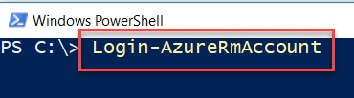

Enter Azure Credentials

It will load Azure Subscription as below:

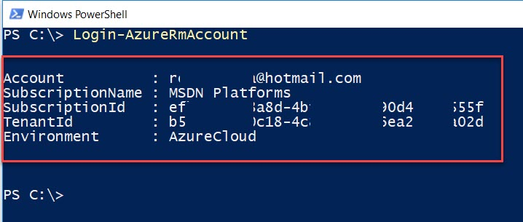

**Step 4:** Create **New Resource Group** on **East US** location

$location = "eastus"

$resourceGroup = "myResourceGroup"

New-AzureRmResourceGroup -Name $resourceGroup -Location $location

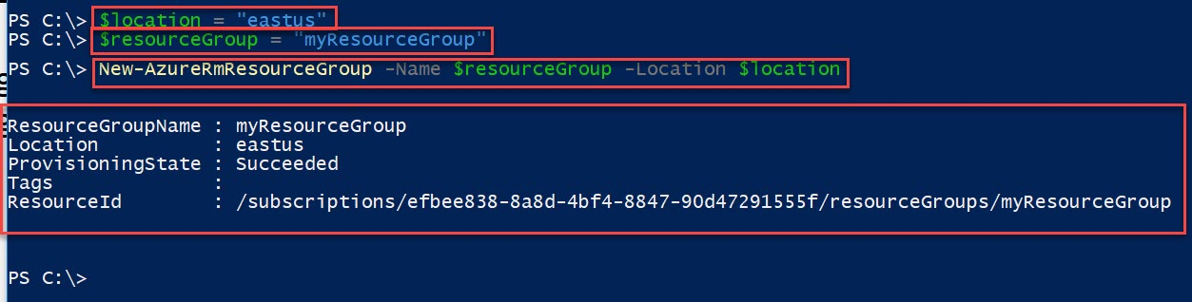

**Step 5:** Create **New Storage account with Standard LRS**

Note: please update storage name with unique name

$storageAccount = New-AzureRmStorageAccount -ResourceGroupName $resourceGroup -Name "mystrgaccount01" -SkuName Standard_LRS -Location $location

$ctx = $storageAccount.Context



**Step 6:** Create **Container with Blob Permission**

$containerName = "mycontainer"

New-AzureStorageContainer -Name $containerName -Context $ctx -Permission blob

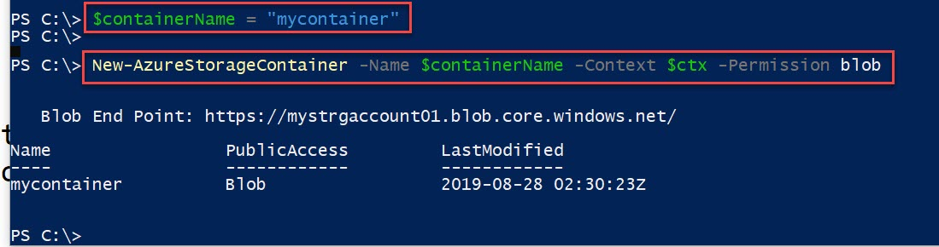

**Step 7:** Before execute below command please create **myfiles** folder and add few images with image01.jpg, image02.jpg, etc

Set-AzureStorageBlobContent -File "C:\myfiles\image01.jpg" -Container $containerName -Blob "Image01.jpg" -Context $ctx

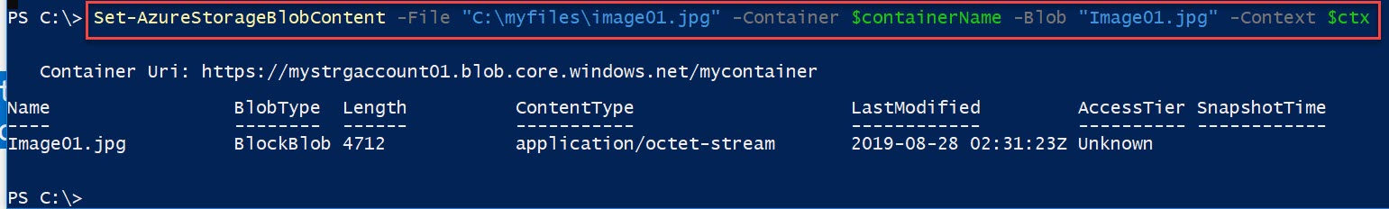

**Step 8:** To **list Blobs** in Container

Get-AzureStorageBlob -Container $ContainerName -Context $ctx | select Name

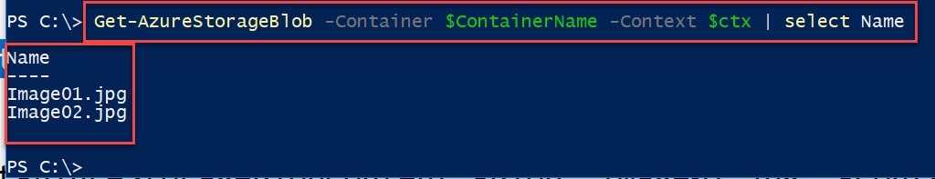

**Step 9:** To **Download** Blob into local system

Note: Also create one Download folder under **C Drive -> myfiles ->** Create **Download** folder

Get-AzureStorageBlobContent -Blob "Image01.jpg" -Container $containerName -Destination "C:\myfiles\Download\" -Context $ctx

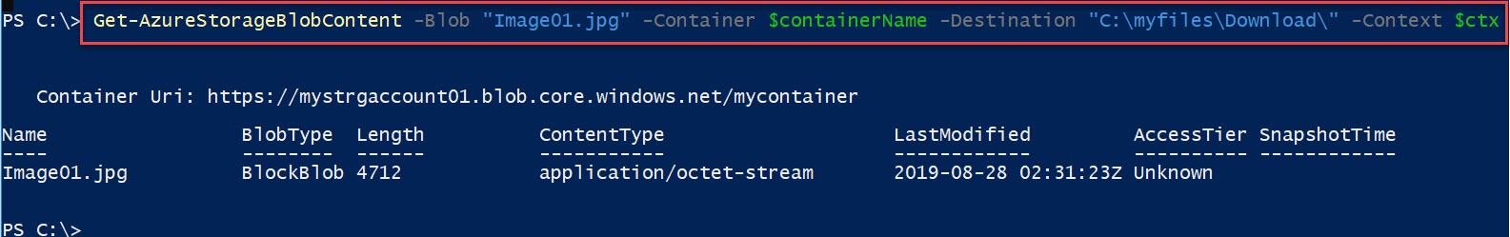

**Step 10:** Delete Resource Group

Remove-AzureRmResourceGroup -Name $resourceGroup