**Create Ubuntu Virtual Machine & Configure LAMP Stack**

In this document you will learn how to create Ubuntu Virtual Machine using Azure Portal. After Creation of Virtual Machine, we will configure LAMP Stack (Linux, Apache, MySQL, PHP) on VM and try to host website on that.

**Step 1:** Open Azure Portal

<https://portal.azure.com>

**Step 2:** Click on **+ Create a resource -> Get started -> Ubuntu Server 18.04 LTS**

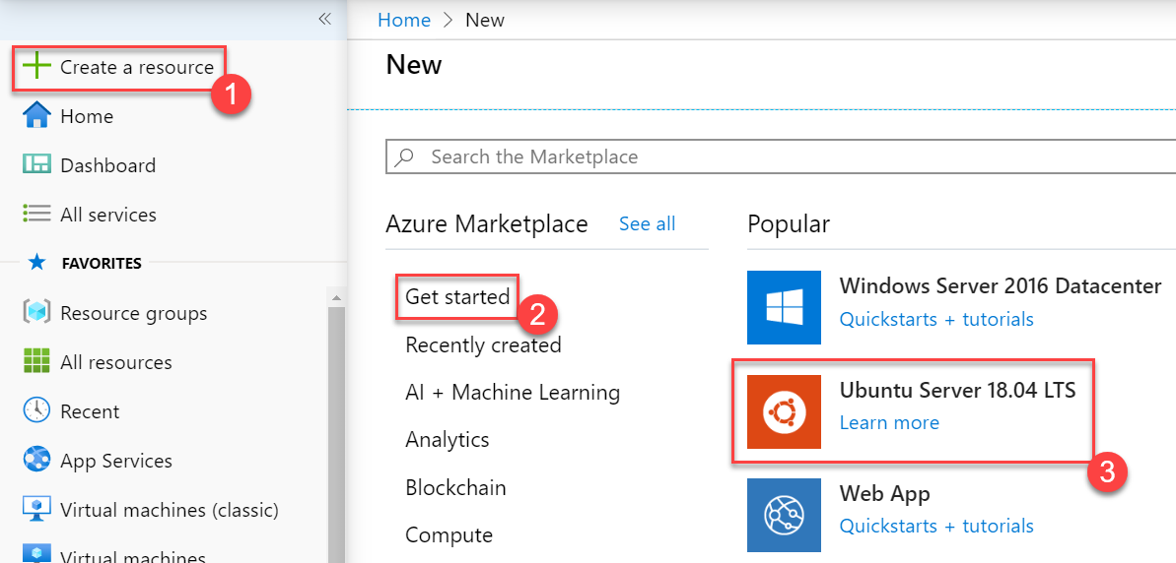

**Step 3:** Enter Virtual Machine Basics details

**Subscription:** Choose your Subscription

**Resource Group:** Create New -> **LAMPVMRG**

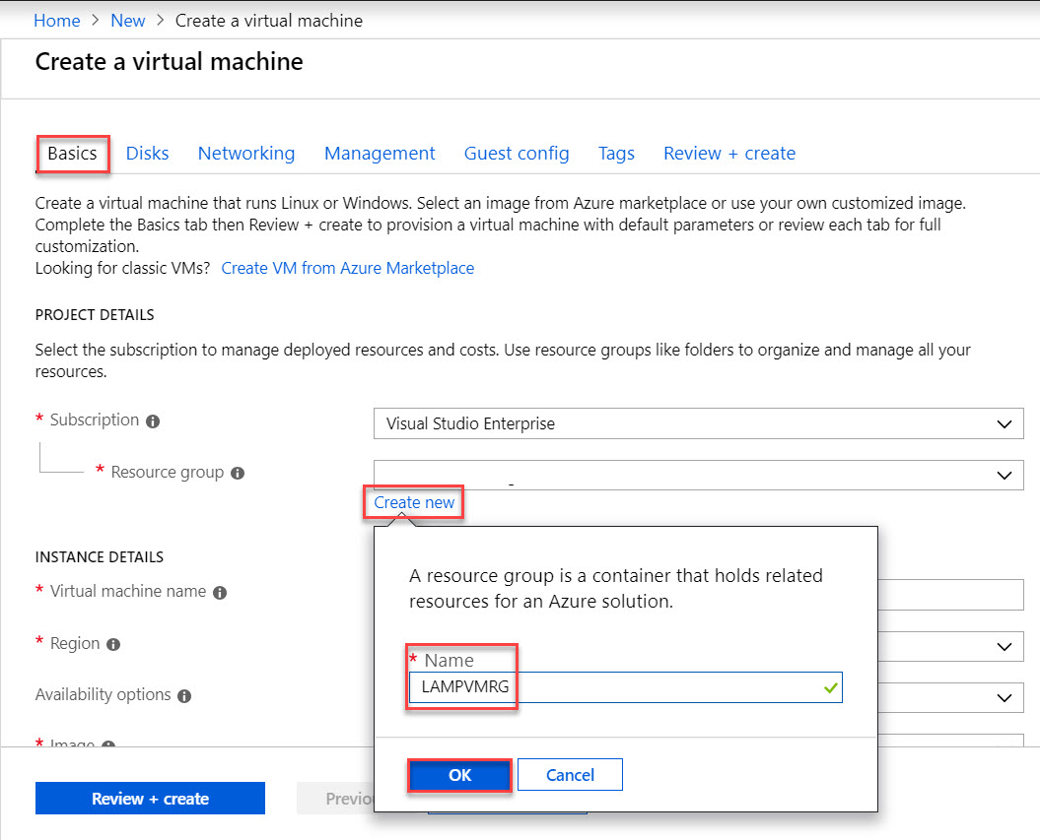

**Virtual Machine Name:** LAMPServer

**Region:** Choose any nearest region

**Image:** Ubuntu Server 18.04 LTS

**Size:** continue with default size or select any other size

**Administrator Username:** demouser

**Administrator Password:** demo@pass123

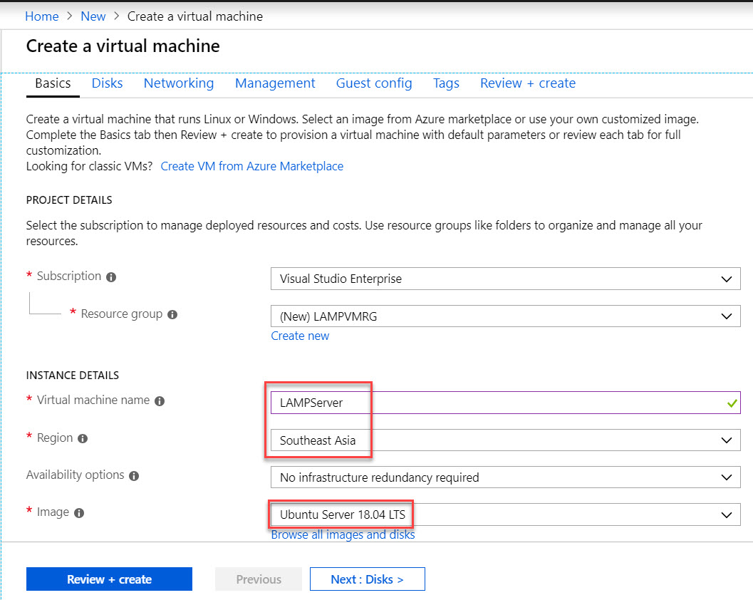

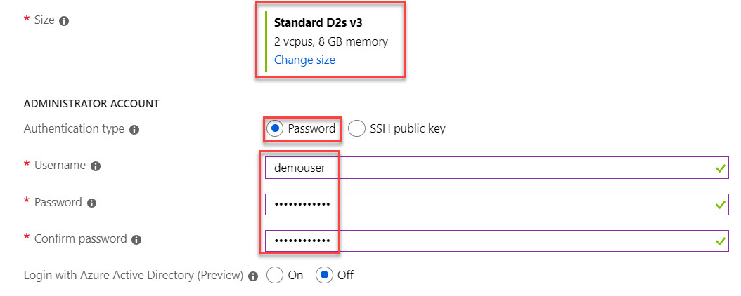

**Public inbound ports:** Allow selected ports. **Select SSH (22)**

**Windows License:** No

Click on **Next: Disks >** button

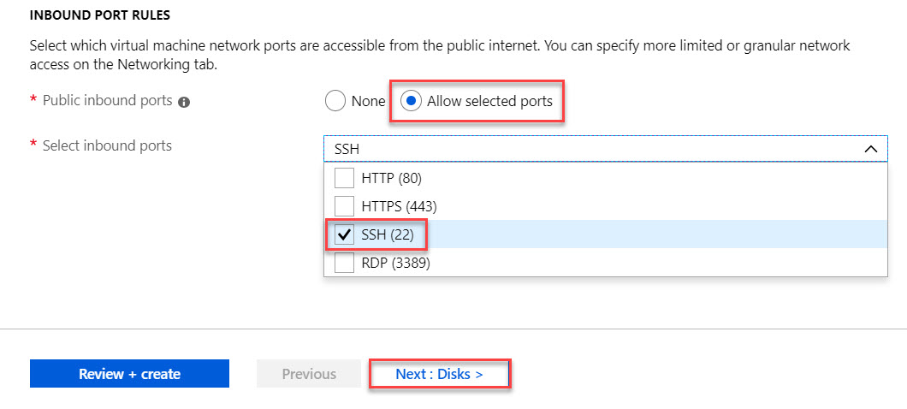

**Step 4:** **Disks** tab

**OS disk type:** Standard HDD

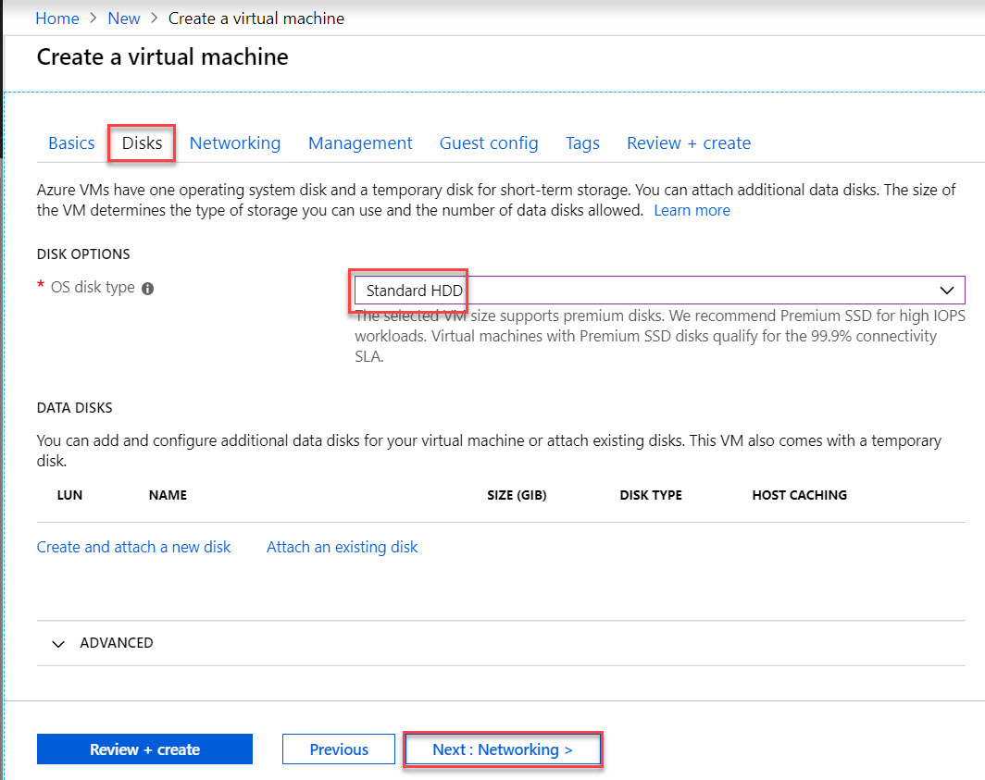

**Step 5: Networking** tab

Continue with default settings

**Virtual network:** Create New

**Subnet:** new

**Public IP:** new

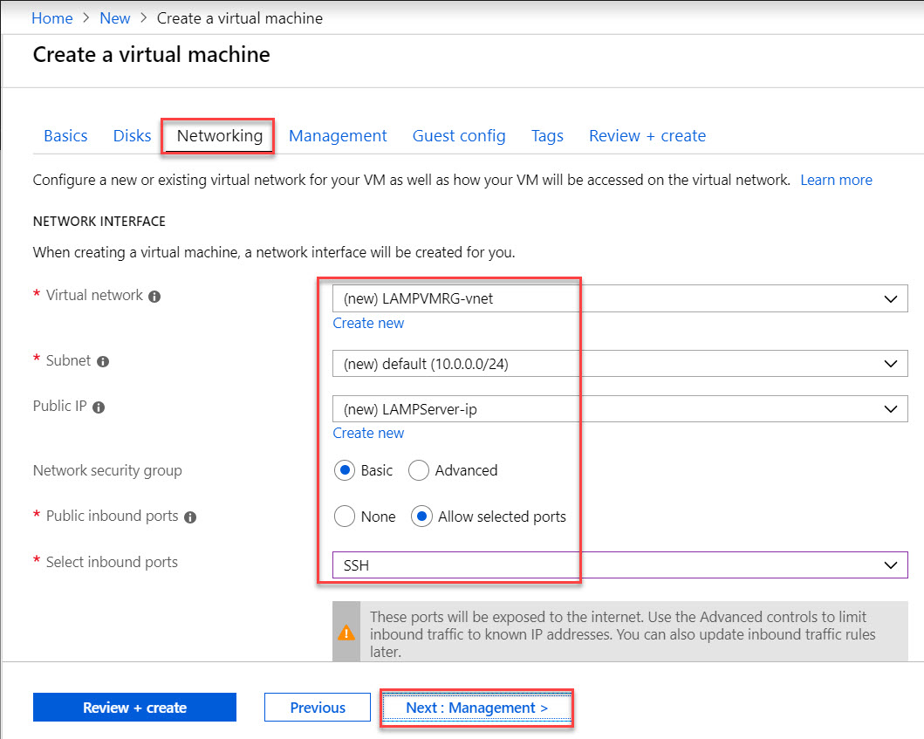

**Step 6:** **Management** tab

Continue with default settings

Click on **Next: Advanced >** button

**Boot diagnostics:** On

**OS guest diagnostics:** Off

**Diagnostics storage account:** new storage account

**Identity:** Off

**Auto-Shutdown:** Off

**Backup:** Off

*Note: for this demo don’t require to setup all.*

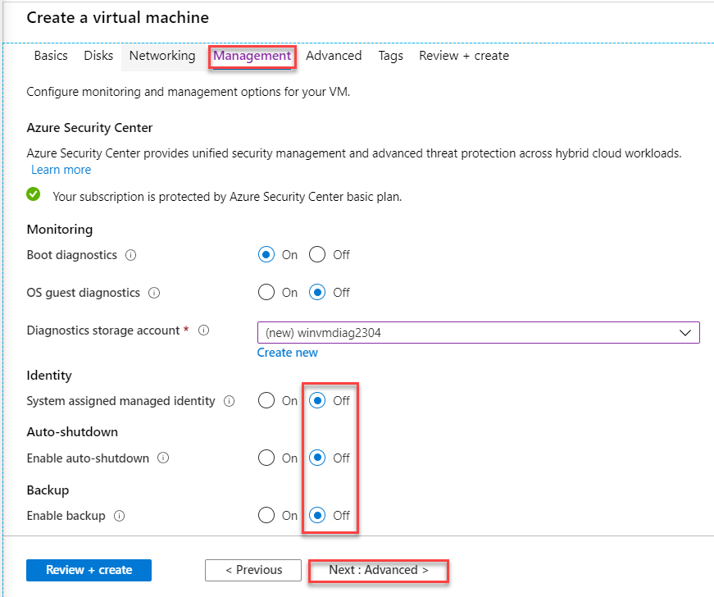

**Step 7:** **Advanced** tab

Click on **Next: Tags >** button

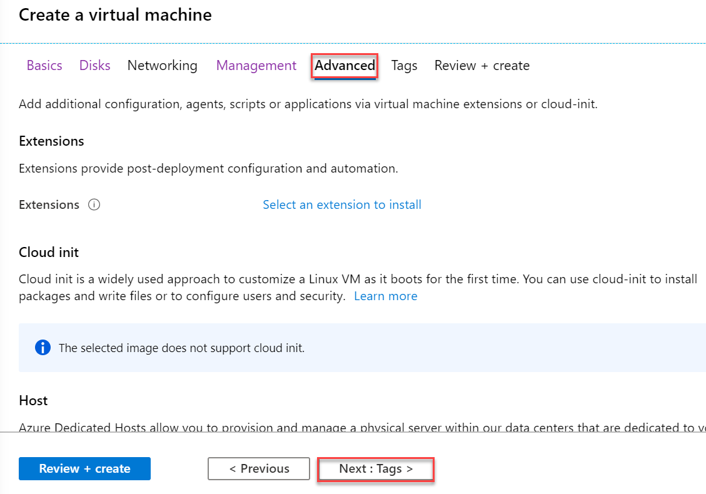

**Step 8:** **Tags** tab.

Click on **Next: Review + create >** button

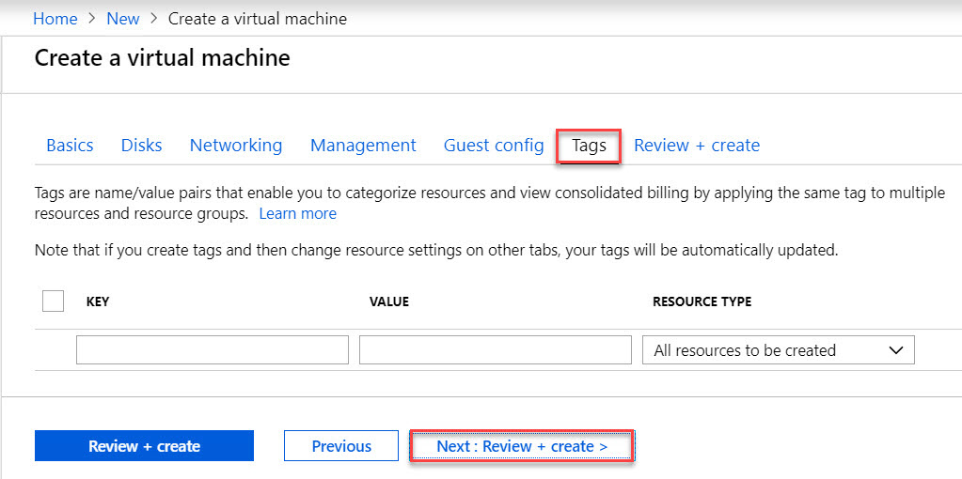

**Step 9:** **Review + create** tab

Validation passed means all settings are right and create virtual machine. If validation failed so verify all the settings.

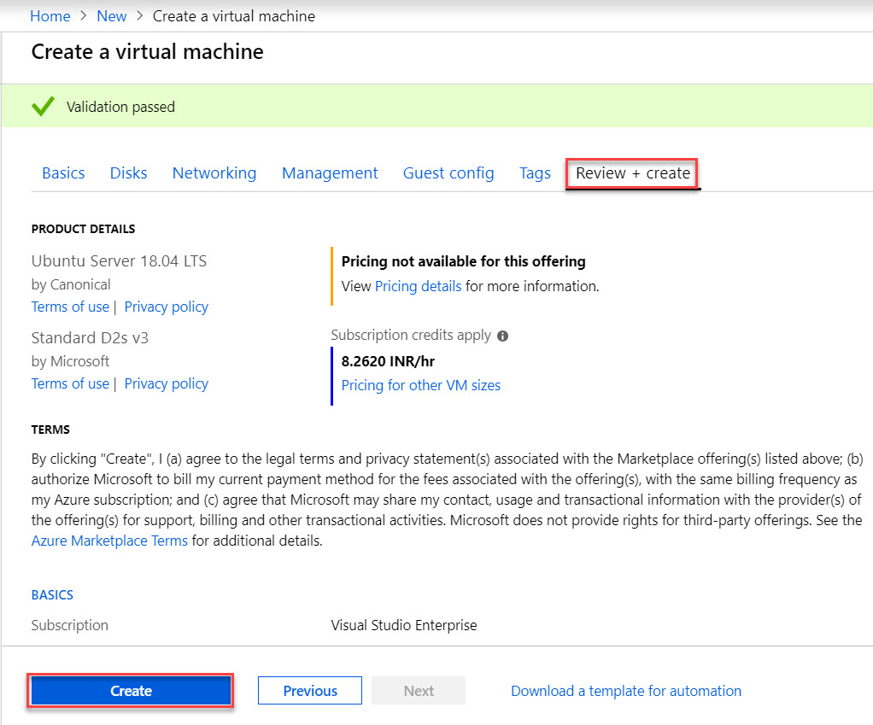

Virtual Machine deployment is underway. Wait for few minutes to complete

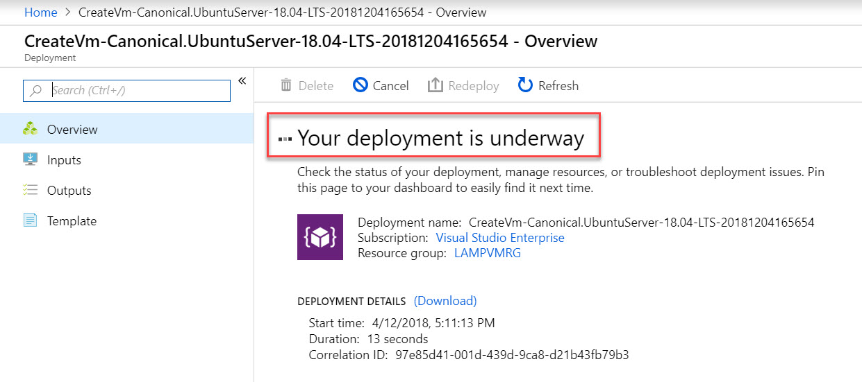

When deployment complete so click on **Go to resource**

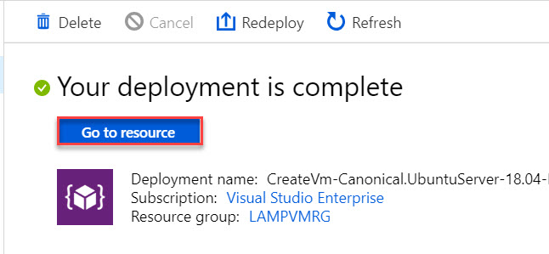

**Step 7:** By default, RDP option like Windows not available with Ubuntu Virtual Machine so we will use SSH for that. So, will require PuTTY software. Please download from here: <https://putty.org/>

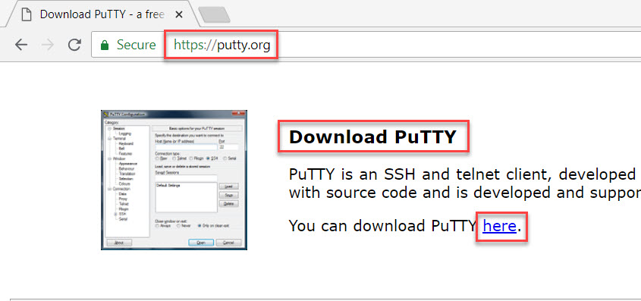

Select **putty.exe** file based on machine like 64-bit or 32-bit.

Download and install on machine

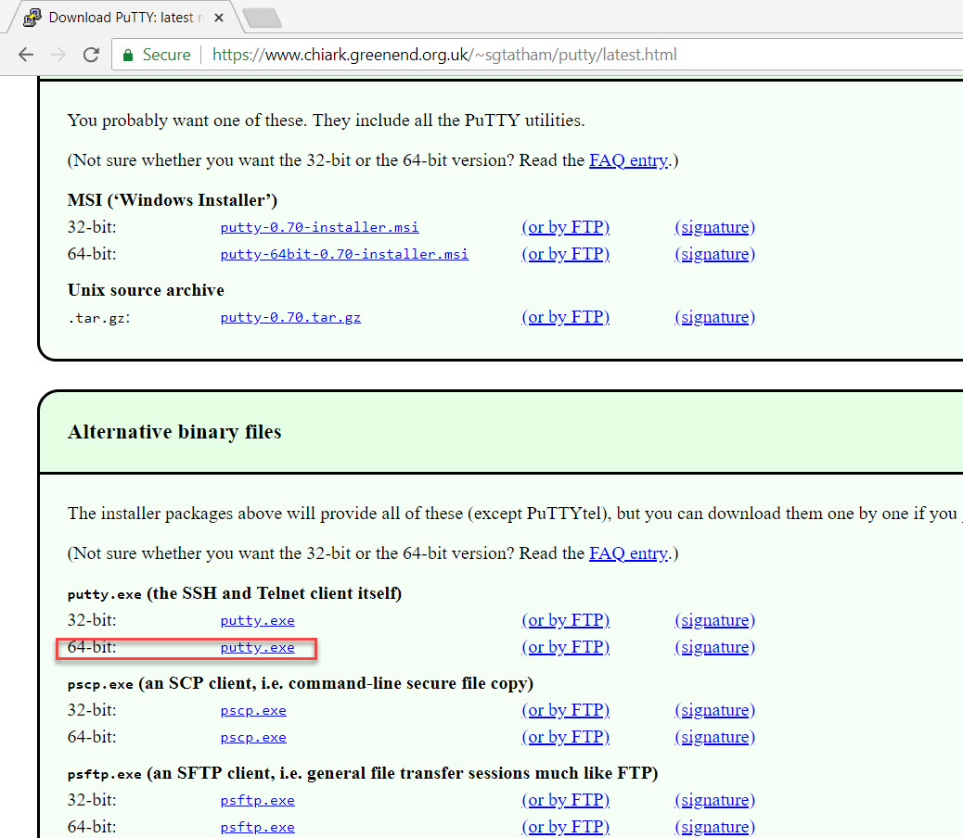

**Step 8:** Now run **PuTTY**

Enter Ubuntu Virtual Machine Public IP Address. To start the session, click on **Open** button.

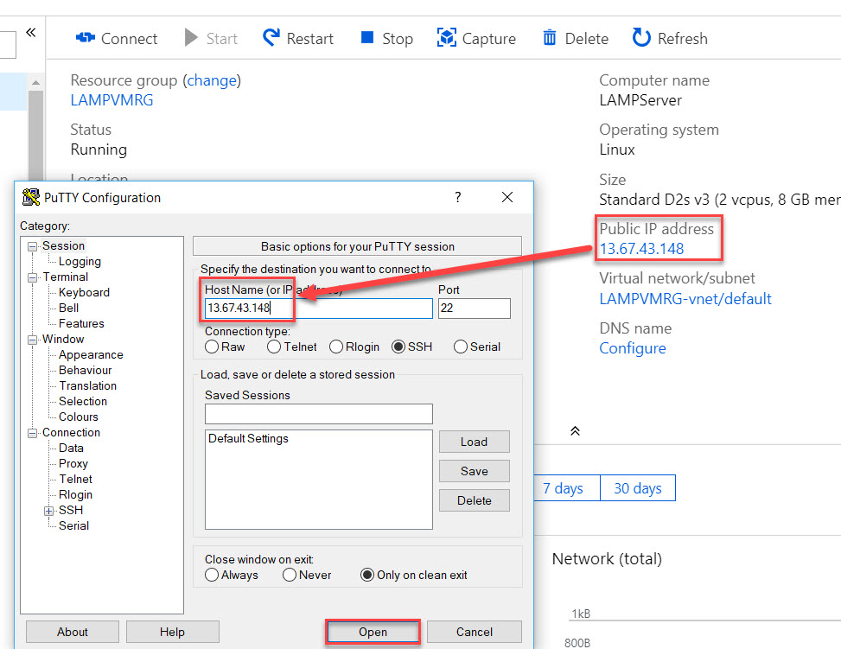

Click on **Yes** button.

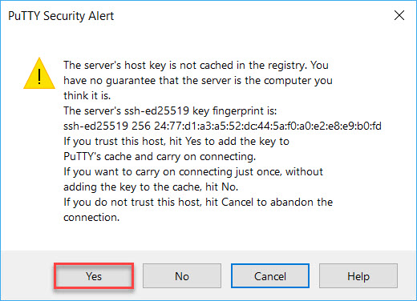

**Step 9:** Enter VM Login Username & Password.

Ex. **Username:** demouser

**Password:** demo@pass123

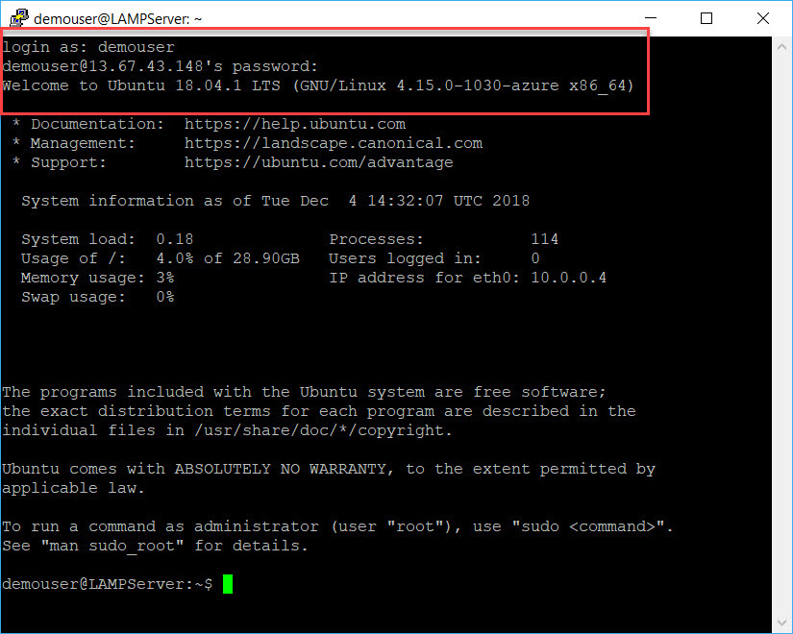

**Step 10:** Change the user to root by typing below command:

*sudo su*



Because to run few command or script will require

**Step 11:** To update the packages run below command

*apt-get update*

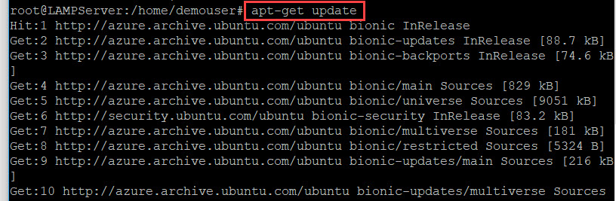

**Step 12:** Tasksel is a Debian/Ubuntu tool that installs multiple related packages as a co-ordinated "**task**" onto your system. Here we will install **LAMP Stack (Linux, Apache, MySQL, PHP)** using this command.

*apt-get install tasksel*

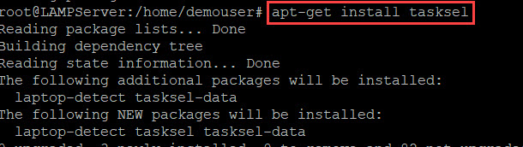

Now run tasksel

*tasksel*



**Step 13:** Use Keyboard arrow for **Up/Down** & Select **LAMP Server** by pressing space.

Navigate to **OK** using TAB and hit Enter for continue.

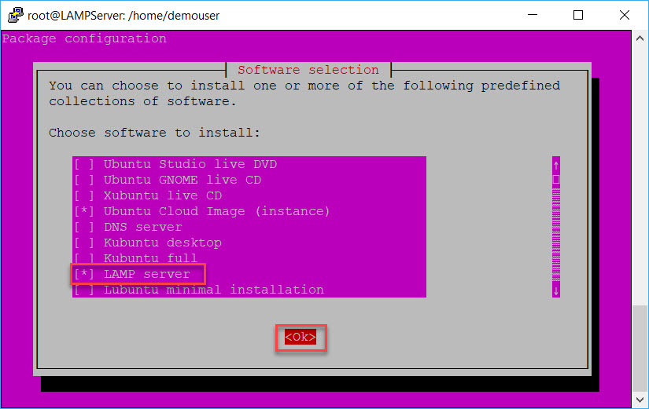

Wait for installation

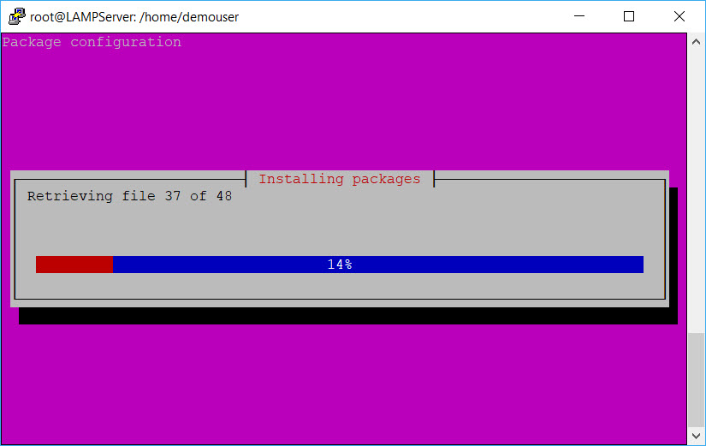

**Step 14:** After installation done type below command to navigate to HTML folder or where we can save our website

*cd /var/www/html*

list files using below command

*ls*

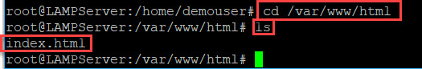

**Step 15:** Create new php file using any editor.

For this demo we are using nano editor

*nano default.php*



Editor will open and add text into the page

<?php echo "<h1>Ubuntu Virtual Machine Demo - LAMP Stack</h1>"; ?>

After designing page press below keys

*“CTRL + x” then “y” and hit “Enter”*

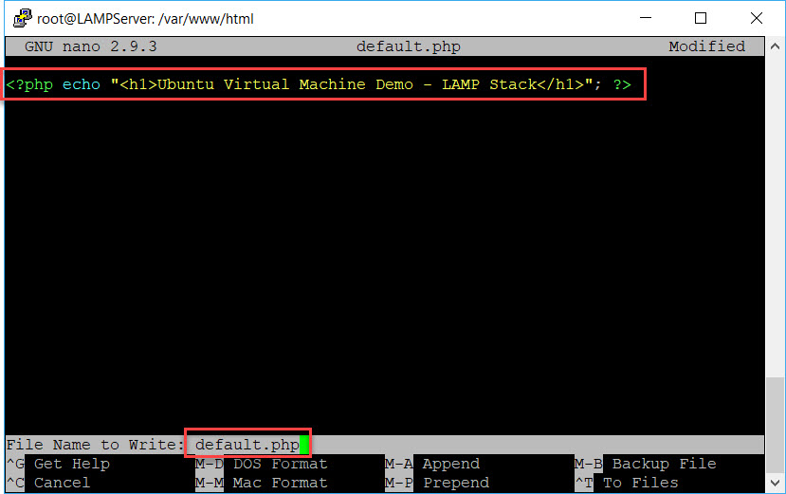

**Step 16:** Now navigate to Azure Portal. Click on **Resource Groups** and select **LAMPVMRG**

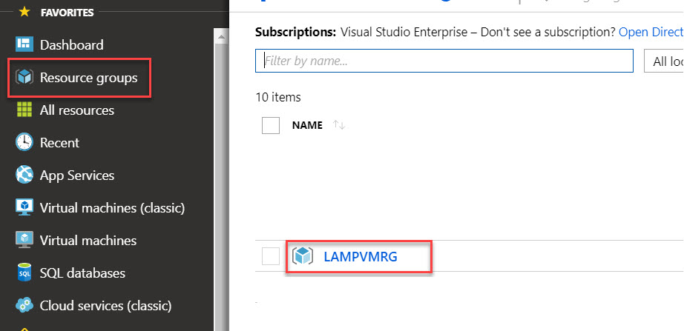

Select Network Security Group

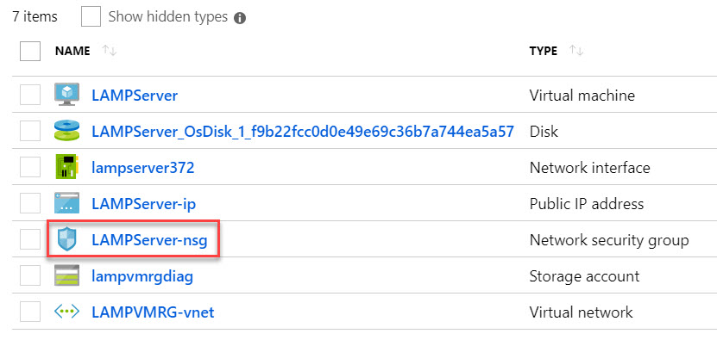

Select **inbound security rules** and click on **+ Add** button

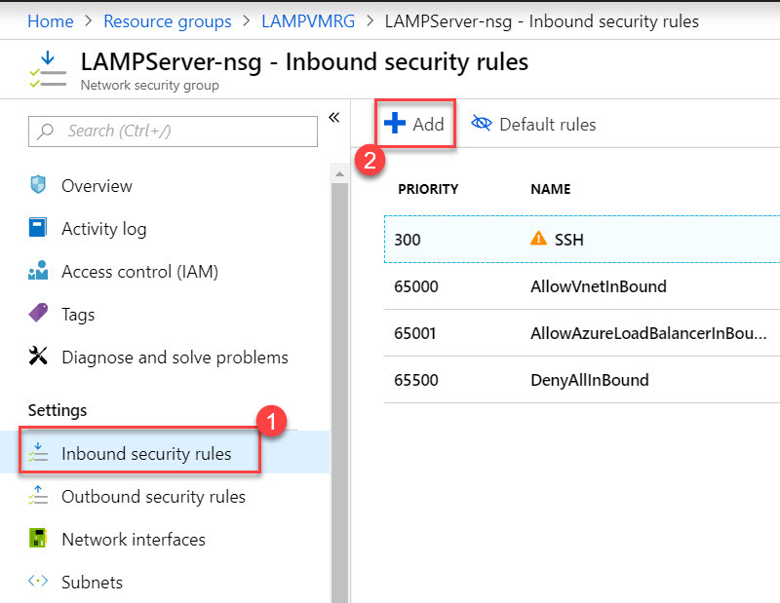

*Note: Inbound port rule – An inbound rule protects the network against incoming traffic from the internet or other network.*

Click on **Basic** option

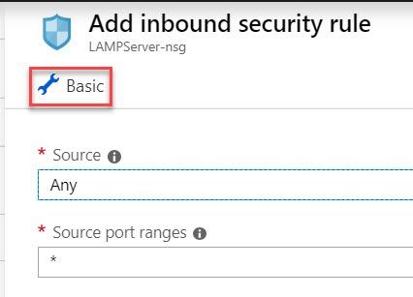

Choose **Service: HTTP** because we need to open 80 port for that. Click on Add button.

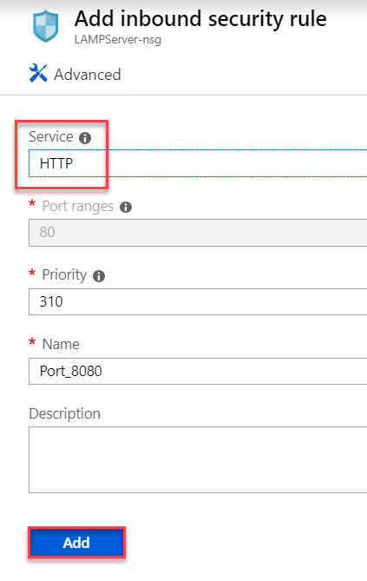

**Step 17:** Select **Resource Group** and Click on **LAMPVMRG**.



Select **Virtual Machine** Ex. **LAMPServer**

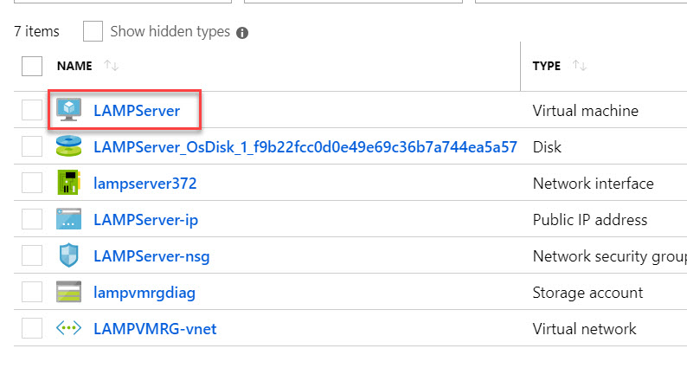

**Step 18:** Copy **Public IP Address**

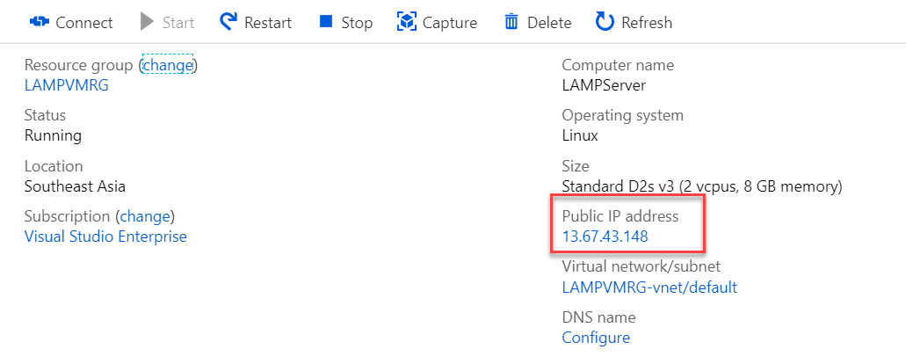

Open Browser and paste IP address with page name.

Ex. 13.67.43.148/default.php

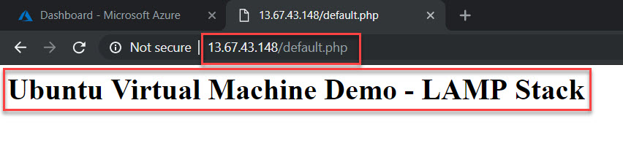

**To Stop Virtual Machine:**

Click on **Stop** button and click on **Yes** option in Overview

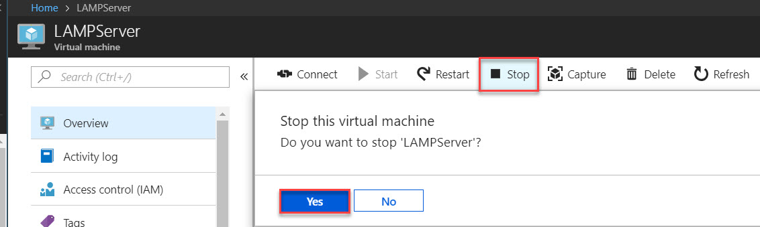

**To Delete Virtual Machine and other resources:**

Click on **Resource groups** (left side) & select Virtual Machine resource group

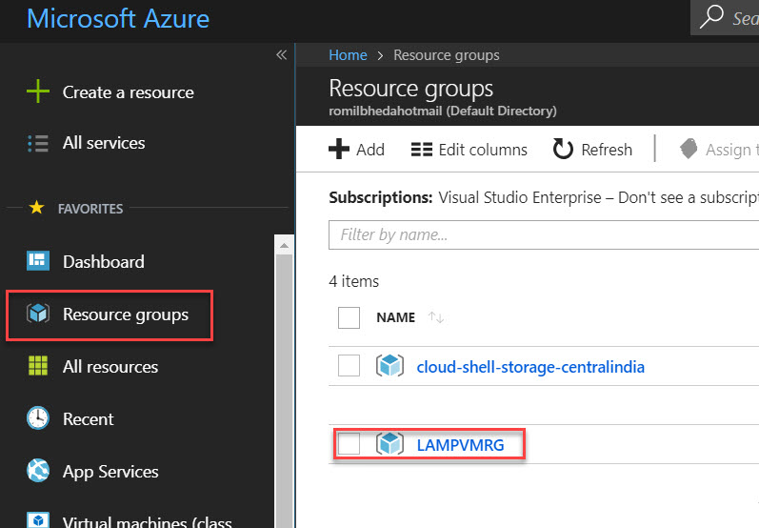

Click on **Delete resource group** option

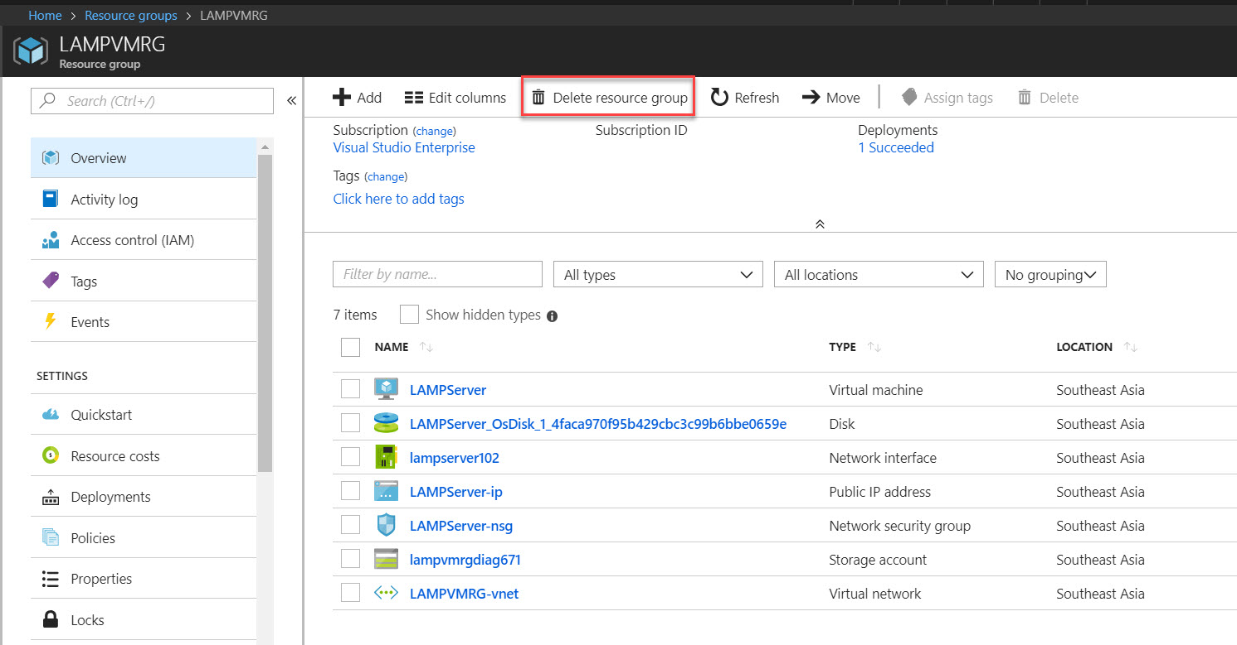

Enter resource group name to confirmation of virtual machine & click on **Delete** button.

