**Create Windows Server 2019 Virtual Machine using PowerShell**

**Step 1:** Click on **Windows** button & search for **powershell**.

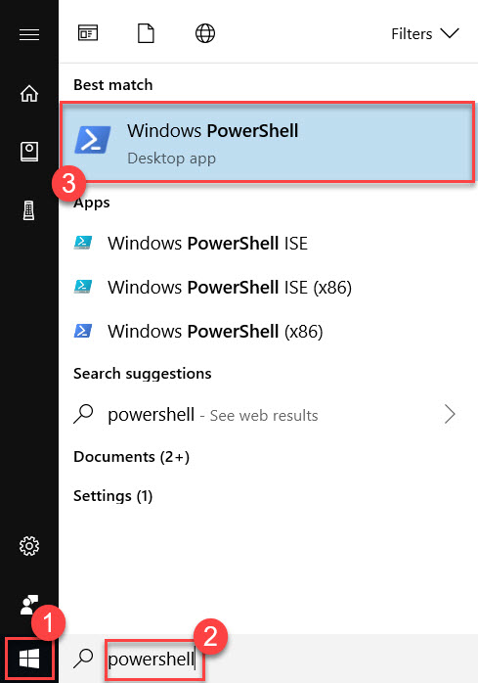

**Step 2:** Enter below command to install **AzureRM Module**

# Install Azure PowerShell Module

Write-Host "Downloading Azure Powershell Module..." -ForegroundColor Green

Install-Module -Name AzureRM

Write-Host "PowerShell Successfully Installed" -ForegroundColor Green

Stop-Process -Name Explorer

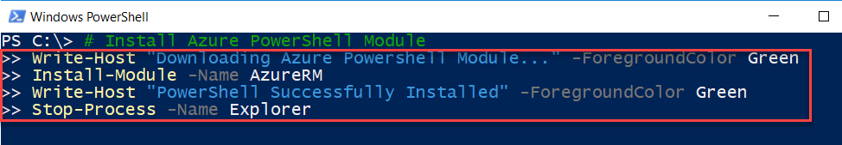

Wait for few minutes to install Azure PowerShell Module.

Close PowerShell.

**Step 3:** Click on **Windows** button & search for **powershell**.

Click **Windows PowerShell**



**Step 4:** PowerShell available on local machine so we need to connect Microsoft Azure account to local machine via PowerShell using below command:

Login-AzureRmAccount or *Connect-AzureRmAccount*

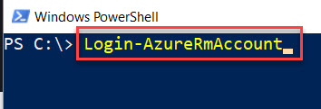

Enter Microsoft Azure Account Credentials

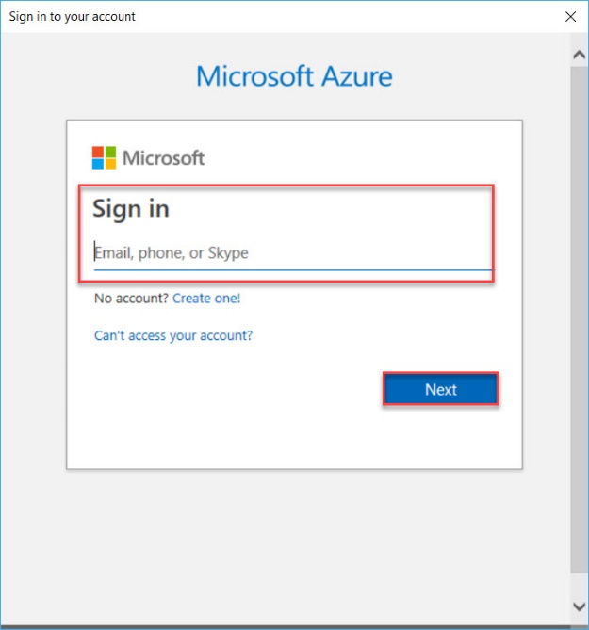

Account Details will load as below

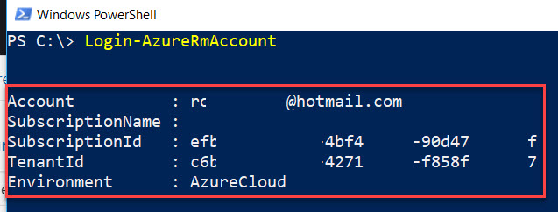

**Step 5:** First we need to create **Resource Group**

New-AzureRmResourceGroup -ResourceGroupName "WinVMPSRG" -Location "EastUS"

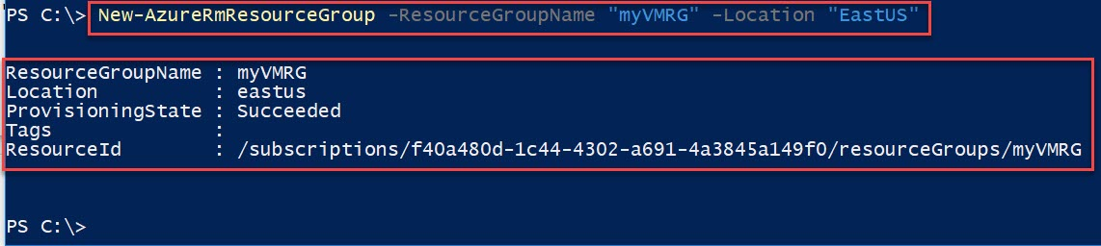

**Step 6:** Before deploying Virtual Machine, we are passing **Credentials** for that.

$cred = Get-Credential

Username: **demouser**

Password: **demo@pass123**

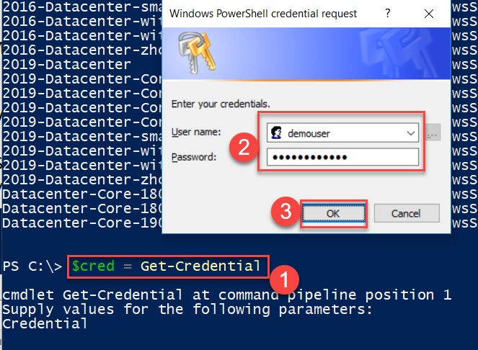

**Step 7:** To **Create Virtual Machine** run below command:

New-AzureRmVm `

-ResourceGroupName "WinVMPSRG" `

-Name "myVM" `

-Location "EastUS" `

-VirtualNetworkName "myVnet" `

-SubnetName "mySubnet" `

-SecurityGroupName "myNSG" `

-PublicIpAddressName "myPublicIpAddress" `

-ImageName "MicrosoftWindowsServer:WindowsServer:2019-Datacenter:latest" `

-Credential $cred `

-OpenPorts 80,3389

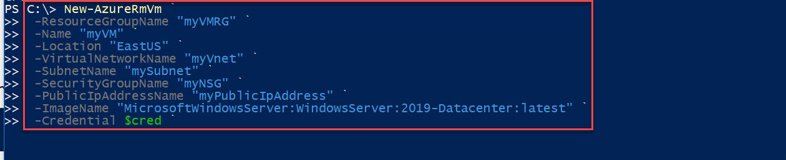

Wait for couple of seconds to deploy **Virtual Machine** on Azure

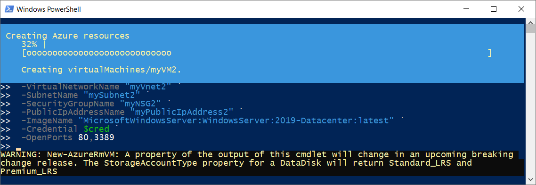

**Step 8:** Get the **Public IP Address** of Virtual Machine

Get-AzureRmPublicIpAddress -ResourceGroupName WinVMPSRG | Select "IpAddress"

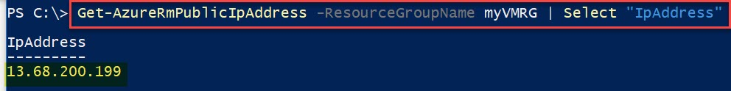

**Step 9:** Now time to **Connect** of Virtual Machine via **RDP**

mstsc /v:PublicIPAddress

Ex. mstsc /v:13.68.200.199

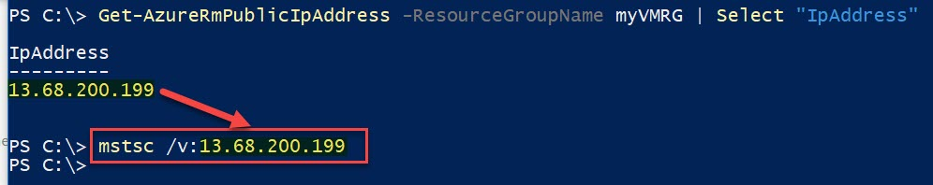

**Step 10:** Enter Virtual Machine Credentials

Username: demouser

Password: demo@pass123

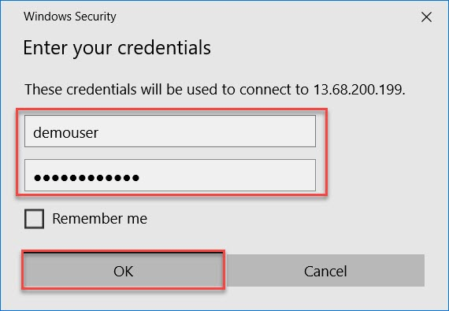

Click on **Yes** button

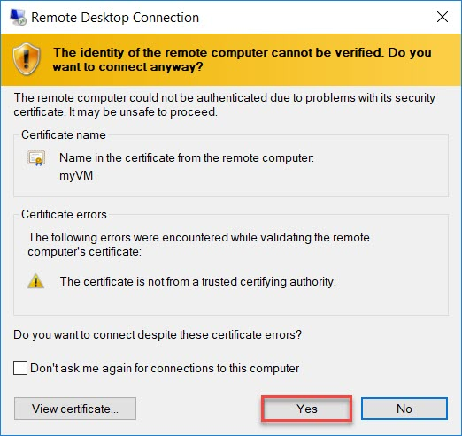

**Step 11:** Wait for few seconds Windows Server 2019 Datacenter will load.

Click on **Start** button and click on **Windows PowerShell**

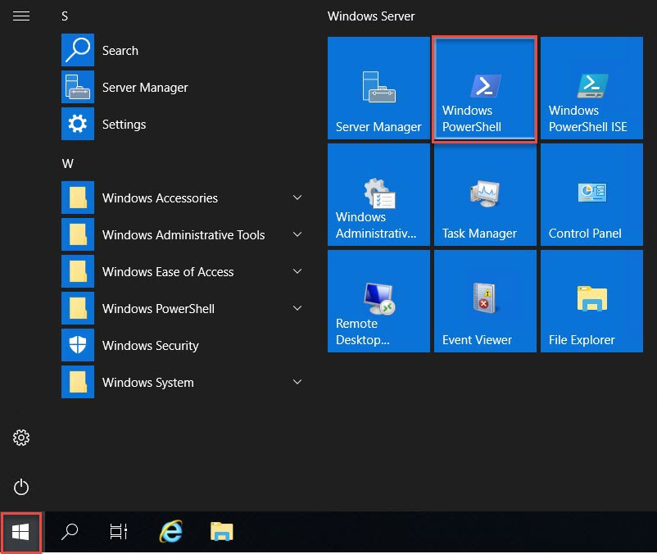

**Step 12:** Run below command to **Install IIS** and add **sample HTML website**

#Install IIS

Install-WindowsFeature -name Web-Server -IncludeManagementTools

#Download Sample Web Project

(New-Object Net.WebClient).DownloadFile('https://github.com/romilbheda/azurevm-powershell-demo1/raw/master/DemoApp.zip','C:\inetpub\wwwroot\DemoApp.zip');(new-object -com shell.application).namespace('C:\inetpub\wwwroot').CopyHere((new-object -com shell.application).namespace('C:\inetpub\wwwroot\DemoApp.zip').Items(),16)

[string]$sourceDirectory = "C:\inetpub\wwwroot\DemoApp\*"

[string]$destinationDirectory = "C:\inetpub\wwwroot\"

Copy-item -Force -Recurse -Verbose $sourceDirectory -Destination $destinationDirectory

Remove-Item –path "C:\inetpub\wwwroot\DemoApp" –recurse

Remove-Item -Path "C:\inetpub\wwwroot\DemoApp.zip" -Force

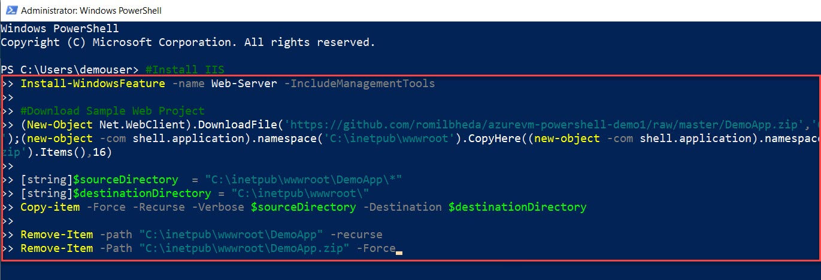

Output will be as below:

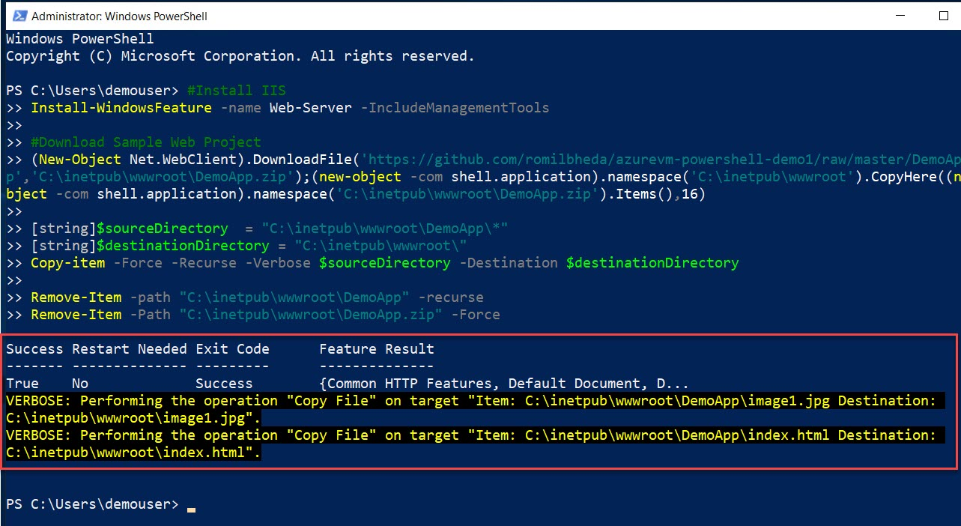

**Step 13:** Minimize Virtual Machine, back to normal machine and run below command to test from Browser.

Start-Process "iexplore.exe" "http://IPAddress"

Ex. Start-Process "iexplore.exe" "http://13.68.200.199"

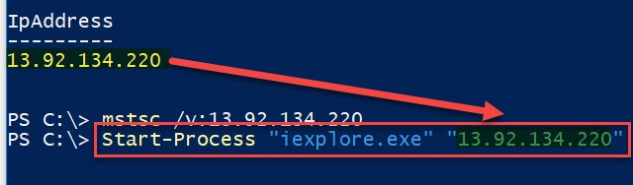

Internet Explorer will open with IP Address and site will run as below:

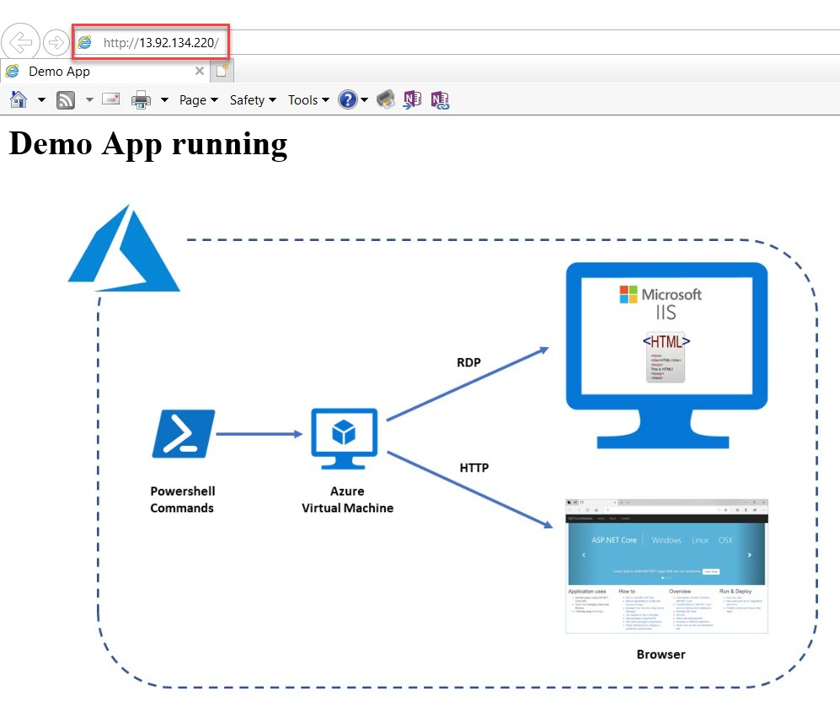

**Delete Resource Group**

Remove-AzureRmResourceGroup -Name "WinVMPSRG"