**Create Linux VM & Configure Apache Server Using CloudShell**

**Step 1:** Open Microsoft Azure Portal

<https://portal.azure.com>

**Step 2:** Click on CloudShell icon (right-top side)



**Step 3:** Choose any working Azure Subscription. Click on **Create Storage** button.

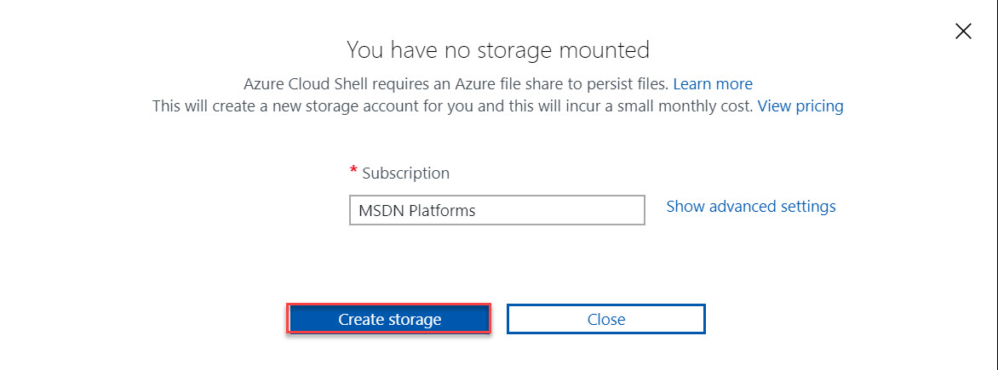

**Step 4**: Wait for couple of seconds to load bash.

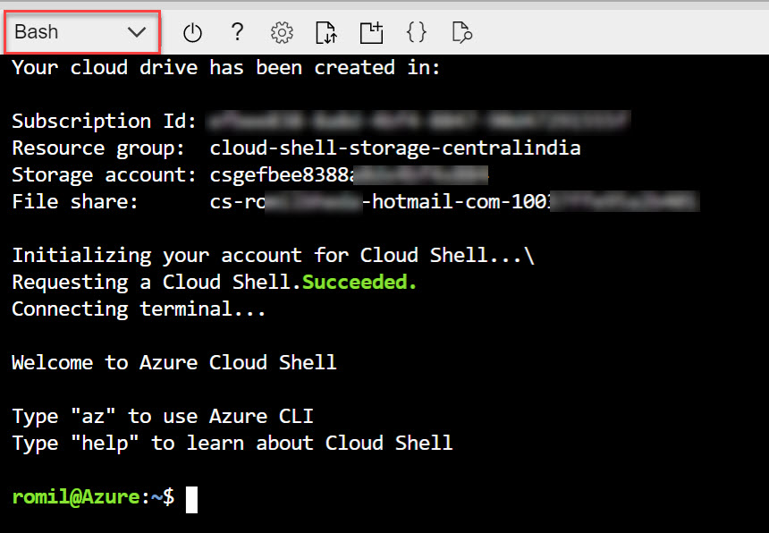

**Step 5:** typeazto check all the commands

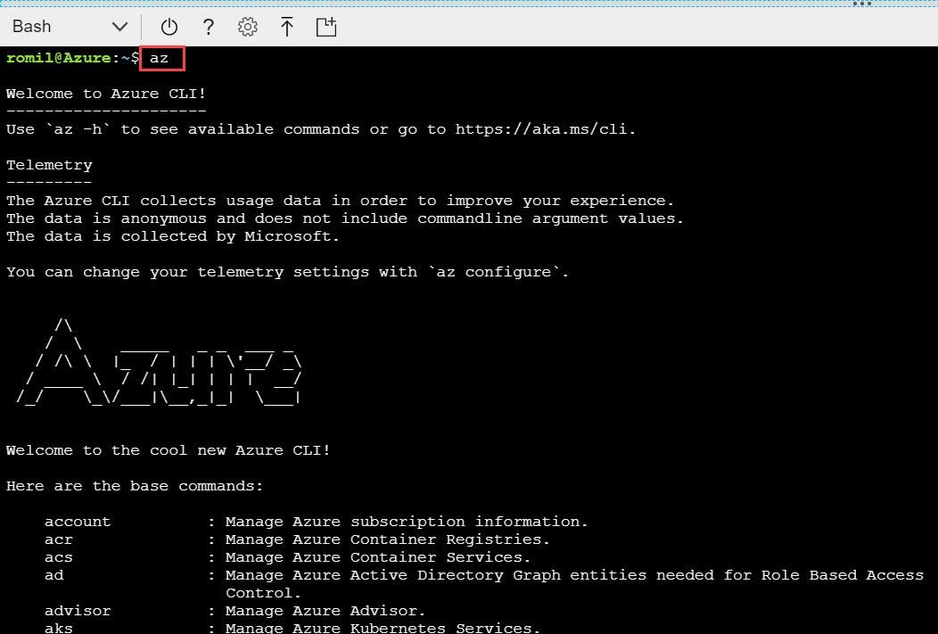

**Step 6:** To Create new resource group on particular location please type below commands:

az group create --name myrg --location southeastasia

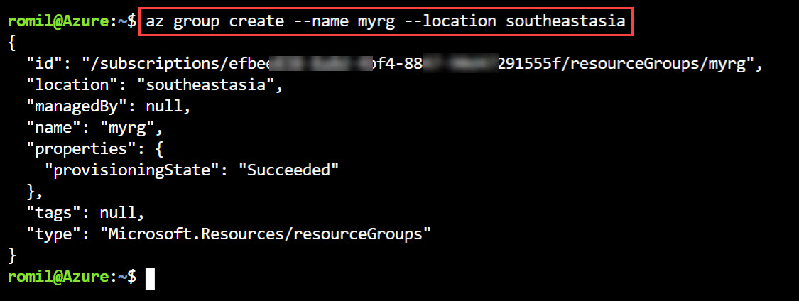

**Step 7:** To Create Ubuntu Virtual Machine with existing resource group & generating SSH Keys instead of VM Password. Type below commands:

az vm create --resource-group myrg --name myubuntuvm1 --image UbuntuLTS --generate-ssh-keys

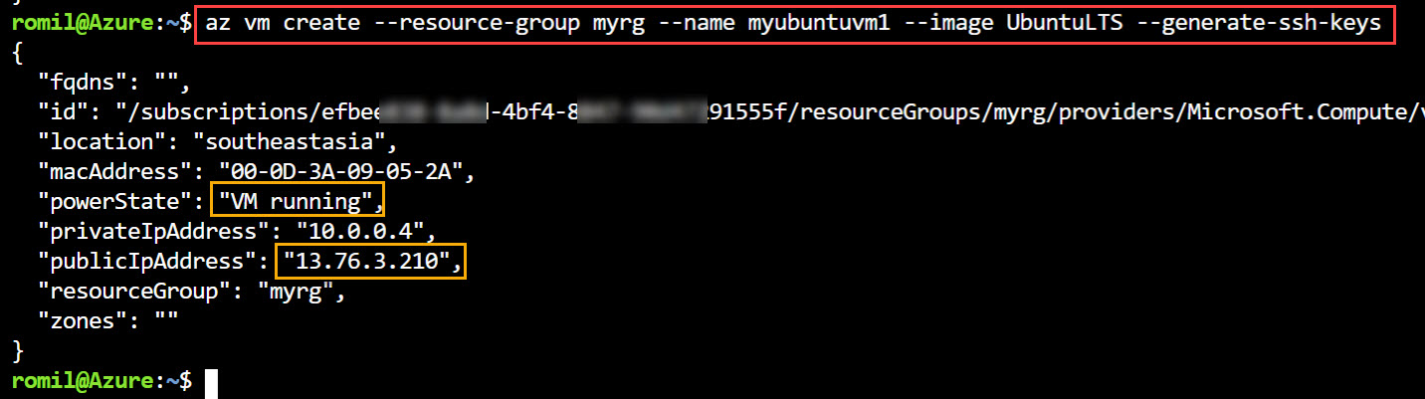

**Step 8:** To add Port 80 (HTTP) as an Inbound Rule to existing Virtual Machine please type below commands

az vm open-port --port 80 --resource-group myrg --name myubuntuvm1

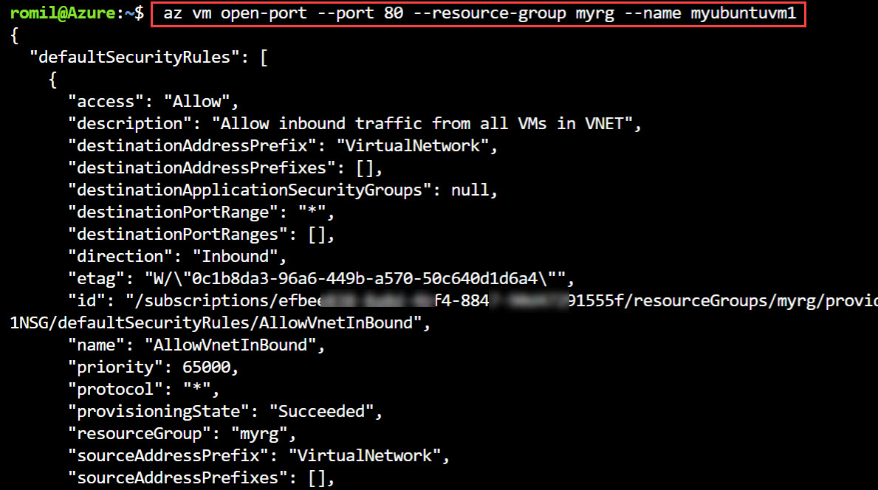

It will add 80 port and list out all other ports.

**Step 9:** To get **Public IP Address** of newly created VM

myubuntuvmpip=$(az vm show -d -g myrg -n myubuntuvm1 --query publicIps -o tsv)



**Step 10:** Display Public IP from last step.

echo "Public IP of VM is:" $myubuntuvmpip

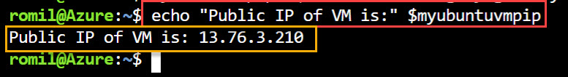

**Step 11:** Type ssh with Virtual Machine IP Address & hit enter. Also type **yes** to connect with machine.

ssh $myubuntuvmpip

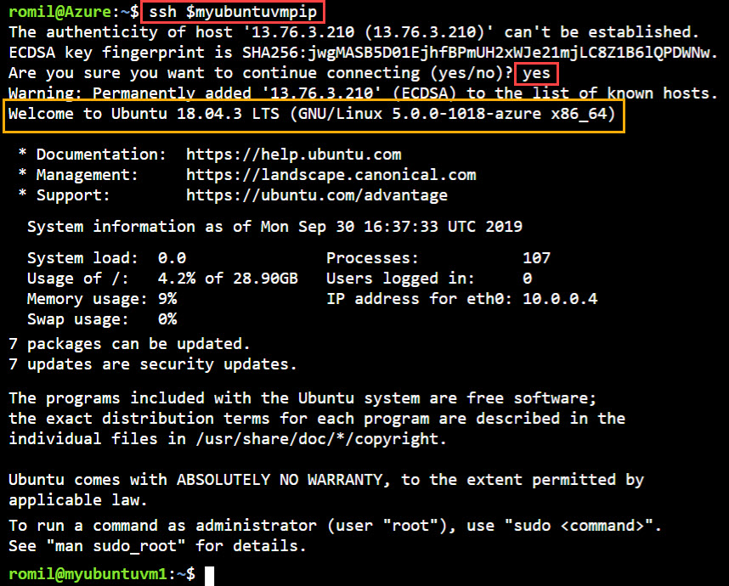

**Step 12:** Change User to Root User (administrator)

sudo su

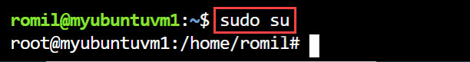

**Step 13:** To Update the Packages of Ubuntu Virtual Machine Please type below command:

apt-get update

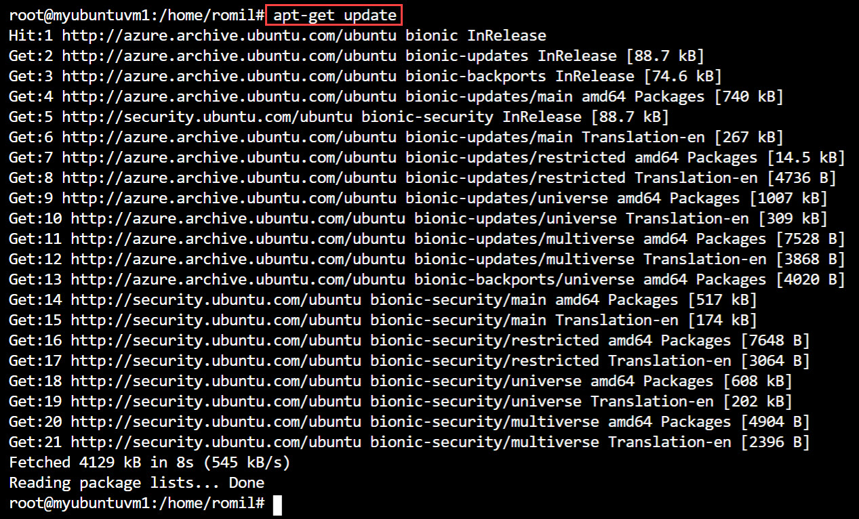

**Step 14:** To install Apache Server on newly created Machine type below command. Also type **y** to continue

sudo apt install apache2

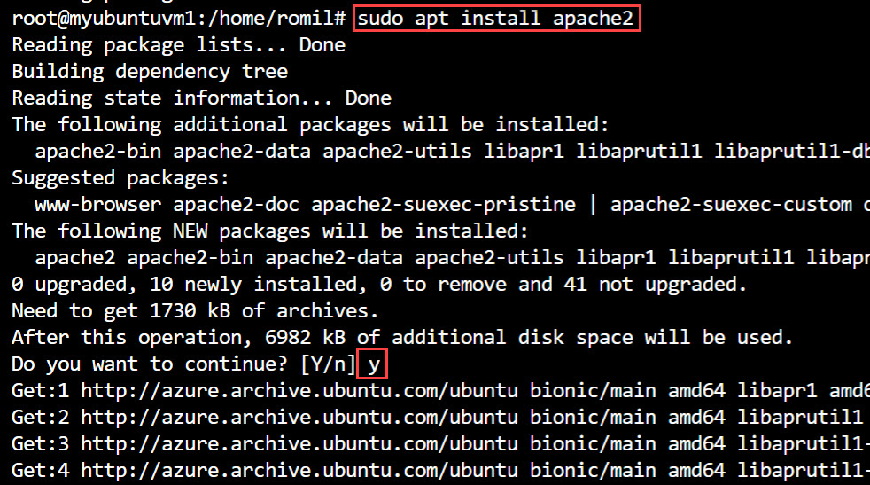

**Step 15:** Type 2 time Exit to navigate to Main Cloud Shell prompt.

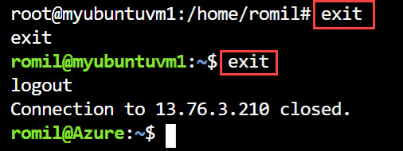

**Step 16:** echo "http://"$myubuntuvmpip

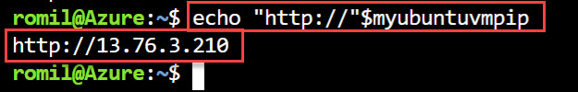

**Step 17:** Sample Page of Apache Server will load

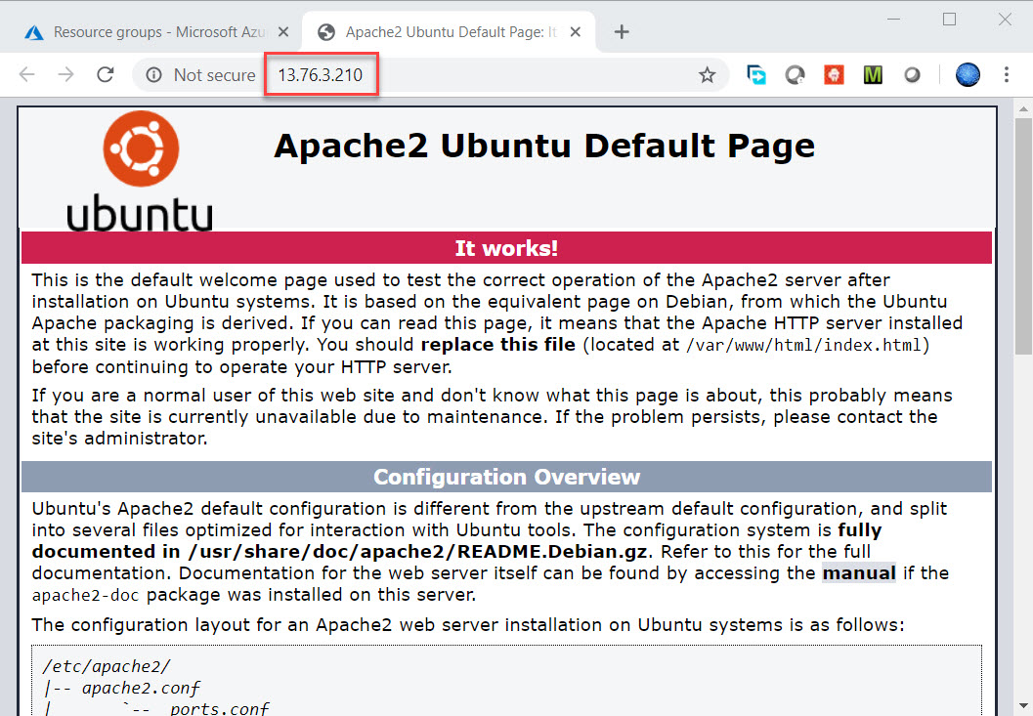

**Step 18:** To Delete Resource Group

az group delete --name myrg

