**Load Balancer – 2 Virtual Machines**

Azure Load Balancer, you can scale your applications and create high availability for your services. Load Balancer supports inbound and outbound scenarios, provides low latency and high throughput, and scales up to millions of flows for all TCP and UDP applications.

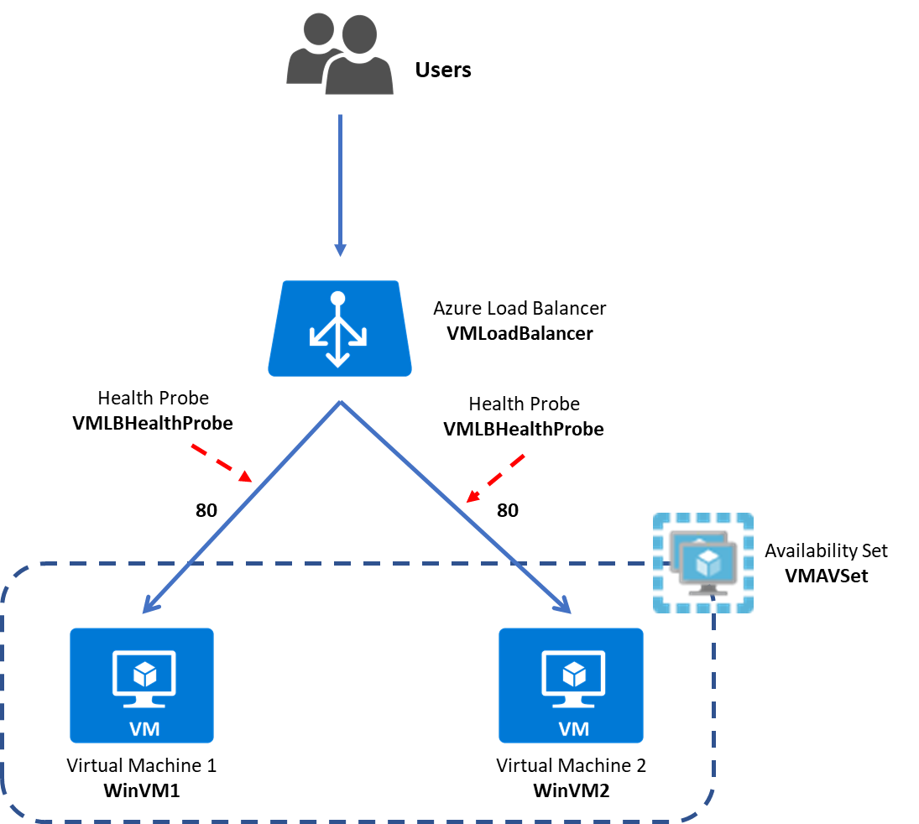

**Summary:**

**Task 1: Create First Virtual Machine – WinVM1**

**Task 2: Create Second Virtual Machine – WinVM2**

**Task 3: Create Load Balancer – Backend Pool, Health Probe, Load Balancer Rule - VMLoadBalancer**

**Task 4: Test Load Balancer**

**Task 1: Create First Virtual Machine – WinVM1**

**Step 1:** Open **Microsoft Azure Portal**

[https://portal.azure.com](https://portal.azure.com/)

**Step 2:** Create **First Virtual Machine**

Click on **+ Create a resource -> Get started -> Windows Server 2016 Datacenter**

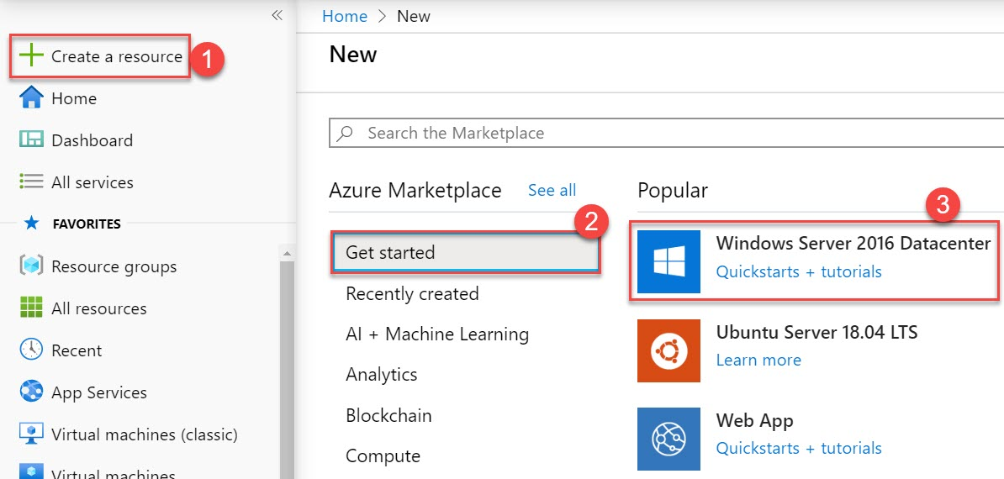

**Step 3:** Create a Virtual Machine

Subscription: **Choose any working Subscription**

Resource Group: **Create New Resource Group** Ex. Name: **VMLoadBalancerLabRG**

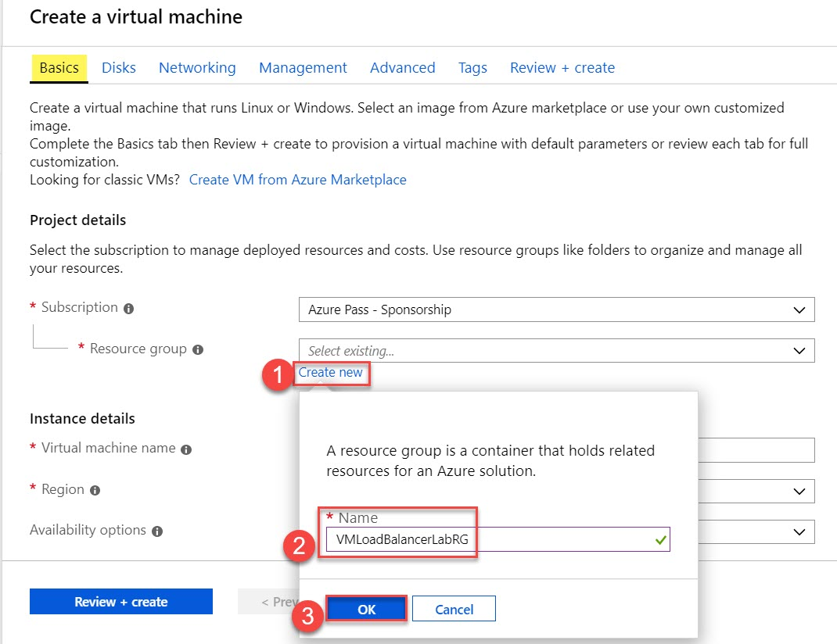

Enter Instance Details

Virtual Machine name: **WinVM1**

Region: **Choose any nearest region**

Availability option: **Availability Set**

Availability Set: **Click on Create new**

Name: **VMAVSet**

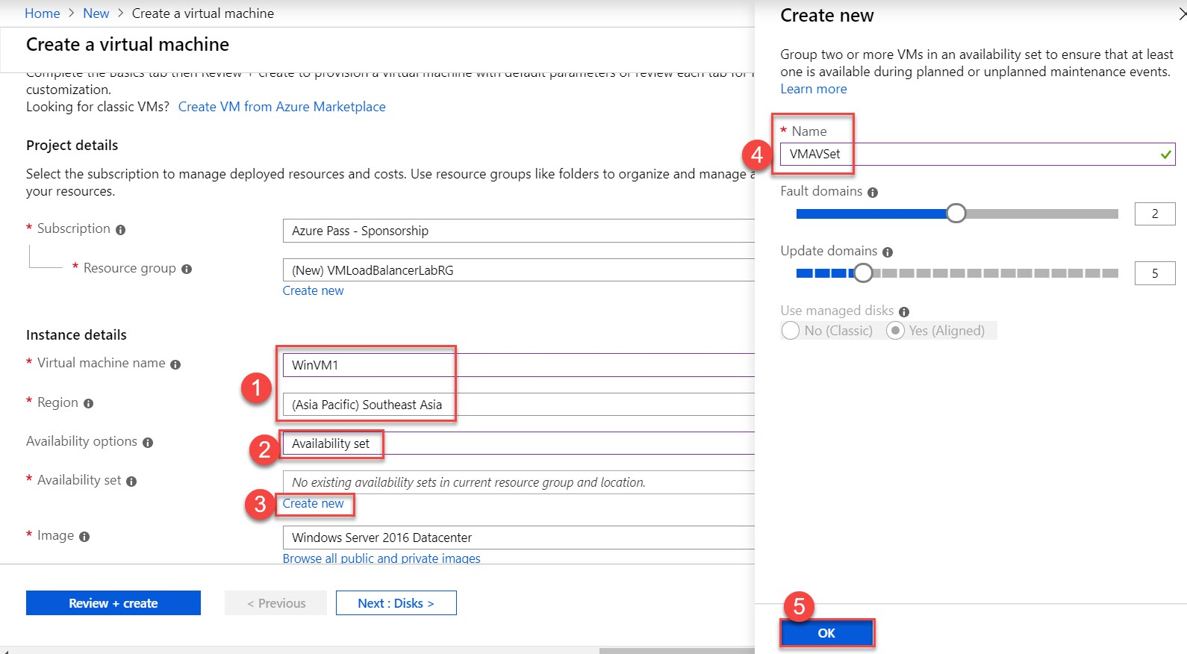

Size: **Go with Default Size** Ex. **Standard DS1 v2**

Username: **demouser**

Password: **demo@pass123**

Confirm Password: **demo@pass123**

Public inbound ports: **Allow selected ports. HTTP & RDP**

Click on **Next: Disks >**

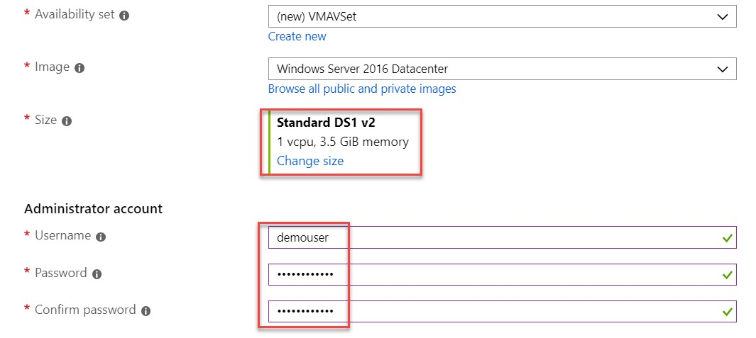

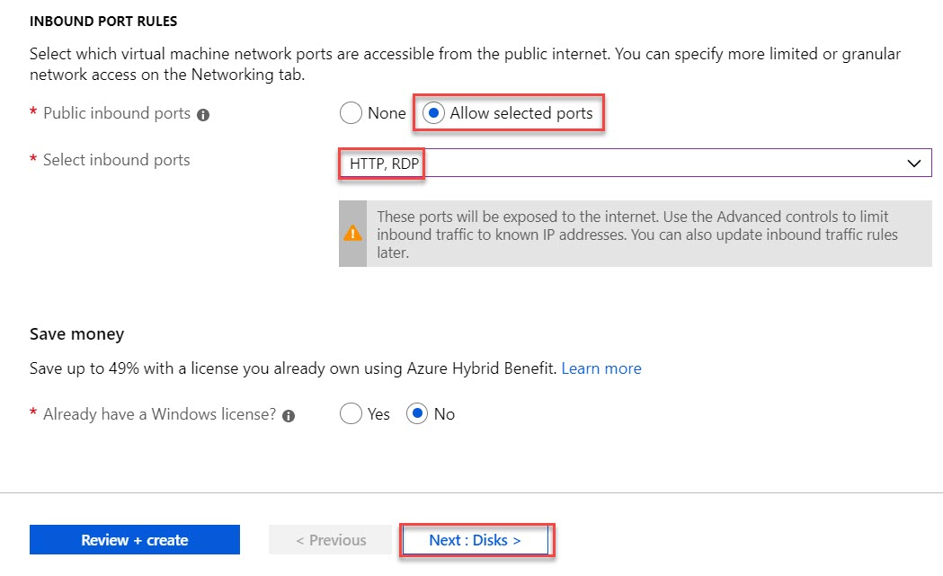

**Step 4:** **Disks** tab

Change OS disk type to **Standard HDD**

Click on **Next: Networking >**

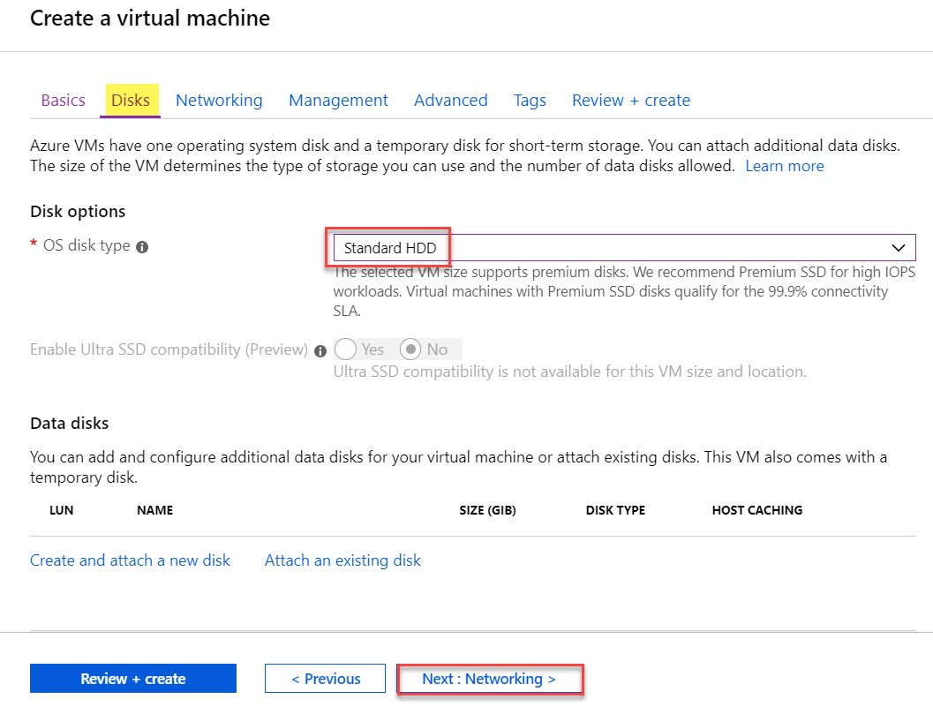

**Step 5:** **Networking** tab

Leave with Default options

Click on **Next: Management >**

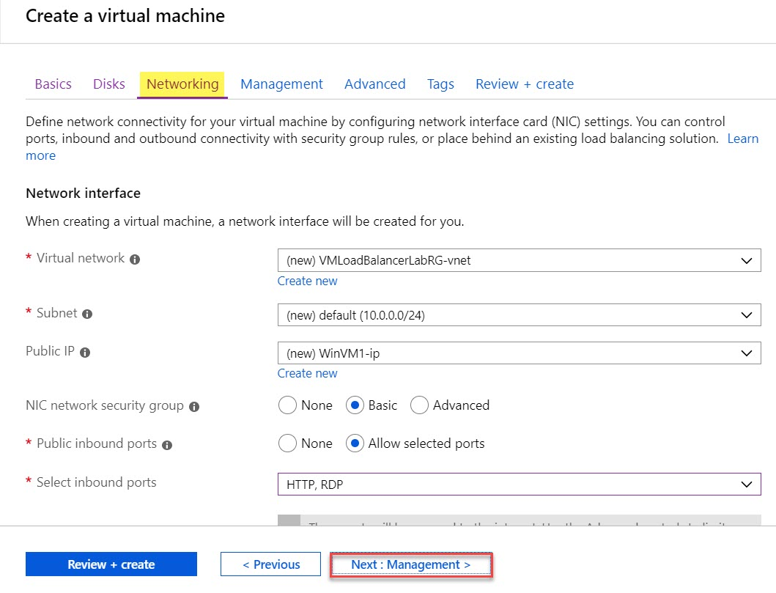

**Step 6:** **Management** tab

Leave with Default options

Click on **Next: Advanced >**

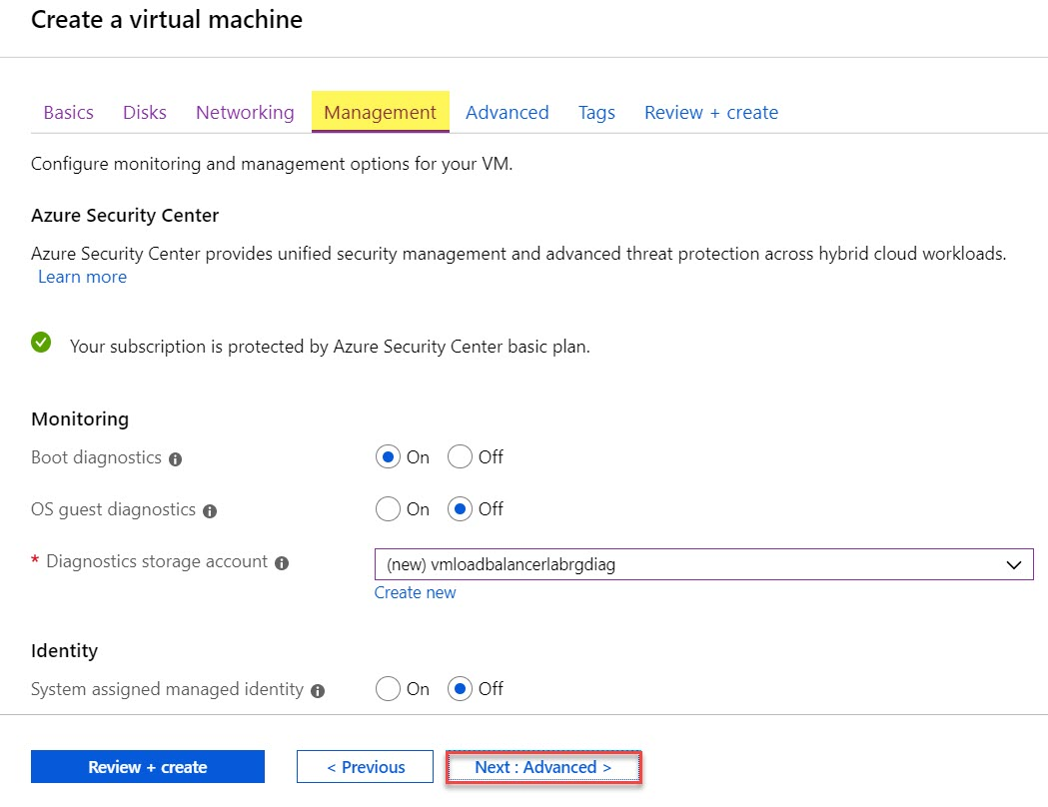

**Step 7:** **Advanced** tab

Click on **Select an extension to install** option

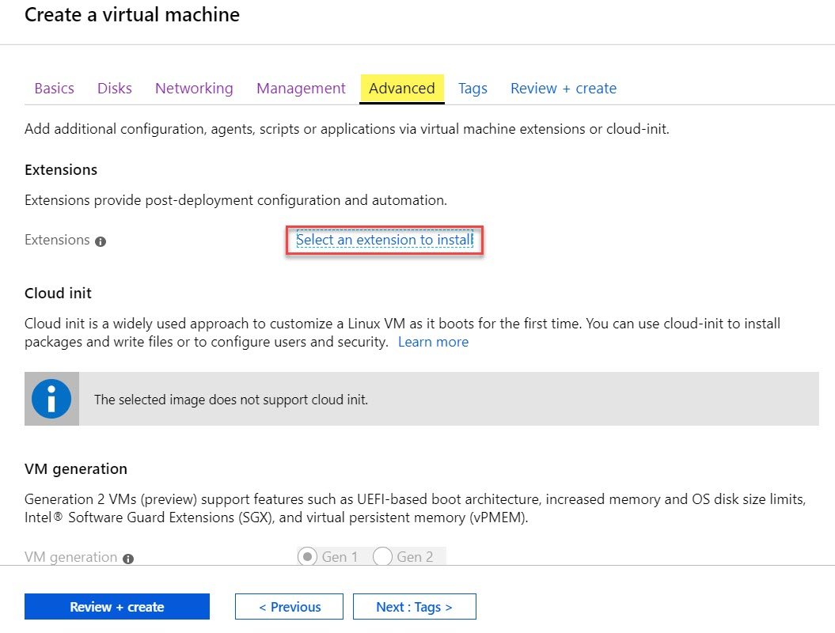

Select **Custom Script Extension** and click on **Create** button

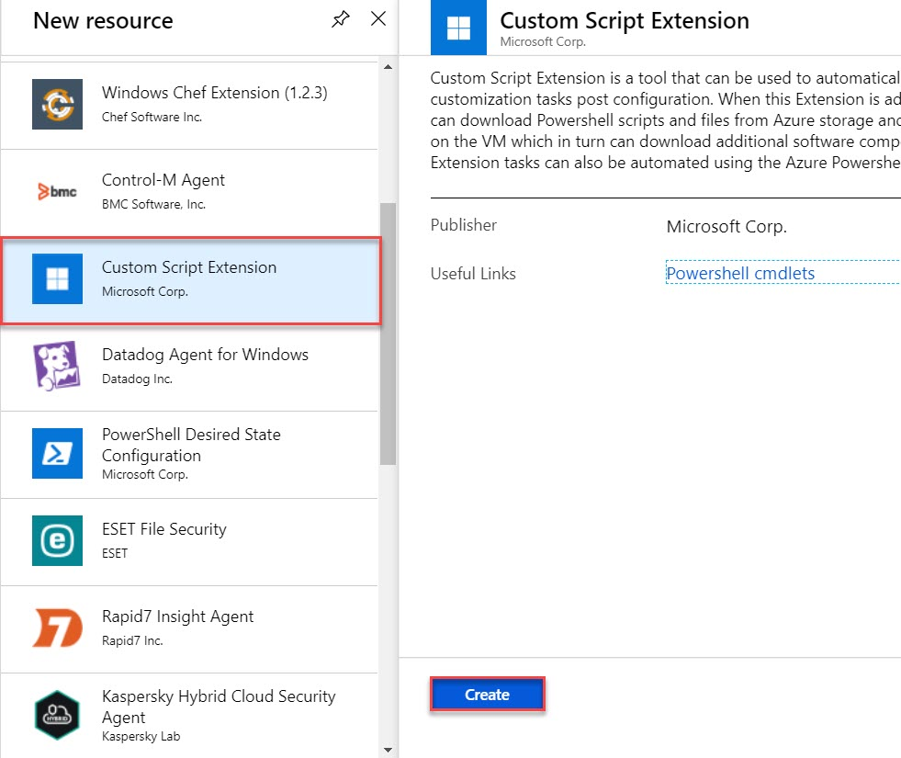

Click on **Browse** button

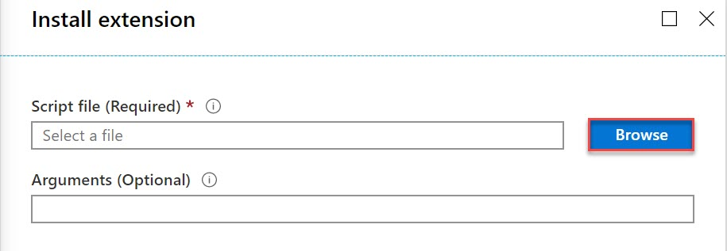

Create Storage accoun

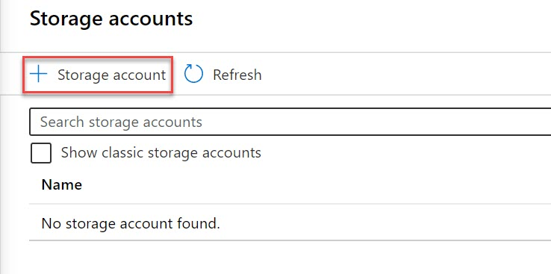

Name: **Enter storage unique name** ex. **vmlbstrg**

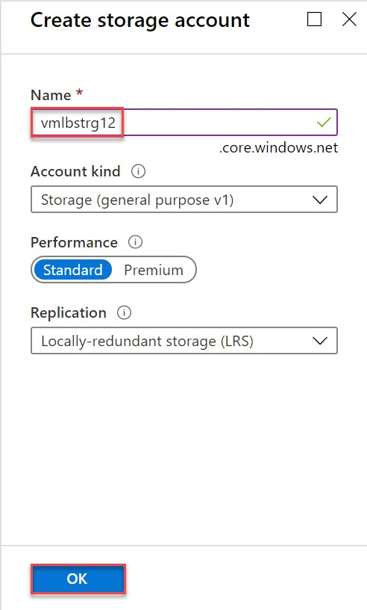

Click on newly created storage account

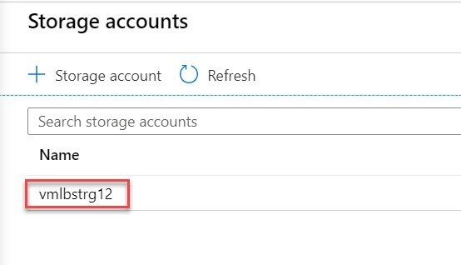

Create New Container

Name: **scriptcontainer**

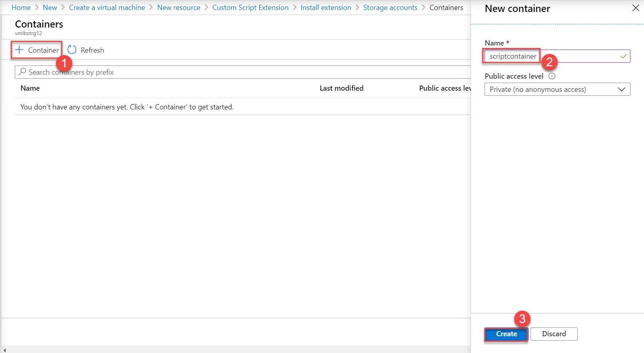

Click on **scriptcontainer**

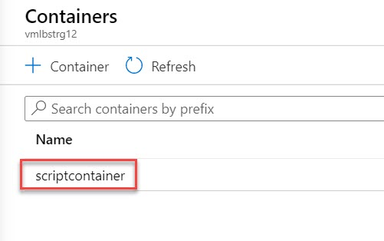

Select Upload option and browse the file

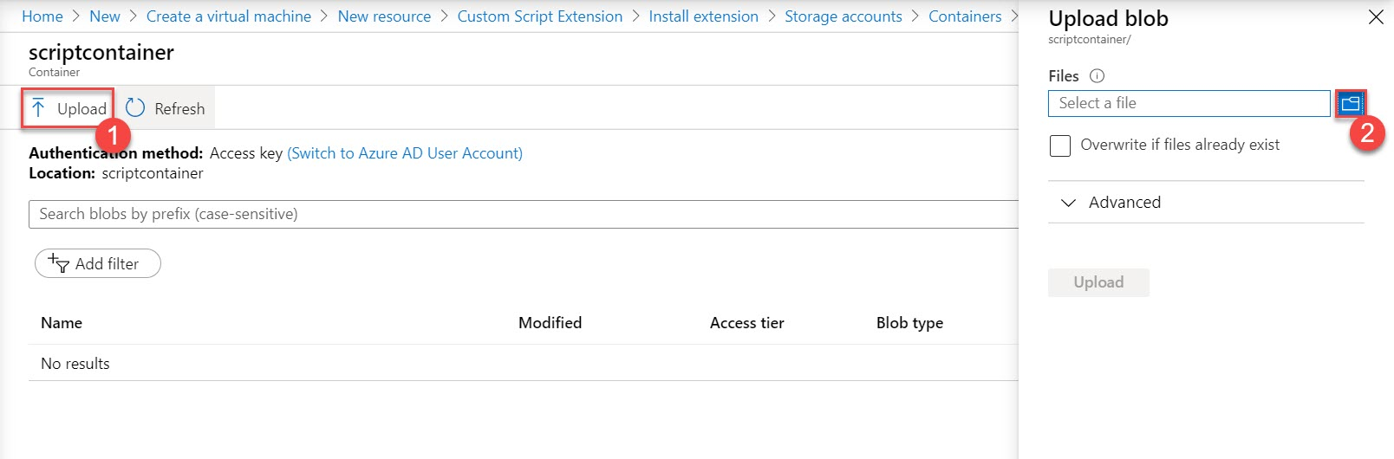

Upload **configure-iis-web.ps1** (available with this document)

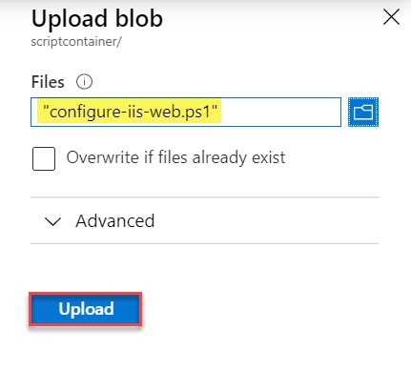

Select **configure-iis-web.ps1**

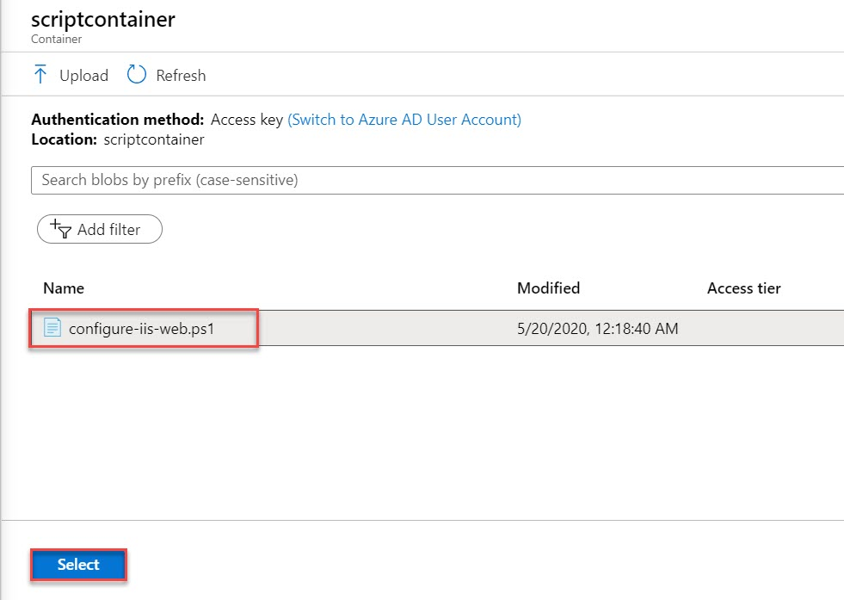

Click on OK button

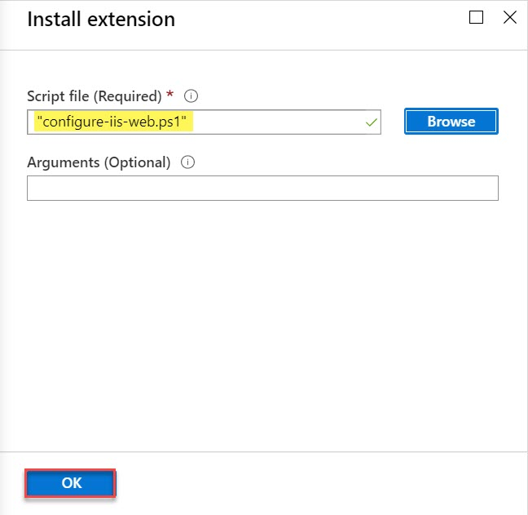

Extensions: **Custom Script Extension** will be there

Click on **Review + create** button.

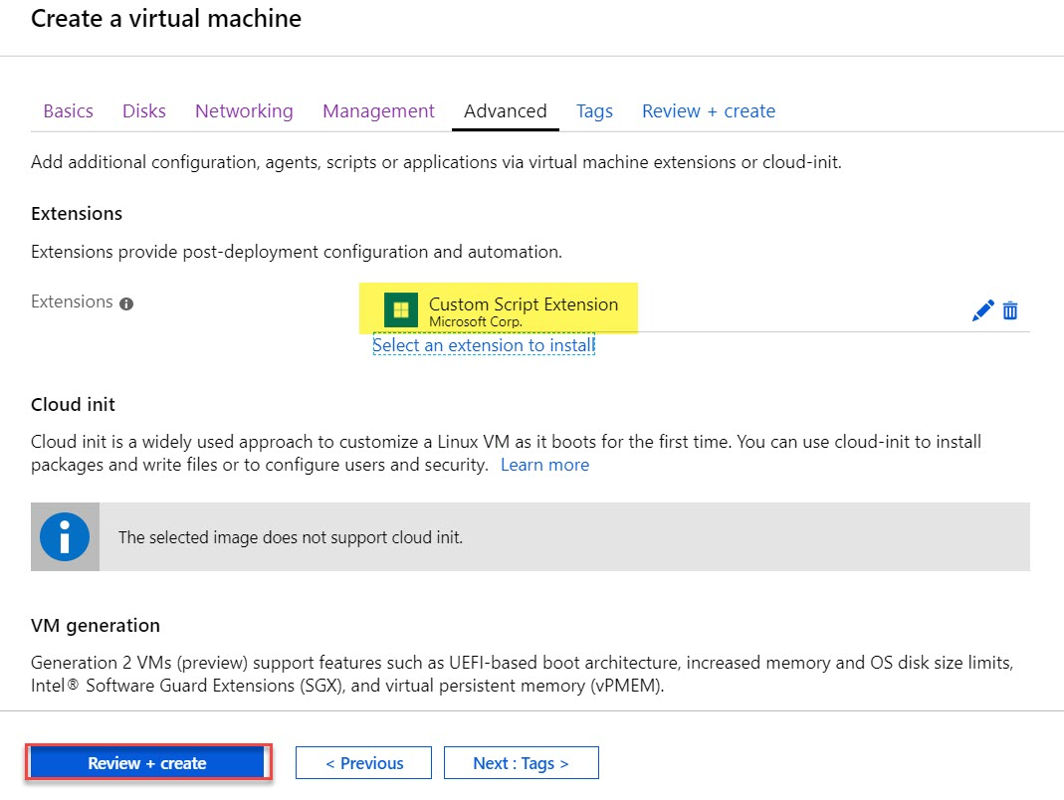

**Step 8:** Review of Virtual Machine blade will be there.

Click on **Create** button.

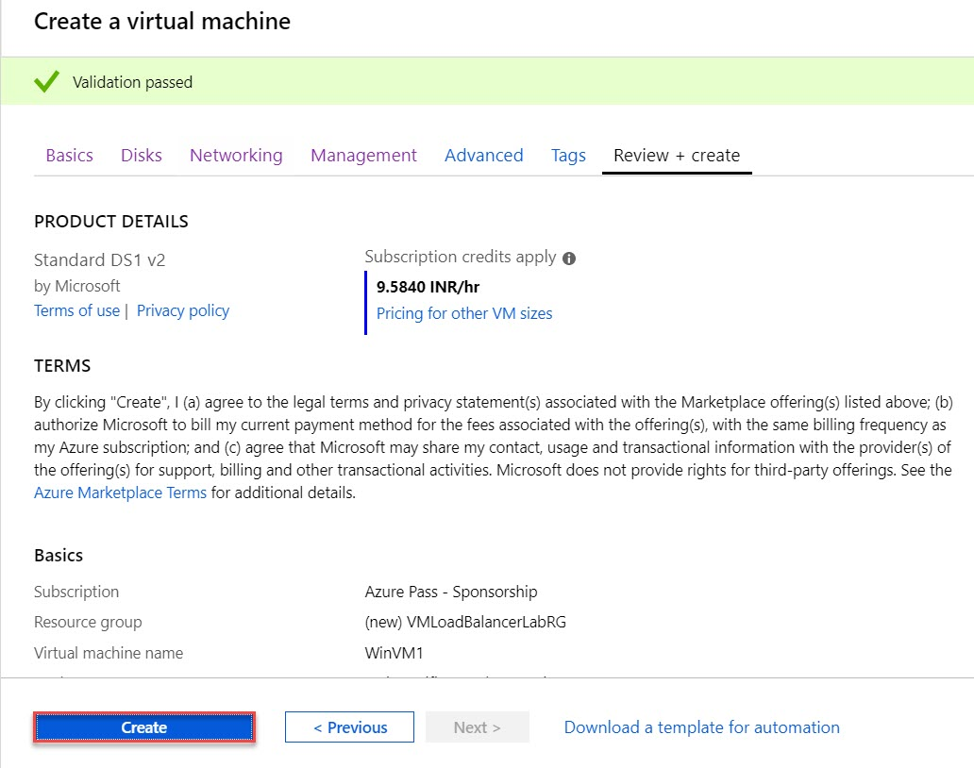

**Note: To deploy Virtual Machine and Extension it will task time so you can continue with Task 2 Create Seconds Virtual Machine.**

**Step 9:** Wait for few minutes to deploy Virtual Machine and click on **Go to resource** option

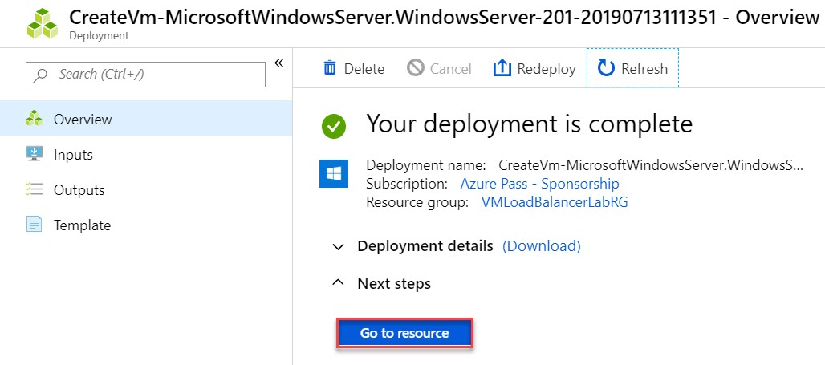

**Step 10:** Virtual Machine 1 blade will open as below:

Copy **Public IP Address of WinVM1** and paste into browser

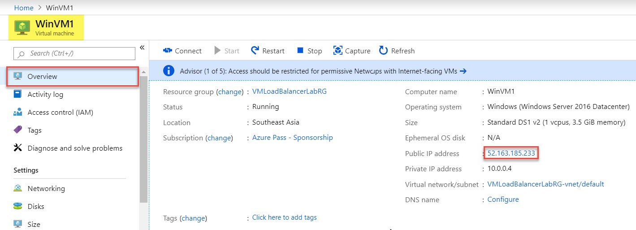

Sample Text message will be there: **Hi from Virtual Machine: WinVM1**

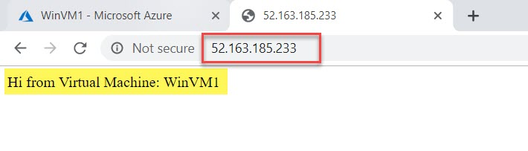

**Task 2: Create Second Virtual Machine – WinVM2**

**Step 11:** Open Azure Portal in another tab and **create another virtual machine**

Click on **+ Create a resource -> Get started -> Windows Server 2016 Datacenter**



**Step 12:** Create a virtual machine

Subscription: **Choose working subscription**

Resource Group: **Choose Existing Resource Group** Ex. **VMLoadBalancerLabRG**

Virtual Machine name: **WinVM2**

Region: **Choose same region** **as deployed first virtual machine** Ex. **Southeast Asia**

Availability options: **Availability Set**

Availability Set: **VMAVSet**

Image: **Windows Server 2016 Datacenter**

Size: **Go with 1 core size** Ex. **Standard DS1 v2**

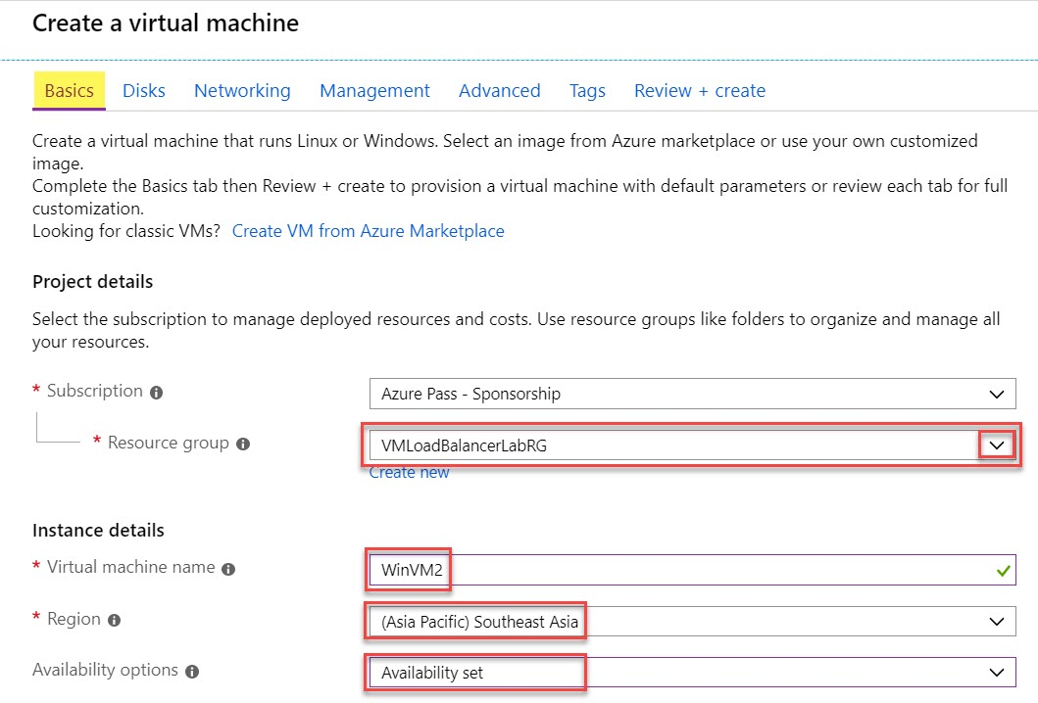

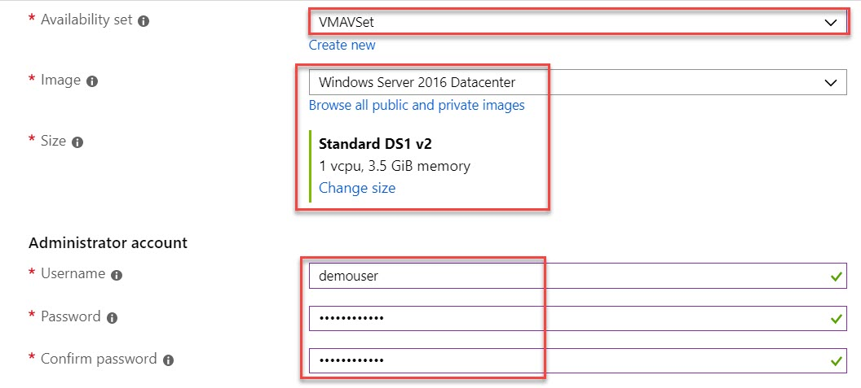

Username: **demouser**

Password: **demo@pass123**

Confirm Password: **demo@pass123**

Public inbound ports: **Allow selected ports** Ex. **HTTP & RDP**

Click on **Next: Disks >**



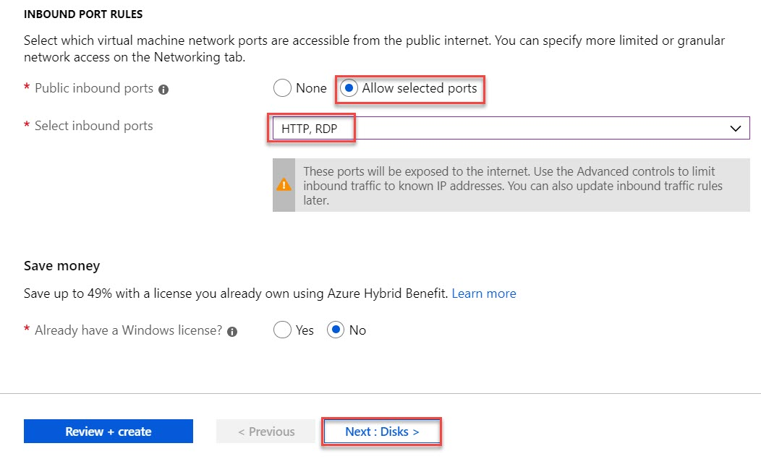

**Step 13:** **Disks** tab

Change OS disk type to **Standard HDD**

Click on **Next: Networking >**

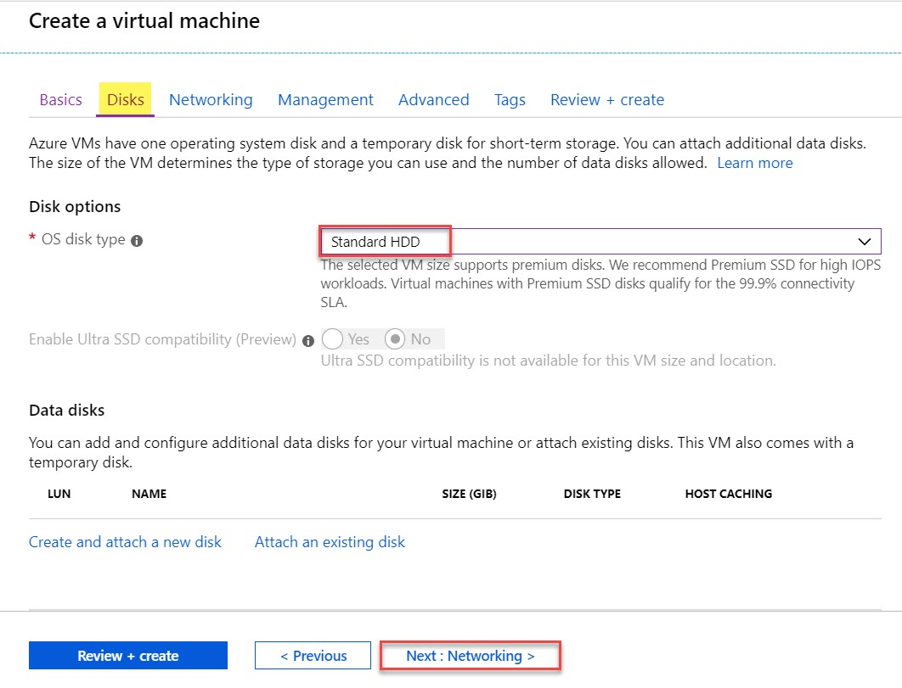

**Step 14:** **Networking** tab

Leave with Default options

Click on **Next: Management >**

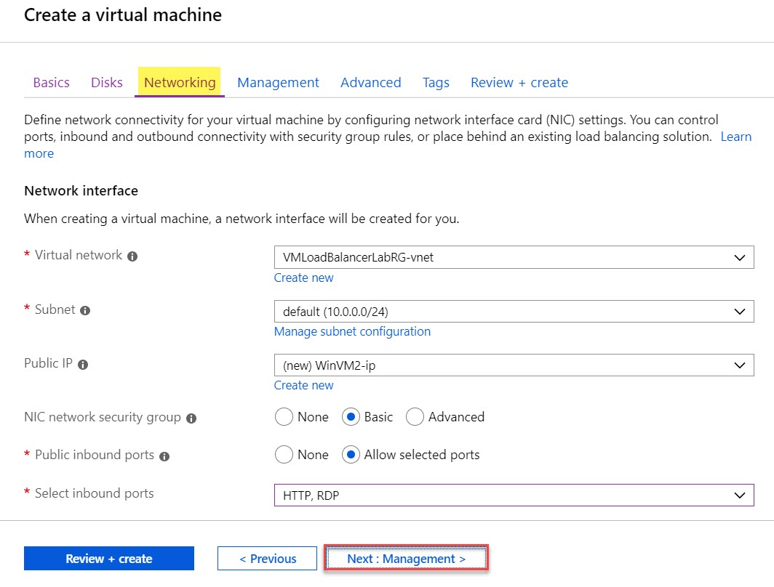

**Step 15:** **Management** tab

Leave with Default options

Click on **Next: Advanced >**

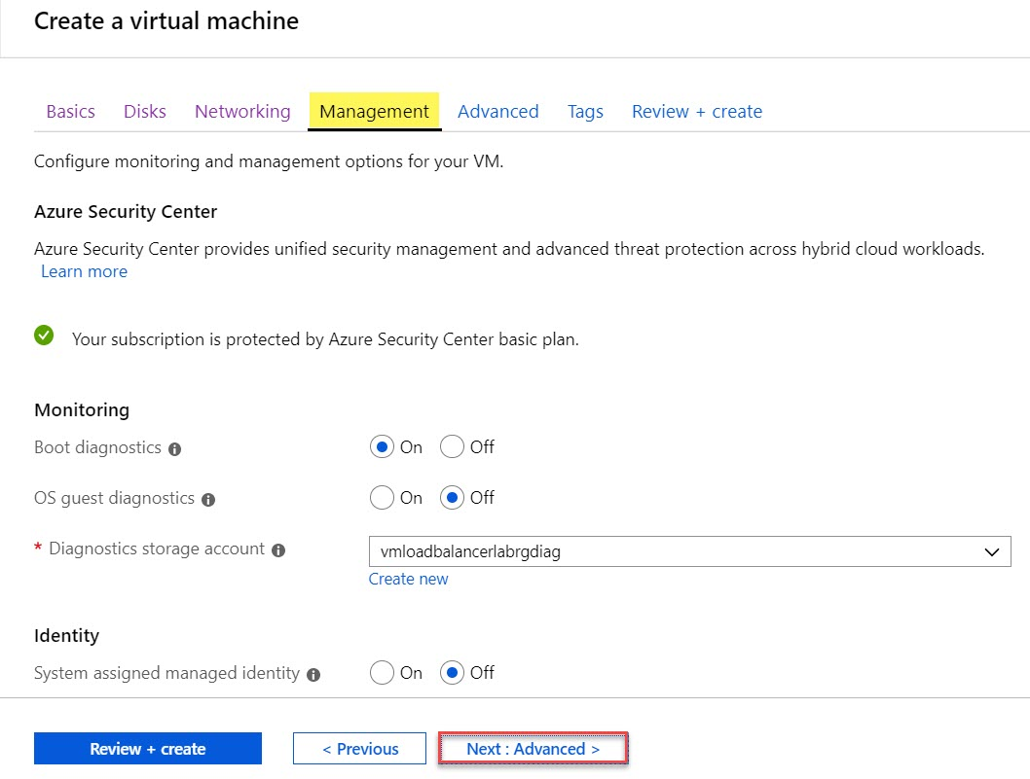

**Step 16:** **Advanced** tab

Click on **Select an extension to install** option

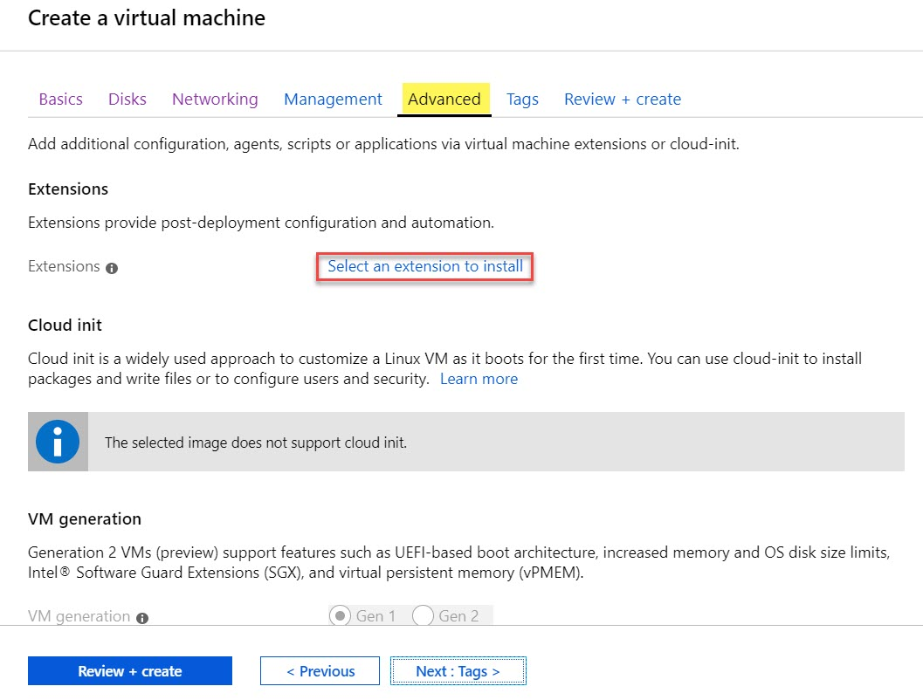

Select **Custom Script Extension** and click on **Create** button



Click on **Browse** button

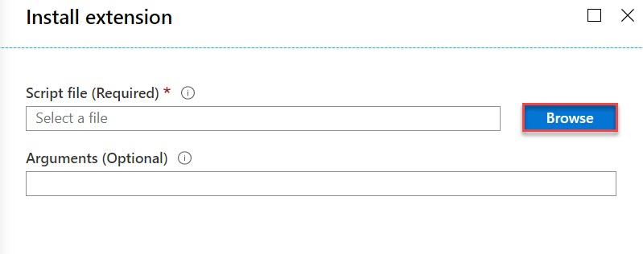

Select existing storage account where we have uploaded script file.

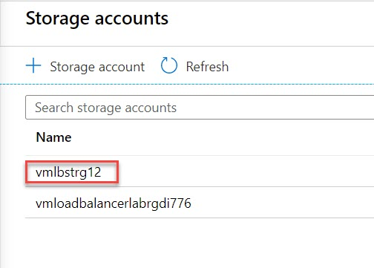

Select **scriptcontainer**

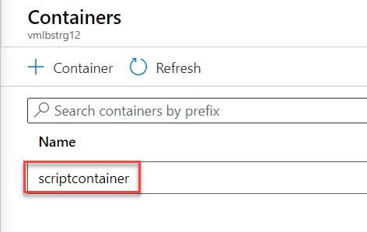

Select **configure-iis-web.ps1**

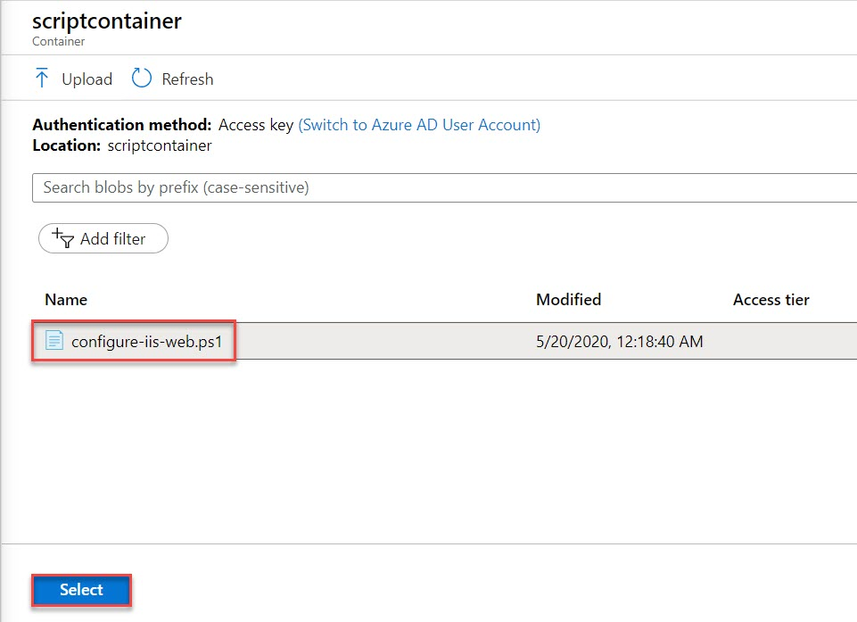

Click on **OK** button

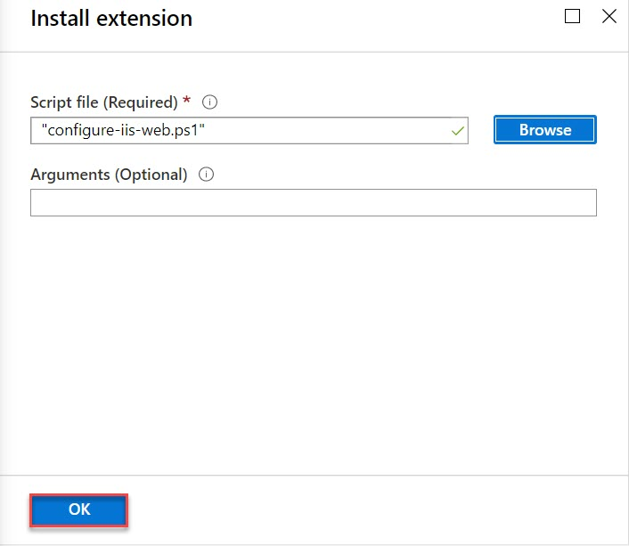

Extensions: **Custom Script Extension** will be there

Click on **Review + create** button.



**Step 17:** Review of Virtual Machine blade will be there.

Click on **Create** button.

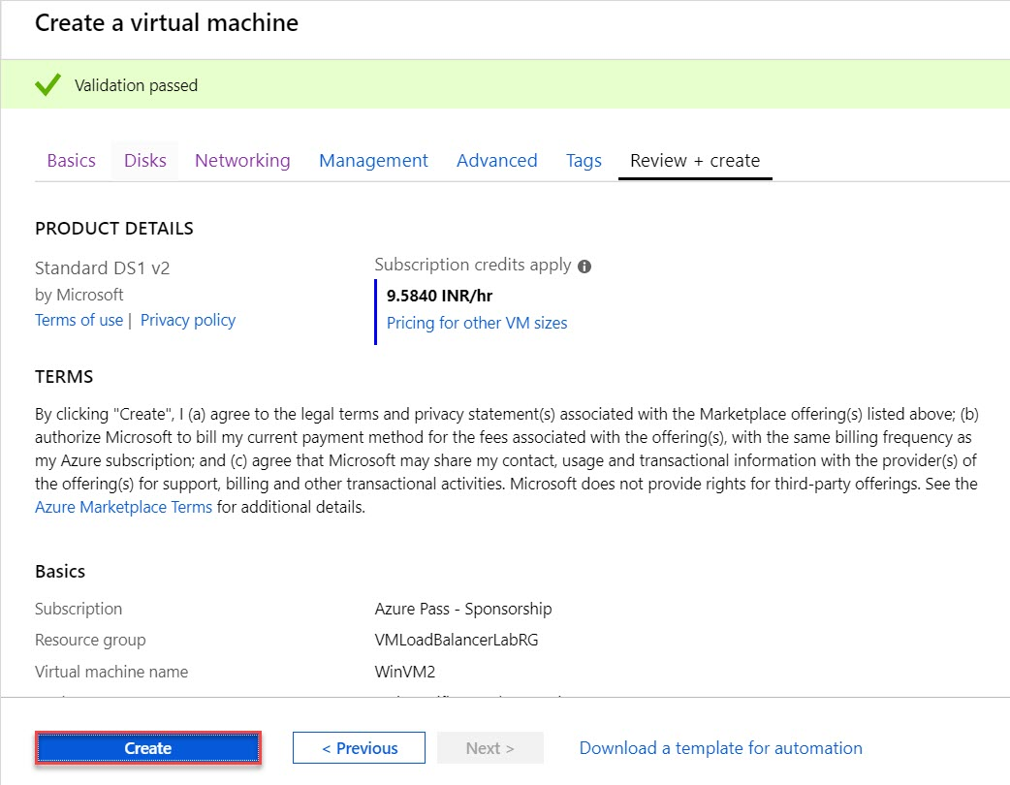

**Step 18:** Wait for few minutes to deploy Virtual Machine and click on **Go to resource** option



**Step 19:** Virtual Machine 2 blade will open as below:

Copy **Public IP Address of WinVM2** and paste into browser

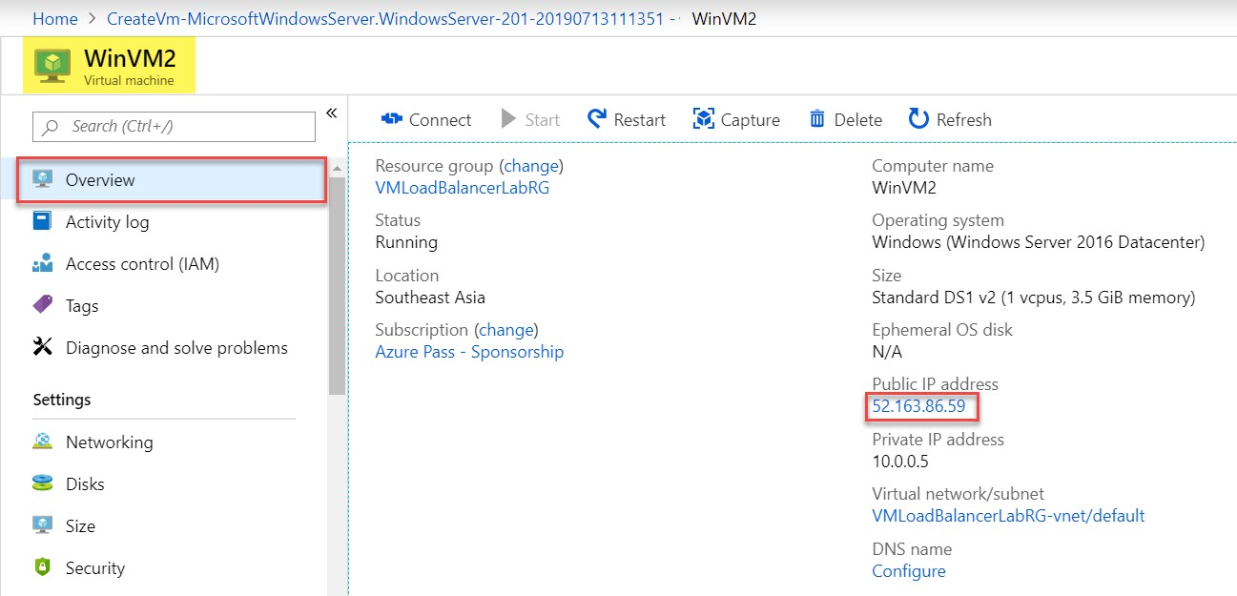

Sample Text message will be there: **Hi from Virtual Machine: WinVM2**

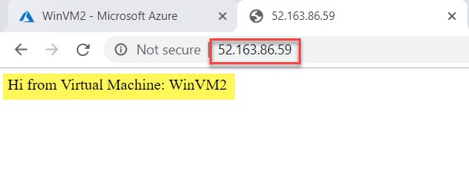

Review both Virtual Machines

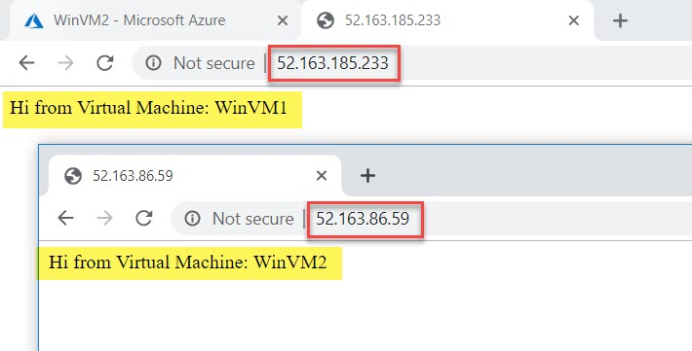

**Task 3: Create Load Balancer – Backend Pool, Health Probe, Load Balancer Rule - VMLoadBalancer**

**Step 20:** Click on **+ Create a resource -> Load Balancer**

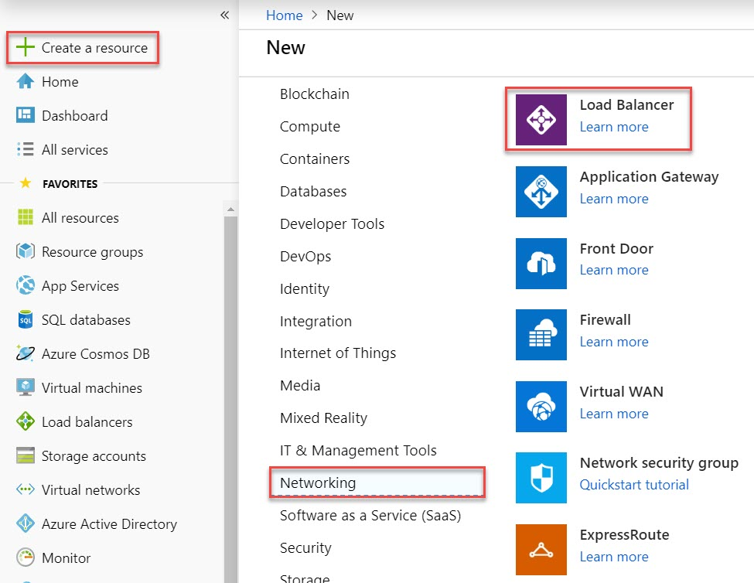

**Step 21:** Create New Load Balancer

Subscription: **Choose same Subscription**

Resource Group: **Choose existing Resource Group** Ex. **VMLoadBalancerLabRG**

Instance Name: **VMLoadBalancer**

Region: **(Asia Pacific) Southeast Asia**

Type: **Public**

SKU: **Basic**

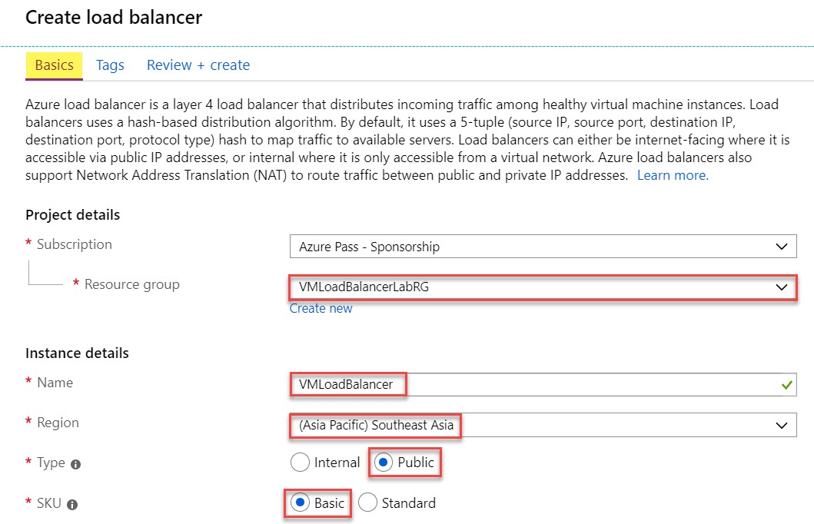

Public IP Address: **Create New**

Public IP Address Name: **VMLoadBalancerPIP**

Assignment: **Dynamic**

Click on **Review + Create** button.

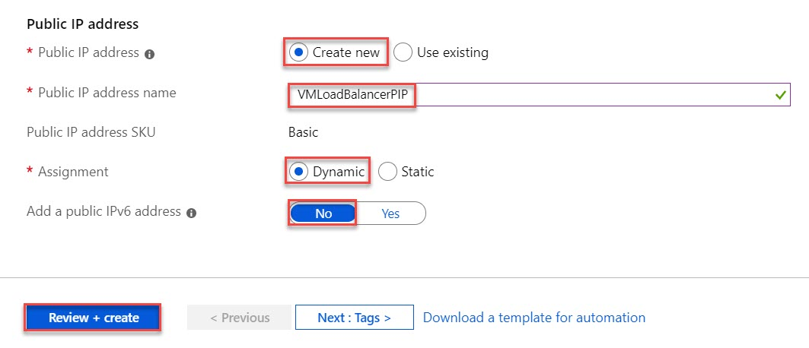

**Step 22:** Click on **Create** button.

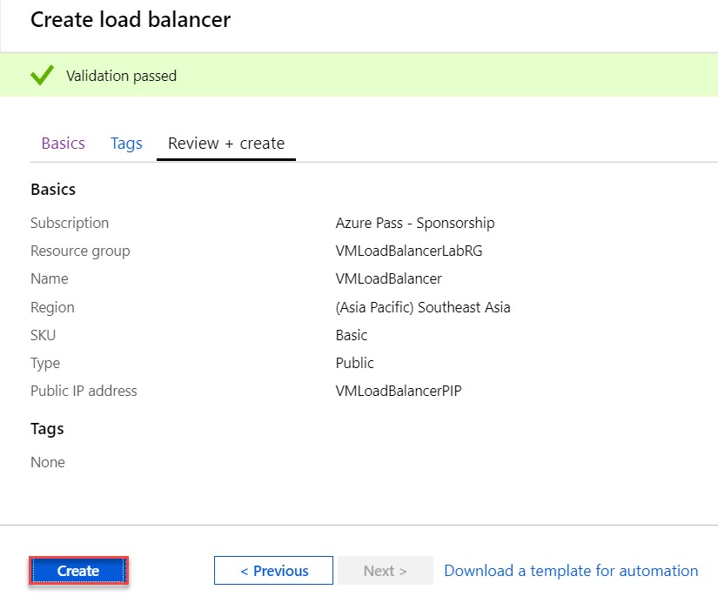

**Step 23:** Navigate to Load Balancer Resource

Click on **Go to resource** button

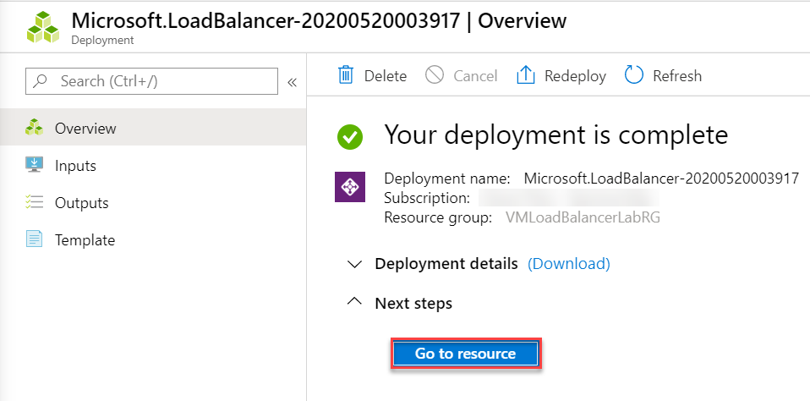

**Step 24:** Add new Backend Pools

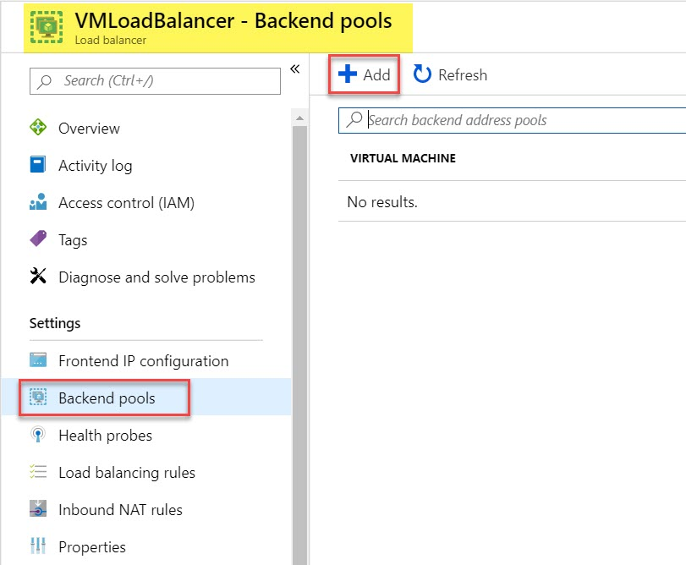

**Step 25:** Add New Backend Pool

Name: **VMLBBackendPool**

Virtual network: **Choose existing** Ex. **VMLoadBalancerLabRGs**

Associate to: **Virtual Machine**

Virtual Machines: (choose one-by-one from drop-down menu)

Virtual Machine: **WinVM1**  IP Address: **ipconfig1 (10.0.0.4)**

Virtual Machine: **WinVM2** IP Address: **ipconfig1 (10.0.0.5)**

Click on **Add** button

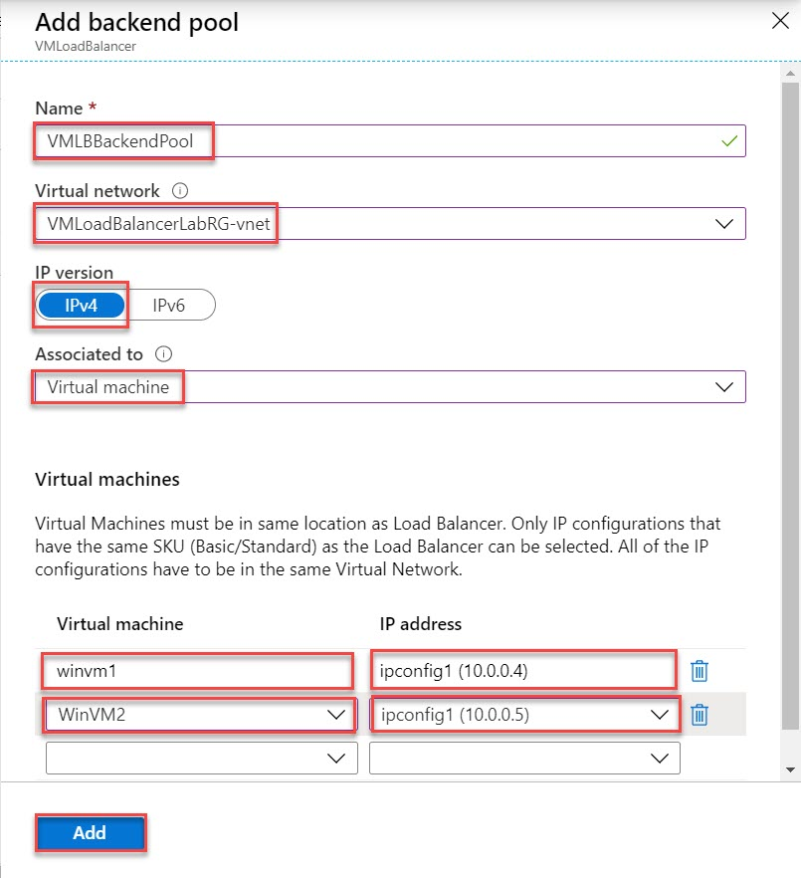

Review Backend Pool. 2 Virtual Machines will list out as below:

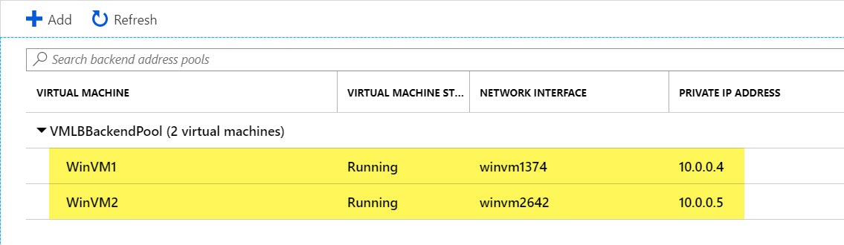

**Step 26:** Add New Health Probe

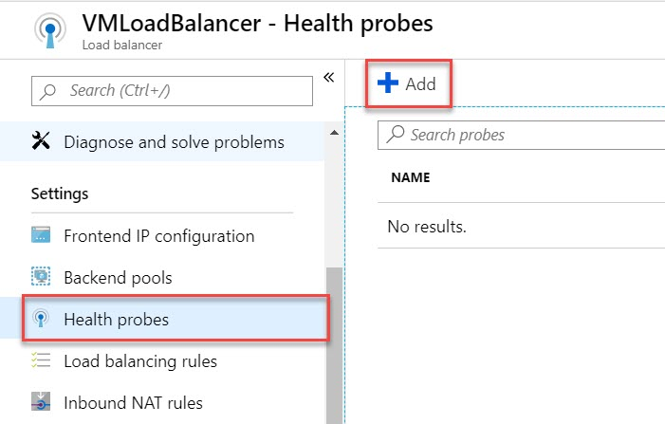

Name: **VMLBHealthProbe**

Protocol: **HTTP**

Interval: **5**

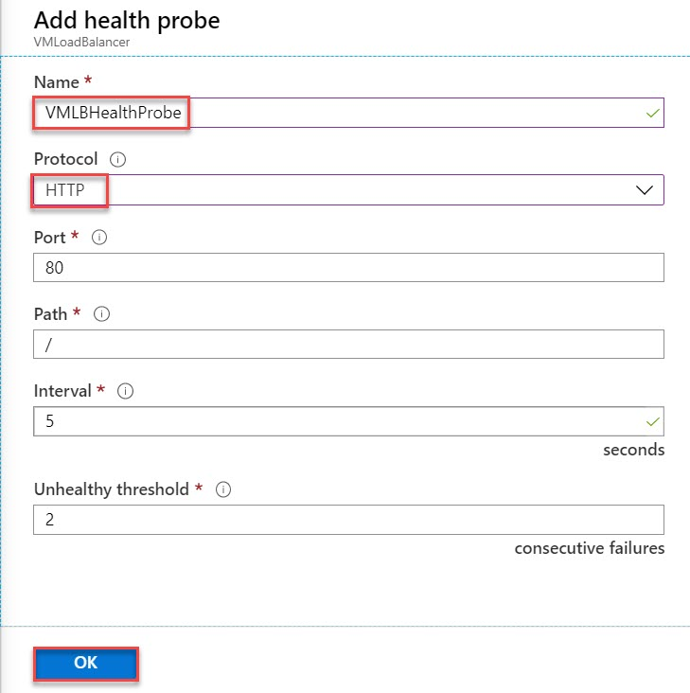

Review Heath Probe added

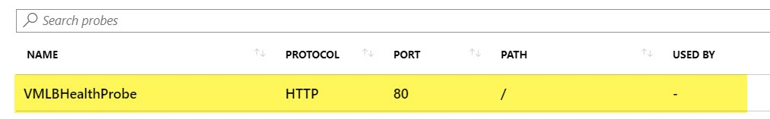

**Note: if notification prompted about health probe and still Updating… header available so refresh browser page.**

**Step 27:** Create New Load Balancer Rules

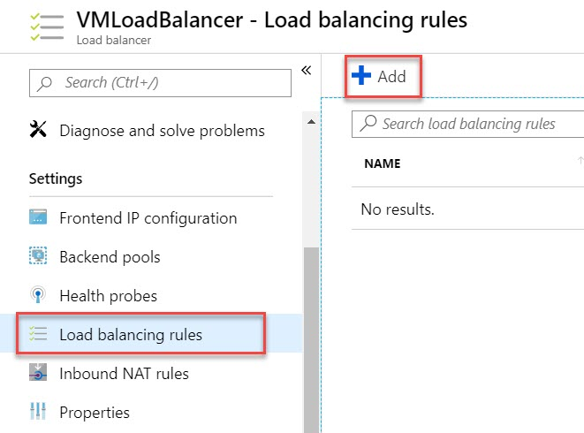

Name: **VMLBRule**

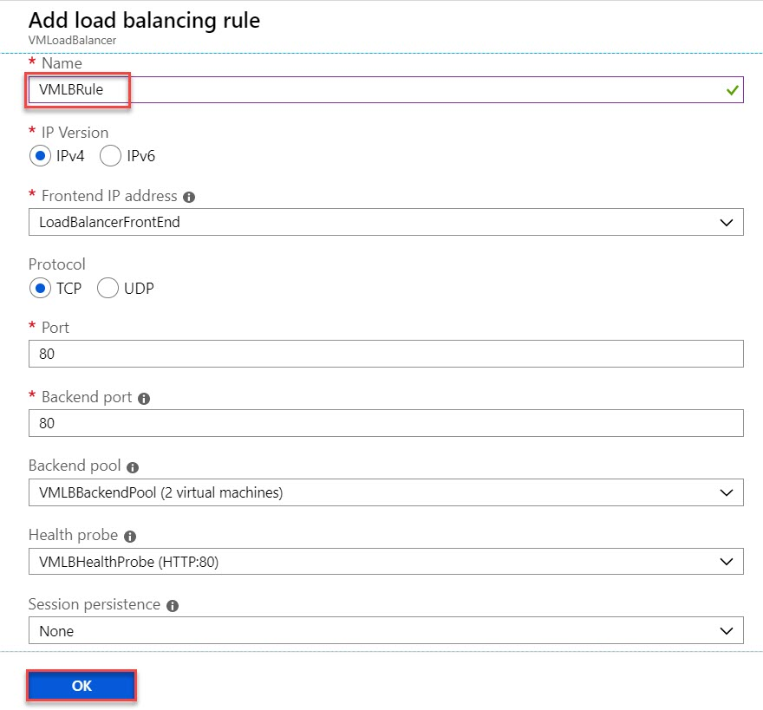

Review Load Balancing Rule

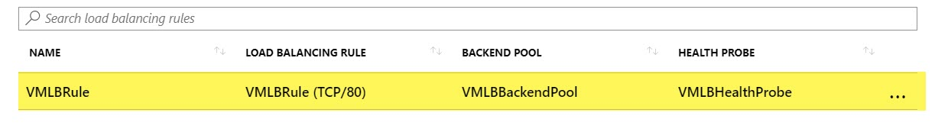

**Note: if notification prompted about rule added but still Updating… header available so refresh browser page.**

**Task 4: Test Azure Load Balancer**

**Step 28:** Navigate to Overview of Load Balancer

**Copy Public IP Address of Load Balancer** and run in browser

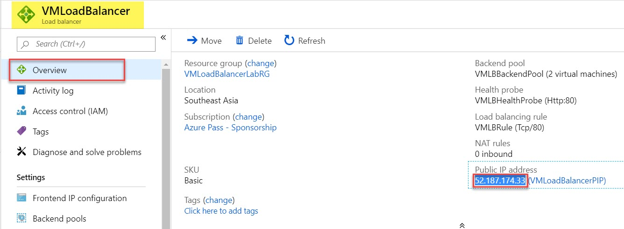

**Output** – Response from Virtual Machine 2 – WinVM2

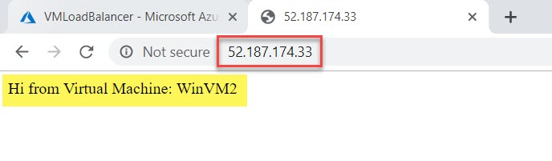

For testing open another browser and test the response

