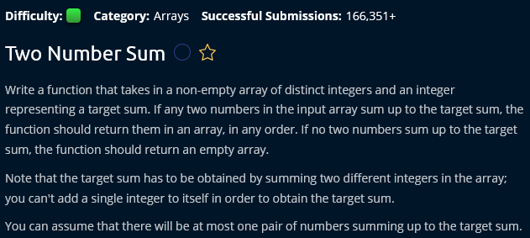

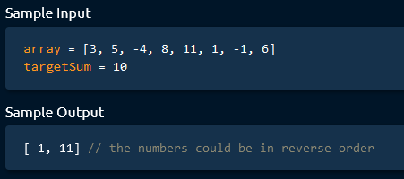

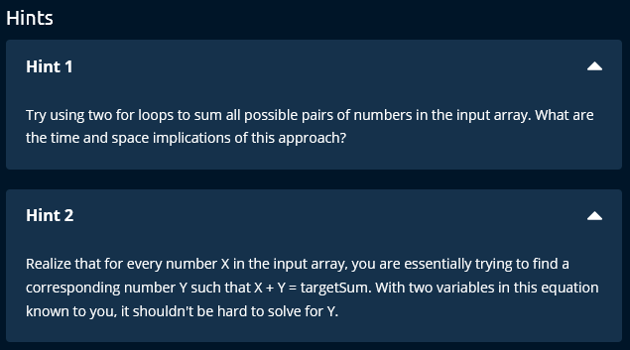

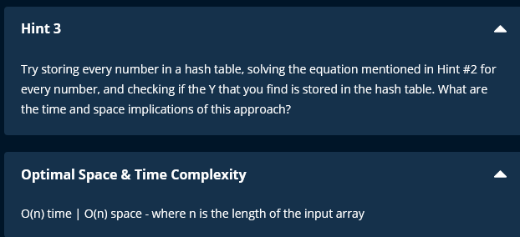

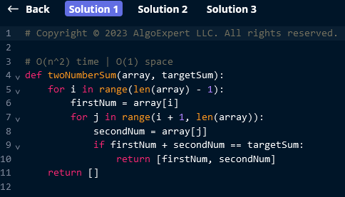

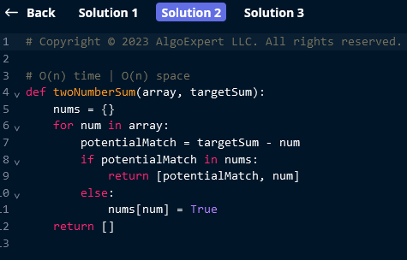

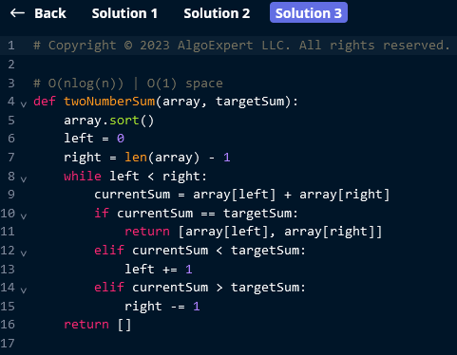

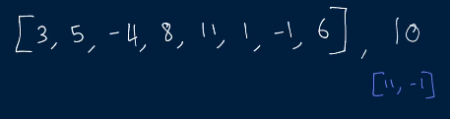

Solution :

* 1st solution :
  + Use 2 for loops to find the sum.
    - This will take square time because we use 2 for loops.
* 2nd solution :
  + Better way to solve this is using Hash Table. It will take extra space but algorithm works faster.
    - We can traverse our array and store every number that we see in a Hash Table, which will allow us to access these numbers in constant time through the Hash Table.
  + 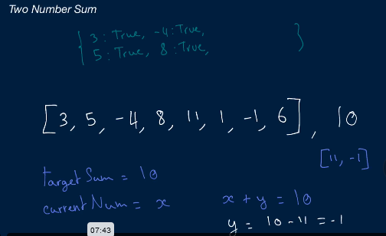
  + 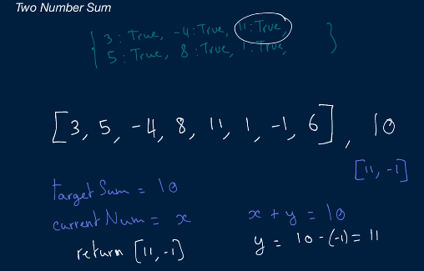
  + Time complexity : O(N) because we are traversing the array only once.
  + Space complexity : O(N) because we are storing all the values that we traverse through array in hast table only once.
* 3rd solution:
  + 