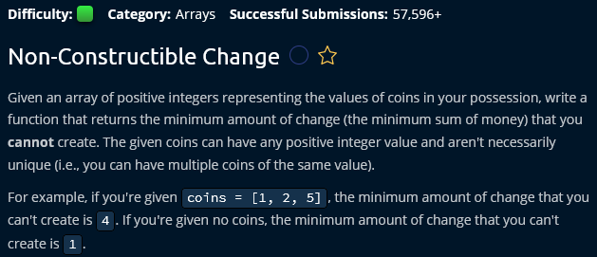

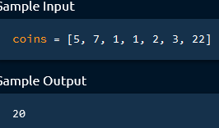

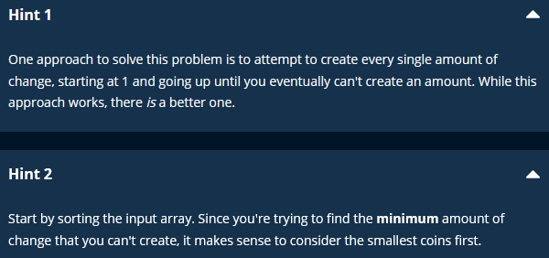

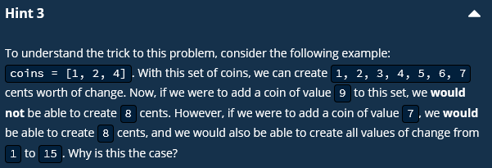

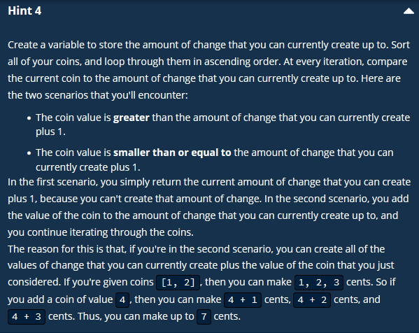



Brute-force approach :

* Simply loop through all of the positive integers until eventually you hit one that you cannot create.
* This is not an optimal solution.
* In this approach, at every iteration we have to look through all the elements/coins.
* Very complicated to implement.

2nd approach :

* Sort the input array. (for any array related problems, sort the input array and what it looks like or is it helpful).
* 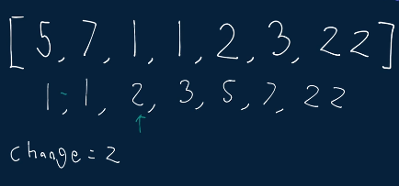
* Iterate over the sorted input array and then add one element at each iteration.
* This way we can find the minimum amount of non constructible change.

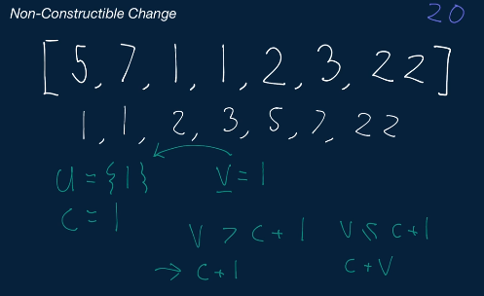

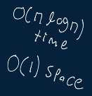

O(nlogn) + O(n) : this is the fastest time that can sort an input array (merge sort or quick sort)+ O(n) as we have to iterate over every element after sorting)

nlogn + n = nlogn (n << nlogn so we remove +n)

<https://www.geeksforgeeks.org/find-smallest-value-represented-sum-subset-given-array/>