**Assignment – 2 – Docker**

1. Check the docker version installed :

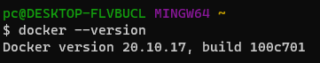

1. List the docker images available locally :

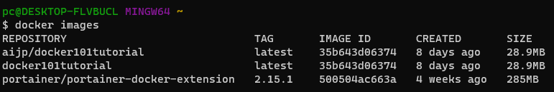

1. Pull the docker image from Docker Hub :

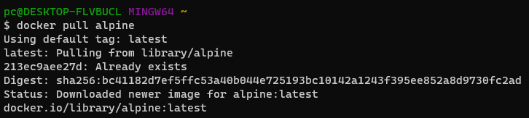

1. Create a docker container using docker image :

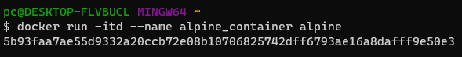

1. List all the docker containers running :

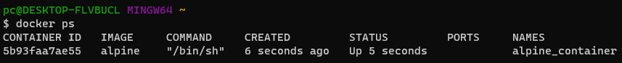

1. Stop the running Docker container :

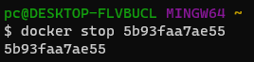

1. Start the Docker container which is in the stopped state :



1. Run shell commands without taking the bash terminal :

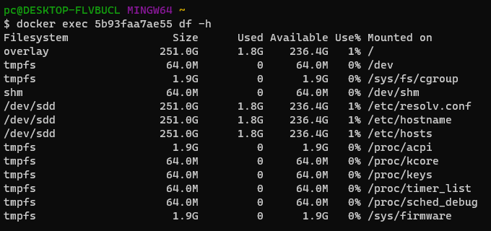

1. Login to Docker Hub via command line

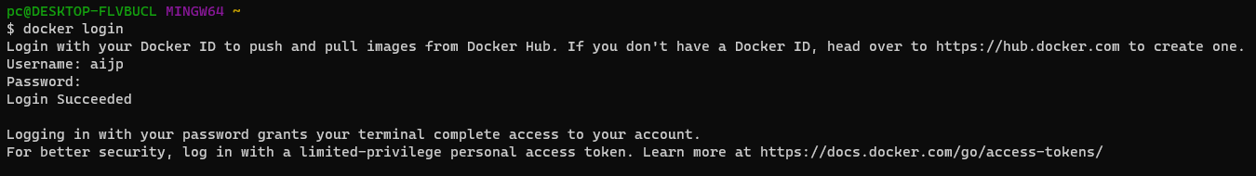

1. Push an image to Docker Hub repository :

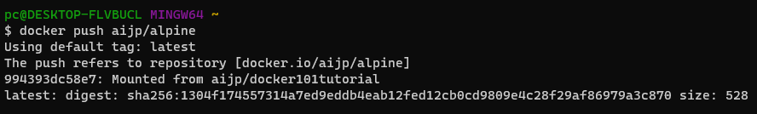

1. Remove the running docker container forcefully :

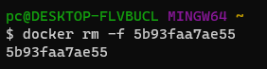

1. Remove the docker image from local storage :

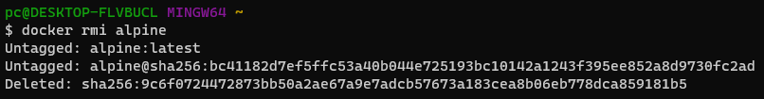

1. Build the docker image using Dockerfile :

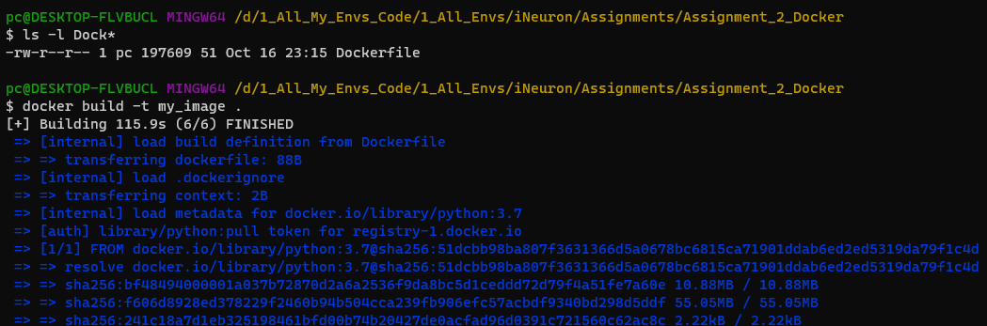

1. Check the docker container logs :

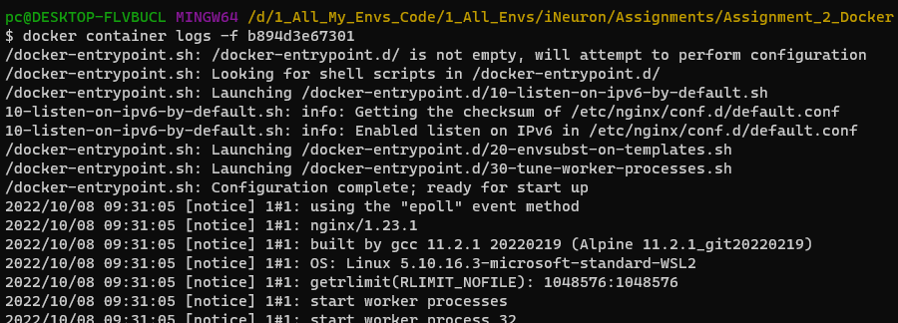

1. To inspect the docker container or to know more details about the container :

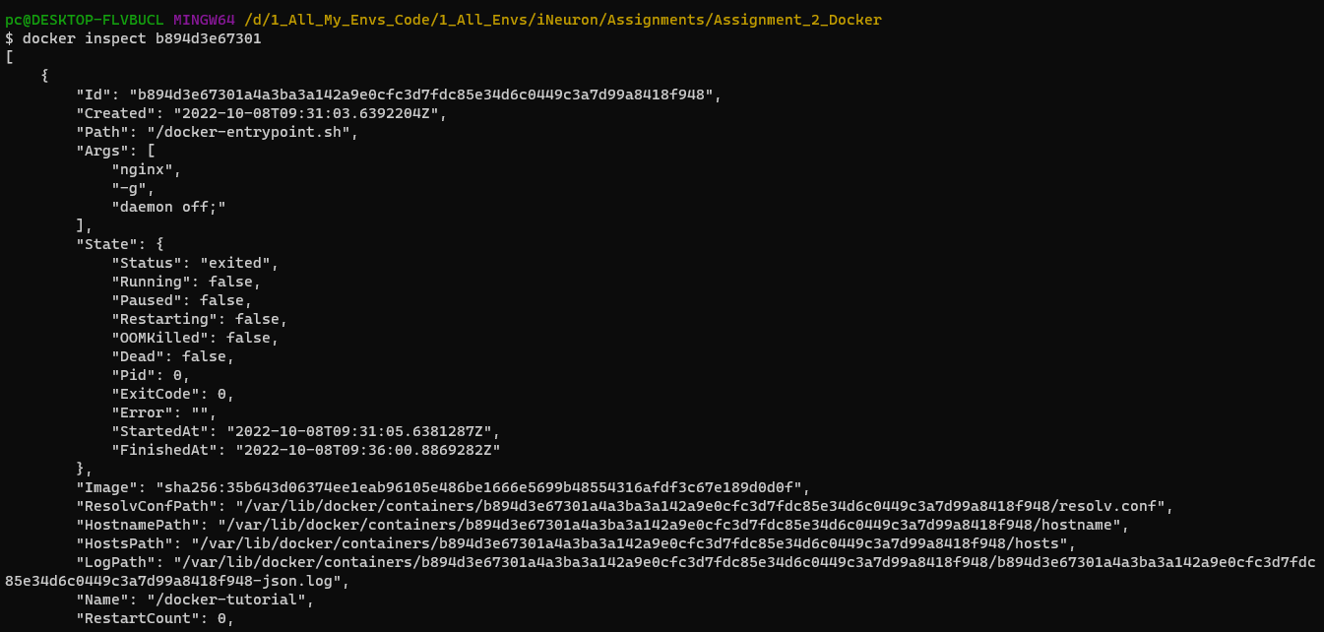

1. Remove all unused containers, networks, images and optionally volumes.

