**Assignment_3_Docker_Create_fastapi_application**

Dockerfile :

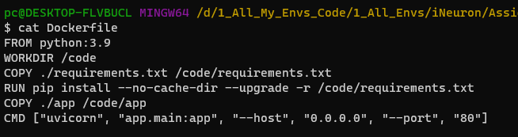

requirements.txt file :

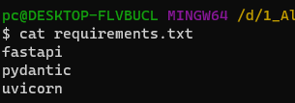

Main.py file :

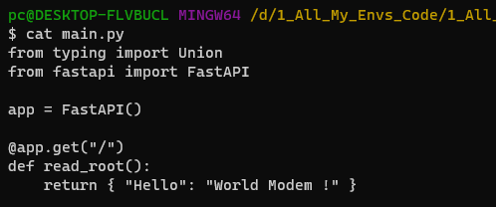

Building Docker image :

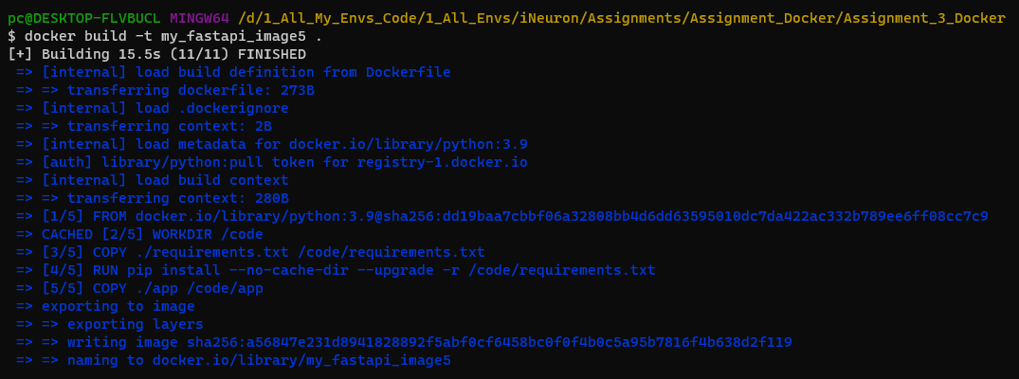

Running a Docker container using the above image we created :

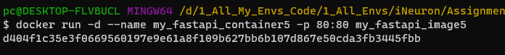

List the running containers :



Tag the image with a new name :



List all images :

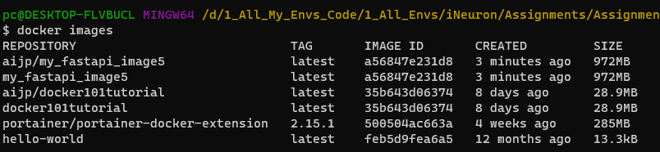

Push the image to docker hub :

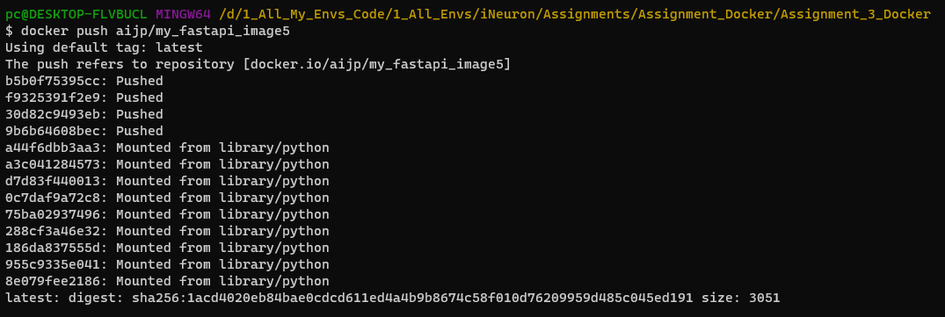

Checking in the browser :

