**Assignment – 4 : Automate building docker image and push to Docker Hub using GitHub Actions**

create a repo in Docker hub :

Click on repositories -> Create repository -> enter name.

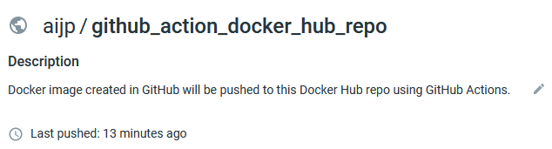

=========================================================================

Now, create a GitHub action to build and publish image to Docker Hub.

Under git repo, click on Actions and then select “set up a workflow yourself”.

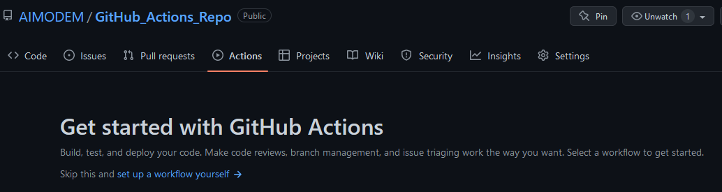

Now, write the workflow definition and then commit the file.

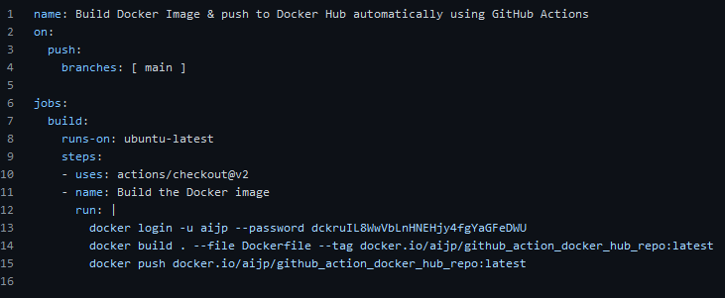

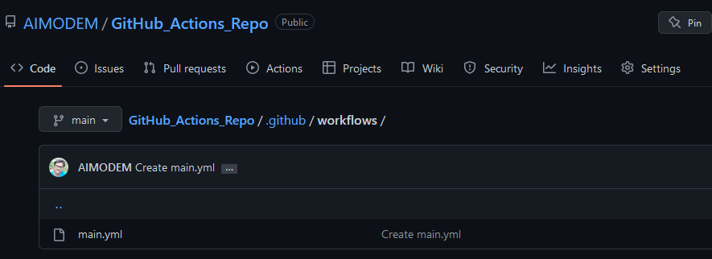

Git push :

* After git push, we’ll see the workflow will run automatically to create image and publish to Docker Hub.

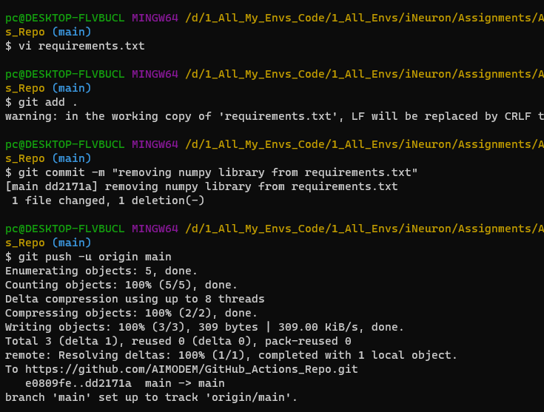

Below screenshot shows that the workflow is in progress.

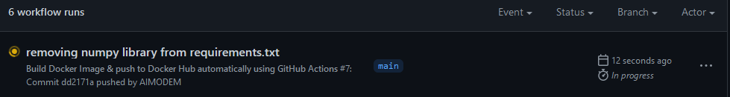

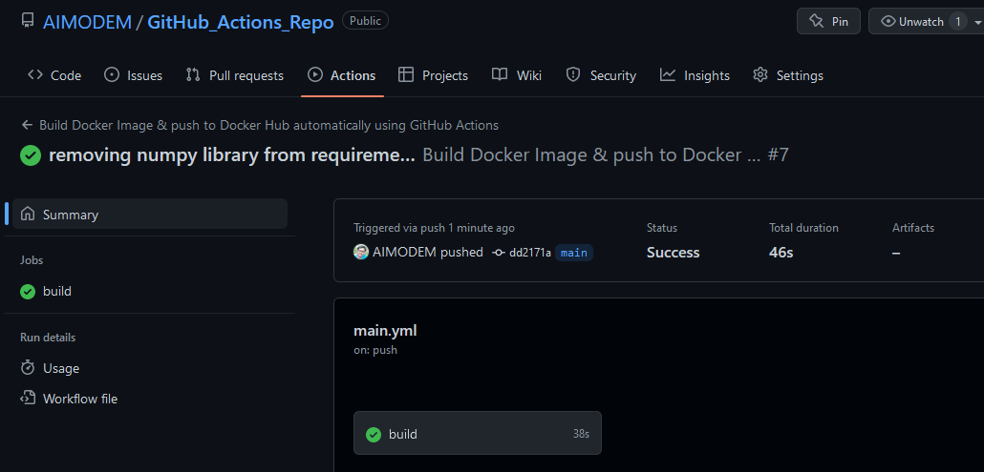

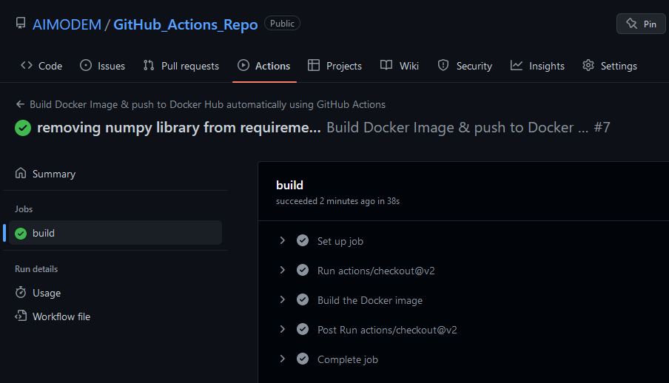

Now, the job was executed successfully.

Verify the published image in Docker hub :

