FIXIT Business Plan

**Business Nature:** Online Web Service

**Prepared By:**

|  |  |  |
| --- | --- | --- |
| **Name** | **Roll #** | **Topic** |
| Muhammad Arslan Yousaf | BITF17A012 | Financial Plan |
| Zainab | BITF17A019 | Organizational Plan |
| Daniyal Ahmad | BITF17A026 | Venture Description |
| Memoona Shakeel | BITF17A038 | Marketing Plan |
| Sohaib Salman | BITF17A040 | Environment and Industry Analysis |
| Tehreem Akhter | BITF17A041 | Executive Summary and Risk Assessment |

***Table of Contents***

**Executive Summary** **3**

**Description of Venture** **3**

The Mission of the Venture 3

Reasons for Starting the Venture 3

Our Services 4

**Environmental and Industrial Analysis** **5**

Economy 5

Culture 5

Technology 6

Legal Concerns 6

Trends 6

Nearest Competitors 7

Customer Profile 7

**Marketing Plan** **8**

Marketing Summary 8

Market Positioning 8

Market Segmentation 8

Market Needs 8

Target Market Segment Strategy 9

Advertising to Local Users and Small Businesses 9

Competition and Buying Patterns 9

**Organizational Plan** **10**

**Financial Plan** **11**

Operating Budget for First Three Months($000s): 11

**Assessment of Risks** **15**

## ***Executive Summary***

In our business venture, we have decided to develop an application that will assist in providing routine services such as Electricians, Mechanics, Plumbers, Carpenters, and any other service which is a requirement of our target market which are the customers who like their work done while staying at home. The person who will provide the specific service will have to register themselves through our application and provide the location of their workplace, along with the description of the services they provide which will be properly verified through a step of certain verification checks and then after that he/she can perform the service in which they have experience. From a user perspective, instead of going out and searching for a service provider, they can use our application to locate various service providers around them and through this application they can easily contact and communicate with them.

## ***Description of Venture***

With this business, we aim to tackle many problems aroused especially during the pandemic of COVID 19, where because of the lockdown many people lost their jobs or faced huge losses in their businesses. Following is a brief description of our venture.

#### **The Mission of the Venture**

The mission of this venture is to provide ease to all citizens of Pakistan and help them find and avail the services of the best service providers around them.

#### **Reasons for Starting the Venture**

At times there are situations when we cannot go outside due to some reasons as in this pandemic condition of COVID or when we move to a new place where the surroundings are unfamiliar and we don’t know which shop is nearby! Thus we have to manually search for the routine services providers like Mechanics, Plumbers, etc.

Mostly all of us have gone through these situations, and it is sometimes difficult especially for women to go out and search for the service provider they are looking for. Keeping in mind these problems and the current pandemic situation of COVID 19, where many people faced loss in their business and loss of their jobs, we are providing a platform to all citizens that will help them in their routine tasks.

* 1. **How will this Venture will be Successful?**

Due to the current pandemic situation, most of us want to stay at home whereas the service providers or shop owners want customers. In this situation, our application will serve as a bridge between the customers and the service providers.

Moreover, since Uber and Careem were introduced in Pakistan, now people are looking forward to buying or getting online services while sitting in their homes. This trend will help our growing venture as the basic aim of our business is to provide home-based services, without leaving the home!

Because of the increasing trend of e-commerce and location-based (Uber, Careem, etc.) services in Pakistan, also the need for the workers who cannot afford to buy/rent a shop to provide their services, this application and business can be a big opportunity for the talented people of Pakistan as well to provide and prove their talent without even having a physical shop.

#### **Our Services**

Our business aims to provide all the routine services that are necessary for any household like plumbers, carpenters, mechanics, as well as complex services like software development, designing, tutors, etc. A single platform for all the needs of life!

Using our application, users can search for the nearby service providers they are looking for. Our application will provide the users with many filters like “Best Rated”, “Low Price”, “Nearest”, etc. to help the users select the service provider suitable for them.

Here is the list of services our application will provide to the customers:

*Main Services:*

* Search nearby service
* Filter out the service
* Messaging and Chat
* Scheduling
* Call a service provider
* Cancellation of service
* Ratings

*Secondary Services:*

* Complaints
* Report service providers/user

*Future Services:*

In the future depending on the feedback from our customers and service providers, we might introduce nearby location search as well that will help users to locate the best nearby hospitals, schools, doctors, or even organizations and companies if any user/group wants a complex service. For example, if someone wants to develop their website, they can use our application to search nearby companies that provide services regarding web development and then contact them.

## ***Environmental and Industrial Analysis***

Pakistan’s economy is in a state of development, and Pakistan’s IT industry is also developing day by day. Pakistan has good potential for IT growth, it is stated in many reports that Pakistan has the potential of becoming the next Biggest Tech Hub in Asia. Many IT startups are being established in Pakistan, most of them are successful.

Keeping in view of all the IT trends in Pakistan, IT-based startups are a good candidate for a successful business.

#### **Economy**

The economy of Pakistan is under development and the Government of Pakistan is investing heavily in the IT sector. Right now, an IT-based startup or a business has a good potential to grow in Pakistan, as Pakistan is providing well-acknowledged contributions to the IT industry world-wide. And it is expected in the upcoming years that Pakistan will be a good candidate for the technological hub.

Moreover, many international companies like Microsoft, Google, Facebook, are looking to invest and open their official stores in Pakistan. This will bring a huge boost to the economy of Pakistan. Another important factor is the CPEC project between China and Pakistan. Once this project is fully completed, it is expected that the economy will increase and develop.

#### **Culture**

The culture of Pakistan has changed dramatically in the past 5-8 years. Now almost everyone has a smartphone and internet facility. We can see that in the past 3-4 years, a large number of people are preferring e-commerce and online shopping. Most Pakistani are ready to adapt according to the latest technological trends. Since the launch of Uber and Careem in Pakistan, people are now looking forward to having location-based services.

Other than that, in Pakistani culture the labor type is well-diversified. We can find different types of workers in a small location. In cities, every block or two has a service provider available. This diversity and abundance of occupations is a key factor for our venture.

#### **Technology**

We have seen a lot of technological advancements in Pakistan in the past 5 years. Now, almost every family in Pakistan has at least one smartphone. This technological advancement is not going to stop in the future. The government of Pakistan is also encouraging youth to learn and explore new technologies by introducing many projects like *Digital Pakistan*, *Kamyab Jawan Program.* These programs and projects are providing a good awareness of using technology.

Other than that, the technology giants like Microsoft, Facebook, Tesla, Google are ready to invest in Pakistan. In the recent list of Open Source Contributions, Pakistani software developers were in the top 5 who contributed most in free software.

In short, Pakistan has good potential for technological growth and is moving towards a technological hub of Asia.

#### **Legal Concerns**

For any service provider business, the first and foremost priority is the safety of both service providers and customers. For this, if someone reports a user/service provider for any misbehavior or suspicious activity, their account will be disabled permanently without any notice.

The other important factor is the fake users/service provider. They will be dealt with in the same way as the previous policy.

Our application will keep the confidentiality of the information provided and will not be sharing it with any third parties.

#### **Trends**

As stated previously, the technological trends are increasing in Pakistan. Now almost every family has a smartphone. With the launch of many e-commerce applications in Pakistan like Draz.pk, iShopping.pk, etc., and online banking systems, people are moving fastly towards online services. The launch of Uber and Careem did a huge boost to this increasing trend of online services. Now people want everything to be done while sitting in their homes.

Here is a small graph of traffic (no. of visits) of online services in Pakistan in 2019.

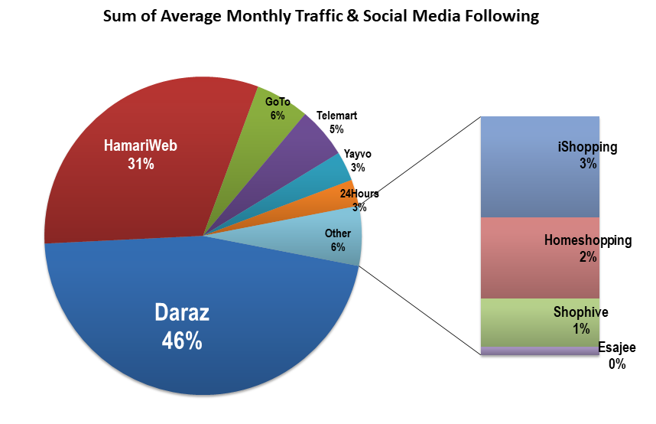

These increasing trends in the use of e-commerce, online shopping, and banking is a key factor for our venture.

#### **Nearest Competitors**

Although there are many businesses available that are providing online services, the nearest competitors to our business are:

* *Supertasker.pk*

It is a venture similar to our business venture, but in Super Tasker, a user/customer has to post that I need the following service and then all available service providers comment their quote to complete that service. Whereas our application will search for nearby available service providers automatically.

* *Careem*

Although careem is widely used for taxi service, it is adding more options like parcel delivery service, etc. Careem also provides location-based service and finds the nearby driver/rider. But our service idea is not just limited to drivers, we are offering diverse occupations.

* *Google Maps*

Google maps is used for entirely different purposes, but it has features to find nearby locations. It is a more complex application and most of Pakistani don’t know how to use these complex applications and features, therefore our application contains a friendly interface with the option to switch to Urdu Language for better understanding.

#### **Customer Profile**

We can divide our customers into two different groups. One group is the service provider, and the other is the service seeker. For example, a plumber will be a service provider and the person calling the plumber will be the service seeker. By dividing the customer in these groups, we can clearly see the diversification of services this venture can provide.

Our customer might be a doctor, engineer, business man, house wife or any other professional. One customer will be providing a service to another customer of our application.

## ***Marketing Plan***

#### **Marketing Summary**

Fixit will target the middle-aged, busy executive. These individuals often have extremely busy schedules, including a great deal of travel time. In addition, they possess a large proportion of disposable income that allows them to afford custom services. This service will allow them more concentration on work, while allowing them to obtain great services for personal and business life.

#### **Market Positioning**

Fixit’s market positioning is based on the emphasis on the quality of services. In other words, apart from making itself available to a large number of clients by means of expansion and wide coverage, Fixit also differentiates itself from the competitors attempting to provide the highest level of comfort and convenience to the clients. This advantage is achieved by means of outsourcing of various processes and operations. For instance, using a regular taxi service, a client would have to call them on the phone, wait for the car to arrive, and then, possibly show the way or explain the route without knowing how much the journey would cost. Fixit’s reliance on the latest technologies allows this business to use a qualitatively different approach. The clients of Fixit place their orders online using the mobile application or a website.

#### **Market Segmentation**

The target market for Fixit is broken into three segments:

* Busy executives desiring to keep pace with the trends, yet not having the time to facilitate their needs.
* Younger business persons who choose to have the luxury and convenience of a personalized online service.
* Those needing consultation in things to buy or not wanting the pressures that are associated with finding custom need for special occasions.

#### **Market Needs**

Fixits primary market, the executive or high-end professional individual, has certain needs that are outlined below.

* They often find that their image is very important, both professionally and personally. They need advice or information on what the latest trends and services are.
* They keep busy schedules that often involve a lot of travel. This leaves little time to look for relevant professional for the specific service and that is time consuming too, such as gift buying, and looking for a good plumber or an electrician or even a cab.
* They have a desire to be pampered and willingly spend money as a symbol of status.

#### **Target Market Segment Strategy**

The best way to develop the company is to make our service necessary and accessible to the public. By facilitating their needs easily, we offer a great service at little inconvenience to them in a time where convenience matters the most.

In its broadest definition, the Pakistani online services providing market consists of every Pakistani who needs to buy goods and services for themselves and their families. Although it is the aim of Fixit to eventually reach out to a wide range of users, including middle income families, busy professionals, and people looking for “hard to find” services, the company will focus first on the busy executive-type users.

#### **Advertising to Local Users and Small Businesses**

* Yellow Pages
* Local newspapers
* Radio
* Hand out flyers to local businesses
* Internet website
* TV
* Social Media

#### **Competition and Buying Patterns**

This is a luxury service. An affordable cost will be needed to maintain clients and keep their needs constant. This requires being aware of economic changes, as well as alterations in trends.

At the moment, there are few services like this in the Lahore area who provides all in one. Therefore, there is a tremendous opportunity to build and retain significant market share. Users choose and retain services like this often through word-of-mouth, when the company is able to achieve a high level of user satisfaction. Although it is the aim of Buy the Time to significantly lower costs of this service, at this time, cost does not play a significant factor in how users choose a Fixit service. The bottom line is establishing a strong intimate relationship with users to capture the long-term profits through repeat business and create the enthusiasm among users that will spur on word-of-mouth marketing.

## ***Organizational Plan***

* 1. **Organizational Structure:**

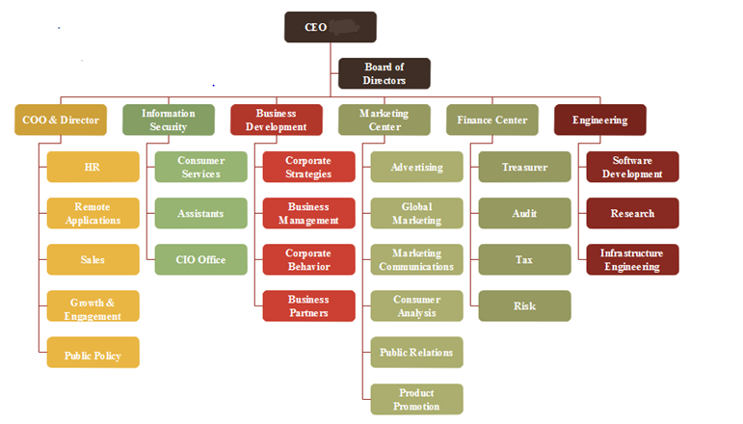

* 1. **Form Of Ownership:**

Our business has relations between the directors who have agreed to share the profit or loss of the business carried by all or any one of them acting for all.

5.2.1. Legal Entity: No separate entity from its owner.

5.2.2. Law: Formed under the act of Partnership Act of 1932.

5.2.3. Registration: Not registered.

5.2.4. Number of Partners: 5

5.2.5. Every board of director has the right to participate in management.

5.2.6. Liability: Unlimited

5.2.7. Business Size: Medium

5.2.8. Stock Exchange: Our venture is not listed in stock exchange.

5.2.9. Wind Up: Our business can be dissolved according to the partnership agreement.

* 1. **Board of Directors and their responsibilities:**

1. **Arslan Yousaf**: Responsible for ensuring the proper usage of assets.
2. **Zainab Zulfiqar**: Will be responsible for developing long-term strategic plans for growth and expansion.
3. **Daniyal Ahmad**: responsible for developing a network of information sources for the venture.
4. **Memoona Shakeel**: responsible for reviewing operating and capital budgets.
5. **Sohaib Salman**:Responsible for supporting the day-to-day operations/activities of venture capital.
6. **Tehreem Akhtar**: Responsible for resolving conflicts among owners or shareholders.
   1. **Functions of Management:**

5.4.1. Planning

5.4.2.Organizing

5.4.3.Commanding

5.4.4.Coordinating

5.4.5. Controlling

* 1. **Function of Engineering Team:**

5.5.1. Software Development

5.5.2. Information Security

5.5.3. Research

## ***Financial Plan***

#### **Operating Budget for First Three Months($000s):**

The operating budget for our business plan of first three months is given below:

|  |  |  |  |
| --- | --- | --- | --- |
| **Expense** | **January** | **February** | **March** |
| Rent | 200 | 200 | 200 |
| Salaries | 800 | 850 | 850 |
| Utilities | 300 | 300 | 300 |
| Advertising | 170 | 175 | 175 |
| Selling Expenses | 160 | 160 | 160 |
| Insurance | 200 | 200 | 200 |
| Payroll taxes | 120 | 120 | 120 |
| Depreciation | 80 | 80 | 80 |
| Office Expenses | 75 | 75 | 75 |
| **Total Expenses** | **$ 2,105** | **$ 2,160** | **$ 2,160** |

* 1. **Pro Forma Income Statement, First Year by Month ($000s):**

|  |  |  |  |  |  |  |  |  |  |  |  |  |  |
| --- | --- | --- | --- | --- | --- | --- | --- | --- | --- | --- | --- | --- | --- |
|  | **Jan.** | **Feb.** | **Mar.** | **Apr.** | **May** | **June** | **July** | **Aug.** | **Sept.** | **Oct.** | **Nov.** | **Dec** | **Totals** |
| Sales | 350 | 370 | 375 | 430 | 450 | 550 | 560 | 570 | 340 | 360 | 420 | 410 | **5,185** |
| Less: Cost of Good sold | 175 | 185 | 190 | 215 | 225 | 275 | 280 | 285 | 170 | 180 | 210 | 205 | **2,592.5** |
| Gross Profit | 175 | 185 | 185 | 215 | 225 | 275 | 280 | 285 | 170 | 180 | 210 | 205 | **2,592.5** |
| Operating Expenses |  |  |  |  |  |  |  |  |  |  |  |  |  |
| Salaries | 800 | 850 | 850 | 850 | 850 | 850 | 860 | 860 | 860 | 860 | 870 | 900 | **10,260** |
| Rent | 200 | 200 | 200 | 200 | 200 | 200 | 220 | 220 | 220 | 220 | 220 | 220 | **2,520** |
| Utilities | 300 | 300 | 300 | 300 | 410 | 420 | 420 | 350 | 300 | 250 | 250 | 290 | **3,890** |
| Advertising | 170 | 175 | 175 | 175 | 175 | 180 | 180 | 190 | 190 | 190 | 200 | 200 | **2,200** |
| Sales Expenses | 160 | 160 | 160 | 160 | 160 | 160 | 160 | 160 | 170 | 170 | 170 | 170 | **1,960** |
| Depreciation | 80 | 80 | 80 | 80 | 80 | 90 | 80 | 80 | 90 | 90 | 90 | 90 | **1,010** |
| Office Expenses | 75 | 75 | 75 | 80 | 80 | 90 | 95 | 95 | 90 | 85 | 70 | 70 | **980** |
| **Total Operating Expenses** | **1,785** | **1,835** | **1,835** | **1,840** | **1,950** | **1965** | **2,000** | **1,940** | **1,905** | **1,850** | **1,870** | **1940** | **22,715** |
| **Gross Profit** | **1,610** | **1,650** | **1,650** | **1,625** | **1,725** | **1,690** | **1,720** | **1,655** | **1,735** | **1,670** | **1,660** | **1,735** | **(20,125)** |

* 1. **Pro Forma Balance Sheet, End of First Year($000s)**

|  |  |  |
| --- | --- | --- |
| **Assets** |  |  |
| Current Assets |  |  |
| Cash | $1,200 |  |
| Accounts Receivable | 1,500 |  |
| Inventory | 200 |  |
| Total Current Assets |  | $2900 |
| **Fixed Assets** |  |  |
| Equipment | 3,000 |  |
| Less Depreciation | 1,200 |  |
| Total Fixed Assets |  | 1,800 |
| Total Assets |  | $4,700 |
| **Liabilities and Owner’s Equity** |  |  |
| Current Liabilities |  |  |
| Accounts Payable | $1,400 |  |
| Total Liabilities |  | $1,400 |
| **Owner’s Equity** |  |  |
| Arslan | 3,500 |  |
| Daniyal | 3,500 |  |
| Sohaib | 3,500 |  |
| Zainab | 3,500 |  |
| Memoona | 3,500 |  |
| Retained Earnings | (4,350.4) |  |
| Total Owners’ Equity |  | 4,000.6 |
| **Total Liabilities and Owners’ Equity** |  | $4,700 |

## ***Assessment of Risks***

Effective risk assessment is extremely important. Here is the Risk Assessment Plan of our venture:

|  |  |  |
| --- | --- | --- |
| **Risk** | **Impact/Consequence** | **Prevention** |
| Absence of service provider after booking | After booking a service if the service provider does not show up then it can directly have a negative impact on our business if this happens continuously | After the estimated time of arrival if the provider does not show up then the booking will be automatically cancelled and customer would be informed |
| Financial Instability | Due to financial instability our business can be in danger and a major loss can be predicted | Additional funds should always be arranged before hand to prevent this situation |
| Major delay after booking a service | Delay due to any cause e.g. traffic , rain or any other disaster can happen. | Provider should be responsible of informing in advance to the customer if he/she stucks somewhere |
| Poor investor match | Poor investors can affect our business e.g. if the investor wants to focus on sales whereas we want to invest in company’s technology | Investors should be wisely chosen after a proper agreement from both sides |
| Poor product market fit | If the product does not stands in the market like the desired way then then profit ratio will be minimum | Market trends should be observed carefully |
| Not assessing market competitors | Poor competitors assessment can result in the downfall of our business | Market competitors should be observed carefully |
| Inexperienced workers | If amount of inexperienced workers overcomes the experienced ones then reputation of product among customers will be defamed | Proper experience check will be performed before maintaining the profile on our application |
| Charging customers more fraudulently | Product can be defamed if it happens more than once | Account of that service provider will be banned. |
| Poor advertisement | Poor advertisement plans will affect the annual profit and loss ratio | Good amount of money will be invested in marketing and advertisements. |
| Upload of inappropriate/inapplicable Services | Market reputation will be defamed due to such unethical services. | Before making the service public, it will first be reviewed by one of admins |
| Data Security | Data is a valuable asset and once it is breached then there is no way to gain trust of customers again | Proper measures should be taken to make sure data is secured. |
| User personal Information theft risk | Theft of personal information can cause great risks to the business organization | Experienced Web Experts should be hired to make sure no information is at risk. |

## 