Logic Circuits Lab #2

In this lab we will connect and attempt to understand a multiplexer / demultiplexer …

First, a multiplexer. Remember this is a combinational circuit that selects on of n inputs lines and provides it on the output. Multiplexer has several inputs an only one output.

A 2 – 1:

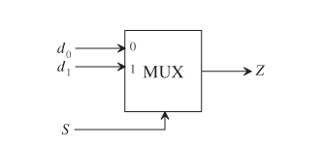

It’s truth table:

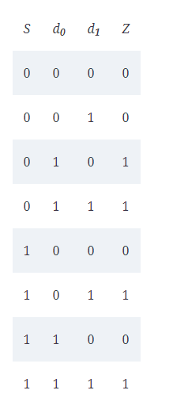

Let’s build and test a multiplexer in Logisim – open to a clean screen.

Add a multiplexer (Plexers folder)

Modify it’s Select bits to 3 – remember this is 2^n or 2^3 = 8 inputs.

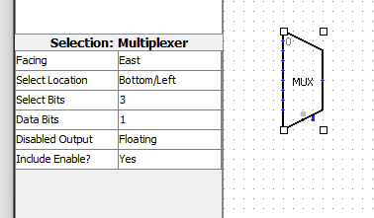

Now let’s connect inputs and output and selectors.

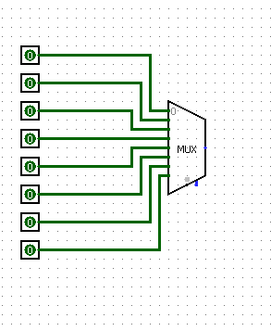

Selector input (north facing):

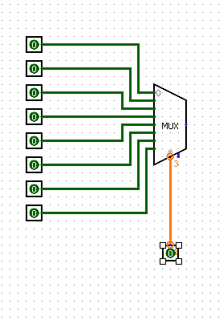

Remember incompatible widths means we need more bits

Notice the small 3 at the top of the orange line – it requires a 3 bit input so modify to 3 Data Bits

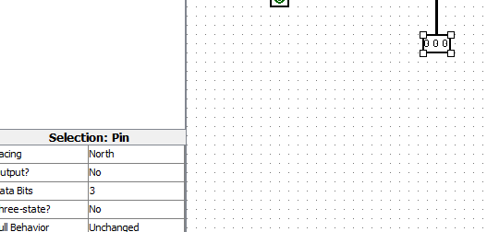

Now should be black and ready for output.

Add output as an LED (Input / Output folder -> LED):

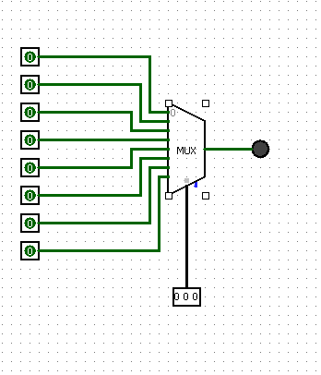

Select the LED – select the On Color and change from red to green:

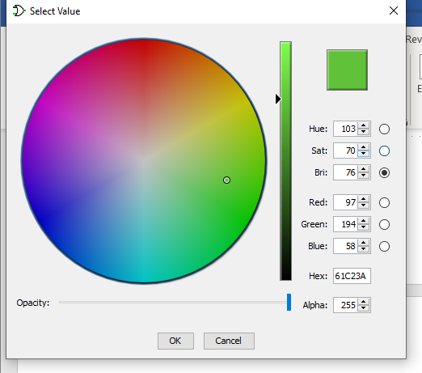

Before we test – review this truth table:

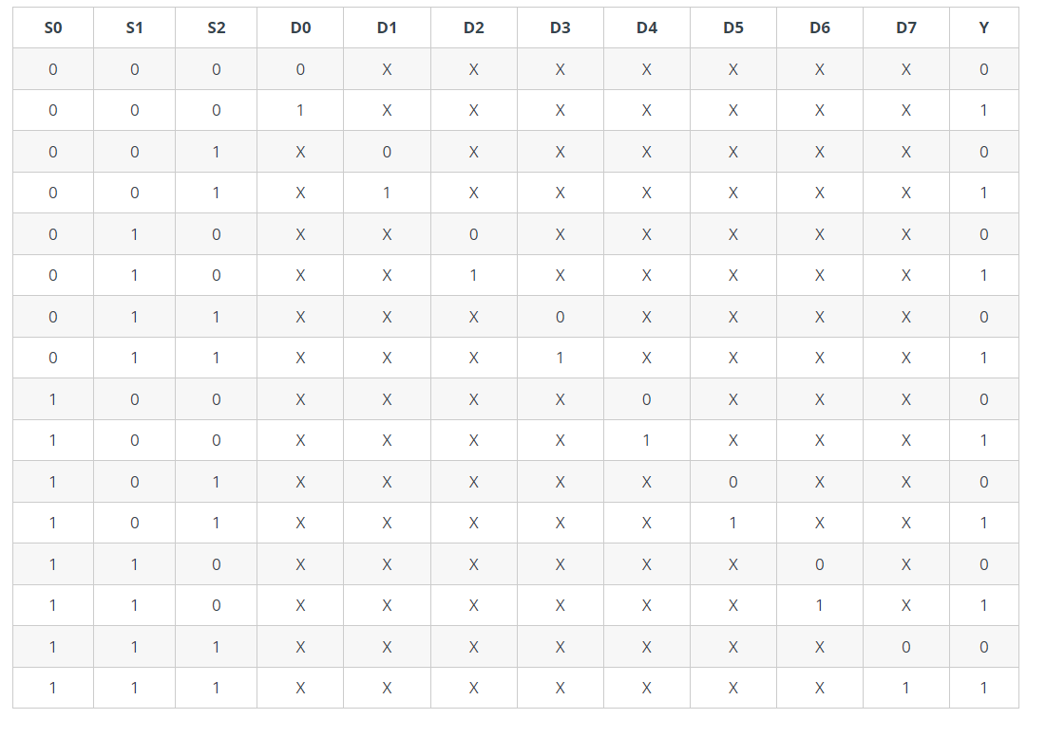

X once again is insignificant, only 0 / 1’s is significant and Y is one off for our LED.

Use your hand tool and test your multiplexer. So, if S0, S1, S2 are 0’s our LED and D0 (top) is a 0, then our LED is off, if D0 is a 1 – LED is one.

Work through this truth table and provide (2) screen shots of 2 different rows.

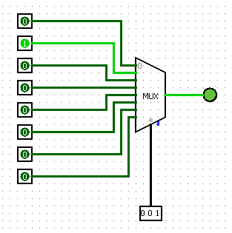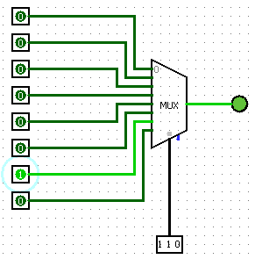

Next a demultiplexer.

This is a combinational circuit that has one input and many outputs.

It receives the information on a single input line and transmits the same information over one of ‘n’ possible output lines.

To select a particular output, use a set of Select lines and the bit combinations of these select lines control the selection of specific output line to be connected to the input at any given instant.

Multiplexers are called Data Selectors, while Demultiplexers are called Data Distributors.

Let’s create a demultiplexer circuit in Logisim. You can use the same screen as your MUX.

First, add the demultiplexer and let’s do a 1 input to 4 output DEMUX.

Add a DMX, change select bits to 2 and add our one input:

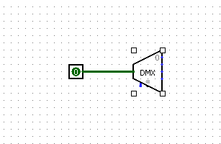

Add 4 outputs:

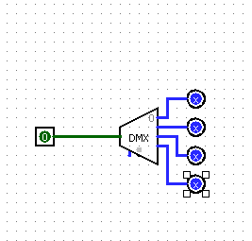

Add north facing select input:

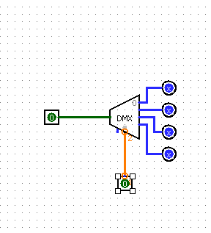

Notice the orange 2 – change that input to two data bits.

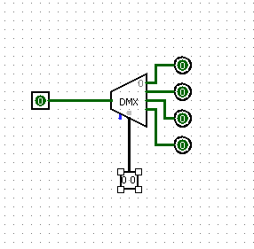

Test it

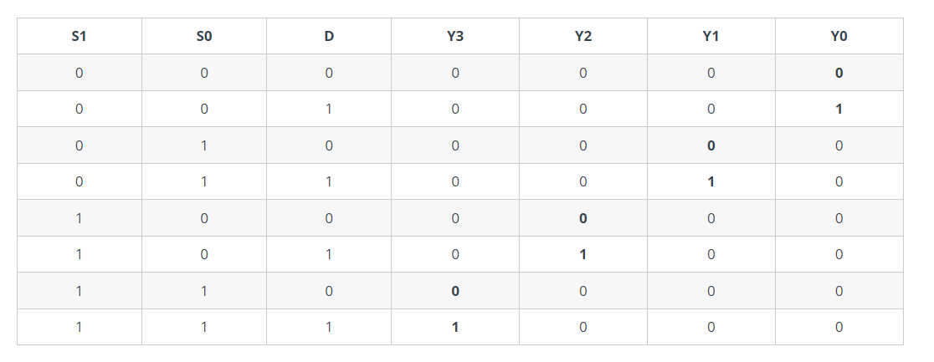

Post two different screen shots representing two of the truth table rows:

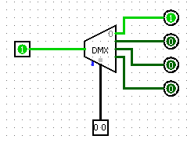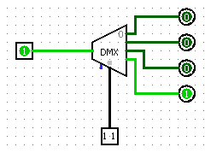

The final circuits for combinational circuits are the Binary and BCD Adders and Binary Subtractors.

When two bits are added, a sum bit and a carry bit are generated. A combinational circuit that adds two bits is called a half-adder.

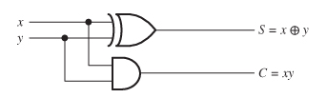

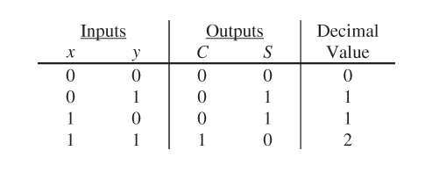

Let’s practice in Logisim. Click on green plus sign in upper left menu: 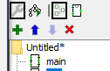

Name this HA for half adder – should now be at a blank screen.

Create two inputs – label A **and B:**

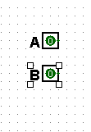

**Now two outputs** – label Sum and Carry

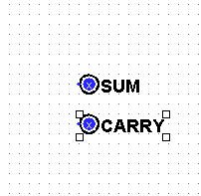

Add a XIR Gate – change to 2 inputs:

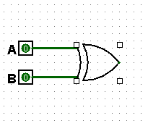

Add a 2 input AND Gate:

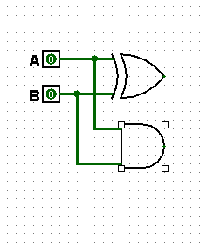

Connect to appropriate outputs:

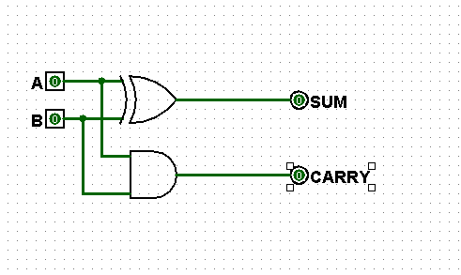

Now right click on HA in explorer window and select Analyze Circuit.

Click Table tab and check out the TT:

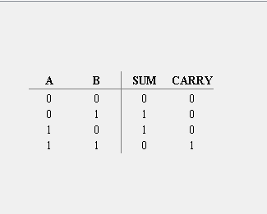

If you need a lesson in binary addition / subtraction – check out here:

<https://www.wikihow.com/Add-Binary-Numbers>

<https://www.wikihow.com/Subtract-Binary-Numbers>

Now double click on the main screen and wipe out any items on this page – make it blank.

Grab two HA circuits and place it on the blank screen.

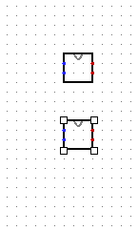

Right click on the HA circuit and select Edit Circuit Appearance.

Grab a corner and make it longer.

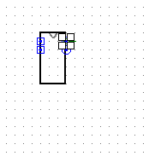

Click on the inputs and sum and carry outputs – a small diagram shows in the lower right corner. Blue is where you have clicked.

Click in the A – click in the middle of the circuit and type HA:

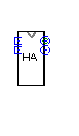

OK, save the circuit – store it in a folder you can find, perhaps Documents / CompOrg.

Now double click on main – erase all the circuits on that page. Click File -> New

Right click on Untitled – click add Load Library -> Logisim Library -> find and select your newly made library for HA.circ

A new folder is created at the bottom with your circuit. That’s how you can create your own libraries and add them to a new project.

Now let’s create a full adder with our half adder circuits. A full adder is central to most digital circuits that perform addition or subtraction. It is so called because it adds together two binary digits, plus a carry-in digit to produce a sum and carry-out digit. Typically has three inputs and two outputs.

The carry may be 0 or 1.

Truth Table

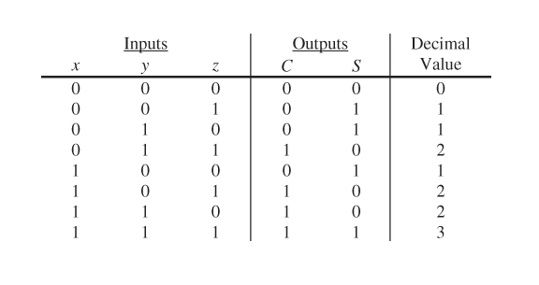

Go back to main / HA circuit and add a new circuit called FA

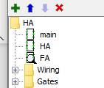

You can build a full adder with two half adders.

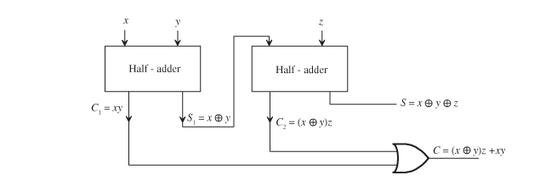

So, create this circuit: (On the FA screen)

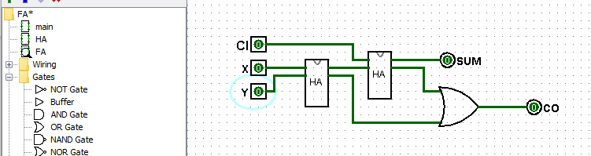

Now test using this TT:



Submit three screen shots of three separate selections from the TT here:

Save as FA.circ

Done!