Logic Gate Lab

Instructions: This assignment will start by providing you a circuit. You need to create it in Logisim, then fill in the truth tables based on that circuit. Then provide the Boolean expression for that circuit in the appropriate spots.

The second part will provide the Boolean expressions, then you create the Logisim circuit and the appropriate truth table.

Answer all questions that ask you to evaluate the equality of several circuits or ask you to simplify the expression with the appropriate gates.

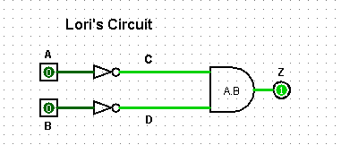

**Submit “your” circuit from Logisim here: (Add labels and put your name in the circuit)**

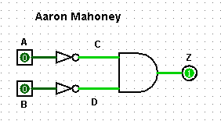

**Fill in this truth table for this circuit:**

|  |  |  |  |  |
| --- | --- | --- | --- | --- |
| A | B | C | D | Z |
| 0 | **0** | **1** | **1** | **1** |
| 0 | **1** | **1** | **0** | **0** |
| 1 | **0** | **0** | **1** | **0** |
| 1 | **1** | **0** | **0** | **0** |

**What is the expression for this circuit:**

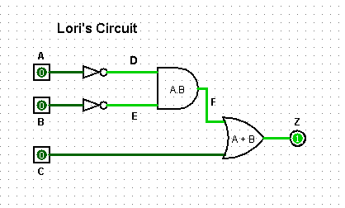

**Submit “your” circuit from Logisim here: (Add labels and put your name in the circuit)**

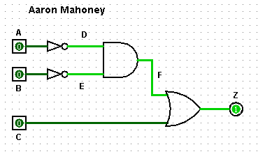

**Fill in this truth table for this circuit:**

|  |  |  |  |  |  |  |
| --- | --- | --- | --- | --- | --- | --- |
| A | B | C | D | E | F | Z |
| 0 | **0** | **0** | **1** | **1** | **1** | **1** |
| 0 | **0** | **1** | **1** | **1** | **1** | **1** |
| 0 | **1** | **0** | **1** | **0** | **0** | **0** |
| 0 | **1** | **1** | **1** | **0** | **0** | **1** |
| 1 | **0** | **0** | **0** | **1** | **0** | **0** |
| 1 | **0** | **1** | **0** | **1** | **0** | **1** |
| 1 | **1** | **0** | **0** | **0** | **0** | **0** |
| 1 | **1** | **1** | **0** | **0** | **0** | **1** |

**What is the expression for this circuit:**

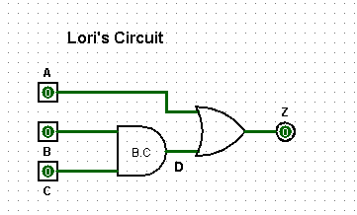

**Submit “your” circuit from Logisim here: (Add labels and put your name in the circuit)**

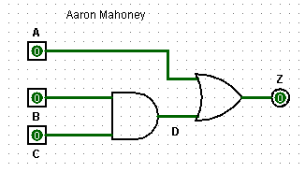

**Fill in this truth table for this circuit:**

|  |  |  |  |  |
| --- | --- | --- | --- | --- |
| A | B | C | D | Z |
| 0 | **0** | **0** | **0** | **0** |
| 0 | **0** | **1** | **0** | **0** |
| 0 | **1** | **0** | **0** | **0** |
| 0 | **1** | **1** | **1** | **1** |
| 1 | **0** | **0** | **0** | **1** |
| 1 | **0** | **1** | **0** | **1** |
| 1 | **1** | **0** | **0** | **1** |
| 1 | **1** | **1** | **1** | **1** |

**What is the expression for this circuit:**

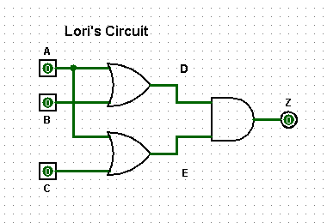

**Submit “your” circuit from Logisim here: (Add labels and put your name in the circuit)**

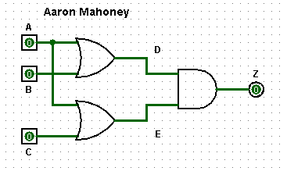

**Fill in this truth table for this circuit:**

|  |  |  |  |  |  |
| --- | --- | --- | --- | --- | --- |
| A | B | C | D | E | Z |
| 0 | **0** | **0** | **0** | **0** | **0** |
| 0 | **0** | **1** | **0** | **1** | **0** |
| 0 | **1** | **0** | **1** | **0** | **0** |
| 0 | **1** | **1** | **1** | **1** | **1** |
| 1 | **0** | **0** | **1** | **1** | **1** |
| 1 | **0** | **1** | **1** | **1** | **1** |
| 1 | **1** | **0** | **1** | **1** | **1** |
| 1 | **1** | **1** | **1** | **1** | **1** |

**What is the expression for this circuit:**

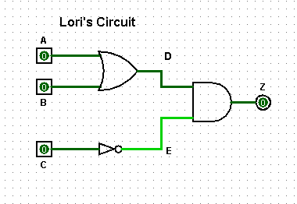

**Submit “your” circuit from Logisim here: (Add labels and put your name in the circuit)**

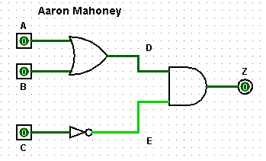

**Fill in this truth table for this circuit:**

|  |  |  |  |  |  |
| --- | --- | --- | --- | --- | --- |
| A | B | C | D | E | Z |
| 0 | **0** | **0** | **0** | **1** | **0** |
| 0 | **0** | **1** | **0** | **0** | **0** |
| 0 | **1** | **0** | **1** | **1** | **1** |
| 0 | **1** | **1** | **1** | **0** | **0** |
| 1 | **0** | **0** | **1** | **1** | **1** |
| 1 | **0** | **1** | **1** | **0** | **0** |
| 1 | **1** | **0** | **1** | **1** | **1** |
| 1 | **1** | **1** | **1** | **0** | **0** |

**What is the expression for this circuit:**

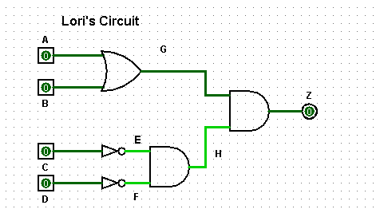

**Submit “your” circuit from Logisim here: (Add labels and put your name in the circuit)**

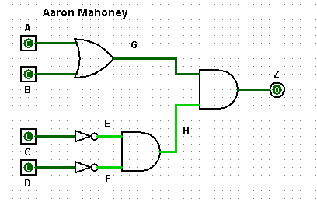

**Fill in this truth table for this circuit:**

|  |  |  |  |  |  |  |  |  |
| --- | --- | --- | --- | --- | --- | --- | --- | --- |
| A | B | C | D | E | F | G | H | Z |
| 0 | **0** | **0** | **0** | **1** | **1** | **0** | **1** | **0** |
| 0 | **0** | **0** | **1** | **1** | **0** | **0** | **0** | **0** |
| 0 | **0** | **1** | **0** | **0** | **1** | **0** | **0** | **0** |
| 0 | **0** | **1** | **1** | **0** | **0** | **0** | **0** | **0** |
| 0 | **1** | **0** | **0** | **1** | **1** | **1** | **1** | **1** |
| 0 | **1** | **0** | **1** | **1** | **0** | **1** | **0** | **0** |
| 0 | **1** | **1** | **0** | **0** | **1** | **1** | **0** | **0** |
| 0 | **1** | **1** | **1** | **0** | **0** | **1** | **0** | **0** |
| 1 | **0** | **0** | **0** | **1** | **1** | **1** | **1** | **1** |
| 1 | **0** | **0** | **1** | **1** | **0** | **1** | **0** | **0** |
| 1 | **0** | **1** | **0** | **0** | **1** | **1** | **0** | **0** |
| 1 | **0** | **1** | **1** | **0** | **0** | **1** | **0** | **0** |
| 1 | **1** | **0** | **0** | **1** | **1** | **1** | **1** | **1** |
| 1 | **1** | **0** | **1** | **1** | **0** | **1** | **0** | **0** |
| 1 | **1** | **1** | **0** | **0** | **1** | **1** | **0** | **0** |
| 1 | **1** | **1** | **1** | **0** | **0** | **1** | **0** | **0** |

**What is the expression for this circuit:**

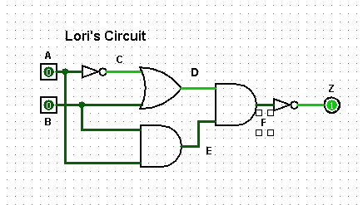

**Submit “your” circuit from Logisim here: (Add labels and put your name in the circuit)**

**Fill in this truth table for this circuit:**

|  |  |  |  |  |  |  |
| --- | --- | --- | --- | --- | --- | --- |
| A | B | C | D | E | F | Z |
| 0 | **0** | **1** | **1** | **0** | **0** | **1** |
| 0 | **1** | **1** | **1** | **0** | **0** | **1** |
| 1 | **0** | **0** | **0** | **0** | **0** | **1** |
| 1 | **1** | **0** | **1** | **1** | **1** | **0** |

**What is the expression for this circuit:**

Now take these expressions and draw the circuits in logisim and fill in the truth tables.

1)

Z = (A AND B) OR (A AND C) OR (A AND B AND C)

**Submit “your” circuit from Logisim here: (Add labels and put your name in the circuit)**

**Fill in this truth table for this circuit:**

|  |  |  |  |  |  |  |
| --- | --- | --- | --- | --- | --- | --- |
| A | B | C | D | E | F | Z |
| 0 | **0** | **0** | **0** | **0** | **0** | **0** |
| 0 | **0** | **1** | **0** | **0** | **0** | **0** |
| 0 | **1** | **0** | **0** | **0** | **0** | **0** |
| 0 | **1** | **1** | **0** | **0** | **0** | **0** |
| 1 | **0** | **0** | **0** | **0** | **0** | **0** |
| 1 | **0** | **1** | **0** | **1** | **0** | **1** |
| 1 | **1** | **0** | **1** | **0** | **0** | **1** |
| 1 | **1** | **1** | **1** | **1** | **1** | **1** |

2)

Z = (A AND B) OR (C AND D)

**Submit “your” circuit from Logisim here: (Add labels and put your name in the circuit)**

**Fill in this truth table for this circuit:**

|  |  |  |  |  |  |  |
| --- | --- | --- | --- | --- | --- | --- |
| A | B | C | D | E | F | Z |
| 0 | **0** | **0** | **0** | **0** | **0** | **0** |
| 0 | **0** | **0** | **1** | **0** | **0** | **0** |
| 0 | **0** | **1** | **0** | **0** | **0** | **0** |
| 0 | **0** | **1** | **1** | **0** | **1** | **1** |
| 0 | **1** | **0** | **0** | **0** | **0** | **0** |
| 0 | **1** | **0** | **1** | **0** | **0** | **0** |
| 0 | **1** | **1** | **0** | **0** | **0** | **0** |
| 0 | **1** | **1** | **1** | **0** | **1** | **1** |
| 1 | **0** | **0** | **0** | **0** | **0** | **0** |
| 1 | **0** | **0** | **1** | **0** | **0** | **0** |
| 1 | **0** | **1** | **0** | **0** | **0** | **0** |
| 1 | **0** | **1** | **1** | **0** | **1** | **1** |
| 1 | **1** | **0** | **0** | **1** | **0** | **1** |
| 1 | **1** | **0** | **1** | **1** | **0** | **1** |
| 1 | **1** | **1** | **0** | **1** | **0** | **1** |
| 1 | **1** | **1** | **1** | **1** | **1** | **1** |

**3)**

**Z = (A AND B AND C) OR (A AND NOT B AND C) OR (A AND NOT B)**

**Submit “your” circuit from Logisim here: (Add labels and put your name in the circuit)**

**Fill in this truth table for this circuit:**

|  |  |  |  |  |  |  |
| --- | --- | --- | --- | --- | --- | --- |
| A | B | C | D | E | F | Z |
| 0 | **0** | **0** | **0** | **0** | **0** | **0** |
| 0 | **0** | **1** | **0** | **0** | **0** | **0** |
| 0 | **1** | **0** | **0** | **0** | **0** | **0** |
| 0 | **1** | **1** | **0** | **0** | **0** | **0** |
| 1 | **0** | **0** | **0** | **0** | **1** | **1** |
| 1 | **0** | **1** | **0** | **1** | **1** | **1** |
| 1 | **1** | **0** | **0** | **0** | **0** | **0** |
| 1 | **1** | **1** | **1** | **0** | **0** | **1** |

**4)**

**Z = (A AND NOT B) OR (NOT B AND C)**

**Submit “your” circuit from Logisim here: (Add labels and put your name in the circuit)**

**Fill in this truth table for this circuit:**

|  |  |  |  |  |  |  |
| --- | --- | --- | --- | --- | --- | --- |
| A | B | C | D | E | F | Z |
| 0 | **0** | **0** | **0** | **0** |  | **0** |
| 0 | **0** | **1** | **0** | **1** |  | **1** |
| 0 | **1** | **0** | **0** | **0** |  | **0** |
| 0 | **1** | **1** | **0** | **0** |  | **0** |
| 1 | **0** | **0** | **1** | **0** |  | **1** |
| 1 | **0** | **1** | **1** | **1** |  | **1** |
| 1 | **1** | **0** | **0** | **0** |  | **0** |
| 1 | **1** | **1** | **0** | **0** |  | **0** |

**5)**

**Z = (A OR B) AND C**

**Submit “your” circuit from Logisim here: (Add labels and put your name in the circuit)**

**Fill in this truth table for this circuit:**

|  |  |  |  |  |  |
| --- | --- | --- | --- | --- | --- |
| A | B | C | D | E | Z |
| 0 | **0** | **0** | **0** |  | **0** |
| 0 | **0** | **1** | **0** |  | **0** |
| 0 | **1** | **0** | **1** |  | **0** |
| 0 | **1** | **1** | **1** |  | **1** |
| 1 | **0** | **0** | **1** |  | **0** |
| 1 | **0** | **1** | **1** |  | **1** |
| 1 | **1** | **0** | **1** |  | **0** |
| 1 | **1** | **1** | **1** |  | **1** |

**6)**

**Z = A AND (B OR C)**

**Submit “your” circuit from Logisim here: (Add labels and put your name in the circuit)**

**Fill in this truth table for this circuit:**

|  |  |  |  |  |
| --- | --- | --- | --- | --- |
| A | B | C | D | Z |
| 0 | **0** | **0** | **0** | **0** |
| 0 | **0** | **1** | **1** | **0** |
| 0 | **1** | **0** | **1** | **0** |
| 0 | **1** | **1** | **1** | **0** |
| 1 | **0** | **0** | **0** | **0** |
| 1 | **0** | **1** | **1** | **1** |
| 1 | **1** | **0** | **1** | **1** |
| 1 | **1** | **1** | **1** | **1** |

**7)**

**Z = (A AND B AND C) OR (A AND NOT B AND C) OR (A AND NOT B)**

**Submit “your” circuit from Logisim here: (Add labels and put your name in the circuit)**

**Fill in this truth table for this circuit:**

|  |  |  |  |  |  |  |
| --- | --- | --- | --- | --- | --- | --- |
| A | B | C | D | E | F | Z |
| 0 | **0** | **0** | **0** | **0** | **0** | **0** |
| 0 | **0** | **1** | **0** | **0** | **0** | **0** |
| 0 | **1** | **0** | **0** | **0** | **0** | **0** |
| 0 | **1** | **1** | **0** | **0** | **0** | **0** |
| 1 | **0** | **0** | **0** | **0** | **1** | **1** |
| 1 | **0** | **1** | **0** | **1** | **1** | **1** |
| 1 | **1** | **0** | **0** | **0** | **0** | **0** |
| 1 | **1** | **1** | **1** | **0** | **0** | **1** |

**8) Answer this question by examining the truth tables of both diagrams.**

**Are these two circuits (8a and 8b) the same ( Y ) or ( N )**

**8a)**

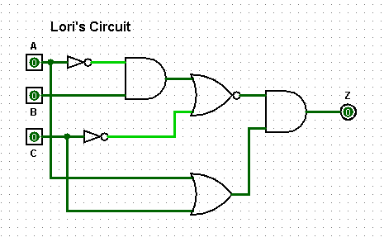

**Circuit (your screen shot)**

**Truth table:**

|  |  |  |  |  |  |  |  |  |
| --- | --- | --- | --- | --- | --- | --- | --- | --- |
| A | B | C | D | E | F | G | H | Z |
| 0 | **0** | **0** | **1** | **0** | **1** | **0** | **0** | **0** |
| 0 | **0** | **1** | **1** | **0** | **0** | **1** | **1** | **1** |
| 0 | **1** | **0** | **1** | **1** | **1** | **0** | **0** | **0** |
| 0 | **1** | **1** | **1** | **1** | **0** | **0** | **1** | **0** |
| 1 | **0** | **0** | **0** | **0** | **1** | **0** | **1** | **0** |
| 1 | **0** | **1** | **0** | **0** | **0** | **1** | **1** | **1** |
| 1 | **1** | **0** | **0** | **0** | **1** | **0** | **1** | **0** |
| 1 | **1** | **1** | **0** | **0** | **0** | **1** | **1** | **1** |

**8b)**

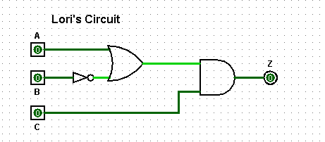

**Circuit (your screen shot)**

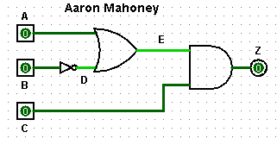

**Truth table:**

|  |  |  |  |  |  |
| --- | --- | --- | --- | --- | --- |
| A | B | C | D | E | Z |
| 0 | **0** | **0** | **1** | **1** | **0** |
| 0 | **0** | **1** | **1** | **1** | **1** |
| 0 | **1** | **0** | **0** | **0** | **0** |
| 0 | **1** | **1** | **0** | **0** | **0** |
| 1 | **0** | **0** | **1** | **1** | **0** |
| 1 | **0** | **1** | **1** | **1** | **1** |
| 1 | **1** | **0** | **0** | **1** | **0** |
| 1 | **1** | **1** | **0** | **1** | **1** |