Week 2 Progress Report
ProcurePrep UG — BSE4104 AI Agentic Capstone

Milestone: Foundation Model Engineering & Prompting
Author: AI Agentic Development Team
Date: September 16, 2026
Course / Project: BSE4104 AI Agentic Capstone

1. Executive Summary: Scope Drift Correction
During Weeks 2 and 3, an unintended scope drift occurred: the ProcurePrep system was mistakenly developed as an external tender-submission completeness checker (evaluating public procurement bid submissions against standard checklists).
The official project Charter defines ProcurePrep UG as an AI-Native SME Procurement-Preparation Agent. Its core operational mission is to automate the internal purchasing preparation cycle for Ugandan Small and Medium Enterprises:
$$
\text{Inventory Tracking} \longrightarrow \text{Reorder Evaluation} \longrightarrow \text{Quotation Tradeoff Analysis} \longrightarrow \text{Requisition Drafting} \longrightarrow \text{Human Store Manager Approval}
$$

Key Rebuild Decisions
- Preserve Legacy for Transparency: Rather than deleting the previous tender checker code, all related files (main.py, checklist.txt, submission_*.txt, baseline results, and cache files) were moved into legacy/ accompanied by legacy/README.md. This maintains working-tree transparency and auditability.
- Rebuild Week 2 Strictly to Charter: Week 2 has been completely rebuilt from the ground up, focusing exclusively on:
- Synthetic SME inventory and quotation datasets in CSV format.
- Foundation model evaluation and selection (gemini-3.5-flash-lite / gemini-3.6-flash).
- Deterministic procedural logic in Python for stock threshold evaluation.
- Formal Prompt Specifications (v1.0 and v1.1) for objective quotation comparison.
- A rigorous 10-case evaluation suite and version history log.

2. Technical Architecture of Rebuilt Week 2
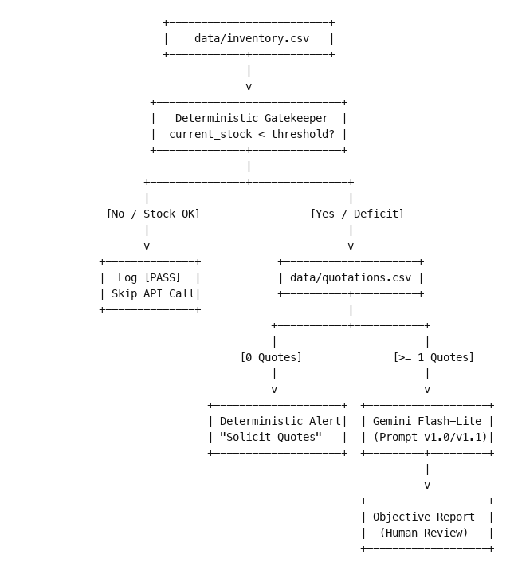

A. Data Layer (`data/`)
- `inventory.csv`: 20 realistic SME inventory items across office supplies, IT hardware, safety gear, cleaning chemicals, packaging, and raw materials (all units and thresholds calibrated for Ugandan SMEs).
- `quotations.csv`: Multi-supplier quotations containing unit prices in UGX, lead times, stock availability, quotation validity dates, and commercial notes.

B. Procedural Engine (`main.py`)
- Deterministic Math: Reorder decisions are executed via pure Python code:
$$
\text{Needs Reorder} \iff \text{current\_stock} < \text{reorder\_threshold}
$$
This avoids probabilistic hallucinations and eliminates API costs on items with adequate stock.
- Zero-Quote Handling: Items needing reorder that lack supplier quotes are deterministically flagged, instructing the user to solicit quotes without invoking the LLM.

C. Foundation Model & Prompt Specifications (`prompts/`)
- Selected Model: Google Gemini 3.5 Flash-Lite via google-genai SDK, offering sub-1.5s latency, reliable constraint following, and negligible operating costs (~$0.0002 per check).
- Prompt Spec v1.0: Established baseline quotation comparison table, price breakdown, and strict human-in-the-loop negative constraint (LLM cannot choose a winner).
- Prompt Spec v1.1: Enhanced with dedicated Critical Alerts & Risk Observations:
- [EXPIRED - INACTIONABLE] flags for lapsed validity dates.
- [MISSING TERMS - CLARIFICATION REQUIRED] for unspecified logistics terms.
- [SUPPLY SHORTFALL] and split-order calculations when vendor stock is less than the deficit.
- [PRICING ANOMALY] for prices exceeding 2.5x variance.
- Working capital impact calculations for Minimum Order Quantity (MOQ) conditions.

3. Evaluation & Prompt Iteration Highlights
The system was evaluated against 10 comprehensive test cases (results/week2_evaluation.md):
- TC-01 (Standard Reorder): Compared 3 valid quotes for Printing Paper (defict 28 reams), computing total outlays (UGX 630k - 728k) and lead-time tradeoffs.
- TC-02 (Sufficient Stock): Correctly bypassed the LLM for Ballpoint Pens (stock 45 >= threshold 20), spending zero API tokens.
- TC-03 (Single Supplier): Handled Heavy Duty Stapler with only 1 quotation on file, explicitly noting the lack of market competition.
- TC-04 (Missing Terms): Flagged PointOfSale Uganda's missing delivery terms, highlighting transport cost risks.
- TC-05 (Expired Quote): Identified CleanPro's quote expired on 2026-08-15 (relative to reference date 2026-09-16), flagging it as non-binding.
- TC-06 (Identical Prices): Evaluated Packaging Tape where two vendors quote UGX 8,500, highlighting the difference between warehouse self-collection and included doorstep delivery.
- TC-07 (No Quotes): Deterministically caught missing quotes for LaserJet Drum, instructing quote solicitation.
- TC-08 (Stockout & Supply Shortfall): Handled a 50-pair glove stockout where suppliers only had 20 and 25 pairs, calculating the mandatory split order and remaining 5-pair shortfall.
- TC-09 (Price Outlier): Flagged QuickFix Electronics' UGX 850,000 quote (>5x standard rate of UGX 160,000) as an emergency-stock outlier.
- TC-10 (MOQ vs Working Capital): Quantified that Lugazi's 50-bag MOQ for sugar forces the purchase of 34 surplus bags, locking up UGX 6,290,000 in excess capital.

4. What Changed from the Original Week 2 Attempt
Dimension | Original Week 2 (Tender Checker) | Rebuilt Week 2 (SME Procurement Agent)
Domain Use Case | External vendor tender bid compliance checking | Internal SME inventory replenishment & quotation analysis
Input Data | Free-text unstructured tender response documents | Structured tabular CSV files (inventory.csv, quotations.csv)
Reorder Decision | Absent (Not an inventory system) | Deterministic code (current_stock < reorder_threshold)
Core LLM Task | Binary checklist presence/absence detection | Tradeoff reasoning (Price vs Delivery vs Validity vs MOQ)
Human Role | Review checklist report | Final vendor selection and purchase order authorization
Economic Relevance | Large public tender bids | Daily SME operational purchasing in Ugandan Shillings (UGX)

5. Next Steps: Roadmap to Week 3
With the Week 2 Foundation Model and Prompting layer solidly established, Week 3 will introduce:
- Retrieval-Augmented Generation (RAG): Integrating Ugandan procurement guidelines (e.g. PPDA SME guidelines, preferred payment terms, and vendor evaluation criteria) from a vector store to ground quotation analysis.
- Requisition Drafting Agent: Automatically generating structured purchase requisition drafts in JSON/PDF format once the human reviewer confirms vendor selection.
- Multi-Source Integration: Adding support for automated quote ingestion from email and messaging channels.

