RAG Architecture
ProcurePrep UG — BSE4104 AI Agentic Capstone

Scope: SME inventory reorder check + quotation comparison, grounded in the corrected procurement knowledge corpus.

End-to-End Flow
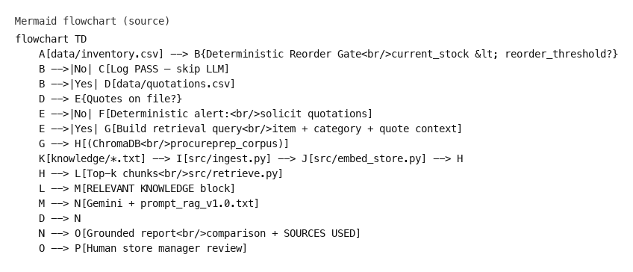

Component Responsibilities
Layer | File(s) | Role
Operational data | data/inventory.csv, data/quotations.csv | Structured SME stock levels and supplier quotes (UGX, validity, delivery).
Deterministic gate | main.py, src/rag_reorder_checker.py | Reorder decision in Python only; no LLM when stock is sufficient or quotes are missing.
Corpus | knowledge/*.txt | 12 SME-focused policy, template, and evaluation documents (see docs/corpus_register.md).
Ingestion | src/ingest.py | Chunk plain-text corpus (400 words / 50 overlap).
Embedding | src/embed_store.py | Gemini embeddings → ChromaDB upsert.
Retrieval | src/retrieve.py | Query embedding + cosine similarity; returns ranked chunks with scores.
RAG orchestration | src/rag_reorder_checker.py | Retrieves chunks, injects RELEVANT KNOWLEDGE, calls Gemini, logs to retrieval_log.txt.
Prompt | prompts/prompt_rag_v1.0.txt | Grounding rules, risk flags, SOURCES USED section, policy-question mode.
Output | results/reorder_reports_rag.md | Markdown reports for human review.

Design Decisions
- Deterministic before probabilistic: Reorder math and zero-quote handling stay in code (Week 2 pattern). RAG augments explanation, not the reorder trigger.
- Corpus aligned to charter: Tender submission checklist removed; SME reorder policy and quotation evaluation criteria added.
- Citation contract: Model must list SOURCES USED filenames; audit trail in retrieval_log.txt.
- No agents yet (Week 4): Single-shot retrieve → generate; no tool calling or multi-step agent loops.

ASCII Overview (simplified)
