

FACULTY OF INFORMATION SCIENCE
UNIVERSITI TEKNOLOGI MARA (UiTM)
KELANTAN BRANCH

BACHELOR OF INFORMATION SCIENCE (Hons.) INFORMATION SYSTEMS MANAGEMENT (CDIM262)

IMS 564: USER EXPERIENCE DESIGN

ASSIGNMENT 1: HEALTH MOBILE APPLICATION (PREGNANT)

PREPARED BY:
NUR AINI FARHANA BINTI MOHD ANUAR (2025158039)
GROUP: CDIM2624B

PREPARED FOR:
TS. INV MOHD ZAFIAN BIN MOHD ZAWAWI

SUBMISSION DATE:
15^{h} JUNE 2025

ASSIGNMENT 1: HEALTH MOBILE APPLICATION

NUR AINI FARHANA BINTI MOHD ANUAR (2025158039)
GROUP: CDIM2624B

USER EXPERIENCE DESIGN (IMS 564)
FACULTY OF INFORMATION SCIENCE
UNIVERSITI TEKNOLOGI MARA (UiTM)
KELANTAN BRANCH

15th JUNE 2025

ACKNOWLEDGEMENT

First and foremost, I would like to express my deepest gratitude to Allah S.W.T. for granting me the strength, wisdom, and perseverance to complete this report.
I sincerely thank my lecturer, Ts. Inv Mohd Zafian Bin Mohd Zawawi, whose advice and knowledge were crucial in forming my comprehension of innovative projects. Their enlightening criticism and support motivated me to learn more about the topic and pursue perfection in my work.
My learning experience was enhanced by my peers' cooperation and helpful debates, for which I am also grateful. Thanks to the various viewpoints and thoughts exchanged during our group activities, I gained a broader grasp of the difficulties and approaches associated with innovation.
Finally, I thank my family for their unwavering support and understanding throughout this journey. Your love and encouragement have motivated me to strive for excellence.

i
TABLE OF CONTENTS
Page
ACKNOWLEDGMENT………………………………………………………….………… i
TABLE OF CONTENTS
1.0 INTRODUCTION 1
1.1 The Evolution of Mobile Applications 2
1.2 The Respective Mobile Applications 3
2.0 UX EVALUTION 4
2.1 Amila Pregnancy Tracker 4
2.1.1 Logo 4
2.1.2 Background 4
2.1.3 How Long is it Used? 5
2.1.4 Review and Analysis 6
2.2 Ovia Pregnancy & Baby Tracker 7
2.2.1 Logo 7
2.2.2 Background 7
2.2.3 How Long is it Used? 8
2.2.4 Review and Analysis 9
2.3 Early Labour App 10
2.3.1 Logo 10
2.3.2 Background 11
2.3.3 Review and Analysis 12
4.0 DISCUSSION 13
4.1 Comparison Between 3 Mobile Health Application 13
4.2 Recommendations/ Final Analysis and Insights 14
5.0 CONCLUSION 15
REFERENCES 16
ii
1.0 INTRODUCTION
To ensure enjoyment, engagement, and satisfaction, the User experience (UX) design of a mobile application, particularly in a healthcare context, is of great importance. A well-structured UX makes feature navigation uncomplicated, fosters trust, and enhances the functionality of the application.
Mobile health applications, also known as mHealth apps, are critical components of the digital era, as they help individuals take better control of their healthcare. Health applications are categorized under several headings, and pregnancy tracker apps rank high among the most popular applications that provide expecting mothers with prompt, relevant, and personalized health information. Pregnancy is a significant life stage in a woman’s life, known to undergo biological, physiological, social, and emotional changes (Bianchi et al., 2016). Women who are pregnant need to make appropriate decisions concerning their health and the postnatal care of their babies throughout the pregnancy. Therefore, they need adequate information. The promotion of efficient health behaviour and the support of individuals during critical periods of their health is an important aspect of public health research and practice (Merrell, 2016). These applications act as virtual assistants for women during pregnancy by providing detailed guidance on fetal development, contraction tracking, general lifestyle tips, as well as medical appointment scheduling.
On the other side, the use of technology in maternal healthcare has boosted not just information accessibility but also user health awareness and readiness. Pregnancy tracker programs are intended to provide users with interactive features such as weekly updates, symptom checks, and reminders. These features can help have a safer and more informed pregnancy.
This report evaluates three pregnancy tracker mobile applications. The evaluation contains a summary of each application’s history, functionality, user download statistics, rating, and personal usage experience. Additionally, the Attractiveness-Different-Questionnaire framework is used to assess each application’s efficacy, usability, and visual appeal. The goal of this analysis I to assess and determine which app provides the best comprehensive and user-friendly assistance for maternal health and well-being.

  - The Evolution of Mobile Applications
According to Anachack Phongtraychack (2018), mobile devices and smartphones can still be considered as new ideas in the technology community. The development of mobile applications is directly related to advances in mobile technology, particularly the widespread adoption of smartphones and greater internet connectivity. Early applications on mobile computing were based simply on providing simple features such as calculators, calendars, and simple games. The technological restrictions at the time had limitations on these.
Moreover, the release of Android smartphones and the Google Play Store played a large part in expanding mobile accessibility worldwide. Two primary platforms have made mobile applications commonly seen with the increasing development of smartphones. One is the Apple App Store for iOS users, and the other is the Google Play Store. The Apple App Store, which launched on July 10, 2008, provides the equivalent of high privacy and a rigorous standard for program quality. On October 22, 2008, the Android Market was introduced and was re-acquired in 2012 as the Google Play Store, which provides flexible software support across many apps and Android devices. The increased speed of smartphone app improvement has facilitated the launch of numerous apps in a variety of fields such as entertainment, education, health, and social networking. In addition, during this period, the technology of the freemium model, which refers to free download applications, additional premium services were developed in the industrial model as a form of income, which increased user engagement.
The advances in numerous developing technologies, such as Global Positioning System, Augmented Reality, and Artificial Intelligence, have facilitated the wide is mostly appreciated due to the great range of uses. Nowadays, mobile applications are irreplaceable in daily life. Moreover, these systems provide an increased number of possibilities, including remote healthcare, mobile banking, online education, and productivity management. In the future, travel experience will be greatly facilitated. In addition, the future of mobile applications will be significantly facilitated by such future technologies as the 5G connection and IoT, making the digital experience more simple, intuitive, and intelligent.
  - The Respective Mobile Applications
For this proposal, it has been decided to go with three mobile applications designed for pregnancy. Each of the apps was taken from two previously chosen articles that focused on the available tools and different approaches to designing software or other mobile health solutions that would support and enrich the experiences of women going through pregnancy and early labour messages. The apps chosen are Amila Pregnancy App, Ovia Pregnancy & Baby Tracker, and ELSA Birth App. The articles emphasized the importance of personalized care, tracking features, and emotional support that could be required by women in more advanced stages of pregnancy and during delivery. The purpose of the following sections is to provide a brief overview of each of the chosen apps to discuss some of their function and the reasons for their inclusion in this proposal, and to explain what other mHealth component was included in the blended care strategy.
Firstly, it has been decided to include the Amila Pregnancy App in the proposed design. This mobile health app has been developed to support different pregnancy-related activities and to help women monitor their state and the state of their babies. One of the main features is the ability to keep track of your baby’s movement, contractions, weight, and different symptoms like morning sickness or stomach pain. Another good thing about the application is the ability to calculate the estimated due date and to regularly measure the growing baby bump. The second application chosen for this proposal was Ovia Pregnancy App, which is a comprehensive tool designed for pregnancy. The app, which provides users with daily updates on the status of their babies, looks out for different physical and emotional symptoms and tracks fertility. Finally, the last chosen app, ELSA Birth App, is designed to support the philosophy of Birth Without Fear and provides women in earlier stages of labour with emotional and practical help.

2.0 UX EVALUATION
2.1 Amila Pregnancy Tracker
2.1.1 Logo
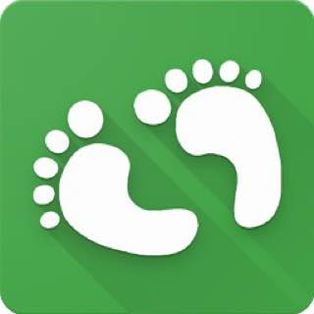
Figure 2.1.1: Logo’s Amila Pregnancy Tracker
2.1.2 Background
Amila Pregnancy Tracker is a health platform app developed by Amila Tech Limited. The app was first launched in 2016, the app has grown in popularity among millions of expectant moms worldwide. According to the most initial available data, the app has been downloaded more than 1.5 million downloads on the Apple App Store and more than 5 million downloads on the Google Play Store, which is a remarkable indication of the growing usage across almost all mobile platforms. In addition, the app has an immersive user rating 4.9 out of 5 based on more than 1,200 ratings, which demonstrates the users’ satisfaction and effectiveness of the service. Additionally, the app's availability in the Huawei App Gallery enhances the number of users and its popularity. The Amila Pregnancy mobile app has improved the healthcare delivery structure for pregnant women all over the globe, which is useful in their everyday lives more and more. (Muhammad Reza Mazaheri Habibi et al., 2024).
The Amila Pregnancy Tracker has a variety of key features that help to make it a useful resource for expectant mothers. These include:
- Pregnancy Calendar: Tracks important milestones and due dates throughout the pregnancy.
- Baby Development Updates: Provides mothers with weekly information about their baby’s development.
- Kick Counter: Allows mothers to monitor their baby’s fetal movements.
- Pregnancy Weight and Kegel Exercise Trainer Tracker: A guided routine to help mothers ensure their pelvic floor muscles are in good health.
- Contraction Counter: Monitors a mother’s contractions throughout their labor.
- Trimester Chart: Gives an overview of the three trimesters and highlights the changes that occur at each stage.
Many of the fundamental key features are still used by millions of pregnant mothers to this day.
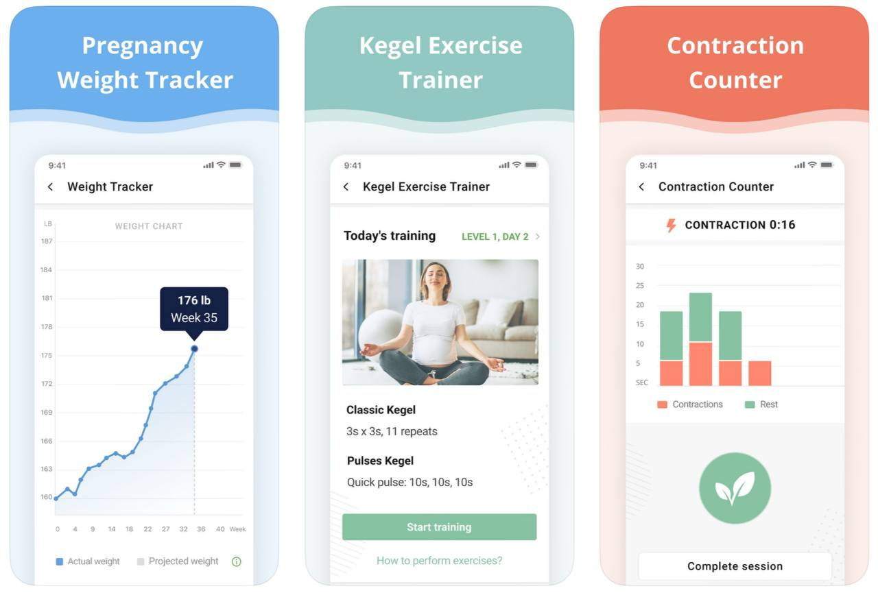
Figure 2.1.2: Features
2.1.3 How Long is it Used?
I downloaded the Amila Pregnancy Tracker in April 2025 as part of a study project on healthcare mobile apps. I have used it for approximately 1 week to test its features and usability. The user interface is both intuitive and visually appealing. I investigated features like the pregnancy calendar, baby development tracker, and kick counter. Notifications and updates were constant and helpful, making it feel like a comprehensive pregnancy monitoring tool.

2.1.4 Review and Analysis
According to the framework of the Attractiveness Different Questionnaire (ADQ), which analyzes user experience on characteristics such as stimulation, novelty, and aesthetic appeal:
Table 2.1.1: Attractiveness Different Questionnaire Amila App
ASPECT | RATINGS
 | Very Good | Fair | Poor
User Interface Design | ✓
Usability and Navigation |  | ✓
Content and Features | ✓
Emotional Impact |  | ✓
Overall Satisfactions |  | ✓

The Amila Pregnancy App includes a complete range of tools that help pregnant women navigate the various stages of pregnancy. The user interface design is rated extremely high because it is intuitive and visually appealing, allowing users to easily navigate through the app’s various components. The content and features are likewise rated as very good, including features for recording pregnancy symptoms, weight, baby movements, and doctor appointments.
However, usability and navigation are evaluated as fair ratings, while the app is quite simple to use, some users may find the navigation options cluttered or confusing. The software has a fair emotional impact. While it offers important tools and information, it falls short in terms of emotional support or guidance when compared to other applications that focus on mindfulness and emotional well-being during pregnancy. The app is rated fair for overall satisfaction (2.6 out of 5), which suggests sending key pregnancy-tracking features. However, it could be improved in many ways by more personalized content and less interaction. The Amila Pregnancy App is good wellbeing support and navigation to enhance the user experience.
2.2 Ovia Pregnancy & Baby Tracker
2.2.1 Logo

Figure 2.2.1: Logo’s Ovia Pregnancy & Baby Tracker
2.2.2 Background
Ovia Pregnancy & Baby Tracker is a well-known app created by Ovia Health for Android and Ovuline, Inc. for iOS that helps pregnant women throughout their pregnancy. Released in July 2014, this app integrates personalized health tracking, educational articles, and playful activities to help women track their health and the development of their child. As part of the broader Ovia Health Platform that includes growth, parenting, and reproductive health apps, this pregnancy tracker stands out for its consistent and patient-friendly approach to maternal care (Muhammad Reza Mazaheri Habibi et al., 2024).
Regarding the reception, the app is highly popular on various platforms. It appears that Ovia has over 325 ratings in the Apple App Store with an overall rating reaching 4.9 out of 5. The app has been downloaded over 1 million times on the Google Play Store, where it maintains a 4.7-star rating. However, the developers do not provide the app on the Huawei App Gallery, which may be limiting for many Huawei device owners. It is worth mentioning that the app is free to use, with in-app subscriptions, and appeals to a global audience with well-organized and customized notifications. Evaluating privacy, Ovia Pregnancy & Baby Tracker follows strict data protection rules, ensuring the safety of the information. The developers guarantee that the app has a robust privacy policy to keep personal health data safe and private.
2.2.3 How Long is it Used?
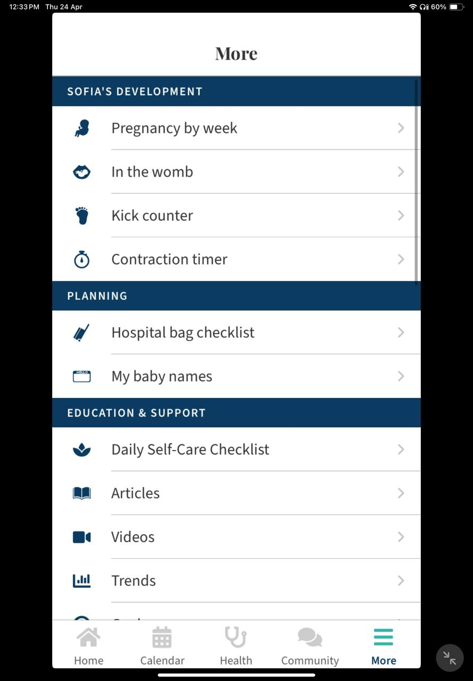
Figure 2.2.2: “More” Menu in an Ovia Pregnancy & Baby Tracker App Interface
I downloaded Ovia Pregnancy & Baby Tracker on April 24, 2025, as part of my study of mobile health applications. The download went smoothly, and the application was installed without any problems. Usage lasted for several days, and I learned that it is a well-organized and specialized tool that lacks faults. The software assists users with their pregnancy for sure, from the very beginning. It cuts out as much useless information as possible. There are available user-friendly services that show the due date of birth, which is beneficial for pregnant women, helping them to keep track of important points. In addition, the “More” option in Figure 2.2.2 provides a wide variety of options, including services to monitor fetal development, a kick counter, and a planning tool. Thus, the software is an extensive service for pregnant women. Moreover, instructions or support tools were also nice. This is a great interactive system of tools that creates a wholesome experience for the users. The application discusses emotional and physical issues, self-care, maintenance, and other content. For example, newborn baby names will be relevant all the time, while, say, the timing of contractions will become incredibly important to use only by the time of childbirth.
2.2.4 Review and Analysis
In terms of the Attractiveness Differentiation Questionnaire (ADQ), I would rate the Ovia Pregnancy & Baby Tracker as close to above average in most dimensions:
Table 2.2.1: Attractiveness Different Questionnaire Ovia App
ASPECT | RATINGS
 | Very Good | Fair | Poor
User Interface Design | ✓
Usability and Navigation | ✓
Content and Features | ✓
Emotional Impact |  | ✓
Overall Satisfactions | ✓

Ovia Pregnancy & Baby Tracker does well on all of the ADQ metrics. The app has a decent and simple structure, and the visual interface looks comfortable and safe. Soft pastel shades are present in the design, which neutralizes the aggressive environment of the app and, oddly enough, soothes. for example, mint is suitable for the target audience. The interface is clear and orderly, without much clutter and all kinds of complex linear structures. In other words, one can easily find sections on baby development, health tips, and tracking tools. The overall attractiveness is even more enhanced by the ease of use of the app, the friendly, clear icons at the top of each section. Each section is separated, and it is generally nice. That said, the app falls into that ideal dichotomy, informative and easy to read, so it will be useful to the target audience.

2.3 Early Labour App
2.3.1 Logo
The Early Labour application has several logos and names depending on the platform. For example, on Android devices, it is advertised as “Birth App | Birth Without Fear”, while on iOS devices, it appears as “ELSA Birth App”, each with its own logo to fit the appropriate branding.

Figure 2.3.1: Birth App | Birth Without Fear for Android Users

Figure 2.3.2: ELSA Birth App for iOS Users

2.3.2 Background
Susanna Heli, a Swedish physiotherapist and doula, developed the Birth Without Fear philosophy to alleviate stress and fear during labour through breathing, relaxation, vocalization, and attitude practices. This method has benefited over 200,000 parents in Sweden and is now offered globally through her business, Birth by Heart AB, which provides courses, books, and digital resources. The Early Labour App, created in collaboration with a software team and an expert group. According to Leonardo Horn Iwaya et al. (2023), the creation of the Early Labour App, a mHealth app to help women improve their physical, emotional, and self-efficacy capacities. The app offers accessible advice and reassurance to both women and their partners, fostering a confident and empowering birth experience. It is user-friendly and helps women and their partners navigate the early stages of labour with minimal assistance.
Released in November 2022, the app is available on both the Google Play Store and the Apple App Store. On the Play Store, it is listed as “Birth App | Birth Without Fear” with over 1,000 downloads, while on the App Store, it is named “ELSA Birth App.” The app currently shows restricted rating information on the iPad due to fewer user reviews relevant to that device. A family of soft pastel colors was used in the various components of the app, as these shades are often described as “calming” and “soothing”.
The ELSA Birth App offers several key features aimed at supporting pregnant women and their partners during early labour. These include:
- Exercises for breathing, relaxation, vocalization, and mindset
- Guidance for providing support during childbirth
- The ability to book online childbirth classes
- Answers to common questions from licensed midwives
- Contraction timer with audio guidance
On the other hand, ELSA Birth App also gives subscription benefits such as access to an online “Give Birth Without Fear” class, teamwork guidance for partners, and emotional safety resources. These features are designed to enhance the preparation of both the mother and her partner for a confident birth experience.
I installed the ELSA Birth App from the App Store on April 25 and have been using it for 5 days. The app offers a few functions, including guided exercise, contraction clocks, and access to online childbirth programs. Throughout my usage, I found the app to be user-friendly, and it provided useful materials to help me comprehend the Birth Without Fear approach and prepare for labour.
2.3.3 Review and Analysis
Table 2.3.1: Answer Different Questionnaire Apps
ASPECT | RATINGS
 | Very Good | Fair | Poor
User Interface Design | ✓
Usability and Navigation | ✓
Content and Features |  | ✓
Emotional Impact | ✓
Overall Satisfactions | ✓

The ELSA Birth App has a very gentle look, such soft, pastel color scheme that can have a calming and soothing effect on users. The design is minimalistic, allowing users to concentrate on the main tools and information without paying attention to too many details. The app instructs first-time mothers, suggesting breathing exercises, vocalization guidance, and mindset support in a visually attractive way. All the features are available in a lovely layout, which does not seem to support emotional tension during early labour. However, the app has no features to offer to pregnant women other than some advice. In general, though, the app has a clean and intuitive interface with clearly labelled sections, so even first-time users should not have any difficulty in using the app. The supplied images, along with the audio cues, seem to be aimed at reducing stress and anxiety and promoting self-confidence. To conclude, the Birth Without Fear app can be a valuable, supportive, and visually pleasant tool for women who are about to experience childbirth.
.
4.0 DISCUSSION
4.1 Comparison Between 3 Mobile Health Applications
Category | Amila Pregnancy App | Ovia Pregnancy & Baby Tracker | Early Labour App (ELSA Birth App)
Developer | Amila Tech Limited | Ovia Health for Android and Ovuline, Inc. for iOS | Birth by Heart AB
Release Date | 2016 | July 2014 | November 2022
Languages | English and Russian | English and Spanish | English, Finnish, and Swedish
Size | 40.9 mb | 87.4 mb | 15 mb
Key Features | Track pregnancy weight, baby kicks, contractions, get a pregnancy calendar, and calculate due date. | Track daily updates on baby development, fertility, physical symptoms, and provide personalized health data. | Provides breathing exercises, vocalization guidance, contraction timer, mindset support, and online childbirth classes.
User Interface | Clean, simple design with easy navigation. | Bright and simple design. | Soft pastel colors and a calm layout.
Subscription Model | Offer in-app purchases for additional features. | Free with premium options for added features. | Subscription for access to advanced classes and emotional support resources.
Audience | Pregnant women looking for comprehensive tracking and guidance. | Women tracking fertility and pregnancy families planning a pregnancy. | Women in early labour and their partners are seeking emotional and practical support.
Platform Availability | Android, iOS, Huawei App Gallery | Android, iOS | Android, iOS

4.2 Recommendations/ Final Analysis and Insights
Based on the evaluation of the Amila Pregnancy App, the Ovia Pregnancy and Baby Tracker, and the ELSA Birth App, it is evident that each mobile health application is designed to fulfill different phases and needs during pregnancy. The Amila Pregnancy App is primarily designed for pregnant women who need to keep track of the exact symptoms in pregnancy, baby movement, and due dates within the smartphone’s polished, intuitive interface. The Ovia Pregnancy and Baby Tracker is distinctive in providing user-focused health insights, daily updates, and fertility tracking, hence, it is suitable for both pregnant women and planning. The ELSA Birth App is designed with the necessary emotional and practical support for the whole period of birth, with particular emphasis on the early labor phase, which includes breathing and attitude learning as well as the resources outlined for the mother and the partner.
Furthermore, the right application to use is directly related to what the user needs to do with it during pregnancy. Therefore, while the Amila Pregnancy App should be designed for everyday tracking applicable to users’ states, the Ovia Pregnancy and Baby Tracker has to be designed to provide an overall user-focused way to monitor their health and plan. The ELSA Birth App should be made to provide emotional support, considering that labor pain is an emotional pain that almost incapacitates mothers as they await their newborns. I would advise developers to incorporate more emotional mobile wellness tools to help users in curing anger, anxiety, distress, depression, and all emotional needs in the Amila Pregnancy App. Developers should also improve ELSA’s performance and its size to reduce the Ovia Pregnancy and Baby Tracker. Additionally, I encourage developers to make the ELSA App to be multilingual information into other languages.
5.0 CONCLUSION
In conclusion, the study underlines the significance of user experience (UX) in the design and operation of mobile health applications, particularly those related to pregnancy. The ELSA Birth App, like other effective mobile apps, strikes a balance between clinical accuracy and consumer comfort. The freemium business model is still widely used, but to keep customers’ trust and improve the user experience overall, premium features must be properly marketed. Incorporating cutting-edge technologies like wearable integration, artificial intelligence, and real-time communication capabilities can also significantly increase user engagement.
Furthermore, developers are urged to promote cultural diversity by offering many language options and tailored content to better serve a global user base. Thoughtful user experience design that considers pregnant women’s emotional and factual needs is crucial for increasing application usage and supporting beneficial health habits. Overall, mobile health applications must continue to evolve by integrating smart technology with careful user experience design, and tailored care to improve pregnant user’s experience throughout the world.

REFERENCES
Babatunde, A. O., Ayede, A. I., Colangelo, A., Nguyen, T. D., Aborode, A. T., Umeh, C., Hernandez, M. P., Ayede, O. I., & Ayede, O. O. (2025). Development of an educational and monitoring mobile application for pregnant women in Nigeria. Frontiers in Public Health, 12. https://doi.org/10.3389/fpubh.2024.1368631
Habibi, M. R. M., Moghbeli, F., Langarizadeh, M., & Aghda, S. a. F. (2024). Mobile health apps for pregnant women usability and quality rating scales: a systematic review. BMC Pregnancy and Childbirth, 24(1). https://doi.org/10.1186/s12884-023-06206-z
Hussain, A., Mkpojiogu, E. O. C., Fadzil, N. M., & Hassan, N. M. (2017). The UX of amila pregnancy on mobile device. AIP Conference Proceedings, 1891, 020061. https://doi.org/10.1063/1.5005394
Iwaya, L. H., Nordin, A., Fritsch, L., Børøsund, E., Johansson, M., Varsi, C., & Ängeby, K. (2023). Early Labour App: Developing a practice-based mobile health application for digital early labour support. International Journal of Medical Informatics, 177, 105139. https://doi.org/10.1016/j.ijmedinf.2023.105139
Ojaperv, K., & Virkus, S. (2021). Pregnancy-related health information behaviour of Estonian women. Global Knowledge Memory and Communication, 72(3), 284–314. https://doi.org/10.1108/gkmc-05-2021-0086
Phongtraychack, A., & Dolgaya, D. (2018). Evolution of mobile applications. MATEC Web of Conferences, 155, 01027. https://doi.org/10.1051/matecconf/201815501027

