
UNIVERSITI TEKNOLOGI MARA,
MERBOK, KEDAH
SCHOOL OF INFORMATION SCIENCE
COLLEGE OF COMPUTING, INFORMATICS AND MATHEMATICS

DIPLOMA IN LIBRARY INFORMATICS (CDIM144)
INTRODUCTION TO WEB CONTENT DEVELOPMENT (IML254)

“CORPOARTE WEBSITE”

PREPARED BY:
NAME | MATRIC NUMBER
BALQIS BATRISYIA BINTI AZHAROLKHAIR | 2022818714
HAWA NABILA BINTI HANIF | 2022625444
NUR ALYA IXORA BINTI ROSLAN | 2022661708
NUR ATIFAH SOPHIA BINTI SABRY | 2022457012
GROUP KCDIM1444F

PREPARED FOR:
MADAM NOR HIDAYAH BINTI OTHMAN

DATE OF SUBMISSION:
25 JUNE 2024

CORPORATE WEBSITE

PREPARED BY:
BALQIS BATRISYIA BINTI AZHAROLKHAIR (2022818714)
HAWA NABILA BINTI HANIF (2022625444)
NUR ALYA IXORA BINTI ROSLAN (2022661708)
NUR ATIFAH SOPHIA BINTI SABRY (2022457012)
GROUP KCDIM1444F

DIPLOMA IN LIBRARY INFORMATICS (CDIM144)
SCHOOL OF INFORMATION SCIENCE
COLLEGE OF COMPUTING, INFORMATICS AND MATHEMATICS
UNIVERSITI TEKNOLOGI MARA (UITM)
KEDAH BRANCH

ACKNOWLEDGEMENT
First and foremost, praises and thanks to Allah for his showers of blessings throughout my task to complete the assignment successfully.
I would like to express my special thanks of gratitude to my lecturer, madam Nor Hidayah binti Othman who give the golden opportunity to do this assignment and for the guidance, encouragement in finishing this assignment and also for teaching us in this course.
Last but not least, I am really grateful because I managed to complete this individual assignment within the time given by my lecturer. The completion of this assignment could not have been accomplished without the help from my classmates. The impact was very beneficial for me in term of enhancing my knowledge in the deep of accounts.
Finally, I would like to extend my thanks to my family, who provided me with the love and support I needed to complete this assignment. Your encouragement and belief in my abilities provided me with the motivation I needed to push through the most difficult moments.
In conclusion, I would like to thank all the individuals who helped me in this journey. Your contributions were instrumental in the successful completion of this assignment, and I am deeply grateful for your support. Thank you.

TABLE OF CONTENTS

ACKNOWLEDGEMENT i
LIST OF FIGURES ii
1.0 INTRODUCTION 1
2.0 PLANNING 3
3.0 ANALYSIS & DISCUSSION 4
4.0 PROTOTYPING & REVIEW 5
5.0 DEVELOPMENT & TESTING 8
6.0 RELEASE & SEO 10
7.0 MAINTANACE 12
8.0 CONCLUSION 13
REFERENCES 14

LIST OF FIGURES
- Figure 1: Layout Sketch on paper
- Figure 2: Homepage draft
- Figure 3: Draft of Products page
- Figure 4: Cart page draft
- Figure 5: Link Feedback to Formspree
- Figure 6: Link Cart to Formspree
- Figure 7: Link Description with Cart
LIST OF TABLES
- Table 1: Gantt Chart of Planning
LIST OF ABBREVIATIONS
- RM: Ringgit Malaysia
- CSS: Cascading Style Sheets
- HTML: HyperText Markup Language
- URL: Uniform Resource Locator

1.0 INTRODUCTION
Before going into the details of our bookstore website, it's essential to establish a solid basis. Our bookshop's website functions as a digital portal to a world of literary study and discovery. With this introduction, we hope to provide customers with a quick overview of the main features and capabilities they may expect when they visit our online bookshop.

First, a clean and easy-to-use header greets customers on our bookstore website. They'll find simple menus here, as well as alternatives for browsing items and accessing the basket. The header stays visible and accessible on all pages, allowing for easy navigation around the site. A header would be incomplete without a footer. Our footer functions as a comprehensive resource for the website for users. It provides connections to important sections such as the privacy policy, terms and conditions, contact information, and maintenance.

Second, the homepage is the gateway to our bookish paradise. Customers are welcomed with video and vivid images that highlight new books that will arrive, the online store, and our recommendations. A user-friendly layout makes it simple to switch between products and other pages, ensuring that everyone discovers their next journey effortlessly.

Third, our bookshop has a broad range of titles, including classic literature, modern fiction, nonfiction, comics, and more. We also have stationary on our products. Customers may explore by clicking on products and it will drop down two options. Customers may choose books or stationery to proceed with their search. To see the book's description, customers may click on the book they want to see the product description. However, it is only for books, not stationery. Each book is accompanied by complete details, such as title, summaries, author, ISBNs, date of publication, genre, physical description, and language, allowing customers to make wise choices. There are also add-to-cart buttons on each page of the book description so that if customers want to buy the book, they just have to add the book to the cart and proceed with the next steps.

Next, our feedback form encourages customer participation and is an important tool for continual improvement. Customers are asked to leave their names, email addresses, and feedback categories such as website usability, book selection, and customer service. Customers may also leave their order number (optional), some comments, score their experience using a star system, and submit their feedback. This specific feedback allows us to improve our services and better fulfill our customers' expectations.

Other than that, we are committed to protecting customer data and privacy rights, as evidenced by our privacy policy. It describes how we acquire, keep, and use personal information, including data encryption and permission from customers. To protect customer's privacy throughout their journey on our platform, we follow industry best practices and regulatory regulations.

Furthermore, the shopping cart function makes the checkout process easier by allowing consumers to evaluate and manage their selected products before completing a purchase. Customers may quickly add and remove products and alter quantities. The cart displays a clear description of the whole cost, allowing customers to make informed purchasing selections before going to checkout.

Lastly, when it comes to payment, we only utilize Touch 'n Go. Recognizing that most of our customers are familiar with and frequently use TNG, we have simplified our payment method to ensure ease and convenience. TNG provides a rapid, safe, and user-friendly payment experience. Customers may utilize an attached account number to make payments using their TNG eWallet, allowing them to pay quickly without having to enter card information many times. This connection improves security by limiting the handling of sensitive financial data. One of the primary advantages of utilizing TNG is that we receive a quick notification once a payment is received. This real-time update enables us to handle orders quickly, resulting in speedier delivery and more customer satisfaction.

To sum up, as this is our first attempt at making the bookshop website, we are devoted to continual improvement. We are continually seeking feedback from customers and monitoring our processes to make the required improvements. Our objective is to improve and enhance our features, ensuring a smooth and delightful experience for all of our customers.

2.0 PLANNING
Task | Week 1 | Week 2 | Week 3 | Week 4 | Week 5 | Week 6 | Week 7 | Week 8 | Week 9 | Week 10 | Week 11 | Week 12 | Week 13
Group Formation and Roles Assignment
Initial Meeting
Project Proposal Preparation
Create a Project Timeline
Resource Allocation
Define Project Scope and Requirements
Searching Content
Finalize Website Structure
Review and Feedback
HTML Development
CSS Styling
JavaScript (if needed)
Responsive Design
Functional Testing
Usability Testing
Upload Website to GitHub
Final Review and Debugging
Documenting the Process
Final Proofreading
Report Submission
Table 2: Gantt Chart of Planning

3.0 ANALYSIS & DISCUSSION
3.1 PURPOSE AND GOAL
Bookworms is a corporate website that aims to give our customers a fully satisfactory experience like they have while purchasing books or stationaries just like a normal bookstore. We will provide up-to-date about new books with a good review, and always give our users the full summary and the book's description to help the users make a good decision before purchasing books or stationaries from our website. This website can be used on a desktop or mobile phone, making it accessible anywhere for future customers.

3.2 TARGET AUDIENCE
Our target audience is any individuals who like to read books and want to purchase the book they want directly from home without going outside to the bookstore. We will advise the user to carefully read the book description before purchasing any of the books we provide, as we may have a book for adults only.

3.3 DESCRIPTION
Welcome to Bookworms, where your final destination for getting the books you want is here. We aim to keep you updated on what books are trending and have a good review nationwide.
At Bookworms, we offer:
- Daily updates on the trending books around the world.
- Provide a detailed description of our books.
- Have a lot of good review books in any language you want.

Our website features a modern design and simple navigation to ensure a nice and smooth browsing experience. With the guide provided on our website, everything you need is quick and easy. Please contact us via our page or check our official Twitter and Facebook for any inquiries.

4.0 PROTOTYPING & REVIEW

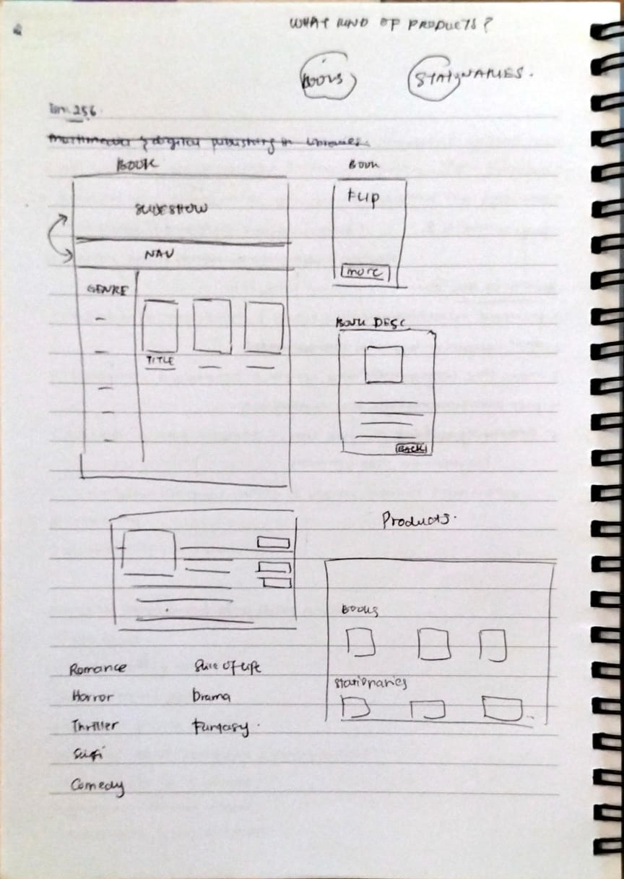
Figure 8: Layout Sketch on paper
We start the project by sketching and imagining what the website will look like from scratch. This initial phase involves brainstorming and creating rough drafts that capture the essence of the website's design and functionality. We focus on understanding the goals, target audience, and key features that need to be included. Our first draft is a comprehensive visual representation of the website's layout and structure. It showcases the design of each page, including the homepage, about us page, feedback page, products pages, contact page, and any other essential sections. This draft helps us visualize the overall look and feel, navigation flow, and user experience.

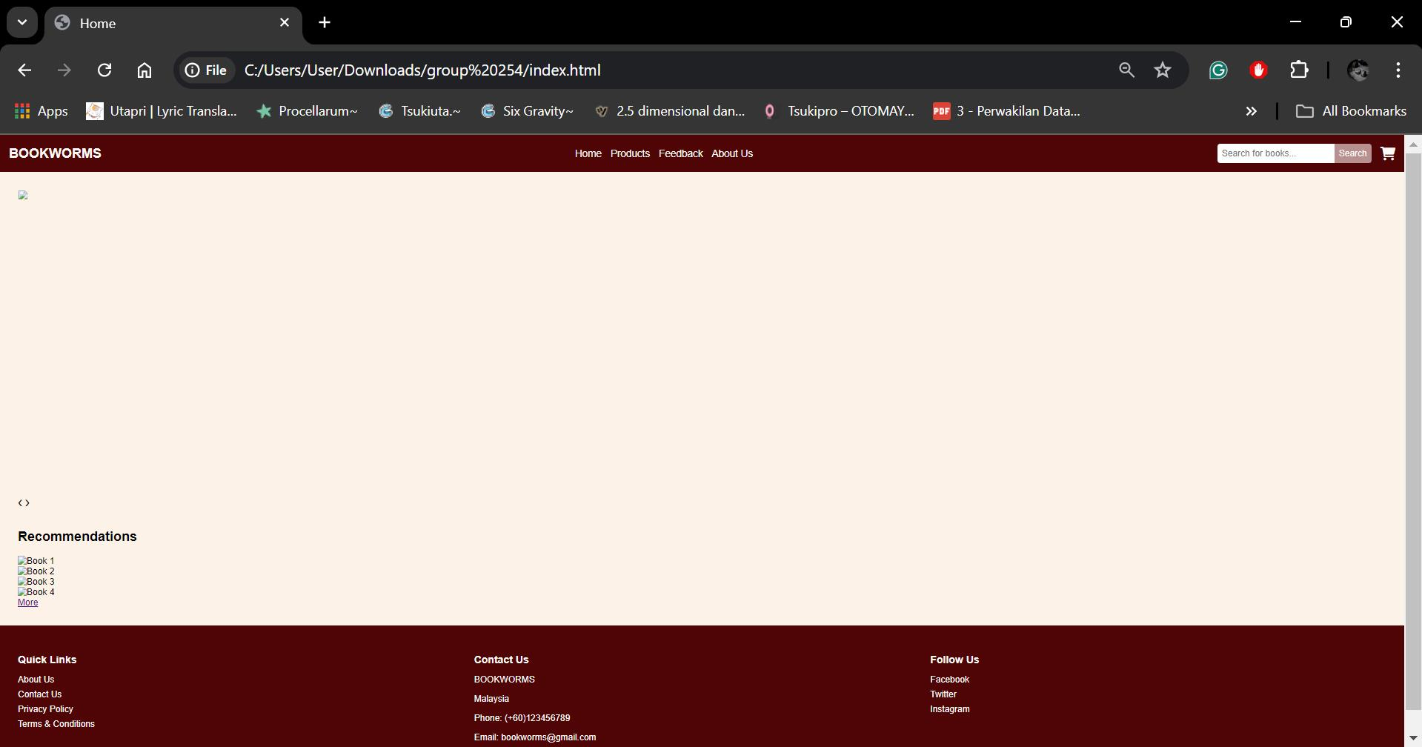
Figure 9: Homepage draft
Next, a draft or mock-up of the website homepage is made. The picture shows a dark-themed website with red highlights and a menu bar with tabs like "Home," "About Us," "Products”, "Feedback," and "Cart." There are placeholders for banners, text, and images to show where content will go, helping to see the layout before finalizing the design. For the banners, it also used slideshow. Next, the draft is checked to make sure it looks and works right. Feedback is collected to make changes, and this process helps make the website user-friendly and meet the desired goals. We also used slideshow for the banner.

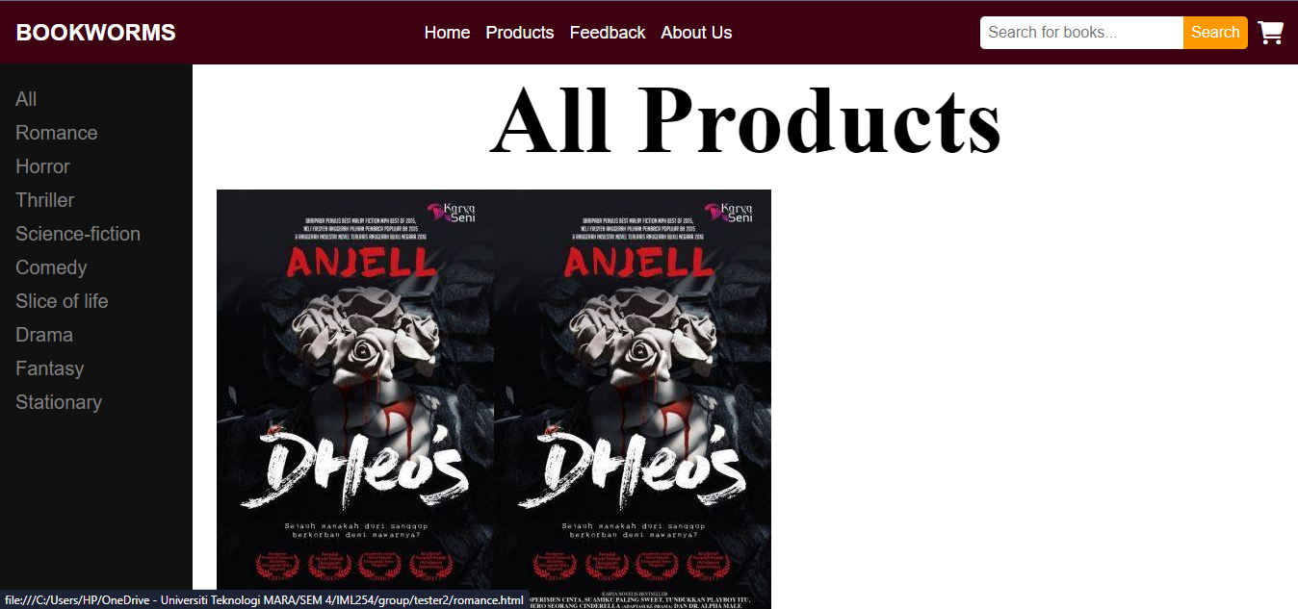
Figure 10: Draft of Products page
This is a draft of our product placements. When users hover over a product card, it will flip to show summary about the product or books. This interactive feature aims to enhance user experience by providing additional information in an engaging manner. The front of the card typically displays the product image and name, while the back show a brief description. This design choice helps to keep the layout clean and organized while still allowing users easy access to important information.

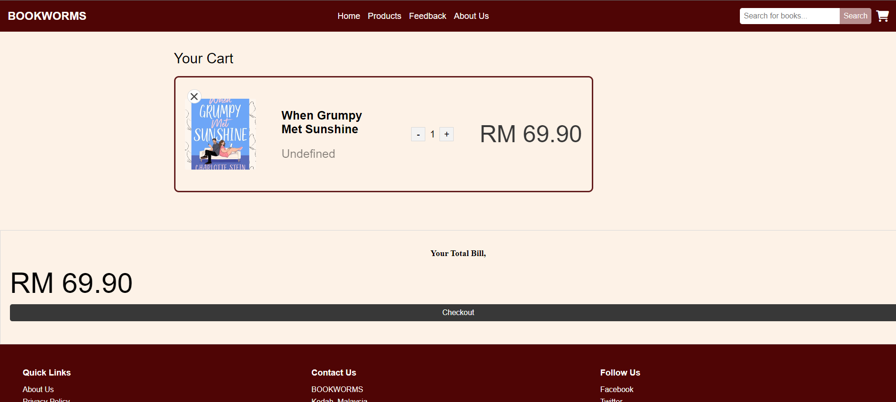
Figure 11: Cart page draft
Below the book details, there is a quantity selector that is initially set to '1'. Next to it, there is another price tag. Additionally, there is a button available, labeled 'Checkout'. The quantity selector allows users to choose the number of books they want to purchase, while the 'View Total Bill' provides an overview of the total cost before proceeding to payment. The 'Checkout' button takes users to the payment process, finalizing their purchase.

5.0 DEVELOPMENT & TESTING

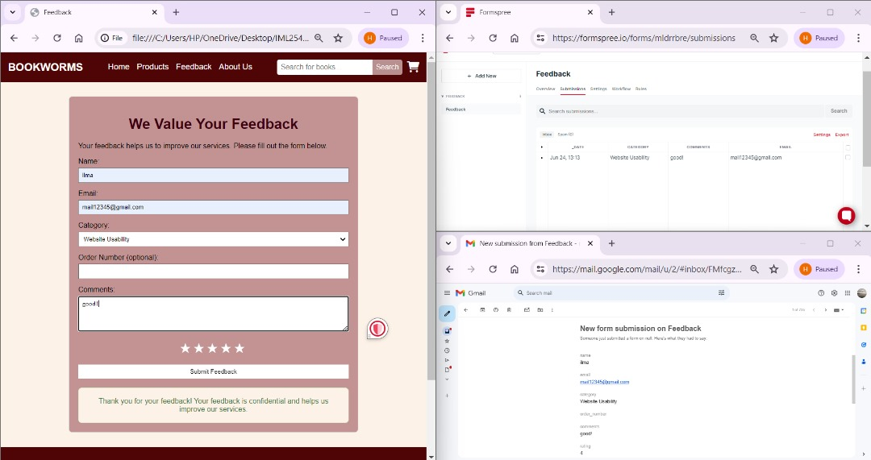
Figure 12: Link Feedback to Formspree
We created and tested a feedback form titled "We Value Your Feedback." It has fields for name, email, category, comments, order number (optional), and a star rating system. This design phase focused on setting up user input fields connected to Formspree. After users submit the form, they see a confirmation page to ensure the form works correctly. We also tested the email alert system by setting up an inbox to receive notifications for new feedback. Additionally, we checked that the feedback was correctly stored and organized in a spreadsheet, making sure all data collection and notification systems worked properly.

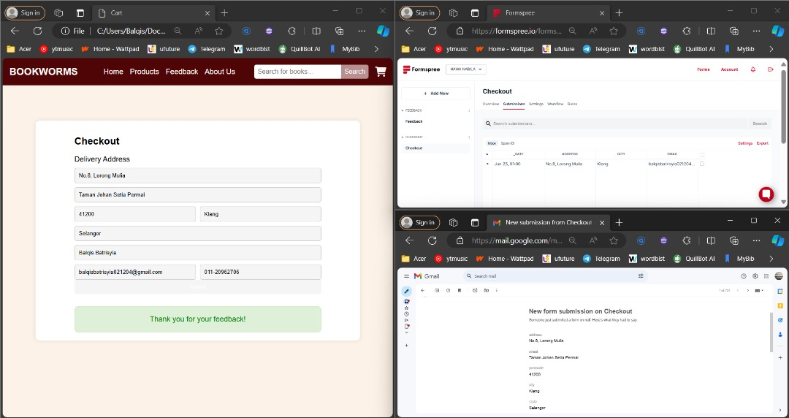
Figure 13: Link Checkout to Formspree
The form in the checkout page includes fields for address, street, postcode, city, state, name, email, and phone number. There is also an image of the TnG eWallet and a submit button. After customers or users fill out the form and click the submit button, a thank you message will appear, confirming that their submission was successful. If any fields are left blank and the form is not fully completed, alert messages will prompt the users to fill in the missing information before they can submit the form. This ensures that all necessary details are provided for a smooth and efficient process.

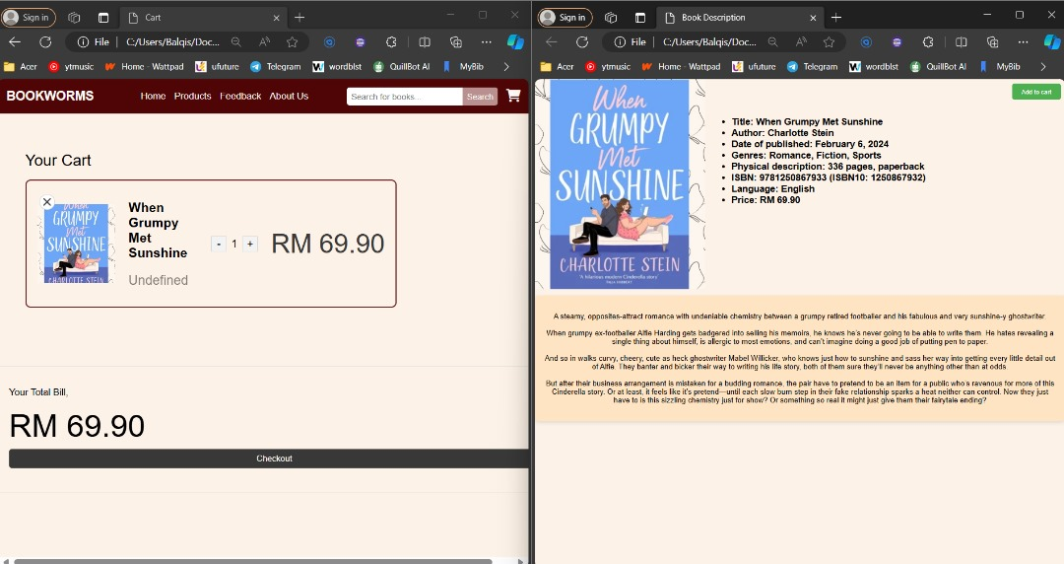
Figure 14: Link Description with Cart
The 'Add to Cart' button on the product description page is linked to the cart page. When customers or users click this button, the product is added to their cart. On the cart page, users can adjust the quantity of each product they want to purchase, and the total amount will be automatically updated. Additionally, they have the option to remove any products they no longer wish to buy. This functionality ensures that users can easily manage their selections before proceeding to checkout.

6.0 RELEASE & SEO
The Bookworms website is newly developed as a place for users and customers to explore and survey the books or stationaries they want or need. To develop this website, several processes are carried out to ensure the functionality of all the features and the content. In this phase, new features, content, and the design of the website are discussed and determined to form a layout or starter plan to develop the website we want. All these elements are developed and staged into a proper site for further testing of the functionality. Next, as the web developer, constant monitoring is done to check any issues regarding the post and release of the content.

To ensure that the website is searchable and discoverable by users and future customers, the keywords used are optimized and aligned with the common words that people use while searching for the products, services, and topics the website discusses and provides. By using the words often used by users, the searchability of the website can be ensured so that it is more discoverable and “crawlable” (Goodwin, 2023). For example, terms used on the website page is easy to detect and attract people to visit the website as well as avoiding errors such as spelling error and grammatical error in the content. In addition, the code used in HTML, CSS, and JavaScript also have an impact on the search engine. The related terms and keywords from the code used in the website-making could enhance engagement and delivery of the website traffic to the search engine. This matter could make the website “search engine friendly” (Goodwin, 2023).

Furthermore, the content and navigation on the page are easy to understand and simple. There is a navigation on the top of the page to ensure that users can easily discover the features and functions. Also, side navigation on the product pages is fixed on the left side of the page to facilitate the search. Moreover, other features such as more button and cart button could bring users to different pages for more details. These buttons also function as internal links in the website for easy use and interesting interaction between the users and the website. Easy instructions and navigation would ensure the satisfaction of the user experience and, eventually, increase the visits to the website. As a result, the website is engaged by the amount of visits among users.

Last but not least, the content on the website pages plays a very important role. This is because it can attract users and visitors to read and interact. As mentioned before, the words used in the content of the page could affect the user’s experience and opinion towards the website. In addition, this website is flexible, so it is mobile-friendly. To elaborate, this website is responsive; it will adapt with the user’s device so it fits to the screen with different size. To conclude, this website is developed using the best practices to meet the need and preferences of users as well as engaging the search engine, resulting improving the visibility in search (Goodwin, 2023).

7.0 MAINTANACE
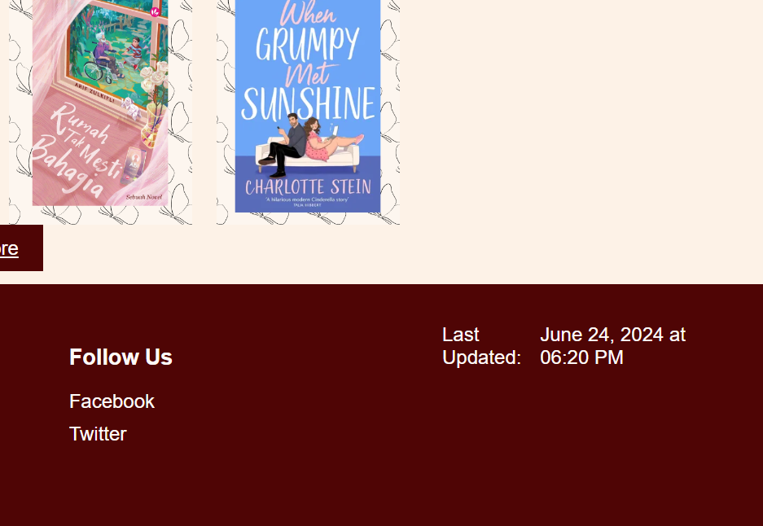
Figure 15: Maintanance update
The website is updated regularly, with maintenance and new content being added once a week. This includes adding new books to the catalog, fixing any bugs or issues that have been identified, and making other necessary improvements. Regular updates ensure that the website remains current, functional, and engaging for users. By consistently adding new books, we keep our content fresh and interesting. Debugging helps to maintain a smooth user experience by addressing any technical problems promptly.

8.0 CONCLUSION
In conclusion, our online bookstore website is designed to offer a seamless and engaging user experience, acting as a digital gateway to a wide world of literary exploration. From the moment customers arrive, they are greeted by a clean, easy-to-use header and a well-organized footer, ensuring easy navigation and access to important information. The homepage, with its dynamic visuals and user-friendly layout, serves as a welcoming introduction to our diverse range of books and stationery.

The feedback form is an integral part of our commitment to continuous improvement, encouraging customer participation and helping us enhance our services. Our privacy policy underlines our dedication to protecting customer data and privacy rights, ensuring a secure browsing experience.

The shopping cart functionality simplifies the checkout process, allowing customers to review and manage their selections easily. The use of Touch 'n Go (TnG) for payments ensures a quick, secure, and user-friendly transaction experience, with real-time updates facilitating faster order processing and delivery.

As this is our first attempt at creating the bookstore website, we are committed to ongoing improvements. We regularly update the website with new books, fix any bugs, and make other necessary enhancements to keep the content fresh and the user experience smooth. By seeking continuous feedback from customers and monitoring our processes, we aim to refine and enhance our features, ensuring a delightful experience for all visitors.

Our planning, analysis, prototyping, development, and testing phases have been meticulously carried out to create a functional and appealing website. The final product is a result of careful consideration of user needs and best practices in web development. The website's search engine optimization (SEO) strategy ensures that it is easily discoverable, enhancing visibility and user engagement.

Regular maintenance ensures the website remains current and functional, with new content added weekly to keep it interesting and engaging. This comprehensive approach guarantees that our bookstore website not only meets but exceeds the expectations of our users, providing them with a reliable and enjoyable platform for their literary and stationery needs.

REFERENCES

Canva. (2013). Canva. Canva. https://www.canva.com/Custom Forms with No Server Code | Formspree. (n.d.). Formspree.io. https://formspree.io/

GoodReads. “Goodreads.” Goodreads, 2022, www.goodreads.com/.

Goodwin, Danny. “What Is SEO / Search Engine Optimization?” Search Engine Land, 2023, https://searchengineland.com/guide/what-is-seo

Modern Web. “Add Products in Cart and Let Them Checkout [ Step by Step Tutorial ].” YouTube, 18 Oct. 2021, www.youtube.com/watch?v=Smtg4zFvjz0&t=3708s. Accessed 24 June 2024.

W3Schools. (2019). How to Create a Slideshow. W3schools.com. https://www.w3schools.com/howto/howto_js_slideshow.asp

