2.0 ENTITIY-RELATIONSHIP DIAGRAM (ERD)
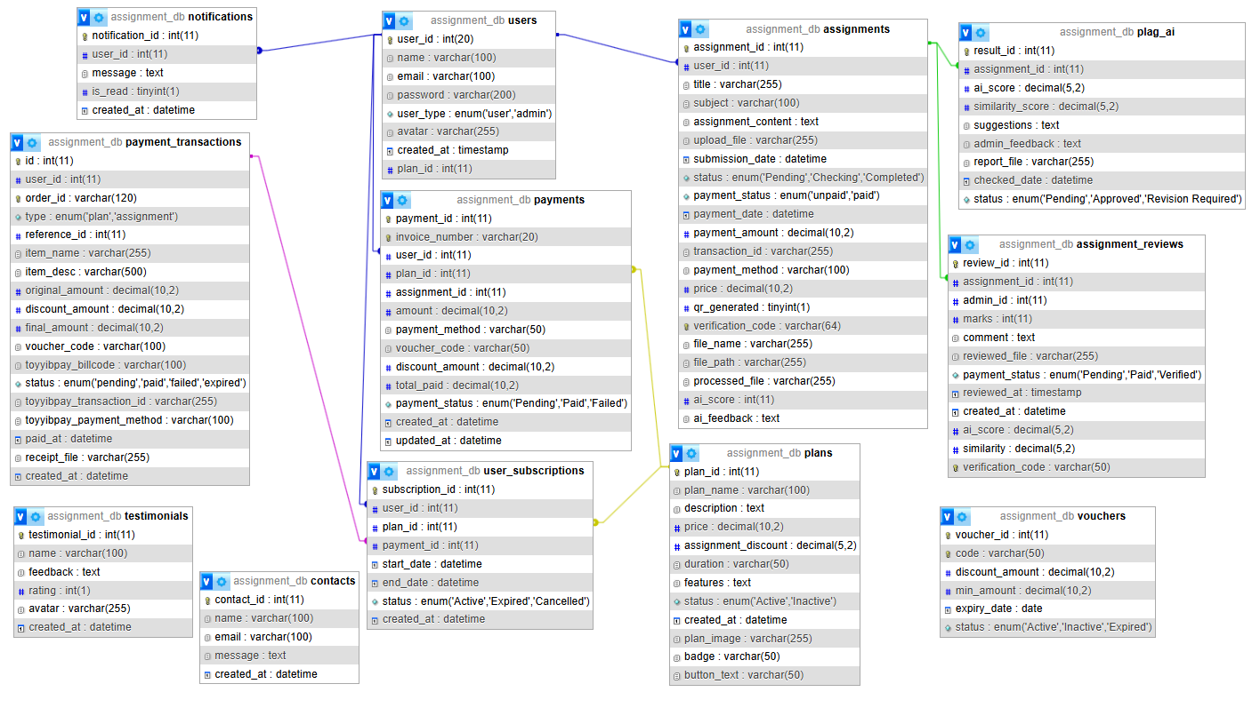
Figure 1 Entity Relationship Diagram for AI Checker System

Figure 1 shows the Entity Relationship Diagram (ERD) for our AI Checker System. The ERD got several main tables such as users, assignments, plans, payments, payment_transactions, user_subscriptions, assignment_reviews, plag_ai, notifications, vouchers, contacts, and testimonials.
Users table is one of the main tables because it stores user and admin information. One user can submit many assignments, receive many notifications, make payments, and subscribe to a plan. The assignment table is connected to assignment_reviews and plag_ai because each submitted assignment can be reviewed by the asmin and checked by for AI or similarity score. The plans, payments, and user_subscriptions table are used to manage subscription plans and payment records.

3.0 SYSTEM REQUIREMENTS
Requirement | Description
Operating System | Windows 10 / Windows 11
Web Hosting Platform | InfinityFree
Server-Side Language | PHP 8.1 or above
Database | MySQL / MariaDB
Database Management Tool | phpMyAdmin from InfinityFree
Local Development Server | XAMPP
Browser for Testing | Google Chrome
Code Editor | Visual Studio Code
CSS Framework | Bootstrap 5
Icon Library | Font Awesome
JavaScript Libraries | Chart.js, SweetAlert2, html2pdf.js, AOS Animation
Payment Gateway | ToyyibPay Development/Sandbox
Internet Connection | Required to access online system, CDN libraries, and payment gateway

This system is developed using PHP and MySQL. XAMPP was used during local development and testing, while InfinityFree was used to publish the system online and become accessible. The database is managed using phpMyAdmin. The system also uses Bootstrap 5 for responsive design, Font Awesome for icons, and ToyyibPay as the payment gateway. Google Chrome is recommended for testing because it support modern web design and responsive layout.

4.0 INSTALLATION & SETUP GUIDE
STEP 1:
Prepare project folder named: aichecker
The folder contains PHP files, CSS files, image folder, upload folders, reports folder, receipts folder, and the database file: assignment_db.sql.
STEP 2:

