HABMANN AUFSTIEGSAKADEMIE · DIGITAL LEARNING · EDUCATIONAL UX/UI DESIGN
DAY 11 · MATERI A AND MATERI B · ROUTES 1 AND 2 · LEVELS 1 TO 3
Gamification and motivation theories
Fundamentals of gamification in UX design, psychological foundations and motivation theories
AI notice · KI-Hinweis
This document was produced with the help of an AI language model (Claude, Anthropic). The AI drafted the text and tables and drew the diagrams from code. The content was then read, corrected and approved by the reviewer named below, who is responsible for its accuracy. Every diagram carries an AI label on the image. Check figures and sources before you quote them.
KI-Hinweis: Dieses Dokument wurde mit Unterstützung eines KI-Sprachmodells (Claude, Anthropic) erstellt. Texte und Tabellen wurden von der KI entworfen, die Abbildungen sind KI-generiert und am Bild gekennzeichnet. Die fachliche Prüfung und Freigabe erfolgte durch die unten genannte Person.

Day | Day 11 · Module 5 (day 1 of 2): Fundamentals of gamification in UX design, psychological foundations and motivation theories
Document | Materi (study material). Materi A has five cards, Materi B has three.
Route and level | Materi A serves Route 1 (Levels 1 and 2, Task 1). Materi B serves Route 2 (Level 3, Task 2).
Time | Materi A about 60 min · Materi B about 60 min (facilitator-led)
Playground (website) | https://aion-dl.vercel.app/day/11/
Case | Worked examples use LearnLoop, an online-course provider. The task case is GameLearn, a platform with high activity and low learning(see the Task document).
Version | 1.1 · release date 14.10.2026
Review and approval | Muhammad Muchson, Mentor (subject-matter review and approval)

ABOUT THIS DOCUMENT
In class we also use the playground, the course website, as the place to practise and learn. Its address is at the end of this document.
This document holds everything you need to study Day 11 without the website. Each card says the idea in plain words, shows it in a picture, gives the details, and ends with the rules you will use in the Task document. Cards marked Optional are not needed for the Core blocks of the task. The worked examples use LearnLoop, a different company from the task case, so no task answer is printed here. Glossary and references are at the end.

IN THIS DOCUMENT
Lesson plan: ten teaching units (Ablaufplan)
Case study and transfer project at a glance
A1 · Game elements: points, badges, levels and leaderboards, and what gamification is · 14 min · Core
A2 · Intrinsic and extrinsic motivation, and the three needs of Self-Determination Theory · 14 min · Core
A3 · Gamification and learning: activity is not learning · 12 min · Core
A4 · Principles of meaningful gamification: link, fairness, challenge · 10 min · Optional
A5 · Weighing a gamification measure: motivation, effort, risk · 10 min · Core
B1 · Gamification as a strategic tool: from objective to mechanic to behaviour · 18 min · Core
B2 · Conflicting goals: short-term effect against sustainable learning, motivation against manipulation · 22 min · Core
B3 · Deciding without proof that gamification works: a decision you can check later · 20 min · Core

Day at a glance
Day 11 has ten teaching units (UE). This document is the study material; it is used in UE1 (Materi A) and UE8 (Materi B). The day is built from three documents and the playground: Materi (study material), Task (worksheet) and Trainer (coaching, feedback and model solutions), plus the course website.

Lesson plan: ten teaching units (Ablaufplan)
UE | Min | Plan item | What happens | Material | Format
1 | 45 | Knowledge transfer · Level 1 | The trainer presents the Core cards of Materi A (A1, A2, A3, A5, about 50 min of cards) on the playground; participants follow in the handout. Optional A4 is read from the handout. | Materi A (Route 1) | Presentation + Handout
2 | 45 | Level 1 · Task 1 | Individual work on Block 1.1 (Core, about 13 min). Pairs then compare their results and the trainer collects open questions. | Task 1 · Part 1 · Block 1.1 | Handout (or on the playground)
3 | 45 | Level 1 · Task 2 | Three options are rated on three criteria and one is chosen with a reason: Block 1.2 (Optional, about 8 min). Groups that skip Optional blocks use the time to finish Block 1.1 and to read the Optional cards. | Task 1 · Part 1 · Block 1.2 | Handout (or on the playground)
4 | 45 | Coaching · transition from Level 1 to Level 2 | Trainer-led. A short talk on the day's coaching focus, then the reflection questions in pairs: Block 1.3 (Optional, about 5 min). The bridge: from reading an interface to deciding under limits. | Task 1 · Block 1.3  Trainer document, section Coaching | Trainer only + Handout
5–6 | 90 | Level 2 · Case study GameLearn (2 UE) incl. model solution | UE5: the trainer presents the case; participants work on Block 2.1 (Optional, about 7 min) and Block 2.2 (Core, about 17 min). UE6: groups compare their order and defend it; the trainer closes with the model solution (core logic). | Task 1 · Part 2 · Blocks 2.1, 2.2  Trainer document, section Case study | Handout; model solution shown after the work
7 | 45 | Level 2 + 3 · Feedback round with a management perspective | Groups present their reasoning, not only their result. The trainer asks the day's Level 3 input questions and leads the discussion. | Trainer document, section Feedback round | Presentation by the groups; Trainer only
8 | 45 | Level 3 · Transfer project, Chief Engagement Officer (3 UE: UE8–10) | The trainer presents Materi B (B1, B2, B3; use the "In plain words" and "How to decide" boxes, the rest is handout) and sets the role and the brief. | Materi B (Route 2) | Presentation + Handout
9 | 45 | Level 3 · Transfer project | Individual work or in pairs on Block 3.1 (Core, about 10 min). | Task 2 · Block 3.1 | Handout (or on the playground)
10 | 45 | Level 3 · Transfer project | Block 3.2 (Core, about 10 min): the decision despite incomplete data. Participants then present the decision and what they give up; the trainer debriefs with the model solution. | Task 2 · Block 3.2  Trainer document, section Transfer project | Handout; model solution shown after the work

One UE is counted as 45 minutes here; breaks are not shown. The times are a guide for the trainer. Optional blocks and cards can be skipped; the Core blocks are enough for a complete answer.

Case study and transfer project at a glance
Component | UE | Duration | Participants work in | Model solution in
Level 2 case study (GameLearn) | UE5–6 | 2 UE · 90 min | Task 1 · Part 2 (Blocks 2.1, 2.2) | Trainer document, section Case study
Level 3 transfer project (Chief Engagement Officer) | UE8–10 | 3 UE · 135 min | Materi B and Task 2 (Blocks 3.1, 3.2) | Trainer document, section Transfer project

Materi A · Route 1 · Levels 1 and 2
How Materi A is used
About 60 minutes, five cards. The plan's Level 1 asks you to understand the fundamentals of the day's topic. Level 2 asks you to analyse a learning interface and to apply them. Task 1 uses all of it on one case. The card A4 is Optional: no Core block of the task needs it.

A1 · Game elements: points, badges, levels and leaderboards, and what gamification is · 14 min · Core
Gamification uses game elements outside a game. Points reward an action, a badge marks an achievement, a level shows a stage, a leaderboard compares people, a progress bar shows how far someone has come.
IN PLAIN WORDS
The idea. Gamification means using elements known from games, such as points, badges, levels, a progress bar or a leaderboard, in something that is not a game, such as a learning platform. Each element does something different to a learner: a point rewards an action, a badge marks an achievement, a level shows a stage, and a leaderboard compares people. Whether the element helps depends on what it rewards.
Why it matters. In Task 1 you sort eight elements of a platform by what they do to motivation. You first need to know what each element is.
How to read the picture. One LearnLoop lesson screen with four features that can be on or off: points, badges, a leaderboard and a progress bar.

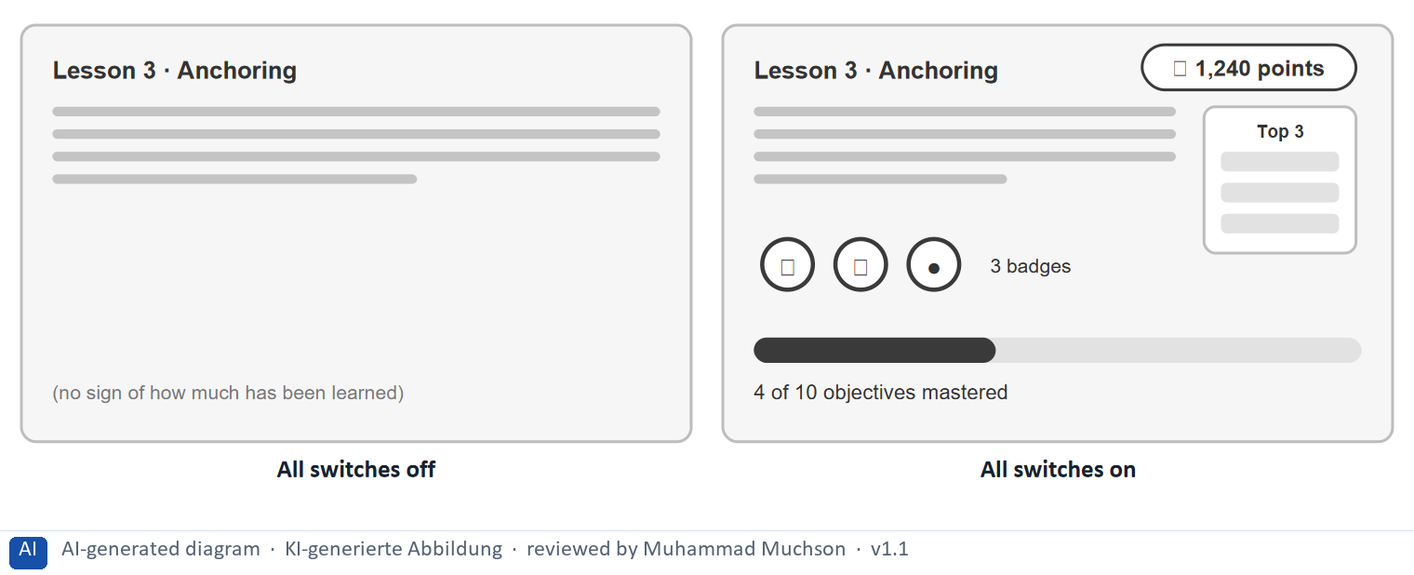
Figure 1 · One LearnLoop lesson screen and four game elements.
The point. Gamification means using elements from games, such as points, badges, a leaderboard and a progress bar, in something that is not a game. Each element does something different: a point rewards an action, a badge marks an achievement, a leaderboard compares people, and a progress bar shows how far someone has come.
A short story in steps.
1. A plain lesson. Let us follow Kim, a learner at LearnLoop, who opens a lesson on anchoring in negotiation. The screen has the lesson text and nothing else, so Kim reads, answers and leaves without any sign of what she has achieved. Nothing is counted and nothing is compared.
2. Four elements added. Now LearnLoop adds all four elements. Points reward every action, badges mark what Kim has done, a leaderboard compares her with everyone, and a bar shows the objectives she has mastered. The elements look alike but do different jobs, and only the bar says anything about what she has learned.
3. Which one matters. So gamification is a set of separate elements, and each is worth judging on its own: what does it reward, and does that help learning? Day 11's task asks you to judge exactly this for GameLearn.
Switches | What it means
All off | 0 of the 4 elements are on. No points: nothing is counted. Nothing shows how much has been learned.
All on (Points, Badges, Leaderboard, Progress bar) | 4 of the 4 elements are on. Points reward every action, whatever it was. Badges mark things the learner has done. The leaderboard compares Kim with everyone else. The bar says what has been mastered, which is about the learning itself.

Five game elements and what each does
Element | What it does | What it can reward
Points | Count actions. | An action, whether or not it taught anything.
Badges | Mark an achievement. | A real result, or just effort, depending on the rule.
Levels | Show a stage. | Meaningful only if the level says what was mastered.
Leaderboard | Compares people. | A rank; most people cannot win.
Progress bar | Shows how far someone has come. | Progress, if it counts something real.

Case assumption
LearnLoop and Kim are made up for this example. The definition of gamification follows Deterding et al. (2011): game design elements in a non-game context.

How to decide when this comes up in the task
- Name the element before judging it: points, a badge, a level, a leaderboard, a streak, a progress bar, a prize, a choice.
- For each element ask what it rewards: an action (a login), an achievement (a task applied at work) or a comparison (a rank).
- Treat gamification as a set of separate elements, each judged on its own, not as one thing that is good or bad.
- Note that gamification is not the same as a game: a platform with game elements is still a learning platform.

Extra · go deeper (optional reading)
Hamari, Koivisto and Sarsa (2014) reviewed studies of gamification and found that it often has positive effects, but that the effects depend on the context and on the learners. So “does gamification work?” has no single answer; the useful question is which element, for whom and for what objective.

Sources · Deterding et al. 2011 · Hamari et al. 2014

A2 · Intrinsic and extrinsic motivation, and the three needs of Self-Determination Theory · 14 min · Core
Extrinsic motivation pushes from outside and fades. Intrinsic motivation comes from interest and lasts. Self-Determination Theory names three needs: autonomy, competence and relatedness.
IN PLAIN WORDS
The idea. Intrinsic motivation means doing something because it is interesting or meaningful in itself. Extrinsic motivation means doing it for a reward or to avoid a penalty. Self-Determination Theory says people stay motivated when three needs are met: autonomy (I choose), competence (I am getting better) and relatedness (I belong). A reward can also crowd out interest that was already there.
Why it matters. Task 1 asks you to sort elements into extrinsic, competence and intrinsic, and to say which would last longest. The test question for each comes from this card.
How to read the picture. The same learner, Kim, three ways: with a prize in front of her, with the prize gone, and with real interest. Below it, the three needs drawn as three small pictures.

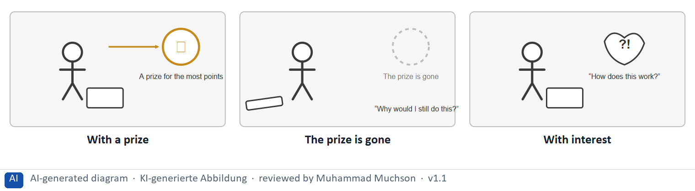
Figure 2 · The same learner with a prize, without it and with interest.
The point. Extrinsic motivation pushes from outside, with a reward or a penalty, and it fades when the reward is gone. Intrinsic motivation comes from interest in the thing itself, and it lasts. A reward can even crowd out interest that was already there.
A short story in steps.
1. A prize. Let us follow Kim, a learner at LearnLoop, who studies hard during a month in which the platform offers a prize for the most points. She is active every evening, and it looks like a success. But the prize is the reason she studies, not the topic.
2. The prize ends. Then the month ends and the prize is gone. Kim puts her book down and asks why she should keep going. The reward pushed her from outside, and nothing inside her was keeping her at it, so the activity stops at once.
3. Interest. Compare a topic that makes Kim curious, such as a story case about a real negotiation. She keeps going with no prize at all. That is intrinsic motivation, and it is the kind that lasts.
State shown in the picture | What it means
With a prize | Kim studies because a prize hangs in front of her. She works hard, but what drives her is the prize, not the topic.
The prize is gone | the prize ends, and Kim puts her book down. The reward pushed her, and when it stopped, so did she. That is how extrinsic motivation fades.
With interest | Kim studies because she wants to know how it works. There is no prize, and she carries on. Interest in the content lasts without a reward.

The three needs of Self-Determination Theory
Need | In plain words | A learning platform meets it with
Autonomy | I choose what I do. | A choice of topic, a say in the order.
Competence | I am getting better. | Progress, explained feedback, difficulty that fits.
Relatedness | I belong to others. | A group goal, a study group, shared work.

Case assumption
LearnLoop and Kim are made up for this example. The theory is Ryan and Deci's (2000). The overjustification effect was shown in children by Lepper et al. (1973) and reviewed by Deci et al. (1999).

How to decide when this comes up in the task
- Sort an element as extrinsic when the learner would stop if the reward or the threat were taken away: a point for a login, a prize, a rank, a streak that breaks.
- Sort an element as competence when it tells the learner how they are doing and how they are improving: a bar of lessons finished, a result line, difficulty that rises with ability.
- Sort an element as intrinsic when it makes the content itself interesting or meaningful, or gives the learner a choice: a story case, a choice of topic.
- Say which element would last longest by asking which one still works when the reward is gone: intrinsic and competence elements last, extrinsic ones fade.
- A reward can crowd out interest that was already there, so adding points to something learners enjoyed can make it worse.

Extra · go deeper (optional reading)
Deci, Koestner and Ryan (1999) reviewed experiments and found that tangible rewards for an activity tend to reduce interest in it afterwards, especially when the reward is expected and given for simply taking part. Informative feedback does not have this effect.

Sources · Ryan & Deci 2000 · Deci et al. 1999 · Lepper et al. 1973

A3 · Gamification and learning: activity is not learning · 12 min · Core
Activity is not learning. A game element helps only if it rewards the learning itself, such as progress against an objective, and not the activity around it.
IN PLAIN WORDS
The idea. A platform can be very busy and teach very little. Activity means logins, clicks and points. Learning means that someone now knows or can do something they could not before. A game element helps learning only when it rewards the learning itself, for example progress against an objective, and not the activity around it.
Why it matters. In Block 1.1 and Block 2.2 you separate measures that reward learning from measures that reward activity. This is the test for that.
How to read the picture. Two bars for the same LearnLoop platform in three set-ups: logins and clicks, and objectives mastered. The values are invented to show the idea.

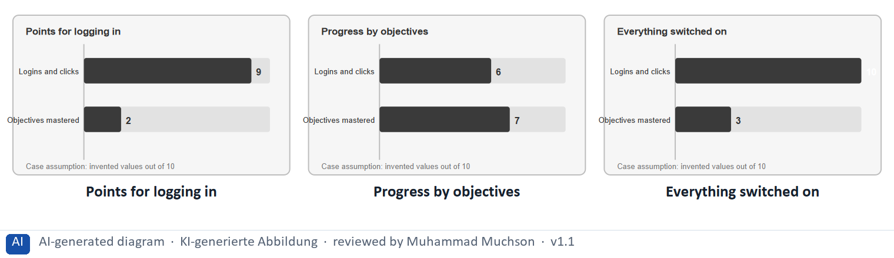
Figure 3 · The same LearnLoop platform in three set-ups: activity against learning.
The point. Activity is not learning. Points for logging in raise logins and clicks, and teach almost nothing. A progress display tied to objectives rewards learning itself. Switching on everything raises activity further and still does not raise learning.
A short story in steps.
1. Busy, not learning. Let us look at LearnLoop again. It gives 10 points for every login, and logins double within a week. The team is delighted, but only a few more objectives are mastered. The platform rewards the activity around learning, so that is what it gets.
2. Reward the learning. Now LearnLoop shows progress per objective instead. Logins are lower, but each one counts, because the bar only moves when something is mastered. Activity and learning are now about the same length, and that is the aim.
3. More is not better. A third idea switches on everything at once. Activity reaches its highest, and learning is still low. So the rule is to ask of each element what it rewards, and to keep the ones that reward learning.
State shown in the picture | What it means
Points for logging in | the platform is very busy, with lots of logins, but few objectives are mastered. The points reward showing up, so learners show up.
Progress by objectives | fewer logins, but about as many objectives mastered. The bar rewards what was learned, so activity and learning move together.
Everything switched on | points, badges, a leaderboard and a streak push activity to its highest, yet learning stays low. More game elements are not more learning.

Activity or learning: how to tell
A measure that rewards | Is it activity or learning? | Why
Points for logging in | Activity | Showing up does not mean learning.
A bar of objectives mastered | Learning | It moves only when something is learned.
A leaderboard of total points | Activity | It ranks how much was done, not what was learned.
A badge for a task applied at work | Learning | It is tied to a real result.

Case assumption
LearnLoop and its values are made up for this example, to show the idea; they are not research findings.

How to decide when this comes up in the task
- Ask of every element: does it reward learning (an objective mastered, a task applied) or activity (a login, a click, time spent)?
- Prefer a measure that ties progress to objectives mastered, with a result line that says what to practise, over one that adds points.
- Treat more badges, more levels and more prizes as more of the problem when the case is that learners chase the reward.
- Name a perverse incentive: a reward that invites people to game it, such as points for logging in that people collect without opening a lesson.
- Check with the learner's own view: would they say they learned something, or only that they collected something?

Extra · go deeper (optional reading)
Goal gradient and endowed progress studies (Kivetz, Urminsky and Zheng 2006) suggest that people try harder as a goal gets closer. That is a reason to show real progress, and a warning against inventing it.

Sources · Hamari et al. 2014 · Ryan & Deci 2000 · Kivetz et al. 2006

A4 · Principles of meaningful gamification: link, fairness, challenge · 10 min · Optional
Meaningful gamification links every element to a learning objective, keeps the rules visible and fair, and matches the challenge to the learner's ability.
IN PLAIN WORDS
The idea. Three principles make gamification meaningful. First, every element is linked to a learning objective. Second, the rules are visible and fair, so nobody feels tricked. Third, the challenge matches the learner's ability, so the task is neither boring nor too hard. This last idea is called flow.
Why it matters. Block 3.1 asks which mechanics are meaningful. The link rule is repeated in A3 and B1, so no Core block needs this card.
How to read the picture. Three small pictures: a badge linked to a goal, a rule everyone can read, and a line where challenge rises with ability.

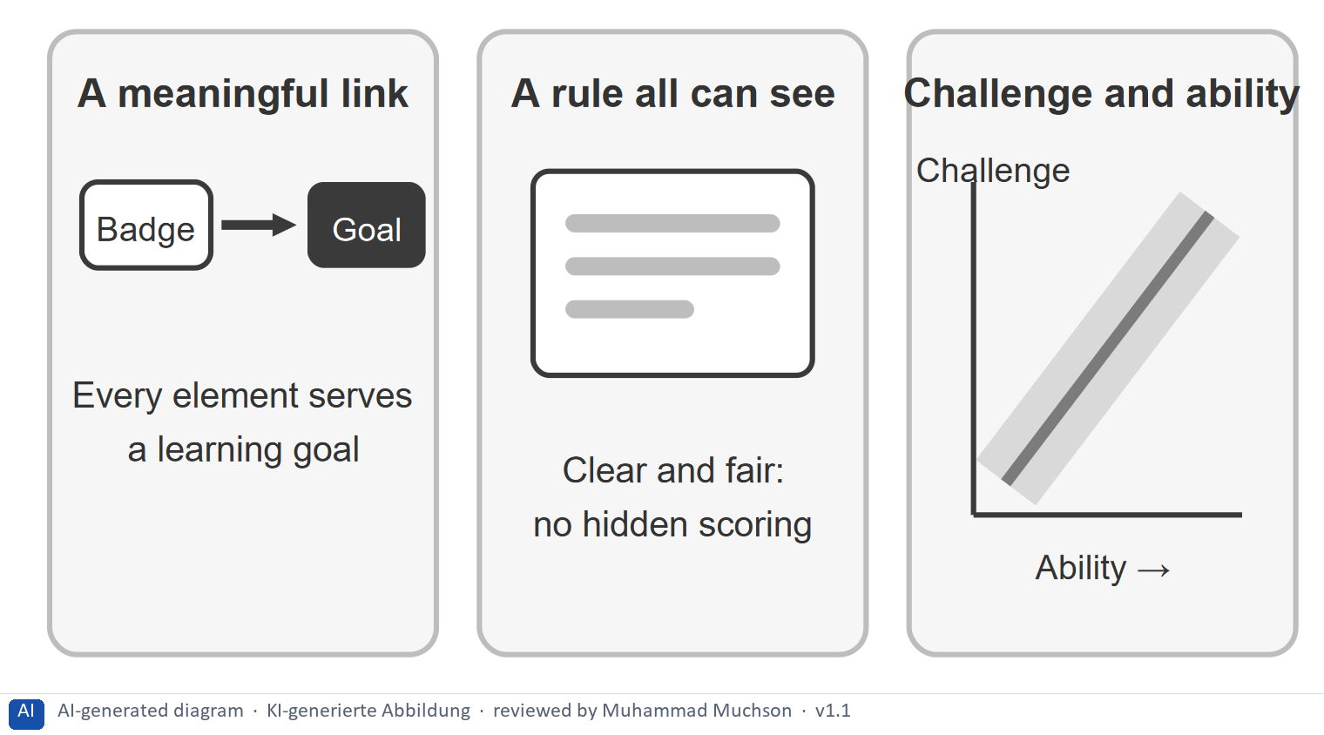
Figure 4 · .
Case assumption
LearnLoop is the example company. Flow follows Csikszentmihalyi (1990).

How to decide when this comes up in the task
- Link: every element serves a learning objective; an element that serves none is dropped.
- Fairness: the rules are visible, and everyone can see how a result came about.
- Challenge: a task that is too easy bores and one that is too hard worries; matching it to ability is called flow.

Extra · go deeper (optional reading)
Day 12 treats adaptive learning, where the platform adjusts the challenge for each learner. The idea of matching challenge to ability is the same.

Sources · Csikszentmihalyi 1990 · Ryan & Deci 2000

A5 · Weighing a gamification measure: motivation, effort, risk · 10 min · Core
Rate a measure by how long it keeps learners going, what it costs and what could go wrong. Learning before reward.
IN PLAIN WORDS
The idea. To choose between gamification measures, rate each on the same three questions. Motivation: how much does it keep the learner going, and for how long? Effort: money and time, decided here by a rule: under €7,000 is Low, up to €14,000 is Mid, above that is High. Risk: what could go wrong, for example that learners chase the reward and learn little.
Why it matters. Block 1.2 and Block 2.2 of the task ask for exactly this. The example uses LearnLoop, so the answer for the task case is not given.
How to read the picture. Three small pictures show LearnLoop's three measures, the bars show the cost of each against the effort rule and the €30,000 budget, and the table gives the rating of each.

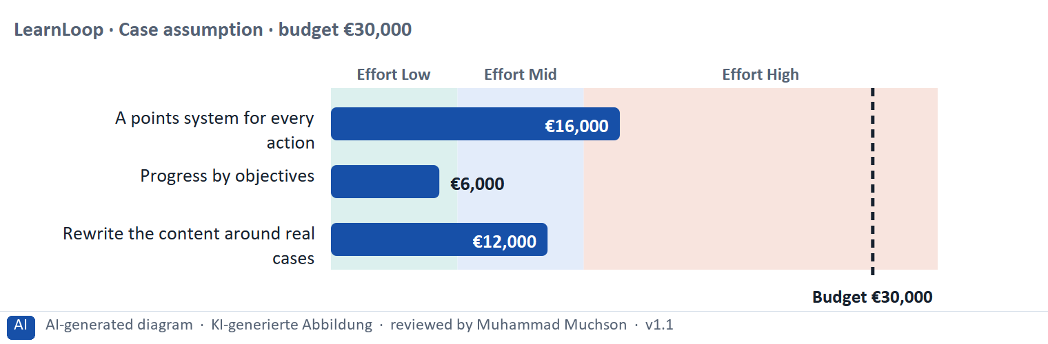
Figure 5 · A worked example: LearnLoop weighs three gamification measures.
The point. Rate a measure by how long it keeps learners going, by its printed cost, and by what could go wrong. A points system looks lively but carries the highest risk, because learners chase the reward. Progress by objectives is cheap and supports learning.
A short story in steps.
1. The setting. Let us look at LearnLoop once more. Learners drop out early, the budget is €30,000, and three ideas are on the table. We rate each on three questions: how long it keeps learners going (motivation), what it costs (effort), and what could go wrong (risk).
2. A points system. A points system costs €16,000, so the effort is High. It lifts activity at once but the lift fades, so the motivation is Mid. The risk is High, because learners learn to chase the points and the content becomes an afterthought.
3. Progress by objectives. Progress by objectives costs €6,000, so the effort is Low. Learners see what they have mastered, so the motivation is High and it lasts, and the risk is Low because there is little to game. The content rewrite costs €12,000, Mid effort, with Mid motivation and Low risk.
4. The order. So the cheap measure that rewards learning comes first, the content rewrite second, and the points system last, if at all. Learning before reward is the rule.
Measure (LearnLoop, Case assumption) | Cost | Effort | Motivation | Risk | Reasons
A points system for every action | €16,000 | High | Mid | High | Effort: €16,000 is above €14,000: High. Motivation: Points lift activity at once, but the lift fades when the novelty is over. Risk: Learners learn to chase the points and the content becomes an afterthought.
Progress by objectives | €6,000 | Low | High | Low | Effort: €6,000 is under €7,000: Low. Motivation: Learners see what they have mastered, which feeds the need to feel competent and lasts. Risk: It rewards learning itself, so there is little to game.
Rewrite the content around real cases | €12,000 | Mid | Mid | Low | Effort: €12,000 lies between €7,000 and €14,000: Mid. Motivation: It builds interest in the topic, which lasts, but it works more slowly. Risk: It adds interest and takes nothing away.

Case assumption
LearnLoop, its costs and its reasons are made up for this example. The task case is in the task.

How to decide when this comes up in the task
- Rate effort by the printed cost: under €7,000 is Low; €7,000 to €14,000 is Mid; above €14,000 is High.
- Rate motivation by how long it keeps the learner going: elements that feed competence and interest last; a reward fades.
- Rate risk by what could go wrong: learners chasing the reward, pressure and worry, a contest most cannot win, a big change that touches every screen.
- Justify the order with the rule learning before reward: say how your first measure leads to the next.
- Say what you do not know, for example whether the progress display raises the return rate, and how you would find out.

Sources · Gibbons 2018 · Hamari et al. 2014

Materi B · Route 2 · Level 3
How Materi B is used
About 60 minutes, three cards. Level 3 asks you to decide as a manager, between goals that pull apart, and to take responsibility. Task 2 uses all three cards.

B1 · Gamification as a strategic tool: from objective to mechanic to behaviour · 18 min · Core
Gamification is a tool, not a goal. Start from the learning objective, choose the mechanic that encourages the behaviour that leads there, then check the result. Motivation is not the same as gamification.
IN PLAIN WORDS
The idea. The plan's coaching says that gamification is a tool, not a goal. A tool serves an objective: you start from what learners should be able to do, choose a mechanic that encourages the behaviour that leads there, and check the result. The chain runs from objective to mechanic to behaviour to result. Motivation is not the same as gamification.
Why it matters. Task 2 asks whether to use gamification at all, which mechanics are meaningful, and how they link to learning objectives. This chain answers all three.
How to read the picture. The chain reads from left to right: objective, mechanic, behaviour, result. Below it, the test for each link.

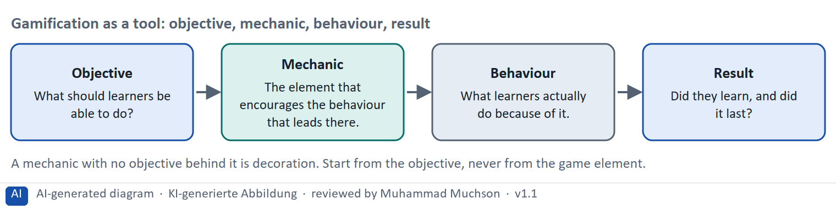
Figure 6 · Gamification as a tool: objective, mechanic, behaviour, result.
The test for each link of the chain
Link | The test | What goes wrong without it
Objective | Can you say what learners should be able to do afterwards? | The mechanic is decoration.
Mechanic | Does it encourage the behaviour that leads to the objective? | Learners do something else, such as collecting points.
Behaviour | Can you watch what learners actually do? | A perverse incentive goes unnoticed.
Result | Did they learn, and does it last after the reward stops? | A short-term lift is mistaken for success.

Case assumption
The chain follows the plan's coaching: gamification is a tool, and motivation is not the same as gamification. LearnLoop is the example company.

How to decide when this comes up in the task
- Decide first whether to gamify at all: say what a mechanic would change in behaviour and which learning objective that serves; “competitors do it” is not a reason.
- Link each mechanic you keep to one learning objective, and drop the ones that serve none.
- Name the perverse incentive of each mechanic: how could people game it, and what would they then do instead of learning?
- Name the risk of over-motivation: pressure, anxiety and a loss that punishes, which make learners stop or cheat.
- Order the measures by the rule learning before reward: progress and feedback first, a say for the learner next, rewards and contests last.

Extra · go deeper (optional reading)
A perverse incentive is a reward that produces the opposite of what was meant. Points for logging in were meant to bring people to learn; they bring people to log in. Asking how a reward could be gamed is a habit worth having for any target, bonus or KPI.

Sources · Deterding et al. 2011 · Ryan & Deci 2000 · Hamari et al. 2014

B2 · Conflicting goals: short-term effect against sustainable learning, motivation against manipulation · 22 min · Core
A reward can lift activity at once and leave nothing behind. Pressure pushes but creates worry. Look for the measure that works now and lasts.
IN PLAIN WORDS
The idea. The plan's conflicts for Day 11 are short-term effect against sustainable learning, motivation against manipulation, and engagement against overload. A reward can lift activity at once and still leave nothing behind. A streak that punishes can push people, but it creates pressure and worry. The aim is the combination that keeps learners going and learning.
Why it matters. Task 2 asks for a risk analysis, with perverse incentives and over-motivation. The rules of this card tell you how to weigh them.
How to read the picture. The matrix places six LearnLoop game ideas by their short-term effect (to the right) and how much sustainable learning they leave (upwards). The position is a reading of the example, not a score. The top right is the aim.

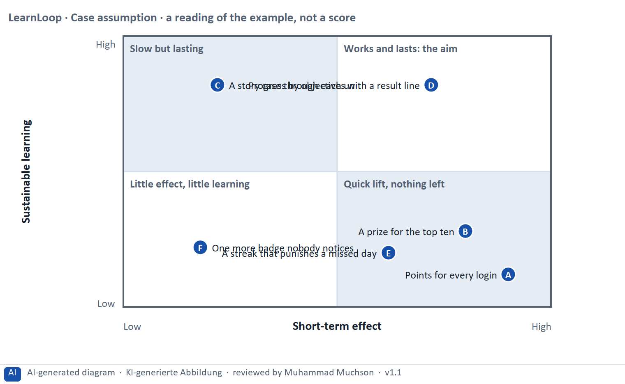
Figure 7 · A worked example: six LearnLoop game ideas by short-term effect and sustainable learning.
The point. A reward can lift activity at once and leave nothing behind. Pressure can push people but creates worry. The aim is the combination that works in the short term and leaves learning behind, and manipulation is the price of ignoring the second.
A short story in steps.
1. A lift that fades. Let us look at LearnLoop's ideas. Points for every login raise activity at once, and a prize for the top ten pushes a few learners very hard. But both leave nothing behind, because the learners are chasing a reward and not the learning.
2. Works and lasts. Progress by objectives with a result line is different. Learners see how they are doing and what to practise, so it works now and it builds skill that stays. A story case is slower but lasting. That is the aim.
3. Motivation against manipulation. A streak that punishes a missed day pushes people back every evening. It works in the short term, yet it creates worry, which is manipulation and not motivation.
Point | The idea | Why it sits there
A | Points for every login | Activity jumps at once, and nothing about learning changes. The effect is short and leaves nothing behind.
B | A prize for the top ten | A strong push for a few, and most learners cannot win, so they stop. It invites gaming the points.
C | A story case through each unit | It takes time to be felt, but interest in the content lasts without a reward. Slow and lasting.
D | Progress by objectives with a result line | Learners see at once how they are doing and what to practise, and it builds real skill. It works now and lasts. This is the aim.
E | A streak that punishes a missed day | The fear of loss pushes people back each day, but it creates pressure and worry, not learning. That is manipulation rather than motivation.
F | One more badge nobody notices | It changes little at the start and nothing later. It adds no learning.

Three conflicts and a rule for deciding each
Conflict | One side gets | The other side gets | A rule for deciding
Short-term effect against sustainable learning | A quick lift in activity | Skill that stays | Prefer what still works when the reward stops.
Motivation against manipulation | Learners brought back by pressure | Learners who want to come back | Never use loss or fear as the main driver.
Engagement against overload | Many elements, always something new | A calm screen that supports the task | Keep the elements that serve an objective; remove the rest.

Case assumption
LearnLoop and its six ideas are made up for this example. The positions in the picture are a reading of the example, not a score.

How to decide when this comes up in the task
- Name both sides of each conflict: the short-term lift (points, a prize) and the lasting learning (progress, feedback, interest). A plan that names one side has not weighed the conflict.
- Tell motivation from manipulation: motivation gives the learner a reason of their own; manipulation uses fear of loss or pressure to bring them back.
- Do not rely on a contest: if most learners cannot win, most will stop trying.
- Keep the learner in control: let them choose the order of topics and switch badges off.

Extra · go deeper (optional reading)
Loss aversion is the finding that people feel a loss more strongly than an equal gain (Kahneman and colleagues describe the related effects of how experiences are remembered). A streak that breaks uses exactly this feeling, which is why it can be effective and still harmful.

Sources · Deci et al. 1999 · Lepper et al. 1973 · Kahneman et al. 1993

B3 · Deciding without proof that gamification works: a decision you can check later · 20 min · Core
When you have no proof that gamification works, choose a small, reversible step, test it against a control group, write a figure you can watch into the plan, and say what you give up.
IN PLAIN WORDS
The idea. The plan asks you to decide although you have no proof yet that gamification works, and competitors use it heavily. A decision under uncertainty states four things: what you decide, what you do not know, what would make you reverse it and by when, and what you give up. A cheap test against a control group is the usual way to get proof.
Why it matters. Block 3.2 asks for exactly this, together with prioritised measures and a risk analysis.
How to read the picture. The four boxes at the top are the parts of the decision, filled in for LearnLoop. The two boxes below are the rule for future decisions.

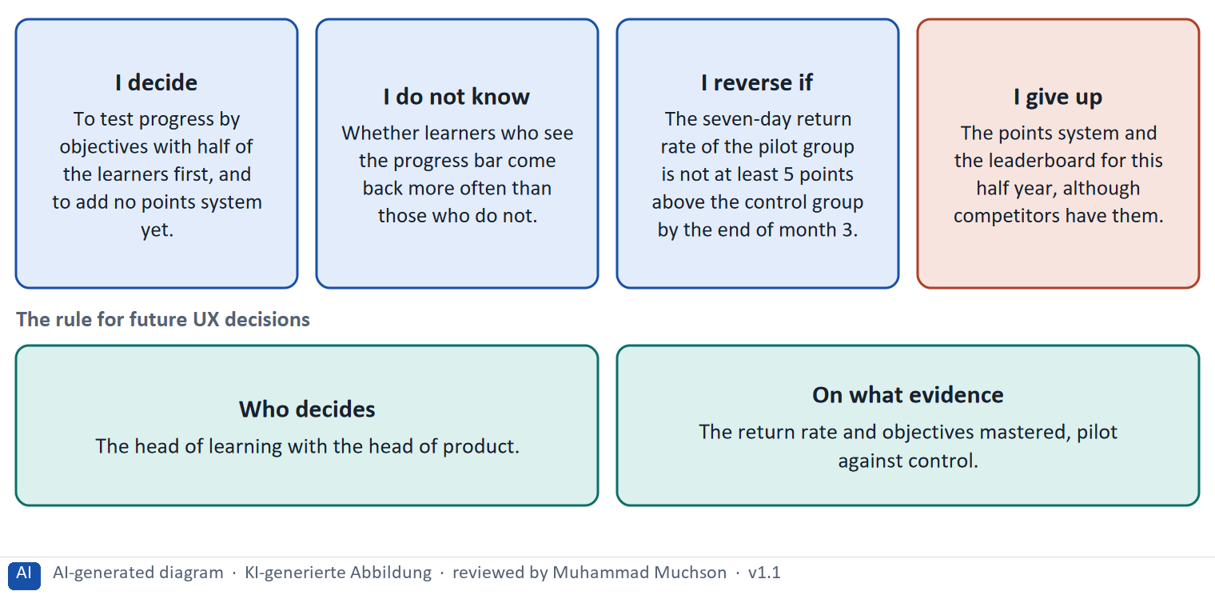
Figure 8 · A decision without proof that gamification works, filled in for LearnLoop.
Five ways to make a decision without proof safer
Way | What it looks like
Test against a control group | Half of the learners get the mechanic; half do not; compare the return rate and objectives mastered.
Start small and reversible | One mechanic first, behind a switch that can be turned off.
Set a figure and a date | The gap you expect, and the month you will look.
Fix who decides | A role, with the evidence it needs.
Name what you give up | Something real that someone would miss.

Case assumption
LearnLoop and its figures are made up for this example; the task case is in the task.

How to decide when this comes up in the task
- A decision under uncertainty states four things: what you decide, what you do not know, what would make you reverse it and by when, and what you give up.
- A reversal condition has a figure you can watch and a time: “the seven-day return rate of the pilot group is not at least 5 points above the control group by the end of month 3”.
- Get proof cheaply: test one mechanic with a pilot group against a control group before you build it for everyone.
- Do not copy competitors because they gamify: their results are not yours, and you cannot see their evidence.
- Giving up nothing means you have not decided: name what you postpone, for example a leaderboard or a points system.

Extra · go deeper (optional reading)
Premortem: imagine the plan failed. Typical answers here: learners chased the points and learned nothing, the leaderboard discouraged most people, and the streak made some anxious. Each answer becomes a check.
One-way and two-way doors: a mechanic behind a switch is a two-way door; a platform rebuilt around points is a one-way door.

Sources · Klein 2007 · Bezos 2016 · Gibbons 2018

Use in class: presentation and handout
Mark of use for the study material. Presentation is what the trainer shows on screen; Handout is what participants read and keep.
Card | Presentation (shown on the playground) | Handout
A1 · Game elements: points, badges, levels and leaderboards, and what gamification is (Core) | Scan line and Figure 1; the "In plain words" and "How to decide" boxes | The whole card
A2 · Intrinsic and extrinsic motivation, and the three needs of Self-Determination Theory (Core) | Scan line and Figure 2; the "In plain words" and "How to decide" boxes | The whole card
A3 · Gamification and learning: activity is not learning (Core) | Scan line and Figure 3; the "In plain words" and "How to decide" boxes | The whole card
A4 · Principles of meaningful gamification: link, fairness, challenge (Optional) | Not shown (self-study) | The whole card
A5 · Weighing a gamification measure: motivation, effort, risk (Core) | Scan line and Figure 5; the "In plain words" and "How to decide" boxes | The whole card
B1 · Gamification as a strategic tool: from objective to mechanic to behaviour (Core) | Scan line and Figure 6; the "In plain words" and "How to decide" boxes | The whole card
B2 · Conflicting goals: short-term effect against sustainable learning, motivation against manipulation (Core) | Scan line and Figure 7; the "In plain words" and "How to decide" boxes | The whole card
B3 · Deciding without proof that gamification works: a decision you can check later (Core) | Scan line and Figure 8; the "In plain words" and "How to decide" boxes | The whole card

References
Check each source and its current edition before you teach from it. Standards and laws marked as in flux can change.
Deterding, S., Dixon, D., Khaled, R., & Nacke, L. (2011). From game design elements to gamefulness: Defining "gamification". Proceedings of MindTrek '11, 9–15. — gamification is the use of game design elements in non-game contexts.
Hamari, J., Koivisto, J., & Sarsa, H. (2014). Does gamification work? A literature review of empirical studies on gamification. Proceedings of HICSS 2014, 3025–3034. — results are mostly positive but depend on context and on the user.
Ryan, R. M., & Deci, E. L. (2000). Self-determination theory and the facilitation of intrinsic motivation, social development, and well-being. American Psychologist, 55(1), 68–78. — autonomy, competence and relatedness as basic psychological needs.
Deci, E. L., Koestner, R., & Ryan, R. M. (1999). A meta-analytic review of experiments examining the effects of extrinsic rewards on intrinsic motivation. Psychological Bulletin, 125(6), 627–668. — expected tangible rewards tended to undermine intrinsic motivation.
Lepper, M. R., Greene, D., & Nisbett, R. E. (1973). Undermining children's intrinsic interest with extrinsic reward. Journal of Personality and Social Psychology, 28(1), 129–137. — the classic study of the overjustification effect.
Kivetz, R., Urminsky, O., & Zheng, Y. (2006). The goal-gradient hypothesis resurrected: Purchase acceleration, illusionary goal progress, and customer retention. Journal of Marketing Research, 43(1), 39–58. — people speed up as they approach a goal.
Csikszentmihalyi, M. (1990). Flow: The Psychology of Optimal Experience. Harper & Row. — people engage most when challenge and skill are in balance.
Gibbons, S. (2018). Using Prioritization Matrices to Inform UX Decisions. Nielsen Norman Group. https://www.nngroup.com/articles/prioritization-matrices/ — a prioritisation matrix plots items on two criteria, for example value to the user against effort.
Kahneman, D., Fredrickson, B. L., Schreiber, C. A., & Redelmeier, D. A. (1993). When more pain is preferred to less: Adding a better end. Psychological Science, 4(6), 401–405. — the peak-end finding: how an experience ended shaped how it was remembered.
Klein, G. (2007). Performing a project premortem. Harvard Business Review, 85(9), 18–19. — imagine the plan has failed and ask why; it brings risks to the surface before the money is spent.
Bezos, J. (2016). 2015 Letter to Shareholders. Amazon. — decisions that are hard to reverse ("one-way doors") deserve more care than those that can be reversed cheaply ("two-way doors").

Glossary
Every term below is used in this document. Terms stay plain text in the body; this list says what they mean in everyday words.
Term | In plain words | Example | Comes from
A/B test and control group | Two versions are shown to similar groups of users at the same time and the results are compared. The group that sees the old version is the control group. It shows whether a change made a difference. | Half of new learners see the old start screen, half the new one; compare how many finish lesson 1. | Kohavi et al. 2020
Adaptive learning | A learning system that changes what a learner sees, for example the next lesson or the difficulty, depending on what that learner does. The rules can be simple (if the test is passed, skip) or learned from data. | A learner who passes the pre-test skips the basics unit. | Kulik & Fletcher 2016
Autonomy, competence and relatedness | The three needs of Self-Determination Theory. Autonomy: I choose what I do. Competence: I am getting better. Relatedness: I belong to others. When they are met, people stay motivated without a reward. | A choice of topic meets autonomy; a result line meets competence; a group goal meets relatedness. | Materi A2
Badge | A small picture or title given to a learner for reaching something, such as finishing a course. A badge is a reward element from games. | "Finished: Contract Basics". | —
Challenge and skill balance (flow) | People engage most when a task is neither too easy (boring) nor too hard (frustrating) for their current skill. Good learning design keeps the challenge just above the learner's level. | A quiz that gets slightly harder as the learner succeeds. | Csikszentmihalyi 1990
Conflicting goals (trade-off) | Two goals that both matter, but cannot both be fully met: for example a simple screen against depth of content. A trade-off means you decide how much of each to keep, and say what you give up. | — | —
Control group | A group that does not get the change you are testing. Comparing it with the test group shows how much of a rise is the change and how much would have happened anyway, for example because of the season. | Half of the learners do not see the new progress display. | Kohavi et al. 2020
Dark pattern and manipulation | A design that pushes users to act against their own interest, for example by pressure, guilt or hidden costs. In learning, loss messages such as "you will lose your streak" can cross from motivation into manipulation. | A pop-up that scolds the learner for missing a day. | Gray et al. 2018
Drop-out rate | The share of people who start something and stop before the end. A 40% drop-out rate means 40 of every 100 learners who start a course do not finish it. It counts who left, not why. | 100 learners start; 60 finish; the drop-out rate is 40%. | —
Engagement | How much a learner actually does on the platform: lessons opened, tasks tried, time spent. High engagement is a sign that the platform holds attention; it does not prove they learned. | — | —
Extrinsic motivation | Doing something for a reward from outside or to avoid a penalty, such as a point, a prize, a rank or a broken streak. It can push someone hard, and it tends to fade when the reward goes away. | A learner studies only in the month a prize is offered. | Materi A2
Feedback (in an interface) | A sign from the system that tells the user what just happened or how they did: “saved”, “4 of 5 correct”, a bar that moves. Without it, users do not know whether their action worked. | — | Nielsen 1994
Game mechanic | One building block taken from games and used in a platform: points, a badge, a level, a leaderboard, a choice. A mechanic is a tool, and it only helps when it serves a learning objective. | A bar of objectives mastered is a mechanic that serves the objective “apply the method at work”. | Materi B1
Gamification | Using elements from games, such as points, badges, levels or rankings, in something that is not a game. Whether it helps depends on whether the learner wanted the result anyway. | A badge after every lesson, or a ranking of all learners. | —
Goal-gradient and endowed progress | People work harder the closer they get to a goal (goal gradient), and they are more likely to continue when they already see some progress (endowed progress). A progress display uses both, but it must be honest. | A bar that starts at 10% after registration because the first step is done. | Kivetz et al. 2006; Nunes & Drèze 2006
Intrinsic and extrinsic motivation | Intrinsic motivation comes from the activity itself: interest, curiosity, the wish to get better. Extrinsic motivation comes from outside: points, money, a deadline, a certificate. Both exist; designs differ in which they lean on. | Studying contracts because you want to understand them (intrinsic) or to get the certificate (extrinsic). | Ryan & Deci 2000
Leaderboard | A ranking of learners by points or activity. It rewards those who are already active and can discourage those at the bottom. | A list of the ten most active learners this week. | —
Learning objective | A clear statement of what learners should be able to do after a lesson or course. It is the thing a game element should serve. Without one, an element is only decoration. | “After the unit, the learner can name the first offer in a negotiation.” | Materi B1
Loss aversion | People feel a loss more strongly than a gain of the same size. A streak that breaks, or points that are taken away, use this feeling to bring people back. It works and it creates pressure and worry. | Losing a 6-day streak hurts more than the pleasure of day 7. | Materi B2
Overjustification effect | When a reward is expected for something a person already enjoys, the person may come to see the reward as the reason and lose interest once it stops. | A learner who liked quizzes starts only for points and stops when the points end. | Deci, Koestner & Ryan 1999
Perverse incentive | An incentive that produces the opposite of what was intended: learners collect points by clicking quickly through lessons instead of learning. | A badge for opening 10 lessons leads to opening lessons without reading them. | —
Pilot | A small, time-limited trial of a change with a few users, run to learn before a full roll-out. | One course for eight weeks with 30 learners. | —
Premortem | A planning exercise: you imagine that the plan has failed a year from now and ask what went wrong. It brings risks to the surface before the money is spent. | "It is next March and the new course paths are not used. Why?" Answer: nobody told the trainers. | Klein 2007
Progress indicator | Something on screen that shows how far along the learner is, for example a bar and “3 of 8 lessons done”. It answers “where am I, and how much is left?”. | — | —
Return rate | The share of learners who come back within a set time, for example within seven days. It is a simple sign of retention. | 62 of 100 new learners return within a week. | —
Rule-based system | A system that decides by rules a person has written down, in the form “if this, then that”. It needs little data, and a learner can be told exactly which rule applied. | “If the test is passed, skip the lesson; if it is failed, repeat it.” | Materi A2
Self-Determination Theory (SDT) | A theory of motivation by Deci and Ryan. It says that people stay motivated when three needs are met: autonomy (I choose), competence (I can see I am getting better) and relatedness (I belong). | A learner can pick the order of units (autonomy), sees skills gained (competence) and a study group (relatedness). | Ryan & Deci 2000
Streak | A count of days in a row on which a learner did something. A loss message (“You will lose your streak”) turns it into pressure. | A flame icon with “12 days”. | —

The playground: where we practise online
In class we use the course website as the place to practise and to learn. Every day has its own address, in the same pattern: the day number is the last part.
What | Address
Course website (playground) | https://aion-dl.vercel.app/
Day 11 | https://aion-dl.vercel.app/day/11/

On the day page, Route 1 (Levels 1 and 2) and Route 2 (Level 3) can be opened; the cards and the tasks of this document are there too. The pattern is the same up to Day 8, for example https://aion-dl.vercel.app/day/6/.

