HABMANN AUFSTIEGSAKADEMIE · DIGITAL LEARNING · EDUCATIONAL UX/UI DESIGN
DAY 13 · MATERI A AND MATERI B · ROUTES 1 AND 2 · LEVELS 1 TO 3
Inclusive UX/UI and WCAG
Fundamentals of inclusive UX/UI design for learning platforms, accessibility in practice: WCAG standards
AI notice · KI-Hinweis
This document was produced with the help of an AI language model (Claude, Anthropic). The AI drafted the text and tables and drew the diagrams from code. The content was then read, corrected and approved by the reviewer named below, who is responsible for its accuracy. Every diagram carries an AI label on the image. Check figures and sources before you quote them.
KI-Hinweis: Dieses Dokument wurde mit Unterstützung eines KI-Sprachmodells (Claude, Anthropic) erstellt. Texte und Tabellen wurden von der KI entworfen, die Abbildungen sind KI-generiert und am Bild gekennzeichnet. Die fachliche Prüfung und Freigabe erfolgte durch die unten genannte Person.

Day | Day 13 · Module 6 (day 1 of 2): Fundamentals of inclusive UX/UI design for learning platforms, accessibility in practice: WCAG standards
Document | Materi (study material). Materi A has five cards, Materi B has three.
Route and level | Materi A serves Route 1 (Levels 1 and 2, Task 1). Materi B serves Route 2 (Level 3, Task 2).
Time | Materi A about 60 min · Materi B about 60 min (facilitator-led)
Playground (website) | https://aion-dl.vercel.app/day/13/
Case | Worked examples use LearnLoop, an online-course provider. The task case is AccessLearn, a platform with barriers(see the Task document).
Version | 1.1 · release date 14.10.2026
Review and approval | Muhammad Muchson, Mentor (subject-matter review and approval)

ABOUT THIS DOCUMENT
In class we also use the playground, the course website, as the place to practise and learn. Its address is at the end of this document.
This document holds everything you need to study Day 13 without the website. Each card says the idea in plain words, shows it in a picture, gives the details, and ends with the rules you will use in the Task document. Cards marked Optional are not needed for the Core blocks of the task. The worked examples use LearnLoop, a different company from the task case, so no task answer is printed here. Glossary and references are at the end.

IN THIS DOCUMENT
Lesson plan: ten teaching units (Ablaufplan)
Case study and transfer project at a glance
A1 · Inclusive design: user groups with different needs, and how it differs from usability · 14 min · Core
A2 · The four principles: perceivable, operable, understandable, robust · 12 min · Core
A3 · WCAG in practice: contrast, text alternatives, structure, keyboard use · 14 min · Core
A4 · Implementation in UX/UI design: plain language, hierarchy, intuitive interaction · 10 min · Optional
A5 · Prioritising accessibility measures: impact, effort, risk · 10 min · Core
B1 · Accessibility as a strategic quality: from requirement to priority, process and measure · 18 min · Core
B2 · Conflicting goals: accessibility against cost, standardisation against flexibility · 22 min · Core
B3 · Deciding without knowing how much of the platform fails: a decision you can check later · 20 min · Core

Day at a glance
Day 13 has ten teaching units (UE). This document is the study material; it is used in UE1 (Materi A) and UE8 (Materi B). The day is built from three documents and the playground: Materi (study material), Task (worksheet) and Trainer (coaching, feedback and model solutions), plus the course website.

Lesson plan: ten teaching units (Ablaufplan)
UE | Min | Plan item | What happens | Material | Format
1 | 45 | Knowledge transfer · Level 1 | The trainer presents the Core cards of Materi A (A1, A2, A3, A5, about 50 min of cards) on the playground; participants follow in the handout. Optional A4 is read from the handout. | Materi A (Route 1) | Presentation + Handout
2 | 45 | Level 1 · Task 1 | Individual work on Block 1.1 (Core, about 13 min). Pairs then compare their results and the trainer collects open questions. | Task 1 · Part 1 · Block 1.1 | Handout (or on the playground)
3 | 45 | Level 1 · Task 2 | Three options are rated on three criteria and one is chosen with a reason: Block 1.2 (Optional, about 8 min). Groups that skip Optional blocks use the time to finish Block 1.1 and to read the Optional cards. | Task 1 · Part 1 · Block 1.2 | Handout (or on the playground)
4 | 45 | Coaching · transition from Level 1 to Level 2 | Trainer-led. A short talk on the day's coaching focus, then the reflection questions in pairs: Block 1.3 (Optional, about 5 min). The bridge: from reading an interface to deciding under limits. | Task 1 · Block 1.3  Trainer document, section Coaching | Trainer only + Handout
5–6 | 90 | Level 2 · Case study AccessLearn (2 UE) incl. model solution | UE5: the trainer presents the case; participants work on Block 2.1 (Optional, about 7 min) and Block 2.2 (Core, about 17 min). UE6: groups compare their order and defend it; the trainer closes with the model solution (core logic). | Task 1 · Part 2 · Blocks 2.1, 2.2  Trainer document, section Case study | Handout; model solution shown after the work
7 | 45 | Level 2 + 3 · Feedback round with a management perspective | Groups present their reasoning, not only their result. The trainer asks the day's Level 3 input questions and leads the discussion. | Trainer document, section Feedback round | Presentation by the groups; Trainer only
8 | 45 | Level 3 · Transfer project, Chief Accessibility Officer (3 UE: UE8–10) | The trainer presents Materi B (B1, B2, B3; use the "In plain words" and "How to decide" boxes, the rest is handout) and sets the role and the brief. | Materi B (Route 2) | Presentation + Handout
9 | 45 | Level 3 · Transfer project | Individual work or in pairs on Block 3.1 (Core, about 10 min). | Task 2 · Block 3.1 | Handout (or on the playground)
10 | 45 | Level 3 · Transfer project | Block 3.2 (Core, about 10 min): the decision despite incomplete data. Participants then present the decision and what they give up; the trainer debriefs with the model solution. | Task 2 · Block 3.2  Trainer document, section Transfer project | Handout; model solution shown after the work

One UE is counted as 45 minutes here; breaks are not shown. The times are a guide for the trainer. Optional blocks and cards can be skipped; the Core blocks are enough for a complete answer.

Case study and transfer project at a glance
Component | UE | Duration | Participants work in | Model solution in
Level 2 case study (AccessLearn) | UE5–6 | 2 UE · 90 min | Task 1 · Part 2 (Blocks 2.1, 2.2) | Trainer document, section Case study
Level 3 transfer project (Chief Accessibility Officer) | UE8–10 | 3 UE · 135 min | Materi B and Task 2 (Blocks 3.1, 3.2) | Trainer document, section Transfer project

Materi A · Route 1 · Levels 1 and 2
How Materi A is used
About 60 minutes, five cards. The plan's Level 1 asks you to understand the fundamentals of the day's topic. Level 2 asks you to analyse a learning interface and to apply them. Task 1 uses all of it on one case. The card A4 is Optional: no Core block of the task needs it.

A1 · Inclusive design: user groups with different needs, and how it differs from usability · 14 min · Core
Inclusive design asks who is left out. Three groups of needs matter: visual, motor and cognitive. A barrier can slow a learner, stop them completely, or lose them quietly.
IN PLAIN WORDS
The idea. Inclusive design means designing so that people with different needs can use a product, not only the typical user. Classic usability asks whether a typical user finds a product easy. Inclusion asks who is left out. Three groups of needs matter: visual (seeing the page), motor (using the controls) and cognitive (understanding and following).
Why it matters. In Task 1 you sort facts about a platform by the user group they affect, and you say which one stops a learner completely.
How to read the picture. One LearnLoop lesson page as three learners meet it: Mia with low vision, Tom with only a keyboard, and Nia who finds long text hard.

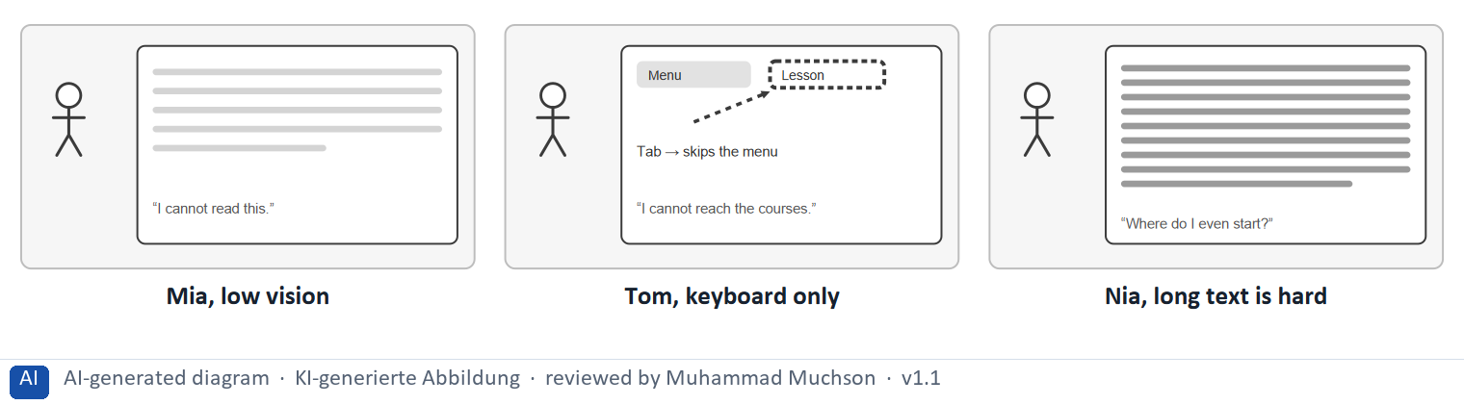
Figure 1 · The same LearnLoop lesson page as three learners meet it.
The point. Inclusive design asks who is left out, not only whether a typical user finds a page easy. The same page can be fine for one learner and a dead end for another, depending on whether they see it, can operate it, or can follow it.
A short story in steps.
1. Pale text. Let us follow Mia, a learner at LearnLoop who has low vision. The lesson text is pale grey on white. She can squint, zoom in and carry on, but it takes effort every time, and she will tire of it long before the others do.
2. A dead end. Now Tom, who uses only a keyboard because of a motor impairment. The course menu opens only when a mouse hovers over it, so pressing Tab skips it. Tom cannot get to any course, and there is nothing he can do about it: the page has stopped him.
3. A wall of text. And Nia, who finds long text hard to follow. The page is one block of text with no headings. She cannot tell where the step she needs begins. So there are barriers that slow, barriers that stop, and barriers that lose people quietly.
State shown in the picture | What it means
Mia, low vision | the text is pale grey on white, and Mia can barely read it. She can still use the page, with a zoom or a high-contrast setting, so this barrier slows her.
Tom, keyboard only | the menu opens only on mouse hover, and Tom presses Tab in vain. He cannot reach a single course, so this barrier stops him completely.
Nia, long text is hard | a wall of text with no headings, so Nia does not know where to start or where the step she needs is. She may give up, so this barrier loses her.

Three groups of needs, with an example of a barrier and a fix
Group | A typical barrier | A typical fix
Visual | Pale text; images with no description. | Strong contrast; a text alternative.
Motor | A menu that needs a mouse; tiny buttons. | Everything reachable by keyboard; large targets.
Cognitive | A wall of text; seven levels of menus. | Headings and short steps; a flat structure.

Case assumption
LearnLoop, Mia, Tom and Nia are made up for this example. The idea that one design should work for people with different needs is that of Universal Design for Learning (CAST) and of inclusive design (Microsoft).

How to decide when this comes up in the task
- Sort a barrier by the user group it hits first: visual (contrast, text size, images without a text alternative), motor (a menu that needs a mouse, tiny buttons) or cognitive (deep navigation, unstructured text, fixed time limits).
- Tell a barrier that stops from one that slows: ask whether the learner has any way around it. If none, it stops.
- Remember that one barrier can hit more than one group: say whom it hits first and who else it hits.
- Do not blame the learner: if a page does not work for a group, the barrier is in the page.

Extra · go deeper (optional reading)
Impairments can be permanent, temporary or situational: a broken arm, a bright train window, a noisy room. Designing for the permanent case usually helps the temporary and the situational one too, which is why inclusion improves UX for everyone.

Sources · CAST 2024 · Microsoft 2016 · WHO 2022

A2 · The four principles: perceivable, operable, understandable, robust · 12 min · Core
WCAG rests on four principles: perceivable, operable, understandable, robust. Every barrier breaks one of them.
IN PLAIN WORDS
The idea. The WCAG standard rests on four principles. Content must be perceivable (people can see or hear it), operable (people can use the controls), understandable (people can follow it) and robust (it works with different browsers and assistive technologies, such as a screen reader). A barrier breaks one of the four.
Why it matters. In Block 2.1 and Block 2.2 you name the barriers behind the facts. The four principles are the way to name them.
How to read the picture. Four small pictures, one for each principle: an eye, a keyboard key, a short text and a plug that fits.

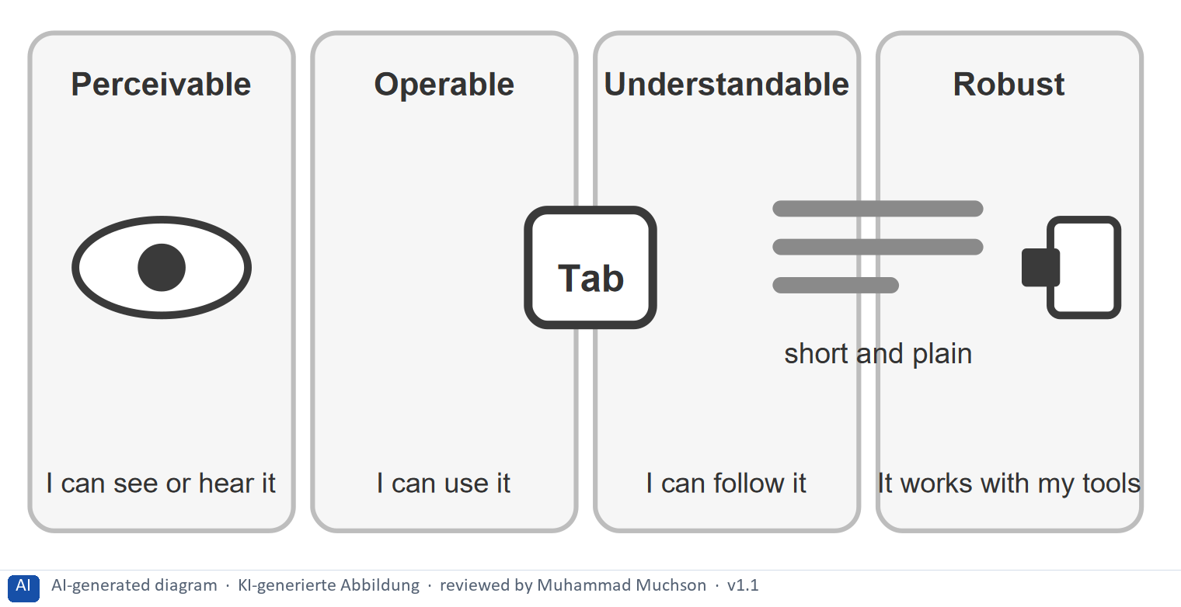
Figure 2 · .
The four principles, the question each asks, and a barrier that breaks it
Principle | The question | A barrier that breaks it
Perceivable | Can it be seen or heard? | Contrast 2.1 : 1; a chart with no text alternative.
Operable | Can it be used with different devices? | A menu that opens only on mouse hover.
Understandable | Can it be followed? | Seven levels of menus; a fixed time limit.
Robust | Does it work with assistive technology? | A custom control that a screen reader cannot name.

Case assumption
LearnLoop is the example company. The four principles are those of WCAG 2.2 (W3C); ARIA is the W3C standard that lets custom controls tell assistive technology what they are.

How to decide when this comes up in the task
- Name the principle a barrier breaks: pale text and missing text alternatives break perceivable; a mouse-only menu and tiny targets break operable; deep navigation and long unstructured text break understandable; code that a screen reader cannot read breaks robust.
- Use the four principles as a checklist when you review a page, one question each: can it be seen or heard, used, followed, and read by assistive technology?
- Treat WCAG as a minimum: meeting it does not by itself make a platform good to use.

Extra · go deeper (optional reading)
In the EU, accessibility rules rest on EN 301 549, which takes over WCAG, and in Germany on the BFSG (Barrierefreiheitsstärkungsgesetz) and the BITV for public bodies. Rules in this area change, so check the current text and dates before you rely on them.

Sources · W3C 2023 · Understanding WCAG 2.2 · W3C 2024 (ARIA)

A3 · WCAG in practice: contrast, text alternatives, structure, keyboard use · 14 min · Core
Four WCAG requirements matter most on a learning platform: contrast of at least 4.5 : 1, text alternatives, clear structure and navigation, and keyboard use. Each is a small, testable change.
IN PLAIN WORDS
The idea. WCAG, the Web Content Accessibility Guidelines, turns the principles into testable requirements. Four matter most on a learning platform: sufficient contrast (at least 4.5 : 1 for normal text), a text alternative for every image that carries content, a clear structure and navigation, and keyboard operability, so that everything works without a mouse.
Why it matters. Block 1.2 and Block 2.2 ask you to prioritise measures. Each one is one of these four requirements.
How to read the picture. One LearnLoop lesson page with four features that can be on or off: contrast, a text alternative, structure and keyboard use.

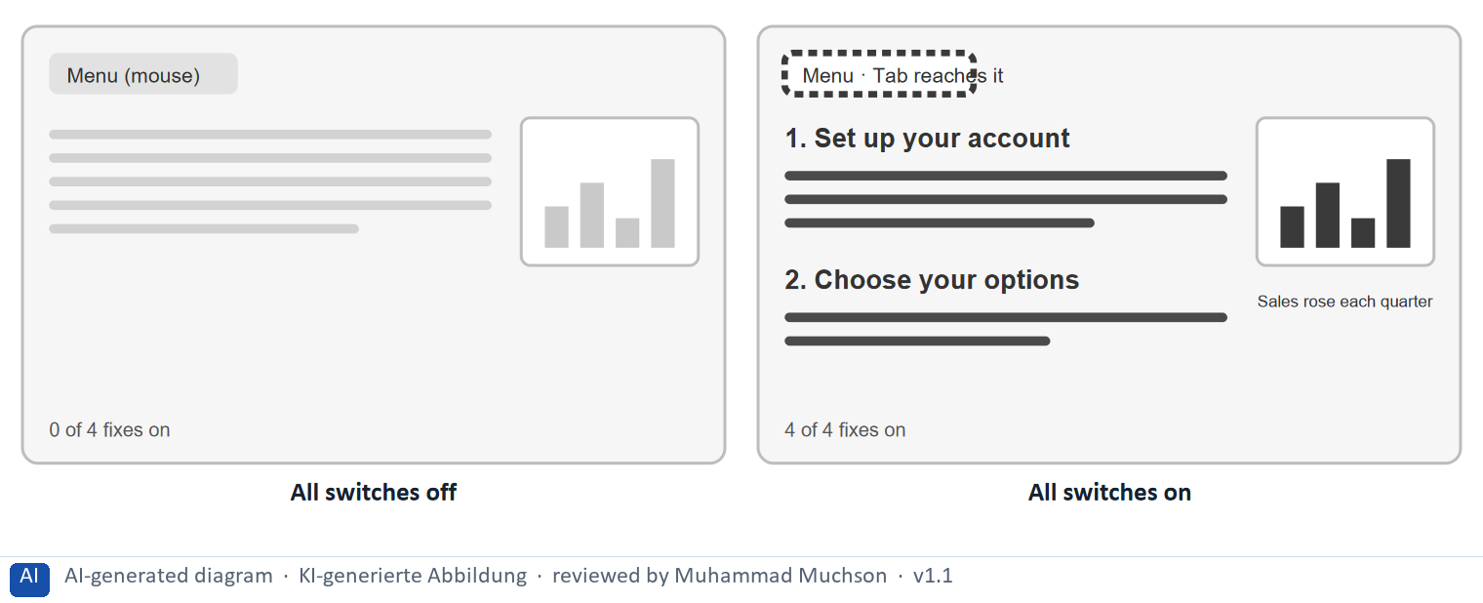
Figure 3 · One LearnLoop lesson page and four WCAG fixes.
The point. WCAG turns the four principles into testable requirements. Four matter most on a learning platform: enough contrast, a text alternative for images, a clear structure, and keyboard use. Each is a small, checkable change, and each frees a different group of learners.
A short story in steps.
1. A page with four barriers. Let us look at a LearnLoop lesson page as it stands: pale text, a chart with no words, no headings, and a menu that needs a mouse. Four learners, each with a different need, are blocked or slowed by it, and none of the four problems is hard to describe.
2. Four small fixes. Now all four WCAG fixes are on. The text meets a contrast of 4.5 : 1, the chart carries a sentence that says what it shows, headings mark the steps, and the menu can be reached with Tab. The lesson has not changed, only how it is built, and each fix can be tested.
3. One at a time. A team rarely does all four at once. Block 1.2 asks you to prioritise exactly this.
Switches | What it means
All off | 0 of the 4 fixes are on. The text is pale and hard to read. The chart has no words, so a blind learner misses it. There are no headings. The menu needs a mouse.
All on (Contrast 4.5 : 1, Text alternative, Clear structure, Keyboard use) | 4 of the 4 fixes are on. The text is dark enough to read in any light. The chart has words, so a screen reader can say it. Headings show where each step begins. The menu can be reached with Tab.

Four requirements, the group each frees, and a test
Requirement | Who it frees | A simple test
Contrast of at least 4.5 : 1 | Learners with low vision, anyone in bright light | A contrast checker on every text colour.
Text alternatives | Blind learners, learners who use a screen reader | Turn images off: is the message still there?
Clear structure | Learners who find structure hard, screen-reader users | List the headings: do they tell the story?
Keyboard use | Keyboard-only users, learners with a tremor | Put the mouse away and press Tab through the page.

Case assumption
LearnLoop is the example company. The requirements are those of WCAG 2.2, summarised; the 4.5 : 1 ratio is criterion 1.4.3. Check the current criteria text before quoting a number in a document.

How to decide when this comes up in the task
- Contrast: normal text needs at least 4.5 : 1 against its background (large text 3 : 1); light grey on white fails.
- Text alternatives: every image or chart that carries content needs a short text that says what it shows; a purely decorative image needs none.
- Structure and navigation: use real headings in order, keep menus shallow and the same on every page, and give each page a clear title.
- Keyboard use: everything that works with a mouse must work with the keyboard, in a sensible order, with a visible focus.
- Videos need captions, and a time limit must be adjustable; both appear as measures in the task.

Extra · go deeper (optional reading)
WCAG has three levels, A, AA and AAA. Level AA is the usual target and the one the European standard asks for. A free automatic tool finds only a part of the barriers, so testing with a keyboard and a screen reader stays necessary.

Sources · W3C 2023 · Understanding WCAG 2.2 · EN 301 549

A4 · Implementation in UX/UI design: plain language, hierarchy, intuitive interaction · 10 min · Optional
Build accessibility into the design: plain language, a clear visual hierarchy and intuitive interactions. They help everyone and are the cheapest barriers to avoid.
IN PLAIN WORDS
The idea. Accessibility is built in the design itself: plain language (short sentences, everyday words, abbreviations explained), a clear visual hierarchy (headings that show what matters), and intuitive interactions (controls that look and behave as people expect). These help everyone and are the cheapest barriers to avoid.
Why it matters. Block 3.1 asks how accessibility joins the UX process. The core rules on structure are repeated in A3 and B1, so no Core block needs this card.
How to read the picture. A before and after: one block of long text, and the same text with headings and short steps.

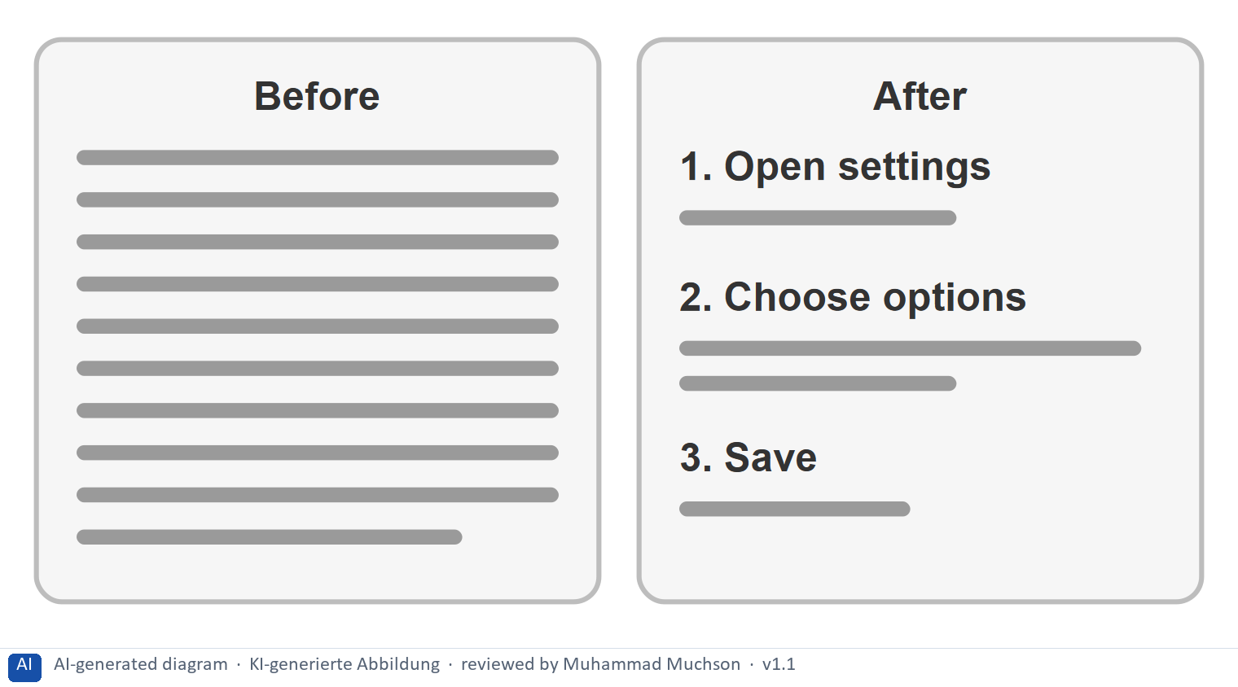
Figure 4 · .
Case assumption
LearnLoop is the example company. Day 14 treats plain language and intuitive environments in depth.

How to decide when this comes up in the task
- Plain language: short sentences, everyday words, each abbreviation explained once.
- Hierarchy: real headings that show what matters, and one main action per screen.
- Intuitive interaction: controls look and behave as people expect, with the same pattern for the same task.

Extra · go deeper (optional reading)
Structure helps a screen reader as well: it lets a blind learner jump from heading to heading, as a sighted learner skims. One structure serves both.

Sources · Nielsen 1994 · W3C 2023

A5 · Prioritising accessibility measures: impact, effort, risk · 10 min · Core
Rate a measure by how many learners it frees and how badly they were blocked, what it costs and what could go wrong. Cheap fixes that free a blocked group go first.
IN PLAIN WORDS
The idea. To choose between accessibility measures, rate each on the same three questions. Impact: how many learners does it free from a barrier, and how badly were they blocked? Effort: money and time, decided here by a rule: under €8,000 is Low, up to €18,000 is Mid, above that is High. Risk: what could go wrong, for example that it takes longer than planned.
Why it matters. Block 1.2 and Block 2.2 of the task ask for exactly this. The example uses LearnLoop, so the answer for the task case is not given.
How to read the picture. Three small pictures show LearnLoop's three measures, the bars show the cost of each against the effort rule and the €40,000 budget, and the table gives the rating of each.

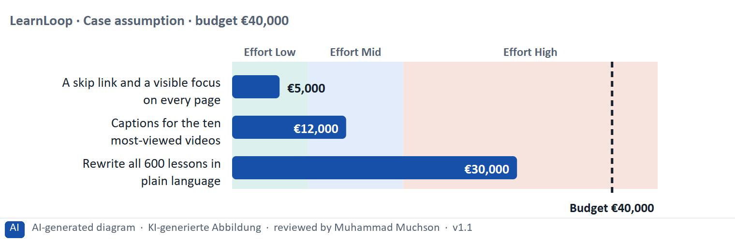
Figure 5 · A worked example: LearnLoop weighs three accessibility measures.
The point. Rate a measure by how many learners it frees from a barrier and how badly they were blocked, by its printed cost, and by what could go wrong. A cheap fix that stops a group from being blocked beats a big rewrite that takes months and helps only a little.
A short story in steps.
1. The setting. Let us look at LearnLoop once more. It has a lot of content, the budget is €40,000, time is short, and three ideas are on the table. We rate each on three questions: how many learners it frees and how badly they were blocked (impact), what it costs (effort), and what could go wrong (risk).
2. A cheap fix that frees a group. A skip link and a visible focus cost €5,000, so the effort is Low. They free keyboard users who were stopped completely, so the impact is High, and the risk is Low because it is a small change in the template. Captions for ten videos cost €12,000, Mid effort, with High impact and Mid risk.
3. A big rewrite. Rewriting all 600 lessons costs €30,000, so the effort is High. It helps many learners a little and only when it is finished, so the impact is Mid, and the risk is High because the budget may run out first. So: cheap fixes that free a blocked group first, the big job later.
Measure (LearnLoop, Case assumption) | Cost | Effort | Impact | Risk | Reasons
A skip link and a visible focus on every page | €5,000 | Low | High | Low | Effort: €5,000 is under €8,000: Low. Impact: Keyboard users can finally move through every page, so a group that was stopped is freed. Risk: A small change in the page template, easy to test.
Captions for the ten most-viewed videos | €12,000 | Mid | High | Mid | Effort: €12,000 lies between €8,000 and €18,000: Mid. Impact: Deaf learners get the content of the videos that most learners watch. Risk: The other videos stay without captions, so the gain is partial.
Rewrite all 600 lessons in plain language | €30,000 | High | Mid | High | Effort: €30,000 is above €18,000: High. Impact: It helps many learners a little, but only once all lessons are done. Risk: It will take months, and the budget may run out before it is finished.

Case assumption
LearnLoop, its costs and its reasons are made up for this example. The task case is in the task.

How to decide when this comes up in the task
- Rate effort by the printed cost: under €8,000 is Low; €8,000 to €18,000 is Mid; above €18,000 is High.
- Rate impact by how many learners are freed and how badly they were blocked: a barrier that stops a group completely outweighs one that only slows.
- Rate risk by what could go wrong: a job that takes longer than the time allows, a fix that covers only part of the content, a new menu that confuses regular users at first.
- Justify the order with accessibility is usability is success: say whom your first measure helps soonest.
- Say what you do not know, for example how many learners use a screen reader, and how you would find out.

Sources · Gibbons 2018 · W3C 2023

Materi B · Route 2 · Level 3
How Materi B is used
About 60 minutes, three cards. Level 3 asks you to decide as a manager, between goals that pull apart, and to take responsibility. Task 2 uses all three cards.

B1 · Accessibility as a strategic quality: from requirement to priority, process and measure · 18 min · Core
Accessibility is a standard, not an add-on, and WCAG is the minimum, not the goal. A strategy moves from requirement to priority, to process, to measure.
IN PLAIN WORDS
The idea. The plan's coaching says that accessibility is not an add-on but a standard, and that WCAG is a minimum, not a goal. A strategy moves from the requirement to a priority (start where most learners meet the barrier), to a process (so that new content stays accessible), to a measure (so that management can see progress).
Why it matters. Task 2 asks for a strategy to implement WCAG, the integration into the UX process and an evaluation approach. This chain gives you the order.
How to read the picture. The chain reads from left to right: requirement, priority, process, measure. Below it, the test for each link.

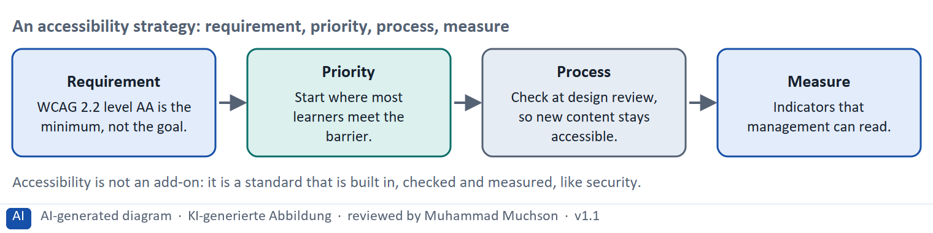
Figure 6 · An accessibility strategy: requirement, priority, process, measure.
The test for each link of the chain
Link | The test | What goes wrong without it
Requirement | Is the standard named (WCAG 2.2 AA) and its status known? | Nobody knows what “accessible” means.
Priority | Do the first steps reach the most learners? | Effort goes into rarely used content.
Process | Does a new page start accessible? | New barriers appear as fast as old ones are fixed.
Measure | Can management see progress in a figure? | Nobody can say whether it works.

Case assumption
The chain follows the plan's coaching: accessibility is a standard and WCAG a minimum. LearnLoop is the example company. Legal duties differ by country and product, so the legal side must be checked for the real case.

How to decide when this comes up in the task
- Choose a strategy that starts where most learners meet the barrier and then builds accessibility into the process; reject “everything at once” (over the budget) and “only when a complaint arrives” (the risk stays).
- Build accessibility into the process early: criteria in the brief, a check at design review, accessible components in the style guide, a test before release, training for the people who make content.
- Make it measurable: use automatic counts (share of pages that pass the contrast check), tests with users (can a keyboard user finish a lesson?) and a figure for management (open barriers by severity).
- Do not use a statement of accessibility as a measure: it is a claim, and it can be wrong.
- Name who else gains: measures built for one group, such as captions or a clear menu, often help everyone.

Extra · go deeper (optional reading)
In Germany, the BFSG (Barrierefreiheitsstärkungsgesetz) makes accessibility a legal requirement for many products and services, and it applies from 28 June 2025; which parts apply to a given learning platform depends on its use, so a legal check is part of the strategy.

Sources · W3C 2023 · EN 301 549 · BFSG · CAST 2024

B2 · Conflicting goals: accessibility against cost, standardisation against flexibility · 22 min · Core
Accessibility competes with cost, and a fixed standard with flexibility. Measures with wide reach and modest cost go first; an overlay that removes no barrier is not a measure.
IN PLAIN WORDS
The idea. The plan's conflicts for Day 13 are accessibility against cost, and standardisation against flexibility. A broad programme is expensive, and a cheap overlay does not remove barriers. A fixed standard is reliable, yet some learners need different solutions. The aim is the measures that reach the most learners for the least cost, with the standard as the floor.
Why it matters. Task 2 asks for prioritised measures and a risk analysis of costs against benefits. The rules of this card tell you how to weigh them.
How to read the picture. The matrix places six LearnLoop measures by their cost (to the right) and the reach, that is how many learners gain (upwards). The position is a reading of the example, not a score.

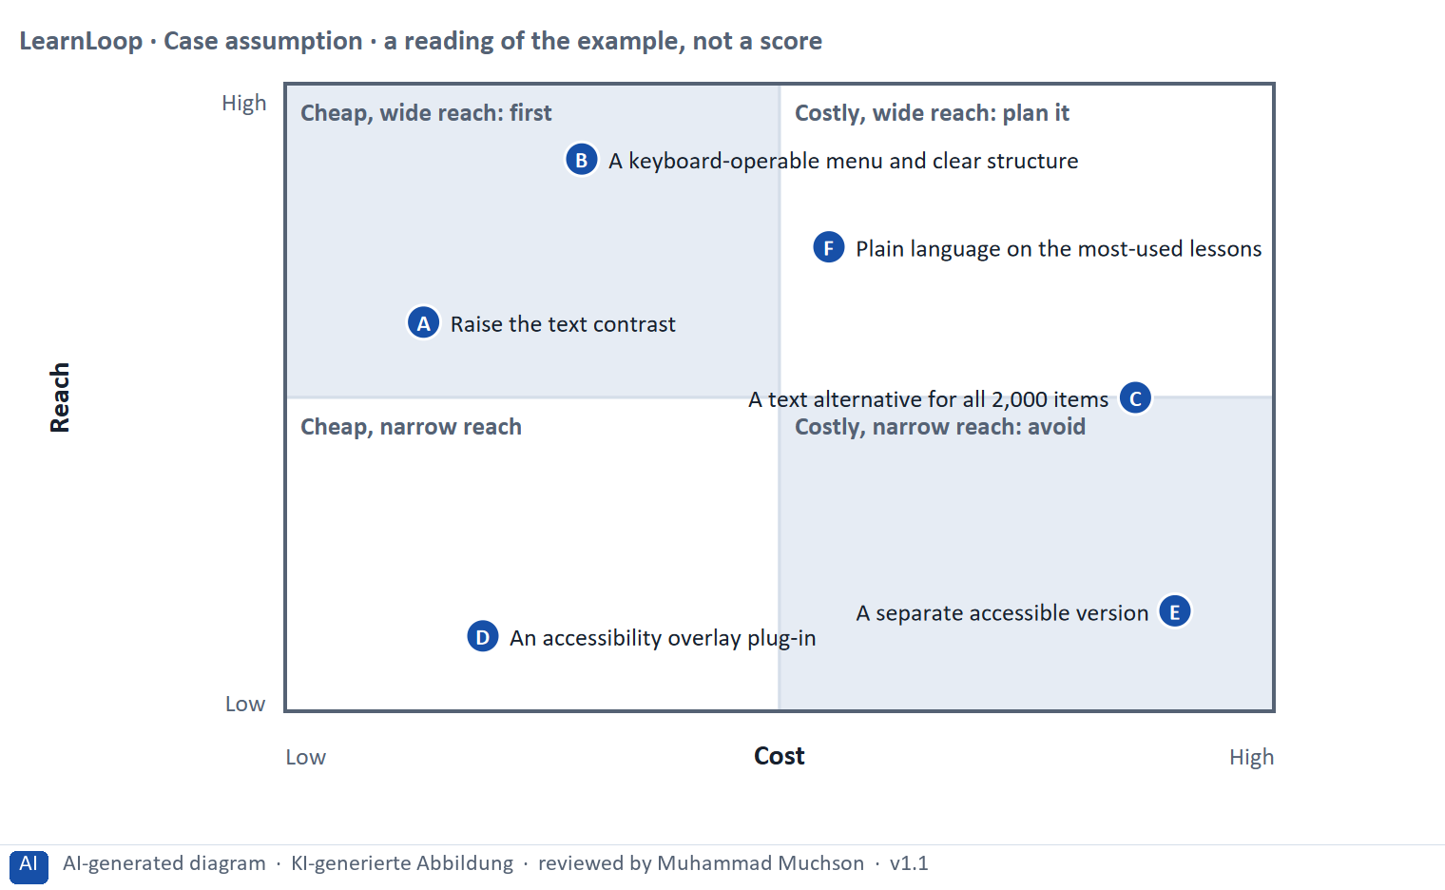
Figure 7 · A worked example: six LearnLoop measures by cost and reach.
The point. Accessibility competes with cost, and a standard competes with flexibility. Rank measures by how many learners gain against what it costs: cheap measures with wide reach go first, and a cheap overlay that removes no barrier is not a measure at all.
A short story in steps.
1. Cheap and wide. Let us look at LearnLoop's options. Raising the text contrast costs little and helps every page, and a keyboard-operable menu with clear structure opens every course to several groups at once. Both gain many learners for modest cost, so both go first.
2. Costly or narrow. Two other ideas look different. A separate accessible version costs the most and serves a narrow group, and a cheap overlay plug-in removes almost nothing. Neither is a good use of a limited budget, however different their price.
3. Accessibility against cost. A text alternative for all 2,000 items matters a great deal and costs a great deal. The answer is not to skip it but to do the most-viewed items first and the rest in steps.
Point | The idea | Why it sits there
A | Raise the text contrast | One change in the style sheet, and every page helps learners with low vision and anyone in bright light. Cheap, with wide reach.
B | A keyboard-operable menu and clear structure | It opens every course for keyboard users, helps learners who find structure hard, and everyone finds courses faster. Mid cost, the widest reach.
C | A text alternative for all 2,000 items | It matters a lot to blind and deaf learners, but the cost is very high and the gain arrives only at the end. Worth doing, in steps, most-used first.
D | An accessibility overlay plug-in | Cheap and quick, and it removes almost no barrier underneath. Low reach, and a false sense of safety.
E | A separate accessible version | The highest cost for a narrow group, and a second platform that must be kept up. Costly, narrow reach.
F | Plain language on the most-used lessons | A mid cost, and it helps learners with dyslexia, non-native speakers and everyone in a hurry. Wide reach, planned in steps.

Two conflicts and a rule for deciding each
Conflict | One side gets | The other side gets | A rule for deciding
Accessibility against cost | A full programme at once | A small budget and little time | Start with the measures of the widest reach for the least cost.
Standardisation against flexibility | One fixed standard for all | Solutions for particular needs | Make the standard the floor; allow adjustment above it.

Case assumption
LearnLoop and its six measures are made up for this example. The positions in the picture are a reading of the example, not a score.

How to decide when this comes up in the task
- Name both sides of each conflict: the cost of a broad programme and the cost of doing too little (complaints, legal action, lost customers). A plan that names only one cost has not weighed the conflict.
- Order measures by reach for cost: cheap with wide reach first, costly with wide reach in steps, cheap with narrow reach only if it removes a real barrier, costly with narrow reach avoided.
- Reject a separate accessible version and an overlay as the main answer: the first is not inclusive and doubles the upkeep; the second leaves the barriers underneath.
- Use the standard as the floor and allow flexibility above it: a learner who needs more time or a different format should be able to ask for it.

Extra · go deeper (optional reading)
Accessibility overlays are plug-ins that promise to fix a site automatically. Many accessibility experts and disabled users have criticised them because the barriers underneath remain, so they are better treated as a risk than as a measure.

Sources · W3C 2023 · CAST 2024 · Gibbons 2018

B3 · Deciding without knowing how much of the platform fails: a decision you can check later · 20 min · Core
When you do not know how much fails, fix the most-used part first, audit a sample, write a figure you can watch into the plan, and say what you give up.
IN PLAIN WORDS
The idea. The plan asks you to decide although you do not know how much of the platform fails WCAG, and requirements are rising. A decision under uncertainty states four things: what you decide, what you do not know, what would make you reverse it and by when, and what you give up. A short audit of a sample is the cheapest way to find out what you do not know.
Why it matters. Block 3.2 asks for exactly this, together with prioritised measures and a risk analysis.
How to read the picture. The four boxes at the top are the parts of the decision, filled in for LearnLoop. The two boxes below are the rule for future decisions.

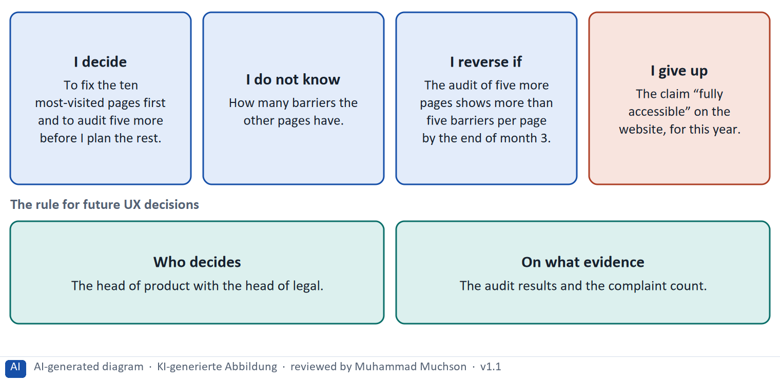
Figure 8 · A decision without knowing how much fails, filled in for LearnLoop.
Five ways to make a decision with an unknown scale safer
Way | What it looks like
Audit a sample | Five to ten pages are checked with a keyboard, a screen reader and a tool.
Start with the most-used content | The twenty courses most learners use are fixed first.
Set a figure and a date | The number of barriers per page you expect, and the month you will look.
Fix who decides | A role, with the evidence it needs.
Name what you give up | Something real that someone would miss.

Case assumption
LearnLoop and its figures are made up for this example; the task case is in the task.

How to decide when this comes up in the task
- A decision under uncertainty states four things: what you decide, what you do not know, what would make you reverse it and by when, and what you give up.
- A reversal condition has a figure you can watch and a time: “the audit of five more pages shows more than five barriers per page by the end of month 3”.
- Learn cheaply: audit a sample of pages with a keyboard, a screen reader and an automatic tool before you plan the whole programme.
- Do not wait for certainty: starting with the most-used courses is useful whatever the audit finds.
- Giving up nothing means you have not decided: name what you postpone, for example the claim “fully accessible” or the old archive.

Extra · go deeper (optional reading)
Premortem: imagine the programme failed. Typical answers here: we did too little and a complaint became a legal case, retrofitting cost far more than planned, and new content brought new barriers. Each answer becomes a check.
One-way and two-way doors: a fix in the style sheet is a two-way door; a second, separate platform is a one-way door.

Sources · Klein 2007 · Bezos 2016 · Gibbons 2018

Use in class: presentation and handout
Mark of use for the study material. Presentation is what the trainer shows on screen; Handout is what participants read and keep.
Card | Presentation (shown on the playground) | Handout
A1 · Inclusive design: user groups with different needs, and how it differs from usability (Core) | Scan line and Figure 1; the "In plain words" and "How to decide" boxes | The whole card
A2 · The four principles: perceivable, operable, understandable, robust (Core) | Scan line and Figure 2; the "In plain words" and "How to decide" boxes | The whole card
A3 · WCAG in practice: contrast, text alternatives, structure, keyboard use (Core) | Scan line and Figure 3; the "In plain words" and "How to decide" boxes | The whole card
A4 · Implementation in UX/UI design: plain language, hierarchy, intuitive interaction (Optional) | Not shown (self-study) | The whole card
A5 · Prioritising accessibility measures: impact, effort, risk (Core) | Scan line and Figure 5; the "In plain words" and "How to decide" boxes | The whole card
B1 · Accessibility as a strategic quality: from requirement to priority, process and measure (Core) | Scan line and Figure 6; the "In plain words" and "How to decide" boxes | The whole card
B2 · Conflicting goals: accessibility against cost, standardisation against flexibility (Core) | Scan line and Figure 7; the "In plain words" and "How to decide" boxes | The whole card
B3 · Deciding without knowing how much of the platform fails: a decision you can check later (Core) | Scan line and Figure 8; the "In plain words" and "How to decide" boxes | The whole card

References
Check each source and its current edition before you teach from it. Standards and laws marked as in flux can change.
CAST (2024). Universal Design for Learning Guidelines, version 3.0. https://udlguidelines.cast.org — multiple means of engagement, representation, and action and expression.
Microsoft (2016). Inclusive Design Toolkit (Inclusive 101 Guidebook). https://inclusive.microsoft.design — the persona spectrum: permanent, temporary and situational limitations.
WHO (2022). Global report on health equity for persons with disabilities. — about 1.3 billion people, roughly one in six, live with a significant disability.
W3C (2023). Web Content Accessibility Guidelines (WCAG) 2.2. W3C Recommendation, 5 October 2023. https://www.w3.org/TR/WCAG22/ — four principles (perceivable, operable, understandable, robust), success criteria at levels A, AA and AAA.
W3C (2023). Understanding WCAG 2.2. https://www.w3.org/WAI/WCAG22/Understanding/ — explains the intent, examples and techniques for each success criterion. Newly added in 2.2 and at AA: 2.4.11 Focus Not Obscured (Minimum), 2.5.7 Dragging Movements, 2.5.8 Target Size (Minimum), 3.3.8 Accessible Authentication (Minimum); 4.1.1 Parsing was removed.
W3C (2024). Using ARIA (W3C Note). https://www.w3.org/TR/using-aria/ — the first rule of ARIA: if a native HTML element or attribute already has the needed meaning and behaviour, use it instead of adding ARIA.
ETSI EN 301 549 V3.2.1 (2021-03). Accessibility requirements for ICT products and services. — the European standard that refers to WCAG for web content. In flux: a revision that refers to WCAG 2.2 is in preparation.
Nielsen, J. (1994, reviewed 2024). 10 Usability Heuristics for User Interface Design. Nielsen Norman Group. https://www.nngroup.com/articles/ten-usability-heuristics/ — for example visibility of system status, match between the system and the real world, consistency and standards, recognition rather than recall.
Gibbons, S. (2018). Using Prioritization Matrices to Inform UX Decisions. Nielsen Norman Group. https://www.nngroup.com/articles/prioritization-matrices/ — a prioritisation matrix plots items on two criteria, for example value to the user against effort.
Barrierefreiheitsstärkungsgesetz (BFSG) of 16 July 2021, implementing Directive (EU) 2019/882 (European Accessibility Act); applies to many digital services from 28 June 2025. In flux: check the scope, the exemptions (for example for very small enterprises) and the ordinance (BFSGV) before you state them.
Klein, G. (2007). Performing a project premortem. Harvard Business Review, 85(9), 18–19. — imagine the plan has failed and ask why; it brings risks to the surface before the money is spent.
Bezos, J. (2016). 2015 Letter to Shareholders. Amazon. — decisions that are hard to reverse ("one-way doors") deserve more care than those that can be reversed cheaply ("two-way doors").

Glossary
Every term below is used in this document. Terms stay plain text in the body; this list says what they mean in everyday words.
Term | In plain words | Example | Comes from
Accessibility | Making sure people with a wide range of abilities can perceive, use and understand a product: people who cannot see, hear, use a mouse or process complex text easily. Usability asks whether a user can reach a goal; accessibility asks whether everyone can get in. | A learner who uses only the keyboard can finish the course. | WCAG 2.2
Accessibility overlay | A third-party toolbar added on top of a site that promises to fix accessibility problems automatically. Many accessibility experts advise that it does not fix the underlying problems, which must be solved in the content and the code. | A widget that claims to make the whole site compliant in a day. | —
ARIA | A set of attributes (WAI-ARIA) that tell assistive technology what a custom control is and does. The first rule: where a native HTML element does the job, use it instead of adding ARIA. | Use a real button, not a clickable box labelled with ARIA. | W3C
Assistive technology | Tools that people with impairments use to work with a computer, such as a screen reader that reads the page aloud, a switch, or a magnifier. A product has to work with them, which is the idea of the principle “robust”. | A blind learner uses a screen reader to hear the lesson. | Materi A2
Barrier | Something in a product that makes it hard or impossible for some people to use. A barrier can slow a person down, stop them completely, or lose them quietly. It is in the product, not in the person. | A menu that opens only when a mouse hovers over it is a barrier for someone who uses only a keyboard. | Materi A1
BFSG, EN 301 549, BITV 2.0 | BFSG is the German law (Barrierefreiheitsstärkungsgesetz) that applies the European Accessibility Act, from 28 June 2025, to many consumer-facing digital services. EN 301 549 is the European standard that refers to WCAG for web content. BITV 2.0 covers the web offers of public bodies. Scope and exemptions are in flux: check them. | A public university and an online shop meet different rules. | Directive (EU) 2019/882
Captions | Text shown with a video that gives the spoken words and important sounds. They let deaf and hard-of-hearing learners follow, and help anyone watching without sound. | Captions for a training video watched on a train with the sound off. | Materi A3
Compliance | Meeting the rules that apply, such as a law or a standard. For accessibility it means that a product meets the required level (for example WCAG 2.2 AA). The coaching point is that this is the minimum, not the goal. | A platform that fails the contrast rule is not compliant, and may face complaints. | Materi B1
Conflicting goals (trade-off) | Two goals that both matter, but cannot both be fully met: for example a simple screen against depth of content. A trade-off means you decide how much of each to keep, and say what you give up. | — | —
Conformance levels A, AA, AAA | WCAG success criteria are rated A (essential), AA (the usual legal and practical target) and AAA (the highest, not always possible for all content). | A public service is usually asked to meet Level AA. | WCAG 2.2
Contrast ratio | How much a text colour differs in brightness from its background, written as a ratio such as 4.5 : 1. WCAG AA asks for at least 4.5 : 1 for normal text and 3 : 1 for large text. | Light grey text on white may only reach 2.3 : 1 and fails. | WCAG 2.2, 1.4.3
Design system and style guide | A shared set of components, colours, fonts and rules (a design system) with a written guide, so that every screen is built the same way. | One button style used on every page. | —
Focus indicator | The outline or highlight that shows which element on a page is selected when someone moves with the keyboard. Without it, a keyboard user cannot tell where they are. | A dark outline around the “Continue” button when Tab reaches it. | Materi A3
Inclusive design | Designing so that as many people as possible can use a product, by thinking about differences from the start (permanent, temporary and situational limits) instead of adding fixes at the end. | Captions help a deaf learner, and also a learner in a noisy train. | Microsoft 2016
Interaction | Anything the learner does on a screen beyond reading or watching: answering a question, doing a task, choosing in a scenario, pressing a button. Interaction helps learning only when it is tied to a goal and answers back. | A short question after a lesson section, with an explained answer. | Materi A3
Keyboard operability | Everything that can be done with a mouse can also be done with the keyboard alone, in a sensible order, with a visible focus. People who cannot use a mouse depend on it. | A quiz that can only be answered by dragging fails this. | WCAG 2.2, 2.1.1
Leaderboard | A ranking of learners by points or activity. It rewards those who are already active and can discourage those at the bottom. | A list of the ten most active learners this week. | —
Navigation | The ways a user moves through a platform: menus, links, buttons, a path above the page, a Next link. Good navigation shows where you are and where you can go. | A path such as Learn › Negotiation › Lesson 3. | Rosenfeld et al. 2015
Plain language (Einfache Sprache, Leichte Sprache) | Clear, short, everyday wording. In German there are two forms: Einfache Sprache (simple language, fewer rules) and Leichte Sprache (easy-to-read language with strict rules, for people with learning difficulties). Day 14 covers it in detail. | "When you finish, upload your answers." | BITV 2.0
POUR (the four WCAG principles) | Perceivable (people can see or hear it), Operable (people can use it), Understandable (people can follow it) and Robust (it works with assistive technology). | Captions make a video perceivable; keyboard access makes a quiz operable. | WCAG 2.2
Premortem | A planning exercise: you imagine that the plan has failed a year from now and ask what went wrong. It brings risks to the surface before the money is spent. | "It is next March and the new course paths are not used. Why?" Answer: nobody told the trainers. | Klein 2007
Rule-based system | A system that decides by rules a person has written down, in the form “if this, then that”. It needs little data, and a learner can be told exactly which rule applied. | “If the test is passed, skip the lesson; if it is failed, repeat it.” | Materi A2
Screen reader and assistive technology | A screen reader reads a page aloud or in Braille. Assistive technology means any tool that helps a person use a computer: screen readers, magnifiers, switches, voice control. A page must give these tools the right names, roles and states. | A button that the screen reader announces as "unlabelled button" cannot be used. | WCAG 2.2
Text alternative (alt text) | A short text that says what an image or chart shows, so that a person who cannot see it, for example with a screen reader, gets the same message. A purely decorative image needs none. | “Sales rose in each of the four quarters” for a bar chart. | Materi A3
Touch target | The area a finger can press to use a button or a link. Small targets are hard to hit, above all for people with a tremor or on a moving train. WCAG 2.2 requires at least 24 px at Level AA; 44 px is a common aim. | A Next button 44 px high is easy to hit with a thumb; one 20 px high is not. | WCAG 2.2
Universal Design for Learning (UDL) | A framework that asks designers to offer several means of engagement (why), representation (what) and action and expression (how), so that learners can reach the goal in different ways. | The same unit as text, as a captioned video and as audio. | CAST 2024
Usability | How well a system lets users reach their goals with little effort and few errors, and how satisfied they are. It is one part of the whole experience. | — | ISO 9241-11
Visual hierarchy | Using size, colour, contrast and position so that the most important thing on a screen is seen first and the least important last. It controls where attention goes. | A large heading, a normal paragraph, a small footnote. | —
WCAG (Web Content Accessibility Guidelines) | The international technical guidelines for accessible web content, by the W3C. WCAG 2.2 has 86 success criteria at levels A, AA and AAA, grouped under four principles: perceivable, operable, understandable, robust. | Success criterion 1.4.3: text needs a contrast of at least 4.5 : 1 against its background. | W3C 2023

The playground: where we practise online
In class we use the course website as the place to practise and to learn. Every day has its own address, in the same pattern: the day number is the last part.
What | Address
Course website (playground) | https://aion-dl.vercel.app/
Day 13 | https://aion-dl.vercel.app/day/13/

On the day page, Route 1 (Levels 1 and 2) and Route 2 (Level 3) can be opened; the cards and the tasks of this document are there too. The pattern is the same up to Day 8, for example https://aion-dl.vercel.app/day/6/.

