HABMANN AUFSTIEGSAKADEMIE · DIGITAL LEARNING · EDUCATIONAL UX/UI DESIGN
DAY 16 · MATERI A AND MATERI B · ROUTES 1 AND 2 · LEVELS 1 TO 3
UX testing, analytics and KPIs
Fundamentals of UX testing, analytics tools and tracking, KPIs and metrics, data analysis and data-driven optimisation
AI notice · KI-Hinweis
This document was produced with the help of an AI language model (Claude, Anthropic). The AI drafted the text and tables and drew the diagrams from code. The content was then read, corrected and approved by the reviewer named below, who is responsible for its accuracy. Every diagram carries an AI label on the image. Check figures and sources before you quote them.
KI-Hinweis: Dieses Dokument wurde mit Unterstützung eines KI-Sprachmodells (Claude, Anthropic) erstellt. Texte und Tabellen wurden von der KI entworfen, die Abbildungen sind KI-generiert und am Bild gekennzeichnet. Die fachliche Prüfung und Freigabe erfolgte durch die unten genannte Person.

Day | Day 16 · Module 8 (1 day): Fundamentals of UX testing, analytics tools and tracking, KPIs and metrics, data analysis and data-driven optimisation
Document | Materi (study material). Materi A has five cards, Materi B has three.
Route and level | Materi A serves Route 1 (Levels 1 and 2, Task 1). Materi B serves Route 2 (Level 3, Task 2).
Time | Materi A about 60 min · Materi B about 60 min (facilitator-led)
Playground (website) | https://aion-dl.vercel.app/day/16/
Case | Worked examples use LearnLoop, an online-course provider. The task case is DataLearn, lots of data but no improvement(see the Task document).
Version | 1.1 · release date 14.10.2026
Review and approval | Muhammad Muchson, Mentor (subject-matter review and approval)

ABOUT THIS DOCUMENT
In class we also use the playground, the course website, as the place to practise and learn. Its address is at the end of this document.
This document holds everything you need to study Day 16 without the website. Each card says the idea in plain words, shows it in a picture, gives the details, and ends with the rules you will use in the Task document. Cards marked Optional are not needed for the Core blocks of the task. The worked examples use LearnLoop, a different company from the task case, so no task answer is printed here. Glossary and references are at the end.

IN THIS DOCUMENT
Lesson plan: ten teaching units (Ablaufplan)
Case study and transfer project at a glance
A1 · UX testing: usability tests, A/B tests and observation, qualitative and quantitative · 14 min · Core
A2 · Tracking and KPIs: what to measure, how to define it, and what data protection asks · 14 min · Core
A3 · Reading data: patterns, symptoms and causes, misreadings and hypotheses · 12 min · Core
A4 · Data-driven optimisation: hypothesis, test, evaluate, repeat · 10 min · Optional
A5 · Weighing a data-based measure: KPI impact, effort, risk · 10 min · Core
B1 · UX as a measurable and controllable system: KPI, hypothesis, test, decision · 18 min · Core
B2 · Conflicting goals: data against intuition, more data against more insight · 22 min · Core
B3 · Deciding when the causes are unclear: a decision you can check later · 20 min · Core

Day at a glance
Day 16 has ten teaching units (UE). This document is the study material; it is used in UE1 (Materi A) and UE8 (Materi B). The day is built from three documents and the playground: Materi (study material), Task (worksheet) and Trainer (coaching, feedback and model solutions), plus the course website.

Lesson plan: ten teaching units (Ablaufplan)
UE | Min | Plan item | What happens | Material | Format
1 | 45 | Knowledge transfer · Level 1 | The trainer presents the Core cards of Materi A (A1, A2, A3, A5, about 50 min of cards) on the playground; participants follow in the handout. Optional A4 is read from the handout. | Materi A (Route 1) | Presentation + Handout
2 | 45 | Level 1 · Task 1 | Individual work on Block 1.1 (Core, about 13 min). Pairs then compare their results and the trainer collects open questions. | Task 1 · Part 1 · Block 1.1 | Handout (or on the playground)
3 | 45 | Level 1 · Task 2 | Three options are rated on three criteria and one is chosen with a reason: Block 1.2 (Optional, about 8 min). Groups that skip Optional blocks use the time to finish Block 1.1 and to read the Optional cards. | Task 1 · Part 1 · Block 1.2 | Handout (or on the playground)
4 | 45 | Coaching · transition from Level 1 to Level 2 | Trainer-led. A short talk on the day's coaching focus, then the reflection questions in pairs: Block 1.3 (Optional, about 5 min). The bridge: from reading an interface to deciding under limits. | Task 1 · Block 1.3  Trainer document, section Coaching | Trainer only + Handout
5–6 | 90 | Level 2 · Case study DataLearn (2 UE) incl. model solution | UE5: the trainer presents the case; participants work on Block 2.1 (Optional, about 7 min) and Block 2.2 (Core, about 17 min). UE6: groups compare their order and defend it; the trainer closes with the model solution (core logic). | Task 1 · Part 2 · Blocks 2.1, 2.2  Trainer document, section Case study | Handout; model solution shown after the work
7 | 45 | Level 2 + 3 · Feedback round with a management perspective | Groups present their reasoning, not only their result. The trainer asks the day's Level 3 input questions and leads the discussion. | Trainer document, section Feedback round | Presentation by the groups; Trainer only
8 | 45 | Level 3 · Transfer project, Chief Data & UX Officer (3 UE: UE8–10) | The trainer presents Materi B (B1, B2, B3; use the "In plain words" and "How to decide" boxes, the rest is handout) and sets the role and the brief. | Materi B (Route 2) | Presentation + Handout
9 | 45 | Level 3 · Transfer project | Individual work or in pairs on Block 3.1 (Core, about 10 min). | Task 2 · Block 3.1 | Handout (or on the playground)
10 | 45 | Level 3 · Transfer project | Block 3.2 (Core, about 10 min): the decision despite incomplete data. Participants then present the decision and what they give up; the trainer debriefs with the model solution. | Task 2 · Block 3.2  Trainer document, section Transfer project | Handout; model solution shown after the work

One UE is counted as 45 minutes here; breaks are not shown. The times are a guide for the trainer. Optional blocks and cards can be skipped; the Core blocks are enough for a complete answer.

Case study and transfer project at a glance
Component | UE | Duration | Participants work in | Model solution in
Level 2 case study (DataLearn) | UE5–6 | 2 UE · 90 min | Task 1 · Part 2 (Blocks 2.1, 2.2) | Trainer document, section Case study
Level 3 transfer project (Chief Data & UX Officer) | UE8–10 | 3 UE · 135 min | Materi B and Task 2 (Blocks 3.1, 3.2) | Trainer document, section Transfer project

Materi A · Route 1 · Levels 1 and 2
How Materi A is used
About 60 minutes, five cards. The plan's Level 1 asks you to understand the fundamentals of the day's topic. Level 2 asks you to analyse a learning interface and to apply them. Task 1 uses all of it on one case. The card A4 is Optional: no Core block of the task needs it.

A1 · UX testing: usability tests, A/B tests and observation, qualitative and quantitative · 14 min · Core
UX testing shows how people really behave. Quantitative tests (counting, A/B) say how many and which is better; qualitative tests (watching a few) say why. You usually need both.
IN PLAIN WORDS
The idea. UX testing finds out how people really behave with a product, so that it can be improved. Three common methods are the usability test (watching people do tasks), the A/B test (comparing two versions with real users) and observation. Qualitative tests, such as watching a few people, tell you why. Quantitative tests, such as counting many people, tell you how many.
Why it matters. In Task 1 you need to tell what a number can show from what only watching can show, and in Block 2.2 you choose tests.
How to read the picture. One LearnLoop drop-out figure seen three ways: as a number only, by watching a learner, and by comparing two versions.

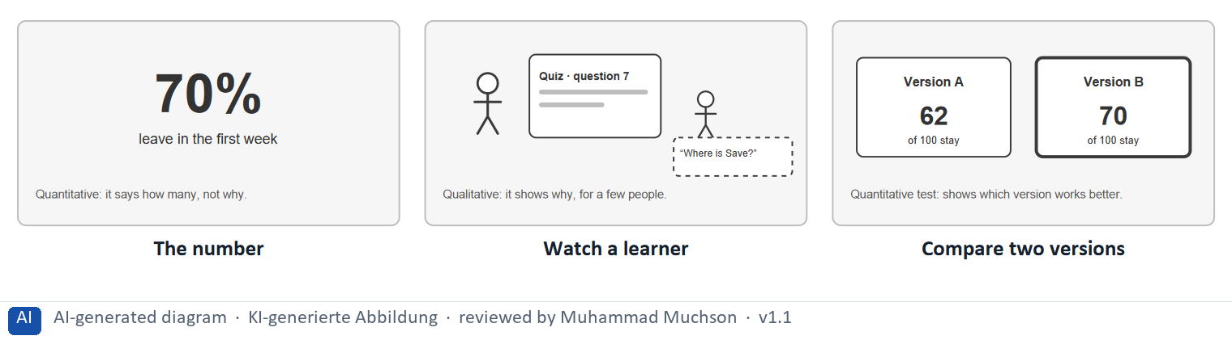
Figure 1 · One LearnLoop drop-out figure seen as a number, by watching, and by comparing.
The point. UX testing finds out how people really behave. Quantitative methods, such as counting or an A/B test, tell you how many and which version is better. Qualitative methods, such as watching a few people, tell you why. You usually need both.
A short story in steps.
1. A number with no reason. Let us look at LearnLoop. Its report says that 70% of new learners leave in the first week. The figure is clear and it is alarming, but it only says how many. The team has no idea why, and any change it makes now is a guess.
2. Watching one learner. Now a researcher watches Sam do the first quiz. He stops at question seven and looks around for a Save button that is hidden below the fold. That is qualitative testing: a few people, and a real reason. It does not say how many are affected.
3. Comparing two versions. So LearnLoop shows half of the learners a version with the button in view, and compares. 70 of 100 stay, against 62 of 100 with the old version. That is quantitative testing, an A/B test: now the team knows how much the change helps.
State shown in the picture | What it means
The number | 70% leave in the first week. That is clear and it matters, and it says nothing about why they leave.
Watch a learner | watching Sam, the team sees him stop at the quiz because he cannot find the Save button. That is a reason, though from only one person.
Compare two versions | the quiz with a visible Save button keeps 70 of 100 learners against 62 of 100. The team now knows the change works, and by how much.

Three test methods, and what each shows
Method | Kind | What it shows
Usability test | Qualitative | Where and why a few people get stuck.
A/B test | Quantitative | Which of two versions does better, and by how much.
Observation | Qualitative | How people behave in their real setting.

Case assumption
LearnLoop and Sam are made up for this example. The rule of thumb of five users for a usability test is Nielsen's, and the A/B test is described by Kohavi and colleagues; check the figures before you use them in a document.

How to decide when this comes up in the task
- Use a usability test to find where and why people get stuck: five to eight learners do set tasks while someone watches.
- Use an A/B test to find which of two versions works better: the same learners are split at random and the figures compared.
- Use observation to learn about real contexts, for example how people use the platform on their own phones.
- Say which kind it is: qualitative gives reasons from few people; quantitative gives amounts from many. A figure alone never says why.
- Combine the two: use figures to find where, and watching to find why.

Extra · go deeper (optional reading)
An A/B test needs enough learners in each group for the difference to mean something. A small difference between 20 and 22 learners is noise, so the size of the groups belongs in the plan.

Sources · Nielsen 2000 · Kohavi et al. 2020 · Rodden et al. 2010

A2 · Tracking and KPIs: what to measure, how to define it, and what data protection asks · 14 min · Core
Tracking records clicks, time and drop-off; data protection sets limits. A KPI is one key figure with a definition and a target, such as completion rate, engagement or drop-out rate.
IN PLAIN WORDS
The idea. Tracking records what users do: clicks, time spent and the points where they drop off. Analytics tools and heatmaps show it, and data protection and ethics set limits on what may be collected. A KPI is one key figure chosen to show whether you reach a goal, such as completion rate, engagement or drop-out rate. A KPI needs a definition and a target.
Why it matters. In Block 1.1 you sort facts into measuring problems, and in Block 2.2 you define three KPIs. This card gives the tests.
How to read the picture. One LearnLoop dashboard with four features that can be on or off: only three KPIs, a definition under each, a target, and a split by device.

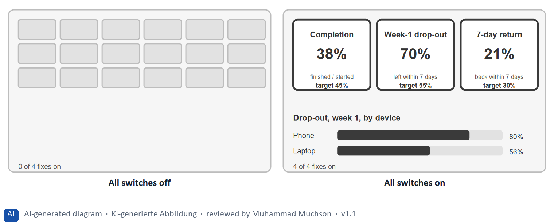
Figure 2 · One LearnLoop dashboard and four fixes.
The point. A KPI is one key figure chosen to show whether a goal is reached. It works when there are only a few, each has a definition and a target, and the figure can be split to show where the problem is. Many undefined metrics hide the one that matters.
A short story in steps.
1. A wall of metrics. Let us follow Mia, a product manager at LearnLoop, who opens the dashboard on Monday. She sees dozens of small metrics. None is marked as the one that matters, none says what it counts, and none has a target, so she cannot tell whether last week was good or bad.
2. Three KPIs that can be judged. Now the dashboard shows three KPIs: completion, first-week drop-out and seven-day return. Each says what it counts and has a target, and the drop-out is split by device. Mia sees at once that 70% leave and that phones are worse.
3. One at a time. A team can do these in steps. Block 2.2 asks you to define three KPIs, and a measure to do the same.
Switches | What it means
All off | 0 of the 4 fixes are on. A wall of small metrics, and none stands out. Nothing shows where the drop-out concentrates.
All on (Only three KPIs, A definition under each, A target for each, A split by device) | 4 of the 4 fixes are on. Three numbers stand out, so Mia knows where to look. Each says what it counts. Each has a target, so it can be judged. Splitting by device shows that phone learners leave more.

Three common KPIs, how to define each, and a trap
KPI | A definition | A trap
Completion rate | Learners who finish a course, out of those who started it. | Counting only those who stayed to the end.
Engagement | A stated behaviour, for example learners who return within seven days. | Defining it as clicks, which may mean nothing.
Drop-out rate | Learners who leave within a stated time, out of those who started. | Leaving the time frame open, so figures cannot be compared.

Case assumption
LearnLoop and Mia are made up for this example. The HEART framework (Rodden et al. 2010) is one way to choose UX metrics; the GDPR sets the rules for personal data in the EU, and which apply to a case depends on the data, so check before relying on it.

How to decide when this comes up in the task
- Sort a fact as a measuring problem when the trouble is in what is tracked or how it is defined: too many metrics, a metric with no definition, a metric that does not measure what its name says, tracking beyond need or without notice.
- Define a KPI with a name, a definition (what exactly is counted) and a target; keep the main ones to about three.
- Prefer KPIs that show an outcome and tie to behaviour: completion rate, first-week drop-out rate, seven-day return rate. Page views and total registered users show use or only rise.
- Check that a metric measures what it claims: engagement as a count of clicks, or time spent as the time a tab is open, may not show attention or learning.
- Collect only what a question needs, tell users what is tracked and get consent where it is required (GDPR); tracking with names and no notice is a problem.

Extra · go deeper (optional reading)
A heatmap shows where people click or how far they scroll on a page, as colour. It shows where, not why, so it is a starting point for a question and not an answer. A vanity metric is a number that looks good and does not guide a decision, such as total registered users.

Sources · Rodden et al. 2010 · GDPR · Croll and Yoskovitz 2013 · Few 2013

A3 · Reading data: patterns, symptoms and causes, misreadings and hypotheses · 12 min · Core
Data shows symptoms, not causes. Look for several possible causes, never jump from a number to an explanation, compare only like with like, and turn a guess into a testable hypothesis.
IN PLAIN WORDS
The idea. Reading data means finding patterns and then looking for causes, not only symptoms. A symptom is what the data shows, such as 70% drop-out. A cause is why, and the data alone rarely says it. Misreadings come from jumping from a number to an explanation, and from comparing periods that are not alike. A hypothesis is a testable guess: we believe …, so we will …, and expect ….
Why it matters. Task 1 asks for causes of a 70% drop-out rate, and Block 1.1 asks which fact jumps from a symptom to a cause. This card is the test for both.
How to read the picture. The same LearnLoop figure read three ways: as a jump to one cause, as a list of possible causes, and as a hypothesis that is tested.

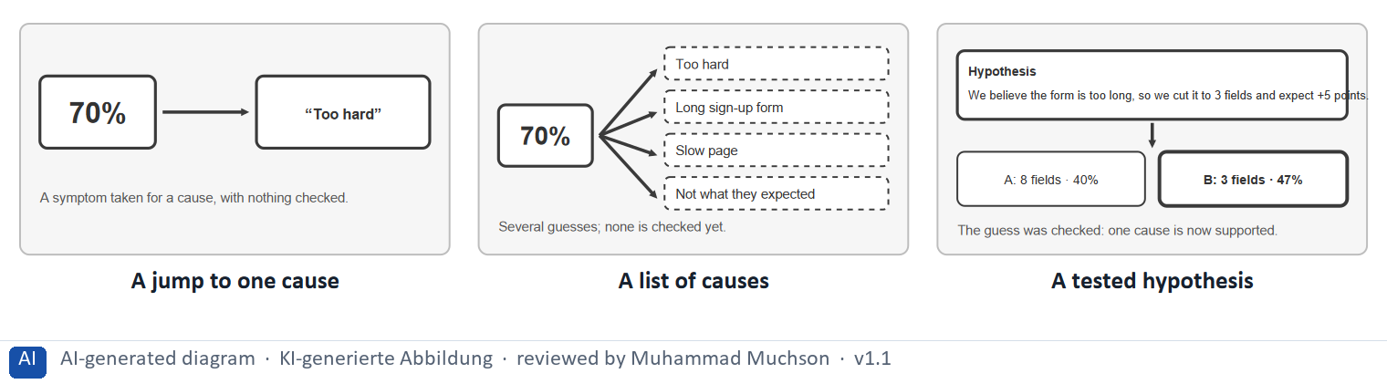
Figure 3 · The same LearnLoop figure read as a jump, as a list of causes, and as a tested hypothesis.
The point. Data shows symptoms, not causes. A symptom such as 70% drop-out has many possible causes. Jumping to one of them without a test is the commonest misreading. A hypothesis, a testable guess, turns a guess into something that can be checked.
A short story in steps.
1. The jump. Let us look at a LearnLoop report: 70% of learners leave in the first week, so the content must be too hard. The team rewrites three lessons over two months. The drop-out stays at 70%, because “too hard” was a guess that nobody had checked.
2. Keeping the question open. A better reading lists what else could cause it: a long sign-up form, a slow page, a course that is not what people expected, and too-hard content as one entry among them. Short time spent fits all of these, so the number alone cannot choose.
3. A guess that can be checked. Then the team writes one cause as a hypothesis: we believe the form is too long, so we cut it to three fields and expect completion to rise. It tests it with half of the learners, and the result is 47% against 40%.
State shown in the picture | What it means
A jump to one cause | the team reads 70% and says the content is too hard. Nothing was checked, so the team rewrites three lessons and the drop-out does not move.
A list of causes | the same 70% could come from content that is too hard, a long sign-up form, a slow page or a course that is not what people expected. The list keeps the question open.
A tested hypothesis | the team picks one cause, writes it as a hypothesis and tests it. A form with three fields keeps 47% against 40%, so the form is a real cause.

Three misreadings, and how to avoid each
Misreading | Example | How to avoid it
A symptom taken for a cause | “70% leave, so the content is too hard.” | List several causes and test one.
Unlike periods compared | A rise called a success; last month had a holiday. | Compare like with like.
Many changes at once | Five launches in a month; which one worked? | One change per cycle, with a hypothesis.

Case assumption
LearnLoop and its figures are made up for this example. The idea of turning a guess into a testable hypothesis follows the lean approach of build, measure, learn (Ries 2011).

How to decide when this comes up in the task
- Sort a fact as a reading problem when a conclusion is drawn that the data does not support: a symptom taken for a cause, or two periods compared that are not alike.
- Tell a symptom from a cause: a symptom is what the data shows (70% leave); a cause is why, and the data alone rarely says it.
- Before acting, list several possible causes for a number, such as a long form, a slow page or a mismatch with expectations, and only then choose which to test.
- Compare like with like: the same weekdays, the same type of learner, no holiday against a normal period.
- Write a hypothesis in the form “we believe …, so we will …, and expect …”, with a figure, and change one thing at a time so that the effect can be seen.

Extra · go deeper (optional reading)
Correlation is not causation: two figures that move together may both be driven by a third. A rise in logins and a rise in drop-out in the same month may both come from a marketing campaign that brought many casual visitors.

Sources · Ries 2011 · Kohavi et al. 2020 · Nielsen 2000

A4 · Data-driven optimisation: hypothesis, test, evaluate, repeat · 10 min · Optional
Data-driven optimisation is a loop: hypothesis, test, evaluate, decide, and back to a new hypothesis. One change at a time, with each result starting the next guess.
IN PLAIN WORDS
The idea. Data-driven optimisation is a loop. You develop a hypothesis, test it, evaluate the result and decide what to do next, and the result starts the next hypothesis. It is continuous improvement: small steps, one change at a time, so that the effect of each can be seen.
Why it matters. Block 3.1 asks for hypotheses and a decision architecture. The core of the loop is repeated in A3 and B1, so no Core block needs this card.
How to read the picture. A loop of four steps: hypothesis, test, evaluate, decide.

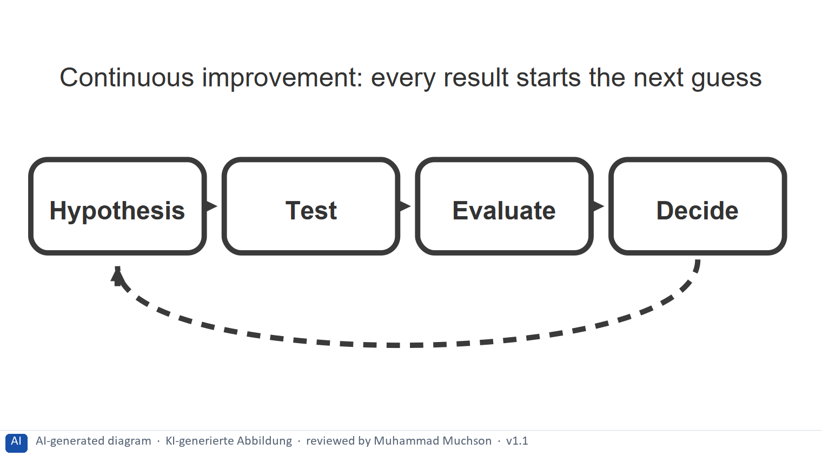
Figure 4 · .
Case assumption
LearnLoop is the example company.

How to decide when this comes up in the task
- Run the loop in short cycles of about two weeks, one change each.
- Decide by a rule agreed in advance: keep, change or drop the change.
- Keep going: every result starts the next hypothesis.

Extra · go deeper (optional reading)
A decision rule agreed before the test, such as “keep the change if first-week drop-out falls by at least three points”, stops the team from arguing about the result afterwards.

Sources · Ries 2011 · Kohavi et al. 2020

A5 · Weighing a data-based measure: KPI impact, effort, risk · 10 min · Core
Rate a measure by how much it would move the KPI or the team's ability to move it, what it costs and what could go wrong. Define what matters first, then look for causes, and show data last.
IN PLAIN WORDS
The idea. To choose between data-based measures, rate each on the same three questions. KPI impact: how much would it move the drop-out rate or the completion rate, or the team's ability to do so? Effort: money and time, decided here by a rule: under €7,000 is Low, up to €14,000 is Mid, above that is High. Risk: what could go wrong, for example that the team reads the data wrongly again.
Why it matters. Block 1.2 and Block 2.2 of the task ask for exactly this. The example uses LearnLoop, so the answer for the task case is not given.
How to read the picture. Three small pictures show LearnLoop's three measures, the bars show the cost of each against the effort rule and the €30,000 budget, and the table gives the rating of each.

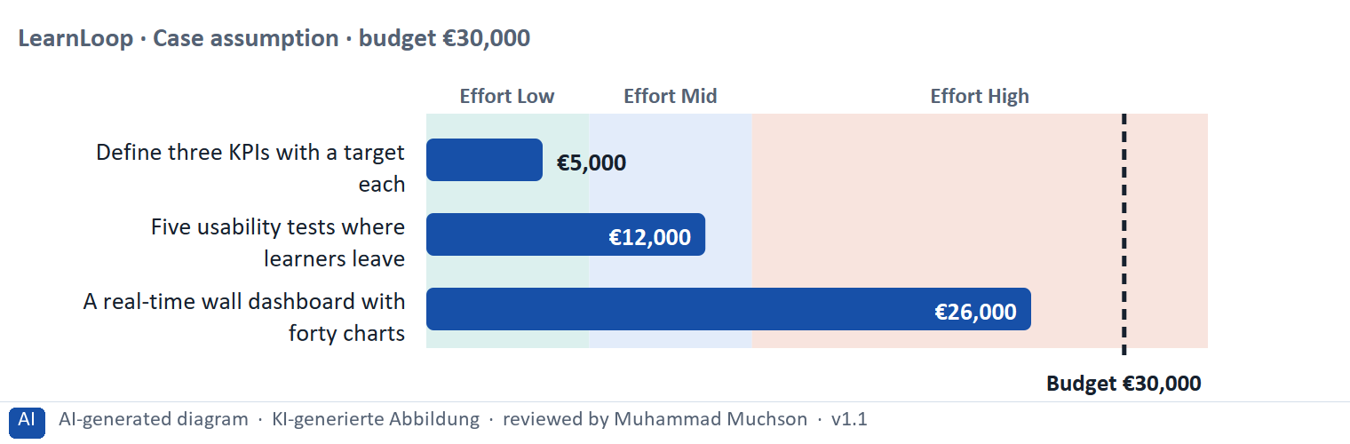
Figure 5 · A worked example: LearnLoop weighs three data-based measures.
The point. Rate a measure by how much it would move the KPI or the team's ability to move it, by its printed cost, and by what could go wrong. Defining three KPIs is cheap and prepares everything else. A wall of charts costs a lot and moves no KPI.
A short story in steps.
1. The setting. Let us look at LearnLoop once more. Learners leave early, the budget is €30,000, and three ideas are on the table. We rate each on three questions: how much it would move the KPI (KPI impact), what it costs (effort), and what could go wrong (risk).
2. Three KPIs. Defining three KPIs costs €5,000, so the effort is Low. The team finally knows which number to move, so the KPI impact is High, and the risk is Low because it only agrees definitions. Five usability tests cost €12,000, Mid effort, with Mid impact and Mid risk.
3. A wall of charts. The wall dashboard costs €26,000, so the effort is High. It shows more numbers but no new insight, so the impact is Low, and the risk is High because it adds noise and looks like action. So: define what matters first, look for causes next, show data last.
Measure (LearnLoop, Case assumption) | Cost | Effort | KPI impact | Risk | Reasons
Define three KPIs with a target each | €5,000 | Low | High | Low | Effort: €5,000 is under €7,000: Low. KPI impact: The team finally knows which number to move and when it has succeeded. Risk: It only agrees definitions and targets.
Five usability tests where learners leave | €12,000 | Mid | Mid | Mid | Effort: €12,000 lies between €7,000 and €14,000: Mid. KPI impact: It finds real causes for the screens tested, though only for those screens. Risk: Five learners show the main hurdles, not every one.
A real-time wall dashboard with forty charts | €26,000 | High | Low | High | Effort: €26,000 is above €14,000: High. KPI impact: More charts show more numbers, but no new insight into why learners leave. Risk: It adds to the noise, and the team may feel it is acting on data when it is only looking.

Case assumption
LearnLoop, its costs and its reasons are made up for this example. The task case is in the task.

How to decide when this comes up in the task
- Rate effort by the printed cost: under €7,000 is Low; €7,000 to €14,000 is Mid; above €14,000 is High.
- Rate KPI impact by how far it would move the drop-out or completion rate, or the team's ability to do so: a measure that fixes a cause or sharpens the KPI outweighs one that only shows more numbers.
- Rate risk by what could go wrong: the team reading the data wrongly again, noise from more charts, a test on too few learners, a privacy problem.
- Justify the order with data, then insight, then decision: say how your first measure turns data into an insight.
- Say what you do not know, for example where the drop-out concentrates, and how you would find out.

Sources · Gibbons 2018 · Rodden et al. 2010

Materi B · Route 2 · Level 3
How Materi B is used
About 60 minutes, three cards. Level 3 asks you to decide as a manager, between goals that pull apart, and to take responsibility. Task 2 uses all three cards.

B1 · UX as a measurable and controllable system: KPI, hypothesis, test, decision · 18 min · Core
UX can be a measurable and controllable system: a KPI says what matters, a hypothesis says what will change it, a test checks the guess, and a decision follows. Data leads to insight, and insight to a decision.
IN PLAIN WORDS
The idea. The plan's goal is to understand UX as a measurable and controllable system. A data-driven strategy chains four things: a KPI that says what matters, a hypothesis that says what will change it, a test that checks the guess, and a decision that follows from the result. The plan's rationale is data, then insight, then decision.
Why it matters. Task 2 asks for the central KPIs, an analysis and tracking strategy, hypotheses and a decision architecture. This chain gives you the order.
How to read the picture. The chain reads from left to right: KPI, hypothesis, test, decision. Below it, the test for each link.

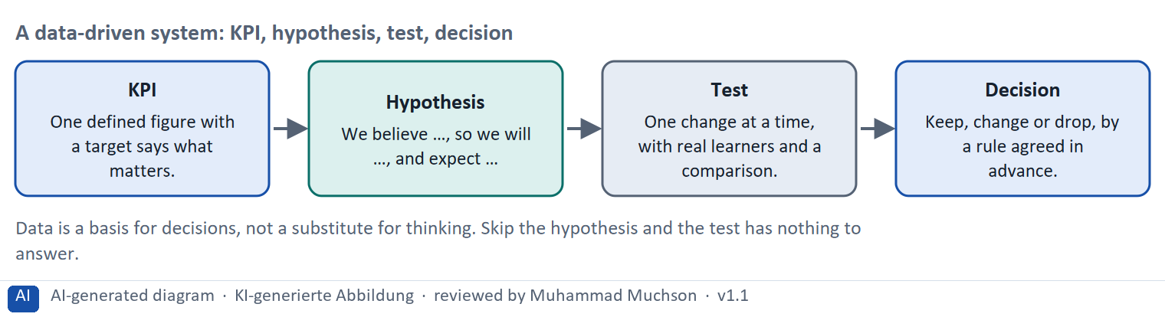
Figure 6 · A data-driven system: KPI, hypothesis, test, decision.
The test for each link of the chain
Link | The test | What goes wrong without it
KPI | Does it have a name, a definition and a target? | Nobody knows what to move.
Hypothesis | Does it name a change and an expected effect? | The test has nothing to answer.
Test | One change at a time, with a comparison? | Effects cannot be told apart.
Decision | Is the rule agreed before the result? | The result is argued about afterwards.

Case assumption
The chain follows the plan's goal: understand UX as a measurable and controllable system. LearnLoop is the example company. Data protection rules apply to tracking; for a real case they must be checked.

How to decide when this comes up in the task
- Decide on a strategy that starts from a question: define three KPIs, write a hypothesis for each change, change one thing at a time, and track only what the hypotheses need. Reject “track everything” (it repeats the misreading and is a privacy risk) and “decide on intuition” (it gives up the measurable system).
- Plan the analysis and tracking: split drop-out by week, device and course; combine numbers with tests with real learners; tell users what is tracked and get consent; write down each KPI's definition and owner.
- Sort a statement as a testable hypothesis only if it names a change and an expected effect, ideally with a figure; “we should improve the UX” and “the new menu is better” are not hypotheses.
- Build a decision architecture: a role decides, on a named figure or test, by a rule agreed before the result, and says what intuition still decides.
- Say what you do not know and how to find out: which screen causes most of the drop-out.

Extra · go deeper (optional reading)
A decision architecture is the set of agreements about who decides what, on which evidence and by which rule. It makes decisions repeatable, so that they depend less on whoever is in the room.

Sources · Ries 2011 · Rodden et al. 2010 · GDPR · Kohavi et al. 2020

B2 · Conflicting goals: data against intuition, more data against more insight · 22 min · Core
More data is not more insight, and intuition alone is not enough. Look for an approach that uses enough data and gives a real insight into causes; data is a basis for decisions, not a substitute for thinking.
IN PLAIN WORDS
The idea. The plan's discussion for Day 16 is data against intuition, and UX as a measurable system. More data is not more insight: a wall of charts can hide the question. Intuition is not useless either: data shows what happened, and judgement still decides what to try and what the product stands for. The aim is data as a basis for decisions, not a substitute for thinking.
Why it matters. Task 2 asks for a risk analysis and a decision architecture. The rules of this card tell you how to weigh them.
How to read the picture. The matrix places six LearnLoop approaches by the amount of data they use (to the right) and the insight into causes they give (upwards). The position is a reading of the example, not a score. The top right is the aim.

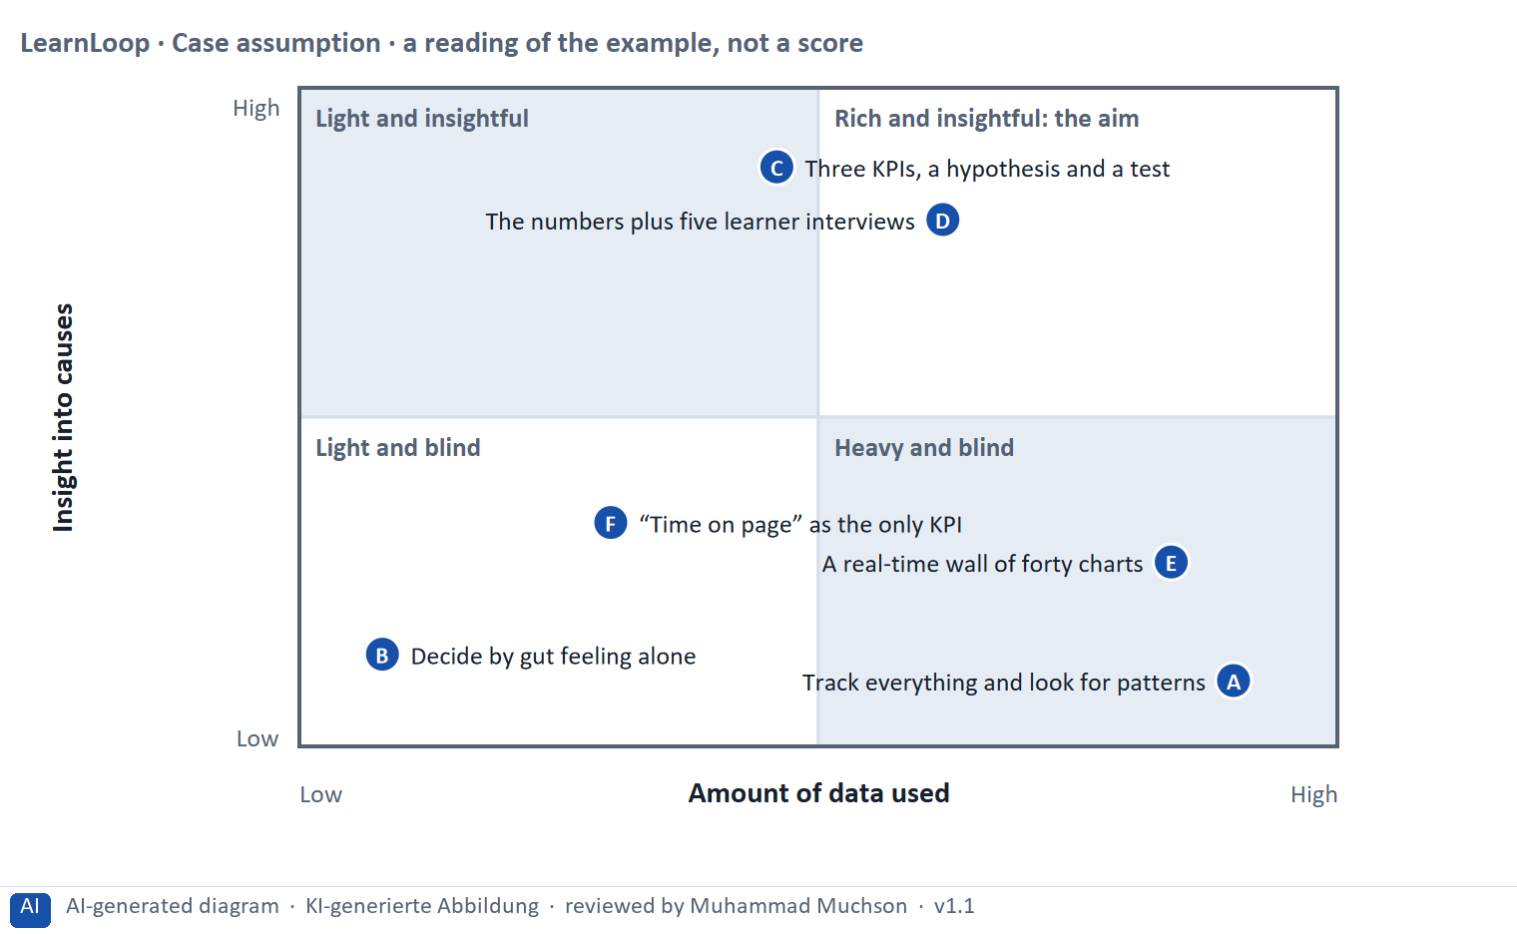
Figure 7 · A worked example: six LearnLoop approaches by the data they use and the insight into causes they give.
The point. More data is not more insight, and intuition alone is not enough. Look for the approach that uses enough data and gives a real insight into causes. Data shows what happened; judgement still decides what to try.
A short story in steps.
1. Too much data, too little insight. Let us look at LearnLoop's approaches. Tracking everything and searching for patterns collects a mountain of data and answers no question, and a wall of forty charts only looks like insight. On the other side, deciding by gut feeling uses no data at all.
2. A small amount of data, aimed. Three KPIs, a written hypothesis and one test use little data and answer one question well. With a few learner interviews added, the numbers say where and the learners say why. That is the aim: enough data, and real insight.
3. Data against intuition. Data does not replace thinking: someone still decides which hypothesis to test first and what the product stands for. And an easy number such as time on page can mislead.
Point | The idea | Why it sits there
A | Track everything and look for patterns | A great deal of data and no question, so the patterns found mean little. Heavy and blind.
B | Decide by gut feeling alone | No data and no test: the team cannot tell whether a guess was right. Light and blind.
C | Three KPIs, a hypothesis and a test | Little data, aimed at one question, and a test that answers it. A real insight into a cause. This is the aim.
D | The numbers plus five learner interviews | The data says where, and the interviews say why. A good combination of numbers and UX understanding.
E | A real-time wall of forty charts | A great deal on show and little understood: it looks like insight and gives none.
F | “Time on page” as the only KPI | One number that is easy to collect and misleading: a tab left open overnight counts as success. Light and misleading.

Two conflicts and a rule for deciding each
Conflict | One side gets | The other side gets | A rule for deciding
Data against intuition | Decisions by figures alone | Decisions by judgement alone | Use data as the basis; keep judgement for what data cannot say.
More data against more insight | Track and show everything | A few figures tied to a question | Collect only what a hypothesis needs.

Case assumption
LearnLoop and its six approaches are made up for this example. The positions in the picture are a reading of the example, not a score.

How to decide when this comes up in the task
- Name both poles: too much data and no question (a wall of charts, tracking everything), and no data at all (gut feeling). A plan that names only one pole has not weighed the conflict.
- Aim for little data aimed at a question: three KPIs, a hypothesis, a test; add learner interviews to learn why.
- Beware a single easy number, such as time on page: it can mislead, so pair every KPI with an outcome.
- Keep judgement where data cannot decide: which hypothesis to test first, how a message should sound, what the product stands for.

Extra · go deeper (optional reading)
Optimising a metric can harm the goal behind it: if time on page is rewarded, pages get slower. The remedy is to pair each KPI with an outcome and with a test, so that the number cannot rise alone.

Sources · Rodden et al. 2010 · Ries 2011 · Klein 2007

B3 · Deciding when the causes are unclear: a decision you can check later · 20 min · Core
When the causes are unclear, test the most likely one cheaply, write a figure you can watch into the plan, agree the decision rule before the result, and say what you give up.
IN PLAIN WORDS
The idea. The plan asks you to decide although the causes of the decline are unclear. A decision under uncertainty states four things: what you decide, what you do not know, what would make you reverse it and by when, and what you give up. A small test of the most likely cause is the cheapest way to learn what you do not know.
Why it matters. Block 3.2 asks for exactly this, together with prioritised measures and a risk analysis.
How to read the picture. The four boxes at the top are the parts of the decision, filled in for LearnLoop. The two boxes below are the rule for future decisions.

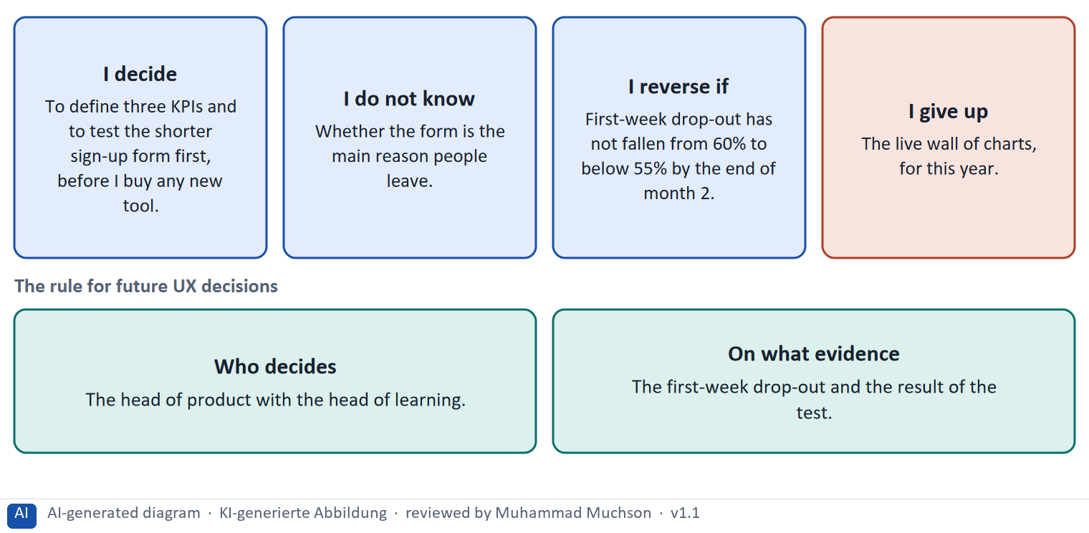
Figure 8 · A decision with unclear causes, filled in for LearnLoop.
Five ways to make a decision with unclear causes safer
Way | What it looks like
Test the likely cause cheaply | A shorter sign-up form for half of the learners, compared with the rest.
Agree the rule first | “Keep it if drop-out falls by five points.” Written down before the test.
Set a figure and a date | The drop-out you expect, and the month you will look.
Fix who decides | A role, with the evidence it needs.
Name what you give up | Something real that someone would miss.

Case assumption
LearnLoop and its figures are made up for this example; the task case is in the task.

How to decide when this comes up in the task
- A decision under uncertainty states four things: what you decide, what you do not know, what would make you reverse it and by when, and what you give up.
- A reversal condition has a figure you can watch and a time: “first-week drop-out has not fallen from 60% to below 55% by the end of month 2”.
- Start with the most likely and cheapest cause to test, such as the sign-up form, and agree what result would count as success before you look.
- Do not wait for perfect data: waiting while drop-out grows is also a decision.
- Giving up nothing means you have not decided: name what you postpone, for example a new tool or a live dashboard.

Extra · go deeper (optional reading)
Premortem: imagine the strategy failed. Typical answers here: we misread the data again, we collected more than anyone could read, and we optimised a number and not the learner. Each answer becomes a check.
One-way and two-way doors: a test behind a switch is a two-way door; storing every click for good is a one-way door that is hard to undo.

Sources · Klein 2007 · Bezos 2016 · Kohavi et al. 2020

Use in class: presentation and handout
Mark of use for the study material. Presentation is what the trainer shows on screen; Handout is what participants read and keep.
Card | Presentation (shown on the playground) | Handout
A1 · UX testing: usability tests, A/B tests and observation, qualitative and quantitative (Core) | Scan line and Figure 1; the "In plain words" and "How to decide" boxes | The whole card
A2 · Tracking and KPIs: what to measure, how to define it, and what data protection asks (Core) | Scan line and Figure 2; the "In plain words" and "How to decide" boxes | The whole card
A3 · Reading data: patterns, symptoms and causes, misreadings and hypotheses (Core) | Scan line and Figure 3; the "In plain words" and "How to decide" boxes | The whole card
A4 · Data-driven optimisation: hypothesis, test, evaluate, repeat (Optional) | Not shown (self-study) | The whole card
A5 · Weighing a data-based measure: KPI impact, effort, risk (Core) | Scan line and Figure 5; the "In plain words" and "How to decide" boxes | The whole card
B1 · UX as a measurable and controllable system: KPI, hypothesis, test, decision (Core) | Scan line and Figure 6; the "In plain words" and "How to decide" boxes | The whole card
B2 · Conflicting goals: data against intuition, more data against more insight (Core) | Scan line and Figure 7; the "In plain words" and "How to decide" boxes | The whole card
B3 · Deciding when the causes are unclear: a decision you can check later (Core) | Scan line and Figure 8; the "In plain words" and "How to decide" boxes | The whole card

References
Check each source and its current edition before you teach from it. Standards and laws marked as in flux can change.
Nielsen, J. (2000). Why You Only Need to Test with 5 Users. Nielsen Norman Group. https://www.nngroup.com/articles/why-you-only-need-to-test-with-5-users/ — five users in a test find most of the usability problems; run several small tests rather than one large one.
Kohavi, R., Tang, D., & Xu, Y. (2020). Trustworthy Online Controlled Experiments: A Practical Guide to A/B Testing. Cambridge University Press. — how to run and read controlled experiments, and why many ideas do not move the metric they were built for.
Rodden, K., Hutchinson, H., & Fu, X. (2010). Measuring the user experience on a large scale: User-centered metrics for web applications. Proceedings of CHI '10, 2395–2398. — the HEART framework: happiness, engagement, adoption, retention, task success.
Regulation (EU) 2016/679 (General Data Protection Regulation, DSGVO), in particular Articles 5 (principles), 6 and 7 (lawfulness and consent) and 22 (automated individual decisions). In flux for tracking: also check § 25 TDDDG (access to information on a user's device) and current guidance of the data-protection authorities.
Croll, A., & Yoskovitz, B. (2013). Lean Analytics. O'Reilly. (Choose one metric that matters, and beware of vanity metrics.)
Few, S. (2013). Information Dashboard Design (2nd ed.). Analytics Press. (A dashboard should show what matters at a glance, not everything.)
Ries, E. (2011). The Lean Startup. Crown Business. — the Build–Measure–Learn loop.
Gibbons, S. (2018). Using Prioritization Matrices to Inform UX Decisions. Nielsen Norman Group. https://www.nngroup.com/articles/prioritization-matrices/ — a prioritisation matrix plots items on two criteria, for example value to the user against effort.
Klein, G. (2007). Performing a project premortem. Harvard Business Review, 85(9), 18–19. — imagine the plan has failed and ask why; it brings risks to the surface before the money is spent.
Bezos, J. (2016). 2015 Letter to Shareholders. Amazon. — decisions that are hard to reverse ("one-way doors") deserve more care than those that can be reversed cheaply ("two-way doors").

Glossary
Every term below is used in this document. Terms stay plain text in the body; this list says what they mean in everyday words.
Term | In plain words | Example | Comes from
A/B test and control group | Two versions are shown to similar groups of users at the same time and the results are compared. The group that sees the old version is the control group. It shows whether a change made a difference. | Half of new learners see the old start screen, half the new one; compare how many finish lesson 1. | Kohavi et al. 2020
Build–Measure–Learn | A loop from lean product development: build the smallest version that can be tested, measure what users do, and learn whether to keep, change or drop the idea. | Build a clickable path, watch five learners use it, learn that nobody sees the Next button. | Ries 2011
Cohort analysis | Looking at a group of users who share something, such as the week they signed up, and following that group over time. It shows whether the same group behaves differently from another, and where drop-out concentrates. | Drop-out of everyone who signed up in March, compared with those who signed up in April. | Materi A5
Completion rate | The share of people who start a course and finish it. It is the opposite side of the drop-out rate: 60% completion means 40% drop-out. | — | —
Conflicting goals (trade-off) | Two goals that both matter, but cannot both be fully met: for example a simple screen against depth of content. A trade-off means you decide how much of each to keep, and say what you give up. | — | —
Consent | A person's free and informed agreement to the collection of their data, given before it happens. In the EU the GDPR requires a lawful basis for collecting personal data, and for some tracking that basis is consent. Which one applies depends on the data and the purpose. | A banner that lets a learner say yes or no to analytics cookies before they are set. | Materi A2
Decision architecture | The rule for how future decisions are made: who decides and what evidence they need. It stops a decision from resting on one person's taste. | — | —
Drop-out rate | The share of people who start something and stop before the end. A 40% drop-out rate means 40 of every 100 learners who start a course do not finish it. It counts who left, not why. | 100 learners start; 60 finish; the drop-out rate is 40%. | —
DSGVO (GDPR) | The European data protection law (in English GDPR). It says when personal data may be collected and used, requires a clear purpose and, for tracking and profiling, often consent. It matters for learning analytics and adaptive systems. | A recommendation engine that profiles learners needs a legal basis. | Regulation (EU) 2016/679
Engagement | How much a learner actually does on the platform: lessons opened, tasks tried, time spent. High engagement is a sign that the platform holds attention; it does not prove they learned. | — | —
HEART framework | Google's list of five user-centred metric categories: happiness, engagement, adoption, retention and task success. It helps to avoid choosing a metric only because it is easy to count. | — | Rodden et al. 2010
Heatmap | A picture of a page in which colour shows where people click, tap or how far they scroll. It shows where something happens, not why, so it is a starting point for a question. | A red patch on a button that nobody reads, but everybody taps. | Materi A2
Hypothesis-based approach | Writing down what you expect before you change something: "We believe that X will lead to Y; we will know when Z moves." It makes the result checkable. | "We believe a next-step button will raise the 7-day return rate by five points." | Gothelf & Seiden 2013
KPI (key performance indicator) | A number a team agrees to watch to judge whether something works, such as completion rate or time to finish a lesson. A good KPI has a baseline and a target. | Completion rate of the first course: 58% today, goal 65% in six months. | —
Machine learning | A way for a computer to find patterns in a lot of data and use them to make predictions, such as which lesson suits a learner. It needs a lot of good data, and it usually cannot say why it chose what it chose. | A model that learns from thousands of learners which lesson to show next. | Materi A2
Premortem | A planning exercise: you imagine that the plan has failed a year from now and ask what went wrong. It brings risks to the surface before the money is spent. | "It is next March and the new course paths are not used. Why?" Answer: nobody told the trainers. | Klein 2007
Qualitative and quantitative data | Qualitative data says why: observations, quotes, interviews, usually from a few people. Quantitative data says how many or how much: counts, rates, times, usually from many people. | Five learners say they miss a Next button (qualitative); 40% leave on lesson 3 (quantitative). | —
Return rate | The share of learners who come back within a set time, for example within seven days. It is a simple sign of retention. | 62 of 100 new learners return within a week. | —
Rule-based system | A system that decides by rules a person has written down, in the form “if this, then that”. It needs little data, and a learner can be told exactly which rule applied. | “If the test is passed, skip the lesson; if it is failed, repeat it.” | Materi A2
Symptom and cause | A symptom is what you can see or count (people leave). A cause is the reason behind it (they cannot find the next lesson). A number such as a drop-out rate shows the symptom, not the cause. | 40 of 100 learners leave is a symptom; "the course has no path" is a cause. | —
Touch target | The area a finger can press to use a button or a link. Small targets are hard to hit, above all for people with a tremor or on a moving train. WCAG 2.2 requires at least 24 px at Level AA; 44 px is a common aim. | A Next button 44 px high is easy to hit with a thumb; one 20 px high is not. | WCAG 2.2
Tracking | Recording what users do on a platform, such as clicks, time spent and where they leave. It helps to understand behaviour, and data protection and ethics set limits on what may be collected and how long it is kept. | Recording that a learner left the course page after 40 seconds. | Materi A2
Usability | How well a system lets users reach their goals with little effort and few errors, and how satisfied they are. It is one part of the whole experience. | — | ISO 9241-11
Usability test | You watch real users try a task on the product while they think aloud, and note where they hesitate or fail. Five to ten people already show the main problems. | — | —
Vanity metric | A number that looks good and does not help to decide anything, because it mostly only rises. Total registered users is a typical case. A useful KPI ties to behaviour and an outcome. | “10,000 users registered” says nothing about how many ever finished a course. | Materi A2

The playground: where we practise online
In class we use the course website as the place to practise and to learn. Every day has its own address, in the same pattern: the day number is the last part.
What | Address
Course website (playground) | https://aion-dl.vercel.app/
Day 16 | https://aion-dl.vercel.app/day/16/

On the day page, Route 1 (Levels 1 and 2) and Route 2 (Level 3) can be opened; the cards and the tasks of this document are there too. The pattern is the same up to Day 8, for example https://aion-dl.vercel.app/day/6/.

