HABMANN AUFSTIEGSAKADEMIE · DIGITAL LEARNING · EDUCATIONAL UX/UI DESIGN
DAY 12 · MATERI A AND MATERI B · ROUTES 1 AND 2 · LEVELS 1 TO 3
Adaptive learning, a gamified prototype
Adaptive learning systems, UX design patterns for personalised learning paths, practical project: prototype a gamified learning platform
AI notice · KI-Hinweis
This document was produced with the help of an AI language model (Claude, Anthropic). The AI drafted the text and tables and drew the diagrams from code. The content was then read, corrected and approved by the reviewer named below, who is responsible for its accuracy. Every diagram carries an AI label on the image. Check figures and sources before you quote them.
KI-Hinweis: Dieses Dokument wurde mit Unterstützung eines KI-Sprachmodells (Claude, Anthropic) erstellt. Texte und Tabellen wurden von der KI entworfen, die Abbildungen sind KI-generiert und am Bild gekennzeichnet. Die fachliche Prüfung und Freigabe erfolgte durch die unten genannte Person.

Day | Day 12 · Module 5 (day 2 of 2): Adaptive learning systems, UX design patterns for personalised learning paths, practical project: prototype a gamified learning platform
Document | Materi (study material). Materi A has five cards, Materi B has three.
Route and level | Materi A serves Route 1 (Levels 1 and 2, Task 1). Materi B serves Route 2 (Level 3, Task 2).
Time | Materi A about 60 min · Materi B about 60 min (facilitator-led)
Playground (website) | https://aion-dl.vercel.app/day/12/
Case | Worked examples use LearnLoop, an online-course provider. The task case is AdaptLearn, an ambitious but ineffective system(see the Task document).
Version | 1.1 · release date 14.10.2026
Review and approval | Muhammad Muchson, Mentor (subject-matter review and approval)

ABOUT THIS DOCUMENT
In class we also use the playground, the course website, as the place to practise and learn. Its address is at the end of this document.
This document holds everything you need to study Day 12 without the website. Each card says the idea in plain words, shows it in a picture, gives the details, and ends with the rules you will use in the Task document. Cards marked Optional are not needed for the Core blocks of the task. The worked examples use LearnLoop, a different company from the task case, so no task answer is printed here. Glossary and references are at the end.

IN THIS DOCUMENT
Lesson plan: ten teaching units (Ablaufplan)
Case study and transfer project at a glance
A1 · Adaptive learning systems: collect, analyse, adapt · 14 min · Core
A2 · Technology and algorithms: rules, models and their limits · 14 min · Core
A3 · UX patterns for personalised learning paths · 12 min · Core
A4 · Opportunities and risks, and the link to gamification · 10 min · Optional
A5 · Weighing a personalisation measure: benefit, effort, risk · 10 min · Core
B1 · Personalisation as a strategic UX option: need, data, technique, explanation · 18 min · Core
B2 · Conflicting goals: UX against technology, personalisation against standardisation · 22 min · Core
B3 · Deciding with an incomplete data basis: a decision you can check later · 20 min · Core

Day at a glance
Day 12 has ten teaching units (UE). This document is the study material; it is used in UE1 (Materi A) and UE8 (Materi B). The day is built from three documents and the playground: Materi (study material), Task (worksheet) and Trainer (coaching, feedback and model solutions), plus the course website.

Lesson plan: ten teaching units (Ablaufplan)
UE | Min | Plan item | What happens | Material | Format
1 | 45 | Knowledge transfer · Level 1 | The trainer presents the Core cards of Materi A (A1, A2, A3, A5, about 50 min of cards) on the playground; participants follow in the handout. Optional A4 is read from the handout. | Materi A (Route 1) | Presentation + Handout
2 | 45 | Level 1 · Task 1 | Individual work on Block 1.1 (Core, about 13 min). Pairs then compare their results and the trainer collects open questions. | Task 1 · Part 1 · Block 1.1 | Handout (or on the playground)
3 | 45 | Level 1 · Task 2 | Three options are rated on three criteria and one is chosen with a reason: Block 1.2 (Optional, about 8 min). Groups that skip Optional blocks use the time to finish Block 1.1 and to read the Optional cards. | Task 1 · Part 1 · Block 1.2 | Handout (or on the playground)
4 | 45 | Coaching · transition from Level 1 to Level 2 | Trainer-led. A short talk on the day's coaching focus, then the reflection questions in pairs: Block 1.3 (Optional, about 5 min). The bridge: from reading an interface to deciding under limits. | Task 1 · Block 1.3  Trainer document, section Coaching | Trainer only + Handout
5–6 | 90 | Level 2 · Case study AdaptLearn (2 UE) incl. model solution | UE5: the trainer presents the case; participants work on Block 2.1 (Optional, about 7 min) and Block 2.2 (Core, about 17 min). UE6: groups compare their order and defend it; the trainer closes with the model solution (core logic). | Task 1 · Part 2 · Blocks 2.1, 2.2  Trainer document, section Case study | Handout; model solution shown after the work
7 | 45 | Level 2 + 3 · Feedback round with a management perspective | Groups present their reasoning, not only their result. The trainer asks the day's Level 3 input questions and leads the discussion. | Trainer document, section Feedback round | Presentation by the groups; Trainer only
8 | 45 | Level 3 · Transfer project, Chief Product & UX Officer (3 UE: UE8–10) | The trainer presents Materi B (B1, B2, B3; use the "In plain words" and "How to decide" boxes, the rest is handout) and sets the role and the brief. | Materi B (Route 2) | Presentation + Handout
9 | 45 | Level 3 · Transfer project | Individual work or in pairs on Block 3.1 (Core, about 10 min). | Task 2 · Block 3.1 | Handout (or on the playground)
10 | 45 | Level 3 · Transfer project | Block 3.2 (Core, about 10 min): the decision despite incomplete data. Participants then present the decision and what they give up; the trainer debriefs with the model solution. | Task 2 · Block 3.2  Trainer document, section Transfer project | Handout; model solution shown after the work

One UE is counted as 45 minutes here; breaks are not shown. The times are a guide for the trainer. Optional blocks and cards can be skipped; the Core blocks are enough for a complete answer.

Case study and transfer project at a glance
Component | UE | Duration | Participants work in | Model solution in
Level 2 case study (AdaptLearn) | UE5–6 | 2 UE · 90 min | Task 1 · Part 2 (Blocks 2.1, 2.2) | Trainer document, section Case study
Level 3 transfer project (Chief Product & UX Officer) | UE8–10 | 3 UE · 135 min | Materi B and Task 2 (Blocks 3.1, 3.2) | Trainer document, section Transfer project

Materi A · Route 1 · Levels 1 and 2
How Materi A is used
About 60 minutes, five cards. The plan's Level 1 asks you to understand the fundamentals of the day's topic. Level 2 asks you to analyse a learning interface and to apply them. Task 1 uses all of it on one case. The card A4 is Optional: no Core block of the task needs it.

A1 · Adaptive learning systems: collect, analyse, adapt · 14 min · Core
An adaptive system collects data about behaviour, analyses it and adapts content or difficulty, to give each learner a path that fits. It helps only when the learner can see why.
IN PLAIN WORDS
The idea. An adaptive learning system adapts content to what the learner does. It works in three steps: it collects data about behaviour, it analyses it (for example progress and mistakes), and it adapts the content or the difficulty. The goal is a path that fits one person rather than everyone.
Why it matters. In Task 1 you sort facts about a platform into changes that are opaque, based on a wrong basis, or helpful. You first need to know what the system does.
How to read the picture. The same LearnLoop course three ways: identical for everyone, adapted with a reason, and adapted with no reason.

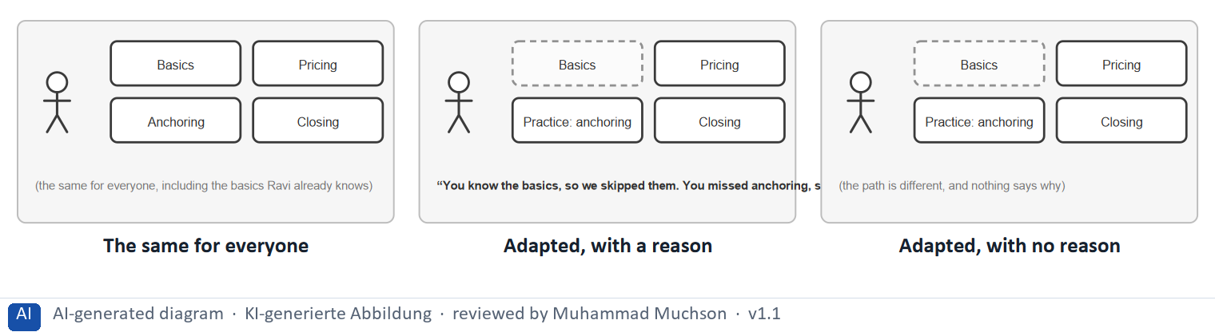
Figure 1 · The same LearnLoop course: identical for all, adapted with a reason, adapted with none.
The point. An adaptive system collects data about what the learner does, analyses it, and adapts the content or the difficulty. Done well, it spares a learner what they know and gives practice where they struggle. Done without a reason, the same adaptation feels like a system that changes things behind the learner's back.
A short story in steps.
1. One path for all. Let us follow Ravi, a learner at LearnLoop who already knows the basics of negotiation. The platform gives him the same four lessons as every other learner, so he spends his first twenty minutes on what he knows. Nothing is wrong, but his time is wasted.
2. An adaptation he can read. Now LearnLoop adapts. It collected his test results, saw that he passed the basics and missed anchoring, and changed the path. A line tells him so: “You know the basics, so we skipped them.” He saves time and knows why, so the adaptation helps.
3. The same change, unexplained. Now take away the line. The path is just as different, but Ravi sees a lesson missing and a new one appear with no word. A good adaptation has become a puzzle, which is how a system ends up not accepted.
State shown in the picture | What it means
The same for everyone | Ravi gets the same four lessons as everyone, including one on basics he already knows. It is clear and cheap, and it ignores how different learners are.
Adapted, with a reason | the basics are skipped and a practice lesson on anchoring is added, and a line says why. Ravi saves time and understands what happened, so he trusts the path.
Adapted, with no reason | the path is exactly as different, but nothing says why. Ravi wonders where a lesson went and whether the platform is working, and may stop trusting it.

The three steps of an adaptive system
Step | What happens | Where it can go wrong
Collect | Data about what the learner does. | Too little data, or the wrong data.
Analyse | Progress, mistakes, speed. | A big conclusion from one data point.
Adapt | Content or difficulty changes. | It changes silently, or cannot be undone.

Case assumption
LearnLoop and Ravi are made up for this example. The definition follows Brusilovsky (2001): adapting content to the individual learner.

How to decide when this comes up in the task
- Sort an adaptation as opaque when something changes with no notice, no reason or no way to see it: a path that says only “updated”, a lesson that vanishes, a recommendation with no reason.
- Sort an adaptation as helpful when the learner sees what changed and why, and can change it back or choose.
- Use the three steps to find where a system goes wrong: it collects the wrong data, it analyses too little, or it adapts too strongly or silently.
- Compare a platform that gives everyone the same content with one that adapts: the first is clear and ignores differences; the second can fit each learner, if it is understandable.

Extra · go deeper (optional reading)
Adaptive systems often rest on a model of the learner, for example what they know. Studies of expertise reversal (Kalyuga et al. 2003) show why adapting matters: help that suits a beginner can slow an expert down.

Sources · Brusilovsky 2001 · Kalyuga et al. 2003

A2 · Technology and algorithms: rules, models and their limits · 14 min · Core
Rules are written by a person, need little data and can be explained. A model finds patterns in a lot of data but cannot say why. With a small data basis, rules are the safer choice.
IN PLAIN WORDS
The idea. There are two broad ways to decide how to adapt. Rule-based systems use if-then logic that a person writes, such as “if the test is passed, skip the lesson”. Data-driven systems, such as machine learning, find patterns in large amounts of data. Their limits are data quality, complexity and transparency: a model with too little data guesses, and a learner cannot be told why it chose.
Why it matters. Block 1.2 asks you to weigh rules against a complex AI system under a small data basis. This card gives the test.
How to read the picture. The same decision three ways: two clear rules, a closed box with lots of data, and a closed box with too little data.

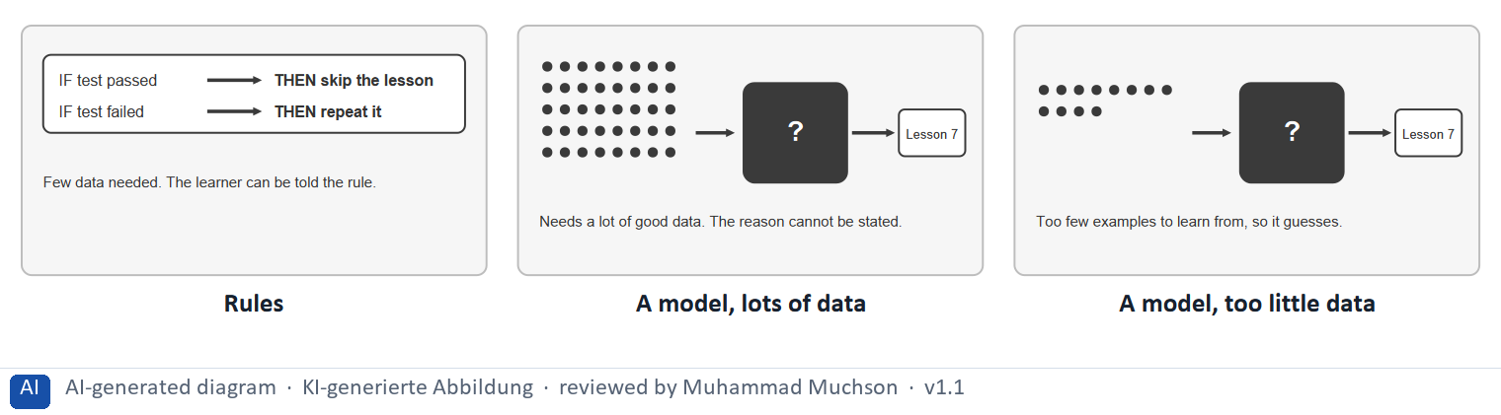
Figure 2 · The same decision by rules, by a model, and by a model with too little data.
The point. Rules are written by a person, need little data and can be explained to the learner. A model finds patterns in a lot of data, but needs good data and cannot say why. With a small data basis, rules are the safer choice.
A short story in steps.
1. Two rules. Let us look at how LearnLoop could choose Ravi's next lesson. The simplest way is two rules a person writes: if he passed the test, skip the lesson; if he failed, repeat it. It needs very little data, and Ravi can be told which rule applied.
2. A model with a lot of data. A model is different. Fed with data from thousands of learners, it may find patterns a person would miss. But the data goes into a closed box, and what comes out has no reason attached, so Ravi cannot be told why he got that lesson.
3. When the data is thin. Now LearnLoop is small, with only a dozen learners to learn from. The model has too little to find a pattern, so it guesses, and a guess in a closed box looks just like a good decision. So with a small data basis, start with rules.
State shown in the picture | What it means
Rules | two if-then rules decide. Little data is needed, a person can read and change them, and the learner can be told exactly which rule applied.
A model, lots of data | a model learns from thousands of learners and may find patterns no person would. It needs a lot of good data, and nobody can say why it picked a lesson.
A model, too little data | with only a dozen examples the model has nothing to learn from, so it guesses, and nobody can tell. This is the case for a small platform.

Rules and models side by side
 | Rule-based | Data-driven (a model)
Needs | Little data and a person who writes the rules. | A lot of good data and skills to build and check it.
Explaining | Easy: “because you passed the test”. | Hard: the reason is inside the box.
Typical risk | Rules too crude for some learners. | Wrong guesses from thin or biased data.

Case assumption
LearnLoop and its values are made up for this example. The need to explain a model's choice is discussed by Ribeiro et al. (2016) and in the guidelines for human-AI interaction (Amershi et al. 2019); the EU AI Act sets rules for AI systems, and which apply to a learning platform depends on its use, so check before relying on it.

How to decide when this comes up in the task
- Match the technique to the data you have: a small data basis points to simple rules; a model needs a lot of good data.
- Prefer a technique you can explain: if the learner cannot be told why a lesson was chosen, trust and acceptance suffer.
- Name the three limits of any system: data quality (is it enough and right?), complexity (can the team maintain it?) and transparency (can it be explained?).
- Treat a complex AI system as high effort and high risk when the data basis is small, however modern it sounds.
- Over-adaptation: a system that reacts strongly to one mistake or a few clicks boxes the learner in; adapt slowly and keep a way back.

Extra · go deeper (optional reading)
A cold start is the moment a new learner has no history, so a model has nothing to go on. A short start questionnaire is the usual answer, and it works with rules as well as with models.

Sources · Ribeiro et al. 2016 · Amershi et al. 2019 · EU AI Act

A3 · UX patterns for personalised learning paths · 12 min · Core
Four UX patterns make a personalised path usable: a recommendation, adaptive difficulty, a dynamic path and behaviour-based feedback. Each works when the learner can see it, understand it and change it.
IN PLAIN WORDS
The idea. A UX pattern is a proven way to show something in an interface. For personalised paths there are four: an individual recommendation, adaptive difficulty levels, a dynamic learning path, and feedback based on behaviour. A pattern works when the learner can see it, understand why it appears, and change it.
Why it matters. In Block 1.1 and Block 2.2 you separate patterns that explain themselves from ones that hide. In Block 3.1 you choose patterns.
How to read the picture. One LearnLoop path screen with four features that can be on or off: a recommendation, difficulty, a path and feedback.

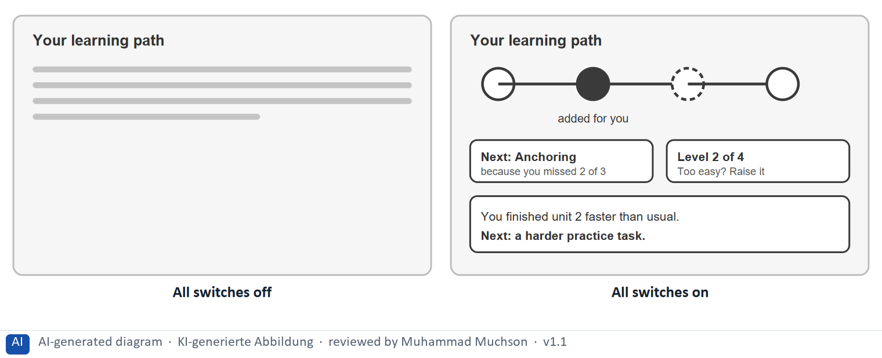
Figure 3 · One LearnLoop path screen and four personalisation patterns.
The point. Four UX patterns make a personalised path usable: an individual recommendation, adaptive difficulty, a dynamic path and behaviour-based feedback. Each works when the learner can see it, understand why it appears and change it.
A short story in steps.
1. A plain list. Let us follow Ravi, a learner at LearnLoop, who opens his path. It is a plain list of lessons, the same for everyone, so he has to work out for himself where to go next and whether the level is right.
2. Four patterns. Now all four patterns are on. A card recommends the next lesson and says why, the level is shown and can be raised, the path shows what was added for him, and a note after each unit says what comes next. Each one tells Ravi something and lets him act.
3. One at a time. A platform does not need all four at once. In Task 2 you choose which ones to build first.
Switches | What it means
All off | 0 of the 4 patterns are on. No recommendation: Ravi must choose alone. The path is a plain list.
All on (Recommendation, Adaptive difficulty, Dynamic path, Behaviour-based feedback) | 4 of the 4 patterns are on. A recommendation says what to do next and why. The level shows and can be raised. The path shows what was added for him. After a unit he is told what comes next.

Four patterns and what makes each one usable
Pattern | What it does | What makes it usable
Individual recommendation | Suggests the next lesson. | A reason, and the full list still reachable.
Adaptive difficulty | Raises or lowers the level. | The level is shown, with an undo.
Dynamic path | Adds, skips or repeats lessons. | Adapted parts are marked on a map.
Behaviour-based feedback | Comments on what the learner did. | It names the behaviour and the next step.

Case assumption
LearnLoop and Ravi are made up for this example. The usability rules follow Nielsen's heuristics and the guidelines for human-AI interaction (Amershi et al. 2019).

How to decide when this comes up in the task
- Choose patterns the learner can see: a recommendation with its reason, a difficulty level that is shown, a path map with adapted parts marked.
- Give every pattern a way back: an undo for a difficulty change, a switch to choose the path alone.
- Avoid silent re-routing, a recommendation with no reason, and a hidden score: each takes control from the learner.
- Start the first adaptation from what the learner says (a short questionnaire they can edit), and let behaviour refine it.

Extra · go deeper (optional reading)
Amershi et al. (2019) propose guidelines for systems that learn from their users, among them: make clear what the system can do, show why it did what it did, and let the user correct it. They apply to a learning platform as much as to any other.

Sources · Amershi et al. 2019 · Shneiderman et al. 2016 · Nielsen 1994

A4 · Opportunities and risks, and the link to gamification · 10 min · Optional
Opportunities: efficiency, motivation and learning success. Risks: opacity, over-adaptation and a wrong data basis. Personalisation links to gamification through a personal goal.
IN PLAIN WORDS
The idea. Adaptive systems offer opportunities (efficiency, motivation and learning success) and risks (opacity, over-adaptation and a wrong data basis). Over-adaptation means the system reacts too strongly to too little and boxes the learner in. Personalisation also links to gamification: a mechanic tied to a personal goal combines motivation with personalisation.
Why it matters. Block 3.1 asks how gamification joins the personalisation. The core rules are repeated in A2 and B2, so no Core block needs this card.
How to read the picture. Two columns: opportunities on the left, risks on the right.

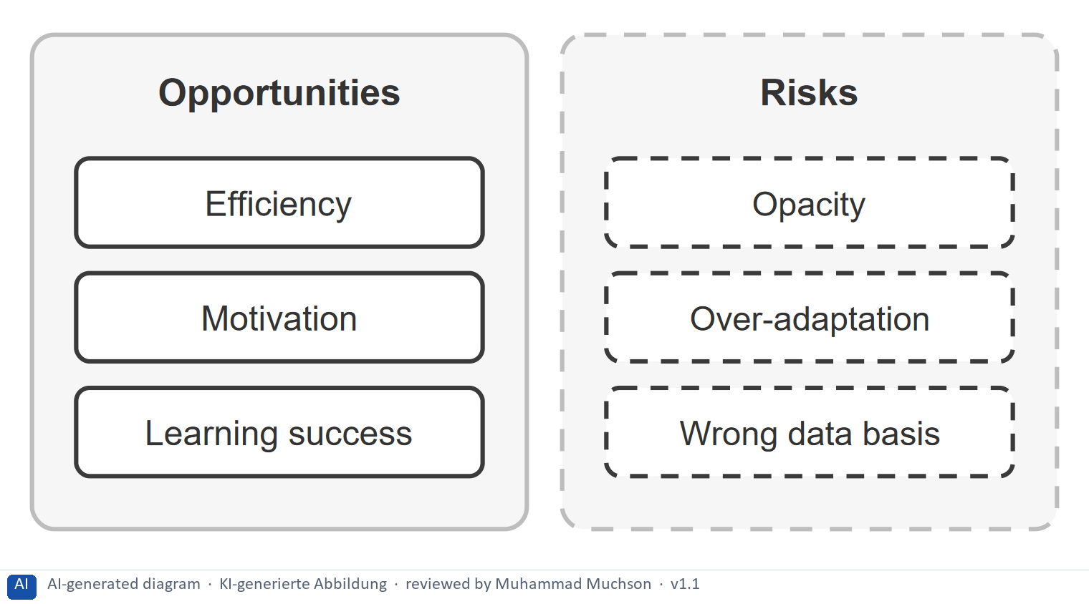
Figure 4 · .
Case assumption
LearnLoop is the example company.

How to decide when this comes up in the task
- Name both sides: an opportunity (time saved, practice where needed) and the risk that comes with it.
- Join gamification to personalisation through a personal goal, not through a point total.

Extra · go deeper (optional reading)
Day 11 showed that points reward activity. A goal the learner chose at the start gives the same bar a meaning of its own: progress toward something they want.

Sources · Brusilovsky 2001 · Deterding et al. 2011

A5 · Weighing a personalisation measure: benefit, effort, risk · 10 min · Core
Rate a measure by how much it helps learners, what it costs and what could go wrong. Technology against benefit: a small data basis points to simple rules.
IN PLAIN WORDS
The idea. To choose between personalisation measures, rate each on the same three questions. Benefit: how much does it help learners reach their goal, for many different users? Effort: money and time, decided here by a rule: under €10,000 is Low, up to €25,000 is Mid, above that is High. Risk: what could go wrong, for example a small data basis or a system nobody understands.
Why it matters. Block 1.2 and Block 2.2 of the task ask for exactly this. The example uses LearnLoop, so the answer for the task case is not given.
How to read the picture. Three small pictures show LearnLoop's three measures, the bars show the cost of each against the effort rule and the €50,000 budget, and the table gives the rating of each.

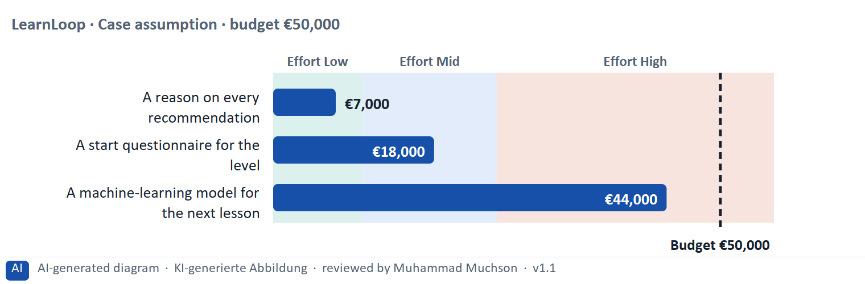
Figure 5 · A worked example: LearnLoop weighs three personalisation measures.
The point. Rate a measure by how much it helps learners, by its printed cost, and by what could go wrong. A reason on every recommendation is cheap and safe. A model needs data a small platform does not have, so it carries the highest risk.
A short story in steps.
1. The setting. Let us look at LearnLoop once more. It is a small platform with little data, the budget is €50,000, and three ideas are on the table. We rate each on three questions: how much it helps learners (benefit), what it costs (effort), and what could go wrong (risk).
2. A reason on every recommendation. A reason on every recommendation costs €7,000, so the effort is Low. Learners see why a lesson was chosen, so the benefit is High, and the risk is Low because it only adds words. The questionnaire costs €18,000, Mid effort, with Mid benefit and Mid risk.
3. The model. The model costs €44,000, so the effort is High. With little data it mostly guesses, so the benefit is Mid, and the risk is High because nobody could explain a wrong adaptation. So: explain first, simple rules next, a model last.
Measure (LearnLoop, Case assumption) | Cost | Effort | Benefit | Risk | Reasons
A reason on every recommendation | €7,000 | Low | High | Low | Effort: €7,000 is under €10,000: Low. Benefit: Learners see why a lesson was chosen, so they trust and use the recommendations. Risk: It only adds words and removes nothing.
A start questionnaire for the level | €18,000 | Mid | Mid | Mid | Effort: €18,000 lies between €10,000 and €25,000: Mid. Benefit: It starts each learner at the right level, but only as well as the learner answers. Risk: Learners may rate themselves wrongly, so the level can be off at the start.
A machine-learning model for the next lesson | €44,000 | High | Mid | High | Effort: €44,000 is above €25,000: High. Benefit: It could fit well in theory, but with little data it mostly guesses. Risk: A small data basis makes wrong adaptations likely, and nobody could explain them.

Case assumption
LearnLoop, its costs and its reasons are made up for this example. The task case is in the task.

How to decide when this comes up in the task
- Rate effort by the printed cost: under €10,000 is Low; €10,000 to €25,000 is Mid; above €25,000 is High.
- Rate benefit by how much it helps different learners understand and use the adaptation, not by how advanced the technology is.
- Rate risk by what could go wrong: a small data basis, a system nobody understands, over-adaptation, a big change that touches every screen.
- Justify the order with the rule comprehensibility before complexity: say how your first measure makes the system understandable.
- Say what you do not know, for example whether learners keep the adaptation on, and how you would find out.

Sources · Gibbons 2018 · Amershi et al. 2019

Materi B · Route 2 · Level 3
How Materi B is used
About 60 minutes, three cards. Level 3 asks you to decide as a manager, between goals that pull apart, and to take responsibility. Task 2 uses all three cards.

B1 · Personalisation as a strategic UX option: need, data, technique, explanation · 18 min · Core
More technology is not better UX. Design personalisation from the learner's need, through the data you have and the simplest technique that fits, to an adaptation the learner can see and change.
IN PLAIN WORDS
The idea. The plan's coaching says that more technology is not better UX. Personalisation is a strategic option, and the chain to design runs from the learner's need, to the data you have, to the technique (a rule or a model), to an adaptation the learner can see and change. Skipping the last step is how a clever system ends up not accepted.
Why it matters. Task 2 asks for a concept for adaptive paths, the UX patterns, how gamification joins in, and a low-fidelity sketch. This chain gives you the order.
How to read the picture. The chain reads from left to right: need, data, technique, an adaptation the learner can see. Below it, the test for each link.

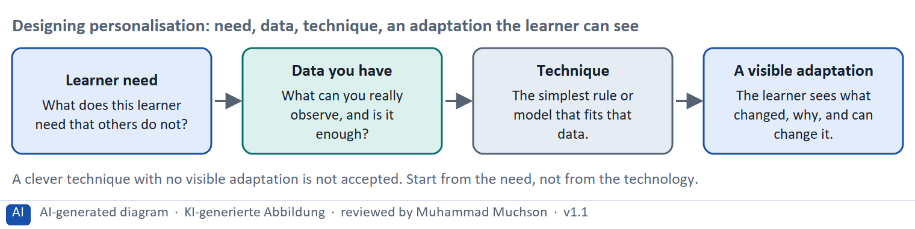
Figure 6 · Designing personalisation: need, data, technique, an adaptation the learner can see.
The test for each link of the chain
Link | The test | What goes wrong without it
Learner need | Can you say who needs what, and why a standard path fails them? | Technology looks for a problem.
Data you have | Is it enough, and is it right? | The system guesses.
Technique | Is it the simplest one that fits the data? | Complexity nobody can maintain.
A visible adaptation | Does the learner see what changed, why, and can they change it? | Low acceptance.

Case assumption
The chain follows the plan's coaching: more technology is not better UX, and data quality matters. LearnLoop is the example company.

How to decide when this comes up in the task
- Decide how far to personalise from the data and the users you have: heterogeneous users argue for some personalisation; a small data basis argues for simple rules.
- Build in two steps when data is incomplete: explained rules first, a model later once there is enough good data.
- Choose UX patterns the learner can see, understand and steer, and drop the silent and hidden ones.
- Join gamification to the personal goal: a goal bar chosen at the start, filled by checked lessons, with no ranking.
- Sketch at low fidelity first: place each element on the screen where it belongs and leave out what a first test does not need.

Extra · go deeper (optional reading)
Over-engineering means building more than the problem needs. In personalisation it often shows as a model where three rules would do, which costs more, is harder to explain and, with little data, works worse.

Sources · Amershi et al. 2019 · Brusilovsky 2001 · Hamari et al. 2014

B2 · Conflicting goals: UX against technology, personalisation against standardisation · 22 min · Core
UX against technology, personalisation against standardisation. Choose the simplest technique the learner understands and that fits the data.
IN PLAIN WORDS
The idea. The plan's conflicts for Day 12 are UX against technology, and personalisation against standardisation. A technique can be powerful and still not understood. Standardisation is cheap and clear and ignores differences. The aim is the simplest technique that the learner can understand and that fits the data you have.
Why it matters. Task 2 asks for a risk analysis and prioritised measures. The rules of this card tell you how to weigh them.
How to read the picture. The matrix places six LearnLoop ideas by their technical complexity (to the right) and how well the learner understands them (upwards). The position is a reading of the example, not a score.

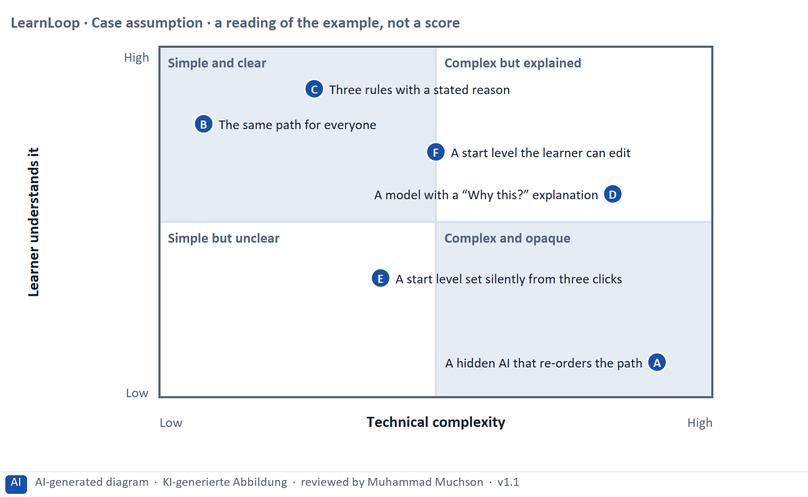
Figure 7 · A worked example: six LearnLoop ideas by technical complexity and how well the learner understands them.
The point. UX and technology pull against each other, and so do personalisation and standardisation. A powerful technique that the learner cannot understand is not better UX. Aim for the simplest technique that the learner understands and that fits the data.
A short story in steps.
1. Powerful but not understood. Let us look at LearnLoop's ideas. A hidden AI that re-orders the path is very powerful, but the learner only sees that things moved. On the other side, the same path for everyone is perfectly clear and adapts to nobody.
2. Simple and clear. Three rules with a stated reason sit between the two. They adapt, because the rules use what the learner did, and they stay clear, because the learner is told which rule applied. For a platform with little data, that is the aim.
3. Personalisation against standardisation. A model with a “Why this?” line can also reach the top, but only with enough good data. So choose the simplest technique that the learner can understand and that fits your data.
Point | The idea | Why it sits there
A | A hidden AI that re-orders the path | Very complex, and the learner sees only that the path changed. It is powerful and opaque.
B | The same path for everyone | As simple as it gets and perfectly clear, but it does not adapt to anyone. Standardisation: cheap and clear, and it ignores differences.
C | Three rules with a stated reason | Simple enough to state, and the learner is told which rule applied. It adapts and stays clear. This is the aim for a small data basis.
D | A model with a “Why this?” explanation | Complex, but the learner gets a short reason for each choice. It can work once there is enough good data, and it needs the explanation.
E | A start level set silently from three clicks | Not complex, but the learner cannot see where the level came from or change it. Simple but unclear.
F | A start level the learner can edit | Only a little more complex, and the learner sees and controls it. A good first adaptation.

Two conflicts and a rule for deciding each
Conflict | One side gets | The other side gets | A rule for deciding
UX against technology | The most powerful technique | A technique the learner understands | Choose the simplest one that fits the data.
Personalisation against standardisation | A path for each learner | One clear path for all | Personalise where learners differ and the data shows it; standardise the rest.

Case assumption
LearnLoop and its six ideas are made up for this example. The positions in the picture are a reading of the example, not a score.

How to decide when this comes up in the task
- Name both sides of each conflict: powerful technique and understood technique; adapted for each and the same for all. A plan that names one side has not weighed the conflict.
- When standardisation is the better choice: short content, a very small data basis, or learners who are alike.
- When personalisation pays off: learners differ a lot in what they know, and you can see the difference in data you trust.
- Keep the full path visible even when it is adapted, so a learner can look beyond what the system suggests.

Extra · go deeper (optional reading)
Explainable AI is the effort to make a model's choices understandable to people (Ribeiro et al. 2016). For a learning platform the practical version is a short reason beside each adaptation, in the learner's words.

Sources · Amershi et al. 2019 · Ribeiro et al. 2016 · Kalyuga et al. 2003

B3 · Deciding with an incomplete data basis: a decision you can check later · 20 min · Core
When the data basis is incomplete, choose a small, reversible step, test the concept in a prototype with a few learners, write a figure you can watch into the plan, and say what you give up.
IN PLAIN WORDS
The idea. The plan asks you to decide although the data basis is not complete, and competitors already use adaptive systems. A decision under uncertainty states four things: what you decide, what you do not know, what would make you reverse it and by when, and what you give up. A low-fidelity prototype tested with a few learners is the cheapest way to learn what you do not know.
Why it matters. Block 3.2 asks for exactly this, together with prioritised measures and a risk analysis.
How to read the picture. The four boxes at the top are the parts of the decision, filled in for LearnLoop. The two boxes below are the rule for future decisions.

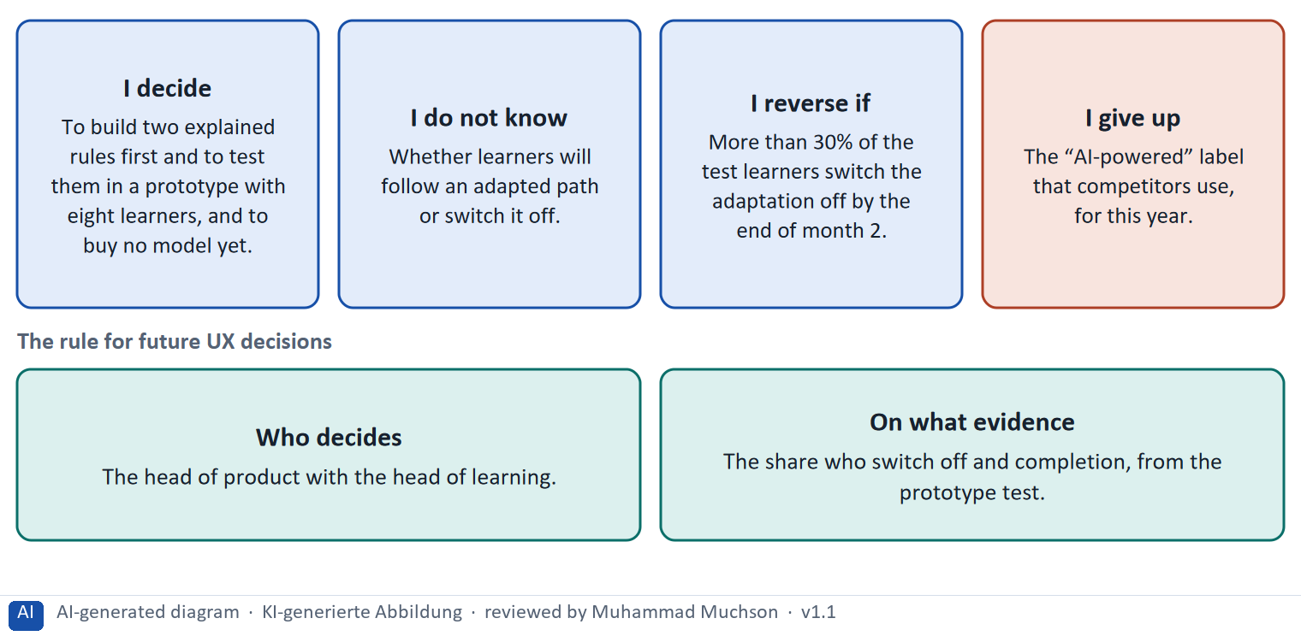
Figure 8 · A decision with an incomplete data basis, filled in for LearnLoop.
Five ways to make a decision with incomplete data safer
Way | What it looks like
Test a prototype | Five to eight learners use paper or clickable screens of the concept.
Start with rules | A few rules that need little data and that can be explained.
Set a figure and a date | The share you expect to keep the adaptation on, and the month you will look.
Fix who decides | A role, with the evidence it needs.
Name what you give up | Something real that someone would miss.

Case assumption
LearnLoop and its figures are made up for this example; the task case is in the task.

How to decide when this comes up in the task
- A decision under uncertainty states four things: what you decide, what you do not know, what would make you reverse it and by when, and what you give up.
- A reversal condition has a figure you can watch and a time: “more than 30% of the test learners have switched the adaptation off by the end of month 2”.
- Learn cheaply: a low-fidelity prototype tested with five to eight learners shows what you do not know before you build.
- Do not copy competitors because they use adaptive systems: you cannot see their evidence, and their data is not yours.
- Giving up nothing means you have not decided: name what you postpone, for example a model or an “AI-powered” label.

Extra · go deeper (optional reading)
Premortem: imagine the platform failed. Typical answers here: learners did not understand the adaptations, the system boxed people in after a few clicks, and the data was too thin. Each answer becomes a check.
One-way and two-way doors: adaptation behind a switch is a two-way door; a platform rebuilt around a model is a one-way door.

Sources · Klein 2007 · Bezos 2016 · Gibbons 2018

Use in class: presentation and handout
Mark of use for the study material. Presentation is what the trainer shows on screen; Handout is what participants read and keep.
Card | Presentation (shown on the playground) | Handout
A1 · Adaptive learning systems: collect, analyse, adapt (Core) | Scan line and Figure 1; the "In plain words" and "How to decide" boxes | The whole card
A2 · Technology and algorithms: rules, models and their limits (Core) | Scan line and Figure 2; the "In plain words" and "How to decide" boxes | The whole card
A3 · UX patterns for personalised learning paths (Core) | Scan line and Figure 3; the "In plain words" and "How to decide" boxes | The whole card
A4 · Opportunities and risks, and the link to gamification (Optional) | Not shown (self-study) | The whole card
A5 · Weighing a personalisation measure: benefit, effort, risk (Core) | Scan line and Figure 5; the "In plain words" and "How to decide" boxes | The whole card
B1 · Personalisation as a strategic UX option: need, data, technique, explanation (Core) | Scan line and Figure 6; the "In plain words" and "How to decide" boxes | The whole card
B2 · Conflicting goals: UX against technology, personalisation against standardisation (Core) | Scan line and Figure 7; the "In plain words" and "How to decide" boxes | The whole card
B3 · Deciding with an incomplete data basis: a decision you can check later (Core) | Scan line and Figure 8; the "In plain words" and "How to decide" boxes | The whole card

References
Check each source and its current edition before you teach from it. Standards and laws marked as in flux can change.
Brusilovsky, P. (2001). Adaptive hypermedia. User Modeling and User-Adapted Interaction, 11(1–2), 87–110. (Adapting content and links to a model of the individual user.)
Kalyuga, S., Ayres, P., Chandler, P., & Sweller, J. (2003). The expertise reversal effect. Educational Psychologist, 38(1), 23–31. — guidance that helps beginners can hinder experts.
Ribeiro, M. T., Singh, S., & Guestrin, C. (2016). “Why should I trust you?”: Explaining the predictions of any classifier. Proceedings of KDD '16. ACM. (Why a model's choices need explaining before people can trust them.)
Amershi, S., et al. (2019). Guidelines for human-AI interaction. Proceedings of CHI '19. ACM. (Make clear what the system can do, show why it did what it did, and let the user correct it.)
Regulation (EU) 2024/1689 (Artificial Intelligence Act). Annex III lists AI systems in education and vocational training that evaluate learning outcomes or steer the learning process as high-risk. In flux: obligations apply in stages and the timetable is under discussion; check the dates before you state them.
Shneiderman, B., Plaisant, C., Cohen, M., Jacobs, S., & Elmqvist, N. (2016). Designing the User Interface (6th ed.). Pearson. — the eight golden rules, including consistency and informative feedback.
Nielsen, J. (1994, reviewed 2024). 10 Usability Heuristics for User Interface Design. Nielsen Norman Group. https://www.nngroup.com/articles/ten-usability-heuristics/ — for example visibility of system status, match between the system and the real world, consistency and standards, recognition rather than recall.
Deterding, S., Dixon, D., Khaled, R., & Nacke, L. (2011). From game design elements to gamefulness: Defining "gamification". Proceedings of MindTrek '11, 9–15. — gamification is the use of game design elements in non-game contexts.
Gibbons, S. (2018). Using Prioritization Matrices to Inform UX Decisions. Nielsen Norman Group. https://www.nngroup.com/articles/prioritization-matrices/ — a prioritisation matrix plots items on two criteria, for example value to the user against effort.
Hamari, J., Koivisto, J., & Sarsa, H. (2014). Does gamification work? A literature review of empirical studies on gamification. Proceedings of HICSS 2014, 3025–3034. — results are mostly positive but depend on context and on the user.
Klein, G. (2007). Performing a project premortem. Harvard Business Review, 85(9), 18–19. — imagine the plan has failed and ask why; it brings risks to the surface before the money is spent.
Bezos, J. (2016). 2015 Letter to Shareholders. Amazon. — decisions that are hard to reverse ("one-way doors") deserve more care than those that can be reversed cheaply ("two-way doors").

Glossary
Every term below is used in this document. Terms stay plain text in the body; this list says what they mean in everyday words.
Term | In plain words | Example | Comes from
Adaptive learning | A learning system that changes what a learner sees, for example the next lesson or the difficulty, depending on what that learner does. The rules can be simple (if the test is passed, skip) or learned from data. | A learner who passes the pre-test skips the basics unit. | Kulik & Fletcher 2016
Black box | A system whose inner workings and reasons cannot be seen. Data goes in and an answer comes out, but nobody can say why. For a learner it means an adaptation they cannot understand. | A recommendation that appears with no reason. | Materi A2
Cold start | The problem that an adaptive or recommending system knows nothing about a new learner or a new course, so its first suggestions are weak until it has collected enough data. | On day one of a new platform no one has finished anything, so there is nothing to learn from. | —
Complexity | How many parts, steps and terms a person has to keep in mind. The plan says it is UX's greatest enemy. Some complexity belongs to the subject and is needed; the complexity the interface adds is the part to remove. | Eleven menu entries add complexity; a demanding legal course may need its depth. | Materi B2
Comprehensibility (understandability) | How easily the intended readers can understand a text or a screen at first reading. The plan's chain is: comprehensibility leads to usage, and usage leads to success. A comprehension check asks readers to explain something back in their own words. | A learner who can say in one sentence what a screen asks of them understands it. | Materi A1
Conflicting goals (trade-off) | Two goals that both matter, but cannot both be fully met: for example a simple screen against depth of content. A trade-off means you decide how much of each to keep, and say what you give up. | — | —
Data quality and data basis | Whether the data a system learns from is enough, correct and typical of the people it serves. A small or biased data basis makes a system guess or treat some learners wrongly, however clever the technique. | Twelve learners are too few for a model to find a pattern. | Materi A2
EU AI Act | A European law that sorts AI systems by risk and sets rules for each class. AI that evaluates learning outcomes or steers the learning process is treated as high-risk in education. Obligations come into force in stages: check the dates. | A system that decides which learners may continue a course. | Regulation (EU) 2024/1689
Expertise reversal | Guidance and simplification that help beginners can get in the way of experts, who already have the knowledge and find the extra support redundant. | Step-by-step hints that slow down a specialist. | Kalyuga et al. 2003
Feedback (in an interface) | A sign from the system that tells the user what just happened or how they did: “saved”, “4 of 5 correct”, a bar that moves. Without it, users do not know whether their action worked. | — | Nielsen 1994
Game mechanic | One building block taken from games and used in a platform: points, a badge, a level, a leaderboard, a choice. A mechanic is a tool, and it only helps when it serves a learning objective. | A bar of objectives mastered is a mechanic that serves the objective “apply the method at work”. | Materi B1
Gamification | Using elements from games, such as points, badges, levels or rankings, in something that is not a game. Whether it helps depends on whether the learner wanted the result anyway. | A badge after every lesson, or a ranking of all learners. | —
Heuristic | A rule of thumb. A usability heuristic is a general rule, such as "keep users informed about what is happening", that experts use to check a screen quickly. | Nielsen's list of ten usability heuristics. | Nielsen 1994
Interaction | Anything the learner does on a screen beyond reading or watching: answering a question, doing a task, choosing in a scenario, pressing a button. Interaction helps learning only when it is tied to a goal and answers back. | A short question after a lesson section, with an explained answer. | Materi A3
Leaderboard | A ranking of learners by points or activity. It rewards those who are already active and can discourage those at the bottom. | A list of the ten most active learners this week. | —
Learning path | A set order in which a learner goes through the material of a course: what to do first, next and last. It tells a beginner where to start and how far there is to go. | “Lesson 1 → Lesson 2 → Quiz → Lesson 3” shown on screen as a path. | —
Low-fidelity and high-fidelity | Low-fidelity means a rough, plain version (sketch, grey boxes). High-fidelity means a polished version that looks like the finished product. The lower the fidelity, the faster and cheaper it is to change. | A grey-box wireframe of the learning path (low) against a fully coloured, clickable mock-up (high). | Rettig 1994
Machine learning | A way for a computer to find patterns in a lot of data and use them to make predictions, such as which lesson suits a learner. It needs a lot of good data, and it usually cannot say why it chose what it chose. | A model that learns from thousands of learners which lesson to show next. | Materi A2
Over-adaptation | When a system reacts too strongly to too little evidence, such as one mistake or a few clicks, and boxes the learner in. The learner then never sees other content and cannot get out. | Difficulty drops two levels after one wrong answer, with no way back. | Materi A2
Over-engineering | Building something more complex or more technical than the problem needs. A complex adaptive engine to fix a missing Next button is over-engineering. | A neural network where a simple rule would do. | —
Personalisation and transparency | Personalisation shapes the platform to each learner. Transparency means the learner can see what the system does and why. The two can conflict: the more the system decides, the harder it is to explain. | "Suggested because you finished Unit 2 quickly." | GDPR
Premortem | A planning exercise: you imagine that the plan has failed a year from now and ask what went wrong. It brings risks to the surface before the money is spent. | "It is next March and the new course paths are not used. Why?" Answer: nobody told the trainers. | Klein 2007
Prototype | An early, simple version of a screen or a flow, made to test an idea before the real thing is built. It can be a paper sketch or a clickable mock-up. | Six paper cards that show the course start; a learner points at what they would tap. | Rettig 1994
Rule-based system | A system that decides by rules a person has written down, in the form “if this, then that”. It needs little data, and a learner can be told exactly which rule applied. | “If the test is passed, skip the lesson; if it is failed, repeat it.” | Materi A2
Transparency | That people can see what a system does and why. In an adaptive platform it means each change says what changed and for what reason, so the learner is not left guessing. | “Difficulty lowered: you missed 3 of 4 questions on pricing.” | Materi A1
Usability | How well a system lets users reach their goals with little effort and few errors, and how satisfied they are. It is one part of the whole experience. | — | ISO 9241-11

The playground: where we practise online
In class we use the course website as the place to practise and to learn. Every day has its own address, in the same pattern: the day number is the last part.
What | Address
Course website (playground) | https://aion-dl.vercel.app/
Day 12 | https://aion-dl.vercel.app/day/12/

On the day page, Route 1 (Levels 1 and 2) and Route 2 (Level 3) can be opened; the cards and the tasks of this document are there too. The pattern is the same up to Day 8, for example https://aion-dl.vercel.app/day/6/.

