HABMANN AUFSTIEGSAKADEMIE · DIGITAL LEARNING · EDUCATIONAL UX/UI DESIGN
DAY 3 · MATERI A AND MATERI B · ROUTES 1 AND 2 · LEVELS 1 TO 3
Learning psychology and cognitive load
Understand how people take in and process information, and design screens that steer thinking instead of overloading it
Day | Day 3 · Module 2 (day 1 of 2): Fundamentals of learning psychology for UX designers, cognitive load and information processing
Document | Materi (study material). Materi A has five cards, Materi B has three.
Route and level | Materi A serves Route 1 (Levels 1 and 2, Task 1). Materi B serves Route 2 (Level 3, Task 2).
Time | Materi A about 60 min · Materi B about 60 min (facilitator-led)
Website (playground) | Not yet published (the link will be added once Day 3 is deployed)
Case | Worked examples use LearnLoop, an online-course provider. The task case is EduCore, a learning platform with an overwhelm effect (see the Task document).

ABOUT THIS DOCUMENT
This document holds everything you need to study Day 3 without the website. Each card says the idea in plain words, shows it in a picture, gives the details, and ends with the rules you will use in the Task document. Cards marked Optional are not needed for the Core blocks of the task. The worked examples use LearnLoop, a different company from the task case, so no task answer is printed here. Glossary and references are at the end.

IN THIS DOCUMENT
A1 · How people learn: intake, processing, storage · 12 min · Core
A2 · Cognitive load: intrinsic, extraneous, germane · 14 min · Core
A3 · Working memory, chunking and focus in the interface · 14 min · Core
A4 · Typical UX mistakes seen through psychology · 10 min · Optional
A5 · Weighing a load-reducing measure: learning impact, effort, risk · 10 min · Core
B1 · Learning effectiveness and cognitive efficiency as strategic measures · 18 min · Core
B2 · Conflicting goals: efficiency, deep learning and over-simplification · 22 min · Core
B3 · Deciding without user data: assume, test, and set a rule for content · 20 min · Core

Materi A · Route 1 · Levels 1 and 2
How Materi A is used
About 60 minutes, five cards. The plan's Level 1 asks you to understand the basics of learning psychology and to classify cognitive processes and load. Level 2 asks you to analyse and optimise learning interfaces with regard to cognitive load. Task 1 uses all of it on one case. The card A4 is Optional: no Core block of the task needs it.

A1 · How people learn: intake, processing, storage · 12 min · Core
Learning happens in three steps: attention picks something, working memory works on it, long-term memory keeps it. A screen can help or hinder each step.
IN PLAIN WORDS
The idea. Think of learning as three steps. First, intake: of everything on the screen, attention picks only a few things. Second, processing: working memory, a small mental workspace, holds those things and works on them. Third, storage: long-term memory keeps what was understood and revisited. Taking in, understanding and applying are different levels, and each asks more of the interface.
Why it matters. In Task 1 you describe how a learning screen feels to the learner. The three steps give you words for it: "I did not know what to look at" is an intake problem, "I lost track of what I had read" is a processing problem.
How to read the picture. The first picture shows the three steps from left to right. The second shows the three levels of learning, from taking in to applying. Read both from left to right.

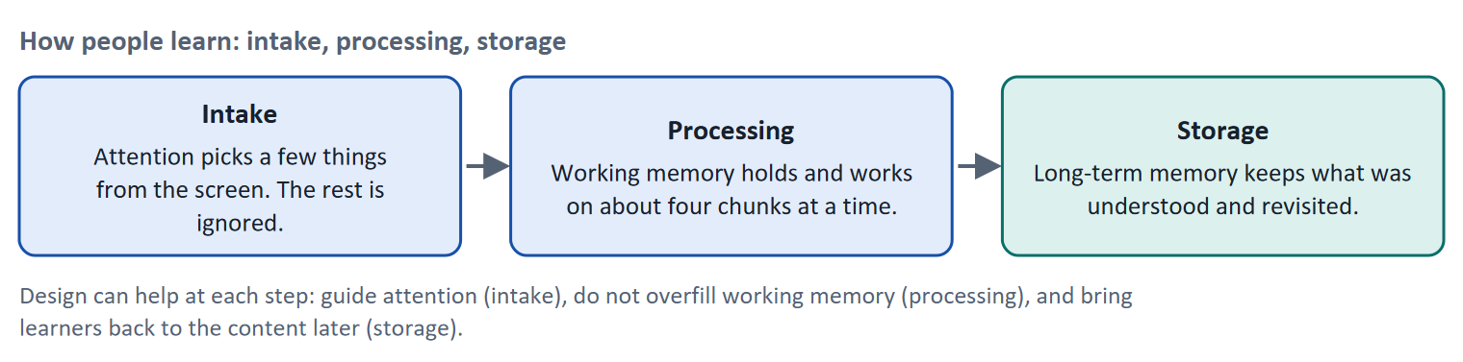
Figure 1 · How people learn: intake, processing, storage. The classic multi-store model (Atkinson and Shiffrin 1968) in a form that designers can use.
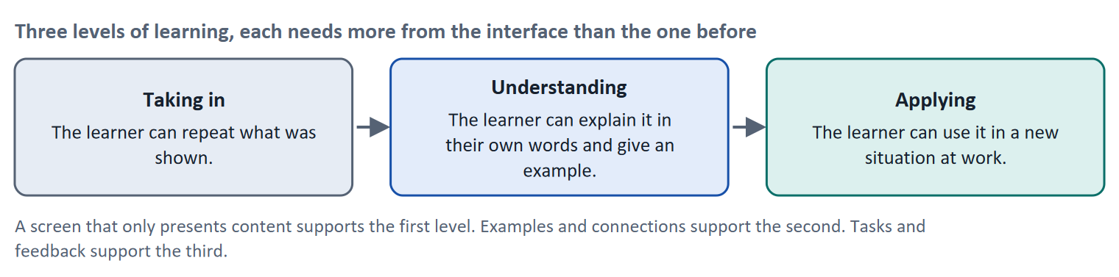
Figure 2 · Three levels of learning, each needs more from the interface than the one before.
Let us follow Karim, who is learning about data protection after work. The lesson shows a long page. His attention jumps from the menu to a banner to the first line of text, which is intake going wrong: nothing on the screen says what matters. When he finally reads, he has to keep the first sentence in mind to understand the third, which fills working memory so that by the fifth sentence he has lost the thread. Later that week he remembers almost nothing, because nothing asked him to revisit what he had read. The three steps failed one after another, and none of the failures is about content.
- Attention and motivation. Attention is selective: learners attend to what is prominent, new or relevant to their goal. Motivation decides whether they spend the effort at all (Day 4).
- Knowing, understanding, applying. In the revised Bloom's taxonomy (Anderson and Krathwohl 2001) these correspond to remember, understand and apply. A screen that only presents supports remembering at best; understanding needs examples and links to what the learner already knows; applying needs tasks and feedback.
- Repetition and context. Memory is strengthened when learners retrieve information instead of re-reading it (Roediger and Karpicke 2006) and when practice is spread over time (Cepeda et al. 2006). Learning in a realistic context helps the learner see when to use it.
How to decide when this comes up in the task
- Describe how a screen feels in terms of the three steps: did the learner know what to look at (intake), could they keep it in mind (processing), will they be able to recall it later (storage)?
- Match the screen to the level you want: if the goal is applying, a page of text with no task cannot get the learner there.
- A problem that makes learners stop early is usually an intake or processing problem. A problem that shows up weeks later (they forget) is a storage problem.
- Do not blame the learner's motivation before checking the screen: a screen that wastes attention also kills motivation.

Extra · go deeper (optional reading)
Retrieval and spacing in an interface. A short question at the start of the next lesson on the last lesson ("what were the three loads?") uses retrieval practice and spacing at almost no cost. A "review" button at the end that replays the whole lesson does neither, because re-reading is the weaker strategy.
Context. The plan names context as part of learning psychology. For a platform it means showing why a unit matters for the learner's job (a work example) before the rule, so that the learner knows what to attend to.

Sources · Atkinson & Shiffrin 1968 · Anderson & Krathwohl 2001 · Roediger & Karpicke 2006 · Cepeda et al. 2006

A2 · Cognitive load: intrinsic, extraneous, germane · 14 min · Core
The subject sets part of the mental effort. Design decides how much of the rest is wasted. Cut the waste; keep room for understanding.
IN PLAIN WORDS
The idea. Cognitive load is how much a person has to hold in mind and work out at once, and it is limited. Cognitive Load Theory (Sweller) distinguishes three kinds. Intrinsic load comes from the subject: how many new ideas there are and how much they depend on each other. Extraneous load comes from poor design: clutter, a wall of text, unclear structure. Germane load is the effort that goes into understanding: linking ideas and working an example. The goal is to minimise the unnecessary load.
Why it matters. In Task 1 you analyse a platform that learners call "too complicated" and decide what to change. The three loads tell you which part you can change by design (the second), which you can only order (the first) and which you want to leave room for (the third).
How to read the picture. Each bar is the learner's working memory at one moment. In the top bar, clutter and a wall of text (extraneous load) take more than half of it. In the bottom bar the same lesson has been redesigned: the subject is the same, the waste is small, and most of the capacity goes to understanding. The numbers are illustrative.

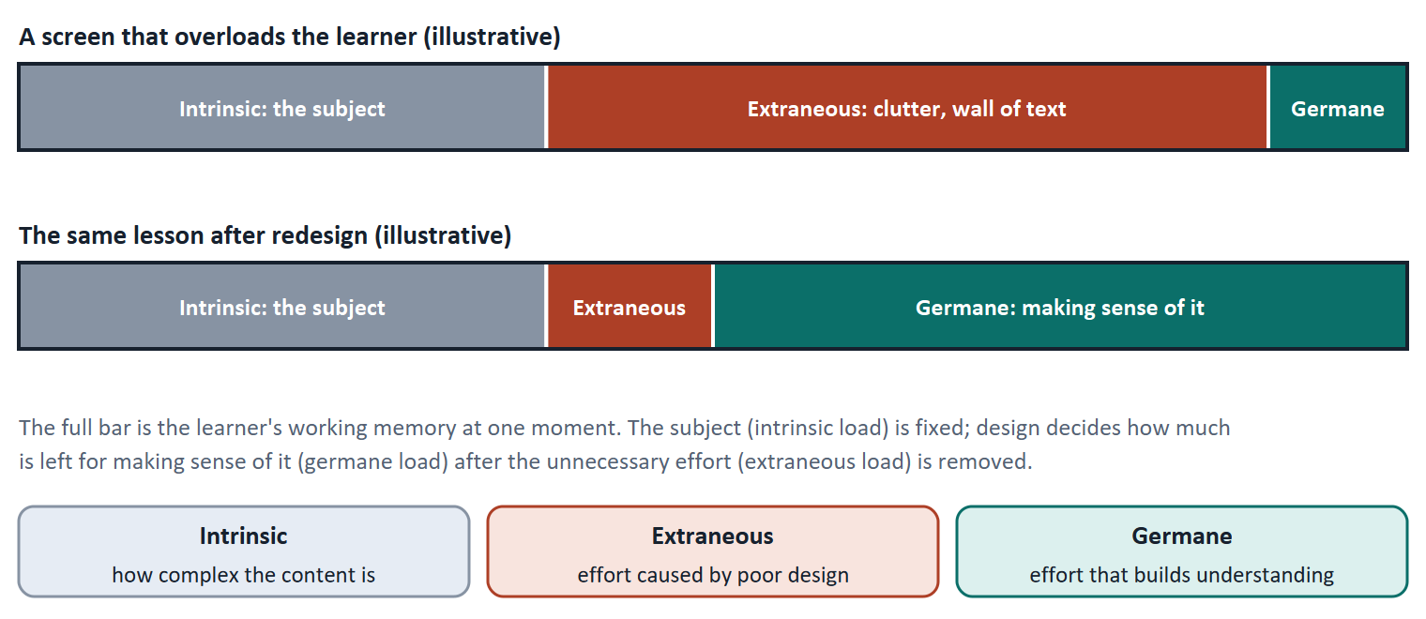
Figure 3 · The three loads in one learner's working memory. Illustrative figures: the subject stays the same, the design decides how much is wasted.
Load | Where it comes from | What a designer can do | Example in a lesson
Intrinsic | The subject: how many new ideas, how linked | Order it: start with the simplest idea, introduce one new idea at a time | Explaining "legitimate interest" before the learner knows what personal data is
Extraneous | The presentation: clutter, structure, wording | Remove it: cut what does not help, structure the rest, explain terms in place | A banner, a chat window and a menu next to a 500-word block
Germane | Making sense of the content | Make room for it: add an example, a question, a link to what the learner knows | A short exercise that applies the rule to a case from the learner's work

A short story: Daniel and the banner
Step 1. Let us follow Daniel, who works in procurement and is studying contract basics on a platform. The lesson he opens is hard, because contracts are hard: this is intrinsic load, and no design can remove it.
Step 2. The page also shows a news banner, a chat window and a menu with nine entries, and the text is one block without headings. Daniel has to ignore all of that while trying to understand a clause. This effort teaches him nothing about contracts, so it is extraneous load.
Step 3. In the redesigned version the page shows one heading, three short paragraphs, one diagram of the clause and a question at the end. The subject is exactly as hard as before, but the effort now goes into the clause itself. That is germane load, and it is what the lesson was meant to ask.

Case assumption
Karim, Daniel and the lessons are made up for this card.

How to decide when this comes up in the task
- Name the kind of load: if the cause is the subject, it is intrinsic and you can only order it; if the cause is how the screen is built, it is extraneous and you should cut it.
- Most "this is too complicated" complaints on a platform come from extraneous load: too much at once, no visual structure, no recognisable order.
- Do not remove intrinsic load by deleting the content the learner needs. Split it, order it and support it instead.
- Keep room for germane load: a screen with nothing to think about is not learning-effective just because it is light.

Extra · go deeper (optional reading)
Where the theory comes from. Sweller (1988) showed that people learn problem solving less well when the task itself consumes working memory; Sweller, van Merriënboer and Paas (1998) set out the three kinds of load. Germane load has been revised by later work and is the most debated of the three; for design decisions the practical split into effort that helps learning and effort that does not is the part that counts.
Mayer and Moreno's design measures. Mayer and Moreno (2003) list nine ways to reduce load in multimedia learning, for example removing extra material (coherence), marking what matters (signalling), splitting a lesson into learner-paced parts (segmenting) and placing words next to the picture they explain (spatial contiguity).

Sources · Sweller 1988 · Sweller et al. 1998 · Mayer & Moreno 2003

A3 · Working memory, chunking and focus in the interface · 14 min · Core
Working memory holds only a few items. Group things into chunks, and use size, contrast and position to tell the eye what comes first.
IN PLAIN WORDS
The idea. Working memory can hold only a few new things at once. Miller (1956) famously put it at seven plus or minus two; later work (Cowan 2001) suggests about four chunks for new material. A chunk is a meaningful group: a phone number written in groups is easier than eleven loose digits. On a screen you help in two ways: by chunking the content, and by using a visual hierarchy (size, colour, contrast, position) so that attention goes to the main thing first.
Why it matters. In Task 1 you decide how to reduce load. Chunking and visual hierarchy are the two most direct tools, and the task's measures use their names.
How to read the picture. On the left are twelve loose items. On the right are the same twelve items in three chunks with a name each. Count how many things you must hold in each case.

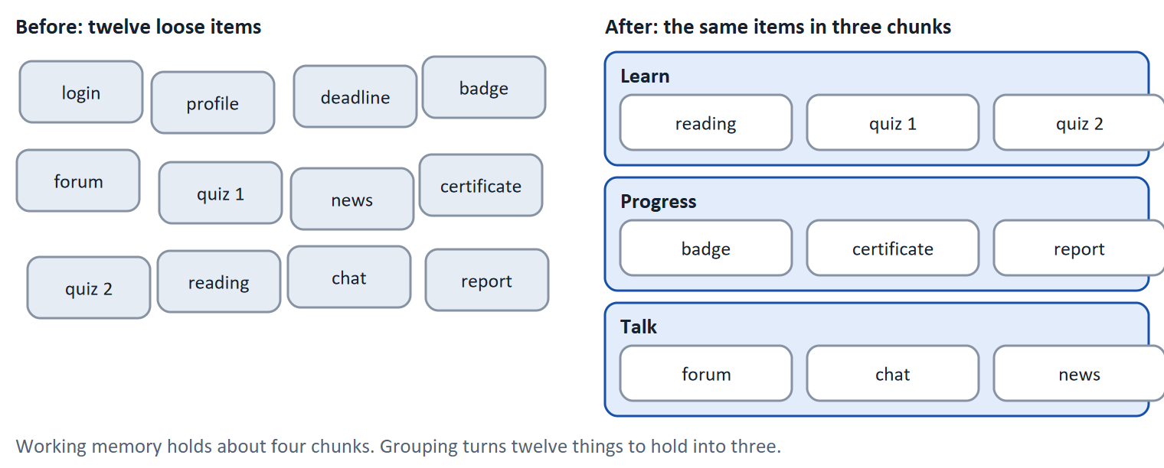
Figure 4 · Chunking: the same twelve items as twelve loose things and as three groups.
- Chunking in a lesson: split a long lesson into units of five to seven minutes, each with one goal; group menu entries; give each group a name.
- Visual hierarchy: the most important element is the largest, highest-contrast or best-placed. A heading above a paragraph, a primary button next to a quieter secondary one, the key sentence of a lesson marked in bold.
- Focus control: remove or quiet what is not needed for the current step (banners, chat, news) while the learner works on the content.
- Text and pictures: a relevant picture next to the words that it explains helps (Mayer's multimedia principle); a decorative picture or an interesting but irrelevant detail does not (Harp and Mayer 1998 found that such "seductive details" reduced learning).
How to decide when this comes up in the task
- If a screen shows more than about four separate things at once that the learner must handle, group them or hide some of them.
- Use a visual hierarchy to answer "what should I look at first?" For a lesson, that is the heading, then the key sentence, then the explanation.
- Chunk the content (units with one goal) and chunk the interface (groups with names); both reduce what the learner must hold.
- A diagram helps when it shows a structure or flow that text describes badly, and when its labels are inside it. A picture that does not explain anything is clutter.
- Remove what does not help the goal of the screen before you add anything.

Extra · go deeper (optional reading)
Why four and not seven. Miller's seven plus or minus two was a landmark paper but counted items that people had already learned to chunk. Cowan's (2001) review of later studies suggests that when chunking cannot be used, capacity is about four. For design this is the safer number: plan for few items.
Reading behaviour. On web pages most readers scan, they do not read word by word: in Nielsen's study 79 percent of test users always scanned a new page and only 16 percent read word for word (Nielsen 1997). A lesson is read more closely than a news page, but a tired learner scans too. Headings, short paragraphs and one idea per paragraph let a scanning reader find the point.

Sources · Miller 1956 · Cowan 2001 · Mayer 2009 · Harp & Mayer 1998 · Nielsen 1997

A4 · Typical UX mistakes seen through psychology · 10 min · Optional
Four mistakes recur: overload, unclear structure, missing feedback and complex navigation. Each has a psychological cost and a typical remedy.
IN PLAIN WORDS
The idea. The plan lists four typical UX mistakes: information overload, unclear structure, missing feedback and overly complex navigation. Seen through psychology, each one wastes a limited resource: attention, working memory, or the learner's wish to carry on.
Why it matters. It gives you a checklist for reading any learning screen, and a plain way to say what each mistake does to the learner.
How to read the picture. Each row reads from left to right: the mistake, what it does in the learner's head, and a way to reduce it.

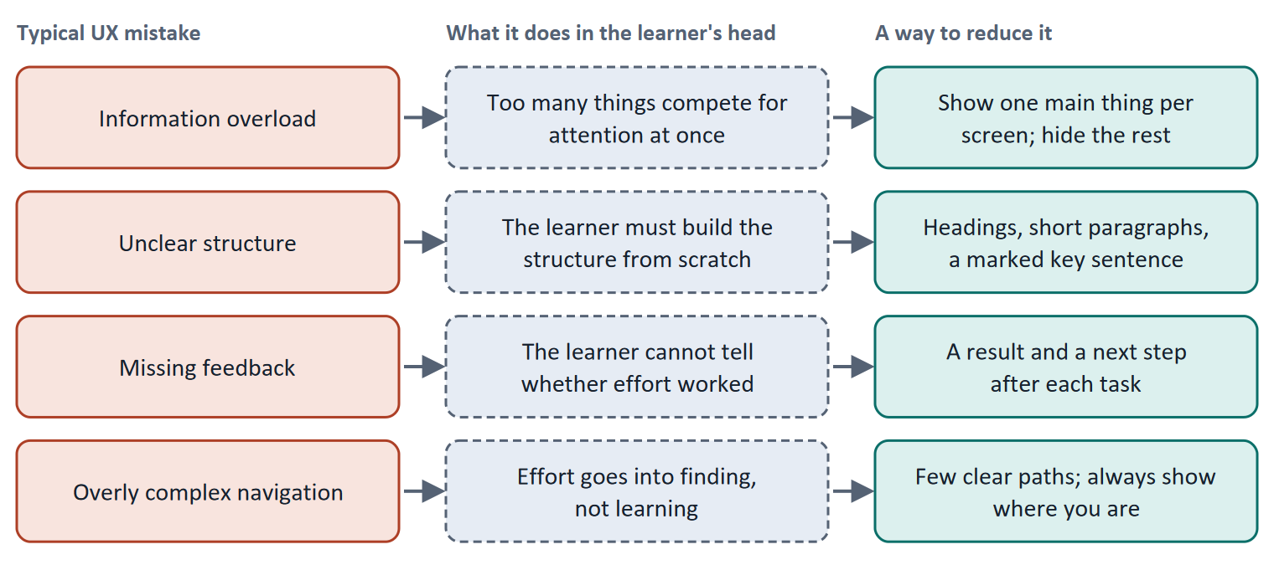
Figure 5 · Four typical UX mistakes, what they do in the learner's head, and a way to reduce each.
How to decide when this comes up in the task
- Information overload is about too many things at once (amount). Unclear structure is about how things are arranged (form). Missing feedback is about not knowing the result. Complex navigation is about effort spent on finding.
- Name the remedy in terms of the load it removes: "group the menu into three" removes extraneous load, "mark the key sentence" directs attention.
- Do not call something a mistake only because it looks plain: ask what it does to the learner.

Extra · go deeper (optional reading)
Expertise changes the answer. Guidance and simplification that help beginners can hinder experts, who find the extra support redundant. This is the expertise reversal effect (Kalyuga et al. 2003). If your learners are beginners, as in the plan's Day 3 task, support them heavily; for an advanced audience, make it possible to skip.
Too simple is also a mistake. Removing difficulty that is part of the learning (for example a worked problem that the learner must try) lowers germane load as well. Materi B2 returns to this as the risk of "too much simplification".

Sources · Sweller et al. 1998 · Kalyuga et al. 2003

A5 · Weighing a load-reducing measure: learning impact, effort, risk · 10 min · Core
Rate each measure on how much it helps learning, what it costs and what could go wrong. Cheap and direct usually beats big and slow when time is short.
IN PLAIN WORDS
The idea. To choose between ways of reducing load, rate each on the same three questions. Learning impact: how much does it help learners understand? Effort: money and time, decided here by a rule: under €8,000 is Low, up to €15,000 is Mid, above that is High. Risk: what could go wrong, for example that too much is removed. Then put the measures in order and say why the first goes first.
Why it matters. Block 1.2 and Block 2.2 of the task ask for exactly this under a time limit. The example here uses LearnLoop, so the answer for the task case is not given.
How to read the picture. The bars show the cost of three LearnLoop measures. The coloured bands behind them are the effort rule. The dashed line is the budget. The table below the picture gives the rating of each option and the reason.

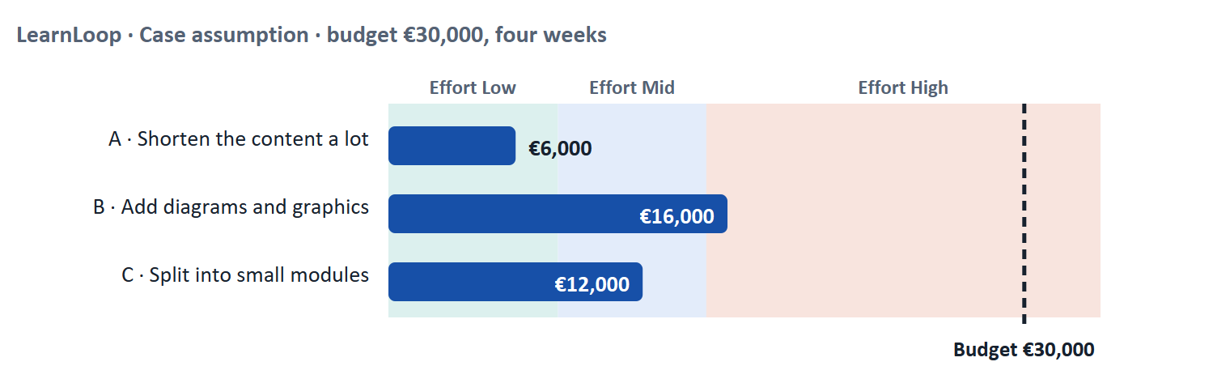
Figure 6 · LearnLoop weighs three load-reducing measures. Cost against the effort rule and the budget (Case assumption).
A short story: LearnLoop's hard course
Step 1. Let us look at LearnLoop again. A course for beginners on a technical subject is rated "too complicated", the content has to stay, and the team has four weeks and €30,000. Three ideas are on the table, and we rate each on learning impact, effort and risk.
Step 2 · Shorten the content a lot. It costs €6,000, so the effort is Low. But the content is professionally necessary, so shortening it a lot removes things learners need: the risk is High, and the impact is Low because what is left may no longer teach the subject.
Step 3 · Add diagrams and graphics. It costs €16,000, which is above €15,000, so the effort is High. A good diagram helps with structures and flows, so the impact is Mid, but it takes the whole four weeks, so the risk is Mid.
Step 4 · Split into small modules. It costs €12,000, so the effort is Mid. Chunking reduces what the learner holds at once without deleting content, so the impact is High, and the risk is Low because the content is the same and the split can be adjusted.

LearnLoop measure | Learning impact | Effort | Risk
Shorten the content a lot · €6,000 | Low. Beginners need the content; cutting it removes what they came for. | Low. €6,000 is under €8,000. | High. Too much is lost, and it cannot easily be put back.
Add diagrams and graphics · €16,000 | Mid. A diagram helps where a structure or flow is described, not everywhere. | High. €16,000 is above €15,000. | Mid. It uses the whole four weeks; weak diagrams add clutter.
Split into small modules · €12,000 | High. Less to hold at once, and the content is kept. | Mid. €12,000 lies between €8,000 and €15,000. | Low. Same content, small units, can be adjusted.

Case assumption
LearnLoop, its costs and its reasons are made up for this example. The task case is in the Task document.

How to decide when this comes up in the task
- Rate effort by the printed cost: under €8,000 is Low; €8,000 to €15,000 is Mid; above €15,000 is High.
- Rate learning impact by the load it removes from what the learner actually does (reading, finding, holding), and whether it keeps the content the learner needs.
- Rate risk by what could be lost or go wrong: removing needed content is a high risk; a change that can be undone is a low risk.
- A measure that makes the screen lighter but not the learning better (a decoration, a new look) has a low learning impact.
- Say which measure has the greatest effect and why, and name the information you lack (for example, whether learners are overloaded by amount or by wording).

Sources · Gibbons 2018 (NN/g) · Sweller et al. 1998

Materi B · Route 2 · Level 3
How Materi B is used
About 60 minutes, three cards. Level 3 asks you to prioritise UX design decisions on the basis of learning effectiveness and cognitive efficiency. Materi B teaches the three things Task 2 asks: use effectiveness and efficiency as measures (B1), weigh the conflict between efficiency and deep learning (B2), and decide without user data (B3).

B1 · Learning effectiveness and cognitive efficiency as strategic measures · 18 min · Core
A UX decision is strategic when it changes what learners can do afterwards and the mental cost of getting there. Define "learning-effective UX" and judge decisions by it.
IN PLAIN WORDS
The idea. Two lenses help a manager judge a UX decision. Learning effectiveness asks whether the learner learned what the course promised. Cognitive efficiency asks how much mental effort that took. A design can be easy and teach nothing, or hard and teach a lot. The aim is a design that gets the learning result at a reasonable mental cost; this card calls it learning-effective UX.
Why it matters. Task 2 asks you to write a definition of learning-effective UX and to prioritise three measures by it. The definition is what lets you say "no" to a measure that only makes things look simpler.
How to read the picture. The chain reads from left to right: learning effectiveness, cognitive efficiency, and where both lead: learners who finish and employers who see results.

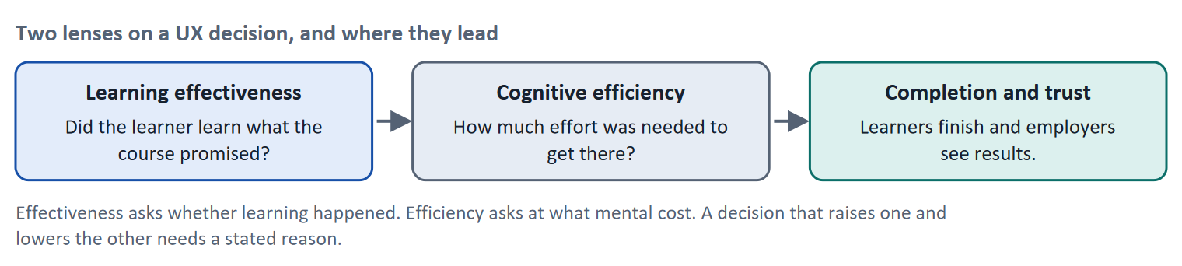
Figure 7 · Two lenses on a UX decision, and where they lead.
A definition you can adapt. "A learning-effective UX is one in which a learner of the intended level can reach the stated learning goal with as little effort as possible that does not help learning, shown by what they can explain or do afterwards." Notice that this definition names the learner (intended level), the goal (stated), the cost (effort that does not help) and the proof (explain or do). A definition without a proof cannot be tested.
Question a manager asks | What it measures | Typical evidence
Did learners learn what we promised? | Effectiveness | A comprehension check, a task in a test, a result after the course
How much effort did it take? | Efficiency | Time to finish, errors, a short rating of effort, observed hesitation
Do learners finish and come back? | Business result | Completion rate, retention

How to decide when this comes up in the task
- Judge a measure on both lenses: does it help learners learn (effectiveness), and does it cost less unnecessary effort (efficiency)? A measure that lowers effort but also lowers learning is not an improvement.
- Define "learning-effective" with a learner, a goal, a cost and a proof, so that it can be checked.
- Prioritise first the measures that remove extraneous load for every learner (structure, chunking) before those that add something (a new feature).
- A drop-out rate is a symptom. Use it to find where to look, then use a test to find the cause.

Extra · go deeper (optional reading)
Learning is not the same as satisfaction. Learners may rate a very easy course highly and learn little. The Kirkpatrick levels (reaction, learning, behaviour, results) are a reminder to measure beyond the first. A platform manager therefore needs at least one measure of learning, not only of ratings.
Desirable difficulty. Some effort helps memory (trying to recall an answer), which is why "as little effort as possible" in the definition is qualified by "that does not help learning".

Sources · Sweller et al. 1998 · Mayer 2009 · Roediger & Karpicke 2006

B2 · Conflicting goals: efficiency, deep learning and over-simplification · 22 min · Core
Lighter is not always better. Efficiency and depth pull against each other; name what each option keeps and what it loses.
IN PLAIN WORDS
The idea. The plan's conflict for Day 3 is efficiency against deep learning, and its risk question is "where is the risk of too much simplification?". Making content lighter helps beginners, but removing the difficulty that is part of the learning leaves learners with a feeling of understanding and little ability. The decision is how much load to remove and how much to keep.
Why it matters. Task 2 asks for a risk analysis of content that is too simple against content that is too complex. This card gives you the two sides.
How to read the picture. The matrix places five options for a hard course by how much mental load they remove (left to right) and how much depth they keep (bottom to top). The position is a reading of the example, not a score. The top right is the aim: much load removed, depth kept.

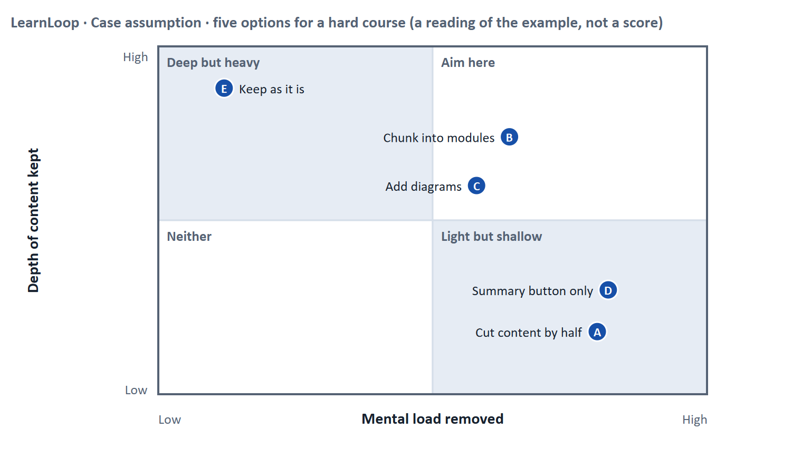
Figure 8 · Five options for a hard course by mental load removed and depth kept. LearnLoop example, Case assumption.
 | Too simple | Too complex
What the learner experiences | A feeling of understanding, but cannot apply it | A feeling of being lost, and stops
What was removed or left in | Examples, practice and the hard steps | Clutter, wall of text, missing structure
Typical sign in the data | High completion, low results in a test or at work | High drop-out, long time on early lessons
Remedy | Restore the worked example and a task; let experts skip | Chunk, structure, explain terms in place

How to decide when this comes up in the task
- Name both risks: content that is too simple (learners finish and cannot apply) and content that is too complex (learners leave). A plan that names only one has not weighed the conflict.
- Remove extraneous load first; keep the intrinsic difficulty the course exists to teach, and support it.
- For beginners support more; for experienced learners let them skip. Guidance that helps one group can hinder the other (expertise reversal).
- To tell the two risks apart you need both a completion measure and a measure of what learners can do afterwards.

Extra · go deeper (optional reading)
UX as a learning amplifier. The plan's discussion line is "UX as a learning amplifier". A good interface does not replace the effort of learning; it directs that effort to the right place. When you argue for a UX measure to management, say which learning effort it protects.
Efficiency against deep learning. Efficient learning (fast, light) is right for routine knowledge such as a form's fields. Deep learning (slow, effortful) is right for judgement such as assessing a contract risk. A platform that serves both needs to tell them apart in its design.

Sources · Sweller et al. 1998 · Kalyuga et al. 2003 · Bjork & Bjork 2011

B3 · Deciding without user data: assume, test, and set a rule for content · 20 min · Core
When you have no user data, state your assumption, choose a step you can test and undo, and fix how future content decisions are made.
IN PLAIN WORDS
The idea. The plan asks you to decide under uncertainty, for example without user data. A decision under uncertainty states four things: what you decide, what you do not know, what would make you reverse it and by when, and what you give up. You also set a decision logic for future content: who decides and what evidence they need.
Why it matters. Block 3.2 asks for exactly this, and for a rule that will be used for every new lesson.
How to read the picture. The four boxes at the top are the parts of the decision, filled in for LearnLoop. The two boxes below are the rule for future decisions.

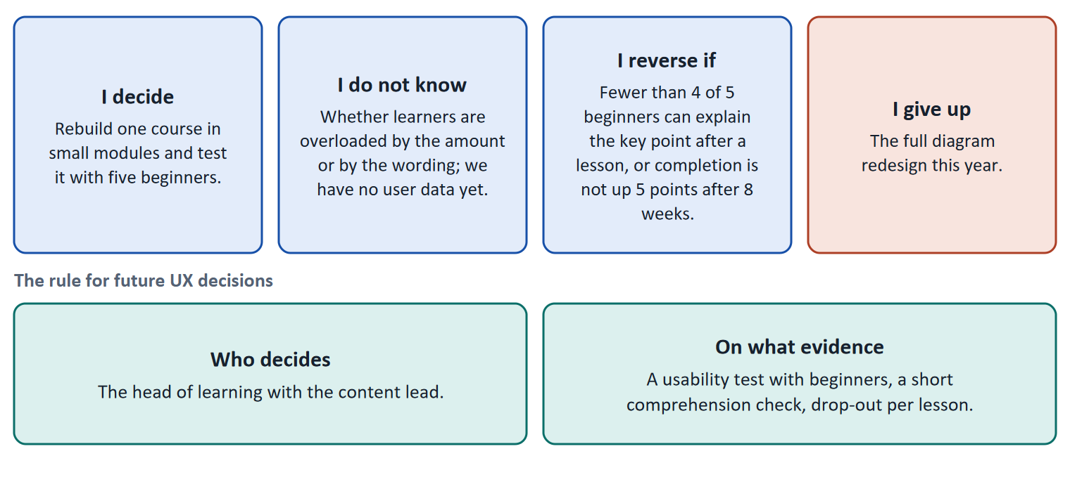
Figure 9 · The four parts of a decision made without user data, filled in for LearnLoop (Case assumption), and the rule for future decisions.
- No data is still a decision. Choose the step whose result will tell you most and which you can undo: rebuild one course, test it with five beginners, and decide the rest afterwards.
- A reversal condition has a figure and a time. "Fewer than four of five beginners can explain the key point" is a figure; "if it does not work" is not.
- Decision logic for future content. Name who decides (a role) and which checks every new lesson passes: one goal, a size that fits the time, the key sentence marked, terms explained, a check at the end.
- A premortem helps. Imagine in a year that learners still call the platform too complicated: what went wrong? The answers become checks.
How to decide when this comes up in the task
- A decision under uncertainty states four things: what you decide, what you do not know, what would make you reverse it and by when, and what you give up.
- A reversal condition is checkable only with a figure and a time, set before the test starts.
- Prefer a step you can undo and learn from; leave the large, hard-to-undo decision for after the evidence.
- A decision logic for content names a role that decides and the checks that a lesson must pass; a style guide that nobody checks is not a decision logic.
- Giving up nothing means you have not decided: name what you postpone.

Extra · go deeper (optional reading)
Evidence without a big study. With five beginners you can learn most of what is wrong with a lesson (see Day 2, card A3). Ask each to explain the key point in their own words after reading: this is a cheap check of effectiveness that works without any platform data.
One-way and two-way doors. Bezos distinguishes decisions that are hard to reverse from decisions that can be reversed cheaply. Rebuilding one course is a two-way door; replacing the whole content library is closer to a one-way door.

Sources · Klein 2007 · Bezos 2016 · Nielsen 2000 · Mayer 2009

References
Check each source and its current edition before you teach from it. Standards and laws marked as in flux can change.
Bjork, E. L., & Bjork, R. A. (2011). Making things hard on yourself, but in a good way: Creating desirable difficulties to enhance learning. In M. A. Gernsbacher et al. (Eds.), Psychology and the Real World (pp. 56–64). Worth. — some difficulty during learning helps long-term retention; not every difficulty does.
Nielsen, J. (2000). Why You Only Need to Test with 5 Users. Nielsen Norman Group. https://www.nngroup.com/articles/why-you-only-need-to-test-with-5-users/ — five users in a test find most of the usability problems; run several small tests rather than one large one.
Sweller, J. (1988). Cognitive load during problem solving: Effects on learning. Cognitive Science, 12(2), 257–285. https://doi.org/10.1207/s15516709cog1202_4 — working memory is limited; effort spent on a badly designed task is missing for learning.
Sweller, J., van Merriënboer, J. J. G., & Paas, F. G. W. C. (1998). Cognitive architecture and instructional design. Educational Psychology Review, 10(3), 251–296. — the distinction between intrinsic, extraneous and germane cognitive load.
Miller, G. A. (1956). The magical number seven, plus or minus two: Some limits on our capacity for processing information. Psychological Review, 63(2), 81–97. — the classic statement that short-term capacity is limited; today's estimates for new material are lower (see Cowan 2001).
Cowan, N. (2001). The magical number 4 in short-term memory: A reconsideration of mental storage capacity. Behavioral and Brain Sciences, 24(1), 87–114. — working memory holds about four chunks of new information.
Atkinson, R. C., & Shiffrin, R. M. (1968). Human memory: A proposed system and its control processes. In K. W. Spence & J. T. Spence (Eds.), The Psychology of Learning and Motivation (Vol. 2, pp. 89–195). Academic Press. — the multi-store model: sensory, short-term and long-term memory.
Anderson, L. W., & Krathwohl, D. R. (Eds.) (2001). A Taxonomy for Learning, Teaching, and Assessing: A Revision of Bloom's Taxonomy of Educational Objectives. Longman. — remember, understand, apply, analyse, evaluate, create.
Cepeda, N. J., Pashler, H., Vul, E., Wixted, J. T., & Rohrer, D. (2006). Distributed practice in verbal recall tasks: A review and quantitative synthesis. Psychological Bulletin, 132(3), 354–380. — spreading practice over time improves retention compared with massing it.
Roediger, H. L., & Karpicke, J. D. (2006). Test-enhanced learning: Taking memory tests improves long-term retention. Psychological Science, 17(3), 249–255. — retrieving information helps memory more than re-reading.
Mayer, R. E. (2009). Multimedia Learning (2nd ed.). Cambridge University Press. — principles such as coherence, signalling, segmenting and spatial contiguity.
Mayer, R. E., & Moreno, R. (2003). Nine ways to reduce cognitive load in multimedia learning. Educational Psychologist, 38(1), 43–52. — design measures that reduce extraneous load.
Harp, S. F., & Mayer, R. E. (1998). How seductive details do their damage: A theory of cognitive interest in science learning. Journal of Educational Psychology, 90(3), 414–434. — interesting but irrelevant additions reduced learning.
Kalyuga, S., Ayres, P., Chandler, P., & Sweller, J. (2003). The expertise reversal effect. Educational Psychologist, 38(1), 23–31. — guidance that helps beginners can hinder experts.
Nielsen, J. (1997). How Users Read on the Web. Nielsen Norman Group (Alertbox, 1 October 1997). https://www.nngroup.com/articles/how-users-read-on-the-web/ — in a study with J. Morkes, 79 percent of test users always scanned a new page and only 16 percent read word for word.
Nielsen, J. (1994, reviewed 2024). 10 Usability Heuristics for User Interface Design. Nielsen Norman Group. https://www.nngroup.com/articles/ten-usability-heuristics/ — for example visibility of system status, match between the system and the real world, consistency and standards, recognition rather than recall.
Gibbons, S. (2018). Using Prioritization Matrices to Inform UX Decisions. Nielsen Norman Group. https://www.nngroup.com/articles/prioritization-matrices/ — a prioritisation matrix plots items on two criteria, for example value to the user against effort.
Klein, G. (2007). Performing a project premortem. Harvard Business Review, 85(9), 18–19. — imagine the plan has failed and ask why; it brings risks to the surface before the money is spent.
Bezos, J. (2016). 2015 Letter to Shareholders. Amazon. — decisions that are hard to reverse ("one-way doors") deserve more care than those that can be reversed cheaply ("two-way doors").

Glossary
Every term below is used in this document. Terms stay plain text in the body; this list says what they mean in everyday words.
Term | In plain words | Example | Comes from
Chunking | Grouping several items into one meaningful unit so that working memory has less to hold. Twelve loose items become three groups of four. | A phone number written as 0151 234 5678 instead of eleven separate digits. | Miller 1956
Cognitive load | How much a person has to hold in mind and work out at once. Attention is limited. Effort spent on decoding a cluttered screen is effort that is missing for learning the content. | A 500-word block of text with no headings costs more attention than the same text in five short parts. | Sweller 1988
Completion rate | The share of people who start a course and finish it. It is the opposite side of the drop-out rate: 60% completion means 40% drop-out. | — | —
Conflicting goals (trade-off) | Two goals that both matter, but cannot both be fully met: for example a simple screen against depth of content. A trade-off means you decide how much of each to keep, and say what you give up. | — | —
Decision architecture | The rule for how future decisions are made: who decides and what evidence they need. It stops a decision from resting on one person's taste. | — | —
Drop-out rate | The share of people who start something and stop before the end. A 40% drop-out rate means 40 of every 100 learners who start a course do not finish it. It counts who left, not why. | 100 learners start; 60 finish; the drop-out rate is 40%. | —
Engagement | How much a learner actually does on the platform: lessons opened, tasks tried, time spent. High engagement is a sign that the platform holds attention; it does not prove they learned. | — | —
Expertise reversal | Guidance and simplification that help beginners can get in the way of experts, who already have the knowledge and find the extra support redundant. | Step-by-step hints that slow down a specialist. | Kalyuga et al. 2003
Extraneous load | Mental effort that is caused by poor presentation and does not help learning: clutter, a wall of text, unclear structure, unexplained terms. This is the load that UX can and should cut. | Searching a long page for the one sentence that matters. | Sweller et al. 1998
Feedback (in an interface) | A sign from the system that tells the user what just happened or how they did: “saved”, “4 of 5 correct”, a bar that moves. Without it, users do not know whether their action worked. | — | Nielsen 1994
Germane load | Mental effort that goes into making sense of the content: linking ideas, working an example, explaining it to oneself. It is the effort you want to leave room for. The idea is still discussed by researchers; for design the useful split is effort that helps learning against effort that does not. | Trying to apply a rule to a new case. | Sweller et al. 1998
Intrinsic load | The mental effort that comes from the subject itself: how many new ideas there are and how much they depend on each other. Design cannot remove it, only order it sensibly. | Learning data-protection law is harder than learning how to log in. | Sweller et al. 1998
KPI (key performance indicator) | A number a team agrees to watch to judge whether something works, such as completion rate or time to finish a lesson. A good KPI has a baseline and a target. | Completion rate of the first course: 58% today, goal 65% in six months. | —
Learning path | A set order in which a learner goes through the material of a course: what to do first, next and last. It tells a beginner where to start and how far there is to go. | “Lesson 1 → Lesson 2 → Quiz → Lesson 3” shown on screen as a path. | —
Learning-effective UX | A design that helps learners reach the intended learning result at reasonable mental cost, not one that merely looks simple. It is judged by what learners understand and can do afterwards. | A lesson after which five beginners can explain the key point in their own words. | —
Long-term memory | The store in which understood and practised knowledge is kept for days, months or years. Content gets there when it is understood, linked to what is known, and revisited. | A skill you can still use a year after the course. | Atkinson & Shiffrin 1968
Microlearning | Learning in short, focused units of a few minutes, each with one goal. It fits the limited capacity of working memory and the time that working adults have. | A six-minute unit with one learning goal and one check. | —
Multimedia principle | People tend to learn better from words and pictures together than from words alone, provided the picture is relevant and placed close to the words it explains. | A diagram with its labels inside it instead of a paragraph describing the same flow. | Mayer 2009
Orientation | Knowing where you are in a system, how you got there and what you can do next. Good orientation means a learner never has to guess. | — | —
Progress indicator | Something on screen that shows how far along the learner is, for example a bar and “3 of 8 lessons done”. It answers “where am I, and how much is left?”. | — | —
Qualitative and quantitative data | Qualitative data says why: observations, quotes, interviews, usually from a few people. Quantitative data says how many or how much: counts, rates, times, usually from many people. | Five learners say they miss a Next button (qualitative); 40% leave on lesson 3 (quantitative). | —
Retrieval practice and spacing | Retrieval practice means trying to recall something instead of re-reading it. Spacing means revisiting it after a delay instead of all at once. Both strengthen long-term memory. | A short quiz at the start of next week's lesson on this week's content. | Roediger & Karpicke 2006
Roadmap | A plan that puts decisions in order over time: what is done first, next and later, and why in that order. | — | —
Seductive details | Interesting but irrelevant additions to a lesson (a funny picture, a side story). Studies found that they can distract from the main point and lower learning. | A decorative photo of a pirate ship in a lesson on invoices. | Harp & Mayer 1998
Stakeholder | A person or group that is affected by a decision or can influence it, such as management, trainers, learners or the customer's HR department. | The head of HR who buys the courses for 200 employees. | —
Symptom and cause | A symptom is what you can see or count (people leave). A cause is the reason behind it (they cannot find the next lesson). A number such as a drop-out rate shows the symptom, not the cause. | 40 of 100 learners leave is a symptom; "the course has no path" is a cause. | —
Usability test | You watch real users try a task on the product while they think aloud, and note where they hesitate or fail. Five to ten people already show the main problems. | — | —
User impact | How much a measure helps the users with the problems they actually have: getting unstuck, understanding, carrying on. A measure that answers none of the findings has little user impact, however good it sounds. | — | —
Visual hierarchy | Using size, colour, contrast and position so that the most important thing on a screen is seen first and the least important last. It controls where attention goes. | A large heading, a normal paragraph, a small footnote. | —
Working memory | The small mental workspace in which a person holds and works on information for a few seconds. It is very limited: current estimates for new material are about four chunks at a time. | Remembering a phone number just long enough to dial it. | Cowan 2001

