HABMANN AUFSTIEGSAKADEMIE · DIGITAL LEARNING · EDUCATIONAL UX/UI DESIGN
DAY 6 · MATERI A AND MATERI B · ROUTES 1 AND 2 · LEVELS 1 TO 3
Personas and user journeys in the learning context
Make learners and teachers tangible, map where their path breaks, and prioritise user segments strategically
Day | Day 6 · Module 3 (day 2 of 3): Developing personas for learners and teachers, and mapping user journeys in the learning context
Document | Materi (study material). Materi A has five cards, Materi B has three.
Route and level | Materi A serves Route 1 (Levels 1 and 2, Task 1). Materi B serves Route 2 (Level 3, Task 2).
Time | Materi A about 60 min · Materi B about 60 min (facilitator-led)
Website (playground) | Not yet published (the link will be added once Day 6 is deployed)
Case | Worked examples use LearnLoop, an online-course provider. The task case is EduPath, a platform on which different users fail in different ways (see the Task document).

ABOUT THIS DOCUMENT
This document holds everything you need to study Day 6 without the website. Each card says the idea in plain words, shows it in a picture, gives the details, and ends with the rules you will use in the Task document. Cards marked Optional are not needed for the Core blocks of the task. The worked examples use LearnLoop, a different company from the task case, so no task answer is printed here. Glossary and references are at the end.

IN THIS DOCUMENT
A1 · Personas: what they are and what is in them · 14 min · Core
A2 · Good and weak personas: data, not clichés · 10 min · Core
A3 · User journeys: phases, pain points and emotions · 14 min · Core
A4 · Learners and teachers: different perspectives · 10 min · Optional
A5 · Weighing a measure along a journey: segment impact, effort, risk · 12 min · Core
B1 · Segments and strategy: which persona is business-critical · 18 min · Core
B2 · Conflicting goals: segments with conflicting needs · 22 min · Core
B3 · Deciding which persona to prioritise under uncertainty · 20 min · Core

Materi A · Route 1 · Levels 1 and 2
How Materi A is used
About 60 minutes, five cards. The plan's Level 1 asks you to understand and classify personas and user journeys. Level 2 asks you to develop personas and to analyse learning processes systematically. Task 1 uses all of it on one case. The card A4 is Optional: no Core block of the task needs it.

A1 · Personas: what they are and what is in them · 14 min · Core
A persona is a representative profile that makes a group's needs tangible. It holds goals, problems and the context of use, and it is used in decisions.
IN PLAIN WORDS
The idea. A persona is a representative user profile. It stands for a group of real users and makes their needs concrete enough to discuss. Three things go into it: goals (why does the person learn?), problems and frustrations (what gets in the way?) and the context of use (time, device, motivation). Learners and teachers need different personas, because their perspectives differ.
Why it matters. In Task 1 you write a persona and then sort evidence into its fields. This card shows what the fields mean and what a usable persona looks like.
How to read the picture. The card is one example persona for LearnLoop. Read the three coloured fields from left to right, and the line at the bottom that says what it is built from.

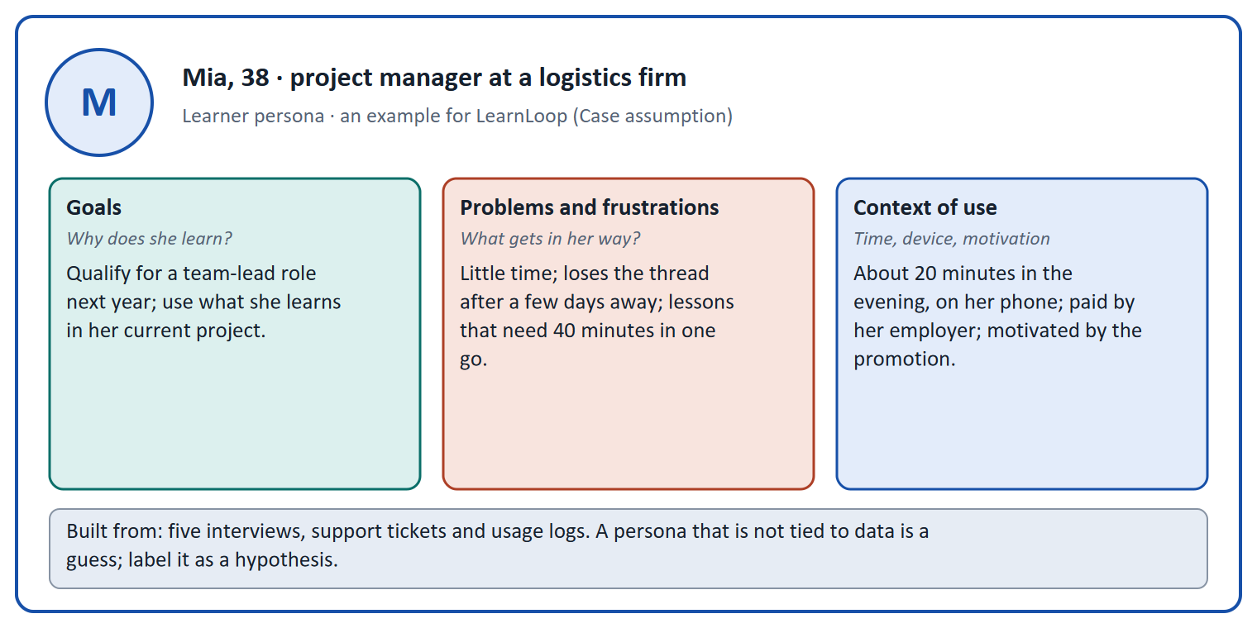
Figure 1 · A learner persona for LearnLoop (Case assumption): goals, problems and frustrations, context of use, and its sources.
Let us look at why a persona is useful in a meeting. Without one, a team argues about "the user" and each person has a different user in mind. With one, someone can ask "would this help Mia, who has twenty minutes on her phone?" and the room can answer. A persona is therefore a decision tool, not a profile. That is the plan's coaching point, and it is the test of every persona you write.
- Goals. Why does the person learn? A goal is a reason in the person's life ("qualify for a team-lead role"), not a feature wish ("a dashboard").
- Problems and frustrations. What gets in the way? Name the situation ("loses the thread after a few days away"), not a verdict ("the platform is bad").
- Context of use. When, where, on which device, and why (voluntary or required). This decides what the design must allow.
- Learners and teachers differ. A learner wants to finish; a teacher wants to build and run courses with little effort. A third group, the organisation that buys the courses, wants visible completion and control of cost.
How to decide when this comes up in the task
- Write a persona with three parts: goals, problems and frustrations, context of use. Add the expectation the person has of a learning platform.
- State each goal as a reason in the person's life, and each problem as a situation, not as a feature wish or a verdict.
- Name the source of each statement (interview, ticket, log). A statement without a source is a hypothesis.
- Make one persona per perspective that really differs: do not mix the learner and the teacher in one profile.

Extra · go deeper (optional reading)
Where personas come from. Cooper (1999) introduced personas as design tools to replace the vague "user" with specific people whose goals drive the design. Pruitt and Grudin (2003) describe what makes them work in practice: they must rest on data and be used in decisions, otherwise they become decoration.
Proto-personas. When there is no research yet, a team can write a proto-persona from its assumptions, and treat it as a hypothesis to test with interviews (Gothelf and Seiden 2013). The danger is forgetting that it is a guess.

Sources · Cooper 1999 · Pruitt & Grudin 2003 · Gothelf & Seiden 2013

A2 · Good and weak personas: data, not clichés · 10 min · Core
A useful persona rests on data, differs from the other personas, and is used in decisions. Clichés and personas for everyone are the typical failures.
IN PLAIN WORDS
The idea. The plan names two typical mistakes: clichés instead of data, and personas that are too general. A persona benefits the team in three ways: it is a basis for design decisions, it helps to prioritise features, and it prevents "design for everyone, which means design for no one".
Why it matters. In Task 1 and Task 2 you write and choose personas. This card is the quality check for what you write.
How to read the picture. The two columns set typical mistakes against what a useful persona looks like, row by row.

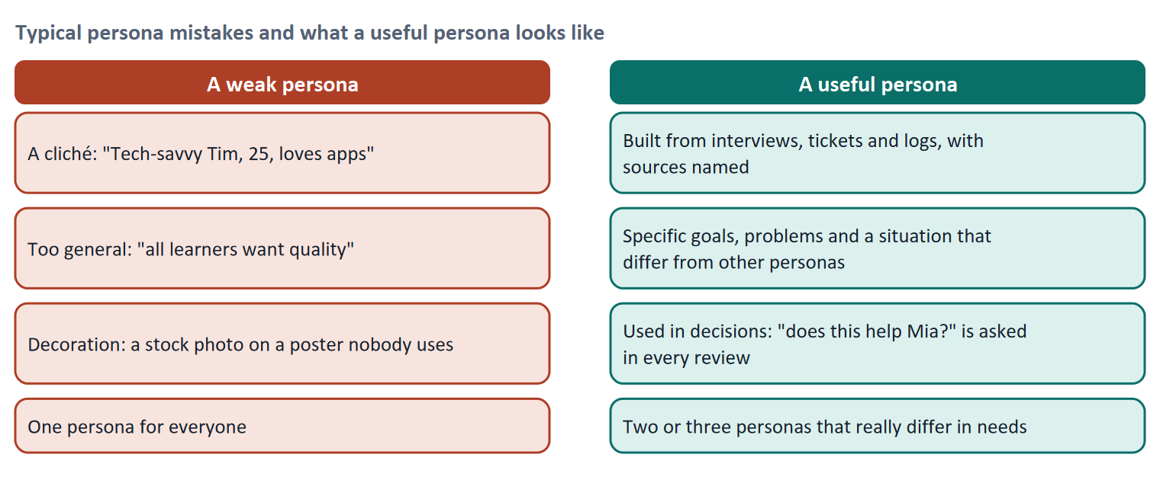
Figure 2 · Typical persona mistakes and what a useful persona looks like.
Where to get the data. A short list: interviews with learners and teachers; support tickets (what people ask for help with); usage logs (when and on what devices they use the platform, where they stop); surveys for size. A persona built from five good interviews and a log analysis is far more useful than one built from a workshop alone.
Why behaviour beats demographics. "Women aged 30 to 45" does not tell you what the platform must allow. "People who study for twenty minutes on a phone in the evening" does. Segments built on goals, situations and behaviour (the plan's contents of a persona) can be acted on; segments built on age or job title often cannot.
How to decide when this comes up in the task
- A persona differs from the others in goals, problems or context. If two personas want the same thing in the same situation, merge them.
- A cliché ("tech-savvy, loves apps") tells the design nothing. Replace it with a goal, a problem or a situation that you can point to in the evidence.
- Test a persona with a question: which decision would change because of it? If none would, it is decoration.
- Two or three personas are usually enough. More than that, and no one remembers them.

Extra · go deeper (optional reading)
Jobs to be done. Instead of describing who the user is, describe the progress they want in their situation (Christensen and colleagues). "Carry on where I stopped in the time I have" is a job; it can unite people of different ages and roles.
Ethical note. Personas simplify. Check that your persona does not turn a group into a stereotype and that you have not left out the learners who are hardest to reach (Day 7 covers inclusive design).

Sources · Pruitt & Grudin 2003 · Gothelf & Seiden 2013 · Christensen et al. 2016

A3 · User journeys: phases, pain points and emotions · 14 min · Core
A journey map follows one persona through phases and shows what they do, think and feel, so that the points where it breaks become visible.
IN PLAIN WORDS
The idea. A user journey is the step-by-step experience of a user. In a learning context the plan names three phases: entry (onboarding), learning (usage), and progress and completion. A journey map shows, for each phase, what the person does, what they think and how they feel, and marks the pain points. The emotional perspective (frustration, motivation) shows where to act first.
Why it matters. Task 1 asks you to sketch a journey and to say which phase is critical. This card gives you the grid and the reading rules.
How to read the picture. The columns are phases. The line is the emotion curve: low points are frustration, high points motivation. The boxes under each phase hold the action and the pain point. Find the lowest point, and read the box under it.

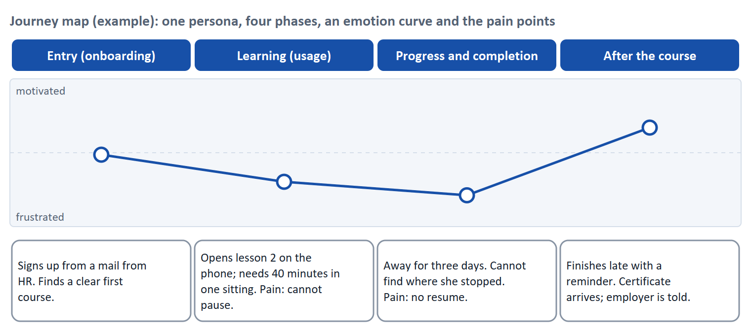
Figure 3 · A journey map for the learner persona of LearnLoop (Case assumption): four phases, an emotion curve and the pain points.
Element of a journey map | What it says | Example
Actor | One persona, not "users" | Mia, the time-poor learner
Scenario | The goal and the situation | "Finish the negotiation course in three weeks"
Phases | The stages of the path | Entry, learning, progress and completion
Actions and thoughts | What the person does and thinks | "Opens lesson 2 on the phone; thinks: I cannot stop now"
Emotions | How the person feels at each step | A curve from motivated to frustrated
Pain points | Where it breaks | "No resume after three days"

Systemic problems, not single errors. A journey reveals a pattern: if the same phase is low for several personas, the cause is in the process, not in a single screen. The plan's coaching puts it as "think in processes instead of screens". The journey also helps you see what happens between screens: reminders, emails, reports.
The end counts. People tend to judge an experience by its most intense moment and by how it ended (the peak-end rule, Kahneman and colleagues 1993). In a course, the progress and completion phase therefore carries more weight in memory than its length suggests.
How to decide when this comes up in the task
- Map one persona at a time, with at least the three phases: entry, learning, progress and completion. Write what they do, think and feel in each.
- Mark a phase as critical where the emotion is lowest or where the person stops. Say why in a sentence.
- A pain point is a place where something goes wrong in the person's path, described as a situation ("cannot find where she stopped"), not as a verdict.
- Look for a pain point that recurs across personas: it points to a systemic cause that one fix can remove.
- A journey includes touchpoints outside the screen: emails, reminders, reports.

Extra · go deeper (optional reading)
What goes into a journey map. Gibbons (2018, Nielsen Norman Group) lists the parts: an actor, a scenario with expectations, journey phases, actions, thoughts and emotions, and opportunities. Kalbach (2020) distinguishes a journey map (one actor, one goal, one path) from an experience map (a general human activity).
Empathy. A map is only as good as the evidence behind it. Mark which parts come from observation and which are assumptions, and test the assumptions with the persona's real counterparts.

Sources · Gibbons 2018 (NN/g) · Kalbach 2020 · Kahneman et al. 1993

A4 · Learners and teachers: different perspectives · 10 min · Optional
The same platform looks different to a learner and to a teacher. Each needs its own persona and its own journey.
IN PLAIN WORDS
The idea. The plan stresses that learners and teachers have different perspectives. The learner wants to finish; the teacher wants to build and run a course with little effort and to see how learners are doing. A platform that serves only one of them fails the other, and, in the organisation's view, shows up as low usage.
Why it matters. The case study asks for one persona and one journey per group. This card shows how far apart they can be.
How to read the picture. The two columns set the learner's perspective next to the teacher's, row by row.

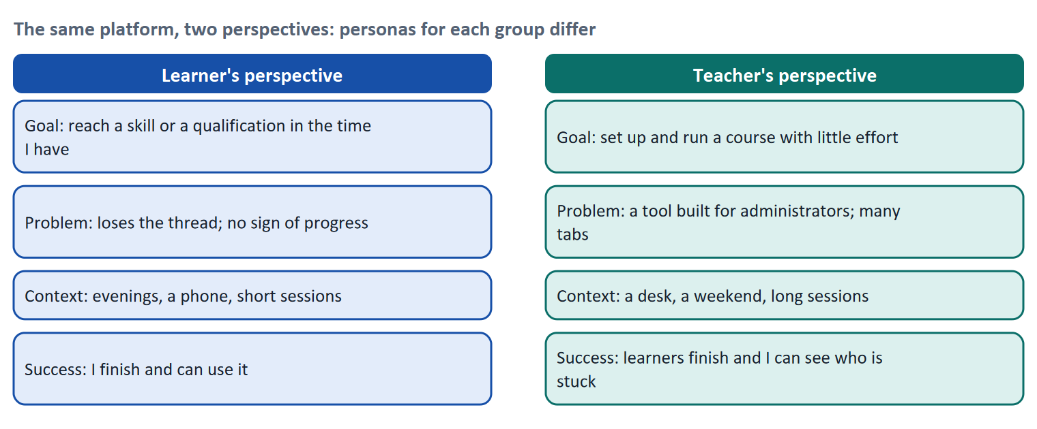
Figure 4 · The same platform, two perspectives.
How to decide when this comes up in the task
- Write the teacher's journey with its own phases (for example set up, run, review), not the learner's phases.
- A measure that helps learners can burden teachers: name who each measure helps and who it burdens.
- Look for a measure that helps both, such as a clear course structure that both can see.

Extra · go deeper (optional reading)
The third user. The organisation that buys the courses (a training manager, an HR department) has goals of its own: visible completion, cost control, simple reporting. In Materi B the training manager appears as a segment that is small and business-critical.

Sources · Pruitt & Grudin 2003 · Kalbach 2020

A5 · Weighing a measure along a journey: segment impact, effort, risk · 12 min · Core
Rate a measure by how much it helps the persona at their critical point, what it costs and what could go wrong.
IN PLAIN WORDS
The idea. To choose between measures, place each on the journey and rate it on three questions. User impact: how much does it help the persona at a pain point, and how many people does that persona stand for? Effort: money and time, decided here by a rule: under €8,000 is Low, up to €15,000 is Mid, above that is High. Risk: what could go wrong or be lost?
Why it matters. Block 2.2 of the task asks for exactly this. The example uses LearnLoop, so the answer for the task case is not given.
How to read the picture. The bars show the cost of three LearnLoop measures. The coloured bands are the effort rule. The dashed line is the budget.

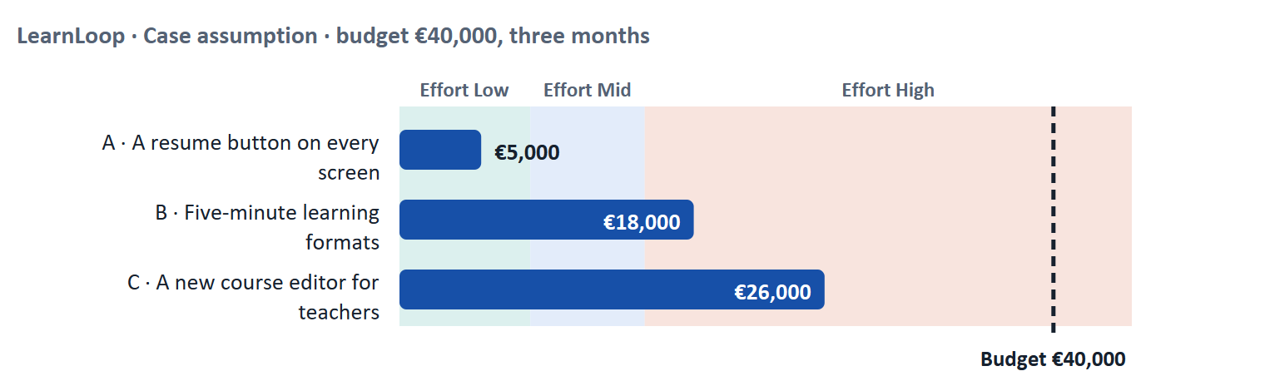
Figure 5 · LearnLoop weighs three measures. Cost against the effort rule and the budget (Case assumption).
A short story: LearnLoop's critical point
Step 1. Let us look at LearnLoop again. Its learner persona, Mia, falls into frustration at one point: when she returns after three days and cannot find where she stopped. LearnLoop has €40,000 and three months.
Step 2 · A resume button on every screen. It costs €5,000, so the effort is Low. It answers Mia's lowest point exactly, and many learners return after a break, so the user impact is High, and the risk is Low.
Step 3 · Five-minute learning formats. It costs €18,000, so the effort is High. It helps time-poor learners a lot, but it rebuilds content, so it uses nearly half the budget; the impact is High and the risk is Mid.
Step 4 · A new course editor for teachers. It costs €26,000, so the effort is High. It helps teachers, a smaller group, and does nothing for Mia's critical point: the impact on this persona is Low. For a different persona it could be right, which is why you must say whom a measure is for.

LearnLoop measure | User impact (on the persona it targets) | Effort | Risk
A resume button on every screen · €5,000 | High. It removes Mia's lowest point, and many learners return after a break. | Low. €5,000 is under €8,000. | Low. A small addition.
Five-minute learning formats · €18,000 | High. It fits the time-poor learner's situation. | High. €18,000 is above €15,000. | Mid. Content must be rebuilt; it uses nearly half the budget.
A new course editor for teachers · €26,000 | Low for Mia; High for teachers. | High. €26,000 is above €15,000. | Mid. A large project for a smaller group.

Case assumption
LearnLoop, its costs and its reasons are made up for this example. The task case is in the Task document.

How to decide when this comes up in the task
- Rate effort by the printed cost: under €8,000 is Low; €8,000 to €15,000 is Mid; above €15,000 is High.
- Rate user impact for a named persona at a named pain point. A measure that does not touch any pain point of a persona has a low impact.
- Say how many people the persona stands for: a measure for a large segment weighs more than one for a small one, unless the small one is business-critical.
- Rate risk by what could be lost or wasted, and by whether the measure can be undone.
- Name the central pain point each of your chosen measures answers and the phase it sits in.

Sources · Gibbons 2018 (NN/g) · Gibbons 2018 (Journey Mapping 101)

Materi B · Route 2 · Level 3
How Materi B is used
About 60 minutes, three cards. Level 3 asks you to prioritise user segments and to steer UX strategies along journeys. Materi B teaches the three things Task 2 asks: decide which segment is business-critical (B1), weigh segments with conflicting needs (B2), and decide which persona to prioritise under uncertainty (B3).

B1 · Segments and strategy: which persona is business-critical · 18 min · Core
Prioritise a persona by the size of its segment, its business value and how critical its journey is. A small segment can be the most critical.
IN PLAIN WORDS
The idea. A platform serves several user segments. Which one deserves the most attention? Three questions help: how large is the segment, what is it worth to the business, and where does its journey break most? The plan's discussion line asks which persona is business-critical, which journey causes the most problems and where optimisation pays off most.
Why it matters. Task 2 asks you to choose two or three strategic personas, to select the most important target group and to map its most critical journey. This card gives you the grid.
How to read the picture. The matrix places five segments of LearnLoop by their size (left to right) and by their business value (bottom to top). The position is a reading of the example, not a score. A small segment high up is small but critical.

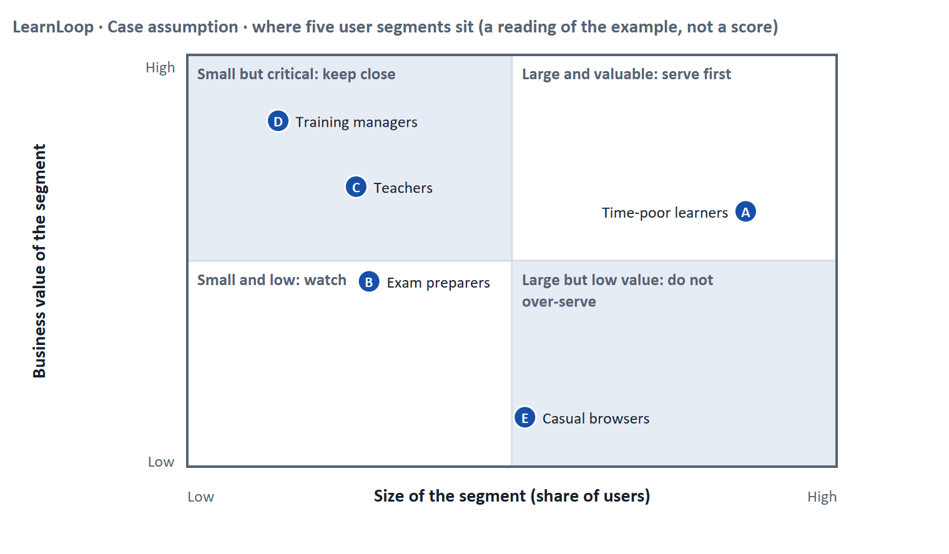
Figure 6 · Five user segments by size and business value. LearnLoop example, Case assumption.
Question | What it tells you | Typical evidence
How large is the segment? | How many people a change reaches | Usage data, accounts, sign-ups
What is it worth? | What the business loses if the segment is unhappy | Revenue, renewal decisions, content supply
Where does its journey break? | Where optimisation pays off most | Journey maps, drop-out per phase, interviews

Small but critical. A group of 60 training managers who renew licences for 5,000 learners decides more of the business than 5,000 learners. A group of teachers that supplies the content decides what the learners can learn at all. The plan calls this "which persona is business-critical". The answer is not always the biggest group.
How to decide when this comes up in the task
- Choose strategic personas by three tests: size, business value and journey breakage. Say which test decided.
- Do not assume the largest segment is the most important. Check who decides renewals, who supplies content, who pays.
- A persona is strategic if a decision would change because of it. A persona that changes no decision should not be on the list.
- Optimisation pays off most where a segment is large or critical and its journey breaks at a point you can fix.

Extra · go deeper (optional reading)
Behaviour over demographics. Segments defined by what people do and want (time-poor on a phone, exam preparation, course building) lead to design decisions; segments defined by age rarely do (Pruitt and Grudin 2003).
Primary and secondary personas. The idea of designing for a specific person (Cooper 1999) leads to naming one primary persona whose needs must be satisfied, and secondary personas who are served as long as it does not harm the first.

Sources · Pruitt & Grudin 2003 · Cooper 1999 · Kalbach 2020

B2 · Conflicting goals: segments with conflicting needs · 22 min · Core
"Design for everyone" serves no one. When segments conflict, say who comes first, what the others get, and when you will revisit.
IN PLAIN WORDS
The idea. The plan's conflict for Day 6 is the prioritisation of user groups: their needs can conflict, and resources are limited. A design that tries to satisfy every segment fully ends up serving none. A strategy picks a primary segment, serves the others as far as it does not harm the primary one, and says what the others give up.
Why it matters. Task 2 asks you to select the most important target group and to prioritise an optimisation strategy. This card gives you the argument.
How to read the picture. The two columns set two segments of LearnLoop side by side. The last row states the problem: a design for both gives up depth or speed.

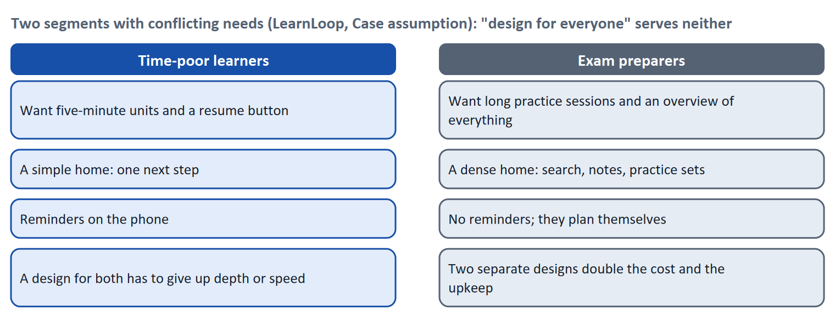
Figure 7 · Two segments with conflicting needs: "design for everyone" serves neither (LearnLoop, Case assumption).
Conflict | One side gets | The other side gets | A rule for deciding
Primary against secondary segment | Its journey fixed first | A later fix, or a smaller one | Name the primary; say when the secondary is revisited
Large against critical segment | Reach: many people helped | Leverage: the group that decides renewals or content | Weigh the cost of losing the critical group against the gain for the large one
One interface against two | Simplicity and consistency | A fit for each segment | Share what is common (structure, language); separate what differs (home screen, tools)
Persona detail against speed | Time to decide | A persona that rests on enough data | Start with a proto-persona, label it a hypothesis, and test it

How to decide when this comes up in the task
- Name the primary segment and say what the others will get and when.
- Share the parts of the platform that are common (structure, language, navigation) and separate only what truly differs.
- Where segments conflict, say which need is given up for which and what you do to limit the damage (a later release, a smaller version, a mode).
- Avoid "design for everyone". If a measure claims to help all segments equally, ask where it is vague.

Extra · go deeper (optional reading)
Do not hide the loser. A strategy that names no segment that waits has not prioritised. Telling a segment honestly when it will be served keeps trust, especially with a business-critical customer such as a training manager.
Journeys as a steering tool. The plan's discussion line is "UX as steering of user flows". A journey map lets you see where one fix helps several segments at once, such as a clear course structure that learners and teachers share.

Sources · Pruitt & Grudin 2003 · Gibbons 2018 (Journey Mapping 101) · Kalbach 2020

B3 · Deciding which persona to prioritise under uncertainty · 20 min · Core
When you are not sure which persona is right, decide a step you can test, write down what would change your mind, and keep personas as hypotheses.
IN PLAIN WORDS
The idea. The plan asks you to decide under uncertainty, for example which persona is prioritised. A decision under uncertainty states four things: what you decide, what you do not know, what would make you reverse it and by when, and what you give up. Personas written from thin data are hypotheses; the decision should include how you will test them.
Why it matters. Block 3.2 asks for exactly this, for a platform with limited data.
How to read the picture. The four boxes at the top are the parts of the decision, filled in for LearnLoop. The two boxes below are the rule for future decisions.

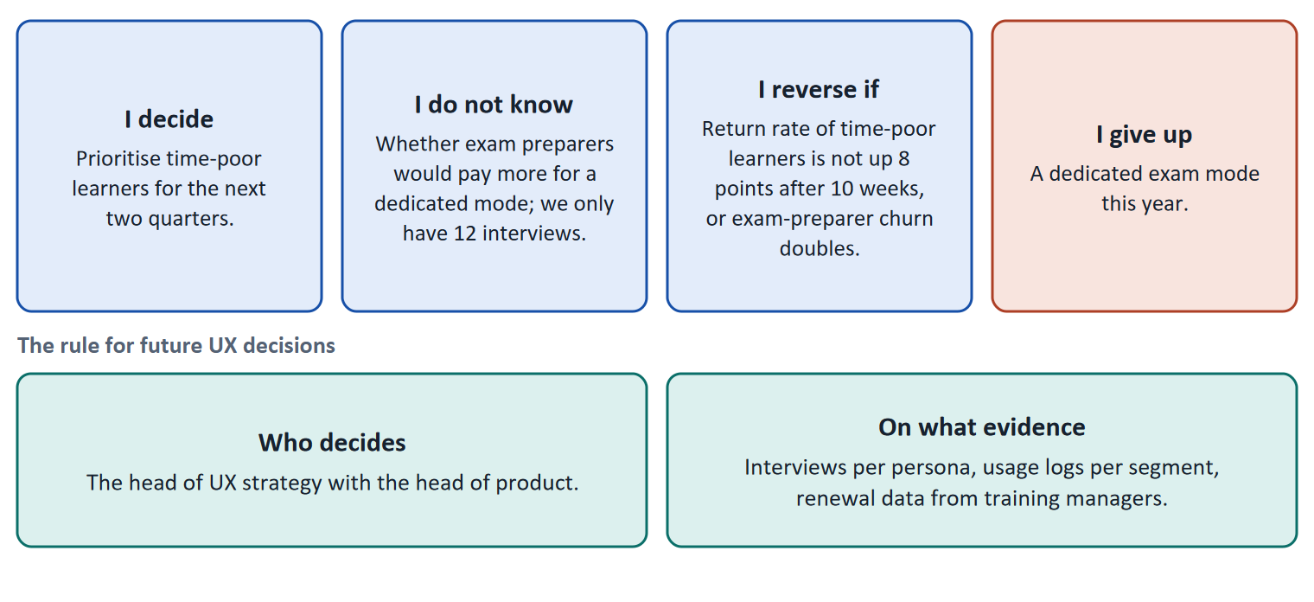
Figure 8 · The four parts of a decision about which persona to prioritise, filled in for LearnLoop (Case assumption), and the rule for future decisions.
- Treat personas as hypotheses. Label each persona with how much data it rests on (for example 12 interviews, one log analysis) and say what would change it.
- Choose a reversible priority. Prioritising one segment for two quarters can be reviewed; a platform rebuilt for it cannot.
- Give the other segments a date. A segment that waits needs to know when it is revisited, and what you watch in the meantime (its churn, its complaints).
- Fix the rule. Name who decides on persona priority and what evidence they need: interviews per persona, usage per segment, renewal data. A persona rule that depends on one person's favourite will not last.
How to decide when this comes up in the task
- A decision under uncertainty states four things: what you decide, what you do not know, what would make you reverse it and by when, and what you give up.
- A reversal condition has a figure and a time: "return rate of the primary segment is not up eight points after ten weeks, or churn of a waiting segment doubles".
- State how much evidence each persona rests on, and what you will do to test it.
- Name who decides on persona priority and which evidence they need.
- Giving up nothing means you have not decided: name which segment waits and until when.

Extra · go deeper (optional reading)
Premortem. Klein's premortem asks the team to imagine that the persona strategy failed. Typical answers: the persona was a cliché, the segment we skipped left, the critical customer was not asked. Each answer becomes a check.
One-way and two-way doors. Bezos distinguishes decisions that are hard to reverse from those that are cheap to reverse. A two-quarter priority is a two-way door; a platform rebuilt around a single persona is closer to a one-way door.

Sources · Klein 2007 · Bezos 2016 · Gothelf & Seiden 2013 · Pruitt & Grudin 2003

References
Check each source and its current edition before you teach from it. Standards and laws marked as in flux can change.
Cooper, A. (1999). The Inmates Are Running the Asylum. Sams. — the origin of personas as design tools.
Pruitt, J., & Grudin, J. (2003). Personas: Practice and theory. Proceedings of DUX '03. ACM. — personas work when they rest on data and are used in decisions; they fail as decoration.
Gothelf, J., & Seiden, J. (2013). Lean UX: Applying Lean Principles to Improve User Experience. O'Reilly. — proto-personas as hypotheses to be tested.
Kalbach, J. (2020). Mapping Experiences (2nd ed.). O'Reilly. — journey maps, experience maps and service blueprints.
Gibbons, S. (2018). Journey Mapping 101. Nielsen Norman Group. https://www.nngroup.com/articles/journey-mapping-101/ — a journey map has an actor, a scenario, phases, actions, thoughts and emotions.
Christensen, C. M., Hall, T., Dillon, K., & Duncan, D. S. (2016). Competing Against Luck. HarperBusiness. — jobs to be done: people "hire" a product to make progress in a situation.
Kahneman, D., Fredrickson, B. L., Schreiber, C. A., & Redelmeier, D. A. (1993). When more pain is preferred to less: Adding a better end. Psychological Science, 4(6), 401–405. — the peak-end finding: how an experience ended shaped how it was remembered.
Knowles, M. S. (1975). Self-Directed Learning: A Guide for Learners and Teachers. Association Press. — a self-directed learner sets goals, finds resources and judges progress; a guided learner gets these from a trainer.
ISO 9241-210:2019. Ergonomics of human-system interaction, Part 210: Human-centred design for interactive systems. — design starts from users, their tasks and their environment, and is repeated with users.
Nielsen, J. (2001). First Rule of Usability? Don't Listen to Users. Nielsen Norman Group. https://www.nngroup.com/articles/first-rule-of-usability-dont-listen-to-users/ — watch what users do; what they say about what they do is unreliable.
Gibbons, S. (2018). Using Prioritization Matrices to Inform UX Decisions. Nielsen Norman Group. https://www.nngroup.com/articles/prioritization-matrices/ — a prioritisation matrix plots items on two criteria, for example value to the user against effort.
Klein, G. (2007). Performing a project premortem. Harvard Business Review, 85(9), 18–19. — imagine the plan has failed and ask why; it brings risks to the surface before the money is spent.
Bezos, J. (2016). 2015 Letter to Shareholders. Amazon. — decisions that are hard to reverse ("one-way doors") deserve more care than those that can be reversed cheaply ("two-way doors").

Glossary
Every term below is used in this document. Terms stay plain text in the body; this list says what they mean in everyday words.
Term | In plain words | Example | Comes from
Business-critical segment | A segment whose behaviour decides the company's results, even if it is small, for example the training managers who decide whether a contract is renewed. | 60 training managers who renew licences for 5,000 learners. | —
Completion rate | The share of people who start a course and finish it. It is the opposite side of the drop-out rate: 60% completion means 40% drop-out. | — | —
Conflicting goals (trade-off) | Two goals that both matter, but cannot both be fully met: for example a simple screen against depth of content. A trade-off means you decide how much of each to keep, and say what you give up. | — | —
Context of use | The situation in which a product is used: who the users are, what goals and tasks they have, what device they use and where they are. Usability is always judged in a context. | A learner on a phone in a train with ten minutes, against a learner at a desk for a whole day. | ISO 9241-11
Decision architecture | The rule for how future decisions are made: who decides and what evidence they need. It stops a decision from resting on one person's taste. | — | —
Drop-out rate | The share of people who start something and stop before the end. A 40% drop-out rate means 40 of every 100 learners who start a course do not finish it. It counts who left, not why. | 100 learners start; 60 finish; the drop-out rate is 40%. | —
Emotion curve | A line in a journey map that shows how the user feels at each step, from frustrated to motivated. Low points show where to act first. | The dip when the learner cannot find where they stopped. | Gibbons 2018
Engagement | How much a learner actually does on the platform: lessons opened, tasks tried, time spent. High engagement is a sign that the platform holds attention; it does not prove they learned. | — | —
Hypothesis-based approach | Writing down what you expect before you change something: "We believe that X will lead to Y; we will know when Z moves." It makes the result checkable. | "We believe a next-step button will raise the 7-day return rate by five points." | Gothelf & Seiden 2013
KPI (key performance indicator) | A number a team agrees to watch to judge whether something works, such as completion rate or time to finish a lesson. A good KPI has a baseline and a target. | Completion rate of the first course: 58% today, goal 65% in six months. | —
Onboarding | The first steps a new user takes on a platform: signing up, finding a first course, getting the first result. A good start makes it likely that the learner carries on. | A welcome screen that offers one first course and shows how long it takes. | —
Pain point | A place in the user's path where something goes wrong or is frustrating: they get stuck, lose time or give up. | Not finding where you stopped after a three-day break. | Gibbons 2018
Peak-end rule | People judge an experience mostly by its most intense moment and by how it ended, not by the average. For a course the last step matters. | A smooth certificate step can colour the memory of a bumpy course. | Kahneman et al. 1993
Persona | A made-up but data-based person who stands for a group of users, with goals, problems and a situation. It makes the needs of a group easy to discuss. (Day 6 covers it in detail.) | "Mia, 38, project manager, ten minutes between meetings." | Cooper 1999
Primary and secondary persona | The primary persona is the one whose needs the design must satisfy first. Secondary personas are served as long as that does not harm the primary one. | Time-poor learners as primary, teachers as secondary. | Cooper 1999
Proto-persona | A first persona written from the team's assumptions, before there is research. It is a hypothesis to be tested with real users, and must be labelled as such. | "We assume our main learner is a busy professional; we will check this with five interviews." | Gothelf & Seiden 2013
Qualitative and quantitative data | Qualitative data says why: observations, quotes, interviews, usually from a few people. Quantitative data says how many or how much: counts, rates, times, usually from many people. | Five learners say they miss a Next button (qualitative); 40% leave on lesson 3 (quantitative). | —
Retention | How many learners come back after the first time, for the next lesson, the next course or the next year. A platform with good retention keeps its learners. | — | —
Roadmap | A plan that puts decisions in order over time: what is done first, next and later, and why in that order. | — | —
Say-do gap | People often do not do what they say they do or would do. So user research should watch behaviour as well as ask opinions. | Learners say they want more features, but they never open the ones that exist. | Nielsen 2001
Self-directed and guided learning | Self-directed learners study alone, at their own pace, and decide for themselves what to do next. Guided learners follow a trainer and a schedule. A platform must supply the structure and feedback a trainer would, for those who learn alone. | — | Knowles 1975
Stakeholder | A person or group that is affected by a decision or can influence it, such as management, trainers, learners or the customer's HR department. | The head of HR who buys the courses for 200 employees. | —
Symptom and cause | A symptom is what you can see or count (people leave). A cause is the reason behind it (they cannot find the next lesson). A number such as a drop-out rate shows the symptom, not the cause. | 40 of 100 learners leave is a symptom; "the course has no path" is a cause. | —
Touchpoint | Any contact between a user and the product or company: a screen, an email, a reminder, a report, a phone call. | The reminder email at 08:00. | Kalbach 2020
User impact | How much a measure helps the users with the problems they actually have: getting unstuck, understanding, carrying on. A measure that answers none of the findings has little user impact, however good it sounds. | — | —
User journey | A step-by-step picture of what a user does, thinks and feels from the first contact to the goal. It shows where the experience breaks. (Day 6 covers it in detail.) | Search, enrol, start lesson 1, stop at lesson 3. | Kalbach 2020
User segment and segmentation | A group of users who share needs or behaviour and differ from other groups. Segmentation splits users into such groups so that decisions can be made for each. Behaviour and goals work better than age or job title. | Time-poor learners on phones against exam preparers on laptops. | Pruitt & Grudin 2003
User-centred design | Designing from what the users want to do and need, not from what the software can do. You start with the people, their tasks and their situation, and check your design with them. | Instead of asking “which features do we have?”, you ask “what does a learner want to do when they open the app?”. | ISO 9241-210

