HABMANN AUFSTIEGSAKADEMIE · DIGITAL LEARNING · EDUCATIONAL UX/UI DESIGN
DAY 7 · MATERI A AND MATERI B · ROUTES 1 AND 2 · LEVELS 1 TO 3
Accessibility, inclusive design and the evaluation of UX concepts
Find the barriers that exclude learners, design inclusive solutions, and build a system that measures UX quality
Day | Day 7 · Module 3 (day 3 of 3): Accessibility and inclusive design of learning platforms, integration and evaluation of user-centred UX concepts
Document | Materi (study material). Materi A has five cards, Materi B has three.
Route and level | Materi A serves Route 1 (Levels 1 and 2, Task 1). Materi B serves Route 2 (Level 3, Task 2).
Time | Materi A about 60 min · Materi B about 60 min (facilitator-led)
Website (playground) | Not yet published (the link will be added once Day 7 is deployed)
Case | Worked examples use LearnLoop, an online-course provider. The task case is InclusiveLearn, a platform with access problems (see the Task document).

ABOUT THIS DOCUMENT
This document holds everything you need to study Day 7 without the website. Each card says the idea in plain words, shows it in a picture, gives the details, and ends with the rules you will use in the Task document. Cards marked Optional are not needed for the Core blocks of the task. The worked examples use LearnLoop, a different company from the task case, so no task answer is printed here. The legal references (BFSG, EN 301 549, BITV 2.0) are in flux; check them before you teach from them. Glossary and references are at the end.

IN THIS DOCUMENT
A1 · Accessibility and inclusive design: what they are and why they matter · 12 min · Core
A2 · Barriers and the four principles: perceivable, operable, understandable, robust · 14 min · Core
A3 · Inclusive learning: plain language, lower load and flexibility · 10 min · Core
A4 · Integrating and evaluating user-centred UX concepts · 12 min · Optional
A5 · Weighing an inclusion measure: user impact, effort, risk · 12 min · Core
B1 · Inclusion as a strategic quality · 18 min · Core
B2 · Conflicting goals: inclusion against cost, and integration against add-on · 22 min · Core
B3 · An evaluation system and a decision under uncertainty · 20 min · Core

Materi A · Route 1 · Levels 1 and 2
How Materi A is used
About 60 minutes, five cards. The plan's Level 1 asks you to understand the basics of accessibility and inclusive UX design and to know the principles of integration and evaluation. Level 2 asks you to identify barriers, develop inclusive solutions and assess UX concepts. Task 1 uses all of it on one case. The card A4 is Optional: no Core block of the task needs it.

A1 · Accessibility and inclusive design: what they are and why they matter · 12 min · Core
Accessibility means everyone can get in; usability means the user can reach the goal. Inclusive design starts from the fact that abilities differ and change.
IN PLAIN WORDS
The idea. Accessibility means enabling access for all user groups: people who cannot see well, cannot hear, cannot use a mouse or find complex text hard. It differs from usability, which asks whether users can reach their goals with effectiveness, efficiency and satisfaction. A platform can be usable for most and still closed to some. Inclusive design goes further: it plans for differences from the start, instead of fixing them at the end.
Why it matters. In Task 1 you look at a platform where users with impairments drop out although the content is good. This card gives you the vocabulary and the reason to treat access as a core quality.
How to read the picture. Each row is an ability. The columns show a limit that can be permanent, temporary or situational. Read across: the same barrier hits very different people.

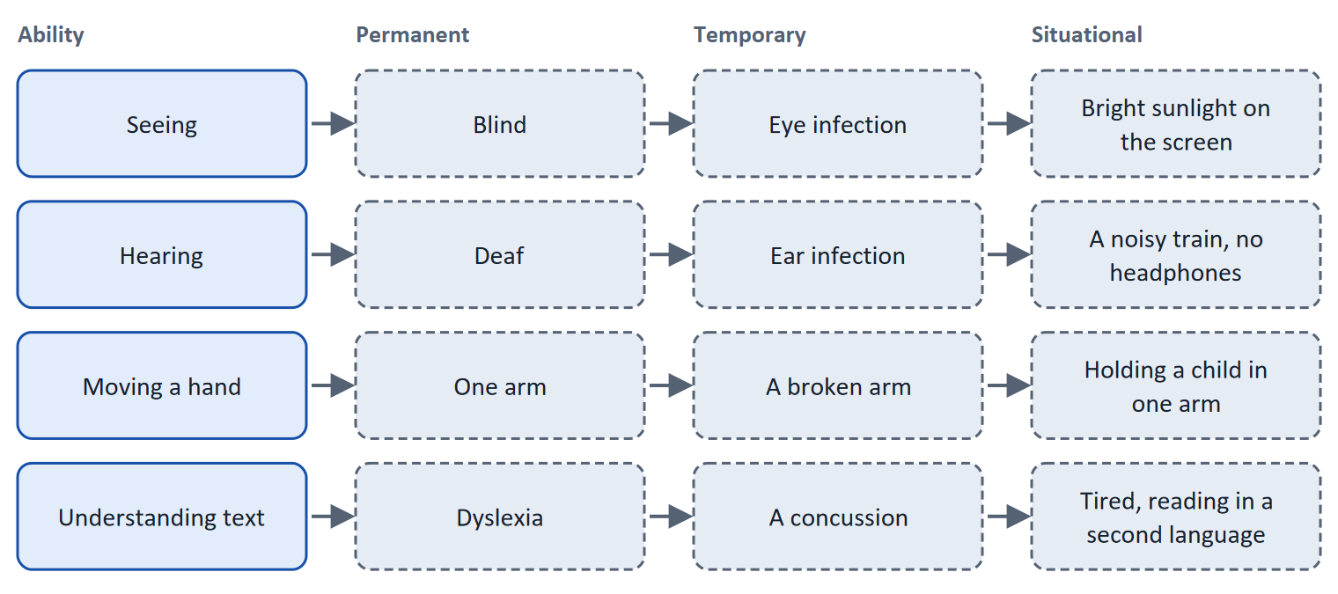
Figure 1 · The persona spectrum (after Microsoft's inclusive design toolkit): permanent, temporary and situational limits.
Let us look at why the spectrum matters for a platform. A video without captions blocks a deaf learner (permanent). It also blocks a learner who has an ear infection this week (temporary), and a learner on a noisy train without headphones (situational). Captions therefore serve far more people than the group they were designed for. The same holds for a keyboard-operable quiz, a clear contrast and plain wording. This is why accessibility is not a niche: the WHO estimates that about 1.3 billion people, around one in six, live with a significant disability (WHO 2022), and many more meet a temporary or situational limit.
- Accessibility against usability. Usability (ISO 9241-11) is judged for specified users in a context of use. Accessibility asks whether the specified users include the full range of abilities. Both are needed.
- The rules around it (in flux). In Europe, the European Accessibility Act (Directive 2019/882) is applied in Germany through the BFSG, which has applied since 28 June 2025 to many consumer-facing digital services. The technical reference is EN 301 549, which for web content refers to WCAG. Public bodies follow BITV 2.0. Whether and how a learning platform is covered depends on the service: a platform that only serves companies as customers may fall outside the BFSG's consumer scope, while registration and contracts with consumers may bring it in. State the year, and check scope and exemptions with a lawyer before you decide.
How to decide when this comes up in the task
- Say what a barrier stops a learner from doing, and who it affects: permanent, temporary and situational groups.
- Treat accessibility as a core quality, not an add-on. Ask of every measure: does it open the platform to more learners, or only improve it for those who are already in?
- A barrier that blocks one group often hurts others in some situations (captions, contrast, keyboard use). Count all of them when you estimate reach.
- Do not state legal obligations as certain. Name the rule, the year and what is still unclear.

Extra · go deeper (optional reading)
Universal Design for Learning. CAST's UDL framework (2024) asks for multiple means of engagement, representation, and action and expression. It is the learning-specific side of inclusive design: the same content offered as text, captioned video and audio lets learners choose.
Accessibility is not the same as an add-on. A platform in which accessibility is added at the end has to retrofit every screen. Practitioners and the W3C's accessibility business-case materials argue that planning early avoids costly rework. The figure differs by project, so treat it as a direction.

Sources · ISO 9241-11:2018 · WHO 2022 · Microsoft 2016 · CAST 2024 · BFSG, EN 301 549 and BITV 2.0 (in flux)

A2 · Barriers and the four principles: perceivable, operable, understandable, robust · 14 min · Core
Barriers are visual, cognitive or motor. WCAG sorts the ways to remove them under four principles that you can apply to any screen.
IN PLAIN WORDS
The idea. The plan names three types of barrier: visual (contrast, font), cognitive (complexity) and motor (operability). The WCAG standard organises its requirements under four principles: perceivable, operable, understandable and robust (POUR). The plan's three principles of inclusive design (perceivability, understandability, operability) are the first three of them.
Why it matters. In Block 1.1 you sort facts about a platform into these principles, and in Block 2.2 you choose measures that remove the barriers.
How to read the picture. The first picture shows the four principles with a question and typical requirements. The second shows the three barrier types, a typical barrier and a remedy.

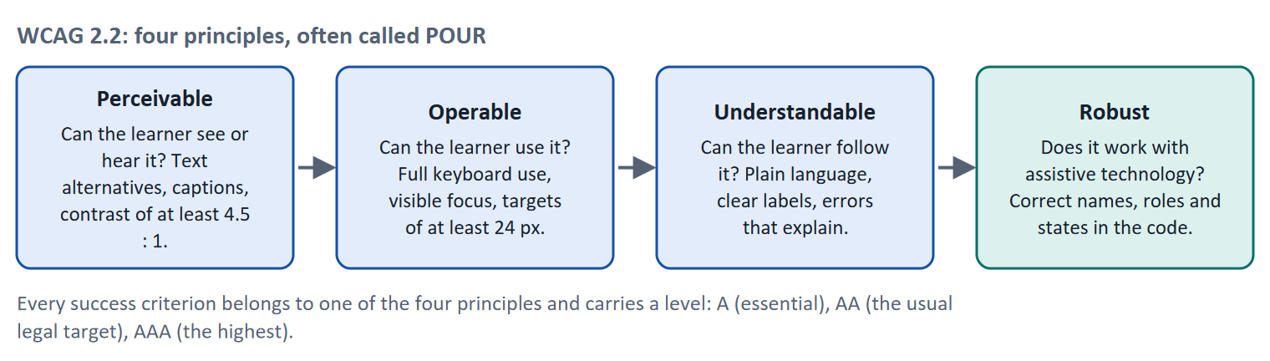
Figure 2 · WCAG 2.2: four principles, often called POUR.
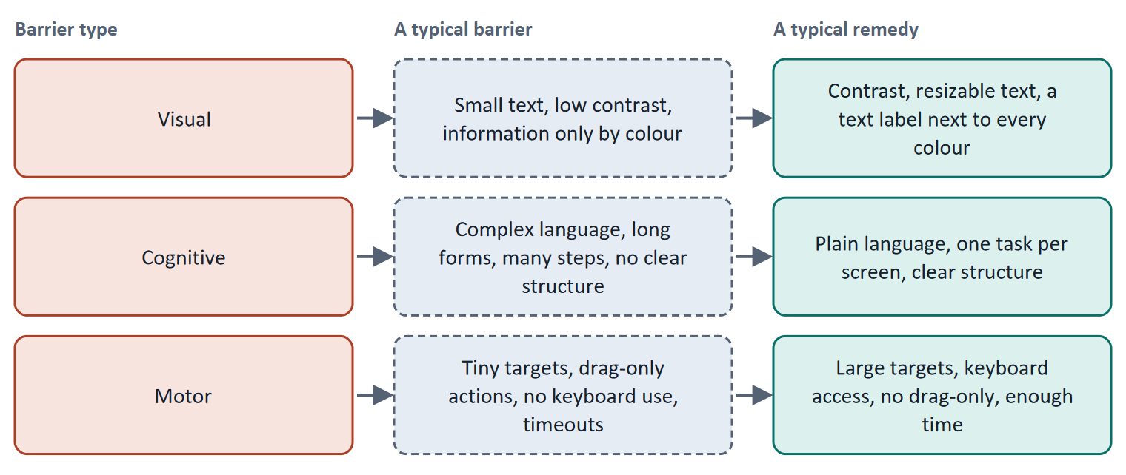
Figure 3 · Three types of barrier, a typical barrier and a typical remedy.
Principle | A learner's question | Success criteria that matter on a learning platform (level)
Perceivable | Can I see or hear it? | 1.1.1 Text alternatives for images (A) · 1.2.2 Captions for recorded video (A) · 1.4.1 Colour is not the only means of conveying information (A) · 1.4.3 Contrast of at least 4.5 : 1 for normal text, 3 : 1 for large (AA) · 1.4.4 Text can be resized to 200% (AA) · 1.4.10 Reflow: content works at 320 CSS px wide without two-way scrolling (AA)
Operable | Can I use it? | 2.1.1 Everything works by keyboard (A) · 2.4.7 The focus is visible (AA) · 2.4.11 The focused element is not hidden by other content (AA, new in 2.2) · 2.5.7 A drag action also works without dragging (AA, new in 2.2) · 2.5.8 Pointer targets are at least 24 × 24 CSS px (AA, new in 2.2)
Understandable | Can I follow it? | 3.1.1 The page language is set (A) · 3.3.2 Fields have labels or instructions (A) · 3.3.8 Logging in does not depend on remembering or solving a puzzle (AA, new in 2.2)
Robust | Does it work with my tools? | 4.1.2 Name, role and value are available to assistive technology (A)

WCAG 2.2 (W3C Recommendation, October 2023) has 86 success criteria. It adds nine to WCAG 2.1 and removes one (4.1.1 Parsing). Level AA is the usual target in law and policy, and the EN 301 549 standard that the BFSG relies on is currently tied to WCAG 2.1 for web content, with a revision expected to refer to WCAG 2.2: because 2.2 is backward-compatible, aiming at 2.2 AA is a safe choice, but check the current reference.
A short story: Lena and the quiz
Step 1. Let us follow Lena, a learner who uses only a keyboard because she cannot use a mouse after an injury. She opens a quiz on LearnLoop that asks her to drag five items onto five boxes.
Step 2. She cannot do it: dragging needs a mouse, and the quiz has no other way. She is blocked by one operable-principle failure, although the content is excellent.
Step 3. The fix is small: each item can also be chosen and placed with the keyboard (WCAG 2.5.7 and 2.1.1). After that, Lena can finish, and so can a learner on a phone who finds dragging awkward.

Case assumption
Lena and the LearnLoop quiz are made up for this example.

How to decide when this comes up in the task
- Sort a barrier by the principle it breaks: cannot see or hear (perceivable), cannot use (operable), cannot follow (understandable). Pick the first one it breaks.
- Name the barrier type too: visual (contrast, text size, colour only), cognitive (complexity, language, steps), motor (target size, drag only, keyboard).
- A fix that works with the keyboard, large targets and clear contrast usually helps several groups at once.
- Automated checks find only some problems; a manual check with the keyboard and a screen reader finds more. Do not call a page accessible because a tool passed.

Extra · go deeper (optional reading)
Using ARIA. WAI-ARIA lets developers add names, roles and states for custom controls. The first rule in the W3C's guidance is to use native HTML (a real button) when it does the job, because native elements already work with keyboards and assistive technology.
New in WCAG 2.2. The nine additions include focus not obscured, dragging alternatives, a minimum target size, consistent help, redundant entry and accessible authentication. For a learning platform, dragging quizzes, sticky headers that hide focus, and login that blocks password managers are the typical failures.

Sources · WCAG 2.2 (W3C 2023) · Understanding WCAG 2.2 (W3C) · Using ARIA (W3C)

A3 · Inclusive learning: plain language, lower load and flexibility · 10 min · Core
An inclusive platform is easy to read, light on the mind, and lets the learner choose how to learn.
IN PLAIN WORDS
The idea. Beyond sensory and motor access, inclusion has a cognitive side. The plan names three tools: plain language and clear structure, reduction of cognitive load (the link to Day 3), and flexibility, meaning different learning paths. Together they make a platform open to learners with learning difficulties, a different first language, a tired mind or little time.
Why it matters. In Task 1 you choose measures against cognitive barriers (complex language, many steps). This card gives you the three tools and a way to say what each does.
How to read the picture. Each row sets a hard-to-read version next to an easier one. The arrows show the change.

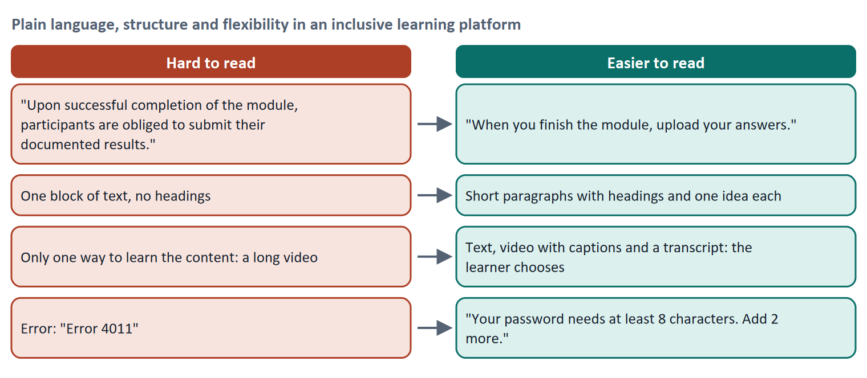
Figure 4 · Plain language, structure and flexibility in an inclusive learning platform.
- Plain language. In German there are two forms: Einfache Sprache (simple language, fewer rules) and Leichte Sprache (easy-to-read language with strict rules, for people with learning difficulties). WCAG has a reading-level criterion at Level AAA (3.1.5). Day 14 treats it in depth.
- Clear structure and low load. Headings, short paragraphs, one task per screen and explained terms reduce extraneous load (Day 3). Fewer steps in a form help everyone.
- Flexibility. Offer the content in more than one form (text, captioned video, a transcript, audio) and let the learner skip what they know. This follows Universal Design for Learning.
How to decide when this comes up in the task
- Name which of the three tools a measure uses: plain language, lower load or flexibility.
- Rewrite instructions in everyday words and short sentences; explain every error and say what to do.
- Offer more than one way to reach the same content; do not force one format.
- A cognitive barrier is real even when a screen passes every technical check. Test it with learners who find reading hard.

Extra · go deeper (optional reading)
Link to Day 3. Plain language and clear structure lower extraneous load. Inclusive design is therefore also the quickest route to a lighter platform for everyone.
Link to Day 14. The next module on plain language and intuitive environments continues here with testing and rewriting.

Sources · CAST 2024 (UDL) · WCAG 2.2 (3.1.5) · Sweller et al. 1998 (Day 3)

A4 · Integrating and evaluating user-centred UX concepts · 12 min · Optional
UX quality is not a single step. Join personas, journeys and design, build them into the organisation, and measure with tests, feedback and data.
IN PLAIN WORDS
The idea. The plan asks for the integration of user-centred concepts: combining personas, journeys and design; treating UX as a continuous process, not a single step; and building it into development and the organisation. It also asks for evaluation: measuring satisfaction, usage and drop-out rates, with tests, feedback and data analysis, and improving iteratively.
Why it matters. The plan's Level 3 task asks for an integration into existing processes and an evaluation system. This card gives you the building blocks.
How to read the picture. The loop shows four stages: plan, design, build, evaluate. In each stage the same question is asked: does this work for all learners? Evaluation feeds the next plan.

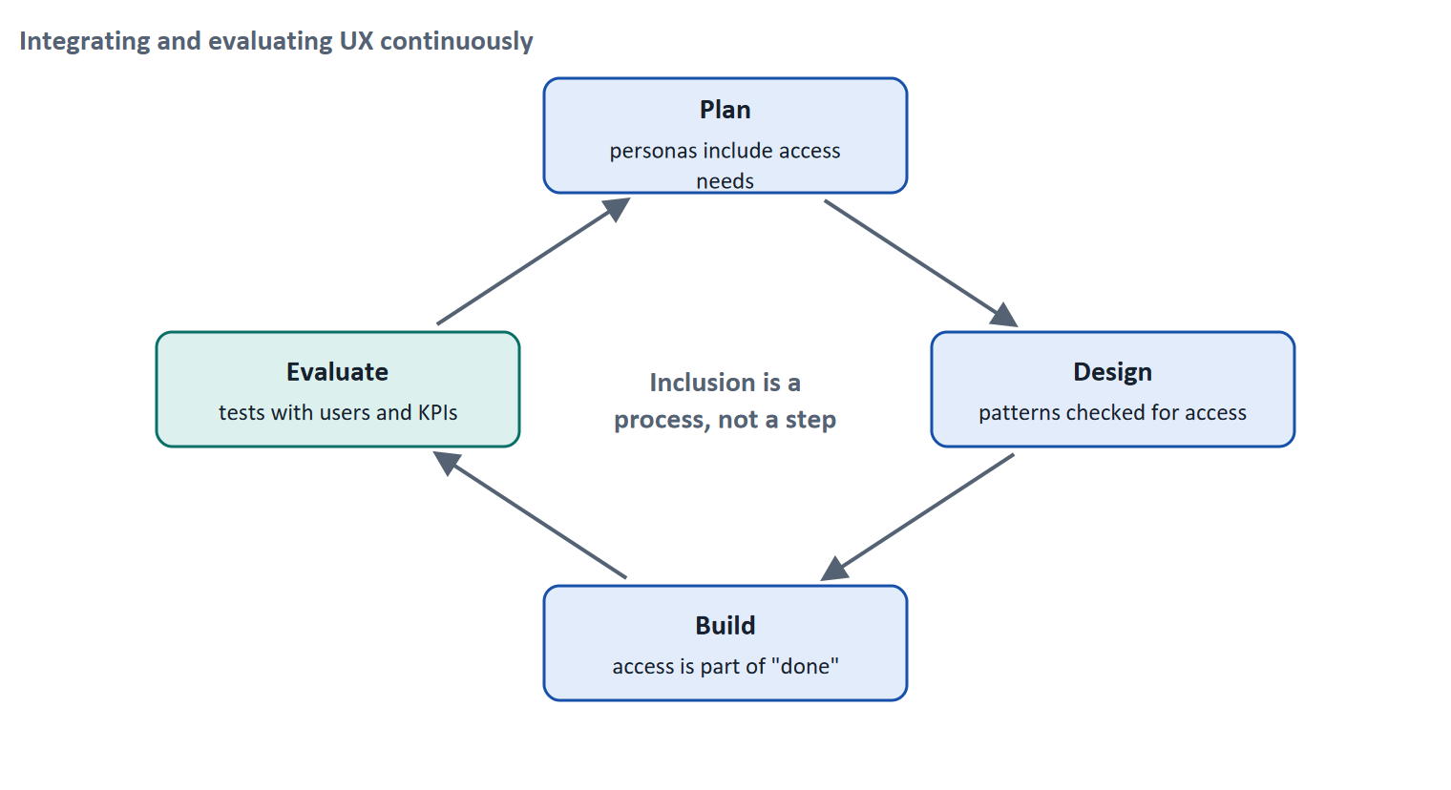
Figure 5 · Integrating and evaluating UX continuously.
Where to integrate | What it looks like for accessibility
Planning | Personas and journeys include learners with access needs
Design | A pattern library whose components are checked against WCAG
Development | Accessibility is part of the definition of "done"; automated checks in every release
Content | Authors follow a plain-language and caption standard
Buying | Third-party tools are checked before purchase
Support | A channel for access problems with a promised reply time

What to measure | Method
Satisfaction | A short questionnaire such as SUS, asked per user group
Usage and task success | Analytics by user group; tests with real tasks
Drop-out | Where and how many leave, by group
Access quality | A manual audit (keyboard, screen reader) plus automated checks

How to decide when this comes up in the task
- Choose evaluation methods that give different kinds of evidence: a test with users with impairments (why), data by group (how many), an audit against WCAG (does it meet the criteria).
- Measure by group. An average score can hide a group that cannot use the platform.
- Make evaluation continuous: a check in every release and a regular test with users, not one audit.
- Automated tools find only part of the problems; they cannot replace a manual check or a user test.

Extra · go deeper (optional reading)
SUS and HEART. The System Usability Scale (Brooke 1996) is a ten-item questionnaire with a score from 0 to 100. Google's HEART framework (Rodden et al. 2010) lists happiness, engagement, adoption, retention and task success as categories of user-centred metrics. Day 16 treats them in detail.
Small tests are enough to start. Five users per group find most problems in a focused test (Nielsen 2000, Day 2). Recruit at least some learners with impairments; their findings differ from the rest.

Sources · Brooke 1996 · Rodden et al. 2010 · Nielsen 2000 · ISO 9241-11:2018

A5 · Weighing an inclusion measure: user impact, effort, risk · 12 min · Core
Rate a measure by the learners it opens the platform to, what it costs and what could go wrong. Prefer fixes at the source to quick patches.
IN PLAIN WORDS
The idea. To choose between measures, rate each on three questions. User impact: how many learners does it open the platform to, and how much does it help them? Effort: money and time, decided here by a rule: under €10,000 is Low, up to €25,000 is Mid, above that is High. Risk: what could go wrong, for example that a quick patch hides the problem without fixing it.
Why it matters. Block 1.2 and Block 2.2 of the task ask for exactly this. The example uses LearnLoop, so the answer for the task case is not given.
How to read the picture. The bars show the cost of three LearnLoop measures. The coloured bands are the effort rule. The dashed line is the budget.

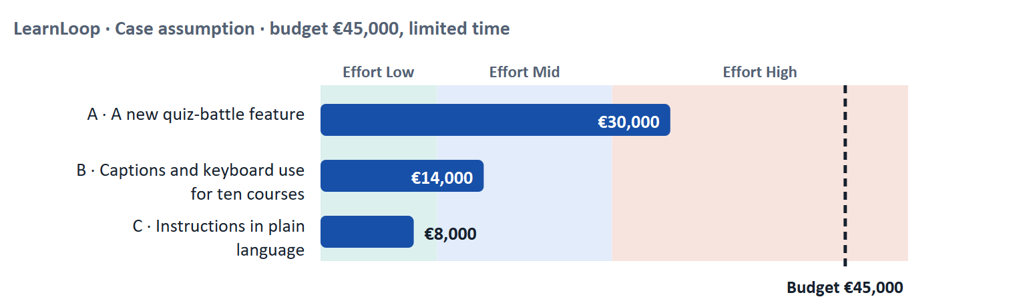
Figure 6 · LearnLoop weighs three measures. Cost against the effort rule and the budget (Case assumption).
A short story: LearnLoop chooses
Step 1. Let us look at LearnLoop again. Users with impairments drop out, complaints are increasing, time is short, and the budget is €45,000. Three ideas are on the table.
Step 2 · A new quiz-battle feature. It costs €30,000, so the effort is High. It is a new feature for engagement, and it opens the platform to nobody who is currently excluded; the user impact on the excluded groups is Low. The risk is Mid, because a new drag-based game could add new barriers.
Step 3 · Captions and keyboard use for ten courses. It costs €14,000, so the effort is Mid. It removes two blocking barriers for the most-used courses, and it helps more groups (deaf, keyboard users, learners on a train), so the user impact is High and the risk is Low.
Step 4 · Instructions in plain language. It costs €8,000, so the effort is Low. It helps learners with reading difficulties and a different first language, and everyone in a hurry, so the user impact is Mid to High, and the risk is Low.

LearnLoop measure | User impact | Effort | Risk
A new quiz-battle feature · €30,000 | Low for excluded groups: it opens nothing. | High. €30,000 is above €25,000. | Mid. A new drag-based game could create new barriers.
Captions and keyboard use for ten courses · €14,000 | High. It removes two blocking barriers for several groups. | Mid. €14,000 lies between €10,000 and €25,000. | Low. It fixes the source and can be tested.
Instructions in plain language · €8,000 | Mid to High. It helps readers with difficulties and many others. | Low. €8,000 is under €10,000. | Low. It changes wording, not structure.

Case assumption
LearnLoop, its costs and its reasons are made up for this example. The task case is in the Task document.

How to decide when this comes up in the task
- Rate effort by the printed cost: under €10,000 is Low; €10,000 to €25,000 is Mid; above €25,000 is High.
- Rate user impact by the barrier it removes and the groups it reaches. A measure that adds new features and removes no barrier has a low impact on excluded groups.
- Rate risk by what could go wrong: a fix that only hides a problem (an overlay) or a new feature that adds new barriers carries more risk than a fix at the source.
- Fix the source (content, code) before you add a layer on top. A toolbar that promises automatic compliance does not remove the barriers underneath.
- Say how you will evaluate the measure: which method and which group.
- Choose evaluation methods that give different kinds of evidence: a test with users with impairments (why), data by group (how many), a manual audit against WCAG (does it meet the criteria). Automated checks find only part of the problems, so they never stand alone.

Sources · Gibbons 2018 (NN/g) · WCAG 2.2 · Nielsen 2000

Materi B · Route 2 · Level 3
How Materi B is used
About 60 minutes, three cards. Level 3 asks you to prioritise inclusion strategically and to evaluate UX quality systematically. Materi B teaches the three things Task 2 asks: inclusion as a strategic quality (B1), the conflict between inclusion and cost and between integration and add-on (B2), and an evaluation system plus a decision under uncertainty (B3).

B1 · Inclusion as a strategic quality · 18 min · Core
Accessibility is a core quality that widens reach, meets growing requirements and improves the platform for everyone.
IN PLAIN WORDS
The idea. The plan's coaching says accessibility is not an add-on but a core quality, and that inclusive systems are more successful in the long run. Three reasons stand behind it: rules and customer expectations, reach, and long-term quality.
Why it matters. Task 2 asks for a strategy for inclusive UX in a company whose platform is growing but does not reach all groups, under growing accessibility requirements and limited resources.
How to read the picture. The chain reads from left to right: the rules and expectations, the reach, the long-term quality.

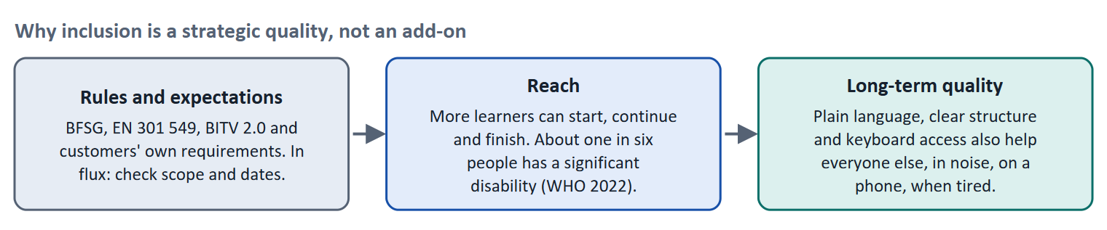
Figure 7 · Why inclusion is a strategic quality, not an add-on.
Reason | What it means | What to watch
Rules and expectations | Law (BFSG for many consumer services since June 2025, BITV 2.0 for public bodies), the standard EN 301 549, and customers who ask for WCAG conformance in tenders | The rules are in flux; scope and dates need checking; B2B platforms may be covered through customers' demands even where the law does not reach them
Reach | About one in six people has a significant disability (WHO 2022), and many more meet temporary or situational limits | Reach is measurable: count which groups finish and which do not
Long-term quality | Plain language, clear structure and keyboard use help everyone | Retrofitting later is more expensive than building in

How to decide when this comes up in the task
- State the strategic case in three parts: rules and expectations, reach, and long-term quality. Add the cost of not acting.
- Say which groups the platform does not reach today, and how you know (or will find out).
- Write legal statements with care: the rule, the year, what is unclear.
- Argue to management in its terms: tenders won or lost, complaints, completion by group, risk.

Extra · go deeper (optional reading)
UX as social responsibility. The plan's discussion line frames inclusion as social responsibility. In a training provider this has a concrete form: learners who are excluded cannot reach the qualification that the platform exists to give.
The business case. Practitioners list benefits such as a larger audience, fewer support requests, better search visibility and lower legal risk. They are plausible, but figures differ by case; use your own data where you can.

Sources · WHO 2022 · BFSG, EN 301 549 and BITV 2.0 (in flux) · WCAG 2.2

B2 · Conflicting goals: inclusion against cost, and integration against add-on · 22 min · Core
Inclusion is cheaper built in than bolted on, but it competes with new features for a limited budget. Weigh reach against cost and say what waits.
IN PLAIN WORDS
The idea. The plan's conflicts for Day 7 are inclusion against costs and integration against expansion. A new feature is visible and easy to justify; accessibility work is less visible, and the benefit is spread over learners who were not reached before. The decision is a matter of reach, cost and risk, and of what waits.
Why it matters. Task 2 asks for a risk analysis of costs against benefits and for three prioritised measures. The rules of this card tell you how to weigh them.
How to read the picture. The matrix places seven measures by the reach they give (left to right) and by their cost and effort (bottom to top). The position is a reading of the example, not a score. The bottom right is where to start.

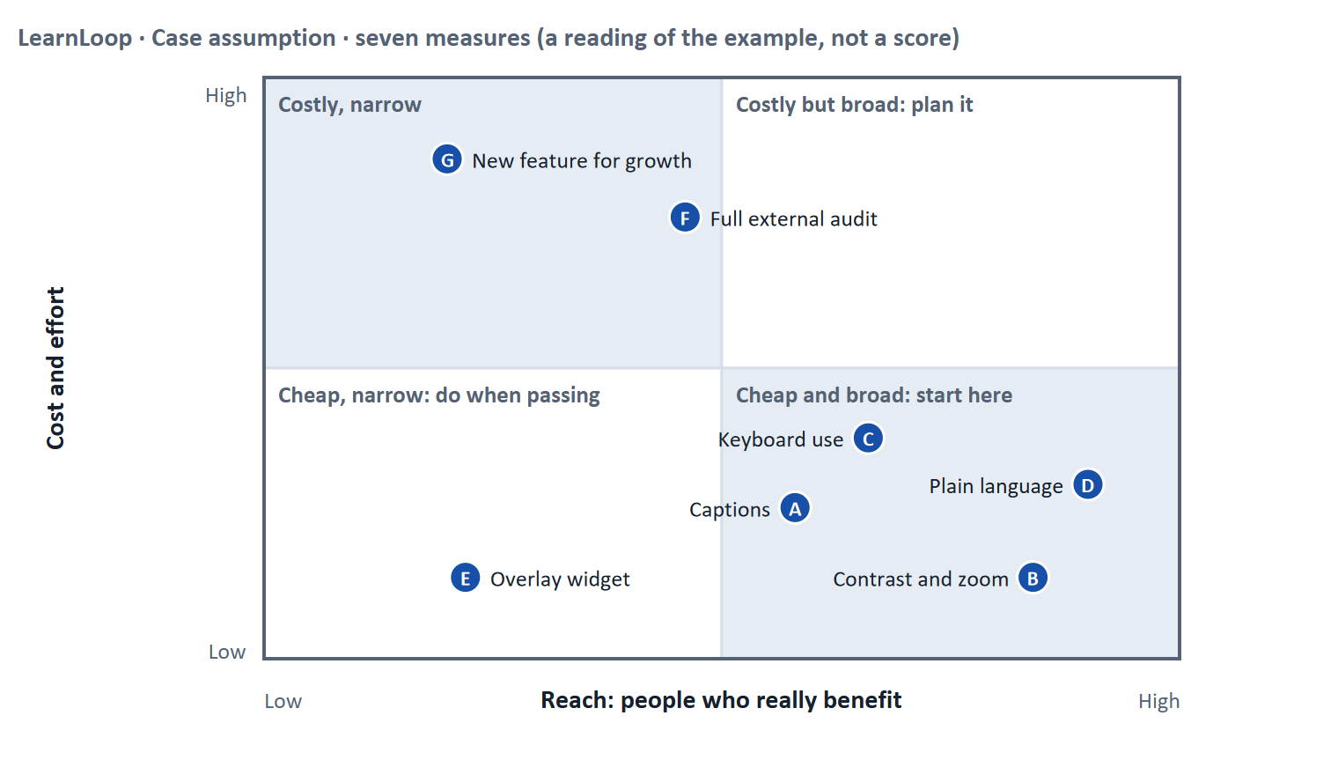
Figure 8 · Seven measures by reach and cost. LearnLoop example, Case assumption.
Conflict | One side gets | The other side gets | A rule for deciding
Inclusion against a new feature | More learners who can use the platform | A visible new feature | Count excluded groups first; a feature that nobody can use adds nothing
Fix at the source against a quick patch | A lasting fix | Speed and low cost today | Prefer the source; use a patch only as a stop-gap with a date
Integration against add-on | Accessibility in every release | A one-off project | Integrate: a definition of done and automated checks; run a project only for the backlog
Full audit against targeted fixes | A complete picture | A fast improvement on the most-used courses | Fix the most-used paths first, audit in stages

How to decide when this comes up in the task
- Weigh each measure by reach (how many learners and which groups), cost and risk. Say what the cheapest, broadest measure is and start there.
- Integrate accessibility into existing processes so that it is not a recurring project: requirements, design review, definition of done, content standard, procurement.
- Be wary of a measure that promises to make a platform compliant automatically. Tools help but do not replace fixing content and code.
- Name what waits, and say what the learners who wait experience in the meantime.

Extra · go deeper (optional reading)
Costs and benefits in the risk analysis. The plan's risk analysis for Day 7 is costs against benefits. Costs: budget, time, training of authors. Risks of not acting: complaints, lost tenders, legal exposure where the law applies, learners lost. Both columns need a number or a statement, not a feeling.
Do not rely on one audit. A single audit gives a snapshot; without an integration into the process, the platform drifts back. The audit becomes useful when its findings enter the backlog and the next release is checked.

Sources · WCAG 2.2 · Gibbons 2018 (NN/g) · Brooke 1996

B3 · An evaluation system and a decision under uncertainty · 20 min · Core
Measure UX quality by group, with a method that shows why and one that shows how many. Decide under uncertainty with a figure and a date for reversal.
IN PLAIN WORDS
The idea. The plan asks for an evaluation system with KPIs and methods, and for a decision without complete user data. An evaluation system has three parts: KPIs (what you count), methods (how you find out) and a rhythm (how often, and who acts). A decision under uncertainty states four things: what you decide, what you do not know, what would make you reverse it and by when, and what you give up.
Why it matters. Block 3.1 and 3.2 ask for exactly this.
How to read the picture. The four boxes at the top are the parts of the decision, filled in for LearnLoop. The two boxes below are the rule for future decisions.

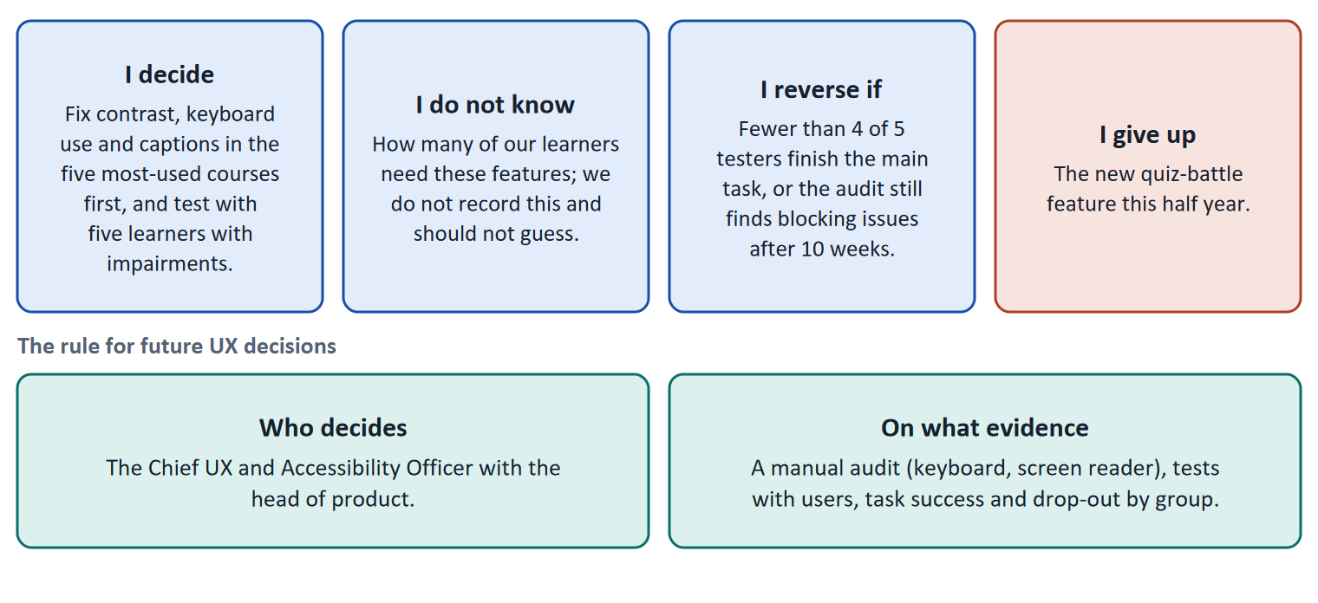
Figure 9 · The four parts of a decision without complete user data, filled in for LearnLoop (Case assumption), and the rule for future decisions.
KPI | Why it fits inclusion | Method to read it
Task success by user group | Shows whether a group cannot finish the main task | Usability tests with learners with impairments; analytics by group where lawful
Drop-out by group | A symptom of exclusion | Analytics; interviews for the reason
Share of pages that meet WCAG 2.2 AA | Measures the product against the standard | Manual audit and automated checks
Access problems reported, and time to fix | Shows whether the process works | The support channel and the backlog
Satisfaction by group (for example SUS) | A compact signal of trouble | A short questionnaire

- Data protection. Measuring by group may touch special categories of data. Ask whether you need it, how you obtain consent, and whether a test with volunteers is enough. This is a DSGVO question, not only a UX one.
- Do not guess how many learners need access features. If the platform does not record it, say you do not know; a test with a few learners shows the barrier, and a survey (with consent) can show the number.
How to decide when this comes up in the task
- Choose KPIs by what they show about excluded groups: success and drop-out by group, share of pages that meet AA, issues and time to fix.
- Choose at least one method that gives reasons (a test with users) and one that gives counts or conformance (analytics, audit).
- A decision under uncertainty states four things: what you decide, what you do not know, what would make you reverse it and by when, and what you give up. The reversal condition has a figure and a time.
- Ask who decides: a role with the evidence it needs, so that accessibility does not depend on one person's interest.
- Check data-protection duties before measuring by group.
- Giving up nothing means you have not decided: name what you postpone.

Extra · go deeper (optional reading)
Premortem. Klein's premortem asks the team to imagine that the inclusion strategy failed: the typical answers are that accessibility stayed a project, authors did not follow the standard, and an overlay was bought instead of fixing the source. Each answer becomes a check.
One-way and two-way doors. Bezos separates hard-to-reverse decisions from cheap-to-reverse ones. Fixing five courses and testing is a two-way door; a platform replacement is a one-way door.

Sources · Brooke 1996 · Rodden et al. 2010 · GDPR (Regulation 2016/679) · Klein 2007 · Bezos 2016

References
Check each source and its current edition before you teach from it. Standards and laws marked as in flux can change.
Regulation (EU) 2016/679 (General Data Protection Regulation, DSGVO), in particular Articles 5 (principles), 6 and 7 (lawfulness and consent) and 22 (automated individual decisions). In flux for tracking: also check § 25 TDDDG (access to information on a user's device) and current guidance of the data-protection authorities.
W3C (2023). Web Content Accessibility Guidelines (WCAG) 2.2. W3C Recommendation, 5 October 2023. https://www.w3.org/TR/WCAG22/ — four principles (perceivable, operable, understandable, robust), success criteria at levels A, AA and AAA.
W3C (2023). Understanding WCAG 2.2. https://www.w3.org/WAI/WCAG22/Understanding/ — explains the intent, examples and techniques for each success criterion. Newly added in 2.2 and at AA: 2.4.11 Focus Not Obscured (Minimum), 2.5.7 Dragging Movements, 2.5.8 Target Size (Minimum), 3.3.8 Accessible Authentication (Minimum); 4.1.1 Parsing was removed.
ETSI EN 301 549 V3.2.1 (2021-03). Accessibility requirements for ICT products and services. — the European standard that refers to WCAG for web content. In flux: a revision that refers to WCAG 2.2 is in preparation.
Barrierefreiheitsstärkungsgesetz (BFSG) of 16 July 2021, implementing Directive (EU) 2019/882 (European Accessibility Act); applies to many digital services from 28 June 2025. In flux: check the scope, the exemptions (for example for very small enterprises) and the ordinance (BFSGV) before you state them.
Barrierefreie-Informationstechnik-Verordnung (BITV 2.0) — accessibility of the web offers of public bodies in Germany; implements Directive (EU) 2016/2102.
CAST (2024). Universal Design for Learning Guidelines, version 3.0. https://udlguidelines.cast.org — multiple means of engagement, representation, and action and expression.
WHO (2022). Global report on health equity for persons with disabilities. — about 1.3 billion people, roughly one in six, live with a significant disability.
Microsoft (2016). Inclusive Design Toolkit (Inclusive 101 Guidebook). https://inclusive.microsoft.design — the persona spectrum: permanent, temporary and situational limitations.
W3C (2024). Using ARIA (W3C Note). https://www.w3.org/TR/using-aria/ — the first rule of ARIA: if a native HTML element or attribute already has the needed meaning and behaviour, use it instead of adding ARIA.
ISO 9241-11:2018. Ergonomics of human-system interaction, Part 11: Usability: Definitions and concepts. — usability is how far a system can be used to reach goals with effectiveness, efficiency and satisfaction in a specified context of use.
Brooke, J. (1996). SUS: A "quick and dirty" usability scale. In P. W. Jordan et al. (Eds.), Usability Evaluation in Industry (pp. 189–194). Taylor & Francis. — the System Usability Scale, ten statements scored 0 to 100.
Rodden, K., Hutchinson, H., & Fu, X. (2010). Measuring the user experience on a large scale: User-centered metrics for web applications. Proceedings of CHI '10, 2395–2398. — the HEART framework: happiness, engagement, adoption, retention, task success.
Nielsen, J. (2000). Why You Only Need to Test with 5 Users. Nielsen Norman Group. https://www.nngroup.com/articles/why-you-only-need-to-test-with-5-users/ — five users in a test find most of the usability problems; run several small tests rather than one large one.
Gibbons, S. (2018). Using Prioritization Matrices to Inform UX Decisions. Nielsen Norman Group. https://www.nngroup.com/articles/prioritization-matrices/ — a prioritisation matrix plots items on two criteria, for example value to the user against effort.
Klein, G. (2007). Performing a project premortem. Harvard Business Review, 85(9), 18–19. — imagine the plan has failed and ask why; it brings risks to the surface before the money is spent.
Bezos, J. (2016). 2015 Letter to Shareholders. Amazon. — decisions that are hard to reverse ("one-way doors") deserve more care than those that can be reversed cheaply ("two-way doors").

Glossary
Every term below is used in this document. Terms stay plain text in the body; this list says what they mean in everyday words.
Term | In plain words | Example | Comes from
Accessibility | Making sure people with a wide range of abilities can perceive, use and understand a product: people who cannot see, hear, use a mouse or process complex text easily. Usability asks whether a user can reach a goal; accessibility asks whether everyone can get in. | A learner who uses only the keyboard can finish the course. | WCAG 2.2
Accessibility audit and automated check | An audit checks a product against criteria such as WCAG, by tools and by hand (keyboard, screen reader). Automated tools find only part of the problems, so they are a start, not proof. | An automated check passes; a manual test finds a quiz that cannot be operated by keyboard. | WCAG 2.2
Accessibility overlay | A third-party toolbar added on top of a site that promises to fix accessibility problems automatically. Many accessibility experts advise that it does not fix the underlying problems, which must be solved in the content and the code. | A widget that claims to make the whole site compliant in a day. | —
ARIA | A set of attributes (WAI-ARIA) that tell assistive technology what a custom control is and does. The first rule: where a native HTML element does the job, use it instead of adding ARIA. | Use a real button, not a clickable box labelled with ARIA. | W3C
BFSG, EN 301 549, BITV 2.0 | BFSG is the German law (Barrierefreiheitsstärkungsgesetz) that applies the European Accessibility Act, from 28 June 2025, to many consumer-facing digital services. EN 301 549 is the European standard that refers to WCAG for web content. BITV 2.0 covers the web offers of public bodies. Scope and exemptions are in flux: check them. | A public university and an online shop meet different rules. | Directive (EU) 2019/882
Cognitive load | How much a person has to hold in mind and work out at once. Attention is limited. Effort spent on decoding a cluttered screen is effort that is missing for learning the content. | A 500-word block of text with no headings costs more attention than the same text in five short parts. | Sweller 1988
Completion rate | The share of people who start a course and finish it. It is the opposite side of the drop-out rate: 60% completion means 40% drop-out. | — | —
Conflicting goals (trade-off) | Two goals that both matter, but cannot both be fully met: for example a simple screen against depth of content. A trade-off means you decide how much of each to keep, and say what you give up. | — | —
Conformance levels A, AA, AAA | WCAG success criteria are rated A (essential), AA (the usual legal and practical target) and AAA (the highest, not always possible for all content). | A public service is usually asked to meet Level AA. | WCAG 2.2
Contrast ratio | How much a text colour differs in brightness from its background, written as a ratio such as 4.5 : 1. WCAG AA asks for at least 4.5 : 1 for normal text and 3 : 1 for large text. | Light grey text on white may only reach 2.3 : 1 and fails. | WCAG 2.2, 1.4.3
Decision architecture | The rule for how future decisions are made: who decides and what evidence they need. It stops a decision from resting on one person's taste. | — | —
Drop-out rate | The share of people who start something and stop before the end. A 40% drop-out rate means 40 of every 100 learners who start a course do not finish it. It counts who left, not why. | 100 learners start; 60 finish; the drop-out rate is 40%. | —
Engagement | How much a learner actually does on the platform: lessons opened, tasks tried, time spent. High engagement is a sign that the platform holds attention; it does not prove they learned. | — | —
Inclusive design | Designing so that as many people as possible can use a product, by thinking about differences from the start (permanent, temporary and situational limits) instead of adding fixes at the end. | Captions help a deaf learner, and also a learner in a noisy train. | Microsoft 2016
Iterative design | Designing in repeated rounds: make a small version, test it, improve it, test again. Each round is short, so mistakes are found while they are cheap to fix. | Three one-week rounds on the course start screen instead of one six-month build. | ISO 9241-210
Keyboard operability | Everything that can be done with a mouse can also be done with the keyboard alone, in a sensible order, with a visible focus. People who cannot use a mouse depend on it. | A quiz that can only be answered by dragging fails this. | WCAG 2.2, 2.1.1
KPI (key performance indicator) | A number a team agrees to watch to judge whether something works, such as completion rate or time to finish a lesson. A good KPI has a baseline and a target. | Completion rate of the first course: 58% today, goal 65% in six months. | —
Persona | A made-up but data-based person who stands for a group of users, with goals, problems and a situation. It makes the needs of a group easy to discuss. (Day 6 covers it in detail.) | "Mia, 38, project manager, ten minutes between meetings." | Cooper 1999
Persona spectrum | A way of seeing that a limit can be permanent (one arm), temporary (a broken arm) or situational (holding a child). Designing for the permanent case often helps the other two. | A one-handed design helps a parent holding a baby. | Microsoft 2016
Plain language (Einfache Sprache, Leichte Sprache) | Clear, short, everyday wording. In German there are two forms: Einfache Sprache (simple language, fewer rules) and Leichte Sprache (easy-to-read language with strict rules, for people with learning difficulties). Day 14 covers it in detail. | "When you finish, upload your answers." | BITV 2.0
POUR (the four WCAG principles) | Perceivable (people can see or hear it), Operable (people can use it), Understandable (people can follow it) and Robust (it works with assistive technology). | Captions make a video perceivable; keyboard access makes a quiz operable. | WCAG 2.2
Qualitative and quantitative data | Qualitative data says why: observations, quotes, interviews, usually from a few people. Quantitative data says how many or how much: counts, rates, times, usually from many people. | Five learners say they miss a Next button (qualitative); 40% leave on lesson 3 (quantitative). | —
Roadmap | A plan that puts decisions in order over time: what is done first, next and later, and why in that order. | — | —
Screen reader and assistive technology | A screen reader reads a page aloud or in Braille. Assistive technology means any tool that helps a person use a computer: screen readers, magnifiers, switches, voice control. A page must give these tools the right names, roles and states. | A button that the screen reader announces as "unlabelled button" cannot be used. | WCAG 2.2
Stakeholder | A person or group that is affected by a decision or can influence it, such as management, trainers, learners or the customer's HR department. | The head of HR who buys the courses for 200 employees. | —
SUS (System Usability Scale) | A ten-question questionnaire that gives a usability score from 0 to 100. It can be asked of each user group to compare them. | Group A scores 78, group B scores 52: group B has a problem. | Brooke 1996
Symptom and cause | A symptom is what you can see or count (people leave). A cause is the reason behind it (they cannot find the next lesson). A number such as a drop-out rate shows the symptom, not the cause. | 40 of 100 learners leave is a symptom; "the course has no path" is a cause. | —
Universal Design for Learning (UDL) | A framework that asks designers to offer several means of engagement (why), representation (what) and action and expression (how), so that learners can reach the goal in different ways. | The same unit as text, as a captioned video and as audio. | CAST 2024
Usability | How well a system lets users reach their goals with little effort and few errors, and how satisfied they are. It is one part of the whole experience. | — | ISO 9241-11
Usability test | You watch real users try a task on the product while they think aloud, and note where they hesitate or fail. Five to ten people already show the main problems. | — | —
User impact | How much a measure helps the users with the problems they actually have: getting unstuck, understanding, carrying on. A measure that answers none of the findings has little user impact, however good it sounds. | — | —
User journey | A step-by-step picture of what a user does, thinks and feels from the first contact to the goal. It shows where the experience breaks. (Day 6 covers it in detail.) | Search, enrol, start lesson 1, stop at lesson 3. | Kalbach 2020
WCAG (Web Content Accessibility Guidelines) | The international technical guidelines for accessible web content, by the W3C. WCAG 2.2 has 86 success criteria at levels A, AA and AAA, grouped under four principles: perceivable, operable, understandable, robust. | Success criterion 1.4.3: text needs a contrast of at least 4.5 : 1 against its background. | W3C 2023

