HABMANN AUFSTIEGSAKADEMIE · DIGITAL LEARNING · EDUCATIONAL UX/UI DESIGN
DAY 8 · MATERI A AND MATERI B · ROUTES 1 AND 2 · LEVELS 1 TO 3
UX/UI basics: structure, visual hierarchy and interaction
Design the structure first, then the surface, and guide the learner's attention and action
Day | Day 8 · Module 4 (day 1 of 3): Fundamentals of UX/UI design for digital learning environments
Document | Materi (study material). Materi A has five cards, Materi B has three.
Route and level | Materi A serves Route 1 (Levels 1 and 2, Task 1). Materi B serves Route 2 (Level 3, Task 2).
Time | Materi A about 60 min · Materi B about 60 min (facilitator-led)
Website (playground) | Not yet published (the link will be added once Day 8 is deployed)
Case | Worked examples use LearnLoop, an online-course provider. The task case is StructLearn, a cluttered learning platform (see the Task document).

ABOUT THIS DOCUMENT
This document holds everything you need to study Day 8 without the website. Each card says the idea in plain words, shows it in a picture, gives the details, and ends with the rules you will use in the Task document. Cards marked Optional are not needed for the Core blocks of the task. The worked examples use LearnLoop, a different company from the task case, so no task answer is printed here. Glossary and references are at the end.

IN THIS DOCUMENT
A1 · Structure: information architecture, hierarchy and orientation · 14 min · Core
A2 · Visual design: hierarchy, legibility, consistency and reduction · 14 min · Core
A3 · Interaction and user guidance: operability, calls to action, feedback · 12 min · Core
A4 · Typical UX/UI mistakes and the link to learning psychology · 10 min · Optional
A5 · Weighing a design measure: user impact, effort, risk · 10 min · Core
B1 · Design as decision architecture: structure beats surface · 18 min · Core
B2 · Conflicting goals: design against functionality, and too complex against too reduced · 22 min · Core
B3 · Deciding without user tests: a structure, principles and guidance you can check later · 20 min · Core

Materi A · Route 1 · Levels 1 and 2
How Materi A is used
About 60 minutes, five cards. The plan's Level 1 asks you to understand the fundamentals of UX/UI design: structure, visual hierarchy and interaction. Level 2 asks you to analyse learning interfaces and make basic design decisions. Task 1 uses all of it on one case. The card A4 is Optional: no Core block of the task needs it.

A1 · Structure: information architecture, hierarchy and orientation · 14 min · Core
Structure comes first. Organise the content so that the learner can answer three questions on any page: where am I, where can I go, what comes next?
IN PLAIN WORDS
The idea. The structure of a learning interface has three parts. Information architecture is how the content is organised and named. Hierarchy and navigation logic say what is a main section and what is a detail, and how you move between them. Orientation in the learning process means the learner always knows where they are and what comes next.
Why it matters. In Task 1 you sort facts about a platform into unclear navigation, visual overload and inconsistent design. The first of these is a structure problem, and the plan's coaching says that structure beats visual design.
How to read the picture. The first picture is a simple information architecture: a root, four sections named after what the learner does, and three items under each. The second shows the three orientation questions.

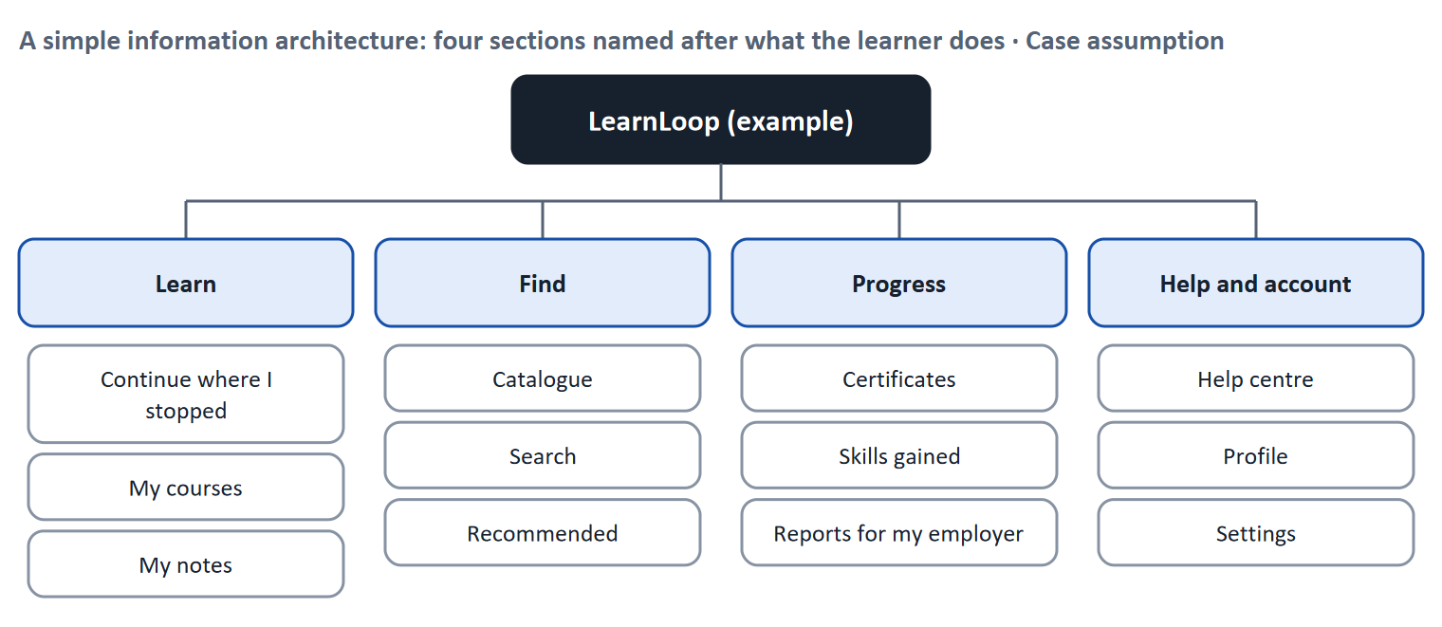
Figure 1 · A simple information architecture: four sections named after what the learner does (LearnLoop example, Case assumption).
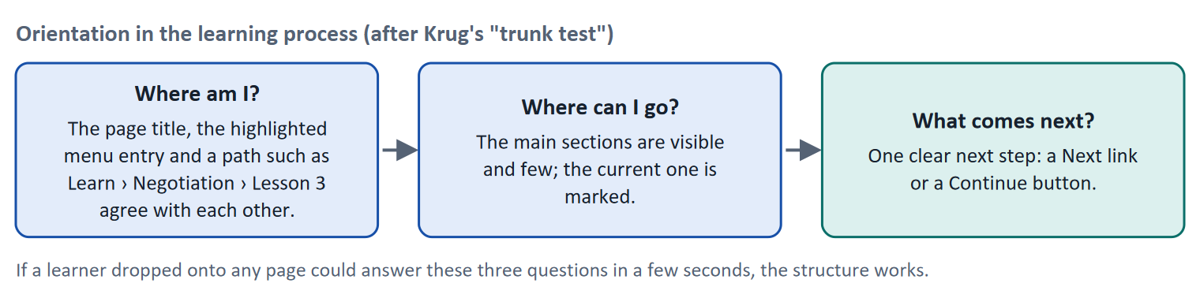
Figure 2 · Orientation in the learning process, after Krug's trunk test.
Let us look at how this works in a lesson. Tom opens a lesson on his phone. The title says "Negotiation basics", the menu highlights "Learn", and a line above the text reads "Learn › Negotiation basics › Lesson 3 of 8". At the bottom a button says "Next: lesson 4". Tom answers all three questions without thinking: he is in lesson 3, he can go to Find or Progress, and what comes next is lesson 4. If the menu highlighted "Home" while he was in a course, or the next step was missing, he would have to build the map himself.
- Four parts of an information architecture (Rosenfeld, Morville and Arango 2015): an organisation system (how content is grouped), a labelling system (what each group is called), a navigation system (how you move) and a search system (how you look for something).
- Check a structure before you build it. In a card sort, people group labelled cards into the categories that make sense to them; in a tree test, they try to find items in a text-only version of the menu (Spencer 2009). Both are cheap and use few participants.
- Krug's trunk test (2014): if you drop a visitor on any page, can they tell what site it is, what page they are on, what the major sections are, what their options are and where they are in the scheme of things?
- Choice. The more options at a decision point, the longer it takes to choose (Hick's law, Hick 1952). Keep the number of main sections small.
How to decide when this comes up in the task
- Check navigation by three questions: where am I (title, highlighted entry and path agree), where can I go (a few clear sections), what comes next (a Next link or Continue button).
- One item has one home. If the same content is reachable from three places under different names, the structure is unclear.
- Name sections after what the learner does (Learn, Find, Progress), not after the system's modules.
- Check a structure with people before you build it: card sort for the groups, tree test for the findability.

Extra · go deeper (optional reading)
Hierarchy of content. A common shape is three levels: sections (a few), groups within sections (several), items (many). If a platform needs more than three levels to reach a lesson, ask whether the structure or the content is too big.
Search is not a cure. A search box helps learners who know the name of what they want; it does not help learners who do not know what exists. Structure and search work together.

Sources · Rosenfeld et al. 2015 · Spencer 2009 · Krug 2014 · Hick 1952

A2 · Visual design: hierarchy, legibility, consistency and reduction · 14 min · Core
Use size, colour, contrast and position to show what matters first. Keep it legible, consistent, and reduced to the essentials.
IN PLAIN WORDS
The idea. Visual design (UI) controls attention. A visual hierarchy uses size, colour, contrast and position so that the most important thing is seen first. Legibility and clarity mean the text can be read comfortably. Consistency means the same thing looks the same everywhere. Reduction to the essentials means leaving out what does not help the learner's goal on this screen.
Why it matters. In Task 1 you decide between simplifying the design and restructuring the navigation. You need to know what a visual change can and cannot do.
How to read the picture. The left screen shows everything competing: seven colours, five equal buttons, banners. The right screen shows the same page with one main thing (the Continue button), quieter secondary actions and a progress bar.

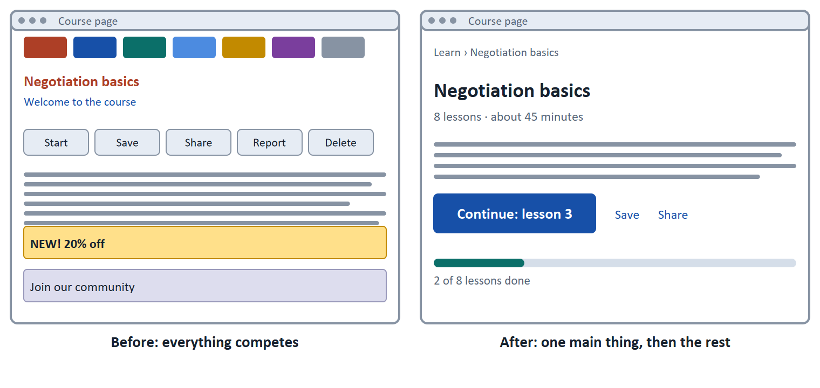
Figure 3 · The same course page before and after a visual hierarchy: on the left everything competes, on the right one main thing comes first.
- Size, colour, contrast, position. The eye goes first to what is largest, most contrasting and in a prominent place. A single filled button among quiet links tells the learner where to go.
- Grouping without boxes. The Gestalt principles (Wertheimer 1923) describe how people group what they see: things that are close together (proximity) or alike (similarity) are read as belonging together.
- Legibility. WCAG sets a contrast of at least 4.5 : 1 for normal text at Level AA (Day 7). For running text a line of about 45 to 75 characters is comfortable (Bringhurst 2012). Do not rely on colour alone.
- Consistency. It is one of Nielsen's usability heuristics, "consistency and standards": the same words and the same actions mean the same thing, and the platform follows the conventions that learners know.
- Reduction. On text-heavy pages many people scan in an F-shaped pattern, reading the top and the left edge more than the rest (Nielsen 2006). Put the key point where the eye goes, and cut what does not help the goal.
How to decide when this comes up in the task
- Name the one main thing on a screen. If five items have the same size, colour and weight, there is no hierarchy.
- Give the main action the strongest visual weight; make secondary actions quieter.
- Use the same style for the same function across the platform (buttons, links, dates, back).
- Reduce: remove what does not help the learner's goal on the screen before you add anything.
- A visual fix does not repair a structural problem. If learners cannot find their course, a new colour scheme will not help.

Extra · go deeper (optional reading)
Visual design supports learning. Mayer's principles (coherence, signalling, spatial contiguity) say that learners learn better when extra material is removed, when what matters is marked, and when labels sit next to what they describe (Mayer 2009). They are the visual-design side of Day 3's cognitive load.
Style guide. A written set of components and rules (a design system) is how consistency survives a team of several people. Without it, each screen gets its own version of a button.

Sources · Wertheimer 1923 · Nielsen 1994 · Nielsen 2006 · Bringhurst 2012 · Mayer 2009

A3 · Interaction and user guidance: operability, calls to action, feedback · 12 min · Core
The learner should be able to see what to do, do it easily, and see that it worked.
IN PLAIN WORDS
The idea. Interaction design has three jobs. Intuitive operability: things look like what they do, so the learner does not have to learn the interface. Clear calls to action: one main button says what to do next. Feedback on actions: when the learner acts, the platform answers at once.
Why it matters. In Task 1 you judge screens with several buttons without priority, and you choose measures for action guidance.
How to read the picture. The three boxes show the response-time limits for feedback: about a tenth of a second feels instant, about a second keeps the train of thought, ten seconds is the limit of attention.

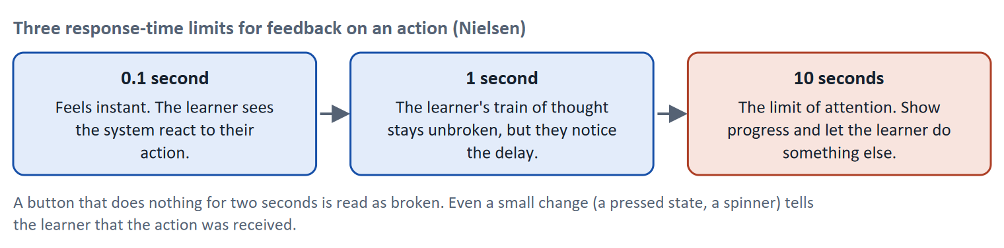
Figure 4 · Three response-time limits for feedback on an action (Nielsen).
- Signifiers. Norman (2013) distinguishes what an object allows (an affordance) from the sign that shows it (a signifier). A button that looks like a button, with a clear label, signals what can be done.
- One main call to action per screen. Say it with a verb and an object: "Continue: lesson 3", "Start the quiz". Make it the strongest element (card A2).
- Fitts's law (Fitts 1954): the time to reach a target depends on its distance and size. Make the main targets large and place them where the learner's attention already is, which matters especially on a phone.
- Feedback. Shneiderman and colleagues (2016) include informative feedback and closure among their golden rules: every action gets a response, and a task has a clear end. Nielsen's response-time limits tell you how fast it must come.
How to decide when this comes up in the task
- Find the main call to action on a screen. If there are several of equal weight, the learner has no priority to follow.
- A button label says what happens ("Start lesson"), not what the system does ("Submit form").
- Every action gets a visible response within about a second; if it takes longer, show that something is happening.
- Make the main targets large and close to where attention is.

Extra · go deeper (optional reading)
Progressive disclosure. Show only what is needed now and put advanced options behind a link such as "More" (Nielsen 2006, progressive disclosure). It keeps the first view calm and supports beginners without removing power for others.
Feedback is also teaching. In a learning platform feedback is more than a click response: a result and a next step after a task (Day 4) are interaction feedback at the level of learning.

Sources · Norman 2013 · Shneiderman et al. 2016 · Fitts 1954 · Nielsen 1993 (response times) · Nielsen 2006 (progressive disclosure)

A4 · Typical UX/UI mistakes and the link to learning psychology · 10 min · Optional
Unclear navigation, visual overload and inconsistent design each waste attention, which is the learner's scarcest resource.
IN PLAIN WORDS
The idea. The plan lists three typical mistakes: unclear navigation, visual overload and inconsistent design. It also asks you to link design to learning psychology: structure reduces cognitive load, and visual support helps learning (Day 3). Each mistake takes attention that learning needs.
Why it matters. The three mistakes are the three areas Block 1.1 sorts facts into. This card gives you the reason for each.
How to read the picture. Each row reads from left to right: the mistake, what it costs the learner, and a structural remedy.

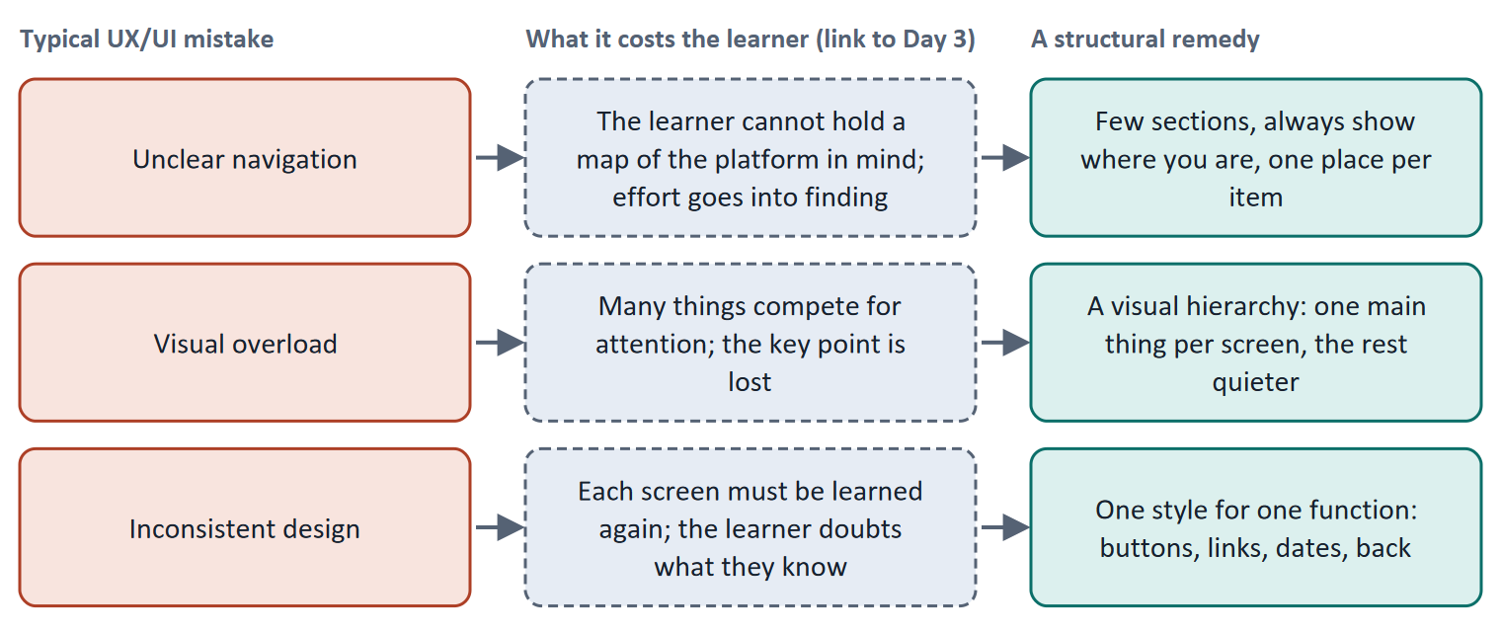
Figure 5 · Three typical UX/UI mistakes, what each costs the learner, and a remedy.
Mistake | How to recognise it | What the learner experiences
Unclear navigation | The learner cannot say where they are or where something is; one item sits in several places; no Next step | "Where did I put it?" Effort goes into finding
Visual overload | Many colours, sizes and elements; several buttons of equal weight; banners | "What should I do?" The key point is lost
Inconsistent design | The same function looks or works differently on different screens | "Does this work like the last one?" Each screen is learned again

How to decide when this comes up in the task
- Sort a fact by what the learner cannot do: find or place themselves (navigation), pick the main thing (overload), rely on what they have learned (inconsistency).
- Several buttons of equal weight with no priority is a hierarchy problem (overload), not an inconsistency.
- The same function with different looks on different screens is inconsistency, even if each screen looks fine alone.
- Explain the cost in terms of attention and working memory (Day 3), not taste.

Extra · go deeper (optional reading)
Structure lowers load. Chunking a menu into four sections and showing a path turns many items to hold into a few (Sweller, van Merriënboer and Paas 1998). This is why the plan places structure before visual polish.
Beginners and experts. A reduced interface helps beginners; experts may want shortcuts. Progressive disclosure serves both (card A3).

Sources · Sweller et al. 1998 · Nielsen 1994 · Mayer 2009

A5 · Weighing a design measure: user impact, effort, risk · 10 min · Core
Rate each measure by how much it helps orientation, what it costs and what could go wrong. Structure usually beats surface.
IN PLAIN WORDS
The idea. To choose between design measures, rate each on the same three questions. User impact: how much does it help the learner find, choose and carry on? Effort: money and time, decided here by a rule: under €8,000 is Low, up to €15,000 is Mid, above that is High. Risk: what could go wrong, for example adding more clutter.
Why it matters. Block 1.2 and Block 2.2 of the task ask for exactly this. The example uses LearnLoop, so the answer for the task case is not given.
How to read the picture. The bars show the cost of three LearnLoop measures. The coloured bands are the effort rule. The dashed line is the budget.

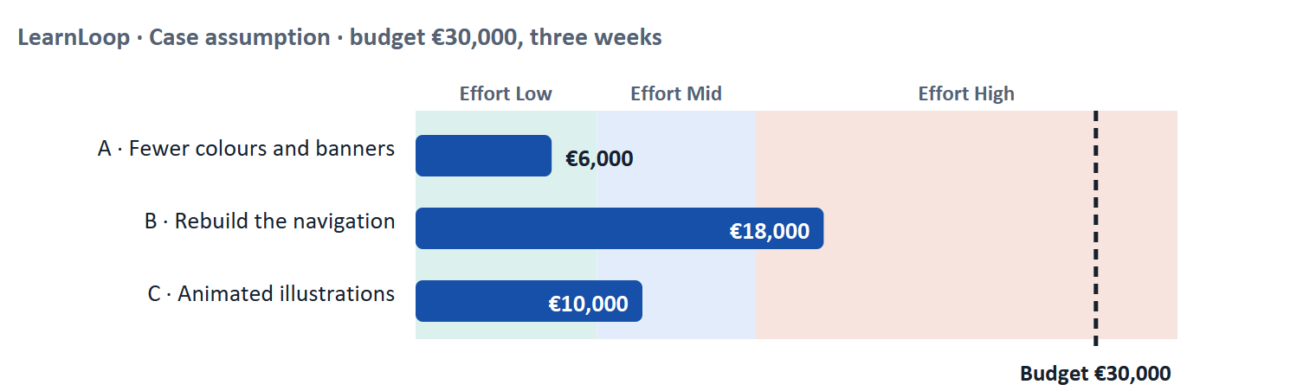
Figure 6 · LearnLoop weighs three measures. Cost against the effort rule and the budget (Case assumption).
A short story: LearnLoop has €30,000 and three weeks
Step 1. Let us look at LearnLoop again. Learners get lost on a busy platform, drop-out is high, the budget is €30,000 and the team has three weeks.
Step 2 · Fewer colours and banners. It costs €6,000, so the effort is Low. It calms the page and helps the learner see the main button, so the user impact is Mid; it does not fix a menu in which the same course sits in three places. The risk is Low.
Step 3 · Rebuild the navigation. It costs €18,000, so the effort is High, and it needs most of the three weeks. It helps the learner find and carry on, so the user impact is High, and the risk is Mid because of the tight schedule.
Step 4 · Animated illustrations. It costs €10,000, so the effort is Mid. They add visual elements without helping the learner find or choose, so the user impact is Low, and the risk is High: more things compete for attention.

LearnLoop measure | User impact | Effort | Risk
Fewer colours and banners · €6,000 | Mid. The main button becomes visible; the structure stays as it is. | Low. €6,000 is under €8,000. | Low. It removes things.
Rebuild the navigation · €18,000 | High. Learners find their course and see what comes next. | High. €18,000 is above €15,000. | Mid. It needs most of the three weeks.
Animated illustrations · €10,000 | Low. They help nobody find or choose. | Mid. €10,000 lies between €8,000 and €15,000. | High. More elements compete for attention.

Case assumption
LearnLoop, its costs and its reasons are made up for this example. The task case is in the Task document.

How to decide when this comes up in the task
- Rate effort by the printed cost: under €8,000 is Low; €8,000 to €15,000 is Mid; above €15,000 is High.
- Rate user impact by what it does for orientation and action: structure and guidance first, surface second.
- Rate risk by what could be added or lost: a measure that adds elements to a cluttered screen carries the risk of more clutter.
- Justify the order in a sentence that begins from the learner's problem: structure leads to orientation, and orientation leads to use.
- Say what you do not know, for example whether learners fail to find content because of the menu or because of the names.

Sources · Gibbons 2018 (NN/g) · Sweller et al. 1998

Materi B · Route 2 · Level 3
How Materi B is used
About 60 minutes, three cards. Level 3 asks you to prioritise design principles strategically and to align them with learning impact. Materi B teaches the three things Task 2 asks: treat design as decision architecture (B1), weigh the conflict between design and function and between too complex and too reduced (B2), and decide without user tests (B3).

B1 · Design as decision architecture: structure beats surface · 18 min · Core
Design does not only decorate. It steers what learners do, and so what they learn. Fix the structure before the look.
IN PLAIN WORDS
The idea. The plan's coaching says design is decision architecture: UI is not about making it pretty but about making it understandable; structure beats visual design; good UX reduces the user's wrong decisions. The chain runs from structure and hierarchy to orientation, from orientation to behaviour, and from behaviour to learning success.
Why it matters. Task 2 asks you to propose a basic structure, principles for visual design and a concept for user guidance, in order of priority. This card gives you the logic of the order.
How to read the picture. The chain reads from left to right: structure and hierarchy, orientation and guidance, behaviour, learning result.

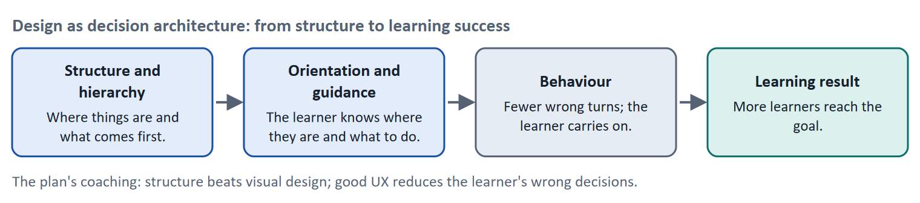
Figure 7 · From structure to learning success: design as decision architecture.
Design layer | What it decides for the learner | Typical business effect
Structure (information architecture, navigation) | Where things are; whether they can be found | Completion, support requests
Hierarchy (visual) | What to look at first | Task success, time to start
Guidance (calls to action, feedback) | What to do next | Progress, return rate
Surface (colour, illustration) | How the platform feels | Brand perception; effects on learning are small unless structure is right

Where design is overestimated. The plan's feedback question asks where design is overestimated. Typical places: a new look is paid for when the problem is structure; an animation is added when the problem is that the next step is hidden; a style guide is written but no one follows it. The test is the same as always: which learner decision does this change?
How to decide when this comes up in the task
- Fix structure first, then hierarchy, then guidance, then surface. A surface change on a broken structure does not reduce drop-out sustainably.
- Argue a design measure by the wrong decision it prevents: "learners no longer pick the wrong menu entry".
- Link every design principle to learning: reduce load (structure), direct attention (hierarchy), confirm progress (feedback).
- A rebrand is justified by brand goals; do not present it as a learning measure unless tests show an effect.

Extra · go deeper (optional reading)
Design principles as a decision tool. A short list of principles (for example "one main action per screen", "same function, same look") lets a team decide quickly and consistently. A principle that cannot be used to say no to a proposal is decoration.
Behaviour. Day 4 showed that behaviour needs motivation, ability and a prompt. Structure and guidance work on ability and the prompt; they are the designer's most direct levers.

Sources · Norman 2013 · Rosenfeld et al. 2015 · Shneiderman et al. 2016

B2 · Conflicting goals: design against functionality, and too complex against too reduced · 22 min · Core
A cluttered platform and an over-reduced one both fail. Reduce clutter, keep the guidance and the functions that learners need.
IN PLAIN WORDS
The idea. The plan's conflicts for Day 8 are design against functionality, and (in the risk analysis) too complex against too reduced. A designer who removes everything to make the screen calm may also remove what learners need: help, options, power for experts. A designer who keeps everything makes the screen unusable. The aim is to remove clutter and keep guidance and function.
Why it matters. Task 2 asks for a risk analysis of too complex against too reduced and for prioritised design measures.
How to read the picture. The matrix places five options by the clutter they remove (left to right) and by the guidance and function they keep (bottom to top). The position is a reading of the example, not a score. The top right is the aim.

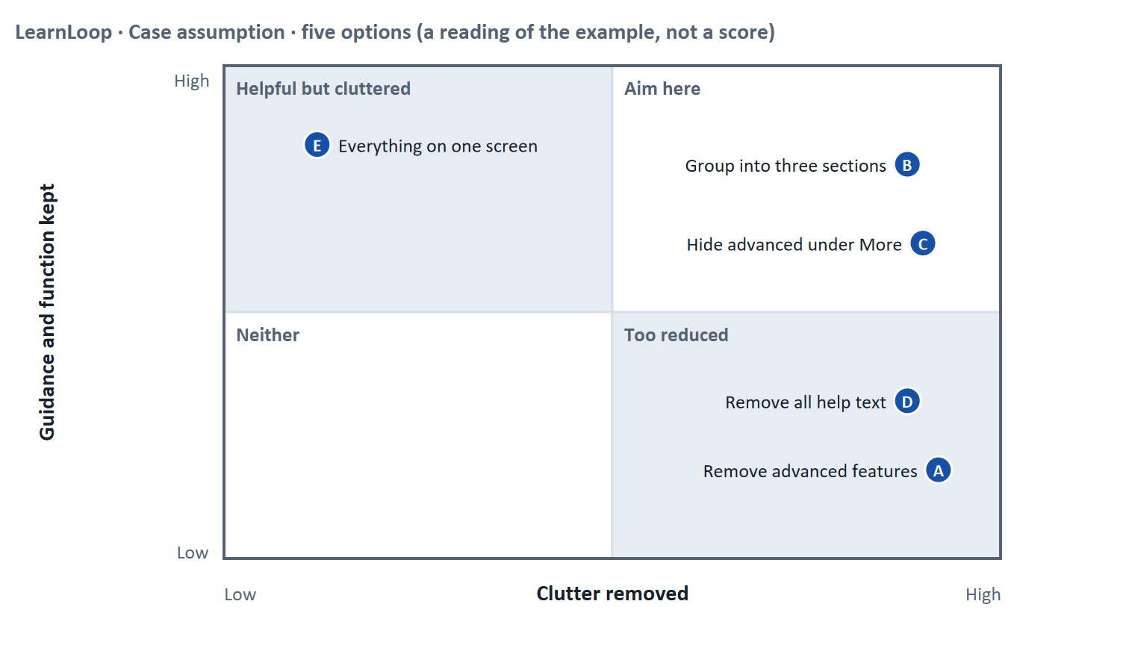
Figure 8 · Five options by clutter removed and guidance kept. LearnLoop example, Case assumption.
Conflict | One side gets | The other side gets | A rule for deciding
Design against functionality | A calm, attractive screen | All the functions learners and trainers need | Keep the functions; change where and when they appear (progressive disclosure)
Too complex against too reduced | A light screen for beginners | Depth and speed for experts | Hide advanced options behind "More"; keep help available
Consistency against local fit | The same pattern everywhere | A pattern tuned to one screen | Default to consistency; break it only with a tested reason
Speed against user tests | A decision this month | A decision based on evidence | If there is no time to test, choose reversible changes and test afterwards

How to decide when this comes up in the task
- Name both risks: too complex (learners are lost in clutter) and too reduced (learners lose guidance or experts lose function). A plan that names one has not weighed the conflict.
- Remove clutter first (banners, equal-weight buttons, duplicate paths); keep guidance (path, Next, help).
- Use progressive disclosure so that beginners see little and experts can reach more.
- Where there is no time or money to test, choose changes that can be reversed, and write the test into the plan.

Extra · go deeper (optional reading)
Design as steering of behaviour. The plan's discussion line is "UX as steering of behaviour". Every layout nudges: an enlarged button invites a click. State openly what you want learners to do, and check that it is what they want too (see Day 4 on manipulation).
Beginners. The plan's Day 8 case users are beginners. Beginners benefit from structure, visible next steps and plain labels more than from advanced options.

Sources · Nielsen 2006 (progressive disclosure) · Nielsen 1994 · Norman 2013

B3 · Deciding without user tests: a structure, principles and guidance you can check later · 20 min · Core
When you cannot test first, choose changes that can be reversed, write the test into the plan, and name who decides what the design may do.
IN PLAIN WORDS
The idea. The plan asks you to decide under uncertainty, for example without user tests. A decision under uncertainty states four things: what you decide, what you do not know, what would make you reverse it and by when, and what you give up. For a design decision the usual unknown is how learners will react to a new structure and new names.
Why it matters. Block 3.2 asks for exactly this, together with prioritised design measures and a risk analysis.
How to read the picture. The four boxes at the top are the parts of the decision, filled in for LearnLoop. The two boxes below are the rule for future decisions.

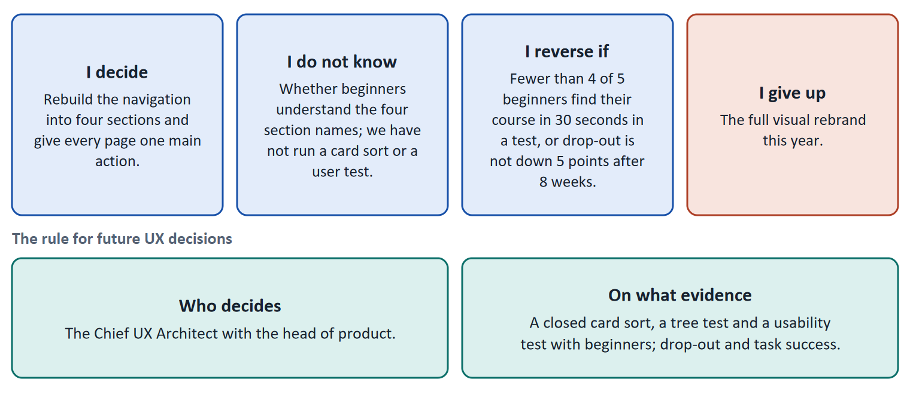
Figure 9 · The four parts of a decision without user tests, filled in for LearnLoop (Case assumption), and the rule for future decisions.
- Test cheaply before you build. A closed card sort with ten learners shows whether the section names make sense; a tree test shows whether they can find items (Spencer 2009). Both can be done in days, before any redesign.
- Prefer reversible changes. Reorganising the menu behind a switch that can be turned off is reversible; a platform rebuilt around an untested structure is not.
- Set design principles that can say no. For example: one main action per screen; the same function always looks the same; no information by colour alone. Each can be checked on any screen.
- A guidance concept. Say how a learner always knows where they are (a path, a marked entry) and what comes next (a Next or Continue button), and how a first-time visitor is guided.
- Fix the rule. Name who decides on a design change and what evidence they need: a test, task success, drop-out. A change that depends on one person's taste will drift.
How to decide when this comes up in the task
- A decision under uncertainty states four things: what you decide, what you do not know, what would make you reverse it and by when, and what you give up.
- A reversal condition has a figure and a time: "fewer than four of five beginners find their course in 30 seconds".
- Choose a reversible change, and write the test (card sort, tree test, usability test) into the plan.
- State design principles that can be used to refuse a proposal, and a guidance concept that answers "where am I, and what next?".
- Giving up nothing means you have not decided: name what you postpone, for example the visual rebrand.

Extra · go deeper (optional reading)
Premortem. Klein's premortem asks the team to imagine that the redesign failed: typical answers are that the new names did not make sense to learners, that the style guide was ignored, and that the redesign removed something experts needed. Each answer becomes a check.
One-way and two-way doors. Bezos separates hard-to-reverse decisions from cheap-to-reverse ones. A menu change behind a switch is a two-way door; replacing the platform is a one-way door.

Sources · Spencer 2009 · Nielsen 2000 · Klein 2007 · Bezos 2016

References
Check each source and its current edition before you teach from it. Standards and laws marked as in flux can change.
Rosenfeld, L., Morville, P., & Arango, J. (2015). Information Architecture: For the Web and Beyond (4th ed.). O'Reilly. — organisation, labelling, navigation and search systems.
Spencer, D. (2009). Card Sorting: Designing Usable Categories. Rosenfeld Media. — card sorting and tree testing as methods to check a structure.
Krug, S. (2014). Don't Make Me Think, Revisited: A Common Sense Approach to Web Usability (3rd ed.). New Riders. — the "trunk test": a visitor should be able to tell where they are, what the main sections are and what their options are.
Wertheimer, M. (1923). Untersuchungen zur Lehre von der Gestalt II. Psychologische Forschung, 4, 301–350. — the Gestalt principles of grouping (proximity, similarity, continuity, closure).
Hick, W. E. (1952). On the rate of gain of information. Quarterly Journal of Experimental Psychology, 4(1), 11–26. — Hick's law: the time to choose grows with the number of options.
Fitts, P. M. (1954). The information capacity of the human motor system in controlling the amplitude of movement. Journal of Experimental Psychology, 47(6), 381–391. — Fitts's law: the time to reach a target depends on its distance and size.
Nielsen, J. (1994, reviewed 2024). 10 Usability Heuristics for User Interface Design. Nielsen Norman Group. https://www.nngroup.com/articles/ten-usability-heuristics/ — for example visibility of system status, match between the system and the real world, consistency and standards, recognition rather than recall.
Nielsen, J. (1993, updated 2014). Response Times: The 3 Important Limits. Nielsen Norman Group. https://www.nngroup.com/articles/response-times-3-important-limits/ — about 0.1 s feels instantaneous, about 1 s keeps the user's flow of thought, about 10 s is the limit of attention.
Nielsen, J. (2006). Progressive Disclosure. Nielsen Norman Group. https://www.nngroup.com/articles/progressive-disclosure/ — defer advanced or rarely used features to a secondary screen to keep the main view simple.
Nielsen, J. (2006). F-Shaped Pattern For Reading Web Content. Nielsen Norman Group. https://www.nngroup.com/articles/f-shaped-pattern-reading-web-content-discovered/ — eye-tracking shows that on text-heavy pages many people scan in an F-shaped pattern.
Norman, D. (2013). The Design of Everyday Things (revised and expanded edition). Basic Books. — affordances, signifiers, feedback, and the warning against "creeping featurism".
Shneiderman, B., Plaisant, C., Cohen, M., Jacobs, S., & Elmqvist, N. (2016). Designing the User Interface (6th ed.). Pearson. — the eight golden rules, including consistency and informative feedback.
Bringhurst, R. (2012). The Elements of Typographic Style (4th ed.). Hartley & Marks. — a line of about 45 to 75 characters is comfortable for single-column text.
Sweller, J., van Merriënboer, J. J. G., & Paas, F. G. W. C. (1998). Cognitive architecture and instructional design. Educational Psychology Review, 10(3), 251–296. — the distinction between intrinsic, extraneous and germane cognitive load.
Mayer, R. E. (2009). Multimedia Learning (2nd ed.). Cambridge University Press. — principles such as coherence, signalling, segmenting and spatial contiguity.
W3C (2023). Web Content Accessibility Guidelines (WCAG) 2.2. W3C Recommendation, 5 October 2023. https://www.w3.org/TR/WCAG22/ — four principles (perceivable, operable, understandable, robust), success criteria at levels A, AA and AAA.
Nielsen, J. (2000). Why You Only Need to Test with 5 Users. Nielsen Norman Group. https://www.nngroup.com/articles/why-you-only-need-to-test-with-5-users/ — five users in a test find most of the usability problems; run several small tests rather than one large one.
Gibbons, S. (2018). Using Prioritization Matrices to Inform UX Decisions. Nielsen Norman Group. https://www.nngroup.com/articles/prioritization-matrices/ — a prioritisation matrix plots items on two criteria, for example value to the user against effort.
Klein, G. (2007). Performing a project premortem. Harvard Business Review, 85(9), 18–19. — imagine the plan has failed and ask why; it brings risks to the surface before the money is spent.
Bezos, J. (2016). 2015 Letter to Shareholders. Amazon. — decisions that are hard to reverse ("one-way doors") deserve more care than those that can be reversed cheaply ("two-way doors").

Glossary
Every term below is used in this document. Terms stay plain text in the body; this list says what they mean in everyday words.
Term | In plain words | Example | Comes from
Affordance and signifier | An affordance is what an object allows you to do; a signifier is a sign that shows it. A button that looks pressable signals that it can be pressed. | A raised, labelled button signals Press me. | Norman 2013
Call to action (CTA) | The button or link that invites the user to take the main next step, such as Start lesson or Continue. A screen should have one main call to action, clearly stronger than the rest. | A filled blue Continue button and two quiet text links. | Shneiderman et al. 2016
Card sorting and tree testing | In a card sort, people group labelled cards into the categories that make sense to them; in a tree test, they try to find items in a text-only version of the menu. Both check an information architecture before it is built. | Ten learners sort 12 cards into four sections. | Spencer 2009
Chunking | Grouping several items into one meaningful unit so that working memory has less to hold. Twelve loose items become three groups of four. | A phone number written as 0151 234 5678 instead of eleven separate digits. | Miller 1956
Cognitive load | How much a person has to hold in mind and work out at once. Attention is limited. Effort spent on decoding a cluttered screen is effort that is missing for learning the content. | A 500-word block of text with no headings costs more attention than the same text in five short parts. | Sweller 1988
Completion rate | The share of people who start a course and finish it. It is the opposite side of the drop-out rate: 60% completion means 40% drop-out. | — | —
Conflicting goals (trade-off) | Two goals that both matter, but cannot both be fully met: for example a simple screen against depth of content. A trade-off means you decide how much of each to keep, and say what you give up. | — | —
Consistency | The same thing looks and works the same way everywhere, so that what a user learns on one screen holds on the next. It is one of Nielsen's usability heuristics. | Every primary button is blue and in the same place. | Nielsen 1994
Decision architecture | The rule for how future decisions are made: who decides and what evidence they need. It stops a decision from resting on one person's taste. | — | —
Design system and style guide | A shared set of components, colours, fonts and rules (a design system) with a written guide, so that every screen is built the same way. | One button style used on every page. | —
Drop-out rate | The share of people who start something and stop before the end. A 40% drop-out rate means 40 of every 100 learners who start a course do not finish it. It counts who left, not why. | 100 learners start; 60 finish; the drop-out rate is 40%. | —
Engagement | How much a learner actually does on the platform: lessons opened, tasks tried, time spent. High engagement is a sign that the platform holds attention; it does not prove they learned. | — | —
Feedback (in an interface) | A sign from the system that tells the user what just happened or how they did: “saved”, “4 of 5 correct”, a bar that moves. Without it, users do not know whether their action worked. | — | Nielsen 1994
Fitts's law | The time to reach a target depends on how far away it is and how big it is. Important targets should be large and close to where the user's attention is. | A big Continue button is easier to tap than a small icon. | Fitts 1954
Gestalt principles | Rules of how people group what they see: things that are close (proximity) or alike (similarity) are seen as belonging together, and a line or flow (continuity) is followed. Designers use them to group without boxes. | Three buttons close together read as one group. | Wertheimer 1923
Hick's law | The more choices a person has, the longer it takes to decide. Designers use it to keep the number of options at a decision point small. | Five main menu entries are quicker to scan than thirty. | Hick 1952
Hierarchy (structure and visual) | A structural hierarchy ranks content from main sections to details. A visual hierarchy uses size, colour, contrast and position so that the most important thing is seen first. | A large heading, a main button, then quieter links. | Wertheimer 1923
Information architecture (IA) | How the content and functions of a platform are organised, grouped and named so that people can find them. It covers organisation, labelling, navigation and search. | Four sections named Learn, Find, Progress, Help and account. | Rosenfeld et al. 2015
Learning path | A set order in which a learner goes through the material of a course: what to do first, next and last. It tells a beginner where to start and how far there is to go. | “Lesson 1 → Lesson 2 → Quiz → Lesson 3” shown on screen as a path. | —
Navigation | The ways a user moves through a platform: menus, links, buttons, a path above the page, a Next link. Good navigation shows where you are and where you can go. | A path such as Learn › Negotiation › Lesson 3. | Rosenfeld et al. 2015
Orientation | Knowing where you are in a system, how you got there and what you can do next. Good orientation means a learner never has to guess. | — | —
Progress indicator | Something on screen that shows how far along the learner is, for example a bar and “3 of 8 lessons done”. It answers “where am I, and how much is left?”. | — | —
Progressive disclosure | Showing only what is needed now and revealing advanced options on request, so that the first view stays simple. | An advanced settings area behind a More link. | Nielsen 2006
Qualitative and quantitative data | Qualitative data says why: observations, quotes, interviews, usually from a few people. Quantitative data says how many or how much: counts, rates, times, usually from many people. | Five learners say they miss a Next button (qualitative); 40% leave on lesson 3 (quantitative). | —
Roadmap | A plan that puts decisions in order over time: what is done first, next and later, and why in that order. | — | —
Stakeholder | A person or group that is affected by a decision or can influence it, such as management, trainers, learners or the customer's HR department. | The head of HR who buys the courses for 200 employees. | —
Symptom and cause | A symptom is what you can see or count (people leave). A cause is the reason behind it (they cannot find the next lesson). A number such as a drop-out rate shows the symptom, not the cause. | 40 of 100 learners leave is a symptom; "the course has no path" is a cause. | —
Usability | How well a system lets users reach their goals with little effort and few errors, and how satisfied they are. It is one part of the whole experience. | — | ISO 9241-11
Usability test | You watch real users try a task on the product while they think aloud, and note where they hesitate or fail. Five to ten people already show the main problems. | — | —
User impact | How much a measure helps the users with the problems they actually have: getting unstuck, understanding, carrying on. A measure that answers none of the findings has little user impact, however good it sounds. | — | —
User-centred design | Designing from what the users want to do and need, not from what the software can do. You start with the people, their tasks and their situation, and check your design with them. | Instead of asking “which features do we have?”, you ask “what does a learner want to do when they open the app?”. | ISO 9241-210
Visual hierarchy | Using size, colour, contrast and position so that the most important thing on a screen is seen first and the least important last. It controls where attention goes. | A large heading, a normal paragraph, a small footnote. | —

