AION · UX DEVELOPER · PSYCHOLOGICAL UX DESIGN AND NEURO-UX
DAY 3 · MATERI A AND MATERI B · ROUTES 1 AND 2 · LEVELS 1 TO 3
Colour, typography and readability
Study material with real research, worked examples and the rules you use in the tasks
AI notice · KI-Hinweis
This document was produced with the help of an AI language model (Claude, Anthropic). The AI drafted the text and tables and built the pictures and working examples of the lab. The content was then read, corrected and approved by the reviewer named below, who is responsible for its accuracy. Every picture carries an AI label on the image. Check figures and sources before you quote them.
KI-Hinweis: Dieses Dokument wurde mit Unterstützung eines KI-Sprachmodells (Claude, Anthropic) erstellt. Texte und Tabellen wurden von der KI entworfen, die Abbildungen sind KI-gestützt erstellt und am Bild gekennzeichnet. Die fachliche Prüfung und Freigabe erfolgte durch die unten genannte Person.

Day | Day 3 · Module 2 (day 2 of 2): Colour, typography and readability
Document | Materi (study material). Materi A has five cards, Materi B has three.
Route and level | Materi A serves Route 1 (Levels 1 and 2, Task 1). Materi B serves Route 2 (Level 3, Task 2).
Time | Materi A about 60 min · Materi B about 60 min (facilitator-led)
Neuro-UX Lab (website) | https://aion-ux-lab.vercel.app/day/3/
Case | Worked examples use a made-up company in each card. The task case is SecureLife (see the Task document).
Version | 1.0 · release date 29.10.2026
Review and approval | Muhammad Muchson, Mentor (subject-matter review and approval)

ABOUT THIS DOCUMENT
In class we also use the Neuro-UX Lab, the course website, as the place to practise and learn. Its address is at the end of this document.
Today is about colour and type as tools that steer people, not as matters of taste. You learn what colours do to attention, trust, activation and warning, the difference between decorative and functional colour, what makes text readable on a screen (size, line spacing, contrast, weight and structure), and how a typographic hierarchy helps people scan. Then you use it on three products and decide what to change first. This document holds everything you need to study Day 3 without the website. Every card says what the idea is in plain words, shows it in a picture, gives the details and ends with the rules you use in the tasks.

IN THIS DOCUMENT
Lesson plan: ten teaching units (Ablaufplan)
Case study and transfer project at a glance
A1 · What colour does: attention, trust, activation, warning and orientation · 12 min · Core
A2 · Decorative against functional colour: colour for action, priority and state · 12 min · Core
A3 · Readable type: size, line spacing, contrast, weight and structure · 13 min · Core
A4 · Typographic hierarchy, and colour, type and structure working together · 12 min · Core
A5 · From colour and type to behaviour, and weighing a measure · 11 min · Core
B1 · Colour and type as strategic effect decisions: a design logic, not a style · 20 min · Core
B2 · Conflicts of goals: brand, accessibility, clarity, activation and standardisation · 20 min · Core
B3 · Who owns the visual standards, and deciding with incomplete data · 20 min · Core

Day at a glance
Day 3 has ten teaching units (UE). This document is the study material; it is used in UE1 (Materi A) and UE8 (Materi B). The day is built from three documents and the Neuro-UX Lab: Materi (study material), Task (worksheet) and Trainer (coaching, feedback and model solutions), plus the course website.

Lesson plan: ten teaching units (Ablaufplan)
UE | Min | Plan item | What happens | Material | Format
1 | 45 | Knowledge transfer · Level 1 | The trainer presents the cards of Materi A (A1, A2, A3, A4, A5, about 60 min of cards) in the Neuro-UX Lab; participants follow in the handout. | Materi A (Route 1) | Presentation + Handout
2 | 45 | Level 1 · Task 1 | Individual work on Block 1.1 (Core, about 10 min): the first product of the day is read and its effect described. Pairs then compare their results and the trainer collects open questions. | Task 1 · Part 1 · Block 1.1 | Handout (or in the lab)
3 | 45 | Level 1 · Task 2 | Three options are rated on the same criteria and one is chosen under the stated conditions: Block 1.2 (Core, about 8 min). | Task 1 · Part 1 · Block 1.2 | Handout (or in the lab)
4 | 45 | Coaching · transition from Level 1 to Level 2 | Trainer-led. A short talk on the day's coaching focus, then the reflection questions in pairs. The bridge: from describing an effect to a decision you answer for. There is no worksheet block in this unit. | Trainer document, section Coaching | Trainer only
5–6 | 90 | Level 2 · Case study SecureLife (2 UE) incl. model solution | UE5: the trainer presents the case; participants work on Block 2.1 (Core, about 15 min). UE6: groups compare their results and defend them; the trainer closes with the model solution. | Task 1 · Part 2 · Block 2.1  Trainer document, section Case study | Handout; model solution shown after the work
7 | 45 | Level 2 + 3 · Feedback round with a management perspective | Groups present their reasoning, not only their result. The trainer asks the day's Level 3 input questions and leads the discussion. | Trainer document, section Feedback round | Presentation by the groups; Trainer only
8 | 45 | Level 3 · Transfer project, Chief Experience Officer (3 UE: UE8–10) | The trainer presents Materi B (B1, B2, B3; use the "In plain words" and "How to decide" boxes, the rest is handout) and sets the role and the situation. | Materi B (Route 2) | Presentation + Handout
9 | 45 | Level 3 · Transfer project | Individual work or in pairs on Block 3.1 (Core, about 20 min): the strategy memo. | Task 2 · Block 3.1 | Handout (or in the lab)
10 | 45 | Level 3 · Transfer project | Participants present their decision and what they give up, including the one decision made under uncertainty; the trainer debriefs with the model solution. | Task 2 · Block 3.1  Trainer document, section Transfer project | Handout; model solution shown after the work

One UE is counted as 45 minutes here; breaks are not shown. The times are a guide for the trainer. The Core blocks are enough for a complete answer.

Case study and transfer project at a glance
Component | UE | Duration | Participants work in | Model solution in
Level 2 case study (SecureLife) | UE5–6 | 2 UE · 90 min | Task 1 · Part 2 (Block 2.1) | Trainer document, section Case study
Level 3 transfer project (Chief Experience Officer) | UE8–10 | 3 UE · 135 min | Materi B and Task 2 (Block 3.1) | Trainer document, section Transfer project

Materi A · Route 1 · Levels 1 and 2
How Materi A is used
About 60 minutes, five cards. Levels 1 and 2: describe what colour and type do on an unfamiliar travel portal, rate three designs of a health platform under a fixed corporate design, then analyse an insurance portal, develop four measures, justify them and decide on the first 12 weeks. The cards give you the ideas and the rules you use in Task 1.

A1 · What colour does: attention, trust, activation, warning and orientation · 12 min · Core
Colour is seen first. It draws attention, signals a warning, invites action, supports trust and gives orientation. Its effect is learnt and depends on context, so it is a hypothesis.
IN PLAIN WORDS
The idea. Colour is seen before shape or text, so it decides much of what people notice and feel first. It can draw attention to one element, signal a warning, make an action inviting, support trust with calm and consistent tones, and give orientation when each area or kind of thing keeps its colour. These effects are learnt and depend on context and culture: red means danger in a form and a sale in a shop. So a colour's effect is a hypothesis about these users in this context, not a law.
Why it matters. Block 1.1 asks for your spontaneous impression of TravelEase and for the problems its four colours cause, Block 1.2 asks you to rate the trust and brand effect of HealthConnect's designs, and Block 2.1 asks about SecureLife's blues, greens and reds. This card gives you the five effects to look for.
How to read the picture. One Kettle & Co order page with three switches for colour: an accent for the main action, red only for a real problem, and one colour per area. A table of what colour does, with evidence, follows.

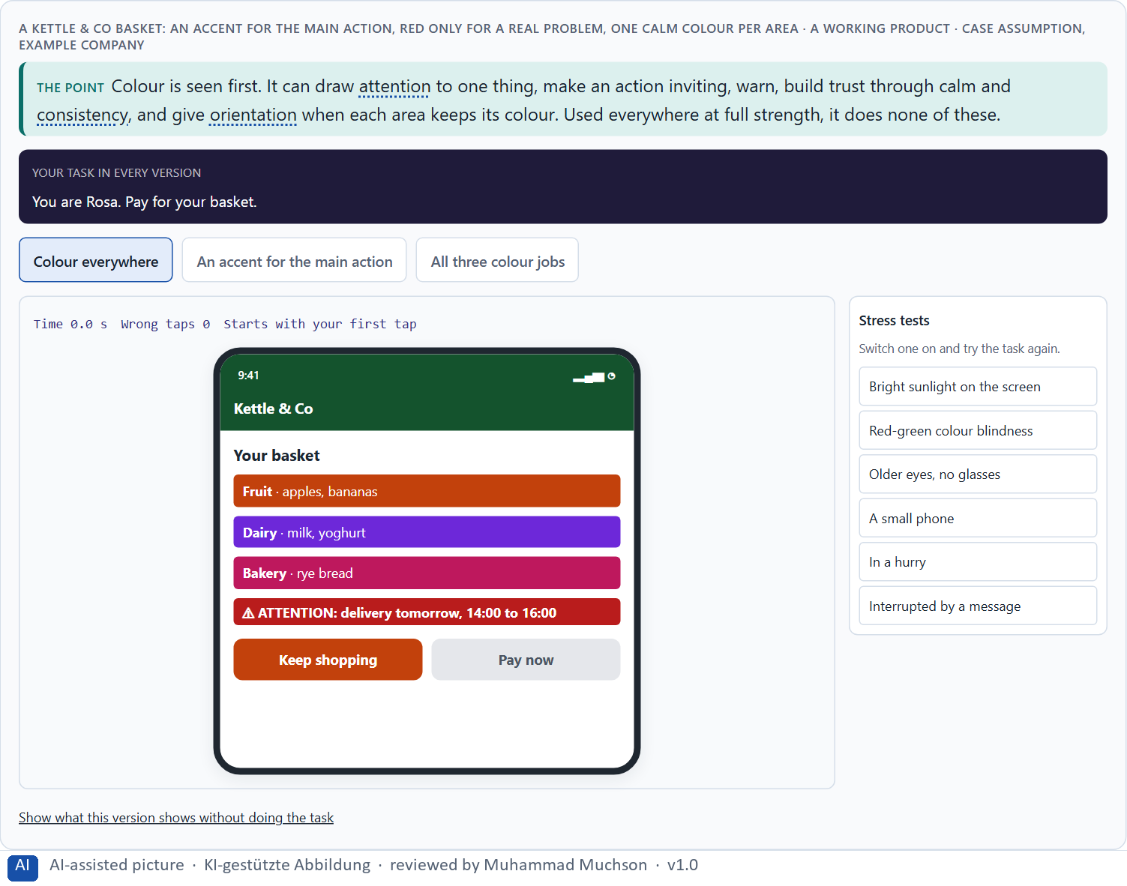
Figure 1 · A Kettle & Co basket: an accent for the main action, red only for a real problem, one calm colour per area. Shown here in its starting state; in the Neuro-UX Lab every version and every stress test can be used.
Five effects of colour, and what breaks them
Effect | Colour that builds it | Colour that breaks it
Attention | One strong accent on the thing that matters. | Many strong colours that compete.
Warning | A warning colour kept for real problems. | Red for ordinary information.
Activation | A warm, inviting colour on the action. | The most inviting colour on the wrong button.
Trust | Calm, consistent colours that keep their meaning. | Loud colours, or colours that change from page to page.
Orientation | Each area or kind of thing keeps its colour. | A colour that means something different on every page.

What colour does, with evidence
Effect | Real finding | What it means for a screen
Attention | Attention goes first to what differs most from its surroundings in colour and contrast (Itti and Koch 2001; Ware 2012). | Give one element the strongest colour difference; a second accent splits the attention.
Activation and thinking | In six tasks with more than 600 participants, red went with better performance on detail-oriented tasks and blue with better performance on creative tasks; the authors link red with avoidance and blue with approach (Mehta and Zhu 2009). | Colour can change how a task is approached, but the effect depends on the task and the group: test it, do not assume it.
Trust and brand | Colours shape how a brand is perceived, for example blue with competence and trust and red with excitement; the effect depends on the context (Labrecque and Milne 2012). | Choose the colour of a service for the feeling it must give, and check it with the people it is for.
Warning | Colour carries meaning learnt from context, such as red for danger (Elliot and Maier 2014). The claim that red lowers intellectual performance did not hold after a correction for publication bias (Gnambs 2020). | Keep red for real problems because people learn it; do not rely on a claim that red changes what people can do.
Orientation | In an eight-country study, colour meanings and preferences showed both similarities and differences across the countries (Madden et al. 2000). | A colour code that works in one country or group has to be checked in the next.

Case assumption
Kettle & Co, Rosa, Theo, Ines and Karim are made up for this example. The effects of colour follow Elliot and Maier (2014); colour and brand perception follow Labrecque and Milne (2012); red as caution and blue as approach follow Mehta and Zhu (2009). The findings in the table of real evidence are real research results, rules and cases; the sources are listed below.

How to decide when this comes up in the task
- Find the strongest colour on the screen and ask whether it sits on the most important thing.
- Ask what each colour is meant to do: draw attention, warn, invite, build trust or show where you are.
- A warning colour on something that is not a problem alarms people and teaches them to ignore it.
- Many strong colours at once compete; colour then gives no orientation and no priority.
- Say a colour's effect as a hypothesis for these users in this context: red means danger in a form and a sale in a shop.

Extra · go deeper (optional reading)
Elliot and Maier (2014) stress that colour effects depend on context: the same red that improves attention to detail in one study can make people avoid a task in another, and the meaning of a colour differs between cultures. For an interface this means: decide the meaning of each colour for your users and your context, and check it; do not rely on a colour chart.

Sources · Elliot & Maier 2014 · Labrecque & Milne 2012 · Mehta & Zhu 2009 · Ware 2012 · Itti & Koch 2001 · Madden et al. 2000 · Gnambs 2020

A2 · Decorative against functional colour: colour for action, priority and state · 12 min · Core
Functional colour has a job: action, priority or state, each with one meaning. Unplanned colour risks overload, misunderstanding and no hierarchy.
IN PLAIN WORDS
The idea. Decorative colour makes a screen look a certain way; functional colour tells people something. Functional colour has a job: it marks what can be done (action), what matters most (priority) and what state something is in (state, such as sent, waiting or failed). Unplanned colour creates three risks: overload, because everything is loud; misunderstanding, because one colour means several things or a colour alone carries a meaning; and no hierarchy, because nothing stands out when everything does.
Why it matters. Block 1.1 asks about warnings, buttons and boxes in similar tones on TravelEase, and Block 2.1 about SecureLife's colours without a system, buttons that look like boxes and status messages coded only by colour. This card gives you the jobs colour can have and the risks when it has none.
How to read the picture. The same Kettle & Co order page twice: coloured to decorate and coloured to function. A table of colour rules and a real case follows.

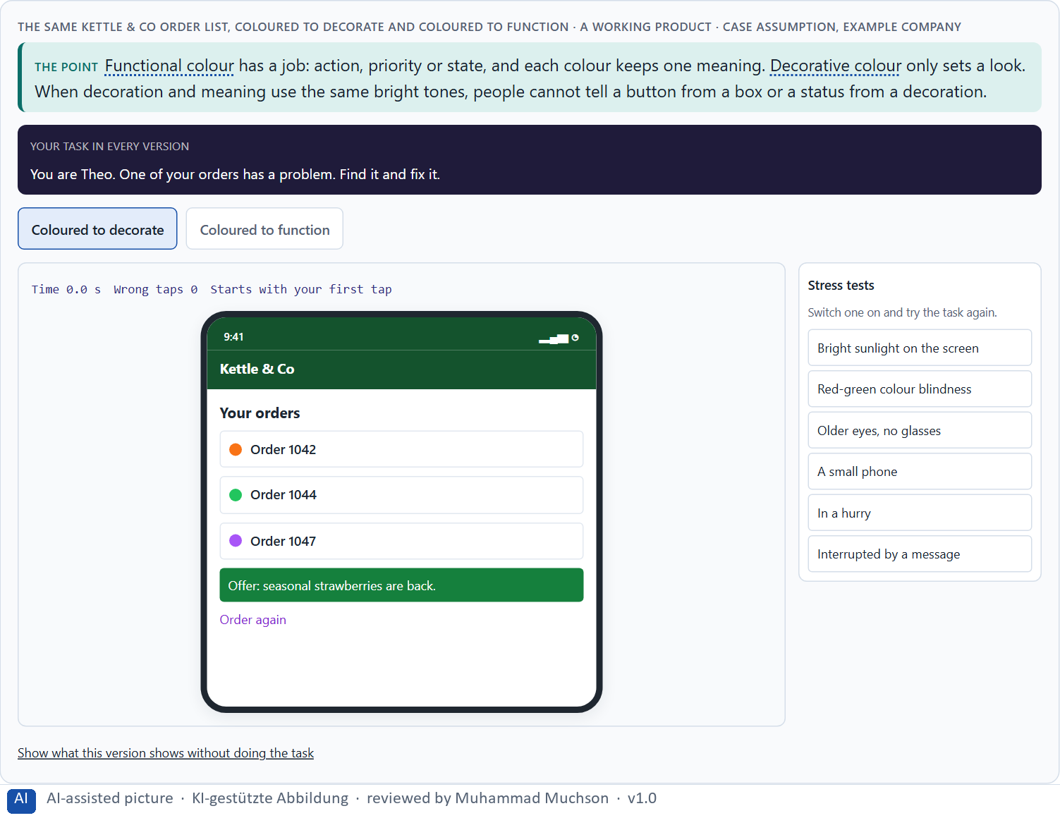
Figure 2 · The same Kettle & Co order list, coloured to decorate and coloured to function. Shown here in its starting state; in the Neuro-UX Lab every version and every stress test can be used.
The jobs of functional colour
Job | What it tells people | A typical use
Action | This can be pressed or done. | One colour for every button that does something.
Priority | This matters most here. | The strongest accent on the main action only.
State | This is the state of your matter. | Green with “Delivered”, amber with “On its way”, red with “Failed”.
Warning | Something needs your attention now. | Red, kept for real problems, with a word.
Information | Good to know, nothing to do. | A calm neutral tone.

Colour for action, priority and state: rules and a real case
Topic | Real rule or case | What it means for a screen
State | Colour must not be the only way to show information such as a state (WCAG 1.4.1); about 1 in 12 men and 1 in 200 women have a colour vision deficiency (Wong 2011). | Put a word or an icon beside every state colour: “Delivered”, “On its way”, “Failed”.
Action and state controls | The parts of controls and states that people need to identify them need a contrast ratio of at least 3 to 1 against their surroundings (WCAG 1.4.11). | Check the border of a button and the mark of a selected state, not only the text.
Decorative or functional | Google tested 41 shades of blue for its links in 2009, each shown to a small share of users; the designer Douglas Bowman left, saying he had “grown tired of debating such minuscule design decisions” (Bowman 2009). | A colour that is chosen to work can be tested, but a test needs a goal, and a team needs a rule for when to stop testing.
Unplanned colour | Attention goes to what differs most (Itti and Koch 2001); every extra strong colour is another candidate for the first glance. | Count the strong colours on a screen: more than one accent, or colours with no rule, mean overload and no hierarchy.

Case assumption
Kettle & Co, Rosa, Theo, Ines and Karim are made up for this example. That colour must not be the only way to convey information is WCAG 2.2, criterion 1.4.1; consistency and standards is Nielsen's heuristic (1994). The findings in the table of real evidence are real research results, rules and cases; the sources are listed below.

How to decide when this comes up in the task
- Sort every colour on the screen into a job: action (can be done), priority (matters most), state (sent, waiting, failed), information, or decoration.
- Check that each job has one colour and each colour one job: a warning must not look like a button, nor a button like an information box.
- Never let a colour alone carry a meaning: add a word or a symbol, so the state is not missed or misread.
- Too many loud colours is overload; one colour with several meanings is a misunderstanding; everything equally strong is no hierarchy.

Extra · go deeper (optional reading)
A noticeable share of people, more men than women, see some colours differently, most often red and green. A status shown only as a red or green dot can look the same to them. A word or a symbol next to the colour is therefore not a nicety but the only way the information reaches everyone.

Sources · WCAG 2.2 · Nielsen 1994 · Ware 2012 · Wong 2011 · Bowman 2009 · Itti & Koch 2001

A3 · Readable type: size, line spacing, contrast, weight and structure · 13 min · Core
Readable type on a screen comes from size, line spacing, contrast, weight and structure. Aesthetic type chooses for the look; functional reading type chooses for the reader.
IN PLAIN WORDS
The idea. On a screen, readability depends on a few levers: type size, line spacing, contrast between text and background, the weight of the type (thin strokes vanish), and the structure of the text (short paragraphs, short lines, clear spacing). Aesthetic typography chooses type for its look; functional reading typography chooses it so people can read quickly and without effort, also older people and people on small screens. A text can look elegant and still be read badly.
Why it matters. Block 1.1 asks about TravelEase's small grey notes and hard-to-read modern sections, Block 1.2 about HealthConnect's low contrast and smaller elegant type for users up to 70, and Block 2.1 about SecureLife's small, dense body text. These five levers are what you check.
How to read the picture. One Kettle & Co delivery notice with four switches: larger type, more line spacing, more contrast and a clear structure. Then a second working example with line length, and a table of the numbers and rules for readable type.

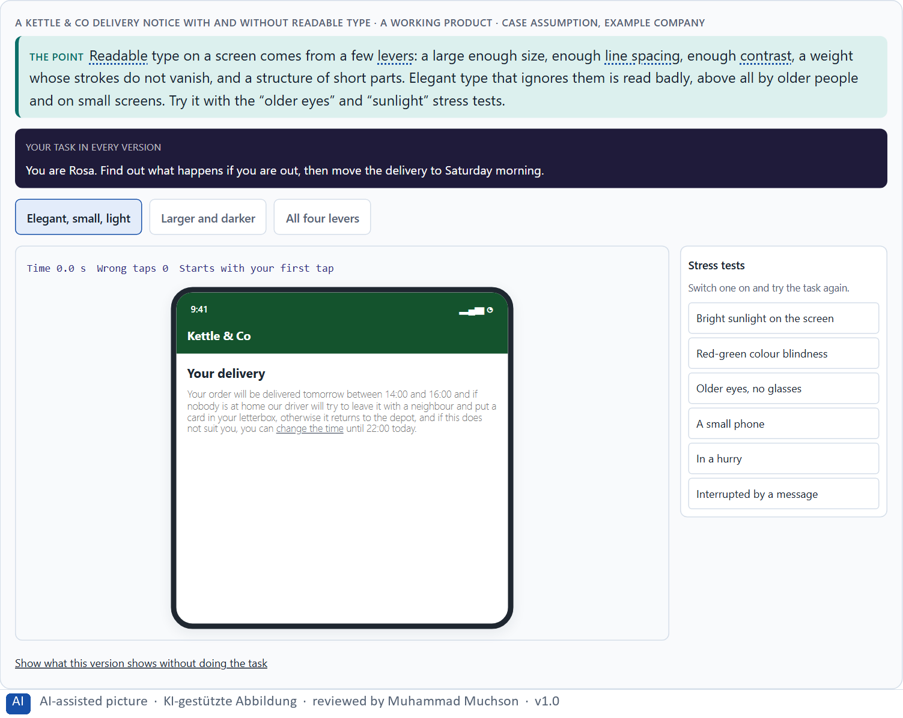
Figure 3 · A Kettle & Co delivery notice with and without readable type. Shown here in its starting state; in the Neuro-UX Lab every version and every stress test can be used.
Aesthetic typography and functional reading typography
Lever | Aesthetic choice | Functional choice
Size | Small, for an elegant look. | Large enough for the whole target group.
Contrast | Light grey or brand tints for softness. | Dark text on a light background, at least the WCAG minimum.
Weight | Thin, light styles. | Regular for text; bold only for emphasis.
Line spacing | Tight, compact blocks. | Enough space for the eye to find the next line.
Structure | One long, flowing paragraph. | Short parts, short lines, clear spacing.

Readable type: numbers and rules
Lever | Real rule or finding | What to check
Size | Reading and comprehension on screen improved with larger type up to 18 points; 10 and 12 points gave the lowest comprehension (Rello et al. 2016). Apple's guidelines give iOS a default body size of 17 points and a minimum of 11 points. WCAG 1.4.4 requires that text can be enlarged to 200% without loss of content. | Set the body text for the whole target group, and test the page at 200%.
Line spacing | WCAG 1.4.12 requires that content still works when a user sets the line height to 1.5 times the font size, the space after paragraphs to 2 times, the letter spacing to 0.12 and the word spacing to 0.16 times the font size. In the study of Rello et al. (2016), tight line spacing lowered comprehension. | Do not fix the height of boxes that hold text: they clip when users change the spacing.
Line length | WCAG 1.4.8 (level AAA) asks for no more than 80 characters per line. In one study, comprehension was highest at about 55 characters per line (Dyson and Haselgrove 2001, as reported). | Cap the width of a text column at about 50 to 80 characters.
Weight and typeface | Thin and decorative letter shapes are harder to read at small sizes (Beier 2012). | Use a regular weight for text and keep light or decorative styles for large headings.
Who it matters for | At least 2.2 billion people have a vision impairment or blindness (World Health Organization 2019). | Readable type is the normal case, not an edge case.

Case assumption
Kettle & Co, Rosa, Theo, Ines and Karim are made up for this example. The effect of type size and line spacing on screen reading follows Rello, Pielot and Marcos (2016); layout and line length follow Dyson (2004); legibility of letter shapes and weights follows Beier (2012); minimum text contrast is WCAG 2.2, criterion 1.4.3. The findings in the table of real evidence are real research results, rules and cases; the sources are listed below.

How to decide when this comes up in the task
- Check the size of the type that carries important information; small type is skipped or misread.
- Check the contrast: light grey on white, or white on a light brand colour, is hard to read.
- Check the weight: thin strokes vanish at small sizes and on phones.
- Check the line spacing and the length of lines and paragraphs: dense blocks are hard to follow.
- Think of the whole target group: older people and small screens are where readability fails first.

Extra · go deeper (optional reading)
In the study by Rello, Pielot and Marcos (2016), larger type improved both reading and comprehension on screen, while line spacing mattered much less. A practical consequence: when a team has room to change only one thing about its body text, a larger size usually helps more than any other single change.

Sources · Rello et al. 2016 · Dyson 2004 · Beier 2012 · WCAG 2.2 · Dyson & Haselgrove 2001 · WHO 2019 · Apple HIG

A4 · Typographic hierarchy, and colour, type and structure working together · 12 min · Core
A typographic hierarchy is a few fixed text levels, clearly different and the same on every page. It lets people scan. Colour, type and structure work together to guide.
IN PLAIN WORDS
The idea. A typographic hierarchy is a small, fixed set of text levels (for example a page heading, a section heading, body text and a note) that look clearly different and mean the same on every page. It lets people scan: their eye jumps from heading to heading and picks the part they need. Colour, type and structure work together: a heading level, an action colour and a group of related content tell the eye where it is and where to go. When the levels differ from page to page, or headings look like body text, scanning breaks.
Why it matters. Block 1.1 asks about TravelEase's decorative headings that do not stand out from the body text, and Block 2.1 about SecureLife's inconsistent typographic hierarchies and calls to action lost among other text. You need the idea of levels to say what is wrong and what a fix would standardise.
How to read the picture. The same Kettle & Co help page in three forms: flat, with a clear hierarchy, and with too many styles. A table of hierarchy and scanning findings follows.

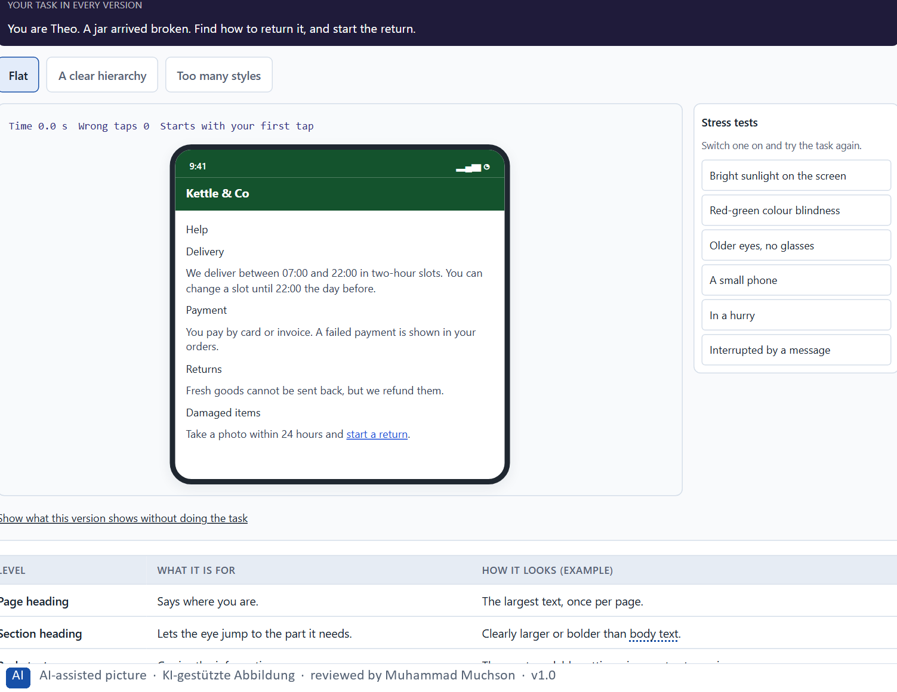
Figure 4 · The same Kettle & Co help page: flat, with a clear hierarchy, and with too many styles. Shown here in its starting state; in the Neuro-UX Lab every version and every stress test can be used.
A small typographic hierarchy
Level | What it is for | How it looks (example)
Page heading | Says where you are. | The largest text, once per page.
Section heading | Lets the eye jump to the part it needs. | Clearly larger or bolder than body text.
Body text | Carries the information. | The most readable setting: size, contrast, spacing.
Note | Adds a detail. | Smaller, but never pale or tiny for important content.

Hierarchy and scanning: evidence
Topic | Real finding or rule | What it means for a screen
Scanning | In eye-tracking of text pages the eyes follow an F-shape; headings, bullet points and bold key words change the pattern (Pernice 2017). 79% of users always scanned a new page (Nielsen and Morkes 1997). | Make the headings carry the content, so a scan reads a summary.
Hierarchy as roles | Apple's guidelines define named text styles for roles such as title, headline, body and footnote, so that size follows the role and grows with the size a person chooses (Dynamic Type). | Define the hierarchy as roles with a size each, not as one-off sizes on single pages.
Structure for software | Structure that is shown by looks must also be in the markup (WCAG 1.3.1). In the WebAIM survey of 2024, 71.6% of the screen reader users said they would first navigate by headings to find information on a long page (as reported). | Use real headings in order, so the visual hierarchy is also the hierarchy for assistive technology.
Colour, type and structure together | Contrast, size and position add up in the eye (Ware 2012). | Make the strongest colour, the largest size and the first position point at the same thing.

Case assumption
Kettle & Co, Rosa, Theo, Ines and Karim are made up for this example. Hierarchy as a service to the reader follows Bringhurst (2004); headings that change how people scan follow Pernice (2017). The findings in the table of real evidence are real research results, rules and cases; the sources are listed below.

How to decide when this comes up in the task
- Count the text levels on a page: page heading, section heading, body text, note. More than four or five, and they blur.
- Check that a heading is clearly different from body text in size or weight, not only in a decorative style.
- Check that the levels are the same on every page; a level that changes from page to page breaks scanning.
- Check that colour, type and structure point the same way: the action colour on the action, the heading level on the heading, related content grouped.
- A call to action set like body text is lost among it.

Extra · go deeper (optional reading)
Important information is often placed in the “note” level because it feels secondary to the designer: a condition, a deadline, a fee. That is the level users skip. A useful check: read only the headings and the body text of a page; if the user would miss something that can cost them money or time, it is in the wrong level.

Sources · Bringhurst 2004 · Pernice 2017 · Nielsen 1994 · Nielsen 1997 · WCAG 2.2 · WebAIM 2024 · Ware 2012

A5 · From colour and type to behaviour, and weighing a measure · 11 min · Core
Colour and type decisions change behaviour, understanding and trust directly. So they are weighed like any measure: effect on users, feasibility, risk and time pressure, with a reason.
IN PLAIN WORDS
The idea. Colour and type decisions change behaviour directly: whether people find the button, read the condition, understand the state of their order and trust the company. That is why they are judged like any other measure, on the four questions Block 2.1 names: effect on users (what it changes for them, and for how many), feasibility (with the people, the technical room and the corporate design there is), risk (what could go wrong or backfire) and time pressure (whether it fits the time and shows soon). The reason next to each rating matters more than the rating.
Why it matters. Block 1.1 asks for the two most critical weaknesses, Block 1.2 for a decision between three designs, and Block 2.1 for four measures with a justification on these four criteria and a decision for 12 weeks. The example uses Kettle & Co and its own measures, so the answer for the task cases is not given.
How to read the picture. Three measures Kettle & Co considered, rated on effect on users, feasibility, risk and time pressure. A rating is a reading of the example, not a mark. A table of findings on behaviour, understanding and trust follows.

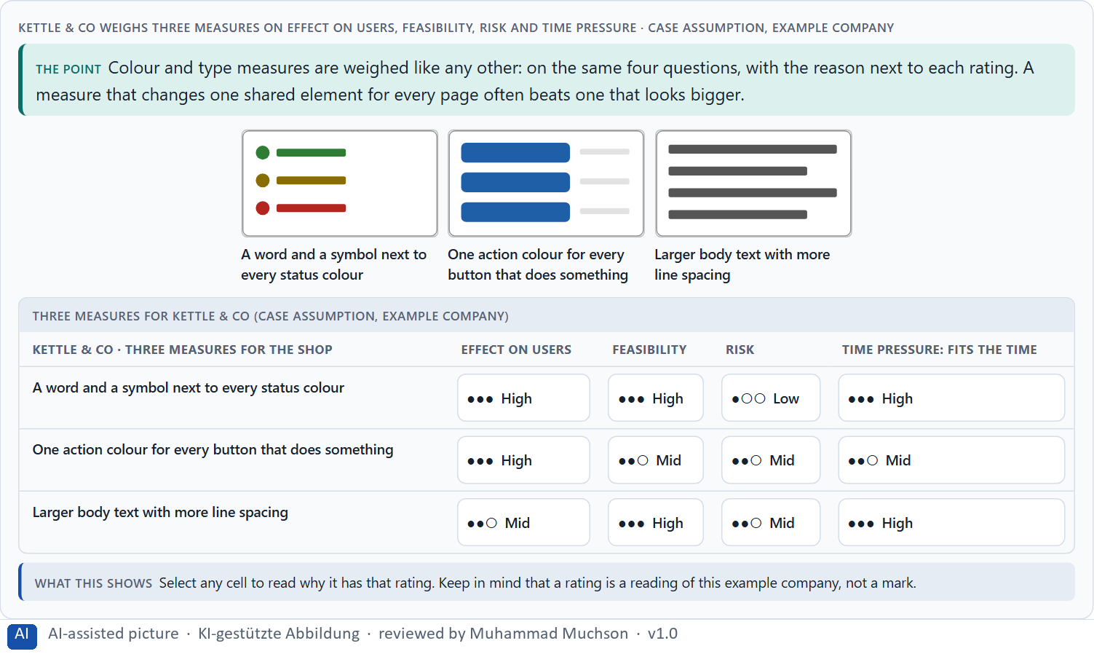
Figure 5 · Kettle & Co weighs three measures on effect on users, feasibility, risk and time pressure.
Colour and type change behaviour, understanding and trust: findings
Effect | Real finding | What it means for a measure
Behaviour | Comprehension of on-screen text rose with larger type (Rello et al. 2016). | A size change is a measure with a visible effect on whether people understand.
Understanding | Design appeal predicted whether women searching for health advice rejected a site (Sillence et al. 2004). | A page that looks careless is rejected before its content is judged.
Trust | The design look was the factor named most often when 2,684 people judged the credibility of 100 websites, in 46.1% of their comments (Fogg et al. 2003). | Type and colour are read as signs of care and seriousness.
Weighing | A colour or type measure is cheap to build and expensive to coordinate: rate its effect, effort, risk and time pressure with a reason (Gibbons 2018). | Write the reason next to the rating, so it can be checked later.

Case assumption
Kettle & Co, Rosa, Theo, Ines and Karim are made up for this example. Rating options on the same criteria with a reason follows Gibbons (2018). The four criteria are the ones the plan names for the case study. The findings in the table of real evidence are real research results, rules and cases; the sources are listed below.

How to decide when this comes up in the task
- Say for each measure what users will do differently: find the button, read the condition, understand the state, trust the page.
- Rate every measure on the same four questions: effect on users, feasibility (people, technical room, corporate design), risk, time pressure.
- A change to one shared element (a button style, a status label, the body text) reaches every page at once and is often the strongest lever.
- A rating is a judgement with a reason, never a mark. A different order with a better reason is a better answer.
- Within a binding corporate design, how colours and type are used can usually change; the brand colours and the typeface themselves cannot.

Extra · go deeper (optional reading)
The plan's transfer question is how colour and type decisions act on behaviour, understanding and trust. A useful habit is to write each measure as “so that”: one action colour, so that customers find what to press; a word with every state, so that nobody misreads a failed payment. A measure without a “so that” is decoration.

Sources · Gibbons 2018 · Nielsen 1994 · WCAG 2.2 · Rello et al. 2016 · Sillence et al. 2004 · Fogg et al. 2003

Materi B · Route 2 · Level 3
How Materi B is used
About 60 minutes, three cards, led by the facilitator. Level 3 in the Chief Experience Officer's chair: a guiding vision for colour and type, three strategic decisions, an order of what is standardised first, a risk analysis, a governance model for brand against usability, one decision under uncertainty and a statement to the management. The cards give you the ideas you use in Task 2.

B1 · Colour and type as strategic effect decisions: a design logic, not a style · 20 min · Core
Colour and type are strategic when they are decided once, as rules and shared components, and used everywhere. The brand is recognised by its consistency.
IN PLAIN WORDS
The idea. Colour and type become strategic when they are decided once, as rules, and used everywhere: which colour means action, warning or state, which type levels exist and how large text must be. Such a design logic, often kept as a small set of named values and shared components, makes every touchpoint consistent and lets the brand be recognised by its consistency. When colours change with every campaign and each team sets type its own way, users have to relearn every screen, and the debate inside stays about taste.
Why it matters. Block 3.1 asks for a guiding vision for colour and type, three decisions on colour, reading, hierarchy and action, and an order of what is standardised first, for a company whose colours changed with campaigns and whose teams set type differently. You decide the rules, not the screens.
How to read the picture. Left the same Kettle & Co elements decided campaign by campaign, right decided once as rules. Below, the chain from the brand to the screens. A table of real systems follows.

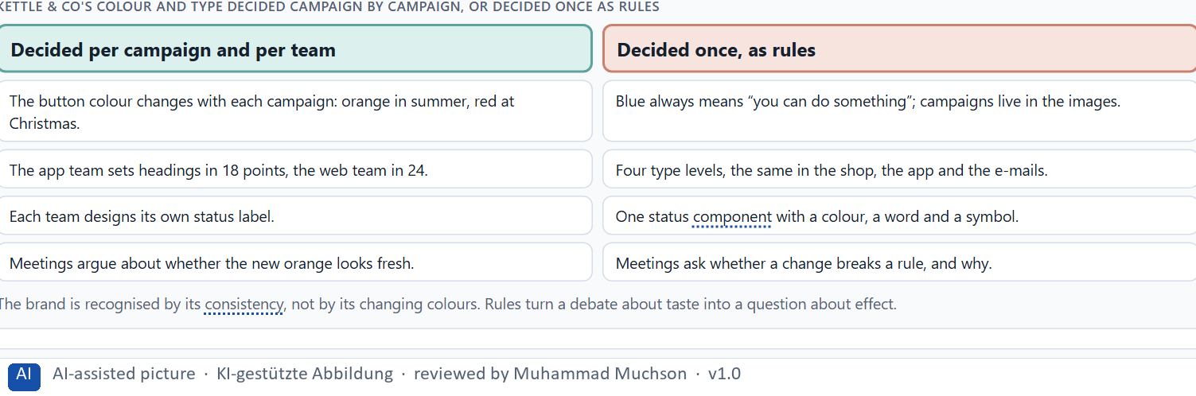
Figure 6 · Kettle & Co's colour and type decided campaign by campaign, or decided once as rules.
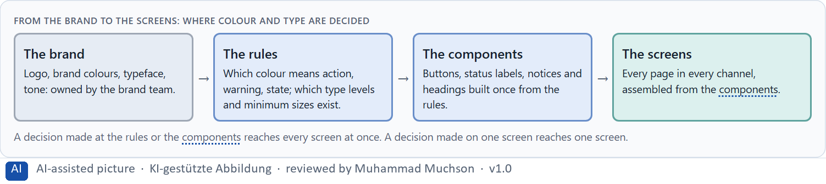
Figure 7 · From the brand to the screens: where colour and type are decided.
Colour and type as strategic decisions: real systems
Decision | Real example | What it means
A rule instead of a choice per page | Atomic design builds interfaces from shared rules and components, from colours and type styles up to whole pages (Frost 2016). | The decision about colour and type is taken once, as a rule.
Roles instead of sizes | Apple's text styles tie size to role and let people choose their own size (Dynamic Type); a design built on roles survives that choice. | A decision about type should hold when the user changes the size.
A standard as the floor | WCAG 2.2 sets the floor: contrast of 4.5 to 1 for text and 3 to 1 for large text and controls, text enlargement to 200%, and text spacing that users can change. | Brand choices are made above the floor, not below it.
Colour shapes the brand | Colour shapes how a brand is perceived (Labrecque and Milne 2012). | A colour decision is a decision about the brand, not only about looks.

Case assumption
Kettle & Co, Rosa, Theo, Ines and Karim are made up for this example. Building interfaces from shared rules and components follows Frost (2016); consistency and standards is Nielsen's heuristic (1994). The findings in the table of real evidence are real research results, rules and cases; the sources are listed below.

How to decide when this comes up in the task
- Look for the places where colour and type are decided today: per campaign, per team, per screen.
- Decide the meaning of each colour and the type levels once, as rules, and build the shared components from them.
- A decision made at the rules or the components reaches every screen; a decision on one screen reaches one.
- Leaders orient design to effect, consistency and usability: ask whether a change breaks a rule and why, not whether it looks fresh.
- Campaigns can live in images and tone; the interface elements keep their meaning.

Extra · go deeper (optional reading)
Many teams keep their rules as a short list of named values, such as “action colour”, “warning colour”, “heading 2” and “body text size”, which every channel uses instead of raw colour codes and sizes. When a value changes, it changes everywhere at once, and a campaign can no longer change a button by accident.

Sources · Frost 2016 · Nielsen 1994 · Labrecque & Milne 2012 · Apple HIG · WCAG 2.2

B2 · Conflicts of goals: brand, accessibility, clarity, activation and standardisation · 20 min · Core
Brand, accessibility, clarity, activation and standardisation pull against each other. A common way through: the brand in the logo, tone and images, the interface in functional rules with minimum readability.
IN PLAIN WORDS
The idea. Colour and type sit between goals that pull against each other. The brand wants recognition and a certain look; accessibility needs contrast and size; clarity needs few, meaningful colours, while activation wants energy; standardisation wants one rule, while campaigns and teams want freedom. A common way through: the brand lives in the logo, the tone and the images, while the interface elements follow functional rules with minimum readability and contrast. The work is to name the conflict, choose, and say what you give up.
Why it matters. Block 3.1 asks for three guiding decisions, a risk analysis about perception and the brand's effect, and a governance model for conflicts between brand and usability. Each of these is a decision between conflicting goals.
How to read the picture. The matrix places five Kettle & Co designs by how readable they are (to the right) and how strongly they carry the brand (upwards). A position is a reading of the example, not a score. A table of conflicts with evidence follows.

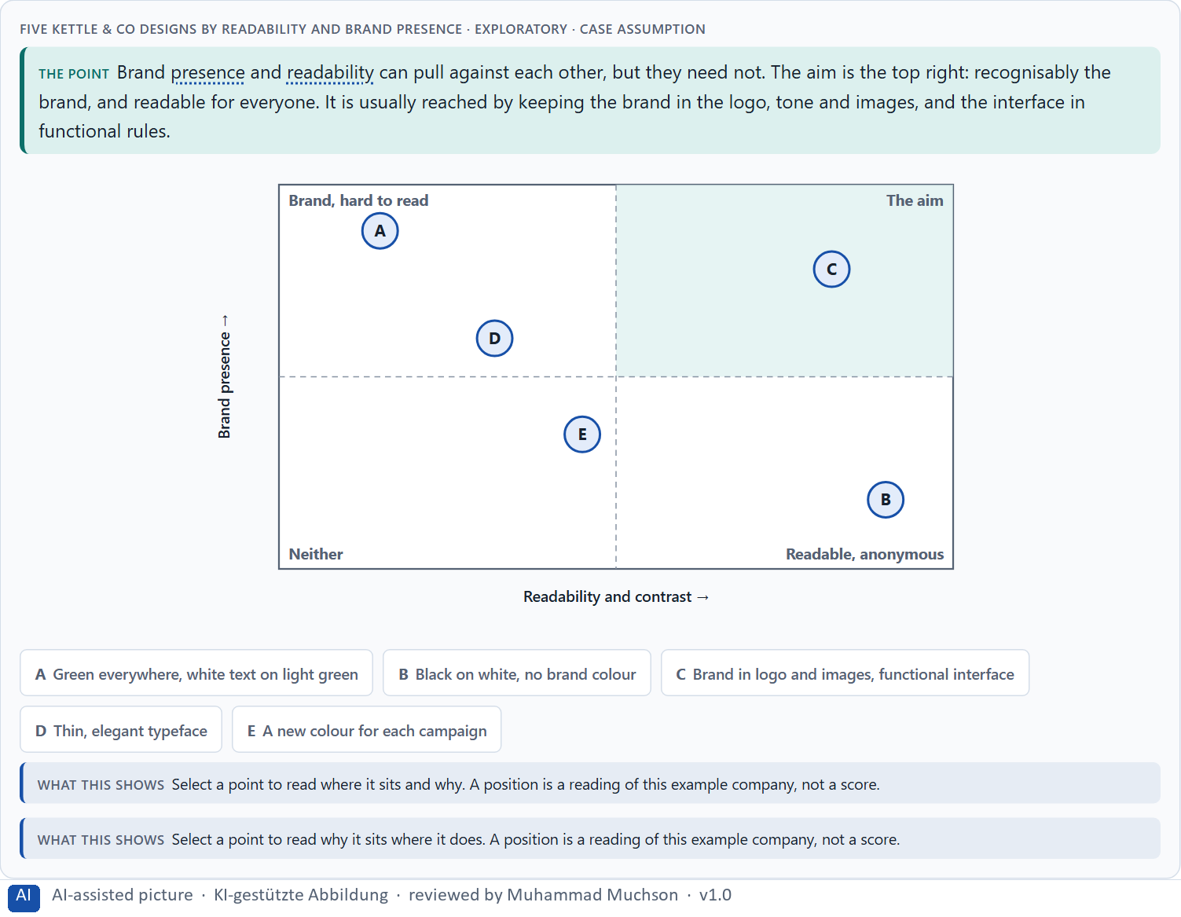
Figure 8 · Five Kettle & Co designs by readability and brand presence · Exploratory.
Standing conflicts of colour and type
Conflict | Who usually stands for each side | What to ask
Brand against accessibility | The brand team, against users who see less well. | Where can the brand live without lowering contrast or size?
Clarity against activation | Users who need few, meaningful colours, against marketing's energy. | Which one element may be loud, and why that one?
Standardisation against freedom | IT and consistency, against campaigns and teams. | Which elements are fixed by rule, and where is freedom allowed?

Conflicts of colour and type, with evidence
Conflict | What the evidence says | A way to decide
Brand against accessibility | At least 2.2 billion people have a vision impairment (World Health Organization 2019); WCAG sets minimum contrast and text enlargement. | Let the brand live in large areas and headlines, and keep text and controls above the WCAG floor.
Clarity against activation | The effect of colour on activity depends on the task: red went with detail work and blue with creative work (Mehta and Zhu 2009). | Allow one loud element, chosen for the task, and keep the rest calm.
Standardisation against freedom | Roles and shared components keep a product consistent (Frost 2016; Apple's text styles). | Fix buttons, states and body text by rule; allow freedom in campaign images and headlines.

Case assumption
Kettle & Co, Rosa, Theo, Ines and Karim are made up for this example. The minimum contrast and the use of colour follow WCAG 2.2; the matrix is a reading of the example, not a score. The findings in the table of real evidence are real research results, rules and cases; the sources are listed below.

How to decide when this comes up in the task
- Name the conflict as two goals and say who stands for each: the brand team, marketing, IT, users of a certain age.
- Readability and contrast below the minimum are not a style choice; they shut people out.
- The brand can live in the logo, the brand colours used in their place, the tone and the images; it does not need every button.
- Campaign freedom against standardisation: decide where campaigns may set colour (images) and where they may not (interface elements).
- Say what the choice gives up; a decision that gives up nothing has not been made.

Extra · go deeper (optional reading)
A brand colour that fails the contrast minimum for text can still be used: as a background for large headings, in the logo, as a thin accent line, or darkened by a step for text. The brand team keeps its colour, and the text stays readable. Most brand-against-accessibility conflicts end there once someone asks where exactly the colour has to appear.

Sources · WCAG 2.2 · Labrecque & Milne 2012 · Gibbons 2018 · WHO 2019 · Mehta & Zhu 2009 · Frost 2016

B3 · Who owns the visual standards, and deciding with incomplete data · 20 min · Core
Visual standards hold only when someone owns them and a rule decides conflicts, minimum readability first. A decision with incomplete data says what it decides, what it does not know, when it would reverse it and what it gives up.
IN PLAIN WORDS
The idea. Visual standards only hold when someone owns them: who keeps the colour and type rules and the shared components, who keeps the brand, and who decides when the two conflict, on what basis. A rule that puts minimum readability and contrast first takes most conflicts out of the realm of taste. Because data is rarely complete, a decision under uncertainty says what you decide, what you do not know, when you would reverse it and what you give up. A wrong priority shows up as lost trust, operating errors and support costs.
Why it matters. Block 3.1 asks for a governance model for the visual standards and the conflict between brand and usability, a decision despite missing data, and a statement to the management. This card gives you the parts of each.
How to read the picture. The four boxes at the top are the parts of a decision, filled in for Kettle & Co. The two boxes below are the rule for future decisions. A table of a real case and a real rule follows.

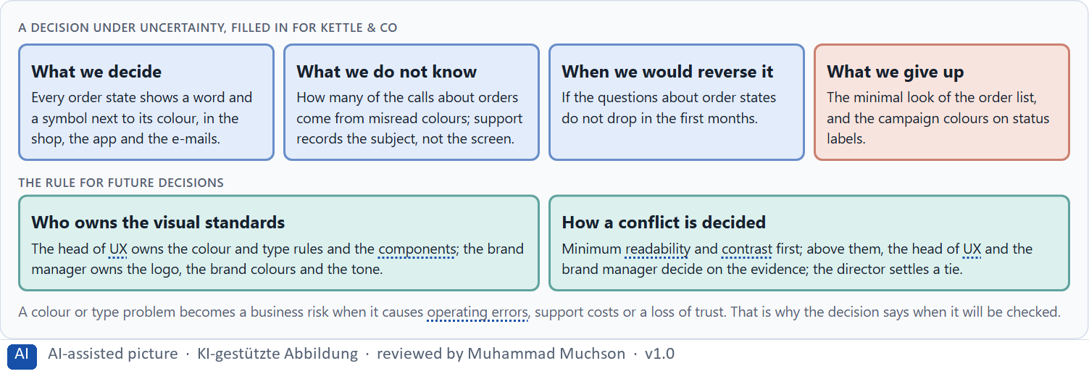
Figure 9 · A decision under uncertainty, filled in for Kettle & Co.
Three parts of a governance model for visual standards
Part | The question | An example (Kettle & Co)
Who owns what | Who owns the rules and components; who owns the brand? | The head of UX owns the rules; the brand manager owns the logo and tone.
How a conflict is decided | What happens when brand and usability clash? | Readability first; then both decide on the evidence; the director settles a tie.
Where freedom is allowed | Where may campaigns and teams set colour and type? | In campaign images and headlines, not in buttons, states or body text.

Who owns visual standards: a real case and a real rule
Part | Real example | What it means
Taste or data | In the Google case the colour of links was settled by testing 41 shades, and the designer who objected left (Bowman 2009). | Decide in advance what is settled by evidence, what by a rule and what by a person.
A rule owner | A platform owner such as Apple publishes text styles and minimum sizes that every app is expected to follow. | Someone must own the rules and the components, with the power to say no.
Incomplete data | WCAG gives thresholds that hold before any test with your own users. | Where data is missing, decide on the standard and say what a test would change.

Case assumption
Kettle & Co, Rosa, Theo, Ines and Karim are made up for this example. Deciding with limited information follows Simon (1956); the premortem follows Klein (2007). The findings in the table of real evidence are real research results, rules and cases; the sources are listed below.

How to decide when this comes up in the task
- Name who owns the colour and type rules and the shared components, and who owns the brand.
- Give conflicts between brand and usability a rule: minimum readability and contrast first, then evidence, then a named person.
- Say what you decide, what you do not know, when you would reverse it and what you give up.
- A wrong priority shows up as lost trust, operating errors and support costs; say when you will check.

Extra · go deeper (optional reading)
Before the standards go live, imagine it is a year later and customers still misread states and miss conditions, and ask why (Klein 2007). The usual answers: a team kept its own components, a campaign overrode a rule, or the minimum was written but nobody checked it. Each answer names an owner who is missing.

Sources · Simon 1956 · Klein 2007 · WCAG 2.2 · Bowman 2009 · Apple HIG

Use in class: presentation and handout
Mark of use for the study material. Presentation is what the trainer shows on screen; Handout is what participants read and keep.
Card | Presentation (shown in the Neuro-UX Lab) | Handout
A1 · What colour does: attention, trust, activation, warning and orientation (Core) | Scan line and Figure 1; the "In plain words" and "How to decide" boxes | The whole card
A2 · Decorative against functional colour: colour for action, priority and state (Core) | Scan line and Figure 2; the "In plain words" and "How to decide" boxes | The whole card
A3 · Readable type: size, line spacing, contrast, weight and structure (Core) | Scan line and Figure 3; the "In plain words" and "How to decide" boxes | The whole card
A4 · Typographic hierarchy, and colour, type and structure working together (Core) | Scan line and Figure 4; the "In plain words" and "How to decide" boxes | The whole card
A5 · From colour and type to behaviour, and weighing a measure (Core) | Scan line and Figure 5; the "In plain words" and "How to decide" boxes | The whole card
B1 · Colour and type as strategic effect decisions: a design logic, not a style (Core) | Scan line and Figures 6–7; the "In plain words" and "How to decide" boxes | The whole card
B2 · Conflicts of goals: brand, accessibility, clarity, activation and standardisation (Core) | Scan line and Figure 8; the "In plain words" and "How to decide" boxes | The whole card
B3 · Who owns the visual standards, and deciding with incomplete data (Core) | Scan line and Figure 9; the "In plain words" and "How to decide" boxes | The whole card

References
Check each source and its current edition before you teach from it. Standards and laws marked as in flux can change.
Elliot, A. J., & Maier, M. A. (2014). Color psychology: Effects of perceiving color on psychological functioning in humans. Annual Review of Psychology, 65, 95–120. (Colour carries meaning learnt from context, such as red for danger or a stop; the effect depends on the context and the culture, so it is a hypothesis, not a law.)
Labrecque, L. I., & Milne, G. R. (2012). Exciting red and competent blue: the importance of color in marketing. Journal of the Academy of Marketing Science, 40(5), 711–727. (Colours shape how a brand is perceived, for example blue with competence and trust, red with excitement; the effect depends on context.)
Mehta, R., & Zhu, R. J. (2009). Blue or red? Exploring the effect of color on cognitive task performances. Science, 323(5918), 1226–1229. (Red is linked with avoidance and caution, blue with approach and openness; colour changes how people approach a task.)
Ware, C. (2012). Information Visualization: Perception for Design (3rd ed.). Morgan Kaufmann. (Contrast, colour and position decide what pops out; a visual order the eye can follow reduces the effort of search.)
Itti, L., & Koch, C. (2001). Computational modelling of visual attention. Nature Reviews Neuroscience, 2(3), 194–203. (Attention is pulled by what differs from its surroundings in colour, contrast, orientation and movement: the bottom-up side of seeing.)
Madden, T. J., Hewett, K., & Roth, M. S. (2000). Managing images in different cultures: A cross-national study of color meanings and preferences. Journal of International Marketing, 8(4), 90–107. (In eight countries, colour meanings and preferences showed both similarities and differences, so a colour code has to be checked with each target group.)
Gnambs, T. (2020). Limited evidence for the effect of red color on cognitive performance: A meta-analysis. Psychonomic Bulletin & Review, 27. https://doi.org/10.3758/s13423-020-01772-1 (After a correction for publication bias, no evidential value for an effect of red on intellectual performance: a caution against claims that a colour changes behaviour.)
W3C (2023). Web Content Accessibility Guidelines (WCAG) 2.2. https://www.w3.org/TR/WCAG22/ (Success criterion 1.4.1 Use of Color: colour must not be the only way to convey information; 1.4.3 Contrast (Minimum) for text.)
Nielsen, J. (1994, reviewed 2024). 10 Usability Heuristics for User Interface Design. Nielsen Norman Group. https://www.nngroup.com/articles/ten-usability-heuristics/ (Visibility of system status, consistency and standards, recognition rather than recall, aesthetic and minimalist design.)
Wong, B. (2011). Color blindness. Nature Methods, 8(6), 441. (About 8% of men and under 1% of women have a colour vision deficiency, so colour alone must not carry a meaning.)
Bowman, D. (2009). Goodbye, Google. stopdesign.com, 20 March 2009. https://stopdesign.com/archive/2009/03/20/goodbye-google.html (The designer's account of leaving Google after a test of 41 shades of blue, and of a process that settles design decisions by data alone.)
Rello, L., Pielot, M., & Marcos, M.-C. (2016). Make it big! The effect of font size and line spacing on online readability. CHI '16, 3637–3648. (Larger type improved reading and comprehension on screen; type size mattered more than line spacing.)
Dyson, M. C. (2004). How physical text layout affects reading from screen. Behaviour & Information Technology, 23(6), 377–393. (Line length, spacing and layout change how well text is read on screen.)
Beier, S. (2012). Reading Letters: Designing for Legibility. BIS Publishers. (How the shapes, weight and spacing of letters affect legibility, and why thin and decorative styles are harder to read.)
Dyson, M. C., & Haselgrove, M. (2001). The influence of reading speed and line length on the effectiveness of reading from screen. International Journal of Human-Computer Studies, 54(4), 585–612. (Comprehension was highest at a medium line length of about 55 characters; the figure is from summaries of the paper, check the original.)
World Health Organization (2019). World report on vision. Geneva: WHO. https://www.who.int/publications/i/item/9789241516570 (At least 2.2 billion people have a vision impairment or blindness; about 1 billion of these cases could have been prevented or have not yet been addressed.)
Apple (current). Human Interface Guidelines: Typography. https://developer.apple.com/design/human-interface-guidelines/typography (Named text styles for roles such as title and body, Dynamic Type that lets people choose their text size, and a default size of 17 points and a minimum of 11 points on iOS; check the current page.)
Bringhurst, R. (2004). The Elements of Typographic Style (3rd ed.). Hartley & Marks. (Typography exists to serve the text and the reader; hierarchy, measure and spacing are its tools.)
Pernice, K. (2017). F-Shaped Pattern of Reading on the Web: Misunderstood, But Still Relevant (Even on Mobile). Nielsen Norman Group. https://www.nngroup.com/articles/f-shaped-pattern-reading-web-content/ (On text-heavy pages without structure, the eye often scans in an F-shape; headings, short paragraphs and clear structure change the pattern.)
Nielsen, J. (1997). How Users Read on the Web. Nielsen Norman Group. https://www.nngroup.com/articles/how-users-read-on-the-web/ (Most users scan a page rather than read it word by word, picking out words, headings and links.)
WebAIM (2024). Screen Reader User Survey #10. https://webaim.org/projects/screenreadersurvey10/ (71.6% of the respondents said they would first navigate by headings to find information on a long page; the sample is not random.)
Gibbons, S. (2018). Using Prioritization Matrices to Inform UX Decisions. Nielsen Norman Group. https://www.nngroup.com/articles/prioritization-matrices/ (Rate each option on the same few criteria, such as value to the user against effort, and put the reason next to each rating.)
Sillence, E., Briggs, P., Fishwick, L., & Harris, P. (2004). Trust and mistrust of online health sites. Proceedings of CHI 2004, 663–670. (Fifteen women searched for health advice over four weeks: design appeal predicted the rejection of a site, credibility of the information and personalisation predicted its selection.)
Fogg, B. J., Soohoo, C., Danielson, D. R., Marable, L., Stanford, J., & Tauber, E. R. (2003). How do users evaluate the credibility of Web sites? A study with over 2,500 participants. Proceedings of DUX '03. (2,684 people judged the credibility of 100 live sites; the design look was the factor mentioned most often, in 46.1% of their comments.)
Frost, B. (2016). Atomic Design. Brad Frost. https://atomicdesign.bradfrost.com/ (Interfaces built from shared rules and components, from colours and type styles up to whole pages, so every screen stays consistent.)
Simon, H. A. (1956). Rational choice and the structure of the environment. Psychological Review, 63(2), 129–138. (With limited information and time, people choose an option that is good enough rather than the best one: a decision under uncertainty.)
Klein, G. (2007). Performing a project premortem. Harvard Business Review, 85(9), 18–19. (Imagine the plan has failed and ask why; it brings risks and wrong assumptions to the surface before the work starts.)

Glossary
Every term below is used in this document. Terms stay plain text in the body; this list says what they mean in everyday words.
Term | In plain words | Example | Comes from
Accessibility | Designing so that everyone can use a product, also people who see less well, see colours differently, or use a keyboard or a screen reader. | — | Day 3
Attention | The mind's spotlight. Only a small part of a screen is processed at any moment; attention decides which part. | A flashing banner takes attention away from the form you were filling in. | Day 1
Body text | The running text of a page, as opposed to headings, labels and buttons. It carries most of the information and must be the easiest to read. | — | Day 3
Brand effect | How a design makes people recognise the company and what they feel about it, such as modern, serious or friendly. | — | Day 3
Call to action | An element that asks people to do something, such as “Report damage” or “Pay now”. It should be the easiest thing on the screen to see and press. | — | Day 3
Case assumption | A fact made up for this exercise to fill a gap in the plan's case. It is marked so you know it is not part of the plan. | — | Day 1
Chief Experience Officer | The manager who is responsible for the experience customers have across all channels, and who decides where the company invests in it. | — | Day 1
Consistency | The same thing looks, is named and works the same way everywhere, so what people learn on one page holds on the next. | — | Day 2
Contrast | How much something differs from its surroundings in brightness, colour or size. Strong contrast makes it stand out; too many strong contrasts make everything compete. | — | Day 2
Contrast ratio | A measure of how much text differs in brightness from its background. WCAG asks for at least 4.5 to 1 for normal text. | — | Day 3
Corporate design | A company's fixed visual identity: logo, brand colours, typeface and the way they are used. Functional adjustments can often be made within it. | — | Day 3
Decorative colour | Colour used for the look only. It is not wrong in itself, but it must not compete with the colours that carry a meaning. | — | Day 3
Design logic | A set of decided rules and shared components, such as which colour means what and which type levels exist, used for every screen so everything stays consistent. | — | Day 3
F-pattern | A common way the eye scans a text-heavy page without structure: across the top, across a little lower, then down the left edge. Headings and short blocks break it up. | — | Day 2
Font weight | How thick the strokes of the letters are: thin, regular, bold. Thin strokes can vanish on a screen, above all at small sizes. | — | Day 3
Functional colour | Colour with a job: it tells people what can be done, what matters most or what state something is in. Each colour keeps one meaning everywhere. | — | Day 3
Governance | The rules about who may decide what, who is answerable for it and how disagreements are settled. | — | Day 1
Grouping | Showing what belongs together, for example by putting it close together or making it look alike. The eye reads a group as one unit. | — | Day 2
Hypothesis | An assumption you could check later. “This red banner could make users uneasy” is a hypothesis; “this banner is bad” is only an opinion. | — | Day 1
Legibility | How easily single letters and words can be told apart. Thin, decorative or very small type is less legible. | — | Day 3
Line spacing | The space between lines of text. Too little and lines run together; enough and the eye finds the next line easily. | — | Day 3
Neuro-UX | Designing an interface with knowledge of how the brain sees, attends, feels and decides, so that the design steers these processes on purpose and responsibly. | — | Day 1
Orientation | Knowing where you are, what you can do here and what happens next. | — | Day 1
Perception | Taking in what the senses deliver, for example what the eyes see on a screen, before thinking about it. | — | Day 1
Primary action | The one thing most people on a screen came to do, such as “Report damage”. It should be the easiest thing to see and press. | — | Day 1
Readability | How easily a text can be read and understood: its size, contrast, line length, wording and how it is broken into parts. | — | Day 2
Scanning | Looking over a screen quickly and picking out what seems relevant, instead of reading it word by word. Most people scan first. | — | Day 2
Status colour | A colour that shows the state of something, such as sent, waiting or failed. It needs a word or a symbol next to it, because colour alone is missed or misread. | — | Day 3
Touchpoint | Any place where a person meets the company: the website, the customer portal, the app, a chatbot or a phone call. | — | Day 1
Typographic hierarchy | A small, fixed set of text levels, such as page heading, section heading, body text and note, that look clearly different and mean the same on every page. | — | Day 3
Typography | How text is set: which typeface, which size, weight, line spacing and line length, and how the text is broken into levels and parts. | — | Day 3
UX (user experience) | Everything a person goes through when using a product: what they notice, understand, feel and do, from the first look to the last step. The screens are only one part of it. | Finding the booking you want at once and feeling sure it went through is a good UX. | Day 1
Visual hierarchy | An order the eye can follow: the most important thing is clearly the strongest, the rest is quieter. Without it, everything competes equally. | — | Day 1

The Neuro-UX Lab: where we practise online
In class we use the course website as the place to practise and to learn. Every day has its own address, in the same pattern: the day number is the last part.
What | Address
Neuro-UX Lab (course website) | https://aion-ux-lab.vercel.app/
Day 3 | https://aion-ux-lab.vercel.app/day/3/

On the day page, Route 1 (Levels 1 and 2) and Route 2 (Level 3) can be opened; the cards and the tasks of this document are there too. The pattern is the same up to Day 8, for example https://aion-ux-lab.vercel.app/day/6/.

