AION · UX DEVELOPER · PSYCHOLOGICAL UX DESIGN AND NEURO-UX
DAY 3 · TASK 1 AND TASK 2 · ROUTES 1 AND 2 · LEVELS 1 TO 3
SecureLife: UX Analysis File and UX Strategy Memo
Describe the effect, choose the measures as a team member, and decide as Chief Experience Officer
AI notice · KI-Hinweis
This document was produced with the help of an AI language model (Claude, Anthropic). The AI drafted the text and tables and built the pictures and working examples of the lab. The content was then read, corrected and approved by the reviewer named below, who is responsible for its accuracy. Every picture carries an AI label on the image. Check figures and sources before you quote them.
KI-Hinweis: Dieses Dokument wurde mit Unterstützung eines KI-Sprachmodells (Claude, Anthropic) erstellt. Texte und Tabellen wurden von der KI entworfen, die Abbildungen sind KI-gestützt erstellt und am Bild gekennzeichnet. Die fachliche Prüfung und Freigabe erfolgte durch die unten genannte Person.

Day | Day 3 · Module 2 (day 2 of 2): Colour, typography and readability
Document | Task (worksheet with answer spaces). Task 1 (UX Analysis File) and Task 2 (UX Strategy Memo).
Route and level | Task 1 = Route 1, Levels 1 and 2 (draws on Materi A). Task 2 = Route 2, Level 3 (draws on Materi B).
Time | Task 1 about 33 min · Task 2 about 20 min
Neuro-UX Lab (website) | https://aion-ux-lab.vercel.app/day/3/
Case | SecureLife, the day's case study; other products appear as warm-ups
Version | 1.0 · release date 29.10.2026
Review and approval | Muhammad Muchson, Mentor (subject-matter review and approval)

ABOUT THIS DOCUMENT
In class we also use the Neuro-UX Lab, the course website, as the place to practise and learn. Its address is at the end of this document.
This is the worksheet for Day 3. Read the case once, study the evidence printed in this document, and write your answers in the boxes and tables. You can work through it on paper or type into the document. All blocks are Core. There are no answer keys and no scores; the reason you give matters more than the choice.

IN THIS DOCUMENT
Lesson plan: ten teaching units (Ablaufplan)
Case study and transfer project at a glance
The case: three products on the UX team's desk, and SecureLife
Block 1.1 · The effect of colour and type without prior knowledge: TravelEase · JUDGED · Core · about 10 min
Block 1.2 · Rate colour and type decisions under conflicting goals: HealthConnect · JUDGED · Core · about 8 min
Block 2.1 · Case study: revising the insurance portal SecureLife · JUDGED · Core · about 15 min
The situation: the insurer behind SecureLife, and years of inconsistent design
Block 3.1 · A strategic design logic for colour, typography and user guidance · JUDGED · Core · about 20 min

Day at a glance
Day 3 has ten teaching units (UE). This document is the worksheet; it is used in UE2 to UE6 (Task 1) and UE8 to UE10 (Task 2). The day is built from three documents and the Neuro-UX Lab: Materi (study material), Task (worksheet) and Trainer (coaching, feedback and model solutions), plus the course website.

Lesson plan: ten teaching units (Ablaufplan)
UE | Min | Plan item | What happens | Material | Format
1 | 45 | Knowledge transfer · Level 1 | The trainer presents the cards of Materi A (A1, A2, A3, A4, A5, about 60 min of cards) in the Neuro-UX Lab; participants follow in the handout. | Materi A (Route 1) | Presentation + Handout
2 | 45 | Level 1 · Task 1 | Individual work on Block 1.1 (Core, about 10 min): the first product of the day is read and its effect described. Pairs then compare their results and the trainer collects open questions. | Task 1 · Part 1 · Block 1.1 | Handout (or in the lab)
3 | 45 | Level 1 · Task 2 | Three options are rated on the same criteria and one is chosen under the stated conditions: Block 1.2 (Core, about 8 min). | Task 1 · Part 1 · Block 1.2 | Handout (or in the lab)
4 | 45 | Coaching · transition from Level 1 to Level 2 | Trainer-led. A short talk on the day's coaching focus, then the reflection questions in pairs. The bridge: from describing an effect to a decision you answer for. There is no worksheet block in this unit. | Trainer document, section Coaching | Trainer only
5–6 | 90 | Level 2 · Case study SecureLife (2 UE) incl. model solution | UE5: the trainer presents the case; participants work on Block 2.1 (Core, about 15 min). UE6: groups compare their results and defend them; the trainer closes with the model solution. | Task 1 · Part 2 · Block 2.1  Trainer document, section Case study | Handout; model solution shown after the work
7 | 45 | Level 2 + 3 · Feedback round with a management perspective | Groups present their reasoning, not only their result. The trainer asks the day's Level 3 input questions and leads the discussion. | Trainer document, section Feedback round | Presentation by the groups; Trainer only
8 | 45 | Level 3 · Transfer project, Chief Experience Officer (3 UE: UE8–10) | The trainer presents Materi B (B1, B2, B3; use the "In plain words" and "How to decide" boxes, the rest is handout) and sets the role and the situation. | Materi B (Route 2) | Presentation + Handout
9 | 45 | Level 3 · Transfer project | Individual work or in pairs on Block 3.1 (Core, about 20 min): the strategy memo. | Task 2 · Block 3.1 | Handout (or in the lab)
10 | 45 | Level 3 · Transfer project | Participants present their decision and what they give up, including the one decision made under uncertainty; the trainer debriefs with the model solution. | Task 2 · Block 3.1  Trainer document, section Transfer project | Handout; model solution shown after the work

One UE is counted as 45 minutes here; breaks are not shown. The times are a guide for the trainer. The Core blocks are enough for a complete answer.

Case study and transfer project at a glance
Component | UE | Duration | Participants work in | Model solution in
Level 2 case study (SecureLife) | UE5–6 | 2 UE · 90 min | Task 1 · Part 2 (Block 2.1) | Trainer document, section Case study
Level 3 transfer project (Chief Experience Officer) | UE8–10 | 3 UE · 135 min | Materi B and Task 2 (Block 3.1) | Trainer document, section Transfer project

Which plan item each block answers
UE | Plan item (Strukturplan, Day 3) | Block in this document
UE2 | Level 1, task 1 · The effect of colour and type without prior knowledge: TravelEase | Block 1.1 (Core)
UE3 | Level 1, task 2 · Rate colour and type decisions under conflicting goals: HealthConnect | Block 1.2 (Core)
UE4 | Coaching: from describing to deciding | A classroom talk led by the trainer; not a worksheet block
UE5–6 | Level 2 case study · Case study: revising the insurance portal SecureLife | Block 2.1 (Core)
UE7 | Feedback round with a management perspective | A classroom discussion led by the trainer; not a worksheet block
UE8–10 | Level 3 transfer project · A strategic design logic for colour, typography and user guidance | Block 3.1 (Core), in Task 2

Your name
Write your full name here. Use the same name on every Task document this week; it is how your work is matched.

Task 1 · Route 1 · UX Analysis File: judge colour and type by their effect, then decide what to change

The case: three products on the UX team's desk, and SecureLife
Read once · about 3 min
You work in the UX team of a digital agency. This week three products land on your desk. Two are warm-ups: TravelEase, a customer portal for travel bookings and rebookings, and HealthConnect, a health platform that has three designs for its interface. The main case is SecureLife, the portal of an insurer for contracts, damage reports and contact with the service. It is complete in content, but complaints pile up: users overlook important notes, do not clearly understand status messages and find the interface exhausting and restless.
What the plan gives you | How the task runs · three blocks
• Block 1.1: TravelEase, with four strong main colours and no system, warnings, buttons and boxes in similar tones, decorative headings, important notes in small grey type, modern but hard-to-read sections, and links, buttons and status displays that look alike  • Block 1.2: three designs for HealthConnect; users from 20 to 70, the wish to look modern and trustworthy, a limited budget, a corporate design that may only partly change, no user tests, 8 weeks to release  • Block 2.1: SecureLife, with €130,000 and 12 weeks, a binding corporate design with room for functional adjustments, users of different ages and no complete relaunch | • Block 1.1: colour and type without prior knowledge. Describe your spontaneous impression, name five problems, sort them into five categories, write three effect statements and pick the two most critical weaknesses.  • Block 1.2: rate three designs under conflicting goals. Rate each on five criteria, choose one, name the conflicts between brand and user-friendliness and the remaining risks, and write a recommendation to the project lead.  • Block 2.1: the case study. The central problems of colour and type, sorted into five categories, four measures, justified on four criteria, a decision for the first 12 weeks and a recommendation to the division management.

What is known and what is open
In the brief | Clear · Case assumption | Open · on purpose
• TravelEase: four strong colours without a system, similar tones for warnings, buttons and boxes, decorative headings, small grey notes, links, buttons and status alike.  • HealthConnect: three designs described in words; users from 20 to 70; corporate design only partly changeable; no tests; 8 weeks.  • SecureLife: colours without a functional system, buttons like boxes, status by colour only, small dense text, inconsistent hierarchy; €130,000 and 12 weeks; no relaunch. | • You review TravelEase and HealthConnect as an agency would: from their screens, with no access to their data.  • SecureLife's corporate design prescribes a blue as the main colour and one typeface; how they are applied is open.  • SecureLife shows the state of a damage report as a coloured dot only: blue, green or red.  • Support at SecureLife hears the same questions: “Has my report arrived?” and “What do I have to do now?” | • How many users of each age group there are: no figure is given.  • Which HealthConnect design the target group would prefer: there are no tests.  • How the brand team would react to functional colours: not asked yet.  • How much of the €130,000 each measure would take: the plan does not say.

As in most projects, not everything is known. Decide anyway, and say what you assume.
Case assumption
The brief says: TravelEase with four colours and no system, similar tones, decorative headings, small grey notes and indistinct links, buttons and status; HealthConnect's three designs for users from 20 to 70, a partly fixed corporate design, no tests and 8 weeks; SecureLife with unsystematic colours, similar buttons and boxes, colour-only status, small dense text, inconsistent hierarchy, €130,000, 12 weeks and no relaunch. Those are the plan's facts and its only figures. Everything else is made up for this exercise: the agency, the pictures, the simulations and the facts marked “Clear”.

Part 1 · Describe the effect and weigh designs · Level 1 · Knowledge

Block 1.1 · The effect of colour and type without prior knowledge: TravelEase · JUDGED · Core · about 10 min
Draws on: A1 · What colour does · A2 · Decorative against functional colour · A3 · Readable type · A4 · Typographic hierarchy, and colour, type and structure working together.
You receive the description of a fictional customer portal, TravelEase, for travel bookings and rebookings. Open it and use it as a traveller who wants to change a booking. You need no prior knowledge: say first how it feels, then what makes it hard. The aim is to recognise perception and readability problems step by step and to describe the effect before the technical terms.
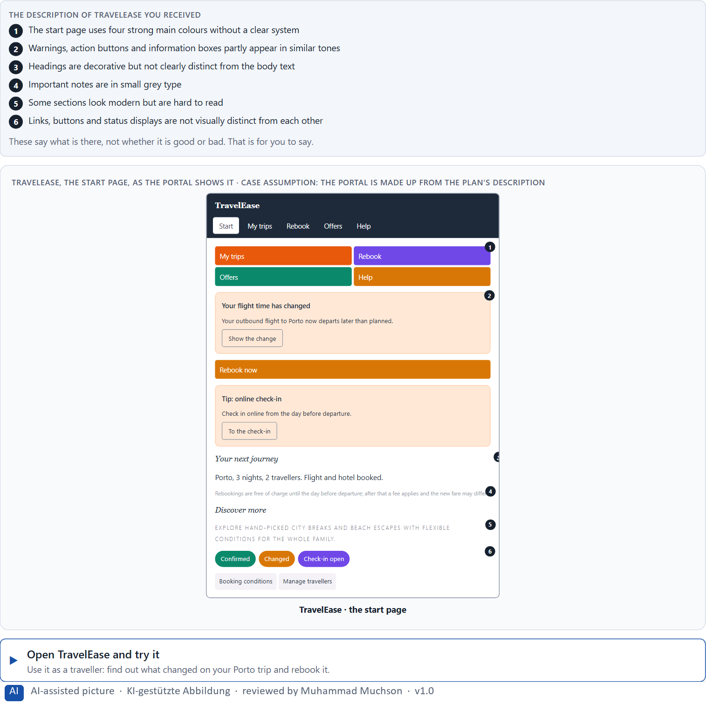
Figure 1 · TravelEase, the start page, as the portal shows it.
Question 1 of 5 · Describe spontaneously what effect the interface has on you
Two to four sentences: how it feels, what you notice first and what you would do. Effect first, no technical terms needed.
How to build the answer:
- Open TravelEase and look at the start page for five seconds without clicking.
- Write how it feels: calm or restless, trustworthy or careless, clear or confusing.
- Add what you noticed first and what you would try to do.

Question 2 of 5 · Name at least 5 problems that could arise from colour or type design
How to build the answer:
- Try to change a booking and to read your booking's status.
- Write down every place where a colour or a piece of text slows you down, misleads you or is hard to read.
Write them as a list, one problem per line, and say whether it comes from colour or from type.

Question 3 of 5 · Assign them to the categories orientation, readability, trust, prioritisation and understandability
Write the problems that belong to each category in a few words. A problem may fit two categories; put it where its effect is strongest.
How to build the answer:
- Take your five problems from question 2 one at a time.
- Ask what each one does: hides the way, makes reading hard, weakens trust, hides what matters most, or leaves the meaning unclear.
- Write it under that category. Each of the five is touched by TravelEase.
Category | The problems in this category
Orientation
Readability
Trust
Prioritisation
Understandability

Question 4 of 5 · Formulate three effect statements: “For users this could mean that …”
How to build the answer:
- Pick three observations from questions 1 to 3.
- Finish the plan's sentence with what the user would do, misread or fail to do.
Write them as a list, one statement per line, each starting with the observation and ending with what it could mean for users.

Question 5 of 5 · Prioritise the two most critical weaknesses from a first-time user's point of view
How to build the answer:
- Think of someone who uses TravelEase for the first time to change a booking.
- Pick the two weaknesses that could make that person do the wrong thing or give up, and say why.
Write them as a list, the more critical first, each with the reason it is so critical for a first-time user.

Block 1.2 · Rate colour and type decisions under conflicting goals: HealthConnect · JUDGED · Core · about 8 min
Draws on: A1 · What colour does · A3 · Readable type · A5 · From colour and type to behaviour, and weighing a measure.
HealthConnect is a health platform. Three designs for its interface are described in words: A) strong brand colours and a high recognition value, but low contrast on central information; B) very factual and high in contrast, highly readable, but with little emotional appeal; C) modern, elegant typography with a high-quality effect, but smaller type sizes and less visible navigation items. The conditions: the platform is for a broad target group from 20 to 70 years, the company wants to look modern and trustworthy, the budget for the revision is limited, the corporate design may only partly be changed, there are no user tests yet, and the release is in 8 weeks. Decide anyway, and say what you assume.
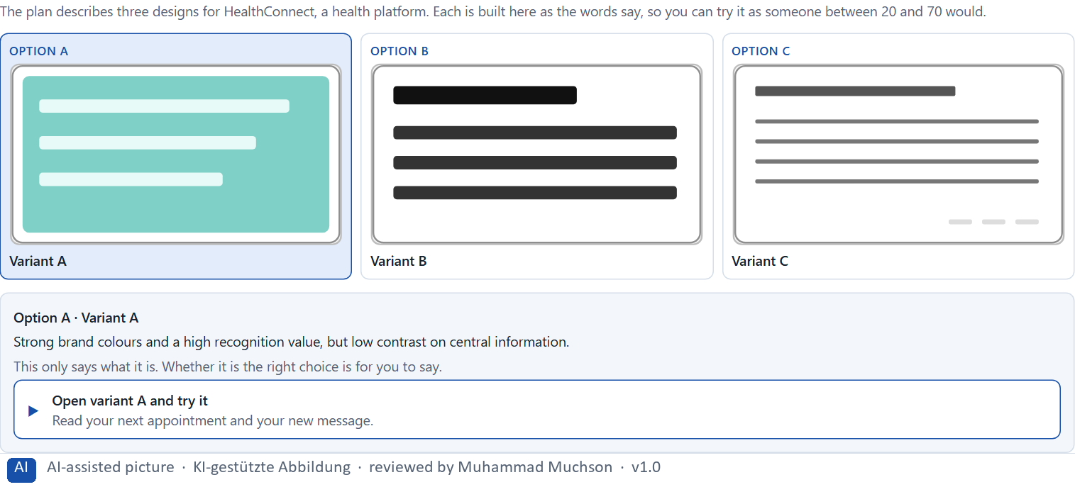
Figure 2 · The product to read, as the lab shows it (designs).
Question 1 of 5 · Rate each variant on readability, orientation, trust, brand effect and usability
Write a few sentences for each variant that cover all five criteria. Many teams rate each criterion Low, Medium or High with a reason; you may do that or write it in your own words.
How to build the answer:
- Take one variant at a time and keep the whole target group in mind, from 20 to 70.
- For each criterion, say how the variant does and which feature of its description makes you say so.
- Use the same five criteria for every variant, so you can compare them.
Variant | Readability | Orientation | Trust | Brand effect | Usability
Variant A · strong brand colours, low contrast
Variant B · factual, high contrast, little emotion
Variant C · elegant type, smaller sizes, hidden navigation

Question 2 of 5 · Decide which variant is the most viable under the given conditions
Choose one variant, then give your reason below. There is no single right choice; the reason has to rest on the users and the conditions.
How to build the answer:
- Say which condition weighs most for you.
- Say how your choice meets it better than the other two.
Tick one:
☐ Variant A · strong brand colours, low contrast
☐ Variant B · factual, high contrast, little emotion
☐ Variant C · elegant type, smaller sizes, hidden navigation
Why this variant, under these conditions?
Give your reason with the conditions: users from 20 to 70, modern and trustworthy, a partly fixed corporate design, no tests, 8 weeks.
How to build the answer:
- Name the condition that weighs most for you.
- Say how your variant meets it and why the other two meet it less well.
- Say what your choice gives up.

Question 3 of 5 · Name the conflicts of goals between the brand's claims and user-friendliness
Name at least two conflicts, each as a brand goal against a user need.
How to build the answer:
- Look at what the brand wants: recognition, a modern and premium look.
- Look at what users need: readable information, visible navigation.
- Write each conflict as “… against …”.

Question 4 of 5 · Which risks remain despite your decision?
Name at least one risk that remains and who would feel it.
How to build the answer:
- Think of what your chosen variant is weak at.
- Say who would notice and what would happen.

Question 5 of 5 · Formulate a short recommendation to the project management
Two to four sentences: what you recommend, why, and what you will check next.
How to build the answer:
- Lead with the recommendation.
- Give the one reason the project management can follow.
- Say what you will check after the release.

Part 2 · The case study · Level 2 · Application · Case study (2 UE)
Case study: 2 teaching units (UE5–6)
This part is the day's Level 2 case study. It takes 2 UE (about 90 minutes): UE5 for the briefing and your own work, UE6 for comparing your results with your group and for the trainer's closing. The block below needs about 15 minutes of writing; the rest of the time is discussion.

Block 2.1 · Case study: revising the insurance portal SecureLife · JUDGED · Core · about 15 min
Draws on: A1 · What colour does · A2 · Decorative against functional colour · A3 · Readable type · A4 · Typographic hierarchy, and colour, type and structure working together · A5 · From colour and type to behaviour, and weighing a measure.
An insurance company runs SecureLife, a digital portal for the contract overview, damage reports and communication with the service. The content is complete, but complaints pile up: users overlook important notes, do not clearly understand status messages and find the interface “exhausting” and “restless”. The observed problems: different blues, greens and reds are used without a clear functional system, buttons and information boxes look too similar, status messages are coded by colour but hardly supported by text, body text is too small and too dense, typographic hierarchies are inconsistent, and important calls to action are lost among other text elements. The conditions: a budget of €130,000, 12 weeks for the implementation, the corporate design is binding in principle but functional adjustments are possible, the portal must be easy to use for different age groups, and a complete relaunch is ruled out. You work through six steps.
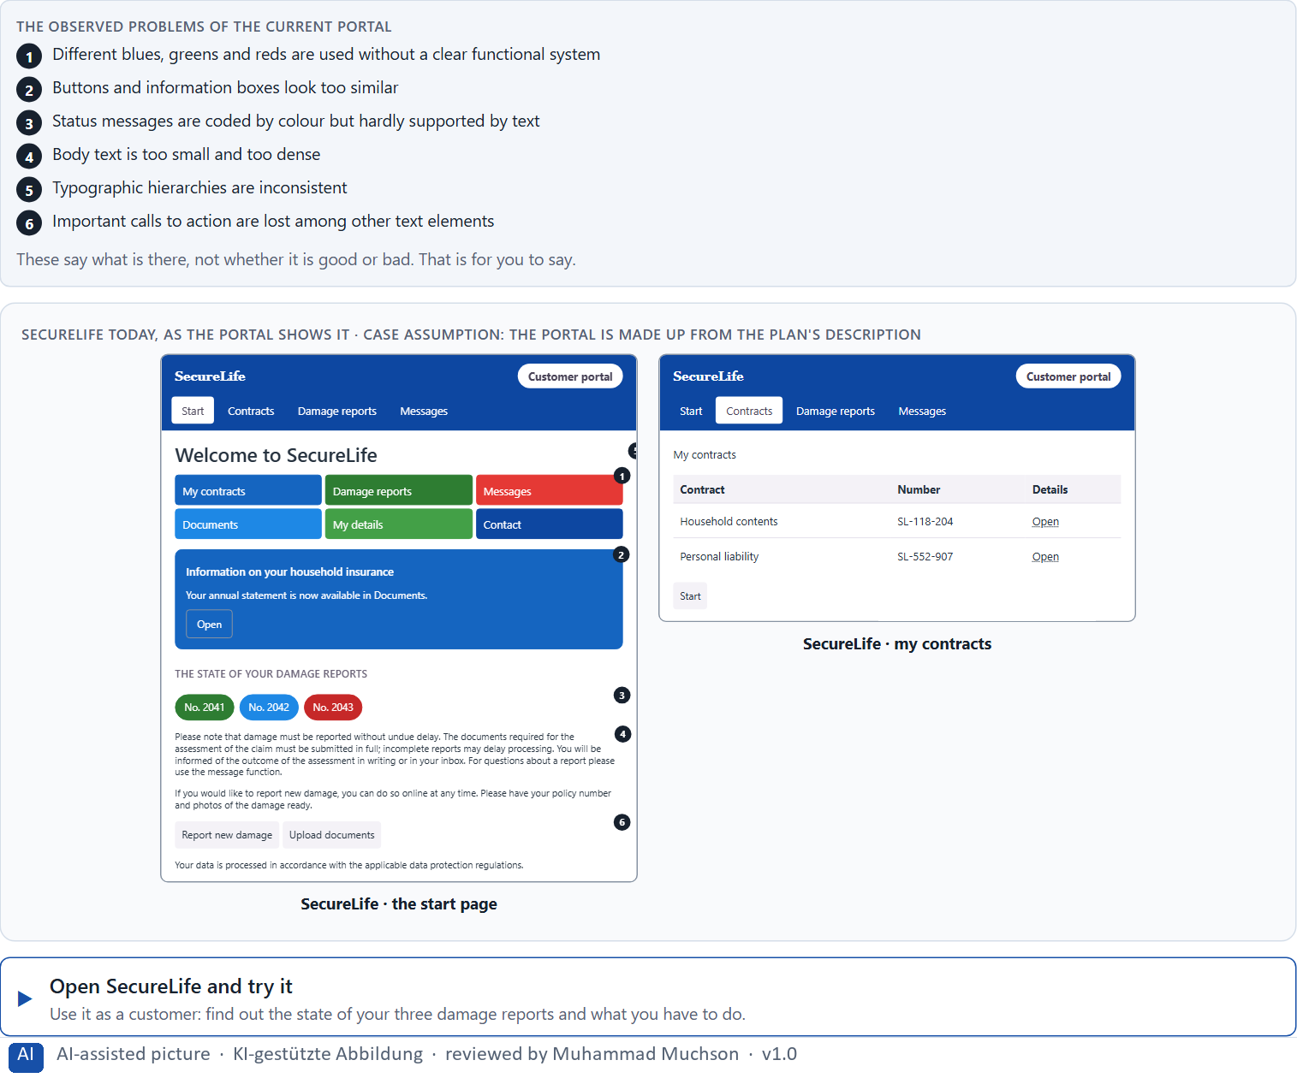
Figure 3 · SecureLife today, as the portal shows it.
Question 1 of 6 · Analyse the central problems in the use of colour and in the typography
How to build the answer:
- Open SecureLife and check the state of a damage report, then report a new one, as a customer would.
- Write one problem per line as an effect on the user: what colour or type makes hard, not only what is wrong with it.
Write them as a list, one problem per line, each as an effect on the user. At least five.

Question 2 of 6 · Assign the problems to the categories readability, orientation, consistency, trust effect and action guidance
Write the problems that belong to each category in a few words. A problem may fit two categories.
How to build the answer:
- Take your problems from question 1.
- Ask which of the five categories each one affects most, and write it there.
Category | The problems in this category
Readability
Orientation
Consistency
Trust effect
Action guidance

Question 3 of 6 · Develop 4 prioritised measures for improvement
How to build the answer:
- Turn each group of problems into something you could change within 12 weeks and within the corporate design.
- Put them in order: what the other measures build on, or what helps users most, first.
Write them as a numbered list, the first priority first, each with what it changes for users.

Question 4 of 6 · Justify your selection using effect on users, feasibility, risk and time pressure
Use all four criteria and say how they support your selection and its order.
How to build the answer:
- Say for your first measures what they change for users and why they are the base for the others.
- Say what is feasible within the corporate design and 12 weeks, and what risk each carries.
- Keep the different age groups in mind.

Question 5 of 6 · Make a prioritisation decision for the first 12 weeks
Say what you do in the first 12 weeks, in which order, and what you leave for later, with the reason.
How to build the answer:
- Say what comes first and why.
- Say what you do in parallel and what waits.
- Keep the corporate design and the age groups in mind.

Question 6 of 6 · Formulate a recommendation to the division management
Three to five sentences: what you recommend, what you prioritise, and what you expect to change.
How to build the answer:
- Lead with the recommendation.
- Name the priorities.
- Say what you expect to change for users and for the company.

Task 2 · Route 2 · UX Strategy Memo: decide as Chief Experience Officer

The situation: the insurer behind SecureLife, and years of inconsistent design
Read once · about 2 min
You take the perspective of the Chief Experience Officer of the insurer that runs SecureLife. The company has a website, a customer portal and an app, and over the years it has taken inconsistent design decisions. Colours were changed for each campaign, the typography was interpreted differently by each team, and the central interaction elements follow no consistent principle. Users find their way only with difficulty, support requests are rising, and inside the company the discussion is mostly about taste rather than effect. You are not to polish single screens but to develop a sound decision architecture for colour, typography and visual user guidance.
The framework | How the task runs · one block
• The budget is limited  • Different stakeholders pursue different goals  • The corporate design is not freely negotiable, but functional adjustments are possible  • The data is partly incomplete  • First improvements must be visible at short notice  • A wrong priority can lead to a loss of trust, operating errors and support costs | • Block 3.1 asks seven questions: a guiding vision for colour and typography, three strategic decisions, a prioritised architecture of measures, a risk analysis, a governance model, one decision under uncertainty and a management statement.

What is known and what is open
In the brief | Clear · Case assumption | Open · on purpose
• A website, a customer portal and an app.  • Colours changed with campaigns; each team set type its own way; interaction elements follow no principle.  • Users find their way with difficulty; support requests rise; the inside argues about taste.  • First improvements must show soon; the corporate design is binding, functional changes are possible. | • The company is the insurer behind SecureLife in Route 1.  • Marketing changes the accent colour for each campaign; the brand team guards the logo blue; IT builds each channel from its own components.  • Support records the subject of each request; nobody records which screen a user was on. | • How large the budget is: “limited” is all the plan says.  • How much the inconsistency costs in support time: the data is partly incomplete.  • How users perceive the brand today: never asked.

As in most projects, not everything is known. Decide anyway, and say what you assume.
Case assumption
The brief says: a company with a website, a customer portal and an app, colours changed by campaign, typography interpreted by each team, interaction elements without a principle, users who find their way with difficulty, rising support requests, a discussion about taste, a limited budget, different stakeholders, a binding corporate design with room for functional changes, partly incomplete data, first improvements soon, and the warning that a wrong priority costs trust, causes operating errors and support costs. Those are the plan's facts. That the company is the insurer of Route 1 and the facts marked “Clear” are made up for this exercise.

The memo is addressed to: The management. Subject: A strategic design logic for colour, typography and user guidance.

Part 3 · Level 3 · Management decision · Transfer project (3 UE)
Transfer project: 3 teaching units (UE8–10)
UE8: the trainer presents Materi B and sets the role. UE9: you write the memo. UE10: you present the decision and what you give up; the trainer debriefs.

Block 3.1 · A strategic design logic for colour, typography and user guidance · JUDGED · Core · about 20 min
Draws on: B1 · Colour and type as strategic effect decisions · B2 · Conflicts of goals · B3 · Who owns the visual standards, and deciding with incomplete data.
Develop a strategic concept for the insurer. Your desk holds what the management, the brand team, marketing, IT and the data say. Open it, then answer the seven questions; your answers build the memo below.
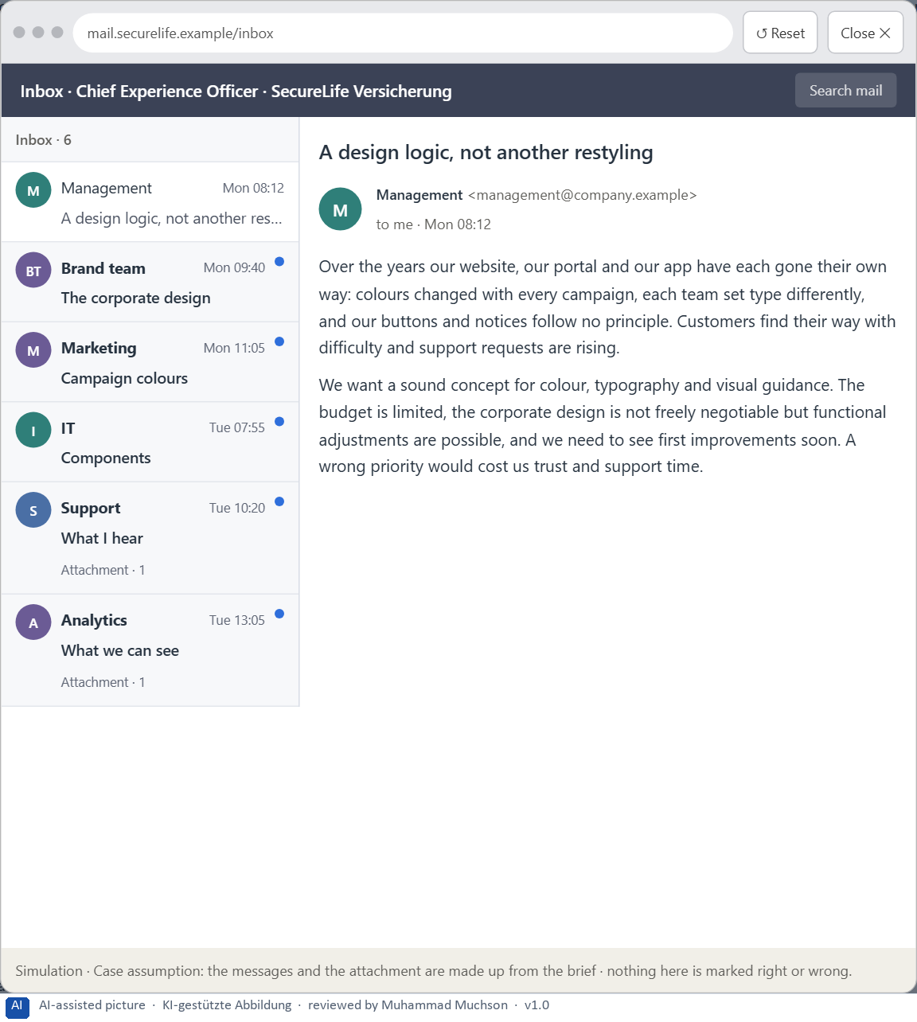
Figure 4 · Your desk: the messages that wait for you, shown in the lab as a mailbox (1 of 6).
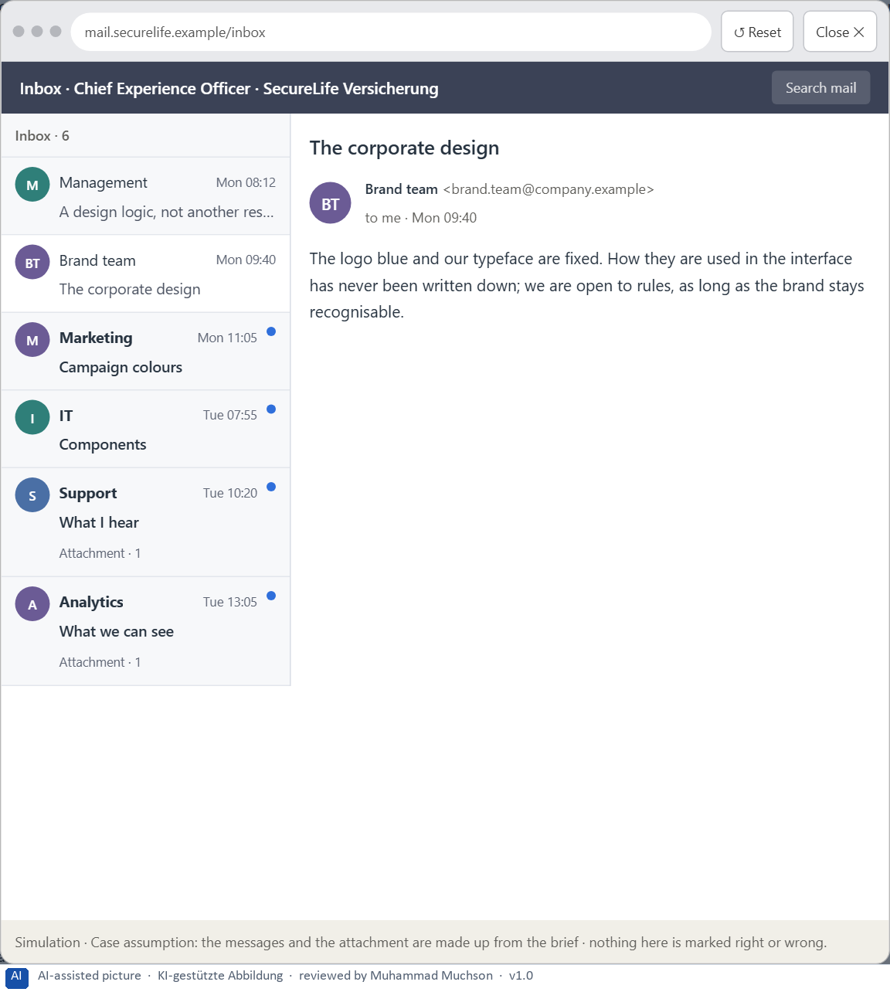
Figure 5 · Your desk: the messages that wait for you, shown in the lab as a mailbox (2 of 6).
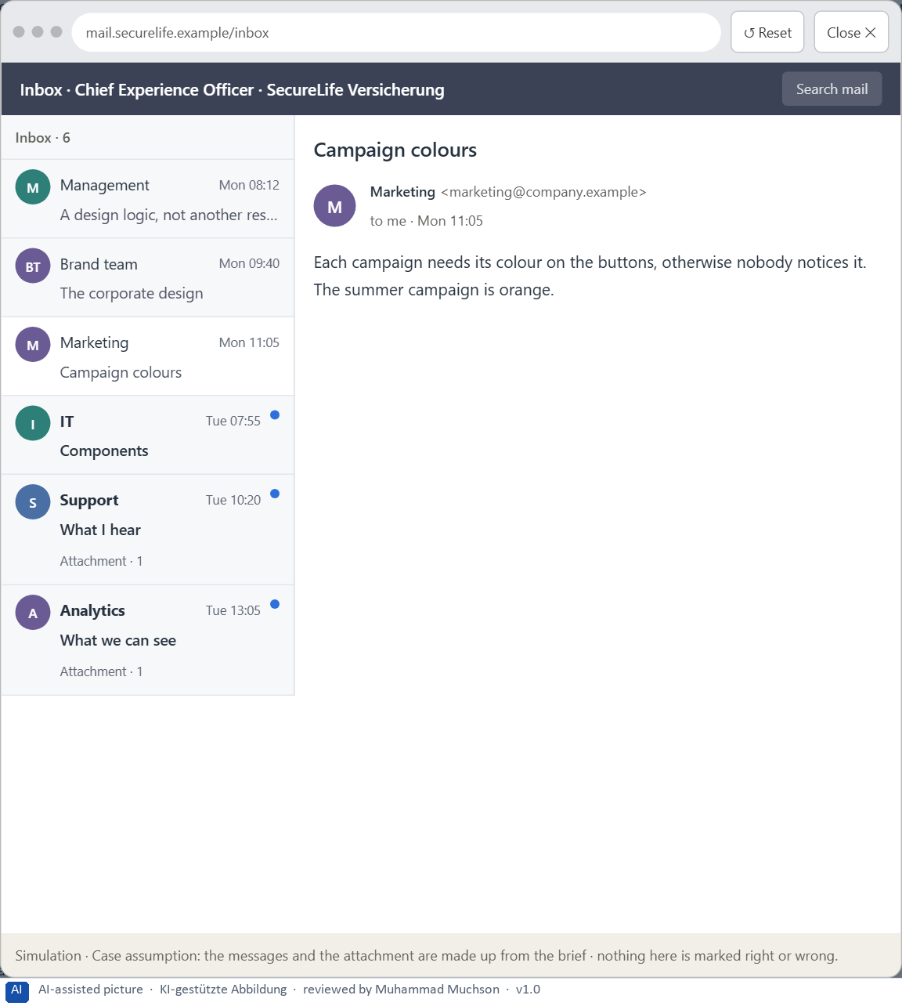
Figure 6 · Your desk: the messages that wait for you, shown in the lab as a mailbox (3 of 6).
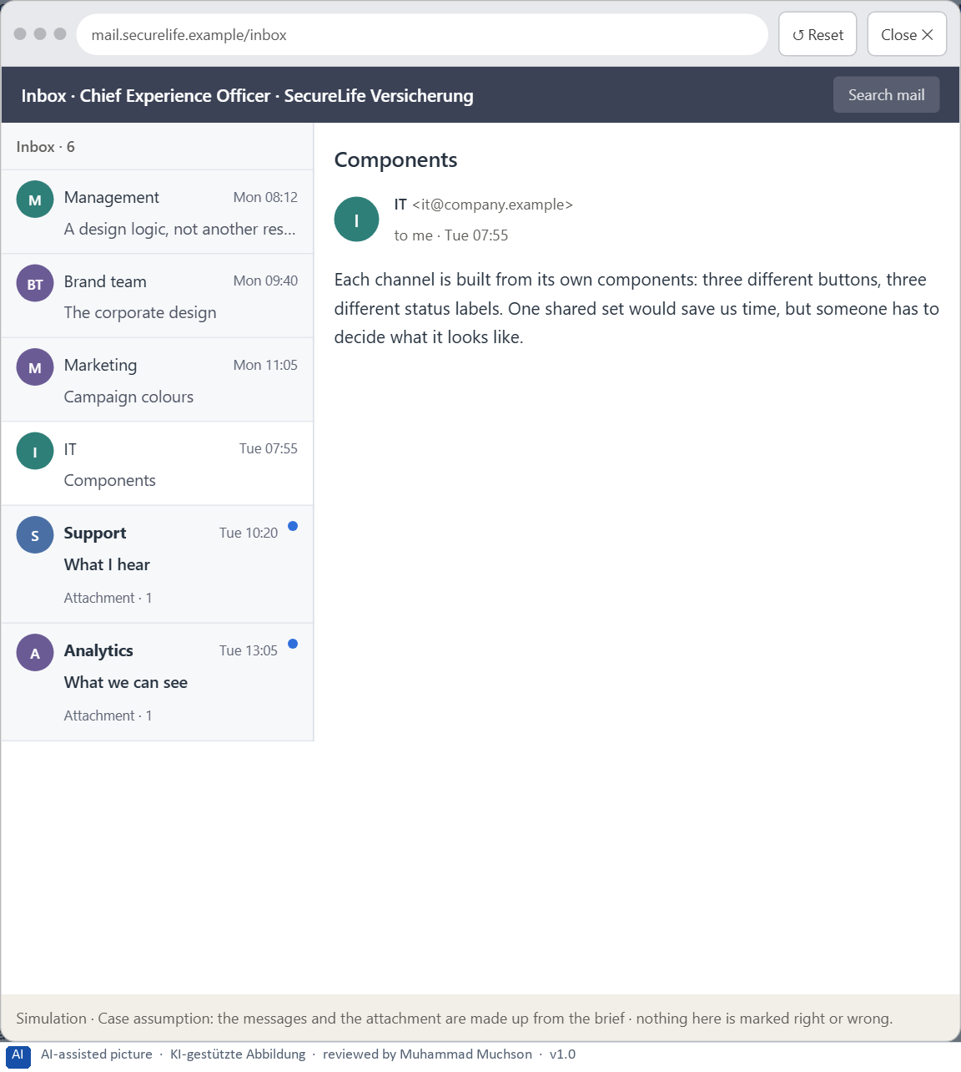
Figure 7 · Your desk: the messages that wait for you, shown in the lab as a mailbox (4 of 6).
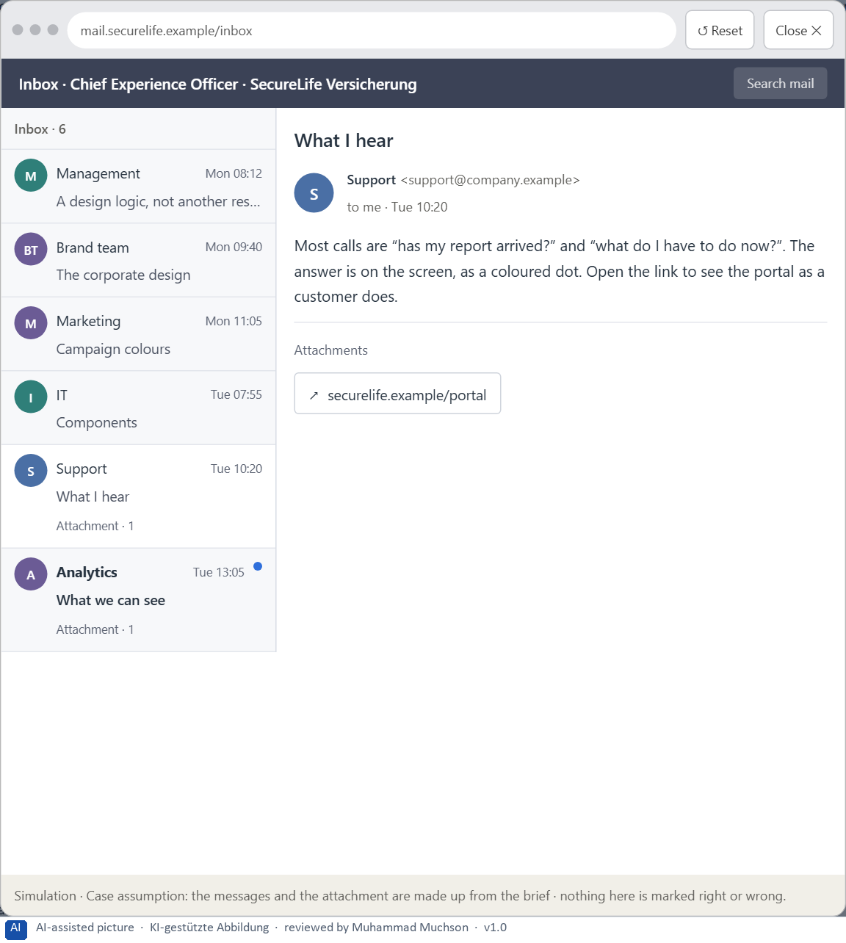
Figure 8 · Your desk: the messages that wait for you, shown in the lab as a mailbox (5 of 6).
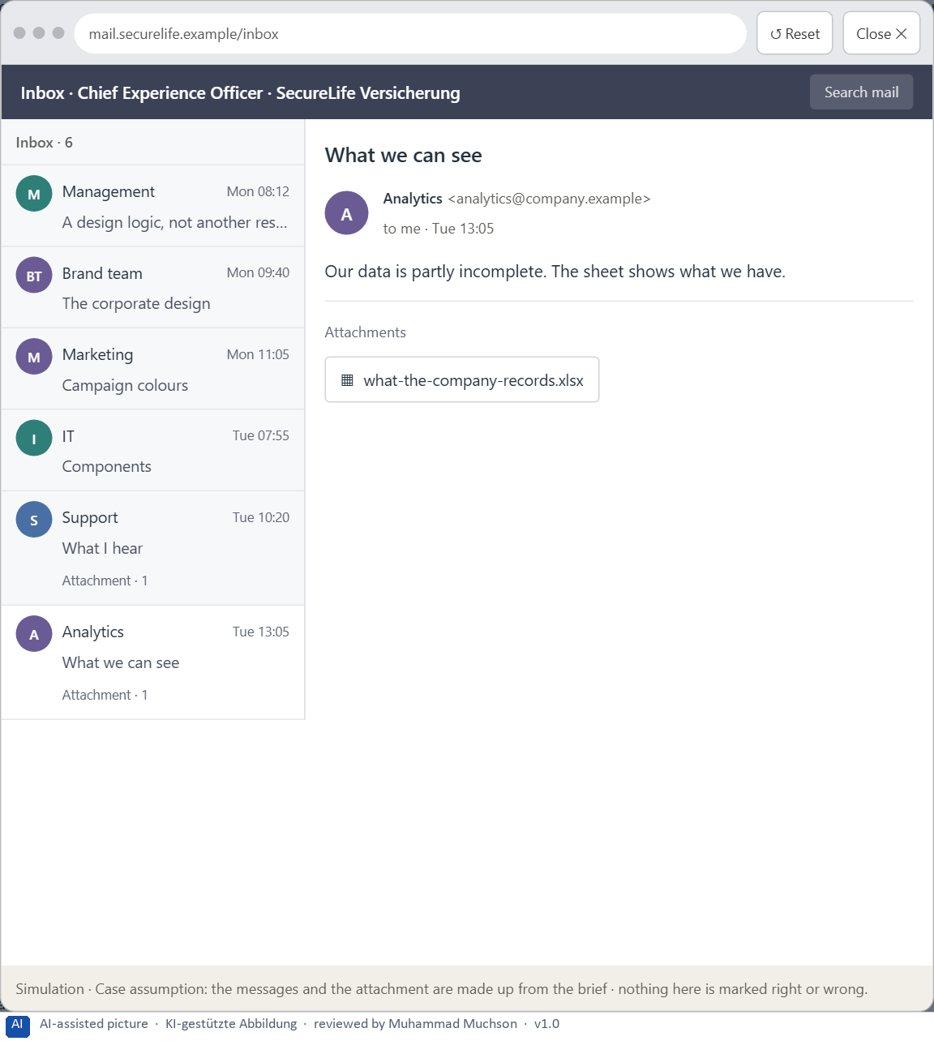
Figure 9 · Your desk: the messages that wait for you, shown in the lab as a mailbox (6 of 6).
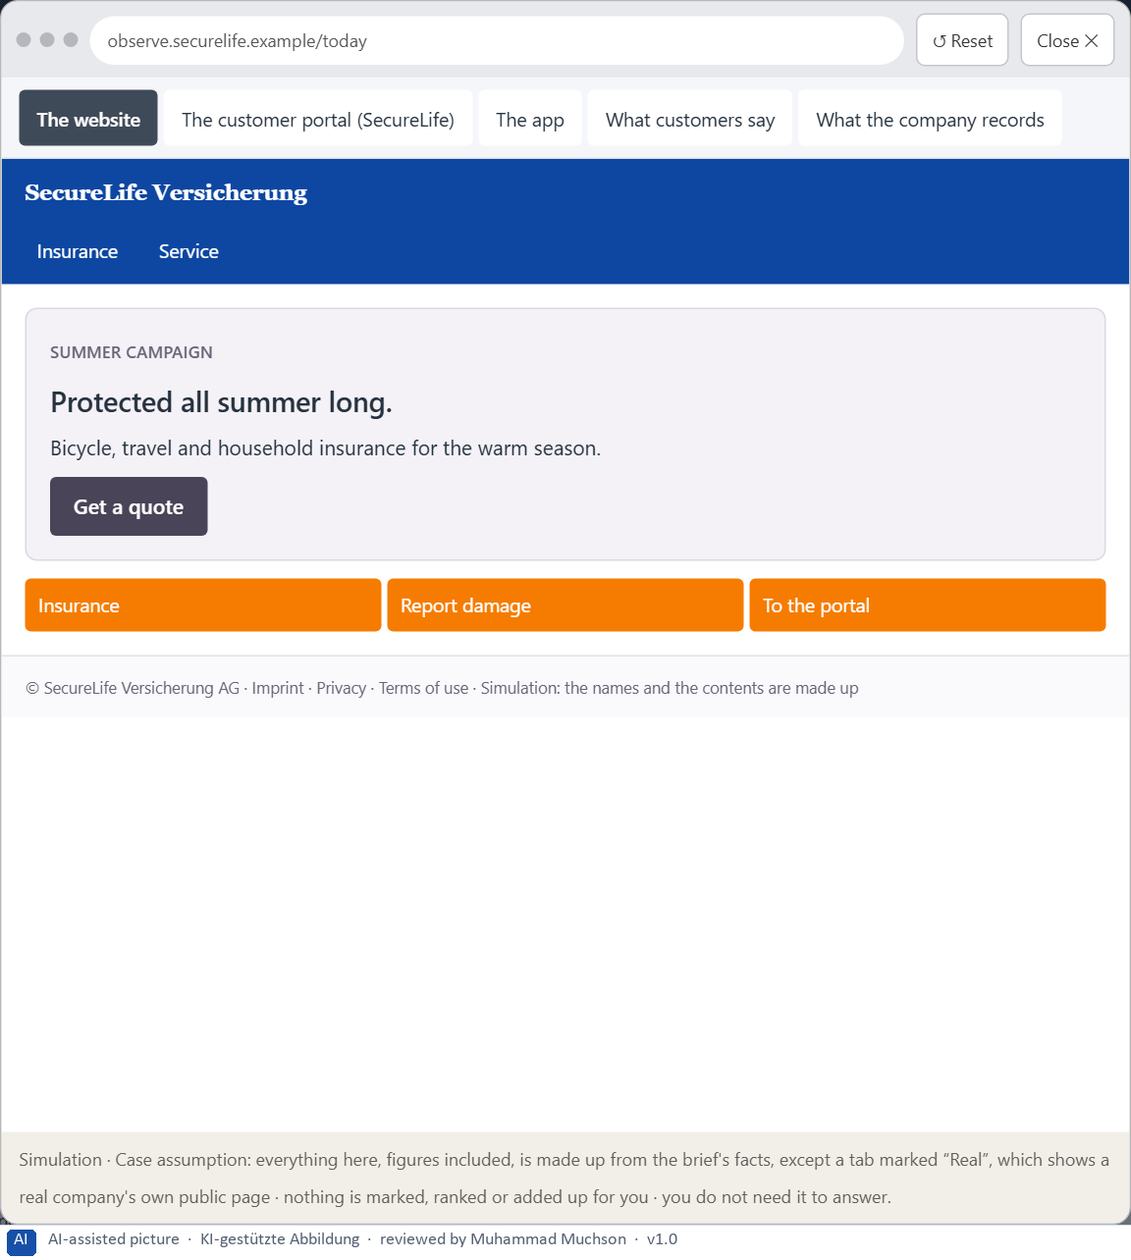
Figure 10 · The platform as it is today, as the lab lets you observe it (1 of 5).
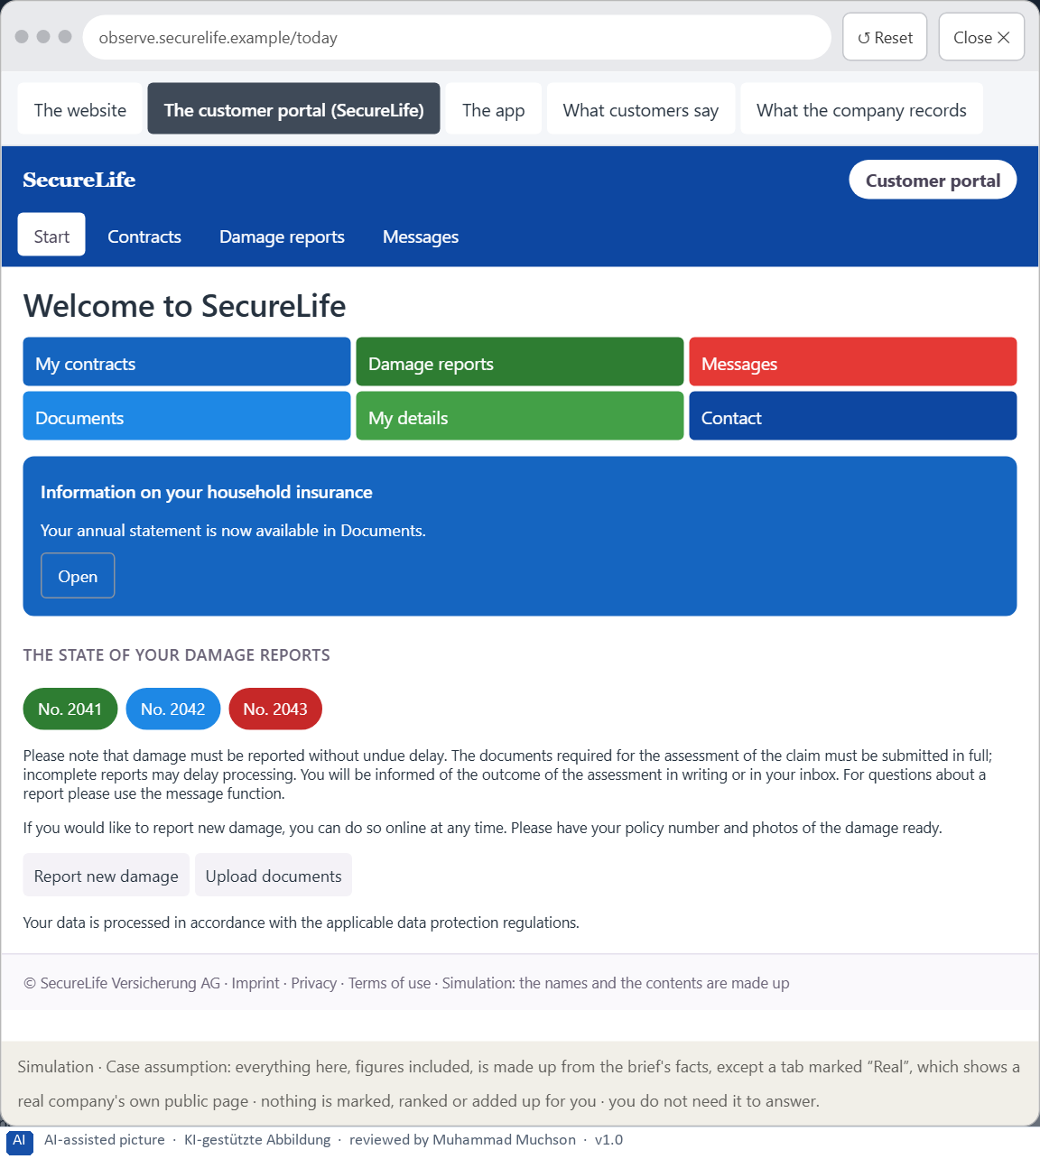
Figure 11 · The platform as it is today, as the lab lets you observe it (2 of 5).
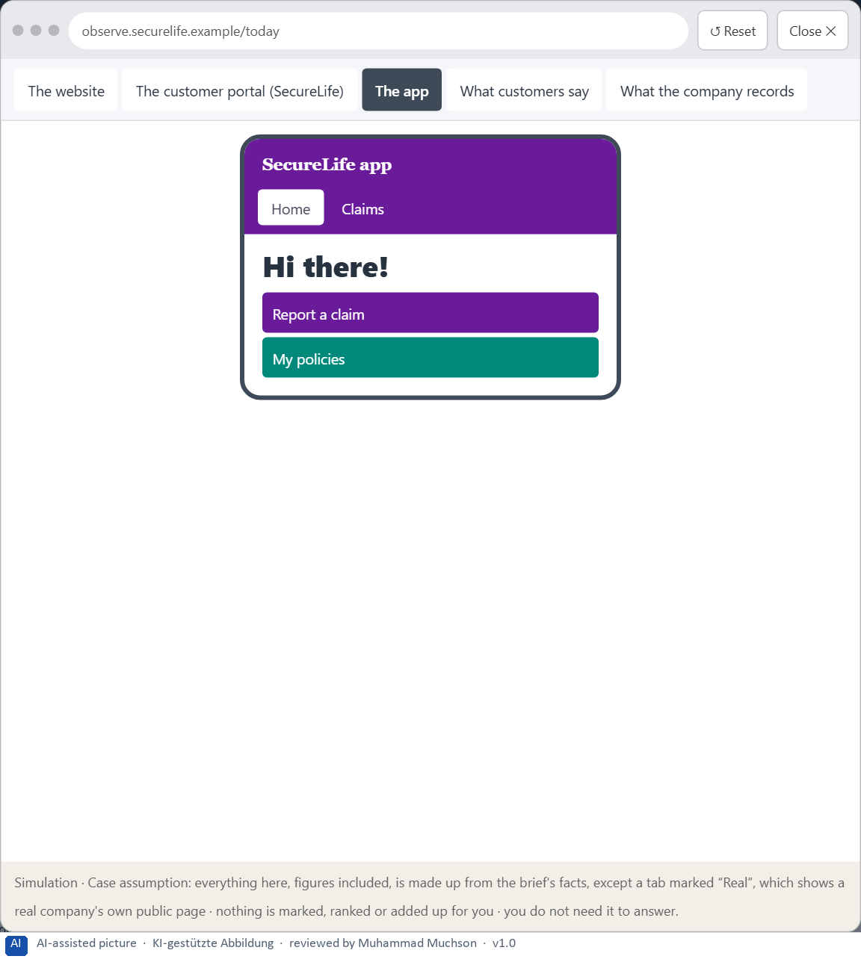
Figure 12 · The platform as it is today, as the lab lets you observe it (3 of 5).
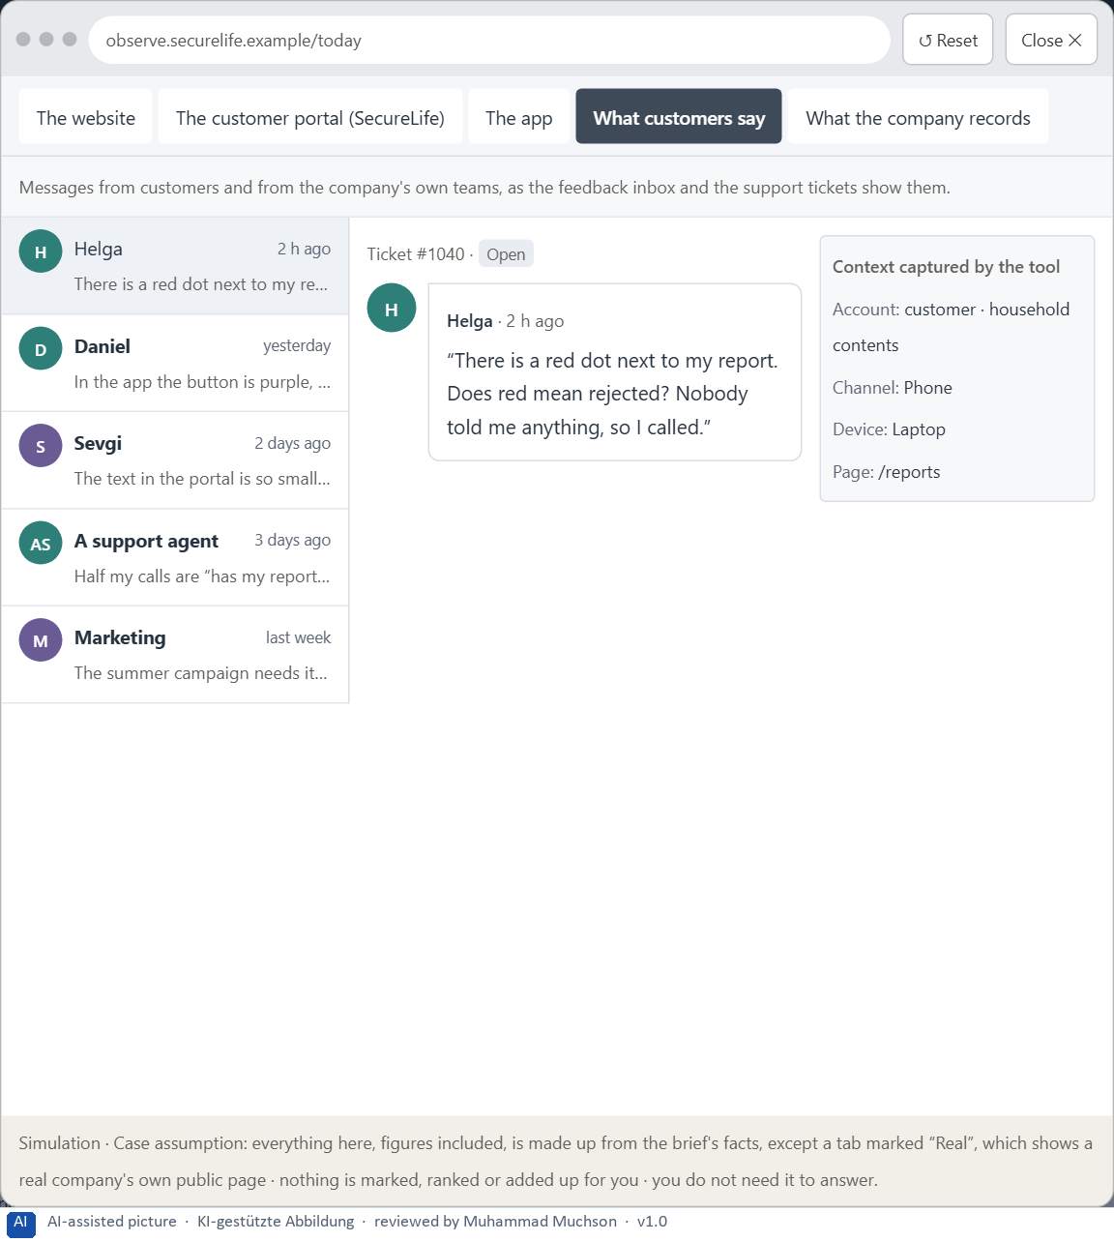
Figure 13 · The platform as it is today, as the lab lets you observe it (4 of 5).
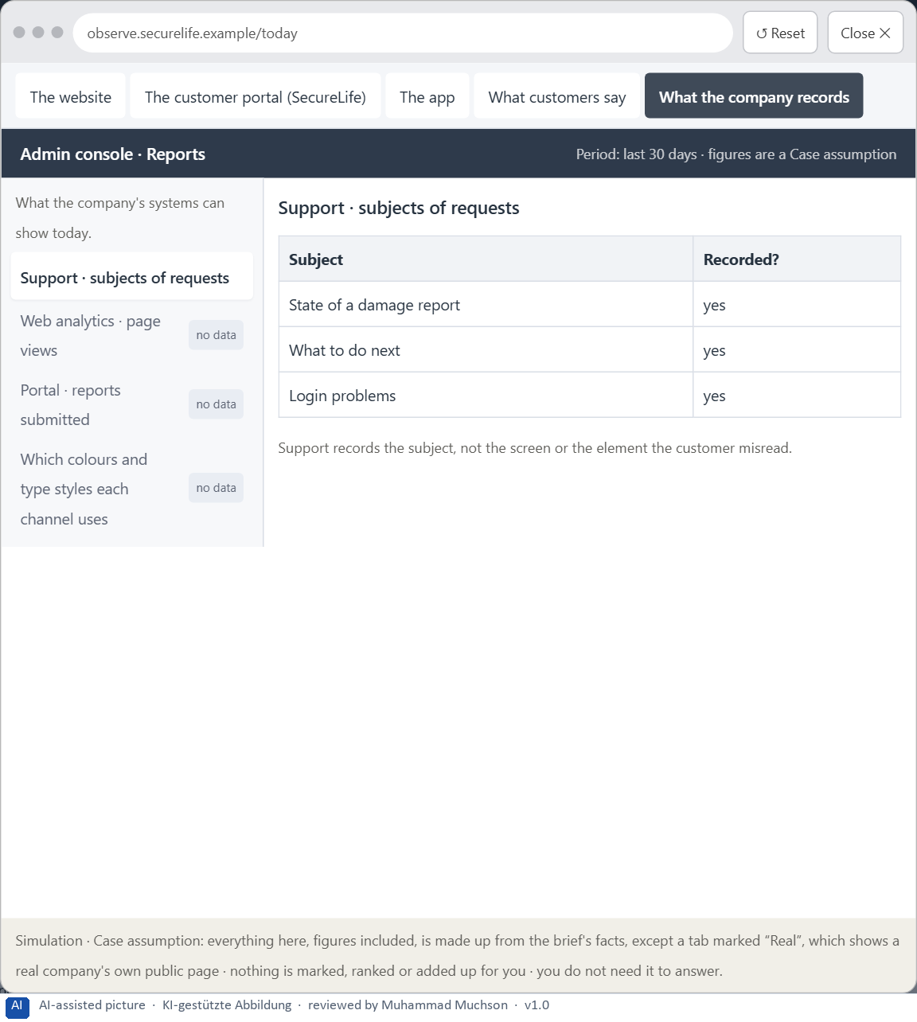
Figure 14 · The platform as it is today, as the lab lets you observe it (5 of 5).
Question 1 of 7 · A guiding vision for colour and typography in the company: which effect and which quality of use should be created systematically?
One or two sentences about what colour and type should do for users in every touchpoint.
How to build the answer:
- Say what users should be able to see and read in every touchpoint.
- Say which feeling colour and type should create, in one effect.

Question 2 of 7 · Three strategic guiding decisions for the use of colour, the reading logic, the visual hierarchy and action guidance
How to build the answer:
- Take your vision and ask which three choices would make it real.
- Write each as “we will …, even though that means …”.
Write them as a list, one decision per line, each with what it gives up.

Question 3 of 7 · A prioritised architecture of measures: which systems or touchpoints are standardised first, and why?
Put the systems or touchpoints in an order and give the reason for the first ones.
How to build the answer:
- List what could be standardised: the colour and type rules, the shared components, the website, the portal, the app.
- Put first what the others build on, or where users fail most.
- Say why the others can wait.

Question 4 of 7 · A risk analysis: which wrong assumptions about users' perception and the brand's effect would be especially critical?
Name two or three assumptions about how users perceive colour and type, or about the brand, and the harm if each is wrong.
How to build the answer:
- Write down what your concept assumes about how users see colour and type.
- Write down what it assumes about the brand's effect.
- For each, say what happens if it is wrong.

Question 5 of 7 · A governance model: who is responsible for the visual standards, and who decides in conflicts between brand and usability?
Name roles, not people: who owns the visual standards, who decides a conflict between brand and usability, and on what basis.
How to build the answer:
- Name who owns the colour and type rules and the shared components.
- Name who decides when brand and usability conflict.
- Say on what basis the conflict is decided.

Question 6 of 7 · A decision under uncertainty: make at least one prioritised decision despite missing data and justify it
Say what you decide, what you do not know, and why the decision is responsible all the same, for example when you would reverse it.
How to build the answer:
- State the decision in one sentence.
- Name what you do not know.
- Say why it is still responsible: it can be reversed, it can be checked soon, or waiting costs more.

Question 7 of 7 · A management statement: a recommendation to the management with a clear priority and a strategic reason
Four to six sentences: the direction first, then the priority, the reason and what you ask of the management.
How to build the answer:
- Start with the direction in one sentence.
- Name the priority and the reason that carries it.
- Say what you ask of the management and what you will report back.

Use in class: presentation and handout
Mark of use for the worksheet. Presentation is what the trainer shows on screen; Handout is what participants fill in and hand in.
Part of the worksheet | Presentation (shown in the Neuro-UX Lab) | Handout
The case: three products on the UX team's desk, and SecureLife | The case read aloud or on screen | The case text
Block 1.1 · The effect of colour and type without prior knowledge: TravelEase | The task wording at the start of the block (no answers are shown) | Worksheet block with answer boxes (Core)
Block 1.2 · Rate colour and type decisions under conflicting goals: HealthConnect | The task wording at the start of the block (no answers are shown) | Worksheet block with answer boxes (Core)
Block 2.1 · Case study: revising the insurance portal SecureLife | The task wording at the start of the block (no answers are shown) | Worksheet block with answer boxes (Core)
The situation: the insurer behind SecureLife, and years of inconsistent design | The case read aloud or on screen | The case text
Block 3.1 · A strategic design logic for colour, typography and user guidance | The task wording at the start of the block (no answers are shown) | Worksheet block with answer boxes (Core)

Glossary
Every term below is used in this document. Terms stay plain text in the body; this list says what they mean in everyday words.
Term | In plain words | Example | Comes from
Body text | The running text of a page, as opposed to headings, labels and buttons. It carries most of the information and must be the easiest to read. | — | Day 3
Brand effect | How a design makes people recognise the company and what they feel about it, such as modern, serious or friendly. | — | Day 3
Call to action | An element that asks people to do something, such as “Report damage” or “Pay now”. It should be the easiest thing on the screen to see and press. | — | Day 3
Case assumption | A fact made up for this exercise to fill a gap in the plan's case. It is marked so you know it is not part of the plan. | — | Day 1
Chief Experience Officer | The manager who is responsible for the experience customers have across all channels, and who decides where the company invests in it. | — | Day 1
Consistency | The same thing looks, is named and works the same way everywhere, so what people learn on one page holds on the next. | — | Day 2
Contrast | How much something differs from its surroundings in brightness, colour or size. Strong contrast makes it stand out; too many strong contrasts make everything compete. | — | Day 2
Corporate design | A company's fixed visual identity: logo, brand colours, typeface and the way they are used. Functional adjustments can often be made within it. | — | Day 3
Decision architecture | A set of connected decisions that are made on purpose and written down: what effect you want, what comes first, who decides and how conflicts are settled. It replaces many separate fixes. | — | Day 1
Design logic | A set of decided rules and shared components, such as which colour means what and which type levels exist, used for every screen so everything stays consistent. | — | Day 3
Functional colour | Colour with a job: it tells people what can be done, what matters most or what state something is in. Each colour keeps one meaning everywhere. | — | Day 3
Governance | The rules about who may decide what, who is answerable for it and how disagreements are settled. | — | Day 1
Orientation | Knowing where you are, what you can do here and what happens next. | — | Day 1
Perception | Taking in what the senses deliver, for example what the eyes see on a screen, before thinking about it. | — | Day 1
Readability | How easily a text can be read and understood: its size, contrast, line length, wording and how it is broken into parts. | — | Day 2
Stakeholder | A person or department with an interest in a decision, such as marketing, compliance, IT or sales. | — | Day 1
Status colour | A colour that shows the state of something, such as sent, waiting or failed. It needs a word or a symbol next to it, because colour alone is missed or misread. | — | Day 3
Touchpoint | Any place where a person meets the company: the website, the customer portal, the app, a chatbot or a phone call. | — | Day 1
Typographic hierarchy | A small, fixed set of text levels, such as page heading, section heading, body text and note, that look clearly different and mean the same on every page. | — | Day 3
Typography | How text is set: which typeface, which size, weight, line spacing and line length, and how the text is broken into levels and parts. | — | Day 3
UX (user experience) | Everything a person goes through when using a product: what they notice, understand, feel and do, from the first look to the last step. The screens are only one part of it. | Finding the booking you want at once and feeling sure it went through is a good UX. | Day 1
Visual hierarchy | An order the eye can follow: the most important thing is clearly the strongest, the rest is quieter. Without it, everything competes equally. | — | Day 1

The Neuro-UX Lab: where we practise online
In class we use the course website as the place to practise and to learn. Every day has its own address, in the same pattern: the day number is the last part.
What | Address
Neuro-UX Lab (course website) | https://aion-ux-lab.vercel.app/
Day 3 | https://aion-ux-lab.vercel.app/day/3/

On the day page, Route 1 (Levels 1 and 2) and Route 2 (Level 3) can be opened; the cards and the tasks of this document are there too. The pattern is the same up to Day 8, for example https://aion-ux-lab.vercel.app/day/6/.

