AION · UX DEVELOPER · PSYCHOLOGICAL UX DESIGN AND NEURO-UX
DAY 15 · TASK 1 AND TASK 2 · ROUTES 1 AND 2 · LEVELS 1 TO 3
VisionMind Lab: UX Analysis File and UX Strategy Memo
Describe the effect, choose the measures as a team member, and decide as Chief Experience Officer
AI notice · KI-Hinweis
This document was produced with the help of an AI language model (Claude, Anthropic). The AI drafted the text and tables and built the pictures and working examples of the lab. The content was then read, corrected and approved by the reviewer named below, who is responsible for its accuracy. Every picture carries an AI label on the image. Check figures and sources before you quote them.
KI-Hinweis: Dieses Dokument wurde mit Unterstützung eines KI-Sprachmodells (Claude, Anthropic) erstellt. Texte und Tabellen wurden von der KI entworfen, die Abbildungen sind KI-gestützt erstellt und am Bild gekennzeichnet. Die fachliche Prüfung und Freigabe erfolgte durch die unten genannte Person.

Day | Day 15 · Module 7 (day 2 of 3): Eye-tracking and gaze behaviour, neurofeedback and brain-computer interfaces
Document | Task (worksheet with answer spaces). Task 1 (UX Analysis File) and Task 2 (UX Strategy Memo).
Route and level | Task 1 = Route 1, Levels 1 and 2 (draws on Materi A). Task 2 = Route 2, Level 3 (draws on Materi B).
Time | Task 1 about 33 min · Task 2 about 20 min
Neuro-UX Lab (website) | https://aion-ux-lab.vercel.app/day/15/
Case | VisionMind Lab, the day's case study; other products appear as warm-ups
Version | 1.0 · release date 29.10.2026
Review and approval | Muhammad Muchson, Mentor (subject-matter review and approval)

ABOUT THIS DOCUMENT
In class we also use the Neuro-UX Lab, the course website, as the place to practise and learn. Its address is at the end of this document.
This is the worksheet for Day 15. Read the case once, study the evidence printed in this document, and write your answers in the boxes and tables. You can work through it on paper or type into the document. All blocks are Core. There are no answer keys and no scores; the reason you give matters more than the choice.

IN THIS DOCUMENT
Lesson plan: ten teaching units (Ablaufplan)
Case study and transfer project at a glance
The case: two projects on the UX team's desk, and VisionMind Lab
Block 1.1 · Weigh the insight value and limits of neuro-based UX technologies: FocusSense · JUDGED · Core · about 10 min
Block 1.2 · Rate eye-tracking and BCI-based approaches under conflicting goals: LearningPulse · JUDGED · Core · about 8 min
Block 2.1 · Case study: an evaluation strategy for the UX research project VisionMind Lab · JUDGED · Core · about 15 min
The situation: great potential, no structure
Block 3.1 · A strategic research and UX architecture for eye-tracking, neurofeedback and BCI-near innovation · JUDGED · Core · about 20 min

Day at a glance
Day 15 has ten teaching units (UE). This document is the worksheet; it is used in UE2 to UE6 (Task 1) and UE8 to UE10 (Task 2). The day is built from three documents and the Neuro-UX Lab: Materi (study material), Task (worksheet) and Trainer (coaching, feedback and model solutions), plus the course website.

Lesson plan: ten teaching units (Ablaufplan)
UE | Min | Plan item | What happens | Material | Format
1 | 45 | Knowledge transfer · Level 1 | The trainer presents the cards of Materi A (A1, A2, A3, A4, A5, about 60 min of cards) in the Neuro-UX Lab; participants follow in the handout. | Materi A (Route 1) | Presentation + Handout
2 | 45 | Level 1 · Task 1 | Individual work on Block 1.1 (Core, about 10 min): the first product of the day is read and its effect described. Pairs then compare their results and the trainer collects open questions. | Task 1 · Part 1 · Block 1.1 | Handout (or in the lab)
3 | 45 | Level 1 · Task 2 | Three options are rated on the same criteria and one is chosen under the stated conditions: Block 1.2 (Core, about 8 min). | Task 1 · Part 1 · Block 1.2 | Handout (or in the lab)
4 | 45 | Coaching · transition from Level 1 to Level 2 | Trainer-led. A short talk on the day's coaching focus, then the reflection questions in pairs. The bridge: from describing an effect to a decision you answer for. There is no worksheet block in this unit. | Trainer document, section Coaching | Trainer only
5–6 | 90 | Level 2 · Case study VisionMind Lab (2 UE) incl. model solution | UE5: the trainer presents the case; participants work on Block 2.1 (Core, about 15 min). UE6: groups compare their results and defend them; the trainer closes with the model solution. | Task 1 · Part 2 · Block 2.1  Trainer document, section Case study | Handout; model solution shown after the work
7 | 45 | Level 2 + 3 · Feedback round with a management perspective | Groups present their reasoning, not only their result. The trainer asks the day's Level 3 input questions and leads the discussion. | Trainer document, section Feedback round | Presentation by the groups; Trainer only
8 | 45 | Level 3 · Transfer project, Chief Experience Officer (3 UE: UE8–10) | The trainer presents Materi B (B1, B2, B3; use the "In plain words" and "How to decide" boxes, the rest is handout) and sets the role and the situation. | Materi B (Route 2) | Presentation + Handout
9 | 45 | Level 3 · Transfer project | Individual work or in pairs on Block 3.1 (Core, about 20 min): the strategy memo. | Task 2 · Block 3.1 | Handout (or in the lab)
10 | 45 | Level 3 · Transfer project | Participants present their decision and what they give up, including the one decision made under uncertainty; the trainer debriefs with the model solution. | Task 2 · Block 3.1  Trainer document, section Transfer project | Handout; model solution shown after the work

One UE is counted as 45 minutes here; breaks are not shown. The times are a guide for the trainer. The Core blocks are enough for a complete answer.

Case study and transfer project at a glance
Component | UE | Duration | Participants work in | Model solution in
Level 2 case study (VisionMind Lab) | UE5–6 | 2 UE · 90 min | Task 1 · Part 2 (Block 2.1) | Trainer document, section Case study
Level 3 transfer project (Chief Experience Officer) | UE8–10 | 3 UE · 135 min | Materi B and Task 2 (Block 3.1) | Trainer document, section Transfer project

Which plan item each block answers
UE | Plan item (Strukturplan, Day 15) | Block in this document
UE2 | Level 1, task 1 · Weigh the insight value and limits of neuro-based UX technologies: FocusSense | Block 1.1 (Core)
UE3 | Level 1, task 2 · Rate eye-tracking and BCI-based approaches under conflicting goals: LearningPulse | Block 1.2 (Core)
UE4 | Coaching: from describing to deciding | A classroom talk led by the trainer; not a worksheet block
UE5–6 | Level 2 case study · Case study: an evaluation strategy for the UX research project VisionMind Lab | Block 2.1 (Core)
UE7 | Feedback round with a management perspective | A classroom discussion led by the trainer; not a worksheet block
UE8–10 | Level 3 transfer project · A strategic research and UX architecture for eye-tracking, neurofeedback and BCI-near innovation | Block 3.1 (Core), in Task 2

Your name
Write your full name here. Use the same name on every Task document this week; it is how your work is matched.

Task 1 · Route 1 · UX Analysis File: weigh the insight and the limits of neuro-based UX, then decide how to research

The case: two projects on the UX team's desk, and VisionMind Lab
Read once · about 3 min
You work in the UX research team of a digital agency. This week three projects land on your desk. Two are warm-ups: FocusSense, an innovation project to analyse and improve a digital learning portal with eye-tracking and neurofeedback, and LearningPulse, a learning platform with three approaches to neuro-based technology. The main case is VisionMind Lab: a company wants to extend its UX research and is examining eye-tracking, neurofeedback and first brain-computer interface concepts to optimise a complex service portal. It wants to understand attention paths better, recognise overload and, in the long run, open up new forms of interaction. Inside, the excitement about what can be measured is great; at the same time, experience with interpreting the data, ethics governance and product-near evaluation criteria is missing.
What the plan gives you | How the task runs · three blocks
• Block 1.1: FocusSense, with eye-tracking to show what learners see first and where they get lost, a neurofeedback approach for concentration and overload, sketches that promise “objective truth data”, a team that wants to base design decisions on measurements, unclear robustness in real use, and ethics, data protection and acceptance only at the margin  • Block 1.2: three approaches for LearningPulse; innovative and close to science, a limited budget, a broad group not prepared for neuro-based technology, sensitive data protection and ethics, few references in its market, first results within 5 months  • Block 2.1: VisionMind Lab, with €240,000 for research, piloting and evaluation, 18 weeks for the first pilot and decision phase, no trust risks allowed, limited product integration, little market data, and insights prepared for management | • Block 1.1: weigh FocusSense's insight and limits. Describe the chances and risks, name five places of real insight or over-stretching, sort them into six categories, write three effect statements and pick the two biggest chances and risks.  • Block 1.2: rate three approaches under conflicting goals. Rate each on six criteria, choose one, name the conflicts between research ambition, market maturity and responsible introduction and the remaining risks, and write a recommendation to the project lead.  • Block 2.1: the case study. The central chances and risks, sorted into six categories, four measures for a responsible pilot and evaluation strategy, justified on five criteria, a decision for the first 18 weeks and a recommendation to the division head.

What is known and what is open
In the brief | Clear · Case assumption | Open · on purpose
• FocusSense: eye-tracking and neurofeedback for a learning portal; “objective truth data” promised; robustness unclear; ethics only at the margin.  • LearningPulse: three approaches in words; a broad, unprepared group; results within 5 months; few references.  • VisionMind Lab: research, innovation and product mixed; no hypotheses; consent open; fast results demanded; €240,000 and 18 weeks; no governance. | • You review FocusSense and LearningPulse as an agency would: by looking at their recordings, dashboards and screens, without access to their learners.  • FocusSense's first study used a lab eye-tracker and a consumer EEG headband with 12 volunteers from the company's own staff.  • VisionMind Lab's ideas on the table: a lab eye-tracking study of the service portal, webcam eye-tracking for remote tests, an EEG “overload detector” for portal users, and a “control the portal by thought” BCI concept for a trade fair.  • Marketing wants a heatmap of the home page banner; product wants an “overload score” built into the portal; the data protection officer has not been asked yet. | • What a long fixation means for these users: nobody has asked them.  • Whether a consumer headband measures concentration reliably: not validated for this use.  • How much of the €240,000 each study would take: the plan does not say.  • Whether customers would accept any measurement of their attention: never asked.

As in most projects, not everything is known. Decide anyway, and say what you assume.
Case assumption
The brief says: FocusSense's eye-tracking of what learners see first and where they get lost, neurofeedback for concentration and overload, “objective truth data” promised, design decisions to rest on measurements, unclear robustness in real use, data protection, ethics and acceptance only at the margin; LearningPulse's three approaches (A comprehensive eye-tracking and experimental neurofeedback, high effort and interpretation risk; B targeted eye-tracking for prototype tests without product integration; C exploratory BCI observation, low risk, high learning), innovative and close to science, a limited budget, a broad and unprepared group, sensitive ethics and data protection, few references, results within 5 months; VisionMind Lab's mixed research, innovation and product, no hypotheses, unclear product-nearness, consent and acceptance open, fast results demanded, no governance, €240,000, 18 weeks, no trust risks, limited product integration, little market data, insights for management. Those are the plan's facts and its only figures. Everything else is made up for this exercise: the agency, the pages, the recordings and the facts marked “Clear”.

Part 1 · Weigh a neuro-based project, and three approaches · Level 1 · Knowledge

Block 1.1 · Weigh the insight value and limits of neuro-based UX technologies: FocusSense · JUDGED · Core · about 10 min
Draws on: A1 · What eye-tracking measures · A2 · Looking is not understanding · A3 · Neurofeedback and brain-computer interfaces at their real maturity · A5 · Ethics, data protection and voluntariness, and weighing a measure.
You receive the description of a fictional innovation project, FocusSense, for analysing and improving a digital learning portal. Open it: replay a learner's gaze on a lesson page, switch between the scanpath and the heatmap, look at the neurofeedback “concentration” curve, then read what the learner said afterwards and look at the recording under real conditions. You need no prior knowledge: notice what the data shows, and what someone would have to add to it. The aim is to judge neuro-based UX technologies in a differentiated way and to tell measurement, interpretation and management use apart.
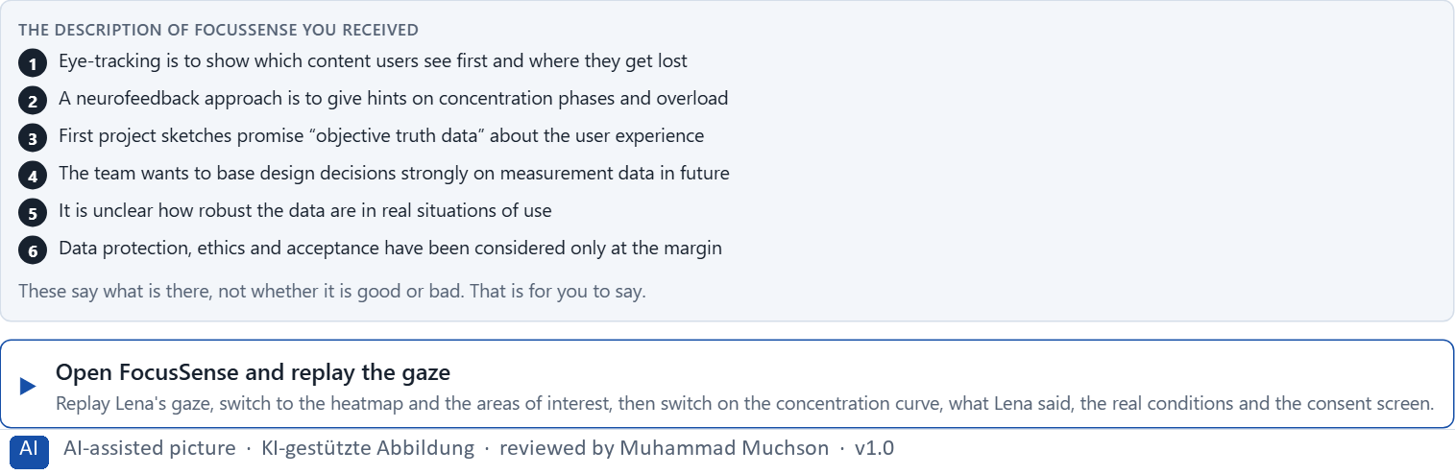
Figure 1 · The product to read, as the lab shows it (focussense).
Question 1 of 5 · Describe spontaneously which chances and risks this project could have from a professional and an organisational point of view
Two to four sentences: for the UX team's work and for the organisation, what could help and what worries you, and why.
How to build the answer:
- Open FocusSense, replay the gaze and switch to the heatmap.
- Look at the concentration curve, then read what the learner said and switch on the real conditions.
- Write what could help and what worries you, for the team's work and for the organisation.

Question 2 of 5 · Name at least 5 places where eye-tracking, neurofeedback or BCI could create real insight or problematic over-stretching
How to build the answer:
- Go through what you saw: the scanpath, the heatmap, the concentration curve, the learner's own words, the real conditions, the promise of “objective truth data”.
- For each place, say whether it gives real insight or over-stretches, and why.
Write them as a list, one place per line, and say whether it gives insight or over-stretches, and why.

Question 3 of 5 · Assign the observations to the categories insight value, interpretation risk, ethics, acceptance, feasibility and decision relevance
Write the observations that belong to each category in a few words. One may fit two; put it where its effect is strongest.
How to build the answer:
- Take your places from question 2.
- Ask which of the six each one affects most, and write it there.
Category | The observations in this category
Insight value
Interpretation risk
Ethics
Acceptance
Feasibility
Decision relevance

Question 4 of 5 · Write an effect statement for three points: “For users, the team or the company this could mean that …”
How to build the answer:
- Pick three places from question 2.
- Finish the plan's sentence with what users, the team or the company would feel, do or fail to do.
Write them as a list, one statement per line, each starting with the observation and ending with what it could mean for users, the team or the company.

Question 5 of 5 · Prioritise the two biggest chances and the two biggest risks of the project
How to build the answer:
- Look at your places with two questions: what gives the team the most reliable insight, and what could do the most harm?
- Write the two chances first, then the two risks, each with why.
Write four lines: chance 1, chance 2, risk 1, risk 2, each with why it weighs most.

Block 1.2 · Rate eye-tracking and BCI-based approaches under conflicting goals: LearningPulse · JUDGED · Core · about 8 min
Draws on: A3 · Neurofeedback and brain-computer interfaces at their real maturity · A4 · Insight, interpretation risk and decision relevance · A5 · Ethics, data protection and voluntariness, and weighing a measure.
LearningPulse is a learning platform. Three innovation approaches are described in words: A) comprehensive eye-tracking and experimental neurofeedback to optimise attention and learning flow, but with high effort and high interpretation risks; B) targeted eye-tracking for prototype tests and interface analysis, without direct integration into the product; C) exploratory observation of BCI technologies with little immediate product use, but low risk and high learning potential. The conditions: the company wants to appear innovative and close to science, the budget for research and piloting is limited, the target group is broad and not prepared for neuro-based technologies, data protection and ethical questions are sensitive, there are only few practical references in its own market, and first results are to be visible within 5 months. Decide anyway, and say what you assume.
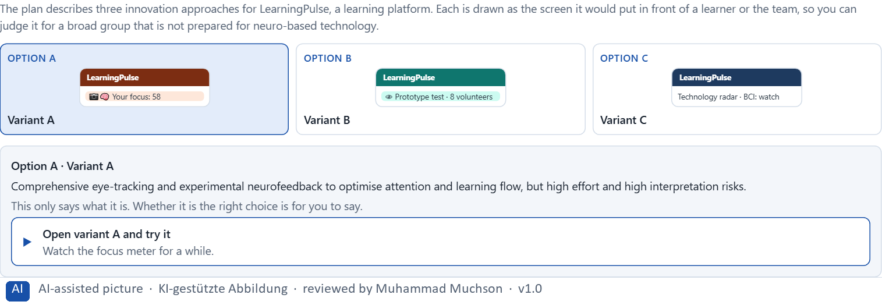
Figure 2 · The product to read, as the lab shows it (designs).
Question 1 of 5 · Rate each variant on insight gain, validity, risk, acceptance, market proximity and economic viability
Write a few sentences for each variant that cover all six criteria. Many teams rate each criterion Low, Medium or High with a reason; you may do that or write it in your own words.
How to build the answer:
- Take one variant at a time and keep the conditions in mind: a broad and unprepared group, 5 months, sensitive data.
- For each criterion, say how the variant does and why.
- Use the same six criteria for every variant.
Variant | Insight gain | Validity | Risk | Acceptance | Market proximity | Economic viability
Variant A · comprehensive eye-tracking and neurofeedback
Variant B · eye-tracking for prototype tests
Variant C · exploratory BCI observation

Question 2 of 5 · Decide which variant is the most viable under the given conditions
Choose one variant, then give your reason below. There is no single right choice; the reason has to rest on the users and the conditions.
How to build the answer:
- Say which condition weighs most for you.
- Say how your choice meets it better than the other two.
Tick one:
☐ Variant A · comprehensive eye-tracking and neurofeedback
☐ Variant B · eye-tracking for prototype tests
☐ Variant C · exploratory BCI observation
Why this variant, under these conditions?
Give your reason with the conditions: innovative and close to science, a limited budget, a broad and unprepared group, sensitive data protection and ethics, few references, results within 5 months.
How to build the answer:
- Name the condition that weighs most for you.
- Say how your variant meets it and why the other two meet it less well.
- Say what your choice gives up and how you would deal with its weakness.

Question 3 of 5 · Name the conflicts of goals between research ambition, market maturity and responsible introduction
Name at least two conflicts, each as one goal against another, and who stands for each side.
How to build the answer:
- Look at what research ambition wants (depth, new methods), what market maturity allows (what works for real users today) and what responsibility needs (consent, validity, trust).
- Write each conflict as “… against …” and say who stands for each side.

Question 4 of 5 · Which risks remain despite your decision?
Name at least one risk that remains and who would feel it.
How to build the answer:
- Think of what your chosen variant is weak at.
- Say who would notice and what would happen.

Question 5 of 5 · Formulate a recommendation to the project lead
Two to four sentences: what you recommend, why, and what you will check next.
How to build the answer:
- Lead with the recommendation.
- Give the one reason the project lead can follow.
- Say what you will check in the first studies.

Part 2 · The case study · Level 2 · Application · Case study (2 UE)
Case study: 2 teaching units (UE5–6)
This part is the day's Level 2 case study. It takes 2 UE (about 90 minutes): UE5 for the briefing and your own work, UE6 for comparing your results with your group and for the trainer's closing. The block below needs about 15 minutes of writing; the rest of the time is discussion.

Block 2.1 · Case study: an evaluation strategy for the UX research project VisionMind Lab · JUDGED · Core · about 15 min
Draws on: A1 · What eye-tracking measures · A2 · Looking is not understanding · A3 · Neurofeedback and brain-computer interfaces at their real maturity · A4 · Insight, interpretation risk and decision relevance · A5 · Ethics, data protection and voluntariness, and weighing a measure.
A company wants to extend its UX research and is examining eye-tracking, neurofeedback and first brain-computer interface concepts to optimise a complex service portal. The aim is to understand attention paths better, to recognise overload and, in the long run, to open up new forms of interaction. Inside there is great excitement about what can be measured; at the same time, experience with interpreting the data, ethics governance and product-near evaluation criteria is missing. The observed problems: research, innovation and product optimisation are mixed without a clear separation; a high gain in insight is hoped for without hypotheses and limits being clearly defined; it is unclear which methods can be used near the product and which only for exploration; data protection, consent and acceptance are not yet addressed enough; departments want fast results although the methods need much explanation and interpretation; and there is no robust governance for neuro-based research. The conditions: a budget of €240,000 for research, piloting and evaluation, 18 weeks for the first pilot and decision phase, the company wants to appear innovative but must not create trust risks, product integration is only realistic to a limited extent in the short term, there is little data in its own market, and first insights must be prepared for management. You work through six steps.
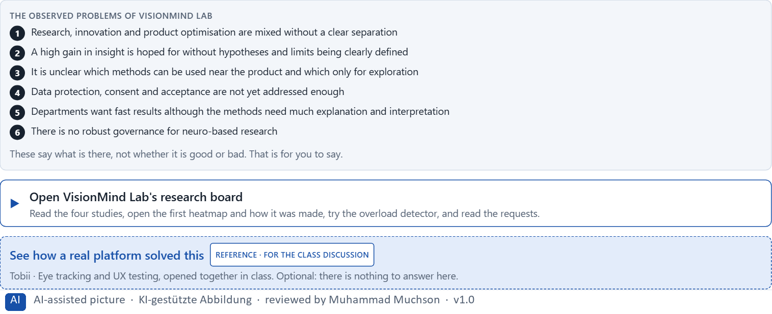
Figure 3 · The product to read, as the lab shows it (visionmind).
Question 1 of 6 · Analyse the central chances and risks of the research project
How to build the answer:
- Open VisionMind Lab's research board, the first heatmap and the requests from the departments.
- Write one point per line: a chance or a risk, and what it does.
Write them as a list, one point per line, each as a chance or a risk and what it does. At least five.

Question 2 of 6 · Assign the observations to the categories insight value, validity, ethics, data protection, market proximity and decision readiness
Write the observations that belong to each category in a few words.
How to build the answer:
- Take your points from question 1.
- Ask which category each affects most, and write it there.
Category | The observations in this category
Insight value
Validity
Ethics
Data protection
Market proximity
Decision readiness

Question 3 of 6 · Develop 4 prioritised measures for a responsible pilot and evaluation strategy
How to build the answer:
- Turn each group of problems into something you could do within 18 weeks and €240,000, with limited product integration.
- Put them in order: what gives scientific and operational robustness first.
Write them as a numbered list, the first priority first, each with what it changes.

Question 4 of 6 · Justify your selection using effect on users, feasibility, risk, time pressure and reputation security
Use all five criteria and say how they support your selection and its order.
How to build the answer:
- Say what your first measures change for robustness.
- Say what is feasible in 18 weeks and what protects the company's reputation.
- Keep the departments' wish for fast results in mind.

Question 5 of 6 · Make a prioritisation decision for the first 18 weeks
Say what you do in the first 18 weeks, in which order, and what you leave for later, with the reason.
How to build the answer:
- Say what comes first and why.
- Say what you do in parallel and what waits.
- Say what management will see at the end.

Question 6 of 6 · Formulate a recommendation to the division head
Three to five sentences: what you recommend, what has priority, and what you hope will change.
How to build the answer:
- Lead with the recommendation.
- Name the priorities.
- Say what you hope will change.

Task 2 · Route 2 · UX Strategy Memo: decide as Chief Experience Officer

The situation: great potential, no structure
Read once · about 2 min
You take the perspective of the Chief Experience Officer of a company with complex digital products, the company behind VisionMind Lab. It wants to extend its UX research and is examining where eye-tracking, neurofeedback and, later, BCI-near approaches can be used sensibly. Innovation leads see great potential for differentiation and deeper insight into users; data protection, ethics and market maturity have not been structured. The management expects a sound strategy for building neuro-based technologies close to research, responsibly and in a steerable way. Your task is not to introduce new measurement methods uncritically, but to develop a sound decision architecture for insight, ethics governance, piloting and the strategic use of neuro-based UX technologies.
The framework | How the task runs · one block
• The budget is limited  • Different stakeholders pursue different goals  • Market maturity and everyday fitness of the technologies vary strongly  • Data protection and ethical sensitivity are high  • Data on real user acceptance is patchy  • First pilots must be set up in a steerable way at short notice  • Wrong decisions can cause reputational damage, bad investments and loss of trust | • Block 3.1 asks seven questions: a guiding vision for neuro-based UX research and interaction, three strategic decisions, a prioritised architecture of measures, a risk analysis, a governance model, one decision under uncertainty and a management statement.

What is known and what is open
In the brief | Clear · Case assumption | Open · on purpose
• Complex digital products; UX research to be extended with eye-tracking, neurofeedback and later BCI-near approaches.  • Innovation leads see differentiation and deeper insight; data protection, ethics and maturity are unstructured.  • Maturity varies; ethical sensitivity is high; acceptance data is patchy.  • First pilots must be steerable soon; wrong decisions cost reputation, money and trust. | • The company is the one behind VisionMind Lab in Route 1.  • The management wants to present “neuro-UX” at a customer event; marketing wants heatmaps for campaigns; product wants an overload score; the data protection officer and the works council ask what is recorded.  • A research team of three runs classic usability tests today; nobody has analysed gaze or EEG data before. | • How large the budget is: “limited” is all the plan says.  • Which neurotechnologies will be mature enough for products in three years: nobody knows.  • Whether customers would accept measurement of their attention for a better product: never asked.

As in most projects, not everything is known. Decide anyway, and say what you assume.
Case assumption
The brief says: a company with complex digital products extending its UX research, examining eye-tracking, neurofeedback and later BCI-near approaches, innovation leads who see differentiation and insight, unstructured data protection, ethics and market maturity, a management that wants a strategy that is close to research, responsible and steerable, a limited budget, stakeholders with different goals, strongly varying maturity, high ethical sensitivity, patchy acceptance data, pilots to be set up soon, and the warning that wrong decisions cause reputational damage, bad investments and loss of trust. Those are the plan's facts. That the company is the one behind VisionMind Lab and the facts marked “Clear” are made up for this exercise.

The memo is addressed to: The management. Subject: A research and UX architecture for eye-tracking, neurofeedback and BCI-near innovation.

Part 3 · Level 3 · Management decision · Transfer project (3 UE)
Transfer project: 3 teaching units (UE8–10)
UE8: the trainer presents Materi B and sets the role. UE9: you write the memo. UE10: you present the decision and what you give up; the trainer debriefs.

Block 3.1 · A strategic research and UX architecture for eye-tracking, neurofeedback and BCI-near innovation · JUDGED · Core · about 20 min
Draws on: B1 · Neuro-based UX as an insight architecture, not measurement fascination · B2 · Value, validity, effort, ethics, data protection, maturity · B3 · Governance for neurodata, and deciding with thin evidence.
Develop a strategic concept for the company. Your desk holds what the management, the innovation lead, research, product, the data protection officer and the works council say. Open it, then answer the seven questions; your answers build the memo below.
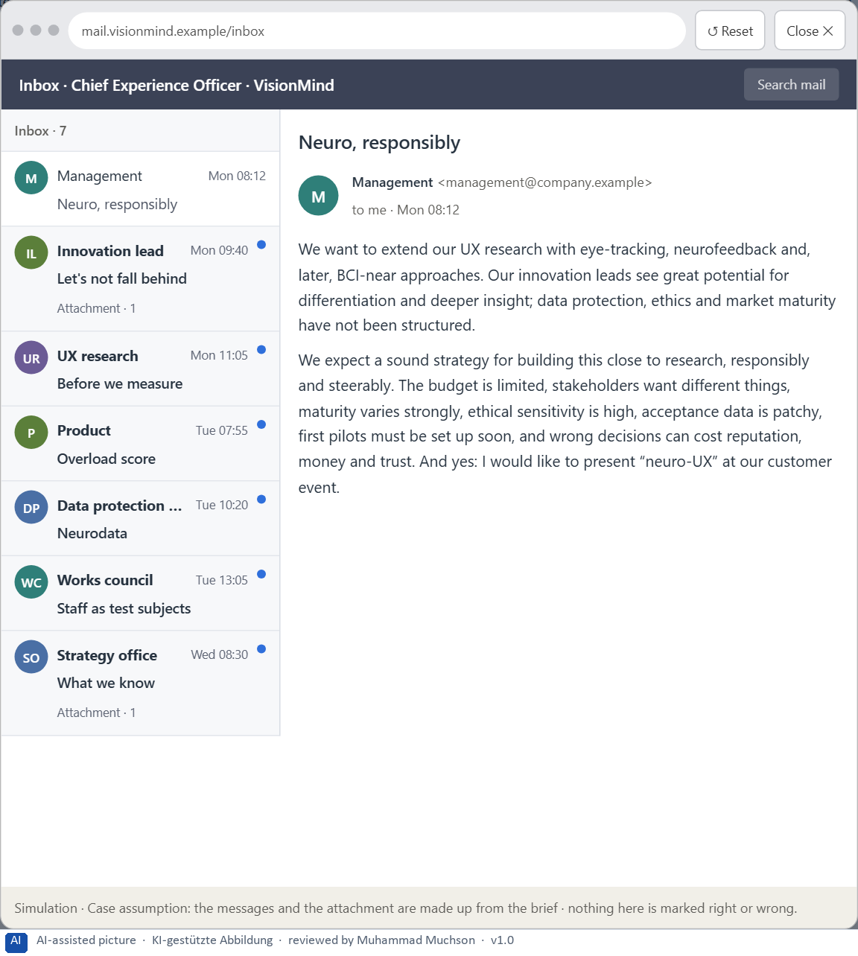
Figure 4 · Your desk: the messages that wait for you, shown in the lab as a mailbox (1 of 7).
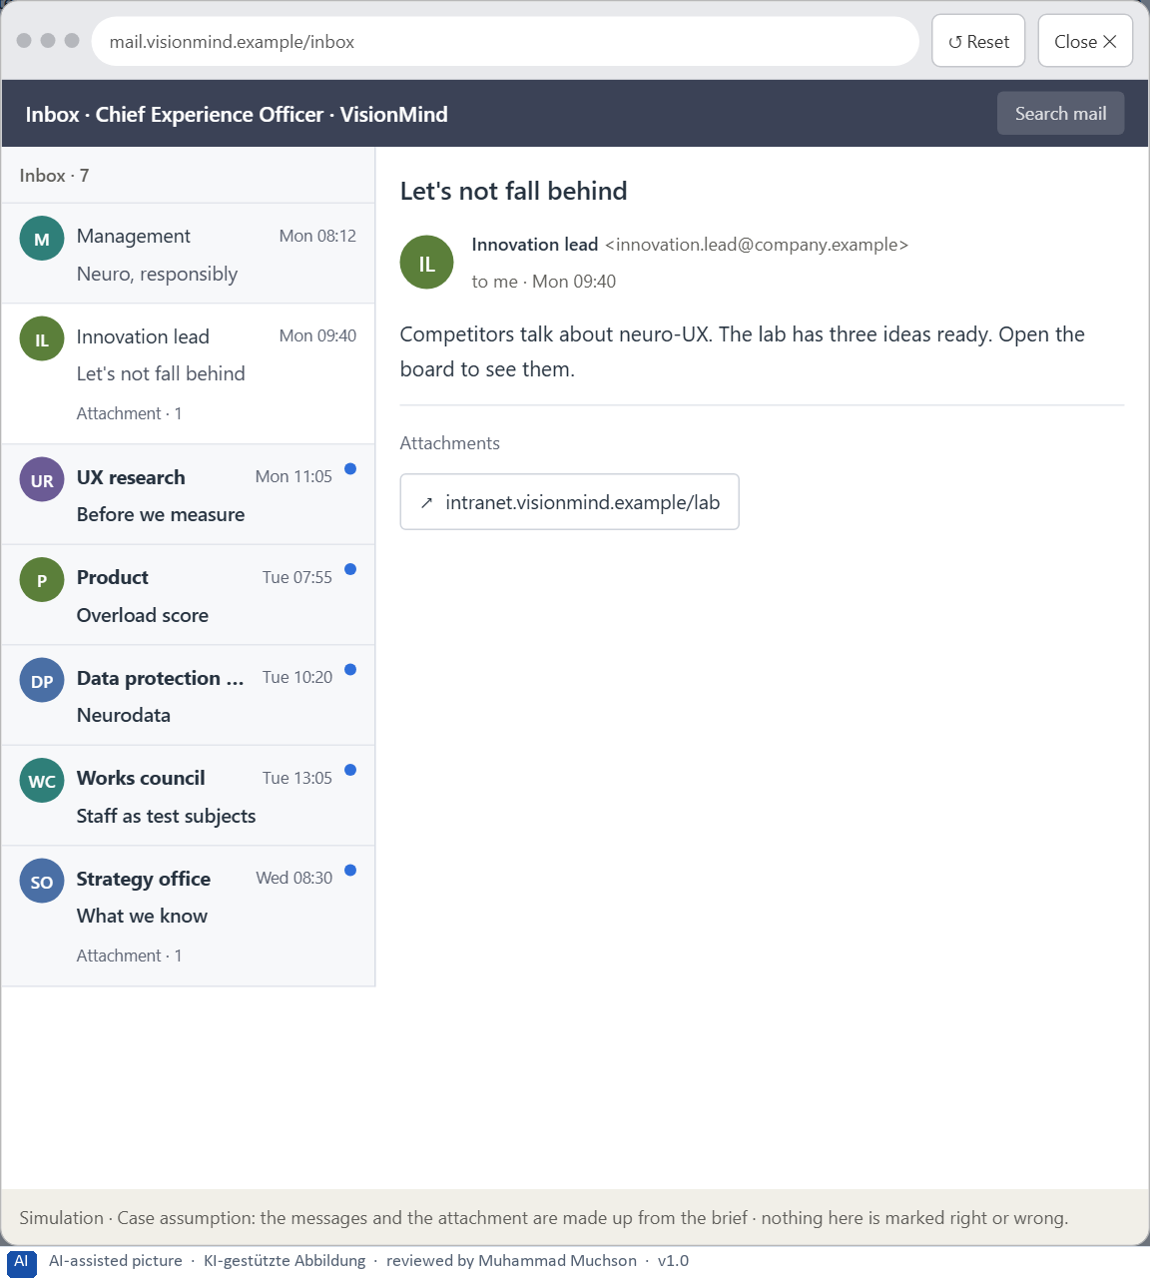
Figure 5 · Your desk: the messages that wait for you, shown in the lab as a mailbox (2 of 7).
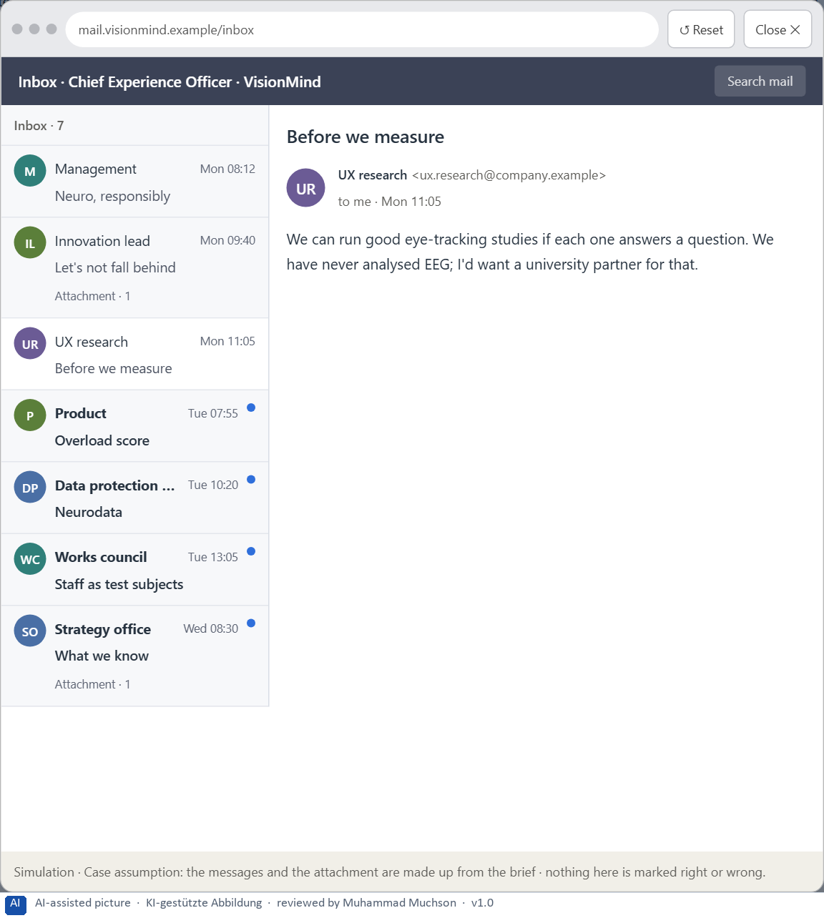
Figure 6 · Your desk: the messages that wait for you, shown in the lab as a mailbox (3 of 7).
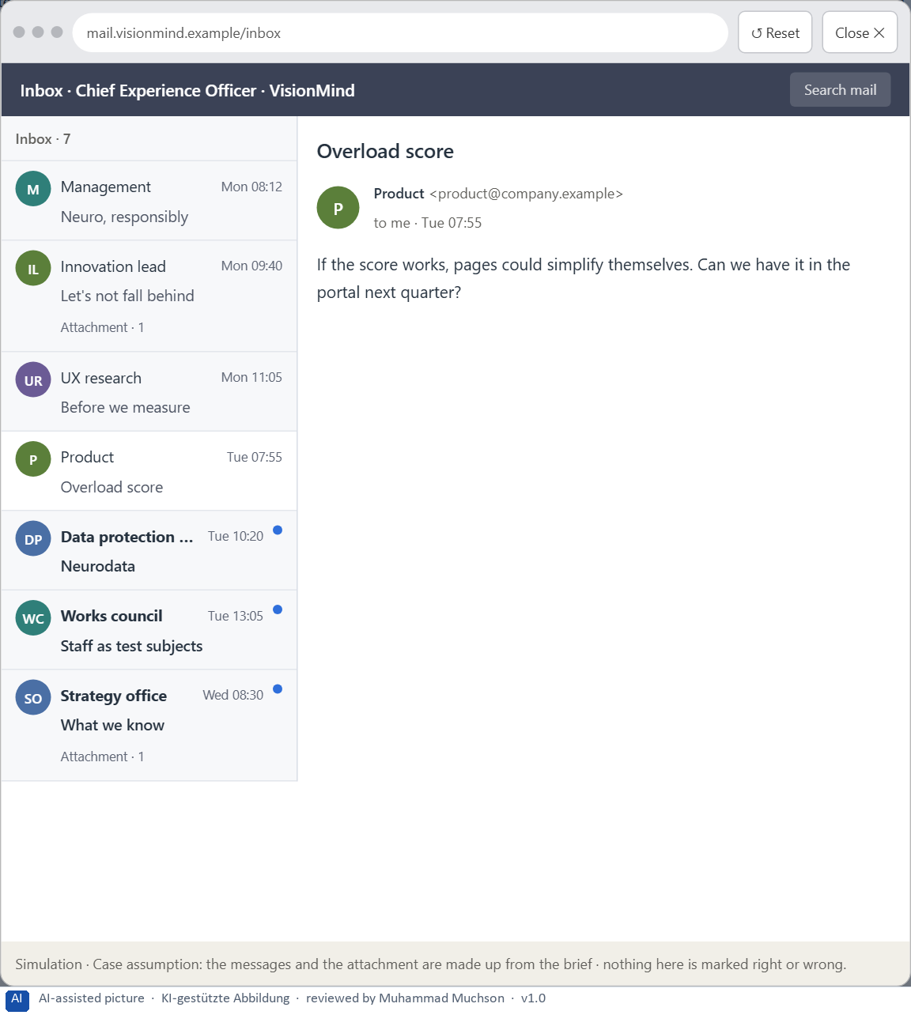
Figure 7 · Your desk: the messages that wait for you, shown in the lab as a mailbox (4 of 7).
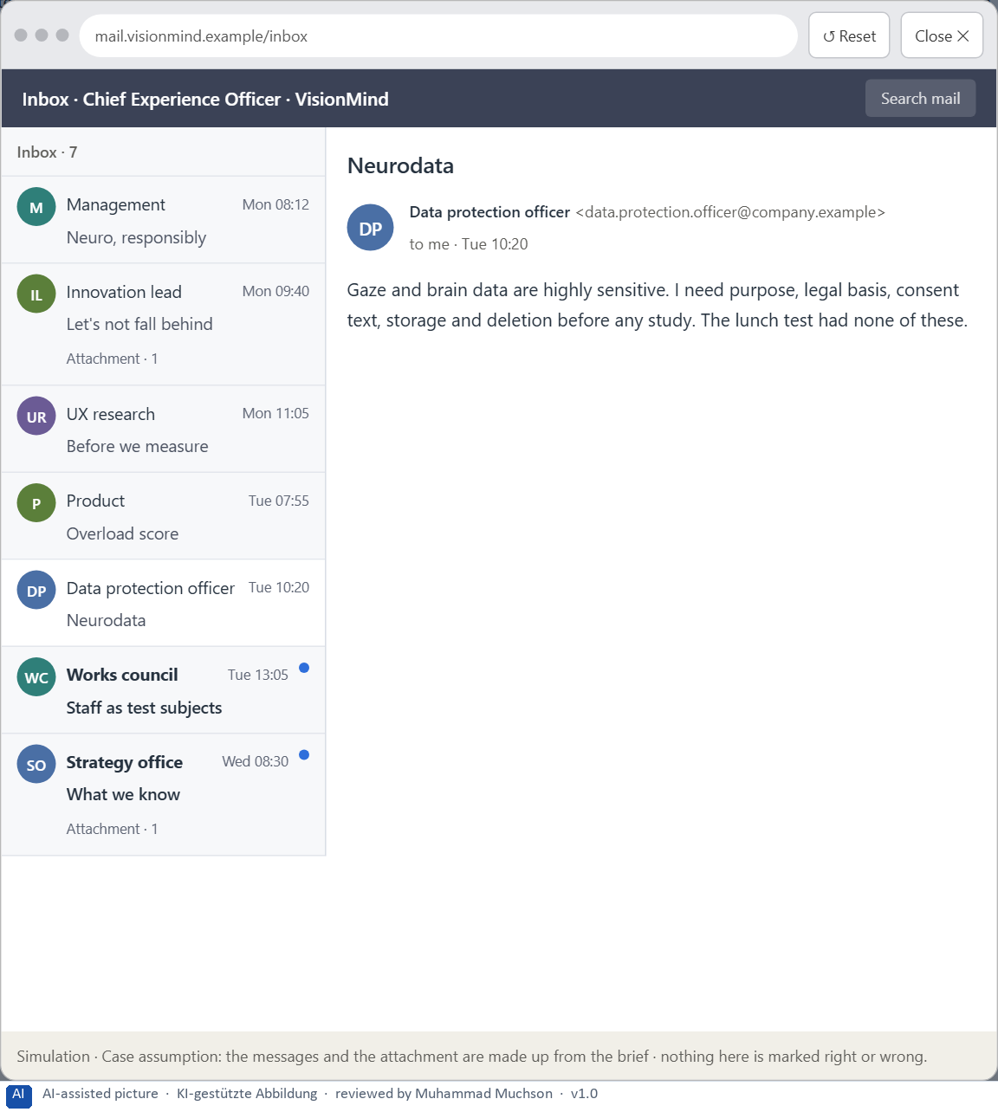
Figure 8 · Your desk: the messages that wait for you, shown in the lab as a mailbox (5 of 7).
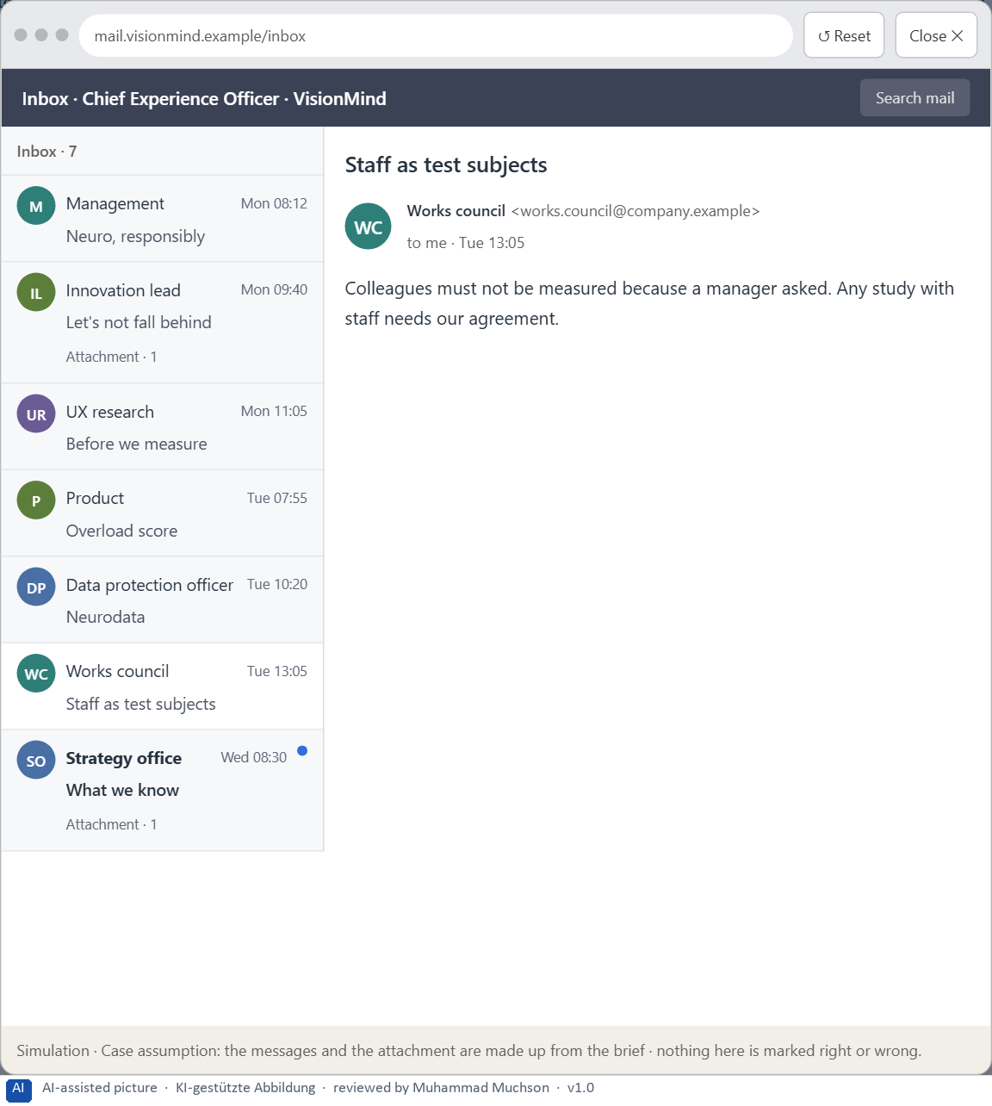
Figure 9 · Your desk: the messages that wait for you, shown in the lab as a mailbox (6 of 7).
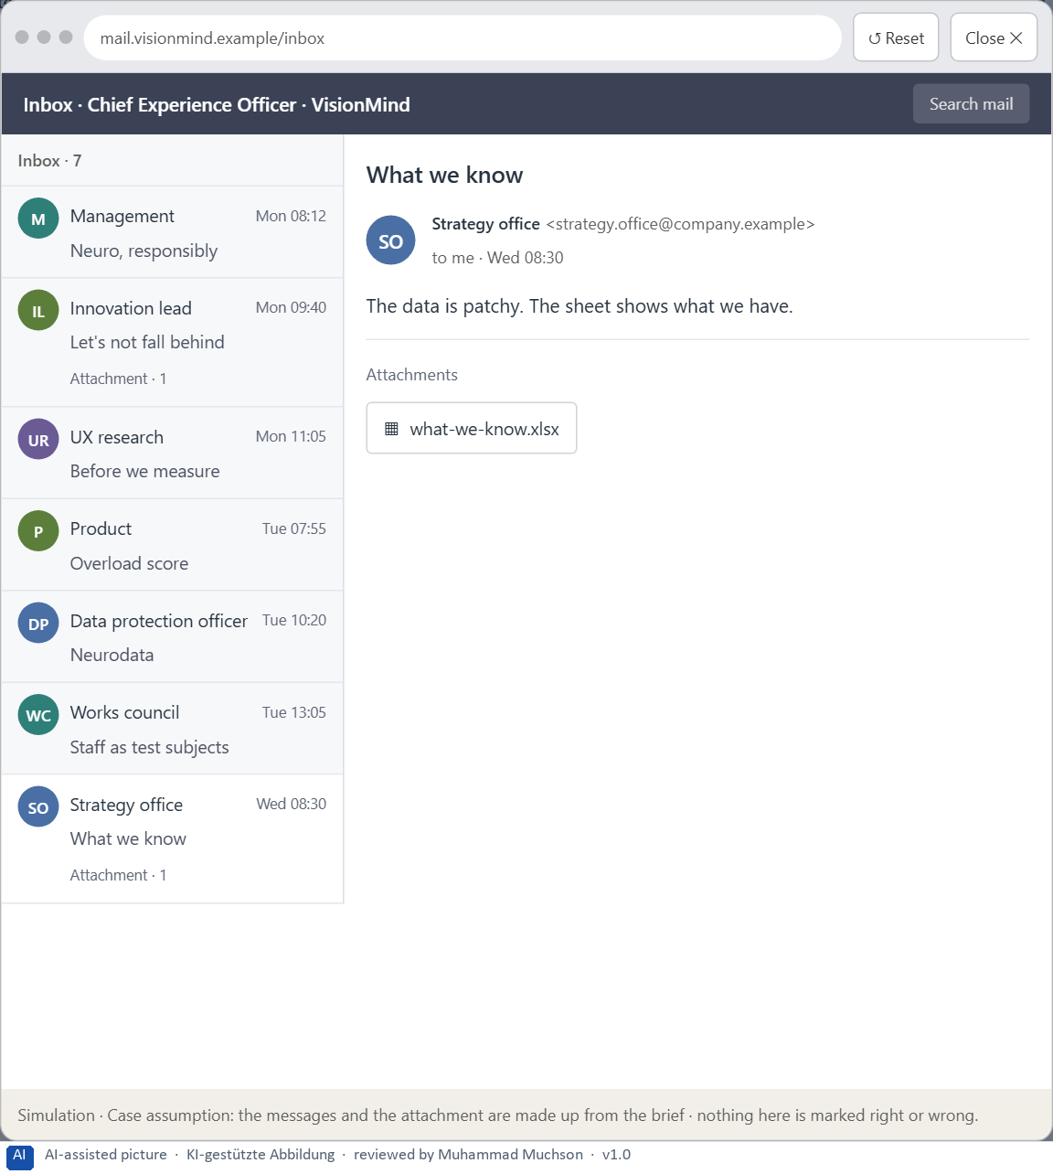
Figure 10 · Your desk: the messages that wait for you, shown in the lab as a mailbox (7 of 7).
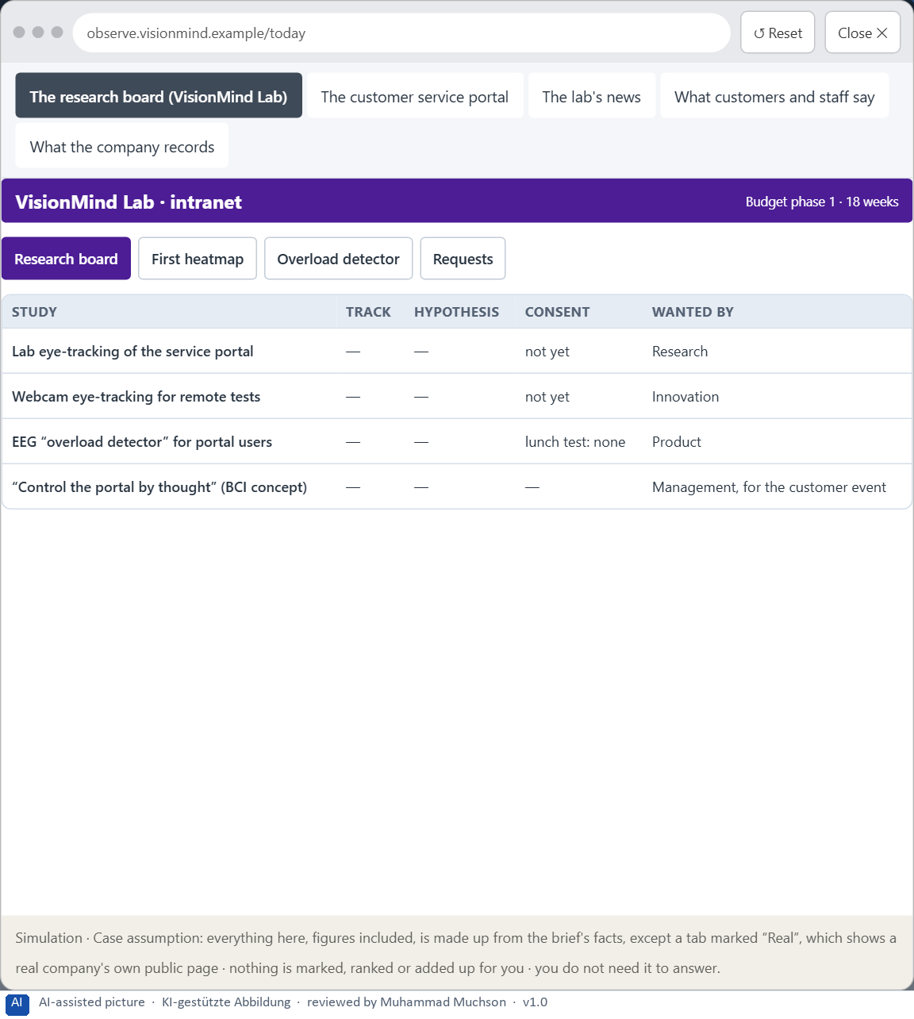
Figure 11 · The platform as it is today, as the lab lets you observe it (1 of 8).
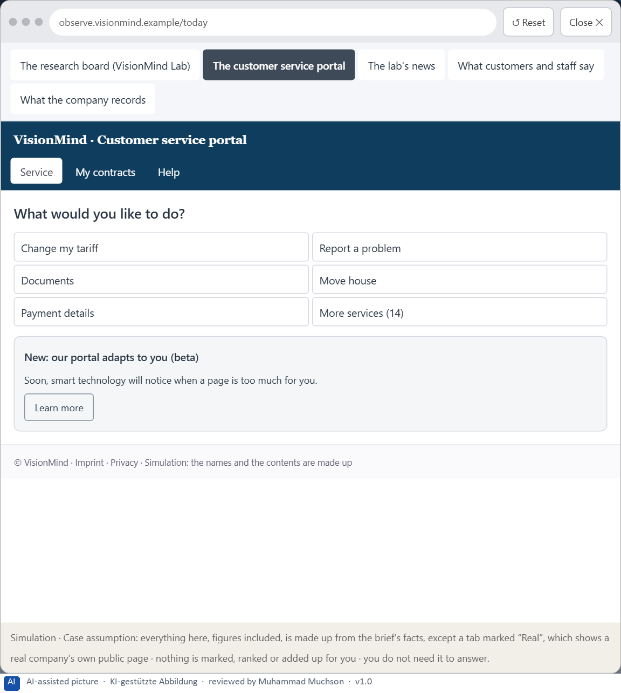
Figure 12 · The platform as it is today, as the lab lets you observe it (2 of 8).
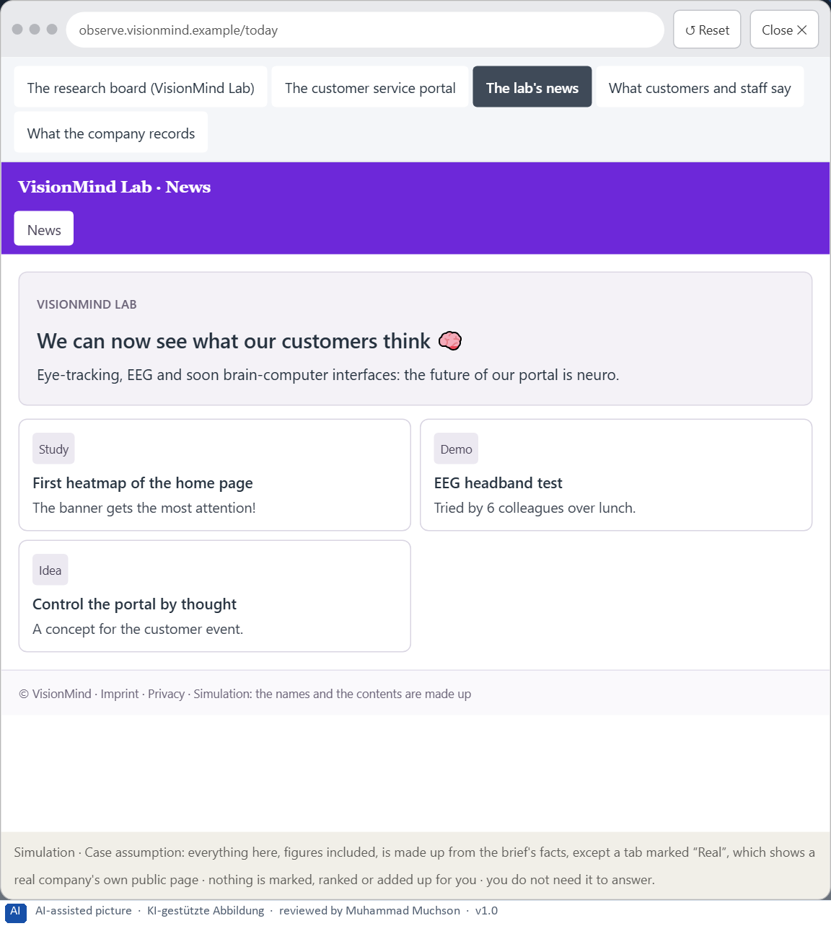
Figure 13 · The platform as it is today, as the lab lets you observe it (3 of 8).
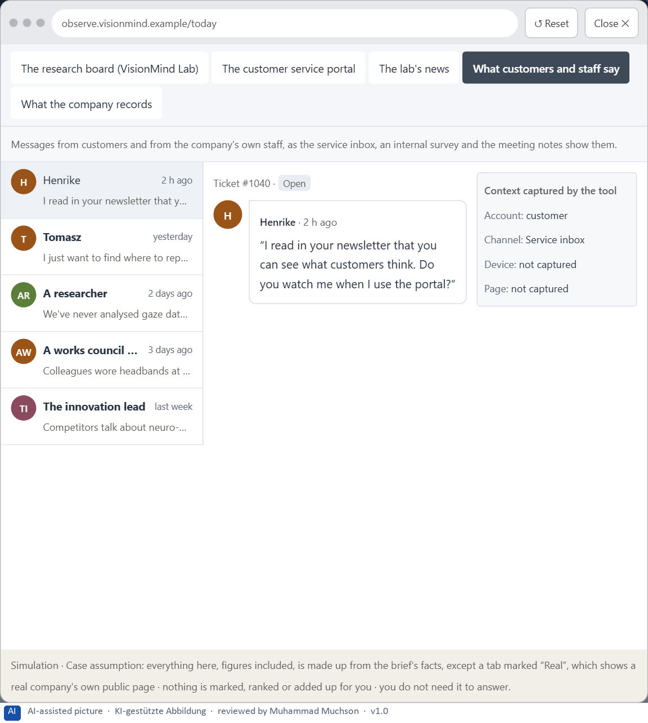
Figure 14 · The platform as it is today, as the lab lets you observe it (4 of 8).
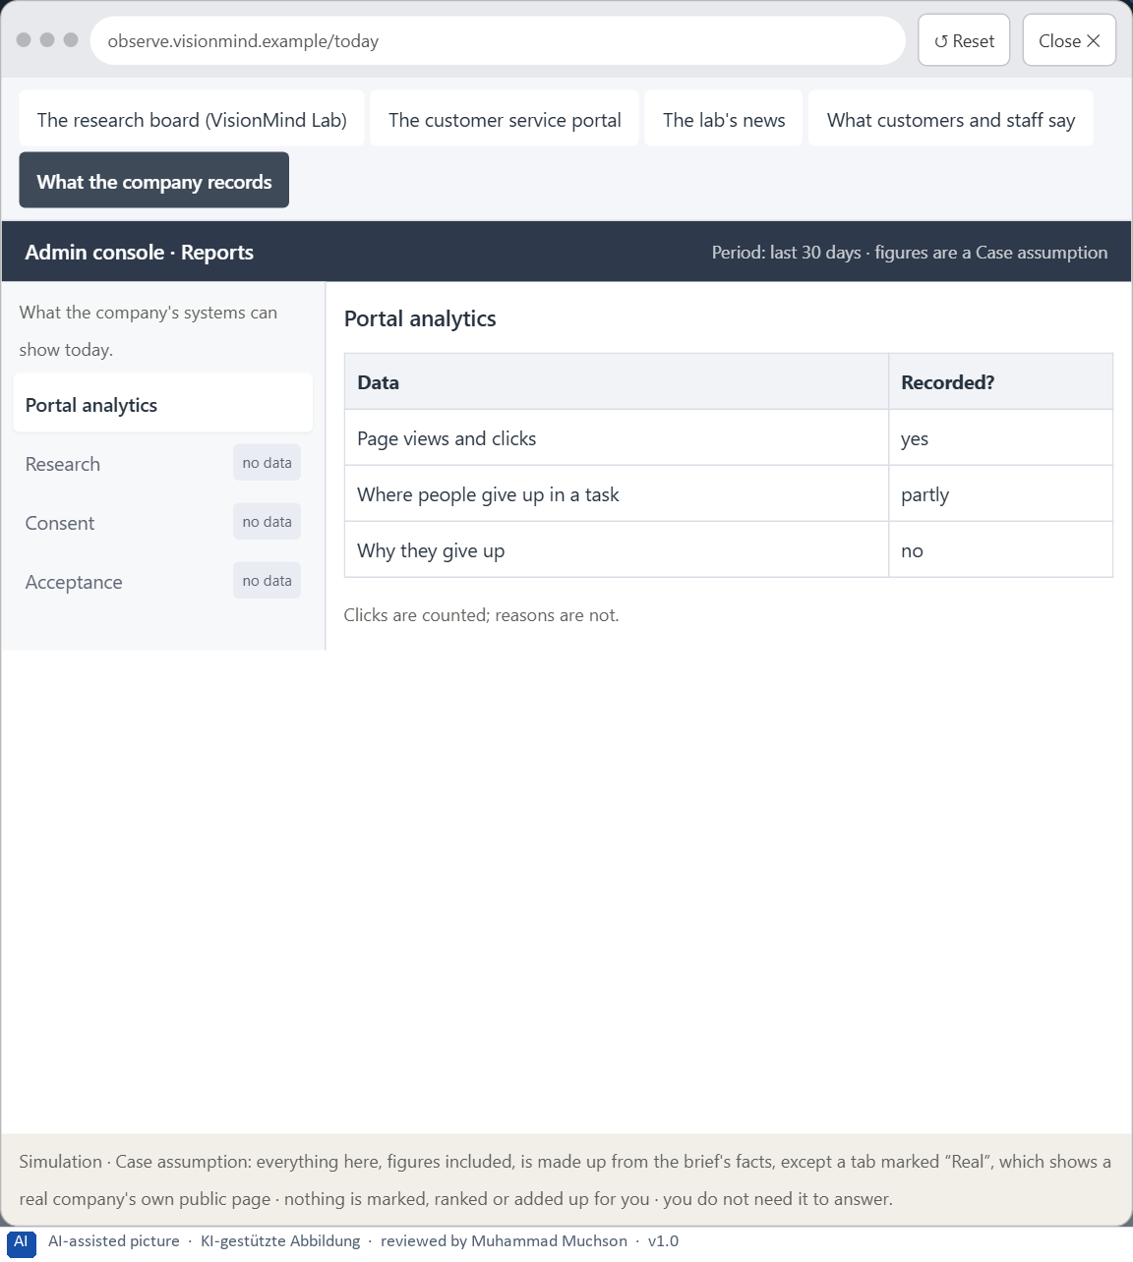
Figure 15 · The platform as it is today, as the lab lets you observe it (5 of 8).
Figure 16 · The platform as it is today, as the lab lets you observe it (6 of 8).
Figure 17 · The platform as it is today, as the lab lets you observe it (7 of 8).
Figure 18 · The platform as it is today, as the lab lets you observe it (8 of 8).
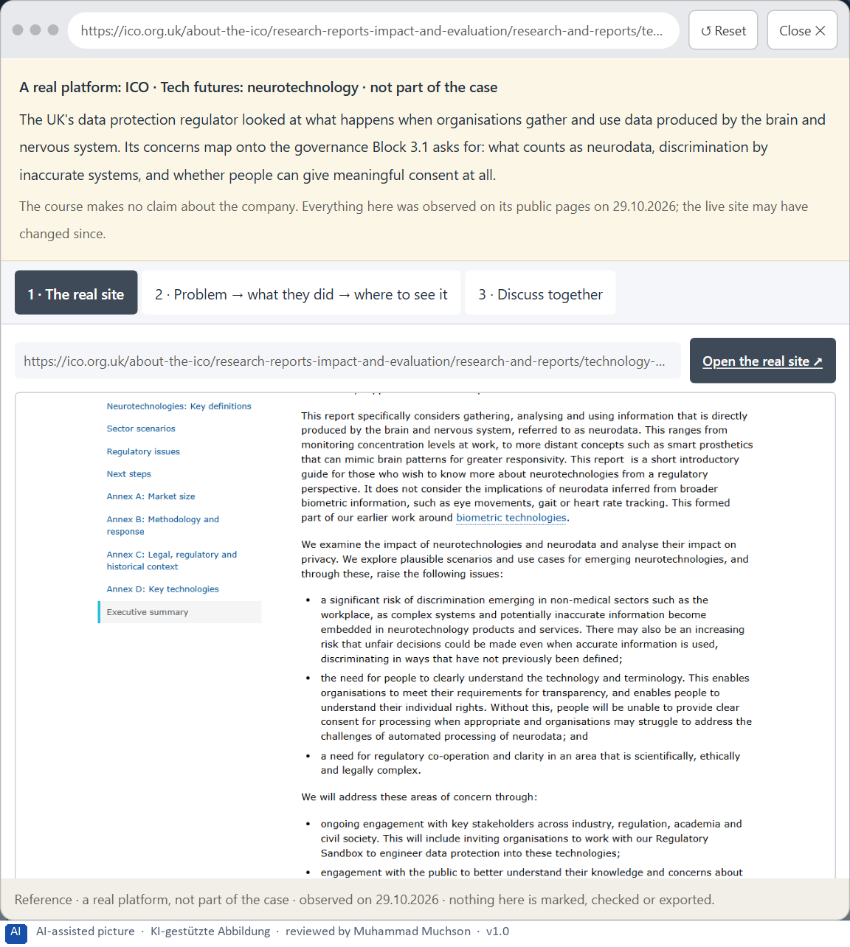
Figure 19 · A real platform that solved this, shown for the class discussion (1 of 3).
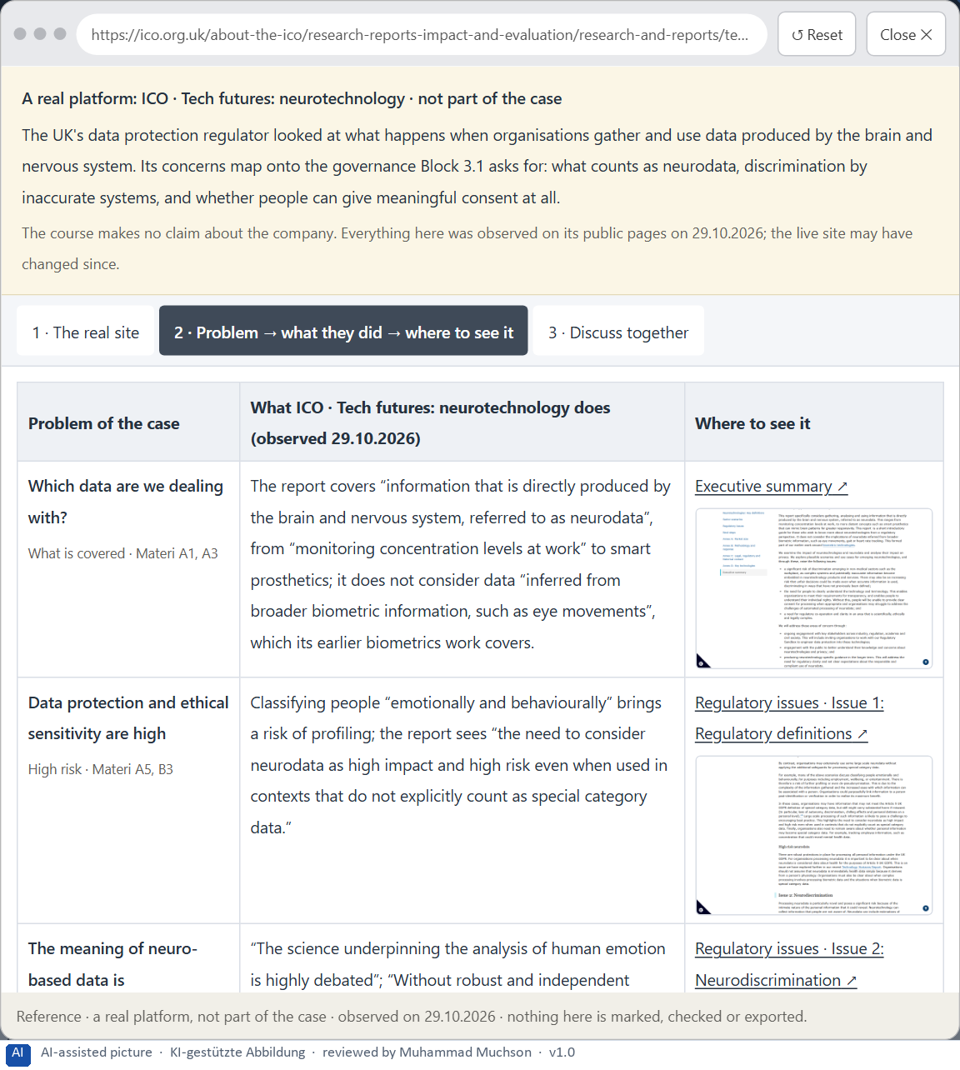
Figure 20 · A real platform that solved this, shown for the class discussion (2 of 3).
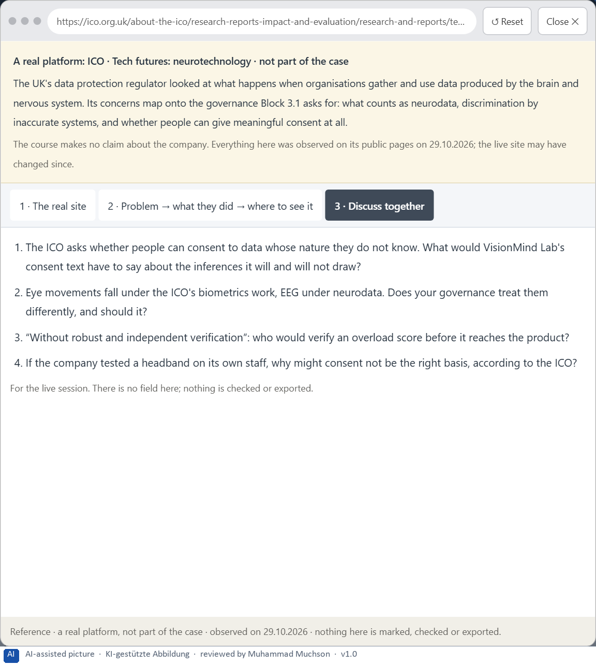
Figure 21 · A real platform that solved this, shown for the class discussion (3 of 3).
Question 1 of 7 · A guiding vision for neuro-based UX research and interaction: which form of insight, innovation and user value should be pursued systematically?
One or two sentences about the kind of insight and value the company wants, for whom, and what it will not do.
How to build the answer:
- Say what kind of insight or interaction the company aims for, and for whom.
- Say what it will not do with people's gaze or brain data.

Question 2 of 7 · Three strategic guiding decisions on eye-tracking, neurofeedback, BCI proximity, ethics, data protection and product connection
How to build the answer:
- Take your vision and ask which three choices would make it real.
- Write each as “we will …, even though that means …”.
Write them as a list, one decision per line, each with what it gives up.

Question 3 of 7 · A prioritised architecture of measures: which research questions, pilot fields or products are looked at first, and why?
Put the research questions, pilot fields or products in an order and give the reason for the first ones.
How to build the answer:
- List the candidates: eye-tracking of the hardest tasks, webcam eye-tracking for remote tests, an EEG overload study, an overload score in the product, a BCI concept.
- Put first what answers a real question with a mature method and controllable risk.
- Say why the others wait.

Question 4 of 7 · A risk analysis: which wrong assumptions about data quality, user acceptance, market maturity and strategic value would be especially critical?
Name two or three assumptions and the harm if each is wrong.
How to build the answer:
- Write down what your concept assumes about the quality and meaning of the data.
- Write down what it assumes about how people will accept being measured.
- Write down what it assumes about market maturity and strategic value.

Question 5 of 7 · A governance model: who is responsible for neuro-based research, ethical approvals and the strategic translation into product or innovation decisions?
Name roles, not people: who owns neuro-based research, who approves a study, who grades the evidence, who decides what may reach a product, and how a conflict is decided.
How to build the answer:
- Name who owns neuro-based research and the evidence grade.
- Say who approves a study ethically and on data protection, and who may stop one.
- Say who translates findings into product decisions, and the rule for a conflict.

Question 6 of 7 · A decision under uncertainty: make at least one prioritised decision despite patchy evidence and justify it responsibly
Say what you decide, what you do not know, and why the decision is responsible all the same, for example when you would reverse it.
How to build the answer:
- State the decision in one sentence.
- Name what you do not know.
- Say why it is still responsible: it can be reversed, it can be checked soon, or waiting costs more.

Question 7 of 7 · A management statement: a recommendation to the management with a clear priority and a strategic reason
Four to six sentences: the direction first, then the priority, the reason and what you ask of the management.
How to build the answer:
- Start with the direction in one sentence.
- Name the priority and the reason that carries it.
- Say what you ask of the management and what you will report back.

Use in class: presentation and handout
Mark of use for the worksheet. Presentation is what the trainer shows on screen; Handout is what participants fill in and hand in.
Part of the worksheet | Presentation (shown in the Neuro-UX Lab) | Handout
The case: two projects on the UX team's desk, and VisionMind Lab | The case read aloud or on screen | The case text
Block 1.1 · Weigh the insight value and limits of neuro-based UX technologies: Foc | The task wording at the start of the block (no answers are shown) | Worksheet block with answer boxes (Core)
Block 1.2 · Rate eye-tracking and BCI-based approaches under conflicting goals: Le | The task wording at the start of the block (no answers are shown) | Worksheet block with answer boxes (Core)
Block 2.1 · Case study: an evaluation strategy for the UX research project VisionM | The task wording at the start of the block (no answers are shown) | Worksheet block with answer boxes (Core)
The situation: great potential, no structure | The case read aloud or on screen | The case text
Block 3.1 · A strategic research and UX architecture for eye-tracking, neurofeedba | The task wording at the start of the block (no answers are shown) | Worksheet block with answer boxes (Core)

Glossary
Every term below is used in this document. Terms stay plain text in the body; this list says what they mean in everyday words.
Term | In plain words | Example | Comes from
Attention | The mind's spotlight. Only a small part of a screen is processed at any moment; attention decides which part. | A flashing banner takes attention away from the form you were filling in. | Day 1
Brain-computer interface (BCI) | A system that turns brain signals into commands for a computer, for example to type without moving; today mostly medical and research use. | — | Day 15
Case assumption | A fact made up for this exercise to fill a gap in the plan's case. It is marked so you know it is not part of the plan. | — | Day 1
Chief Experience Officer | The manager who is responsible for the experience customers have across all channels, and who decides where the company invests in it. | — | Day 1
Decision architecture | A set of connected decisions that are made on purpose and written down: what effect you want, what comes first, who decides and how conflicts are settled. It replaces many separate fixes. | — | Day 1
EEG | Measuring the brain's electrical activity through sensors on the scalp; cheap headbands do it roughly and are disturbed by movement and muscles. | — | Day 15
Evidence grade | A label for how sure a finding is, from a first hint to a result that held up again, so that only robust findings drive decisions. | — | Day 15
Eye-tracking | Measuring where a person looks, usually with infrared light and a camera, and recording it so it can be replayed and analysed. | — | Day 15
Fixation | A short pause of the eye on one spot, usually a fraction of a second; most of what we take in, we take in during fixations. | — | Day 15
Governance | The rules about who may decide what, who is answerable for it and how disagreements are settled. | — | Day 1
Heatmap | A picture that colours a page by how long or how often people looked at each part, added up over people; it loses the order and the individual. | — | Day 15
Hypothesis | An assumption you could check later. “This red banner could make users uneasy” is a hypothesis; “this banner is bad” is only an opinion. | — | Day 1
Maturity | How far a technology is from an idea to reliable use: does it work, in the real environment, for real users, at scale? | — | Day 14
Neuro-UX | Designing an interface with knowledge of how the brain sees, attends, feels and decides, so that the design steers these processes on purpose and responsibly. | — | Day 1
Neurodata | Information produced directly by the brain and nervous system; regulators treat it as high-risk personal data. | — | Day 15
Neurofeedback | Showing people a signal of their own brain activity, usually from EEG, so they can learn to change it; used in therapy and research, with mixed evidence. | — | Day 15
Proximity | A Gestalt law: things that are close together are seen as belonging together. | — | Day 6
Scanpath | The order of fixations and jumps across a page: where someone looked first, next and last. | — | Day 15
Stakeholder | A person or department with an interest in a decision, such as marketing, compliance, IT or sales. | — | Day 1
UX (user experience) | Everything a person goes through when using a product: what they notice, understand, feel and do, from the first look to the last step. The screens are only one part of it. | Finding the booking you want at once and feeling sure it went through is a good UX. | Day 1
Validity | Whether a measure really measures what it claims to, for example whether a “concentration score” shows concentration and not just movement. | — | Day 15

The Neuro-UX Lab: where we practise online
In class we use the course website as the place to practise and to learn. Every day has its own address, in the same pattern: the day number is the last part.
What | Address
Neuro-UX Lab (course website) | https://aion-ux-lab.vercel.app/
Day 15 | https://aion-ux-lab.vercel.app/day/15/

On the day page, Route 1 (Levels 1 and 2) and Route 2 (Level 3) can be opened; the cards and the tasks of this document are there too. The pattern is the same up to Day 8, for example https://aion-ux-lab.vercel.app/day/6/.

