AION · UX DEVELOPER · PSYCHOLOGICAL UX DESIGN AND NEURO-UX
DAY 2 · MATERI A AND MATERI B · ROUTES 1 AND 2 · LEVELS 1 TO 3
Visual perception and user-centred design
Study material with real research, worked examples and the rules you use in the tasks
AI notice · KI-Hinweis
This document was produced with the help of an AI language model (Claude, Anthropic). The AI drafted the text and tables and built the pictures and working examples of the lab. The content was then read, corrected and approved by the reviewer named below, who is responsible for its accuracy. Every picture carries an AI label on the image. Check figures and sources before you quote them.
KI-Hinweis: Dieses Dokument wurde mit Unterstützung eines KI-Sprachmodells (Claude, Anthropic) erstellt. Texte und Tabellen wurden von der KI entworfen, die Abbildungen sind KI-gestützt erstellt und am Bild gekennzeichnet. Die fachliche Prüfung und Freigabe erfolgte durch die unten genannte Person.

Day | Day 2 · Module 2 (day 1 of 2): Visual perception and user-centred design
Document | Materi (study material). Materi A has five cards, Materi B has three.
Route and level | Materi A serves Route 1 (Levels 1 and 2, Task 1). Materi B serves Route 2 (Level 3, Task 2).
Time | Materi A about 60 min · Materi B about 60 min (facilitator-led)
Neuro-UX Lab (website) | https://aion-ux-lab.vercel.app/day/2/
Case | Worked examples use a made-up company in each card. The task case is CampusNow (see the Task document).
Version | 1.0 · release date 29.10.2026
Review and approval | Muhammad Muchson, Mentor (subject-matter review and approval)

ABOUT THIS DOCUMENT
In class we also use the Neuro-UX Lab, the course website, as the place to practise and learn. Its address is at the end of this document.
Today is about reading an interface the way its users do. You learn how people scan a screen, pick out what looks relevant and decide what to look at first, what guides the eye (contrast and colour, grouping, structure), what information density does to orientation and load, and why a design has to start from the user's logic and not from the provider's. Then you use it on three products and decide what to change first. This document holds everything you need to study Day 2 without the website. Every card says what the idea is in plain words, shows it in a picture, gives the details and ends with the rules you use in the tasks.

IN THIS DOCUMENT
Lesson plan: ten teaching units (Ablaufplan)
Case study and transfer project at a glance
A1 · Seeing an interface, and designing from the user's side: user-centred against provider-centred design · 13 min · Core
A2 · How people scan, select and prioritise: perception as the basis of UI decisions · 12 min · Core
A3 · What guides the eye: contrast and colour, grouping and structure · 13 min · Core
A4 · How much at once: information density, orientation, load and why order looks like quality · 12 min · Core
A5 · Recognition instead of search, clarity instead of overload, and weighing a measure · 10 min · Core
B1 · Inside logic against user logic: why good UI decisions come from the user's side · 21 min · Core
B2 · Conflicts of goals: much information against simplicity, stakeholders against users · 20 min · Core
B3 · User-centredness as the basis of accountable decisions: who owns the structure, and deciding with partial data · 19 min · Core

Day at a glance
Day 2 has ten teaching units (UE). This document is the study material; it is used in UE1 (Materi A) and UE8 (Materi B). The day is built from three documents and the Neuro-UX Lab: Materi (study material), Task (worksheet) and Trainer (coaching, feedback and model solutions), plus the course website.

Lesson plan: ten teaching units (Ablaufplan)
UE | Min | Plan item | What happens | Material | Format
1 | 45 | Knowledge transfer · Level 1 | The trainer presents the cards of Materi A (A1, A2, A3, A4, A5, about 60 min of cards) in the Neuro-UX Lab; participants follow in the handout. | Materi A (Route 1) | Presentation + Handout
2 | 45 | Level 1 · Task 1 | Individual work on Block 1.1 (Core, about 10 min): the first product of the day is read and its effect described. Pairs then compare their results and the trainer collects open questions. | Task 1 · Part 1 · Block 1.1 | Handout (or in the lab)
3 | 45 | Level 1 · Task 2 | Three options are rated on the same criteria and one is chosen under the stated conditions: Block 1.2 (Core, about 8 min). | Task 1 · Part 1 · Block 1.2 | Handout (or in the lab)
4 | 45 | Coaching · transition from Level 1 to Level 2 | Trainer-led. A short talk on the day's coaching focus, then the reflection questions in pairs. The bridge: from describing an effect to a decision you answer for. There is no worksheet block in this unit. | Trainer document, section Coaching | Trainer only
5–6 | 90 | Level 2 · Case study CampusNow (2 UE) incl. model solution | UE5: the trainer presents the case; participants work on Block 2.1 (Core, about 15 min). UE6: groups compare their results and defend them; the trainer closes with the model solution. | Task 1 · Part 2 · Block 2.1  Trainer document, section Case study | Handout; model solution shown after the work
7 | 45 | Level 2 + 3 · Feedback round with a management perspective | Groups present their reasoning, not only their result. The trainer asks the day's Level 3 input questions and leads the discussion. | Trainer document, section Feedback round | Presentation by the groups; Trainer only
8 | 45 | Level 3 · Transfer project, Chief Experience Officer (3 UE: UE8–10) | The trainer presents Materi B (B1, B2, B3; use the "In plain words" and "How to decide" boxes, the rest is handout) and sets the role and the situation. | Materi B (Route 2) | Presentation + Handout
9 | 45 | Level 3 · Transfer project | Individual work or in pairs on Block 3.1 (Core, about 20 min): the strategy memo. | Task 2 · Block 3.1 | Handout (or in the lab)
10 | 45 | Level 3 · Transfer project | Participants present their decision and what they give up, including the one decision made under uncertainty; the trainer debriefs with the model solution. | Task 2 · Block 3.1  Trainer document, section Transfer project | Handout; model solution shown after the work

One UE is counted as 45 minutes here; breaks are not shown. The times are a guide for the trainer. The Core blocks are enough for a complete answer.

Case study and transfer project at a glance
Component | UE | Duration | Participants work in | Model solution in
Level 2 case study (CampusNow) | UE5–6 | 2 UE · 90 min | Task 1 · Part 2 (Block 2.1) | Trainer document, section Case study
Level 3 transfer project (Chief Experience Officer) | UE8–10 | 3 UE · 135 min | Materi B and Task 2 (Block 3.1) | Trainer document, section Transfer project

Materi A · Route 1 · Levels 1 and 2
How Materi A is used
About 60 minutes, five cards. Levels 1 and 2: read an unfamiliar municipal portal as a first-time user, rate three start pages of a further-education platform and decide despite missing data, then analyse an education portal, develop four user-centred measures, rate them and decide what comes first. The cards give you the ideas and the rules you use in Task 1.

A1 · Seeing an interface, and designing from the user's side: user-centred against provider-centred design · 13 min · Core
People see a screen before they read it. User-centred design starts from what users come to do and how they see; provider-centred design starts from how the organisation is built.
IN PLAIN WORDS
The idea. Before people read a screen they see it: shapes, contrasts and groups decide what is noticed and what is missed. User-centred design starts from what the users come to do and how they see, and checks the design with them. Provider-centred design starts from how the organisation is built and what it wants to say, so the menu mirrors its departments and the start page mirrors its wishes. Both can be complete; only one is easy to use.
Why it matters. Block 1.1 asks you to read CityDesk as a first-time user, Block 1.2 to choose a start page from a user-centred point of view, and Block 2.1 to find CampusNow's problems, several of which come from inside logic. This card gives you the difference to look for.
How to read the picture. The same Brightwater start page twice: built from the provider's side and from the user's side. Below, a table of what the eye and the brain do before anyone reads, and a real case of user-centred design, GOV.UK.

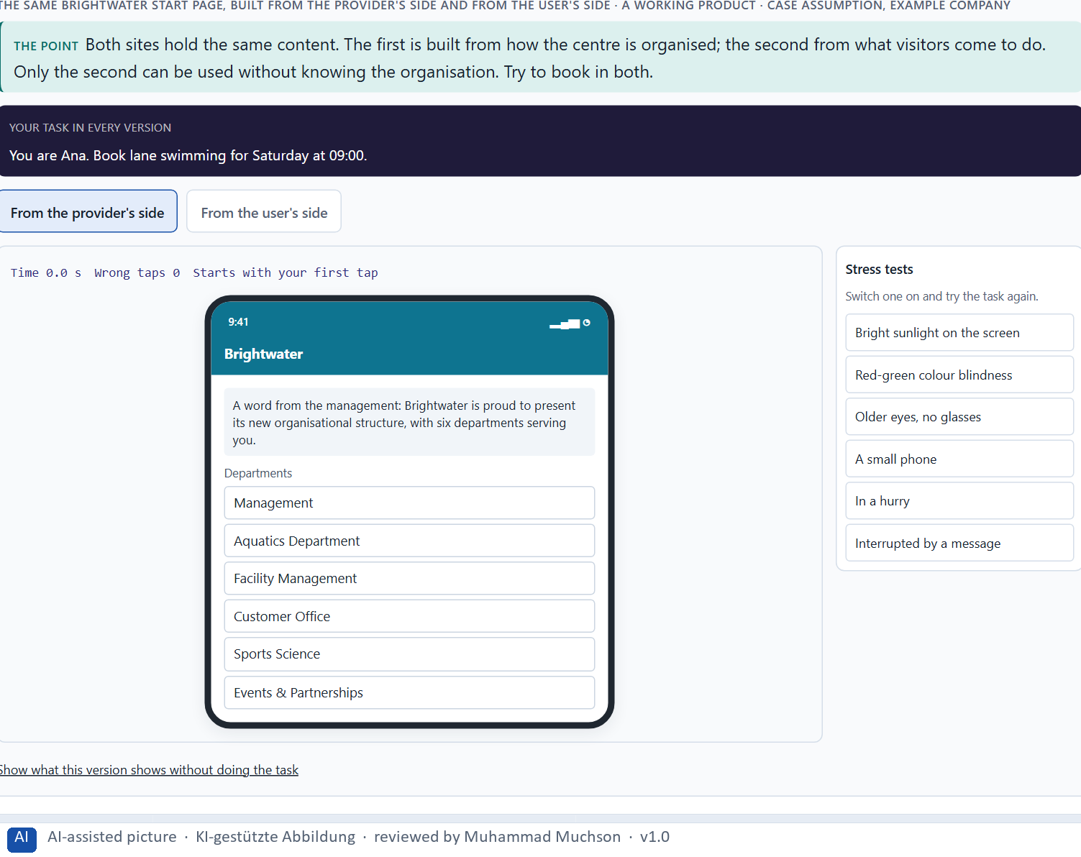
Figure 1 · The same Brightwater start page, built from the provider's side and from the user's side. Shown here in its starting state; in the Neuro-UX Lab every version and every stress test can be used.
Provider-centred and user-centred design
Aspect | Provider-centred | User-centred
Starts from | The organisation's structure and wishes. | The users' tasks, words and way of seeing.
The menu | One item per department. | One item per task people come for.
The words | The organisation's terms. | The words users would type or say.
Checked by | Whether everything is there. | Whether users can do their task, tested with them.
Typical result | Complete, but people search and call. | The same content, found and used.

Seeing a screen: what happens before anyone reads
Step | What happens | Real finding | What it means for a screen
Noticing | Features such as colour, size, orientation and movement are picked out in parallel, before attention is placed. | A single odd item pops out at once; a combination of features has to be searched item by item (Treisman and Gelade 1980). | One clear difference is enough to be seen first; many differences compete.
Fixating | Only a spot of about 2° is sharp; the eyes jump and rest, three to four times a second. | A fixation lasts about 200 to 300 ms (Rayner 1998). | What is not fixated is seen only as a blur, so the important thing must sit where the eye goes.
Recognising | Shapes and groups are matched to what the person knows within a fraction of a second. | People tell whether a photo shown for 20 ms contains an animal; the brain shows the difference after about 150 ms (Thorpe et al. 1996). | Layout, icons and groups are understood before the first word is read.
Judging | A first impression of the whole forms before the page is used. | People rate the appeal of a web page after 50 ms (Lindgaard et al. 2006). | The look that is seen first sets the expectation for everything that follows.

User-centred design in practice: GOV.UK
What happened | Real fact | What it shows
The principle | The design principles of GOV.UK begin with “Start with user needs”: the process starts from real user needs and designs around them, not around the way the official process is at the moment (Government Digital Service 2012). | A principle is only user-centred if it comes first, before the organisation's own wishes.
The change | GOV.UK replaced the two main government websites, Directgov and Business Link, on 17 October 2012. The team analysed every piece of information on both sites and built new pages and tools around the needs it found; 28,500 mappings kept the old addresses working. | User-centred design is not a new coat of paint on the same content: it changes what is there and how it is found.
The result | The Government Digital Service reported 61% task success on GOV.UK against 46% on Business Link. | These figures come from the Government Digital Service itself and are not an independent test: say who measured a result.

Case assumption
Brightwater, Ana, Felix, Lea and Omar are made up for this example. User-centred design follows ISO 9241-210 and the principles of Gould and Lewis (1985): an early focus on users and their tasks, testing with real users, and iteration. The findings in the table of real evidence are real research results and real cases; the sources are listed below.

How to decide when this comes up in the task
- Read the screen as someone who has never seen it: what would they come to do, and can they see where to do it?
- Look for the organisation in the interface: menu items named after departments, the organisation's own words, a page that opens with what the provider wants to say.
- A complete interface is not the same as a usable one: everything can be there and still not be found.
- Judge a UI decision from the user's side, not from the inside logic of the people who built it.

Extra · go deeper (optional reading)
ISO 9241-210 calls it human-centred design and names four activities that repeat: understand the context of use, specify the users' requirements, produce design solutions, and evaluate them against the requirements. The point is the loop: a design is not finished when it is complete, but when users can do what they came for.

Sources · ISO 9241-210 · Gould & Lewis 1985 · Norman & Nielsen · Rosenfeld et al. 2015 · Treisman & Gelade 1980 · Rayner 1998 · Thorpe et al. 1996 · Lindgaard et al. 2006 · Government Digital Service 2012

A2 · How people scan, select and prioritise: perception as the basis of UI decisions · 12 min · Core
People scan before they read: the eye jumps to what stands out and what looks relevant, ranks it and skips the rest. What the scan does not catch is, for the user, not there.
IN PLAIN WORDS
The idea. People rarely read a screen; they scan it. The eye jumps to what stands out, picks out headings, words and buttons that look relevant to the goal, and skips the rest. On text-heavy pages the jumps often follow an F-shape: across the top, across a little lower, then down the left edge. What is not picked out in this first pass is, for the user, not there. A UI decision is therefore a decision about what the scan will catch.
Why it matters. Block 1.1 asks what a first-time user perceives first on CityDesk and which obstacles stop them, and Block 2.1 asks why CampusNow's long text blocks are hard to scan. You need the scan to say why something is seen or missed.
How to read the picture. First the four steps of a scan. Then one Brightwater page in two forms: a dense block of text and the same content structured for scanning. A table of scanning in real numbers follows.

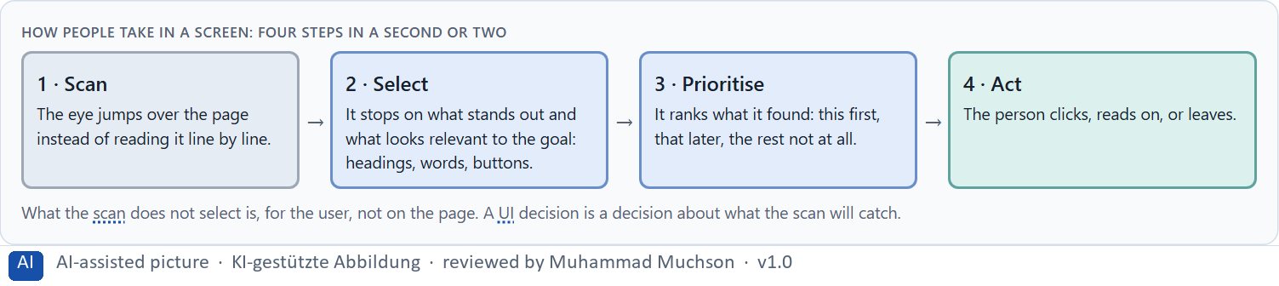
Figure 2 · How people take in a screen: four steps in a second or two.
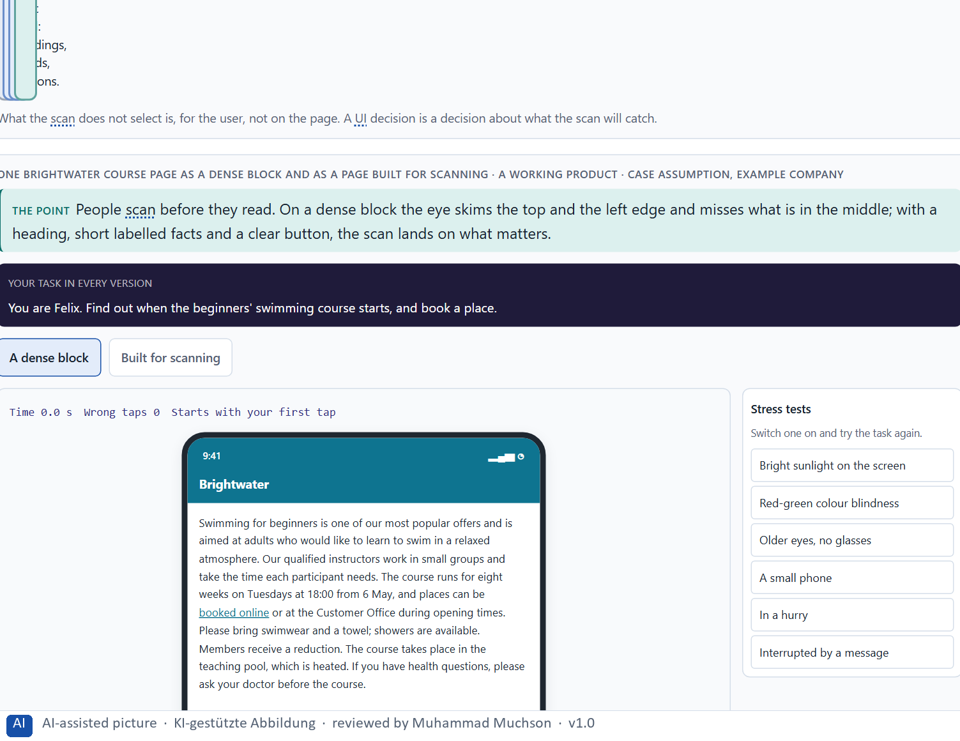
Figure 3 · One Brightwater course page as a dense block and as a page built for scanning. Shown here in its starting state; in the Neuro-UX Lab every version and every stress test can be used.
What the scan catches, and what it misses
The scan catches | The scan misses
Strong contrasts, large shapes, movement. | Pale, small or low-contrast elements, such as a grey search box.
Headings and the first words of lines. | The middle of long, dense paragraphs.
Words that match the goal (“Book”, “Opening hours”). | The organisation's own terms the user does not know.
The top of the page and the left edge. | What is far down the page or only after long scrolling.

Scanning in numbers: what people read, and what they skip
Step | Real finding | What it means for a screen
Scan | In a test of web pages, 79% of the users always scanned a new page and only 16% read it word by word (Nielsen and Morkes 1997). | Set the page for a scan: clear headings, short paragraphs, one idea each.
Select | On the average page view of 593 words, users could read at most 28% of the words if they spent all their time reading, and about 20% is more realistic. Reading time rose by only 4.4 seconds for each added 100 words (Nielsen 2008; data from 2005; an upper bound from time on page, not an eye-tracking result). | Every extra paragraph is read by fewer people: put the important thing first and cut the rest.
Prioritise | Users read half of the information on an average visit only on pages of 111 words or fewer (Nielsen 2008). | If everything on the page must be read, there is too much on the page.
Follow a pattern | In eye-tracking of unstructured text pages with 232 users, the eyes moved in an F-shape: across the top, across a little lower, then down the left edge (Pernice 2017). | The pattern shows what a page gives the eye; headings and bold key words change it.

Case assumption
Brightwater, Ana, Felix, Lea and Omar are made up for this example. Scanning follows Nielsen (1997); the F-shaped pattern on unstructured text follows Pernice (2017); the pull of strong signals follows Itti and Koch (2001). The findings in the table of real evidence are real research results and real cases; the sources are listed below.

How to decide when this comes up in the task
- Ask what a first-time user sees in the first second or two: the strongest contrasts, the largest shapes, the top and the left edge.
- Ask what they would look for, in their own words, and whether those words appear where the scan passes.
- Treat a long, dense block as invisible in the first pass: what is in its middle is usually missed.
- Headings, short labelled facts and clear buttons give the scan something to catch.

Extra · go deeper (optional reading)
The F-pattern is not a rule to design for; it is a sign that a page gives the eye nothing better. Pernice (2017) describes how headings, bullet points, bold key words and short paragraphs change the pattern: the eye then jumps from anchor to anchor instead of skimming the top and sliding down the left edge.

Sources · Nielsen 1997 · Pernice 2017 · Krug 2014 · Itti & Koch 2001 · Nielsen 2008

A3 · What guides the eye: contrast and colour, grouping and structure · 13 min · Core
Contrast makes one thing stand out, grouping shows what belongs together, structure gives the eye a path. Used on purpose, they guide the eye; used against each other, everything competes.
IN PLAIN WORDS
The idea. Four means guide the eye. Contrast makes one thing stand out from its surroundings. Grouping shows what belongs together: things that are close to each other or look alike are read as one group. Structure gives an order the eye can follow, such as headings, columns and alignment. Visual guidance is these three used on purpose, so that the eye goes first to what matters and then along a path. Used against each other, boxes, colours and lines compete and the eye finds no way. Colour is the strongest of these signals: it is seen before shape or text and carries meaning people have learnt, such as red for danger. Used strategically, one accent colour marks the main action and a warning colour is kept for real warnings.
Why it matters. Block 1.1 asks you to sort CityDesk's problems into visual guidance, structure and other categories, and Block 2.1 asks about CampusNow's missing prioritisation and inconsistent page types. These means, and how colour is used, are what you check.
How to read the picture. One Brightwater page with three switches: contrast, grouping and structure. Then the Book button at three contrast ratios, with the ratio shown, and a table of the real rules and numbers behind each means.

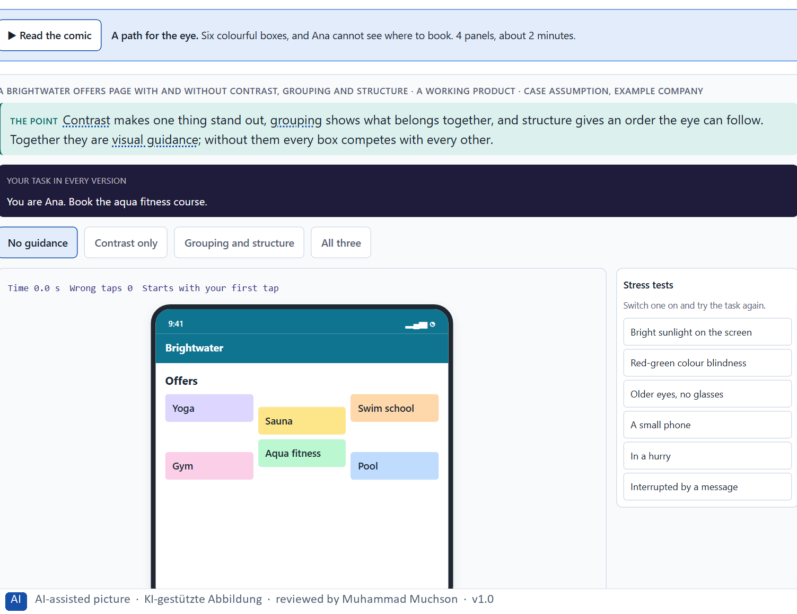
Figure 4 · A Brightwater offers page with and without contrast, grouping and structure. Shown here in its starting state; in the Neuro-UX Lab every version and every stress test can be used.
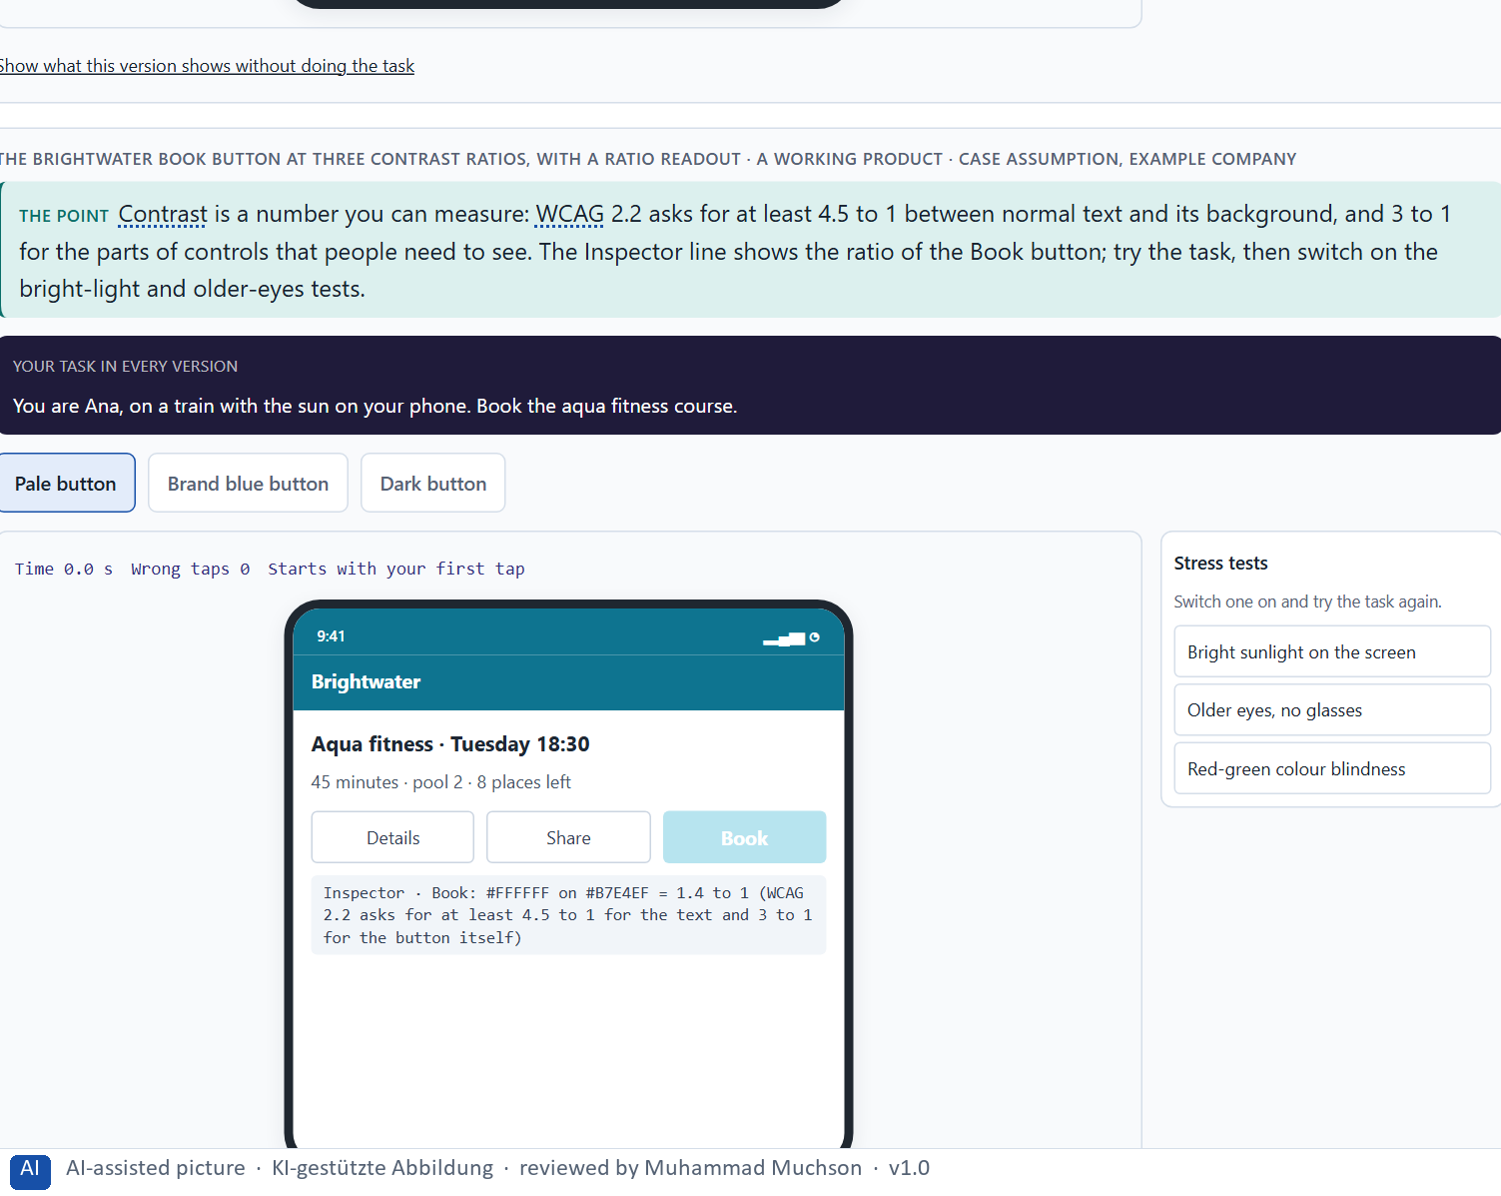
Figure 5 · The Brightwater Book button at three contrast ratios, with a ratio readout. Shown here in its starting state; in the Neuro-UX Lab every version and every stress test can be used.
The means of visual guidance, and a sign that one is missing
Means | What it does | A sign it is missing
Contrast | Makes one element stand out from its surroundings. | The main action is as pale as everything else; or everything is loud.
Grouping | Shows what belongs together (close together, alike). | Related items are scattered; unrelated items share a box.
Structure | Gives an order the eye can follow: headings, columns, alignment. | Boxes placed anywhere; every page type laid out differently.
Visual guidance | All three on purpose: the eye goes first to what matters, then along a path. | Boxes, colours and lines compete; the eye jumps.

Colour used strategically, and colour used against the user
Strategic use | What it does | Used against the user
One accent colour for the main action | The eye finds the action first. | Three button colours with no meaning: the eye compares instead of acting.
A warning colour only for real warnings | Red keeps its meaning, so people react when it matters. | Red on neutral information: people learn to ignore it, or feel unsafe.
Colour plus a word or an icon | Everyone gets the meaning, also people who see colours differently. | Colour alone: “the red fields are required”.
Colours that group | Things of one kind share a colour, so the eye reads groups. | A different colour for every box: nothing belongs together.

Rules and numbers behind the means of visual guidance
Means | Real rule or finding | What to check
Contrast | WCAG 2.2 asks for a contrast ratio of at least 4.5 to 1 for normal text and 3 to 1 for large text (success criterion 1.4.3), and 3 to 1 for the parts of controls and graphics people need to see (1.4.11). | Measure the ratio of the main action and its label; do not judge it by how it looks on your own screen.
Colour | Colour must not be the only way to give information (1.4.1). About 1 in 12 men and 1 in 200 women have a colour vision deficiency, roughly 8% and 0.5% (Wong 2011). | Add a word, an icon or a position to every colour that carries meaning.
Grouping | Things that are close, alike or inside one boundary are read as a group; the principles come from Gestalt psychology (Wertheimer 1923; summary in Wagemans et al. 2012). | Make the space between related items smaller than the space between groups.
Structure | Alignment, headings and columns give the eye a path; eye-tracking of text pages shows a pull to the top and to the left edge (Pernice 2017). | Put the first thing to see at the top left of the area it belongs to.
Guidance of the gaze | Attention goes first to what differs most from its surroundings in colour, contrast, orientation or motion (Itti and Koch 2001; Ware 2012). | Give exactly one thing the strongest difference on the screen.
A caution on colour meaning | Claims that one colour changes how people perform have not held up: a 2020 meta-analysis found no evidential value for an effect of red on intellectual performance after correcting for publication bias (Gnambs 2020). | Use colour for contrast, grouping and a few fixed meanings; do not rely on a claim that a colour makes people feel or act in one way.

Case assumption
Brightwater, Ana, Felix, Lea and Omar are made up for this example. Grouping by proximity and similarity follows the Gestalt research summarised by Wagemans et al. (2012); contrast and visual search follow Ware (2012); the meaning of colour follows Elliot and Maier (2014); not using colour alone follows WCAG 2.2, criterion 1.4.1. The findings in the table of real evidence are real research results and real cases; the sources are listed below.

How to decide when this comes up in the task
- Find the strongest contrast on the screen and ask whether it is the most important thing. If not, it misleads the eye.
- Check grouping: things that belong together should be close together or look alike, and unrelated things should not.
- Check structure: headings, columns and alignment the eye can follow from top to bottom.
- Count the competing boxes, colours and lines. Many strong ones of equal weight mean there is no visual guidance.
- Different page types with different structures make people learn every page again: keep one structure per page type.
- Use colour strategically: one accent for the main action, a warning colour only for real warnings, and never colour alone to carry a meaning.

Extra · go deeper (optional reading)
Proximity usually wins over colour: two items close together are read as a group even if their colours differ, and a heading placed nearer the text below it than the text above it is read as belonging to the text below. Much visual guidance is therefore done with spacing alone, before any colour is chosen.

Sources · Wagemans et al. 2012 · Ware 2012 · Elliot & Maier 2014 · WCAG 2.2 · Nielsen 1994 · Wong 2011 · Gnambs 2020 · Wertheimer 1923 · Pernice 2017 · Itti & Koch 2001

A4 · How much at once: information density, orientation, load and why order looks like quality · 12 min · Core
Too much at once and everything competes: orientation is lost and the load rises. Too little and people click a lot. An ordered page also looks more trustworthy and of higher quality.
IN PLAIN WORDS
The idea. Information density is how much a screen shows at once. When it is too high, everything competes, orientation is lost and the cognitive load rises: people have to hold and sort too much. When it is very low, people click a lot to reach anything. Visual order also changes how good a product seems: a calm, ordered page is judged more trustworthy and of higher quality, often before it has been used. Order is not decoration; it is part of the quality people perceive.
Why it matters. Block 1.1 asks about CityDesk's information density, Block 1.2 asks you to weigh EduFlex's crowded, reduced and image-led start pages, and Block 2.1 asks about the overloaded start page of CampusNow. This card gives you the trade-off and its effect on load and on perceived quality.
How to read the picture. One Brightwater start page at three densities: crowded, balanced and sparse. A table of real findings on density, choice and trust follows.

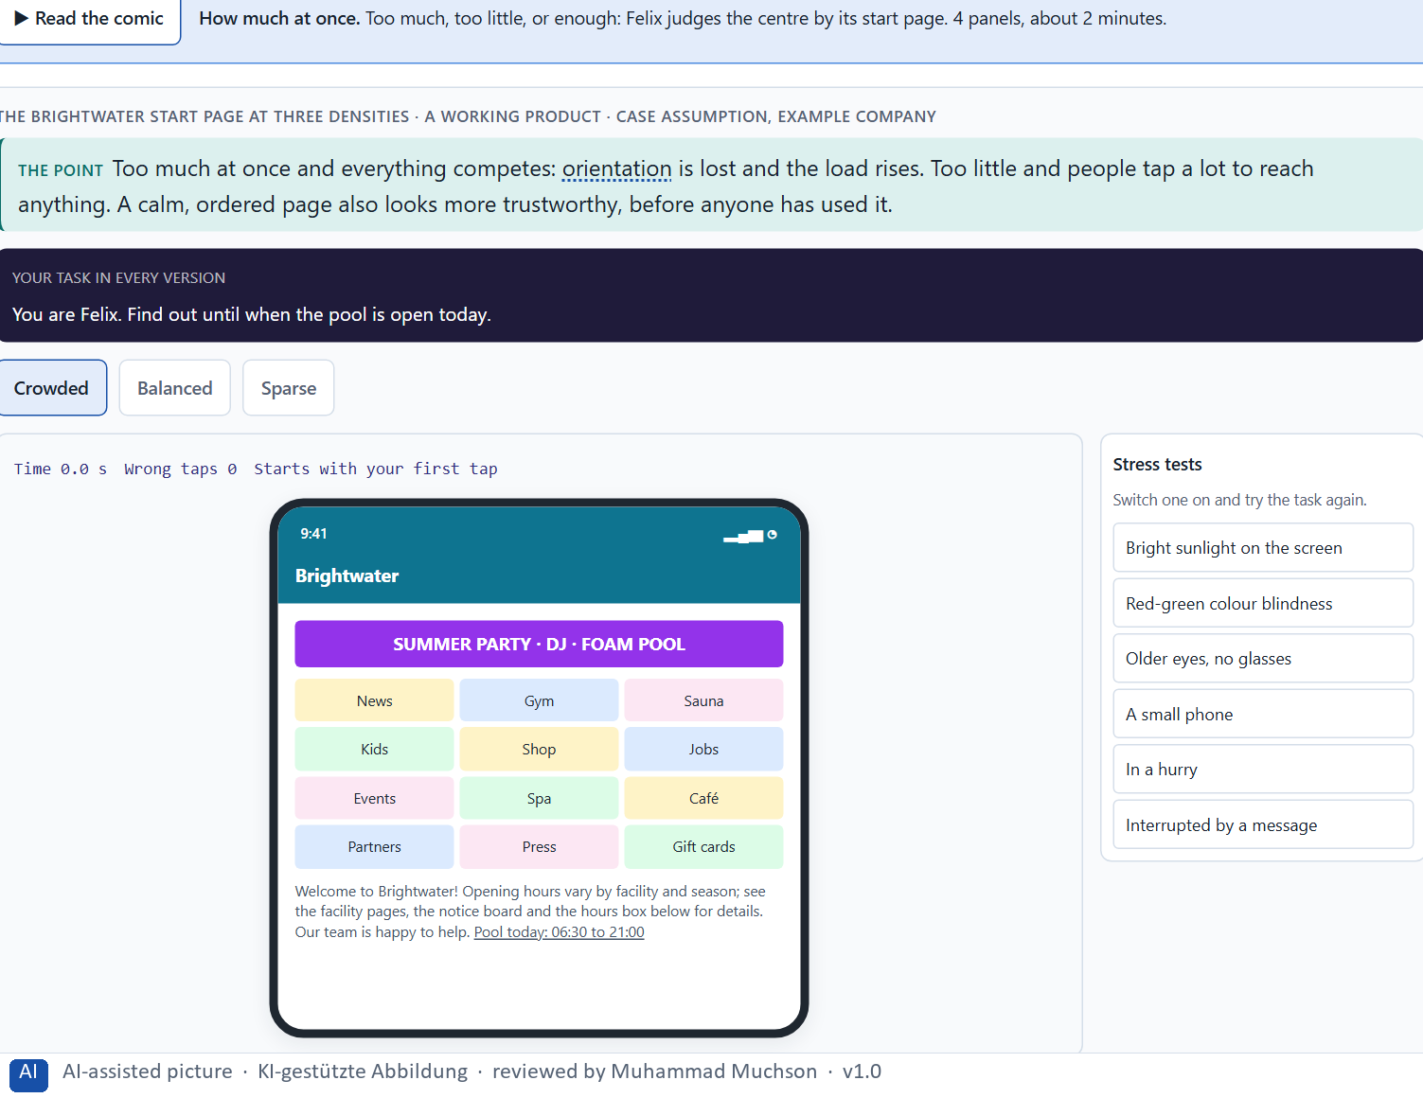
Figure 6 · The Brightwater start page at three densities. Shown here in its starting state; in the Neuro-UX Lab every version and every stress test can be used.
Three densities and what they do
Density | Orientation and load | How the product seems
Crowded | Everything competes; orientation is lost; the load is high. | Chaotic, less trustworthy.
Balanced | The main tasks are seen at once; the rest is close by. | Calm, well run, of higher quality.
Sparse | Calm, but the tasks are behind menus; many clicks. | Elegant, but it can seem empty or evasive.

Density, choice and trust: real findings
Finding | What was measured | What it means for a screen
Choice overload (Iyengar and Lepper 2000) | At a shop booth with 24 jams, about 60% of the passers-by stopped to taste and 3% of those who stopped bought a jar; with 6 jams, about 40% stopped and 30% of them bought. | More to choose from drew more interest and fewer decisions. The study rests on few purchases and later reviews find the effect inconsistent: treat it as a warning, not as a law.
Working memory (Cowan 2001) | People hold about four chunks in mind at once. | A screen that asks people to compare more than a few things at once asks for more than they have.
Design appeal and rejection (Sillence et al. 2004) | In a four-week study, fifteen women searching for health advice rejected sites because of their design appeal, and chose sites for the credibility of the information and its personalisation. | A cluttered or careless page is rejected before its content is judged: order earns the chance to be read.

Case assumption
Brightwater, Ana, Felix, Lea and Omar are made up for this example. Cognitive load follows Sweller (1988); the aesthetic-usability effect follows Kurosu and Kashimura (1995) and Tractinsky et al. (2000); simplicity as a facet of visual aesthetics follows Moshagen and Thielsch (2010). The findings in the table of real evidence are real research results and real cases; the sources are listed below.

How to decide when this comes up in the task
- Count what the first screen asks the user to take in at once. Every extra element adds to the cognitive load.
- A crowded page costs orientation; a very sparse one costs clicks. Choose the density for the task the page serves.
- Visual order changes how good a product seems: a disordered page is judged less trustworthy before it is used.
- On a phone the same content is longer and narrower, so density problems grow.

Extra · go deeper (optional reading)
Moshagen and Thielsch (2010) found four facets of how good a website looks: simplicity, diversity, colour and craftsmanship. Simplicity, the order and clarity of the layout, is the one a crowded page loses first. That is why an overloaded portal is judged not only harder to use but also of lower quality, even when its content is complete.

Sources · Sweller 1988 · Kurosu & Kashimura 1995 · Moshagen & Thielsch 2010 · Tractinsky et al. 2000 · Iyengar & Lepper 2000 · Cowan 2001 · Sillence et al. 2004

A5 · Recognition instead of search, clarity instead of overload, and weighing a measure · 10 min · Core
Let people recognise instead of search, and give a few clear signals instead of many loud ones. To put measures in order, weigh each on effect on users, effort, risk and timeliness, with a reason.
IN PLAIN WORDS
The idea. Two first principles of user guidance. Recognition instead of search: show people the options, words and next step so they can recognise them, instead of making them remember or hunt. Clarity instead of overload: a few clear signals do more than many loud ones. To put measures in order, weigh each one on the four questions Block 2.1 names: effect on users, effort (the time and the people it takes), risk and timeliness (how soon users notice it). The reason next to each rating matters more than the rating.
Why it matters. Block 1.1 asks for the two biggest hurdles for an inexperienced user, Block 1.2 asks you to rate start pages on findability and focus, and Block 2.1 asks you to rate four measures on effect, effort, risk and timeliness and to decide what comes first. The example uses Brightwater and its own measures, so the answer for the task cases is not given.
How to read the picture. Three measures Brightwater considered, rated on effect on users, effort, risk and timeliness. A rating is a reading of the example, not a mark. A table of recognition and clarity with evidence follows.

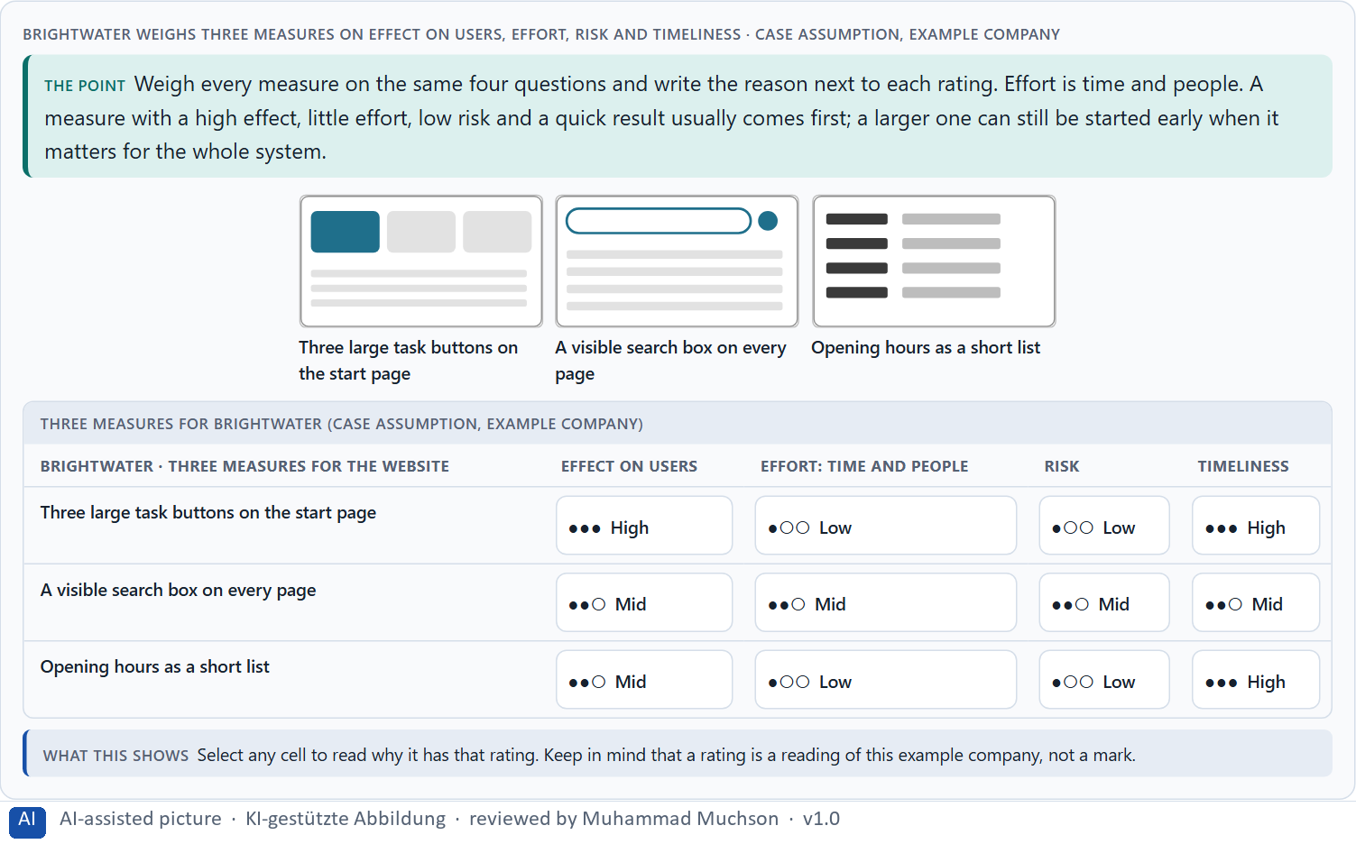
Figure 7 · Brightwater weighs three measures on effect on users, effort, risk and timeliness.
Recognition and clarity, with evidence
Principle | Real finding | What it looks like on a screen
Recognition rather than recall | Nielsen's sixth heuristic: make elements, actions and options visible so users do not have to remember them (Nielsen 1994). | A menu that lists the options; a form that shows the date format; the last search offered again.
Recognition memory is large | In Standing's experiments (1973) people recognised pictures they had seen once among thousands, with no sign of saturation after 10,000 pictures. | Show people the thing, with its picture and its words; do not ask them to name it from memory.
Clarity rather than overload | The design principles of GOV.UK list “Do less” second, directly after “Start with user needs” (Government Digital Service 2012). | Remove a signal before adding one: ask what the person can do without.

Case assumption
Brightwater, Ana, Felix, Lea and Omar are made up for this example. Recognition rather than recall and aesthetic and minimalist design are Nielsen's heuristics (1994); rating options on the same criteria with a reason follows Gibbons (2018). The four criteria are the ones the plan names for the case study. The findings in the table of real evidence are real research results and real cases; the sources are listed below.

How to decide when this comes up in the task
- Recognition instead of search: show the options, the words and the next step so people recognise them, instead of making them remember or hunt.
- Clarity instead of overload: one main action per screen, a visible search, and only the signals that help the task.
- Rate every measure on the same four questions: effect on users, effort (the time and the people it takes), risk, timeliness (how soon users notice it).
- A rating is a judgement with a reason, never a mark. A different order with a better reason is a better answer.
- A measure with a high effect, little effort, low risk and a quick result usually comes first; a larger, strategic one can still be started early.

Extra · go deeper (optional reading)
Effort on this course is always time and people: who has to work on a measure and for how long. That keeps the comparison honest when the money is fixed, and it shows where a measure needs a department's time, such as agreeing new names, rather than a developer's.

Sources · Nielsen 1994 · Krug 2014 · Gibbons 2018 · Standing 1973 · Government Digital Service 2012

Materi B · Route 2 · Level 3
How Materi B is used
About 60 minutes, three cards, led by the facilitator. Level 3 in the Chief Experience Officer's chair: a guiding vision of user-centred design, three strategic decisions, an order of the areas to rework, a risk analysis, a governance model, one decision under uncertainty and a statement to the management. The cards give you the ideas you use in Task 2.

B1 · Inside logic against user logic: why good UI decisions come from the user's side · 21 min · Core
Organisations tend to build what mirrors their own structure. Good UI decisions start from the users' tasks and words and work back to screens, structures and owners.
IN PLAIN WORDS
The idea. Organisations tend to build their digital services the way they are built themselves: one menu item per department, one page layout per team, the organisation's own words. Users do not know the organisation chart; they know their task. Good UI decisions therefore start from the users' tasks and words and work back to screens, structures and owners. When the inside logic wins, users search instead of being guided, and the problem is no longer a design problem but one of how the organisation decides.
Why it matters. Block 3.1 asks for a guiding vision, three decisions on orientation, structure, information priority and guidance, and an order of the areas to rework, for an organisation that discusses colours while the cause lies in its structure. You work from the users' tasks, not from the organisation chart.
How to read the picture. Left the same Brightwater services ordered by the inside logic, right by the users' tasks. Below, the chain from a single screen to the structure behind it. A table of the evidence for inside logic against user logic follows.

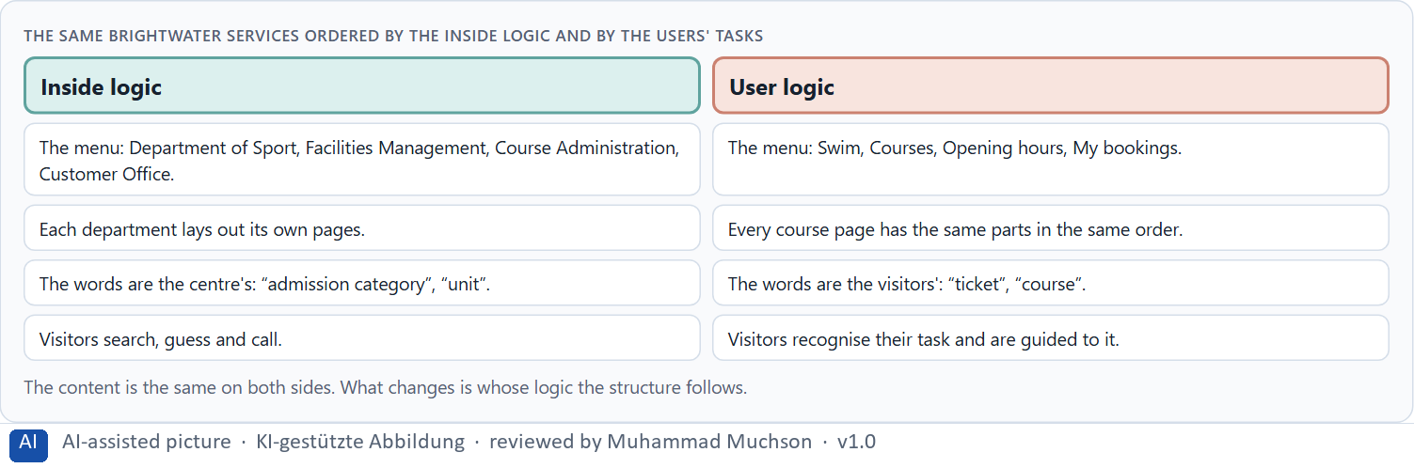
Figure 8 · The same Brightwater services ordered by the inside logic and by the users' tasks.
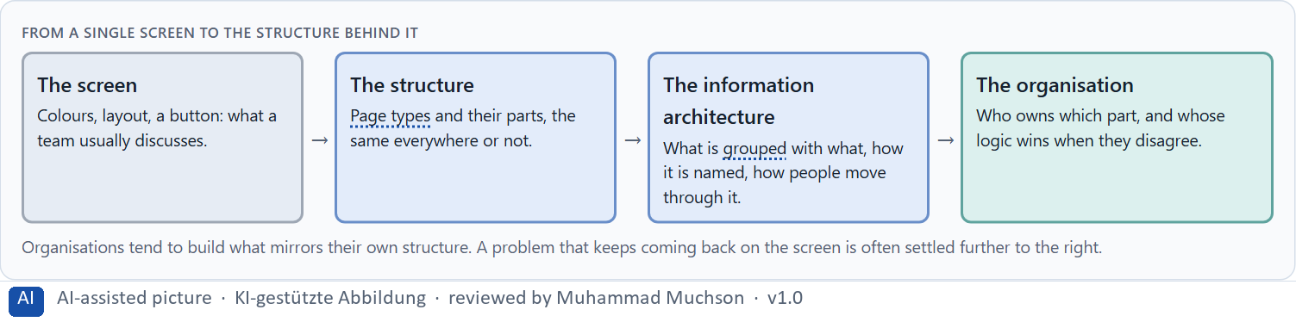
Figure 9 · From a single screen to the structure behind it.
Inside logic against user logic: the evidence
Evidence | What it shows | What it means for a decision
Conway 1968 | Organisations that design systems produce designs that are copies of their own communication structure. | A menu with one item per department is not a coincidence: it is the organisation chart on the screen.
Nagappan, Murphy and Basili 2008 | On Windows Vista (3,404 binaries, more than 50 million lines of code), measures of the organisation behind the code predicted failure-proneness better than measures of the code itself. | How an organisation is built shows in the product, down to its quality.
GOV.UK 2012 | The team did not copy the content of Directgov and Business Link; it started from user needs and built new pages and tools (Government Digital Service 2012). | To leave the inside logic, start from what the user comes to do and work back to the structure and the owners.
Card sorting (Spencer 2009) | Users group the content in their own words, and the groups are compared with the organisation's structure. | The gap between the two groupings is the inside logic, made visible.

Case assumption
Brightwater, Ana, Felix, Lea and Omar are made up for this example. That organisations build what mirrors their communication structure follows Conway (1968); labelling in the users' language follows Rosenfeld, Morville and Arango (2015); card sorting follows Spencer (2009). The findings in the table of real evidence are real research results and real cases; the sources are listed below.

How to decide when this comes up in the task
- Look for the organisation chart in the interface: menu items per department, page layouts per team, the organisation's words.
- Start from the users' tasks: name and order everything by what people come to do.
- When a problem keeps coming back on the screen, look further down: the structure, the information architecture, who owns them.
- Discussions about colours and single screens are a sign that nobody owns the structure.
- Find the users' logic with them, for example with a card sort, instead of guessing it from the inside.

Extra · go deeper (optional reading)
A card sort is simple: write the names of the content on cards, ask a few users to group them and name the groups, and compare their groups with your menu. Where users put things together that your menu keeps apart, the structure follows the inside logic.

Sources · Conway 1968 · Rosenfeld et al. 2015 · Spencer 2009 · Nagappan et al. 2008 · Government Digital Service 2012

B2 · Conflicts of goals: much information against simplicity, stakeholders against users · 20 min · Core
Much information against simplicity, standardisation against fit, stakeholders against users: the goals pull against each other. Show the few central tasks first and the rest one step deeper.
IN PLAIN WORDS
The idea. In user-centred design the goals pull against each other. Much information on the first page helps the department that wants everything seen, and hurts the user who needs relief. One standard for every page helps IT and predictability, and limits what a team can adapt. Activation helps marketing and can cost focus. A common way through is to show the few central tasks first and the rest one step deeper (progressive disclosure). The work is to name the conflict, choose, and say what you give up.
Why it matters. Block 3.1 asks for three guiding decisions, a risk analysis and a governance model for stakeholders with different goals. Each of these is a decision between conflicting goals.
How to read the picture. The matrix places five Brightwater start pages by how much they show at once (to the right) and how easily people find their task (upwards). A position is a reading of the example, not a score. A table of conflicts weighed with evidence follows.

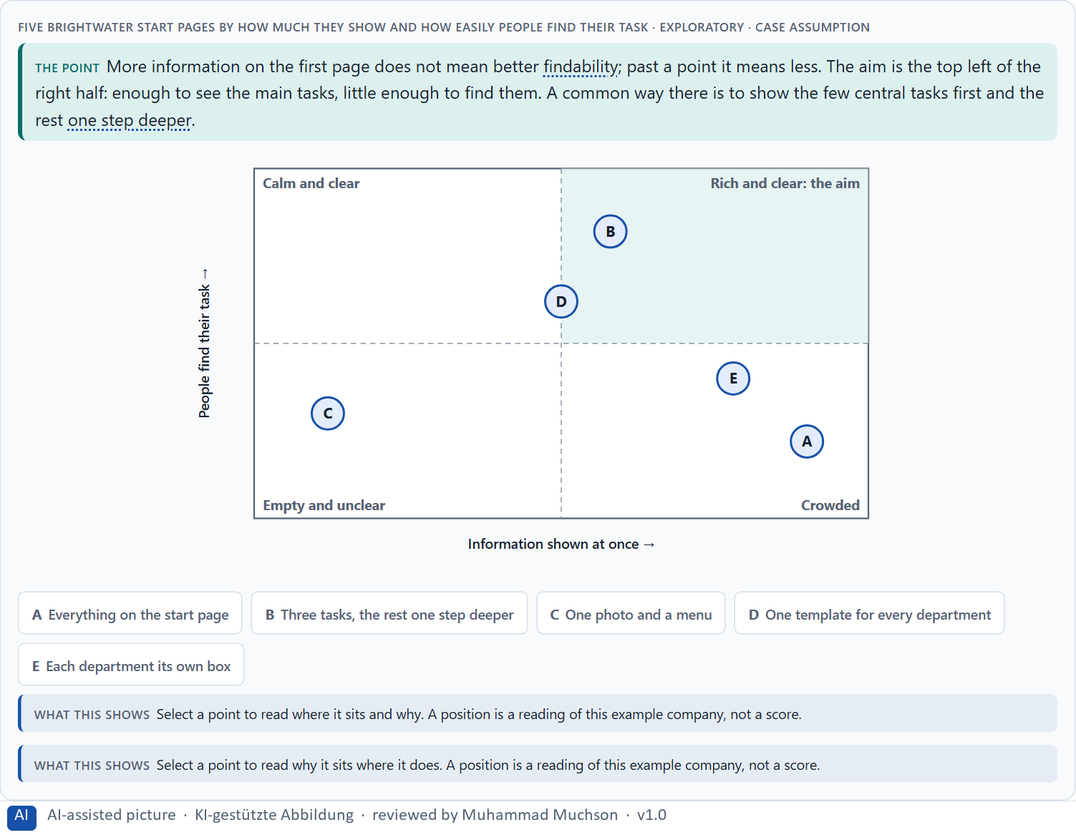
Figure 10 · Five Brightwater start pages by how much they show and how easily people find their task · Exploratory.
Three standing conflicts of user-centred design
Conflict | Who usually stands for each side | What to ask
Much information against simplicity | A department that wants everything seen, against users who need relief. | What do most users need first, and what can be one step deeper?
Standardisation against fit | IT and predictability, against a team with a special case. | Does the special case really need its own structure?
Stakeholders against users | Marketing's activation, a department's visibility, against the users' task. | Whose goal does this element serve, and at what cost to the task?

Conflicts weighed with evidence
Conflict | What the evidence says | A way to decide
Much information against simplicity | Users could read at most 28% of the words of an average page view (Nielsen 2008); a display of 24 jams led to fewer purchases than a display of 6 (Iyengar and Lepper 2000). | Show the few central tasks first and the rest one step deeper (Nielsen 2006); keep the detail available.
Stakeholders against users | For GOV.UK, the team analysed all the information on both old sites against user needs rather than carrying over each department's wish list (Government Digital Service 2012). | Put the user needs, found with users, on the table next to each department's wish.

Case assumption
Brightwater, Ana, Felix, Lea and Omar are made up for this example. Progressive disclosure follows Nielsen (2006); the matrix is a reading of the example, not a score. The findings in the table of real evidence are real research results and real cases; the sources are listed below.

How to decide when this comes up in the task
- Name the conflict as two goals before you choose between them, and say who stands for each.
- More on the first page is not better findability; past a point it is worse.
- Progressive disclosure: the few central tasks first, the rest on request, so the first screen stays clear.
- A standard for every page helps predictability and IT; say where it does not fit and what happens then.
- Say what the choice gives up; a decision that gives up nothing has not been made.

Extra · go deeper (optional reading)
Progressive disclosure has one condition: the first level must hold what most people need most of the time. If it does not, people dig through the second level for everything and the design is slower than a crowded page. Choosing the first level is therefore the real decision, and it needs evidence about the users' tasks.

Sources · Nielsen 2006 · Gibbons 2018 · Krug 2014 · Nielsen 2008 · Iyengar & Lepper 2000 · Government Digital Service 2012

B3 · User-centredness as the basis of accountable decisions: who owns the structure, and deciding with partial data · 19 min · Core
User-centredness lasts only when someone owns it. A decision with partial data says what it decides, what it does not know, when it would reverse it and what it gives up.
IN PLAIN WORDS
The idea. User-centredness only lasts when someone is responsible for it: who owns the structure and the words across all touchpoints, who answers for what users experience, and how a conflict between departments is settled. Because the data is rarely complete, a decision under uncertainty says four things: what you decide, what you do not know, when you would reverse it, and what you give up. A wrong priority is not neutral; it shows up as support effort and dissatisfied users.
Why it matters. Block 3.1 asks for a governance model, a decision under uncertainty that you can still justify, and a statement to the management. This card gives you the parts of each.
How to read the picture. The four boxes at the top are the parts of a decision, filled in for Brightwater. The two boxes below are the rule for future decisions. A table of a real governance example follows.

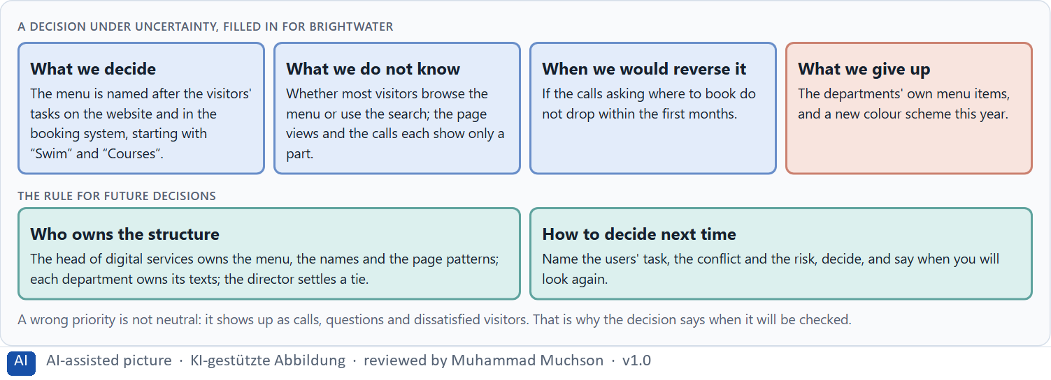
Figure 11 · A decision under uncertainty, filled in for Brightwater.
Three parts of a governance model for user-centred design
Part | The question | An example (Brightwater)
Who owns what | Who owns the structure, the names and the page patterns; who owns the content? | Digital services own the structure; each department owns its texts.
Who answers for it | Who answers for what users experience across touchpoints? | The head of digital services.
How conflicts are settled | What happens when departments want different things? | The visitors' task decides, shown by calls, searches and tests; the director settles a tie.

Owning user-centredness: a real example of governance
Part | Real example | What it means
A standard to meet | The GOV.UK Service Standard has 14 points since July 2019 (18 before); point 1 is to understand users and their needs. | Write down what every service must meet, and start with the users.
An assessment | Services are assessed against the standard by a panel; a published assessment report says whether point 1 was met and what evidence of users the panel saw. | Decide who checks, and on what evidence, before the work is finished.
A named order | “Start with user needs” stands first among the GOV.UK design principles. | The order of the principles shows what wins when they conflict.

Case assumption
Brightwater, Ana, Felix, Lea and Omar are made up for this example. Deciding with limited information follows Simon (1956); the premortem follows Klein (2007). The findings in the table of real evidence are real research results and real cases; the sources are listed below.

How to decide when this comes up in the task
- Name who owns the structure and the names across all touchpoints, and who owns only the content.
- Name who answers for what users experience, not only for a single page.
- Give conflicts a rule: the users' task decides, shown by evidence; where it does not settle it, a named person does.
- Say what you decide, what you do not know, when you would reverse it and what you give up.
- A wrong priority is not neutral: it shows up as support effort and dissatisfied users. Say when you will check.

Extra · go deeper (optional reading)
Before committing, imagine it is a year later and the reorganisation has failed, and ask why (Klein 2007). The answers are usually wrong assumptions about users: that they browse when they search, that they know a term they do not, that they use a desktop when they use a phone. Those are the assumptions to check first.

Sources · Simon 1956 · Klein 2007 · ISO 9241-210 · GOV.UK Service Standard · Government Digital Service 2012

Use in class: presentation and handout
Mark of use for the study material. Presentation is what the trainer shows on screen; Handout is what participants read and keep.
Card | Presentation (shown in the Neuro-UX Lab) | Handout
A1 · Seeing an interface, and designing from the user's side: user-centred against provider-centred design (Core) | Scan line and Figure 1; the "In plain words" and "How to decide" boxes | The whole card
A2 · How people scan, select and prioritise: perception as the basis of UI decisions (Core) | Scan line and Figures 2–3; the "In plain words" and "How to decide" boxes | The whole card
A3 · What guides the eye: contrast and colour, grouping and structure (Core) | Scan line and Figures 4–5; the "In plain words" and "How to decide" boxes | The whole card
A4 · How much at once: information density, orientation, load and why order looks like quality (Core) | Scan line and Figure 6; the "In plain words" and "How to decide" boxes | The whole card
A5 · Recognition instead of search, clarity instead of overload, and weighing a measure (Core) | Scan line and Figure 7; the "In plain words" and "How to decide" boxes | The whole card
B1 · Inside logic against user logic: why good UI decisions come from the user's side (Core) | Scan line and Figures 8–9; the "In plain words" and "How to decide" boxes | The whole card
B2 · Conflicts of goals: much information against simplicity, stakeholders against users (Core) | Scan line and Figure 10; the "In plain words" and "How to decide" boxes | The whole card
B3 · User-centredness as the basis of accountable decisions: who owns the structure, and deciding with partial data (Core) | Scan line and Figure 11; the "In plain words" and "How to decide" boxes | The whole card

References
Check each source and its current edition before you teach from it. Standards and laws marked as in flux can change.
ISO 9241-210:2019. Ergonomics of human-system interaction, Part 210: Human-centred design for interactive systems. (Defines user experience as a person's perceptions and responses that result from the use or anticipated use of a product, system or service.) Check the current edition before you teach from it.
Gould, J. D., & Lewis, C. (1985). Designing for usability: Key principles and what designers think. Communications of the ACM, 28(3), 300–311. (Early focus on users and their tasks, empirical measurement with real users, and iterative design: the core of user-centred design.)
Norman, D., & Nielsen, J. The Definition of User Experience (UX). Nielsen Norman Group. https://www.nngroup.com/articles/definition-user-experience/ (User experience covers every part of a person's interaction with a company, its services and its products; the interface is one part of it.)
Rosenfeld, L., Morville, P., & Arango, J. (2015). Information Architecture: For the Web and Beyond (4th ed.). O'Reilly. (Organising, labelling and navigation systems; labels should speak the users' language, not the organisation's.)
Treisman, A. M., & Gelade, G. (1980). A feature-integration theory of attention. Cognitive Psychology, 12(1), 97–136. (Simple features such as a colour pop out at once; a combination of features has to be searched one item at a time.)
Rayner, K. (1998). Eye movements in reading and information processing: 20 years of research. Psychological Bulletin, 124(3), 372–422. (Only the fovea, about 2° of the visual field, sees sharply; the eyes jump in saccades and rest in fixations of about 200 to 300 ms, taking in information only while they rest.)
Thorpe, S., Fize, D., & Marlot, C. (1996). Speed of processing in the human visual system. Nature, 381(6582), 520–522. (People tell whether a photo they see for 20 ms contains an animal, and the brain shows the difference about 150 ms after the image appears.)
Lindgaard, G., Fernandes, G., Dudek, C., & Brown, J. (2006). Attention web designers: You have 50 milliseconds to make a good first impression! Behaviour & Information Technology, 25(2), 115–126. (A first judgement of a web page forms within a fraction of a second and stays close to the judgement people give later.)
Government Digital Service (2012). Why GOV.UK matters, and the GOV.UK design principles. Government Digital Service blog. https://gds.blog.gov.uk/2012/10/17/why-gov-uk-matters (GOV.UK replaced Directgov and Business Link on 17 October 2012, starting from user needs; the design principles begin with “Start with user needs”. Reported figures such as 61% against 46% task success are the service's own.)
Nielsen, J. (1997). How Users Read on the Web. Nielsen Norman Group. https://www.nngroup.com/articles/how-users-read-on-the-web/ (Most users scan a page rather than read it word by word, picking out words, headings and links.)
Pernice, K. (2017). F-Shaped Pattern of Reading on the Web: Misunderstood, But Still Relevant (Even on Mobile). Nielsen Norman Group. https://www.nngroup.com/articles/f-shaped-pattern-reading-web-content/ (On text-heavy pages without structure, the eye often scans in an F-shape; headings, short paragraphs and clear structure change the pattern.)
Krug, S. (2014). Don't Make Me Think, Revisited (3rd ed.). New Riders. (People scan rather than read, follow conventions they know, and should be able to tell at once where they are and what they can do.)
Itti, L., & Koch, C. (2001). Computational modelling of visual attention. Nature Reviews Neuroscience, 2(3), 194–203. (Attention is pulled by what differs from its surroundings in colour, contrast, orientation and movement: the bottom-up side of seeing.)
Nielsen, J. (2008). How Little Do Users Read? Nielsen Norman Group (Alertbox, May 2008). https://www.nngroup.com/articles/how-little-do-users-read/ (On the average page view of 593 words, users could read at most 28% of the words, about 20% more realistically; an upper bound from time on page, not an eye-tracking result; the data are from 2005.)
Wagemans, J., Elder, J. H., Kubovy, M., Palmer, S. E., Peterson, M. A., Singh, M., & von der Heydt, R. (2012). A century of Gestalt psychology in visual perception: I. Perceptual grouping and figure–ground organization. Psychological Bulletin, 138(6), 1172–1217. (Things that are close together or look alike are seen as one group.)
Ware, C. (2012). Information Visualization: Perception for Design (3rd ed.). Morgan Kaufmann. (Contrast, colour and position decide what pops out; a visual order the eye can follow reduces the effort of search.)
Elliot, A. J., & Maier, M. A. (2014). Color psychology: Effects of perceiving color on psychological functioning in humans. Annual Review of Psychology, 65, 95–120. (Colour carries meaning learnt from context, such as red for danger or a stop; the effect depends on the context and the culture, so it is a hypothesis, not a law.)
W3C (2023). Web Content Accessibility Guidelines (WCAG) 2.2. https://www.w3.org/TR/WCAG22/ (Success criterion 1.4.1 Use of Color: colour must not be the only way to convey information; 1.4.3 Contrast (Minimum) for text.)
Nielsen, J. (1994, reviewed 2024). 10 Usability Heuristics for User Interface Design. Nielsen Norman Group. https://www.nngroup.com/articles/ten-usability-heuristics/ (Visibility of system status, consistency and standards, recognition rather than recall, aesthetic and minimalist design.)
Wong, B. (2011). Color blindness. Nature Methods, 8(6), 441. (About 8% of men and under 1% of women have a colour vision deficiency, so colour alone must not carry a meaning.)
Gnambs, T. (2020). Limited evidence for the effect of red color on cognitive performance: A meta-analysis. Psychonomic Bulletin & Review, 27. https://doi.org/10.3758/s13423-020-01772-1 (After a correction for publication bias, no evidential value for an effect of red on intellectual performance: a caution against claims that a colour changes behaviour.)
Wertheimer, M. (1923). Untersuchungen zur Lehre von der Gestalt II. Psychologische Forschung, 4, 301–350. (The founding description of perceptual grouping by proximity, similarity, continuity and closure.)
Sweller, J. (1988). Cognitive load during problem solving: Effects on learning. Cognitive Science, 12(2), 257–285. https://doi.org/10.1207/s15516709cog1202_4 (Working memory is limited; effort spent on working out a screen is missing for the task itself.)
Kurosu, M., & Kashimura, K. (1995). Apparent usability vs. inherent usability: Experimental analysis on the determinants of the apparent usability. CHI '95 Conference Companion, 292–293. (People judge an ordered, attractive interface as easier to use: the aesthetic-usability effect.)
Moshagen, M., & Thielsch, M. T. (2010). Facets of visual aesthetics. International Journal of Human-Computer Studies, 68(10), 689–709. (Simplicity, diversity, colour and craftsmanship shape how good a website seems; simplicity is the order and clarity of the layout.)
Tractinsky, N., Katz, A. S., & Ikar, D. (2000). What is beautiful is usable. Interacting with Computers, 13(2), 127–145. (People judge an attractive interface as easier to use before they have used it; looks shape the first judgement, they do not replace testing.)
Iyengar, S. S., & Lepper, M. R. (2000). When choice is demotivating: Can one desire too much of a good thing? Journal of Personality and Social Psychology, 79(6), 995–1006. (Many options can attract interest and still make people choose less often.)
Cowan, N. (2001). The magical number 4 in short-term memory: A reconsideration of mental storage capacity. Behavioral and Brain Sciences, 24(1), 87–114. (The limit of working memory is nearer four chunks than seven.)
Sillence, E., Briggs, P., Fishwick, L., & Harris, P. (2004). Trust and mistrust of online health sites. Proceedings of CHI 2004, 663–670. (Fifteen women searched for health advice over four weeks: design appeal predicted the rejection of a site, credibility of the information and personalisation predicted its selection.)
Gibbons, S. (2018). Using Prioritization Matrices to Inform UX Decisions. Nielsen Norman Group. https://www.nngroup.com/articles/prioritization-matrices/ (Rate each option on the same few criteria, such as value to the user against effort, and put the reason next to each rating.)
Standing, L. (1973). Learning 10,000 pictures. Quarterly Journal of Experimental Psychology, 25(2), 207–222. https://doi.org/10.1080/14640747308400340 (Recognition memory for pictures has an almost limitless capacity: no sign of saturation after 10,000 pictures.)
Conway, M. E. (1968). How do committees invent? Datamation, 14(4), 28–31. (Organisations tend to produce designs that copy their own communication structure: the menu mirrors the departments.)
Spencer, D. (2009). Card Sorting: Designing Usable Categories. Rosenfeld Media. (Card sorting shows how users group and name content, so the structure can follow their logic.)
Nagappan, N., Murphy, B., & Basili, V. (2008). The influence of organizational structure on software quality: An empirical case study. Proceedings of ICSE 2008, 521–530. (On Windows Vista, measures of the organisation behind the code predicted failure-proneness better than measures of the code.)
Nielsen, J. (2006). Progressive Disclosure. Nielsen Norman Group. https://www.nngroup.com/articles/progressive-disclosure/ (Show the few most important options first and the rest on request; it helps both new and experienced users.)
Simon, H. A. (1956). Rational choice and the structure of the environment. Psychological Review, 63(2), 129–138. (With limited information and time, people choose an option that is good enough rather than the best one: a decision under uncertainty.)
Klein, G. (2007). Performing a project premortem. Harvard Business Review, 85(9), 18–19. (Imagine the plan has failed and ask why; it brings risks and wrong assumptions to the surface before the work starts.)
GOV.UK Service Manual. Service Standard. https://www.gov.uk/service-manual/service-standard (14 points since July 2019, 18 before; point 1 is to understand users and their needs; services are assessed against the standard.)

Glossary
Every term below is used in this document. Terms stay plain text in the body; this list says what they mean in everyday words.
Term | In plain words | Example | Comes from
Aesthetic-usability effect | People judge an ordered, attractive interface as easier to use, often before they have used it. | — | Day 2
Attention | The mind's spotlight. Only a small part of a screen is processed at any moment; attention decides which part. | A flashing banner takes attention away from the form you were filling in. | Day 1
Card sorting | A simple method: users sort cards with the names of content into groups and name the groups, which shows how they think the content belongs together. | — | Day 2
Case assumption | A fact made up for this exercise to fill a gap in the plan's case. It is marked so you know it is not part of the plan. | — | Day 1
Chief Experience Officer | The manager who is responsible for the experience customers have across all channels, and who decides where the company invests in it. | — | Day 1
Cognitive load | How much a person has to hold in mind and work out at the same time. Every extra signal or choice adds to it; when it is too high, people skip, freeze or leave. | — | Day 1
Consistency | The same thing looks, is named and works the same way everywhere, so what people learn on one page holds on the next. | — | Day 2
Contrast | How much something differs from its surroundings in brightness, colour or size. Strong contrast makes it stand out; too many strong contrasts make everything compete. | — | Day 2
F-pattern | A common way the eye scans a text-heavy page without structure: across the top, across a little lower, then down the left edge. Headings and short blocks break it up. | — | Day 2
Findability | How easily people can find what they are looking for, by browsing the menu or by searching. | — | Day 2
Gestalt principles | Rules for how people see parts as a whole, such as proximity (close things belong together) and similarity (alike things belong together). | — | Day 2
Governance | The rules about who may decide what, who is answerable for it and how disagreements are settled. | — | Day 1
Grouping | Showing what belongs together, for example by putting it close together or making it look alike. The eye reads a group as one unit. | — | Day 2
Information architecture | How the content of a website or app is organised, grouped and named, and how people move through it. It is the structure behind the screens. | — | Day 2
Information density | How much a screen shows at once. Too much and everything competes; too little and people have to click a lot to reach anything. | — | Day 2
Neuro-UX | Designing an interface with knowledge of how the brain sees, attends, feels and decides, so that the design steers these processes on purpose and responsibly. | — | Day 1
Orientation | Knowing where you are, what you can do here and what happens next. | — | Day 1
Page type | A kind of page that appears many times, such as a course page, a certificate page or a booking page. Each type should keep the same structure. | — | Day 2
Perception | Taking in what the senses deliver, for example what the eyes see on a screen, before thinking about it. | — | Day 1
Primary action | The one thing most people on a screen came to do, such as “Report damage”. It should be the easiest thing to see and press. | — | Day 1
Progressive disclosure | Showing the few most important things first and the rest one step deeper, on request, so the first screen stays clear. | — | Day 2
Provider-centred design | Designing from the organisation's own point of view: its departments, its terms and what it wants to say. The result is often complete but hard to use. | A menu with one item per department, named as the departments call themselves. | Day 2
Recognition instead of recall | Showing people the options and the next step so they can recognise them, instead of making them remember or hunt for them. | — | Day 2
Scanning | Looking over a screen quickly and picking out what seems relevant, instead of reading it word by word. Most people scan first. | — | Day 2
Stakeholder | A person or department with an interest in a decision, such as marketing, compliance, IT or sales. | — | Day 1
Timeliness | How soon a measure shows its effect for the users. A measure with high timeliness is noticed in days or weeks, not next year. | — | Day 2
Touchpoint | Any place where a person meets the company: the website, the customer portal, the app, a chatbot or a phone call. | — | Day 1
UI (user interface) | What a person sees and touches on a screen: buttons, colours, text, icons and their layout. It is the surface of the experience. | Changing a button from grey to blue is a UI change. | Day 1
User-centred design | Designing from what the users come to do, how they see and what words they use, and checking the design with them, instead of starting from how the organisation is built. | — | Day 2
UX (user experience) | Everything a person goes through when using a product: what they notice, understand, feel and do, from the first look to the last step. The screens are only one part of it. | Finding the booking you want at once and feeling sure it went through is a good UX. | Day 1
Visual guidance | Using contrast, grouping and structure on purpose so the eye goes first to what matters and then along a clear path. | — | Day 2

The Neuro-UX Lab: where we practise online
In class we use the course website as the place to practise and to learn. Every day has its own address, in the same pattern: the day number is the last part.
What | Address
Neuro-UX Lab (course website) | https://aion-ux-lab.vercel.app/
Day 2 | https://aion-ux-lab.vercel.app/day/2/

On the day page, Route 1 (Levels 1 and 2) and Route 2 (Level 3) can be opened; the cards and the tasks of this document are there too. The pattern is the same up to Day 8, for example https://aion-ux-lab.vercel.app/day/6/.

