AION · UX DEVELOPER · PSYCHOLOGICAL UX DESIGN AND NEURO-UX
DAY 2 · TASK 1 AND TASK 2 · ROUTES 1 AND 2 · LEVELS 1 TO 3
CampusNow: UX Analysis File and UX Strategy Memo
Describe the effect, choose the measures as a team member, and decide as Chief Experience Officer
AI notice · KI-Hinweis
This document was produced with the help of an AI language model (Claude, Anthropic). The AI drafted the text and tables and built the pictures and working examples of the lab. The content was then read, corrected and approved by the reviewer named below, who is responsible for its accuracy. Every picture carries an AI label on the image. Check figures and sources before you quote them.
KI-Hinweis: Dieses Dokument wurde mit Unterstützung eines KI-Sprachmodells (Claude, Anthropic) erstellt. Texte und Tabellen wurden von der KI entworfen, die Abbildungen sind KI-gestützt erstellt und am Bild gekennzeichnet. Die fachliche Prüfung und Freigabe erfolgte durch die unten genannte Person.

Day | Day 2 · Module 2 (day 1 of 2): Visual perception and user-centred design
Document | Task (worksheet with answer spaces). Task 1 (UX Analysis File) and Task 2 (UX Strategy Memo).
Route and level | Task 1 = Route 1, Levels 1 and 2 (draws on Materi A). Task 2 = Route 2, Level 3 (draws on Materi B).
Time | Task 1 about 33 min · Task 2 about 20 min
Neuro-UX Lab (website) | https://aion-ux-lab.vercel.app/day/2/
Case | CampusNow, the day's case study; other products appear as warm-ups
Version | 1.0 · release date 29.10.2026
Review and approval | Muhammad Muchson, Mentor (subject-matter review and approval)

ABOUT THIS DOCUMENT
In class we also use the Neuro-UX Lab, the course website, as the place to practise and learn. Its address is at the end of this document.
This is the worksheet for Day 2. Read the case once, study the evidence printed in this document, and write your answers in the boxes and tables. You can work through it on paper or type into the document. All blocks are Core. There are no answer keys and no scores; the reason you give matters more than the choice.

IN THIS DOCUMENT
Lesson plan: ten teaching units (Ablaufplan)
Case study and transfer project at a glance
The case: three portals on the UX team's desk, and CampusNow
Block 1.1 · Read an interface as a user and find perception barriers: CityDesk · JUDGED · Core · about 10 min
Block 1.2 · Rate user-centred design under conflicting goals: EduFlex · JUDGED · Core · about 8 min
Block 2.1 · Case study: reorganising the service portal CampusNow · JUDGED · Core · about 15 min
The situation: the education organisation behind CampusNow, and all its touchpoints
Block 3.1 · A user-centred design architecture for a digital service · JUDGED · Core · about 20 min

Day at a glance
Day 2 has ten teaching units (UE). This document is the worksheet; it is used in UE2 to UE6 (Task 1) and UE8 to UE10 (Task 2). The day is built from three documents and the Neuro-UX Lab: Materi (study material), Task (worksheet) and Trainer (coaching, feedback and model solutions), plus the course website.

Lesson plan: ten teaching units (Ablaufplan)
UE | Min | Plan item | What happens | Material | Format
1 | 45 | Knowledge transfer · Level 1 | The trainer presents the cards of Materi A (A1, A2, A3, A4, A5, about 60 min of cards) in the Neuro-UX Lab; participants follow in the handout. | Materi A (Route 1) | Presentation + Handout
2 | 45 | Level 1 · Task 1 | Individual work on Block 1.1 (Core, about 10 min): the first product of the day is read and its effect described. Pairs then compare their results and the trainer collects open questions. | Task 1 · Part 1 · Block 1.1 | Handout (or in the lab)
3 | 45 | Level 1 · Task 2 | Three options are rated on the same criteria and one is chosen under the stated conditions: Block 1.2 (Core, about 8 min). | Task 1 · Part 1 · Block 1.2 | Handout (or in the lab)
4 | 45 | Coaching · transition from Level 1 to Level 2 | Trainer-led. A short talk on the day's coaching focus, then the reflection questions in pairs. The bridge: from describing an effect to a decision you answer for. There is no worksheet block in this unit. | Trainer document, section Coaching | Trainer only
5–6 | 90 | Level 2 · Case study CampusNow (2 UE) incl. model solution | UE5: the trainer presents the case; participants work on Block 2.1 (Core, about 15 min). UE6: groups compare their results and defend them; the trainer closes with the model solution. | Task 1 · Part 2 · Block 2.1  Trainer document, section Case study | Handout; model solution shown after the work
7 | 45 | Level 2 + 3 · Feedback round with a management perspective | Groups present their reasoning, not only their result. The trainer asks the day's Level 3 input questions and leads the discussion. | Trainer document, section Feedback round | Presentation by the groups; Trainer only
8 | 45 | Level 3 · Transfer project, Chief Experience Officer (3 UE: UE8–10) | The trainer presents Materi B (B1, B2, B3; use the "In plain words" and "How to decide" boxes, the rest is handout) and sets the role and the situation. | Materi B (Route 2) | Presentation + Handout
9 | 45 | Level 3 · Transfer project | Individual work or in pairs on Block 3.1 (Core, about 20 min): the strategy memo. | Task 2 · Block 3.1 | Handout (or in the lab)
10 | 45 | Level 3 · Transfer project | Participants present their decision and what they give up, including the one decision made under uncertainty; the trainer debriefs with the model solution. | Task 2 · Block 3.1  Trainer document, section Transfer project | Handout; model solution shown after the work

One UE is counted as 45 minutes here; breaks are not shown. The times are a guide for the trainer. The Core blocks are enough for a complete answer.

Case study and transfer project at a glance
Component | UE | Duration | Participants work in | Model solution in
Level 2 case study (CampusNow) | UE5–6 | 2 UE · 90 min | Task 1 · Part 2 (Block 2.1) | Trainer document, section Case study
Level 3 transfer project (Chief Experience Officer) | UE8–10 | 3 UE · 135 min | Materi B and Task 2 (Block 3.1) | Trainer document, section Transfer project

Which plan item each block answers
UE | Plan item (Strukturplan, Day 2) | Block in this document
UE2 | Level 1, task 1 · Read an interface as a user and find perception barriers: CityDesk | Block 1.1 (Core)
UE3 | Level 1, task 2 · Rate user-centred design under conflicting goals: EduFlex | Block 1.2 (Core)
UE4 | Coaching: from describing to deciding | A classroom talk led by the trainer; not a worksheet block
UE5–6 | Level 2 case study · Case study: reorganising the service portal CampusNow | Block 2.1 (Core)
UE7 | Feedback round with a management perspective | A classroom discussion led by the trainer; not a worksheet block
UE8–10 | Level 3 transfer project · A user-centred design architecture for a digital service | Block 3.1 (Core), in Task 2

Your name
Write your full name here. Use the same name on every Task document this week; it is how your work is matched.

Task 1 · Route 1 · UX Analysis File: read the interface as a user, then decide what to change

The case: three portals on the UX team's desk, and CampusNow
Read once · about 3 min
You work in the UX team of a digital agency. This week three products land on your desk. Two are warm-ups: CityDesk, a booking portal for municipal services, and EduFlex, a platform for professional further education that has three designs for its start page. The main case is CampusNow, the portal of an education organisation for course booking, certificates, dates and learning materials. All the content is there, but people cannot find many functions, complaints are rising, bookings are abandoned more often, and using it on a phone is especially hard.
What the plan gives you | How the task runs · three blocks
• Block 1.1: CityDesk, with 12 menu items of similar visual weight, the most important services not emphasised, very dense text, competing boxes, colours and lines, an inconspicuous search, and important forms only after long scrolling  • Block 1.2: three start pages for EduFlex; published within 10 weeks, working people with little time, marketing wants high activation, the department wants much information on the start page, a limited budget for test runs, no real user data  • Block 2.1: CampusNow, with €150,000 and 14 weeks, no complete relaunch, first improvements visible quickly, and marketing, support and IT each asking for something else | • Block 1.1: read an interface as a user. Say what a first-time user sees first, name five obstacles, sort them into five categories, write three effect statements and pick the two biggest hurdles.  • Block 1.2: rate three designs under conflicting goals. Rate each start page on five criteria, choose one, name the conflicts and the remaining risks, and write a recommendation to the project lead.  • Block 2.1: the case study. The central problems, sorted into five categories, four user-centred measures, rated on four criteria, a decision for the first 14 weeks and a recommendation to the division management.

What is known and what is open
In the brief | Clear · Case assumption | Open · on purpose
• CityDesk: 12 menu items of similar weight, main services not emphasised, dense text, competing boxes and colours, an inconspicuous search, forms only after long scrolling.  • EduFlex: three start pages described in words; 10 weeks, working people with little time, a limited test budget, no real user data.  • CampusNow: an overloaded start page, navigation in internal terms, unprioritised functions, inconsistent page types, long text blocks; €150,000 and 14 weeks; no relaunch. | • You review CityDesk and EduFlex as an agency would: from their screens, with no access to their data.  • CampusNow belongs to a regional education organisation with several departments; each department edits its own pages.  • The navigation of CampusNow follows the organisation chart: each menu item is the name of a department.  • Support keeps a list of the questions it is asked most; nobody has looked at it for the portal yet. | • How many people use each product: no figure is given.  • How much worse the phone is than the desktop: the plan says only that it is especially problematic.  • Which EduFlex start page the target group would prefer: there is no real user data.  • How much of the €150,000 each measure would take: the plan does not say.

As in most projects, not everything is known. Decide anyway, and say what you assume.
Case assumption
The brief says: CityDesk with 12 equally weighted menu items, unemphasised main services, dense text, competing boxes, an inconspicuous search and forms far down; EduFlex's three start pages under 10 weeks, a target group with little time, a limited test budget and no user data; CampusNow with an overloaded start page, internal naming, inconsistent page types, long texts, €150,000, 14 weeks and no relaunch. Those are the plan's facts and its only figures. Everything else is made up for this exercise: the agency, the pictures, the simulations and the facts marked “Clear”.

Part 1 · Read the interface and weigh designs · Level 1 · Knowledge

Block 1.1 · Read an interface as a user and find perception barriers: CityDesk · JUDGED · Core · about 10 min
Draws on: A1 · Seeing an interface, and designing from the user's side · A2 · How people scan, select and prioritise · A3 · What guides the eye · A4 · How much at once.
You receive the description of a fictional booking portal, CityDesk, for municipal services such as an appointment at the citizens' office or a parking permit. Open it and use it as someone who has never seen it before. You need no prior knowledge: ask yourself where your eye goes, what you would look for and what stops you. The aim is to take the user's perspective and make perception problems visible step by step.
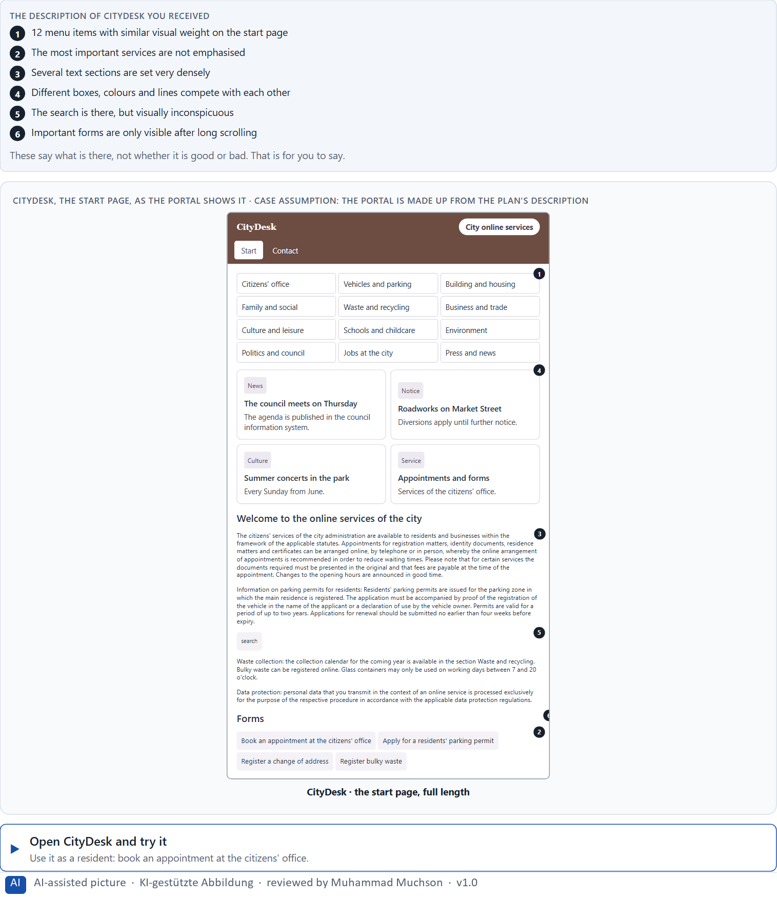
Figure 1 · CityDesk, the start page, as the portal shows it.
Question 1 of 5 · Describe what a first-time user probably perceives first
Say what the eye goes to first, second and third, and why.
How to build the answer:
- Open CityDesk and look at the start page for five seconds without clicking.
- Write down where your eye went first, second and third.
- For each, say what made it stand out: size, colour, contrast, position or movement.

Question 2 of 5 · Name 5 obstacles that could make orientation or understanding difficult
How to build the answer:
- Try to do one thing a resident would come for, for example book an appointment at the citizens' office.
- Write down every place where you hesitate, search or read twice.
Write them as a list, one obstacle per line, and say what it makes difficult.

Question 3 of 5 · Assign the problems to the categories visual guidance, information density, structure, findability and readability
Write the problems that belong to each category in a few words. A problem may fit two categories; put it where its effect is strongest.
How to build the answer:
- Take your five obstacles from question 2 one at a time.
- Ask what each one does: misleads the eye, crowds the page, breaks the order, hides the way, or makes reading hard.
- Write it under that category. Each of the five is touched by CityDesk.
Category | The problems in this category
Visual guidance
Information density
Structure
Findability
Readability

Question 4 of 5 · Write an effect statement for three of your observations: “For users this could mean that …”
How to build the answer:
- Pick three observations from questions 1 to 3.
- Finish the plan's sentence with what the user would do or fail to do, not with a judgement of the design.
Write them as a list, one statement per line, each starting with the observation and ending with what it could mean for users.

Question 5 of 5 · Determine the two biggest hurdles from the point of view of an inexperienced user
How to build the answer:
- Think of someone who uses the portal once a year and has never seen it before.
- Pick the two obstacles that would stop that person, not only slow them down, and say why.
Write them as a list, the bigger hurdle first, each with the reason it is so big for an inexperienced user.

Block 1.2 · Rate user-centred design under conflicting goals: EduFlex · JUDGED · Core · about 8 min
Draws on: A1 · Seeing an interface, and designing from the user's side · A4 · How much at once · A5 · Recognition instead of search, clarity instead of overload, and weighing a measure.
EduFlex is a platform for professional further education. Three designs for its start page are described in words: A) much content directly visible and a high volume of information, but little visual calm; B) a clear structure and less information, but more clicks to the goal; C) strongly image-led and modern, but the central functions recede into the background. The conditions: the platform is to be published within 10 weeks, the target group is working people with little time, marketing wants high activation, the department wants a lot of information directly on the start page, the budget for test runs is limited and there is no real user data yet. Decide anyway, and say what you assume.
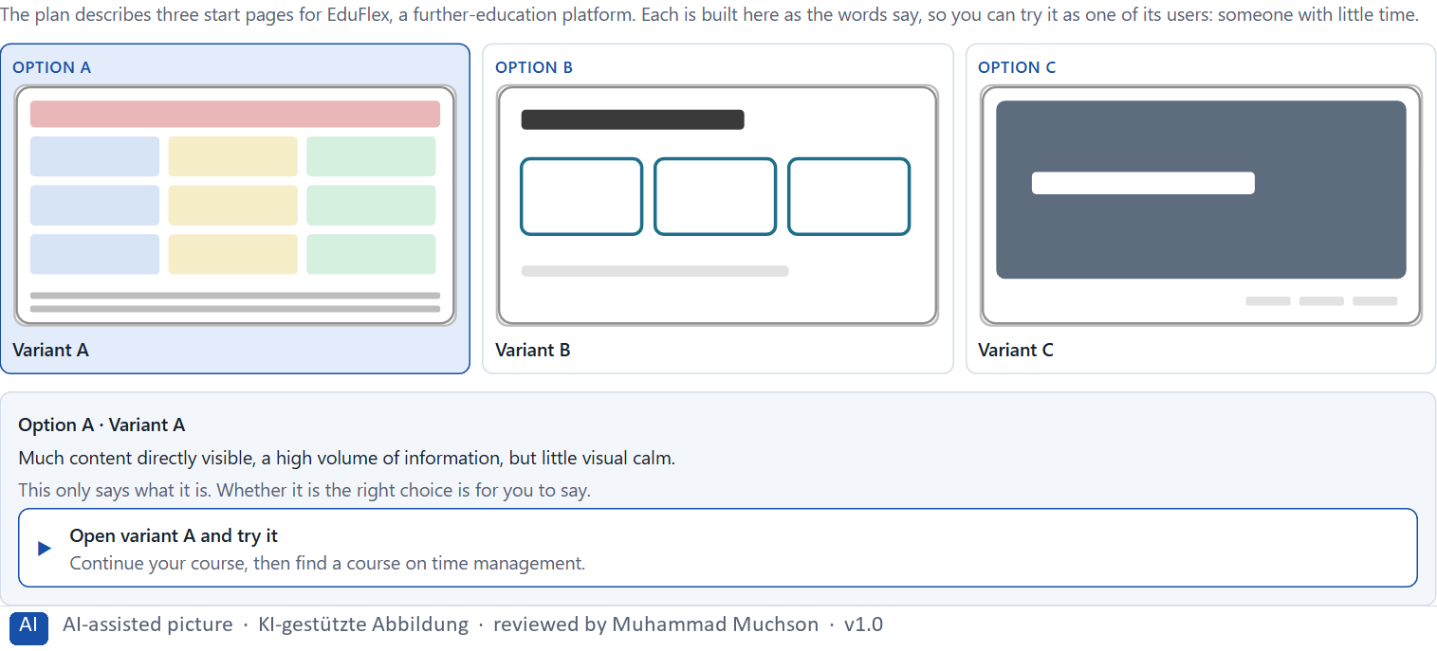
Figure 2 · The product to read, as the lab shows it (variants).
Question 1 of 5 · Rate each variant on orientation, findability, understandability, focus and user-friendliness
Write a few sentences for each variant that cover all five criteria. Many teams rate each criterion Low, Medium or High with a reason; you may do that or write it in your own words.
How to build the answer:
- Take one variant at a time and keep the target group in mind: working people with little time.
- For each criterion, say how the variant does and which feature of its description makes you say so.
- Use the same five criteria for every variant, so you can compare them.
Variant | Orientation | Findability | Understandability | Focus | User-friendliness
Variant A · much content, little visual calm
Variant B · clear structure, more clicks
Variant C · image-led, central functions recede

Question 2 of 5 · Decide which variant is the most viable from a user-centred point of view at present
Choose one variant, then give your reason below. There is no single right choice; the reason has to rest on the users and the conditions.
How to build the answer:
- Say what the target group needs most.
- Say how your choice meets it better than the other two.
Tick one:
☐ Variant A · much content, little visual calm
☐ Variant B · clear structure, more clicks
☐ Variant C · image-led, central functions recede
Why this variant, from the users' point of view?
Give your reason with the target group and the conditions: working people with little time, 10 weeks, a limited test budget, no user data.
How to build the answer:
- Name what the target group needs most.
- Say how your variant meets it and why the other two meet it less well.
- Say what your choice gives up.

Question 3 of 5 · Name the conflicts of goals that make your decision difficult
Name at least two conflicts, each as two goals that pull against each other.
How to build the answer:
- Look at who wants what: marketing, the department, the users.
- Write each conflict as “… against …”, and say who stands for each side.

Question 4 of 5 · Which risks remain, although you have to decide?
Name at least one risk that remains and who would feel it.
How to build the answer:
- Think of what your chosen variant is weak at.
- Say who would notice and what would happen.

Question 5 of 5 · Formulate a short decision recommendation for the project management
Two to four sentences: what you recommend, why, and what you will check next.
How to build the answer:
- Lead with the recommendation.
- Give the one reason the project management can follow.
- Say what you will check once the platform is live.

Part 2 · The case study · Level 2 · Application · Case study (2 UE)
Case study: 2 teaching units (UE5–6)
This part is the day's Level 2 case study. It takes 2 UE (about 90 minutes): UE5 for the briefing and your own work, UE6 for comparing your results with your group and for the trainer's closing. The block below needs about 15 minutes of writing; the rest of the time is discussion.

Block 2.1 · Case study: reorganising the service portal CampusNow · JUDGED · Core · about 15 min
Draws on: A1 · Seeing an interface, and designing from the user's side · A2 · How people scan, select and prioritise · A3 · What guides the eye · A4 · How much at once · A5 · Recognition instead of search, clarity instead of overload, and weighing a measure.
An education organisation runs CampusNow, a digital portal for course booking, certificates, dates and learning materials. All the content is there, but users find many functions only with difficulty. Complaints are rising, abandonment in the booking process is increasing, and mobile use is especially problematic. The observed problems: the start page is overloaded with information, the navigation items are named after the internal organisation, important functions are not visually prioritised, different page types use different structures, the text blocks are long and hard to scan, and users often have to search instead of being guided directly. The conditions: a budget of €150,000, 14 weeks for the implementation, no complete relaunch, first improvements have to be visible quickly, and marketing asks for a modern look, support for fewer questions and IT for standardisation. You work through six steps.
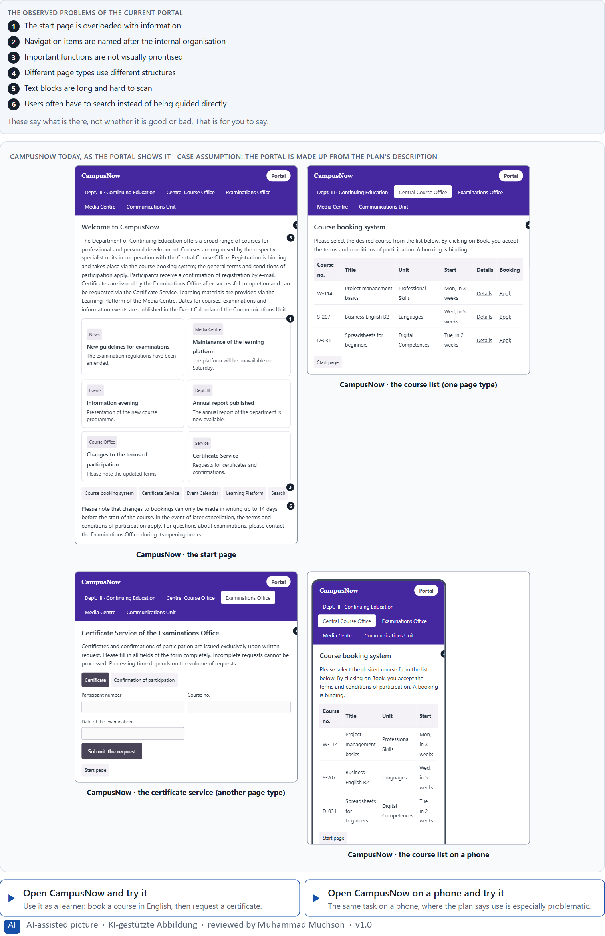
Figure 3 · CampusNow today, as the portal shows it.
Question 1 of 6 · Analyse the central perception and structure problems of the portal
How to build the answer:
- Open CampusNow and book a course as a learner would, once on the desktop and once on the phone.
- Write one problem per line as an effect on the user: what the portal makes hard, not only what is wrong with it.
Write them as a list, one problem per line, each as an effect on the user. At least five.

Question 2 of 6 · Assign the problems to the categories orientation, readability, findability, consistency and cognitive load
Write the problems that belong to each category in a few words. A problem may fit two categories.
How to build the answer:
- Take your problems from question 1.
- Ask which of the five categories each one affects most, and write it there.
Category | The problems in this category
Orientation
Readability
Findability
Consistency
Cognitive load

Question 3 of 6 · Develop 4 prioritised user-centred measures
How to build the answer:
- Turn each group of problems into something you could change within 14 weeks and without a relaunch.
- Put them in order: the measure that helps users most and shows soonest first.
Write them as a numbered list, the first priority first, each with what it changes for users.

Question 4 of 6 · Rate your measures on effect on users, effort, risk and timeliness
Write a few words for each of your four measures that cover all four criteria. Effort means time and people, not money. Many teams rate each Low, Medium or High with a reason.
How to build the answer:
- Take your measures in the order of question 3.
- For each criterion, say how the measure does and why; effort is the time and the people it takes.
- Let the ratings check your order: if a later measure rates better, say why it still comes later, or change the order.
Measure | Effect on users | Effort (time and people) | Risk | Timeliness
Your measure 1
Your measure 2
Your measure 3
Your measure 4

Question 5 of 6 · Make a reasoned prioritisation decision for the first 14 weeks
Say what you do in the first 14 weeks, in which order, and what you leave for later, with the reason.
How to build the answer:
- Use your ratings: what shows quickly and helps most comes first.
- Say what you start now but finish later, and what waits.
- Keep the conditions in mind: no relaunch, first improvements visible quickly, marketing, support and IT.

Question 6 of 6 · Formulate a recommendation to the division management
Three to five sentences: what you recommend, what you do not, and what you expect to change.
How to build the answer:
- Lead with the recommendation.
- Say what you do not prioritise and why.
- Say what you expect to change for users and for the organisation.

Task 2 · Route 2 · UX Strategy Memo: decide as Chief Experience Officer

The situation: the education organisation behind CampusNow, and all its touchpoints
Read once · about 2 min
You take the perspective of the Chief Experience Officer of the education organisation that runs CampusNow. It has several digital touchpoints: a website, the self-service portal CampusNow, an app and a support area. Many users do not finish their tasks efficiently. Inside the organisation the discussion is mostly about colours, layout questions and single screens, while the real cause lies deeper: too little user-centredness, inconsistent structures and no priorities in the information architecture. You are not to optimise single screens but to develop a sound decision architecture for user-centred design based on visual perception.
The framework | How the task runs · one block
• The budget is limited  • Only part of the systems can be reworked at short notice  • The stakeholders pursue different goals  • The data is only partly reliable  • First results must be visible in 3 months  • Wrong priorities would raise support costs and dissatisfaction | • Block 3.1 asks seven questions: a guiding vision of user-centred design, three strategic decisions, a prioritised architecture of measures, a risk analysis, a governance model, one decision under uncertainty and a management statement.

What is known and what is open
In the brief | Clear · Case assumption | Open · on purpose
• A website, the self-service portal CampusNow, an app and a support area.  • Users do not finish many tasks efficiently.  • Inside, the debate is about colours, layouts and single screens.  • First results in 3 months; only part of the systems can be changed soon. | • The organisation is the one behind CampusNow in Route 1.  • Each department names and structures its own pages; nobody owns the structure across touchpoints.  • Support records the subject of each question; web analytics records page views and searches on the website; the portal records bookings. | • How large the budget is: “limited” is all the plan says.  • Which tasks users fail at most, across touchpoints: the data is only partly reliable.  • How much a wrong priority would cost in support time: the plan does not say.

As in most projects, not everything is known. Decide anyway, and say what you assume.
Case assumption
The brief says: a company with a website, a self-service portal, an app and a support area, users who do not finish tasks efficiently, an inside discussion about colours, layouts and single screens, a deeper cause in user-centredness, structure and information priority, a limited budget, only part of the systems in the short term, stakeholders with different goals, partly reliable data, first results in 3 months, and the warning that wrong priorities raise support costs and dissatisfaction. Those are the plan's facts. That the company is the education organisation of Route 1 and the facts marked “Clear” are made up for this exercise.

The memo is addressed to: The management. Subject: A user-centred design architecture for our digital services.

Part 3 · Level 3 · Management decision · Transfer project (3 UE)
Transfer project: 3 teaching units (UE8–10)
UE8: the trainer presents Materi B and sets the role. UE9: you write the memo. UE10: you present the decision and what you give up; the trainer debriefs.

Block 3.1 · A user-centred design architecture for a digital service · JUDGED · Core · about 20 min
Draws on: B1 · Inside logic against user logic · B2 · Conflicts of goals · B3 · User-centredness as the basis of accountable decisions.
Develop a strategic concept for the education organisation. Your desk holds what the management, the departments and the data say. Open it, then answer the seven questions; your answers build the memo below.
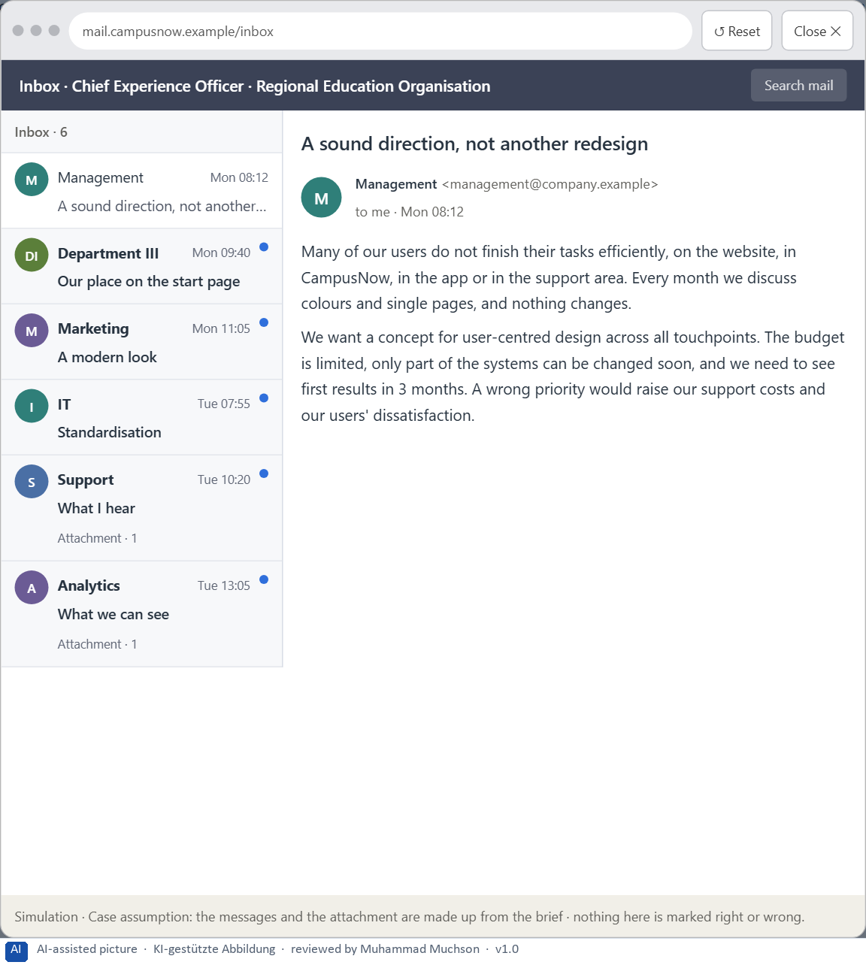
Figure 4 · Your desk: the messages that wait for you, shown in the lab as a mailbox (1 of 6).
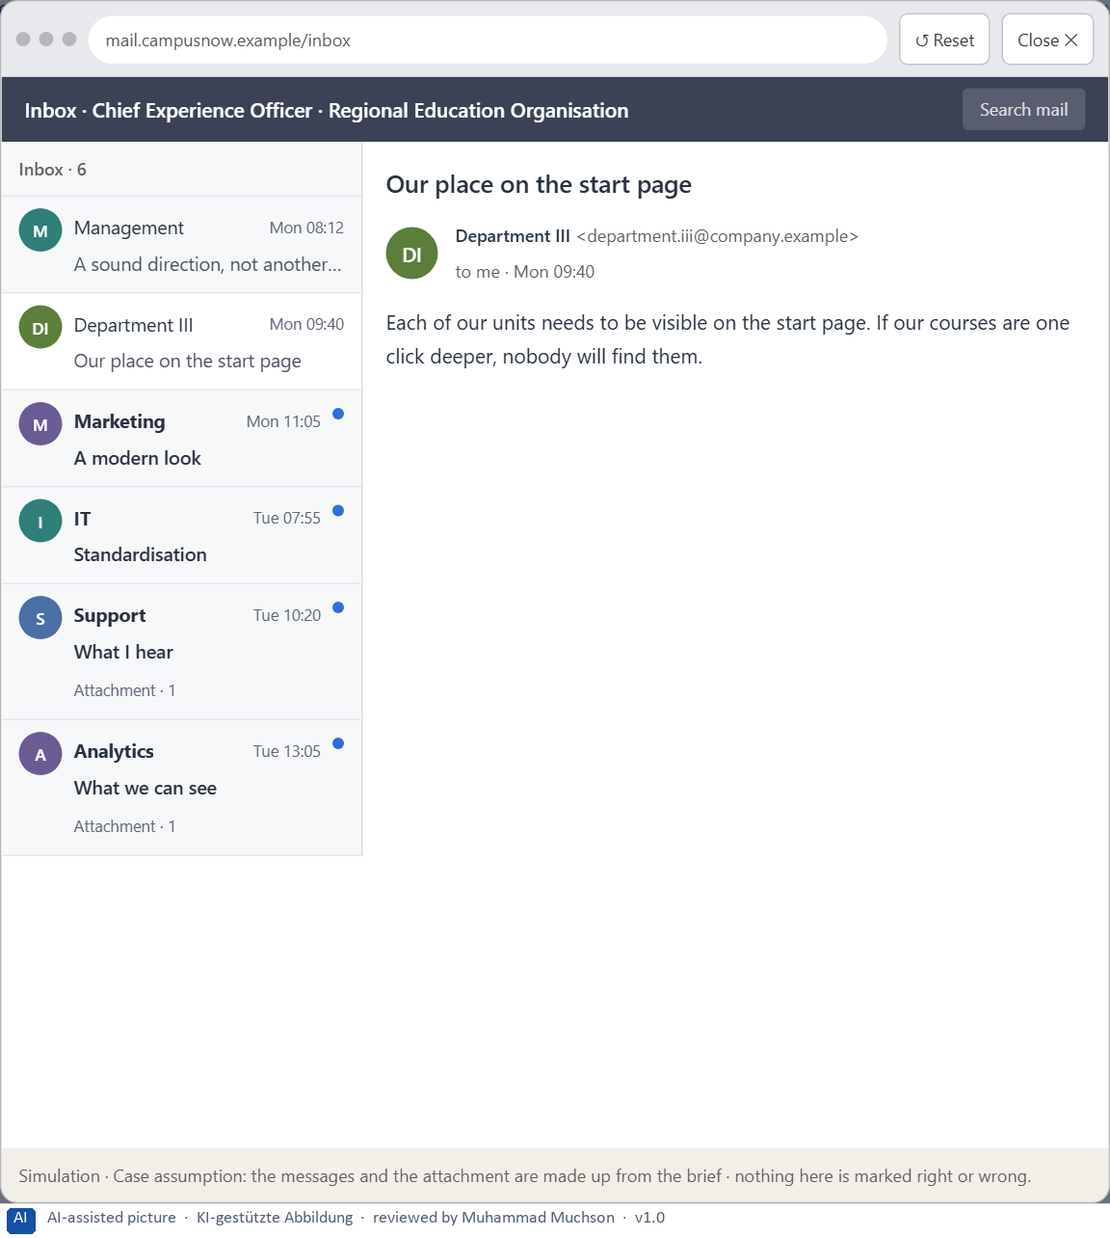
Figure 5 · Your desk: the messages that wait for you, shown in the lab as a mailbox (2 of 6).
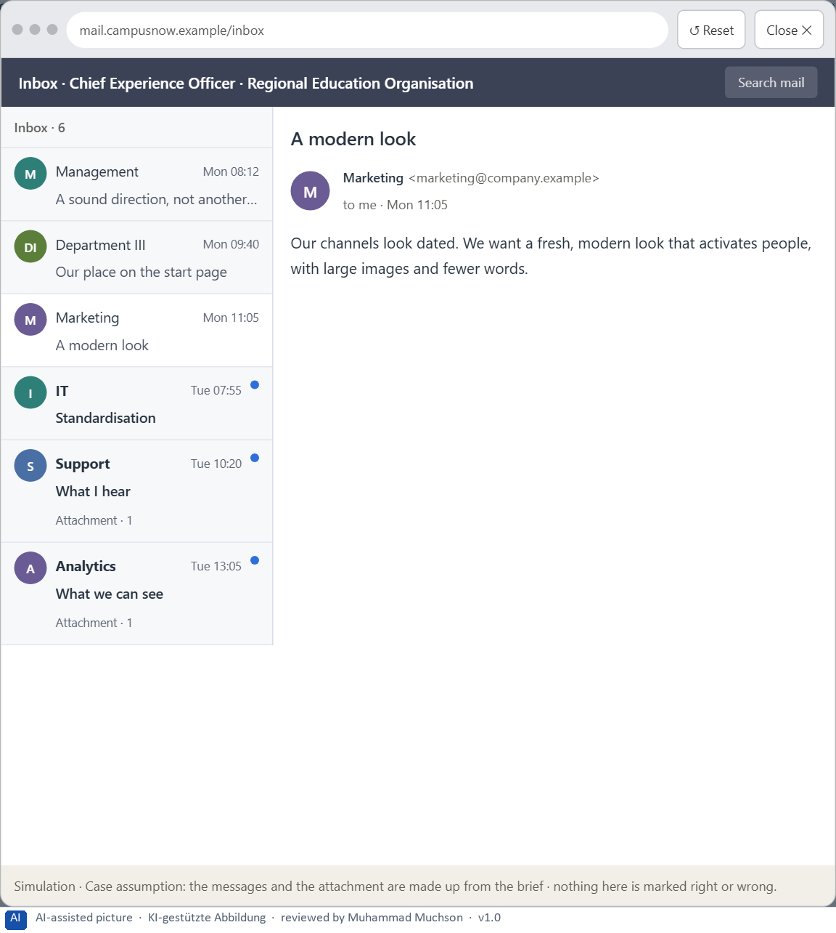
Figure 6 · Your desk: the messages that wait for you, shown in the lab as a mailbox (3 of 6).
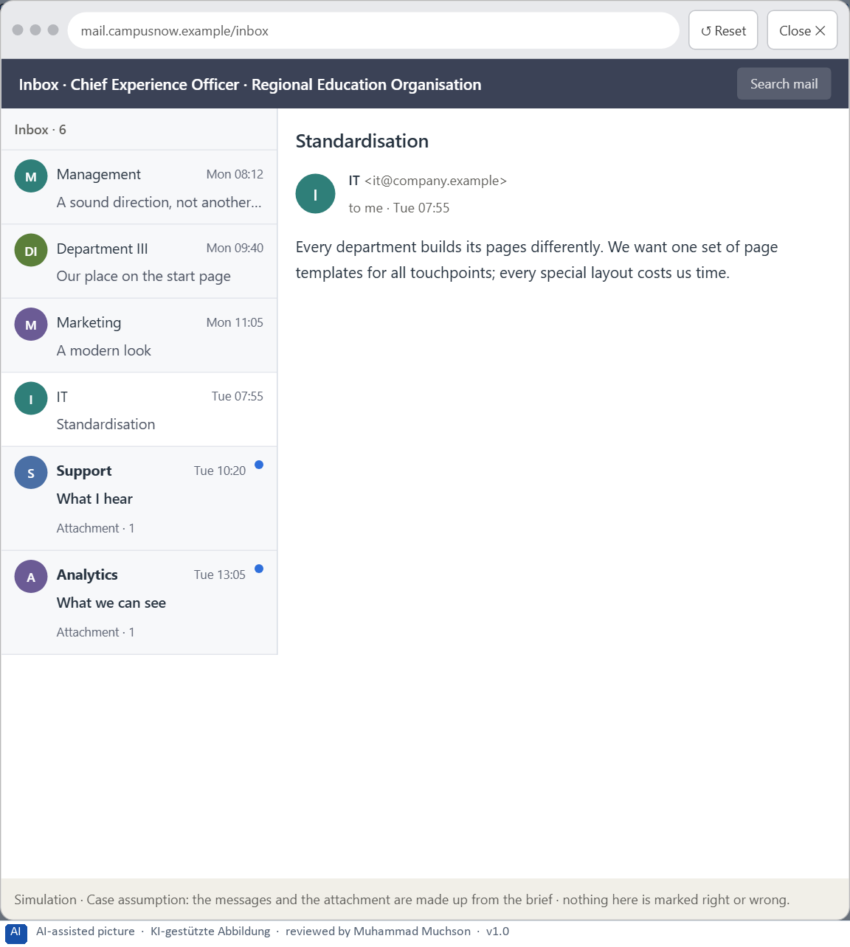
Figure 7 · Your desk: the messages that wait for you, shown in the lab as a mailbox (4 of 6).
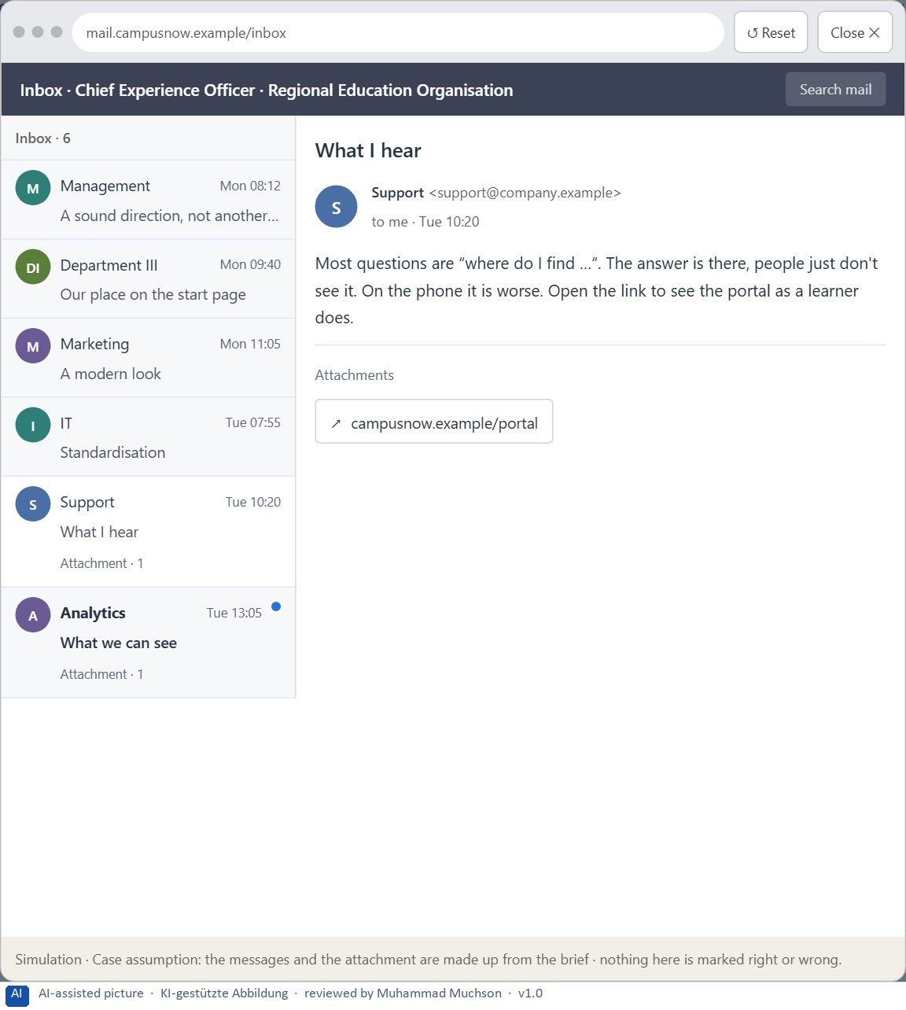
Figure 8 · Your desk: the messages that wait for you, shown in the lab as a mailbox (5 of 6).
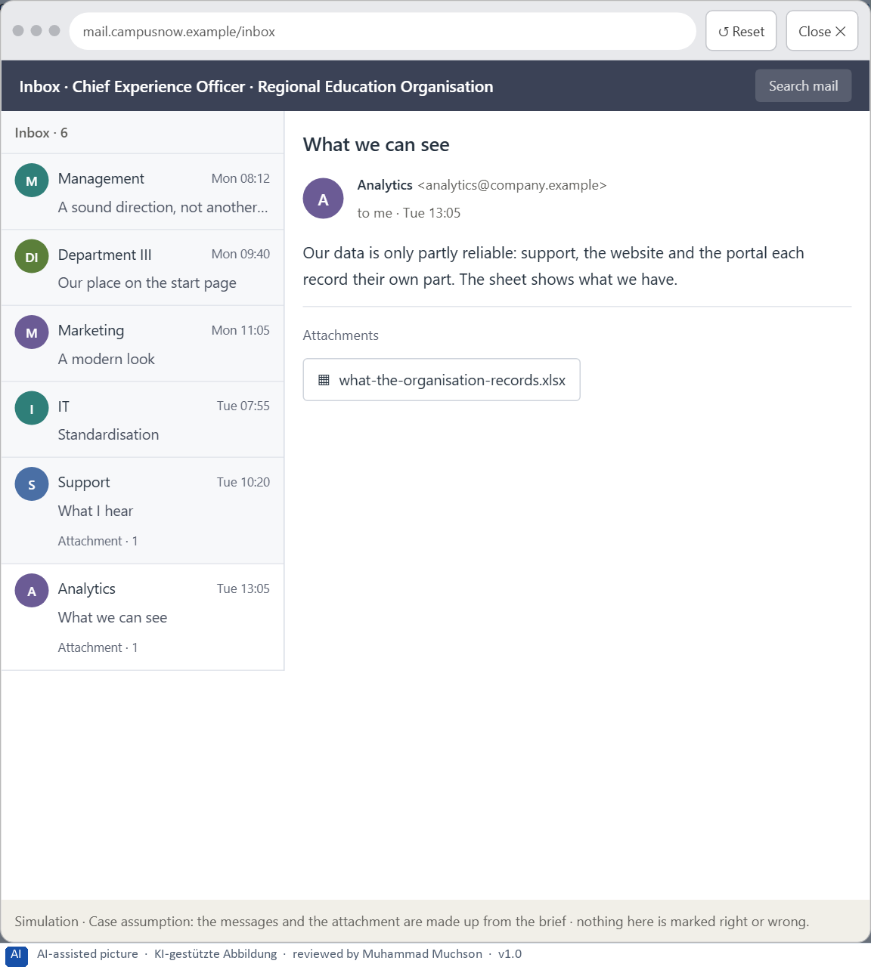
Figure 9 · Your desk: the messages that wait for you, shown in the lab as a mailbox (6 of 6).
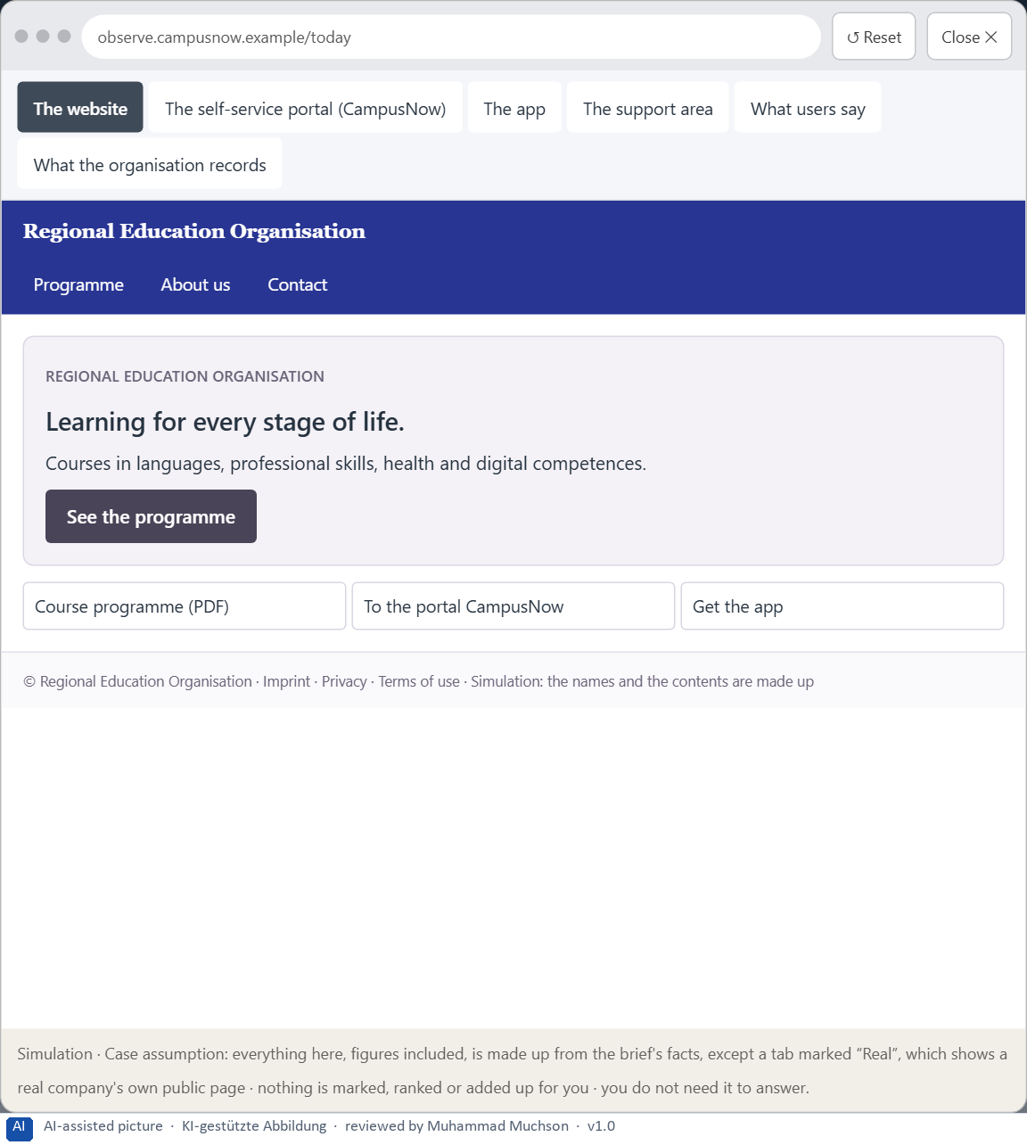
Figure 10 · The platform as it is today, as the lab lets you observe it (1 of 6).
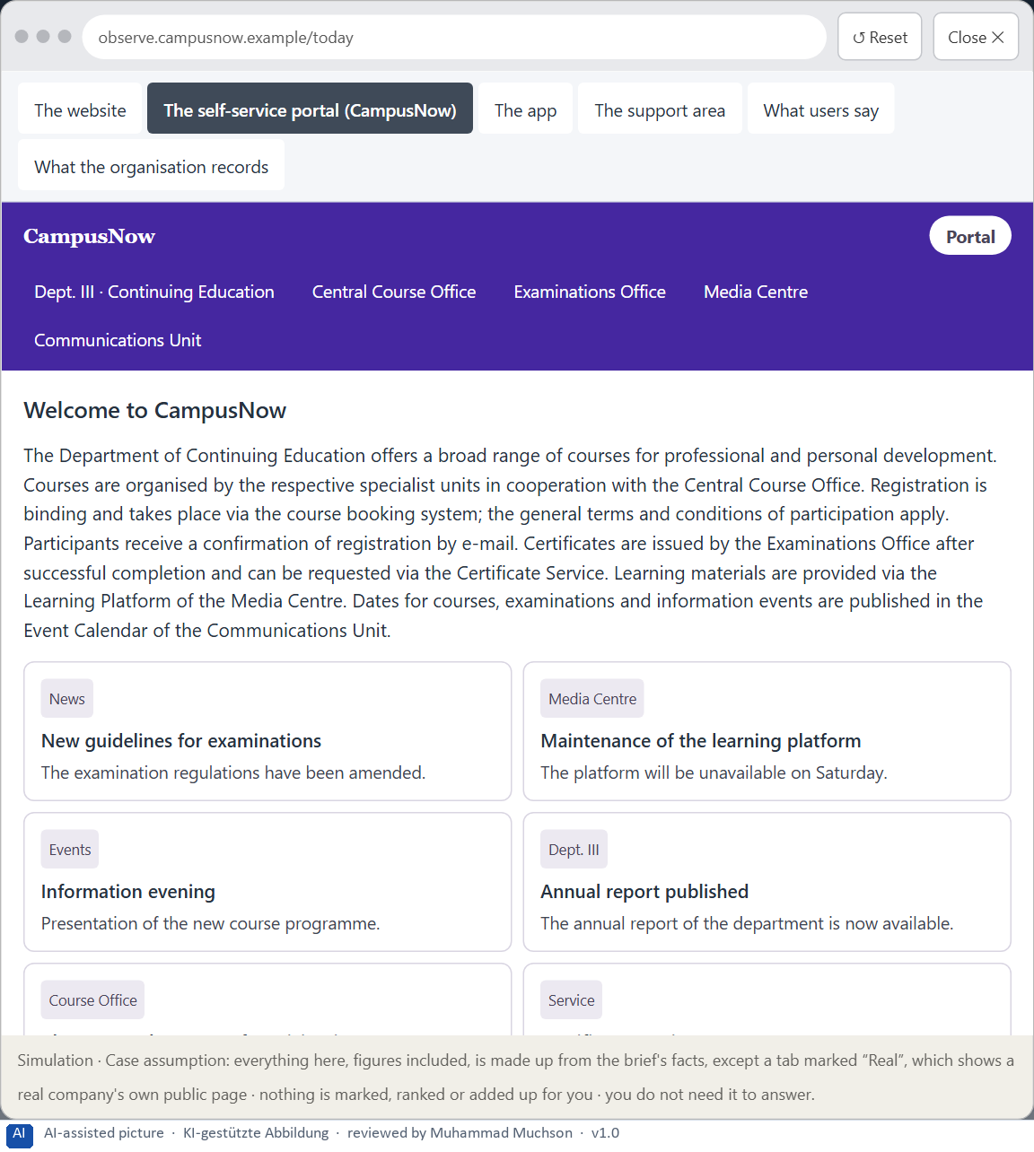
Figure 11 · The platform as it is today, as the lab lets you observe it (2 of 6).
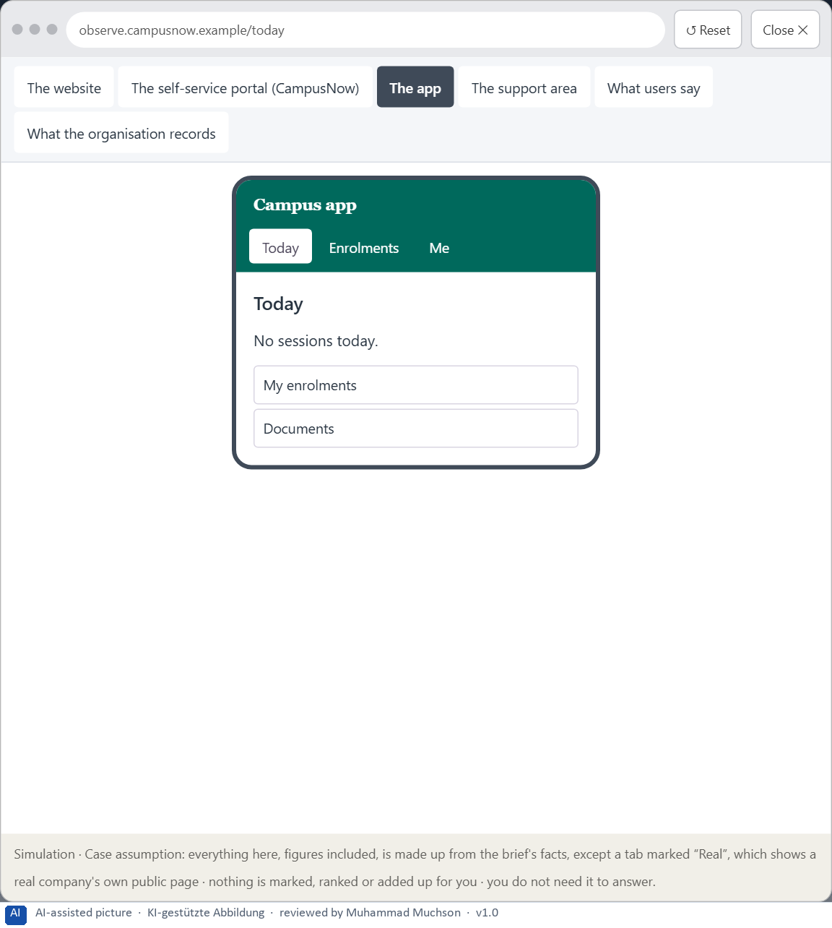
Figure 12 · The platform as it is today, as the lab lets you observe it (3 of 6).
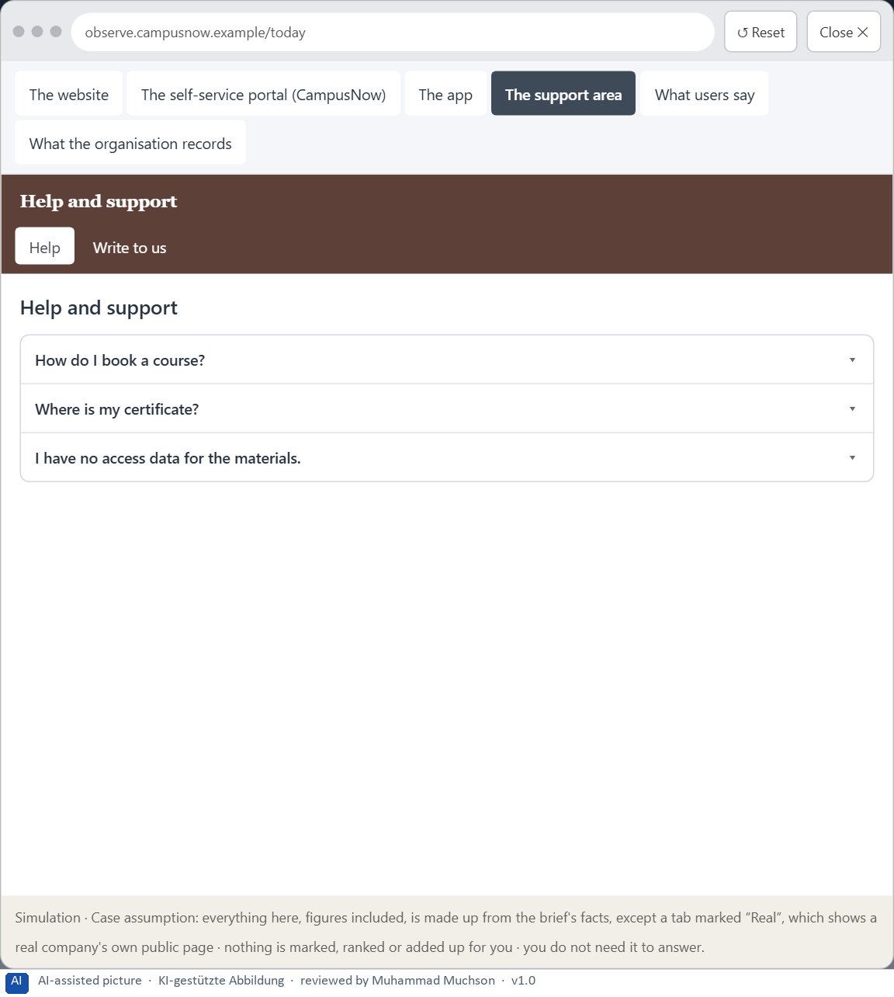
Figure 13 · The platform as it is today, as the lab lets you observe it (4 of 6).
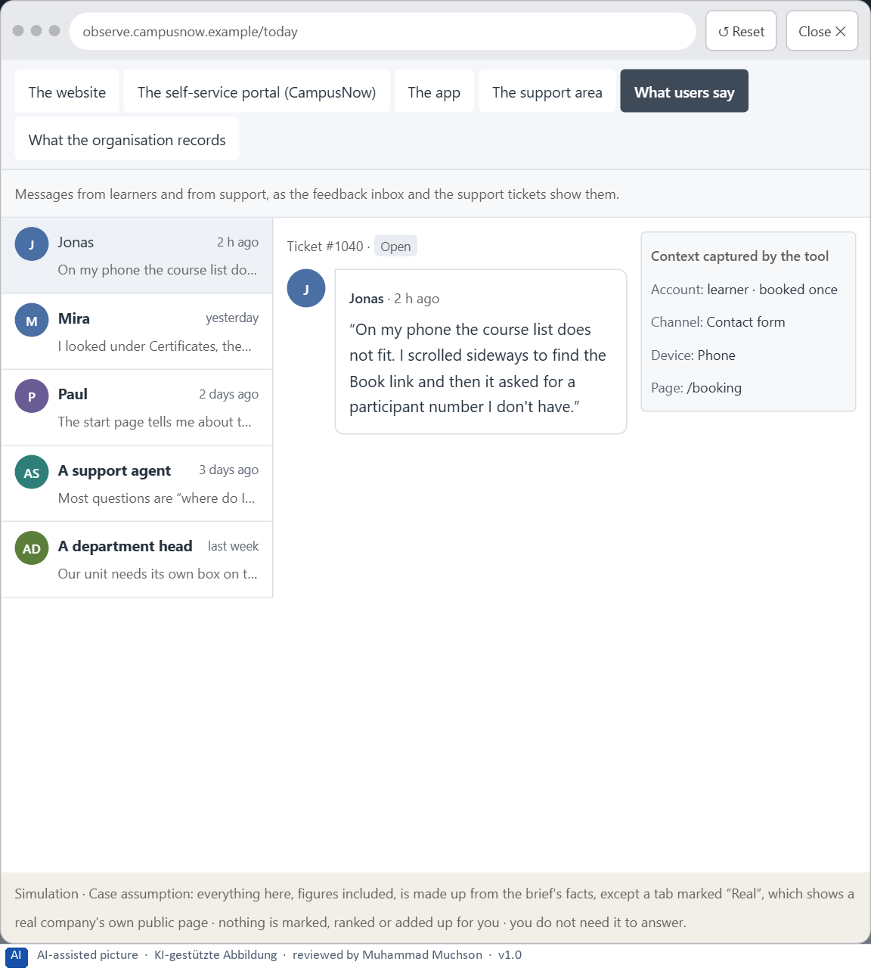
Figure 14 · The platform as it is today, as the lab lets you observe it (5 of 6).
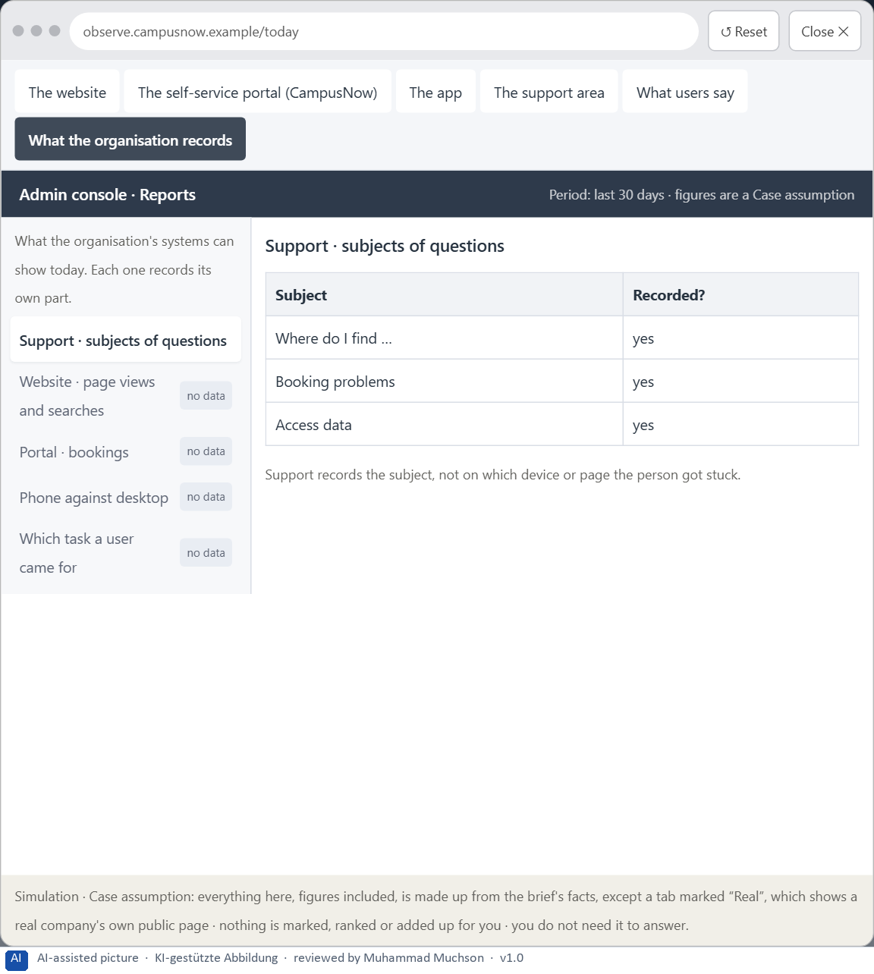
Figure 15 · The platform as it is today, as the lab lets you observe it (6 of 6).
Question 1 of 7 · A guiding vision of user-centred design: which perception and user experience should be created systematically?
One or two sentences about what users should perceive and experience in every touchpoint.
How to build the answer:
- Say who the users are and what they come to do.
- Say what they should see and experience in every touchpoint, in one effect.

Question 2 of 7 · Three strategic guiding decisions for orientation, structure, information priority and user guidance
How to build the answer:
- Take your vision and ask which three choices would make it real.
- Write each as “we will …, even though that means …”.
Write them as a list, one decision per line, each with what it gives up.

Question 3 of 7 · A prioritised architecture of measures: which areas are reworked first, and why?
Put the areas in an order and give the reason for the first ones.
How to build the answer:
- List the areas: the touchpoints and the structures across them.
- Put first what most users need and what helps the other areas most.
- Say why the others can wait.

Question 4 of 7 · A risk analysis: which wrong assumptions about user behaviour would be especially critical?
Name two or three assumptions about how users behave and the harm if each is wrong.
How to build the answer:
- Write down what your concept assumes about how users behave.
- For each, say what happens if it is wrong.
- Remember the plan's warning: wrong priorities raise support costs and dissatisfaction.

Question 5 of 7 · A governance model: who is responsible for user-centred decisions, and how are conflicts of goals resolved?
Name roles, not people: who decides, who answers for it, and how a conflict between departments, marketing, support and IT is settled.
How to build the answer:
- Name who owns the structure and the naming across touchpoints.
- Name who answers for the effect on users.
- Say how a conflict is decided, and by whom.

Question 6 of 7 · A decision under uncertainty: make at least one decision although data is missing, and justify it responsibly
Say what you decide, what you do not know, and why the decision is responsible all the same, for example when you would reverse it.
How to build the answer:
- State the decision in one sentence.
- Name what you do not know.
- Say why it is still responsible: it can be reversed, it can be checked soon, or waiting costs more.

Question 7 of 7 · A management statement: a recommendation to the management with a clear priority and a strategic reason
Four to six sentences: the direction first, then the priority, the reason and what you ask of the management.
How to build the answer:
- Start with the direction in one sentence.
- Name the priority and the reason that carries it.
- Say what you ask of the management and what you will report back.

Use in class: presentation and handout
Mark of use for the worksheet. Presentation is what the trainer shows on screen; Handout is what participants fill in and hand in.
Part of the worksheet | Presentation (shown in the Neuro-UX Lab) | Handout
The case: three portals on the UX team's desk, and CampusNow | The case read aloud or on screen | The case text
Block 1.1 · Read an interface as a user and find perception barriers: CityDesk | The task wording at the start of the block (no answers are shown) | Worksheet block with answer boxes (Core)
Block 1.2 · Rate user-centred design under conflicting goals: EduFlex | The task wording at the start of the block (no answers are shown) | Worksheet block with answer boxes (Core)
Block 2.1 · Case study: reorganising the service portal CampusNow | The task wording at the start of the block (no answers are shown) | Worksheet block with answer boxes (Core)
The situation: the education organisation behind CampusNow, and all its touchpoints | The case read aloud or on screen | The case text
Block 3.1 · A user-centred design architecture for a digital service | The task wording at the start of the block (no answers are shown) | Worksheet block with answer boxes (Core)

Glossary
Every term below is used in this document. Terms stay plain text in the body; this list says what they mean in everyday words.
Term | In plain words | Example | Comes from
Case assumption | A fact made up for this exercise to fill a gap in the plan's case. It is marked so you know it is not part of the plan. | — | Day 1
Chief Experience Officer | The manager who is responsible for the experience customers have across all channels, and who decides where the company invests in it. | — | Day 1
Cognitive load | How much a person has to hold in mind and work out at the same time. Every extra signal or choice adds to it; when it is too high, people skip, freeze or leave. | — | Day 1
Consistency | The same thing looks, is named and works the same way everywhere, so what people learn on one page holds on the next. | — | Day 2
Contrast | How much something differs from its surroundings in brightness, colour or size. Strong contrast makes it stand out; too many strong contrasts make everything compete. | — | Day 2
Decision architecture | A set of connected decisions that are made on purpose and written down: what effect you want, what comes first, who decides and how conflicts are settled. It replaces many separate fixes. | — | Day 1
Effort | What a measure takes in time and people: who has to work on it and for how long. On this course effort is never a price. | — | Day 2
Findability | How easily people can find what they are looking for, by browsing the menu or by searching. | — | Day 2
Governance | The rules about who may decide what, who is answerable for it and how disagreements are settled. | — | Day 1
Information architecture | How the content of a website or app is organised, grouped and named, and how people move through it. It is the structure behind the screens. | — | Day 2
Information density | How much a screen shows at once. Too much and everything competes; too little and people have to click a lot to reach anything. | — | Day 2
Orientation | Knowing where you are, what you can do here and what happens next. | — | Day 1
Page type | A kind of page that appears many times, such as a course page, a certificate page or a booking page. Each type should keep the same structure. | — | Day 2
Perception | Taking in what the senses deliver, for example what the eyes see on a screen, before thinking about it. | — | Day 1
Provider-centred design | Designing from the organisation's own point of view: its departments, its terms and what it wants to say. The result is often complete but hard to use. | A menu with one item per department, named as the departments call themselves. | Day 2
Readability | How easily a text can be read and understood: its size, contrast, line length, wording and how it is broken into parts. | — | Day 2
Recognition instead of recall | Showing people the options and the next step so they can recognise them, instead of making them remember or hunt for them. | — | Day 2
Scanning | Looking over a screen quickly and picking out what seems relevant, instead of reading it word by word. Most people scan first. | — | Day 2
Self-service portal | A website where customers do things themselves that once needed a call or a visit, such as reporting damage or downloading a document. | — | Day 1
Stakeholder | A person or department with an interest in a decision, such as marketing, compliance, IT or sales. | — | Day 1
Timeliness | How soon a measure shows its effect for the users. A measure with high timeliness is noticed in days or weeks, not next year. | — | Day 2
Touchpoint | Any place where a person meets the company: the website, the customer portal, the app, a chatbot or a phone call. | — | Day 1
User-centred design | Designing from what the users come to do, how they see and what words they use, and checking the design with them, instead of starting from how the organisation is built. | — | Day 2
UX (user experience) | Everything a person goes through when using a product: what they notice, understand, feel and do, from the first look to the last step. The screens are only one part of it. | Finding the booking you want at once and feeling sure it went through is a good UX. | Day 1
Visual guidance | Using contrast, grouping and structure on purpose so the eye goes first to what matters and then along a clear path. | — | Day 2

The Neuro-UX Lab: where we practise online
In class we use the course website as the place to practise and to learn. Every day has its own address, in the same pattern: the day number is the last part.
What | Address
Neuro-UX Lab (course website) | https://aion-ux-lab.vercel.app/
Day 2 | https://aion-ux-lab.vercel.app/day/2/

On the day page, Route 1 (Levels 1 and 2) and Route 2 (Level 3) can be opened; the cards and the tasks of this document are there too. The pattern is the same up to Day 8, for example https://aion-ux-lab.vercel.app/day/6/.

