AION · UX DEVELOPER · PSYCHOLOGICAL UX DESIGN AND NEURO-UX
DAY 9 · TASK 1 AND TASK 2 · ROUTES 1 AND 2 · LEVELS 1 TO 3
MoveWell: UX Analysis File and UX Strategy Memo
Describe the effect, choose the measures as a team member, and decide as Chief Experience Officer
AI notice · KI-Hinweis
This document was produced with the help of an AI language model (Claude, Anthropic). The AI drafted the text and tables and built the pictures and working examples of the lab. The content was then read, corrected and approved by the reviewer named below, who is responsible for its accuracy. Every picture carries an AI label on the image. Check figures and sources before you quote them.
KI-Hinweis: Dieses Dokument wurde mit Unterstützung eines KI-Sprachmodells (Claude, Anthropic) erstellt. Texte und Tabellen wurden von der KI entworfen, die Abbildungen sind KI-gestützt erstellt und am Bild gekennzeichnet. Die fachliche Prüfung und Freigabe erfolgte durch die unten genannte Person.

Day | Day 9 · Module 4 (day 3 of 3): Gamification strategies, and storytelling with gamification
Document | Task (worksheet with answer spaces). Task 1 (UX Analysis File) and Task 2 (UX Strategy Memo).
Route and level | Task 1 = Route 1, Levels 1 and 2 (draws on Materi A). Task 2 = Route 2, Level 3 (draws on Materi B).
Time | Task 1 about 33 min · Task 2 about 20 min
Neuro-UX Lab (website) | https://aion-ux-lab.vercel.app/day/9/
Case | MoveWell, the day's case study; other products appear as warm-ups
Version | 1.0 · release date 29.10.2026
Review and approval | Muhammad Muchson, Mentor (subject-matter review and approval)

ABOUT THIS DOCUMENT
In class we also use the Neuro-UX Lab, the course website, as the place to practise and learn. Its address is at the end of this document.
This is the worksheet for Day 9. Read the case once, study the evidence printed in this document, and write your answers in the boxes and tables. You can work through it on paper or type into the document. All blocks are Core. There are no answer keys and no scores; the reason you give matters more than the choice.

IN THIS DOCUMENT
Lesson plan: ten teaching units (Ablaufplan)
Case study and transfer project at a glance
The case: two platforms on the UX team's desk, and MoveWell
Block 1.1 · Recognise activation and retention potential in a digital offer: SkillRise · JUDGED · Core · about 10 min
Block 1.2 · Rate gamification under conflicting goals: HealthJourney · JUDGED · Core · about 8 min
Block 2.1 · Case study: an activation strategy for the prevention programme MoveWell · JUDGED · Core · about 15 min
The situation: the health provider behind MoveWell, many who start and few who stay
Block 3.1 · A strategic activation and retention architecture for digital user experiences · JUDGED · Core · about 20 min

Day at a glance
Day 9 has ten teaching units (UE). This document is the worksheet; it is used in UE2 to UE6 (Task 1) and UE8 to UE10 (Task 2). The day is built from three documents and the Neuro-UX Lab: Materi (study material), Task (worksheet) and Trainer (coaching, feedback and model solutions), plus the course website.

Lesson plan: ten teaching units (Ablaufplan)
UE | Min | Plan item | What happens | Material | Format
1 | 45 | Knowledge transfer · Level 1 | The trainer presents the cards of Materi A (A1, A2, A3, A4, A5, about 60 min of cards) in the Neuro-UX Lab; participants follow in the handout. | Materi A (Route 1) | Presentation + Handout
2 | 45 | Level 1 · Task 1 | Individual work on Block 1.1 (Core, about 10 min): the first product of the day is read and its effect described. Pairs then compare their results and the trainer collects open questions. | Task 1 · Part 1 · Block 1.1 | Handout (or in the lab)
3 | 45 | Level 1 · Task 2 | Three options are rated on the same criteria and one is chosen under the stated conditions: Block 1.2 (Core, about 8 min). | Task 1 · Part 1 · Block 1.2 | Handout (or in the lab)
4 | 45 | Coaching · transition from Level 1 to Level 2 | Trainer-led. A short talk on the day's coaching focus, then the reflection questions in pairs. The bridge: from describing an effect to a decision you answer for. There is no worksheet block in this unit. | Trainer document, section Coaching | Trainer only
5–6 | 90 | Level 2 · Case study MoveWell (2 UE) incl. model solution | UE5: the trainer presents the case; participants work on Block 2.1 (Core, about 15 min). UE6: groups compare their results and defend them; the trainer closes with the model solution. | Task 1 · Part 2 · Block 2.1  Trainer document, section Case study | Handout; model solution shown after the work
7 | 45 | Level 2 + 3 · Feedback round with a management perspective | Groups present their reasoning, not only their result. The trainer asks the day's Level 3 input questions and leads the discussion. | Trainer document, section Feedback round | Presentation by the groups; Trainer only
8 | 45 | Level 3 · Transfer project, Chief Experience Officer (3 UE: UE8–10) | The trainer presents Materi B (B1, B2, B3; use the "In plain words" and "How to decide" boxes, the rest is handout) and sets the role and the situation. | Materi B (Route 2) | Presentation + Handout
9 | 45 | Level 3 · Transfer project | Individual work or in pairs on Block 3.1 (Core, about 20 min): the strategy memo. | Task 2 · Block 3.1 | Handout (or in the lab)
10 | 45 | Level 3 · Transfer project | Participants present their decision and what they give up, including the one decision made under uncertainty; the trainer debriefs with the model solution. | Task 2 · Block 3.1  Trainer document, section Transfer project | Handout; model solution shown after the work

One UE is counted as 45 minutes here; breaks are not shown. The times are a guide for the trainer. The Core blocks are enough for a complete answer.

Case study and transfer project at a glance
Component | UE | Duration | Participants work in | Model solution in
Level 2 case study (MoveWell) | UE5–6 | 2 UE · 90 min | Task 1 · Part 2 (Block 2.1) | Trainer document, section Case study
Level 3 transfer project (Chief Experience Officer) | UE8–10 | 3 UE · 135 min | Materi B and Task 2 (Block 3.1) | Trainer document, section Transfer project

Which plan item each block answers
UE | Plan item (Strukturplan, Day 9) | Block in this document
UE2 | Level 1, task 1 · Recognise activation and retention potential in a digital offer: SkillRise | Block 1.1 (Core)
UE3 | Level 1, task 2 · Rate gamification under conflicting goals: HealthJourney | Block 1.2 (Core)
UE4 | Coaching: from describing to deciding | A classroom talk led by the trainer; not a worksheet block
UE5–6 | Level 2 case study · Case study: an activation strategy for the prevention programme MoveWell | Block 2.1 (Core)
UE7 | Feedback round with a management perspective | A classroom discussion led by the trainer; not a worksheet block
UE8–10 | Level 3 transfer project · A strategic activation and retention architecture for digital user experiences | Block 3.1 (Core), in Task 2

Your name
Write your full name here. Use the same name on every Task document this week; it is how your work is matched.

Task 1 · Route 1 · UX Analysis File: find what weakens motivation, then decide what to change

The case: two platforms on the UX team's desk, and MoveWell
Read once · about 3 min
You work in the UX team of a digital agency. This week three products land on your desk. Two are warm-ups: SkillRise, a learning and development platform for professional further training, and HealthJourney, a prevention platform that has three designs for how it should activate its users. The main case is MoveWell, a health provider's platform for exercise, prevention and personal health goals. Its content is of high quality, but many users leave after a short time: they find it sensible, but not very motivating. The provider wants more activation and retention without losing seriousness or credibility.
What the plan gives you | How the task runs · three blocks
• Block 1.1: SkillRise, with learning paths, tasks and certificates but little visible progress, only neutral system messages after a completed step, no motivating intermediate goals or milestones, a path sensible in content but not very activating, and nothing that shows personal development or successes  • Block 1.2: three activation designs for HealthJourney; adults aged 25 to 65, motivating but serious and trustworthy, a limited budget, no user tests, 10 weeks to release, marketing wants high activation and the department warns against a too playful approach  • Block 2.1: MoveWell, with €150,000 and 12 weeks, a brand that must stay trustworthy and close to health, no complete relaunch, limited technical resources for complex features, and only partial user data | • Block 1.1: find where SkillRise weakens or promotes activation and retention. Describe the effect, name five places, sort them into six categories, write three effect statements and pick the two biggest weaknesses.  • Block 1.2: rate three activation designs under conflicting goals. Rate each on five criteria, choose one, name the conflicts between activation, seriousness and user autonomy and the remaining risks, and write a recommendation to the project lead.  • Block 2.1: the case study. The central deficits in activation and retention, sorted into six categories, four measures, justified on four criteria, a decision for the first 12 weeks and a recommendation to the division management.

What is known and what is open
In the brief | Clear · Case assumption | Open · on purpose
• SkillRise: paths, tasks and certificates; little visible progress; neutral system messages; no milestones; nothing that shows development or success.  • HealthJourney: three designs in words; adults 25 to 65; no tests; 10 weeks; marketing's activation against the department's warning.  • MoveWell: good content, many leave early; €150,000 and 12 weeks; trustworthy and close to health; no relaunch; partial user data. | • You review SkillRise and HealthJourney as an agency would: from their screens, with no access to their data.  • SkillRise is bought by employers for their staff; its learners fit it around a full working week.  • MoveWell's members set a personal goal at the start (more exercise, a healthier back, more stamina) and log their activities in the app.  • MoveWell's messages are written by the IT team that built the platform and are correct. | • When exactly people leave MoveWell: the user data is only partial.  • Which HealthJourney design the target group would accept: there are no tests.  • How much of the €150,000 each measure would take: the plan does not say.  • Whether MoveWell's members would welcome game elements at all: never asked.

As in most projects, not everything is known. Decide anyway, and say what you assume.
Case assumption
The brief says: SkillRise with learning paths, tasks and certificates, little visible progress, neutral system messages, no intermediate goals or milestones, content that is sensible but not activating, and nothing that shows development or success; HealthJourney's three designs (A strong gamification with points, badges, daily challenges and rankings; B progress displays, milestones and confirming feedback; C a narrative journey with stages but fewer classic rewards) for adults aged 25 to 65, motivating but serious, a limited budget, no tests, 10 weeks, marketing against the department; MoveWell with good content, many who leave early, faint progress, hardly any feedback on successes, no stages, a functional journey, no link between development and use, technical messages, €150,000, 12 weeks, a trustworthy brand close to health, no relaunch, limited resources and partial data. Those are the plan's facts and its only figures. Everything else is made up for this exercise: the agency, the pictures, the simulations and the facts marked “Clear”.

Part 1 · Find the motivation gaps and weigh activation designs · Level 1 · Knowledge

Block 1.1 · Recognise activation and retention potential in a digital offer: SkillRise · JUDGED · Core · about 10 min
Draws on: A1 · Gamification, playful design and a game · A2 · Why people react to progress, feedback and recognition · A3 · Points, badges, levels, streaks.
You receive the description of a fictional learning and development platform, SkillRise, for professional further training. Open it and use it as an employee who has been given a learning path by their employer: finish a module and look at your progress. You need no prior knowledge: notice whether you want to come back tomorrow, not only whether the steps work. The aim is to recognise motivation and retention mechanisms systematically and tell them apart from pure functionality.
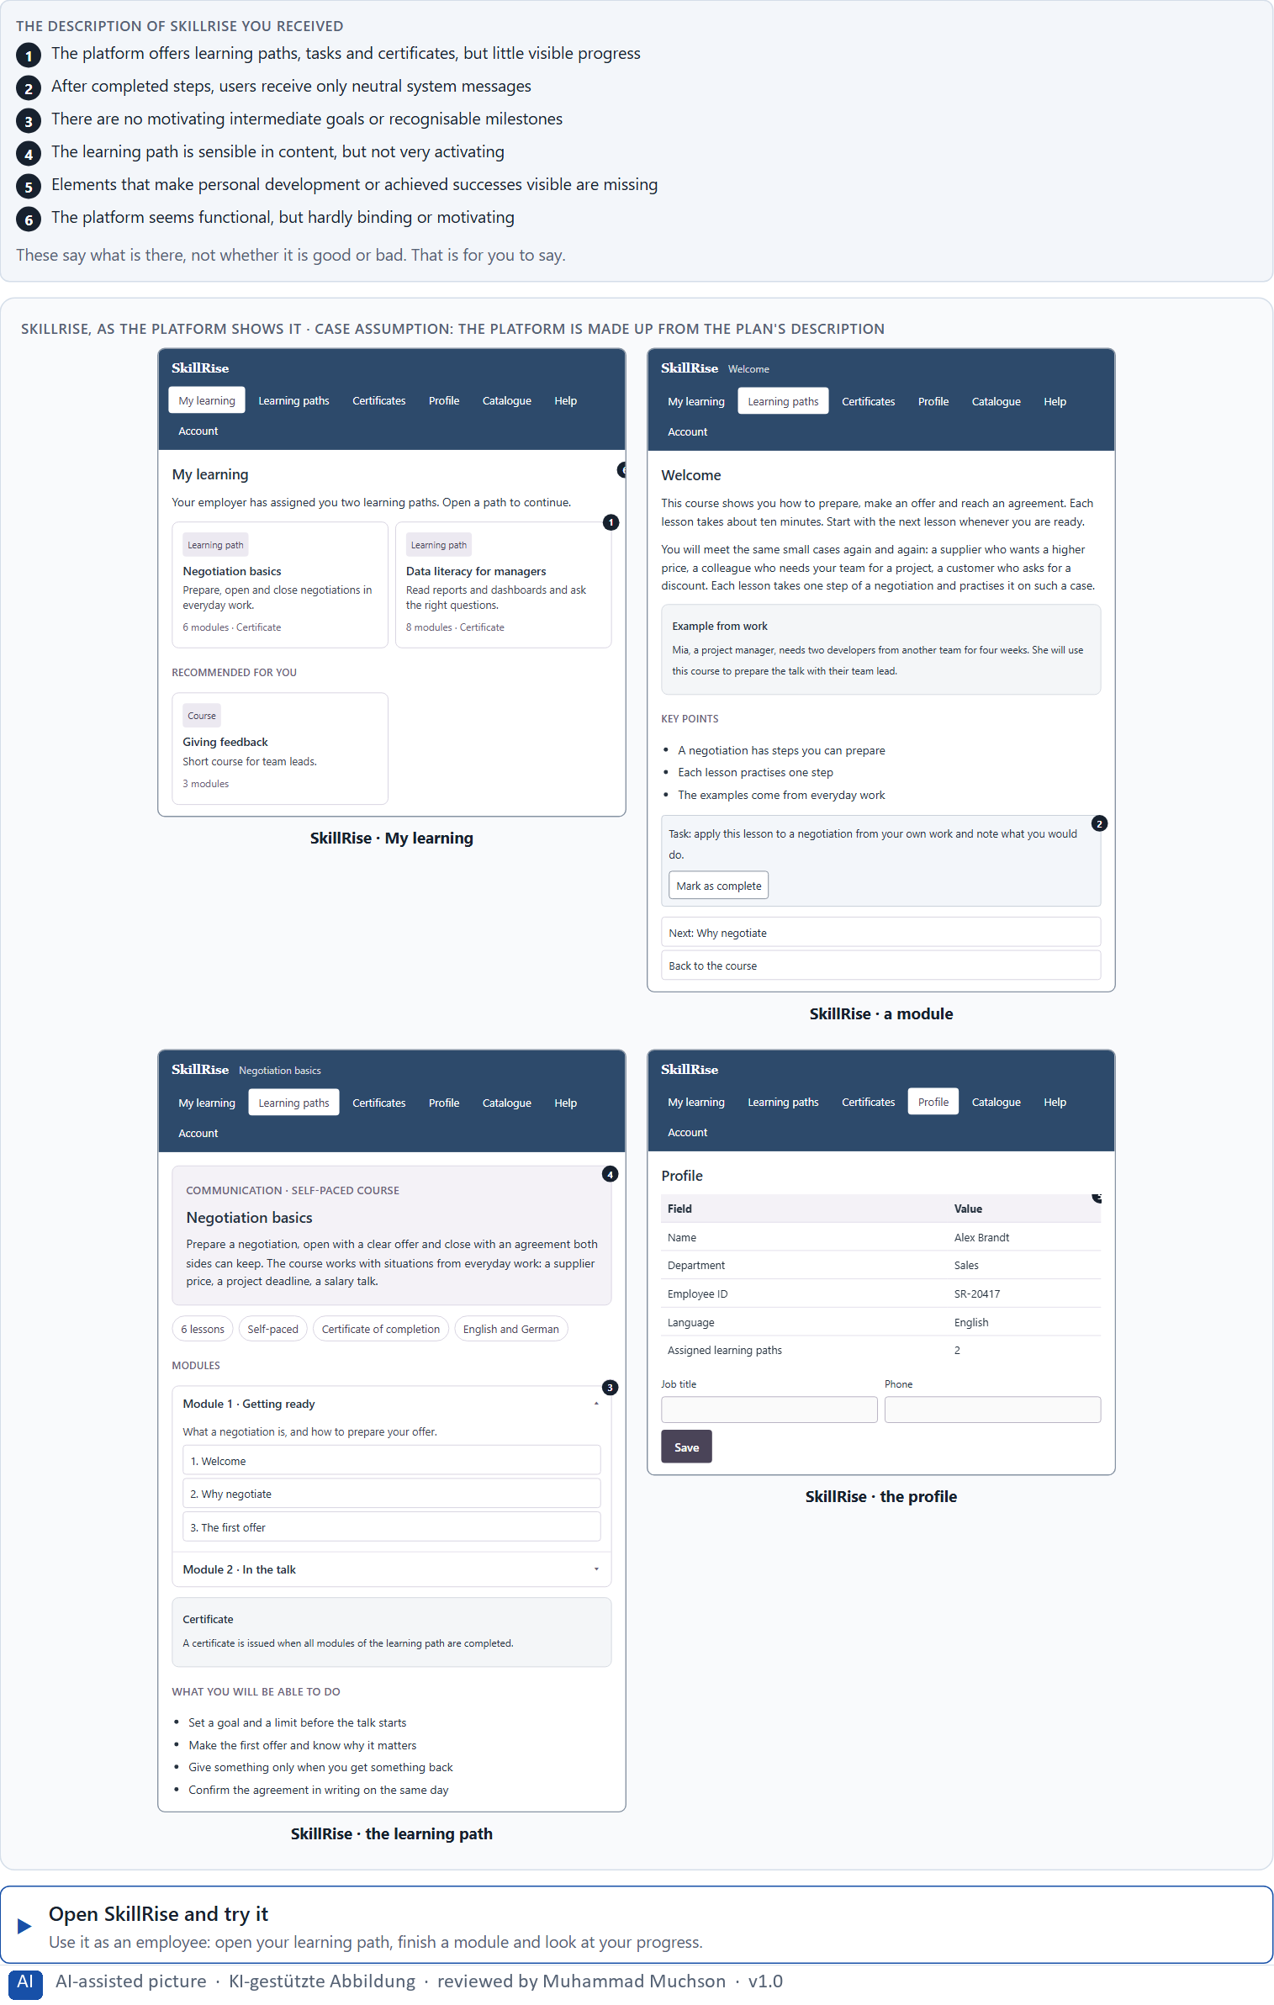
Figure 1 · SkillRise, as the platform shows it.
Question 1 of 5 · Describe spontaneously what effect the offer could have on motivation and retention
Two to four sentences: how it feels to use it, where the feeling comes from, and whether you would come back.
How to build the answer:
- Open SkillRise, finish a module and look at what the platform tells you afterwards.
- Write how it feels: do you see how far you have come, what you can do now, why it is worth going on?
- Add whether you would come back tomorrow, and why.

Question 2 of 5 · Name at least 5 places where activation or retention is weakened or promoted
How to build the answer:
- Go through your visit: the dashboard, the path, a module, the message after it, the profile, the certificate.
- For each place, say what it does to activation or retention, and whether it weakens or promotes it.
Write them as a list, one place per line, and say whether it weakens or promotes activation or retention, and why.

Question 3 of 5 · Assign the observations to the categories motivation, progress, recognition, feedback, retention and self-efficacy
Write the observations that belong to each category in a few words. One may fit two categories; put it where its effect is strongest.
How to build the answer:
- Take your places from question 2.
- Ask which of the six each one affects most, and write it there.
- Each of the six is touched by SkillRise.
Category | The observations in this category
Motivation
Progress
Recognition
Feedback
Retention
Self-efficacy

Question 4 of 5 · Write an effect statement for three points: “For users this could mean that …”
How to build the answer:
- Pick three places from question 2.
- Finish the plan's sentence with what the user would feel, do or fail to do.
Write them as a list, one statement per line, each starting with the observation and ending with what it could mean for users.

Question 5 of 5 · Prioritise the two biggest weaknesses with regard to user activation
How to build the answer:
- Look at your places with one question: which gap stops people from starting the next step on their own?
- Pick the two that weigh most and say why.
Write them as a list, the bigger weakness first, each with why it weighs most.

Block 1.2 · Rate gamification under conflicting goals: HealthJourney · JUDGED · Core · about 8 min
Draws on: A3 · Points, badges, levels, streaks · A4 · Story and game together, and a quick spike against lasting use · A5 · Intrinsic motivation, credible gamification in serious fields, and weighing a measure.
HealthJourney is a platform for health prevention. Three designs for its activation logic are described in words: A) strong gamification with points, badges, daily challenges and rankings; B) a restrained activation logic with progress displays, milestones and confirming feedback; C) a narratively embedded user journey with motivating stages, but less visible classic reward elements. The conditions: the target group is adults aged 25 to 65, the company wants to motivate but stay serious and trustworthy, the budget for technical extensions is limited, there are no user tests yet, the release is in 10 weeks, and marketing demands high activation while the department warns against too playful an approach. Decide anyway, and say what you assume.
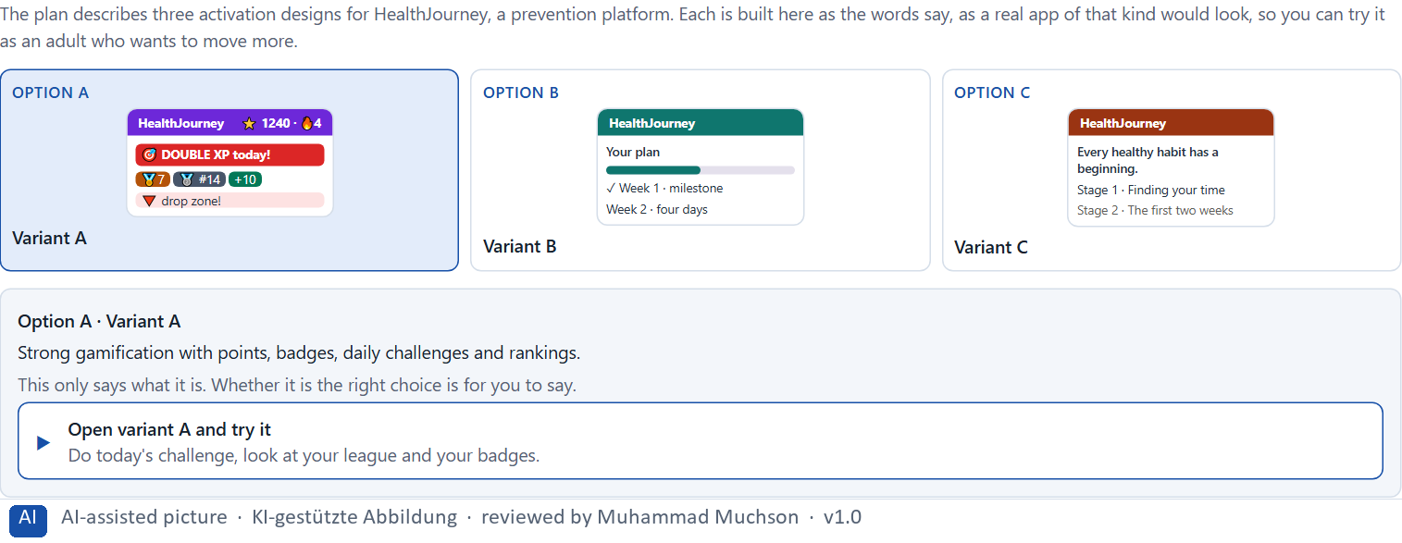
Figure 2 · The product to read, as the lab shows it (designs).
Question 1 of 5 · Rate each variant on motivation, credibility, long-term retention, clarity and user acceptance
Write a few sentences for each variant that cover all five criteria. Many teams rate each criterion Low, Medium or High with a reason; you may do that or write it in your own words.
How to build the answer:
- Take one variant at a time and keep the target group in mind: adults aged 25 to 65, in a health context.
- For each criterion, say how the variant does and why.
- Use the same five criteria for every variant, so you can compare them.
Variant | Motivation | Credibility | Long-term retention | Clarity | User acceptance
Variant A · points, badges, daily challenges, rankings
Variant B · progress displays, milestones, confirming feedback
Variant C · a narrative journey with stages, fewer rewards

Question 2 of 5 · Decide which variant is the most viable under the given conditions
Choose one variant, then give your reason below. There is no single right choice; the reason has to rest on the users and the conditions.
How to build the answer:
- Say which condition weighs most for you.
- Say how your choice meets it better than the other two.
Tick one:
☐ Variant A · points, badges, daily challenges, rankings
☐ Variant B · progress displays, milestones, confirming feedback
☐ Variant C · a narrative journey with stages, fewer rewards
Why this variant, under these conditions?
Give your reason with the conditions: adults aged 25 to 65, motivating but serious and trustworthy, a limited budget, no tests, 10 weeks, marketing against the department.
How to build the answer:
- Name the condition that weighs most for you.
- Say how your variant meets it and why the other two meet it less well.
- Say what your choice gives up and how you would deal with its weakness.

Question 3 of 5 · Name the conflicts of goals between activation, seriousness and user autonomy
Name at least two conflicts, each as one goal against another, and who stands for each side.
How to build the answer:
- Look at what activation needs (strong signals, daily triggers), what seriousness needs (a calm, credible tone) and what autonomy needs (people choose what and when).
- Write each conflict as “… against …” and say who stands for each side.

Question 4 of 5 · Which risks remain despite your decision?
Name at least one risk that remains and who would feel it.
How to build the answer:
- Think of what your chosen variant is weak at.
- Say who would notice and what would happen.

Question 5 of 5 · Formulate a recommendation to the project management
Two to four sentences: what you recommend, why, and what you will check next.
How to build the answer:
- Lead with the recommendation.
- Give the one reason the project management can follow.
- Say what you will check after the release.

Part 2 · The case study · Level 2 · Application · Case study (2 UE)
Case study: 2 teaching units (UE5–6)
This part is the day's Level 2 case study. It takes 2 UE (about 90 minutes): UE5 for the briefing and your own work, UE6 for comparing your results with your group and for the trainer's closing. The block below needs about 15 minutes of writing; the rest of the time is discussion.

Block 2.1 · Case study: an activation strategy for the prevention programme MoveWell · JUDGED · Core · about 15 min
Draws on: A1 · Gamification, playful design and a game · A2 · Why people react to progress, feedback and recognition · A3 · Points, badges, levels, streaks · A4 · Story and game together, and a quick spike against lasting use · A5 · Intrinsic motivation, credible gamification in serious fields, and weighing a measure.
A health provider runs MoveWell, a digital platform for exercise, prevention and personal health goals. Its content is of high quality, but many users leave after a short time. The platform is experienced as sensible, but not very motivating. The company wants to raise activation and retention without losing seriousness or credibility. The observed problems: progress is only faintly visible; successes are hardly fed back or emotionally reinforced; motivating intermediate goals and stages are missing; the user journey is functional but not very activating; there is no clear link between individual development and the experience of use; and the feedback so far is technical and not very stimulating. The conditions: a budget of €150,000, 12 weeks for the implementation, a brand that must stay trustworthy and close to health, no complete relaunch, limited technical resources for complex features, and only partial user data. You work through six steps.
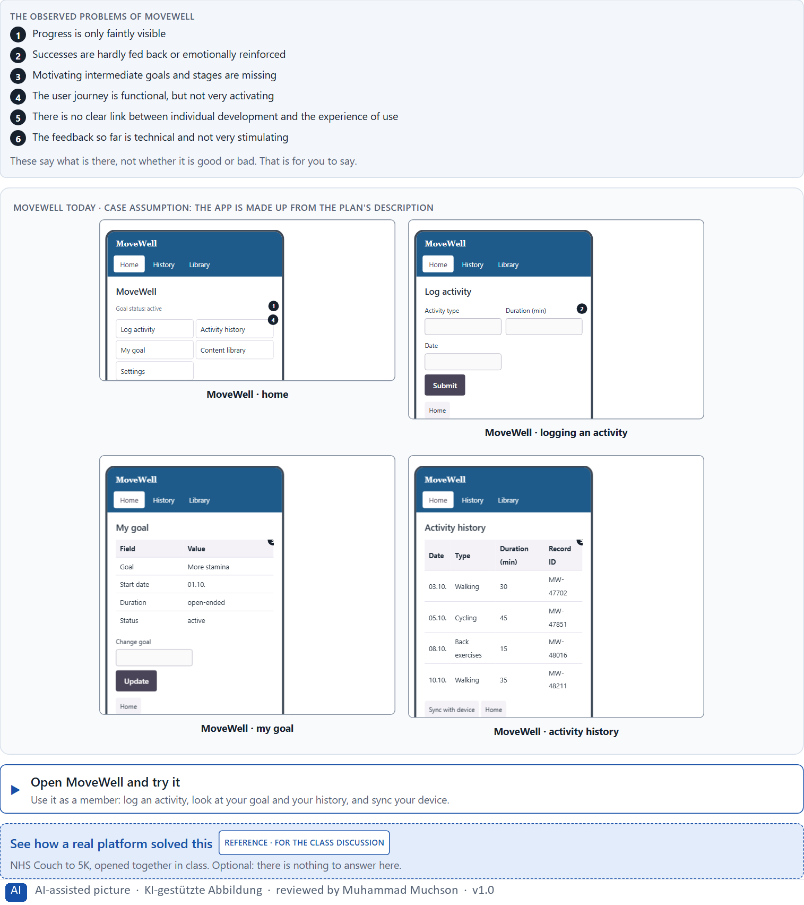
Figure 3 · MoveWell today.
Question 1 of 6 · Analyse the central deficits in activation and retention
How to build the answer:
- Open MoveWell and use it as a member for a week: set your goal, log activities, look at your progress and the messages.
- Write one deficit per line and what it does to motivation or retention.
Write them as a list, one deficit per line, each with what it does to motivation or retention. At least five.

Question 2 of 6 · Assign the problems to the categories progress, feedback, motivation, self-efficacy, credibility and long-term retention
Write the problems that belong to each category in a few words. A problem may fit two categories.
How to build the answer:
- Take your problems from question 1.
- Ask which of the six categories each one affects most, and write it there.
- Credibility: ask what any change must protect.
Category | The problems in this category
Progress
Feedback
Motivation
Self-efficacy
Credibility
Long-term retention

Question 3 of 6 · Develop 4 prioritised measures for improvement
How to build the answer:
- Turn each group of problems into something you could change within 12 weeks and €150,000, without a relaunch and without complex features.
- Put them in order: what gives people a reason to come back first.
Write them as a numbered list, the first priority first, each with what it changes for users.

Question 4 of 6 · Justify your selection using effect on users, feasibility, risk and time pressure
Use all four criteria and say how they support your selection and its order.
How to build the answer:
- Say for your first measures what they change for motivation and coming back.
- Say what is feasible without a relaunch and with limited resources, and the risk of each.
- Keep the trustworthy brand and the 12 weeks in mind.

Question 5 of 6 · Make a prioritisation decision for the first 12 weeks
Say what you do in the first 12 weeks, in which order, and what you leave for later, with the reason.
How to build the answer:
- Say what comes first and why.
- Say what you do in parallel and what waits.
- Say how you keep the brand trustworthy and close to health.

Question 6 of 6 · Formulate a recommendation to the division management
Three to five sentences: what you recommend, what has priority, and what you expect to change.
How to build the answer:
- Lead with the recommendation.
- Name the priorities.
- Say what you expect to change for members and for the company.

Task 2 · Route 2 · UX Strategy Memo: decide as Chief Experience Officer

The situation: the health provider behind MoveWell, many who start and few who stay
Read once · about 2 min
You take the perspective of the Chief Experience Officer of the health provider that runs MoveWell. The company has an app, a customer portal and a digital service offer. It sees that many users start, but only some stay active over time. The offers are experienced as good in content, but not very motivating and hardly binding. Inside the company there is a debate about whether stronger gamification is the answer, without anyone being clear which mechanics fit the brand, the target group and the situations people use the products in. The management expects a sound strategy for designing activation, storytelling and retention systematically and responsibly. You are not to choose single game mechanics, but to develop a sound decision architecture for motivation, the experience of progress, narrative activation and lasting retention.
The framework | How the task runs · one block
• The budget is limited  • Several stakeholders pursue different goals  • The brand must not lose credibility  • Not all systems can be extended at the same time  • The data is partly incomplete  • First improvements must be visible at short notice  • Wrong decisions can harm motivation, trust and the brand's image | • Block 3.1 asks seven questions: a guiding vision for activation and retention, three strategic decisions, a prioritised architecture of measures, a risk analysis, a governance model, one decision under uncertainty and a management statement.

What is known and what is open
In the brief | Clear · Case assumption | Open · on purpose
• An app, a customer portal and a digital service offer.  • Many start, only some stay active; good content, little motivation and retention.  • An internal debate about more gamification, without clarity on which mechanics fit.  • Credibility must stay; first improvements must show soon. | • The company is the health provider behind MoveWell in Route 1; MoveWell is its app.  • Marketing would like badges and a monthly ranking of the most active members; the medical advisory board is against rankings.  • The customer portal holds the member's programme and documents; the service offer includes coaching calls and a hotline. | • How large the budget is: “limited” is all the plan says.  • Why exactly people stop: the data is partly incomplete.  • How members would react to game elements: never tested.

As in most projects, not everything is known. Decide anyway, and say what you assume.
Case assumption
The brief says: a company with an app, a customer portal and a digital service offer, many who start and only some who stay, offers that are good in content but not very motivating or binding, an internal debate about stronger gamification without clarity on what fits the brand, target group and situation, a limited budget, several stakeholders, a credible brand, not all systems at once, partly incomplete data, first improvements soon, and the warning that wrong decisions can harm motivation, trust and the brand. Those are the plan's facts. That the company is the provider of Route 1 and the facts marked “Clear” are made up for this exercise.

The memo is addressed to: The management. Subject: An activation and retention architecture for our digital offers.

Part 3 · Level 3 · Management decision · Transfer project (3 UE)
Transfer project: 3 teaching units (UE8–10)
UE8: the trainer presents Materi B and sets the role. UE9: you write the memo. UE10: you present the decision and what you give up; the trainer debriefs.

Block 3.1 · A strategic activation and retention architecture for digital user experiences · JUDGED · Core · about 20 min
Draws on: B1 · Gamification as activation architecture, not a game layer · B2 · Motivation against seriousness and autonomy · B3 · Who answers for a mechanic, and deciding without knowing who stays.
Develop a strategic concept for the health provider. Your desk holds what the management, marketing, the medical advisory board, the product team and the data say. Open it, then answer the seven questions; your answers build the memo below.
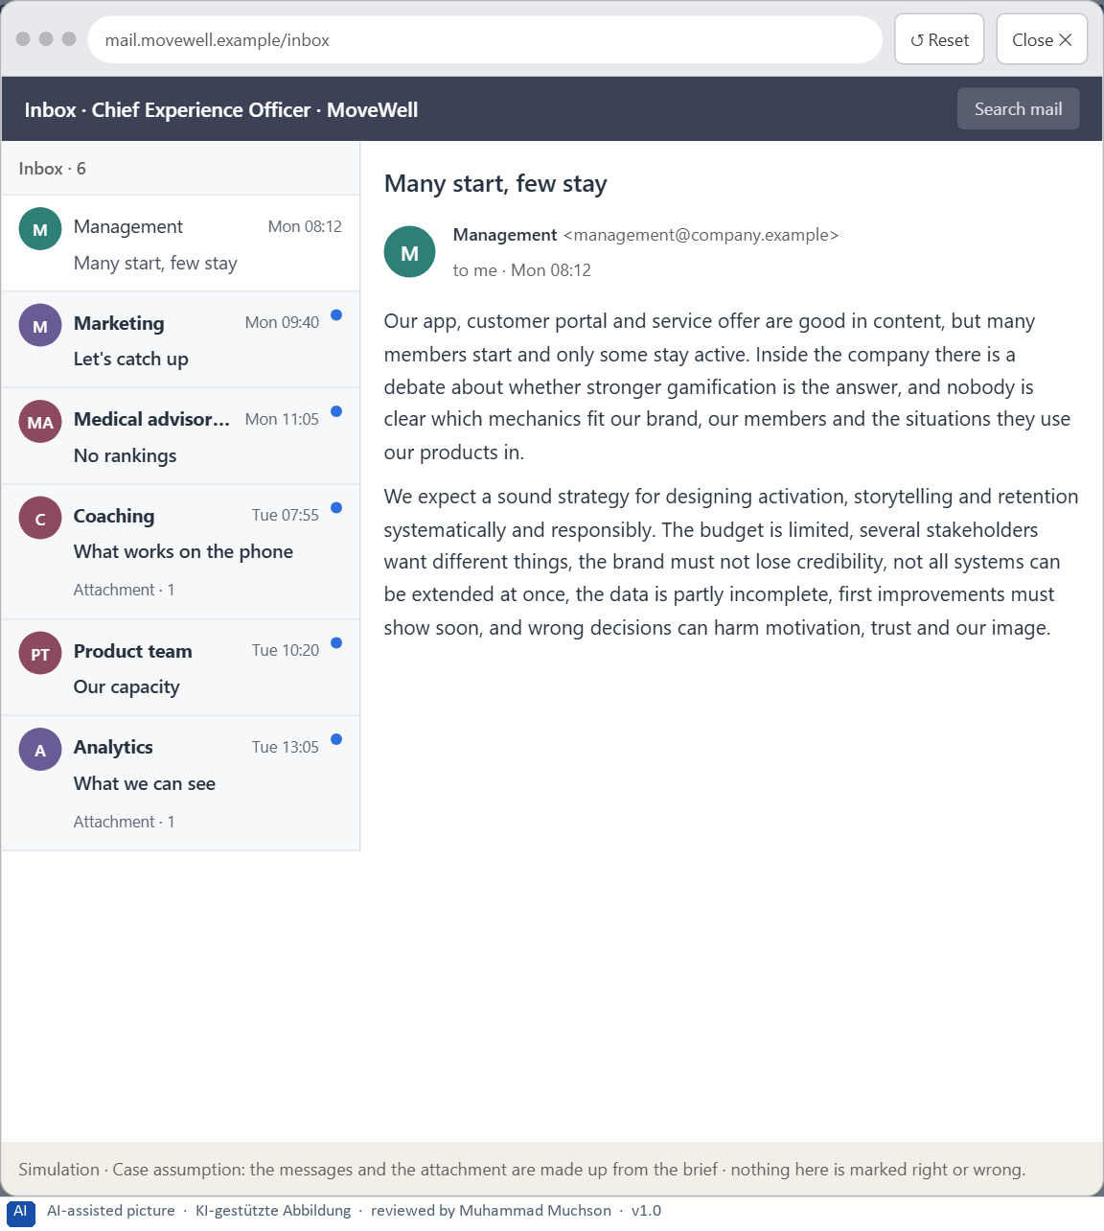
Figure 4 · Your desk: the messages that wait for you, shown in the lab as a mailbox (1 of 6).
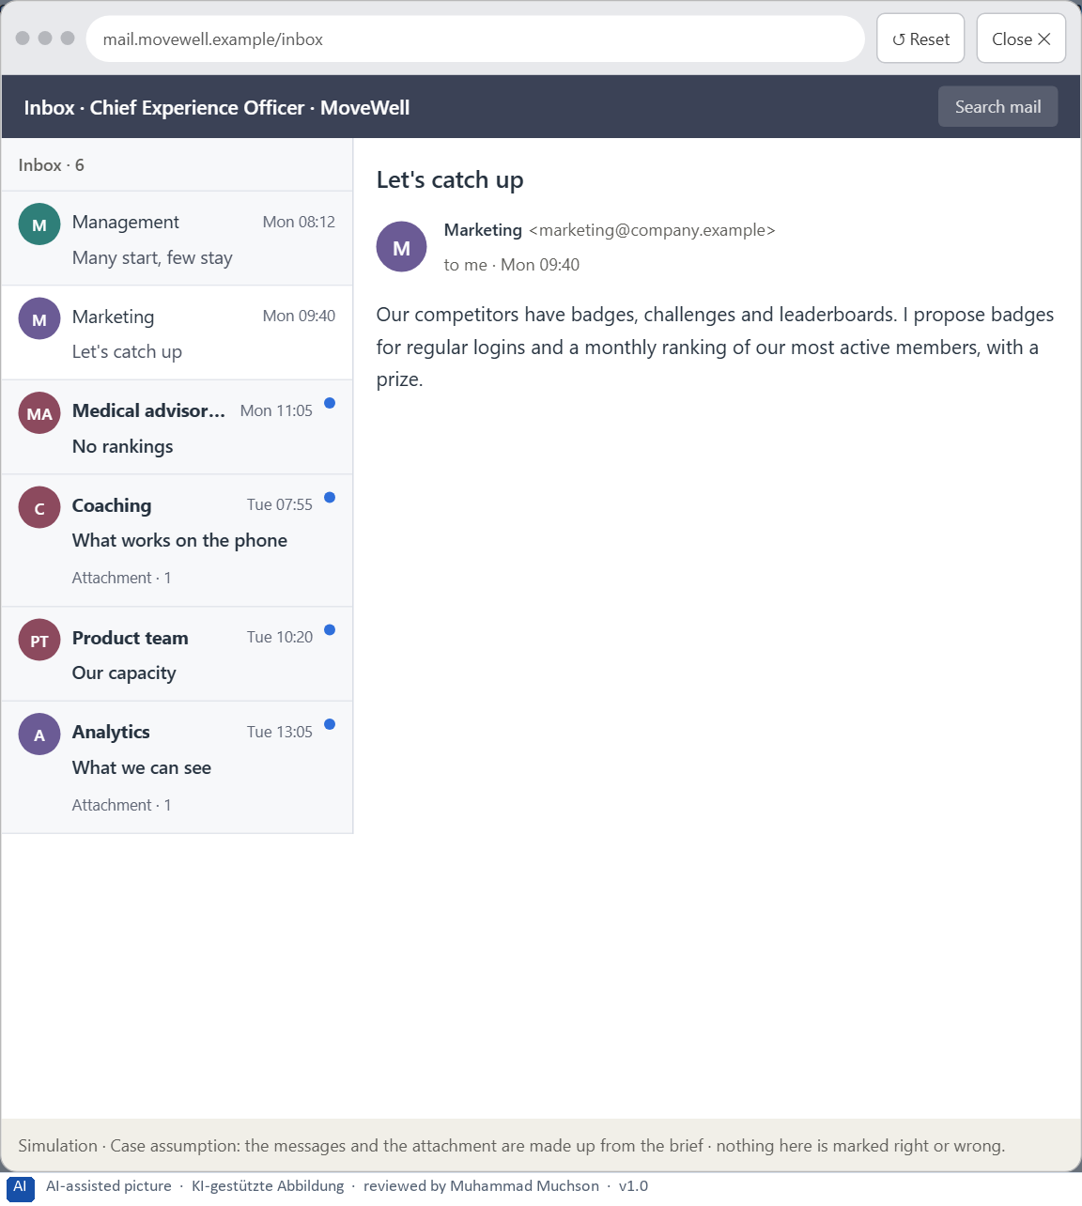
Figure 5 · Your desk: the messages that wait for you, shown in the lab as a mailbox (2 of 6).
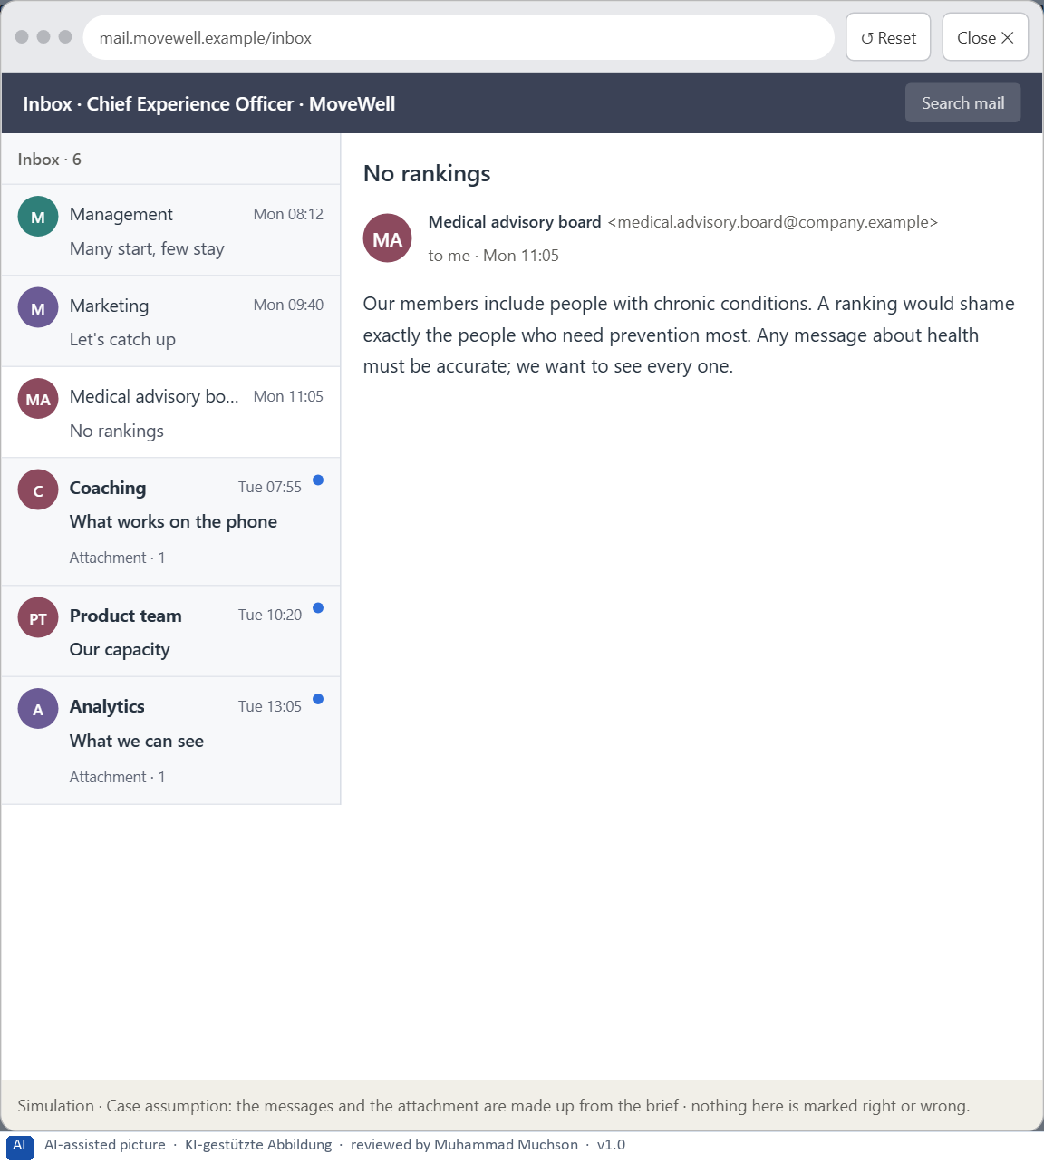
Figure 6 · Your desk: the messages that wait for you, shown in the lab as a mailbox (3 of 6).
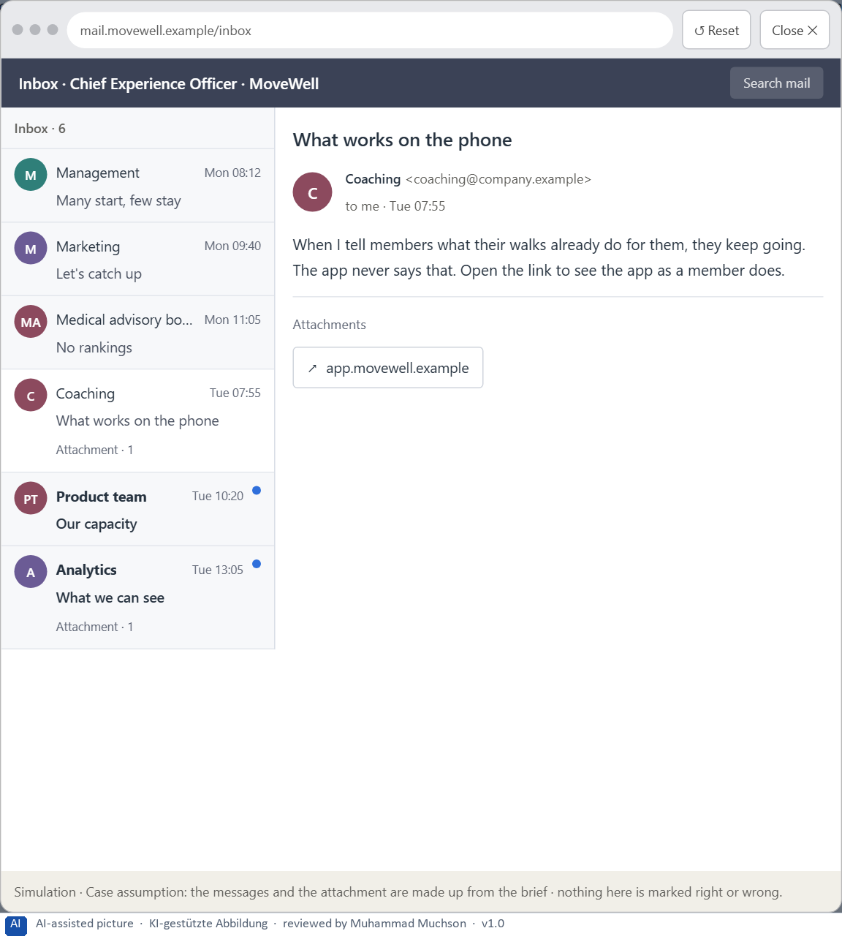
Figure 7 · Your desk: the messages that wait for you, shown in the lab as a mailbox (4 of 6).
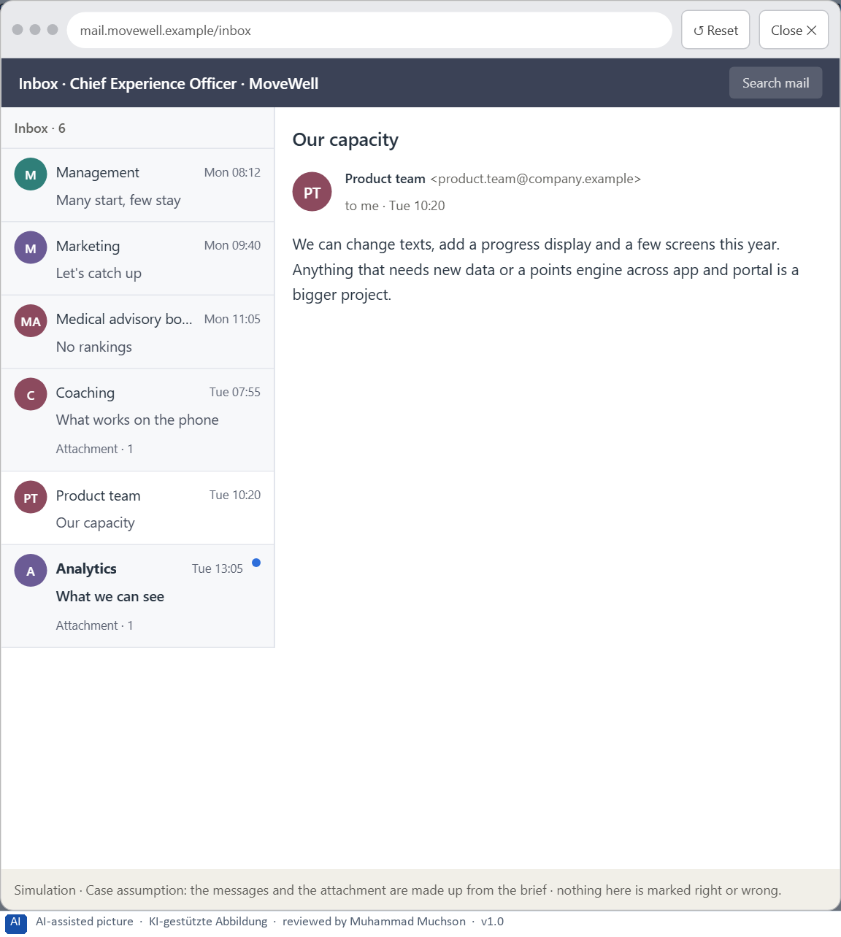
Figure 8 · Your desk: the messages that wait for you, shown in the lab as a mailbox (5 of 6).
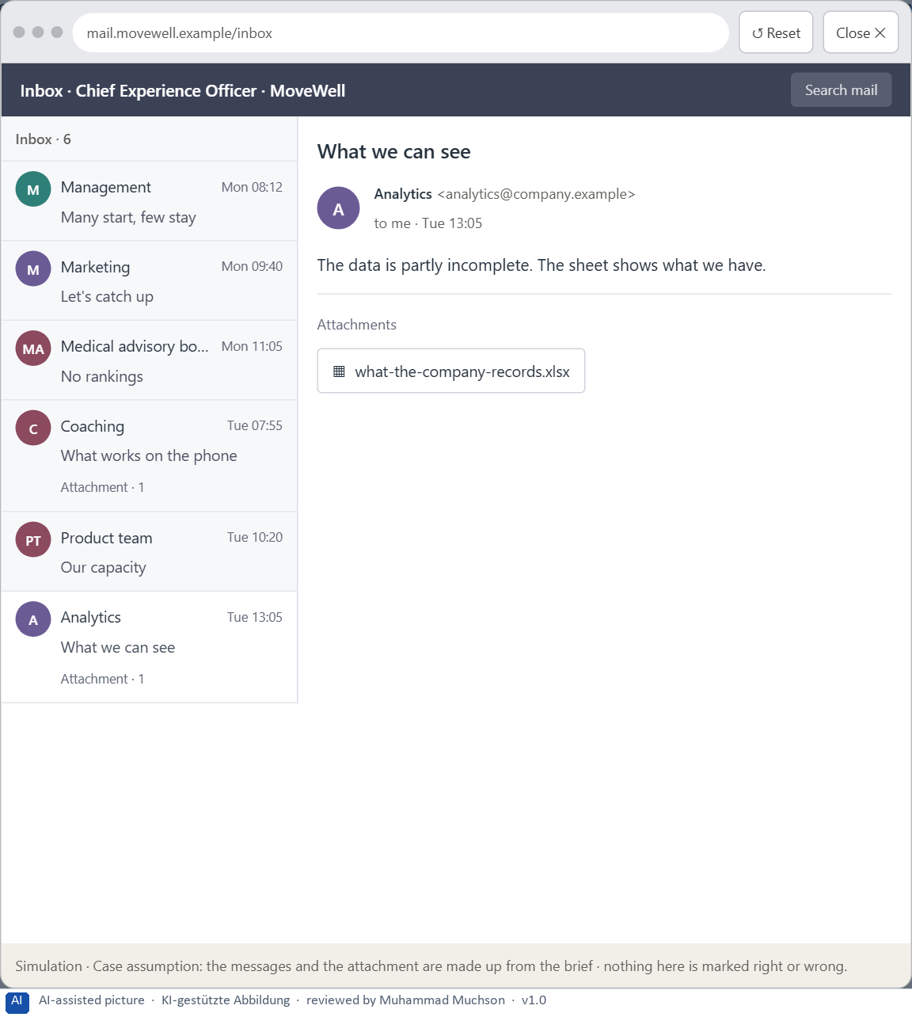
Figure 9 · Your desk: the messages that wait for you, shown in the lab as a mailbox (6 of 6).
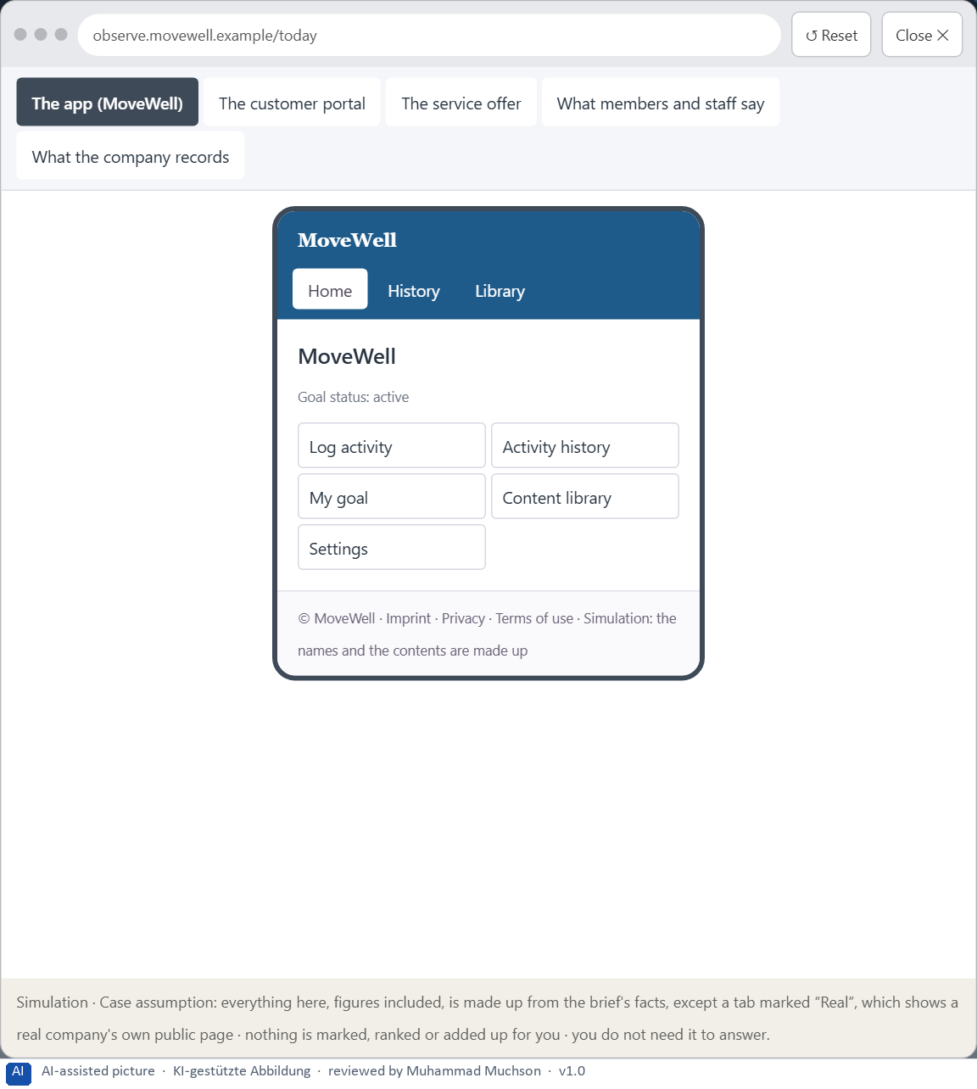
Figure 10 · The platform as it is today, as the lab lets you observe it (1 of 5).
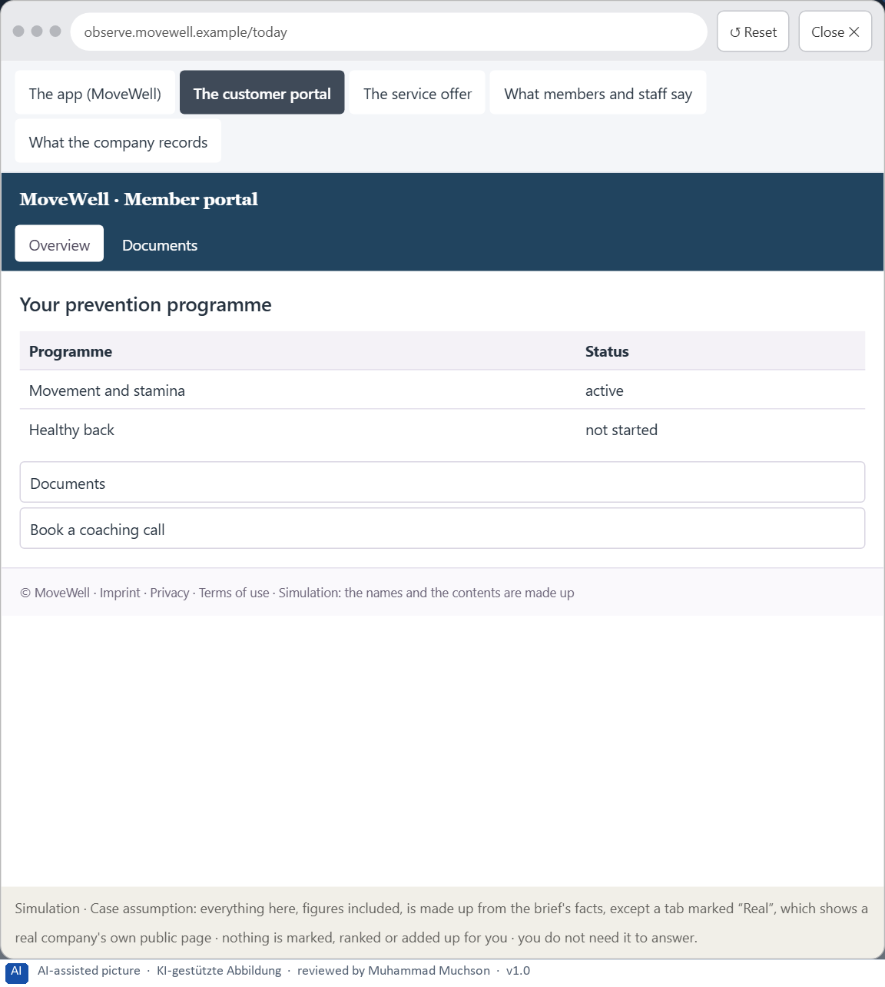
Figure 11 · The platform as it is today, as the lab lets you observe it (2 of 5).
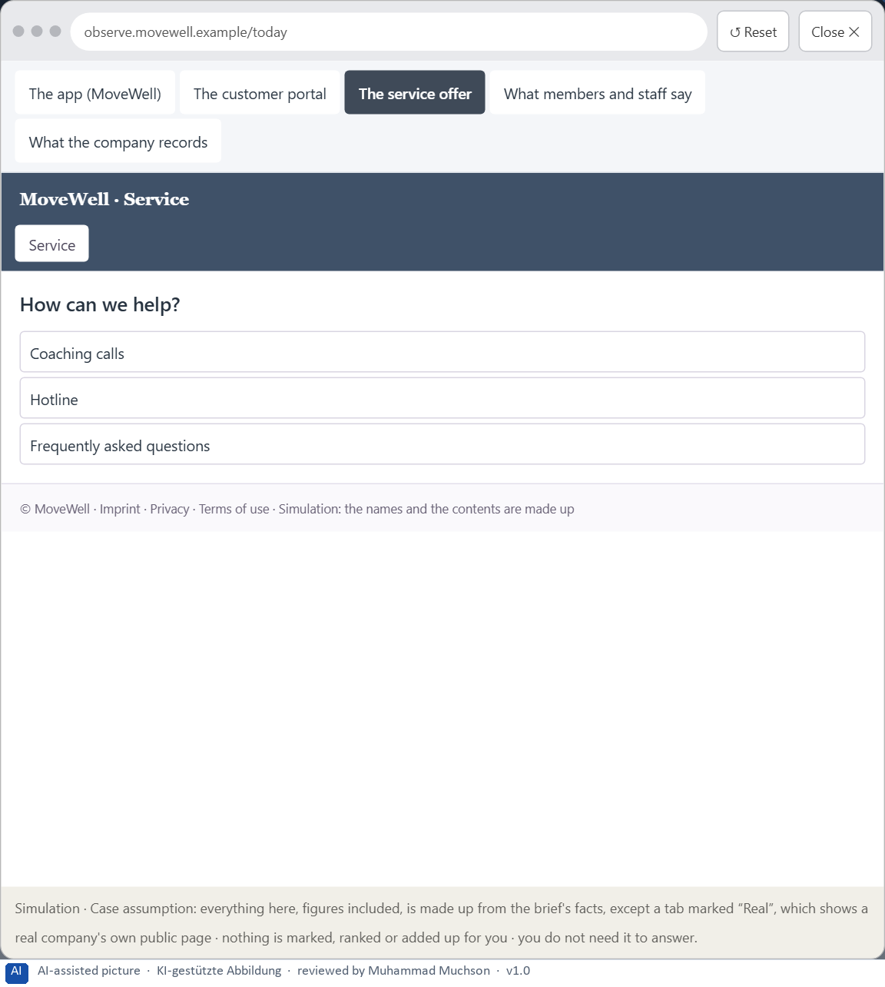
Figure 12 · The platform as it is today, as the lab lets you observe it (3 of 5).
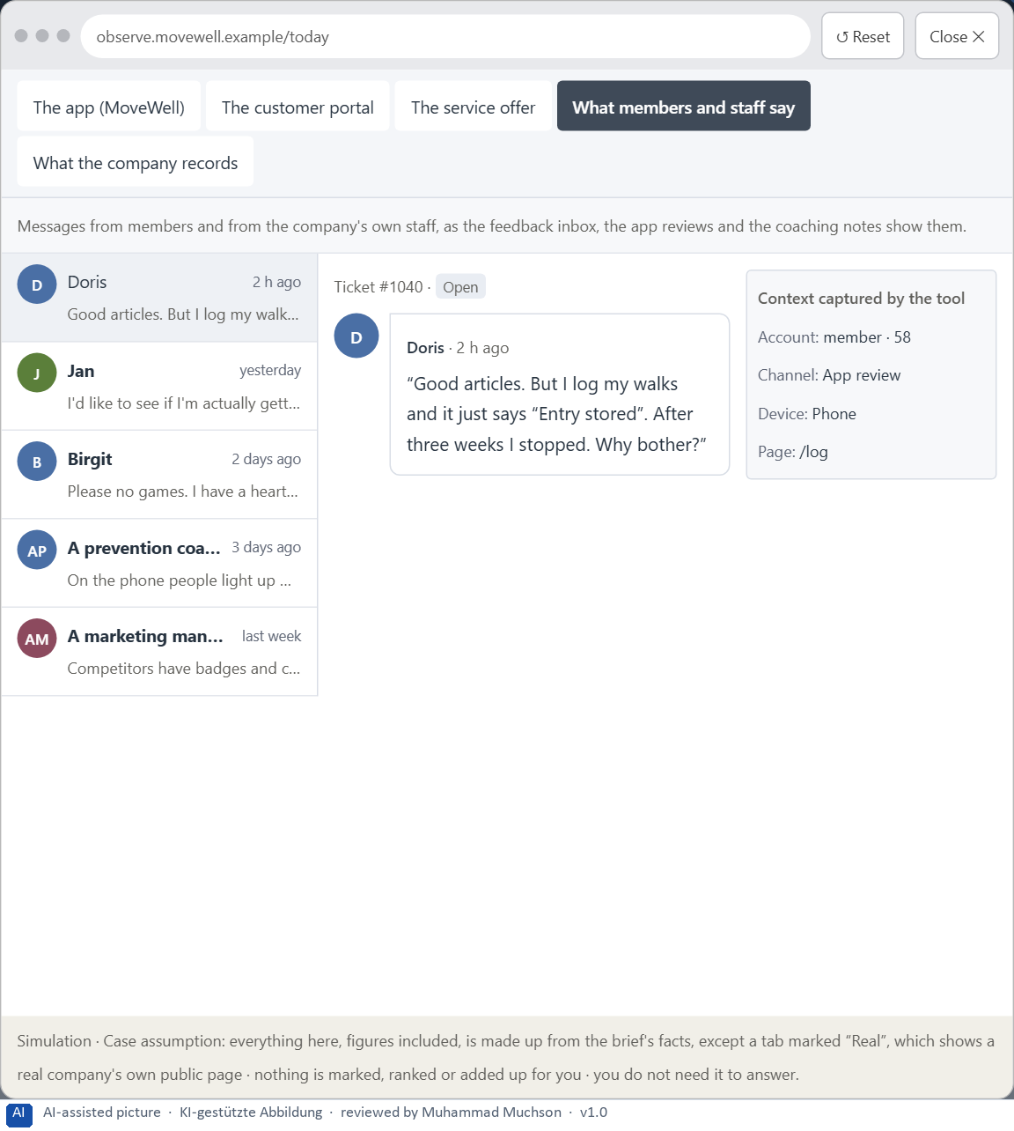
Figure 13 · The platform as it is today, as the lab lets you observe it (4 of 5).
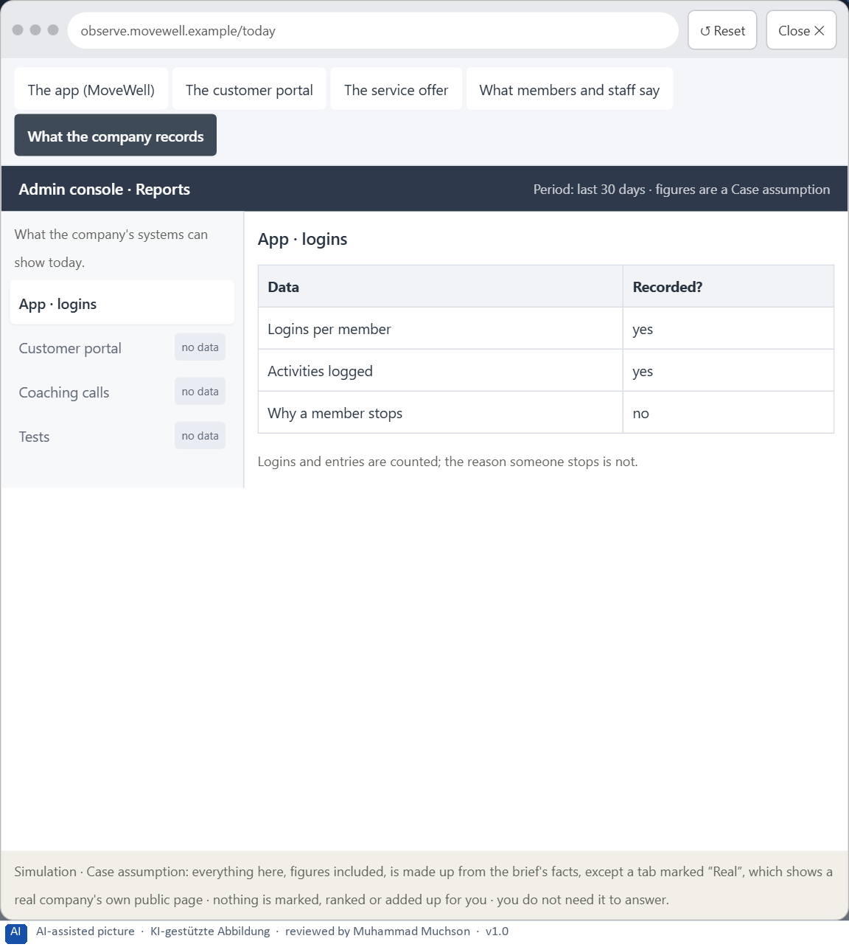
Figure 14 · The platform as it is today, as the lab lets you observe it (5 of 5).
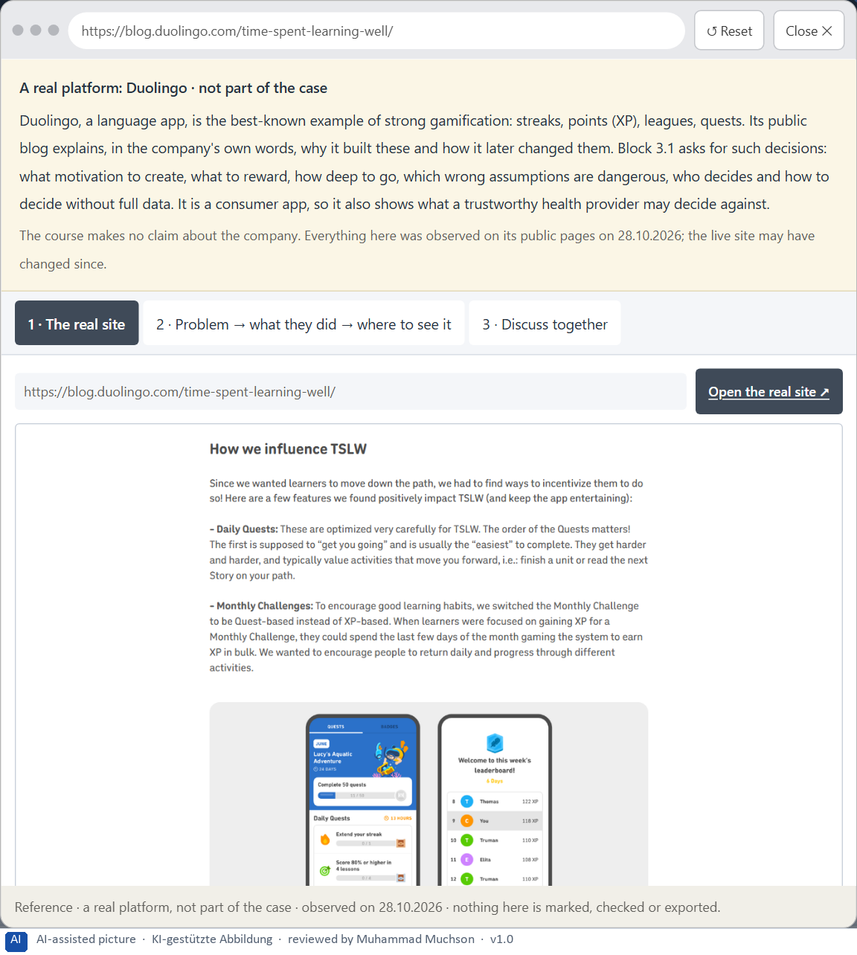
Figure 15 · A real platform that solved this, shown for the class discussion (1 of 3).
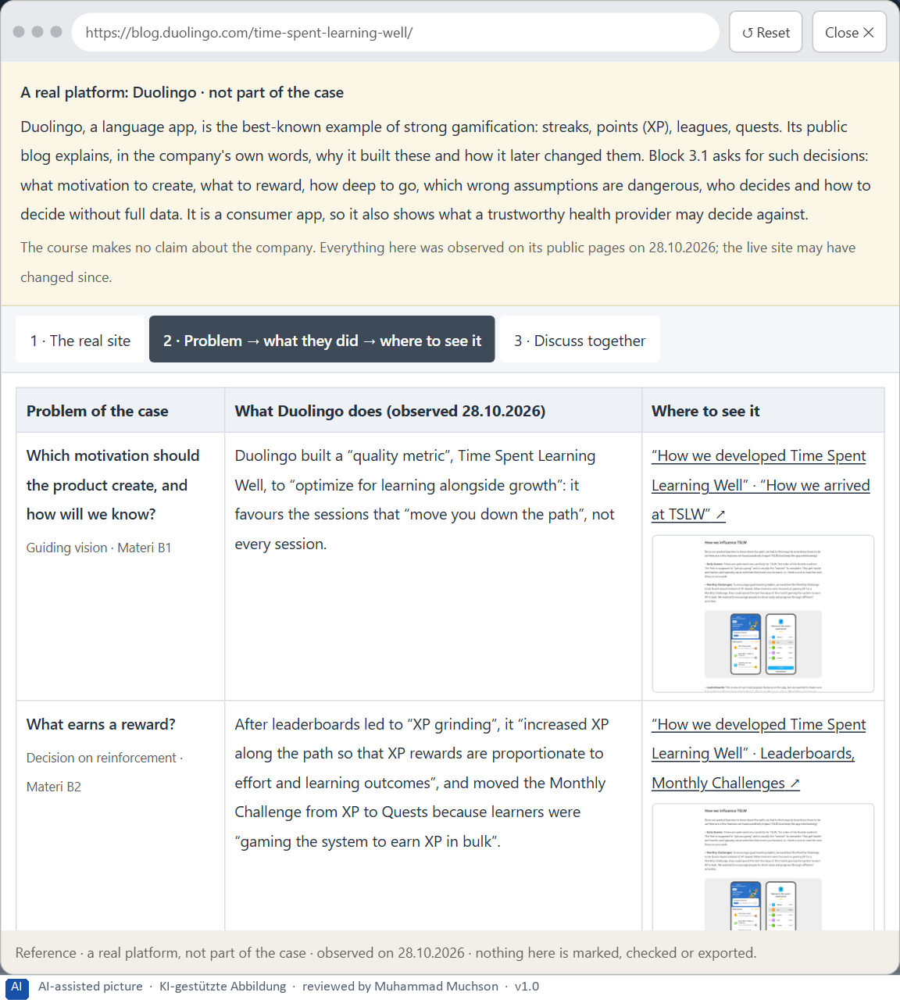
Figure 16 · A real platform that solved this, shown for the class discussion (2 of 3).
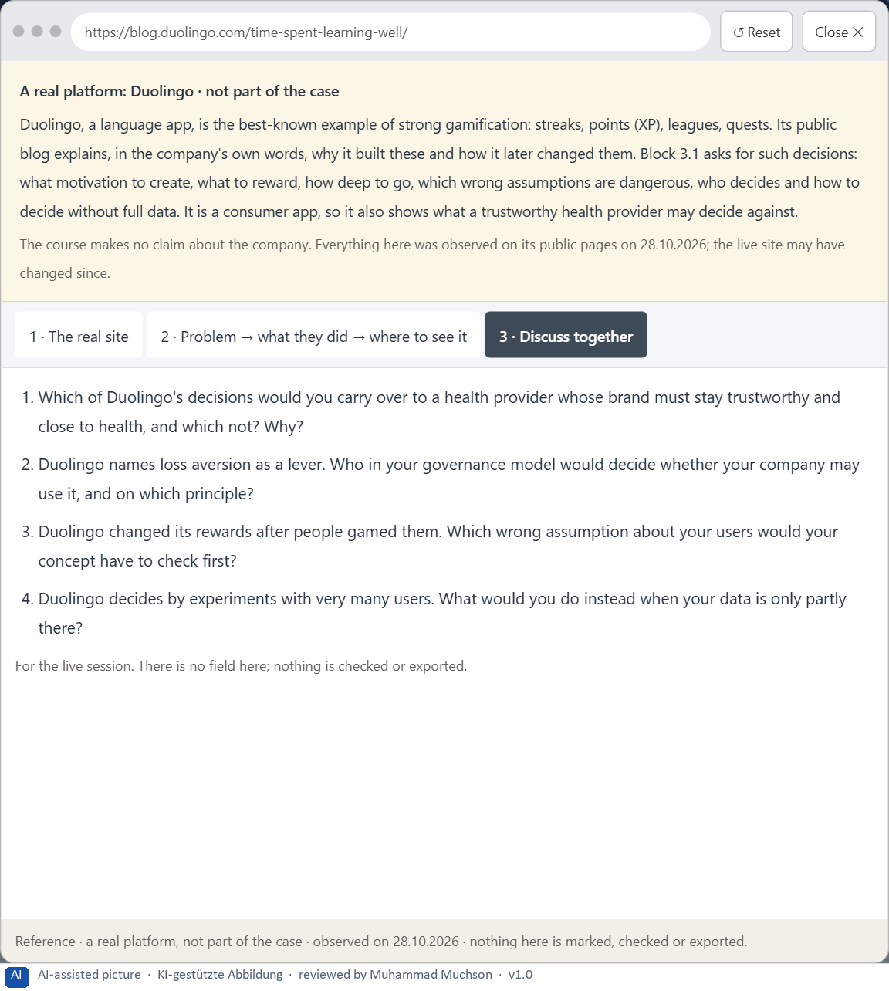
Figure 17 · A real platform that solved this, shown for the class discussion (3 of 3).
Question 1 of 7 · A guiding vision for activation and retention: which motivation and which experience of use should be created systematically?
One or two sentences about what members should feel and do in every offer, and what the company will not do to get there.
How to build the answer:
- Say which motivation you want: people coming back because they see their own progress, not because they are pushed.
- Say what experience every offer should give, and the limit you set.

Question 2 of 7 · Three strategic guiding decisions on progress, reinforcement, the depth of gamification, storytelling and long-term retention
How to build the answer:
- Take your vision and ask which three choices would make it real.
- Write each as “we will …, even though that means …”.
Write them as a list, one decision per line, each with what it gives up.

Question 3 of 7 · A prioritised architecture of measures: which journeys, functions or touchpoints are improved first, and why?
Put the journeys, functions or touchpoints in an order and give the reason for the first ones.
How to build the answer:
- List the candidates: the first weeks in the app, the progress display, the feedback after an activity, the customer portal, the coaching calls and hotline.
- Put first where most people start and leave, or what all others build on.
- Say why the others can wait.

Question 4 of 7 · A risk analysis: which wrong assumptions about motivation, target group and game mechanics would be especially critical?
Name two or three assumptions about what motivates people, who the members are, or what a mechanic does, and the harm if each is wrong.
How to build the answer:
- Write down what your concept assumes about motivation.
- Write down what it assumes about the target group.
- Write down what it assumes about game mechanics.

Question 5 of 7 · A governance model: who is responsible for the activation principles, and how are conflicts between brand, user interest and economic viability decided?
Name roles, not people: who owns the activation principles and patterns, the roles of marketing and the medical side, how a mechanic is added or removed, and how a conflict between brand, user interest and economic viability is decided.
How to build the answer:
- Name who owns the activation principles and the patterns.
- Name the roles of marketing and the medical advisory board, and how a mechanic is added or removed.
- Say how a conflict between brand, user interest and economic viability is decided.

Question 6 of 7 · A decision under uncertainty: make at least one prioritised decision despite patchy data and justify it responsibly
Say what you decide, what you do not know, and why the decision is responsible all the same, for example when you would reverse it.
How to build the answer:
- State the decision in one sentence.
- Name what you do not know.
- Say why it is still responsible: it can be reversed, it can be checked soon, or waiting costs more.

Question 7 of 7 · A management statement: a recommendation to the management with a clear priority and a strategic reason
Four to six sentences: the direction first, then the priority, the reason and what you ask of the management.
How to build the answer:
- Start with the direction in one sentence.
- Name the priority and the reason that carries it.
- Say what you ask of the management and what you will report back.

Use in class: presentation and handout
Mark of use for the worksheet. Presentation is what the trainer shows on screen; Handout is what participants fill in and hand in.
Part of the worksheet | Presentation (shown in the Neuro-UX Lab) | Handout
The case: two platforms on the UX team's desk, and MoveWell | The case read aloud or on screen | The case text
Block 1.1 · Recognise activation and retention potential in a digital offer: Skill | The task wording at the start of the block (no answers are shown) | Worksheet block with answer boxes (Core)
Block 1.2 · Rate gamification under conflicting goals: HealthJourney | The task wording at the start of the block (no answers are shown) | Worksheet block with answer boxes (Core)
Block 2.1 · Case study: an activation strategy for the prevention programme MoveWe | The task wording at the start of the block (no answers are shown) | Worksheet block with answer boxes (Core)
The situation: the health provider behind MoveWell, many who start and few who stay | The case read aloud or on screen | The case text
Block 3.1 · A strategic activation and retention architecture for digital user exp | The task wording at the start of the block (no answers are shown) | Worksheet block with answer boxes (Core)

Glossary
Every term below is used in this document. Terms stay plain text in the body; this list says what they mean in everyday words.
Term | In plain words | Example | Comes from
Activation | Getting people to act now, often with strong stimuli. It can help for a moment and tire or push people if overdone. | — | Day 7
Activation architecture | A company's whole plan for why people start and keep using its products: a vision, principles on which levers it uses, shared patterns and an owner. | — | Day 9
Badge | A small symbol that marks something someone has done; it means something only while it is rare. | — | Day 9
Case assumption | A fact made up for this exercise to fill a gap in the plan's case. It is marked so you know it is not part of the plan. | — | Day 1
Chief Experience Officer | The manager who is responsible for the experience customers have across all channels, and who decides where the company invests in it. | — | Day 1
Decision architecture | A set of connected decisions that are made on purpose and written down: what effect you want, what comes first, who decides and how conflicts are settled. It replaces many separate fixes. | — | Day 1
Game mechanic | One visible element borrowed from games, such as points, a badge, a level, a streak or a ranking. | — | Day 9
Gamification | Using the structure of games (a goal, a visible position, feedback, recognition, a challenge) in something that is not a game. | — | Day 9
Governance | The rules about who may decide what, who is answerable for it and how disagreements are settled. | — | Day 1
Intrinsic motivation | Doing something because it is worth it to you, not for a reward from outside. | — | Day 9
Milestone | A visible point on the way that shows a part of the journey is done. | — | Day 8
Playful design | Changing only the look and tone of a product to feel light and fun (colours, round shapes, cheerful words), without adding goals or feedback. | — | Day 9
Ranking (leaderboard) | A list that orders people by points or results; it motivates those near the top and can shame those near the bottom. | — | Day 9
Retention | People coming back and staying active over time, not only trying something once. | — | Day 9
Self-efficacy | Believing you can do something; it grows mostly from your own experience of succeeding. | — | Day 9
Stakeholder | A person or department with an interest in a decision, such as marketing, compliance, IT or sales. | — | Day 1
Storytelling in UX | Building a digital journey so it has what a story has: a beginning that shows the goal, a way that shows progress, and an end that feels like an end. | — | Day 8
Streak | A count of days in a row on which someone did something; it rewards regularity and punishes a single missed day. | — | Day 9
Touchpoint | Any place where a person meets the company: the website, the customer portal, the app, a chatbot or a phone call. | — | Day 1
User journey | The whole path a person takes to reach a goal with a product, across steps and touchpoints. | — | Day 8
UX (user experience) | Everything a person goes through when using a product: what they notice, understand, feel and do, from the first look to the last step. The screens are only one part of it. | Finding the booking you want at once and feeling sure it went through is a good UX. | Day 1

The Neuro-UX Lab: where we practise online
In class we use the course website as the place to practise and to learn. Every day has its own address, in the same pattern: the day number is the last part.
What | Address
Neuro-UX Lab (course website) | https://aion-ux-lab.vercel.app/
Day 9 | https://aion-ux-lab.vercel.app/day/9/

On the day page, Route 1 (Levels 1 and 2) and Route 2 (Level 3) can be opened; the cards and the tasks of this document are there too. The pattern is the same up to Day 8, for example https://aion-ux-lab.vercel.app/day/6/.

