AION · UX DEVELOPER · PSYCHOLOGICAL UX DESIGN AND NEURO-UX
DAY 1 · MATERI A AND MATERI B · ROUTES 1 AND 2 · LEVELS 1 TO 3
Psychological UX design and neuro-design
Study material with real research, worked examples and the rules you use in the tasks
AI notice · KI-Hinweis
This document was produced with the help of an AI language model (Claude, Anthropic). The AI drafted the text and tables and built the pictures and working examples of the lab. The content was then read, corrected and approved by the reviewer named below, who is responsible for its accuracy. Every picture carries an AI label on the image. Check figures and sources before you quote them.
KI-Hinweis: Dieses Dokument wurde mit Unterstützung eines KI-Sprachmodells (Claude, Anthropic) erstellt. Texte und Tabellen wurden von der KI entworfen, die Abbildungen sind KI-gestützt erstellt und am Bild gekennzeichnet. Die fachliche Prüfung und Freigabe erfolgte durch die unten genannte Person.

Day | Day 1 · Module 1 (day 1 of 1): Psychological UX design and neuro-design
Document | Materi (study material). Materi A has five cards, Materi B has three.
Route and level | Materi A serves Route 1 (Levels 1 and 2, Task 1). Materi B serves Route 2 (Level 3, Task 2).
Time | Materi A about 60 min · Materi B about 60 min (facilitator-led)
Neuro-UX Lab (website) | https://aion-ux-lab.vercel.app/day/1/
Case | Worked examples use a made-up company in each card. The task case is SafeHome Online (see the Task document).
Version | 1.0 · release date 29.10.2026
Review and approval | Muhammad Muchson, Mentor (subject-matter review and approval)

ABOUT THIS DOCUMENT
In class we also use the Neuro-UX Lab, the course website, as the place to practise and learn. Its address is at the end of this document.
Today is about judging a design by what it does to people before judging how it looks. You learn the basic words of psychological UX design, how the eye and the brain take in a screen, how expectations and habits steer what people see, and which feelings a design triggers before anyone thinks about it. Then you use them on three products and decide what to fix first. This document holds everything you need to study Day 1 without the website. Every card says what the idea is in plain words, shows it in a picture, gives the details and ends with the rules you use in the tasks.

IN THIS DOCUMENT
Lesson plan: ten teaching units (Ablaufplan)
Case study and transfer project at a glance
The course: sixteen days
How every day runs
Your documents and the Neuro-UX Lab
How we work
A1 · UX, UI and the psychology behind them: looking good is not the same as working well · 12 min · Core
A2 · How people see: from stimulus to decision, bottom-up and top-down · 16 min · Core
A3 · Expectations and habits, and three aims of an interface: orientation, less confusion, steered attention · 12 min · Core
A4 · Feelings that work before thinking: trust, reactance, overload, safety, liking · 11 min · Core
A5 · Weighing a design measure: effect on users, feasibility, risk, time pressure · 9 min · Core
B1 · Design steers perception, behaviour and decision: a Neuro-UX strategy · 22 min · Core
B2 · Conflicting goals: aesthetics against clarity, innovation against familiarity, activation against overload · 20 min · Core
B3 · Accountable decisions under uncertainty: the role, the rules and a decision you can answer for · 18 min · Core

Day at a glance
Day 1 has ten teaching units (UE). This document is the study material; it is used in UE1 (Materi A) and UE8 (Materi B). The day is built from three documents and the Neuro-UX Lab: Materi (study material), Task (worksheet) and Trainer (coaching, feedback and model solutions), plus the course website.

Lesson plan: ten teaching units (Ablaufplan)
UE | Min | Plan item | What happens | Material | Format
1 | 45 | Knowledge transfer · Level 1 | The trainer presents the cards of Materi A (A1, A2, A3, A4, A5, about 60 min of cards) in the Neuro-UX Lab; participants follow in the handout. | Materi A (Route 1) | Presentation + Handout
2 | 45 | Level 1 · Task 1 | Individual work on Block 1.1 (Core, about 10 min): the first product of the day is read and its effect described. Pairs then compare their results and the trainer collects open questions. | Task 1 · Part 1 · Block 1.1 | Handout (or in the lab)
3 | 45 | Level 1 · Task 2 | Three options are rated on the same criteria and one is chosen under the stated conditions: Block 1.2 (Core, about 8 min). | Task 1 · Part 1 · Block 1.2 | Handout (or in the lab)
4 | 45 | Coaching · transition from Level 1 to Level 2 | Trainer-led. A short talk on the day's coaching focus, then the reflection questions in pairs. The bridge: from describing an effect to a decision you answer for. There is no worksheet block in this unit. | Trainer document, section Coaching | Trainer only
5–6 | 90 | Level 2 · Case study SafeHome Online (2 UE) incl. model solution | UE5: the trainer presents the case; participants work on Block 2.1 (Core, about 15 min). UE6: groups compare their results and defend them; the trainer closes with the model solution. | Task 1 · Part 2 · Block 2.1  Trainer document, section Case study | Handout; model solution shown after the work
7 | 45 | Level 2 + 3 · Feedback round with a management perspective | Groups present their reasoning, not only their result. The trainer asks the day's Level 3 input questions and leads the discussion. | Trainer document, section Feedback round | Presentation by the groups; Trainer only
8 | 45 | Level 3 · Transfer project, Chief Experience Officer (3 UE: UE8–10) | The trainer presents Materi B (B1, B2, B3; use the "In plain words" and "How to decide" boxes, the rest is handout) and sets the role and the situation. | Materi B (Route 2) | Presentation + Handout
9 | 45 | Level 3 · Transfer project | Individual work or in pairs on Block 3.1 (Core, about 20 min): the strategy memo. | Task 2 · Block 3.1 | Handout (or in the lab)
10 | 45 | Level 3 · Transfer project | Participants present their decision and what they give up, including the one decision made under uncertainty; the trainer debriefs with the model solution. | Task 2 · Block 3.1  Trainer document, section Transfer project | Handout; model solution shown after the work

One UE is counted as 45 minutes here; breaks are not shown. The times are a guide for the trainer. The Core blocks are enough for a complete answer.

Case study and transfer project at a glance
Component | UE | Duration | Participants work in | Model solution in
Level 2 case study (SafeHome Online) | UE5–6 | 2 UE · 90 min | Task 1 · Part 2 (Block 2.1) | Trainer document, section Case study
Level 3 transfer project (Chief Experience Officer) | UE8–10 | 3 UE · 135 min | Materi B and Task 2 (Block 3.1) | Trainer document, section Transfer project

Block orientation (Blockorientierung)
This page orients you before the first day. It says what the course is, how a day runs, which documents you will meet, and what is expected of you.

The course: sixteen days
The AION UX Developer course runs over sixteen days. It begins with psychological UX design and neuro-design and ends with immersive technologies and the ethics of future interaction. One thread runs through every day: a design is judged by what it does to people, and a design decision is a decision you answer for. You are asked to think like a decision-maker, not only like a designer: to weigh options against a budget, a deadline and a risk, and to decide even when the data is incomplete.
Module | Day | Topic
Module 1 | 1 | Psychological UX design and neuro-design
Module 2 | 2 | Visual perception and user-centred design
 | 3 | Colour, typography and readability
Module 3 | 4 | UX laws and cognitive perception
 | 5 | Fitts, Hick and Miller in practice
 | 6 | Gestalt, hierarchy, progressive disclosure and design systems
Module 4 | 7 | Emotional bonding in design
 | 8 | Storytelling in UX/UI design
 | 9 | Gamification strategies, and storytelling with gamification
Module 5 | 10 | Intelligent interfaces and AI-supported interaction
 | 11 | Voice interfaces, neuro-design and testing AI interfaces
Module 6 | 12 | Accessibility, standards and neurodiversity
 | 13 | Neurodiversity, inclusive patterns and assistive technologies
Module 7 | 14 | Immersive technologies and neuroscientific UX basics
 | 15 | Eye-tracking and gaze behaviour, neurofeedback and brain-computer interfaces
 | 16 | Immersive prototyping and testing, future strategies and ethical aspects

How every day runs
Every day has the same ten teaching units (UE) and the same three levels of work.
UE | What happens | Level
1 | Knowledge transfer: the trainer presents the day's topic | Level 1 · Knowledge
2–3 | Two short tasks: read a product and describe its effect, then weigh three options under limits | Level 1 · Knowledge
4 | Coaching: from understanding to application | Level 1 to 2
5–6 | Case study (2 UE) with a model solution | Level 2 · Application
7 | Feedback round with a management perspective | Level 2 + 3
8–10 | Transfer project (3 UE): you take a management role and decide | Level 3 · Management decision

Level 1 asks you to understand the day's ideas and to describe what a design does to people. Level 2 asks you to analyse a product, develop measures and put them in order. Level 3 asks you to decide as a manager: to set priorities between user effect, effort, risk and the business, and to decide even when the data is incomplete.

Your documents and the Neuro-UX Lab
Document | What it is | Who has it
Materi (A and B) | Study material. Materi A serves Route 1 (Levels 1 and 2); Materi B serves Route 2 (Level 3). | Participants (handout)
Task (1 and 2) | The worksheet with answer boxes. Task 1 is Route 1; Task 2 is Route 2. There are no answer keys and no scores in it. | Participants (handout)
Trainer | Coaching, feedback round, model solutions and assessment criteria. | Trainer only
Neuro-UX Lab | The course website (https://aion-ux-lab.vercel.app/). In class it is the place to practise and learn: the cards, the working examples and the tasks are there too, and you can work in them directly. | Everyone

How we work
- Blocks marked Core are enough for a complete answer.
- In the judged parts, a different choice with a clear reason is a good answer. The reason matters more than the result.
- The worked examples in the Materi use a made-up company that is not one of the task cases. No task answer is printed in the study material.
- Real research findings and rules in the Materi carry their source; check a source and its current edition before you quote it.
- Every document names its version, its release date and the person who reviewed and approved it. Pictures are screenshots of the lab, drawn with the help of AI, and are labelled on the image.

Materi A · Route 1 · Levels 1 and 2
How Materi A is used
About 60 minutes, five cards. Levels 1 and 2: describe what an unfamiliar health app does to its users, rate three start pages of a learning platform and decide under uncertainty, then analyse an insurance portal, develop four measures, put them in order and justify the decision. The cards give you the ideas and the rules you use in Task 1.

A1 · UX, UI and the psychology behind them: looking good is not the same as working well · 12 min · Core
UX is what people go through, UI is the surface. A design is judged by its effect on attention, understanding, feeling and decision, not only by how it looks.
IN PLAIN WORDS
The idea. UX (user experience) is everything a person goes through when using a product: what they notice, understand, feel and do. UI (user interface) is only the surface they see and touch. A page can look beautiful and still make people overlook the button, doubt the company or give up. Psychological UX design therefore judges a design by its effect on attention, understanding, feeling and decision, not only by how it looks.
Why it matters. Block 1.1 asks you to describe what the CarePath app does to its users before you judge it, and Block 2.1 asks for the effect problems of the SafeHome portal. This card gives you the words for an effect and the test that separates it from taste.
How to read the picture. The same Nordwind booking page twice: designed to look good, and designed to work.

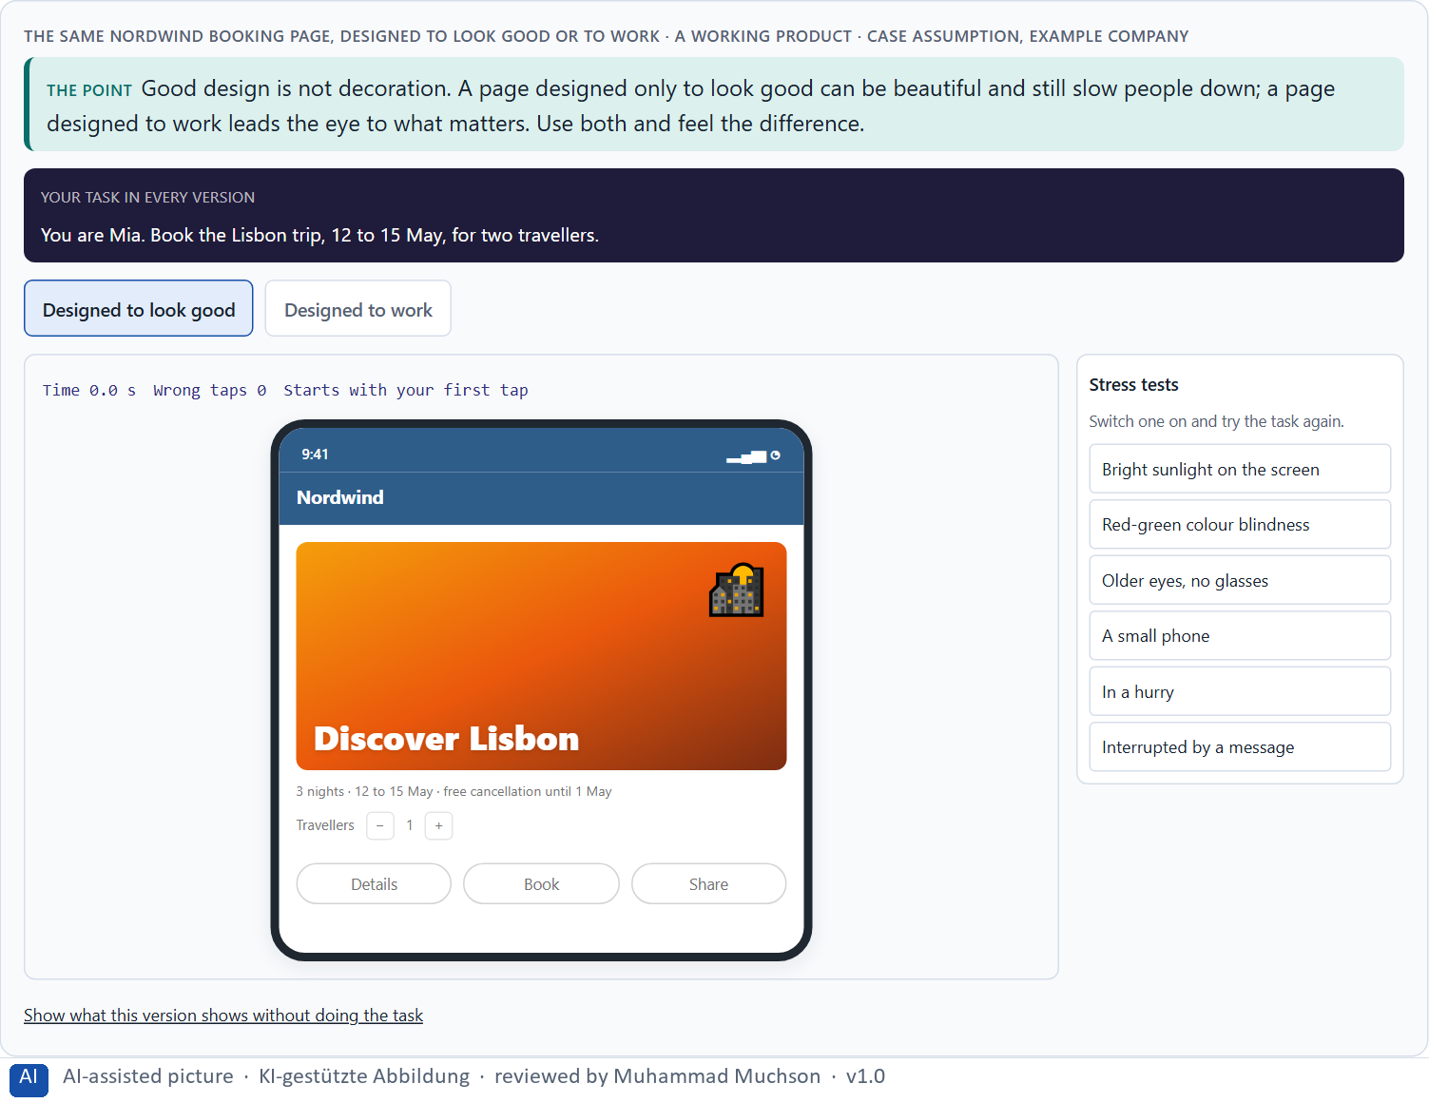
Figure 1 · The same Nordwind booking page, designed to look good or to work. Shown here in its starting state; in the Neuro-UX Lab every version and every stress test can be used.
The basic words of psychological UX design
Word | What it means | On a screen
UX (user experience) | Everything a person goes through when using a product. | Finding the trip, understanding it, booking, feeling sure it worked.
UI (user interface) | The surface: what is seen and touched. | Buttons, colours, type, layout.
Perception | Taking in what the senses deliver. | Seeing a banner, a button, a colour.
Attention | What the mind picks out to work on. | The banner is noticed, the small link is not.
Cognition | Thinking, remembering, comparing, deciding. | Working out which of three buttons books.
Emotion | The feeling a design triggers. | Feeling safe, rushed or worried.
Mental model | What a person believes the product is and does. | “The basket shows what I chose.”

Each word with a real finding: what research shows, and what it means for a screen
Word | A real finding | What it means for a screen
UX | ISO 9241-210 counts the responses to the use and to the anticipated use of a product: the experience starts before the first tap, with the store page, the advert and what friends say. | A good booking screen cannot repair a confusing confirmation e-mail: both are the experience.
UI | Norman (2013) opens his book with doors: a handle that says “pull” on a door that must be pushed. The surface tells the hand one thing and the product does another. | A button that looks like a label, or a label that looks like a button, is a UI fault even when the function behind it works.
Perception | Only a spot of about 2° of the visual field is seen sharply; the eyes jump three to four times a second and take in information only during fixations of about 200 to 300 ms (Rayner 1998). | What the eye never lands on is seen only as a blur. A screen is perceived in jumps, not as a whole.
Attention | 46% of observers counting basketball passes did not notice a person in a gorilla suit walking through the video (Simons and Chabris 1999). Web users overlook what looks like an advert, even when it is what they need (Benway and Lane 1998). | Being on the screen is not being seen. What lies outside the task, or looks like an advert, is often not noticed at all.
Cognition | Working memory holds about four chunks at once (Cowan 2001). | A form that asks people to remember a code from the previous screen, plus a date and a price, asks for most of what they have.
Emotion | People rate the visual appeal of a web page after 50 ms, and the rating barely changes with longer viewing (Lindgaard et al. 2006). | The first feeling comes before the first word is read; it colours everything that follows.
Mental model | Users spend most of their time on other sites, so they expect yours to work like those (Nielsen 2000, later called Jakob's Law). | The logo at the top left leads home, the magnifier means search, the basket sits at the top right: breaking such a model costs every user a moment of doubt.

Case assumption
Nordwind, Mia, Tom, Jana and Ben are made up for this example. The definition of user experience follows ISO 9241-210 and Norman and Nielsen; mental models follow Norman (2013). The findings in the second table are real research results; the sources are listed below.

How to decide when this comes up in the task
- Describe the effect before you judge: what does the person notice first, understand, feel and do?
- Separate taste (“I like it”) from an effect assumption (“users will probably overlook the button, because …”). Only the second can be tested.
- Check the mental model: does the screen work the way the person believes it works?
- A beautiful page can work badly and a plain one well: judge each by what it does, not by how it looks.

Extra · go deeper (optional reading)
People rate an attractive interface as easier to use before they have used it (Tractinsky, Katz and Ikar 2000). That is why looks matter, and also why they mislead: the first judgement is not the experience. Psychological UX design takes both seriously and tests which one holds.

Sources · Norman & Nielsen · ISO 9241-210 · Norman 2013 · Tractinsky et al. 2000 · Rayner 1998 · Simons & Chabris 1999 · Benway & Lane 1998 · Cowan 2001 · Lindgaard et al. 2006 · Nielsen 2000

A2 · How people see: from stimulus to decision, bottom-up and top-down · 16 min · Core
The brain takes in the stimulus, steers attention, recognises patterns and makes sense of them. A strong signal pulls the eye by itself (bottom-up); the goal pulls it too (top-down).
IN PLAIN WORDS
The idea. Seeing is not a camera. The eye takes in light, the brain picks out what stands out, recognises patterns and then makes sense of them. Two forces steer this at once. A strong signal, such as movement, a bright colour or a large shape, pulls attention by itself (bottom-up). What a person wants, knows and expects pulls it too (top-down). When the two point to different places, people are slowed down or led astray.
Why it matters. Block 1.1 asks which elements of CarePath bind or distract attention, and Block 1.2 asks you to rate three start pages on orientation and activation. You need both forces to say why an element pulls the eye and whether that helps the user.
How to read the picture. First the four steps from what the eye takes in to a decision, then a table of what the brain does at each step, with real numbers. Then the Nordwind ferry board as only the sharp centre of the eye takes it in: each tap is one jump of the eyes. Then one Nordwind screen in three readings: the strongest signal wins, Mia's goal leads, and both pull at once.

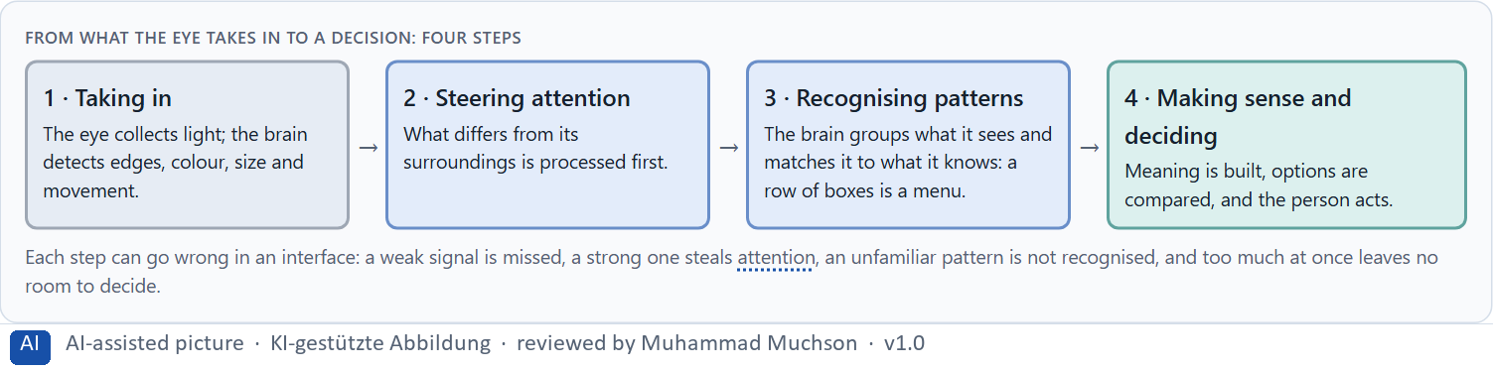
Figure 2 · From what the eye takes in to a decision: four steps.
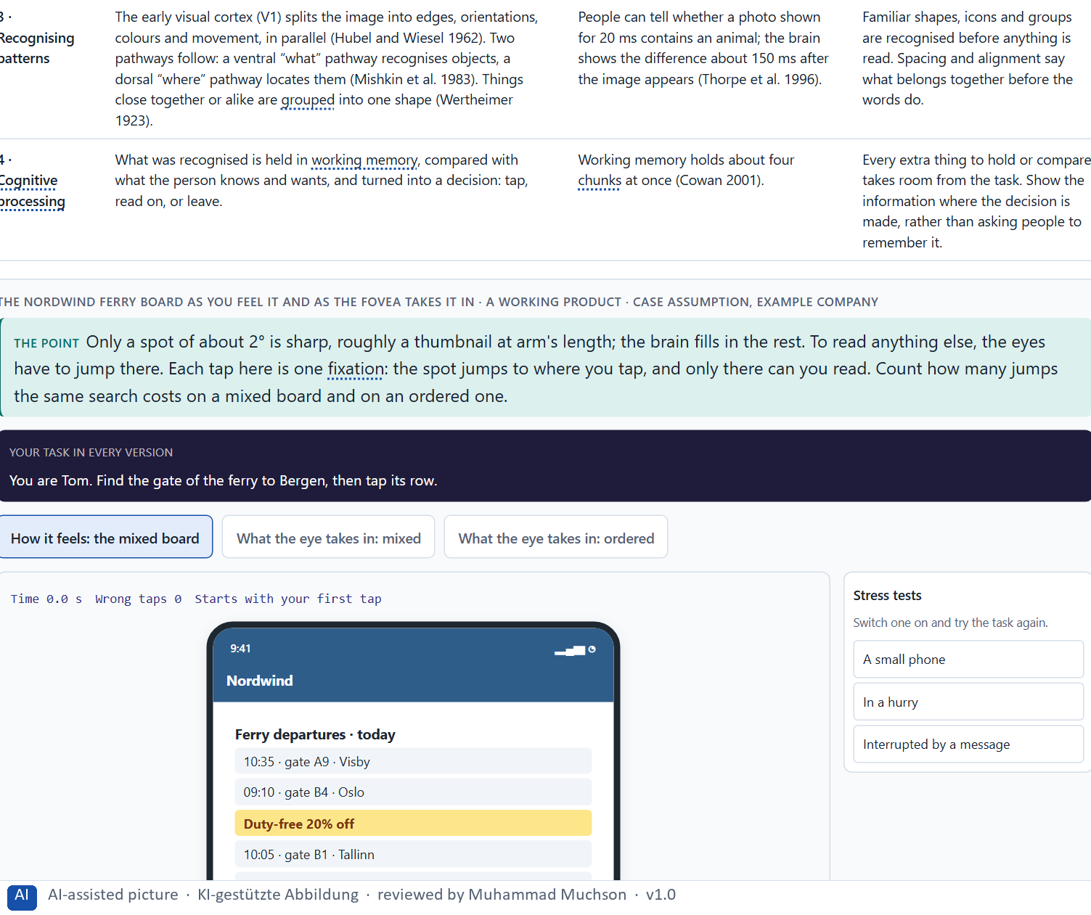
Figure 3 · The Nordwind ferry board as you feel it and as the fovea takes it in. Shown here in its starting state; in the Neuro-UX Lab every version and every stress test can be used.
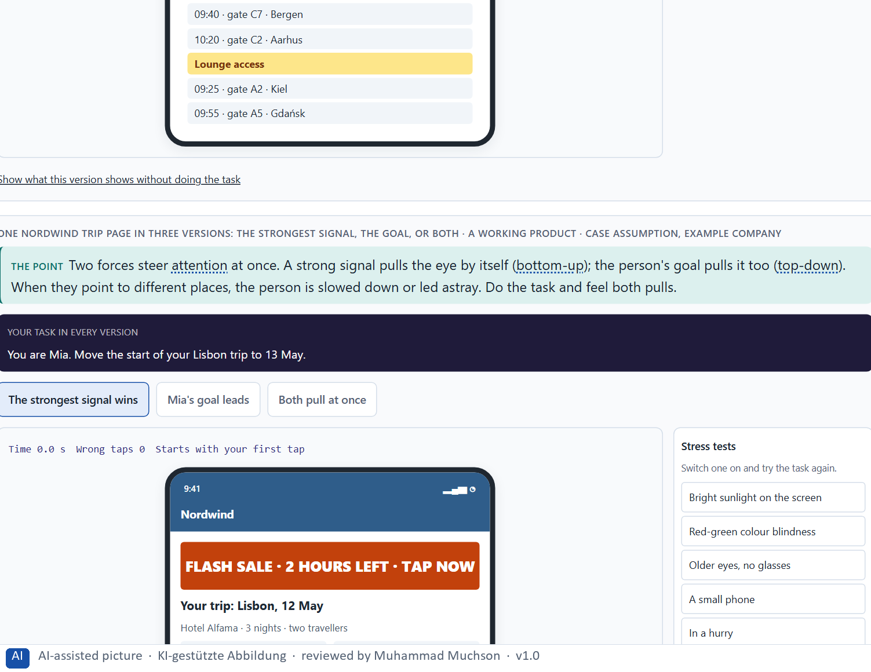
Figure 4 · One Nordwind trip page in three versions: the strongest signal, the goal, or both. Shown here in its starting state; in the Neuro-UX Lab every version and every stress test can be used.
From light to meaning: the four steps in the brain, with real numbers
Step | What happens in the brain | Real numbers | What it means for a screen
1 · Taking in the stimulus | Light falls on the retina. Only its centre, the fovea, sees sharp detail and colour; the edge of the field sees movement and contrast, blurred. The eyes jump (saccades) and rest (fixations); information comes in only while they rest. | Sharp vision covers about 2° (a thumbnail at arm's length); three to four fixations a second, each about 200 to 300 ms (Rayner 1998). | People never see the whole screen sharp at once. Every element they need costs a jump of the eyes.
2 · Steering attention | The brain decides where the next jump goes. Bottom-up, a “saliency map” marks what differs most from its surroundings; top-down, the goal marks what fits the search. Both feed the same decision. | In eye-tracking studies with 232 users (2006, confirmed in 2017), people scanned text pages mostly in an F shape: the top lines, a shorter line below, then down the left edge (Pernice 2017). | The top and the left edge of a page get the jumps; what matters should start there, with the words people are looking for.
3 · Recognising patterns | The early visual cortex (V1) splits the image into edges, orientations, colours and movement, in parallel (Hubel and Wiesel 1962). Two pathways follow: a ventral “what” pathway recognises objects, a dorsal “where” pathway locates them (Mishkin et al. 1983). Things close together or alike are grouped into one shape (Wertheimer 1923). | People can tell whether a photo shown for 20 ms contains an animal; the brain shows the difference about 150 ms after the image appears (Thorpe et al. 1996). | Familiar shapes, icons and groups are recognised before anything is read. Spacing and alignment say what belongs together before the words do.
4 · Cognitive processing | What was recognised is held in working memory, compared with what the person knows and wants, and turned into a decision: tap, read on, or leave. | Working memory holds about four chunks at once (Cowan 2001). | Every extra thing to hold or compare takes room from the task. Show the information where the decision is made, rather than asking people to remember it.

Two forces of attention, and what they mean for a screen
Force | What steers it | What it means for a screen
Bottom-up | The stimulus: movement, colour, contrast, size. | Strong signals are seen first, wanted or not.
Top-down | The person's goal, knowledge and expectation. | People look for what they came for, in the words they expect.
Both at once | A strong signal that is not the goal. | Slower, with more mistakes: the signal competes with the task.

Case assumption
Nordwind, Mia, Tom, Jana and Ben are made up for this example. Bottom-up attention follows Itti and Koch (2001); the two attention systems follow Corbetta and Shulman (2002). The numbers in the table of the four steps are real research results; the ferry board is made up.

How to decide when this comes up in the task
- Find the strongest signals on a screen: what moves, glows, is red or much larger than the rest. They are seen first.
- Ask whether the strongest signal is the task. If it is not, it competes with the task: count it as a distraction.
- Ask what the person is looking for (their goal) and whether it is easy to find with that goal in mind.
- A single feature, such as a colour, pops out at once; a combination of features has to be searched. Make the important thing differ in one clear way.

Extra · go deeper (optional reading)
Feature-integration theory explains why a single red item among grey ones pops out immediately, while a red square among red circles and grey squares has to be searched item by item (Treisman and Gelade 1980). For a screen, it means: the important thing should differ from the rest in one clear way, and only a few things should differ at all.

Sources · Itti & Koch 2001 · Corbetta & Shulman 2002 · Treisman & Gelade 1980 · Rayner 1998 · Hubel & Wiesel 1962 · Mishkin et al. 1983 · Thorpe et al. 1996 · Wertheimer 1923 · Cowan 2001 · Pernice 2017

A3 · Expectations and habits, and three aims of an interface: orientation, less confusion, steered attention · 12 min · Core
People bring prior knowledge, expectations, context and habits. A good interface uses them to give orientation, reduce confusion and steer attention to what matters.
IN PLAIN WORDS
The idea. People never meet a screen empty-handed. They bring prior knowledge, expectations, their situation and habits: they look for the menu where other products put it and read a red colour as danger. A good interface uses this to reach three aims: orientation (where am I, what can I do, what comes next), less confusion (few competing signals, one system, plain words) and steered attention (what matters is the strongest thing on the screen).
Why it matters. Block 1.1 asks you to sort CarePath's problems into categories such as orientation and cognitive load, Block 1.2 asks for orientation and understandability, and Block 2.1 asks for problems of perception and action guidance. These three aims are what you check.
How to read the picture. One Nordwind screen with three switches: where am I, one main action, and the menu where people expect it.

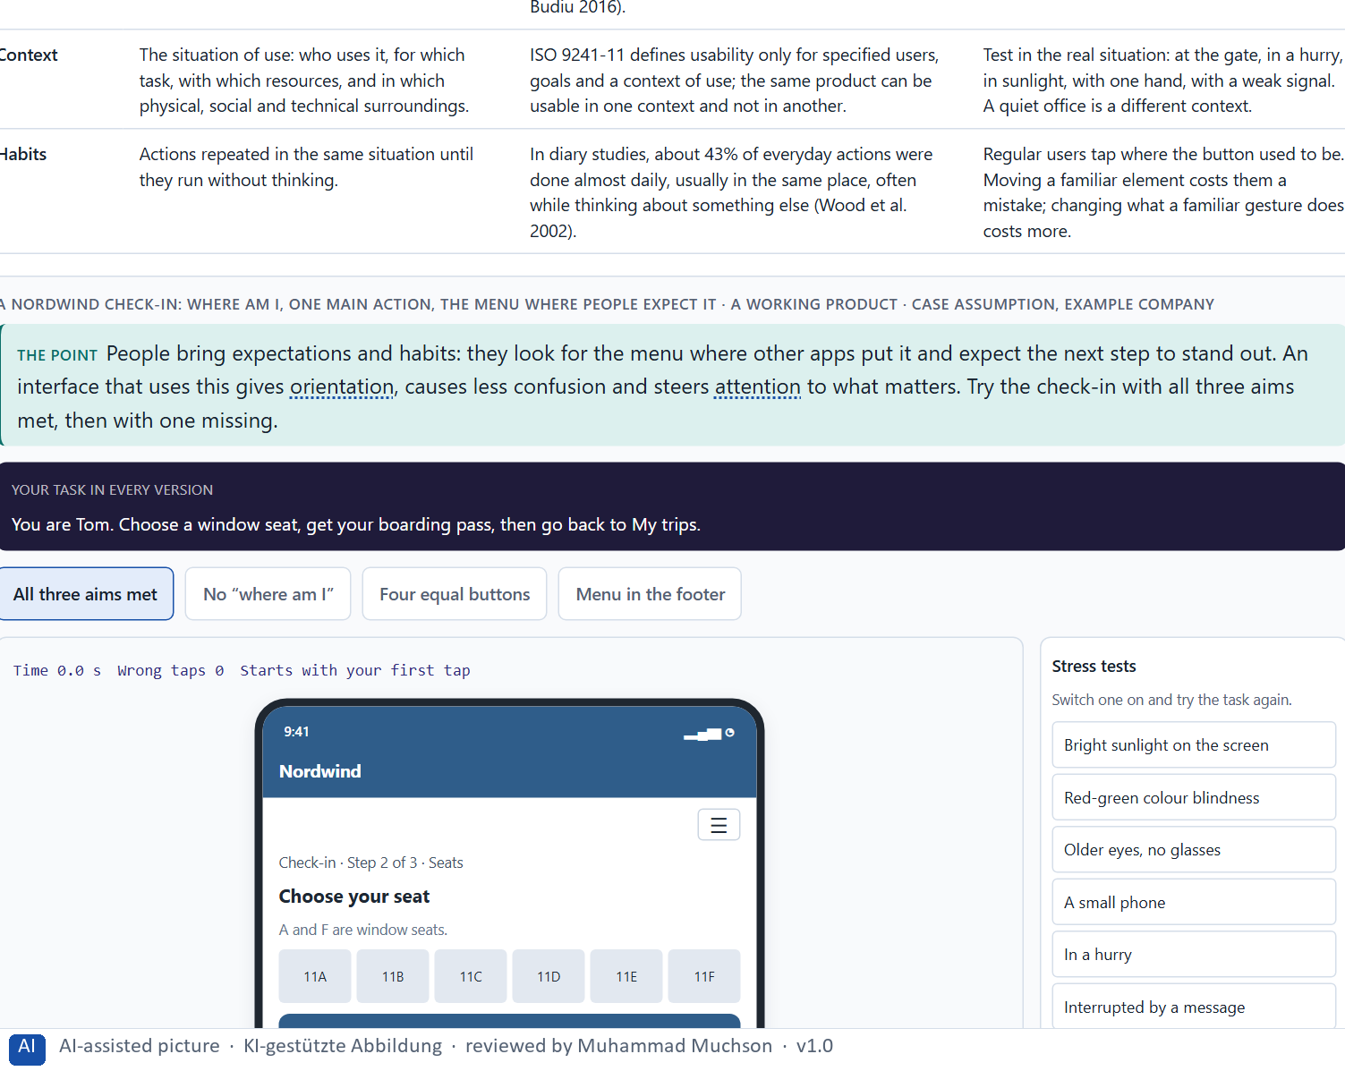
Figure 5 · A Nordwind check-in: where am I, one main action, the menu where people expect it. Shown here in its starting state; in the Neuro-UX Lab every version and every stress test can be used.
What people bring to every screen, with real evidence
What they bring | What it is | Real evidence | What it means for a screen
Prior knowledge | What people already know from other products and from the world: the alphabet, the clock, what a magnifier or a basket stands for. | Users spend most of their time on other sites, so they expect yours to work the same way (Nielsen 2000). | Use the patterns people already know; a new pattern has to be learned, and every learner pays for it once.
Expectations | What people believe will happen next, built from prior knowledge and from what the screen has shown so far. | When navigation was hidden behind a menu icon, people on six live websites used it less often and later in the task, on desktop and on phones (Pernice and Budiu 2016). | People look for what they expect to see. What is hidden, or sits where nobody expects it, is used less, however good it is.
Context | The situation of use: who uses it, for which task, with which resources, and in which physical, social and technical surroundings. | ISO 9241-11 defines usability only for specified users, goals and a context of use; the same product can be usable in one context and not in another. | Test in the real situation: at the gate, in a hurry, in sunlight, with one hand, with a weak signal. A quiet office is a different context.
Habits | Actions repeated in the same situation until they run without thinking. | In diary studies, about 43% of everyday actions were done almost daily, usually in the same place, often while thinking about something else (Wood et al. 2002). | Regular users tap where the button used to be. Moving a familiar element costs them a mistake; changing what a familiar gesture does costs more.

Three aims of an interface, and a sign that one is missing
Aim | What it means | A sign it is missing
Orientation | Where am I, what can I do, what comes next. | Nine equal tiles; no step line; the menu in an unexpected place.
Less confusion | Few competing signals, one system, plain words. | Three button colours with no meaning; legal text before the action.
Steered attention | What matters is the strongest thing on the screen. | A flashing banner is stronger than the main button.

Case assumption
Nordwind, Mia, Tom, Jana and Ben are made up for this example. The orientation questions follow Krug (2014); consistency and minimalist design follow Nielsen (1994); cognitive load follows Sweller (1988). The evidence in the first table is real research; the sources are listed below.

How to decide when this comes up in the task
- Orientation: can the person tell where they are, what they can do here and what comes next?
- Count how many elements are equally strong. Many equally strong elements mean there is no visual order: an orientation problem.
- A variation with no system (three button colours that mean nothing) breaks orientation, because the person cannot learn what a colour means.
- Every extra signal adds to the cognitive load. Small type on important information and moving elements that must be ignored cost effort that is missing for the task.
- Put things where people expect them and use the words they use; going against a habit is a cost, not a style.

Extra · go deeper (optional reading)
Context changes the effect: the same screen is read differently by someone in a hurry, someone worried, or someone using it for the first time. A health app or an insurance portal is often opened in a stressful moment, so every extra signal weighs more than it would in a game.

Sources · Krug 2014 · Nielsen 1994 · Sweller 1988 · Nielsen 2000 · ISO 9241-11 · Wood et al. 2002 · Pernice & Budiu 2016

A4 · Feelings that work before thinking: trust, reactance, overload, safety, liking · 11 min · Core
People feel a screen before they read it. Trust, reactance, overload, safety and liking work unconsciously; you infer them from the design and write them as a hypothesis.
IN PLAIN WORDS
The idea. People react to a design before they have thought about it. In a fraction of a second they feel whether it looks trustworthy, safe and pleasant, and that first feeling colours what follows. Five effects matter most: trust, reactance (pushing back when you feel pushed), overload, a sense of safety and plain liking. Because they work unconsciously, users rarely name them; you have to infer them from the design and say them as a hypothesis.
Why it matters. Block 1.1 asks for the emotional effect of CarePath, three places where an unconscious effect could play a role, and a hypothesis per category. Block 1.2 asks about trust and activation, and Block 2.1 about trust and the off-putting upload. This card gives you the five effects and how to write one as a hypothesis.
How to read the picture. The same Nordwind payment step in three tones: alarm, pressure and calm.

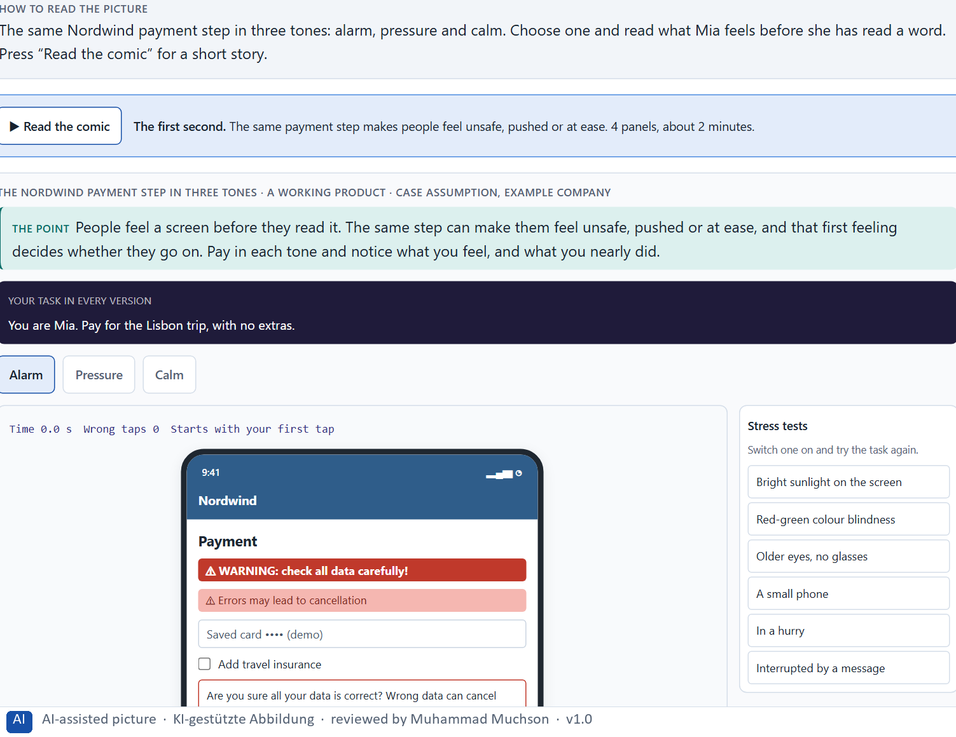
Figure 6 · The Nordwind payment step in three tones. Shown here in its starting state; in the Neuro-UX Lab every version and every stress test can be used.
Five effects that work before thinking
Effect | What builds it | What breaks it
Trust | Clear language, consistency, warnings that match a real risk. | False alarms; data next to advertising.
Reactance | (Avoid it) Leave people the choice. | Countdowns, pressure, “only 1 left”.
Overload | (Avoid it) Few signals, one step at a time. | Many equal elements, moving notices, long texts.
Safety | A visible way back, clear steps, a calm tone. | Threatening wording; no sign of progress.
Liking | Warmth, tone, visual quality. | A cold or careless look; it helps, but it is not clarity.

Liking and trust in numbers: what research shows about the first feeling
Finding | What was measured | What it means for a screen
50 ms are enough (Lindgaard et al. 2006) | People rated the visual appeal of web pages shown for 50 ms; the ratings were close to those after a longer look. | Liking forms before reading. A careless or cold look is judged before the content can speak for itself.
The look carries trust (Fogg et al. 2003) | 2,684 people judged the credibility of 100 live websites; the design look was the factor they mentioned most often, in 46.1% of their comments. | People judge whether they can trust a company from its screens. Layout, type and care are read as signs of seriousness.
Beautiful seems easier (Kurosu and Kashimura 1995; Tractinsky et al. 2000) | People rated how easy cash-machine screen layouts would be to use mainly by how attractive they looked, before using them; a later study in Israel confirmed it. | Liking lends a design credit. It buys patience for a small flaw; it does not repair a screen that does not work.

Case assumption
Nordwind, Mia, Tom, Jana and Ben are made up for this example. The first impression follows Lindgaard et al. (2006); reactance follows Brehm (1966); how people judge credibility follows Fogg (2003). The numbers in the second table are real research results.

How to decide when this comes up in the task
- A warning shown when nothing is wrong teaches people to ignore warnings or to feel unsafe: a trust problem and an emotional one.
- Pressure in the wording or the design (countdowns, “only 1 left”) can trigger reactance instead of action.
- Personal data placed next to advertising or clutter weakens the feeling of safety, often without the person knowing why.
- Write an effect as a hypothesis: “This element could make users feel …”. It is an assumption until it is tested.

Extra · go deeper (optional reading)
Kahneman (2011) describes two ways of judging: a fast, automatic one and a slow, deliberate one. Most of what a design does to people happens in the fast one, which is why users can rarely tell you that a red banner made them uneasy; they only know they did not trust the page.

Sources · Lindgaard et al. 2006 · Brehm 1966 · Fogg 2003 · Kahneman 2011 · Fogg et al. 2003 · Kurosu & Kashimura 1995 · Tractinsky et al. 2000

A5 · Weighing a design measure: effect on users, feasibility, risk, time pressure · 9 min · Core
To put design measures in order, weigh each on the same four questions: effect on users, feasibility, risk and time pressure. The reason next to each rating carries the decision.
IN PLAIN WORDS
The idea. To put design measures in order, weigh each one on the same four questions that Block 2.1 names. Effect on users: what does it change for the people who use the product, and for how many? Feasibility: can it be done with the people and the technical room there is? Risk: what could go wrong or backfire? Time pressure: does it fit the time there is, and does it show results soon? The reason next to each rating matters more than the rating.
Why it matters. Block 1.1 asks for a first prioritisation, Block 1.2 for a decision between three start pages, and Block 2.1 for four measures in order with a justification on these four criteria. The example uses Nordwind and its own measures, so the answer for the task cases is not given.
How to read the picture. Three measures Nordwind considered, rated on effect on users, feasibility, risk and time pressure. A rating is a reading of the example, not a mark.

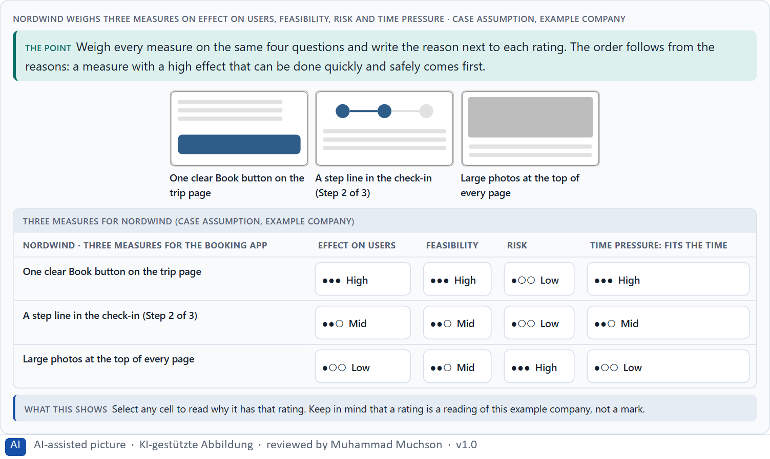
Figure 7 · Nordwind weighs three measures on effect on users, feasibility, risk and time pressure.
Case assumption
Nordwind, Mia, Tom, Jana and Ben are made up for this example. Rating options on the same criteria with a reason follows Gibbons (2018). The four criteria are the ones the plan names for the case study.

How to decide when this comes up in the task
- Rate every measure on the same four questions, so they can be compared.
- Effect on users: what does it change for the people who use the product, and for how many?
- Feasibility: can it be done with the people and the technical room there is? Risk: what could go wrong or backfire? Time pressure: does it fit the time, and does it show results soon?
- A rating is a judgement with a reason, never a mark. A different order with a better reason is a better answer.
- When the conditions are tight, the measure with a high effect that can be done quickly and safely usually comes first.

Extra · go deeper (optional reading)
Many teams use Low, Medium and High for each criterion. The scale only helps if the reason is written next to it; without the reason, nobody can tell later why one measure came first, and nobody can check whether the reason still holds.

Sources · Gibbons 2018 · Nielsen 1994

Materi B · Route 2 · Level 3
How Materi B is used
About 60 minutes, three cards, led by the facilitator. Level 3 in the Chief Experience Officer's chair: a Neuro-UX guiding vision, three strategic decisions for 24 months, an order of touchpoints, a risk analysis, a governance model, one decision under uncertainty and a statement to the board. The cards give you the ideas you use in Task 2.

B1 · Design steers perception, behaviour and decision: a Neuro-UX strategy · 22 min · Core
A design steers what people perceive, understand, do and decide. A Neuro-UX strategy chooses one effect and makes every touchpoint serve it.
IN PLAIN WORDS
The idea. A design is not only a surface. Every choice steers what people perceive, what they understand, what they do and what they decide. A Neuro-UX strategy states the effect a company wants to create, such as orientation, trust or less overload, and then makes every touchpoint serve that one effect. Screens that each follow their own logic lose people where they move from one channel to the next.
Why it matters. Block 3.1 asks for a guiding vision, three strategic decisions for 24 months and an order of touchpoints for a company that loses users between its website, portal, app and chatbot. You work from the effect you want, not from single screens.
How to read the picture. The chain reads from left to right: what people perceive, understand, do and decide. Below it, a table of the levers that steer behaviour, with real evidence and the legal limits, and the same Nordwind journey with a different logic in each channel and with one shared logic.

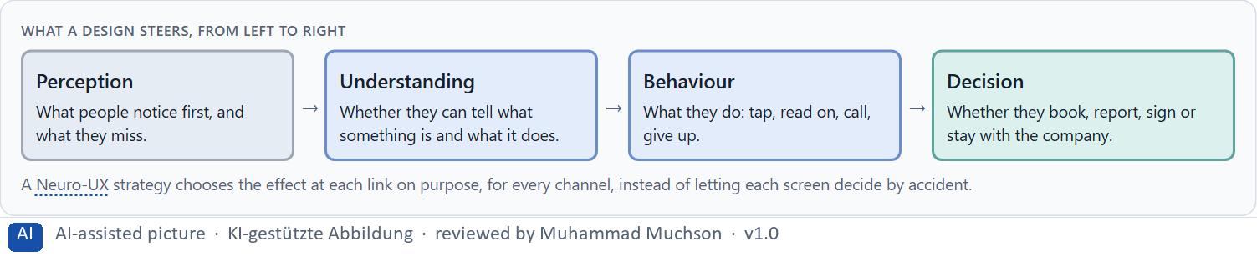
Figure 8 · What a design steers, from left to right.
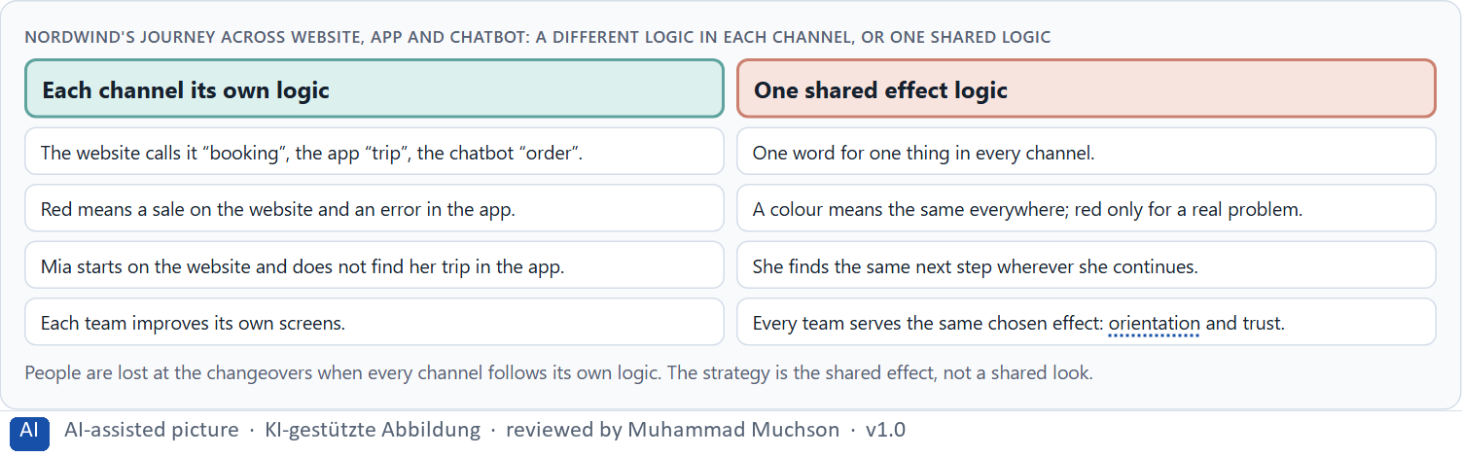
Figure 9 · Nordwind's journey across website, app and chatbot: a different logic in each channel, or one shared logic.
How design steers behaviour: three levers with real evidence, and the limits
Lever | What it is | Real evidence | What it means for a strategy
Motivation, ability, prompt | A behaviour happens when the person wants it enough, can do it easily enough, and is prompted at that moment: B = MAP. | The Fogg Behavior Model (Fogg 2009). When a behaviour does not happen, one of the three is missing; most often it is ability or the right moment. | Before adding persuasion, make the action easy and prompt it when people can act, for example a check-in reminder with a one-tap button, sent when check-in opens.
Defaults | What happens if the person does nothing. Most people keep the default, because changing it costs effort and looks like a recommendation. | In European countries where people had to opt out, almost everyone counted as a consenting organ donor; where they had to opt in, only a small minority did (Johnson and Goldstein 2003). Actual donations differ far less than these consent figures (Steffel et al. 2019). | Every default is a decision the company takes for its customers. Set it in their interest, and say so.
Friction | Effort placed on purpose: removed from the wanted action, added before an action that is risky or hard to undo. | Ability is the lever that is easiest to design (Fogg 2009): fewer steps, fewer fields, less to read. | Make the main path the easy one; a confirmation step belongs before a deletion, not before a booking.
The limits | Steering stops being design and becomes manipulation when it works against the person's interest or takes away an informed choice. | The EU Digital Services Act (Article 25) forbids online platforms to design interfaces that deceive or manipulate users. The Court of Justice of the EU ruled in Planet49 (2019) that a pre-ticked box is not valid consent. | A strategy names the behaviour it wants and why that is in the customer's interest. Pre-ticked extras, countdowns and hidden opt-outs are a legal risk as well as a risk to trust.

Case assumption
Nordwind, Mia, Tom, Jana and Ben are made up for this example. The chain from perception to decision restates the plan's “design as the steering of perception, behaviour and decision”. The evidence in the table of levers is real research and real law; the sources are listed below.

How to decide when this comes up in the task
- Start from the effect you want (what should customers perceive, understand, feel and do?), then choose the design means.
- Prefer one shared effect logic for every channel over isolated improvements to single screens.
- Look at the changeovers between channels: that is where people are lost when each channel follows its own logic.
- Steering behaviour is a responsibility: say why an effect is in the customer's interest; if you cannot, it is a risk.

Extra · go deeper (optional reading)
User experience, in Norman and Nielsen's definition, covers every part of a person's interaction with a company, its services and its products. A strategy therefore cannot stop at one channel: the customer judges the company by the whole journey, including the moment of moving from one channel to the next.

Sources · Norman 2013 · Kahneman 2011 · Norman & Nielsen · Fogg 2009 · Johnson & Goldstein 2003 · Steffel et al. 2019 · EU Digital Services Act · CJEU Planet49 2019

B2 · Conflicting goals: aesthetics against clarity, innovation against familiarity, activation against overload · 20 min · Core
Goals pull against each other: aesthetics against clarity, innovation against familiarity, activation against overload. At management level, effort, risk, brand and economics join them.
IN PLAIN WORDS
The idea. In UX the goals often pull against each other: the most attractive page is not always the clearest, a new pattern impresses while a familiar one is understood at once, and activating elements raise energy until there are too many. At management level the conflicts widen to user effect, brand image, effort, risk and economics. There is rarely one right answer, so the work is to name the conflict, choose, and say what you give up.
Why it matters. Block 3.1 asks for three guiding decisions, a risk analysis (what happens if you optimise for aesthetics rather than effect) and a governance model for conflicts between marketing, compliance, IT and sales. Each of these is a decision between conflicting goals.
How to read the picture. The matrix places five Nordwind designs by how clear they are (to the right) and how strongly they activate (upwards). A position is a reading of the example, not a score.

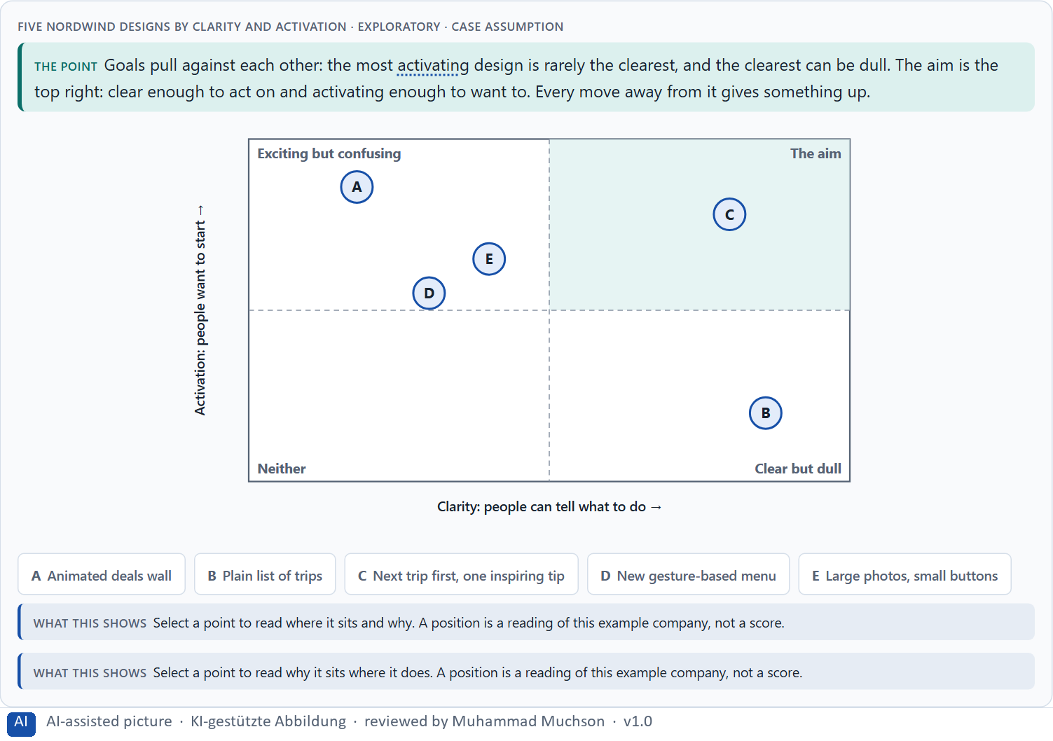
Figure 10 · Five Nordwind designs by clarity and activation · Exploratory.
Three standing conflicts of UX design
Conflict | What each side gives | What to ask
Aesthetics against clarity | Attraction against ease of use. | Does the look help people do what they came for?
Innovation against familiarity | Surprise against effortless use. | Is the new pattern worth learning?
Activation against overload | Energy against mental load. | How many activating elements before it tires people out?

Case assumption
Nordwind, Mia, Tom, Jana and Ben are made up for this example. The three conflicts are the plan's own; the matrix is a reading of the example, not a score.

How to decide when this comes up in the task
- Name the conflict as two goals before you choose between them.
- Say what the choice gives up; a decision that gives up nothing has not been made.
- Optimising for aesthetics instead of effect gives a handsome interface that can still lose people: name it as a risk.
- A new pattern must earn the cost of being unfamiliar; where it does not, prefer the familiar one.
- Good management decisions balance user interest, feasibility, regulatory requirements, brand impact and resources.

Extra · go deeper (optional reading)
Krug (2014) argues that conventions are a gift to the user: a pattern people already know needs no thinking. That is why innovation in an interface has a price paid by the user, and why it should be spent where it changes something that matters to them.

Sources · Tractinsky et al. 2000 · Krug 2014 · Gibbons 2018

B3 · Accountable decisions under uncertainty: the role, the rules and a decision you can answer for · 18 min · Core
Design decisions are accountable effect decisions, not matters of taste. They need rules for who decides, and, because data is never complete, a decision that says what is not known and when it will be checked.
IN PLAIN WORDS
The idea. A person who leads UX is accountable for the effect of design decisions: “I like it” is not a reason, an effect, a risk and a priority are. Accountability needs rules: who may decide what, who answers for it and how a conflict is settled. And because perfect information never arrives, a decision under uncertainty says four things: what you decide, what you do not know, when you would reverse it, and what you give up.
Why it matters. Block 3.1 asks for a governance model, a decision under uncertainty that you can still answer for, and a statement to the board. This card gives you the parts of each.
How to read the picture. The four boxes at the top are the parts of a decision, filled in for Nordwind. The two boxes below are the rule for future decisions.

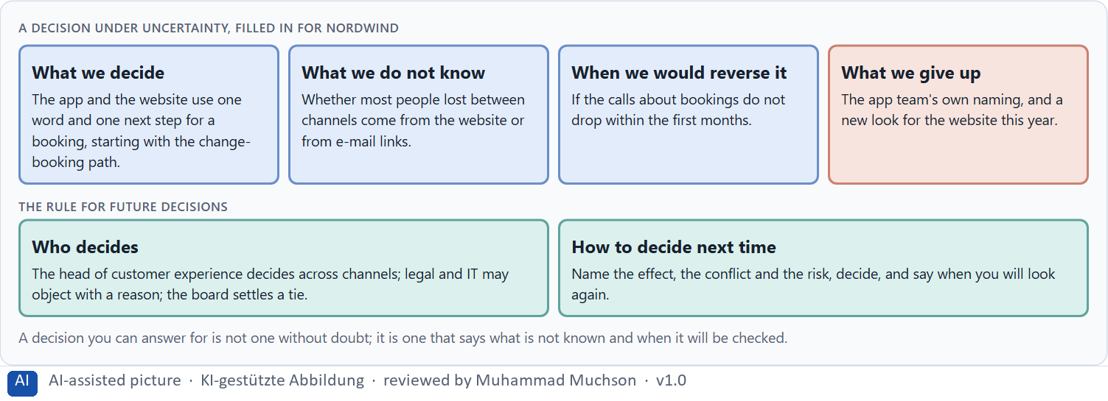
Figure 11 · A decision under uncertainty, filled in for Nordwind.
Three parts of a governance model
Part | The question | An example (Nordwind)
Who decides | Who may take which UX decision? | The head of customer experience, across channels.
Who answers for it | Who carries the professional responsibility for the effect? | The head of customer experience.
How conflicts are settled | What happens when departments want different things? | The effect principles decide; legal and IT may object with a reason; the board settles a tie.

Case assumption
Nordwind, Mia, Tom, Jana and Ben are made up for this example. Deciding with limited information follows Simon (1956); the premortem follows Klein (2007).

How to decide when this comes up in the task
- Say what you decide, what you do not know, when you would reverse it and what you give up.
- Name who decides and on what basis whenever departments disagree; that is a governance question, not a design question.
- Prefer the decision that can be reversed and that the first results will show within a short time.
- Before you commit, imagine the plan has failed and ask why: the answers are the wrong assumptions to watch.
- Make the effect, the risk and the priority explicit, so the board can challenge them.

Extra · go deeper (optional reading)
Simon (1956) showed that people with limited time and information choose an option that is good enough rather than search for the best one. A manager who waits for complete data is not more careful; they have only postponed a decision under uncertainty and paid for the wait.

Sources · Simon 1956 · Klein 2007 · Kahneman 2011

Use in class: presentation and handout
Mark of use for the study material. Presentation is what the trainer shows on screen; Handout is what participants read and keep.
Card | Presentation (shown in the Neuro-UX Lab) | Handout
A1 · UX, UI and the psychology behind them: looking good is not the same as working well (Core) | Scan line and Figure 1; the "In plain words" and "How to decide" boxes | The whole card
A2 · How people see: from stimulus to decision, bottom-up and top-down (Core) | Scan line and Figures 2–4; the "In plain words" and "How to decide" boxes | The whole card
A3 · Expectations and habits, and three aims of an interface: orientation, less confusion, steered attention (Core) | Scan line and Figure 5; the "In plain words" and "How to decide" boxes | The whole card
A4 · Feelings that work before thinking: trust, reactance, overload, safety, liking (Core) | Scan line and Figure 6; the "In plain words" and "How to decide" boxes | The whole card
A5 · Weighing a design measure: effect on users, feasibility, risk, time pressure (Core) | Scan line and Figure 7; the "In plain words" and "How to decide" boxes | The whole card
B1 · Design steers perception, behaviour and decision: a Neuro-UX strategy (Core) | Scan line and Figures 8–9; the "In plain words" and "How to decide" boxes | The whole card
B2 · Conflicting goals: aesthetics against clarity, innovation against familiarity, activation against overload (Core) | Scan line and Figure 10; the "In plain words" and "How to decide" boxes | The whole card
B3 · Accountable decisions under uncertainty: the role, the rules and a decision you can answer for (Core) | Scan line and Figure 11; the "In plain words" and "How to decide" boxes | The whole card

References
Check each source and its current edition before you teach from it. Standards and laws marked as in flux can change.
Norman, D., & Nielsen, J. The Definition of User Experience (UX). Nielsen Norman Group. https://www.nngroup.com/articles/definition-user-experience/ (User experience covers every part of a person's interaction with a company, its services and its products; the interface is one part of it.)
ISO 9241-210:2019. Ergonomics of human-system interaction, Part 210: Human-centred design for interactive systems. (Defines user experience as a person's perceptions and responses that result from the use or anticipated use of a product, system or service.) Check the current edition before you teach from it.
Norman, D. A. (2013). The Design of Everyday Things (revised and expanded edition). Basic Books. (Mental models and conceptual models: a design works when what people believe it does matches what it does.)
Tractinsky, N., Katz, A. S., & Ikar, D. (2000). What is beautiful is usable. Interacting with Computers, 13(2), 127–145. (People judge an attractive interface as easier to use before they have used it; looks shape the first judgement, they do not replace testing.)
Rayner, K. (1998). Eye movements in reading and information processing: 20 years of research. Psychological Bulletin, 124(3), 372–422. (Only the fovea, about 2° of the visual field, sees sharply; the eyes jump in saccades and rest in fixations of about 200 to 300 ms, taking in information only while they rest.)
Simons, D. J., & Chabris, C. F. (1999). Gorillas in our midst: Sustained inattentional blindness for dynamic events. Perception, 28(9), 1059–1074. (Across the conditions, 46% of the observers who counted passes in a video did not notice a person in a gorilla suit walking through it.)
Benway, J. P., & Lane, D. M. (1998). Banner blindness: Web searchers often miss “obvious” links. Internetworking, 1(3). (Information made to look like a banner advertisement is overlooked, even when it is large and is exactly what people are looking for.)
Cowan, N. (2001). The magical number 4 in short-term memory: A reconsideration of mental storage capacity. Behavioral and Brain Sciences, 24(1), 87–114. (The limit of working memory is nearer four chunks than seven.)
Lindgaard, G., Fernandes, G., Dudek, C., & Brown, J. (2006). Attention web designers: You have 50 milliseconds to make a good first impression! Behaviour & Information Technology, 25(2), 115–126. (A first judgement of a web page forms within a fraction of a second and stays close to the judgement people give later.)
Nielsen, J. (2000). End of Web Design. Nielsen Norman Group. https://www.nngroup.com/articles/end-of-web-design/ (Users spend most of their time on other sites, so they expect a site to work like the ones they already know: later called Jakob's Law.)
Itti, L., & Koch, C. (2001). Computational modelling of visual attention. Nature Reviews Neuroscience, 2(3), 194–203. (Attention is pulled by what differs from its surroundings in colour, contrast, orientation and movement: the bottom-up side of seeing.)
Corbetta, M., & Shulman, G. L. (2002). Control of goal-directed and stimulus-driven attention in the brain. Nature Reviews Neuroscience, 3(3), 201–215. (Two attention systems work together: one steered by goals and expectations, one by strong stimuli.)
Treisman, A. M., & Gelade, G. (1980). A feature-integration theory of attention. Cognitive Psychology, 12(1), 97–136. (Simple features such as a colour pop out at once; a combination of features has to be searched one item at a time.)
Hubel, D. H., & Wiesel, T. N. (1962). Receptive fields, binocular interaction and functional architecture in the cat's visual cortex. Journal of Physiology, 160(1), 106–154. (Cells of the early visual cortex respond to simple features such as edges of a certain orientation: the first step from light to shape.)
Mishkin, M., Ungerleider, L. G., & Macko, K. A. (1983). Object vision and spatial vision: Two cortical pathways. Trends in Neurosciences, 6, 414–417. (A ventral “what” pathway recognises objects; a dorsal “where” pathway locates them in space.)
Thorpe, S., Fize, D., & Marlot, C. (1996). Speed of processing in the human visual system. Nature, 381(6582), 520–522. (People tell whether a photo they see for 20 ms contains an animal, and the brain shows the difference about 150 ms after the image appears.)
Wertheimer, M. (1923). Untersuchungen zur Lehre von der Gestalt II. Psychologische Forschung, 4, 301–350. (The founding description of perceptual grouping by proximity, similarity, continuity and closure.)
Pernice, K. (2017). F-Shaped Pattern of Reading on the Web: Misunderstood, But Still Relevant (Even on Mobile). Nielsen Norman Group. https://www.nngroup.com/articles/f-shaped-pattern-reading-web-content/ (On text-heavy pages without structure, the eye often scans in an F-shape; headings, short paragraphs and clear structure change the pattern.)
Krug, S. (2014). Don't Make Me Think, Revisited (3rd ed.). New Riders. (People scan rather than read, follow conventions they know, and should be able to tell at once where they are and what they can do.)
Nielsen, J. (1994, reviewed 2024). 10 Usability Heuristics for User Interface Design. Nielsen Norman Group. https://www.nngroup.com/articles/ten-usability-heuristics/ (Visibility of system status, consistency and standards, recognition rather than recall, aesthetic and minimalist design.)
Sweller, J. (1988). Cognitive load during problem solving: Effects on learning. Cognitive Science, 12(2), 257–285. https://doi.org/10.1207/s15516709cog1202_4 (Working memory is limited; effort spent on working out a screen is missing for the task itself.)
ISO 9241-11:2018. Ergonomics of human-system interaction, Part 11: Usability: Definitions and concepts. (Usability always holds for specified users, goals and a context of use: the users, their tasks, their resources and the physical, social and technical environment.)
Wood, W., Quinn, J. M., & Kashy, D. A. (2002). Habits in everyday life: Thought, emotion, and action. Journal of Personality and Social Psychology, 83(6), 1281–1297. (In diary studies, about 43% of everyday actions were done almost daily and usually in the same place, often while thinking about something else.)
Pernice, K., & Budiu, R. (2016). Hamburger Menus and Hidden Navigation Hurt UX Metrics. Nielsen Norman Group. https://www.nngroup.com/articles/find-navigation-mobile-even-hamburger/ (On six live websites, people used hidden navigation less often and later in the task than visible navigation, on desktop and on phones.)
Brehm, J. W. (1966). A Theory of Psychological Reactance. Academic Press. (When people feel their freedom to choose is threatened, they push back, often by doing the opposite of what is asked.)
Fogg, B. J. (2003). Prominence-interpretation theory: Explaining how people assess credibility online. CHI '03 Extended Abstracts, 722–723. (People judge credibility from the elements they notice and how they interpret them, such as the layout, the tone and the mix of content and advertising.)
Kahneman, D. (2011). Thinking, Fast and Slow. Farrar, Straus and Giroux. (A fast, automatic way of judging and a slow, deliberate one; much of what a design does happens in the fast one.)
Fogg, B. J., Soohoo, C., Danielson, D. R., Marable, L., Stanford, J., & Tauber, E. R. (2003). How do users evaluate the credibility of Web sites? A study with over 2,500 participants. Proceedings of DUX '03. (2,684 people judged the credibility of 100 live sites; the design look was the factor mentioned most often, in 46.1% of their comments.)
Kurosu, M., & Kashimura, K. (1995). Apparent usability vs. inherent usability: Experimental analysis on the determinants of the apparent usability. CHI '95 Conference Companion, 292–293. (People judge an ordered, attractive interface as easier to use: the aesthetic-usability effect.)
Gibbons, S. (2018). Using Prioritization Matrices to Inform UX Decisions. Nielsen Norman Group. https://www.nngroup.com/articles/prioritization-matrices/ (Rate each option on the same few criteria, such as value to the user against effort, and put the reason next to each rating.)
Fogg, B. J. (2009). A behavior model for persuasive design. Proceedings of the 4th International Conference on Persuasive Technology (Persuasive '09), Article 40. (A behaviour happens when motivation, ability and a prompt come together at the same moment: B = MAP.)
Johnson, E. J., & Goldstein, D. (2003). Do defaults save lives? Science, 302(5649), 1338–1339. (In European countries where people had to opt out, almost everyone counted as a consenting organ donor; where they had to opt in, only a small minority did.)
Steffel, M., Williams, E. F., & Tannenbaum, D. (2019). Does changing defaults save lives? Effects of presumed consent organ donation policies. Behavioral Science & Policy, 5(1), 69–88. (Presumed consent is linked to higher consent and donation, but it is one factor among many: actual donations rise far less than the consent figures.)
Regulation (EU) 2022/2065 of the European Parliament and of the Council (Digital Services Act), Article 25. https://eur-lex.europa.eu/eli/reg/2022/2065/oj (Online platforms must not design their interfaces in a way that deceives or manipulates users or impairs their ability to make free and informed decisions.)
Court of Justice of the European Union (2019). Judgment of 1 October 2019, Planet49, C-673/17. (A pre-ticked checkbox is not valid consent: consent needs an active choice by the user.)
Simon, H. A. (1956). Rational choice and the structure of the environment. Psychological Review, 63(2), 129–138. (With limited information and time, people choose an option that is good enough rather than the best one: a decision under uncertainty.)
Klein, G. (2007). Performing a project premortem. Harvard Business Review, 85(9), 18–19. (Imagine the plan has failed and ask why; it brings risks and wrong assumptions to the surface before the work starts.)

Glossary
Every term below is used in this document. Terms stay plain text in the body; this list says what they mean in everyday words.
Term | In plain words | Example | Comes from
Attention | The mind's spotlight. Only a small part of a screen is processed at any moment; attention decides which part. | A flashing banner takes attention away from the form you were filling in. | Day 1
Bottom-up perception | Attention pulled by the stimulus itself: something moves, glows, is red or very large, so you look at it whether or not it matters to you. | — | Day 1
Case assumption | A fact made up for this exercise to fill a gap in the plan's case. It is marked so you know it is not part of the plan. | — | Day 1
Chief Experience Officer | The manager who is responsible for the experience customers have across all channels, and who decides where the company invests in it. | — | Day 1
Cognition | The thinking side of the mind: remembering, comparing, understanding and deciding. | — | Day 1
Cognitive load | How much a person has to hold in mind and work out at the same time. Every extra signal or choice adds to it; when it is too high, people skip, freeze or leave. | — | Day 1
Governance | The rules about who may decide what, who is answerable for it and how disagreements are settled. | — | Day 1
Hypothesis | An assumption you could check later. “This red banner could make users uneasy” is a hypothesis; “this banner is bad” is only an opinion. | — | Day 1
Mental model | What a person believes a product is and how it works. A design feels natural when it fits that belief and confusing when it does not. | Most people expect a basket icon to show what they have chosen so far. | Day 1
Neuro-UX | Designing an interface with knowledge of how the brain sees, attends, feels and decides, so that the design steers these processes on purpose and responsibly. | — | Day 1
Orientation | Knowing where you are, what you can do here and what happens next. | — | Day 1
Perception | Taking in what the senses deliver, for example what the eyes see on a screen, before thinking about it. | — | Day 1
Primary action | The one thing most people on a screen came to do, such as “Report damage”. It should be the easiest thing to see and press. | — | Day 1
Psychological UX design | Designing with knowledge of how people see, pay attention, feel and decide, and judging a design by what it does to them rather than only by how it looks. | — | Day 1
Reactance | The urge to resist when something feels like pressure or control. A pushy prompt can make people do the opposite of what it asks. | — | Day 1
Top-down perception | Attention steered by what you want, know and expect: you look for the word “Pay” because you want to pay. | — | Day 1
Touchpoint | Any place where a person meets the company: the website, the customer portal, the app, a chatbot or a phone call. | — | Day 1
UI (user interface) | What a person sees and touches on a screen: buttons, colours, text, icons and their layout. It is the surface of the experience. | Changing a button from grey to blue is a UI change. | Day 1
Unconscious design effect | An effect a design has before the person can say why: a screen feels unsafe, rushed or friendly in the first second, and that feeling colours what they do next. | — | Day 1
UX (user experience) | Everything a person goes through when using a product: what they notice, understand, feel and do, from the first look to the last step. The screens are only one part of it. | Finding the booking you want at once and feeling sure it went through is a good UX. | Day 1

The Neuro-UX Lab: where we practise online
In class we use the course website as the place to practise and to learn. Every day has its own address, in the same pattern: the day number is the last part.
What | Address
Neuro-UX Lab (course website) | https://aion-ux-lab.vercel.app/
Day 1 | https://aion-ux-lab.vercel.app/day/1/

On the day page, Route 1 (Levels 1 and 2) and Route 2 (Level 3) can be opened; the cards and the tasks of this document are there too. The pattern is the same up to Day 8, for example https://aion-ux-lab.vercel.app/day/6/.

