AION · UX DEVELOPER · PSYCHOLOGICAL UX DESIGN AND NEURO-UX
DAY 1 · TASK 1 AND TASK 2 · ROUTES 1 AND 2 · LEVELS 1 TO 3
SafeHome Online: UX Analysis File and UX Strategy Memo
Describe the effect, choose the measures as a team member, and decide as Chief Experience Officer
AI notice · KI-Hinweis
This document was produced with the help of an AI language model (Claude, Anthropic). The AI drafted the text and tables and built the pictures and working examples of the lab. The content was then read, corrected and approved by the reviewer named below, who is responsible for its accuracy. Every picture carries an AI label on the image. Check figures and sources before you quote them.
KI-Hinweis: Dieses Dokument wurde mit Unterstützung eines KI-Sprachmodells (Claude, Anthropic) erstellt. Texte und Tabellen wurden von der KI entworfen, die Abbildungen sind KI-gestützt erstellt und am Bild gekennzeichnet. Die fachliche Prüfung und Freigabe erfolgte durch die unten genannte Person.

Day | Day 1 · Module 1 (day 1 of 1): Psychological UX design and neuro-design
Document | Task (worksheet with answer spaces). Task 1 (UX Analysis File) and Task 2 (UX Strategy Memo).
Route and level | Task 1 = Route 1, Levels 1 and 2 (draws on Materi A). Task 2 = Route 2, Level 3 (draws on Materi B).
Time | Task 1 about 33 min · Task 2 about 20 min
Neuro-UX Lab (website) | https://aion-ux-lab.vercel.app/day/1/
Case | SafeHome Online, the day's case study; other products appear as warm-ups
Version | 1.0 · release date 29.10.2026
Review and approval | Muhammad Muchson, Mentor (subject-matter review and approval)

ABOUT THIS DOCUMENT
In class we also use the Neuro-UX Lab, the course website, as the place to practise and learn. Its address is at the end of this document.
This is the worksheet for Day 1. Read the case once, study the evidence printed in this document, and write your answers in the boxes and tables. You can work through it on paper or type into the document. All blocks are Core. There are no answer keys and no scores; the reason you give matters more than the choice.

IN THIS DOCUMENT
Lesson plan: ten teaching units (Ablaufplan)
Case study and transfer project at a glance
The case: three products on the UX team's desk, and SafeHome Online
Block 1.1 · The effect of an unfamiliar interface: CarePath · JUDGED · Core · about 10 min
Block 1.2 · Rate design effects and decide under uncertainty: SkillFlow · JUDGED · Core · about 8 min
Block 2.1 · Case study: redesigning SafeHome Online · JUDGED · Core · about 15 min
The situation: the insurer behind SafeHome Online, 24 months ahead
Block 3.1 · A Neuro-UX strategy for a digital service ecosystem · JUDGED · Core · about 20 min

Day at a glance
Day 1 has ten teaching units (UE). This document is the worksheet; it is used in UE2 to UE6 (Task 1) and UE8 to UE10 (Task 2). The day is built from three documents and the Neuro-UX Lab: Materi (study material), Task (worksheet) and Trainer (coaching, feedback and model solutions), plus the course website.

Lesson plan: ten teaching units (Ablaufplan)
UE | Min | Plan item | What happens | Material | Format
1 | 45 | Knowledge transfer · Level 1 | The trainer presents the cards of Materi A (A1, A2, A3, A4, A5, about 60 min of cards) in the Neuro-UX Lab; participants follow in the handout. | Materi A (Route 1) | Presentation + Handout
2 | 45 | Level 1 · Task 1 | Individual work on Block 1.1 (Core, about 10 min): the first product of the day is read and its effect described. Pairs then compare their results and the trainer collects open questions. | Task 1 · Part 1 · Block 1.1 | Handout (or in the lab)
3 | 45 | Level 1 · Task 2 | Three options are rated on the same criteria and one is chosen under the stated conditions: Block 1.2 (Core, about 8 min). | Task 1 · Part 1 · Block 1.2 | Handout (or in the lab)
4 | 45 | Coaching · transition from Level 1 to Level 2 | Trainer-led. A short talk on the day's coaching focus, then the reflection questions in pairs. The bridge: from describing an effect to a decision you answer for. There is no worksheet block in this unit. | Trainer document, section Coaching | Trainer only
5–6 | 90 | Level 2 · Case study SafeHome Online (2 UE) incl. model solution | UE5: the trainer presents the case; participants work on Block 2.1 (Core, about 15 min). UE6: groups compare their results and defend them; the trainer closes with the model solution. | Task 1 · Part 2 · Block 2.1  Trainer document, section Case study | Handout; model solution shown after the work
7 | 45 | Level 2 + 3 · Feedback round with a management perspective | Groups present their reasoning, not only their result. The trainer asks the day's Level 3 input questions and leads the discussion. | Trainer document, section Feedback round | Presentation by the groups; Trainer only
8 | 45 | Level 3 · Transfer project, Chief Experience Officer (3 UE: UE8–10) | The trainer presents Materi B (B1, B2, B3; use the "In plain words" and "How to decide" boxes, the rest is handout) and sets the role and the situation. | Materi B (Route 2) | Presentation + Handout
9 | 45 | Level 3 · Transfer project | Individual work or in pairs on Block 3.1 (Core, about 20 min): the strategy memo. | Task 2 · Block 3.1 | Handout (or in the lab)
10 | 45 | Level 3 · Transfer project | Participants present their decision and what they give up, including the one decision made under uncertainty; the trainer debriefs with the model solution. | Task 2 · Block 3.1  Trainer document, section Transfer project | Handout; model solution shown after the work

One UE is counted as 45 minutes here; breaks are not shown. The times are a guide for the trainer. The Core blocks are enough for a complete answer.

Case study and transfer project at a glance
Component | UE | Duration | Participants work in | Model solution in
Level 2 case study (SafeHome Online) | UE5–6 | 2 UE · 90 min | Task 1 · Part 2 (Block 2.1) | Trainer document, section Case study
Level 3 transfer project (Chief Experience Officer) | UE8–10 | 3 UE · 135 min | Materi B and Task 2 (Block 3.1) | Trainer document, section Transfer project

Which plan item each block answers
UE | Plan item (Strukturplan, Day 1) | Block in this document
UE2 | Level 1, task 1 · The effect of an unfamiliar interface: CarePath | Block 1.1 (Core)
UE3 | Level 1, task 2 · Rate design effects and decide under uncertainty: SkillFlow | Block 1.2 (Core)
UE4 | Coaching: from describing to deciding | A classroom talk led by the trainer; not a worksheet block
UE5–6 | Level 2 case study · Case study: redesigning SafeHome Online | Block 2.1 (Core)
UE7 | Feedback round with a management perspective | A classroom discussion led by the trainer; not a worksheet block
UE8–10 | Level 3 transfer project · A Neuro-UX strategy for a digital service ecosystem | Block 3.1 (Core), in Task 2

Your name
Write your full name here. Use the same name on every Task document this week; it is how your work is matched.

Task 1 · Route 1 · UX Analysis File: describe the effect, then decide on the improvements

The case: three products on the UX team's desk, and SafeHome Online
Read once · about 3 min
You work in the UX team of a digital agency. This week three products land on your desk. Two are warm-ups: CarePath, a health app for appointments, medication notes and contact with doctors, and SkillFlow, a learning platform that has three designs for its start page. The main case is SafeHome Online, the self-service portal of an insurer, where customers report damage, look at their contracts and download documents. It is complete in content, but people give up, call the service centre and call it complicated, cold and unsafe.
What the plan gives you | How the task runs · three blocks
• Block 1.1: CarePath, with nine equally strong tiles, a red warning without an acute problem, three button colours with no system, very small type, moving elements, and health data, notices and advertising close together  • Block 1.2: three start pages for SkillFlow; live in 8 weeks, working adults between 25 and 55, a limited budget, management wants a “modern effect”, support wants “as few questions as possible”, no user tests yet  • Block 2.1: SafeHome Online, with a 46 % abandonment rate on damage reports, €180,000 and 12 weeks for a first optimisation, legal notices that must stay, limited IT capacity and no full relaunch | • Block 1.1: the effect of an unfamiliar interface. Mark what binds or distracts attention, sort the problems, write a hypothesis for each category, name three unconscious effects and say what to fix first.  • Block 1.2: rate three designs and decide under uncertainty. Rate each start page on five criteria, choose one, name the risks and the missing information, and write a management statement.  • Block 2.1: the case study. Five effect problems, sorted into five categories, four measures in order, a justification on four criteria and a recommendation to the management.

What is known and what is open
In the brief | Clear · Case assumption | Open · on purpose
• CarePath: nine equally strong tiles, a red warning without an acute problem, three button colours with no system, very small type, moving elements, data and advertising close together.  • SkillFlow: three start pages described in words; 8 weeks, working adults 25 to 55, a limited budget, no user tests.  • SafeHome Online: 46 % abandonment on damage reports, many calls, “complicated”, “cold”, “unsafe”; €180,000 and 12 weeks; legal notices stay; no relaunch. | • You review CarePath and SkillFlow as an agency would: from their screens, with no access to their data.  • SafeHome Online belongs to a mid-sized insurer. The damage report runs over several screens; the portal records which screen a report stops on, but not why.  • “A limited budget” for SkillFlow means the revision cannot rebuild the platform; it can change the start page.  • The specialist departments that want more notices are the claims team and the legal team. | • How many people use each product: no figure is given.  • Why people stop the damage report: the portal does not record it.  • Which SkillFlow design the target group would prefer: there are no tests.  • How much of the €180,000 each measure would take: the plan does not say.

As in most projects, not everything is known. Decide anyway, and say what you assume.
Case assumption
The brief says: CarePath with nine equally strong tiles, a red warning, three button colours, very small type, moving elements and data next to advertising; SkillFlow's three start pages under 8 weeks, a target group of working adults, a limited budget and no tests; SafeHome Online with a 46 % abandonment rate, €180,000, 12 weeks, legal notices that stay and no relaunch. Those are the plan's facts and its only figures. Everything else is made up for this exercise: the agency, the pictures, the simulations and the facts marked “Clear”.

Part 1 · Describe the effect and weigh designs · Level 1 · Knowledge

Block 1.1 · The effect of an unfamiliar interface: CarePath · JUDGED · Core · about 10 min
Draws on: A1 · UX, UI and the psychology behind them · A2 · How people see · A3 · Expectations and habits, and three aims of an interface · A4 · Feelings that work before thinking.
You receive the description of a fictional product, CarePath, a health app for organising appointments, medication notes and contact with doctors. Open it and use it as a patient would. You need no prior knowledge: ask yourself what feels confusing, stressful, unsafe or unclear. The aim is to see the effect before you judge it.
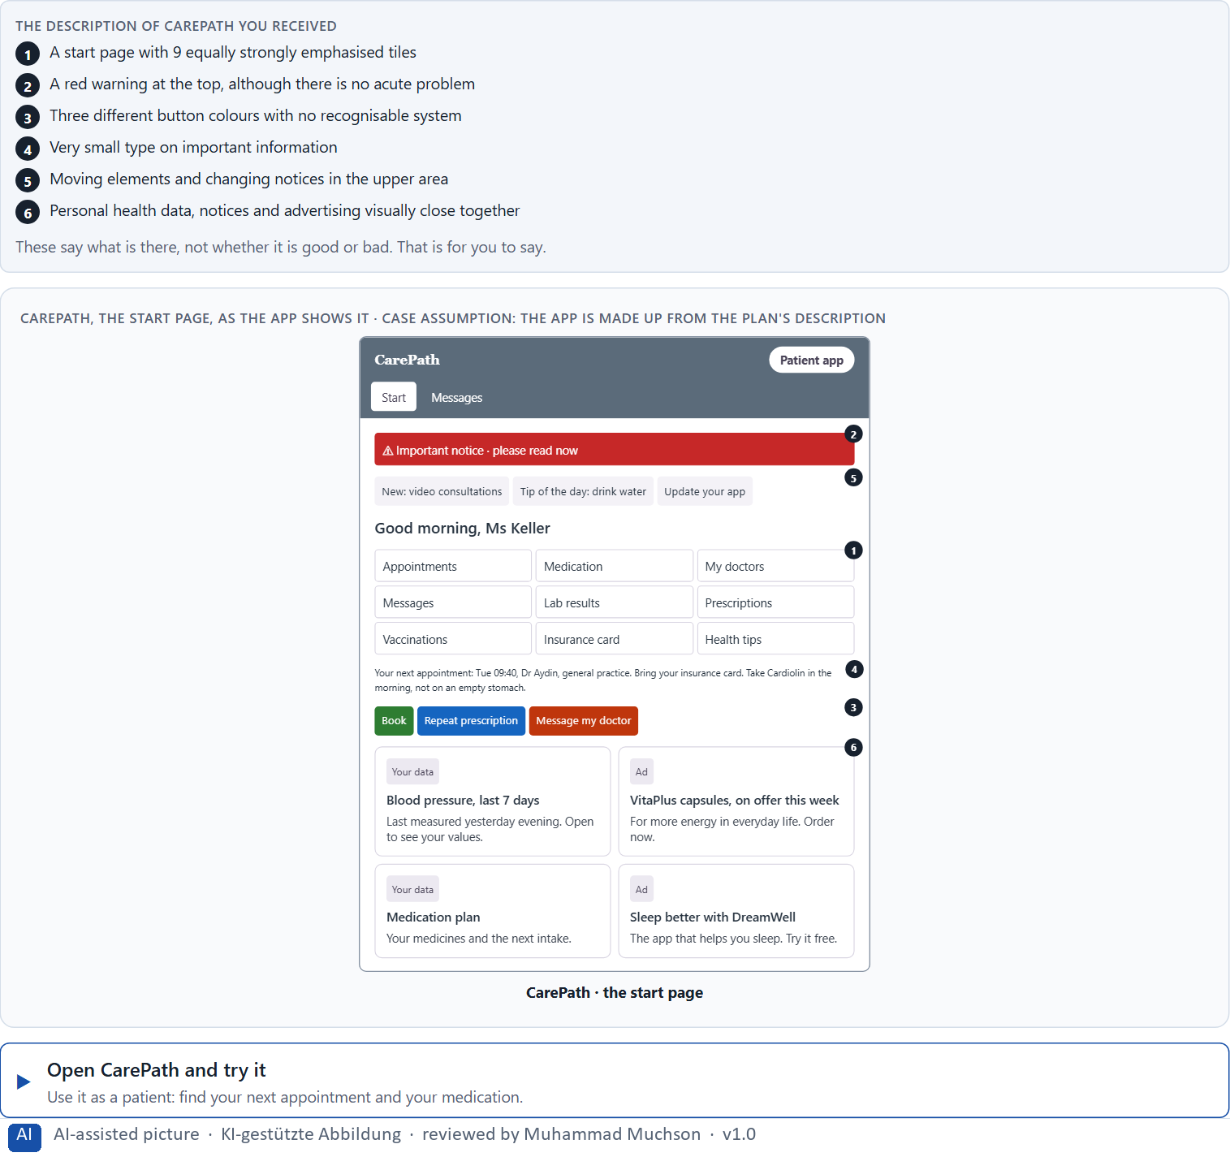
Figure 1 · CarePath, the start page, as the app shows it.
Question 1 of 5 · Mark all the elements that could bind or distract attention
Name every element that pulls your eye, one per line, and say whether it binds attention to the task or distracts from it.
How to build the answer:
- Open CarePath and look at the start screen for five seconds. Write down what your eye went to first, second and third.
- For each element, ask whether it helps you do what you came for (an appointment, a medication note) or only pulls the eye.
- Write one element per line, in the description's own words, and add “binds” or “distracts” with a reason.

Question 2 of 5 · Assign the possible problems to the categories attention, orientation, trust, emotional effect and cognitive load
Write the problems that belong to each category in a few words. One problem may fit two categories; put it where its effect is strongest and mention it again if you like.
How to build the answer:
- Take the elements from question 1 one at a time.
- Ask what each one does: pull attention, hide the way, weaken belief in the app, raise a feeling, or add mental effort.
- Write it under that category. If a category seems empty, look again at the description: each of the five is touched by CarePath.
Category | The problems in this category
Attention
Orientation
Trust
Emotional effect
Cognitive load

Question 3 of 5 · Formulate a hypothesis for each category: “This design element could trigger the following effect in the user …”
One hypothesis per category, as one sentence that starts with the element and says what it could trigger: “The red warning at the top could …”. Say “could”: a hypothesis is an assumption you could test.
How to build the answer:
- Pick for each category the element you placed there in question 2.
- Finish the plan's sentence with a feeling or an action of the user, not with a judgement of the design.
- Keep it to one effect per sentence, and say “could”.
Category | This design element … | … could trigger this effect in the user
Attention
Orientation
Trust
Emotional effect
Cognitive load

Question 4 of 5 · Name three places where an unconscious design effect could play a role
How to build the answer:
- Think of the first second on the start screen, before anything is read: what would you feel?
- Name the place (an element or a combination of elements) and what it could do before the user notices it.
Write them as a list, one place per line, with what it could do before the user notices.

Question 5 of 5 · Develop a first simple prioritisation: what would have to be improved first, and why?
Say what you would improve first and why, and what can wait.
How to build the answer:
- Pick the problem that affects the most later steps, or the one that could do harm if it stays.
- Say what you would change first and what you expect it to change for the user.
- Say in one sentence why the others can wait.

Block 1.2 · Rate design effects and decide under uncertainty: SkillFlow · JUDGED · Core · about 8 min
Draws on: A3 · Expectations and habits, and three aims of an interface · A4 · Feelings that work before thinking · A5 · Weighing a design measure.
SkillFlow is a learning platform. Three alternative designs for its start page are described in words: A) modern, strongly animated and emotionally activating, but dense with information; B) very sober and factual, clearly structured, but not very motivating; C) visually high quality with strong imagery and a reduced navigation, but less transparent about the next steps. The conditions: the product goes live within 8 weeks, the target group is working adults between 25 and 55, the budget for the revision is limited, management asks for a “modern effect” and the support team for “as few questions as possible”, and there are no user tests yet. As in most projects, how large the budget is and how many users there are is not set. Decide anyway, and say what you assume.
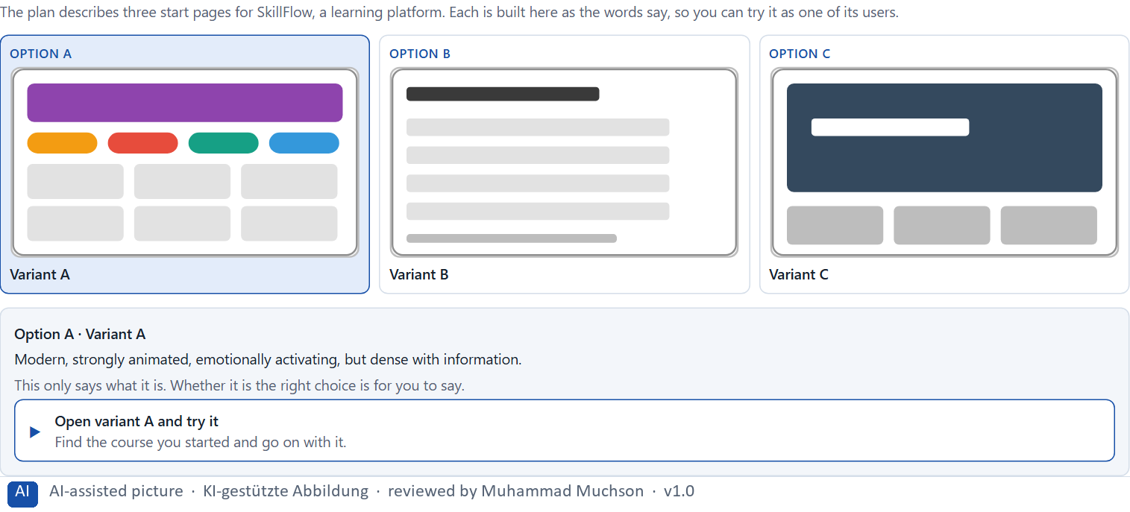
Figure 2 · The product to read, as the lab shows it (variants).
Question 1 of 5 · Rate each variant on orientation, cognitive load, trust, activation and understandability
Write a few sentences for each variant that cover all five criteria. Many teams rate each criterion Low, Medium or High with a reason; you may do that or write it in your own words.
How to build the answer:
- Take one variant at a time and keep the target group in mind: working adults with little time.
- For each of the five criteria, say how the variant does and which feature of its description makes you say so.
- Use the same five criteria for every variant, so you can compare them.
Variant | Orientation | Cognitive load | Trust | Activation | Understandability
Variant A · modern, animated, activating, dense
Variant B · sober, clear, not very motivating
Variant C · strong imagery, reduced navigation, next steps unclear

Question 2 of 5 · Make a reasoned prioritisation decision: which variant would be the most viable under the given conditions?
Choose one variant, then give your reason below. There is no single right choice; the reason has to rest on the conditions.
How to build the answer:
- Say which condition weighs most for you.
- Say how your choice meets it better than the other two.
Tick one:
☐ Variant A · modern, animated, activating, dense
☐ Variant B · sober, clear, not very motivating
☐ Variant C · strong imagery, reduced navigation, next steps unclear
Why this variant, under these conditions?
Give your reason with the conditions: 8 weeks, working adults 25 to 55, a limited budget, management against support, no tests.
How to build the answer:
- Name the condition that weighs most for you.
- Say how your variant meets it and why the other two meet it less well.
- Say what your choice gives up.

Question 3 of 5 · Which risks are you knowingly taking with your decision?
Name at least one risk and who would feel it.
How to build the answer:
- Think of what your chosen variant is weak at.
- Say who would notice (users, management, support) and what would happen.

Question 4 of 5 · Which information is missing for a safe decision?
Say what you would want to know and how you could find it out.
How to build the answer:
- Name the assumption your decision rests on.
- Say what would confirm or refute it, and who or what could supply it.

Question 5 of 5 · Formulate a management statement: “Under uncertainty we provisionally decide for …, because …”
Complete the plan's sentence in one or two sentences.
How to build the answer:
- Fill both gaps of the plan's sentence.
- Add what you will check next, if it fits.

Part 2 · The case study · Level 2 · Application · Case study (2 UE)
Case study: 2 teaching units (UE5–6)
This part is the day's Level 2 case study. It takes 2 UE (about 90 minutes): UE5 for the briefing and your own work, UE6 for comparing your results with your group and for the trainer's closing. The block below needs about 15 minutes of writing; the rest of the time is discussion.

Block 2.1 · Case study: redesigning SafeHome Online · JUDGED · Core · about 15 min
Draws on: A1 · UX, UI and the psychology behind them · A2 · How people see · A3 · Expectations and habits, and three aims of an interface · A4 · Feelings that work before thinking · A5 · Weighing a design measure.
An insurance company runs SafeHome Online, a self-service portal for damage reports, contract overviews and document downloads. It is judged complete in content but has massive usage problems: 46 % of damage reports are abandoned, many customers call the service centre although the functions exist online, users call the portal “complicated”, “cold” and “unsafe”, the specialist departments want to add more notices and safeguards, and the management wants a modern, trustworthy and more efficient customer experience. The current portal: very many blocks of text and legal notices on the entry page, primary actions that are not visually emphasised, no visible progress in the process, warning colours used often, even for neutral information, an upload that is formally correct but worded in an off-putting way, and important actions partly placed below long texts. The conditions: €180,000 and 12 weeks for a first optimisation, the legal notices must stay, IT can only intervene to a limited extent at short notice, and there is no full relaunch, so the measures must be targeted. You carry out a simplified psychological UX analysis in five steps.
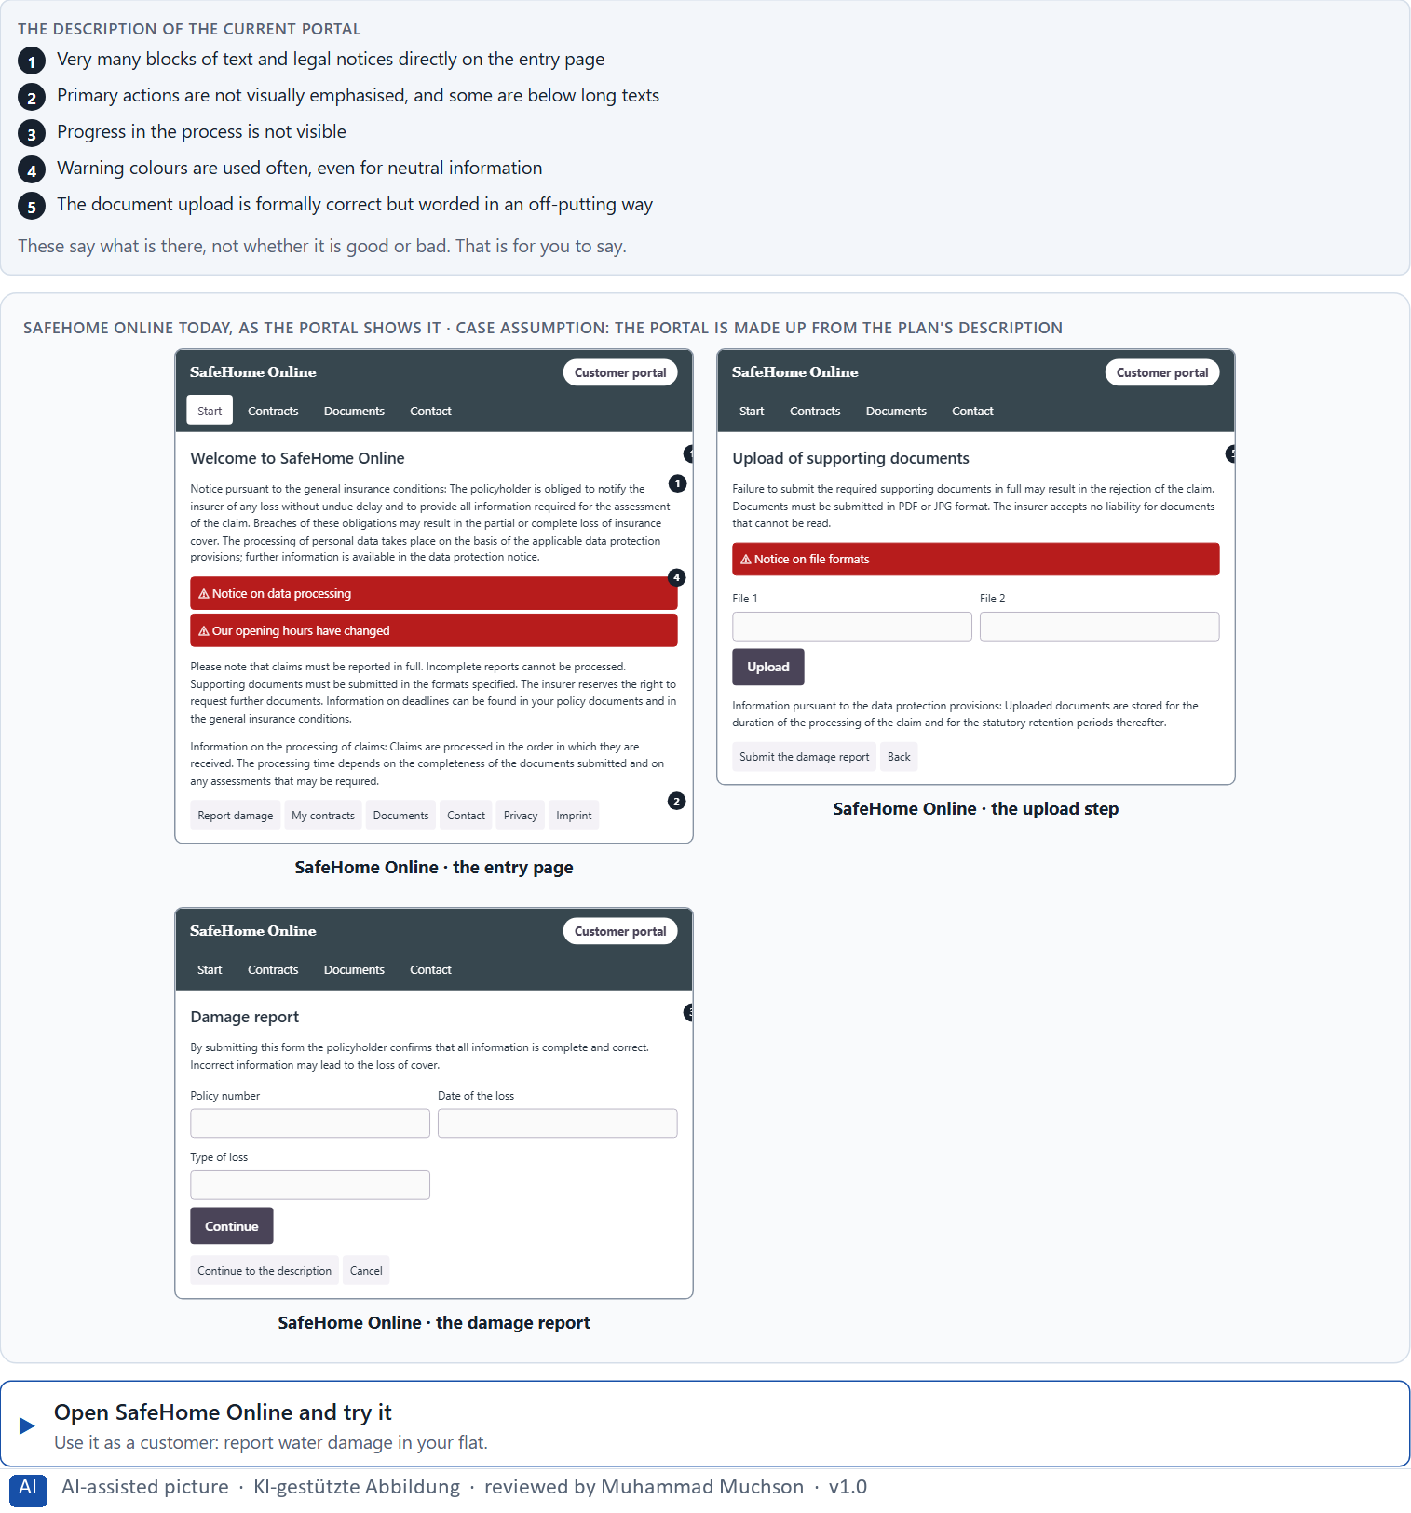
Figure 3 · SafeHome Online today, as the portal shows it.
Question 1 of 5 · Identify at least 5 central effect problems in the current portal
How to build the answer:
- Open SafeHome Online and start a damage report as a customer would.
- Write one problem per line as an effect: what the design does to the customer, not only what is wrong with it.
Write them as a list, one problem per line, each as an effect on the customer.

Question 2 of 5 · Assign the problems to the categories perception, cognitive load, trust, emotional effect and action guidance
Write the problems that belong to each category in a few words. A problem may fit two categories.
How to build the answer:
- Take your five problems from question 1.
- Ask which of the five categories each one affects most, and write it there.
Category | The problems in this category
Perception
Cognitive load
Trust
Emotional effect
Action guidance

Question 3 of 5 · Develop 4 prioritised improvement measures
How to build the answer:
- Turn each group of problems into something you could change within 12 weeks and with little IT capacity.
- Put them in order: the measure that helps customers most within the conditions first.
Write them as a numbered list, the first priority first, each with what it changes for customers.

Question 4 of 5 · Justify your prioritisation using the criteria effect on users, feasibility, risk and time pressure
Use all four criteria and say how they support your order.
How to build the answer:
- Say for your first measure what it changes for customers and why it is feasible with limited IT.
- Say what risk each carries and how the 12 weeks shape the order.
- Keep the legal notices in mind: they stay, but they can be placed and worded differently.

Question 5 of 5 · Formulate a short recommendation to the management
Three to five sentences: what you recommend, what you do not, and what you expect to change.
How to build the answer:
- Lead with the recommendation.
- Give the one reason that will carry the management.
- Say what you expect to change.

Task 2 · Route 2 · UX Strategy Memo: decide as Chief Experience Officer

The situation: the insurer behind SafeHome Online, 24 months ahead
Read once · about 2 min
You take the perspective of the Chief Experience Officer of the insurer that runs SafeHome Online. The company has several digital touchpoints: a website, the customer portal, an app and a chatbot. It loses users when they move between them, complaints are rising, conversion is stagnating, and inside the company people discuss isolated design changes. The management wants a viable UX direction for the next 24 months. You are not to optimise single screens but to design a sound decision architecture for psychologically effective and responsible UX.
The framework | How the task runs · one block
• The budget is limited: not all touchpoints can be reworked at the same time  • The data is incomplete: only partial information from support, web analytics and sales  • The company wants to appear more innovative but must not lose trust  • Marketing wants activation, compliance wants safety, IT wants standardisation, sales wants closing  • First results should be visible in 3 months | • Block 3.1 asks seven questions: a Neuro-UX guiding vision, three strategic decisions for 24 months, a prioritised order of touchpoints, a risk analysis, a governance model, one decision under uncertainty and a management statement.

What is known and what is open
In the brief | Clear · Case assumption | Open · on purpose
• Website, customer portal, app and chatbot; users are lost between them.  • Complaints are rising and conversion is stagnating.  • The direction is for 24 months; first results are expected in 3 months.  • Only partial data from support, web analytics and sales. | • The company is the insurer of Route 1, and the customer portal is SafeHome Online.  • Each channel was built by a different team, so each one names and orders things in its own way.  • Support records the reason for a call; web analytics records page views; sales records signed contracts. Nobody records the path a customer takes across channels. | • How large the budget is: “limited” is all the plan says.  • Where exactly customers are lost between channels.  • How customers would react to a more innovative look.

As in most projects, not everything is known. Decide anyway, and say what you assume.
Case assumption
The brief says: a mid-sized company with a website, a customer portal, an app and a chatbot that loses users between them, rising complaints, stagnating conversion, isolated design changes, a direction for 24 months, a limited budget, partial data, the wish to look more innovative without losing trust, four departments with competing goals and first results in 3 months. Those are the plan's facts. That the company is the insurer of Route 1 and the facts marked “Clear” are made up for this exercise.

The memo is addressed to: The management board. Subject: A Neuro-UX strategy for our digital touchpoints.

Part 3 · Level 3 · Management decision · Transfer project (3 UE)
Transfer project: 3 teaching units (UE8–10)
UE8: the trainer presents Materi B and sets the role. UE9: you write the memo. UE10: you present the decision and what you give up; the trainer debriefs.

Block 3.1 · A Neuro-UX strategy for a digital service ecosystem · JUDGED · Core · about 20 min
Draws on: B1 · Design steers perception, behaviour and decision · B2 · Conflicting goals · B3 · Accountable decisions under uncertainty.
Develop a strategic decision concept for the insurer. Your desk holds what the management, the departments and the data say. Open it, then answer the seven questions; your answers build the memo below.
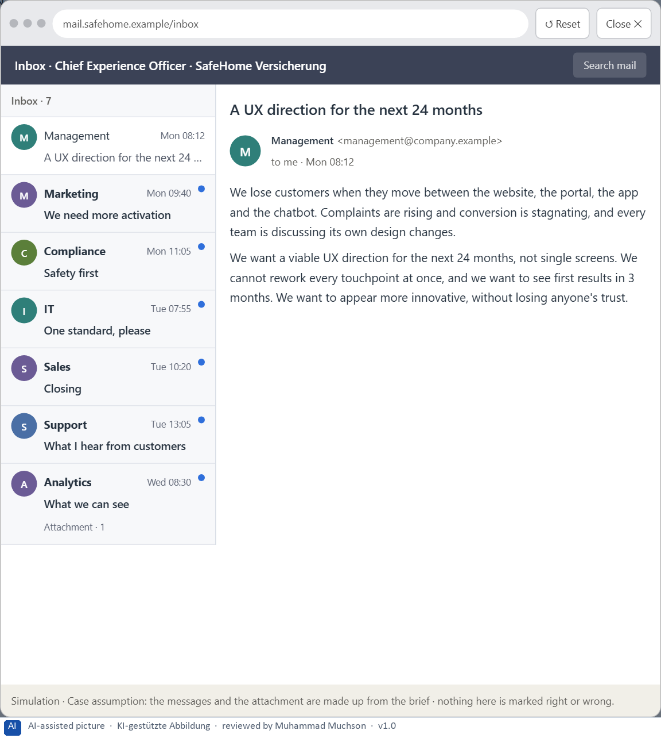
Figure 4 · Your desk: the messages that wait for you, shown in the lab as a mailbox (1 of 7).
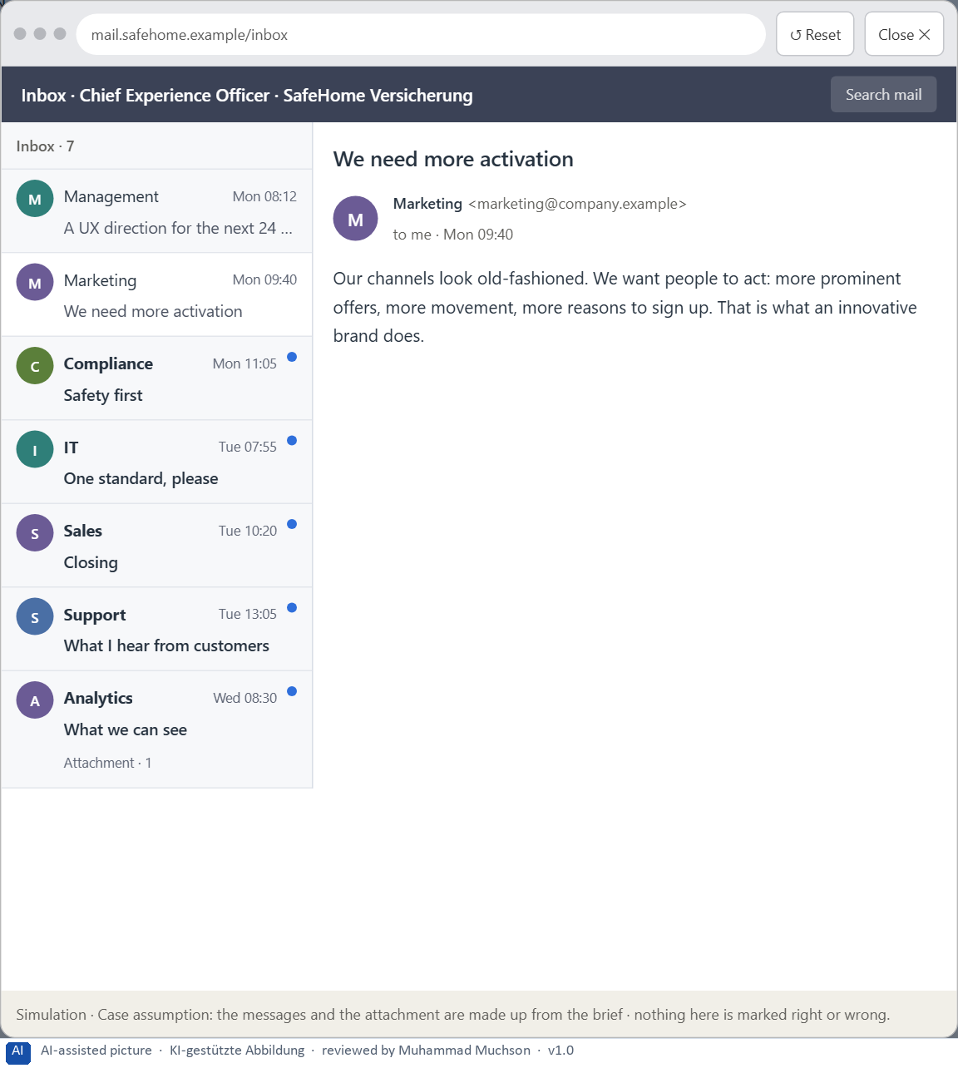
Figure 5 · Your desk: the messages that wait for you, shown in the lab as a mailbox (2 of 7).
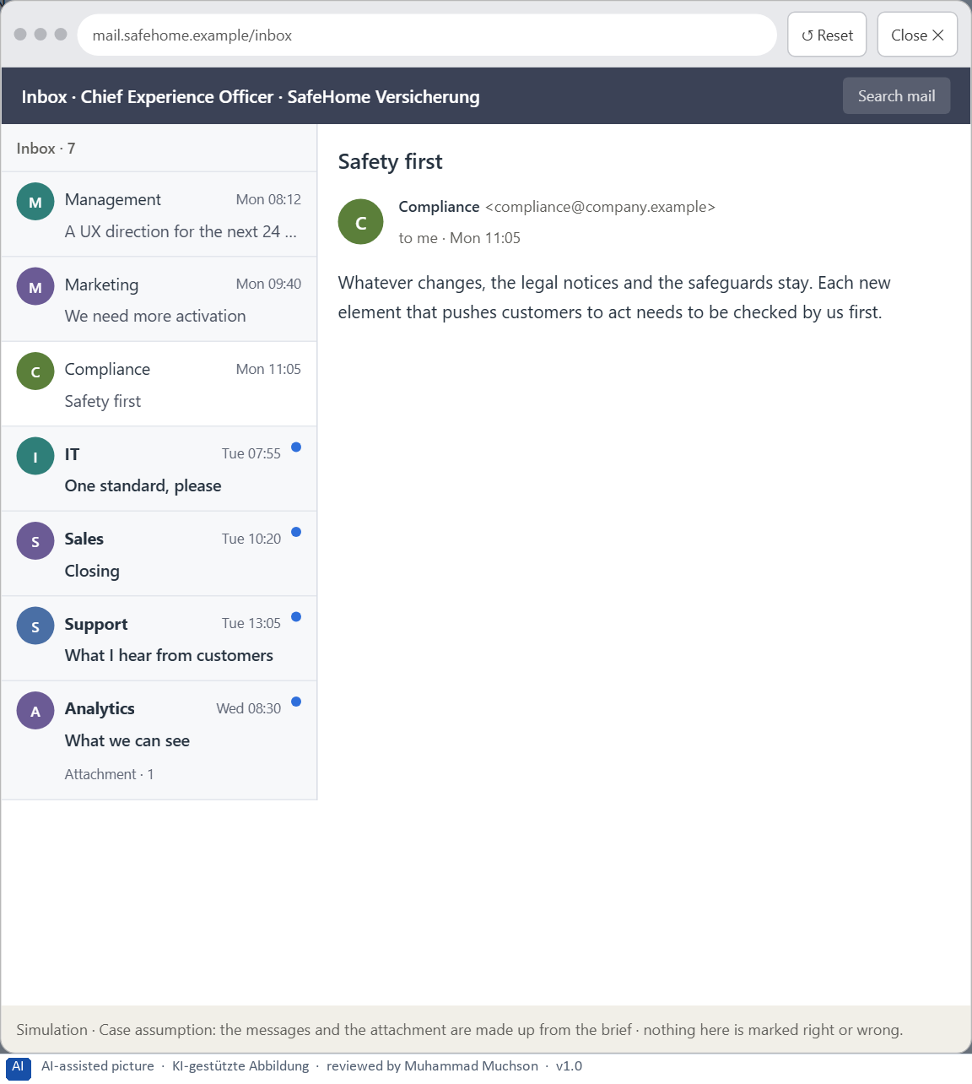
Figure 6 · Your desk: the messages that wait for you, shown in the lab as a mailbox (3 of 7).
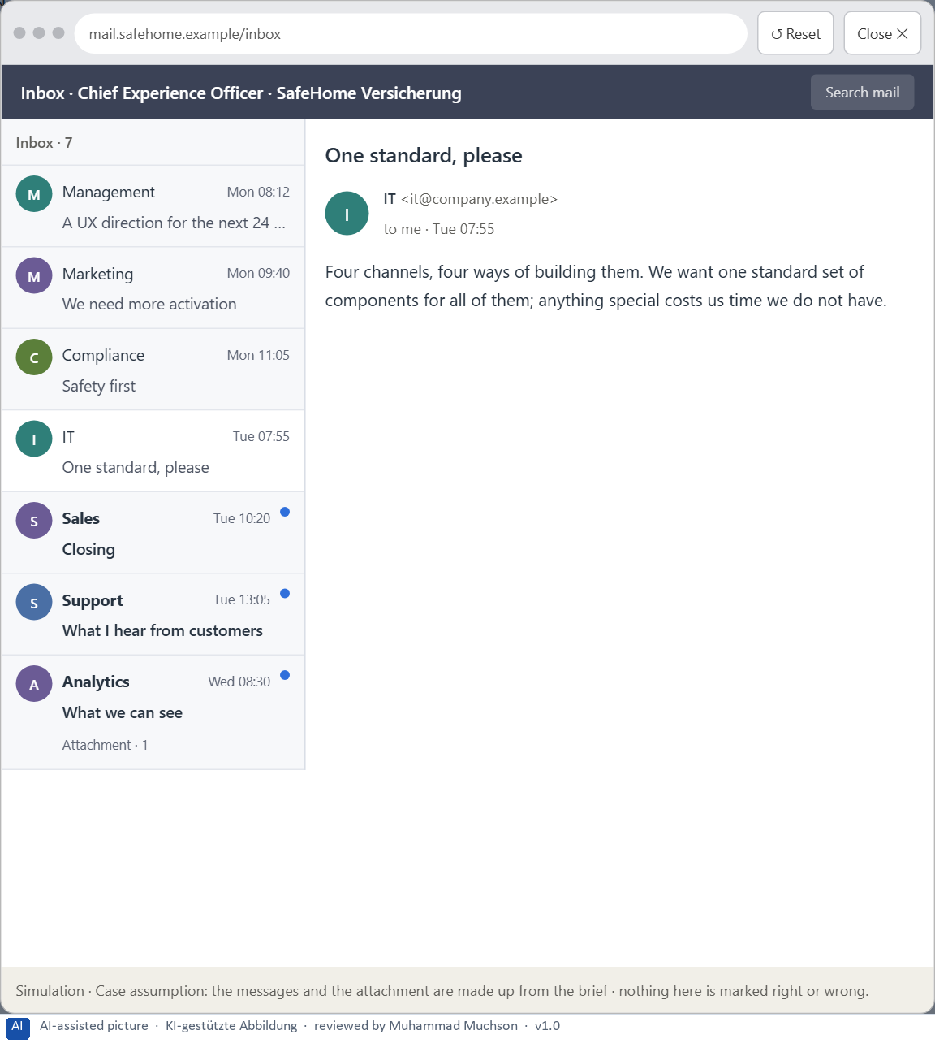
Figure 7 · Your desk: the messages that wait for you, shown in the lab as a mailbox (4 of 7).
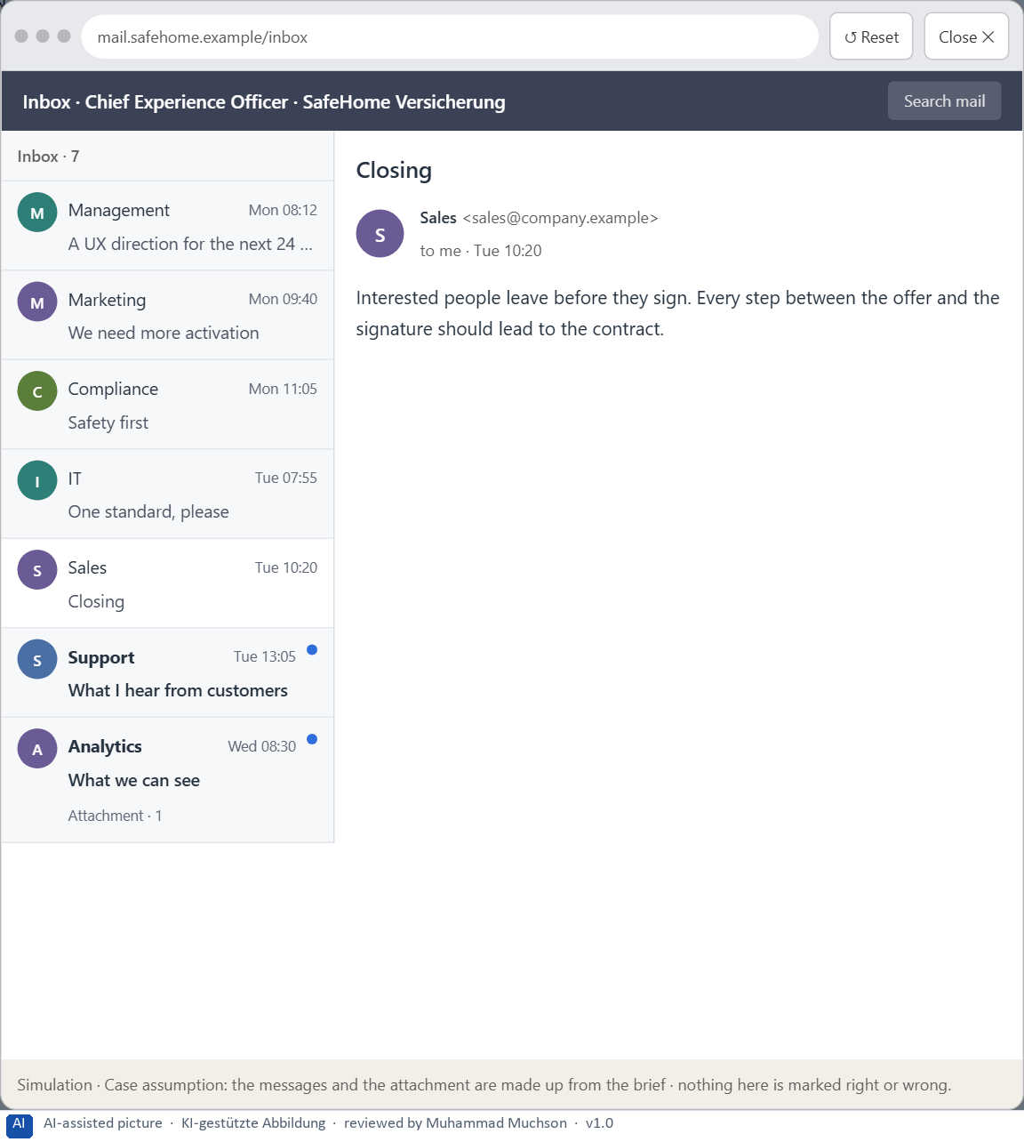
Figure 8 · Your desk: the messages that wait for you, shown in the lab as a mailbox (5 of 7).
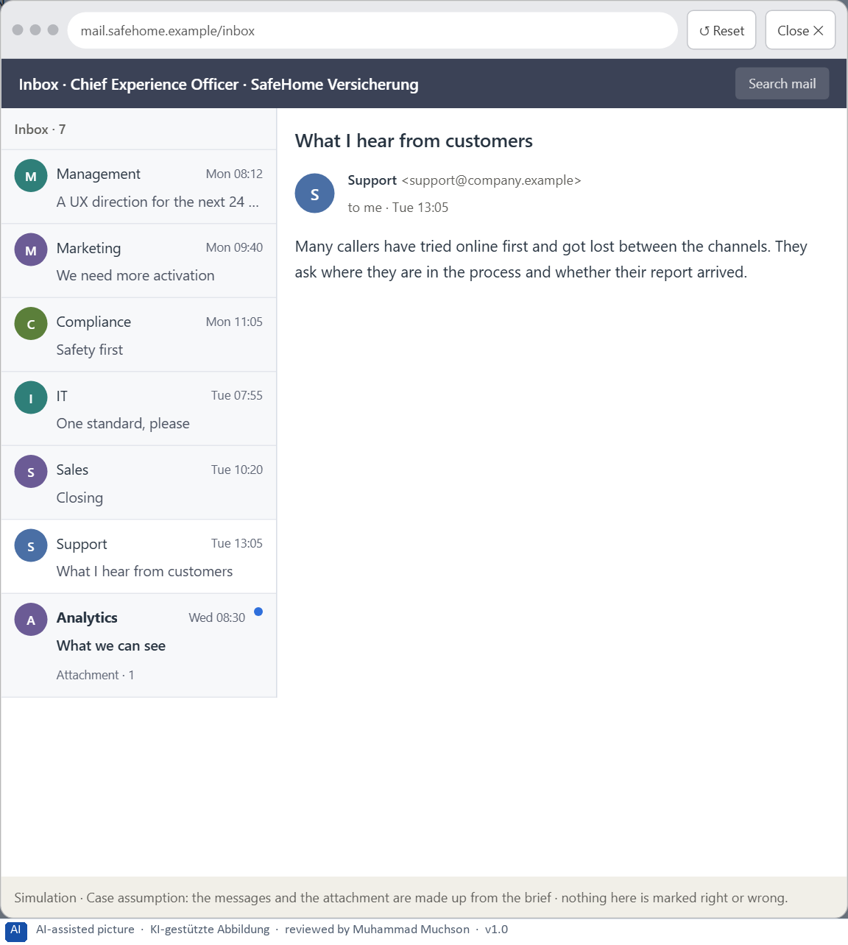
Figure 9 · Your desk: the messages that wait for you, shown in the lab as a mailbox (6 of 7).
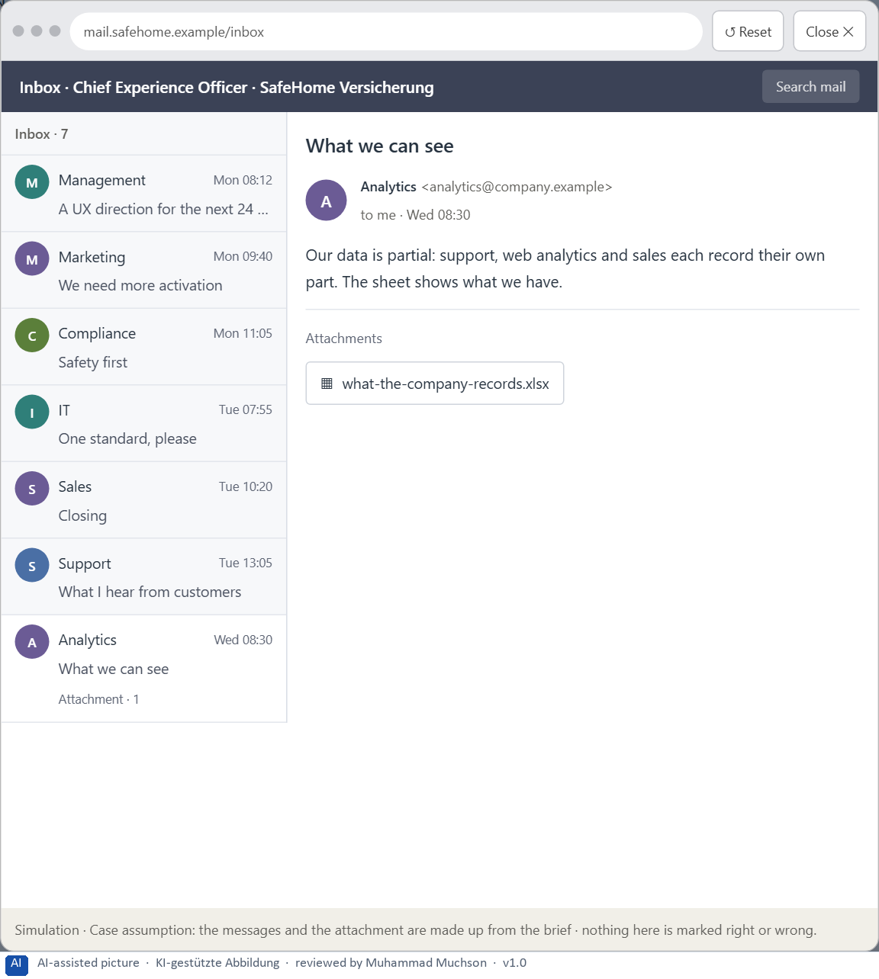
Figure 10 · Your desk: the messages that wait for you, shown in the lab as a mailbox (7 of 7).
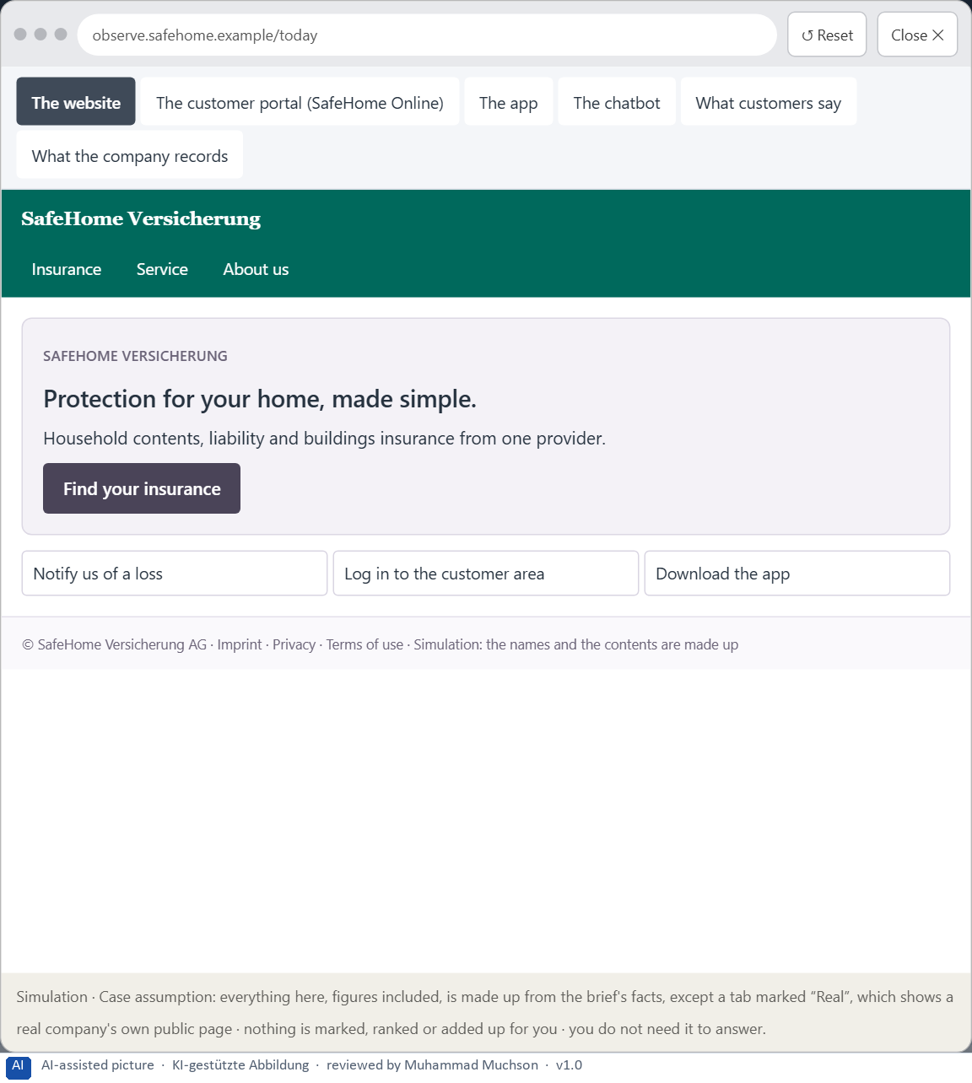
Figure 11 · The platform as it is today, as the lab lets you observe it (1 of 6).
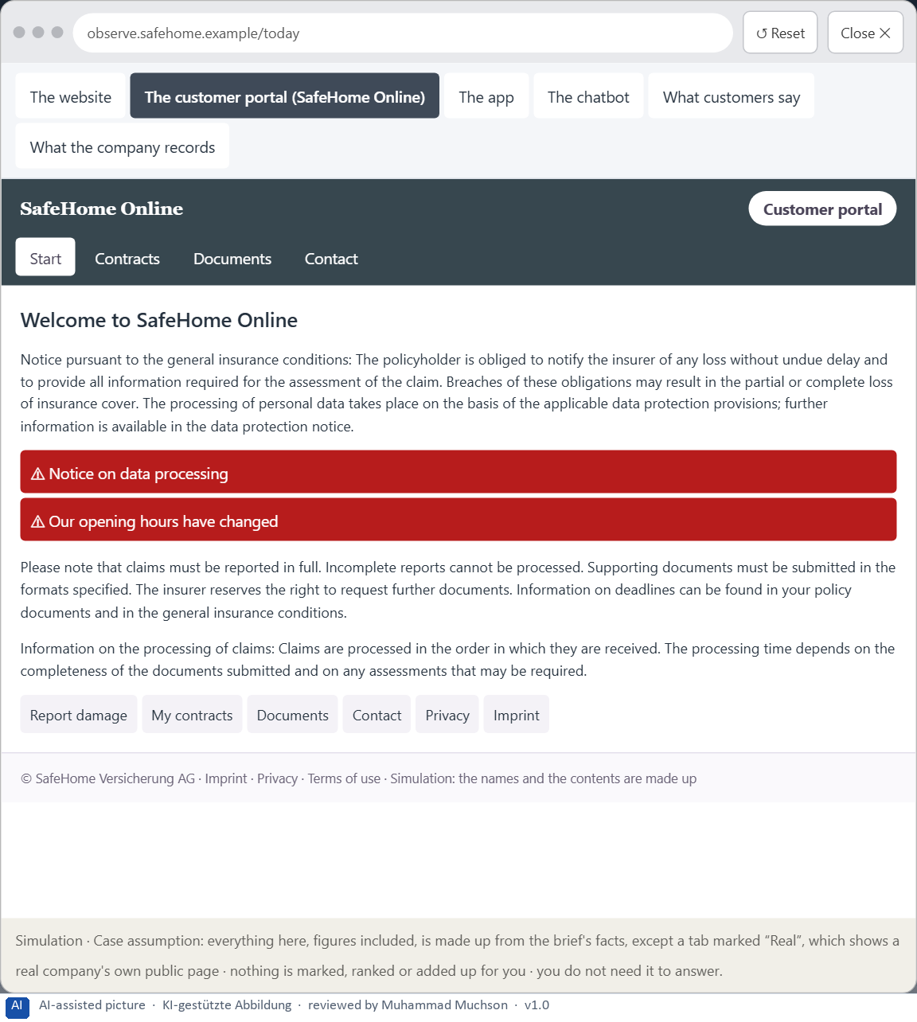
Figure 12 · The platform as it is today, as the lab lets you observe it (2 of 6).
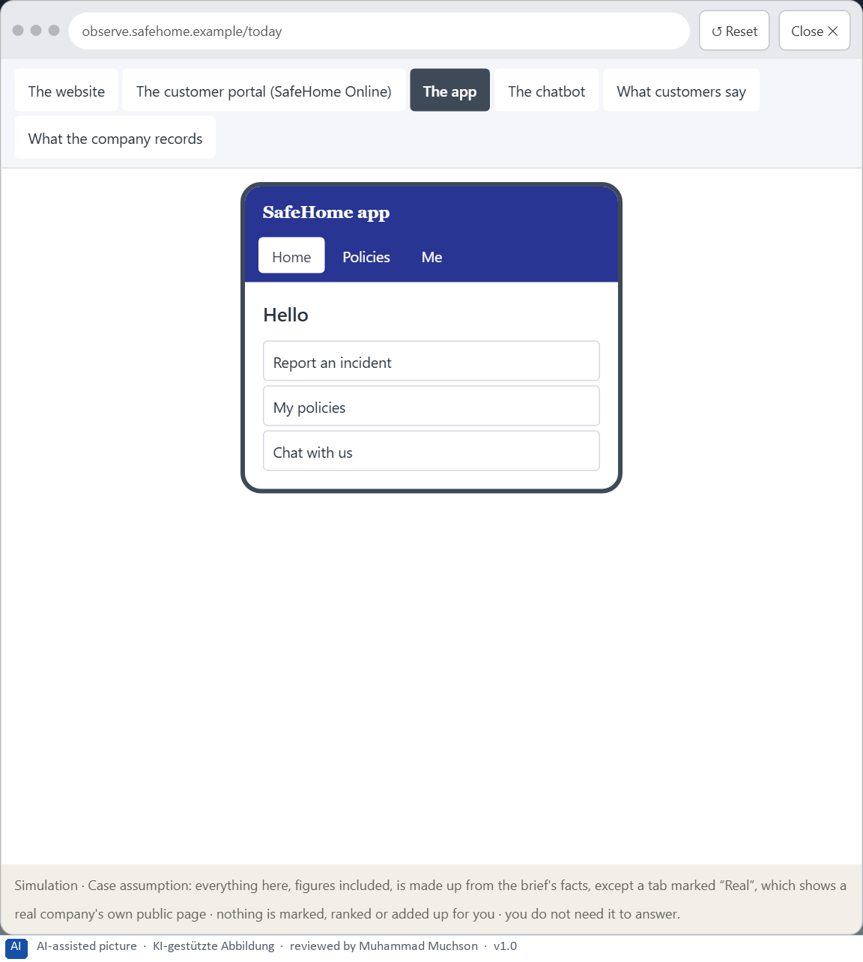
Figure 13 · The platform as it is today, as the lab lets you observe it (3 of 6).
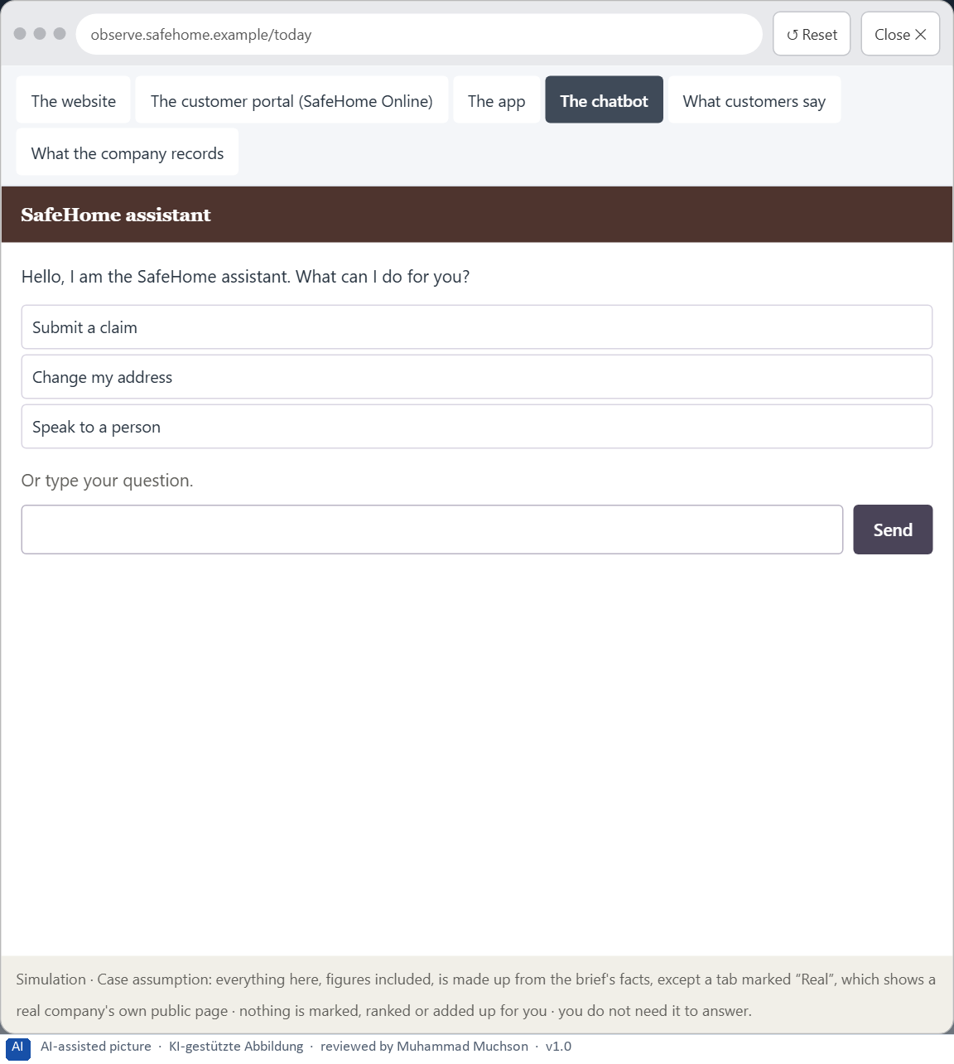
Figure 14 · The platform as it is today, as the lab lets you observe it (4 of 6).
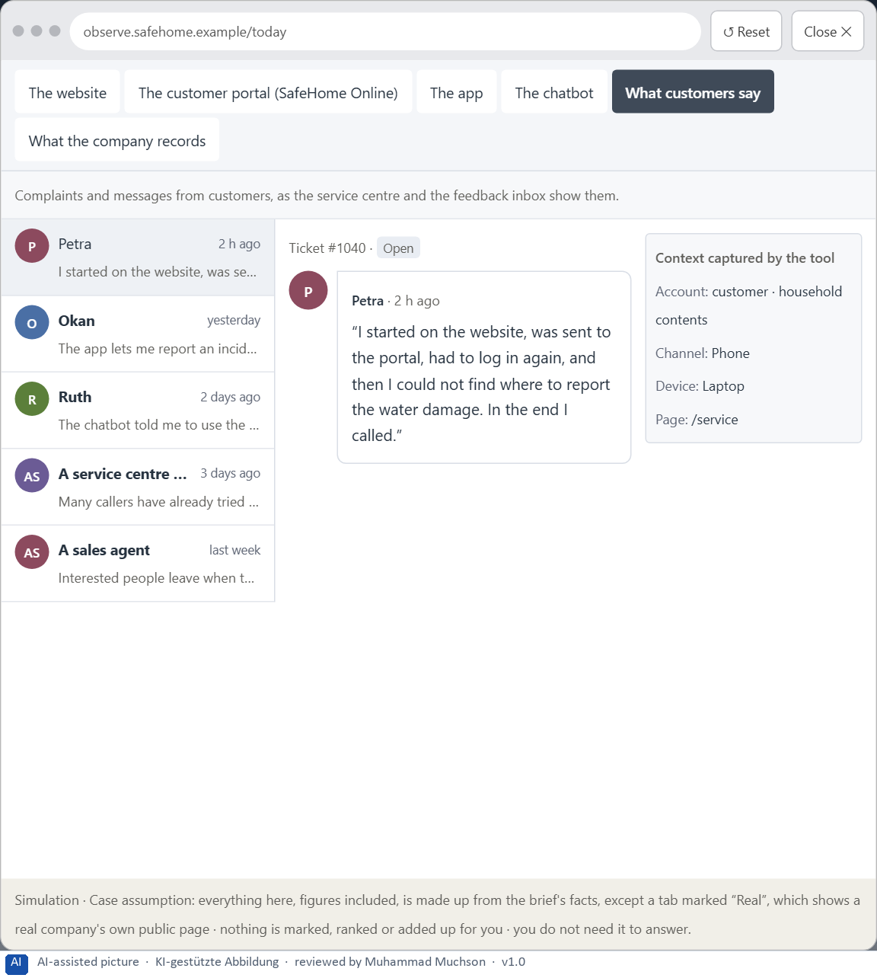
Figure 15 · The platform as it is today, as the lab lets you observe it (5 of 6).
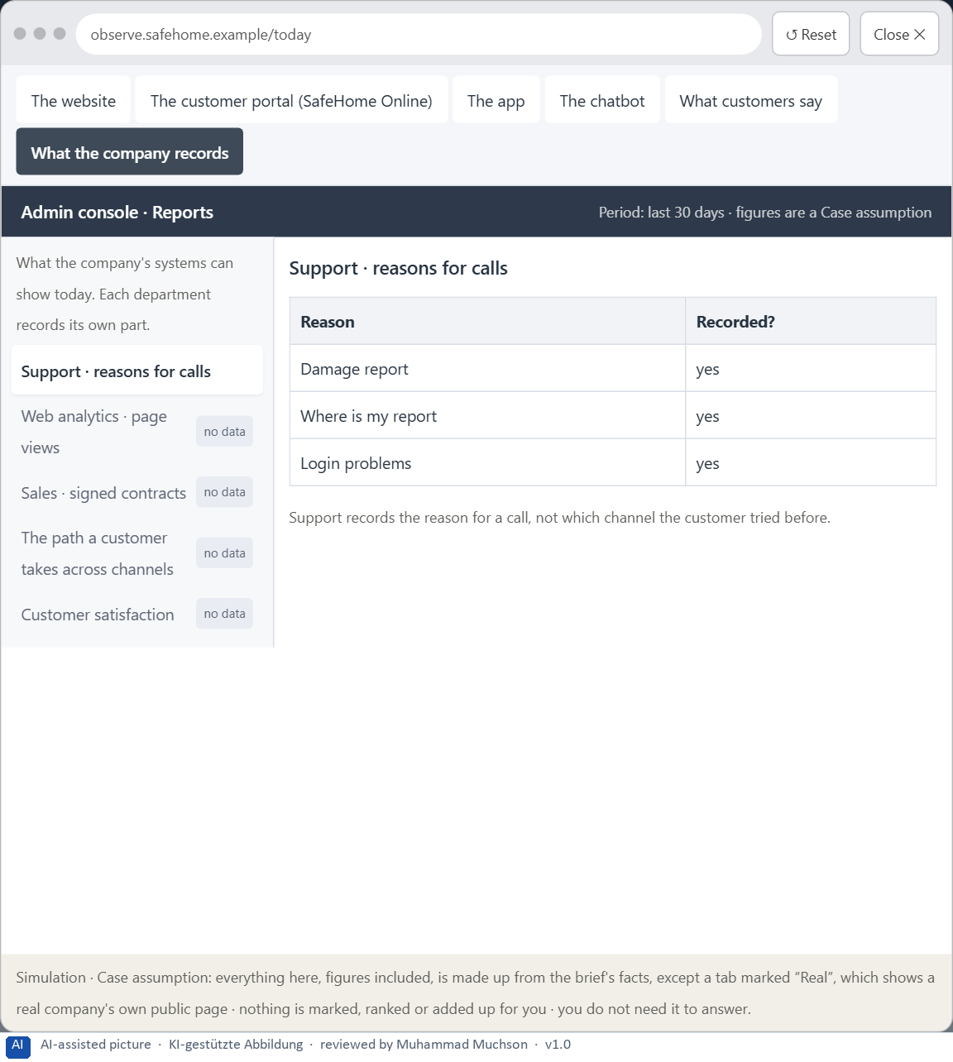
Figure 16 · The platform as it is today, as the lab lets you observe it (6 of 6).
Question 1 of 7 · A Neuro-UX guiding vision for the company: which psychological effect on users should be created systematically?
One or two sentences about the effect every channel should create: what customers should perceive, understand and feel.
How to build the answer:
- Say who the customers are and what they should feel and be able to do in every channel.
- Keep it to one effect that every touchpoint can serve.

Question 2 of 7 · Three strategic guiding decisions for the next 24 months, for example on the priority of orientation, trust design, reducing cognitive load or consistency across channels
How to build the answer:
- Take your vision and ask which three choices would make it real.
- Write each as “we will …, even though that means …”.
Write them as a list, one decision per line, each with what it gives up.

Question 3 of 7 · A prioritised intervention architecture: which touchpoints are changed first, and why these in particular?
Put the touchpoints in an order and give the reason for the first ones.
How to build the answer:
- List the four touchpoints the case names.
- Put first where customers are lost, or where a change helps the other channels most.
- Say why the others can wait.

Question 4 of 7 · A risk analysis: which wrong assumptions would be especially dangerous, and what happens if you optimise for aesthetics instead of effect?
Name two or three assumptions your strategy makes and the harm if each is wrong, and say what optimising for looks would do.
How to build the answer:
- Write down what your strategy assumes about customers.
- For each, say what happens if it is wrong.
- Say what optimising for looks instead of effect would do.

Question 5 of 7 · A governance model: who may take UX-relevant decisions, who carries the professional responsibility, and how are conflicts of goals decided?
Name roles, not people: who decides, who answers for it, and how a conflict between marketing, compliance, IT and sales is settled.
How to build the answer:
- Name who may decide what.
- Name who carries the professional responsibility.
- Say how a conflict between the four departments is decided, and by whom.

Question 6 of 7 · A decision under uncertainty: make at least one prioritised decision although important information is missing, and say why it is still responsible
Say what you decide, what you do not know, and why the decision is responsible all the same, for example when you would reverse it.
How to build the answer:
- State the decision in one sentence.
- Name what you do not know.
- Say why it is still responsible: it can be reversed, it can be checked soon, or waiting costs more.

Question 7 of 7 · A management statement: a short statement to the board in which you stand for your strategy
Four to six sentences: the direction first, then the reason, then what you ask of the board.
How to build the answer:
- Start with the direction in one sentence.
- Give the one reason that carries it.
- Say what you ask of the board and what you will report back.

Use in class: presentation and handout
Mark of use for the worksheet. Presentation is what the trainer shows on screen; Handout is what participants fill in and hand in.
Part of the worksheet | Presentation (shown in the Neuro-UX Lab) | Handout
The case: three products on the UX team's desk, and SafeHome Online | The case read aloud or on screen | The case text
Block 1.1 · The effect of an unfamiliar interface: CarePath | The task wording at the start of the block (no answers are shown) | Worksheet block with answer boxes (Core)
Block 1.2 · Rate design effects and decide under uncertainty: SkillFlow | The task wording at the start of the block (no answers are shown) | Worksheet block with answer boxes (Core)
Block 2.1 · Case study: redesigning SafeHome Online | The task wording at the start of the block (no answers are shown) | Worksheet block with answer boxes (Core)
The situation: the insurer behind SafeHome Online, 24 months ahead | The case read aloud or on screen | The case text
Block 3.1 · A Neuro-UX strategy for a digital service ecosystem | The task wording at the start of the block (no answers are shown) | Worksheet block with answer boxes (Core)

Glossary
Every term below is used in this document. Terms stay plain text in the body; this list says what they mean in everyday words.
Term | In plain words | Example | Comes from
Abandonment rate | The share of people who start a process, such as a damage report, and leave before they finish it. | — | Day 1
Attention | The mind's spotlight. Only a small part of a screen is processed at any moment; attention decides which part. | A flashing banner takes attention away from the form you were filling in. | Day 1
Case assumption | A fact made up for this exercise to fill a gap in the plan's case. It is marked so you know it is not part of the plan. | — | Day 1
Chief Experience Officer | The manager who is responsible for the experience customers have across all channels, and who decides where the company invests in it. | — | Day 1
Cognitive load | How much a person has to hold in mind and work out at the same time. Every extra signal or choice adds to it; when it is too high, people skip, freeze or leave. | — | Day 1
Conversion | The share of visitors who do what the company hopes for, such as signing a contract or finishing a request. | — | Day 1
Decision architecture | A set of connected decisions that are made on purpose and written down: what effect you want, what comes first, who decides and how conflicts are settled. It replaces many separate fixes. | — | Day 1
Governance | The rules about who may decide what, who is answerable for it and how disagreements are settled. | — | Day 1
Hypothesis | An assumption you could check later. “This red banner could make users uneasy” is a hypothesis; “this banner is bad” is only an opinion. | — | Day 1
Neuro-UX | Designing an interface with knowledge of how the brain sees, attends, feels and decides, so that the design steers these processes on purpose and responsibly. | — | Day 1
Orientation | Knowing where you are, what you can do here and what happens next. | — | Day 1
Perception | Taking in what the senses deliver, for example what the eyes see on a screen, before thinking about it. | — | Day 1
Primary action | The one thing most people on a screen came to do, such as “Report damage”. It should be the easiest thing to see and press. | — | Day 1
Psychological UX design | Designing with knowledge of how people see, pay attention, feel and decide, and judging a design by what it does to them rather than only by how it looks. | — | Day 1
Self-service portal | A website where customers do things themselves that once needed a call or a visit, such as reporting damage or downloading a document. | — | Day 1
Touchpoint | Any place where a person meets the company: the website, the customer portal, the app, a chatbot or a phone call. | — | Day 1
UI (user interface) | What a person sees and touches on a screen: buttons, colours, text, icons and their layout. It is the surface of the experience. | Changing a button from grey to blue is a UI change. | Day 1
Unconscious design effect | An effect a design has before the person can say why: a screen feels unsafe, rushed or friendly in the first second, and that feeling colours what they do next. | — | Day 1
UX (user experience) | Everything a person goes through when using a product: what they notice, understand, feel and do, from the first look to the last step. The screens are only one part of it. | Finding the booking you want at once and feeling sure it went through is a good UX. | Day 1

The Neuro-UX Lab: where we practise online
In class we use the course website as the place to practise and to learn. Every day has its own address, in the same pattern: the day number is the last part.
What | Address
Neuro-UX Lab (course website) | https://aion-ux-lab.vercel.app/
Day 1 | https://aion-ux-lab.vercel.app/day/1/

On the day page, Route 1 (Levels 1 and 2) and Route 2 (Level 3) can be opened; the cards and the tasks of this document are there too. The pattern is the same up to Day 8, for example https://aion-ux-lab.vercel.app/day/6/.

