AION · UX DEVELOPER · PSYCHOLOGICAL UX DESIGN AND NEURO-UX
DAY 10 · MATERI A AND MATERI B · ROUTES 1 AND 2 · LEVELS 1 TO 3
Intelligent interfaces and AI-supported interaction
Study material with real research, worked examples and the rules you use in the tasks
AI notice · KI-Hinweis
This document was produced with the help of an AI language model (Claude, Anthropic). The AI drafted the text and tables and built the pictures and working examples of the lab. The content was then read, corrected and approved by the reviewer named below, who is responsible for its accuracy. Every picture carries an AI label on the image. Check figures and sources before you quote them.
KI-Hinweis: Dieses Dokument wurde mit Unterstützung eines KI-Sprachmodells (Claude, Anthropic) erstellt. Texte und Tabellen wurden von der KI entworfen, die Abbildungen sind KI-gestützt erstellt und am Bild gekennzeichnet. Die fachliche Prüfung und Freigabe erfolgte durch die unten genannte Person.

Day | Day 10 · Module 5 (day 1 of 2): Intelligent interfaces and AI-supported interaction
Document | Materi (study material). Materi A has five cards, Materi B has three.
Route and level | Materi A serves Route 1 (Levels 1 and 2, Task 1). Materi B serves Route 2 (Level 3, Task 2).
Time | Materi A about 60 min · Materi B about 60 min (facilitator-led)
Neuro-UX Lab (website) | https://aion-ux-lab.vercel.app/day/10/
Case | Worked examples use a made-up company in each card. The task case is CareGuide (see the Task document).
Version | 1.0 · release date 29.10.2026
Review and approval | Muhammad Muchson, Mentor (subject-matter review and approval)

ABOUT THIS DOCUMENT
In class we also use the Neuro-UX Lab, the course website, as the place to practise and learn. Its address is at the end of this document.
Today is about interfaces that seem to think: recommendations, assistants that suggest the next step, help that appears on its own. You learn the difference between rule-based, adaptive and learning systems, how AI supports guidance and help, the difference between adapting to the situation, personalising from data and steering the interaction, what intelligent interfaces give and how they go wrong, and why people need to see why, change it and undo it. Then you use it on three platforms, and you look at how two real ones explain their recommendations. This document holds everything you need to study Day 10 without the website. Every card says what the idea is in plain words, shows it in a picture, gives the details and ends with the rules you use in the tasks.

IN THIS DOCUMENT
Lesson plan: ten teaching units (Ablaufplan)
Case study and transfer project at a glance
A1 · Rule-based, adaptive or learning: what makes an interface intelligent · 12 min · Core
A2 · How AI guides, recommends and helps: context, personal data and steering · 12 min · Core
A3 · What intelligent interfaces give, and how they go wrong · 12 min · Core
A4 · Why, change, undo: transparency, control and the feeling of control · 12 min · Core
A5 · Data, context and situation, and weighing a measure · 12 min · Core
B1 · Intelligent UX as a decision architecture, not a technology trend · 20 min · Core
B2 · Personalisation against transparency and trust: the conflicts of intelligent UX · 20 min · Core
B3 · Who answers for an intelligent interface, and deciding with patchy data · 20 min · Core

Day at a glance
Day 10 has ten teaching units (UE). This document is the study material; it is used in UE1 (Materi A) and UE8 (Materi B). The day is built from three documents and the Neuro-UX Lab: Materi (study material), Task (worksheet) and Trainer (coaching, feedback and model solutions), plus the course website.

Lesson plan: ten teaching units (Ablaufplan)
UE | Min | Plan item | What happens | Material | Format
1 | 45 | Knowledge transfer · Level 1 | The trainer presents the cards of Materi A (A1, A2, A3, A4, A5, about 60 min of cards) in the Neuro-UX Lab; participants follow in the handout. | Materi A (Route 1) | Presentation + Handout
2 | 45 | Level 1 · Task 1 | Individual work on Block 1.1 (Core, about 10 min): the first product of the day is read and its effect described. Pairs then compare their results and the trainer collects open questions. | Task 1 · Part 1 · Block 1.1 | Handout (or in the lab)
3 | 45 | Level 1 · Task 2 | Three options are rated on the same criteria and one is chosen under the stated conditions: Block 1.2 (Core, about 8 min). | Task 1 · Part 1 · Block 1.2 | Handout (or in the lab)
4 | 45 | Coaching · transition from Level 1 to Level 2 | Trainer-led. A short talk on the day's coaching focus, then the reflection questions in pairs. The bridge: from describing an effect to a decision you answer for. There is no worksheet block in this unit. | Trainer document, section Coaching | Trainer only
5–6 | 90 | Level 2 · Case study CareGuide (2 UE) incl. model solution | UE5: the trainer presents the case; participants work on Block 2.1 (Core, about 15 min). UE6: groups compare their results and defend them; the trainer closes with the model solution. | Task 1 · Part 2 · Block 2.1  Trainer document, section Case study | Handout; model solution shown after the work
7 | 45 | Level 2 + 3 · Feedback round with a management perspective | Groups present their reasoning, not only their result. The trainer asks the day's Level 3 input questions and leads the discussion. | Trainer document, section Feedback round | Presentation by the groups; Trainer only
8 | 45 | Level 3 · Transfer project, Chief Experience Officer (3 UE: UE8–10) | The trainer presents Materi B (B1, B2, B3; use the "In plain words" and "How to decide" boxes, the rest is handout) and sets the role and the situation. | Materi B (Route 2) | Presentation + Handout
9 | 45 | Level 3 · Transfer project | Individual work or in pairs on Block 3.1 (Core, about 20 min): the strategy memo. | Task 2 · Block 3.1 | Handout (or in the lab)
10 | 45 | Level 3 · Transfer project | Participants present their decision and what they give up, including the one decision made under uncertainty; the trainer debriefs with the model solution. | Task 2 · Block 3.1  Trainer document, section Transfer project | Handout; model solution shown after the work

One UE is counted as 45 minutes here; breaks are not shown. The times are a guide for the trainer. The Core blocks are enough for a complete answer.

Case study and transfer project at a glance
Component | UE | Duration | Participants work in | Model solution in
Level 2 case study (CareGuide) | UE5–6 | 2 UE · 90 min | Task 1 · Part 2 (Block 2.1) | Trainer document, section Case study
Level 3 transfer project (Chief Experience Officer) | UE8–10 | 3 UE · 135 min | Materi B and Task 2 (Block 3.1) | Trainer document, section Transfer project

Materi A · Route 1 · Levels 1 and 2
How Materi A is used
About 60 minutes, five cards. Levels 1 and 2: find the chances and risks of an insurance service platform's intelligent interaction, rate three personalisation designs of a career platform under conflicting goals, then analyse a health portal, develop four measures, justify them and decide on the first 14 weeks. The cards give you the ideas and the rules you use in Task 1.

A1 · Rule-based, adaptive or learning: what makes an interface intelligent · 12 min · Core
Three kinds of system can stand behind a smart-looking screen: a rule (same input, same output), an adaptive system (reacts to the situation now) and a learning system (changes with data about a person). An interface is intelligent when its support fits the situation; doing things automatically is only automation.
IN PLAIN WORDS
The idea. An interface can look smart for three different reasons. A rule-based system follows fixed rules: the same input gives the same output, every time, and the rule can be explained in one sentence. An adaptive system reacts to the situation now: where you are, what time it is, what you just did. A learning system changes with data over time: it gets to know a person, and the same input can give a different output next month. Many products mix the three. An interface is intelligent when it supports people in a way that fits their situation; one that only does things automatically is automated, not intelligent.
Why it matters. Block 1.1 asks what SmartAssist's suggestions do for users and notes that they cannot tell rules from AI, and Block 2.1 asks why CareGuide's recommendations fit only sometimes. This card gives you the three kinds of system behind a smart-looking screen.
How to read the picture. The same Northline Rail moment, a delayed train, handled by a rule, by the situation and by what the app has learned.

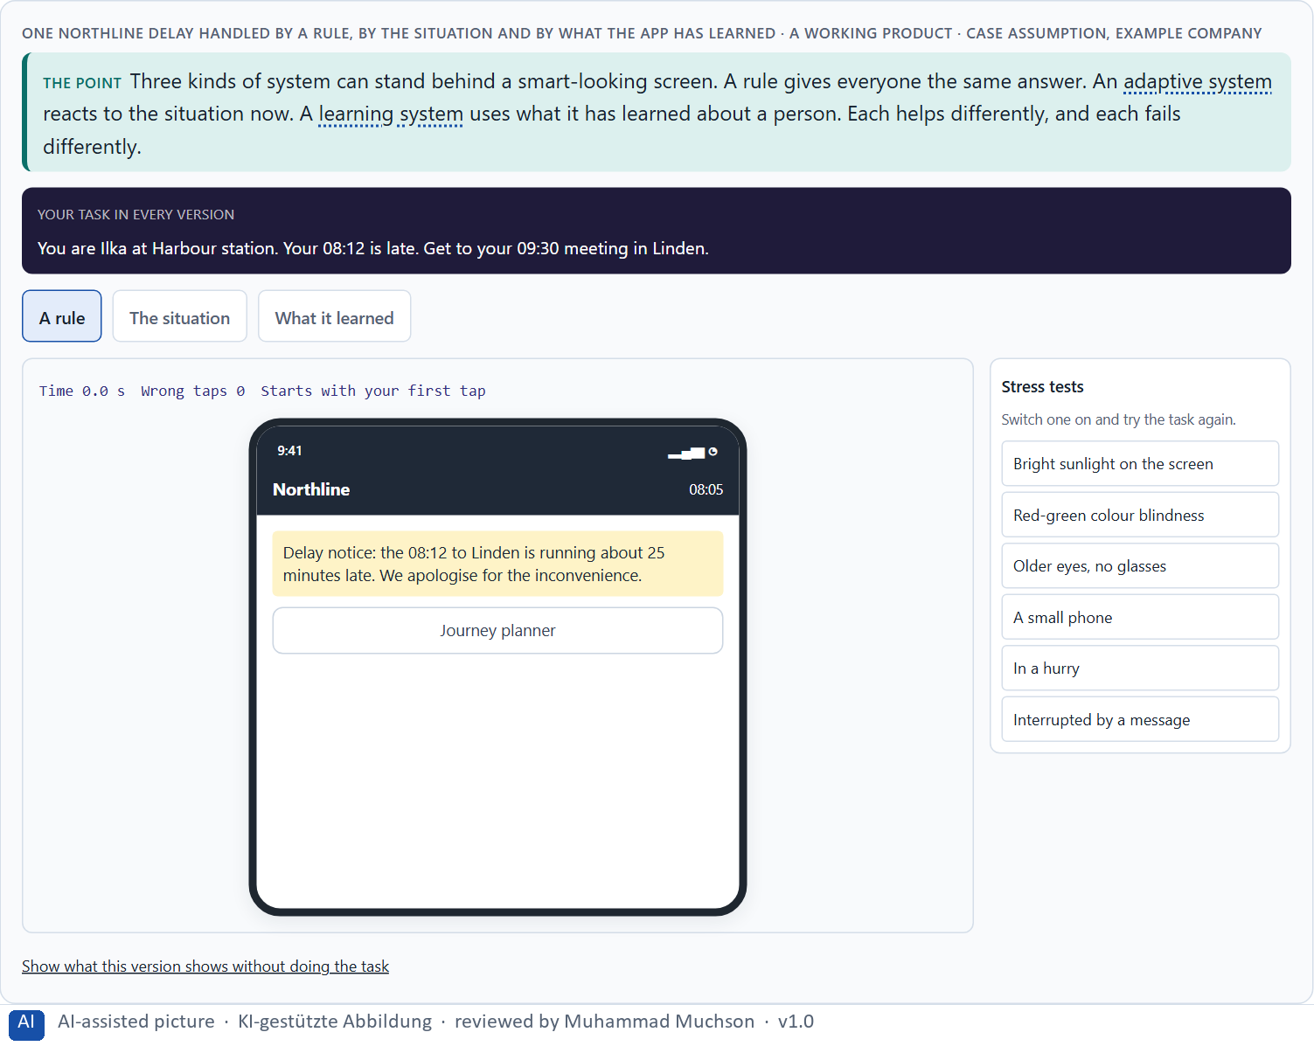
Figure 1 · One Northline delay handled by a rule, by the situation and by what the app has learned. Shown here in its starting state; in the Neuro-UX Lab every version and every stress test can be used.
Three kinds of system behind an interface
Kind | What it uses | Can it explain itself? | Typical mistake
Rule-based | Fixed rules written by people. | Yes, in one sentence. | Treats everyone the same, also when the situation differs.
Adaptive | The situation now: place, time, device, the last step. | Yes, if it names the situation. | Misreads the situation.
Learning | Data about the person, collected over time. | Only partly; it has to be designed. | Confident mistakes from old or missing data.

Case assumption
Northline Rail, Ilka, Mats, Saskia and Bram are made up for this example. When an automated service should act, ask or wait follows Horvitz (1999); making clear what a system can do and why it did something follows Amershi et al. (2019).

How to decide when this comes up in the task
- Ask which kind of system is behind a suggestion: a rule, the situation, or learning about the person.
- A rule can be explained in one sentence; check whether the screen says it.
- An adaptive system needs the situation to be read correctly; check what happens when it is misread.
- A learning system can change its answer over time; check whether people can see what it learned.
- Do not call it intelligent because it is automatic; call it intelligent when its help fits.

Extra · go deeper (optional reading)
Many products mix the three, and the people using them cannot tell which part is which. That matters: a rule that is wrong is wrong for everyone and is fixed once; a learning system that is wrong may be wrong only for some people, quietly, for months. When nobody can say which kind decided, nobody can say who to ask when it goes wrong. “Which type is this?” is the first question to ask of any smart-looking screen.

Sources · Horvitz 1999 · Amershi et al. 2019

A2 · How AI guides, recommends and helps: context, personal data and steering · 12 min · Core
AI supports people in four places: guidance, recommendations, help, and the course of an interaction. It adapts in three ways: to the context now, to personal data, or by steering the interaction itself. Each needs different data and carries a different risk. A voice interface is one form; it must say back what it understood.
IN PLAIN WORDS
The idea. AI can support people in four places: guidance (what to do next), recommendations (what might suit them), help (an answer at the moment of need) and the course of an interaction (a dialogue that shortens itself). There are three ways to adapt. Adapting to context uses the situation now (time, place, device). Personalising from data uses what is known about the person (history, preferences). Dynamic steering changes the interaction itself (skipping steps, reordering, a voice assistant asking only what is missing). Each needs different data and carries a different risk; voice interfaces are one form, where saying back what was understood replaces what a screen would show.
Why it matters. Block 1.2 asks you to rate three ways CareerNavigator could personalise, and Block 2.1 asks what CareGuide's recommendations do. This card tells context, personal data and steering apart.
How to read the picture. The Northline Rail app in three versions: adapting to the station Mats is at, personalising from his usual trips, and steering the booking itself.

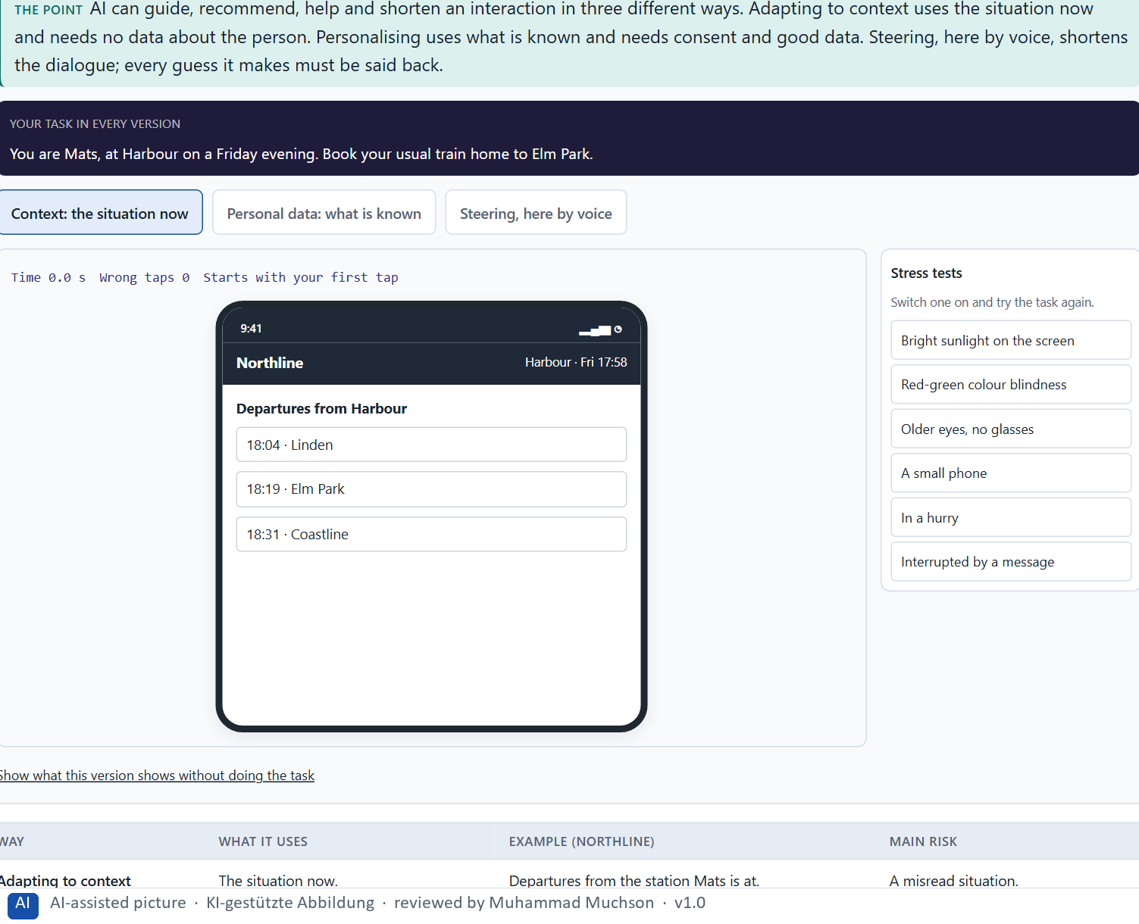
Figure 2 · The Northline app adapting to context, personalising from data and steering the interaction by voice. Shown here in its starting state; in the Neuro-UX Lab every version and every stress test can be used.
Three ways an interface can adapt
Way | What it uses | Example (Northline) | Main risk
Adapting to context | The situation now. | Departures from the station Mats is at. | A misread situation.
Personalising from data | What is known about the person. | His usual Friday trip, ready to book. | Old data; feeling watched.
Steering the interaction | The course of the dialogue itself. | The voice assistant asks only what is missing. | Guesses the person did not see.

Case assumption
Northline Rail, Ilka, Mats, Saskia and Bram are made up for this example. People reacting to an AI's agency, as convenient or intrusive depending on control, follows Sundar (2020). Voice interfaces go deeper on Day 11.

How to decide when this comes up in the task
- Say which of the four a feature does: guide, recommend, help, or shorten the interaction.
- Say which way it adapts: context, personal data or steering.
- Context needs no data about the person; prefer it where it is enough.
- Personal data needs consent and good data; check both.
- Steering skips steps; check that people can still see and correct what was filled in, by voice especially.

Extra · go deeper (optional reading)
Context is the cheapest and safest kind of intelligence, and the most often skipped. Teams reach for personal data because it feels more impressive, when the situation alone (where someone is, what they just did) would have answered the question without storing anything. Ask first whether the situation is enough; personalise only for what it cannot answer.

Sources · Amershi et al. 2019 · Horvitz 1999 · Sundar 2020

A3 · What intelligent interfaces give, and how they go wrong · 12 min · Core
Intelligent interfaces can raise relevance, save time, relieve people of steps, help before they ask and fit how people work. They go wrong through opacity, loss of control, misadaptation, over-personalisation and loss of trust. The same feature can do both.
IN PLAIN WORDS
The idea. Intelligent interfaces can raise relevance (what people see fits them), save time, relieve people of steps, help before they ask, and fit the way people already work. They can also go wrong in five ways: opacity (nobody can see why), loss of control (people cannot change it), misadaptation (it fits the wrong situation), over-personalisation (it knows too much, or narrows what people see) and loss of trust (after one bad surprise, people doubt every suggestion). The same feature can do both; whether it helps depends on how well it fits, and how easy it is to see and to correct.
Why it matters. Block 1.1 asks for the chances and risks of SmartAssist and for its two biggest chances and risks, and Block 2.1 asks for CareGuide's central chances and risks. This card gives you the potentials and the risks by name.
How to read the picture. One Northline Rail message, from not personal at all to far too personal.

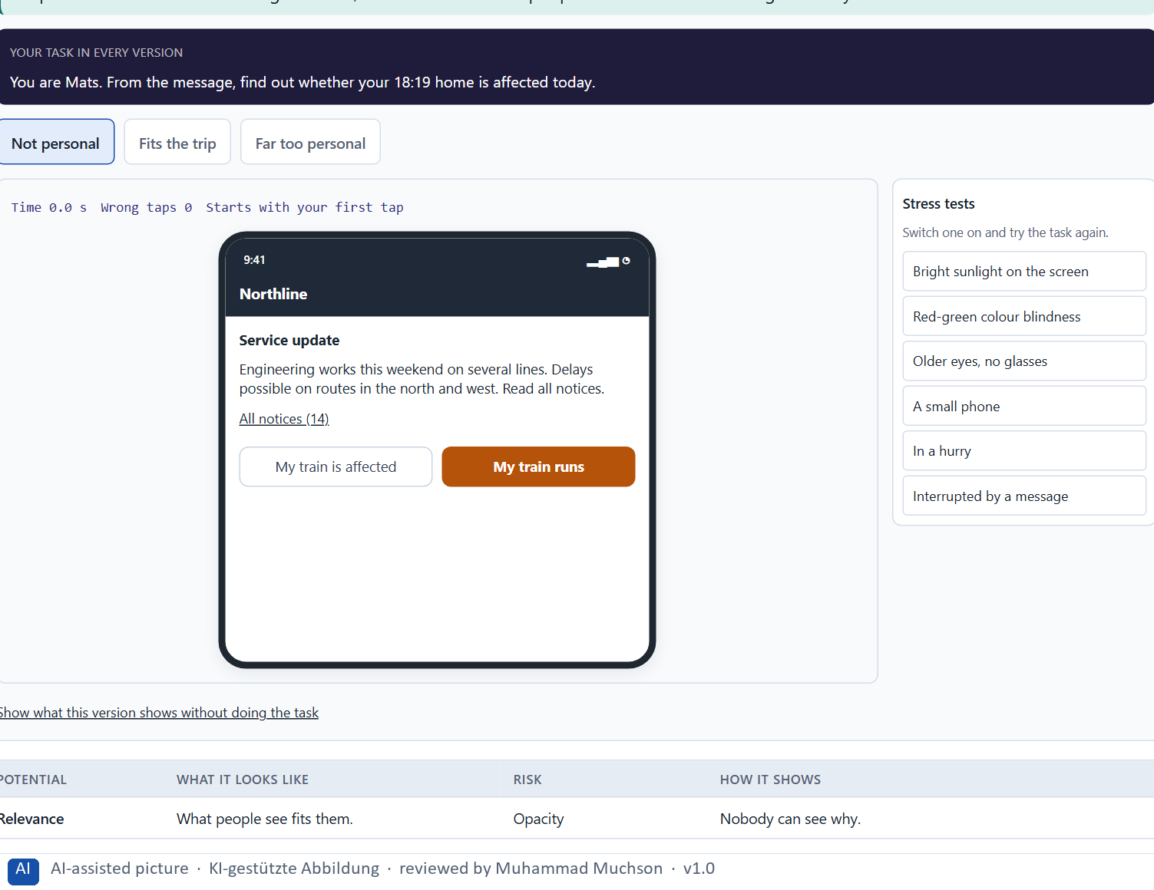
Figure 3 · One Northline message from not personal at all to far too personal. Shown here in its starting state; in the Neuro-UX Lab every version and every stress test can be used.
What intelligent interfaces give, and how they go wrong
Potential | What it looks like | Risk | How it shows
Relevance | What people see fits them. | Opacity | Nobody can see why.
Time saved | Fewer steps to the goal. | Loss of control | People cannot change it.
Relief | The system does the routine part. | Misadaptation | It fits the wrong situation.
Anticipating help | Help before people ask. | Over-personalisation | It knows too much, or narrows the view.
Fit | It matches how people already work. | Loss of trust | After one bad surprise, every suggestion is doubted.

Case assumption
Northline Rail, Ilka, Mats, Saskia and Bram are made up for this example. Personalisation narrowing what people see follows Pariser (2011); people abandoning automation after visible failures follows Parasuraman and Riley (1997); trust that should match what a system can do follows Lee and See (2004).

How to decide when this comes up in the task
- Name the potential a feature aims at: relevance, time, relief, anticipating help, fit.
- Name the risk next to it: opacity, loss of control, misadaptation, over-personalisation, loss of trust.
- Ask where more personal stops being more helpful.
- Remember that one bad surprise lowers trust in every suggestion after it.
- Check whether personalisation narrows what people can find.

Extra · go deeper (optional reading)
Trust in automation is lost faster than it is gained. People who see a system make an obvious mistake often stop using it altogether, including for the things it does well. That is why a few confident wrong suggestions can cost more than many right ones bring: the risk is not one bad recommendation, but every recommendation after it.

Sources · Pariser 2011 · Parasuraman & Riley 1997 · Lee & See 2004

A4 · Why, change, undo: transparency, control and the feeling of control · 12 min · Core
People trust what they can understand and change. Ask three questions of every suggestion: can they see why (transparency), change it (control), undo it (recoverability)? Clear expectations matter: what the system will and will not do. The more it acts alone, the more people need to feel in control.
IN PLAIN WORDS
The idea. People trust a suggestion they can understand and change. Three questions test it: Can the person see why the system did what it did (transparency)? Can they change, steer or turn it off (control)? If it gets it wrong, can it be undone (recoverability)? If the answer to all three is no, the feature needs redesign before it ships, however clever the system behind it. Clear expectations matter too: people should know what the system will and will not do. The more a system acts on its own, the more people need to feel in control; perceived control is not the same as real control, but it decides how people feel about automation.
Why it matters. Block 1.1 asks about transparency and control at SmartAssist, Block 1.2 asks you to weigh explainability and user control at CareerNavigator, and Block 2.1 asks why CareGuide's members do not understand its recommendations. This card gives you the three questions to ask of every suggestion.
How to read the picture. One Northline Rail suggestion with three switches: a reason, a way to change it, and an undo.

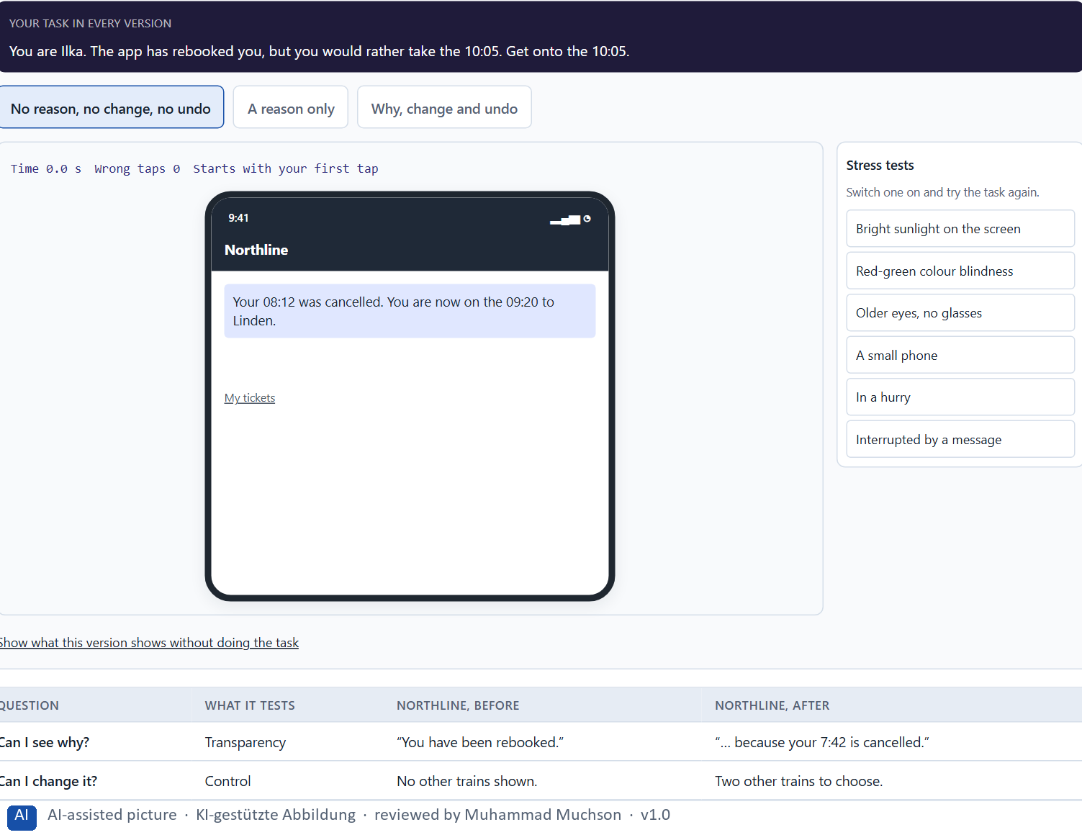
Figure 4 · Northline's automatic rebooking with a reason, a way to change it and an undo. Shown here in its starting state; in the Neuro-UX Lab every version and every stress test can be used.
The three questions, with Northline examples
Question | What it tests | Northline, before | Northline, after
Can I see why? | Transparency | “You have been rebooked.” | “… because your 7:42 is cancelled.”
Can I change it? | Control | No other trains shown. | Two other trains to choose.
Can I undo it? | Recoverability | Only through the hotline. | “Undo rebooking” in one tap.

Case assumption
Northline Rail, Ilka, Mats, Saskia and Bram are made up for this example. Showing why, supporting dismissal and correction follows Amershi et al. (2019); perceived control shaping how people feel about automation follows Sundar (2020).

How to decide when this comes up in the task
- Why: does the screen say why, in the person's words?
- Change: can the person steer, dismiss or switch it off?
- Undo: if it is wrong, can the person go back without help?
- If all three answers are no, redesign before it ships.
- Say what the system will and will not do, so people know what to expect.

Extra · go deeper (optional reading)
Automation and autonomy pull against each other. The more a system does on its own, the less the person decides, and the more it matters that they could decide if they wanted to. An undo that nobody uses is still worth building: knowing it is there is what makes people comfortable letting the system act at all.

Sources · Amershi et al. 2019 · Lee & See 2004 · Sundar 2020

A5 · Data, context and situation, and weighing a measure · 12 min · Core
An intelligent interface is only as good as its data and its reading of the situation. Incomplete data gives confident mistakes. So intelligent interfaces are a psychological and strategic design task, not only a technical one. Start with robust, frequent cases; weigh measures on effect on users, feasibility, risk and time pressure.
IN PLAIN WORDS
The idea. An intelligent interface is only as good as its data and its sense of the situation. Incomplete or old data produces confident mistakes; a suggestion that fits at home may not fit on a platform in the rain. So intelligent interfaces are a psychological task (expectations, trust, the feeling of control) and a strategic one (where it is worth it, and where it is too risky), not only a technical one. Start with robust cases: the frequent, simple situations where the data is good. To put measures in order, weigh each on effect on users, feasibility, risk and time pressure, the four Block 2.1 names.
Why it matters. Block 1.2 asks about CareerNavigator with only partial user data, and Block 2.1 asks for four prioritised measures for CareGuide, justified on effect on users, feasibility, risk and time pressure, with data of mixed quality. The example uses Northline Rail and its own measures, so the answer for the task cases is not given.
How to read the picture. First the chain from data to a suggestion and where it breaks. Then three measures Northline Rail considered, rated on effect on users, feasibility, risk and time pressure.

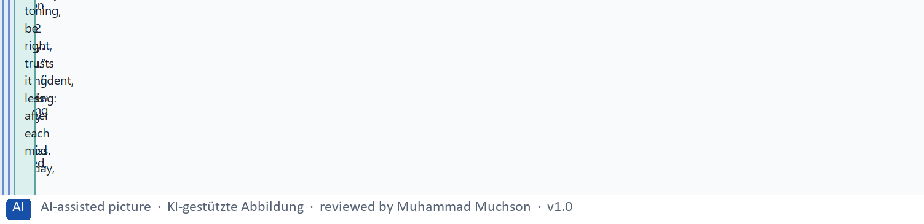
Figure 5 · From data to a suggestion in the Northline app, and where it breaks.
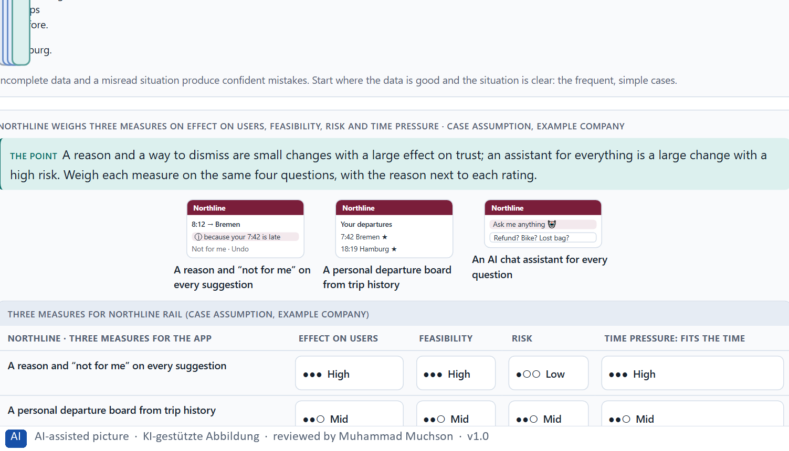
Figure 6 · Northline weighs three measures on effect on users, feasibility, risk and time pressure.
Case assumption
Northline Rail, Ilka, Mats, Saskia and Bram are made up for this example. Rating options on the same criteria with a reason follows Gibbons (2018). The four criteria are the ones the plan names for the case study.

How to decide when this comes up in the task
- Ask which data a suggestion uses, and how complete and current it is.
- Ask whether the situation of use is read correctly: at home, on the move, in a hurry.
- Start with frequent cases where the data is good; leave rare, costly ones to people.
- Treat expectations, trust and the feeling of control as part of the design.
- Rate every measure on the same four questions, with a reason; a rating is a judgement, never a mark.

Extra · go deeper (optional reading)
Data quality is rarely even. Most companies have one kind of data that is complete and current (bookings, appointments, contracts) and several that are patchy (reading history, preferences, free text). The robust core cases are where the good data is. An intelligent interface that starts there earns the trust it later needs for the harder cases; one that starts with the impressive cases on patchy data spends that trust before it has any.

Sources · Parasuraman & Riley 1997 · Lee & See 2004 · Gibbons 2018

Materi B · Route 2 · Level 3
How Materi B is used
About 60 minutes, three cards, led by the facilitator. Level 3 in the Chief Experience Officer's chair: a guiding vision for intelligent UX, three strategic decisions, an order of what comes first, a risk analysis, a governance model for intelligent UX principles, one decision under uncertainty and a statement to the management. The cards give you the ideas you use in Task 2.

B1 · Intelligent UX as a decision architecture, not a technology trend · 20 min · Core
Inside many companies AI is first an innovation signal. At senior level an intelligent interface is a decision architecture: what support, how much personalisation and how much autonomy users get, decided once for every journey. It shapes guidance, service quality and differentiation, and is designed from the user's need.
IN PLAIN WORDS
The idea. Inside many companies AI is first an innovation signal: a feature to announce. At senior level an intelligent interface is a decision architecture: what kind of support, how much personalisation and how much autonomy the company wants for its users, decided once and applied in every journey. It shapes guidance, service quality and how the product stands apart, so it is designed from the user's need, not from what the technology can do. The rule of thumb: fewer, reliable, explainable suggestions in the journeys where they help most, before anything clever anywhere else.
Why it matters. Block 3.1 asks for a guiding vision for intelligent UX, three decisions on transparency, control, adaptivity, depth of personalisation and trustworthy AI interaction, and an order of which journeys, functions or touchpoints become intelligent first. You decide the architecture, not single AI features.
How to read the picture. Left Northline Rail adding AI features to look modern, right building an intelligent UX architecture. Below, the layers from a guiding vision to every touchpoint.

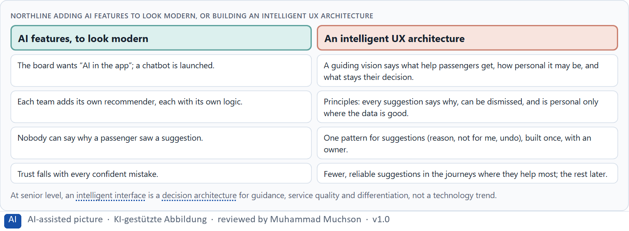
Figure 7 · Northline adding AI features to look modern, or building an intelligent UX architecture.
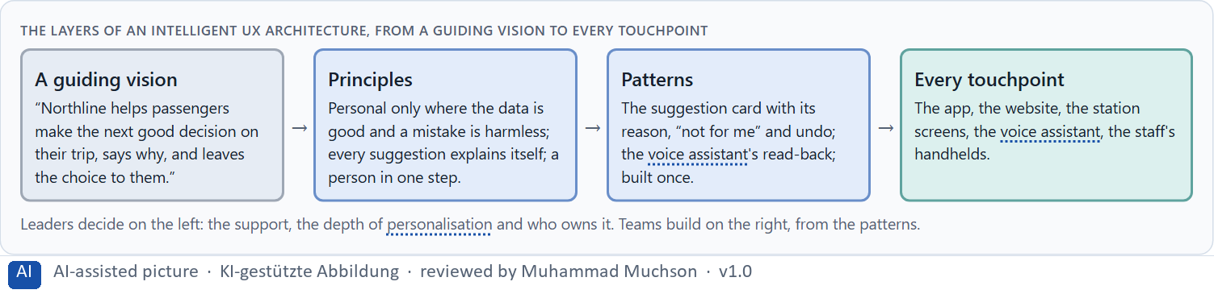
Figure 8 · The layers of an intelligent UX architecture, from a guiding vision to every touchpoint.
Case assumption
Northline Rail, Ilka, Mats, Saskia and Bram are made up for this example. Designing the human side of AI from the user's need follows Amershi et al. (2019).

How to decide when this comes up in the task
- Check where intelligent features are decided today: in a vision, or one AI feature at a time?
- Write a guiding vision: what help people get, how personal it may be, what stays their decision.
- Turn it into principles on transparency, control, depth of personalisation and AI interaction.
- Decide which journeys become intelligent first: frequent, good data, low harm if wrong.
- Prefer fewer, reliable, explainable suggestions to many clever ones.

Extra · go deeper (optional reading)
A guiding vision for intelligent UX is short and testable. “Northline helps passengers make the next good decision, says why and leaves the choice to them” can be checked on every screen: does this suggestion say why, and can the passenger decline it? “AI-first” cannot be checked, and it invites every feature anyone proposes.

Sources · Amershi et al. 2019 · Horvitz 1999 · Lee & See 2004

B2 · Personalisation against transparency and trust: the conflicts of intelligent UX · 20 min · Core
Intelligent UX sits between goals that pull apart: personalisation against transparency, automation against autonomy, comfort against data protection, efficiency against trust, and all of them against what can be built. Decide the depth of personalisation per journey, say what you give up, and keep a person for the exceptions.
IN PLAIN WORDS
The idea. Intelligent UX sits between goals that pull apart: personalisation against transparency (the deeper it goes, the harder to explain), automation against autonomy (doing it for people against letting them choose), comfort against data protection, efficiency against trust, and all of these against what can be built. The way through is to decide the depth of personalisation per journey: shallow where mistakes are costly or data is poor, deeper where it is safe and the person benefits; to say what is given up; and to keep a human answer for the exceptions.
Why it matters. Block 3.1 asks for three guiding decisions, a risk analysis of wrong assumptions about user behaviour, data quality and the effect of AI, and a governance model for conflicts between innovation, data protection, trust and economic viability. Each is a decision between conflicting goals.
How to read the picture. Three Northline Rail journeys and how deep the personalisation should go in each, with who stands for each side.

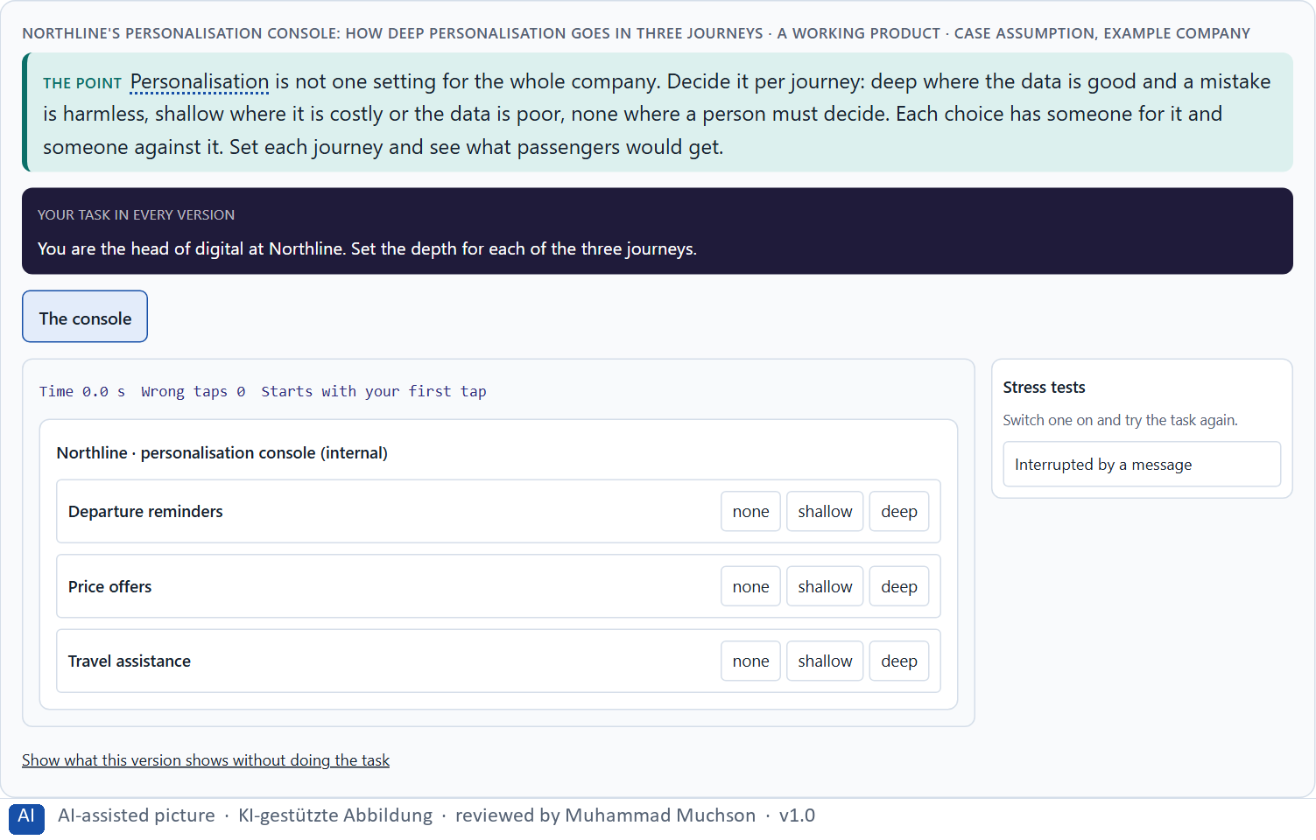
Figure 9 · Northline's personalisation console: how deep personalisation goes in three journeys. Shown here in its starting state; in the Neuro-UX Lab every version and every stress test can be used.
Standing conflicts of intelligent UX
Conflict | Who usually stands for each side | What to ask
Personalisation against transparency | Product, against data protection. | Can we still explain it at this depth?
Automation against autonomy | Efficiency targets, against the user's own choice. | Would people choose to let it act for them?
Innovation against trust | The innovation team, against service and the brand. | What happens after its first confident mistake?
All of these against economic viability | Finance, against everyone. | What does it cost to build, explain and maintain?

Case assumption
Northline Rail, Ilka, Mats, Saskia and Bram are made up for this example. The duty to inform people when they interact with an AI system follows the EU AI Act (2024); check the current state of its application before a course run.

How to decide when this comes up in the task
- Name each conflict as two goals and say who stands for each: innovation, data protection, sales, service.
- Decide the depth per journey: deep where data is good and mistakes are harmless, none where a person must decide.
- Write down the assumptions about user behaviour, data quality and what AI does, and which would be critical if wrong.
- Tell people when they deal with an automated system.
- Say what the choice gives up; a decision that gives up nothing has not been made.

Extra · go deeper (optional reading)
Click numbers cannot see the cost of a wrong suggestion. A recommendation that was clicked may have been clicked out of curiosity, confusion or alarm; one that was not clicked may have quietly lowered trust. Decide which signals you will look at (dismissals, reasons opened, controls used, complaints) before you decide how deep to personalise, or the click rate will decide for you.

Sources · Pariser 2011 · Lee & See 2004 · EU AI Act 2024

B3 · Who answers for an intelligent interface, and deciding with patchy data · 20 min · Core
An intelligent interface needs an owner: someone who owns its principles, a data protection side that may veto, teams that apply it, and a rule for when innovation and trust disagree. With patchy data, a decision says what it decides, does not know, would reverse and gives up. Explanations, controls and undo are a safe start.
IN PLAIN WORDS
The idea. An intelligent interface needs an owner: someone who owns the principles (what the system may suggest, what it must explain, what users can switch off), the data protection side that may veto, the product teams that apply it, and a rule for when innovation and trust disagree. Data is often patchy; a decision under uncertainty says what you decide, what you do not know, when you would reverse it and what you give up. Explanations, controls and undo are cheap to add and quick to check: a safe start when nobody knows how users will react.
Why it matters. Block 3.1 asks for a governance model for intelligent UX principles, a decision despite patchy data, and a statement to the management. This card gives you the parts of each.
How to read the picture. The four boxes at the top are the parts of a decision, filled in for Northline Rail. The two boxes below are the rule for future decisions.

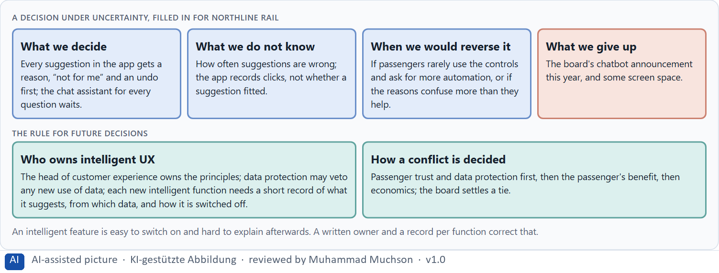
Figure 10 · A decision under uncertainty, filled in for Northline Rail.
Four parts of intelligent UX governance
Part | The question | An example (Northline)
Who owns what | Who owns the principles; who applies them? | The head of customer experience owns them; every product team applies them.
Who checks | Who makes sure no suggestion misleads or misuses data? | Data protection may veto; service checks the wording.
The record | What is written down for each intelligent function? | What it suggests, from which data, how it explains itself, how it is switched off.
How a conflict is decided | What happens when innovation, data protection and economics disagree? | Trust and data protection first, then the passenger, then economics; the board settles a tie.

Case assumption
Northline Rail, Ilka, Mats, Saskia and Bram are made up for this example. Deciding with limited information follows Simon (1956); the premortem follows Klein (2007).

How to decide when this comes up in the task
- Name who owns what the system may suggest, explain and switch off.
- Give data protection a veto on every new use of data.
- Require a short record for every intelligent function: what it suggests, from which data, how it explains itself, how it is switched off.
- Settle conflicts by trust and data protection first, then the user's benefit, then economics; say who settles a tie.
- Say what you decide, what you do not know, when you would reverse it and what you give up.

Extra · go deeper (optional reading)
When a passenger, a regulator or a journalist asks why the app suggested something, the answer has to exist before the question. A company that keeps a one-paragraph record per intelligent function (what it suggests, from which data, how it explains itself, how it is switched off, who owns it) can answer in a day. One that cannot has found its first governance gap.

Sources · Simon 1956 · Klein 2007 · EU AI Act 2024

Use in class: presentation and handout
Mark of use for the study material. Presentation is what the trainer shows on screen; Handout is what participants read and keep.
Card | Presentation (shown in the Neuro-UX Lab) | Handout
A1 · Rule-based, adaptive or learning: what makes an interface intelligent (Core) | Scan line and Figure 1; the "In plain words" and "How to decide" boxes | The whole card
A2 · How AI guides, recommends and helps: context, personal data and steering (Core) | Scan line and Figure 2; the "In plain words" and "How to decide" boxes | The whole card
A3 · What intelligent interfaces give, and how they go wrong (Core) | Scan line and Figure 3; the "In plain words" and "How to decide" boxes | The whole card
A4 · Why, change, undo: transparency, control and the feeling of control (Core) | Scan line and Figure 4; the "In plain words" and "How to decide" boxes | The whole card
A5 · Data, context and situation, and weighing a measure (Core) | Scan line and Figures 5–6; the "In plain words" and "How to decide" boxes | The whole card
B1 · Intelligent UX as a decision architecture, not a technology trend (Core) | Scan line and Figures 7–8; the "In plain words" and "How to decide" boxes | The whole card
B2 · Personalisation against transparency and trust: the conflicts of intelligent UX (Core) | Scan line and Figure 9; the "In plain words" and "How to decide" boxes | The whole card
B3 · Who answers for an intelligent interface, and deciding with patchy data (Core) | Scan line and Figure 10; the "In plain words" and "How to decide" boxes | The whole card

References
Check each source and its current edition before you teach from it. Standards and laws marked as in flux can change.
Horvitz, E. (1999). Principles of mixed-initiative user interfaces. Proceedings of the SIGCHI Conference on Human Factors in Computing Systems (CHI '99), 159–166. (When an automated service should act, ask or wait, weighed against the cost of being wrong; let people refine and dismiss what it does.)
Amershi, S., Weld, D., Vorvoreanu, M., Fourney, A., Nushi, B., Collisson, P., Suh, J., Iqbal, S., Bennett, P. N., Inkpen, K., Teevan, J., Kikin-Gil, R., & Horvitz, E. (2019). Guidelines for human-AI interaction. Proceedings of the 2019 CHI Conference on Human Factors in Computing Systems, Paper 3. (Eighteen guidelines: make clear what the system can do and how well, show why it did something, support dismissal and correction, learn from feedback cautiously.)
Sundar, S. S. (2020). Rise of machine agency: A framework for studying the psychology of human–AI interaction. Journal of Computer-Mediated Communication, 25(1), 74–88. (People react to an AI's agency itself: help that acts for them can feel convenient or intrusive, depending on control.)
Pariser, E. (2011). The Filter Bubble: What the Internet Is Hiding from You. Penguin Press. (Personalisation that narrows what people see to what they saw before.)
Parasuraman, R., & Riley, V. (1997). Humans and automation: Use, misuse, disuse, abuse. Human Factors, 39(2), 230–253. (People over-rely on automation that seems reliable and abandon it after visible failures.)
Lee, J. D., & See, K. A. (2004). Trust in automation: Designing for appropriate reliance. Human Factors, 46(1), 50–80. (Trust should match what a system can actually do; showing how it works and where it fails helps people rely on it appropriately.)
Gibbons, S. (2018). Using Prioritization Matrices to Inform UX Decisions. Nielsen Norman Group. https://www.nngroup.com/articles/prioritization-matrices/ (Rate each option on the same few criteria, such as value to the user against effort, and put the reason next to each rating.)
Regulation (EU) 2024/1689 of the European Parliament and of the Council laying down harmonised rules on artificial intelligence (Artificial Intelligence Act). Official Journal of the European Union, 12 July 2024. (Among other duties, people must be informed when they interact with an AI system; check the current state of its application before a course run.)
Simon, H. A. (1956). Rational choice and the structure of the environment. Psychological Review, 63(2), 129–138. (With limited information and time, people choose an option that is good enough rather than the best one: a decision under uncertainty.)
Klein, G. (2007). Performing a project premortem. Harvard Business Review, 85(9), 18–19. (Imagine the plan has failed and ask why; it brings risks and wrong assumptions to the surface before the work starts.)

Glossary
Every term below is used in this document. Terms stay plain text in the body; this list says what they mean in everyday words.
Term | In plain words | Example | Comes from
Adaptive system | A system that reacts to the situation now (time, place, device, what someone just did) without learning about the person over time. | — | Day 10
Case assumption | A fact made up for this exercise to fill a gap in the plan's case. It is marked so you know it is not part of the plan. | — | Day 1
Chief Experience Officer | The manager who is responsible for the experience customers have across all channels, and who decides where the company invests in it. | — | Day 1
Decision architecture | A set of connected decisions that are made on purpose and written down: what effect you want, what comes first, who decides and how conflicts are settled. It replaces many separate fixes. | — | Day 1
Explainability | A system can say, in words the person understands, why it suggested or did something. | — | Day 10
Governance | The rules about who may decide what, who is answerable for it and how disagreements are settled. | — | Day 1
Intelligent interface | An interface that supports people in a way that fits their situation: it suggests, adapts or helps, instead of only doing the same thing for everyone. | — | Day 10
Learning system | A system that changes with data over time; it gets to know a person, so the same input can give a different output next month. | — | Day 10
Misadaptation | When a system adapts to the wrong situation or the wrong picture of a person, so its help does not fit. | — | Day 10
Neuro-UX | Designing an interface with knowledge of how the brain sees, attends, feels and decides, so that the design steers these processes on purpose and responsibly. | — | Day 1
Over-personalisation | Personalising so much that it feels like being watched, or so narrowly that people only ever see more of the same. | — | Day 10
Perceived control | How much people feel they can steer a system; it decides how they feel about automation, even when it differs from the control they really have. | — | Day 10
Personalisation | Changing what someone sees from what is known about them: their history, their preferences, their profile. | — | Day 10
Recoverability | If the system gets it wrong, the person can undo it or set it right without help. | — | Day 10
Rule-based system | A system that follows fixed rules written by people: the same input always gives the same output, and the rule can be said in one sentence. | — | Day 10
Touchpoint | Any place where a person meets the company: the website, the customer portal, the app, a chatbot or a phone call. | — | Day 1
UX (user experience) | Everything a person goes through when using a product: what they notice, understand, feel and do, from the first look to the last step. The screens are only one part of it. | Finding the booking you want at once and feeling sure it went through is a good UX. | Day 1
Voice user interface | An interface people use by speaking and listening; it has no screen to show what it understood, so it has to say it back. | — | Day 10

The Neuro-UX Lab: where we practise online
In class we use the course website as the place to practise and to learn. Every day has its own address, in the same pattern: the day number is the last part.
What | Address
Neuro-UX Lab (course website) | https://aion-ux-lab.vercel.app/
Day 10 | https://aion-ux-lab.vercel.app/day/10/

On the day page, Route 1 (Levels 1 and 2) and Route 2 (Level 3) can be opened; the cards and the tasks of this document are there too. The pattern is the same up to Day 8, for example https://aion-ux-lab.vercel.app/day/6/.

