AION · UX DEVELOPER · PSYCHOLOGICAL UX DESIGN AND NEURO-UX
DAY 12 · TASK 1 AND TASK 2 · ROUTES 1 AND 2 · LEVELS 1 TO 3
CitizenConnect: UX Analysis File and UX Strategy Memo
Describe the effect, choose the measures as a team member, and decide as Chief Experience Officer
AI notice · KI-Hinweis
This document was produced with the help of an AI language model (Claude, Anthropic). The AI drafted the text and tables and built the pictures and working examples of the lab. The content was then read, corrected and approved by the reviewer named below, who is responsible for its accuracy. Every picture carries an AI label on the image. Check figures and sources before you quote them.
KI-Hinweis: Dieses Dokument wurde mit Unterstützung eines KI-Sprachmodells (Claude, Anthropic) erstellt. Texte und Tabellen wurden von der KI entworfen, die Abbildungen sind KI-gestützt erstellt und am Bild gekennzeichnet. Die fachliche Prüfung und Freigabe erfolgte durch die unten genannte Person.

Day | Day 12 · Module 6 (day 1 of 2): Accessibility, standards and neurodiversity
Document | Task (worksheet with answer spaces). Task 1 (UX Analysis File) and Task 2 (UX Strategy Memo).
Route and level | Task 1 = Route 1, Levels 1 and 2 (draws on Materi A). Task 2 = Route 2, Level 3 (draws on Materi B).
Time | Task 1 about 33 min · Task 2 about 20 min
Neuro-UX Lab (website) | https://aion-ux-lab.vercel.app/day/12/
Case | CitizenConnect, the day's case study; other products appear as warm-ups
Version | 1.0 · release date 29.10.2026
Review and approval | Muhammad Muchson, Mentor (subject-matter review and approval)

ABOUT THIS DOCUMENT
In class we also use the Neuro-UX Lab, the course website, as the place to practise and learn. Its address is at the end of this document.
This is the worksheet for Day 12. Read the case once, study the evidence printed in this document, and write your answers in the boxes and tables. You can work through it on paper or type into the document. All blocks are Core. There are no answer keys and no scores; the reason you give matters more than the choice.

IN THIS DOCUMENT
Lesson plan: ten teaching units (Ablaufplan)
Case study and transfer project at a glance
The case: two platforms on the UX team's desk, and CitizenConnect
Block 1.1 · Recognise barriers in a digital offer without prior knowledge: PublicAccess · JUDGED · Core · about 10 min
Block 1.2 · Rate inclusive design under conflicting goals: LearnAccess · JUDGED · Core · about 8 min
Block 2.1 · Case study: making the portal CitizenConnect more accessible · JUDGED · Core · about 15 min
The situation: services that formally work, but not for everyone
Block 3.1 · A strategic accessibility and inclusion architecture for digital services · JUDGED · Core · about 20 min

Day at a glance
Day 12 has ten teaching units (UE). This document is the worksheet; it is used in UE2 to UE6 (Task 1) and UE8 to UE10 (Task 2). The day is built from three documents and the Neuro-UX Lab: Materi (study material), Task (worksheet) and Trainer (coaching, feedback and model solutions), plus the course website.

Lesson plan: ten teaching units (Ablaufplan)
UE | Min | Plan item | What happens | Material | Format
1 | 45 | Knowledge transfer · Level 1 | The trainer presents the cards of Materi A (A1, A2, A3, A4, A5, about 60 min of cards) in the Neuro-UX Lab; participants follow in the handout. | Materi A (Route 1) | Presentation + Handout
2 | 45 | Level 1 · Task 1 | Individual work on Block 1.1 (Core, about 10 min): the first product of the day is read and its effect described. Pairs then compare their results and the trainer collects open questions. | Task 1 · Part 1 · Block 1.1 | Handout (or in the lab)
3 | 45 | Level 1 · Task 2 | Three options are rated on the same criteria and one is chosen under the stated conditions: Block 1.2 (Core, about 8 min). | Task 1 · Part 1 · Block 1.2 | Handout (or in the lab)
4 | 45 | Coaching · transition from Level 1 to Level 2 | Trainer-led. A short talk on the day's coaching focus, then the reflection questions in pairs. The bridge: from describing an effect to a decision you answer for. There is no worksheet block in this unit. | Trainer document, section Coaching | Trainer only
5–6 | 90 | Level 2 · Case study CitizenConnect (2 UE) incl. model solution | UE5: the trainer presents the case; participants work on Block 2.1 (Core, about 15 min). UE6: groups compare their results and defend them; the trainer closes with the model solution. | Task 1 · Part 2 · Block 2.1  Trainer document, section Case study | Handout; model solution shown after the work
7 | 45 | Level 2 + 3 · Feedback round with a management perspective | Groups present their reasoning, not only their result. The trainer asks the day's Level 3 input questions and leads the discussion. | Trainer document, section Feedback round | Presentation by the groups; Trainer only
8 | 45 | Level 3 · Transfer project, Chief Experience Officer (3 UE: UE8–10) | The trainer presents Materi B (B1, B2, B3; use the "In plain words" and "How to decide" boxes, the rest is handout) and sets the role and the situation. | Materi B (Route 2) | Presentation + Handout
9 | 45 | Level 3 · Transfer project | Individual work or in pairs on Block 3.1 (Core, about 20 min): the strategy memo. | Task 2 · Block 3.1 | Handout (or in the lab)
10 | 45 | Level 3 · Transfer project | Participants present their decision and what they give up, including the one decision made under uncertainty; the trainer debriefs with the model solution. | Task 2 · Block 3.1  Trainer document, section Transfer project | Handout; model solution shown after the work

One UE is counted as 45 minutes here; breaks are not shown. The times are a guide for the trainer. The Core blocks are enough for a complete answer.

Case study and transfer project at a glance
Component | UE | Duration | Participants work in | Model solution in
Level 2 case study (CitizenConnect) | UE5–6 | 2 UE · 90 min | Task 1 · Part 2 (Block 2.1) | Trainer document, section Case study
Level 3 transfer project (Chief Experience Officer) | UE8–10 | 3 UE · 135 min | Materi B and Task 2 (Block 3.1) | Trainer document, section Transfer project

Which plan item each block answers
UE | Plan item (Strukturplan, Day 12) | Block in this document
UE2 | Level 1, task 1 · Recognise barriers in a digital offer without prior knowledge: PublicAccess | Block 1.1 (Core)
UE3 | Level 1, task 2 · Rate inclusive design under conflicting goals: LearnAccess | Block 1.2 (Core)
UE4 | Coaching: from describing to deciding | A classroom talk led by the trainer; not a worksheet block
UE5–6 | Level 2 case study · Case study: making the portal CitizenConnect more accessible | Block 2.1 (Core)
UE7 | Feedback round with a management perspective | A classroom discussion led by the trainer; not a worksheet block
UE8–10 | Level 3 transfer project · A strategic accessibility and inclusion architecture for digital services | Block 3.1 (Core), in Task 2

Your name
Write your full name here. Use the same name on every Task document this week; it is how your work is matched.

Task 1 · Route 1 · UX Analysis File: find the barriers, then decide what to repair

The case: two platforms on the UX team's desk, and CitizenConnect
Read once · about 3 min
You work in the UX team of a digital agency. This week three platforms land on your desk. Two are warm-ups: PublicAccess, a service portal for citizen services, appointments and documents, and LearnAccess, a platform for digital further training with three redesigns to choose from. The main case is CitizenConnect, a city's service platform for information, appointment bookings and applications. It is heavily used, but complaints about poor legibility, unclear navigation and poor operability with assistive technologies keep coming. The city wants it to become more accessible and inclusive, without a complete relaunch.
What the plan gives you | How the task runs · three blocks
• Block 1.1: PublicAccess, with navigation that works well only with a mouse, hints marked by colour only, weak contrast in places, complex terms and long nested sentences in forms, error messages that explain too little, and images and symbols that are not self-explanatory or described  • Block 1.2: three redesigns of LearnAccess; a very heterogeneous target group, modern and inclusive, a limited budget, release in 10 weeks, legal requirements that must be met, department and marketing with different priorities  • Block 2.1: CitizenConnect, with €160,000 and 14 weeks, no complete relaunch, legal requirements first, several departments supplying content, and first improvements soon | • Block 1.1: find the barriers of PublicAccess without prior knowledge. Describe the hurdles, name five barriers, sort them into five categories, write three effect statements and pick the two most serious barriers.  • Block 1.2: rate three redesigns under conflicting goals. Rate each on six criteria, choose one, name the conflicts between design ambition, accessibility and effort and the remaining risks, and write a recommendation to the project lead.  • Block 2.1: the case study. The central barriers, sorted into five categories, four measures, justified on five criteria, a decision for the first 14 weeks and a recommendation to the division management.

What is known and what is open
In the brief | Clear · Case assumption | Open · on purpose
• PublicAccess: mouse-only navigation, colour-only hints, weak contrast, complex forms, unhelpful errors, undescribed images.  • LearnAccess: three redesigns in words; a very heterogeneous group; 10 weeks; legal requirements; department against marketing.  • CitizenConnect: weak contrast, unstructured forms, patchy keyboard use, visual-only hints, complicated content, inconsistent pages; €160,000 and 14 weeks; no relaunch. | • You review PublicAccess and LearnAccess as an agency would: by using them, with the keyboard too, without access to their code.  • CitizenConnect is built from a few page templates (information page, appointment booking, application form) that every department fills with its own content.  • The city must meet the accessibility rules for public bodies; the target it has set itself is WCAG 2.2 level AA.  • Complaints arrive by phone and e-mail and are not sorted by barrier. | • How many users meet each barrier: nobody has measured it.  • Which assistive technologies citizens use: never asked.  • How much of the €160,000 each measure would take: the plan does not say.  • Whether disabled citizens were ever part of a test: no record.

As in most projects, not everything is known. Decide anyway, and say what you assume.
Case assumption
The brief says: PublicAccess with mouse-only navigation, colour-only hints, weak contrast in places, complex terms and long nested sentences in forms, insufficient error messages, and images and symbols that are not self-explanatory or described; LearnAccess's three redesigns (A modern and brand-strong with reduced contrast and small text, B structured, high-contrast, plain and well focusable but less premium, C good basic accessibility with optional adaptations but more technical effort) for a very heterogeneous group, modern and inclusive, a limited budget, 10 weeks, legal requirements, department against marketing; CitizenConnect's weak contrast, unstructured forms with unclear errors, patchy keyboard operation, visual-only hints, complicated content and inconsistent page types, €160,000, 14 weeks, no relaunch, legal requirements first, several departments supplying content, first improvements soon. Those are the plan's facts and its only figures. Everything else is made up for this exercise: the agency, the pages, the simulations and the facts marked “Clear”.

Part 1 · Find the barriers, and weigh redesigns · Level 1 · Knowledge

Block 1.1 · Recognise barriers in a digital offer without prior knowledge: PublicAccess · JUDGED · Core · about 10 min
Draws on: A1 · Accessibility, usability and inclusive design · A2 · Barriers in perception · A3 · Barriers in interaction · A4 · Barriers in language and structure.
You receive the description of a fictional service portal, PublicAccess, for citizen services, appointments and documents. Open it and use it as a citizen: book an appointment, find a document, fill in a form and make a mistake. Then try the same with the keyboard alone (Tab, Enter, the arrow keys). You need no prior knowledge: notice where you get stuck, and imagine who else would. The aim is to recognise barriers systematically and to understand accessibility from the user's side, not only as a technical matter.
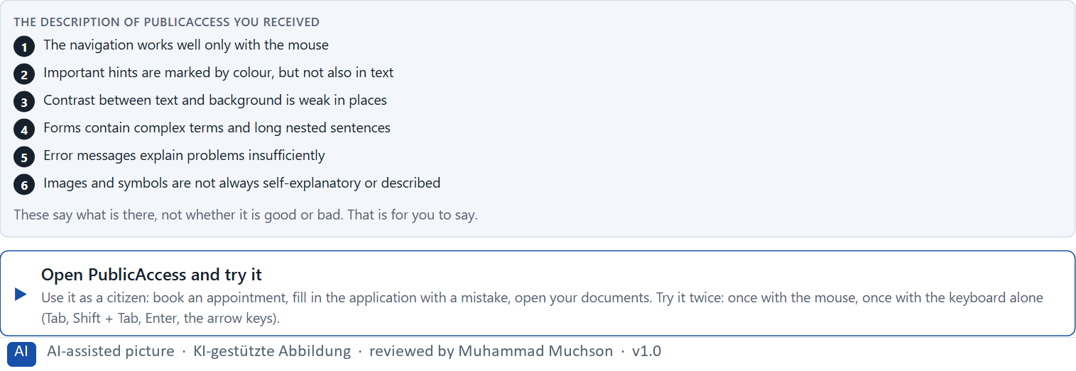
Figure 1 · The product to read, as the lab shows it (publicaccess).
Question 1 of 5 · Describe spontaneously which hurdles the offer could have for different groups of users
Two to four sentences: which groups, and what stops them.
How to build the answer:
- Open PublicAccess and book an appointment with the mouse, then try it with the keyboard alone.
- Look at the colours, the pictures and the form texts, and make a mistake in the form.
- Write who would get stuck where.

Question 2 of 5 · Name at least 5 possible barriers in the interface
How to build the answer:
- Go through your visit: the menu, the calendar, the text, the pictures, the form, the error.
- For each barrier, say what it is and whom it stops.
Write them as a list, one barrier per line, each with whom it stops.

Question 3 of 5 · Assign the observations to the categories perceivability, operability, comprehensibility, error tolerance and participation
Write the observations that belong to each category in a few words. One may fit two; put it where its effect is strongest.
How to build the answer:
- Take your barriers from question 2.
- Ask which of the five each one affects most, and write it there.
Category | The observations in this category
Perceivability
Operability
Comprehensibility
Error tolerance
Participation

Question 4 of 5 · Write an effect statement for three points: “For users this could mean that …”
How to build the answer:
- Pick three barriers from question 2.
- Finish the plan's sentence with what the user would feel, do or fail to do.
Write them as a list, one statement per line, each starting with the barrier and ending with what it could mean for users.

Question 5 of 5 · Prioritise the two most serious barriers with regard to usability and the risk of exclusion
How to build the answer:
- Look at your barriers with two questions: which stops people completely, and which affects the most people?
- Write the two, each with why it weighs most.
Write two lines: barrier 1 and barrier 2, each with why it weighs most.

Block 1.2 · Rate inclusive design under conflicting goals: LearnAccess · JUDGED · Core · about 8 min
Draws on: A1 · Accessibility, usability and inclusive design · A2 · Barriers in perception · A4 · Barriers in language and structure · A5 · Standards, law and risk.
LearnAccess is a platform for digital further training that is to be redesigned. Three variants are described in words: A) visually modern and brand-strong, but with reduced contrast and small text; B) clearly structured, high in contrast, in plain language and well focusable, but less “premium” in its brand; C) good basic accessibility with some optional adaptation functions, but a higher technical effort. The conditions: the target group is very heterogeneous, the company wants to look modern and inclusive, the budget for technical changes is limited, the release is in 10 weeks, legal requirements must be met, and the department and marketing set different priorities. Decide anyway, and say what you assume.
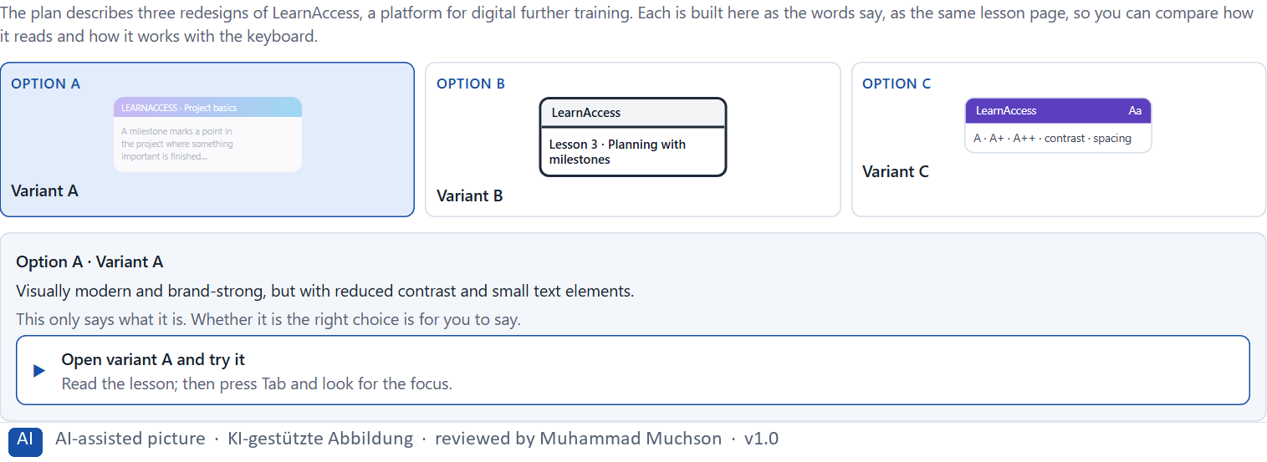
Figure 2 · The product to read, as the lab shows it (designs).
Question 1 of 5 · Rate each variant on accessibility, comprehensibility, brand effect, feasibility, legal certainty and user-friendliness
Write a few sentences for each variant that cover all six criteria. Many teams rate each criterion Low, Medium or High with a reason; you may do that or write it in your own words.
How to build the answer:
- Take one variant at a time and keep the conditions in mind: heterogeneous users, 10 weeks, legal requirements.
- For each criterion, say how the variant does and why.
- Use the same six criteria for every variant.
Variant | Accessibility | Comprehensibility | Brand effect | Feasibility | Legal certainty | User-friendliness
Variant A · modern and brand-strong
Variant B · structured, high contrast, plain
Variant C · basic accessibility with options

Question 2 of 5 · Decide which variant is the most viable under the given conditions
Choose one variant, then give your reason below. There is no single right choice; the reason has to rest on the users and the conditions.
How to build the answer:
- Say which condition weighs most for you.
- Say how your choice meets it better than the other two.
Tick one:
☐ Variant A · modern and brand-strong
☐ Variant B · structured, high contrast, plain
☐ Variant C · basic accessibility with options
Why this variant, under these conditions?
Give your reason with the conditions: a very heterogeneous group, modern and inclusive, a limited budget, 10 weeks, legal requirements, department against marketing.
How to build the answer:
- Name the condition that weighs most for you.
- Say how your variant meets it and why the other two meet it less well.
- Say what your choice gives up and how you would deal with its weakness.

Question 3 of 5 · Name the conflicts of goals between design ambition, accessibility and effort
Name at least two conflicts, each as one goal against another, and who stands for each side.
How to build the answer:
- Look at what the design ambition wants (a premium look), what accessibility needs (contrast, size, plain words) and what effort allows (10 weeks, budget).
- Write each conflict as “… against …” and say who stands for each side.

Question 4 of 5 · Which risks remain despite your decision?
Name at least one risk that remains and who would feel it.
How to build the answer:
- Think of what your chosen variant is weak at.
- Say who would notice and what would happen.

Question 5 of 5 · Formulate a recommendation to the project management
Two to four sentences: what you recommend, why, and what you will check next.
How to build the answer:
- Lead with the recommendation.
- Give the one reason the project management can follow.
- Say what you will test before and after the release.

Part 2 · The case study · Level 2 · Application · Case study (2 UE)
Case study: 2 teaching units (UE5–6)
This part is the day's Level 2 case study. It takes 2 UE (about 90 minutes): UE5 for the briefing and your own work, UE6 for comparing your results with your group and for the trainer's closing. The block below needs about 15 minutes of writing; the rest of the time is discussion.

Block 2.1 · Case study: making the portal CitizenConnect more accessible · JUDGED · Core · about 15 min
Draws on: A1 · Accessibility, usability and inclusive design · A2 · Barriers in perception · A3 · Barriers in interaction · A4 · Barriers in language and structure · A5 · Standards, law and risk.
A municipal service platform offers information, appointment bookings and application processes digitally. It is heavily used, but complaints about poor legibility, unclear navigation and poor operability with assistive technologies keep coming. The organisation wants to make the portal more accessible and inclusive without a complete relaunch. The observed problems: weak contrast makes central information hard to read; forms are not cleanly structured and contain unclear error messages; keyboard operation is patchy; important hints are differentiated visually but not in words; content is partly complicated; and different page types are not built consistently. The conditions: a budget of €160,000, 14 weeks for the implementation, no complete relaunch, legal requirements that must be considered first, several departments that supply content, and first improvements that must show soon. You work through six steps.
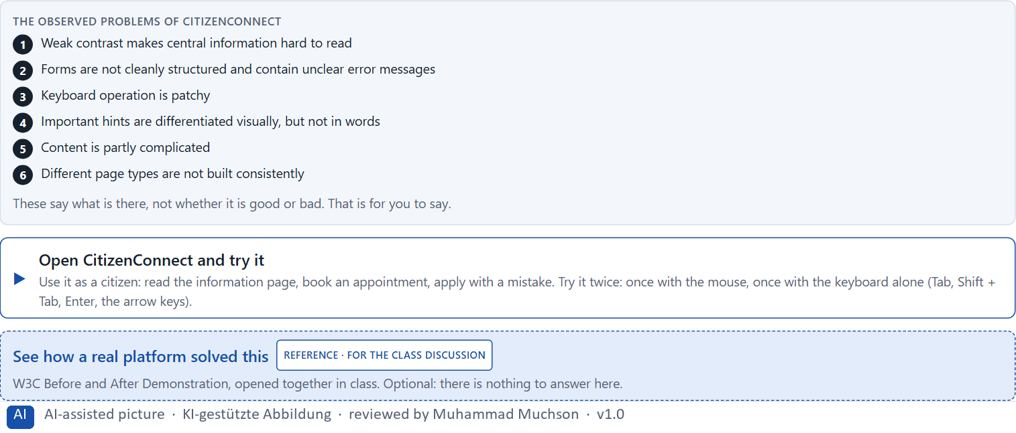
Figure 3 · The product to read, as the lab shows it (citizenconnect).
Question 1 of 6 · Analyse the central barriers and gaps in inclusion of the portal
How to build the answer:
- Open CitizenConnect as a citizen: read an information page, book an appointment, fill in an application with a mistake, then try it all with the keyboard alone.
- Write one barrier per line, and what it does.
Write them as a list, one barrier per line, each with what it does. At least five.

Question 2 of 6 · Assign the problems to the categories perceivability, operability, comprehensibility, error tolerance and consistency
Write the problems that belong to each category in a few words.
How to build the answer:
- Take your barriers from question 1.
- Ask which category each affects most, and write it there.
Category | The problems in this category
Perceivability
Operability
Comprehensibility
Error tolerance
Consistency

Question 3 of 6 · Develop 4 prioritised measures for improvement
How to build the answer:
- Turn each group of problems into something you could change within 14 weeks and €160,000, without a relaunch.
- Put them in order: what reduces exclusion first.
Write them as a numbered list, the first priority first, each with what it changes for citizens.

Question 4 of 6 · Justify your selection using effect on users, legal certainty, feasibility, risk and time pressure
Use all five criteria and say how they support your selection and its order.
How to build the answer:
- Say what your first measures change for exclusion.
- Say how they serve legal certainty, and what is feasible without a relaunch.
- Keep the 14 weeks and the several departments in mind.

Question 5 of 6 · Make a prioritisation decision for the first 14 weeks
Say what you do in the first 14 weeks, in which order, and what you leave for later, with the reason.
How to build the answer:
- Say what comes first and why.
- Say what you do in parallel and what waits.
- Say how you make the first improvements visible.

Question 6 of 6 · Formulate a recommendation to the division management
Three to five sentences: what you recommend, what has priority, and what you expect to change.
How to build the answer:
- Lead with the recommendation.
- Name the priorities.
- Say what you expect to change.

Task 2 · Route 2 · UX Strategy Memo: decide as Chief Experience Officer

The situation: services that formally work, but not for everyone
Read once · about 2 min
You take the perspective of the Chief Experience Officer of the organisation behind CitizenConnect: a website, a customer portal and digital service processes. Its systems formally work, but they are not equally accessible to all users, and complaints about legibility, operability and comprehensibility keep rising. Inside, accessibility is seen mostly as a compliance topic, not as an integral part of UX quality and service responsibility. The management expects a sound strategy for building accessibility and inclusive design systematically into product development and governance. You are not to repair single barriers, but to develop a sound decision architecture for accessibility, inclusion and legally secure UX quality.
The framework | How the task runs · one block
• The budget is limited  • Several stakeholders pursue different goals  • Legal requirements are binding  • Not all systems can be adapted at the same time  • Data on real barriers in use is partly incomplete  • First improvements must be visible at short notice  • Wrong decisions can increase exclusion, reputational damage and legal risks | • Block 3.1 asks seven questions: a guiding vision of digital participation, three strategic decisions, a prioritised architecture of measures, a risk analysis, a governance model, one decision under uncertainty and a management statement.

What is known and what is open
In the brief | Clear · Case assumption | Open · on purpose
• A website, a customer portal and digital service processes that formally work.  • Not equally accessible; complaints about legibility, operability and comprehensibility rise.  • Inside, accessibility is seen as compliance, not as UX quality.  • Legal requirements are binding; first improvements must show soon. | • The organisation is the city's citizen services department behind CitizenConnect in Route 1; the website and the customer portal are its other channels.  • Every department writes its own content; an external agency builds the templates; the brand team owns the colours.  • An external audit last year listed many failures; nobody owns the list. | • How large the budget is: “limited” is all the plan says.  • Which barriers hurt most in daily use: the complaints are not sorted.  • How many disabled citizens stopped using the portal: unknown.

As in most projects, not everything is known. Decide anyway, and say what you assume.
Case assumption
The brief says: an organisation with a website, a customer portal and digital service processes that formally work but are not equally accessible, rising complaints about legibility, operability and comprehensibility, accessibility seen inside as compliance, a limited budget, several stakeholders, binding legal requirements, not all systems at once, incomplete data on real barriers, first improvements soon, and the warning that wrong decisions can increase exclusion, reputational damage and legal risks. Those are the plan's facts. That the organisation is the one behind CitizenConnect and the facts marked “Clear” are made up for this exercise.

The memo is addressed to: The management. Subject: An accessibility and inclusion architecture for our digital services.

Part 3 · Level 3 · Management decision · Transfer project (3 UE)
Transfer project: 3 teaching units (UE8–10)
UE8: the trainer presents Materi B and sets the role. UE9: you write the memo. UE10: you present the decision and what you give up; the trainer debriefs.

Block 3.1 · A strategic accessibility and inclusion architecture for digital services · JUDGED · Core · about 20 min
Draws on: B1 · Accessibility as quality and responsibility, not a compliance task · B2 · Effort, standards, diversity, law · B3 · Who owns accessibility, and deciding with incomplete data.
Develop a strategic concept for the organisation. Your desk holds what the management, the legal team, the brand team, the departments, the template agency and citizen service say. Open it, then answer the seven questions; your answers build the memo below.
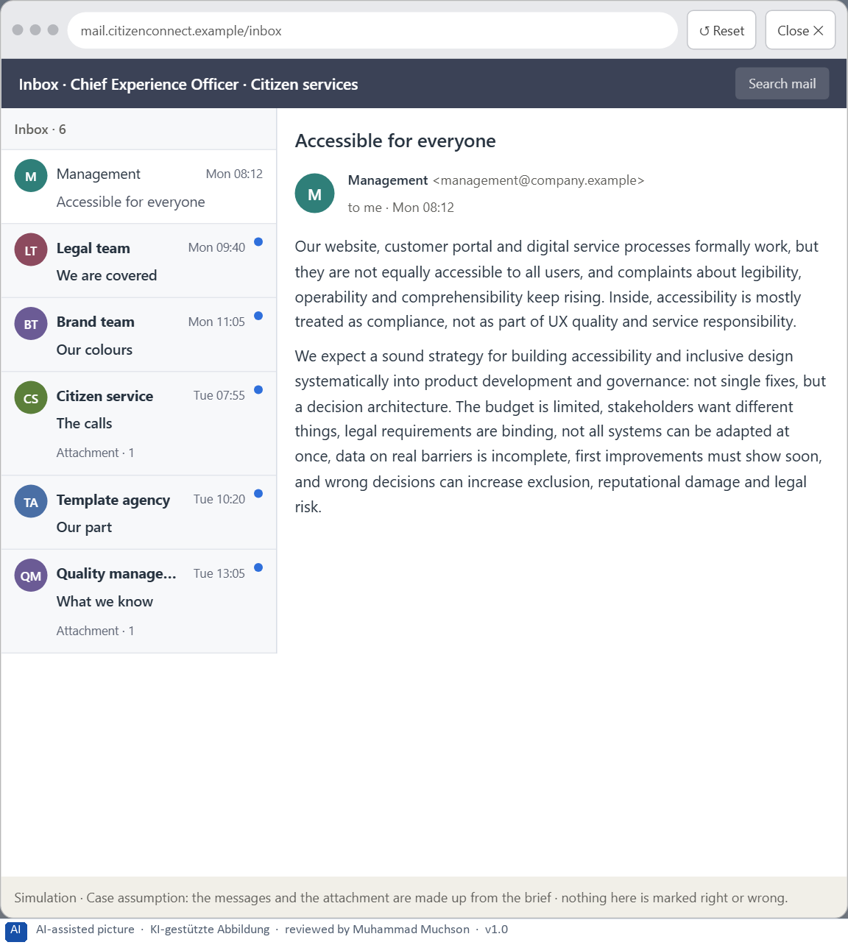
Figure 4 · Your desk: the messages that wait for you, shown in the lab as a mailbox (1 of 6).
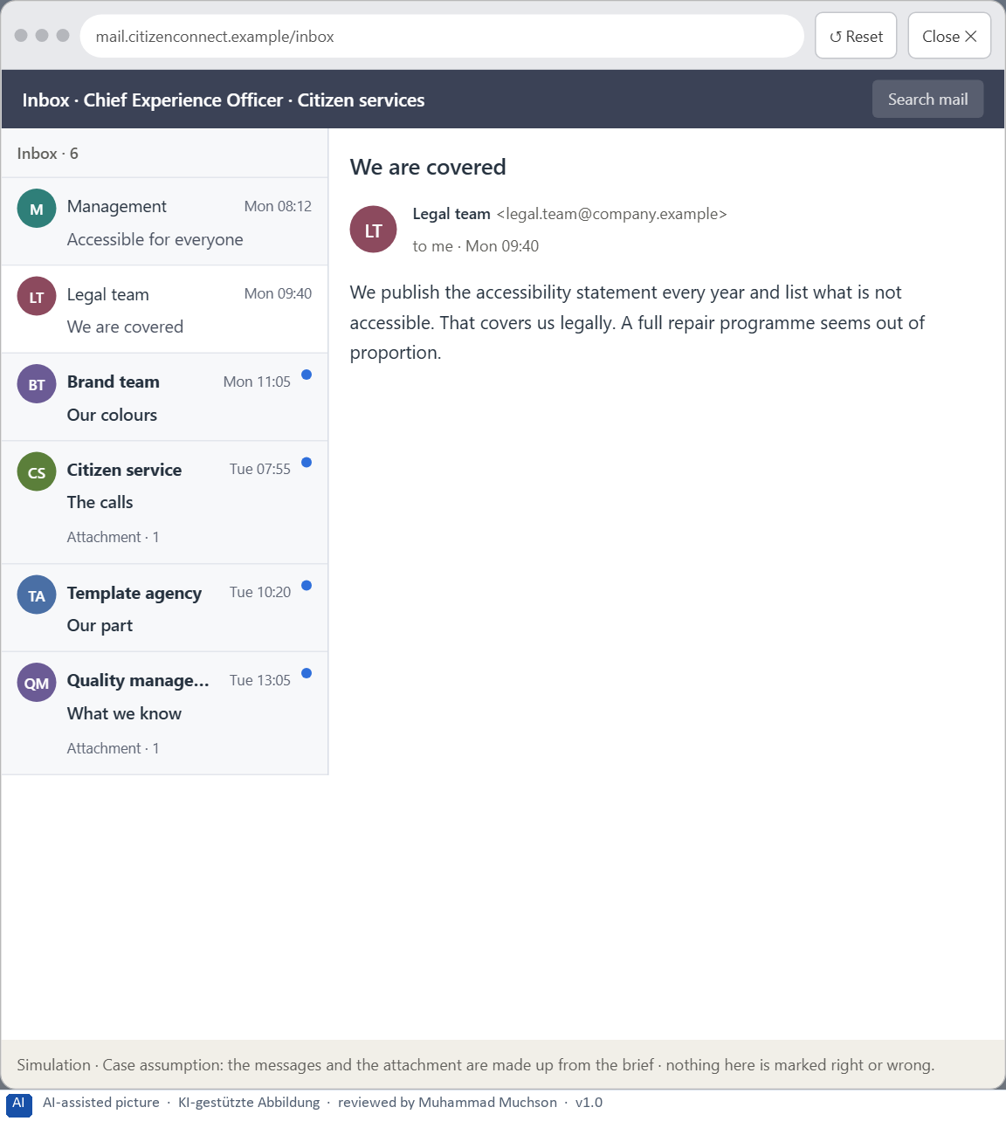
Figure 5 · Your desk: the messages that wait for you, shown in the lab as a mailbox (2 of 6).
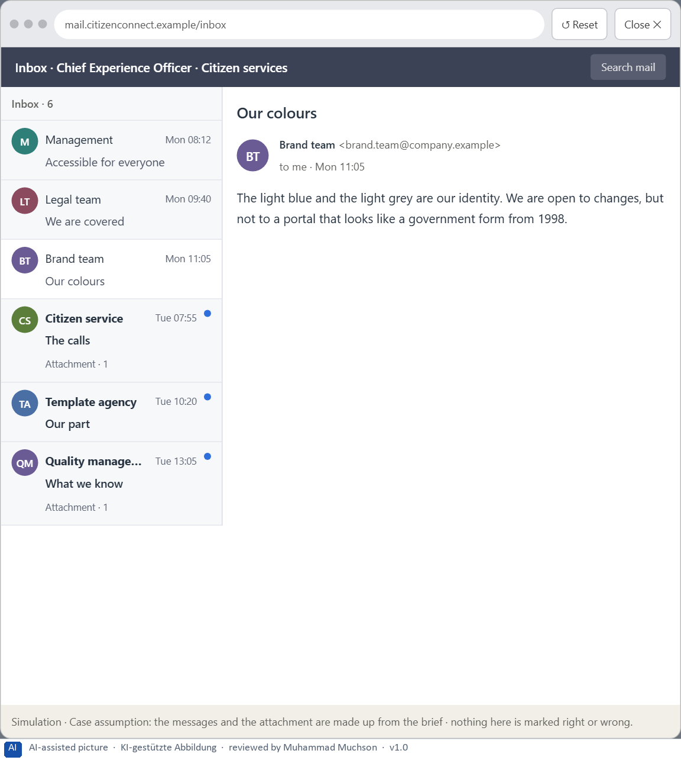
Figure 6 · Your desk: the messages that wait for you, shown in the lab as a mailbox (3 of 6).
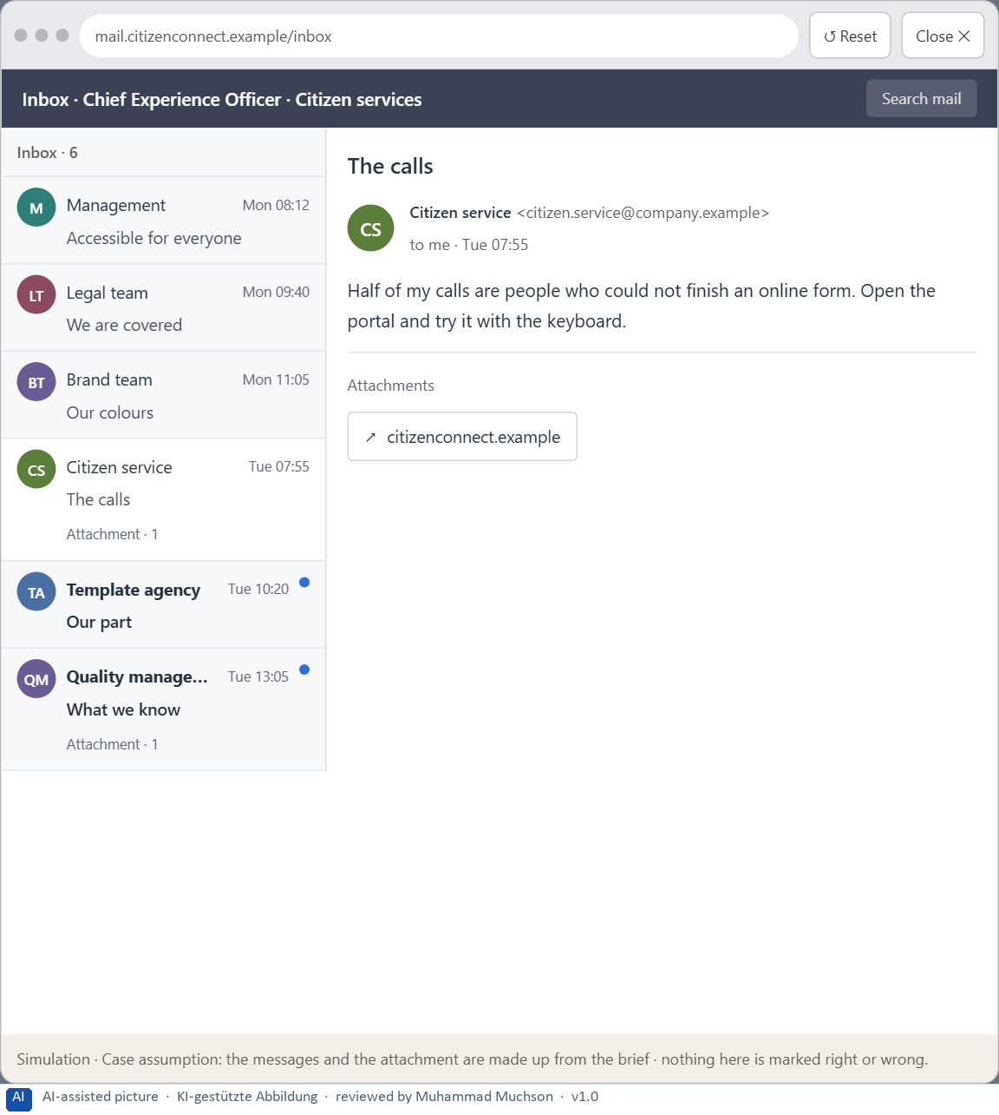
Figure 7 · Your desk: the messages that wait for you, shown in the lab as a mailbox (4 of 6).
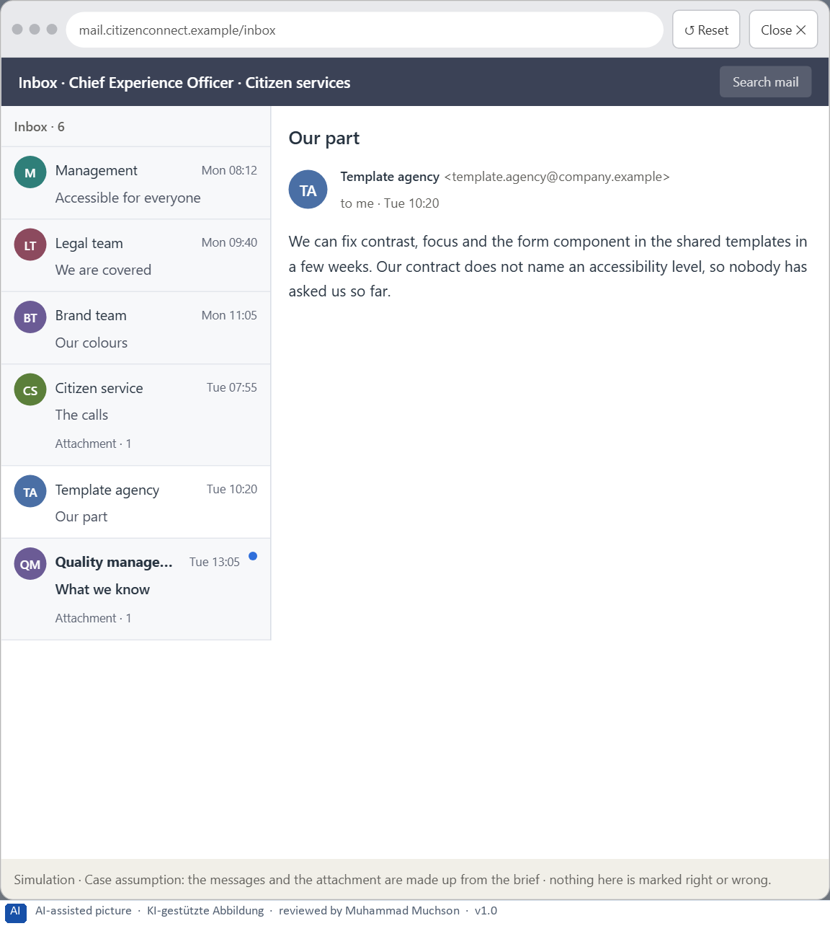
Figure 8 · Your desk: the messages that wait for you, shown in the lab as a mailbox (5 of 6).
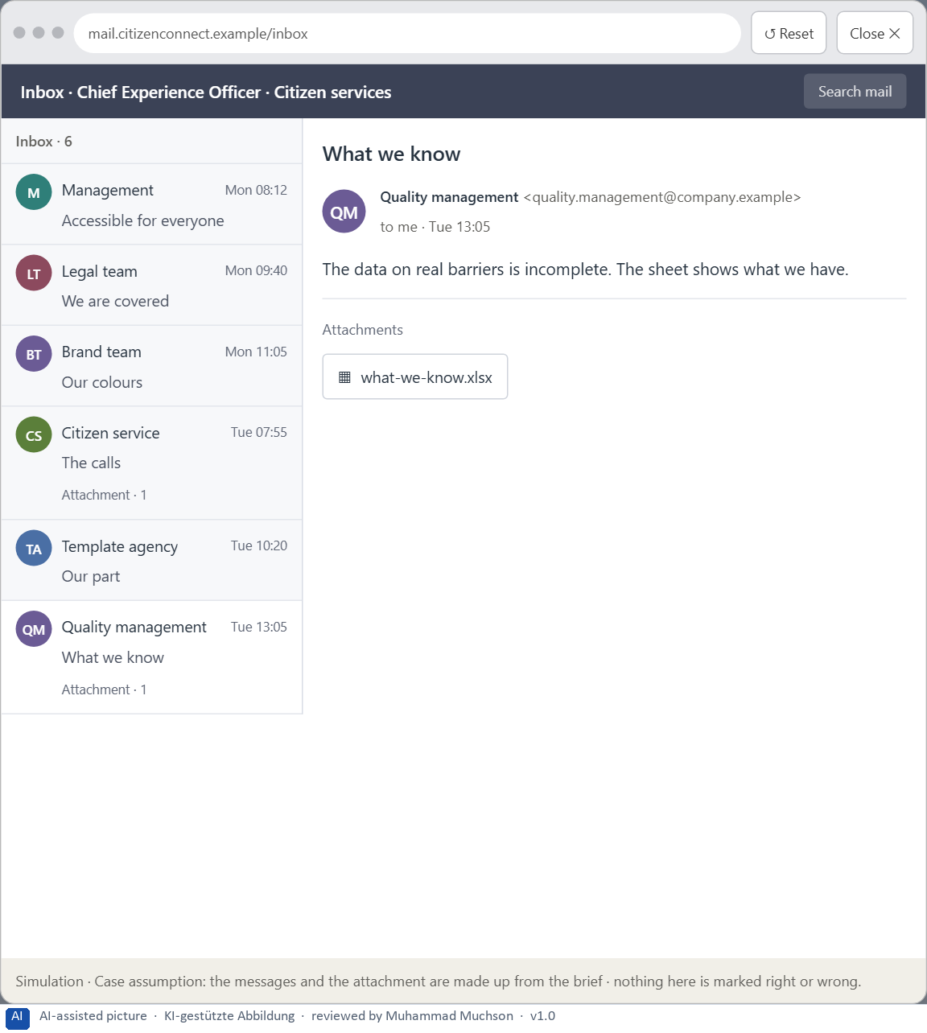
Figure 9 · Your desk: the messages that wait for you, shown in the lab as a mailbox (6 of 6).
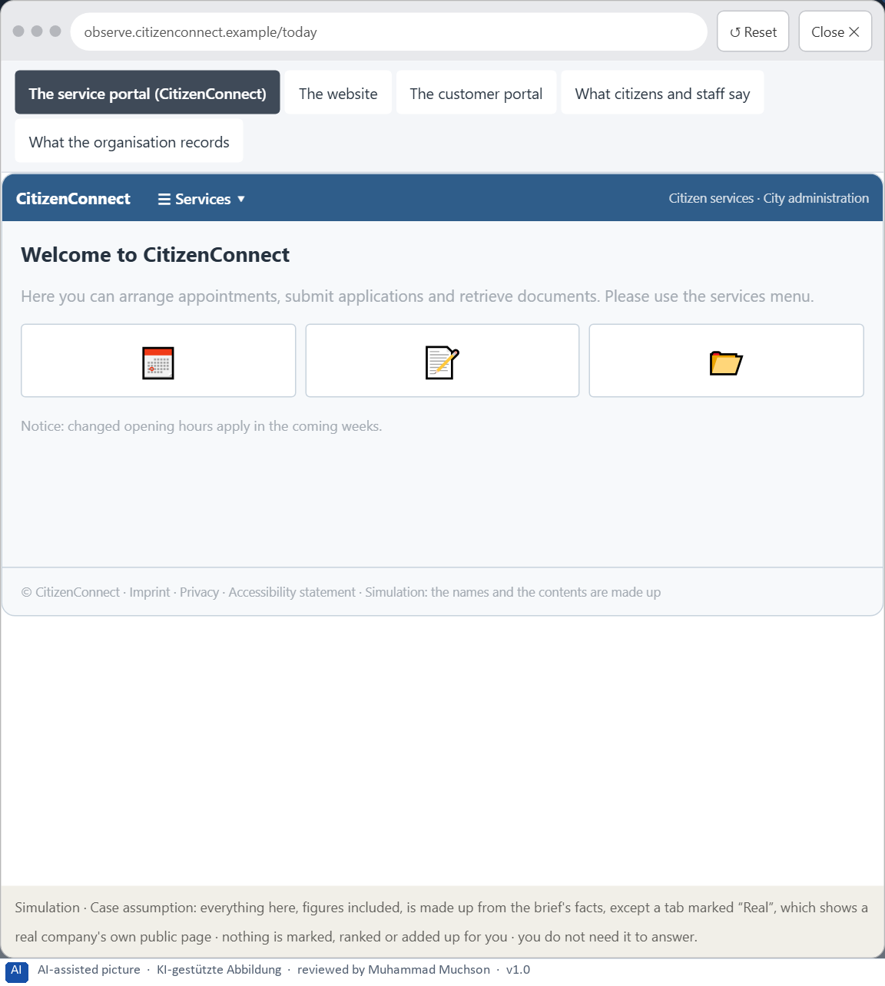
Figure 10 · The platform as it is today, as the lab lets you observe it (1 of 5).
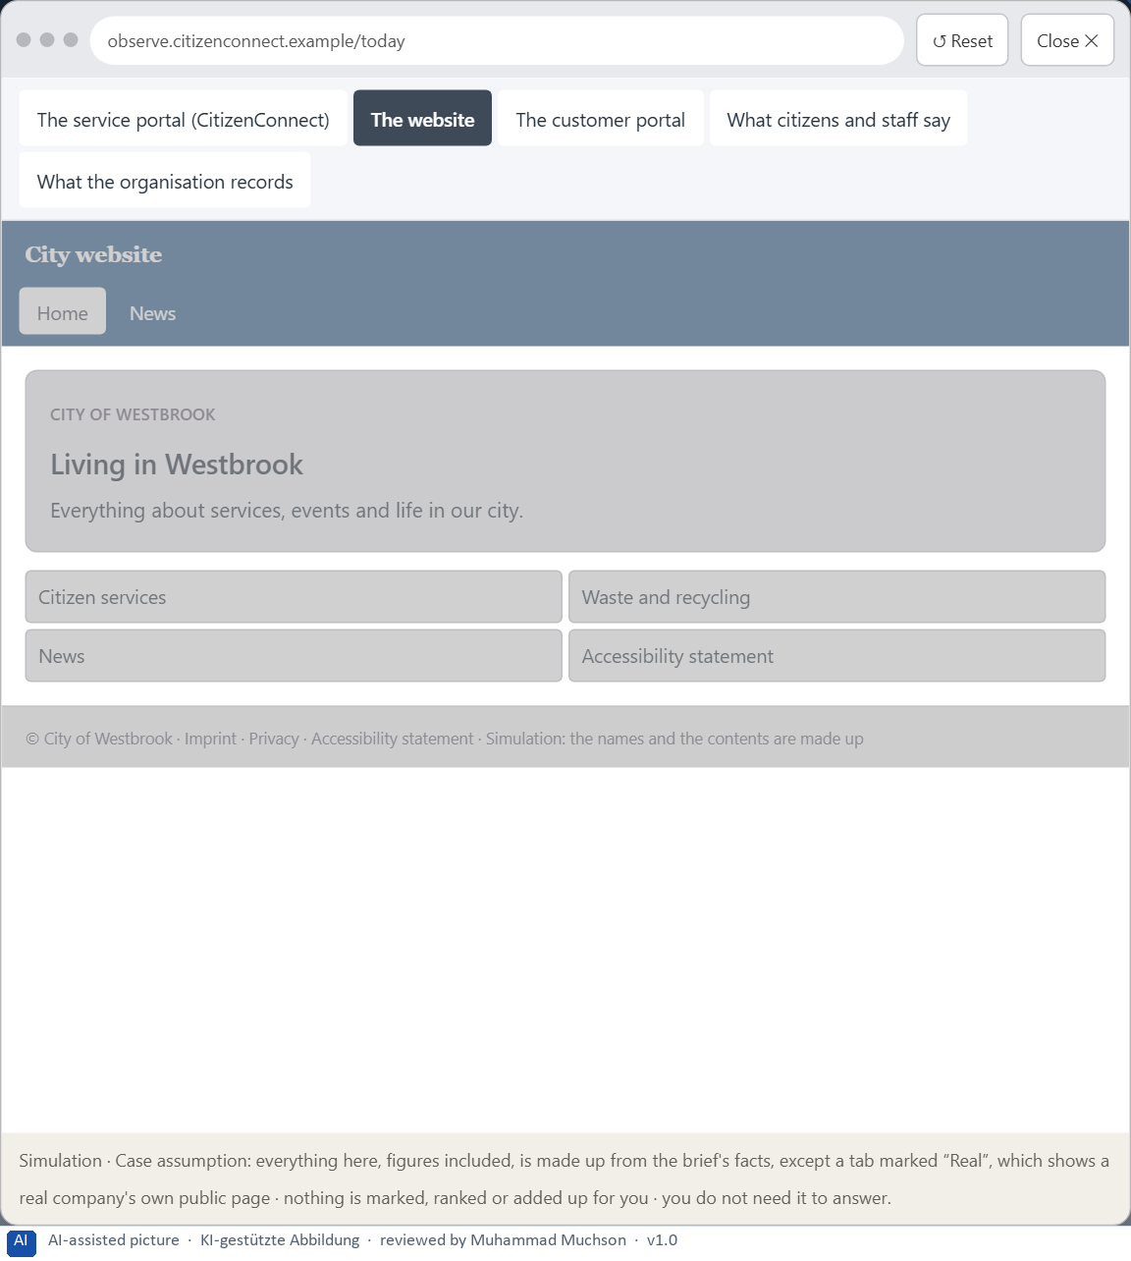
Figure 11 · The platform as it is today, as the lab lets you observe it (2 of 5).
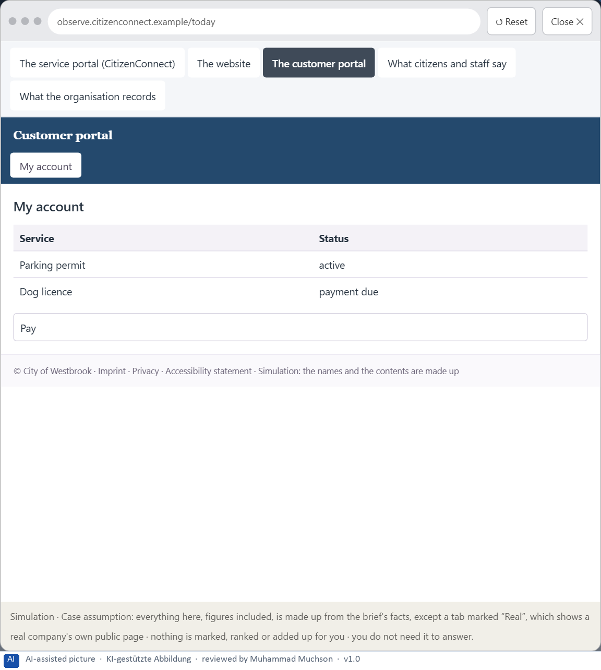
Figure 12 · The platform as it is today, as the lab lets you observe it (3 of 5).
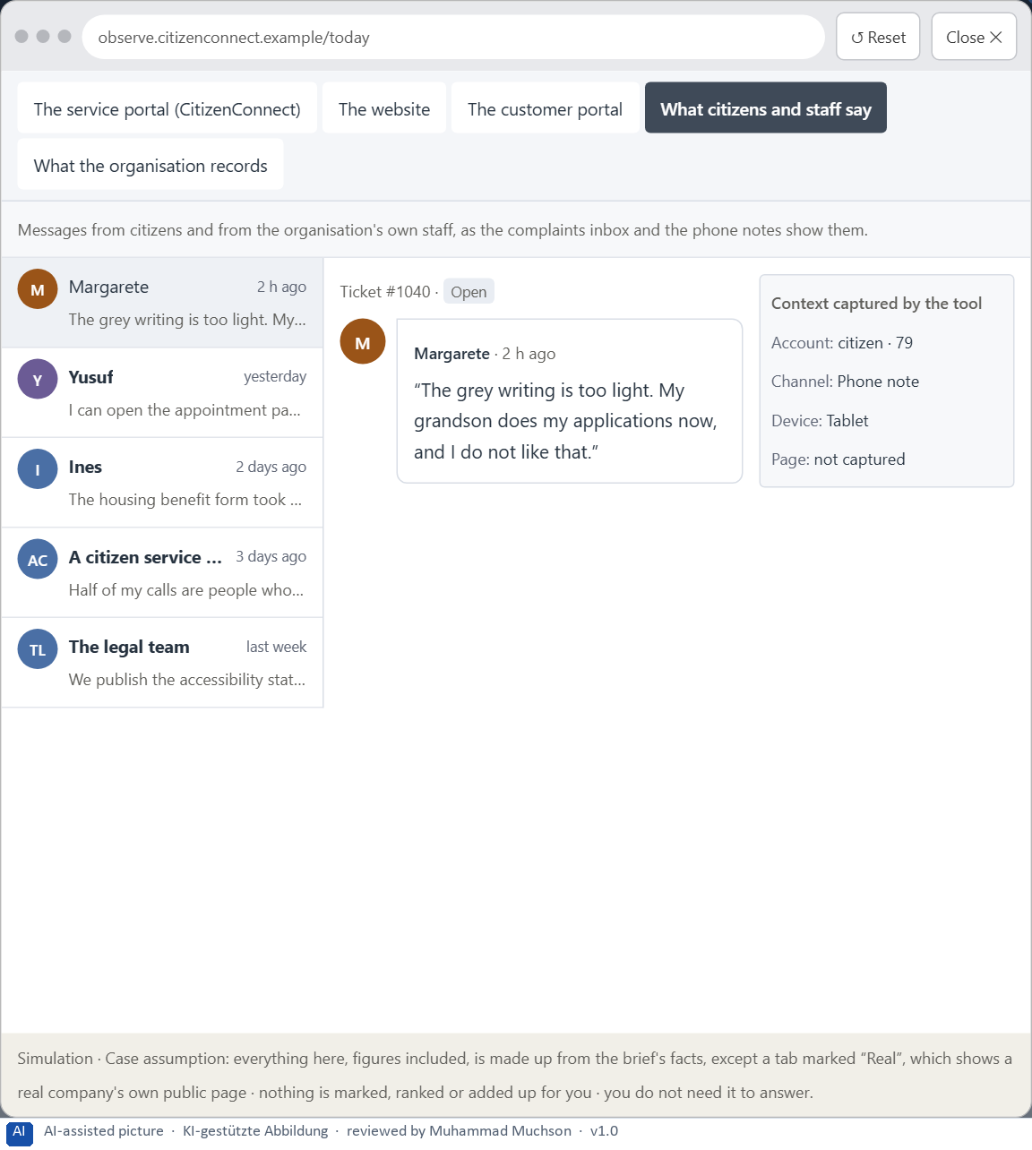
Figure 13 · The platform as it is today, as the lab lets you observe it (4 of 5).
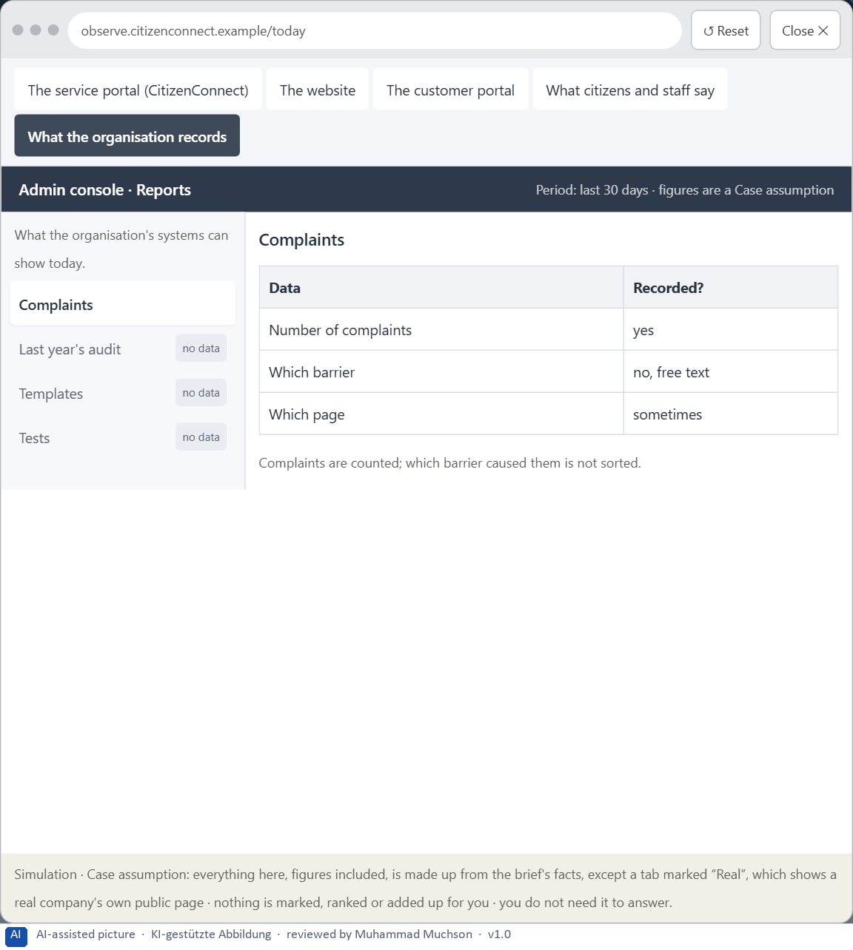
Figure 14 · The platform as it is today, as the lab lets you observe it (5 of 5).
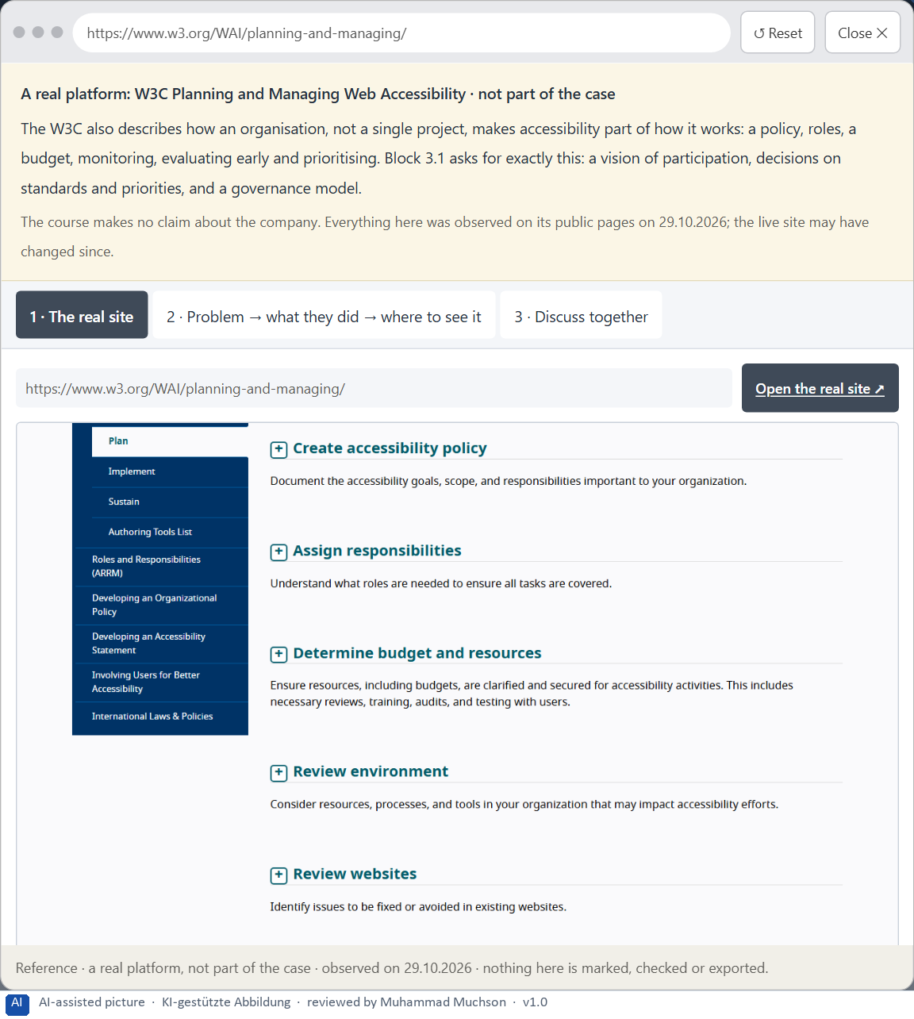
Figure 15 · A real platform that solved this, shown for the class discussion (1 of 3).
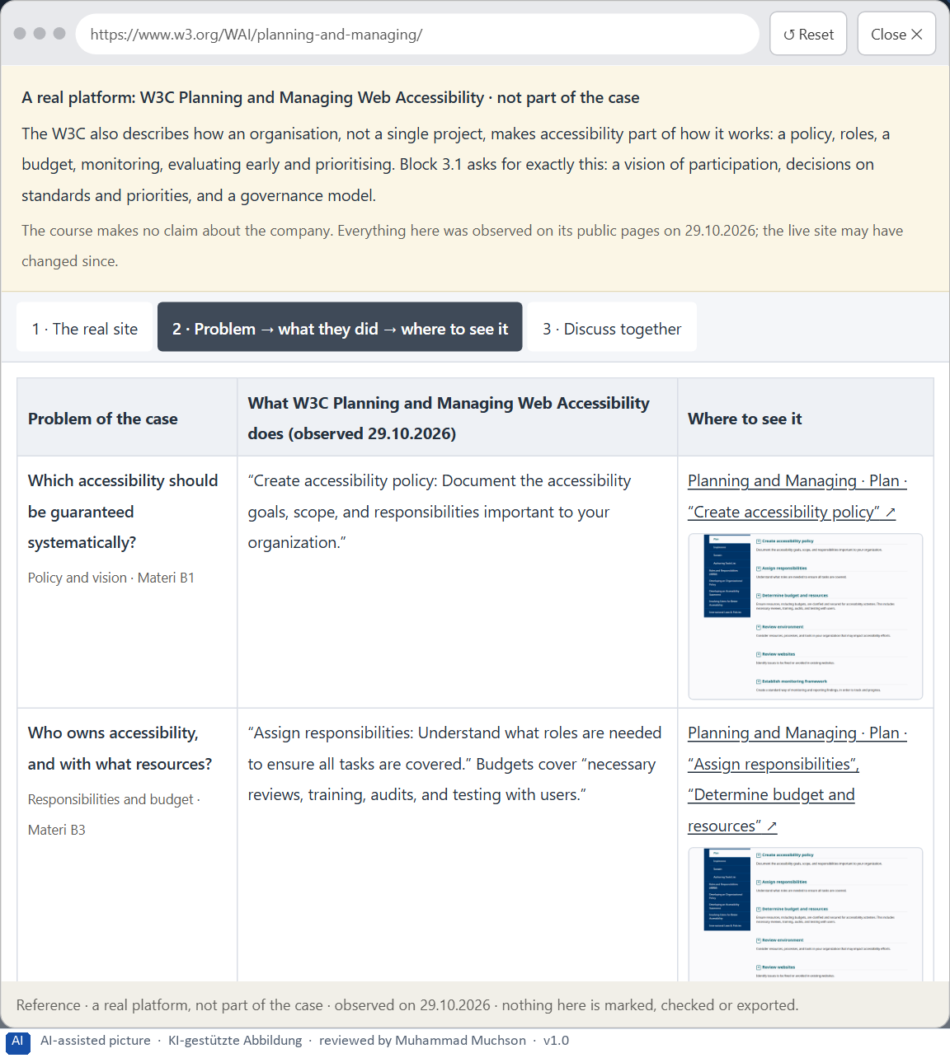
Figure 16 · A real platform that solved this, shown for the class discussion (2 of 3).
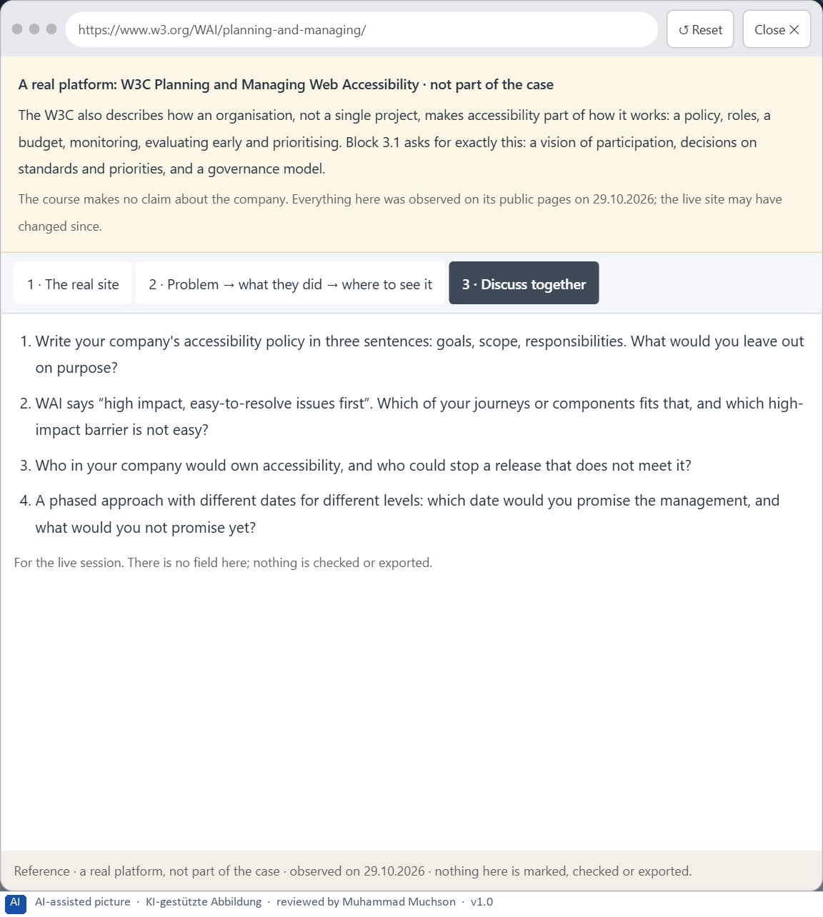
Figure 17 · A real platform that solved this, shown for the class discussion (3 of 3).
Question 1 of 7 · A guiding vision of digital participation: which form of accessibility, comprehensibility and quality of use should be guaranteed systematically?
One or two sentences about who must be able to use the services, how well, and what that means for every product.
How to build the answer:
- Say who must be able to use every service.
- Say what quality of use that means: perceivable, operable, understandable.

Question 2 of 7 · Three strategic guiding decisions on accessibility standards, inclusive design, prioritising barriers and governance
How to build the answer:
- Take your vision and ask which three choices would make it real.
- Write each as “we will …, even though that means …”.
Write them as a list, one decision per line, each with what it gives up.

Question 3 of 7 · A prioritised architecture of measures: which journeys, components or systems are improved first, and why?
Put the journeys, components or systems in an order and give the reason for the first ones.
How to build the answer:
- List the candidates: the page templates, the form component, the appointment journey, the application journeys, the website, the customer portal, PDFs.
- Put first what reaches the most people and removes total exclusion.
- Say why the others wait.

Question 4 of 7 · A risk analysis: which wrong assumptions about user diversity, effort and legal certainty would be especially critical?
Name two or three assumptions and the harm if each is wrong.
How to build the answer:
- Write down what your concept assumes about who the users are.
- Write down what it assumes about the effort.
- Write down what it assumes about legal certainty.

Question 5 of 7 · A governance model: who is responsible for accessibility principles, and how are conflicts between brand, technology, law and user interest decided?
Name roles, not people: who owns the principles and the target level, how it is checked in every release, the roles of the legal team, the brand team and the departments, and how a conflict is decided.
How to build the answer:
- Name who owns the accessibility principles and the target level.
- Say how it is checked in every release and every purchase.
- Say how a conflict between brand, technology, law and user interest is decided.

Question 6 of 7 · A decision under uncertainty: make at least one prioritised decision despite patchy data and justify it responsibly
Say what you decide, what you do not know, and why the decision is responsible all the same, for example when you would reverse it.
How to build the answer:
- State the decision in one sentence.
- Name what you do not know.
- Say why it is still responsible: it can be reversed, it can be checked soon, or waiting costs more.

Question 7 of 7 · A management statement: a recommendation to the management with a clear priority and a strategic reason
Four to six sentences: the direction first, then the priority, the reason and what you ask of the management.
How to build the answer:
- Start with the direction in one sentence.
- Name the priority and the reason that carries it.
- Say what you ask of the management and what you will report back.

Use in class: presentation and handout
Mark of use for the worksheet. Presentation is what the trainer shows on screen; Handout is what participants fill in and hand in.
Part of the worksheet | Presentation (shown in the Neuro-UX Lab) | Handout
The case: two platforms on the UX team's desk, and CitizenConnect | The case read aloud or on screen | The case text
Block 1.1 · Recognise barriers in a digital offer without prior knowledge: PublicA | The task wording at the start of the block (no answers are shown) | Worksheet block with answer boxes (Core)
Block 1.2 · Rate inclusive design under conflicting goals: LearnAccess | The task wording at the start of the block (no answers are shown) | Worksheet block with answer boxes (Core)
Block 2.1 · Case study: making the portal CitizenConnect more accessible | The task wording at the start of the block (no answers are shown) | Worksheet block with answer boxes (Core)
The situation: services that formally work, but not for everyone | The case read aloud or on screen | The case text
Block 3.1 · A strategic accessibility and inclusion architecture for digital servi | The task wording at the start of the block (no answers are shown) | Worksheet block with answer boxes (Core)

Glossary
Every term below is used in this document. Terms stay plain text in the body; this list says what they mean in everyday words.
Term | In plain words | Example | Comes from
Accessibility | Designing so that everyone can use a product, also people who see less well, see colours differently, or use a keyboard or a screen reader. | — | Day 3
Assistive technology | Tools people use to operate digital products, such as a screen reader that reads the screen aloud, a magnifier, a switch or voice control. | — | Day 12
Brand effect | How a design makes people recognise the company and what they feel about it, such as modern, serious or friendly. | — | Day 3
Case assumption | A fact made up for this exercise to fill a gap in the plan's case. It is marked so you know it is not part of the plan. | — | Day 1
Chief Experience Officer | The manager who is responsible for the experience customers have across all channels, and who decides where the company invests in it. | — | Day 1
Component | A reusable building block of an interface, such as a button, a form field or a status label, built once and used on many screens. | — | Day 6
Consistency | The same thing looks, is named and works the same way everywhere, so what people learn on one page holds on the next. | — | Day 2
Contrast | How much something differs from its surroundings in brightness, colour or size. Strong contrast makes it stand out; too many strong contrasts make everything compete. | — | Day 2
Decision architecture | A set of connected decisions that are made on purpose and written down: what effect you want, what comes first, who decides and how conflicts are settled. It replaces many separate fixes. | — | Day 1
Governance | The rules about who may decide what, who is answerable for it and how disagreements are settled. | — | Day 1
Inclusive design | Designing with the full range of people from the start, including permanent, temporary and situational limits and different minds. | — | Day 12
Keyboard operability | Everything can be reached and used with the keyboard alone (Tab, Enter, the arrow keys), which many assistive technologies rely on. | — | Day 12
Legibility | How easily single letters and words can be told apart. Thin, decorative or very small type is less legible. | — | Day 3
Page type | A kind of page that appears many times, such as a course page, a certificate page or a booking page. Each type should keep the same structure. | — | Day 2
Perception | Taking in what the senses deliver, for example what the eyes see on a screen, before thinking about it. | — | Day 1
Stakeholder | A person or department with an interest in a decision, such as marketing, compliance, IT or sales. | — | Day 1
UX (user experience) | Everything a person goes through when using a product: what they notice, understand, feel and do, from the first look to the last step. The screens are only one part of it. | Finding the booking you want at once and feeling sure it went through is a good UX. | Day 1
WCAG | The Web Content Accessibility Guidelines: the international standard for accessible web content, with levels A, AA and AAA; AA is the usual target. | — | Day 12

The Neuro-UX Lab: where we practise online
In class we use the course website as the place to practise and to learn. Every day has its own address, in the same pattern: the day number is the last part.
What | Address
Neuro-UX Lab (course website) | https://aion-ux-lab.vercel.app/
Day 12 | https://aion-ux-lab.vercel.app/day/12/

On the day page, Route 1 (Levels 1 and 2) and Route 2 (Level 3) can be opened; the cards and the tasks of this document are there too. The pattern is the same up to Day 8, for example https://aion-ux-lab.vercel.app/day/6/.

