AION · UX DEVELOPER · PSYCHOLOGICAL UX DESIGN AND NEURO-UX
DAY 13 · MATERI A AND MATERI B · ROUTES 1 AND 2 · LEVELS 1 TO 3
Neurodiversity, inclusive patterns and assistive technologies
Study material with real research, worked examples and the rules you use in the tasks
AI notice · KI-Hinweis
This document was produced with the help of an AI language model (Claude, Anthropic). The AI drafted the text and tables and built the pictures and working examples of the lab. The content was then read, corrected and approved by the reviewer named below, who is responsible for its accuracy. Every picture carries an AI label on the image. Check figures and sources before you quote them.
KI-Hinweis: Dieses Dokument wurde mit Unterstützung eines KI-Sprachmodells (Claude, Anthropic) erstellt. Texte und Tabellen wurden von der KI entworfen, die Abbildungen sind KI-gestützt erstellt und am Bild gekennzeichnet. Die fachliche Prüfung und Freigabe erfolgte durch die unten genannte Person.

Day | Day 13 · Module 6 (day 2 of 2): Neurodiversity, inclusive patterns and assistive technologies
Document | Materi (study material). Materi A has five cards, Materi B has three.
Route and level | Materi A serves Route 1 (Levels 1 and 2, Task 1). Materi B serves Route 2 (Level 3, Task 2).
Time | Materi A about 60 min · Materi B about 60 min (facilitator-led)
Neuro-UX Lab (website) | https://aion-ux-lab.vercel.app/day/13/
Case | Worked examples use a made-up company in each card. The task case is LifeGuide (see the Task document).
Version | 1.0 · release date 29.10.2026
Review and approval | Muhammad Muchson, Mentor (subject-matter review and approval)

ABOUT THIS DOCUMENT
In class we also use the Neuro-UX Lab, the course website, as the place to practise and learn. Its address is at the end of this document.
Today is about minds that work differently. You learn what loads people with ADHD, autistic people and people with dyslexia most, how stimuli, predictability and readability decide whether a page can be used, which inclusive design patterns help many groups at once, how assistive technologies fit in, and how to prototype and test so real hurdles show up instead of assumptions. This is the start of the practice project: you sketch an inclusive prototype and a test plan. This document holds everything you need to study Day 13 without the website. Every card says what the idea is in plain words, shows it in a picture, gives the details and ends with the rules you use in the tasks.

IN THIS DOCUMENT
Lesson plan: ten teaching units (Ablaufplan)
Case study and transfer project at a glance
A1 · Neurodiversity: different minds, different loads · 12 min · Core
A2 · Stimuli and focus: when a page is too much (ADHD, sensory sensitivity) · 12 min · Core
A3 · Predictability: consistent patterns and literal words (autism) · 12 min · Core
A4 · Readability: text structure, typography and language (dyslexia) · 12 min · Core
A5 · Inclusive patterns, assistive technologies, and testing a prototype · 12 min · Core
B1 · Neurodiverse UX as better base architecture, not a special case · 20 min · Core
B2 · One standard or many modes: the conflicts of neurodiverse UX · 20 min · Core
B3 · Who owns it, how it is tested, and deciding with patchy data · 20 min · Core

Day at a glance
Day 13 has ten teaching units (UE). This document is the study material; it is used in UE1 (Materi A) and UE8 (Materi B). The day is built from three documents and the Neuro-UX Lab: Materi (study material), Task (worksheet) and Trainer (coaching, feedback and model solutions), plus the course website.

Lesson plan: ten teaching units (Ablaufplan)
UE | Min | Plan item | What happens | Material | Format
1 | 45 | Knowledge transfer · Level 1 | The trainer presents the cards of Materi A (A1, A2, A3, A4, A5, about 60 min of cards) in the Neuro-UX Lab; participants follow in the handout. | Materi A (Route 1) | Presentation + Handout
2 | 45 | Level 1 · Task 1 | Individual work on Block 1.1 (Core, about 10 min): the first product of the day is read and its effect described. Pairs then compare their results and the trainer collects open questions. | Task 1 · Part 1 · Block 1.1 | Handout (or in the lab)
3 | 45 | Level 1 · Task 2 | Three options are rated on the same criteria and one is chosen under the stated conditions: Block 1.2 (Core, about 8 min). | Task 1 · Part 1 · Block 1.2 | Handout (or in the lab)
4 | 45 | Coaching · transition from Level 1 to Level 2 | Trainer-led. A short talk on the day's coaching focus, then the reflection questions in pairs. The bridge: from describing an effect to a decision you answer for. There is no worksheet block in this unit. | Trainer document, section Coaching | Trainer only
5–6 | 90 | Level 2 · Case study LifeGuide (2 UE) incl. model solution | UE5: the trainer presents the case; participants work on Block 2.1 (Core, about 15 min). UE6: groups compare their results and defend them; the trainer closes with the model solution. | Task 1 · Part 2 · Block 2.1  Trainer document, section Case study | Handout; model solution shown after the work
7 | 45 | Level 2 + 3 · Feedback round with a management perspective | Groups present their reasoning, not only their result. The trainer asks the day's Level 3 input questions and leads the discussion. | Trainer document, section Feedback round | Presentation by the groups; Trainer only
8 | 45 | Level 3 · Transfer project, Chief Experience Officer (3 UE: UE8–10) | The trainer presents Materi B (B1, B2, B3; use the "In plain words" and "How to decide" boxes, the rest is handout) and sets the role and the situation. | Materi B (Route 2) | Presentation + Handout
9 | 45 | Level 3 · Transfer project | Individual work or in pairs on Block 3.1 (Core, about 20 min): the strategy memo. | Task 2 · Block 3.1 | Handout (or in the lab)
10 | 45 | Level 3 · Transfer project | Participants present their decision and what they give up, including the one decision made under uncertainty; the trainer debriefs with the model solution. | Task 2 · Block 3.1  Trainer document, section Transfer project | Handout; model solution shown after the work

One UE is counted as 45 minutes here; breaks are not shown. The times are a guide for the trainer. The Core blocks are enough for a complete answer.

Case study and transfer project at a glance
Component | UE | Duration | Participants work in | Model solution in
Level 2 case study (LifeGuide) | UE5–6 | 2 UE · 90 min | Task 1 · Part 2 (Block 2.1) | Trainer document, section Case study
Level 3 transfer project (Chief Experience Officer) | UE8–10 | 3 UE · 135 min | Materi B and Task 2 (Block 3.1) | Trainer document, section Transfer project

Materi A · Route 1 · Levels 1 and 2
How Materi A is used
About 60 minutes, five cards. Levels 1 and 2: find the hurdles of a learning platform for people with ADHD, autism or dyslexia, rate three designs of a career platform under conflicting goals, then analyse a support portal, develop four measures, justify them and sketch a prototype and what to test first. The cards give you the ideas and the rules you use in Task 1.

A1 · Neurodiversity: different minds, different loads · 12 min · Core
Minds differ in how they take in, process and remember information. ADHD: overstimulation, distraction, complex task structures, lack of focus. Autism: sensory overload, unclear navigation logic, inconsistent patterns, ambiguous communication. Dyslexia: difficult reading structures, unsuitable typography, unclear text structure, complex language.
IN PLAIN WORDS
The idea. Neurodiversity means that human minds differ in how they take in, process and remember information. People with ADHD are loaded most by overstimulation, distraction, complex task structures and a lack of focus. Autistic people are loaded most by sensory overload, unclear navigation logic, inconsistent patterns and ambiguous communication. People with dyslexia are loaded most by difficult reading structures, unsuitable typography, unclear text structure and complex language. These are design factors, not exceptions: many people without a diagnosis feel the same loads when they are tired, stressed or distracted.
Why it matters. Block 1.1 asks which hurdles StudyPath puts in front of people with different ways of perceiving and processing, and Block 2.1 asks for LifeGuide's deficits for neurodiverse use. This card gives you the load factors of ADHD, autism and dyslexia by name.
How to read the picture. The same Hearth Energy start page seen through three lenses: what loads Ayo (ADHD), Mirko (autism) and Tilda (dyslexia).

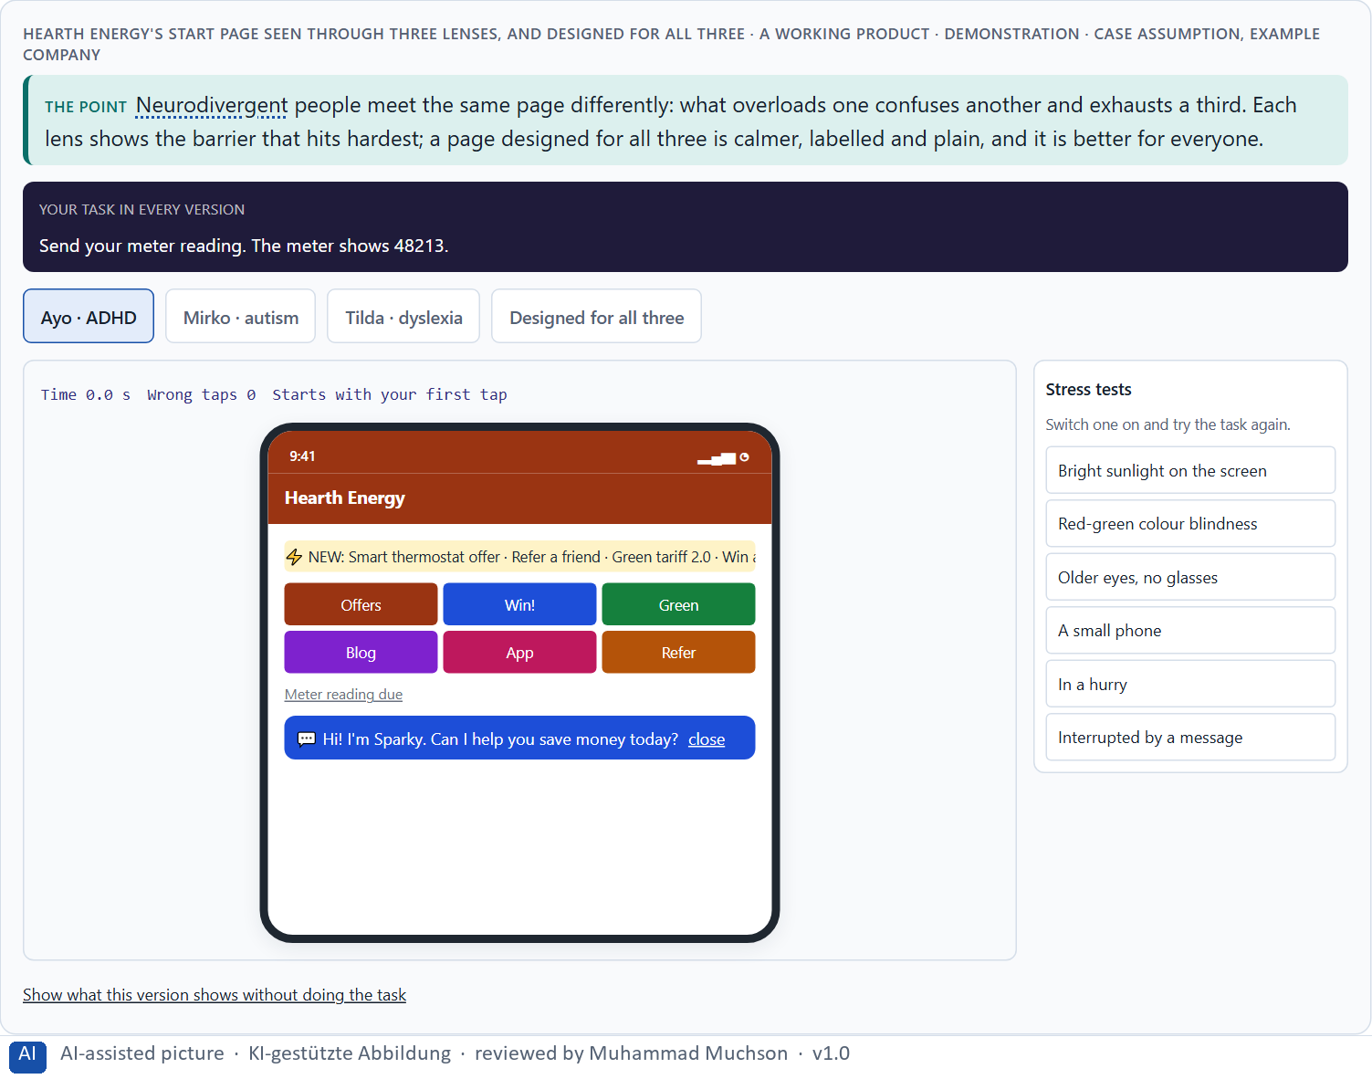
Figure 1 · Hearth Energy's start page seen through three lenses, and designed for all three · demonstration. Shown here in its starting state; in the Neuro-UX Lab every version and every stress test can be used.
Load factors by mind, and what usually helps
Mind | What loads most | What usually helps
ADHD | Overstimulation, distraction, complex task structures, lack of focus. | One main task, quiet extras, short steps, a visible next step.
Autism | Sensory overload, unclear navigation logic, inconsistent patterns, ambiguous words. | Calm colours, the same patterns everywhere, literal and descriptive words.
Dyslexia | Difficult reading structures, unsuitable typography, unclear structure, complex language. | Left-aligned, readable type, spacing, headings, plain language, read-aloud.

Case assumption
Hearth Energy, Ayo, Mirko, Tilda, Pia and Lukas are made up for this example. The load factors are the ones the plan names; ADHD as a difference in attention and executive function follows Barkley (2015); the dos and don'ts follow the Home Office posters (Pun 2016) and the British Dyslexia Association (2023).

How to decide when this comes up in the task
- Look at a screen through three lenses: ADHD, autism, dyslexia.
- Ask what overloads, what confuses, and what tires.
- Remember that many people without a diagnosis feel the same in stress.
- Tell neurodiverse needs apart from general usability: the same screen can be usable and still overload.
- Expect some needs to pull in different directions, and test to find the balance.

Extra · go deeper (optional reading)
Many hurdles come less from technology than from the mental model of the people who design: a team that reads fast, ignores banners easily and likes variety builds a product for people like itself. Neurodiversity asks the team to design for minds that work differently from their own, and to test with them, because intuition is exactly what fails here.

Sources · Barkley 2015 · Pun 2016 · British Dyslexia Association 2023

A2 · Stimuli and focus: when a page is too much (ADHD, sensory sensitivity) · 12 min · Core
Every element competes for attention. A busy page is hard to start, easy to drift from and tiring to finish, for people with ADHD or sensory sensitivity most of all. Show one main task first, keep extras quiet, avoid movement and interruptions, and break long tasks into short steps.
IN PLAIN WORDS
The idea. Every banner, badge, colour, notification and moving element competes for attention. For people with ADHD or sensory sensitivity, a busy page is not just untidy: it is hard to start, easy to drift from and tiring to finish. Calm pages show one main task first, keep secondary things quiet, avoid movement and interruptions, and break long tasks into steps with a visible next step. Fewer stimuli help almost everyone find what matters.
Why it matters. Block 1.1 asks about StudyPath's start page full of hints, colours and notifications and its unprioritised tasks, Block 1.2 rates JobAccess's dense Variant A, and Block 2.1 asks about LifeGuide's competing stimuli and long forms. This card lets you turn the stimuli up and down.
How to read the picture. A dial turns the Hearth Energy start page from calm to overloaded: banners, badges, a moving ticker, a chat bubble, notifications. Then the same long form in one piece and in steps.

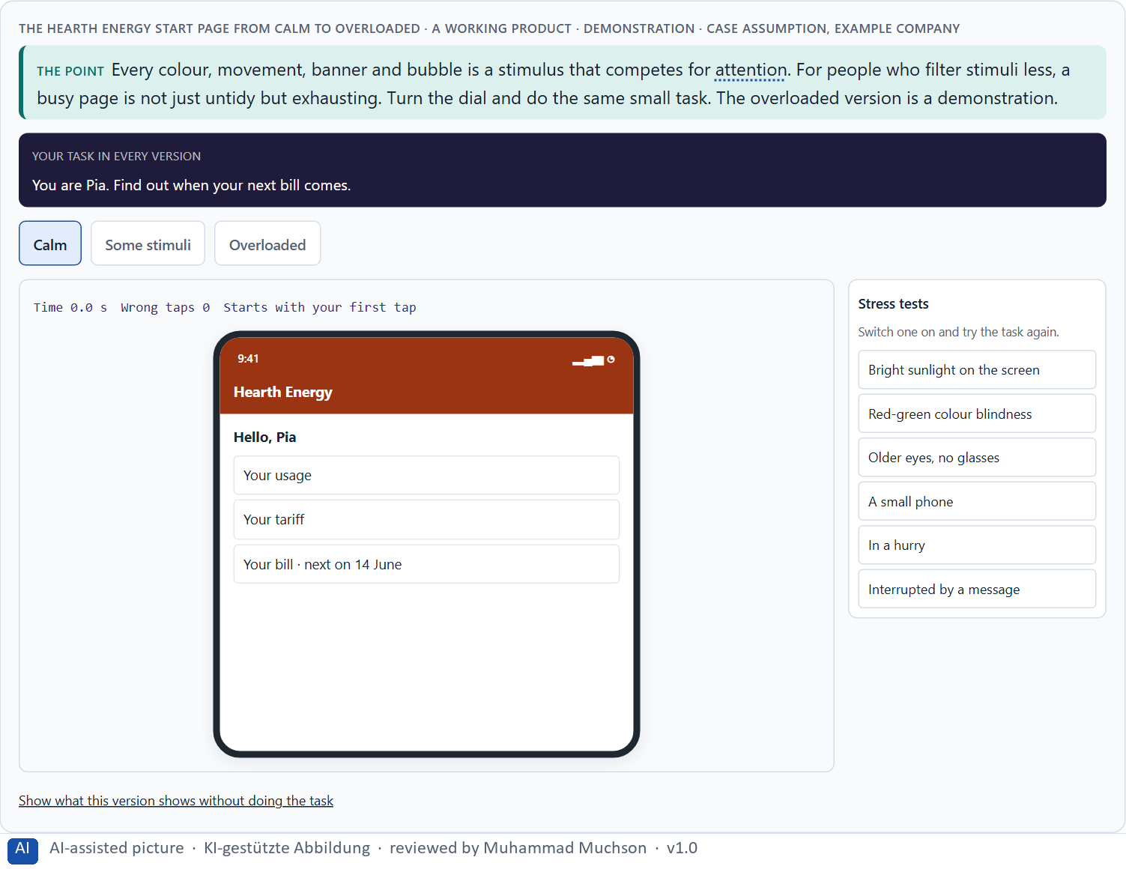
Figure 2 · The Hearth Energy start page from calm to overloaded · demonstration. Shown here in its starting state; in the Neuro-UX Lab every version and every stress test can be used.
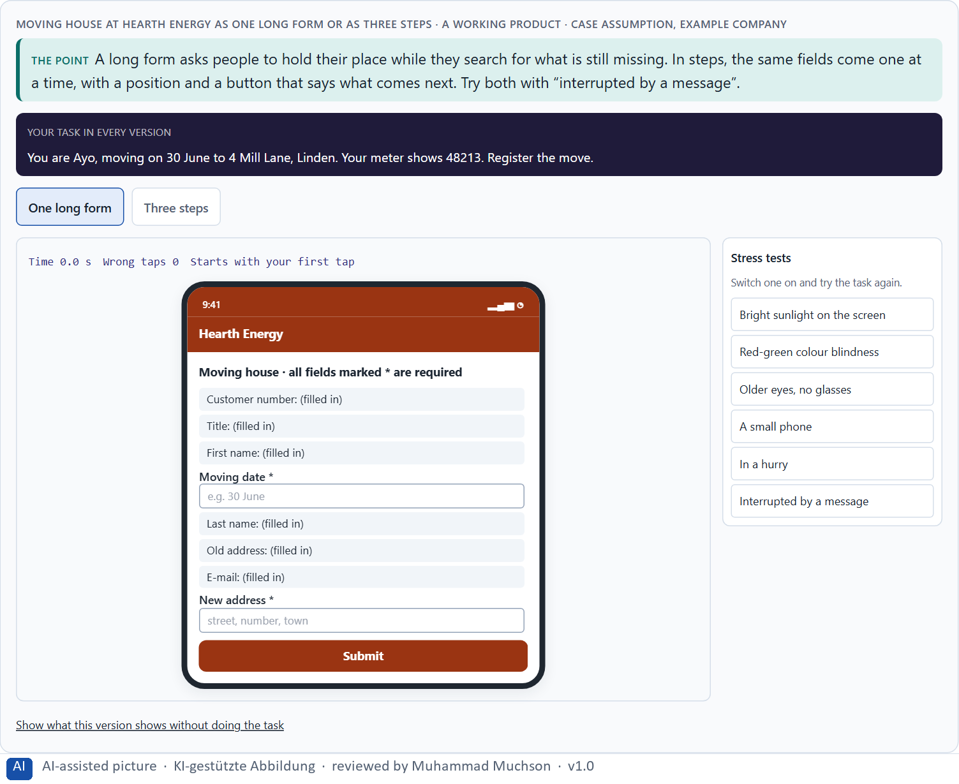
Figure 3 · Moving house at Hearth Energy as one long form or as three steps. Shown here in its starting state; in the Neuro-UX Lab every version and every stress test can be used.
Case assumption
Hearth Energy, Ayo, Mirko, Tilda, Pia and Lukas are made up for this example. Limiting interruptions, avoiding too much content and five or fewer main choices per screen follow the W3C's “Making Content Usable” (2021).

How to decide when this comes up in the task
- Count what competes for attention on the first screen.
- Is the most important task the most visible thing?
- Does anything move, blink or pop up without being asked?
- Are long tasks broken into steps with a visible position and a named next step?
- Can people stop and come back without losing their place?

Extra · go deeper (optional reading)
Stimulus reduction is often resisted because each element has an owner who wants it seen. The page fills up one reasonable request at a time. A rule such as “one main task per screen, everything else quiet” protects the page from its own stakeholders, and it helps the customers who never asked for the extras.

Sources · W3C COGA 2021 · Barkley 2015

A3 · Predictability: consistent patterns and literal words (autism) · 12 min · Core
Predictability means people can tell what will happen: the menu stays in one place, the same action has the same name, buttons say what they do, words mean what they say. Inconsistent patterns and ambiguous words are a real barrier for many autistic people and raise anxiety for many others.
IN PLAIN WORDS
The idea. Predictability means people can tell what will happen: the navigation is in the same place on every page, the same action has the same name, and words mean what they say. For many autistic people inconsistent patterns and ambiguous words are not a small annoyance but a real barrier, and they raise anxiety. Consistent layouts, descriptive buttons (“Send meter reading”, not “Go”) and literal language (no idioms, no vague hints) make an interface safe to use.
Why it matters. Block 1.1 asks about StudyPath's navigation that varies between course areas, Block 1.2 about JobAccess A's changing navigation, and Block 2.1 about LifeGuide's inconsistent patterns and low predictability. This card shows the same three pages built consistently and inconsistently.
How to read the picture. Three Hearth Energy pages, first built inconsistently (the menu moves, the main button changes name and place), then consistently.

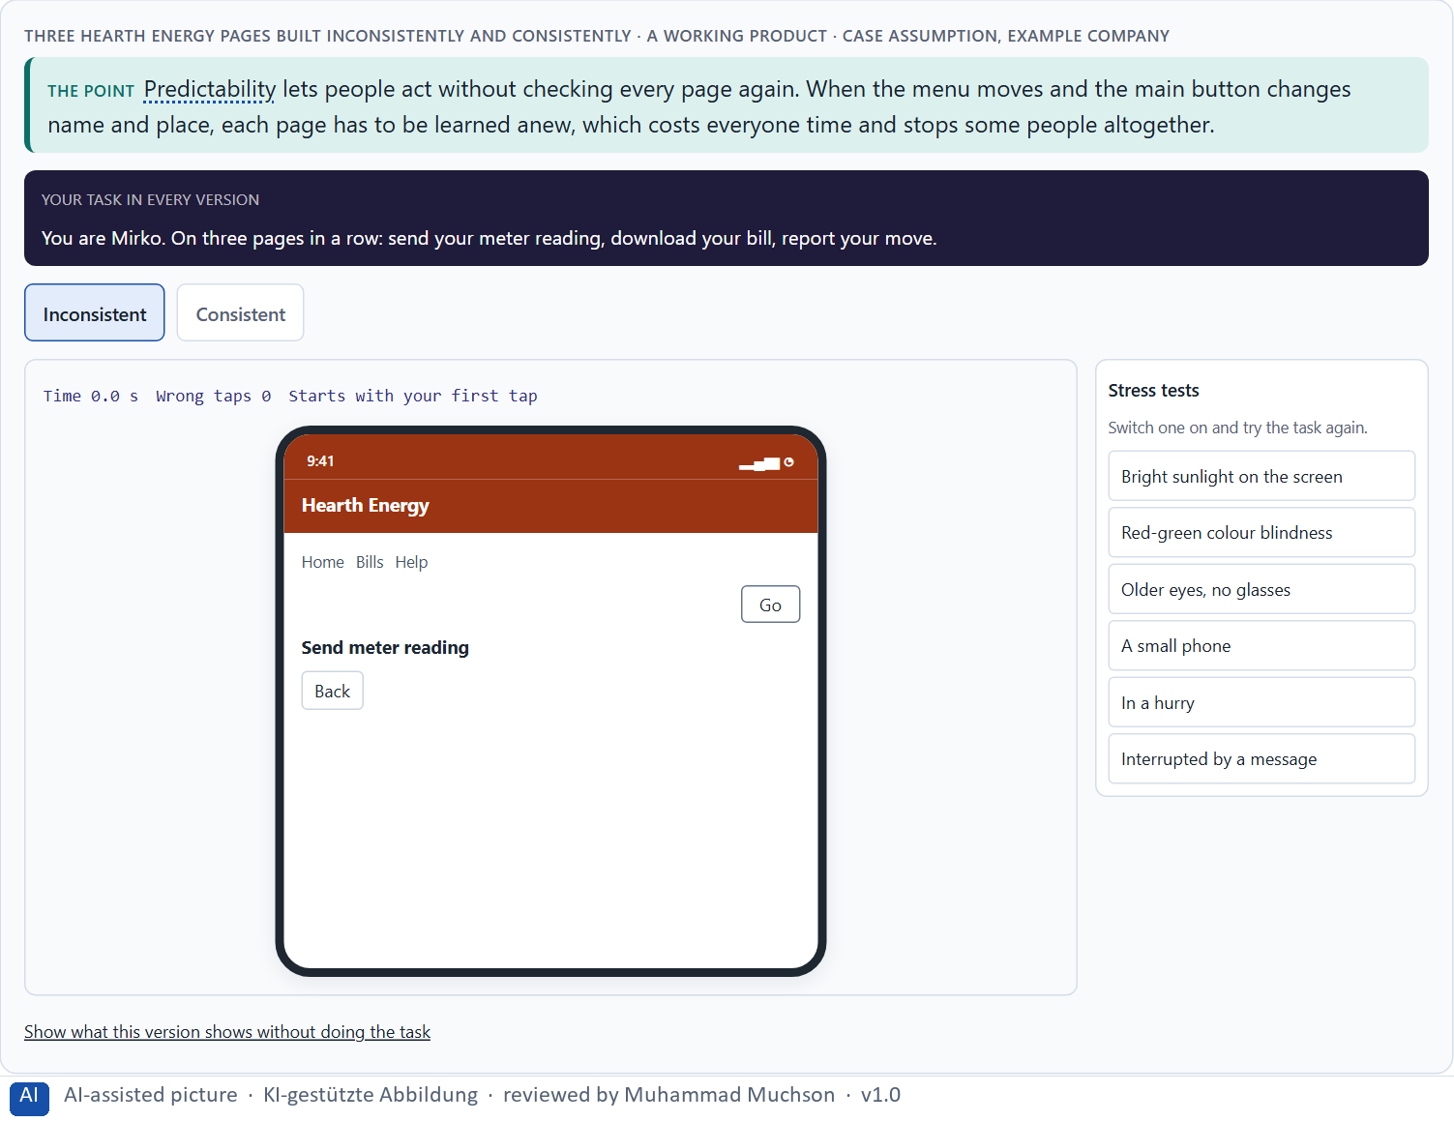
Figure 4 · Three Hearth Energy pages built inconsistently and consistently. Shown here in its starting state; in the Neuro-UX Lab every version and every stress test can be used.
Ambiguous or literal
Ambiguous | Literal | Why it matters
“Let's go!” | “Report your move” | People know what will happen.
“You're all set!” | “Your meter reading for 31 October was received.” | People know what was done.
“Hang tight…” | “Loading your bills. This takes about 10 seconds.” | No idiom; a time to expect.
“Oops, something went sideways” | “We could not save your reading. Please try again.” | What happened, and what to do.

Case assumption
Hearth Energy, Ayo, Mirko, Tilda, Pia and Lukas are made up for this example. Descriptive buttons, simple consistent layouts and no figures of speech follow the Home Office poster for users on the autistic spectrum (Pun 2016).

How to decide when this comes up in the task
- Is the navigation in the same place on every page?
- Does the same action always have the same name and place?
- Do buttons say what they do (“Send meter reading”), not “Go” or “Click here”?
- Is the language literal, without idioms or vague hints?
- Does the product say what will happen before it happens?

Extra · go deeper (optional reading)
Playful copy (“Oops!”, “Let's go!”) is often added to make a product feel friendly. For many autistic people, and for anyone using a translation tool or reading in a second language, it does the opposite: it hides what happened. Friendliness can be in the tone of a literal sentence; it does not need idioms.

Sources · Pun 2016 · W3C COGA 2021

A4 · Readability: text structure, typography and language (dyslexia) · 12 min · Core
Reading is work for people with dyslexia and for many others. Left-aligned text, a plain sans-serif font at a good size, enough line height and spacing, short lines and paragraphs, no blocks of capitals, italics or underlining, clear headings and plain language decide whether people read to the end.
IN PLAIN WORDS
The idea. For people with dyslexia, and for many others, reading is work. Text is easier to read when it is left-aligned, in a plain sans-serif font at a good size, with enough line height and spacing, in short lines and short paragraphs, without blocks of capitals, italics or underlining, and in plain language with clear headings. Small typographic choices decide whether someone reads to the end.
Why it matters. Block 1.1 asks about StudyPath's long, dense, complex texts, Block 1.2 rates JobAccess's readability, and Block 2.1 about LifeGuide's texts that are correct but hard to read. This card lets you change the typography of a real paragraph yourself.
How to read the picture. A Hearth Energy notice you can change: size, line height, line length, alignment, spacing, and an official or plain version.

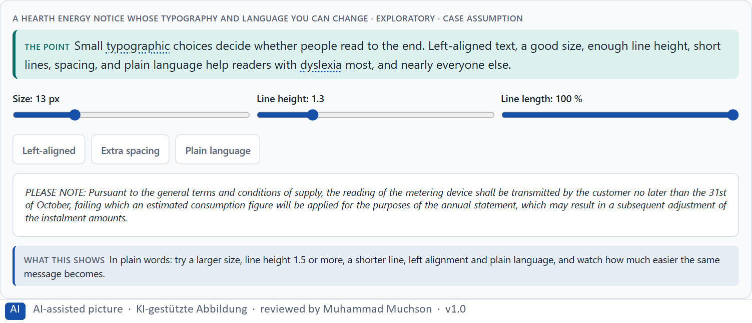
Figure 5 · A Hearth Energy notice whose typography and language you can change · Exploratory.
Case assumption
Hearth Energy, Ayo, Mirko, Tilda, Pia and Lukas are made up for this example. The typography advice follows the British Dyslexia Association's style guide (2023) and the Home Office poster for users with dyslexia (Pun 2016).

How to decide when this comes up in the task
- Left-aligned, never justified.
- At least 15 to 16 pixels, line height around 1.5, lines of 60 to 75 characters.
- No blocks of capitals, italics or underlining.
- Short paragraphs under clear headings; one idea per sentence.
- Let people change contrast and size; offer read-aloud where reading is long.

Extra · go deeper (optional reading)
Justified text is a print habit. On paper, with careful hyphenation, it looks tidy; on a screen it opens uneven gaps between words that form “rivers” down the text, and readers with dyslexia lose their place in them. Left alignment costs nothing and removes the problem.

Sources · British Dyslexia Association 2023 · Pun 2016

A5 · Inclusive patterns, assistive technologies, and testing a prototype · 12 min · Core
Inclusive design patterns help several groups at once; assistive technologies let people use content their own way, but only on a good base; and only prototypes tested with real people show the real hurdles. Test orientation, stimulus load, task completion, readability and the feeling of control. Weigh measures on effect, gain for inclusion, feasibility, risk and time pressure.
IN PLAIN WORDS
The idea. Inclusive design patterns are reusable solutions that help several groups at once: one task per screen, a step indicator, descriptive buttons, a summary before sending, a calm mode, a reading mode. Assistive technologies (screen readers, text-to-speech, reader modes, text scaling, focus and stimulus filters) let people use content their own way, but only if the base structure is good. And only prototypes tested with real people show the real hurdles instead of assumptions: test orientation, stimulus load, task completion, readability and the feeling of control, in calm and in stressful situations. To put measures in order, weigh each on effect on users, gain for inclusion, feasibility, risk and time pressure.
Why it matters. Block 2.1 asks for four measures for LifeGuide, justified on effect on users, gain for inclusion, feasibility, risk and time pressure, and for an inclusive prototype approach with what to test first; Block 1.2 rates JobAccess C's adaptation modes. The example uses Hearth Energy and its own measures, so the answer for the task cases is not given.
How to read the picture. The same Hearth Energy content through five assistive technologies, with a real text-to-speech button. Then a test plan for a prototype, and three measures rated on five criteria.

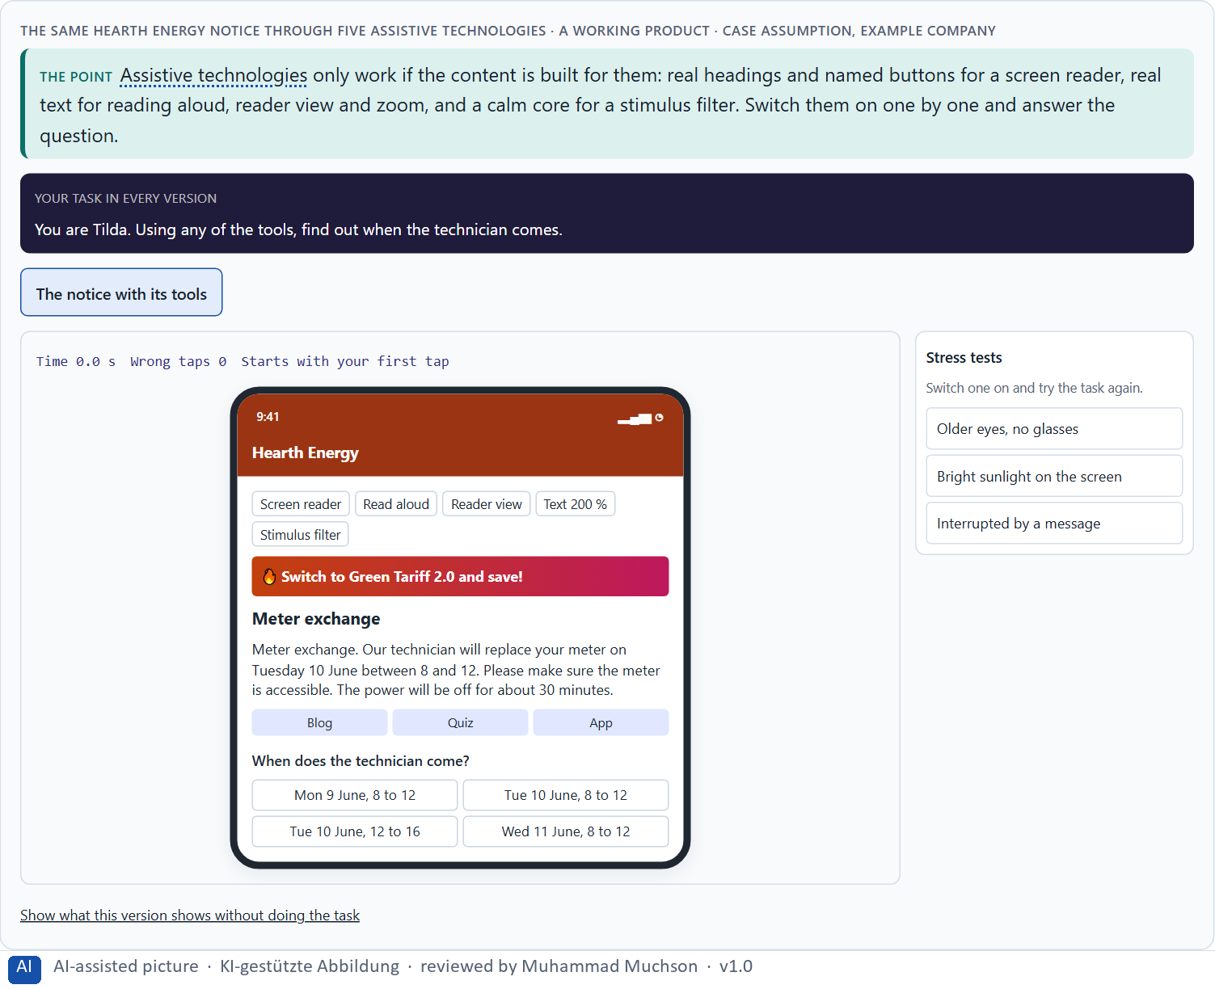
Figure 6 · The same Hearth Energy notice through five assistive technologies. Shown here in its starting state; in the Neuro-UX Lab every version and every stress test can be used.
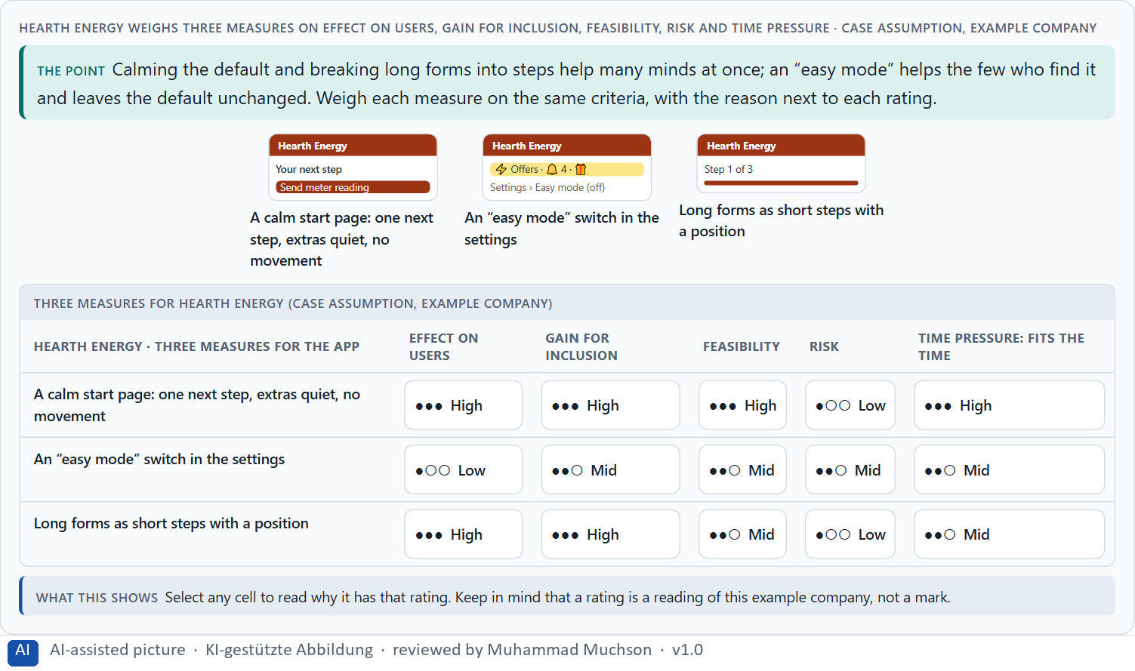
Figure 7 · Hearth Energy weighs three measures on effect on users, gain for inclusion, feasibility, risk and time pressure.
A first test plan for a Hearth Energy prototype
Part | What we do
What the prototype contains | The start page, the menu, and the moving-house form in steps; a quiet mode.
Who takes part | Six customers, among them people with ADHD, autistic people and people with dyslexia; asked ahead what support they need.
Tasks | Send a meter reading; report a move; find your last bill.
A stressful moment | A phone call in the middle of the form; a time limit on one task.
What we watch | Orientation, stimulus load, task completion, readability, the feeling of control.
How we evaluate | Where people stopped, hesitated, misread or felt unsure; quotes; then the next change.

Case assumption
Hearth Energy, Ayo, Mirko, Tilda, Pia and Lukas are made up for this example. Including people in usability testing and asking ahead about support follow the W3C's “Making Content Usable” (2021); choosing a prototype by its question follows Houde and Hill (1997) and Kelley (1984); rating options on the same criteria follows Gibbons (2018).

How to decide when this comes up in the task
- Prefer a pattern that helps many (steps, one main task, descriptive buttons) over a special screen.
- Check that assistive technology can work: real headings, buttons, text, layouts that grow.
- Prototype the entry pages, the navigation and the core forms first.
- Test with neurodivergent people, with the support they need, also in a stressful moment.
- Evaluate where people stop, hesitate or feel unsure, not only technical errors.

Extra · go deeper (optional reading)
Inclusive design is often presented as adaptation: extra options for people who need them. The stronger argument is architecture: the patterns that neurodivergent people need most (calm, consistent, readable, step by step) make the product better for nearly everyone, and they make assistive technology work. A better base is cheaper than many special cases.

Sources · W3C COGA 2021 · Houde & Hill 1997 · Kelley 1984 · Gibbons 2018

Materi B · Route 2 · Level 3
How Materi B is used
About 60 minutes, three cards, led by the facilitator. Level 3 in the Chief Experience Officer's chair: a guiding vision for neurodiverse UX, three strategic decisions, an order of what comes first, a risk analysis, a governance model, one decision under uncertainty and a statement to the management. The cards give you the ideas you use in Task 2.

B1 · Neurodiverse UX as better base architecture, not a special case · 20 min · Core
Treated as a special case, neurodiversity becomes an option few people find. At senior level it is a strategic dimension of product architecture: calm, predictable, readable defaults built from shared patterns, with adaptation modes on top. The question is which base to build, not which option to add.
IN PLAIN WORDS
The idea. Many companies treat neurodiversity as a special case: an extra option, a separate “easy” version, a setting few people find. At senior level it is a strategic dimension of the product architecture: calm, predictable, readable defaults help everyone and especially neurodivergent people; patterns built once carry that into every product; adaptation modes come on top of a good base, not instead of it. The question is not “which option do we add?” but “what base do we build?”.
Why it matters. Block 3.1 asks for a guiding vision of neurodiverse UX, three decisions on base architecture, patterns, assistive technologies, adaptation modes and test strategy, and an order of which journeys, components or product areas come first. You decide the architecture, not single screens.
How to read the picture. Left Hearth Energy adding an “easy mode” on top of a busy product, right building a calm base with patterns and modes. Below, the layers from a guiding vision to every product.

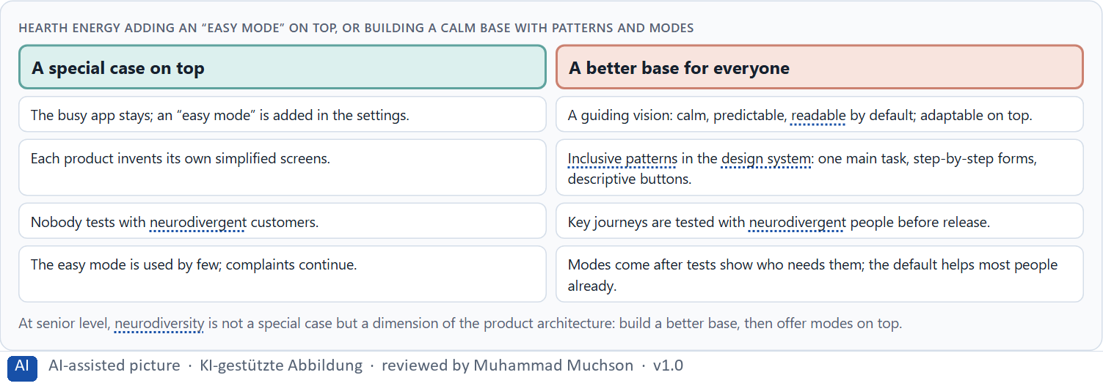
Figure 8 · Hearth Energy adding an “easy mode” on top, or building a calm base with patterns and modes.
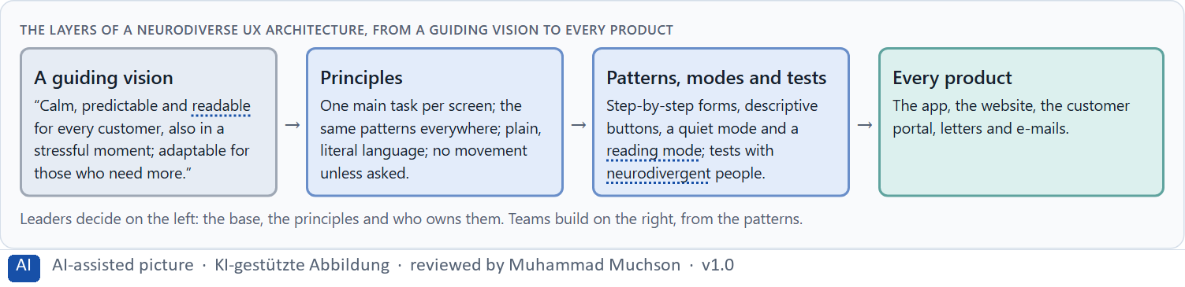
Figure 9 · The layers of a neurodiverse UX architecture, from a guiding vision to every product.
Case assumption
Hearth Energy, Ayo, Mirko, Tilda, Pia and Lukas are made up for this example. Inclusion as better design for many follows Holmes (2018); a simplified version from the same code base follows the W3C's “Making Content Usable” (2021).

How to decide when this comes up in the task
- Check whether neurodiverse needs sit in the base or in an option.
- Write a guiding vision: relief, predictability, readability, adaptability.
- Put the inclusive patterns in the design system, so every product gets them.
- Add modes on top of the base, after tests show who uses them.
- Order the work: shared patterns and journeys taken in stress first.

Extra · go deeper (optional reading)
The “easy mode” is attractive to management because it is visible and contained: one switch, one announcement. It is also the version that changes least for most customers. The harder message for a board is that the default itself is the product most people use, and that is where inclusion has to happen.

Sources · W3C COGA 2021 · Holmes 2018

B2 · One standard or many modes: the conflicts of neurodiverse UX · 20 min · Core
Neurodiverse UX sits between one standard and individual adaptation, a dynamic brand and a calm interface, economic viability and the diversity of users, and the cost of testing against the risk of not testing. Decide what belongs in the base, what becomes a mode, and whom to test with first; write down the assumptions.
IN PLAIN WORDS
The idea. Neurodiverse UX sits between goals that pull apart: one standard for all against individual adaptation, a dynamic brand against a calm interface, economic viability against the diversity of users, and the cost of testing with many groups against the risk of not testing. The way through is to decide what belongs in the base (calm, consistent, readable), what becomes an optional mode, and whom to test with first; and to write down which assumptions about diversity, standardisation and cost the plan rests on.
Why it matters. Block 3.1 asks for three decisions, a risk analysis of wrong assumptions about user diversity, standardisation and economic viability, and a governance model for conflicts between brand, technology, product logic and inclusion. Each is a decision between conflicting goals.
How to read the picture. Three Hearth Energy decisions between conflicting goals: the dynamic brand, an extra mode, and whom to test with.

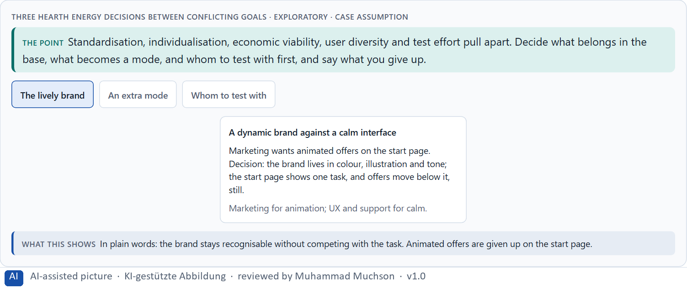
Figure 10 · Three Hearth Energy decisions between conflicting goals · Exploratory.
Standing conflicts of neurodiverse UX
Conflict | Who usually stands for each side | What to ask
One standard against individual adaptation | Engineering, against the people a standard does not fit. | Which needs pull apart, and which do all share?
A dynamic brand against a calm interface | Marketing, against UX and support. | Where can the brand live without competing with the task?
Economic viability against diversity | Finance, against users. | What does the busy default cost in support calls and abandoned tasks?
Test effort against the risk of not testing | Finance, against research. | Which small test would find the most serious hurdles?

Case assumption
Hearth Energy, Ayo, Mirko, Tilda, Pia and Lukas are made up for this example. That some needs pull in different directions, and that testing finds the balance, follows the Home Office's note on its posters (Pun 2016).

How to decide when this comes up in the task
- Name each conflict as two goals and say who stands for each: marketing, engineering, research, finance, users.
- Put what helps nearly everyone into the base; make only what pulls apart into a mode.
- Write down the assumptions about user diversity, standardisation and cost, and which would be critical if wrong.
- Choose a small, well-composed test over no test.
- Say what the choice gives up.

Extra · go deeper (optional reading)
The most expensive assumption is usually “neurodivergent customers are a small group”. Many people never had a diagnosis, and anyone under stress (after a high bill, a bereavement, a move) processes like someone with less attention to spare. Designing for the stressed customer is designing for a large share of the customers who matter most to a service.

Sources · W3C COGA 2021 · Pun 2016

B3 · Who owns it, how it is tested, and deciding with patchy data · 20 min · Core
Neurodiverse UX needs an owner of the principles and patterns, a test strategy that includes neurodivergent people with the right support, checks in every release, and a rule for when brand, technology, product logic and inclusion disagree. With patchy test data, a decision says what it decides, does not know, would reverse and gives up.
IN PLAIN WORDS
The idea. Neurodiverse UX needs owners: someone who owns the principles and the patterns, a test strategy that includes neurodivergent people with the right support (a quiet room, breaks, time), checks built into every release, and a rule for when brand, technology, product logic and inclusion disagree. Test data is often patchy; a decision under uncertainty says what you decide, what you do not know, when you would reverse it and what you give up.
Why it matters. Block 3.1 asks for a governance model for neurodiverse UX principles, a decision despite patchy test data, and a statement to the management. This card gives you the parts of each.
How to read the picture. The four boxes at the top are the parts of a decision, filled in for Hearth Energy. The two boxes below are the rule for future decisions.

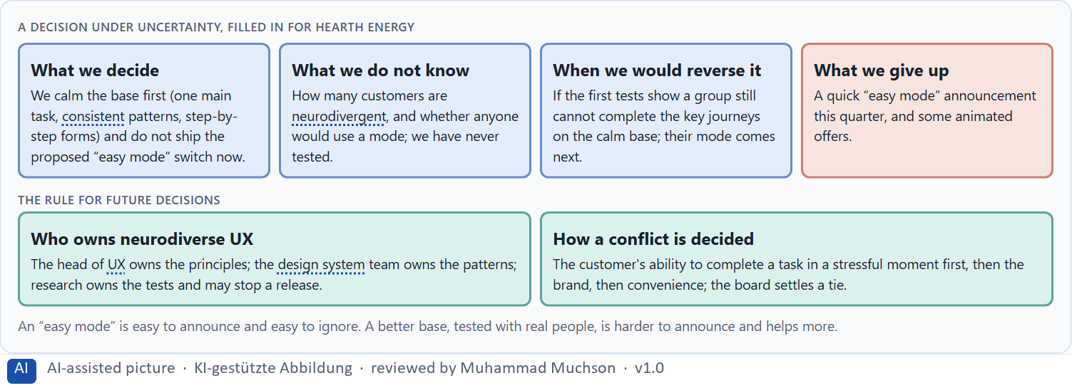
Figure 11 · A decision under uncertainty, filled in for Hearth Energy.
Four parts of neurodiverse UX governance
Part | The question | An example (Hearth Energy)
Owners | Who owns the principles and the patterns? | The head of UX the principles; the design system team the patterns.
Test strategy | Who tests what, with whom, before release? | Research tests the key journeys with six people incl. neurodivergent customers; may stop a release.
Checks | How does each release keep the base calm and consistent? | A pattern check in the definition of done.
How a conflict is decided | What happens when brand, technology, product logic and inclusion disagree? | Completing a task in stress first, then brand, then convenience; the board settles a tie.

Case assumption
Hearth Energy, Ayo, Mirko, Tilda, Pia and Lukas are made up for this example. Including people with cognitive and learning disabilities in research and testing follows the W3C's “Making Content Usable” (2021); deciding with limited information follows Simon (1956); the premortem follows Klein (2007).

How to decide when this comes up in the task
- Name who owns the principles, and who owns the patterns in the design system.
- Name who owns the test strategy, and give them a stop right.
- Include neurodivergent people in research and tests, with a quiet room, breaks and time.
- Settle conflicts by the user's ability to complete a task in stress first, then brand, then convenience.
- Say what you decide, what you do not know, when you would reverse it and what you give up.

Extra · go deeper (optional reading)
Without an owner, a design system drifts: each product adds one exception, and two years later the consistency that autistic customers relied on is gone. Owning the patterns means saying no to exceptions, and it is the least visible and most important job in neurodiverse UX.

Sources · W3C COGA 2021 · Simon 1956 · Klein 2007

Use in class: presentation and handout
Mark of use for the study material. Presentation is what the trainer shows on screen; Handout is what participants read and keep.
Card | Presentation (shown in the Neuro-UX Lab) | Handout
A1 · Neurodiversity: different minds, different loads (Core) | Scan line and Figure 1; the "In plain words" and "How to decide" boxes | The whole card
A2 · Stimuli and focus: when a page is too much (ADHD, sensory sensitivity) (Core) | Scan line and Figures 2–3; the "In plain words" and "How to decide" boxes | The whole card
A3 · Predictability: consistent patterns and literal words (autism) (Core) | Scan line and Figure 4; the "In plain words" and "How to decide" boxes | The whole card
A4 · Readability: text structure, typography and language (dyslexia) (Core) | Scan line and Figure 5; the "In plain words" and "How to decide" boxes | The whole card
A5 · Inclusive patterns, assistive technologies, and testing a prototype (Core) | Scan line and Figures 6–7; the "In plain words" and "How to decide" boxes | The whole card
B1 · Neurodiverse UX as better base architecture, not a special case (Core) | Scan line and Figures 8–9; the "In plain words" and "How to decide" boxes | The whole card
B2 · One standard or many modes: the conflicts of neurodiverse UX (Core) | Scan line and Figure 10; the "In plain words" and "How to decide" boxes | The whole card
B3 · Who owns it, how it is tested, and deciding with patchy data (Core) | Scan line and Figure 11; the "In plain words" and "How to decide" boxes | The whole card

References
Check each source and its current edition before you teach from it. Standards and laws marked as in flux can change.
Barkley, R. A. (Ed.) (2015). Attention-Deficit Hyperactivity Disorder: A Handbook for Diagnosis and Treatment (4th ed.). Guilford Press. (ADHD as a difference in attention, impulse control and executive function; distraction and task structure as load factors.)
Pun, K. (2016). Dos and don'ts on designing for accessibility. Accessibility in government (UK Home Office Digital), 2 September 2016. https://accessibility.blog.gov.uk/2016/09/02/dos-and-donts-on-designing-for-accessibility/ (Posters of dos and don'ts for users on the autistic spectrum, with dyslexia, and other needs.)
British Dyslexia Association (2023). Dyslexia Style Guide. (Plain language, short sentences, left-aligned text, good spacing and no blocks of italics or capitals help readers with dyslexia.)
W3C (2021). Making Content Usable for People with Cognitive and Learning Disabilities. W3C Working Group Note, 29 April 2021. https://www.w3.org/TR/coga-usable/ (Eight objectives and design patterns for cognitive accessibility, and how to include people in design and usability testing.)
Houde, S., & Hill, C. (1997). What do prototypes prototype? In M. Helander, T. Landauer, & P. Prabhu (Eds.), Handbook of Human-Computer Interaction (2nd ed., pp. 367–381). Elsevier. (A prototype answers a question about role, look and feel, or implementation; choose it by the question.)
Kelley, J. F. (1984). An iterative design methodology for user-friendly natural language office information applications. ACM Transactions on Information Systems, 2(1), 26–41. (The Wizard-of-Oz method: a person secretly plays the system to test a dialogue before it is built.)
Gibbons, S. (2018). Using Prioritization Matrices to Inform UX Decisions. Nielsen Norman Group. https://www.nngroup.com/articles/prioritization-matrices/ (Rate each option on the same few criteria, such as value to the user against effort, and put the reason next to each rating.)
Holmes, K. (2018). Mismatch: How Inclusion Shapes Design. MIT Press. (Disability as a mismatch between a person and a design; permanent, temporary and situational limits; solving for one extends to many.)
Simon, H. A. (1956). Rational choice and the structure of the environment. Psychological Review, 63(2), 129–138. (With limited information and time, people choose an option that is good enough rather than the best one: a decision under uncertainty.)
Klein, G. (2007). Performing a project premortem. Harvard Business Review, 85(9), 18–19. (Imagine the plan has failed and ask why; it brings risks and wrong assumptions to the surface before the work starts.)

Glossary
Every term below is used in this document. Terms stay plain text in the body; this list says what they mean in everyday words.
Term | In plain words | Example | Comes from
Adaptation mode | An optional setting that changes how a product looks or behaves for someone's needs, such as fewer stimuli, a reading mode or a simplified view; it works best on top of a good default. | — | Day 13
ADHD | Attention deficit hyperactivity disorder: a different way of directing attention and controlling impulses; busy pages, distractions and long unstructured tasks are especially hard. | — | Day 13
Assistive technology | Tools people use to operate digital products, such as a screen reader that reads the screen aloud, a magnifier, a switch or voice control. | — | Day 12
Attention | The mind's spotlight. Only a small part of a screen is processed at any moment; attention decides which part. | A flashing banner takes attention away from the form you were filling in. | Day 1
Autism | A different way of perceiving and processing; inconsistent patterns, ambiguous words and sensory overload are especially hard, predictability helps. | — | Day 13
Badge | A small symbol that marks something someone has done; it means something only while it is rare. | — | Day 9
Case assumption | A fact made up for this exercise to fill a gap in the plan's case. It is marked so you know it is not part of the plan. | — | Day 1
Chief Experience Officer | The manager who is responsible for the experience customers have across all channels, and who decides where the company invests in it. | — | Day 1
Component | A reusable building block of an interface, such as a button, a form field or a status label, built once and used on many screens. | — | Day 6
Consistency | The same thing looks, is named and works the same way everywhere, so what people learn on one page holds on the next. | — | Day 2
Contrast | How much something differs from its surroundings in brightness, colour or size. Strong contrast makes it stand out; too many strong contrasts make everything compete. | — | Day 2
Design logic | A set of decided rules and shared components, such as which colour means what and which type levels exist, used for every screen so everything stays consistent. | — | Day 3
Dyslexia | A difference in reading and spelling; dense, justified text, unsuitable typography and complex language are especially hard. | — | Day 13
Governance | The rules about who may decide what, who is answerable for it and how disagreements are settled. | — | Day 1
Inclusive design | Designing with the full range of people from the start, including permanent, temporary and situational limits and different minds. | — | Day 12
Inclusive design pattern | A reusable solution that helps several groups at once, such as one task per screen, a step indicator or a summary before sending. | — | Day 13
Mental model | What a person believes a product is and how it works. A design feels natural when it fits that belief and confusing when it does not. | Most people expect a basket icon to show what they have chosen so far. | Day 1
Neuro-UX | Designing an interface with knowledge of how the brain sees, attends, feels and decides, so that the design steers these processes on purpose and responsibly. | — | Day 1
Neurodiversity | The natural variety of human minds, including ADHD, autism and dyslexia; designs that reduce distraction and use plain, predictable language help many of them. | — | Day 12
Orientation | Knowing where you are, what you can do here and what happens next. | — | Day 1
Overstimulation | Too many signals at once (badges, sounds, pop-ups, counters), so people stop noticing any of them or feel pushed. | — | Day 9
Perceived control | How much people feel they can steer a system; it decides how they feel about automation, even when it differs from the control they really have. | — | Day 10
Predictability | Being able to tell in advance how something will work, because it works like what you have seen before. | — | Day 6
Readability | How easily a text can be read and understood: its size, contrast, line length, wording and how it is broken into parts. | — | Day 2
Stakeholder | A person or department with an interest in a decision, such as marketing, compliance, IT or sales. | — | Day 1
Stimulus load | How much competes for attention at once (colours, banners, movement, notifications); too much tires, distracts or overwhelms. | — | Day 13
Stimulus reduction | Showing or saying fewer things at once, so the mind can attend to what matters. | — | Day 11
Typography | How text is set: which typeface, which size, weight, line spacing and line length, and how the text is broken into levels and parts. | — | Day 3
UX (user experience) | Everything a person goes through when using a product: what they notice, understand, feel and do, from the first look to the last step. The screens are only one part of it. | Finding the booking you want at once and feeling sure it went through is a good UX. | Day 1

The Neuro-UX Lab: where we practise online
In class we use the course website as the place to practise and to learn. Every day has its own address, in the same pattern: the day number is the last part.
What | Address
Neuro-UX Lab (course website) | https://aion-ux-lab.vercel.app/
Day 13 | https://aion-ux-lab.vercel.app/day/13/

On the day page, Route 1 (Levels 1 and 2) and Route 2 (Level 3) can be opened; the cards and the tasks of this document are there too. The pattern is the same up to Day 8, for example https://aion-ux-lab.vercel.app/day/6/.

