AION · UX DEVELOPER · PSYCHOLOGICAL UX DESIGN AND NEURO-UX
DAY 14 · MATERI A AND MATERI B · ROUTES 1 AND 2 · LEVELS 1 TO 3
Immersive technologies and neuroscientific UX basics
Study material with real research, worked examples and the rules you use in the tasks
AI notice · KI-Hinweis
This document was produced with the help of an AI language model (Claude, Anthropic). The AI drafted the text and tables and built the pictures and working examples of the lab. The content was then read, corrected and approved by the reviewer named below, who is responsible for its accuracy. Every picture carries an AI label on the image. Check figures and sources before you quote them.
KI-Hinweis: Dieses Dokument wurde mit Unterstützung eines KI-Sprachmodells (Claude, Anthropic) erstellt. Texte und Tabellen wurden von der KI entworfen, die Abbildungen sind KI-gestützt erstellt und am Bild gekennzeichnet. Die fachliche Prüfung und Freigabe erfolgte durch die unten genannte Person.

Day | Day 14 · Module 7 (day 1 of 3): Immersive technologies and neuroscientific UX basics
Document | Materi (study material). Materi A has five cards, Materi B has three.
Route and level | Materi A serves Route 1 (Levels 1 and 2, Task 1). Materi B serves Route 2 (Level 3, Task 2).
Time | Materi A about 60 min · Materi B about 60 min (facilitator-led)
Neuro-UX Lab (website) | https://aion-ux-lab.vercel.app/day/14/
Case | Worked examples use a made-up company in each card. The task case is IndustryXR (see the Task document).
Version | 1.0 · release date 29.10.2026
Review and approval | Muhammad Muchson, Mentor (subject-matter review and approval)

ABOUT THIS DOCUMENT
In class we also use the Neuro-UX Lab, the course website, as the place to practise and learn. Its address is at the end of this document.
Today is about interfaces that leave the screen: augmented, virtual and mixed reality, spatial and sensory interaction. You learn what each technology is, what immersion does to attention and cognitive load, where it intensifies an experience and where it overwhelms, how to tell real user value from fascination, and which ethical questions come with it. Then you use it on three platforms, including a real 3D machine with AR overlays you can turn (and, on a phone, place in your room), and you look at what a headset maker and a government service manual advise. This document holds everything you need to study Day 14 without the website. Every card says what the idea is in plain words, shows it in a picture, gives the details and ends with the rules you use in the tasks.

IN THIS DOCUMENT
Lesson plan: ten teaching units (Ablaufplan)
Case study and transfer project at a glance
A1 · From screen to space: AR, VR, MR and other future interfaces · 12 min · Core
A2 · Presence, attention and load: what the brain does in immersive space · 12 min · Core
A3 · Intensify or overwhelm: the chances and risks of immersive UX · 12 min · Core
A4 · Fascination or impact: user value, maturity and marketability · 12 min · Core
A5 · Ethics and responsibility, and weighing a measure · 12 min · Core
B1 · Future technologies as decision architecture, not a trend · 20 min · Core
B2 · Innovation, value, maturity, risk, ethics: the conflicts of the future · 20 min · Core
B3 · Who decides on future technologies, and deciding without test data · 20 min · Core

Day at a glance
Day 14 has ten teaching units (UE). This document is the study material; it is used in UE1 (Materi A) and UE8 (Materi B). The day is built from three documents and the Neuro-UX Lab: Materi (study material), Task (worksheet) and Trainer (coaching, feedback and model solutions), plus the course website.

Lesson plan: ten teaching units (Ablaufplan)
UE | Min | Plan item | What happens | Material | Format
1 | 45 | Knowledge transfer · Level 1 | The trainer presents the cards of Materi A (A1, A2, A3, A4, A5, about 60 min of cards) in the Neuro-UX Lab; participants follow in the handout. | Materi A (Route 1) | Presentation + Handout
2 | 45 | Level 1 · Task 1 | Individual work on Block 1.1 (Core, about 10 min): the first product of the day is read and its effect described. Pairs then compare their results and the trainer collects open questions. | Task 1 · Part 1 · Block 1.1 | Handout (or in the lab)
3 | 45 | Level 1 · Task 2 | Three options are rated on the same criteria and one is chosen under the stated conditions: Block 1.2 (Core, about 8 min). | Task 1 · Part 1 · Block 1.2 | Handout (or in the lab)
4 | 45 | Coaching · transition from Level 1 to Level 2 | Trainer-led. A short talk on the day's coaching focus, then the reflection questions in pairs. The bridge: from describing an effect to a decision you answer for. There is no worksheet block in this unit. | Trainer document, section Coaching | Trainer only
5–6 | 90 | Level 2 · Case study IndustryXR (2 UE) incl. model solution | UE5: the trainer presents the case; participants work on Block 2.1 (Core, about 15 min). UE6: groups compare their results and defend them; the trainer closes with the model solution. | Task 1 · Part 2 · Block 2.1  Trainer document, section Case study | Handout; model solution shown after the work
7 | 45 | Level 2 + 3 · Feedback round with a management perspective | Groups present their reasoning, not only their result. The trainer asks the day's Level 3 input questions and leads the discussion. | Trainer document, section Feedback round | Presentation by the groups; Trainer only
8 | 45 | Level 3 · Transfer project, Chief Experience Officer (3 UE: UE8–10) | The trainer presents Materi B (B1, B2, B3; use the "In plain words" and "How to decide" boxes, the rest is handout) and sets the role and the situation. | Materi B (Route 2) | Presentation + Handout
9 | 45 | Level 3 · Transfer project | Individual work or in pairs on Block 3.1 (Core, about 20 min): the strategy memo. | Task 2 · Block 3.1 | Handout (or in the lab)
10 | 45 | Level 3 · Transfer project | Participants present their decision and what they give up, including the one decision made under uncertainty; the trainer debriefs with the model solution. | Task 2 · Block 3.1  Trainer document, section Transfer project | Handout; model solution shown after the work

One UE is counted as 45 minutes here; breaks are not shown. The times are a guide for the trainer. The Core blocks are enough for a complete answer.

Case study and transfer project at a glance
Component | UE | Duration | Participants work in | Model solution in
Level 2 case study (IndustryXR) | UE5–6 | 2 UE · 90 min | Task 1 · Part 2 (Block 2.1) | Trainer document, section Case study
Level 3 transfer project (Chief Experience Officer) | UE8–10 | 3 UE · 135 min | Materi B and Task 2 (Block 3.1) | Trainer document, section Transfer project

Materi A · Route 1 · Levels 1 and 2
How Materi A is used
About 60 minutes, five cards. Levels 1 and 2: analyse the chances and risks of an AR service platform, rate three innovation approaches for a health platform under conflicting goals, then analyse an industrial company's immersive plans, develop four measures, justify them and decide on the first 16 weeks. The cards give you the ideas and the rules you use in Task 1.

A1 · From screen to space: AR, VR, MR and other future interfaces · 12 min · Core
Classic interfaces are flat; immersive ones put content into space. AR lays information over the real world, VR replaces it, MR lets digital objects sit in the real room. Spatial interfaces, sensory interaction and context-adaptive systems add depth, touch, sound and situation. Each solves different problems at different cost and maturity.
IN PLAIN WORDS
The idea. Classic interfaces are flat: a screen you look at. Immersive interfaces put content into space. Augmented reality (AR) lays digital information over the real world; virtual reality (VR) replaces the world with a digital one; mixed reality (MR) lets digital objects sit in and react to the real room. Spatial interfaces use position and depth, sensory interaction adds touch, sound or gesture, and context-adaptive systems change with the situation. Each solves different problems, at different cost and maturity.
Why it matters. Block 1.1 asks what BuildVision's AR overlays and spatial visualisation add, Block 1.2 rates HealthSpace's AR and VR designs, and Block 2.1 asks which of IndustryXR's ideas offer real immersive value. This card tells the technologies apart.
How to read the picture. A real 3D Brewline coffee machine you can turn: as a flat picture, as a 3D object, and with AR labels anchored to its parts. On a phone, “View in your space” places it on your table.

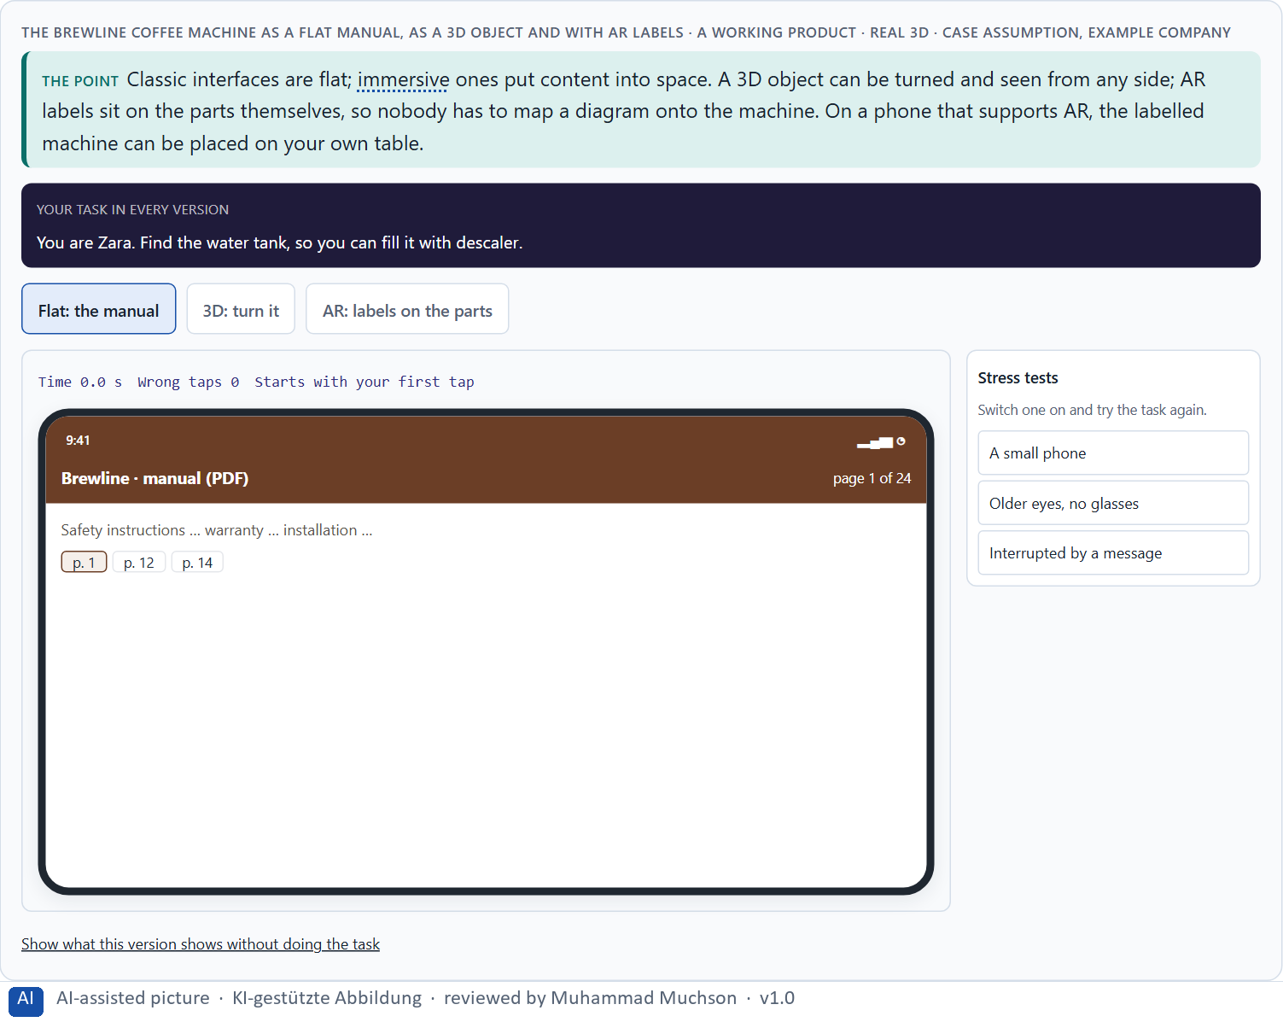
Figure 1 · The Brewline coffee machine as a flat manual, as a 3D object and with AR labels · real 3D. Shown here in its starting state; in the Neuro-UX Lab every version and every stress test can be used.
Future interfaces and what they are good for
Technology | What it does | Good for | Needs
Augmented reality (AR) | Lays information over the real world. | Help at an object; seeing if something fits. | A phone or glasses, light, a stable view.
Virtual reality (VR) | Replaces the world with a digital one. | Practice without risk; places you cannot visit. | A headset, space, short sessions.
Mixed reality (MR) | Digital objects in and reacting to the real room. | Planning in place; working on a virtual object. | Advanced headsets; mapping of the room.
Spatial interfaces | Use position and depth. | Seeing structure and order. | 3D content.
Sensory interaction | Touch, sound, gesture. | Hands-busy work; feedback without looking. | Sensors; careful design.
Context-adaptive systems | Change with the situation. | The right help at the right moment. | Good data about the situation.

Case assumption
Brewline, Zara, Edgar, Kim and Ruth are made up for this example; the 3D machine is a generic model. The continuum from the real world through AR to VR follows Milgram and Kishino (1994).

How to decide when this comes up in the task
- Say which technology a proposal means: AR, VR, MR, spatial, sensory or context-adaptive.
- Ask what it adds over a flat screen for this task: place, depth, hands-free, practice without risk.
- Ask what it needs: devices, light, network, space, content.
- Remember that AR keeps people in their world; VR takes them out of it.
- Treat “the metaverse” as a word, not a plan: ask for the task.

Extra · go deeper (optional reading)
Flat and spatial are not better and worse; they are good at different things. A list of steps is faster to scan on a flat screen; the place of a part is faster to find in space. Most good immersive products combine both: the step in a calm panel, the place on the object.

Sources · Milgram & Kishino 1994 · Slater & Sanchez-Vives 2016

A2 · Presence, attention and load: what the brain does in immersive space · 12 min · Core
Immersion creates presence: the feeling of being there, with space, attention, the body and several senses involved. The brain's limits stay: attention is narrow, working memory small, and under stress people follow the most visible cue. Good immersive design steers perception, keeps load low and supports decisions.
IN PLAIN WORDS
The idea. In immersive space people feel present: they are “there”. Space, presence, attention, embodiment (using the body) and several senses at once make experiences intense. The brain's limits stay the same: attention is narrow, working memory small, and every overlay, sound and movement competes for it. Good immersive design steers perception (what people notice first), keeps cognitive load low, and remembers that decisions under stress follow the most visible cue, not the most important one.
Why it matters. Block 1.1 asks why BuildVision's users are impressed but overwhelmed in stressful situations, Block 1.2 about acceptance of immersive formats, and Block 2.1 about IndustryXR's attention steering and overload risks. This card explains what immersion does to attention and load.
How to read the picture. The same Brewline machine with two AR labels, with nine, and with nine plus movement and sound cues.

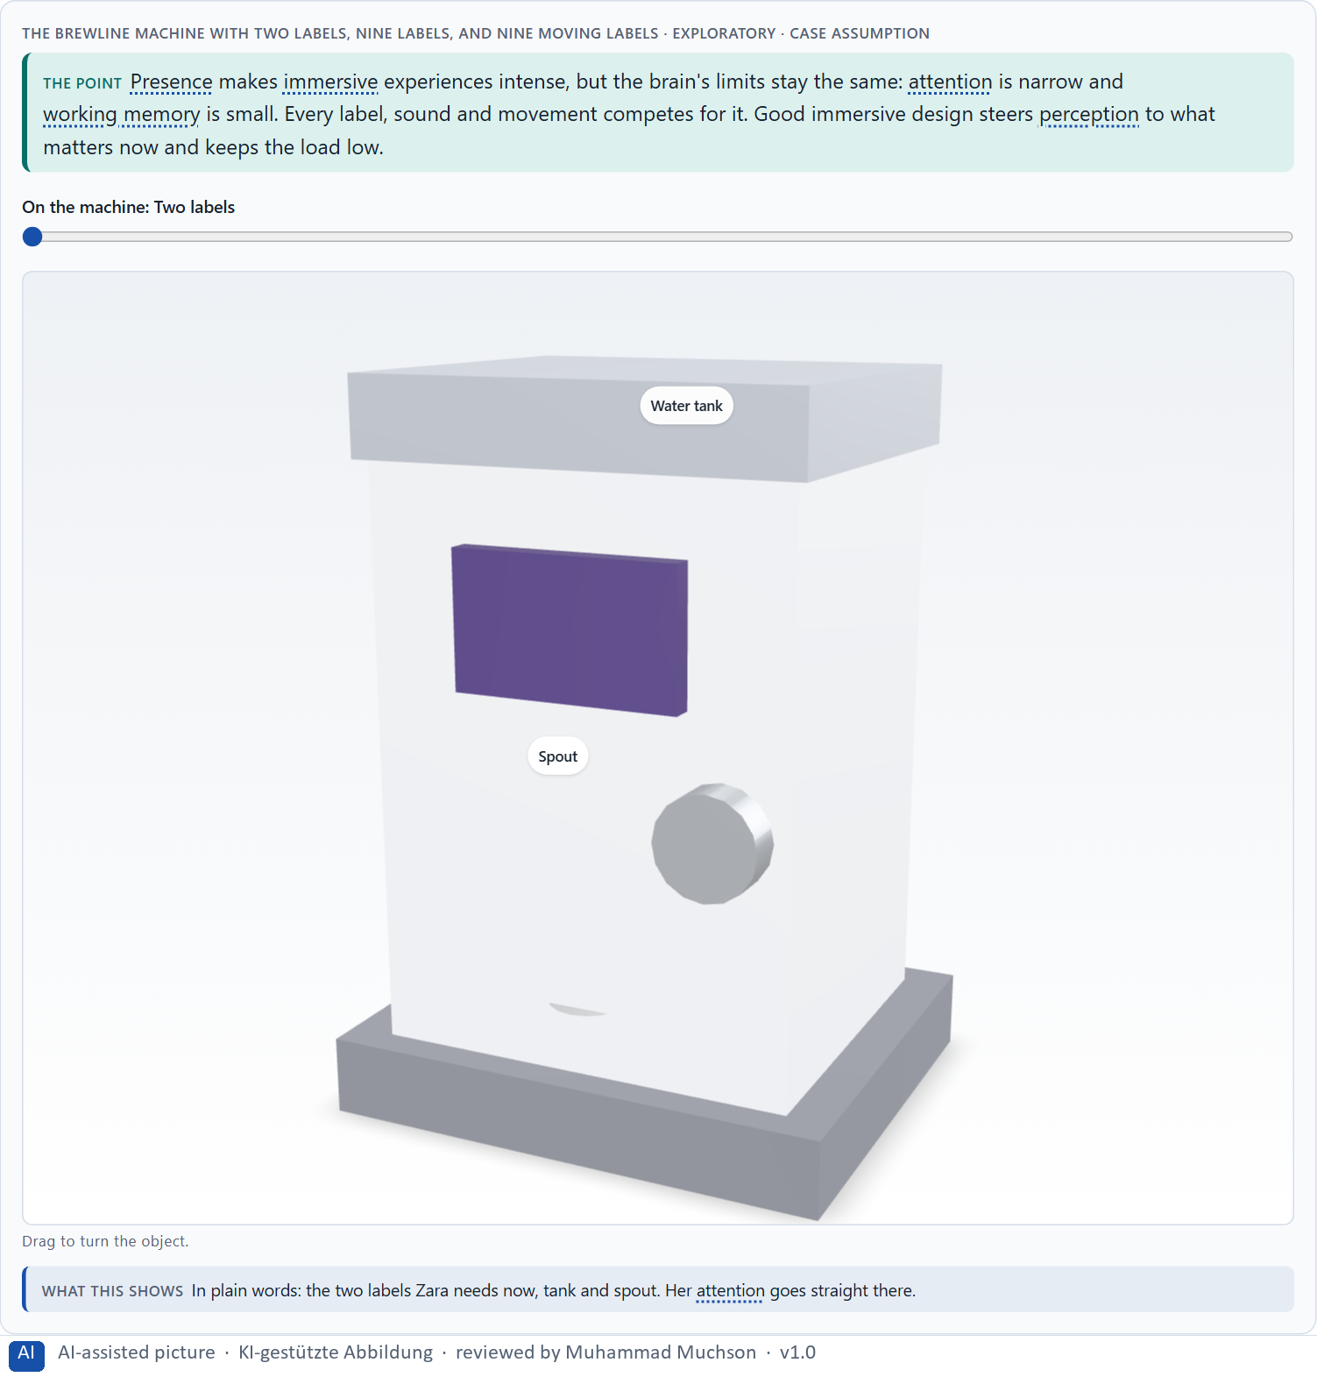
Figure 2 · The Brewline machine with two labels, nine labels, and nine moving labels · Exploratory.
Neuroscience basics, and what they mean in immersive space
Basic | What it means | For immersive design
Attention | Only a little can be attended to at once. | One focus per step; quiet everything else.
Cognitive load | Working memory fills up fast. | Show, don't make people remember; short steps.
Perception steering | Contrast, movement, sound and position decide what is noticed. | Make the important thing the most noticeable.
Stimulus processing | More stimuli, more effort; some people are more sensitive. | Fewer stimuli; a calm option.
Decision behaviour | Under stress, people take the most available cue. | Make the right action the obvious one.

Case assumption
Brewline, Zara, Edgar, Kim and Ruth are made up for this example; the 3D machine is a generic model. Presence follows Slater and Sanchez-Vives (2016); selective attention under load follows Lavie (2005).

How to decide when this comes up in the task
- Count what competes for attention in the scene: labels, sounds, movement.
- Show only what the person needs for this step.
- Use movement and sound sparingly: they capture attention whether people want it or not.
- Design the most important cue to be the most visible one.
- Test in the stressful moment, when attention narrows most.

Extra · go deeper (optional reading)
Presence is double-edged. The feeling of being there is what makes VR training memorable, and it is also why a badly designed scene can feel threatening or exhausting. The same intensity that teaches a safety procedure can overwhelm someone who is already anxious.

Sources · Slater & Sanchez-Vives 2016 · Lavie 2005

A3 · Intensify or overwhelm: the chances and risks of immersive UX · 12 min · Core
Immersive UX can intensify experiences or overwhelm people. Chances: better visualisation, support in the situation, training, experiencing complex content, new interaction. Risks: stimulus overload, disorientation, low acceptance, technical hurdles and high implementation effort. The same feature can help in calm and hurt in stress.
IN PLAIN WORDS
The idea. Immersive technology can intensify an experience or overwhelm it. Its chances: better visualisation (seeing inside a machine), support in the situation (help at the object), training (practising without risk), experiencing complex content (a building before it is built), and new forms of interaction. Its risks: stimulus overload, disorientation, low acceptance, technical hurdles (devices, connection, light, noise) and high implementation effort. The same feature can be a help in a quiet room and a burden in a stressful moment.
Why it matters. Block 1.1 asks for BuildVision's chances and risks and its two biggest of each, Block 1.2 for HealthSpace's risks, and Block 2.1 for IndustryXR's central chances and risks. This card gives you both lists by name.
How to read the picture. The Brewline descaling guide in AR, once on a quiet Sunday and once with a crying child, a beeping machine and a weak connection.

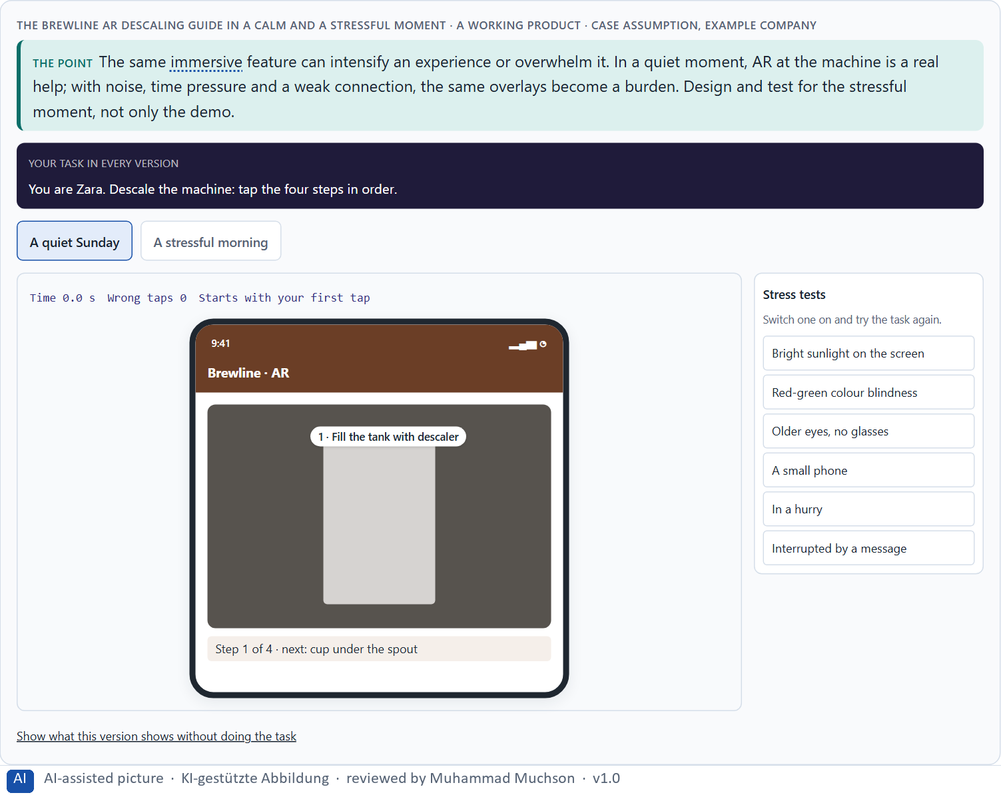
Figure 3 · The Brewline AR descaling guide in a calm and a stressful moment. Shown here in its starting state; in the Neuro-UX Lab every version and every stress test can be used.
Chances and risks of immersive UX
Chance | Example (Brewline) | Risk | What it looks like
Better visualisation | See inside the machine. | Stimulus overload | Nine labels and an advert.
Support in the situation | The descaling step on the tank. | Disorientation | Labels that drift with a weak signal.
Training | Café staff practise milk foam in VR. | Low acceptance | Edgar will not use AR at all.
Experiencing complex content | How the brewing unit works. | Technical hurdles | Steam, bad light, old phones.
New interaction | Ask the machine with your hands full. | High effort | Content for every model, every update.

Case assumption
Brewline, Zara, Edgar, Kim and Ruth are made up for this example; the 3D machine is a generic model. Motion sickness in VR follows Rebenitsch and Owen (2016).

How to decide when this comes up in the task
- Name the chance: what does immersion make possible that a screen does not?
- Name the risk next to it: overload, disorientation, acceptance, technology, effort.
- Picture the worst realistic moment of use: noise, gloves, time pressure, bad light, no network.
- Ask who will not or cannot use it: older users, people prone to motion sickness, people without the device.
- Count the effort beyond the demo: devices, content, updates, support.

Extra · go deeper (optional reading)
Users are often impressed in the first test and overwhelmed in the third week. The first test measures novelty; daily use measures value. A pilot that ends after the wow phase has not tested anything that matters for an investment decision.

Sources · Rebenitsch & Owen 2016 · Lavie 2005

A4 · Fascination or impact: user value, maturity and marketability · 12 min · Core
A future technology is relevant only when it creates real value for users: it solves a real problem better than a classic interface. Four things decide together: the user's need, the innovation, its maturity in the real environment, and its marketability. Fascination is not a reason.
IN PLAIN WORDS
The idea. A future technology is relevant only when it creates real value for users: it solves a real problem better than a classic interface would. Four things decide together: the user's need, the innovation itself, its maturity (does it work reliably, in the real environment, for real users?) and its marketability (will people use it, can it be built and paid for at scale?). Fascination is not a reason; many impressive demos solve nothing.
Why it matters. Block 1.1 asks which of BuildVision's uses are helpful and which only demonstrative, Block 1.2 rates user value, maturity and economics, and Block 2.1 asks to prioritise IndustryXR's use cases by value and feasibility. This card gives you the test.
How to read the picture. Brewline's five ideas placed by user value and maturity. Below, the steps from an idea to a product in use.

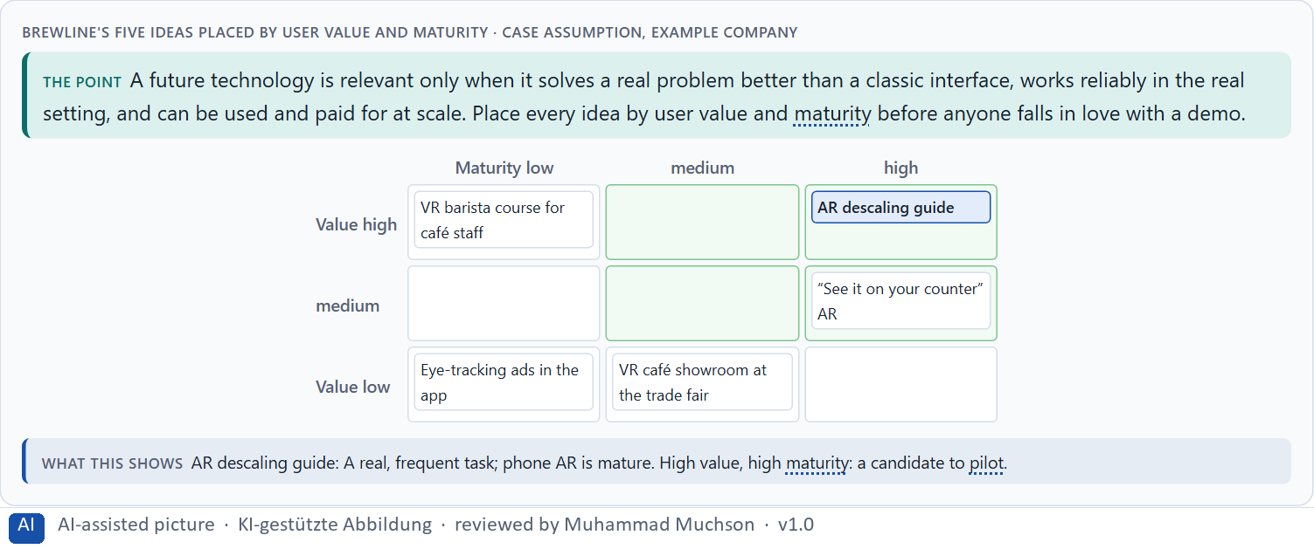
Figure 4 · Brewline's five ideas placed by user value and maturity.
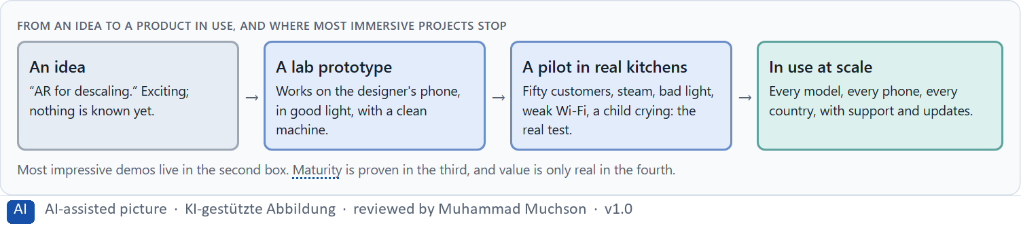
Figure 5 · From an idea to a product in use, and where most immersive projects stop.
Case assumption
Brewline, Zara, Edgar, Kim and Ruth are made up for this example; the 3D machine is a generic model. Reserving immersion for meaningful moments follows Apple's guidelines; reframing a solution as a problem follows the GOV.UK Service Manual.

How to decide when this comes up in the task
- Name the user's problem first, then the technology.
- Compare with the classic solution: is the immersive one clearly better for this task?
- Judge maturity in the real environment, not in the lab.
- Ask whether people will use it and whether it can be built, run and paid for at scale.
- Leave out what only impresses.

Extra · go deeper (optional reading)
Demonstrative use cases are attractive because they are easy to show and hard to evaluate. A useful test: would a customer miss it if it disappeared next month? A descaling guide they used twice, yes; a trade-fair showroom they saw once, no.

Sources · GOV.UK Service Manual · Apple HIG

A5 · Ethics and responsibility, and weighing a measure · 12 min · Core
Immersive and neuro-based interfaces see more of people than screens: rooms, bodies, gaze. They can make people sick, exclude those without devices, and steer attention in the company's interest. Responsible leaders prioritise by effect, economics and responsibility, not fascination. Weigh measures on effect, feasibility, risk, time pressure and investment security.
IN PLAIN WORDS
The idea. Immersive and neuro-based interfaces raise their own ethical questions: cameras that scan homes and workplaces, data about where people look and how their body moves, motion sickness and exhaustion, exclusion of people who cannot use headsets, and attention steering that can slip into manipulation. Responsible leaders prioritise future technologies by effect, economics and responsibility, not by fascination. To put measures in order, weigh each on effect on users, feasibility, risk, time pressure and investment security.
Why it matters. Block 1.2 asks about trust and risk in health, and Block 2.1 asks for four prioritised measures for IndustryXR, justified on effect on users, feasibility, risk, time pressure and investment security. The example uses Brewline and its own measures, so the answer for the task cases is not given.
How to read the picture. Five ethical questions asked of three Brewline ideas. Then three measures rated on five criteria.

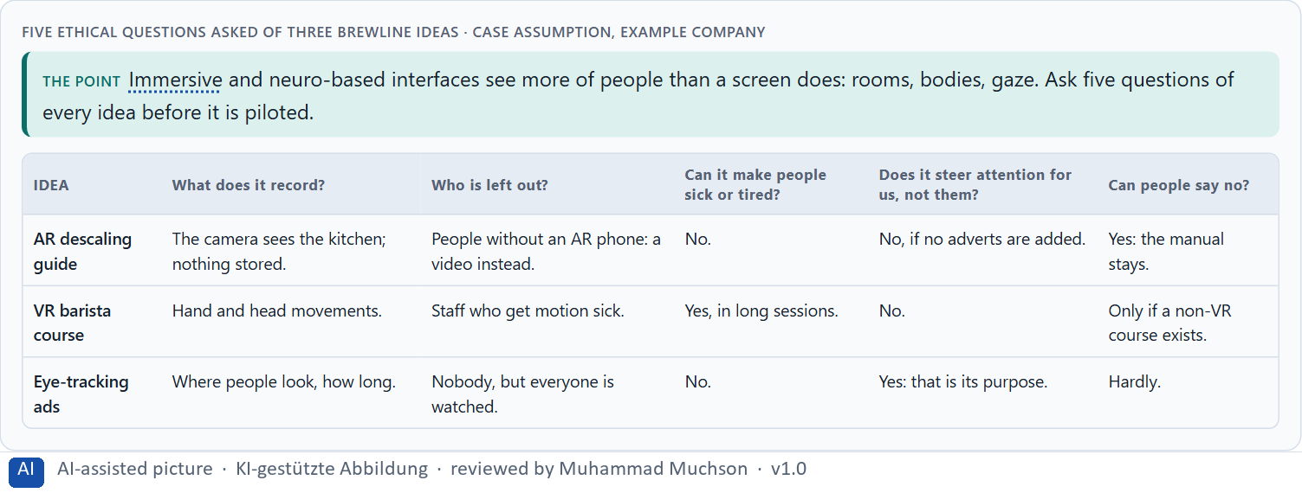
Figure 6 · Five ethical questions asked of three Brewline ideas.
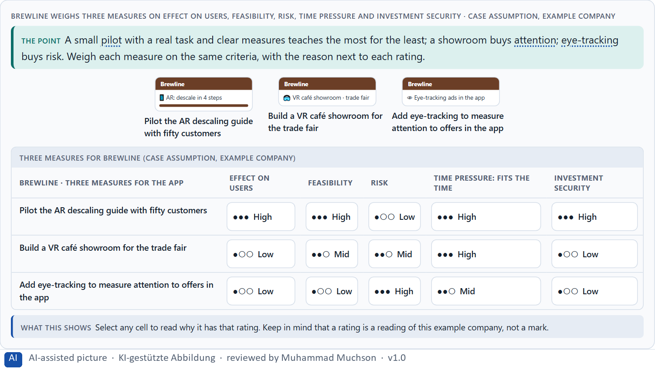
Figure 7 · Brewline weighs three measures on effect on users, feasibility, risk, time pressure and investment security.
Case assumption
Brewline, Zara, Edgar, Kim and Ruth are made up for this example; the 3D machine is a generic model. Rating options on the same criteria follows Gibbons (2018); the five criteria are the ones the plan names for the case study.

How to decide when this comes up in the task
- What does it record about people and their surroundings, and where does it go?
- Who is left out, and what do they use instead?
- Can it make people sick, tired or anxious?
- Does it steer attention for the user or for the company?
- Rate every measure on the same five criteria, with a reason; a rating is a judgement, never a mark.

Extra · go deeper (optional reading)
Neuro-informed design knows how attention works, which makes it powerful in both directions. The same knowledge that puts the right step in front of a technician can put an offer in front of a tired customer. The line between guidance and manipulation is whose interest the steering serves.

Sources · Rebenitsch & Owen 2016 · Gibbons 2018

Materi B · Route 2 · Level 3
How Materi B is used
About 60 minutes, three cards, led by the facilitator. Level 3 in the Chief Experience Officer's chair: a guiding vision for future UX innovation, three strategic decisions, an order of what is piloted first, a risk analysis, a governance model, one decision under uncertainty and a statement to the management. The cards give you the ideas you use in Task 2.

B1 · Future technologies as decision architecture, not a trend · 20 min · Core
At senior level future technologies are a decision architecture for innovation, service quality and differentiation: a guiding vision of the immersive value wanted, a portfolio that separates watching, piloting and scaling, one evaluation grid, and stage gates where pilots prove themselves. Innovation is managed like an investment.
IN PLAIN WORDS
The idea. At senior level, future technologies are not a trend to follow but a decision architecture for innovation, service quality and differentiation: a guiding vision of what immersive value the company wants, a portfolio that separates watching, piloting and scaling, an evaluation grid (value, maturity, effort, scaling potential, responsibility), and stage gates where a pilot must prove itself before it grows. Innovation is managed like an investment, not like a showcase.
Why it matters. Block 3.1 asks for a guiding vision for future UX innovation, three decisions on technology use, maturity assessment, user value and portfolio, and an order of which use cases, touchpoints or product areas are piloted first. You decide the architecture, not single trend technologies.
How to read the picture. Left Brewline chasing headsets to look innovative, right running an innovation portfolio with gates. Below, the layers from a guiding vision to every pilot.

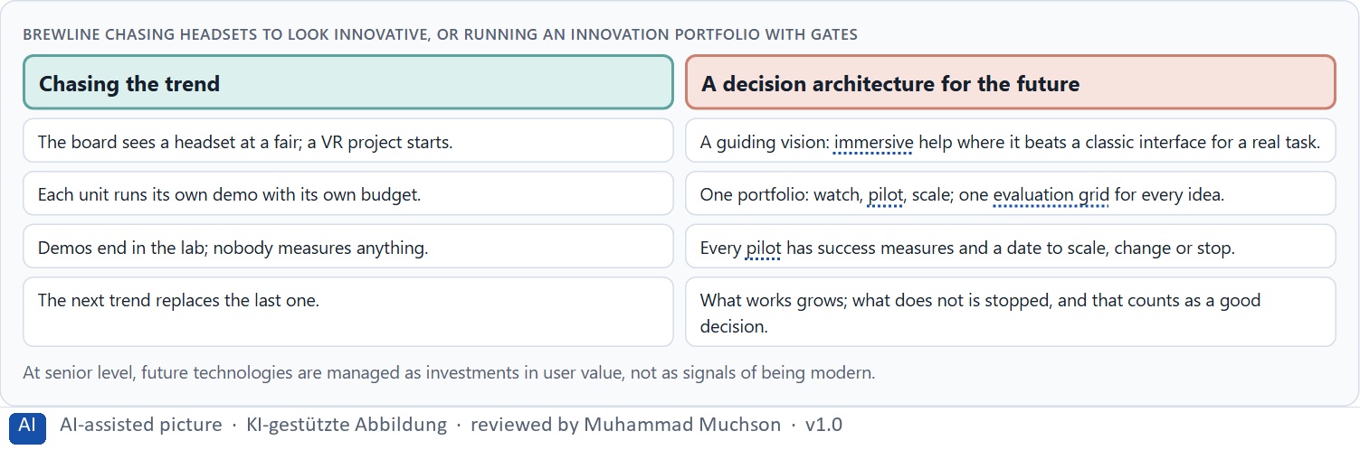
Figure 8 · Brewline chasing headsets to look innovative, or running an innovation portfolio with gates.
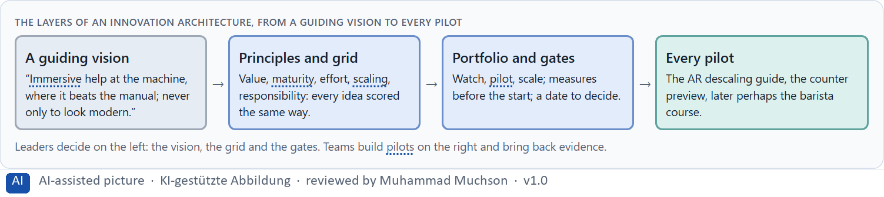
Figure 9 · The layers of an innovation architecture, from a guiding vision to every pilot.
Case assumption
Brewline, Zara, Edgar, Kim and Ruth are made up for this example; the 3D machine is a generic model. Discovery, alpha and the decision to go on or stop follow the GOV.UK Service Manual.

How to decide when this comes up in the task
- Check how future technologies are decided today: by enthusiasm, or by a grid?
- Write a guiding vision: what immersive value, for whom, and what is not done for show.
- Separate watching, piloting and scaling in one portfolio.
- Use one evaluation grid: value, maturity, effort, scaling, responsibility.
- Put a gate before every step up: measures set in advance, a date to decide.

Extra · go deeper (optional reading)
Innovation labs often produce demos rather than products, because a demo is the end of their task. A portfolio changes the task: the lab's job is to produce evidence for a decision, and a stopped pilot with clear evidence is a success.

Sources · GOV.UK Service Manual · Apple HIG

B2 · Innovation, value, maturity, risk, ethics: the conflicts of the future · 20 min · Core
Future technologies sit between the degree of innovation and user value, visibility and maturity, investment risk and the risk of falling behind, ethics and speed, and feasibility. A portfolio of a few bets of different size, each with a reason, measures set in advance and a decision date, makes the conflicts manageable; write down what each bet assumes.
IN PLAIN WORDS
The idea. Future technologies sit between goals that pull apart: the degree of innovation against user value, visibility against maturity, investment risk against the risk of falling behind, ethics against speed, and all of them against feasibility. The way through is a portfolio: a few bets of different size and maturity, each with a reason, success measures set in advance, and a date to decide whether to scale, change or stop; and a written list of the assumptions each bet rests on.
Why it matters. Block 3.1 asks for three decisions, a risk analysis of wrong assumptions about innovation, user behaviour, market maturity and economics, and a governance model for conflicts between visibility, effect, risk and effort. Each is a decision between conflicting goals.
How to read the picture. Brewline's three bets, a safe one, a medium one and a bold one, with what each costs and what it can teach.

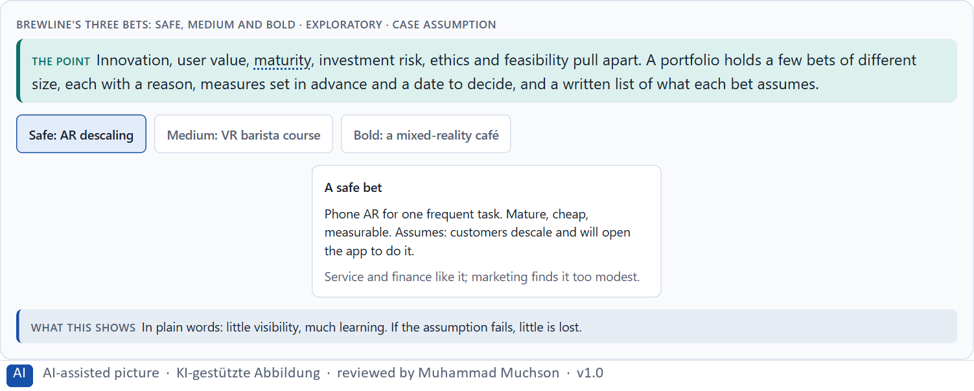
Figure 10 · Brewline's three bets: safe, medium and bold · Exploratory.
Standing conflicts of future technologies
Conflict | Who usually stands for each side | What to ask
Innovation against user value | The board and the lab, against users and service. | Which user problem does it solve better?
Visibility against maturity | Marketing, against engineering. | Does it work in the real environment, at scale?
Investment risk against falling behind | Finance, against strategy. | What is the smallest bet that teaches us enough?
Ethics against speed | Data protection and safety, against the launch date. | What does it record, and who could be harmed?

Case assumption
Brewline, Zara, Edgar, Kim and Ruth are made up for this example; the 3D machine is a generic model. The bets are a reading of the example, not a rule for every company.

How to decide when this comes up in the task
- Name each conflict as two goals and say who stands for each: board, units, safety, finance, users.
- Hold a few bets of different size: safe, medium, bold.
- Write down the assumptions each bet rests on: innovation, user behaviour, market maturity, economics.
- Set the measures and the decision date before the pilot starts.
- Say what the choice gives up.

Extra · go deeper (optional reading)
A future technology becomes a reputational risk when it is launched as a promise and experienced as a gimmick: when the headline outruns the product. The safest way to protect reputation is to let the evidence lead the announcement, not the other way round.

Sources · GOV.UK Service Manual · Slater & Sanchez-Vives 2016

B3 · Who decides on future technologies, and deciding without test data · 20 min · Core
Future technologies need an owner of the portfolio, one evaluation grid for every idea, stage gates with measures set before a pilot, the right to stop a pilot (not a failure), and a rule for when visibility, effect, risk and effort disagree. With patchy tests, a decision says what it decides, does not know, would reverse and gives up.
IN PLAIN WORDS
The idea. Future technologies need owners and gates: someone who owns the innovation portfolio, an evaluation grid used for every idea, stage gates with success measures set before a pilot starts, the right to stop a pilot (it is not a failure), and a rule for when visibility, effect, risk and effort disagree. Real test data is usually missing at the start; a decision under uncertainty says what you decide, what you do not know, when you would reverse it and what you give up.
Why it matters. Block 3.1 asks for a governance model for future technologies in the UX portfolio, a decision despite missing tests, and a statement to the management. This card gives you the parts of each.
How to read the picture. The four boxes at the top are the parts of a decision, filled in for Brewline. The two boxes below are the rule for future decisions.

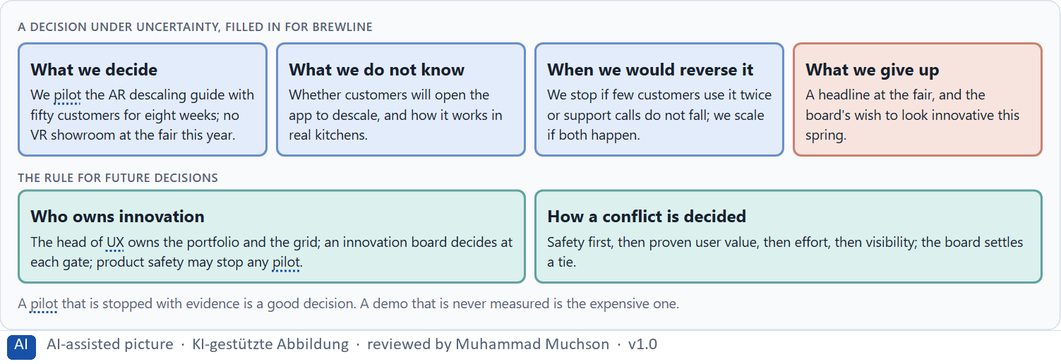
Figure 11 · A decision under uncertainty, filled in for Brewline.
Four parts of innovation governance
Part | The question | An example (Brewline)
Owner and grid | Who owns the portfolio; how is every idea scored? | The head of UX; value, maturity, effort, scaling, responsibility.
Gates | What must a pilot show before it grows? | Use, completion, support calls, cost, by a set date.
Stop right | Who may stop a pilot? | The innovation board; product safety at any time.
How a conflict is decided | What happens when visibility, effect, risk and effort disagree? | Safety, then proven value, then effort, then visibility; the board settles a tie.

Case assumption
Brewline, Zara, Edgar, Kim and Ruth are made up for this example; the 3D machine is a generic model. “It's not a failure to stop” follows the GOV.UK Service Manual; deciding with limited information follows Simon (1956); the premortem follows Klein (2007).

How to decide when this comes up in the task
- Name who owns the innovation portfolio and the grid.
- Set the measures and the decision date before every pilot.
- Give a board the right to scale, change or stop, and safety the right to stop.
- Settle conflicts by safety first, then proven value, then effort, then visibility; say who settles a tie.
- Say what you decide, what you do not know, when you would reverse it and what you give up.

Extra · go deeper (optional reading)
The most expensive innovation decisions are the ones nobody made: pilots that were never stopped and never scaled, kept alive by goodwill. A gate with a date forces the decision. Write the stop criteria down before the pilot starts, when nobody is attached to it yet.

Sources · GOV.UK Service Manual · Simon 1956 · Klein 2007

Use in class: presentation and handout
Mark of use for the study material. Presentation is what the trainer shows on screen; Handout is what participants read and keep.
Card | Presentation (shown in the Neuro-UX Lab) | Handout
A1 · From screen to space: AR, VR, MR and other future interfaces (Core) | Scan line and Figure 1; the "In plain words" and "How to decide" boxes | The whole card
A2 · Presence, attention and load: what the brain does in immersive space (Core) | Scan line and Figure 2; the "In plain words" and "How to decide" boxes | The whole card
A3 · Intensify or overwhelm: the chances and risks of immersive UX (Core) | Scan line and Figure 3; the "In plain words" and "How to decide" boxes | The whole card
A4 · Fascination or impact: user value, maturity and marketability (Core) | Scan line and Figures 4–5; the "In plain words" and "How to decide" boxes | The whole card
A5 · Ethics and responsibility, and weighing a measure (Core) | Scan line and Figures 6–7; the "In plain words" and "How to decide" boxes | The whole card
B1 · Future technologies as decision architecture, not a trend (Core) | Scan line and Figures 8–9; the "In plain words" and "How to decide" boxes | The whole card
B2 · Innovation, value, maturity, risk, ethics: the conflicts of the future (Core) | Scan line and Figure 10; the "In plain words" and "How to decide" boxes | The whole card
B3 · Who decides on future technologies, and deciding without test data (Core) | Scan line and Figure 11; the "In plain words" and "How to decide" boxes | The whole card

References
Check each source and its current edition before you teach from it. Standards and laws marked as in flux can change.
Milgram, P., & Kishino, F. (1994). A taxonomy of mixed reality visual displays. IEICE Transactions on Information and Systems, E77-D(12), 1321–1329. (The reality–virtuality continuum from the real world through augmented reality to virtual reality.)
Slater, M., & Sanchez-Vives, M. V. (2016). Enhancing our lives with immersive virtual reality. Frontiers in Robotics and AI, 3, 74. (Presence: the feeling of being there, and what immersion can and cannot do.)
Lavie, N. (2005). Distracted and confused?: Selective attention under load. Trends in Cognitive Sciences, 9(2), 75–82. (Attention is limited; under load, what is processed depends on what competes for it.)
Rebenitsch, L., & Owen, C. (2016). Review on cybersickness in applications and visual displays. Virtual Reality, 20(2), 101–125. (Motion sickness in VR and the factors that make it worse.)
Government Digital Service. Service Manual: How the discovery phase works; How the alpha phase works. https://www.gov.uk/service-manual/agile-delivery (read 29.10.2026). (Define the problem, test the riskiest assumptions with throwaway prototypes, decide with evidence, including to stop.)
Apple Inc. Human Interface Guidelines: Immersive experiences. https://developer.apple.com/design/human-interface-guidelines/immersive-experiences (read 29.10.2026). (Reserve immersion for meaningful moments; comfort; let people choose when to enter and exit.)
Gibbons, S. (2018). Using Prioritization Matrices to Inform UX Decisions. Nielsen Norman Group. https://www.nngroup.com/articles/prioritization-matrices/ (Rate each option on the same few criteria, such as value to the user against effort, and put the reason next to each rating.)
Simon, H. A. (1956). Rational choice and the structure of the environment. Psychological Review, 63(2), 129–138. (With limited information and time, people choose an option that is good enough rather than the best one: a decision under uncertainty.)
Klein, G. (2007). Performing a project premortem. Harvard Business Review, 85(9), 18–19. (Imagine the plan has failed and ask why; it brings risks and wrong assumptions to the surface before the work starts.)

Glossary
Every term below is used in this document. Terms stay plain text in the body; this list says what they mean in everyday words.
Term | In plain words | Example | Comes from
Adaptive system | A system that reacts to the situation now (time, place, device, what someone just did) without learning about the person over time. | — | Day 10
Attention | The mind's spotlight. Only a small part of a screen is processed at any moment; attention decides which part. | A flashing banner takes attention away from the form you were filling in. | Day 1
Augmented reality (AR) | Digital information laid over the real world, for example labels on a machine seen through a phone or glasses. | — | Day 14
Case assumption | A fact made up for this exercise to fill a gap in the plan's case. It is marked so you know it is not part of the plan. | — | Day 1
Chief Experience Officer | The manager who is responsible for the experience customers have across all channels, and who decides where the company invests in it. | — | Day 1
Cognitive load | How much a person has to hold in mind and work out at the same time. Every extra signal or choice adds to it; when it is too high, people skip, freeze or leave. | — | Day 1
Contrast | How much something differs from its surroundings in brightness, colour or size. Strong contrast makes it stand out; too many strong contrasts make everything compete. | — | Day 2
Cybersickness | Dizziness or nausea in VR when what the eyes see and what the body feels do not match. | — | Day 14
Dark pattern | A design that uses emotion against people's own interest, such as false urgency, guilt or hidden costs. | — | Day 7
Decision architecture | A set of connected decisions that are made on purpose and written down: what effect you want, what comes first, who decides and how conflicts are settled. It replaces many separate fixes. | — | Day 1
Embodiment | Using the body (hands, movement, position) to interact, instead of only a mouse or a touch screen. | — | Day 14
Governance | The rules about who may decide what, who is answerable for it and how disagreements are settled. | — | Day 1
Immersion | How much a technology surrounds the senses and shuts out the real surroundings; more immersion can mean more presence, and more load. | — | Day 14
Maturity | How far a technology is from an idea to reliable use: does it work, in the real environment, for real users, at scale? | — | Day 14
Mixed reality (MR) | Digital objects that sit in the real room and react to it, between AR and VR. | — | Day 14
Neuro-UX | Designing an interface with knowledge of how the brain sees, attends, feels and decides, so that the design steers these processes on purpose and responsibly. | — | Day 1
Overstimulation | Too many signals at once (badges, sounds, pop-ups, counters), so people stop noticing any of them or feel pushed. | — | Day 9
Perception | Taking in what the senses deliver, for example what the eyes see on a screen, before thinking about it. | — | Day 1
Presence | The feeling of really being in a place that is digital or partly digital. | — | Day 14
Scanning | Looking over a screen quickly and picking out what seems relevant, instead of reading it word by word. Most people scan first. | — | Day 2
Stage gate | A planned decision point where a pilot must show evidence before it gets more money: scale, change or stop. | — | Day 14
Touchpoint | Any place where a person meets the company: the website, the customer portal, the app, a chatbot or a phone call. | — | Day 1
UX (user experience) | Everything a person goes through when using a product: what they notice, understand, feel and do, from the first look to the last step. The screens are only one part of it. | Finding the booking you want at once and feeling sure it went through is a good UX. | Day 1
Virtual reality (VR) | A digital world that replaces the real one, usually through a headset. | — | Day 14
Working memory | The part of memory that holds what you are using right now, such as a code you just read. It is small and easily overloaded. | — | Day 4

The Neuro-UX Lab: where we practise online
In class we use the course website as the place to practise and to learn. Every day has its own address, in the same pattern: the day number is the last part.
What | Address
Neuro-UX Lab (course website) | https://aion-ux-lab.vercel.app/
Day 14 | https://aion-ux-lab.vercel.app/day/14/

On the day page, Route 1 (Levels 1 and 2) and Route 2 (Level 3) can be opened; the cards and the tasks of this document are there too. The pattern is the same up to Day 8, for example https://aion-ux-lab.vercel.app/day/6/.

