AION · UX DEVELOPER · PSYCHOLOGICAL UX DESIGN AND NEURO-UX
DAY 14 · TASK 1 AND TASK 2 · ROUTES 1 AND 2 · LEVELS 1 TO 3
IndustryXR: UX Analysis File and UX Strategy Memo
Describe the effect, choose the measures as a team member, and decide as Chief Experience Officer
AI notice · KI-Hinweis
This document was produced with the help of an AI language model (Claude, Anthropic). The AI drafted the text and tables and built the pictures and working examples of the lab. The content was then read, corrected and approved by the reviewer named below, who is responsible for its accuracy. Every picture carries an AI label on the image. Check figures and sources before you quote them.
KI-Hinweis: Dieses Dokument wurde mit Unterstützung eines KI-Sprachmodells (Claude, Anthropic) erstellt. Texte und Tabellen wurden von der KI entworfen, die Abbildungen sind KI-gestützt erstellt und am Bild gekennzeichnet. Die fachliche Prüfung und Freigabe erfolgte durch die unten genannte Person.

Day | Day 14 · Module 7 (day 1 of 3): Immersive technologies and neuroscientific UX basics
Document | Task (worksheet with answer spaces). Task 1 (UX Analysis File) and Task 2 (UX Strategy Memo).
Route and level | Task 1 = Route 1, Levels 1 and 2 (draws on Materi A). Task 2 = Route 2, Level 3 (draws on Materi B).
Time | Task 1 about 33 min · Task 2 about 20 min
Neuro-UX Lab (website) | https://aion-ux-lab.vercel.app/day/14/
Case | IndustryXR, the day's case study; other products appear as warm-ups
Version | 1.0 · release date 29.10.2026
Review and approval | Muhammad Muchson, Mentor (subject-matter review and approval)

ABOUT THIS DOCUMENT
In class we also use the Neuro-UX Lab, the course website, as the place to practise and learn. Its address is at the end of this document.
This is the worksheet for Day 14. Read the case once, study the evidence printed in this document, and write your answers in the boxes and tables. You can work through it on paper or type into the document. All blocks are Core. There are no answer keys and no scores; the reason you give matters more than the choice.

IN THIS DOCUMENT
Lesson plan: ten teaching units (Ablaufplan)
Case study and transfer project at a glance
The case: two platforms on the UX team's desk, and IndustryXR
Block 1.1 · Analyse immersive potentials and risks of a future scenario: BuildVision · JUDGED · Core · about 10 min
Block 1.2 · Rate future technologies in UX design under conflicting goals: HealthSpace · JUDGED · Core · about 8 min
Block 2.1 · Case study: a future strategy for the training and service offer IndustryXR · JUDGED · Core · about 15 min
The situation: great enthusiasm, no priorities
Block 3.1 · A strategic UX innovation architecture for immersive and neuro-based future technologies · JUDGED · Core · about 20 min

Day at a glance
Day 14 has ten teaching units (UE). This document is the worksheet; it is used in UE2 to UE6 (Task 1) and UE8 to UE10 (Task 2). The day is built from three documents and the Neuro-UX Lab: Materi (study material), Task (worksheet) and Trainer (coaching, feedback and model solutions), plus the course website.

Lesson plan: ten teaching units (Ablaufplan)
UE | Min | Plan item | What happens | Material | Format
1 | 45 | Knowledge transfer · Level 1 | The trainer presents the cards of Materi A (A1, A2, A3, A4, A5, about 60 min of cards) in the Neuro-UX Lab; participants follow in the handout. | Materi A (Route 1) | Presentation + Handout
2 | 45 | Level 1 · Task 1 | Individual work on Block 1.1 (Core, about 10 min): the first product of the day is read and its effect described. Pairs then compare their results and the trainer collects open questions. | Task 1 · Part 1 · Block 1.1 | Handout (or in the lab)
3 | 45 | Level 1 · Task 2 | Three options are rated on the same criteria and one is chosen under the stated conditions: Block 1.2 (Core, about 8 min). | Task 1 · Part 1 · Block 1.2 | Handout (or in the lab)
4 | 45 | Coaching · transition from Level 1 to Level 2 | Trainer-led. A short talk on the day's coaching focus, then the reflection questions in pairs. The bridge: from describing an effect to a decision you answer for. There is no worksheet block in this unit. | Trainer document, section Coaching | Trainer only
5–6 | 90 | Level 2 · Case study IndustryXR (2 UE) incl. model solution | UE5: the trainer presents the case; participants work on Block 2.1 (Core, about 15 min). UE6: groups compare their results and defend them; the trainer closes with the model solution. | Task 1 · Part 2 · Block 2.1  Trainer document, section Case study | Handout; model solution shown after the work
7 | 45 | Level 2 + 3 · Feedback round with a management perspective | Groups present their reasoning, not only their result. The trainer asks the day's Level 3 input questions and leads the discussion. | Trainer document, section Feedback round | Presentation by the groups; Trainer only
8 | 45 | Level 3 · Transfer project, Chief Experience Officer (3 UE: UE8–10) | The trainer presents Materi B (B1, B2, B3; use the "In plain words" and "How to decide" boxes, the rest is handout) and sets the role and the situation. | Materi B (Route 2) | Presentation + Handout
9 | 45 | Level 3 · Transfer project | Individual work or in pairs on Block 3.1 (Core, about 20 min): the strategy memo. | Task 2 · Block 3.1 | Handout (or in the lab)
10 | 45 | Level 3 · Transfer project | Participants present their decision and what they give up, including the one decision made under uncertainty; the trainer debriefs with the model solution. | Task 2 · Block 3.1  Trainer document, section Transfer project | Handout; model solution shown after the work

One UE is counted as 45 minutes here; breaks are not shown. The times are a guide for the trainer. The Core blocks are enough for a complete answer.

Case study and transfer project at a glance
Component | UE | Duration | Participants work in | Model solution in
Level 2 case study (IndustryXR) | UE5–6 | 2 UE · 90 min | Task 1 · Part 2 (Block 2.1) | Trainer document, section Case study
Level 3 transfer project (Chief Experience Officer) | UE8–10 | 3 UE · 135 min | Materi B and Task 2 (Block 3.1) | Trainer document, section Transfer project

Which plan item each block answers
UE | Plan item (Strukturplan, Day 14) | Block in this document
UE2 | Level 1, task 1 · Analyse immersive potentials and risks of a future scenario: BuildVision | Block 1.1 (Core)
UE3 | Level 1, task 2 · Rate future technologies in UX design under conflicting goals: HealthSpace | Block 1.2 (Core)
UE4 | Coaching: from describing to deciding | A classroom talk led by the trainer; not a worksheet block
UE5–6 | Level 2 case study · Case study: a future strategy for the training and service offer IndustryXR | Block 2.1 (Core)
UE7 | Feedback round with a management perspective | A classroom discussion led by the trainer; not a worksheet block
UE8–10 | Level 3 transfer project · A strategic UX innovation architecture for immersive and neuro-based future technologies | Block 3.1 (Core), in Task 2

Your name
Write your full name here. Use the same name on every Task document this week; it is how your work is matched.

Task 1 · Route 1 · UX Analysis File: find where immersion helps or overwhelms, then decide how to pilot

The case: two platforms on the UX team's desk, and IndustryXR
Read once · about 3 min
You work in the UX team of a digital agency. This week three projects land on your desk. Two are warm-ups: BuildVision, a platform for planning, training and remote support in technical service, and HealthSpace, a health and prevention platform with three innovation approaches. The main case is IndustryXR: an industrial company plans to develop its training, maintenance and support processes with immersive technologies, discussing AR instructions, VR training environments and neuroscience-informed UX concepts for better attention steering. Inside, enthusiasm for the technology is high, but there is no robust experience of acceptance, economic viability or how it fits existing processes.
What the plan gives you | How the task runs · three blocks
• Block 1.1: BuildVision, with AR overlays of maintenance steps on the device, procedures in space instead of a PDF, a remote support mode, impressed but partly overwhelmed users in stress, technology that is not stable everywhere, and use cases that are partly demonstrative  • Block 1.2: three approaches for HealthSpace; innovative but trustworthy and economic, a limited budget, a heterogeneous and not always tech-savvy group, first pilots in 6 months, hardly any user data on immersive formats, management against departments  • Block 2.1: IndustryXR, with €220,000 for the first phase, 16 weeks for piloting and decision preparation, no full integration soon, several business units, hardly any test data, and first visible innovation steps wanted soon | • Block 1.1: analyse BuildVision's chances and risks for users and the company. Describe them, name five places of real value or overload, sort them into six categories, write three effect statements and pick the two biggest chances and risks.  • Block 1.2: rate three innovation approaches under conflicting goals. Rate each on six criteria, choose one, name the conflicts between visible innovation and responsible introduction and the remaining risks, and write a recommendation to the project lead.  • Block 2.1: the case study. The central chances and risks, sorted into six categories, four measures for a responsible pilot strategy, justified on five criteria, a decision for the first 16 weeks and a recommendation to the division management.

What is known and what is open
In the brief | Clear · Case assumption | Open · on purpose
• BuildVision: AR overlays at the device, spatial procedures, remote support; impressive but overwhelming in stress; unstable in some environments.  • HealthSpace: three approaches in words; a heterogeneous group; pilots in 6 months; hardly any data on immersive formats.  • IndustryXR: unclear value, unprioritised pilots, divergent goals, unassessed risks, no roadmap; €220,000 and 16 weeks; hardly any test data. | • You review BuildVision and HealthSpace as an agency would: by trying them, without access to their users or their data.  • IndustryXR's ideas on the table: AR maintenance instructions, a VR safety training, an AR remote expert, a VR showroom for trade fairs, and an attention-guidance overlay for assembly.  • The company has two headsets and a few tablets; most of its halls have Wi-Fi, the outdoor sites do not.  • Business units sales, service, training and safety each want their own pilot. | • Which idea creates the most value: nobody has compared them.  • How technicians and trainees accept headsets: never tested.  • How much of the €220,000 each pilot would take: the plan does not say.  • Whether any pilot would scale beyond one site: unknown.

As in most projects, not everything is known. Decide anyway, and say what you assume.
Case assumption
The brief says: BuildVision's AR overlays at the device, spatial procedures instead of a PDF, remote expert support, users impressed but overwhelmed in stress, technology unstable in some environments, use cases partly demonstrative; HealthSpace's three approaches (A strongly immersive with high effort, B single elements for defined situations, C classic UX with monitoring and later pilots), innovative but trustworthy and economic, a limited budget, a heterogeneous and not tech-savvy group, pilots in 6 months, hardly any data, management against departments; IndustryXR's unclear value, unprioritised pilots, divergent goals, unassessed risks, an unclear link between fascination and relevance and no roadmap, €220,000, 16 weeks, no full integration, several business units, hardly any test data, first visible steps wanted soon. Those are the plan's facts and its only figures. Everything else is made up for this exercise: the agency, the pages, the 3D scene and the facts marked “Clear”.

Part 1 · Analyse an immersive scenario, and weigh innovation approaches · Level 1 · Knowledge

Block 1.1 · Analyse immersive potentials and risks of a future scenario: BuildVision · JUDGED · Core · about 10 min
Draws on: A1 · From screen to space · A2 · Presence, attention and load · A3 · Intensify or overwhelm · A4 · Fascination or impact.
You receive the description of a fictional platform, BuildVision, for planning, training and remote support in technical service. Open it: a real 3D service device you can turn, with AR overlays of the maintenance steps. Compare the overlays with the PDF checklist, switch on the remote expert, then try it in a stressful situation and with a weak connection. You need no prior knowledge: notice what really helps you at the device and what only impresses. The aim is to analyse immersive technology not only as innovation, but as a system of effects with a logic of benefit and risk.
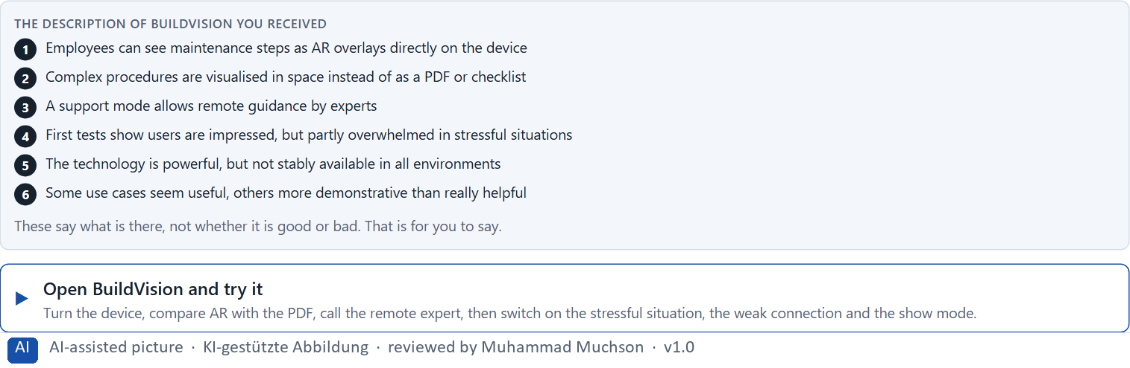
Figure 1 · The product to read, as the lab shows it (buildvision).
Question 1 of 5 · Describe spontaneously which chances and risks this scenario could have from the user's and the company's point of view
Two to four sentences: for the technician and for the company, what helps and what worries you, and why.
How to build the answer:
- Open BuildVision, turn the device and compare the AR steps with the PDF checklist.
- Switch on the remote expert, then the stressful situation and the weak connection.
- Write what helps and what worries, for the technician and for the company.

Question 2 of 5 · Name at least 5 places where immersive technology creates real value or potential overload
How to build the answer:
- Go through your visit: the AR steps, the PDF, the remote expert, the stressful situation, the weak connection, the 3D show view.
- For each place, say whether it creates value or overload, and why.
Write them as a list, one place per line, and say whether it creates value or overload, and why.

Question 3 of 5 · Assign the observations to the categories user value, orientation, load, maturity, acceptance and feasibility
Write the observations that belong to each category in a few words. One may fit two; put it where its effect is strongest.
How to build the answer:
- Take your places from question 2.
- Ask which of the six each one affects most, and write it there.
Category | The observations in this category
User value
Orientation
Load
Maturity
Acceptance
Feasibility

Question 4 of 5 · Write an effect statement for three points: “For users or the organisation this could mean that …”
How to build the answer:
- Pick three places from question 2.
- Finish the plan's sentence with what users or the organisation would feel, do or fail to do.
Write them as a list, one statement per line, each starting with the observation and ending with what it could mean for users or the organisation.

Question 5 of 5 · Prioritise the two biggest chances and the two biggest risks of the scenario
How to build the answer:
- Look at your places with two questions: what helps most technicians most, and what could do the most harm?
- Write the two chances first, then the two risks, each with why.
Write four lines: chance 1, chance 2, risk 1, risk 2, each with why it weighs most.

Block 1.2 · Rate future technologies in UX design under conflicting goals: HealthSpace · JUDGED · Core · about 8 min
Draws on: A3 · Intensify or overwhelm · A4 · Fascination or impact · A5 · Ethics and responsibility, and weighing a measure.
HealthSpace is a platform in health and prevention. Three innovation approaches are described in words: A) a strongly immersive application with AR and VR components for counselling, training and motivation, but a high technical and organisational effort; B) targeted use of single immersive elements for clearly defined situations, with high practical relevance and a controllable scope; C) classic UX for now, with preparatory technology monitoring and later piloting. The conditions: the company wants to act innovatively but trustworthily and economically, the budget for future projects is limited, the target group is heterogeneous and not always tech-savvy, first pilot solutions can be released in 6 months, there is hardly any real user data on immersive formats yet, and the management wants visible innovation signals while the departments want robust value. Decide anyway, and say what you assume.
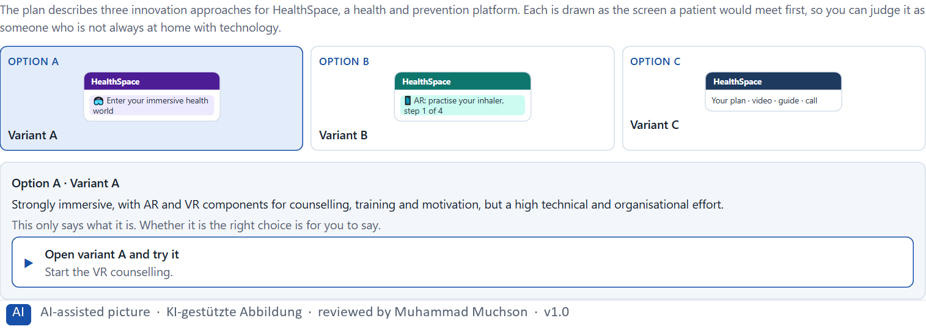
Figure 2 · The product to read, as the lab shows it (designs).
Question 1 of 5 · Rate each variant on user value, degree of innovation, maturity, acceptance, risk and economic viability
Write a few sentences for each variant that cover all six criteria. Many teams rate each criterion Low, Medium or High with a reason; you may do that or write it in your own words.
How to build the answer:
- Take one variant at a time and keep the conditions in mind: a heterogeneous group, 6 months, hardly any user data.
- For each criterion, say how the variant does and why.
- Use the same six criteria for every variant.
Variant | User value | Degree of innovation | Maturity | Acceptance | Risk | Economic viability
Variant A · strongly immersive, AR and VR
Variant B · single immersive elements, defined situations
Variant C · classic UX, monitoring, later pilots

Question 2 of 5 · Decide which variant is the most viable under the given conditions
Choose one variant, then give your reason below. There is no single right choice; the reason has to rest on the users and the conditions.
How to build the answer:
- Say which condition weighs most for you.
- Say how your choice meets it better than the other two.
Tick one:
☐ Variant A · strongly immersive, AR and VR
☐ Variant B · single immersive elements, defined situations
☐ Variant C · classic UX, monitoring, later pilots
Why this variant, under these conditions?
Give your reason with the conditions: innovative but trustworthy and economic, a limited budget, a heterogeneous and not tech-savvy group, pilots in 6 months, hardly any user data, management against departments.
How to build the answer:
- Name the condition that weighs most for you.
- Say how your variant meets it and why the other two meet it less well.
- Say what your choice gives up and how you would deal with its weakness.

Question 3 of 5 · Name the conflicts of goals between visible innovation and responsible introduction
Name at least two conflicts, each as one goal against another, and who stands for each side.
How to build the answer:
- Look at what visibility wants (an impressive signal, soon) and what responsibility needs (evidence, trust, inclusion, cost control).
- Write each conflict as “… against …” and say who stands for each side.

Question 4 of 5 · Which risks remain despite your decision?
Name at least one risk that remains and who would feel it.
How to build the answer:
- Think of what your chosen variant is weak at.
- Say who would notice and what would happen.

Question 5 of 5 · Formulate a recommendation to the project management
Two to four sentences: what you recommend, why, and what you will check next.
How to build the answer:
- Lead with the recommendation.
- Give the one reason the project management can follow.
- Say what you will measure in the pilot.

Part 2 · The case study · Level 2 · Application · Case study (2 UE)
Case study: 2 teaching units (UE5–6)
This part is the day's Level 2 case study. It takes 2 UE (about 90 minutes): UE5 for the briefing and your own work, UE6 for comparing your results with your group and for the trainer's closing. The block below needs about 15 minutes of writing; the rest of the time is discussion.

Block 2.1 · Case study: a future strategy for the training and service offer IndustryXR · JUDGED · Core · about 15 min
Draws on: A1 · From screen to space · A2 · Presence, attention and load · A3 · Intensify or overwhelm · A4 · Fascination or impact · A5 · Ethics and responsibility, and weighing a measure.
An industrial company plans to develop its training, maintenance and support processes with immersive technologies. AR instructions, VR training environments and neuroscience-informed UX concepts for better attention steering are being discussed. Inside there is enthusiasm for the technology, but robust experience of acceptance, economic viability and fit with existing processes is missing. The observed problems: it is unclear which use cases really offer immersive value; single pilot ideas are technically exciting but hardly prioritised by effect and benefit; stakeholders pursue divergent goals between innovation, safety, efficiency and cost control; usage risks such as overload, technical failures and acceptance problems have not been assessed enough; the link between technical fascination and strategic relevance is unclear; and there is no robust roadmap for introduction, testing and scaling. The conditions: a budget of €220,000 for the first phase, 16 weeks for piloting and decision preparation, full technological integration not possible in the short term, several business units that want to take part, hardly any data from real user tests, and first visible innovation steps the management wants to see soon. You work through six steps.
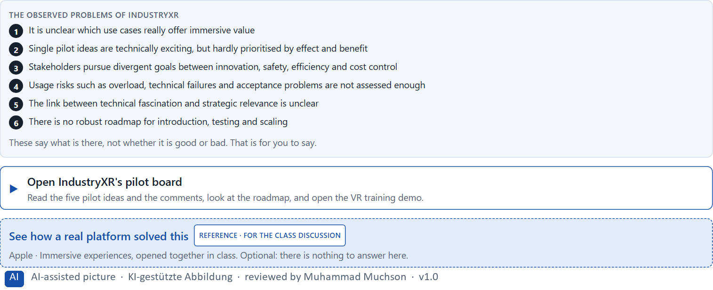
Figure 3 · The product to read, as the lab shows it (industryxr).
Question 1 of 6 · Analyse the central chances and risks of the planned immersive development
How to build the answer:
- Open IndustryXR's pilot board and the VR training demo; read what each business unit wants.
- Write one point per line: a chance or a risk, and what it does.
Write them as a list, one point per line, each as a chance or a risk and what it does. At least five.

Question 2 of 6 · Assign the observations to the categories user value, maturity, acceptance, overload, economic viability and scalability
Write the observations that belong to each category in a few words.
How to build the answer:
- Take your points from question 1.
- Ask which category each affects most, and write it there.
Category | The observations in this category
User value
Maturity
Acceptance
Overload
Economic viability
Scalability

Question 3 of 6 · Develop 4 prioritised measures for a responsible pilot strategy
How to build the answer:
- Turn each group of problems into something you could do within 16 weeks and €220,000, without full integration.
- Put them in order: what reduces investment and reputational risk first.
Write them as a numbered list, the first priority first, each with what it changes.

Question 4 of 6 · Justify your selection using effect on users, feasibility, risk, time pressure and investment security
Use all five criteria and say how they support your selection and its order.
How to build the answer:
- Say what your first measures change for investment and reputational risk.
- Say what is feasible in 16 weeks and what makes the investment safer.
- Keep the several business units and the visible steps wanted soon in mind.

Question 5 of 6 · Make a prioritisation decision for the first 16 weeks
Say what you do in the first 16 weeks, in which order, and what you leave for later, with the reason.
How to build the answer:
- Say what comes first and why.
- Say what you do in parallel and what waits.
- Say what the management will see at the end.

Question 6 of 6 · Formulate a recommendation to the division management
Three to five sentences: what you recommend, what has priority, and what you expect to change.
How to build the answer:
- Lead with the recommendation.
- Name the priorities.
- Say what you expect to change.

Task 2 · Route 2 · UX Strategy Memo: decide as Chief Experience Officer

The situation: great enthusiasm, no priorities
Read once · about 2 min
You take the perspective of the Chief Experience Officer of the company behind IndustryXR, which offers digital service, training and support solutions. It wants to extend its UX strategy with immersive technologies and neuroscience-informed interaction concepts. AR, VR and other future technologies are seen inside as a great chance for innovation, but clear priorities, evaluation standards and governance rules are missing. The management expects a sound strategy for bringing future technologies with real user value, controlled risk and economic viability into the UX portfolio. You are not to pick single trend technologies, but to develop a sound decision architecture for immersive UX, neuroscience-based user guidance and innovation governance.
The framework | How the task runs · one block
• The budget is limited  • Several stakeholders pursue different goals  • Technology maturity varies strongly by use case  • Data on real user acceptance is patchy  • First pilots must be visible at short notice  • Wrong decisions can raise costs, frustration and reputational damage | • Block 3.1 asks seven questions: a guiding vision for future UX innovation, three strategic decisions, a prioritised architecture of measures, a risk analysis, a governance model, one decision under uncertainty and a management statement.

What is known and what is open
In the brief | Clear · Case assumption | Open · on purpose
• Digital service, training and support solutions; plans for immersive and neuro-informed interaction.  • AR and VR seen as a great chance; no priorities, criteria or governance.  • Maturity varies by use case; acceptance data is patchy.  • First pilots must show soon; wrong decisions raise costs, frustration and reputational damage. | • The company is the one behind IndustryXR in Route 1.  • The management wants a headset demo at next spring's trade fair; the training team wants a VR safety course; service wants AR instructions; finance wants a business case first.  • An innovation lab exists, but its projects end as demos; none has reached daily use. | • How large the budget is: “limited” is all the plan says.  • Which technologies will be mature enough in two years: nobody knows.  • Whether customers would pay more for immersive services: never asked.

As in most projects, not everything is known. Decide anyway, and say what you assume.
Case assumption
The brief says: a company with digital service, training and support solutions that wants immersive and neuro-informed interaction in its UX strategy, AR and VR seen as a great chance, no priorities, evaluation standards or governance, a limited budget, several stakeholders, maturity varying by use case, patchy acceptance data, first pilots visible soon, and the warning that wrong decisions can raise costs, frustration and reputational damage. Those are the plan's facts. That the company is the one behind IndustryXR and the facts marked “Clear” are made up for this exercise.

The memo is addressed to: The management. Subject: A UX innovation architecture for immersive and neuro-based technologies.

Part 3 · Level 3 · Management decision · Transfer project (3 UE)
Transfer project: 3 teaching units (UE8–10)
UE8: the trainer presents Materi B and sets the role. UE9: you write the memo. UE10: you present the decision and what you give up; the trainer debriefs.

Block 3.1 · A strategic UX innovation architecture for immersive and neuro-based future technologies · JUDGED · Core · about 20 min
Draws on: B1 · Future technologies as decision architecture, not a trend · B2 · Innovation, value, maturity, risk, ethics · B3 · Who decides on future technologies, and deciding without test data.
Develop a strategic concept for the company. Your desk holds what the management, the innovation lab, service, training, safety and finance say. Open it, then answer the seven questions; your answers build the memo below.
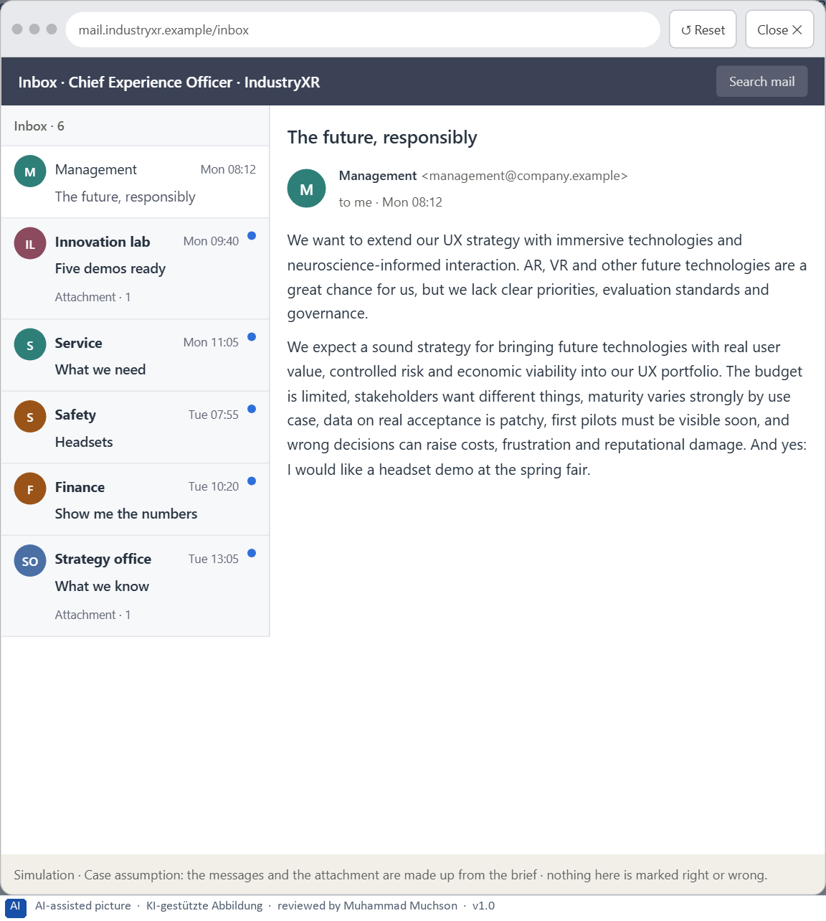
Figure 4 · Your desk: the messages that wait for you, shown in the lab as a mailbox (1 of 6).
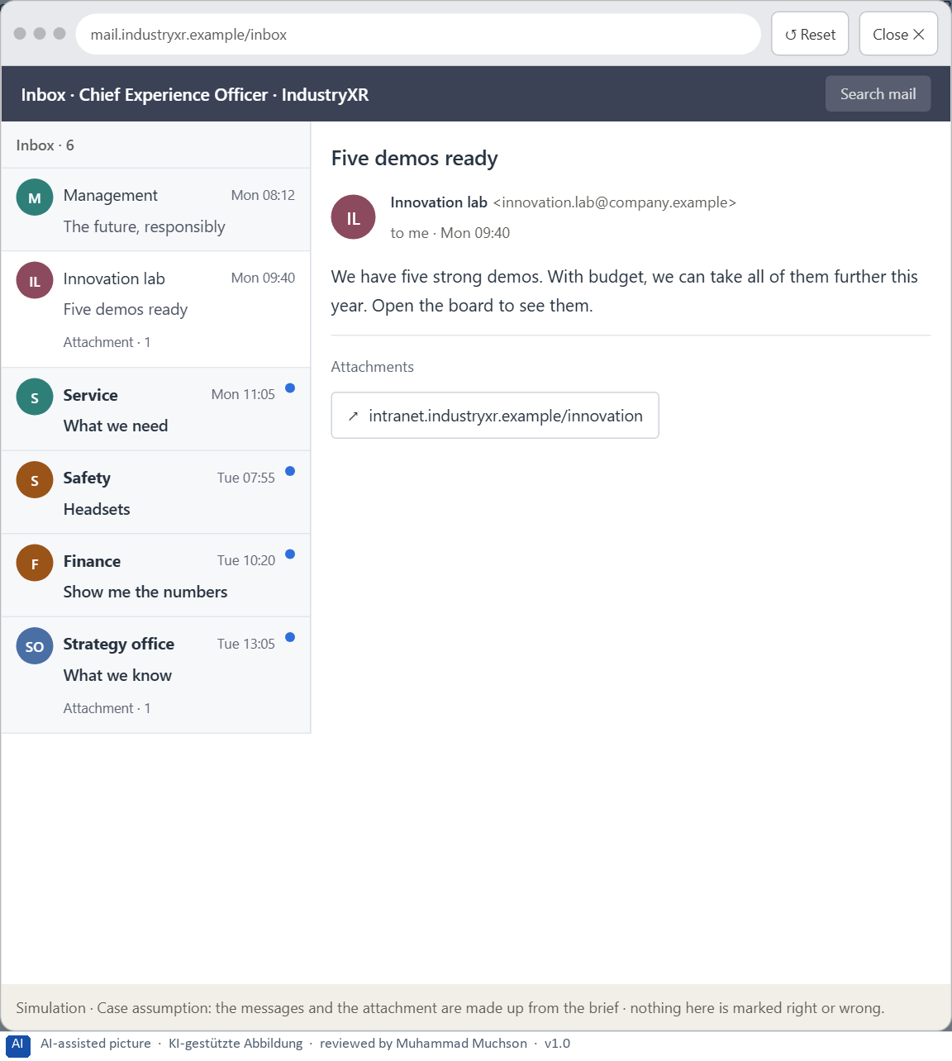
Figure 5 · Your desk: the messages that wait for you, shown in the lab as a mailbox (2 of 6).
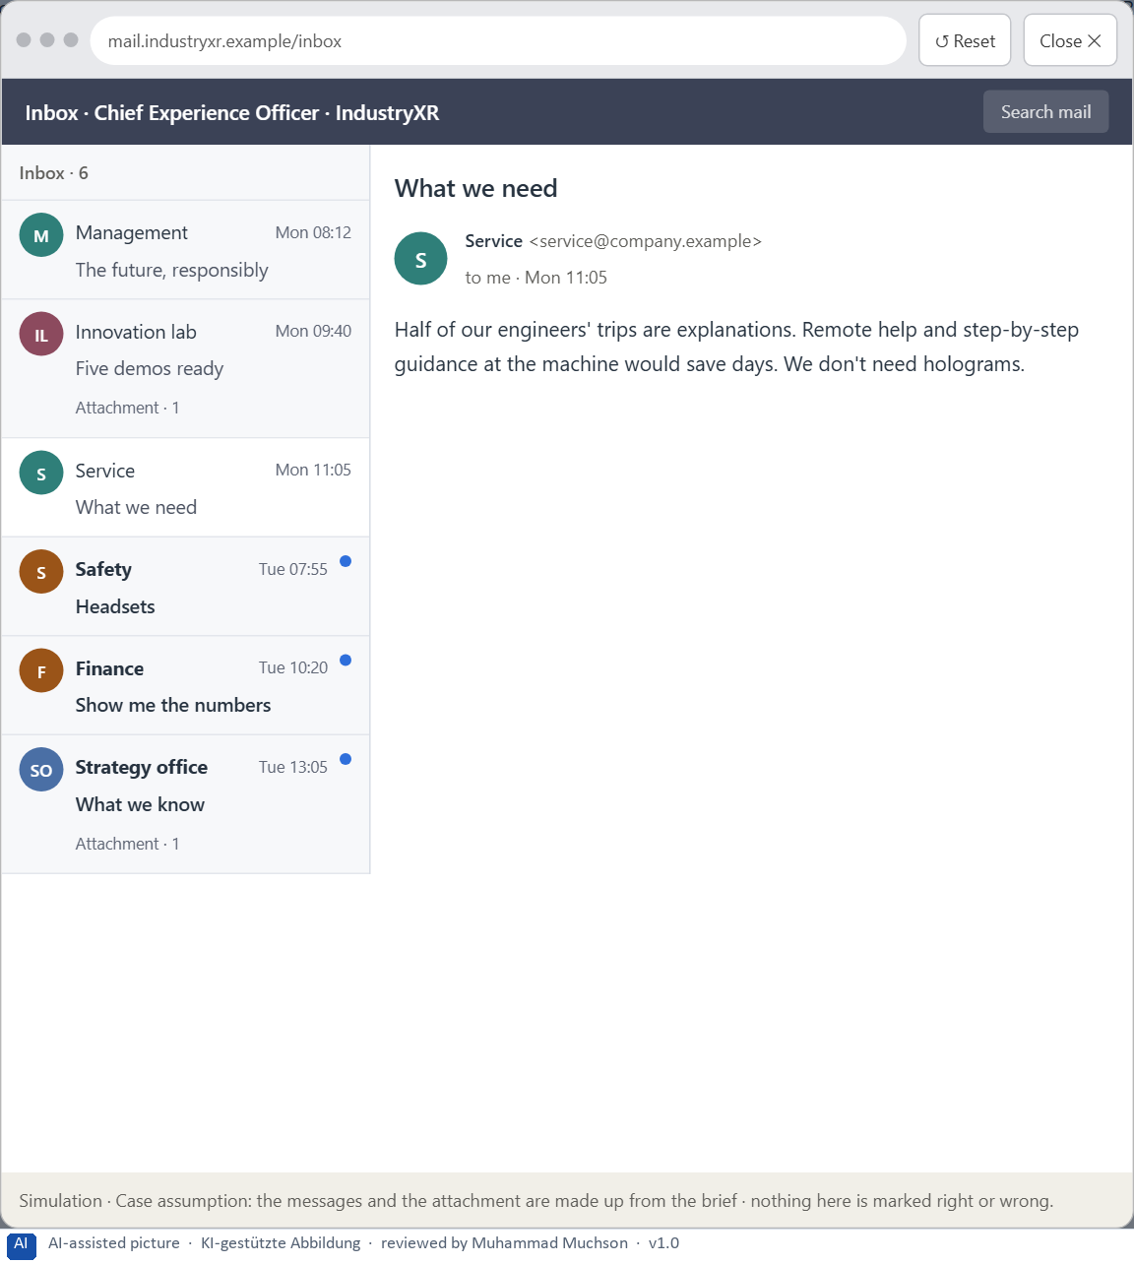
Figure 6 · Your desk: the messages that wait for you, shown in the lab as a mailbox (3 of 6).
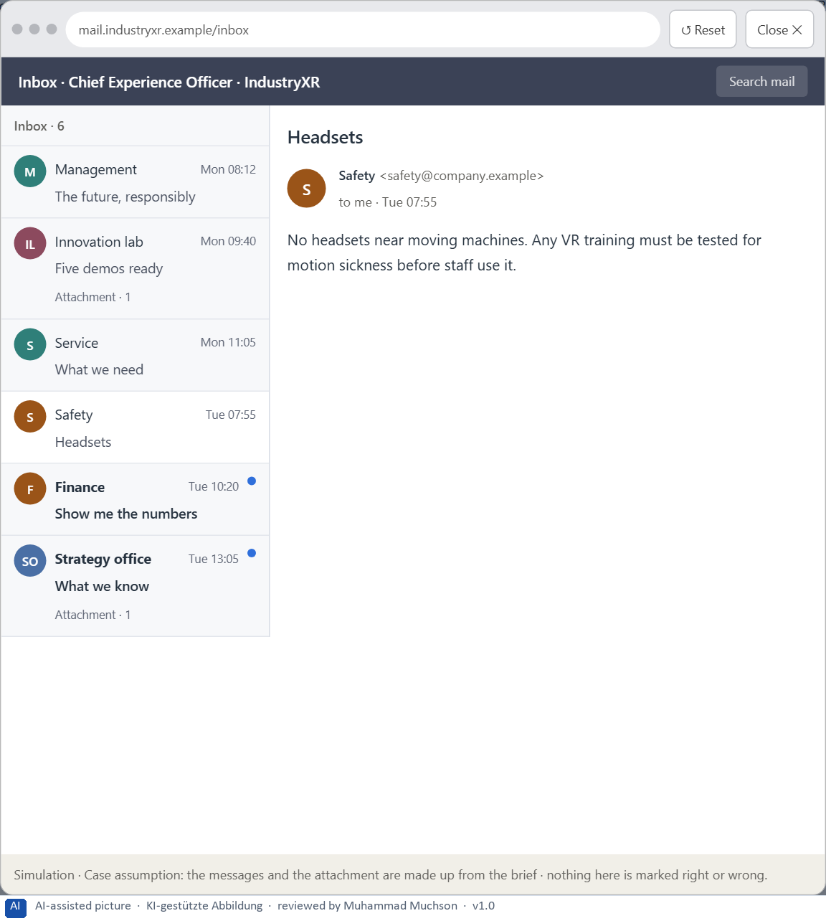
Figure 7 · Your desk: the messages that wait for you, shown in the lab as a mailbox (4 of 6).
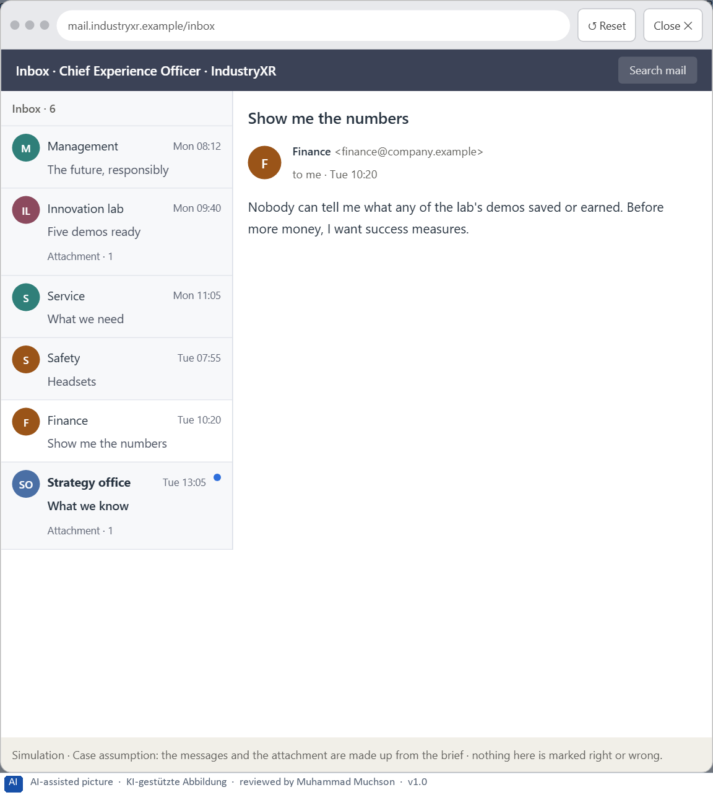
Figure 8 · Your desk: the messages that wait for you, shown in the lab as a mailbox (5 of 6).
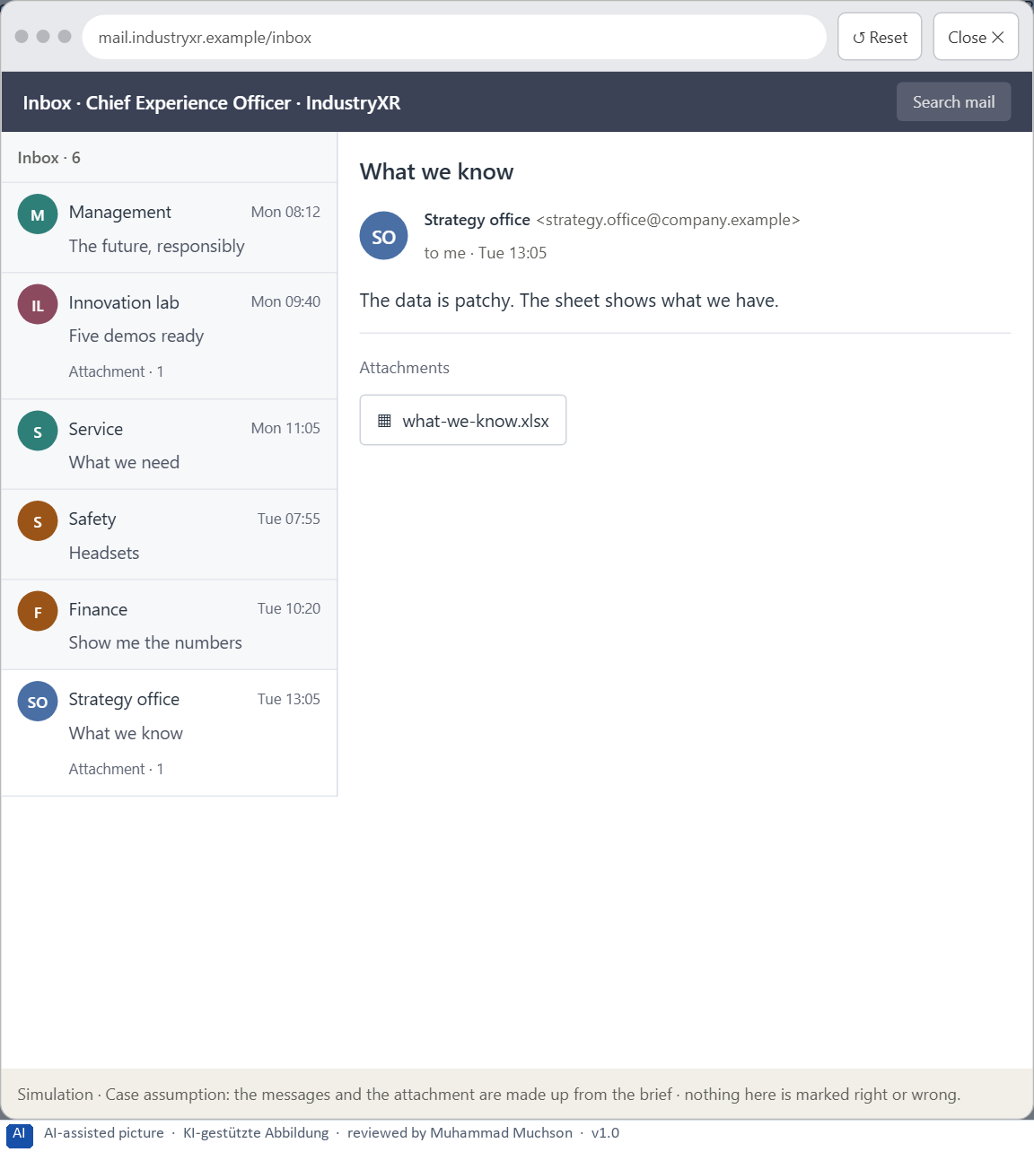
Figure 9 · Your desk: the messages that wait for you, shown in the lab as a mailbox (6 of 6).
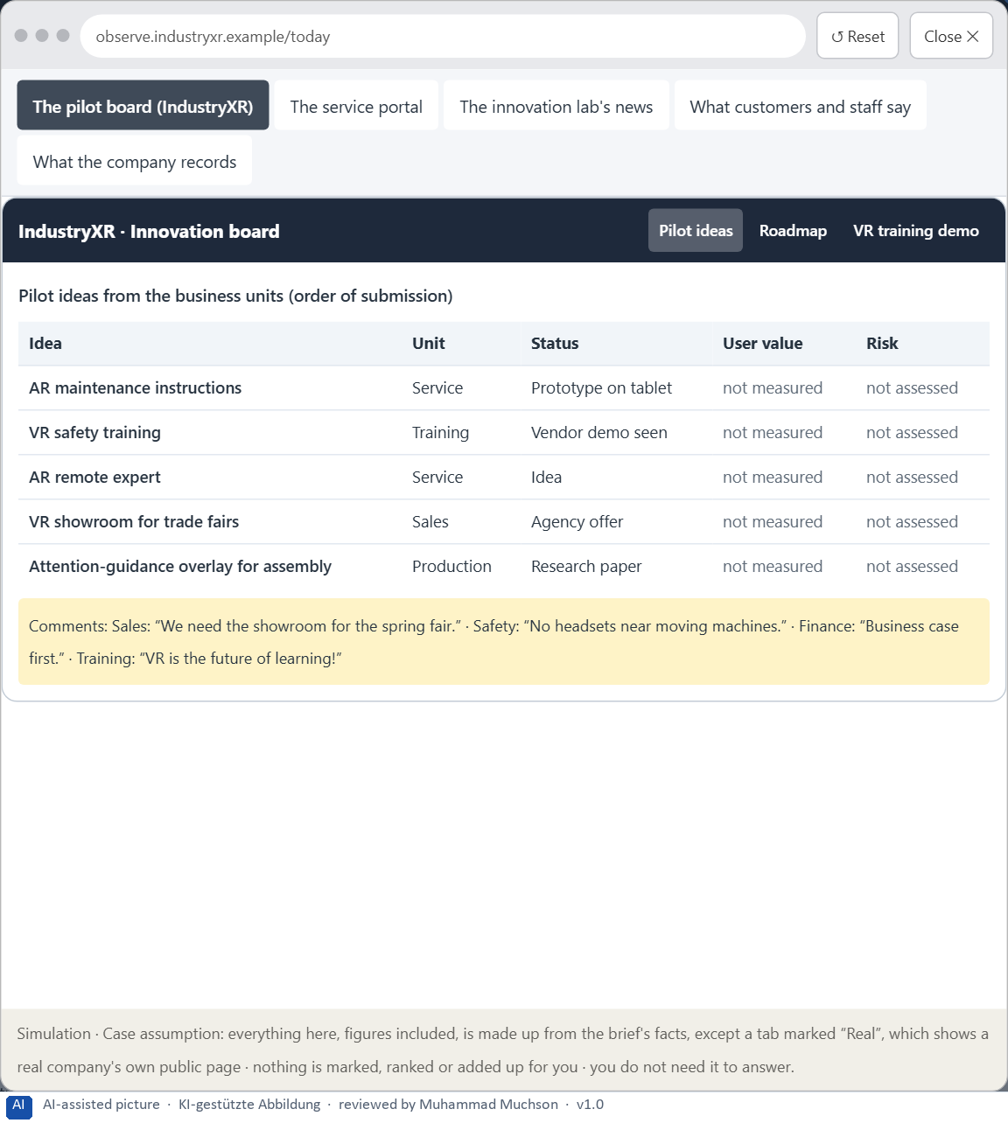
Figure 10 · The platform as it is today, as the lab lets you observe it (1 of 5).
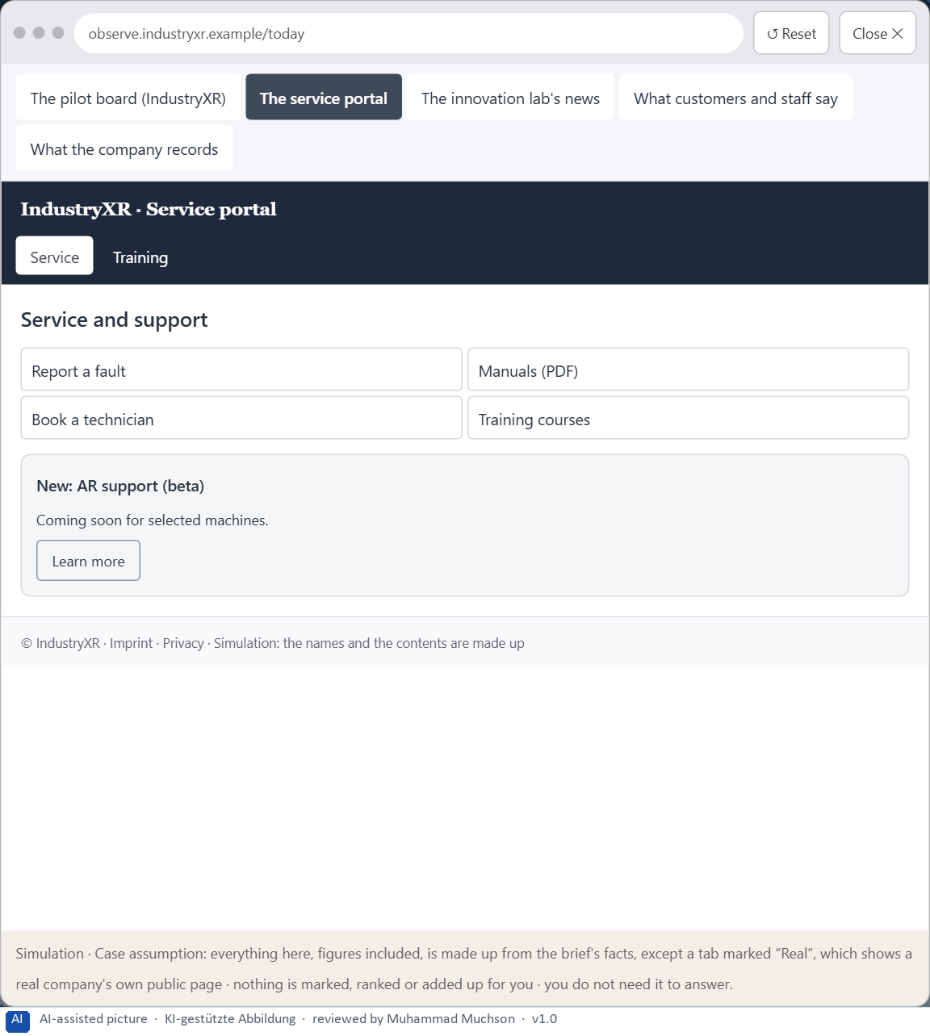
Figure 11 · The platform as it is today, as the lab lets you observe it (2 of 5).
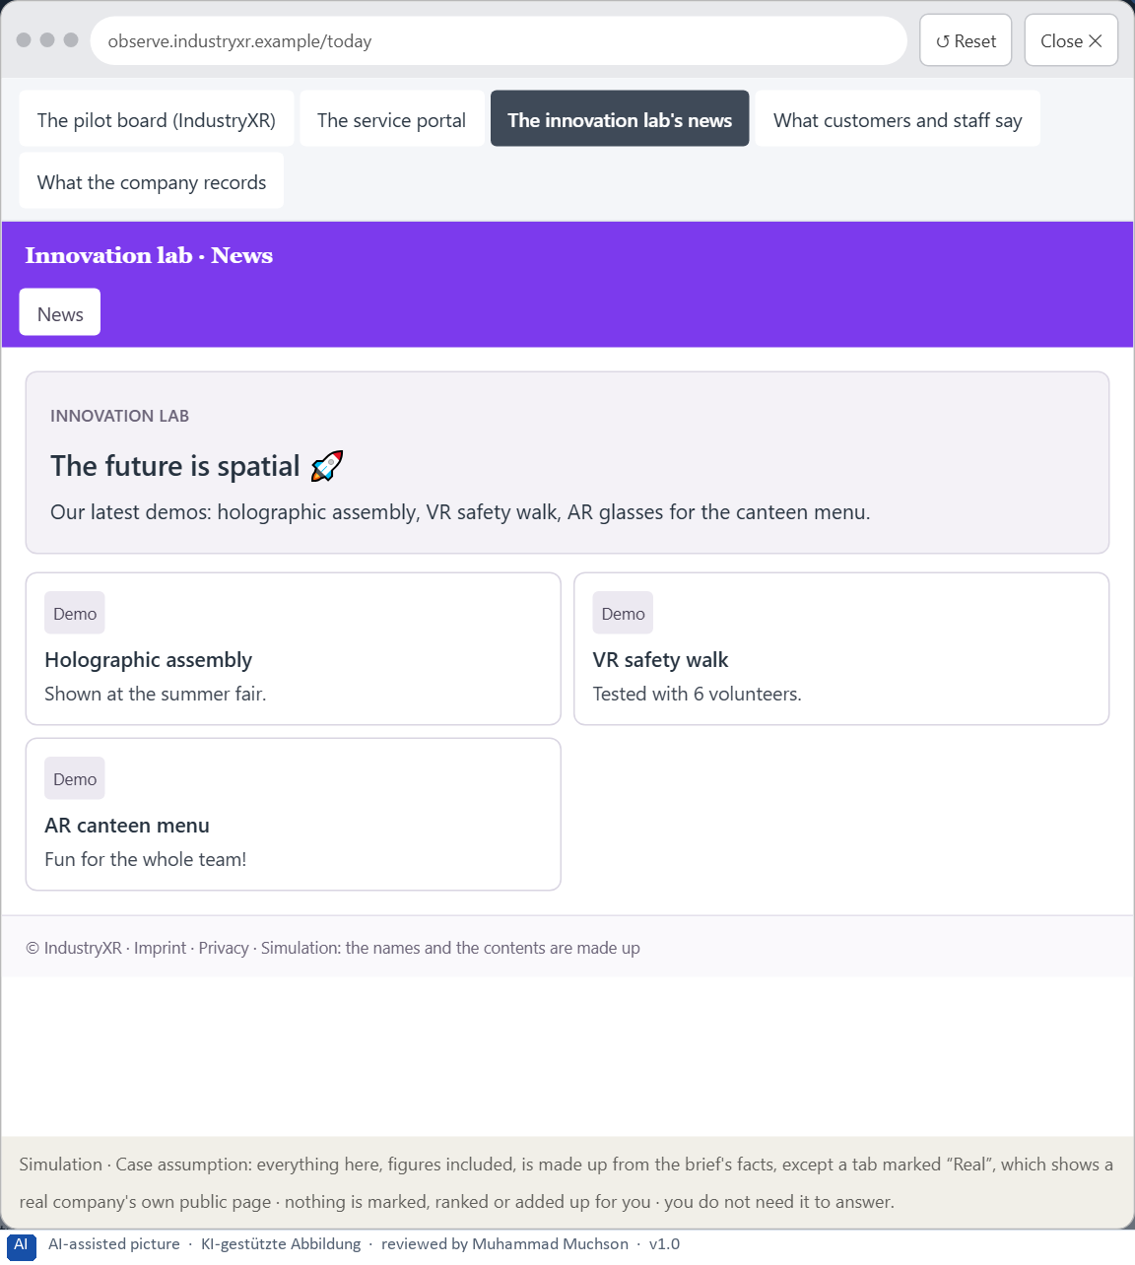
Figure 12 · The platform as it is today, as the lab lets you observe it (3 of 5).
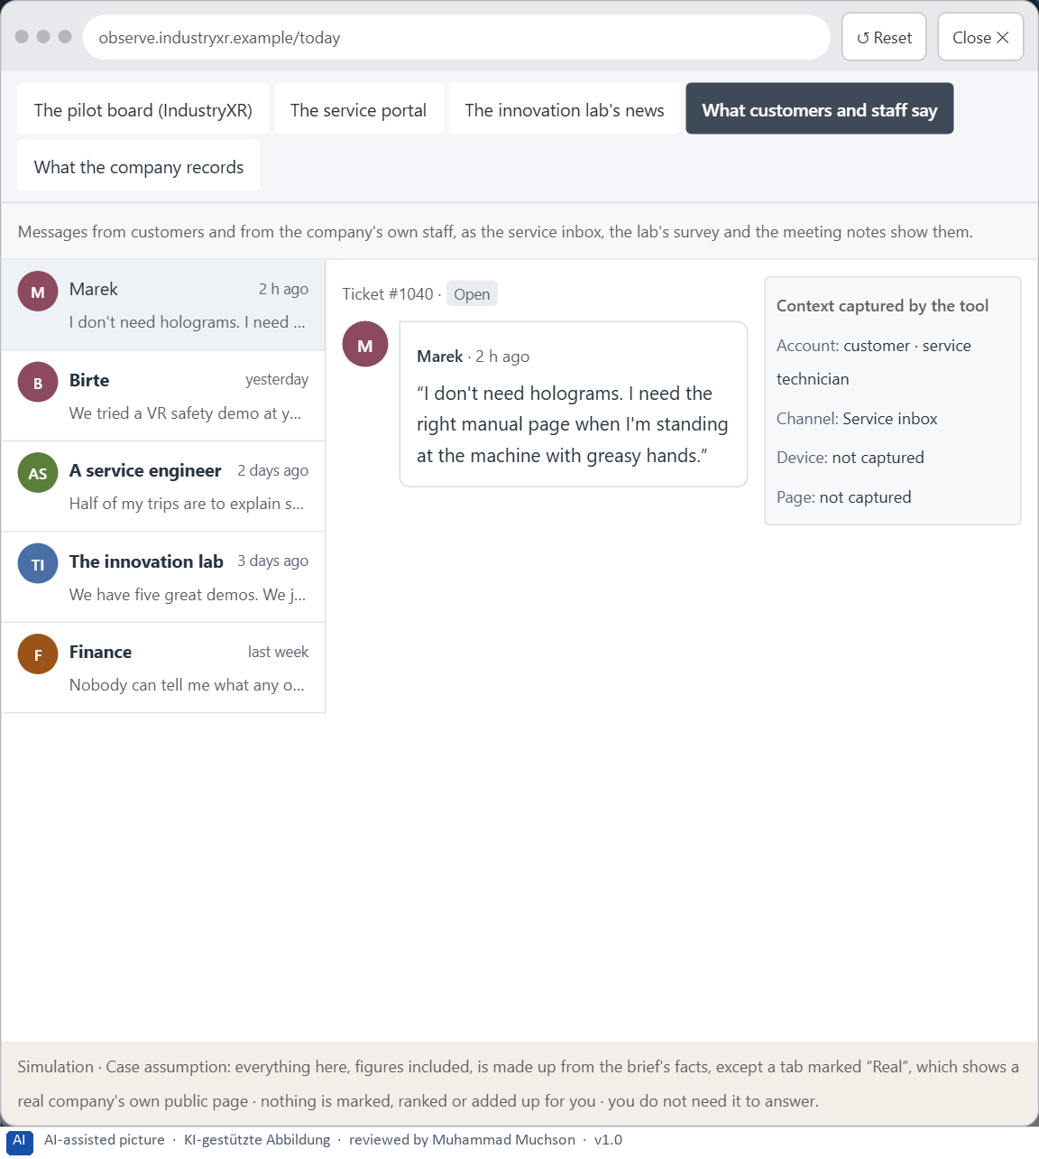
Figure 13 · The platform as it is today, as the lab lets you observe it (4 of 5).
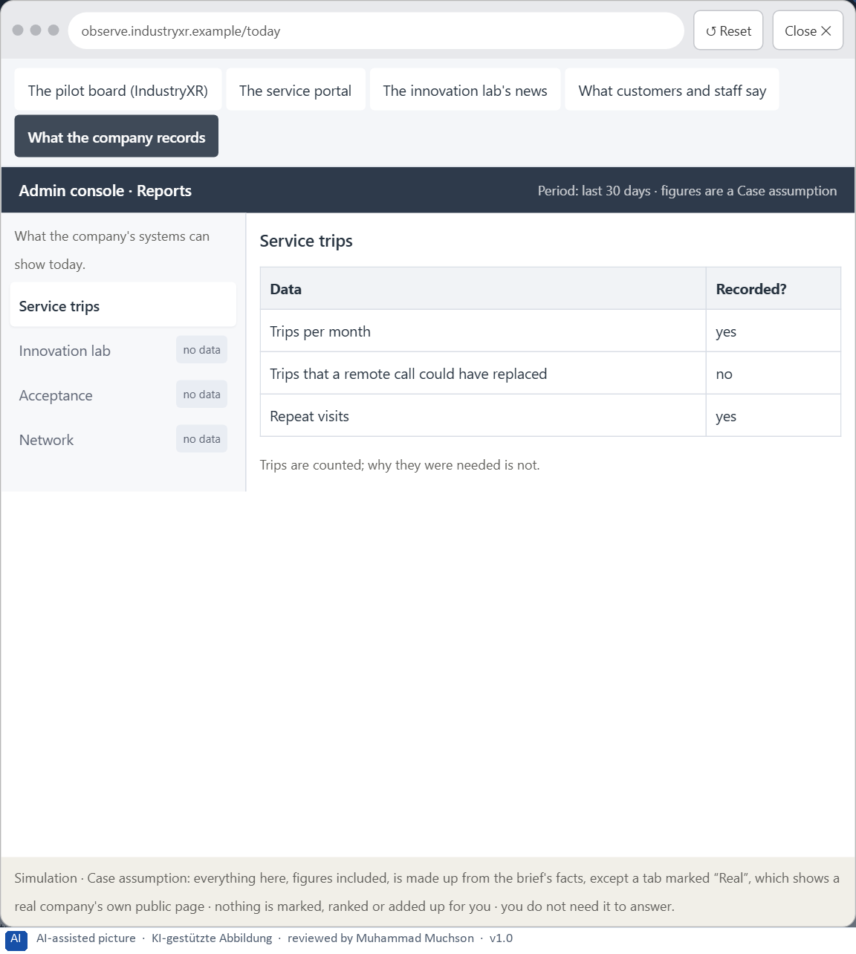
Figure 14 · The platform as it is today, as the lab lets you observe it (5 of 5).
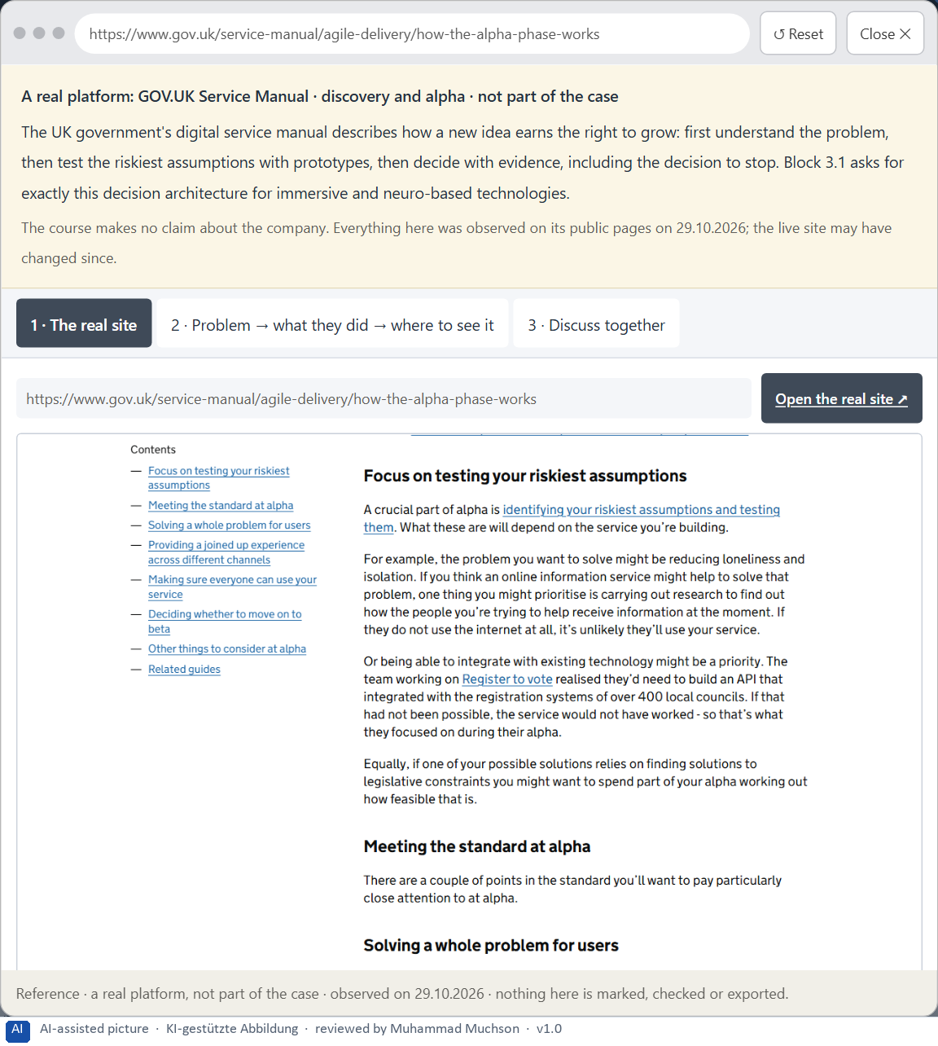
Figure 15 · A real platform that solved this, shown for the class discussion (1 of 3).
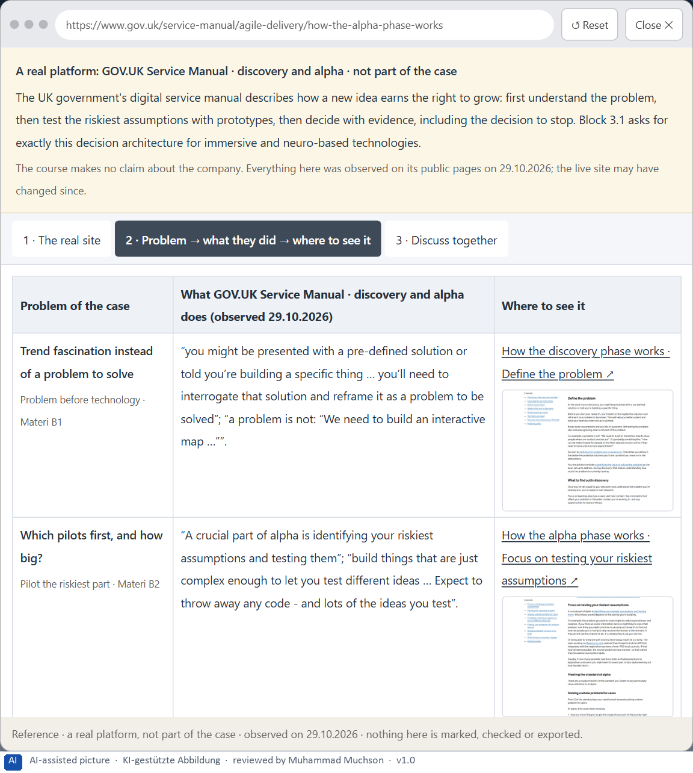
Figure 16 · A real platform that solved this, shown for the class discussion (2 of 3).
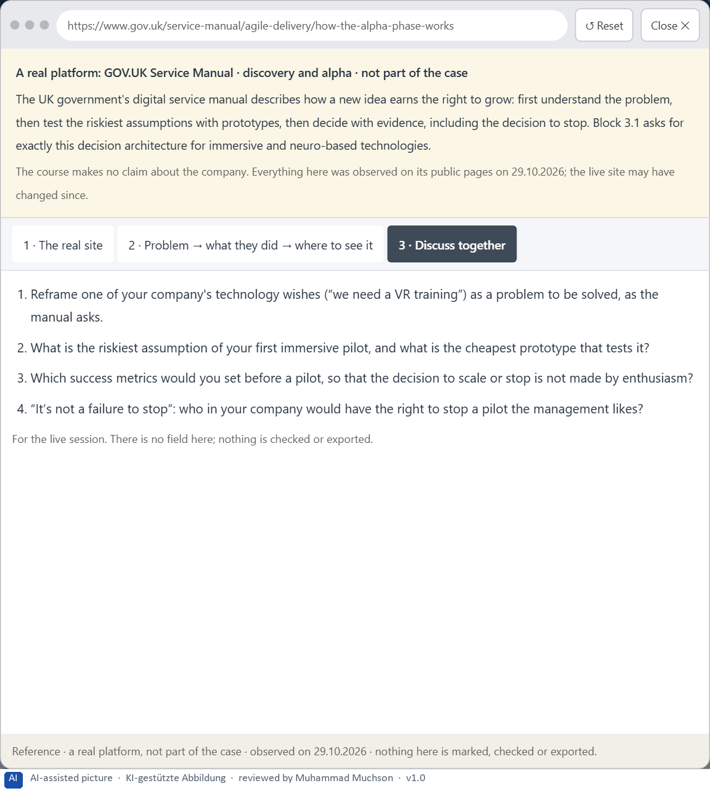
Figure 17 · A real platform that solved this, shown for the class discussion (3 of 3).
Question 1 of 7 · A guiding vision for future UX innovation: which form of immersive value and user experience should be aimed for systematically?
One or two sentences about the kind of immersive value the company wants and for whom.
How to build the answer:
- Say what immersive value the company aims for, and for whom.
- Say what it will not do for the sake of being seen.

Question 2 of 7 · Three strategic guiding decisions on technology use, maturity assessment, user value and innovation portfolio
How to build the answer:
- Take your vision and ask which three choices would make it real.
- Write each as “we will …, even though that means …”.
Write them as a list, one decision per line, each with what it gives up.

Question 3 of 7 · A prioritised architecture of measures: which use cases, touchpoints or product areas are piloted first, and why?
Put the use cases, touchpoints or product areas in an order and give the reason for the first ones.
How to build the answer:
- List the candidates: AR maintenance instructions, AR remote expert, VR safety training, VR trade-fair showroom, attention-guidance overlay.
- Put first what has a clear advantage, mature technology and a controllable risk.
- Say why the others wait.

Question 4 of 7 · A risk analysis: which wrong assumptions about innovation, user behaviour, market maturity and economic viability would be especially critical?
Name two or three assumptions and the harm if each is wrong.
How to build the answer:
- Write down what your concept assumes about innovation and its effect.
- Write down what it assumes about how people will use it.
- Write down what it assumes about market maturity and money.

Question 5 of 7 · A governance model: who is responsible for future technologies in the UX portfolio, and how are conflicts between visibility, effect, risk and effort decided?
Name roles, not people: who owns the innovation portfolio, who uses the evaluation grid, who may stop a pilot, the roles of the business units, and how a conflict is decided.
How to build the answer:
- Name who owns the innovation portfolio and the evaluation grid.
- Say who sets success measures and who may stop a pilot.
- Say how a conflict between visibility, effect, risk and effort is decided.

Question 6 of 7 · A decision under uncertainty: make at least one prioritised decision despite patchy practical tests and justify it responsibly
Say what you decide, what you do not know, and why the decision is responsible all the same, for example when you would reverse it.
How to build the answer:
- State the decision in one sentence.
- Name what you do not know.
- Say why it is still responsible: it can be reversed, it can be checked soon, or waiting costs more.

Question 7 of 7 · A management statement: a recommendation to the management with a clear priority and a strategic reason
Four to six sentences: the direction first, then the priority, the reason and what you ask of the management.
How to build the answer:
- Start with the direction in one sentence.
- Name the priority and the reason that carries it.
- Say what you ask of the management and what you will report back.

Use in class: presentation and handout
Mark of use for the worksheet. Presentation is what the trainer shows on screen; Handout is what participants fill in and hand in.
Part of the worksheet | Presentation (shown in the Neuro-UX Lab) | Handout
The case: two platforms on the UX team's desk, and IndustryXR | The case read aloud or on screen | The case text
Block 1.1 · Analyse immersive potentials and risks of a future scenario: BuildVisi | The task wording at the start of the block (no answers are shown) | Worksheet block with answer boxes (Core)
Block 1.2 · Rate future technologies in UX design under conflicting goals: HealthS | The task wording at the start of the block (no answers are shown) | Worksheet block with answer boxes (Core)
Block 2.1 · Case study: a future strategy for the training and service offer Indus | The task wording at the start of the block (no answers are shown) | Worksheet block with answer boxes (Core)
The situation: great enthusiasm, no priorities | The case read aloud or on screen | The case text
Block 3.1 · A strategic UX innovation architecture for immersive and neuro-based f | The task wording at the start of the block (no answers are shown) | Worksheet block with answer boxes (Core)

Glossary
Every term below is used in this document. Terms stay plain text in the body; this list says what they mean in everyday words.
Term | In plain words | Example | Comes from
Attention | The mind's spotlight. Only a small part of a screen is processed at any moment; attention decides which part. | A flashing banner takes attention away from the form you were filling in. | Day 1
Case assumption | A fact made up for this exercise to fill a gap in the plan's case. It is marked so you know it is not part of the plan. | — | Day 1
Chief Experience Officer | The manager who is responsible for the experience customers have across all channels, and who decides where the company invests in it. | — | Day 1
Component | A reusable building block of an interface, such as a button, a form field or a status label, built once and used on many screens. | — | Day 6
Decision architecture | A set of connected decisions that are made on purpose and written down: what effect you want, what comes first, who decides and how conflicts are settled. It replaces many separate fixes. | — | Day 1
Governance | The rules about who may decide what, who is answerable for it and how disagreements are settled. | — | Day 1
Immersion | How much a technology surrounds the senses and shuts out the real surroundings; more immersion can mean more presence, and more load. | — | Day 14
Maturity | How far a technology is from an idea to reliable use: does it work, in the real environment, for real users, at scale? | — | Day 14
Orientation | Knowing where you are, what you can do here and what happens next. | — | Day 1
Presence | The feeling of really being in a place that is digital or partly digital. | — | Day 14
Stakeholder | A person or department with an interest in a decision, such as marketing, compliance, IT or sales. | — | Day 1
Touchpoint | Any place where a person meets the company: the website, the customer portal, the app, a chatbot or a phone call. | — | Day 1
UX (user experience) | Everything a person goes through when using a product: what they notice, understand, feel and do, from the first look to the last step. The screens are only one part of it. | Finding the booking you want at once and feeling sure it went through is a good UX. | Day 1

The Neuro-UX Lab: where we practise online
In class we use the course website as the place to practise and to learn. Every day has its own address, in the same pattern: the day number is the last part.
What | Address
Neuro-UX Lab (course website) | https://aion-ux-lab.vercel.app/
Day 14 | https://aion-ux-lab.vercel.app/day/14/

On the day page, Route 1 (Levels 1 and 2) and Route 2 (Level 3) can be opened; the cards and the tasks of this document are there too. The pattern is the same up to Day 8, for example https://aion-ux-lab.vercel.app/day/6/.

