AION · UX DEVELOPER · PSYCHOLOGICAL UX DESIGN AND NEURO-UX
DAY 15 · MATERI A AND MATERI B · ROUTES 1 AND 2 · LEVELS 1 TO 3
Eye-tracking and gaze behaviour, neurofeedback and brain-computer interfaces
Study material with real research, worked examples and the rules you use in the tasks
AI notice · KI-Hinweis
This document was produced with the help of an AI language model (Claude, Anthropic). The AI drafted the text and tables and built the pictures and working examples of the lab. The content was then read, corrected and approved by the reviewer named below, who is responsible for its accuracy. Every picture carries an AI label on the image. Check figures and sources before you quote them.
KI-Hinweis: Dieses Dokument wurde mit Unterstützung eines KI-Sprachmodells (Claude, Anthropic) erstellt. Texte und Tabellen wurden von der KI entworfen, die Abbildungen sind KI-gestützt erstellt und am Bild gekennzeichnet. Die fachliche Prüfung und Freigabe erfolgte durch die unten genannte Person.

Day | Day 15 · Module 7 (day 2 of 3): Eye-tracking and gaze behaviour, neurofeedback and brain-computer interfaces
Document | Materi (study material). Materi A has five cards, Materi B has three.
Route and level | Materi A serves Route 1 (Levels 1 and 2, Task 1). Materi B serves Route 2 (Level 3, Task 2).
Time | Materi A about 60 min · Materi B about 60 min (facilitator-led)
Neuro-UX Lab (website) | https://aion-ux-lab.vercel.app/day/15/
Case | Worked examples use a made-up company in each card. The task case is VisionMind Lab (see the Task document).
Version | 1.0 · release date 29.10.2026
Review and approval | Muhammad Muchson, Mentor (subject-matter review and approval)

ABOUT THIS DOCUMENT
In class we also use the Neuro-UX Lab, the course website, as the place to practise and learn. Its address is at the end of this document.
Today is about measuring people's attention: where their eyes go, and what their brain activity might say. You learn what eye-tracking really records (fixations, scanpaths, heatmaps), why looking is not understanding, what neurofeedback and brain-computer interfaces are and how mature they are, and why neurodata needs more care than any click. Then you use it on three platforms, including a gaze recording you can replay and re-read, and you look at what an eye-tracking maker and a data protection regulator say. This document holds everything you need to study Day 15 without the website. Every card says what the idea is in plain words, shows it in a picture, gives the details and ends with the rules you use in the tasks.

IN THIS DOCUMENT
Lesson plan: ten teaching units (Ablaufplan)
Case study and transfer project at a glance
A1 · What eye-tracking measures: fixations, scanpaths, heatmaps and areas of interest · 12 min · Core
A2 · Looking is not understanding: the limits of gaze data · 12 min · Core
A3 · Neurofeedback and brain-computer interfaces at their real maturity · 12 min · Core
A4 · Insight, interpretation risk and decision relevance: research, experiment or product? · 12 min · Core
A5 · Ethics, data protection and voluntariness, and weighing a measure · 12 min · Core
B1 · Neuro-based UX as an insight architecture, not measurement fascination · 20 min · Core
B2 · Value, validity, effort, ethics, data protection, maturity: the conflicts of neuro-based UX · 20 min · Core
B3 · Governance for neurodata, and deciding with thin evidence · 20 min · Core

Day at a glance
Day 15 has ten teaching units (UE). This document is the study material; it is used in UE1 (Materi A) and UE8 (Materi B). The day is built from three documents and the Neuro-UX Lab: Materi (study material), Task (worksheet) and Trainer (coaching, feedback and model solutions), plus the course website.

Lesson plan: ten teaching units (Ablaufplan)
UE | Min | Plan item | What happens | Material | Format
1 | 45 | Knowledge transfer · Level 1 | The trainer presents the cards of Materi A (A1, A2, A3, A4, A5, about 60 min of cards) in the Neuro-UX Lab; participants follow in the handout. | Materi A (Route 1) | Presentation + Handout
2 | 45 | Level 1 · Task 1 | Individual work on Block 1.1 (Core, about 10 min): the first product of the day is read and its effect described. Pairs then compare their results and the trainer collects open questions. | Task 1 · Part 1 · Block 1.1 | Handout (or in the lab)
3 | 45 | Level 1 · Task 2 | Three options are rated on the same criteria and one is chosen under the stated conditions: Block 1.2 (Core, about 8 min). | Task 1 · Part 1 · Block 1.2 | Handout (or in the lab)
4 | 45 | Coaching · transition from Level 1 to Level 2 | Trainer-led. A short talk on the day's coaching focus, then the reflection questions in pairs. The bridge: from describing an effect to a decision you answer for. There is no worksheet block in this unit. | Trainer document, section Coaching | Trainer only
5–6 | 90 | Level 2 · Case study VisionMind Lab (2 UE) incl. model solution | UE5: the trainer presents the case; participants work on Block 2.1 (Core, about 15 min). UE6: groups compare their results and defend them; the trainer closes with the model solution. | Task 1 · Part 2 · Block 2.1  Trainer document, section Case study | Handout; model solution shown after the work
7 | 45 | Level 2 + 3 · Feedback round with a management perspective | Groups present their reasoning, not only their result. The trainer asks the day's Level 3 input questions and leads the discussion. | Trainer document, section Feedback round | Presentation by the groups; Trainer only
8 | 45 | Level 3 · Transfer project, Chief Experience Officer (3 UE: UE8–10) | The trainer presents Materi B (B1, B2, B3; use the "In plain words" and "How to decide" boxes, the rest is handout) and sets the role and the situation. | Materi B (Route 2) | Presentation + Handout
9 | 45 | Level 3 · Transfer project | Individual work or in pairs on Block 3.1 (Core, about 20 min): the strategy memo. | Task 2 · Block 3.1 | Handout (or in the lab)
10 | 45 | Level 3 · Transfer project | Participants present their decision and what they give up, including the one decision made under uncertainty; the trainer debriefs with the model solution. | Task 2 · Block 3.1  Trainer document, section Transfer project | Handout; model solution shown after the work

One UE is counted as 45 minutes here; breaks are not shown. The times are a guide for the trainer. The Core blocks are enough for a complete answer.

Case study and transfer project at a glance
Component | UE | Duration | Participants work in | Model solution in
Level 2 case study (VisionMind Lab) | UE5–6 | 2 UE · 90 min | Task 1 · Part 2 (Block 2.1) | Trainer document, section Case study
Level 3 transfer project (Chief Experience Officer) | UE8–10 | 3 UE · 135 min | Materi B and Task 2 (Block 3.1) | Trainer document, section Transfer project

Materi A · Route 1 · Levels 1 and 2
How Materi A is used
About 60 minutes, five cards. Levels 1 and 2: analyse the insight value and limits of an eye-tracking and neurofeedback project, rate three approaches for a learning platform under conflicting goals, then analyse a company's neuro-based research plans, develop four measures, justify them and decide on the first 18 weeks. The cards give you the ideas and the rules you use in Task 1.

A1 · What eye-tracking measures: fixations, scanpaths, heatmaps and areas of interest · 12 min · Core
An eye-tracker records where people look: fixations (pauses) and saccades (jumps). One recording can be shown as a scanpath (the order), a heatmap (time added up) or areas of interest (marked parts, with when and how long). Each view shows something and hides something. In UX it helps with navigation, information architecture, interface evaluation and prototype tests.
IN PLAIN WORDS
The idea. An eye-tracker records where a person looks. The eye does not glide; it jumps (saccades) and pauses (fixations), and we take in information during the pauses. One recording can be shown in several ways: as a scanpath (the order of fixations, numbered), as a heatmap (where looks piled up, added over people) or as areas of interest (marked parts of the page, with how soon and how long they were looked at). Each view shows something and hides something; which one a team is shown is a decision someone made. In UX, eye-tracking helps with navigation, information architecture, interface evaluation and prototype tests: what is seen first, what is never seen, where people search.
Why it matters. Block 1.1 asks where FocusSense's eye-tracking gives real insight, Block 1.2 rates eye-tracking in prototype tests, and Block 2.1 asks which of VisionMind Lab's methods are product-near. This card tells you what the data actually is.
How to read the picture. One recording of Mara on the Tessel transfer page, shown three ways: as a numbered scanpath, as a heatmap, and as areas of interest with when and how long she looked.

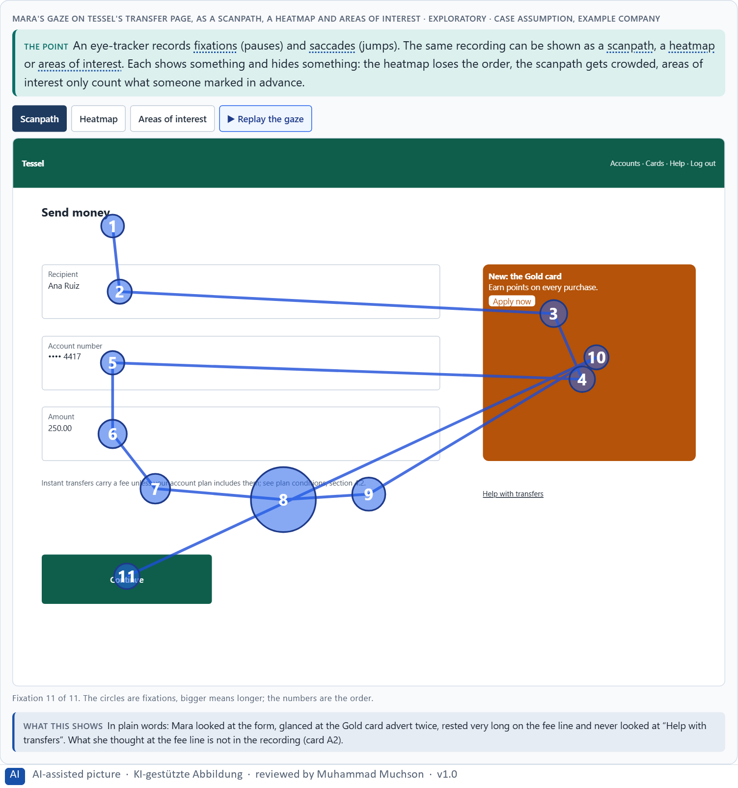
Figure 1 · Mara's gaze on Tessel's transfer page, as a scanpath, a heatmap and areas of interest · Exploratory.
What eye-tracking can make visible
What it shows | Example (Tessel) | Useful for
Fixations | 1.5 s on the fee line. | Where effort or interest sits.
Scanpaths | Form, advert, form, fee line. | Search behaviour and getting lost.
Distribution of attention | Most time on the form; none on Help. | Interface evaluation.
Search behaviour | Jumps between fields and the advert. | Navigation and information architecture.
Visual priority | The advert is seen before the fee. | Prototype tests of hierarchy.

Case assumption
Tessel, Mara, Joon, Ines and Bastian are made up for this example; the gaze recordings are drawn for the lesson, not measured. The measures follow Holmqvist et al. (2011); how trackers work follows Duchowski (2017).

How to decide when this comes up in the task
- Ask which view you are looking at, and what it leaves out.
- Read a scanpath for order: what came first, where people searched, what they never reached.
- Read a heatmap for time, not for order or for single people.
- Mark areas of interest before the analysis, not after you have seen the colours.
- Note the conditions: how many people, which task, which device, what light.

Extra · go deeper (optional reading)
Which visualisation a meeting is shown is a decision someone made. A heatmap of all participants looks like a fact and hides that three people searched desperately while seven found the button at once. Ask for the scanpaths of the people who failed.

Sources · Holmqvist et al. 2011 · Duchowski 2017

A2 · Looking is not understanding: the limits of gaze data · 12 min · Core
Capturing gaze, steering attention and actual understanding are different things. Looking is not understanding, attention is not agreement, and the eye can rest on something without it being noticed. The measurement is a fact; its meaning is an interpretation that needs another source. Every step from seen to agreed needs more evidence.
IN PLAIN WORDS
The idea. Capturing where someone looks, steering their attention, and what they actually understand are three different things. Looking is not understanding: a long fixation can mean interest, confusion or slow reading. Attention is not agreement: looking at an offer is not wanting it. And the eye can rest on something without the person noticing it. The measurement is a fact; its meaning is an interpretation, and it needs another source, such as asking people what they were thinking. Each step up the ladder (seen, attended, understood, agreed) needs more evidence.
Why it matters. Block 1.1 asks where FocusSense over-stretches its data and why “objective truth data” is a problem, and Block 2.1 asks about VisionMind Lab's overestimated data and missing hypotheses. This card gives you the limits by name.
How to read the picture. The same gaze pattern on Tessel's fee line, read three ways. The picture stays the same; only what Mara said afterwards changes. Below, the ladder from seen to agreed.

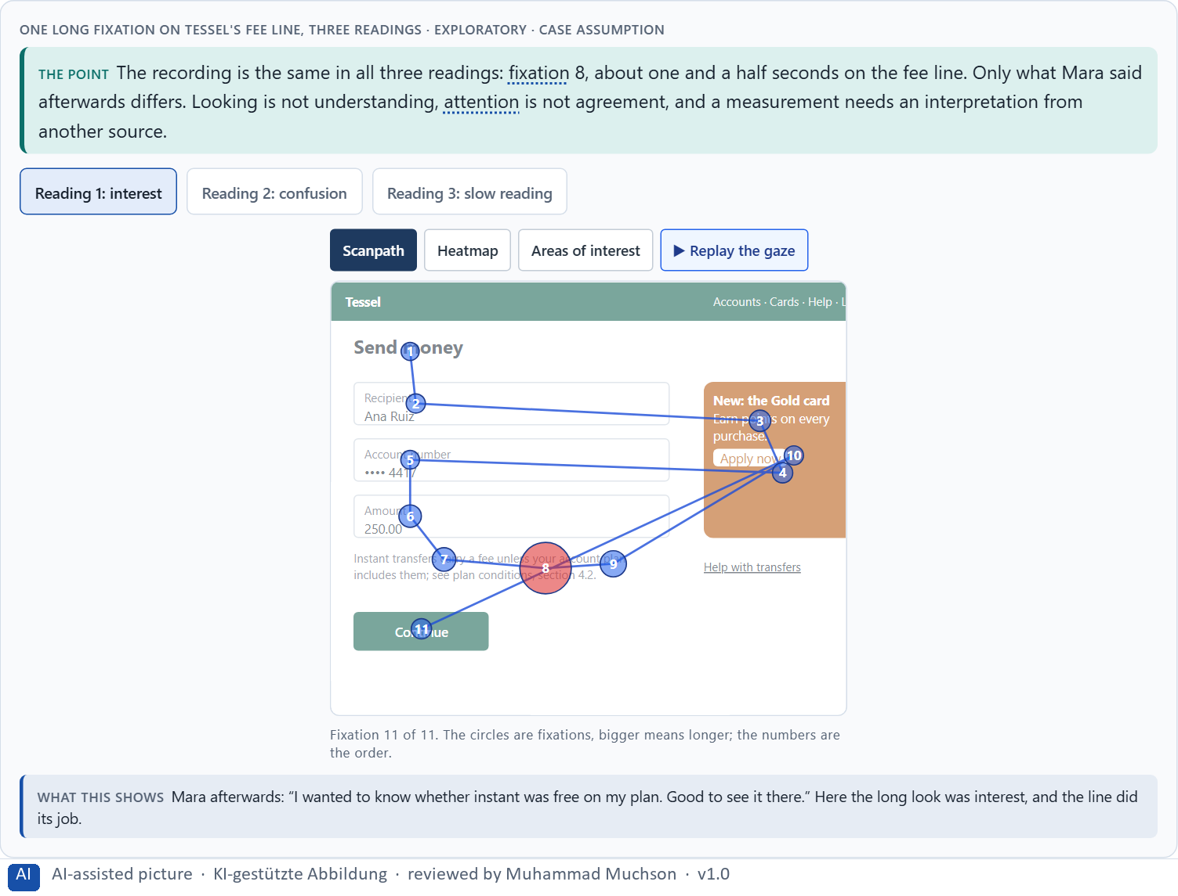
Figure 2 · One long fixation on Tessel's fee line, three readings · Exploratory.
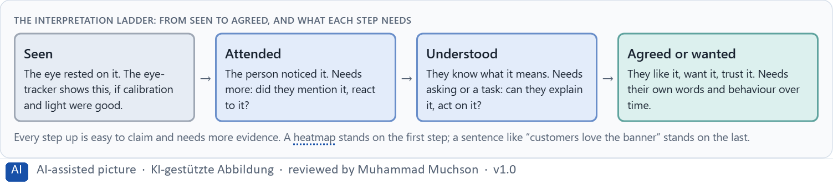
Figure 3 · The interpretation ladder: from seen to agreed, and what each step needs.
Case assumption
Tessel, Mara, Joon, Ines and Bastian are made up for this example; the gaze recordings are drawn for the lesson, not measured. The working assumption that what is fixated is being processed, and that longer fixations can mean more effort, follows Just and Carpenter (1980).

How to decide when this comes up in the task
- Say what the data shows in the plainest words: “the eye rested here for 1.5 seconds”.
- List at least three readings of the same pattern before choosing one.
- Ask the person: show them their recording and let them explain (retrospective think-aloud).
- Never write “users want” or “users love” on the basis of gaze alone.
- Say which step of the ladder a claim stands on: seen, attended, understood or agreed.

Extra · go deeper (optional reading)
“Measurable” is often confused with “reliable”. A number feels objective because it is precise; but a precise measure of where the eye rested is not a precise measure of what the person thought. The more scientific a chart looks, the more carefully ask which step of the ladder it really stands on.

Sources · Just & Carpenter 1980 · Holmqvist et al. 2011

A3 · Neurofeedback and brain-computer interfaces at their real maturity · 12 min · Core
Neurofeedback shows people a signal of their own brain activity so they can learn to change it; brain-computer interfaces turn brain signals into commands. Fields: training, adaptive systems, attention support, assistive use, experimental interaction. Maturity differs enormously. Chances: deeper insight into load and reactions, new interaction. Risks: over-interpretation, poor everyday fitness, technical hurdles, data protection and ethics.
IN PLAIN WORDS
The idea. Neurofeedback shows people a signal of their own brain activity (usually from EEG) so they can learn to change it; it is used in therapy and research, with mixed evidence. A brain-computer interface (BCI) turns brain signals into commands, for example to type without moving; today it is mostly medical and research use. Possible fields: training, adaptive systems, support for attention, assistive use and experimental interaction. Maturity differs enormously: eye-tracking in lab tests is an established method, a consumer headband's “focus score” is not validated, and a BCI to control a website by thought is a research topic. Chances: deeper insight into load, attention and reactions, new ways to interact. Risks: over-interpretation, poor fitness for daily use, high technical hurdles, data protection and ethics.
Why it matters. Block 1.1 asks about FocusSense's neurofeedback for concentration and overload, Block 1.2 rates experimental neurofeedback and BCI observation for LearningPulse, and Block 2.1 asks which methods are product-near. This card places them where they really are.
How to read the picture. Seven technologies placed by evidence and everyday use, for Tessel.

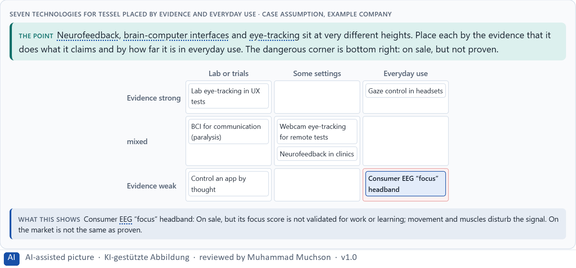
Figure 4 · Seven technologies for Tessel placed by evidence and everyday use.
Chances and risks of neuro-based UX
Chance | Example (Tessel) | Risk | What it looks like
Insight into load | Where the transfer flow strains people. | Over-interpretation | A focus score read as truth.
Insight into attention | The fee is seen too late. | Poor everyday fitness | Works in the lab, not on a bus.
Insight into reactions | Hesitation before Continue. | Technical hurdles | Calibration, glasses, bad light.
New interaction | Gaze to scroll for people who cannot use their hands. | Data protection and ethics | Brain data on a vendor's cloud.

Case assumption
Tessel, Mara, Joon, Ines and Bastian are made up for this example; the gaze recordings are drawn for the lesson, not measured. Neurofeedback follows Sitaram et al. (2017); brain-computer interfaces for communication and control follow Wolpaw et al. (2002). The placements are a reading of the example, not a ranking of products.

How to decide when this comes up in the task
- Say exactly which technology is meant: lab eye-tracking, webcam gaze, consumer EEG, clinical neurofeedback, medical BCI.
- Ask for the evidence that it measures what it claims, in a setting like yours.
- Separate “on sale” from “proven”.
- Check everyday fitness: movement, noise, light, glasses, hair, fatigue.
- Name the field: training, adaptation, attention support, assistance or experiment.

Extra · go deeper (optional reading)
Assistive use is where brain-computer interfaces matter most today: for someone who cannot move, a slow, tiring interface that works is life-changing. For everyone else, the same interface is slower than a thumb. Ask whose problem a neurotechnology solves before asking whether it is impressive.

Sources · Sitaram et al. 2017 · Wolpaw et al. 2002

A4 · Insight, interpretation risk and decision relevance: research, experiment or product? · 12 min · Core
Robust UX research, experimental technology and a marketable application are three tracks with different rules. Mixing them is how weak data ends up deciding a product. Fund the question, not the technology: a question, a hypothesis, a fitting method, what it can show, and the decision it informs. Judge every finding on insight value, interpretation risk and decision relevance.
IN PLAIN WORDS
The idea. Not every measurement belongs in a product. Robust UX research answers a written question with a fitting method and the participants' consent; experimental technology is explored to learn what it can do; a marketable application must work reliably for everyone, every day. Mixing the three is how weak data ends up deciding a product. Fund the question, not the technology: start from what you need to know, write a hypothesis, choose the method that can answer it, and say which decision the answer will inform. Then judge each finding on its insight value, its interpretation risk and its decision relevance.
Why it matters. Block 1.1 asks about decision relevance and the two biggest chances and risks, Block 1.2 compares approaches near and far from the product, and Block 2.1 asks for separate tracks and hypothesis-based pilots. This card gives you the three tracks and the chain from question to decision.
How to read the picture. Tessel's five ideas sorted into research, experiment, product, or not at all. Below, the chain from a question to a decision.

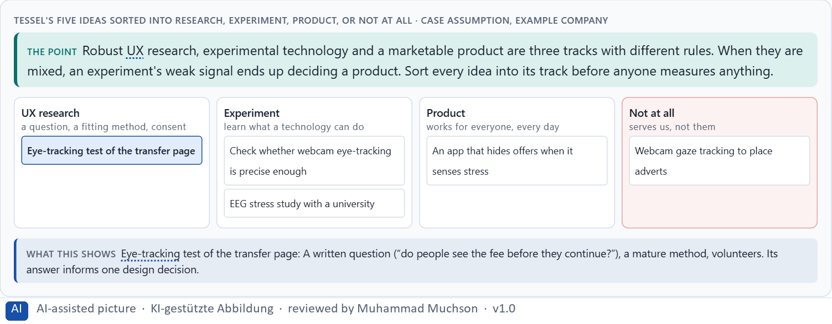
Figure 5 · Tessel's five ideas sorted into research, experiment, product, or not at all.
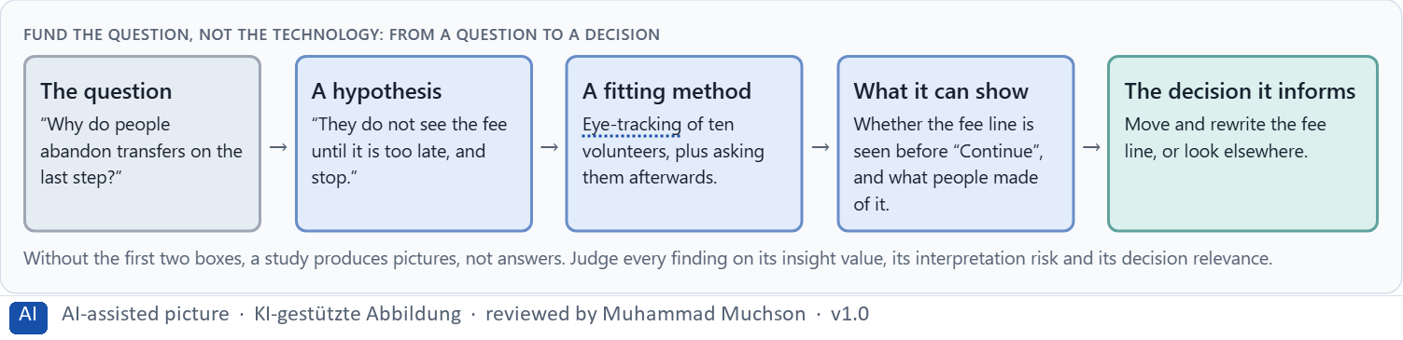
Figure 6 · Fund the question, not the technology: from a question to a decision.
Case assumption
Tessel, Mara, Joon, Ines and Bastian are made up for this example; the gaze recordings are drawn for the lesson, not measured. Narrow questions, one feature at a time and measurable outcomes follow Tobii's own advice to UX researchers (2019).

How to decide when this comes up in the task
- Sort every idea into research, experiment, product, or not at all.
- Write the question and the hypothesis before choosing a method.
- Choose the simplest method that can answer it; sometimes that is not eye-tracking.
- Name the decision the answer will inform.
- Let only robust findings cross from research into the product.

Extra · go deeper (optional reading)
A pilot without an exit criterion is not a pilot; it is a subscription. Write down before a study what result would make you stop, change course or go on. Otherwise every result will be read as a reason to continue.

Sources · Tobii 2019 · Holmqvist et al. 2011

A5 · Ethics, data protection and voluntariness, and weighing a measure · 12 min · Core
Gaze and brain data can reveal tiredness, stress, reading difficulties or health, often without the person knowing; regulators treat neurodata as high risk. Consent is design: what is recorded, what will not be inferred, who sees it, when it is deleted, and a no as easy as a yes. Weigh measures on effect on users, feasibility, risk, time pressure and reputation security.
IN PLAIN WORDS
The idea. Gaze and brain data are more intimate than clicks: they can reveal tiredness, stress, reading difficulties or health, often without the person knowing. Regulators treat neurodata as high risk. Consent is part of the design: say what is recorded, what will and will not be inferred, who sees it, when it is deleted, and make saying no as easy as saying yes. At work, consent is rarely free. Leaders weigh neuro-based measures by effect on users, feasibility, risk, time pressure and reputation security, and judge them with a differentiated view instead of a scientific aura.
Why it matters. Block 1.1 asks about ethics and acceptance, Block 1.2 about sensitive data protection, and Block 2.1 asks for an ethics, data protection and consent framework and four measures justified on effect on users, feasibility, risk, time pressure and reputation security. The example uses Tessel and its own measures, so the answer for the task cases is not given.
How to read the picture. Three consent screens for the same Tessel study: hidden, clear, and clear with limits on what is inferred. Then three measures rated on five criteria.

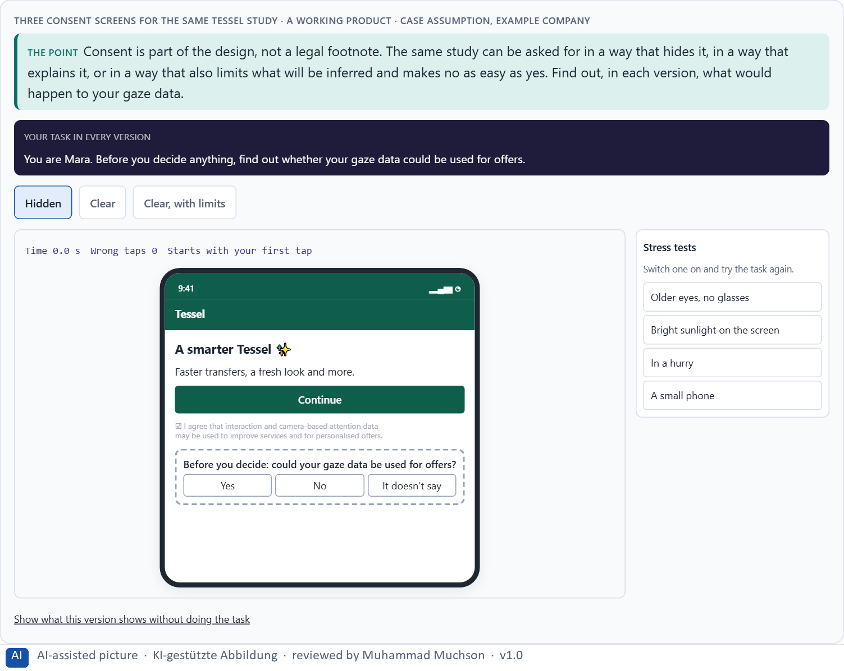
Figure 7 · Three consent screens for the same Tessel study. Shown here in its starting state; in the Neuro-UX Lab every version and every stress test can be used.
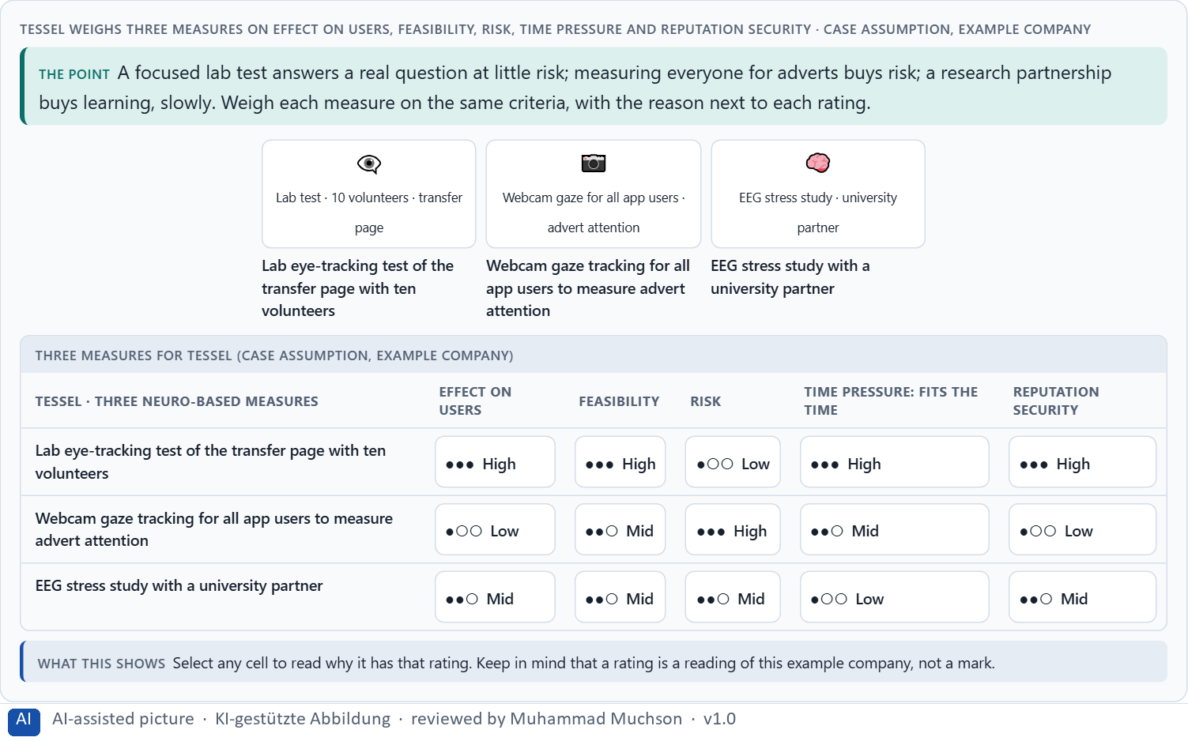
Figure 8 · Tessel weighs three measures on effect on users, feasibility, risk, time pressure and reputation security.
Case assumption
Tessel, Mara, Joon, Ines and Bastian are made up for this example; the gaze recordings are drawn for the lesson, not measured. Neurodata as high risk and the limits of consent follow the UK ICO (2023); mental privacy follows Ienca and Andorno (2017); rating options on the same criteria follows Gibbons (2018).

How to decide when this comes up in the task
- What is recorded, and what could be inferred from it, even by accident?
- Is taking part truly voluntary? At work, rarely.
- Say what you will not infer, and keep to it.
- Who sees the data, where is it stored, when is it deleted?
- Rate every measure on the same five criteria, with a reason; a rating is a judgement, never a mark.

Extra · go deeper (optional reading)
Reputation risk is a cost with a slow fuse. A study that looks harmless inside can read very differently as a headline: “bank measured customers' eyes”. Ask before every study how it would sound if a customer described it to a journalist.

Sources · ICO 2023 · Ienca & Andorno 2017 · Gibbons 2018

Materi B · Route 2 · Level 3
How Materi B is used
About 60 minutes, three cards, led by the facilitator. Level 3 in the Chief Experience Officer's chair: a guiding vision for neuro-based UX research and interaction, three strategic decisions, an order of what is researched first, a risk analysis, a governance model, one decision under uncertainty and a statement to the management. The cards give you the ideas you use in Task 2.

B1 · Neuro-based UX as an insight architecture, not measurement fascination · 20 min · Core
At senior level, neuro-based UX is a decision architecture for insight, personalisation and new interaction: a guiding vision of what the company wants to understand and what it will not do, separate tracks for research, UX analysis and product, hypotheses before studies, and an evidence grade for what may influence strategy.
IN PLAIN WORDS
The idea. At senior level, neuro-based UX is not a new gadget but a decision architecture for insight, personalisation and new interaction: a guiding vision of what the company wants to understand and why, separate tracks for research, UX analysis and product, hypotheses before studies, and an evidence grade that decides what may influence strategy. Operational decisions concern a single study; strategic ones concern the research portfolio, product development and the protection of trust.
Why it matters. Block 3.1 asks for a guiding vision for neuro-based UX research and interaction, three decisions on eye-tracking, neurofeedback, BCI, ethics, data protection and product connection, and an order of what is looked at first. You decide the architecture, not single methods.
How to read the picture. Left Tessel chasing measurements to look scientific, right running an insight architecture. Below, the layers from a guiding vision to every study.

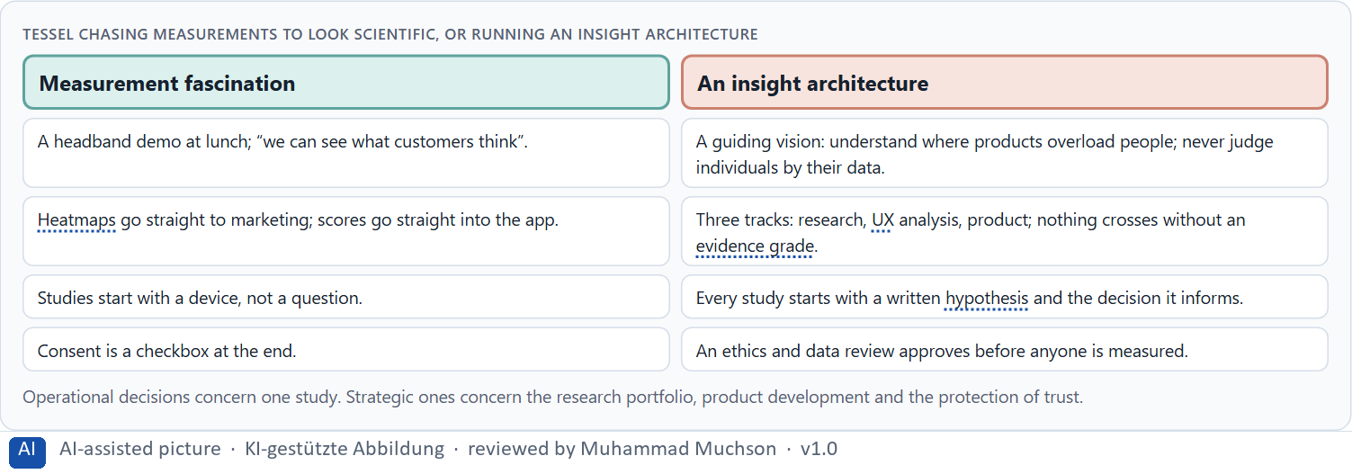
Figure 9 · Tessel chasing measurements to look scientific, or running an insight architecture.
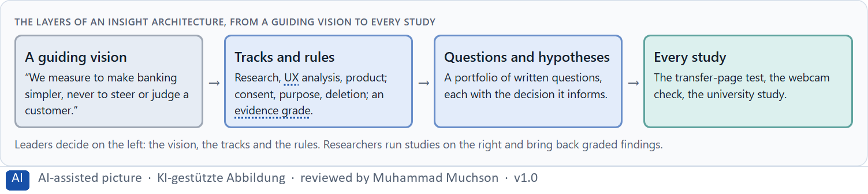
Figure 10 · The layers of an insight architecture, from a guiding vision to every study.
Case assumption
Tessel, Mara, Joon, Ines and Bastian are made up for this example; the gaze recordings are drawn for the lesson, not measured. The regulator's concerns about neurodata follow the UK ICO (2023); framing each study narrowly follows Tobii (2019).

How to decide when this comes up in the task
- Check how neuro-based methods are decided today: by fascination, or by a question?
- Write a guiding vision: what insight, for whom, and what is never done with the data.
- Separate research, UX analysis and product, with rules for crossing.
- Hold a portfolio of written questions, each with the decision it informs.
- Tell operational decisions (one study) from strategic ones (portfolio, product, trust).

Extra · go deeper (optional reading)
Your job is the standard, not the study. A leader does not need to read EEG curves; they need to decide which questions are worth asking, which methods may answer them, and what counts as an answer. That standard outlives every single study.

Sources · ICO 2023 · Tobii 2019

B2 · Value, validity, effort, ethics, data protection, maturity: the conflicts of neuro-based UX · 20 min · Core
Neuro-based UX sits between insight and validity, a scientific image and what the data can carry, personalisation and privacy, research depth and market maturity, speed and interpretation effort. A portfolio of a few bets of different size, each with a hypothesis, a measure of success and an exit date, makes the conflicts manageable; write down what each bet assumes.
IN PLAIN WORDS
The idea. Neuro-based UX sits between goals that pull apart: insight against validity, a scientific image against what the data can carry, personalisation against privacy, research depth against market maturity, speed against interpretation effort, and all of them against effort and money. The way through is a portfolio of a few bets of different size, each with a hypothesis, a measure of success and an exit date, and a written list of what each bet assumes about data quality, acceptance, maturity and strategic value.
Why it matters. Block 3.1 asks for three decisions, a risk analysis of wrong assumptions about data quality, user acceptance, market maturity and strategic value, and a governance model for conflicts. Each is a decision between conflicting goals.
How to read the picture. Tessel's three bets, a safe one, a medium one and a bold one, with what each costs and what it assumes.

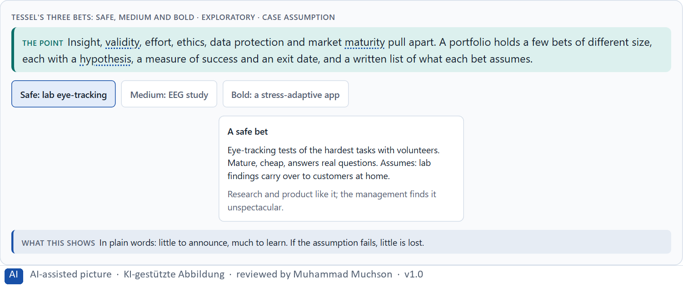
Figure 11 · Tessel's three bets: safe, medium and bold · Exploratory.
Standing conflicts of neuro-based UX
Conflict | Who usually stands for each side | What to ask
Insight against validity | Innovation, against research. | Does the measure mean what it claims, here?
A scientific image against what the data carries | Marketing, against research. | Which step of the ladder does the claim stand on?
Personalisation against privacy | Product, against data protection and customers. | What would we infer, and would people agree?
Speed against interpretation effort | Departments, against research. | What is the smallest study that answers the question?

Case assumption
Tessel, Mara, Joon, Ines and Bastian are made up for this example; the gaze recordings are drawn for the lesson, not measured. The bets are a reading of the example, not a rule for every company.

How to decide when this comes up in the task
- Name each conflict as two goals and say who stands for each: board, research, product, data protection, customers.
- Hold a few bets of different size: safe, medium, bold.
- Write down the assumptions each bet rests on: data quality, acceptance, maturity, strategic value.
- Set the measure of success and the exit date before the study starts.
- Say what the choice gives up.

Extra · go deeper (optional reading)
A data-driven project becomes a trust problem when people learn about it from someone else. The same study, explained openly in advance, is research; discovered later, it is surveillance. Openness is cheap now and cannot be bought later.

Sources · ICO 2023 · Sitaram et al. 2017

B3 · Governance for neurodata, and deciding with thin evidence · 20 min · Core
Neurodata needs an owner of research and the evidence grade, an ethics and data review that approves every study and may stop any, a translation step that decides what may reach a product, and a rule for when insight, speed and trust disagree. With thin evidence, a decision says what it decides, does not know, would reverse and gives up.
IN PLAIN WORDS
The idea. Neurodata needs owners and limits: someone who owns neuro-based research and the evidence grade, an ethics and data review that approves every study and may stop any, a translation step that decides what may reach a product, and a rule for when insight, speed and trust disagree. Four roles help: whoever sets the standard, whoever approves, whoever runs the studies, whoever translates. Evidence is usually thin at the start; a decision under uncertainty says what you decide, what you do not know, when you would reverse it and what you give up.
Why it matters. Block 3.1 asks for a governance model for neuro-based research, ethical approvals and the translation into product decisions, a decision despite patchy evidence, and a statement to the management. This card gives you the parts of each.
How to read the picture. The four boxes at the top are the parts of a decision, filled in for Tessel. The two boxes below are the rule for future decisions.

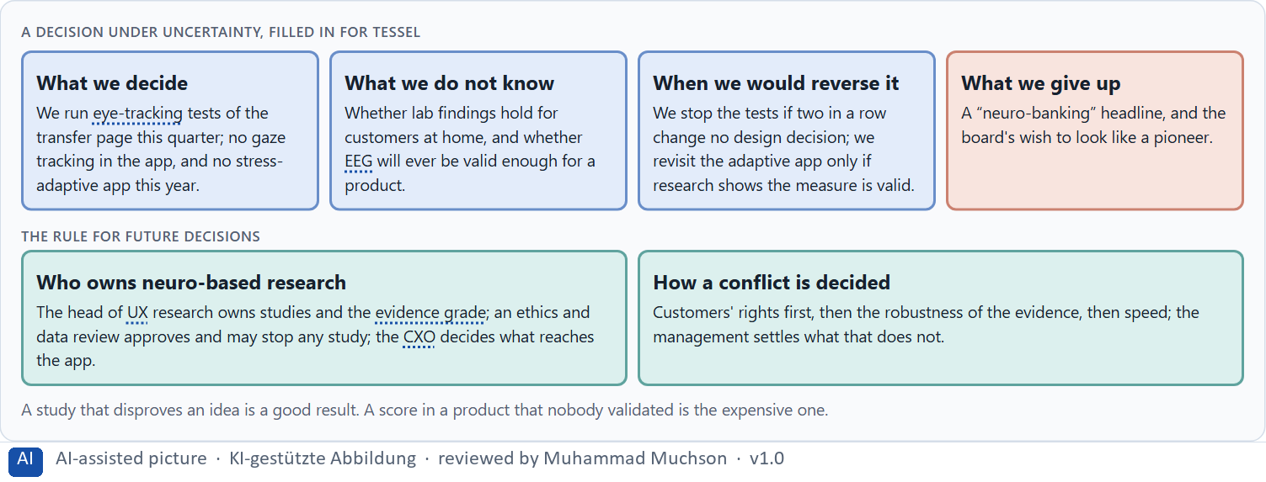
Figure 12 · A decision under uncertainty, filled in for Tessel.
Four roles of governance for neurodata
Role | The question | An example (Tessel)
Sets the standard | Who owns the research and the evidence grade? | The head of UX research.
Approves | Who says yes to a study, and may stop it? | An ethics and data review with the data protection officer.
Runs the studies | Who designs and analyses them? | The research team, with a university for EEG.
Translates | Who decides what reaches the product? | The CXO, only for graded findings.

Case assumption
Tessel, Mara, Joon, Ines and Bastian are made up for this example; the gaze recordings are drawn for the lesson, not measured. The limits of consent at work follow the UK ICO (2023); deciding with limited information follows Simon (1956); imagining the failure in advance (premortem) follows Klein (2007).

How to decide when this comes up in the task
- Name who sets the standard and owns the evidence grade.
- Name who approves a study and may stop it, including data protection and employee representatives.
- Name who runs studies, and who translates findings into product decisions.
- Settle conflicts by people's rights first, then robust evidence, then speed; say who settles a tie.
- Say what you decide, what you do not know, when you would reverse it and what you give up.

Extra · go deeper (optional reading)
Name the roles before you need them. When a study goes wrong, the first question is “who approved this?”; if nobody can answer, the problem is no longer the data, it is the company.

Sources · ICO 2023 · Simon 1956 · Klein 2007

Use in class: presentation and handout
Mark of use for the study material. Presentation is what the trainer shows on screen; Handout is what participants read and keep.
Card | Presentation (shown in the Neuro-UX Lab) | Handout
A1 · What eye-tracking measures: fixations, scanpaths, heatmaps and areas of interest (Core) | Scan line and Figure 1; the "In plain words" and "How to decide" boxes | The whole card
A2 · Looking is not understanding: the limits of gaze data (Core) | Scan line and Figures 2–3; the "In plain words" and "How to decide" boxes | The whole card
A3 · Neurofeedback and brain-computer interfaces at their real maturity (Core) | Scan line and Figure 4; the "In plain words" and "How to decide" boxes | The whole card
A4 · Insight, interpretation risk and decision relevance: research, experiment or product? (Core) | Scan line and Figures 5–6; the "In plain words" and "How to decide" boxes | The whole card
A5 · Ethics, data protection and voluntariness, and weighing a measure (Core) | Scan line and Figures 7–8; the "In plain words" and "How to decide" boxes | The whole card
B1 · Neuro-based UX as an insight architecture, not measurement fascination (Core) | Scan line and Figures 9–10; the "In plain words" and "How to decide" boxes | The whole card
B2 · Value, validity, effort, ethics, data protection, maturity: the conflicts of neuro-based UX (Core) | Scan line and Figure 11; the "In plain words" and "How to decide" boxes | The whole card
B3 · Governance for neurodata, and deciding with thin evidence (Core) | Scan line and Figure 12; the "In plain words" and "How to decide" boxes | The whole card

References
Check each source and its current edition before you teach from it. Standards and laws marked as in flux can change.
Holmqvist, K., Nyström, M., Andersson, R., Dewhurst, R., Jarodzka, H., & van de Weijer, J. (2011). Eye tracking: A comprehensive guide to methods and measures. Oxford University Press. (Fixations, saccades, scanpaths, areas of interest and heatmaps, and what each measure can support.)
Duchowski, A. T. (2017). Eye tracking methodology: Theory and practice (3rd ed.). Springer. (How eye-trackers work, calibration, accuracy, and where the measurement ends and interpretation begins.)
Just, M. A., & Carpenter, P. A. (1980). A theory of reading: From eye fixations to comprehension. Psychological Review, 87(4), 329–354. (The eye-mind assumption: what is fixated is being processed; longer fixations can mean more effort, not more liking.)
Sitaram, R., Ros, T., Stoeckel, L., et al. (2017). Closed-loop brain training: The science of neurofeedback. Nature Reviews Neuroscience, 18(2), 86–100. (What neurofeedback is, where the evidence is promising and where it is still weak.)
Wolpaw, J. R., Birbaumer, N., McFarland, D. J., Pfurtscheller, G., & Vaughan, T. M. (2002). Brain–computer interfaces for communication and control. Clinical Neurophysiology, 113(6), 767–791. (What a BCI is, and its main use so far: communication for people who cannot move.)
Tobii (2019, 13 November). Eye tracking and UX testing: when, how, and if you should use it. https://www.tobii.com/blog/eye-tracking-and-ux-testing (read 29.10.2026). (An eye-tracker maker's advice: narrow questions, measurable outcomes, retrospective think-aloud, pilot the test.)
Information Commissioner's Office (2023). ICO tech futures: neurotechnology. https://ico.org.uk/about-the-ico/research-reports-impact-and-evaluation/research-and-reports/technology-and-innovation/tech-horizons-and-ico-tech-futures/ico-tech-futures-neurotechnology/ (read 29.10.2026). (Neurodata as high risk, neurodiscrimination, and the limits of consent.)
Ienca, M., & Andorno, R. (2017). Towards new human rights in the age of neuroscience and neurotechnology. Life Sciences, Society and Policy, 13(1), 5. (Mental privacy, cognitive liberty and mental integrity as rights to protect.)
Gibbons, S. (2018). Using Prioritization Matrices to Inform UX Decisions. Nielsen Norman Group. https://www.nngroup.com/articles/prioritization-matrices/ (Rate each option on the same few criteria, such as value to the user against effort, and put the reason next to each rating.)
Simon, H. A. (1956). Rational choice and the structure of the environment. Psychological Review, 63(2), 129–138. (With limited information and time, people choose an option that is good enough rather than the best one: a decision under uncertainty.)
Klein, G. (2007). Performing a project premortem. Harvard Business Review, 85(9), 18–19. (Imagine the plan has failed and ask why; it brings risks and wrong assumptions to the surface before the work starts.)

Glossary
Every term below is used in this document. Terms stay plain text in the body; this list says what they mean in everyday words.
Term | In plain words | Example | Comes from
Adaptive system | A system that reacts to the situation now (time, place, device, what someone just did) without learning about the person over time. | — | Day 10
Area of interest | A part of a page marked before the analysis, for example the price or a button, so the time and order of looks at it can be counted. | — | Day 15
Attention | The mind's spotlight. Only a small part of a screen is processed at any moment; attention decides which part. | A flashing banner takes attention away from the form you were filling in. | Day 1
Brain-computer interface (BCI) | A system that turns brain signals into commands for a computer, for example to type without moving; today mostly medical and research use. | — | Day 15
Case assumption | A fact made up for this exercise to fill a gap in the plan's case. It is marked so you know it is not part of the plan. | — | Day 1
Chief Experience Officer | The manager who is responsible for the experience customers have across all channels, and who decides where the company invests in it. | — | Day 1
Decision architecture | A set of connected decisions that are made on purpose and written down: what effect you want, what comes first, who decides and how conflicts are settled. It replaces many separate fixes. | — | Day 1
EEG | Measuring the brain's electrical activity through sensors on the scalp; cheap headbands do it roughly and are disturbed by movement and muscles. | — | Day 15
Evidence grade | A label for how sure a finding is, from a first hint to a result that held up again, so that only robust findings drive decisions. | — | Day 15
Eye-tracking | Measuring where a person looks, usually with infrared light and a camera, and recording it so it can be replayed and analysed. | — | Day 15
Fixation | A short pause of the eye on one spot, usually a fraction of a second; most of what we take in, we take in during fixations. | — | Day 15
Governance | The rules about who may decide what, who is answerable for it and how disagreements are settled. | — | Day 1
Heatmap | A picture that colours a page by how long or how often people looked at each part, added up over people; it loses the order and the individual. | — | Day 15
Hypothesis | An assumption you could check later. “This red banner could make users uneasy” is a hypothesis; “this banner is bad” is only an opinion. | — | Day 1
Information architecture | How the content of a website or app is organised, grouped and named, and how people move through it. It is the structure behind the screens. | — | Day 2
Maturity | How far a technology is from an idea to reliable use: does it work, in the real environment, for real users, at scale? | — | Day 14
Neuro-UX | Designing an interface with knowledge of how the brain sees, attends, feels and decides, so that the design steers these processes on purpose and responsibly. | — | Day 1
Neurodata | Information produced directly by the brain and nervous system; regulators treat it as high-risk personal data. | — | Day 15
Neurofeedback | Showing people a signal of their own brain activity, usually from EEG, so they can learn to change it; used in therapy and research, with mixed evidence. | — | Day 15
Personalisation | Changing what someone sees from what is known about them: their history, their preferences, their profile. | — | Day 10
Ranking (leaderboard) | A list that orders people by points or results; it motivates those near the top and can shame those near the bottom. | — | Day 9
Retrospective think-aloud | Showing people their own recording after a test and asking them to say what they were thinking; it adds the why that the gaze cannot give. | — | Day 15
Saccade | The fast jump of the eye from one fixation to the next; during it, we hardly see anything. | — | Day 15
Scanpath | The order of fixations and jumps across a page: where someone looked first, next and last. | — | Day 15
UX (user experience) | Everything a person goes through when using a product: what they notice, understand, feel and do, from the first look to the last step. The screens are only one part of it. | Finding the booking you want at once and feeling sure it went through is a good UX. | Day 1
Validity | Whether a measure really measures what it claims to, for example whether a “concentration score” shows concentration and not just movement. | — | Day 15
Visual hierarchy | An order the eye can follow: the most important thing is clearly the strongest, the rest is quieter. Without it, everything competes equally. | — | Day 1

The Neuro-UX Lab: where we practise online
In class we use the course website as the place to practise and to learn. Every day has its own address, in the same pattern: the day number is the last part.
What | Address
Neuro-UX Lab (course website) | https://aion-ux-lab.vercel.app/
Day 15 | https://aion-ux-lab.vercel.app/day/15/

On the day page, Route 1 (Levels 1 and 2) and Route 2 (Level 3) can be opened; the cards and the tasks of this document are there too. The pattern is the same up to Day 8, for example https://aion-ux-lab.vercel.app/day/6/.

