AION · UX DEVELOPER · PSYCHOLOGICAL UX DESIGN AND NEURO-UX
DAY 16 · MATERI A AND MATERI B · ROUTES 1 AND 2 · LEVELS 1 TO 3
Immersive prototyping and testing, future strategies and ethical aspects
Study material with real research, worked examples and the rules you use in the tasks
AI notice · KI-Hinweis
This document was produced with the help of an AI language model (Claude, Anthropic). The AI drafted the text and tables and built the pictures and working examples of the lab. The content was then read, corrected and approved by the reviewer named below, who is responsible for its accuracy. Every picture carries an AI label on the image. Check figures and sources before you quote them.
KI-Hinweis: Dieses Dokument wurde mit Unterstützung eines KI-Sprachmodells (Claude, Anthropic) erstellt. Texte und Tabellen wurden von der KI entworfen, die Abbildungen sind KI-gestützt erstellt und am Bild gekennzeichnet. Die fachliche Prüfung und Freigabe erfolgte durch die unten genannte Person.

Day | Day 16 · Module 7 (day 3 of 3): Immersive prototyping and testing, future strategies and ethical aspects
Document | Materi (study material). Materi A has five cards, Materi B has three.
Route and level | Materi A serves Route 1 (Levels 1 and 2, Task 1). Materi B serves Route 2 (Level 3, Task 2).
Time | Materi A about 60 min · Materi B about 60 min (facilitator-led)
Neuro-UX Lab (website) | https://aion-ux-lab.vercel.app/day/16/
Case | Worked examples use a made-up company in each card. The task case is NextWorld UX (see the Task document).
Version | 1.0 · release date 29.10.2026
Review and approval | Muhammad Muchson, Mentor (subject-matter review and approval)

ABOUT THIS DOCUMENT
In class we also use the Neuro-UX Lab, the course website, as the place to practise and learn. Its address is at the end of this document.
Today is about turning experiments into decisions. You learn the steps from a concept idea through a prototype and a pilot to a scalable solution, what an immersive prototype must do before it can be tested, which aspects to test (orientation, presence, overload, error robustness, acceptance, transfer to real use), the ethical questions new interaction and neurotechnologies raise, and why a technology has to be responsible, connectable and governable, not only new. Then you use it on three platforms, including real 3D prototypes you can turn, and you look at what a headset maker requires before an app goes to market and what the European Union bans and demands. This document holds everything you need to study Day 16 without the website. Every card says what the idea is in plain words, shows it in a picture, gives the details and ends with the rules you use in the tasks.

IN THIS DOCUMENT
Lesson plan: ten teaching units (Ablaufplan)
Case study and transfer project at a glance
A1 · From concept idea to scalable solution: the ladder of immersive prototyping · 12 min · Core
A2 · Testing immersive systems: orientation, presence, overload, error robustness, acceptance, transfer · 12 min · Core
A3 · Feasible or responsible: future-proof UX strategy and its ethical questions · 12 min · Core
A4 · Responsible, connectable, governable: maturity, learning and the UX portfolio · 12 min · Core
A5 · When not to scale, and weighing a scaling decision · 12 min · Core
B1 · Future-proof UX as a responsible innovation and decision architecture · 20 min · Core
B2 · Innovation pressure, ethics, economics, value, maturity, portfolio: the conflicts · 20 min · Core
B3 · Who decides to scale, pause or stop, and deciding with incomplete data · 20 min · Core

Day at a glance
Day 16 has ten teaching units (UE). This document is the study material; it is used in UE1 (Materi A) and UE8 (Materi B). The day is built from three documents and the Neuro-UX Lab: Materi (study material), Task (worksheet) and Trainer (coaching, feedback and model solutions), plus the course website.

Lesson plan: ten teaching units (Ablaufplan)
UE | Min | Plan item | What happens | Material | Format
1 | 45 | Knowledge transfer · Level 1 | The trainer presents the cards of Materi A (A1, A2, A3, A4, A5, about 60 min of cards) in the Neuro-UX Lab; participants follow in the handout. | Materi A (Route 1) | Presentation + Handout
2 | 45 | Level 1 · Task 1 | Individual work on Block 1.1 (Core, about 10 min): the first product of the day is read and its effect described. Pairs then compare their results and the trainer collects open questions. | Task 1 · Part 1 · Block 1.1 | Handout (or in the lab)
3 | 45 | Level 1 · Task 2 | Three options are rated on the same criteria and one is chosen under the stated conditions: Block 1.2 (Core, about 8 min). | Task 1 · Part 1 · Block 1.2 | Handout (or in the lab)
4 | 45 | Coaching · transition from Level 1 to Level 2 | Trainer-led. A short talk on the day's coaching focus, then the reflection questions in pairs. The bridge: from describing an effect to a decision you answer for. There is no worksheet block in this unit. | Trainer document, section Coaching | Trainer only
5–6 | 90 | Level 2 · Case study NextWorld UX (2 UE) incl. model solution | UE5: the trainer presents the case; participants work on Block 2.1 (Core, about 15 min). UE6: groups compare their results and defend them; the trainer closes with the model solution. | Task 1 · Part 2 · Block 2.1  Trainer document, section Case study | Handout; model solution shown after the work
7 | 45 | Level 2 + 3 · Feedback round with a management perspective | Groups present their reasoning, not only their result. The trainer asks the day's Level 3 input questions and leads the discussion. | Trainer document, section Feedback round | Presentation by the groups; Trainer only
8 | 45 | Level 3 · Transfer project, Chief Experience Officer (3 UE: UE8–10) | The trainer presents Materi B (B1, B2, B3; use the "In plain words" and "How to decide" boxes, the rest is handout) and sets the role and the situation. | Materi B (Route 2) | Presentation + Handout
9 | 45 | Level 3 · Transfer project | Individual work or in pairs on Block 3.1 (Core, about 20 min): the strategy memo. | Task 2 · Block 3.1 | Handout (or in the lab)
10 | 45 | Level 3 · Transfer project | Participants present their decision and what they give up, including the one decision made under uncertainty; the trainer debriefs with the model solution. | Task 2 · Block 3.1  Trainer document, section Transfer project | Handout; model solution shown after the work

One UE is counted as 45 minutes here; breaks are not shown. The times are a guide for the trainer. The Core blocks are enough for a complete answer.

Case study and transfer project at a glance
Component | UE | Duration | Participants work in | Model solution in
Level 2 case study (NextWorld UX) | UE5–6 | 2 UE · 90 min | Task 1 · Part 2 (Block 2.1) | Trainer document, section Case study
Level 3 transfer project (Chief Experience Officer) | UE8–10 | 3 UE · 135 min | Materi B and Task 2 (Block 3.1) | Trainer document, section Transfer project

Materi A · Route 1 · Levels 1 and 2
How Materi A is used
About 60 minutes, five cards. Levels 1 and 2: judge an immersive innovation project strategically, organisationally and ethically, rate three strategy options under uncertainty, then analyse a company's immersive prototypes, develop four measures for a responsible scaling decision, justify them and decide on the first 16 weeks. The cards give you the ideas and the rules you use in Task 1.

A1 · From concept idea to scalable solution: the ladder of immersive prototyping · 12 min · Core
An immersive idea climbs a ladder: a concept idea says what could be, a prototype makes one question testable, a pilot shows whether it works for real users in one place, a scalable solution keeps working for many with support and an owner. Each rung proves something different, with a gate before the next. A prototype must fit the context of use, make the interaction clear, be technically robust, resilient and testable.
IN PLAIN WORDS
The idea. An immersive idea climbs a ladder. A concept idea describes what could be. A prototype makes one question testable, for example “can guests find their room with AR arrows?”. A pilot puts a working version in front of real users in one place for a limited time. A scalable solution keeps working for many people, places and devices, with support and maintenance. Each rung proves something different, and each needs a gate before the next. An immersive prototype must fit the context of use, make the interaction clear, be technically robust, cope with stress (resilience) and be testable.
Why it matters. Block 1.1 asks where RealityFlow's prototyping is not clarified enough, Block 1.2 compares strategies that climb at different speeds, and Block 2.1 asks which of NextWorld UX's prototypes is ready to scale. This card gives you the rungs and what each must prove.
How to read the picture. Fernwood's AR wayfinding on four rungs: a sketch, a prototype, a pilot in one hotel, and forty hotels. Below, the five requirements a prototype must meet.

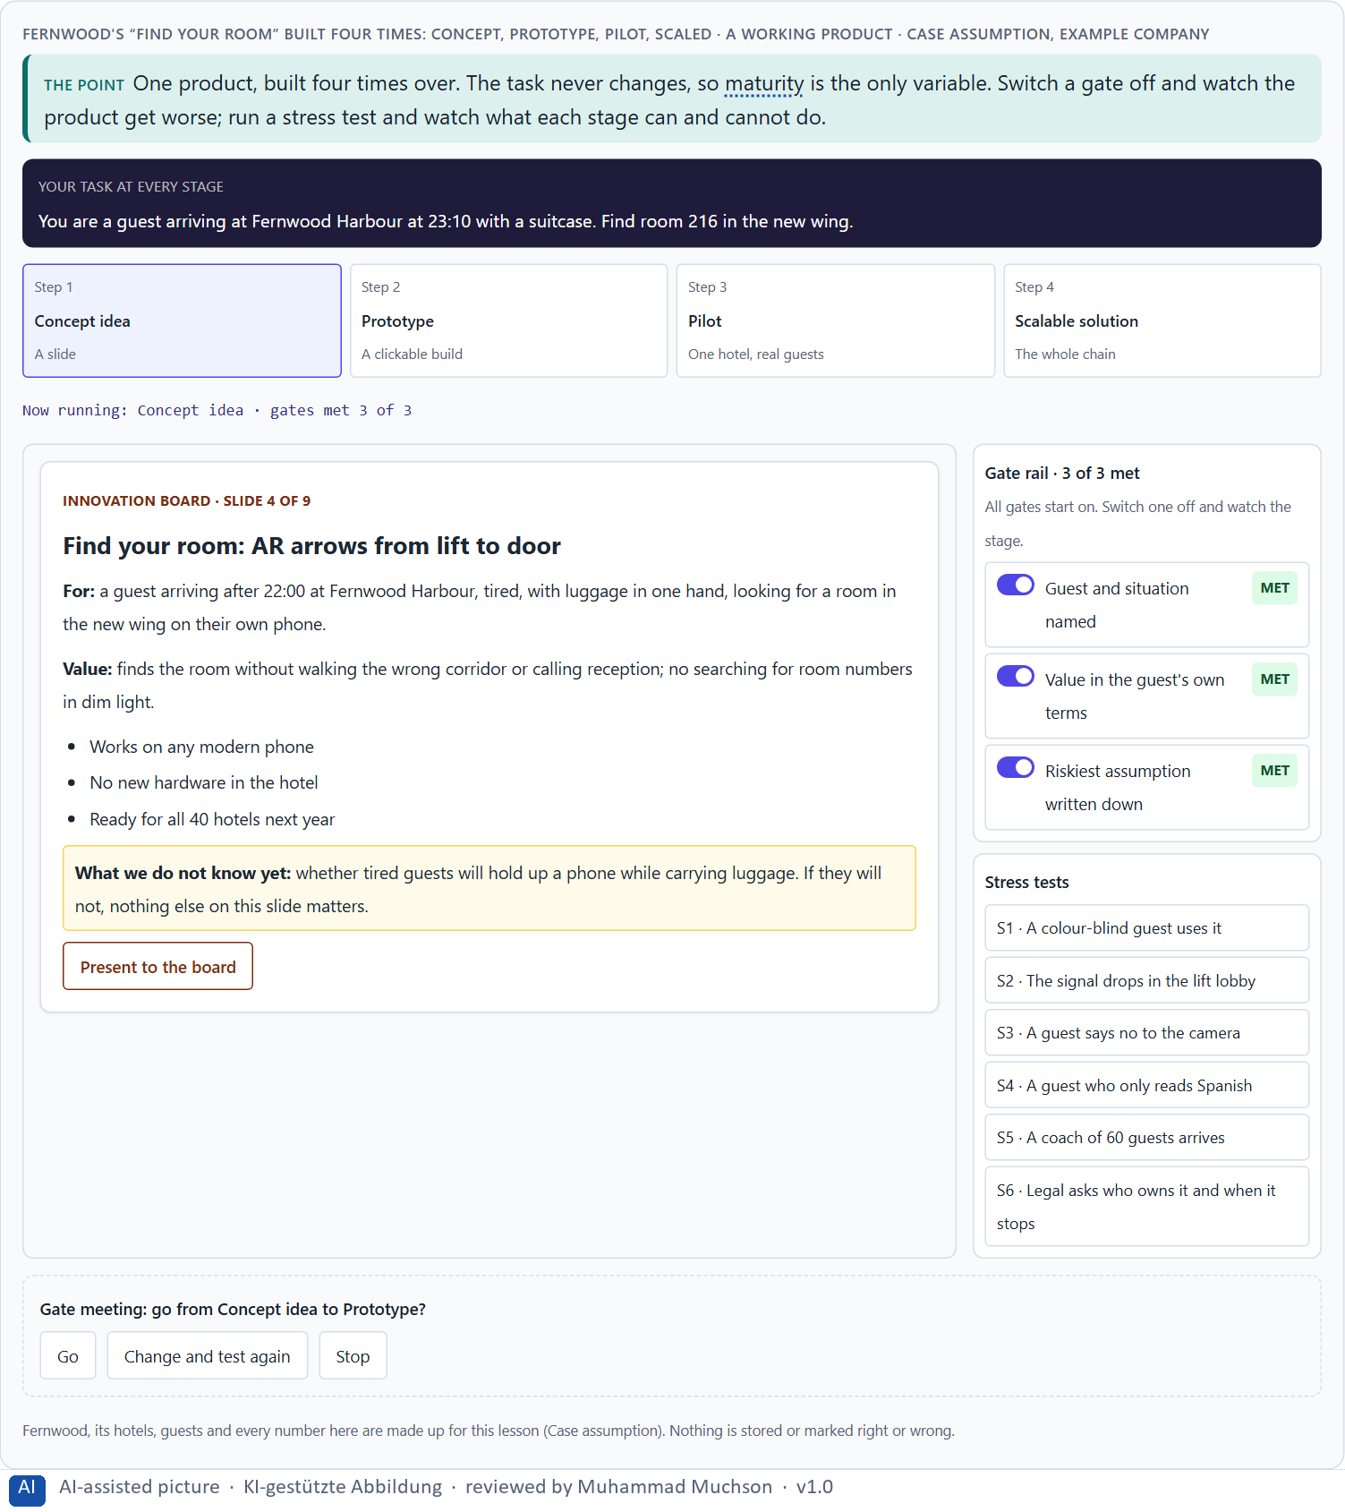
Figure 1 · Fernwood's “Find your room” built four times: concept, prototype, pilot, scaled. Shown here in its starting state; in the Neuro-UX Lab every version and every stress test can be used.
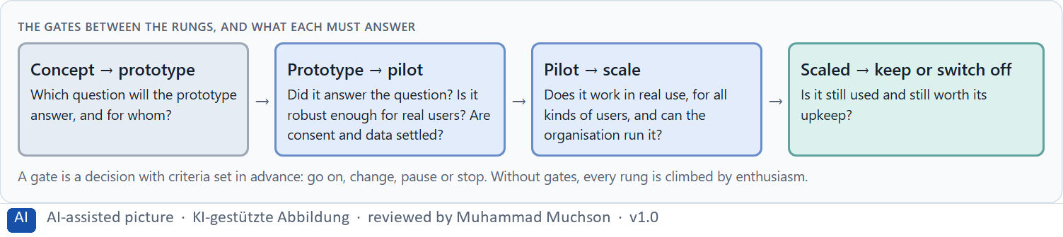
Figure 2 · The gates between the rungs, and what each must answer.
What an immersive prototype must have
Requirement | The question | Example (Fernwood)
Context of use | Where, when and by whom will it be used? | Late arrivals with luggage, tired, in a new wing.
Clarity of interaction | Is it obvious what to do? | One arrow, one room number, nothing else.
Technical robustness | Does it work on the devices guests have? | Old phones, low battery, weak signal.
Resilience | Does it cope with stress and failure? | A fallback route when tracking is lost.
Testability | Can a test show something? | A task, a measure: found the room without asking staff.

Case assumption
Fernwood, Leila, Sam, Rafael and Greta are made up for this example; the corridor and the reports are drawn for the lesson. What prototypes prototype follows Houde and Hill (1997) and Buchenau and Fulton Suri (2000); gates between stages follow Cooper (1990).

How to decide when this comes up in the task
- Say which rung a project is really on, whatever its slides say.
- Name the one question a prototype must answer.
- Check the five requirements: context of use, clear interaction, robustness, resilience, testability.
- Set the gate criteria before the rung is climbed.
- Count the cost of the last rung: maps, support, updates, an owner.

Extra · go deeper (optional reading)
The go/no-go meeting is the moment a ladder is either climbed or abandoned. It works only if the criteria were written before the rung, by people who will not be judged by the answer. Otherwise every prototype passes, because everyone in the room wants it to.

Sources · Houde & Hill 1997 · Buchenau & Fulton Suri 2000 · Cooper 1990

A2 · Testing immersive systems: orientation, presence, overload, error robustness, acceptance, transfer · 12 min · Core
Immersive systems need six kinds of test: orientation (do people know where they are), presence (do they feel there, and does it help), overload (is it too much), error robustness (what happens when something fails), acceptance (will all kinds of people use it again) and transfer (does it work in real use). Transfer is the most underestimated and the most decisive for scaling.
IN PLAIN WORDS
The idea. Immersive systems need tests that a screen never needed. Orientation: do people know where they are and where to go? Presence: do they feel there, and is that helpful? Overload: is it too much to take in? Error robustness: what happens when the signal drops or someone makes a mistake? Acceptance: will people use it again, all kinds of people? Transfer: does what works in the test work in real use, with noise, time pressure and other people? Transfer is the most underestimated, and the most decisive for scaling.
Why it matters. Block 1.1 asks where RealityFlow's testing is unclear, and Block 2.1 asks why NextWorld UX's feedback cannot be compared and what makes a prototype ready to scale. This card gives you the six aspects and a way to test each.
How to read the picture. Fernwood's AR arrow under test. Below, the six test aspects with how to test each.

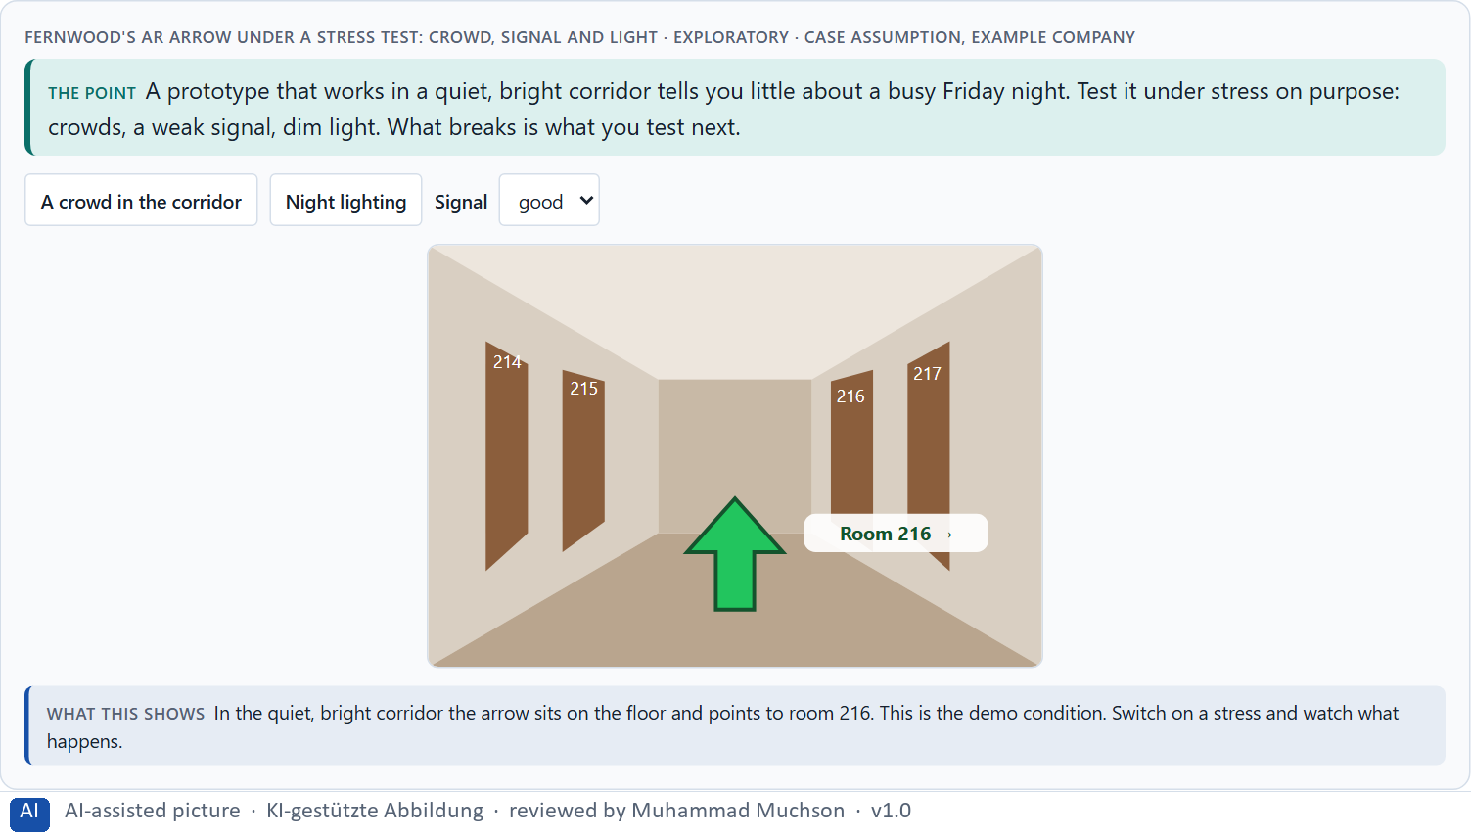
Figure 3 · Fernwood's AR arrow under a stress test: crowd, signal and light · Exploratory.
Six test aspects and how to test them
Aspect | How to test it | Example (Fernwood)
Orientation | Give a task; watch where people hesitate or turn back. | Find room 216 from the lift.
Presence | Ask a short presence questionnaire after the session. | Did the VR room feel like a real room?
Overload | Count what competes for attention; ask how demanding it was. | Arrow, number, offers, sounds.
Error robustness | Cause failures on purpose: lost signal, a wrong turn. | Tracking lost in the lift lobby.
Acceptance | Ask again after the second and third use; include sceptics. | Would Sam use it on his next stay?
Transfer | Test in the real place and moment, not the lab. | Friday night, crowd, night lighting.

Case assumption
Fernwood, Leila, Sam, Rafael and Greta are made up for this example; the corridor and the reports are drawn for the lesson. Asking about presence follows Witmer and Singer (1998); asking about simulator sickness follows Kennedy et al. (1993); rating comfort on one scale before release follows Meta's store policies.

How to decide when this comes up in the task
- Test in the worst realistic moment: crowds, dark, no signal, time pressure.
- Ask about presence and discomfort with standard questions after each session.
- Break things on purpose and watch what people do.
- Test with the people least like the team: older, newer, tired, sceptical.
- Make every test comparable: the same tasks and measures across prototypes.

Extra · go deeper (optional reading)
Grade the evidence, not only the result. A finding from five colleagues in a quiet room is a hint; the same finding from thirty real guests on busy nights is evidence. Write the grade next to every result, so that a hint is never presented as proof.

Sources · Witmer & Singer 1998 · Kennedy et al. 1993 · Meta Horizon Store policies

A3 · Feasible or responsible: future-proof UX strategy and its ethical questions · 12 min · Core
Feasibility asks “can we build it?”; a responsible UX strategy asks “should we, for whom, and how?”. New interaction and neurotechnologies raise seven ethical questions: data protection, voluntariness, potential for manipulation, cognitive overload, transparency, accessibility and inclusion. They are cheapest to answer at the concept stage and most expensive after scaling.
IN PLAIN WORDS
The idea. Technological feasibility asks “can we build it?”. A responsible UX strategy asks “should we, for whom, and how?”. New interaction and neurotechnologies raise seven ethical questions: data protection (what is recorded), voluntariness (can people say no), potential for manipulation (does it steer people for us), cognitive overload (is it too much), transparency (do people know what happens), accessibility (can everyone use it) and inclusion (who is left out). They are cheapest to answer at the concept stage and most expensive after scaling.
Why it matters. Block 1.1 asks where RealityFlow's ethics are unclear, Block 1.2 rates the ethics of three strategies, and Block 2.1 asks to build ethics into the scaling logic. This card gives you the questions by name.
How to read the picture. Left Fernwood asking “can we build it?”, right “should we, and how?”. Below, the seven ethical questions asked of three Fernwood ideas.

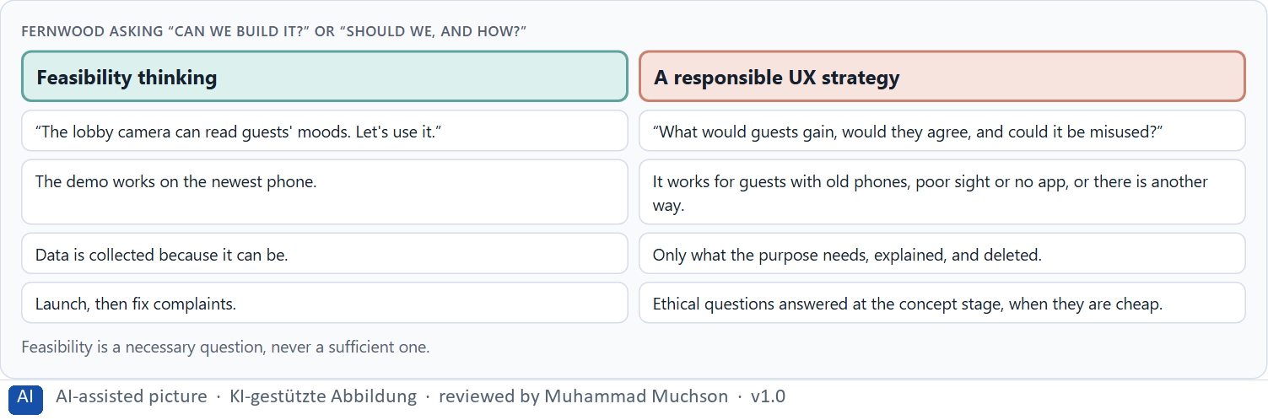
Figure 4 · Fernwood asking “can we build it?” or “should we, and how?”.
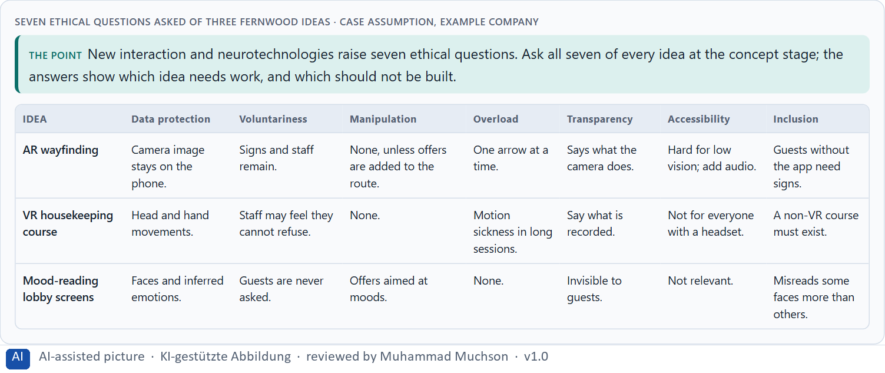
Figure 5 · Seven ethical questions asked of three Fernwood ideas.
Case assumption
Fernwood, Leila, Sam, Rafael and Greta are made up for this example; the corridor and the reports are drawn for the lesson. Anticipation, reflection, inclusion and responsiveness follow Stilgoe, Owen and Macnaghten (2013); the EU bans emotion recognition at work and in education and harmful manipulation (European Commission, AI Act).

How to decide when this comes up in the task
- Ask all seven questions of every idea before the first prototype.
- Write down what is recorded, inferred and kept, and for how long.
- Check that saying no is possible and costs nothing.
- Ask whose interest any steering serves.
- Name who cannot use it, and what they get instead.

Extra · go deeper (optional reading)
The biggest blind spots sit between feasibility and responsibility: a team that can build something rarely asks whether it should, and the people who would ask are rarely in the room when it is built. Invite them to the concept stage, not the launch.

Sources · Stilgoe, Owen & Macnaghten 2013 · European Commission, AI Act · EU AI Act 2024

A4 · Responsible, connectable, governable: maturity, learning and the UX portfolio · 12 min · Core
A new technology must be responsible (no avoidable harm), connectable (fits the products, processes and systems already run) and governable (someone can decide, measure and stop it). How far a company can go depends on the technology's maturity and on its own ability to learn. Together they shape the UX portfolio: scale, test further, pause, stop.
IN PLAIN WORDS
The idea. A new technology must be not only innovative but responsible (it does no avoidable harm), connectable (it fits the products, processes and systems the company already runs) and governable (someone can decide about it, measure it and stop it). How far a company can go depends on the maturity of the technology and on its own ability to learn: an organisation that tests, compares and decides well can hold more bold bets. Together they shape the UX portfolio: what is scaled, what is tested further, what is paused, what is stopped.
Why it matters. Block 1.1 asks about RealityFlow's scalability and organisational capability, Block 1.2 rates capacity to innovate and steerability, and Block 2.1 asks to focus NextWorld UX's portfolio. This card gives you the three tests and the four moves of a portfolio.
How to read the picture. Fernwood's five initiatives on a portfolio board. Below, how experiments grow into a steerable future architecture.

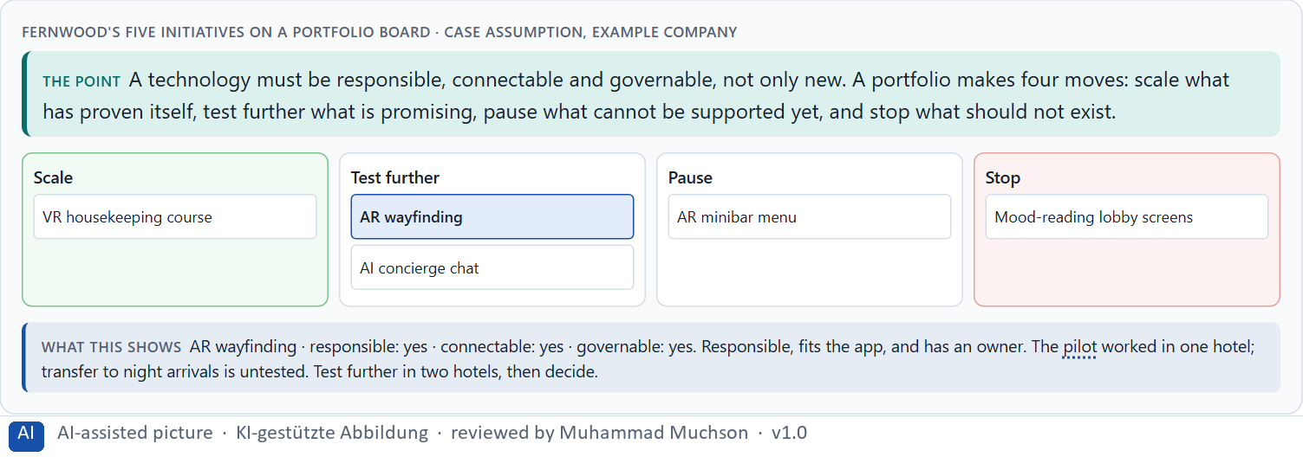
Figure 6 · Fernwood's five initiatives on a portfolio board.
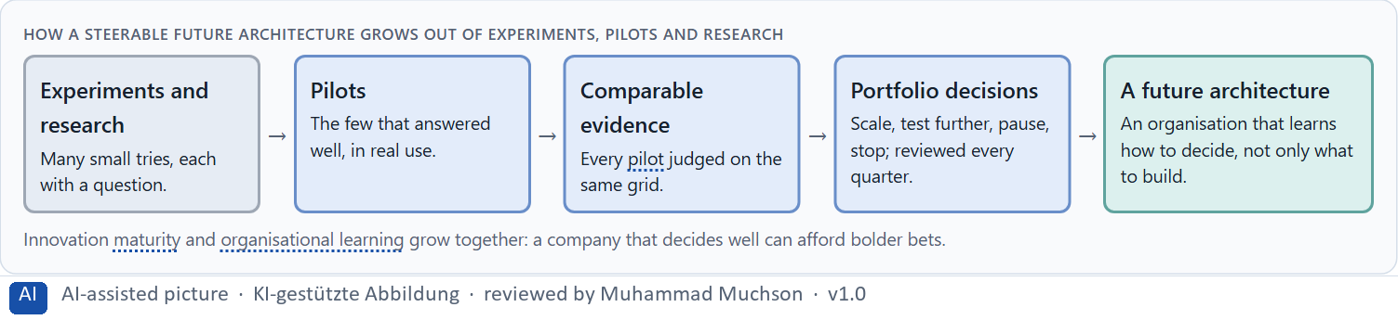
Figure 7 · How a steerable future architecture grows out of experiments, pilots and research.
Case assumption
Fernwood, Leila, Sam, Rafael and Greta are made up for this example; the corridor and the reports are drawn for the lesson. Learning by questioning one's own assumptions follows Argyris and Schön (1978); deciding at gates follows Cooper (1990).

How to decide when this comes up in the task
- Ask three questions of every initiative: responsible, connectable, governable?
- Place it by maturity: concept, prototype, pilot, scalable.
- Make one of four moves: scale, test further, pause, stop.
- Review the portfolio regularly, not only when something goes wrong.
- Ask what the organisation learned, not only what it built.

Extra · go deeper (optional reading)
Keep a quarter log: every three months, one line per initiative saying what was decided and why. After a year the log shows whether the company learns from its experiments, or only starts new ones.

Sources · Argyris & Schön 1978 · Cooper 1990

A5 · When not to scale, and weighing a scaling decision · 12 min · Core
Not scaling can be the best decision. Signs: it impresses but is rarely used again; it works only for some; it has not been tested in real use; its ethics are not settled; the organisation cannot support it; it does not fit the strategy. Weigh measures on effect on users, feasibility, risk, time pressure and strategic viability, with a reason for every rating.
IN PLAIN WORDS
The idea. Not scaling can be the best decision. Signs that a technology should not be scaled yet: it impresses but is rarely used again; it works only for some users; it has not been tested in real use; its ethics are not settled; the organisation cannot support it; or it does not fit the strategy. To put measures in order, weigh each on effect on users, feasibility, risk, time pressure and strategic viability, with a reason for every rating.
Why it matters. Block 1.1 asks for the biggest strategic risks, and Block 2.1 asks for four measures for a responsible scaling decision, justified on effect on users, feasibility, risk, time pressure and strategic viability. The example uses Fernwood and its own measures, so the answer for the task cases is not given.
How to read the picture. Six signs that Fernwood should not scale yet, as a checklist you can try on its AR minibar. Then three measures rated on five criteria.

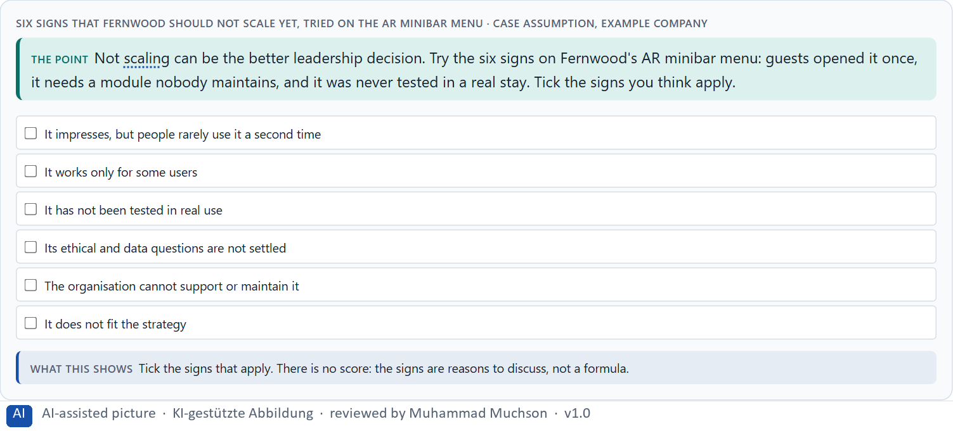
Figure 8 · Six signs that Fernwood should not scale yet, tried on the AR minibar menu.
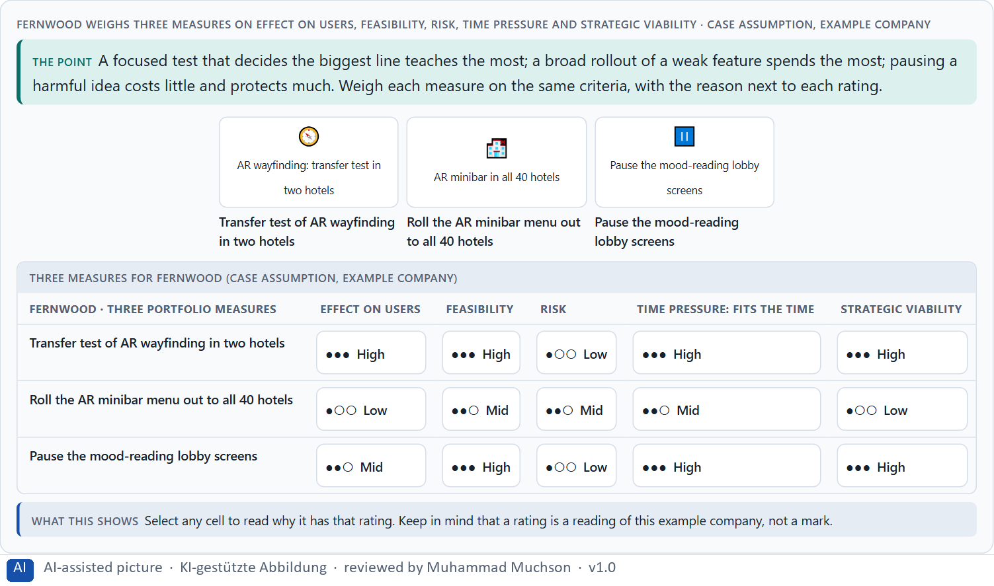
Figure 9 · Fernwood weighs three measures on effect on users, feasibility, risk, time pressure and strategic viability.
Case assumption
Fernwood, Leila, Sam, Rafael and Greta are made up for this example; the corridor and the reports are drawn for the lesson. Rating options on the same criteria follows Gibbons (2018); the five criteria are the ones the plan names for the case study.

How to decide when this comes up in the task
- Check the six signs before every step to scale.
- Treat a pause as a decision with a date to look again.
- Treat a stop as a result: write down what was learned.
- Rate every measure on the same five criteria, with a reason; a rating is a judgement, never a mark.
- Prefer the measure that decides the biggest question for the least.

Extra · go deeper (optional reading)
When ethics are only looked at after scaling, every answer is expensive: the system is built, people rely on it, and changing it means breaking promises. The same question asked at the concept stage costs a conversation.

Sources · Cooper 1990 · Gibbons 2018

Materi B · Route 2 · Level 3
How Materi B is used
About 60 minutes, three cards, led by the facilitator. Level 3 in the Chief Experience Officer's chair: a guiding vision for future-proof UX, three strategic decisions, what continues, pauses or ends, a risk analysis, a governance model, one decision under uncertainty and a statement to the management. The cards give you the ideas you use in Task 2.

B1 · Future-proof UX as a responsible innovation and decision architecture · 20 min · Core
At senior level, future-proof UX is a responsible innovation and decision architecture: a guiding vision of the innovation and responsibility wanted, one evaluation grid with comparable evidence, gates from prototype to pilot to scale with ethics built in, and a portfolio reviewed regularly. Experiments become a future when each one ends in a decision.
IN PLAIN WORDS
The idea. At senior level, future-proof UX is a responsible innovation and decision architecture: a guiding vision of the innovation and responsibility the company wants, one evaluation grid with comparable evidence, gates from prototype to pilot to scale with ethics built in, and a portfolio reviewed regularly. A steerable future architecture grows out of experiments, pilots and research when each one ends in a decision, not in a demo.
Why it matters. Block 3.1 asks for a guiding vision for future-proof UX, three decisions on prototyping, testing, scaling, ethics and portfolio, and what continues, pauses or ends. You decide the architecture, not single technologies.
How to read the picture. Left Fernwood collecting experiments, right running a steerable future architecture. Below, the layers from a guiding vision to every pilot.

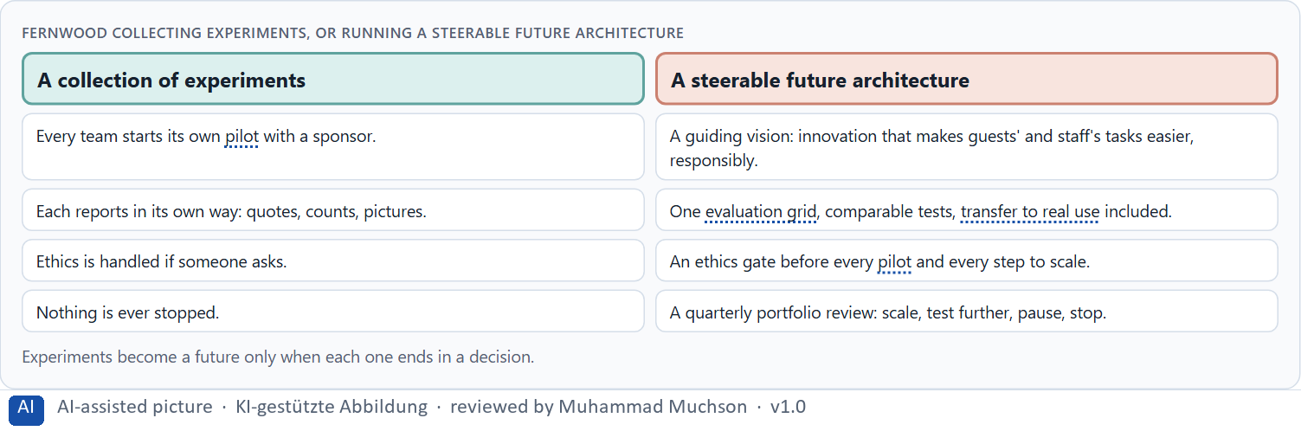
Figure 10 · Fernwood collecting experiments, or running a steerable future architecture.
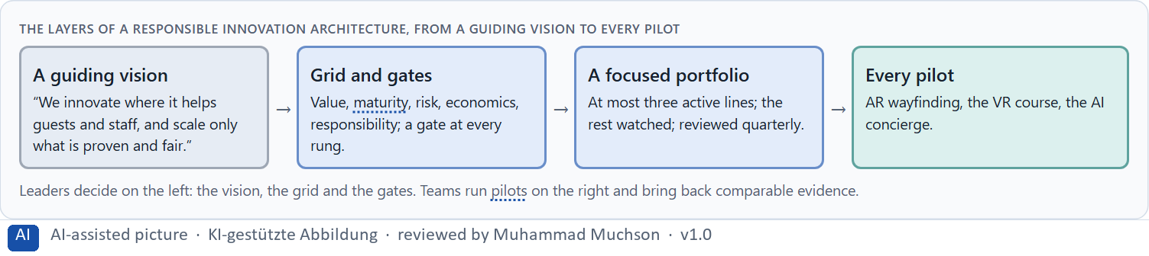
Figure 11 · The layers of a responsible innovation architecture, from a guiding vision to every pilot.
Closing question of the course · talk it through
What makes a UX strategy sustainable in the long run? A starting point from this card: a vision that outlives single technologies, decisions made on comparable evidence, responsibility built in before scaling, and the courage to pause or stop.

Case assumption
Fernwood, Leila, Sam, Rafael and Greta are made up for this example; the corridor and the reports are drawn for the lesson. Responsible innovation follows Stilgoe, Owen and Macnaghten (2013); gates follow Cooper (1990).

How to decide when this comes up in the task
- Write a guiding vision: what innovation, for whom, and what responsibility.
- Use one evaluation grid for every prototype and pilot.
- Put an ethics gate before every pilot and every step to scale.
- Keep a focused portfolio and review it every quarter.
- Tell operational decisions (one pilot) from strategic ones (portfolio, governance, market position).

Extra · go deeper (optional reading)
A future project is strategically connected when it would still matter if the technology changed: when it serves a lasting need of customers or staff. If it only matters because the technology is new, it is symbolic innovation, and it will age with the technology.

Sources · Stilgoe, Owen & Macnaghten 2013 · Cooper 1990

B2 · Innovation pressure, ethics, economics, value, maturity, portfolio: the conflicts · 20 min · Core
Future-proof UX sits between innovation pressure and maturity, ethics and speed, economic viability and a pioneer role, user value and visibility, the next quarter and the long-term portfolio. More active lines bring more visibility and less learning per line. A good portfolio states which conflicts it accepts and writes down what each line assumes.
IN PLAIN WORDS
The idea. Future-proof UX sits between goals that pull apart: innovation pressure against maturity, ethics against speed, economic viability against the pioneer role, user value against visibility, and the next quarter against the long-term portfolio. More active lines bring more visibility and less learning per line; fewer lines bring focus and the risk of missing something. A good portfolio states which conflicts it accepts, and writes down what each line assumes.
Why it matters. Block 3.1 asks for three decisions, a risk analysis of wrong assumptions about future technologies, market maturity, user acceptance and governance, and a governance model for conflicts. Each is a decision between conflicting goals.
How to read the picture. A slider for how many lines Fernwood runs at once, from one to five.

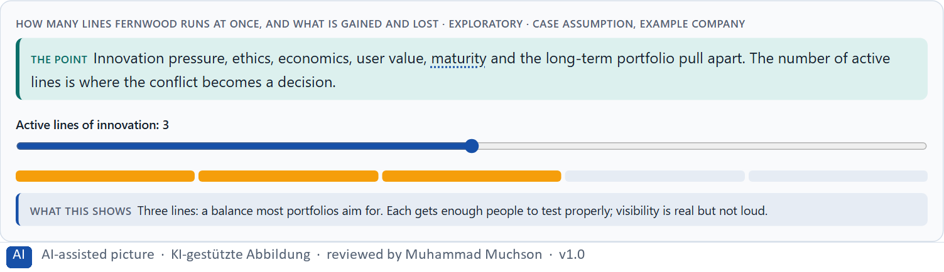
Figure 12 · How many lines Fernwood runs at once, and what is gained and lost · Exploratory.
Standing conflicts of future-proof UX
Conflict | Who usually stands for each side | What to ask
Innovation pressure against maturity | Management and innovation, against product and IT. | Which rung is it really on?
Ethics against speed | Data protection and works council, against the launch date. | What would we regret if it went wrong at scale?
Pioneer role against economic viability | Strategy, against finance. | What is the smallest step that keeps us ahead?
Short-term signal against long-term portfolio | Marketing, against the portfolio owner. | Will this still matter when the technology changes?

Case assumption
Fernwood, Leila, Sam, Rafael and Greta are made up for this example; the corridor and the reports are drawn for the lesson. The lines and their trade-offs are a reading of the example, not a rule for every company.

How to decide when this comes up in the task
- Name each conflict as two goals and say who stands for each: management, innovation, IT, departments, data protection, users.
- Decide how many lines can be tested properly at once.
- Write down what each line assumes about technology, market, acceptance and governance.
- Check which lines fall under stricter rules, such as AI that recognises emotions.
- Say what the choice gives up.

Extra · go deeper (optional reading)
Stopping an innovation is the better leadership decision when continuing it would teach nothing new, cost trust, or keep people from work that matters more. The sign of a mature portfolio is not how much it starts, but how calmly it stops.

Sources · European Commission, AI Act · Stilgoe, Owen & Macnaghten 2013

B3 · Who decides to scale, pause or stop, and deciding with incomplete data · 20 min · Core
Scaling needs owners: someone who owns the evaluation grid, an ethics and data protection review that approves before a pilot and before scaling and may stop anything, a board that decides at each gate to scale, test further, pause or stop, and a regular portfolio review. With incomplete data, a decision says what it decides, does not know, would reverse and gives up.
IN PLAIN WORDS
The idea. Scaling needs owners: someone who owns the evaluation grid and scores every initiative, an ethics and data protection review that approves before a pilot and before scaling and may stop anything, a board that decides at each gate to scale, test further, pause or stop, and a regular portfolio review. With incomplete data, a decision says what it decides, what it does not know, when it would reverse and what it gives up.
Why it matters. Block 3.1 asks for a governance model for innovation evaluation, ethical approvals, scaling decisions and portfolio adjustments, a decision despite incomplete data, and a statement to the management. This card gives you the parts of each.
How to read the picture. The four boxes at the top are the parts of a decision, filled in for Fernwood. The two boxes below are the rule for future decisions.

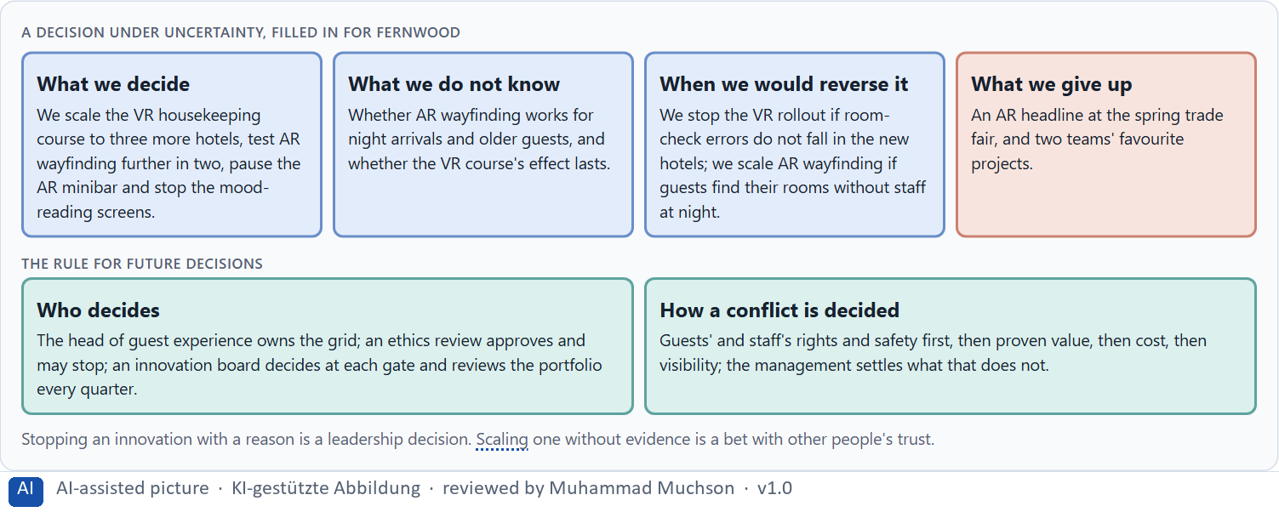
Figure 13 · A decision under uncertainty, filled in for Fernwood.
Four responsibilities of innovation governance
Responsibility | The question | An example (Fernwood)
Innovation evaluation | Who scores every initiative on one grid? | The head of guest experience and a small team.
Ethical approval | Who says yes before a pilot and before scaling, and may stop? | An ethics and data review with the data protection officer.
Scaling decision | Who decides scale, test further, pause or stop at each gate? | An innovation board.
Portfolio adjustment | Who reviews the whole portfolio, and how often? | The board, every quarter, at most three active lines.

Case assumption
Fernwood, Leila, Sam, Rafael and Greta are made up for this example; the corridor and the reports are drawn for the lesson. Monitoring after launch follows the European Commission's summary of the AI Act; deciding with limited information follows Simon (1956); the premortem follows Klein (2007).

How to decide when this comes up in the task
- Name who owns the grid and scores every initiative.
- Name who approves ethically and may stop, including data protection and employee representatives.
- Name who decides at each gate, and how often the portfolio is reviewed.
- Settle conflicts by rights and safety first, then proven value, then cost, then visibility; say who settles a tie.
- Say what you decide, what you do not know, when you would reverse it and what you give up.

Extra · go deeper (optional reading)
Write the stop criteria before the pilot starts, when nobody is attached to it yet. The person who may stop an initiative should not be the person whose bonus depends on it.

Sources · European Commission, AI Act · Simon 1956 · Klein 2007

Use in class: presentation and handout
Mark of use for the study material. Presentation is what the trainer shows on screen; Handout is what participants read and keep.
Card | Presentation (shown in the Neuro-UX Lab) | Handout
A1 · From concept idea to scalable solution: the ladder of immersive prototyping (Core) | Scan line and Figures 1–2; the "In plain words" and "How to decide" boxes | The whole card
A2 · Testing immersive systems: orientation, presence, overload, error robustness, acceptance, transfer (Core) | Scan line and Figure 3; the "In plain words" and "How to decide" boxes | The whole card
A3 · Feasible or responsible: future-proof UX strategy and its ethical questions (Core) | Scan line and Figures 4–5; the "In plain words" and "How to decide" boxes | The whole card
A4 · Responsible, connectable, governable: maturity, learning and the UX portfolio (Core) | Scan line and Figures 6–7; the "In plain words" and "How to decide" boxes | The whole card
A5 · When not to scale, and weighing a scaling decision (Core) | Scan line and Figures 8–9; the "In plain words" and "How to decide" boxes | The whole card
B1 · Future-proof UX as a responsible innovation and decision architecture (Core) | Scan line and Figures 10–11; the "In plain words" and "How to decide" boxes | The whole card
B2 · Innovation pressure, ethics, economics, value, maturity, portfolio: the conflicts (Core) | Scan line and Figure 12; the "In plain words" and "How to decide" boxes | The whole card
B3 · Who decides to scale, pause or stop, and deciding with incomplete data (Core) | Scan line and Figure 13; the "In plain words" and "How to decide" boxes | The whole card

References
Check each source and its current edition before you teach from it. Standards and laws marked as in flux can change.
Houde, S., & Hill, C. (1997). What do prototypes prototype? In M. Helander, T. Landauer, & P. Prabhu (Eds.), Handbook of Human-Computer Interaction (2nd ed., pp. 367–381). Elsevier. (A prototype answers a question about role, look and feel, or implementation; choose it by the question.)
Buchenau, M., & Fulton Suri, J. (2000). Experience prototyping. Proceedings of DIS 2000, 424–433. ACM. (Prototypes that let people experience a situation, not only look at a design, and what each prototype is meant to answer.)
Cooper, R. G. (1990). Stage-gate systems: A new tool for managing new products. Business Horizons, 33(3), 44–54. (Stages separated by gates where a project must meet criteria to continue, change or stop.)
Witmer, B. G., & Singer, M. J. (1998). Measuring presence in virtual environments: A presence questionnaire. Presence: Teleoperators and Virtual Environments, 7(3), 225–240. (Presence can be asked about in a structured way after a session.)
Kennedy, R. S., Lane, N. E., Berbaum, K. S., & Lilienthal, M. G. (1993). Simulator Sickness Questionnaire: An enhanced method for quantifying simulator sickness. The International Journal of Aviation Psychology, 3(3), 203–220. (A standard questionnaire for discomfort and sickness in simulators and VR.)
Meta Platforms Technologies. App policies, Meta Horizon Store. https://developers.meta.com/horizon/policy/store-policies/ (read 29.10.2026). (Comfort ratings on one scale, a minimum of utility, content ratings and warnings before release.)
Stilgoe, J., Owen, R., & Macnaghten, P. (2013). Developing a framework for responsible innovation. Research Policy, 42(9), 1568–1580. (Anticipation, reflexivity, inclusion and responsiveness as dimensions of responsible innovation.)
European Commission. AI Act. Shaping Europe's digital future. https://digital-strategy.ec.europa.eu/en/policies/regulatory-framework-ai (read 29.10.2026). (Four levels of risk, banned practices including emotion recognition at work and in education, obligations before market, monitoring after.)
Regulation (EU) 2024/1689 of the European Parliament and of the Council laying down harmonised rules on artificial intelligence (Artificial Intelligence Act). Official Journal of the European Union, 12 July 2024. (Among other duties, people must be informed when they interact with an AI system; check the current state of its application before a course run.)
Argyris, C., & Schön, D. A. (1978). Organizational learning: A theory of action perspective. Addison-Wesley. (Organisations learn when they question not only their actions but the assumptions behind them.)
Gibbons, S. (2018). Using Prioritization Matrices to Inform UX Decisions. Nielsen Norman Group. https://www.nngroup.com/articles/prioritization-matrices/ (Rate each option on the same few criteria, such as value to the user against effort, and put the reason next to each rating.)
Simon, H. A. (1956). Rational choice and the structure of the environment. Psychological Review, 63(2), 129–138. (With limited information and time, people choose an option that is good enough rather than the best one: a decision under uncertainty.)
Klein, G. (2007). Performing a project premortem. Harvard Business Review, 85(9), 18–19. (Imagine the plan has failed and ask why; it brings risks and wrong assumptions to the surface before the work starts.)

Glossary
Every term below is used in this document. Terms stay plain text in the body; this list says what they mean in everyday words.
Term | In plain words | Example | Comes from
Accessibility | Designing so that everyone can use a product, also people who see less well, see colours differently, or use a keyboard or a screen reader. | — | Day 3
Attention | The mind's spotlight. Only a small part of a screen is processed at any moment; attention decides which part. | A flashing banner takes attention away from the form you were filling in. | Day 1
Case assumption | A fact made up for this exercise to fill a gap in the plan's case. It is marked so you know it is not part of the plan. | — | Day 1
Chief Experience Officer | The manager who is responsible for the experience customers have across all channels, and who decides where the company invests in it. | — | Day 1
Concept idea | A described possibility: what it could be and for whom. Nothing has been built or tested yet. | — | Day 16
Dark pattern | A design that uses emotion against people's own interest, such as false urgency, guilt or hidden costs. | — | Day 7
Decision architecture | A set of connected decisions that are made on purpose and written down: what effect you want, what comes first, who decides and how conflicts are settled. It replaces many separate fixes. | — | Day 1
Error handling | What an assistant does when it does not understand: a good one asks a better question or hands over to a person instead of repeating itself. | — | Day 11
Error robustness | How well a system copes with mistakes and failures, such as a lost signal or a wrong step, without leaving people stuck. | — | Day 16
Evaluation grid | One set of criteria used for every idea, prototype and pilot, so that they can be compared and decided the same way. | — | Day 16
Governance | The rules about who may decide what, who is answerable for it and how disagreements are settled. | — | Day 1
Immersion | How much a technology surrounds the senses and shuts out the real surroundings; more immersion can mean more presence, and more load. | — | Day 14
Maturity | How far a technology is from an idea to reliable use: does it work, in the real environment, for real users, at scale? | — | Day 14
Neuro-UX | Designing an interface with knowledge of how the brain sees, attends, feels and decides, so that the design steers these processes on purpose and responsibly. | — | Day 1
Organisational learning | An organisation getting better at deciding, by questioning not only what it did but the assumptions behind it. | — | Day 16
Orientation | Knowing where you are, what you can do here and what happens next. | — | Day 1
Pilot | A real use of a solution by real users in one limited place and time, to learn whether it works before it grows. | — | Day 16
Presence | The feeling of really being in a place that is digital or partly digital. | — | Day 14
Responsible innovation | Innovation that anticipates harm, reflects on its own assumptions, includes those affected and changes course when needed. | — | Day 16
Scalable solution | A solution that keeps working when many more people, places or devices use it, with support, maintenance and governance in place. | — | Day 16
Testability | Whether a prototype is built so that a test can show something: a task, a measure and a question it can answer. | — | Day 16
UX (user experience) | Everything a person goes through when using a product: what they notice, understand, feel and do, from the first look to the last step. The screens are only one part of it. | Finding the booking you want at once and feeling sure it went through is a good UX. | Day 1

The Neuro-UX Lab: where we practise online
In class we use the course website as the place to practise and to learn. Every day has its own address, in the same pattern: the day number is the last part.
What | Address
Neuro-UX Lab (course website) | https://aion-ux-lab.vercel.app/
Day 16 | https://aion-ux-lab.vercel.app/day/16/

On the day page, Route 1 (Levels 1 and 2) and Route 2 (Level 3) can be opened; the cards and the tasks of this document are there too. The pattern is the same up to Day 8, for example https://aion-ux-lab.vercel.app/day/6/.

