AION · UX DEVELOPER · PSYCHOLOGICAL UX DESIGN AND NEURO-UX
DAY 16 · TASK 1 AND TASK 2 · ROUTES 1 AND 2 · LEVELS 1 TO 3
NextWorld UX: UX Analysis File and UX Strategy Memo
Describe the effect, choose the measures as a team member, and decide as Chief Experience Officer
AI notice · KI-Hinweis
This document was produced with the help of an AI language model (Claude, Anthropic). The AI drafted the text and tables and built the pictures and working examples of the lab. The content was then read, corrected and approved by the reviewer named below, who is responsible for its accuracy. Every picture carries an AI label on the image. Check figures and sources before you quote them.
KI-Hinweis: Dieses Dokument wurde mit Unterstützung eines KI-Sprachmodells (Claude, Anthropic) erstellt. Texte und Tabellen wurden von der KI entworfen, die Abbildungen sind KI-gestützt erstellt und am Bild gekennzeichnet. Die fachliche Prüfung und Freigabe erfolgte durch die unten genannte Person.

Day | Day 16 · Module 7 (day 3 of 3): Immersive prototyping and testing, future strategies and ethical aspects
Document | Task (worksheet with answer spaces). Task 1 (UX Analysis File) and Task 2 (UX Strategy Memo).
Route and level | Task 1 = Route 1, Levels 1 and 2 (draws on Materi A). Task 2 = Route 2, Level 3 (draws on Materi B).
Time | Task 1 about 33 min · Task 2 about 20 min
Neuro-UX Lab (website) | https://aion-ux-lab.vercel.app/day/16/
Case | NextWorld UX, the day's case study; other products appear as warm-ups
Version | 1.0 · release date 29.10.2026
Review and approval | Muhammad Muchson, Mentor (subject-matter review and approval)

ABOUT THIS DOCUMENT
In class we also use the Neuro-UX Lab, the course website, as the place to practise and learn. Its address is at the end of this document.
This is the worksheet for Day 16. Read the case once, study the evidence printed in this document, and write your answers in the boxes and tables. You can work through it on paper or type into the document. All blocks are Core. There are no answer keys and no scores; the reason you give matters more than the choice.

IN THIS DOCUMENT
Lesson plan: ten teaching units (Ablaufplan)
Case study and transfer project at a glance
The case: two projects on the UX team's desk, and NextWorld UX
Block 1.1 · Judge how future-proof an immersive UX concept is: RealityFlow · JUDGED · Core · about 10 min
Block 1.2 · Prioritise future-proof UX strategies under uncertainty: FutureInteraction Hub · JUDGED · Core · about 8 min
Block 2.1 · Case study: a scaling decision for the immersive innovation programme NextWorld UX · JUDGED · Core · about 15 min
The situation: many experiments, no portfolio
Block 3.1 · A future-proof UX and innovation governance for immersive and neuro-based systems · JUDGED · Core · about 20 min

Day at a glance
Day 16 has ten teaching units (UE). This document is the worksheet; it is used in UE2 to UE6 (Task 1) and UE8 to UE10 (Task 2). The day is built from three documents and the Neuro-UX Lab: Materi (study material), Task (worksheet) and Trainer (coaching, feedback and model solutions), plus the course website.

Lesson plan: ten teaching units (Ablaufplan)
UE | Min | Plan item | What happens | Material | Format
1 | 45 | Knowledge transfer · Level 1 | The trainer presents the cards of Materi A (A1, A2, A3, A4, A5, about 60 min of cards) in the Neuro-UX Lab; participants follow in the handout. | Materi A (Route 1) | Presentation + Handout
2 | 45 | Level 1 · Task 1 | Individual work on Block 1.1 (Core, about 10 min): the first product of the day is read and its effect described. Pairs then compare their results and the trainer collects open questions. | Task 1 · Part 1 · Block 1.1 | Handout (or in the lab)
3 | 45 | Level 1 · Task 2 | Three options are rated on the same criteria and one is chosen under the stated conditions: Block 1.2 (Core, about 8 min). | Task 1 · Part 1 · Block 1.2 | Handout (or in the lab)
4 | 45 | Coaching · transition from Level 1 to Level 2 | Trainer-led. A short talk on the day's coaching focus, then the reflection questions in pairs. The bridge: from describing an effect to a decision you answer for. There is no worksheet block in this unit. | Trainer document, section Coaching | Trainer only
5–6 | 90 | Level 2 · Case study NextWorld UX (2 UE) incl. model solution | UE5: the trainer presents the case; participants work on Block 2.1 (Core, about 15 min). UE6: groups compare their results and defend them; the trainer closes with the model solution. | Task 1 · Part 2 · Block 2.1  Trainer document, section Case study | Handout; model solution shown after the work
7 | 45 | Level 2 + 3 · Feedback round with a management perspective | Groups present their reasoning, not only their result. The trainer asks the day's Level 3 input questions and leads the discussion. | Trainer document, section Feedback round | Presentation by the groups; Trainer only
8 | 45 | Level 3 · Transfer project, Chief Experience Officer (3 UE: UE8–10) | The trainer presents Materi B (B1, B2, B3; use the "In plain words" and "How to decide" boxes, the rest is handout) and sets the role and the situation. | Materi B (Route 2) | Presentation + Handout
9 | 45 | Level 3 · Transfer project | Individual work or in pairs on Block 3.1 (Core, about 20 min): the strategy memo. | Task 2 · Block 3.1 | Handout (or in the lab)
10 | 45 | Level 3 · Transfer project | Participants present their decision and what they give up, including the one decision made under uncertainty; the trainer debriefs with the model solution. | Task 2 · Block 3.1  Trainer document, section Transfer project | Handout; model solution shown after the work

One UE is counted as 45 minutes here; breaks are not shown. The times are a guide for the trainer. The Core blocks are enough for a complete answer.

Case study and transfer project at a glance
Component | UE | Duration | Participants work in | Model solution in
Level 2 case study (NextWorld UX) | UE5–6 | 2 UE · 90 min | Task 1 · Part 2 (Block 2.1) | Trainer document, section Case study
Level 3 transfer project (Chief Experience Officer) | UE8–10 | 3 UE · 135 min | Materi B and Task 2 (Block 3.1) | Trainer document, section Transfer project

Which plan item each block answers
UE | Plan item (Strukturplan, Day 16) | Block in this document
UE2 | Level 1, task 1 · Judge how future-proof an immersive UX concept is: RealityFlow | Block 1.1 (Core)
UE3 | Level 1, task 2 · Prioritise future-proof UX strategies under uncertainty: FutureInteraction Hub | Block 1.2 (Core)
UE4 | Coaching: from describing to deciding | A classroom talk led by the trainer; not a worksheet block
UE5–6 | Level 2 case study · Case study: a scaling decision for the immersive innovation programme NextWorld UX | Block 2.1 (Core)
UE7 | Feedback round with a management perspective | A classroom discussion led by the trainer; not a worksheet block
UE8–10 | Level 3 transfer project · A future-proof UX and innovation governance for immersive and neuro-based systems | Block 3.1 (Core), in Task 2

Your name
Write your full name here. Use the same name on every Task document this week; it is how your work is matched.

Task 1 · Route 1 · UX Analysis File: judge how future-proof immersive projects are, then decide what to scale

The case: two projects on the UX team's desk, and NextWorld UX
Read once · about 3 min
You work in the UX strategy team of a digital agency. This week three projects land on your desk. Two are warm-ups: RealityFlow, an innovation project for immersive advice, service support and training, and FutureInteraction Hub, a platform with three strategy options for its future. The main case is NextWorld UX: over the past months a company has developed several prototypes for AR-supported advice, VR-based training and neuro-informed UX research. First results are promising but uneven: some users experience high value, others show overload or scepticism. The management now demands a decision on which approaches are scaled, which are tested further, and which are stopped for now.
What the plan gives you | How the task runs · three blocks
• Block 1.1: RealityFlow, combining AR-supported service, immersive training and neuro-informed interaction analysis; prototypes that impress but are untested in real work; management wants signals, departments want practical fitness; ethics and acceptance only roughly addressed; no test and scaling logic; broad investments discussed on unsecured assumptions  • Block 1.2: three strategy options for FutureInteraction Hub; seen as innovative, a limited budget, patchy test data, stakeholders between visibility, safety, economics and a pioneer role, first visible results within 6 months  • Block 2.1: NextWorld UX, with €260,000 for the next scaling and pilot phase, 16 weeks for prioritisation, governance and new pilot planning, not all approaches at once, five stakeholder groups, and market signals that should stay visible | • Block 1.1: judge how future-proof RealityFlow is. Describe the chances and risks, name five places where prototyping, testing, strategy or ethics are unclear, sort them into six categories, write three effect statements and pick the two biggest strategic chances and risks.  • Block 1.2: rate three strategy options under uncertainty. Rate each on six criteria, choose one, name the conflicts between visible innovation, responsibility and maturity and the remaining risks, and write a recommendation to the project lead.  • Block 2.1: the case study. The weaknesses of the approach so far, sorted into six categories, four measures for a responsible scaling decision, justified on five criteria, a decision for the first 16 weeks and a recommendation to the division head.

What is known and what is open
In the brief | Clear · Case assumption | Open · on purpose
• RealityFlow: AR service, immersive training, neuro-informed analysis; impressive but untested in real work; no test or scaling logic; broad investment discussed.  • FutureInteraction Hub: three strategy options in words; a limited budget; patchy test data; results within 6 months.  • NextWorld UX: uneven prototypes, no common evaluation logic, feedback not comparable, ethics handled differently, attention over use; €260,000 and 16 weeks; no governance. | • You review RealityFlow and FutureInteraction Hub as an agency would: by looking at their prototypes and plans, without access to their users.  • NextWorld UX's three prototypes: AR advice for customers in branches, a VR safety training for technicians, and a neuro-informed research study of the online shop.  • Each prototype team reported its own measures: one quotes enthusiastic users, one counts completed trainings, one shows heatmaps.  • The management wants an AR showcase at the spring trade fair; IT warns about maintaining three different platforms. | • Which prototype creates the most value: the reports cannot be compared.  • How the VR training transfers to real work on the machines: not tested.  • How much of the €260,000 each continuation would take: the plan does not say.  • Whether customers would accept AR advice in branches beyond the first visit: unknown.

As in most projects, not everything is known. Decide anyway, and say what you assume.
Case assumption
The brief says: RealityFlow's combination of AR service, immersive training and neuro-informed analysis, prototypes that impress but are untested in real work, management against departments, ethics and acceptance only roughly addressed, no test and scaling logic, broad investment on unsecured assumptions; FutureInteraction Hub's three options (A fast and broad, B focused with a test and ethics framework, C waiting and researching), seen as innovative, a limited budget, patchy test data, stakeholders between visibility, safety, economics and a pioneer role, results within 6 months, and wrong decisions that cost money, trust or cause an innovation backlog; NextWorld UX's uneven prototypes, no common evaluation logic, incomparable feedback, ethics handled differently, attention over use, investment under time pressure, no strategy or governance, €260,000, 16 weeks, not all approaches at once, five stakeholder groups, market signals to stay visible. Those are the plan's facts and its only figures. Everything else is made up for this exercise: the agency, the prototypes, the 3D scenes and the facts marked “Clear”.

Part 1 · Judge an immersive project, and three strategies · Level 1 · Knowledge

Block 1.1 · Judge how future-proof an immersive UX concept is: RealityFlow · JUDGED · Core · about 10 min
Draws on: A1 · From concept idea to scalable solution · A2 · Testing immersive systems · A3 · Feasible or responsible · A4 · Responsible, connectable, governable.
You receive the description of a fictional innovation project, RealityFlow, for immersive advice, service support and training. Open it: three prototypes you can try, an AR service guide on a real 3D device, a training module on a real 3D machine and a neuro-informed analysis dashboard. Then take them into a real work situation, read what the management and the departments want, and look at the investment proposal. You need no prior knowledge: notice what is shown and what has not been tested. The aim is to judge immersive future projects not only technically, but strategically, organisationally and ethically.
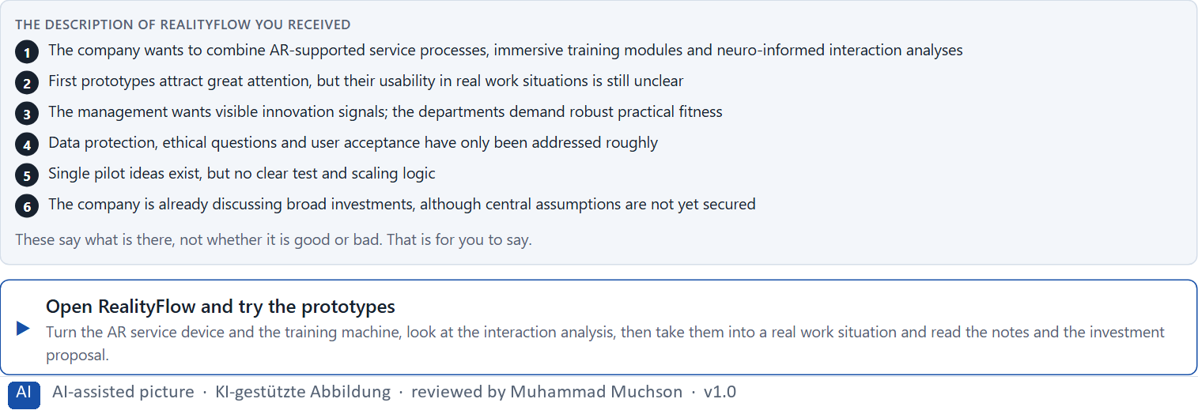
Figure 1 · The product to read, as the lab shows it (realityflow).
Question 1 of 5 · Describe spontaneously which chances and risks this project could have for users, the organisation and the market position
Two to four sentences: for users, for the organisation and for its market position, what could help and what worries you, and why.
How to build the answer:
- Open RealityFlow and try the three prototypes.
- Switch on the real work situation, then read the management's and the departments' notes and the investment proposal.
- Write what could help and what worries you for users, the organisation and the market position.

Question 2 of 5 · Name at least 5 places where prototyping, testing, strategy or ethics are not yet clarified enough
How to build the answer:
- Go through what you saw: the three prototypes, the real work situation, the notes, the investment proposal, the consent of the analysis.
- For each place, say which of the four is unclear, and why it matters.
Write them as a list, one place per line, and say whether prototyping, testing, strategy or ethics is unclear there, and why it matters.

Question 3 of 5 · Assign the observations to the categories user value, test maturity, scalability, ethics, investment risk and organisational capability
Write the observations that belong to each category in a few words. One may fit two; put it where its effect is strongest.
How to build the answer:
- Take your places from question 2.
- Ask which of the six each one affects most, and write it there.
Category | The observations in this category
User value
Test maturity
Scalability
Ethics
Investment risk
Organisational capability

Question 4 of 5 · Write an effect statement for three points: “For users, the organisation or the management this could mean that …”
How to build the answer:
- Pick three places from question 2.
- Finish the plan's sentence with what users, the organisation or the management would feel, do or fail to do.
Write them as a list, one statement per line, each starting with the observation and ending with what it could mean for users, the organisation or the management.

Question 5 of 5 · Prioritise the two biggest strategic chances and the two biggest risks of the project
How to build the answer:
- Look at your places with two questions: what could give the company the most lasting advantage, and what could do the most harm?
- Write the two chances first, then the two risks, each with why.
Write four lines: chance 1, chance 2, risk 1, risk 2, each with why it weighs most.

Block 1.2 · Prioritise future-proof UX strategies under uncertainty: FutureInteraction Hub · JUDGED · Core · about 8 min
Draws on: A3 · Feasible or responsible · A4 · Responsible, connectable, governable · A5 · When not to scale, and weighing a scaling decision.
FutureInteraction Hub is a platform. Three strategy options for its future are described in words: A) a fast, broad introduction of immersive pilot functions in several areas, with high innovation pressure but higher risks for consistency, acceptance and governance; B) focused piloting of a few clearly prioritised future applications with a strong test and ethics framework; C) a waiting strategy with observation, research and little immediate implementation, with lower risk and lower visibility. The conditions: the company wants to be seen as innovative, the budget is limited and not all lines of innovation can be pursued at once, data from earlier tests is patchy, several stakeholders stand for different interests between visibility, safety, economic viability and a pioneer role, first visible results are wanted within 6 months, and wrong decisions can lead to costs, loss of trust or an innovation backlog. Decide anyway, and say what you assume.
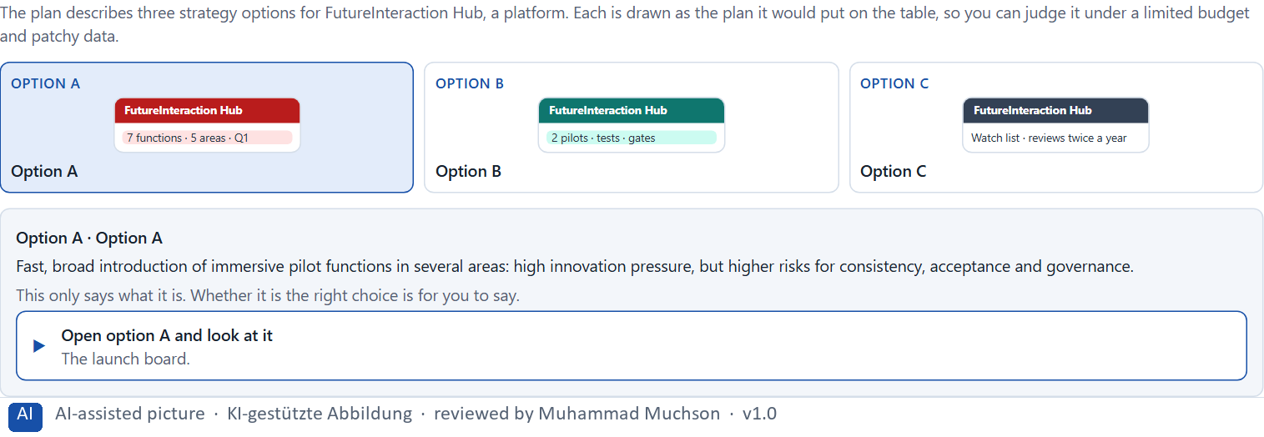
Figure 2 · The product to read, as the lab shows it (designs).
Question 1 of 5 · Rate each option on capacity to innovate, user value, risk, steerability, ethics and economic viability
Write a few sentences for each option that cover all six criteria. Many teams rate each criterion Low, Medium or High with a reason; you may do that or write it in your own words.
How to build the answer:
- Take one option at a time and keep the conditions in mind: a limited budget, patchy data, results within 6 months.
- For each criterion, say how the option does and why.
- Use the same six criteria for every option.
Option | Capacity to innovate | User value | Risk | Steerability | Ethics | Economic viability
Option A · fast, broad introduction
Option B · focused pilots, test and ethics framework
Option C · wait, observe, research

Question 2 of 5 · Decide which option is the most viable under the given conditions
Choose one option, then give your reason below. There is no single right choice; the reason has to rest on the users and the conditions.
How to build the answer:
- Say which condition weighs most for you.
- Say how your choice meets it better than the other two.
Tick one:
☐ Option A · fast, broad introduction
☐ Option B · focused pilots, test and ethics framework
☐ Option C · wait, observe, research
Why this option, under these conditions?
Give your reason with the conditions: seen as innovative, a limited budget, not all lines at once, patchy test data, different stakeholder interests, results within 6 months, the cost of wrong decisions.
How to build the answer:
- Name the condition that weighs most for you.
- Say how your option meets it and why the other two meet it less well.
- Say what your choice gives up and how you would deal with its weakness.

Question 3 of 5 · Name the conflicts of goals between visible innovation, responsibility and maturity
Name at least two conflicts, each as one goal against another, and who stands for each side.
How to build the answer:
- Look at what visibility wants (many signals, soon), what responsibility needs (tests, ethics, consistency) and what maturity allows (what works today).
- Write each conflict as “… against …” and say who stands for each side.

Question 4 of 5 · Which risks remain despite your decision?
Name at least one risk that remains and who would feel it.
How to build the answer:
- Think of what your chosen option is weak at.
- Say who would notice and what would happen.

Question 5 of 5 · Formulate a recommendation to the project lead
Two to four sentences: what you recommend, why, and what you will check next.
How to build the answer:
- Lead with the recommendation.
- Give the one reason the project lead can follow.
- Say what you will check at the first gate.

Part 2 · The case study · Level 2 · Application · Case study (2 UE)
Case study: 2 teaching units (UE5–6)
This part is the day's Level 2 case study. It takes 2 UE (about 90 minutes): UE5 for the briefing and your own work, UE6 for comparing your results with your group and for the trainer's closing. The block below needs about 15 minutes of writing; the rest of the time is discussion.

Block 2.1 · Case study: a scaling decision for the immersive innovation programme NextWorld UX · JUDGED · Core · about 15 min
Draws on: A1 · From concept idea to scalable solution · A2 · Testing immersive systems · A3 · Feasible or responsible · A4 · Responsible, connectable, governable · A5 · When not to scale, and weighing a scaling decision.
Over the past months a company has developed several prototypes for AR-supported advice, VR-based training and neuro-informed UX research. First results are promising but uneven. Some users experience high value, others show overload or scepticism. The management now demands a decision on which approaches are scaled, which are tested further and which are stopped for now. The observed problems: the prototypes were developed with different depth and without a common evaluation logic; user feedback exists but is not systematically comparable; ethical and organisational implications were handled differently in the single projects; some pilot ideas attract strong attention but have only limited practical use; investment decisions are under time pressure although maturity varies strongly; and an overarching future strategy and governance structure is missing. The conditions: a budget of €260,000 for the next scaling and pilot phase, 16 weeks for prioritisation, building governance and planning new pilots, not all approaches can be continued at once, stakeholders from innovation, IT, the department, data protection and management pursue different goals, first market signals should stay visible, and wrong decisions could increase costs, reputational risks and internal blockades. You work through six steps.
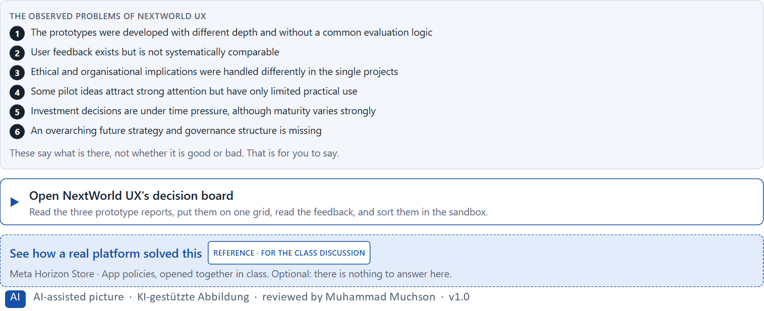
Figure 3 · The product to read, as the lab shows it (nextworld).
Question 1 of 6 · Analyse the central weaknesses of the approach so far regarding prototyping, testing, ethics and strategy
How to build the answer:
- Open NextWorld UX's decision board: the three prototypes, their reports, the feedback and the ethics status.
- Write one weakness per line, and what it does.
Write them as a list, one weakness per line, each with what it does. At least five.

Question 2 of 6 · Assign the problems to the categories evaluation logic, scaling maturity, user value, ethics, governance and investment security
Write the problems that belong to each category in a few words.
How to build the answer:
- Take your weaknesses from question 1.
- Ask which category each affects most, and write it there.
Category | The problems in this category
Evaluation logic
Scaling maturity
User value
Ethics
Governance
Investment security

Question 3 of 6 · Develop 4 prioritised measures for a responsible scaling decision
How to build the answer:
- Turn each group of problems into something you could do within 16 weeks and €260,000, without continuing everything.
- Put them in order: what creates decision readiness first.
Write them as a numbered list, the first priority first, each with what it changes.

Question 4 of 6 · Justify your selection using effect on users, feasibility, risk, time pressure and strategic viability
Use all five criteria and say how they support your selection and its order.
How to build the answer:
- Say what your first measures change for decision readiness.
- Say what is feasible in 16 weeks and what reduces risk.
- Keep the wish to stay visible in the market in mind.

Question 5 of 6 · Make a prioritisation decision for the first 16 weeks
Say what you do in the first 16 weeks, in which order, and what you leave for later, with the reason.
How to build the answer:
- Say what comes first and why.
- Say what you do in parallel and what pauses.
- Say what the management will see at the end.

Question 6 of 6 · Formulate a recommendation to the division head
Three to five sentences: what you recommend, what has priority, and what you hope will change.
How to build the answer:
- Lead with the recommendation.
- Name the priorities.
- Say what you hope will change.

Task 2 · Route 2 · UX Strategy Memo: decide as Chief Experience Officer

The situation: many experiments, no portfolio
Read once · about 2 min
You take the perspective of the Chief Experience Officer of the company behind NextWorld UX. It stands at the transition from experimental future projects to a strategically steered UX innovation landscape. Several prototypes and pilots for immersive, AI-supported and neuro-based interaction exist, but there is no overarching portfolio logic. The management expects a long-term strategy that connects innovation, user value, ethics, economic viability and the organisation's ability to learn. Your task is not to judge single technologies in isolation, but to develop a sound decision architecture for prototyping, testing, ethics, scaling and the governance of future UX systems.
The framework | How the task runs · one block
• The budget is limited  • Different stakeholders pursue different interests  • Not all lines of innovation can be continued  • Data on use, effect and market acceptance is incomplete  • Reputational and investment risks are relevant  • First strategic decisions must become visible at short notice  • Long-term capacity to innovate must not be weakened by short-term symbolic decisions | • Block 3.1 asks seven questions: a guiding vision for future-proof UX, three strategic decisions, a prioritised architecture of what continues, pauses or ends, a risk analysis, a governance model, one decision under uncertainty and a management statement.

What is known and what is open
In the brief | Clear · Case assumption | Open · on purpose
• Several prototypes and pilots: immersive, AI-supported and neuro-based interaction.  • No overarching portfolio logic; the management wants a long-term strategy.  • Not all lines can continue; data on use, effect and acceptance is incomplete.  • Reputation and investment are at risk; first decisions must show soon. | • The company is the one behind NextWorld UX in Route 1.  • Its lines today: AR advice in branches, VR safety training, a neuro-informed shop study, an AI chat assistant in the app, and an emotion-adaptive learning module in the staff academy.  • Innovation wants all five to grow; IT wants fewer platforms; data protection has concerns about two of them; the management wants a headline at the spring trade fair. | • How large the budget is: “limited” is all the plan says.  • Which of the five lines users would miss if they stopped: never asked.  • How the rules for AI and emotion recognition will be applied to the company's lines: not checked.

As in most projects, not everything is known. Decide anyway, and say what you assume.
Case assumption
The brief says: a company at the transition from experimental future projects to a steered UX innovation landscape, several prototypes and pilots on immersive, AI-supported and neuro-based interaction, no portfolio logic, a management that wants a long-term strategy linking innovation, user value, ethics, economics and organisational learning, a limited budget, different interests, not all lines continued, incomplete data on use, effect and acceptance, reputational and investment risks, first decisions visible soon, and long-term capacity to innovate not to be weakened by symbolic decisions. Those are the plan's facts. That the company is the one behind NextWorld UX, its five lines and the facts marked “Clear” are made up for this exercise.

The memo is addressed to: The management. Subject: A future-proof UX and innovation governance for immersive and neuro-based systems.

Part 3 · Level 3 · Management decision · Transfer project (3 UE)
Transfer project: 3 teaching units (UE8–10)
UE8: the trainer presents Materi B and sets the role. UE9: you write the memo. UE10: you present the decision and what you give up; the trainer debriefs.

Block 3.1 · A future-proof UX and innovation governance for immersive and neuro-based systems · JUDGED · Core · about 20 min
Draws on: B1 · Future-proof UX as a responsible innovation and decision architecture · B2 · Innovation pressure, ethics, economics, value, maturity, portfolio · B3 · Who decides to scale, pause or stop, and deciding with incomplete data.
Develop a strategic concept for the company. Your desk holds what the management, innovation, IT, the department, data protection and the works council say about the five lines of innovation. Open it, then answer the seven questions; your answers build the memo below.
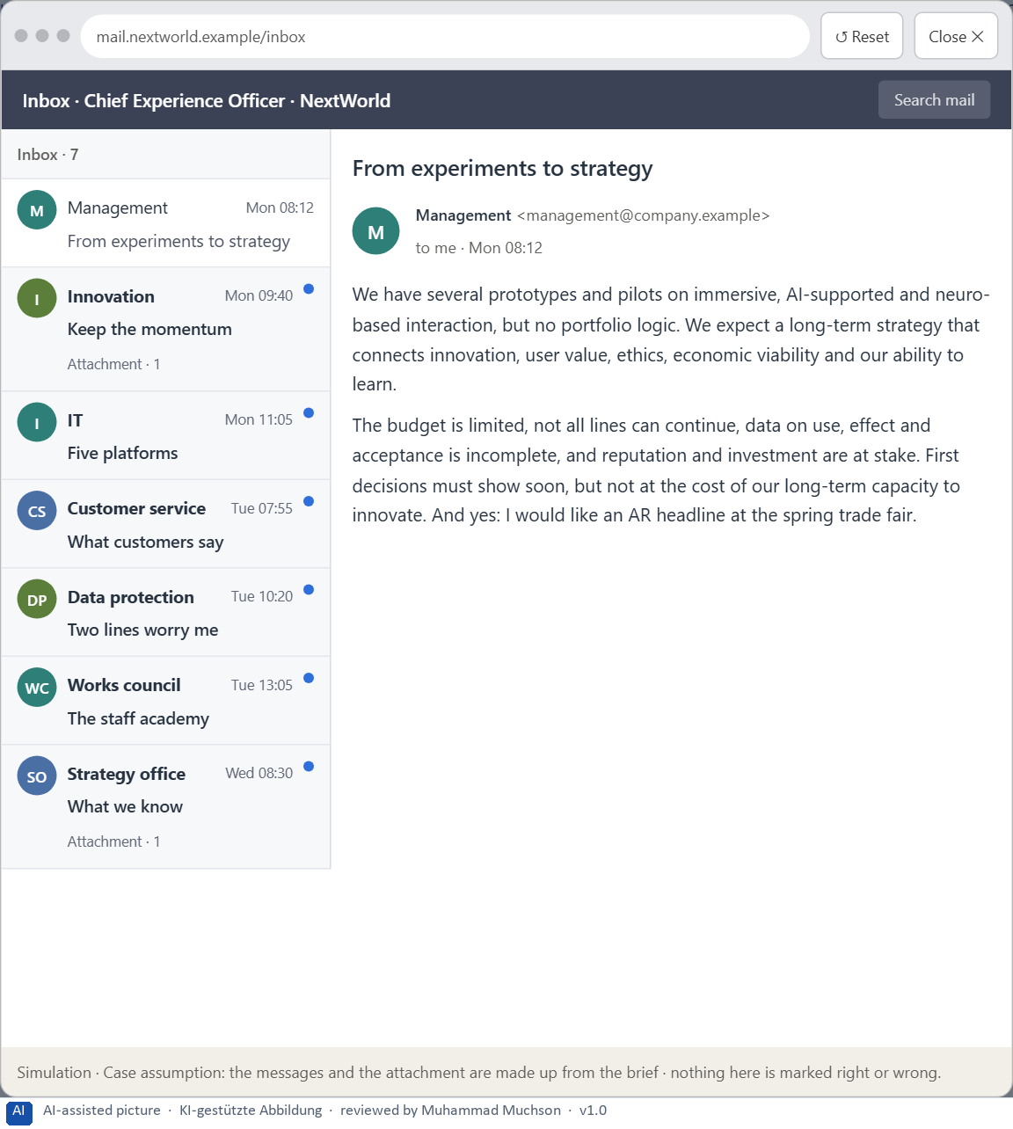
Figure 4 · Your desk: the messages that wait for you, shown in the lab as a mailbox (1 of 7).
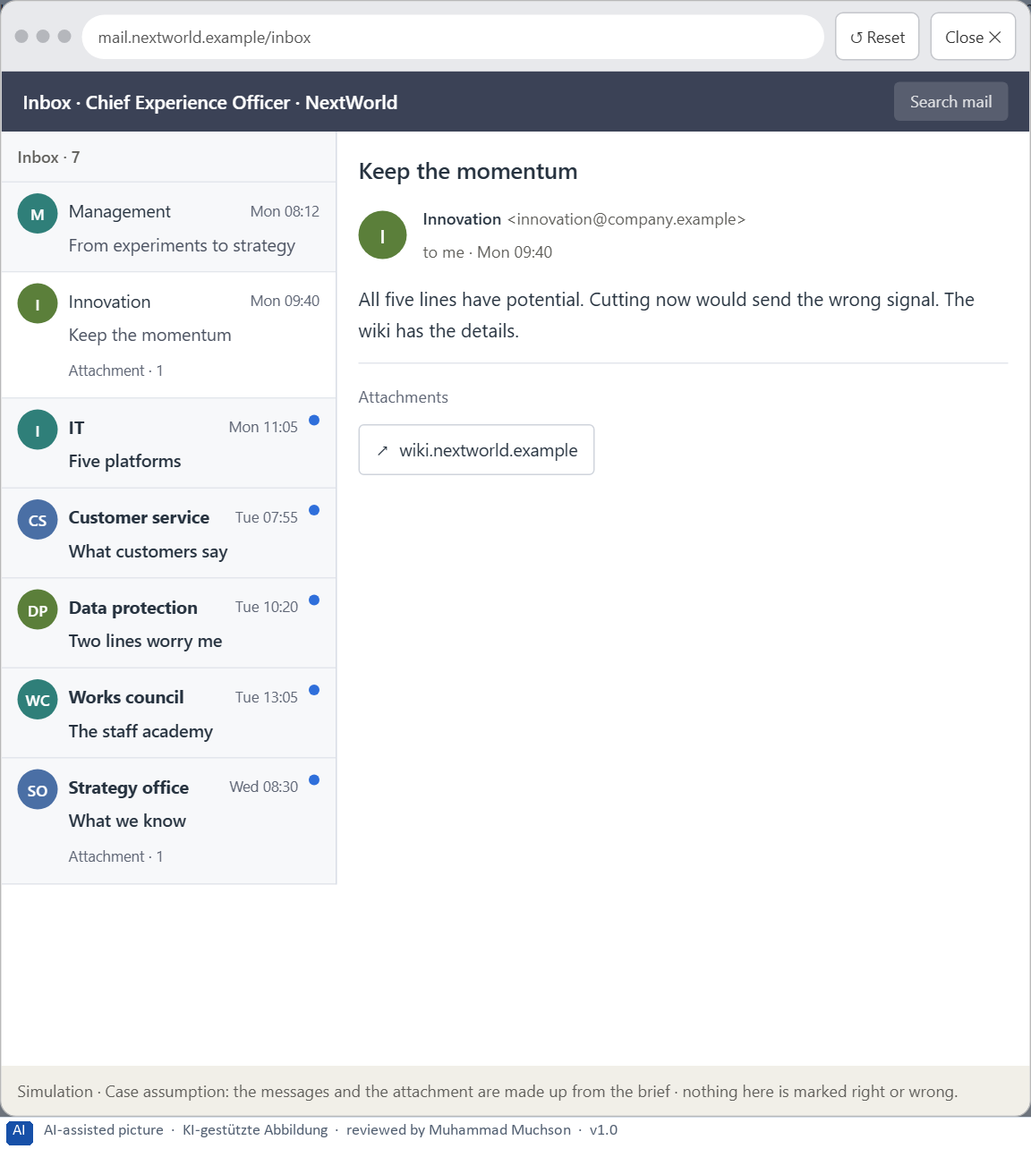
Figure 5 · Your desk: the messages that wait for you, shown in the lab as a mailbox (2 of 7).
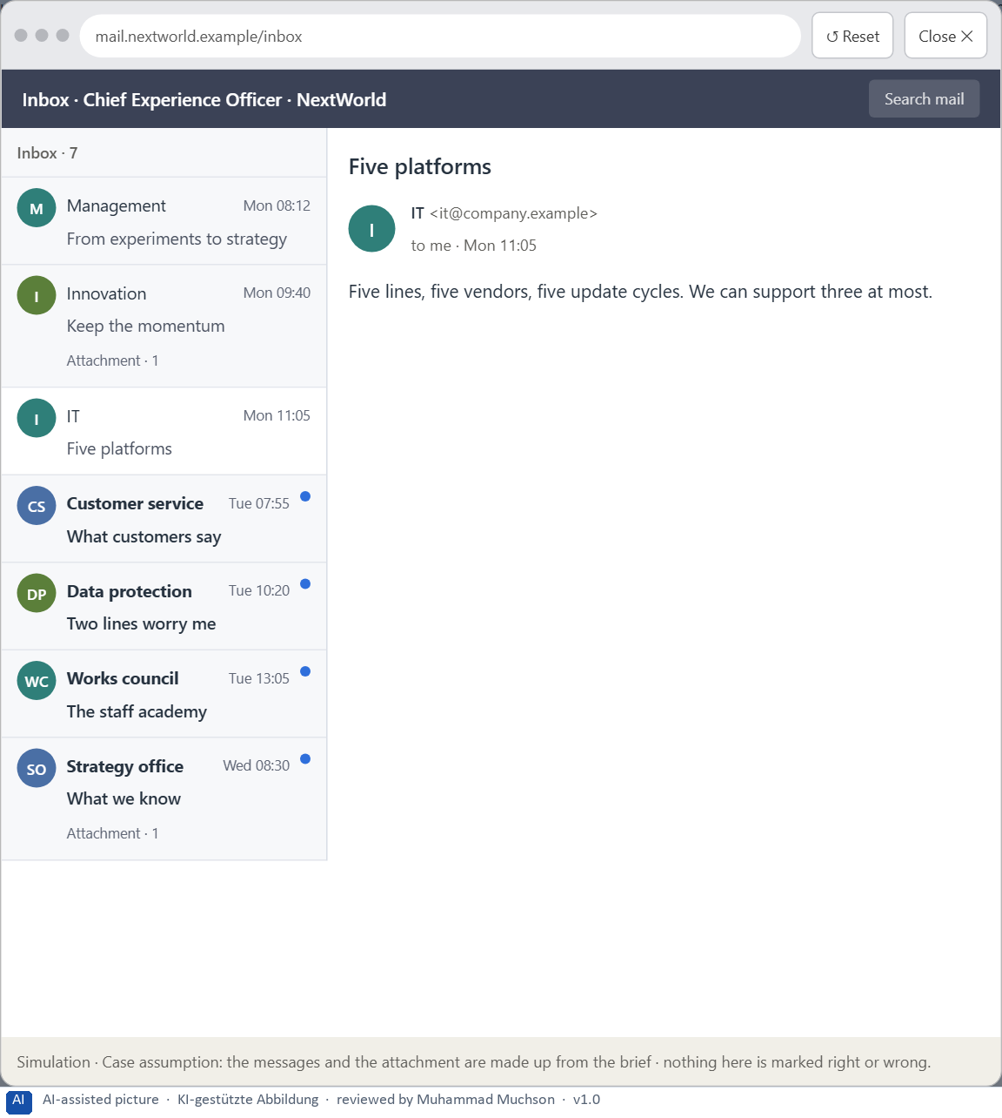
Figure 6 · Your desk: the messages that wait for you, shown in the lab as a mailbox (3 of 7).
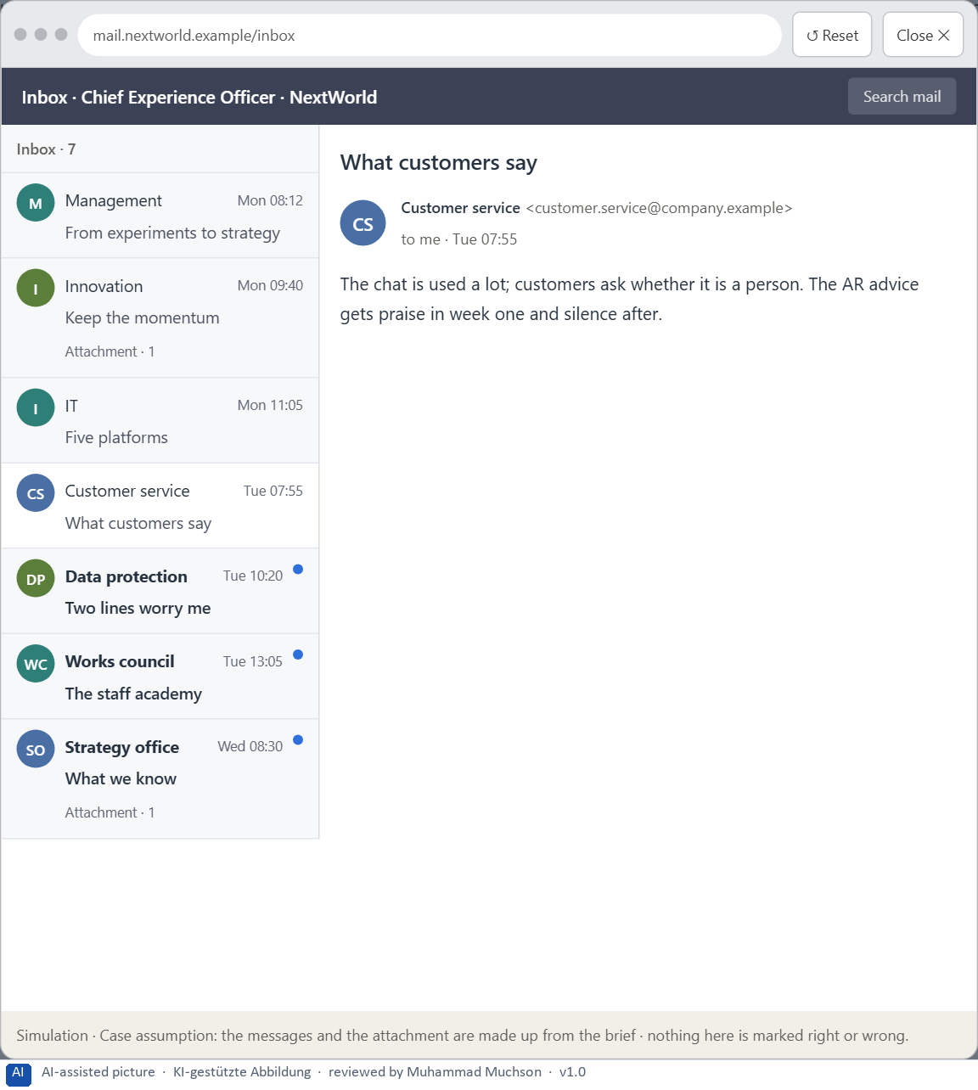
Figure 7 · Your desk: the messages that wait for you, shown in the lab as a mailbox (4 of 7).
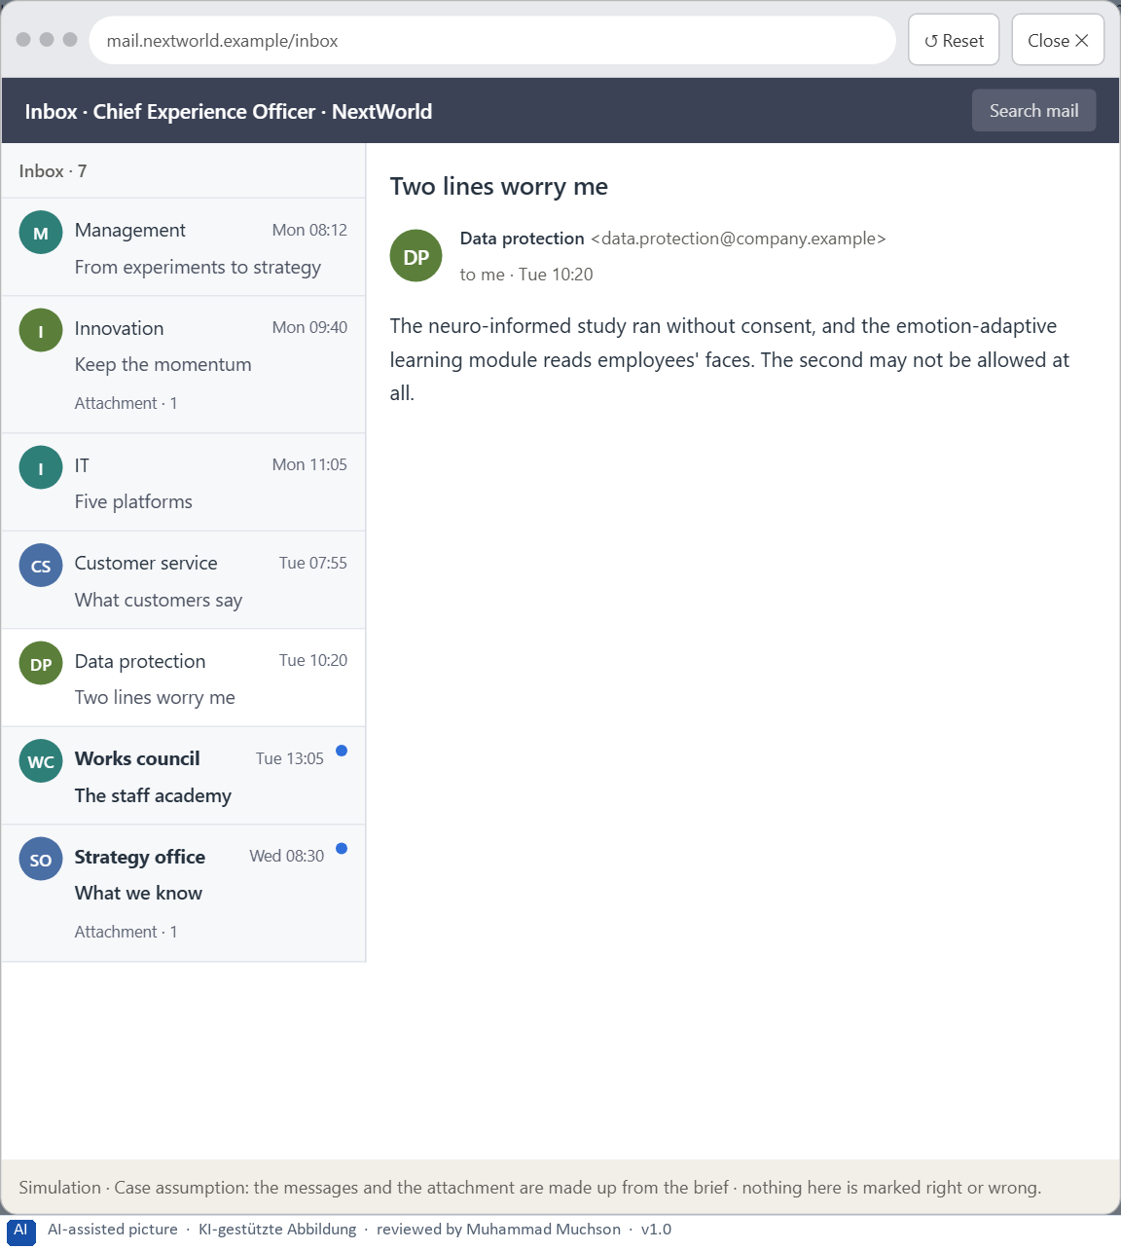
Figure 8 · Your desk: the messages that wait for you, shown in the lab as a mailbox (5 of 7).
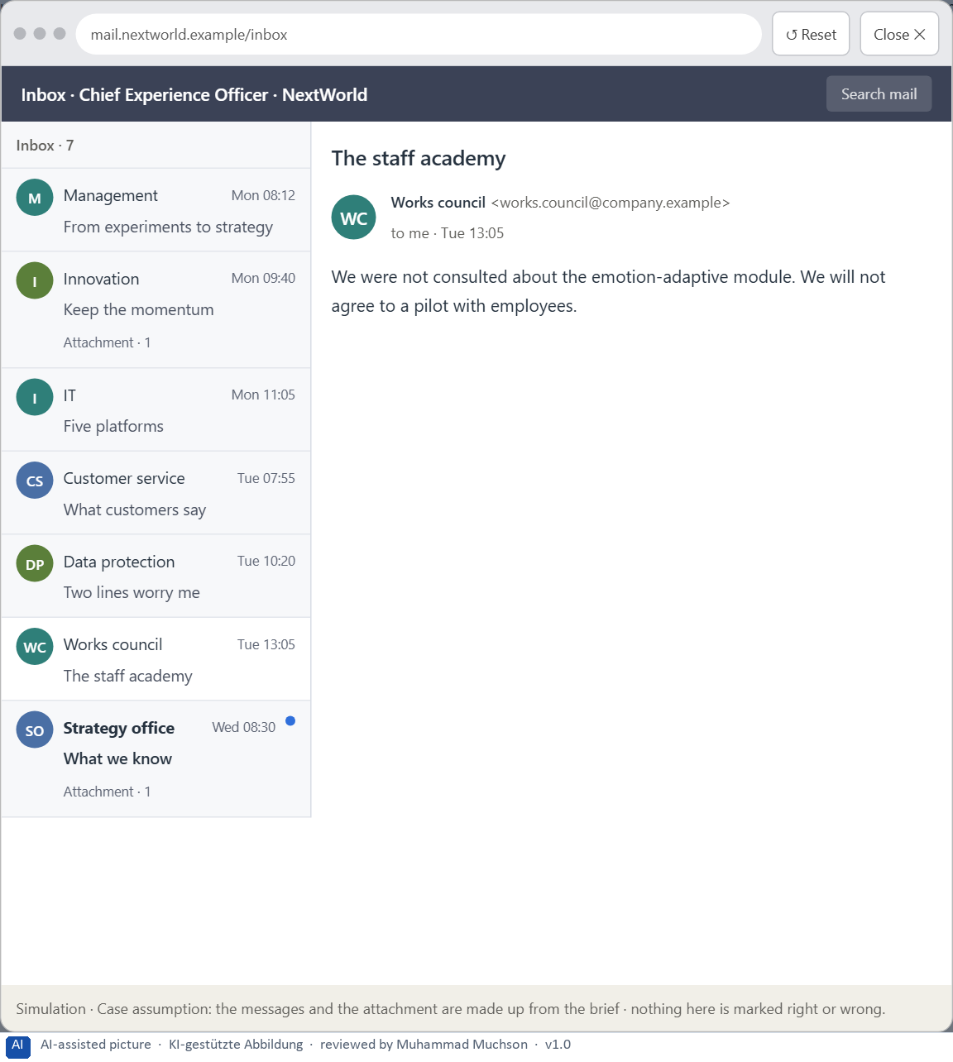
Figure 9 · Your desk: the messages that wait for you, shown in the lab as a mailbox (6 of 7).
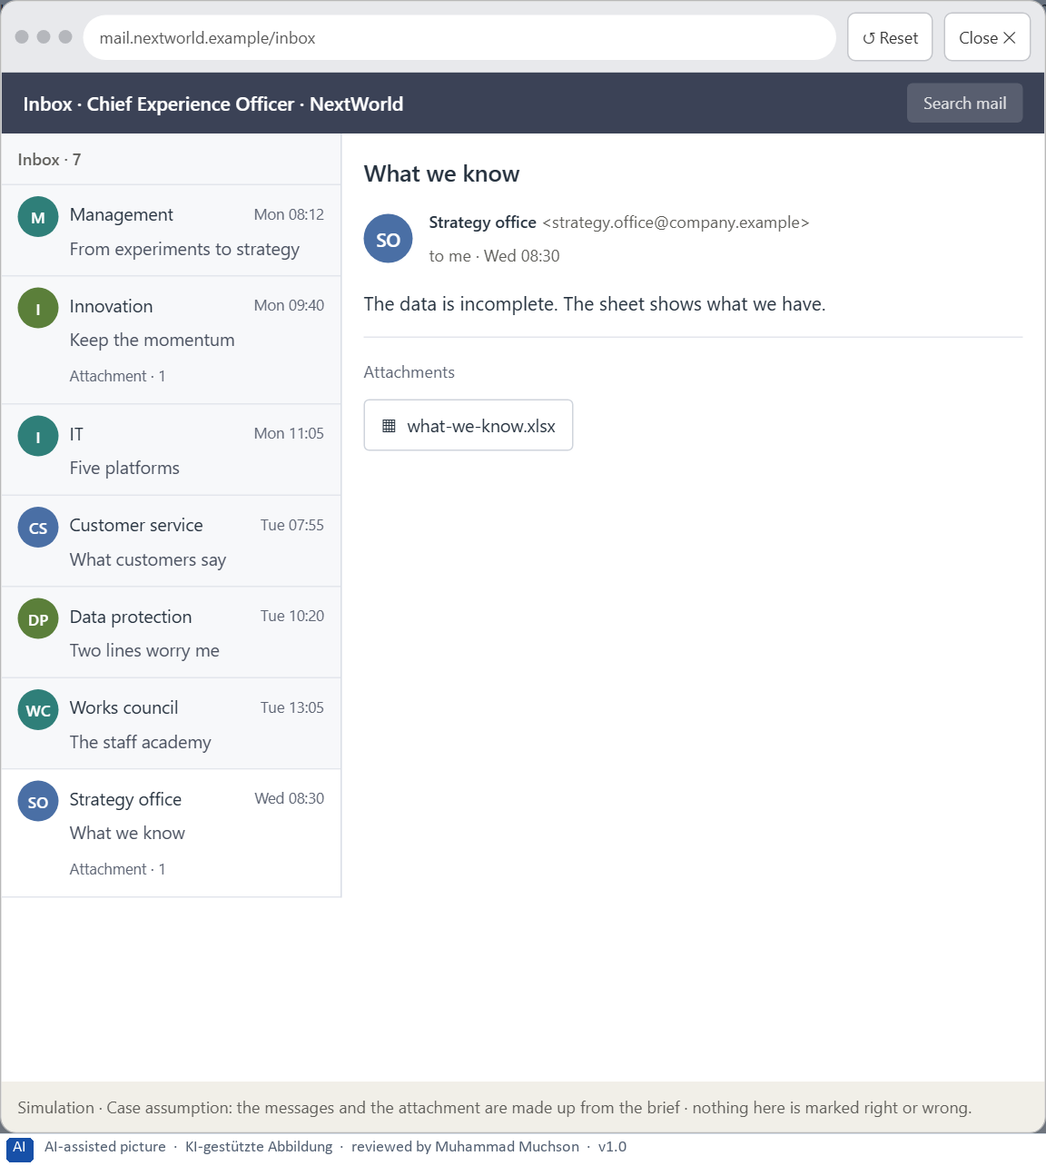
Figure 10 · Your desk: the messages that wait for you, shown in the lab as a mailbox (7 of 7).
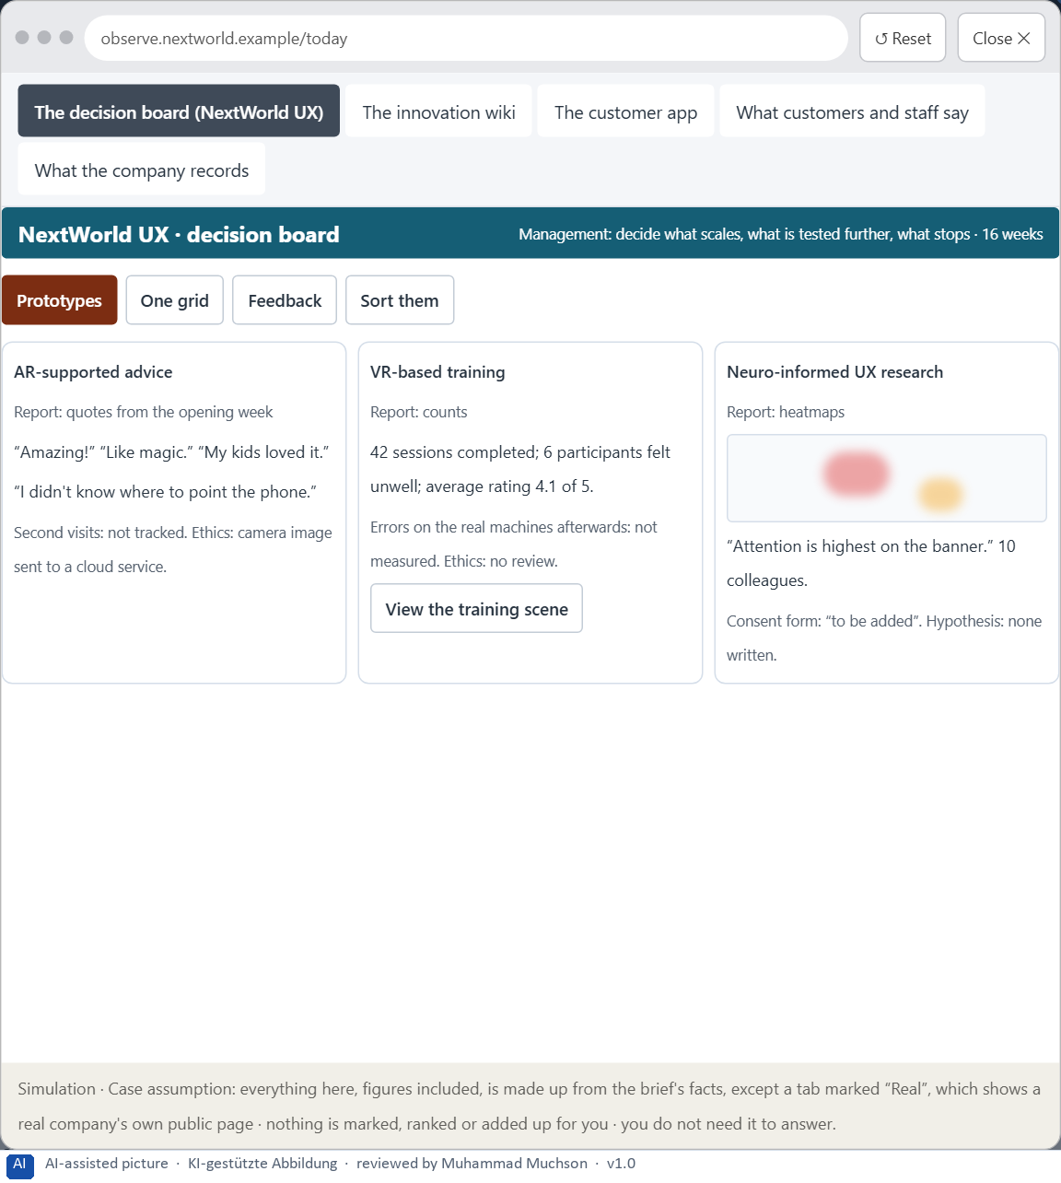
Figure 11 · The platform as it is today, as the lab lets you observe it (1 of 5).
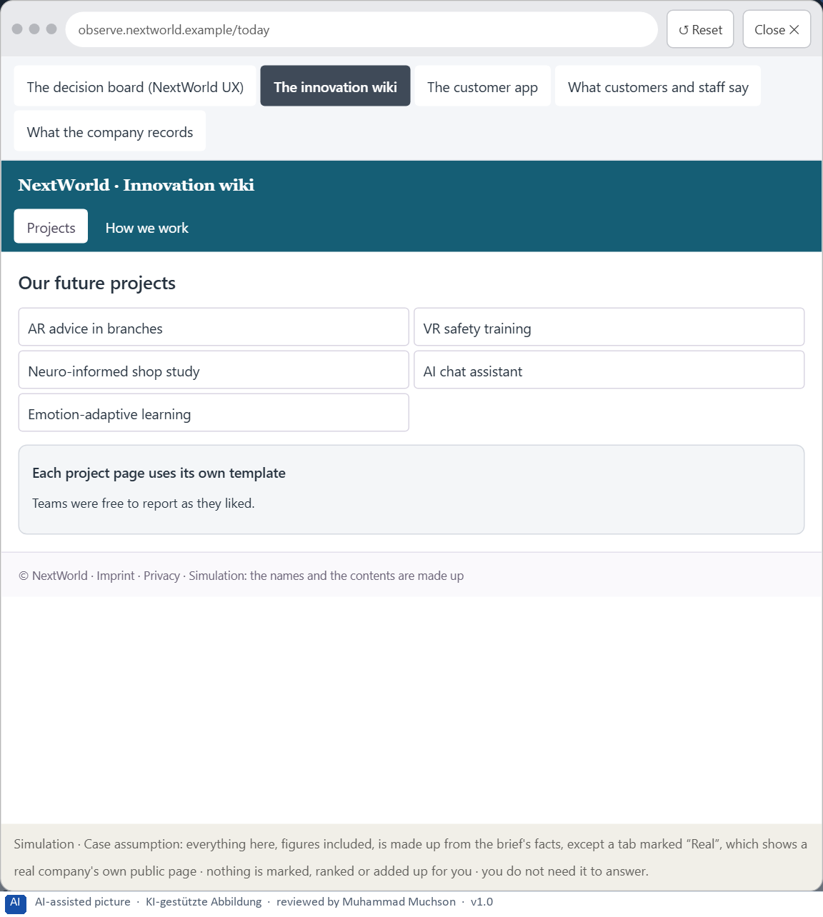
Figure 12 · The platform as it is today, as the lab lets you observe it (2 of 5).
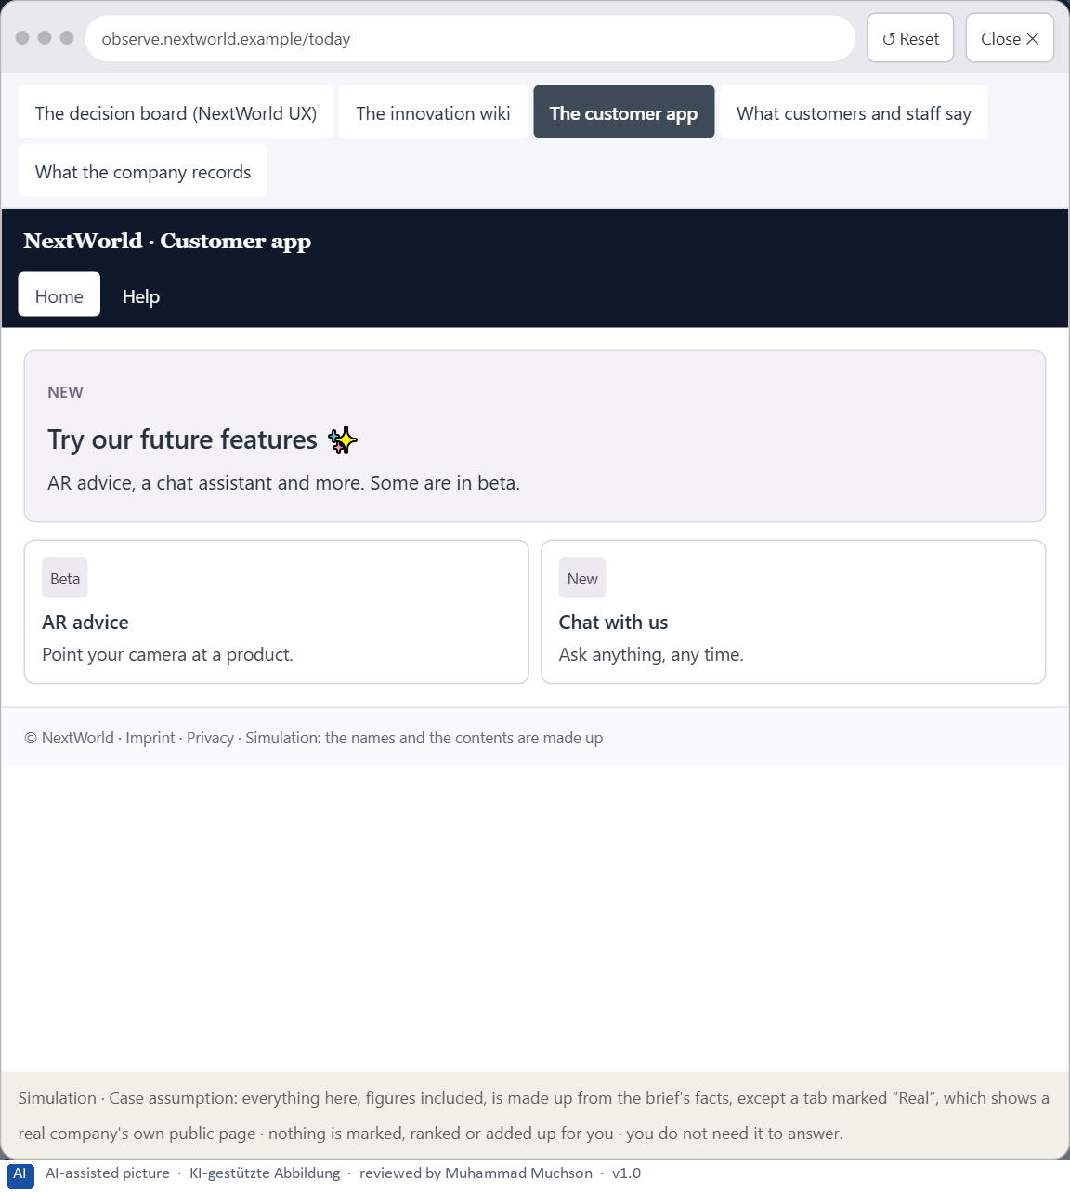
Figure 13 · The platform as it is today, as the lab lets you observe it (3 of 5).
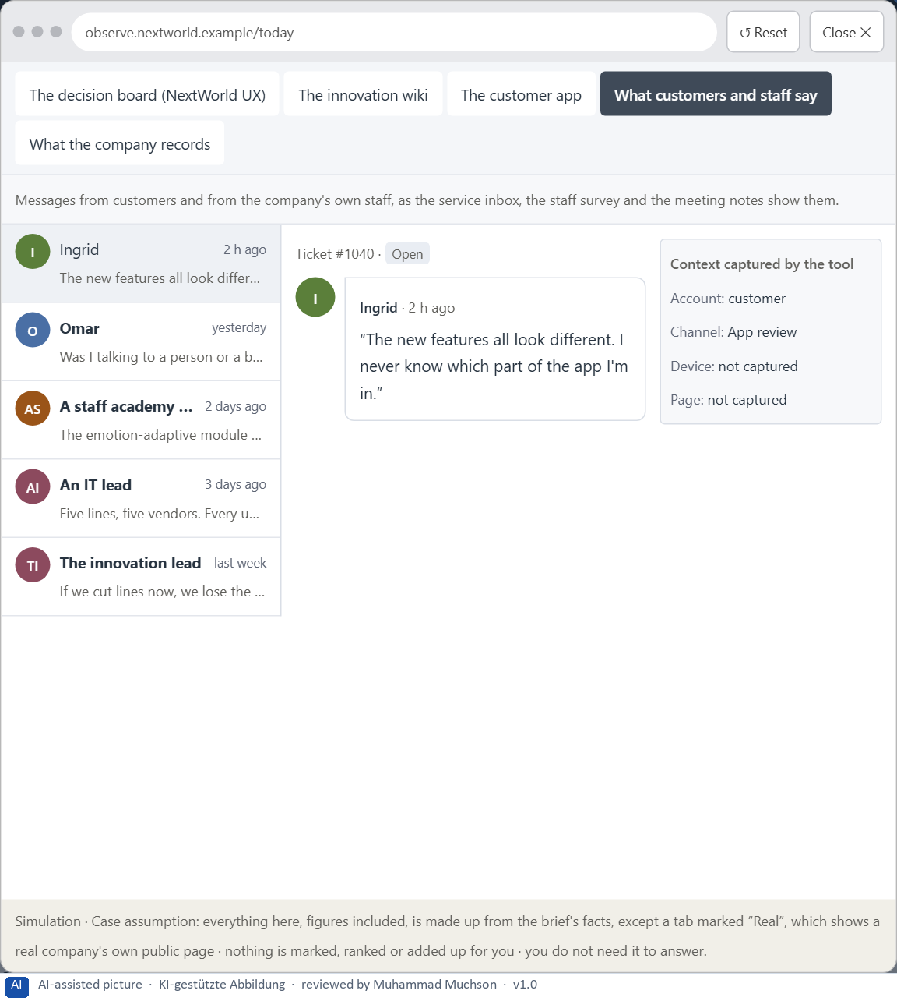
Figure 14 · The platform as it is today, as the lab lets you observe it (4 of 5).
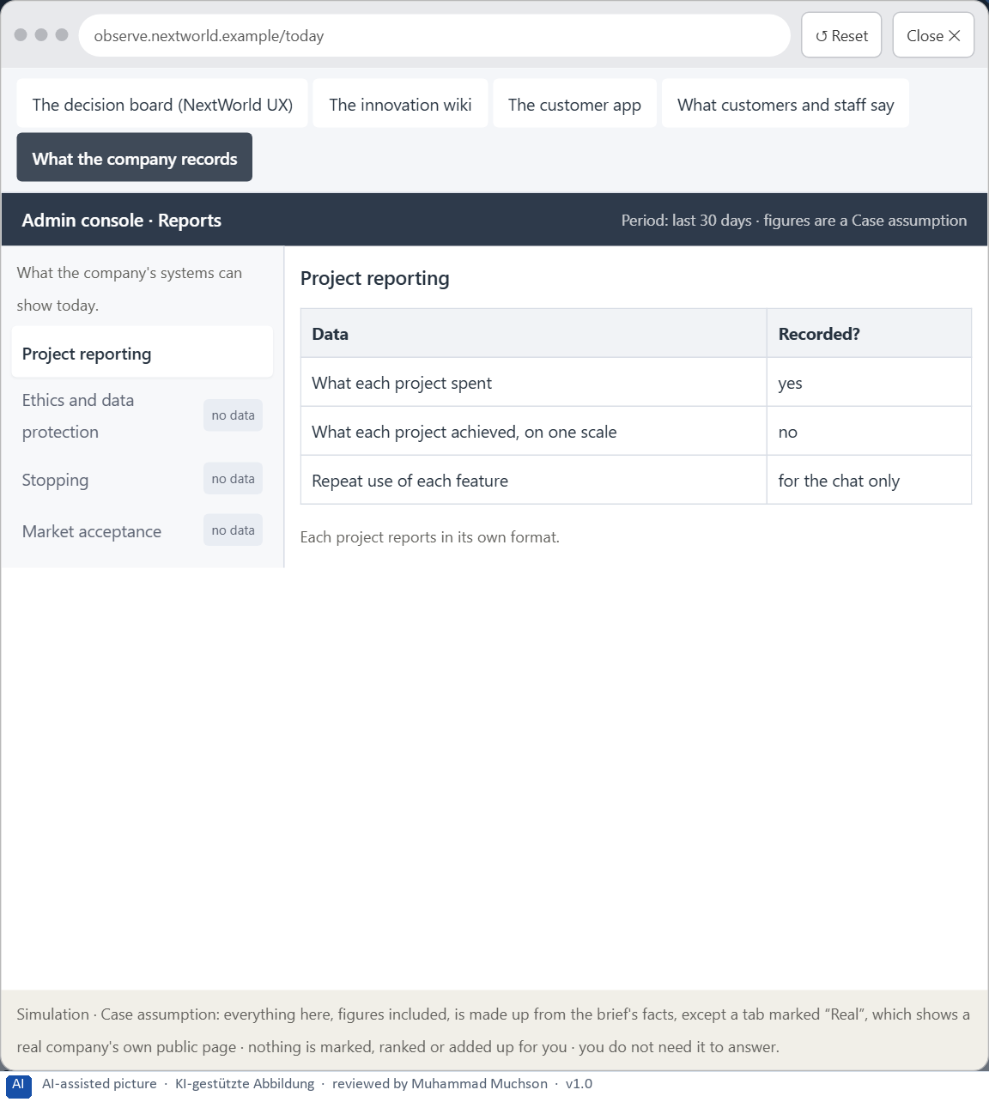
Figure 15 · The platform as it is today, as the lab lets you observe it (5 of 5).
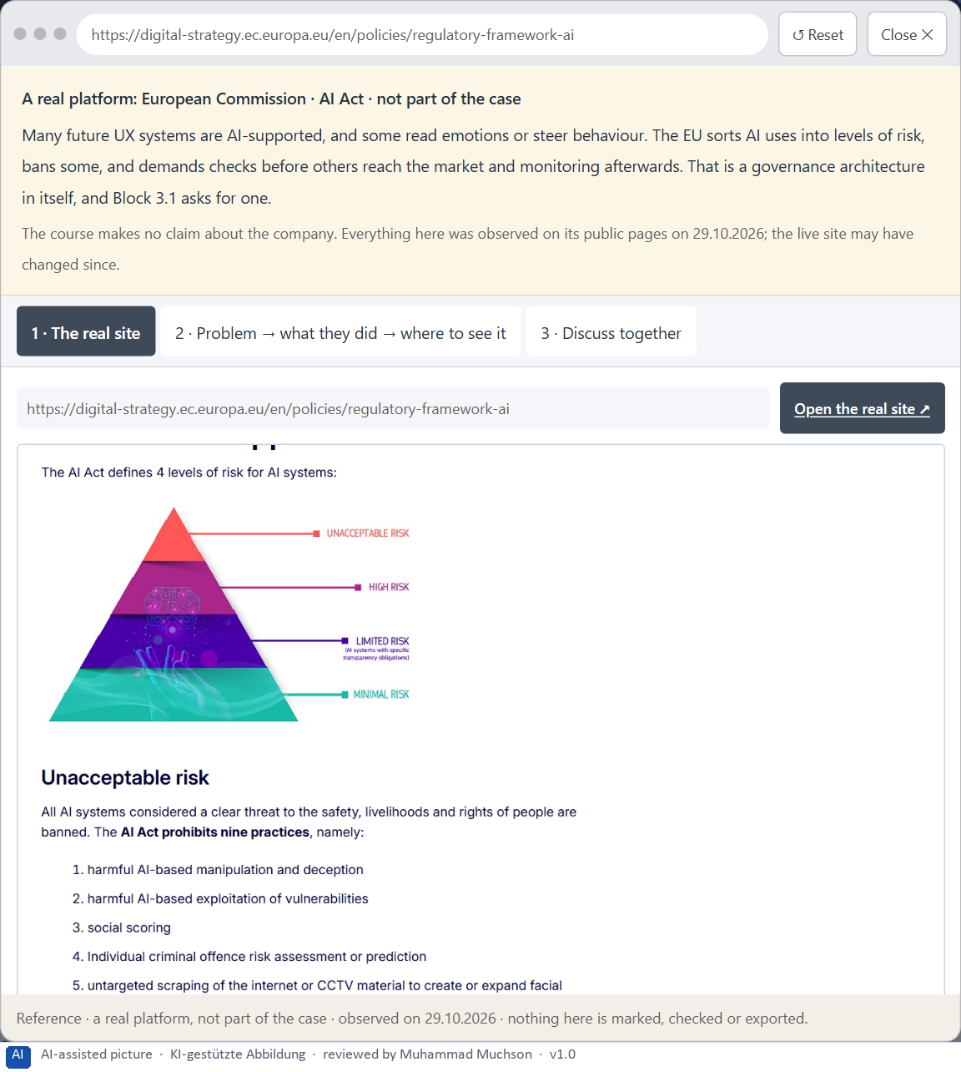
Figure 16 · A real platform that solved this, shown for the class discussion (1 of 3).
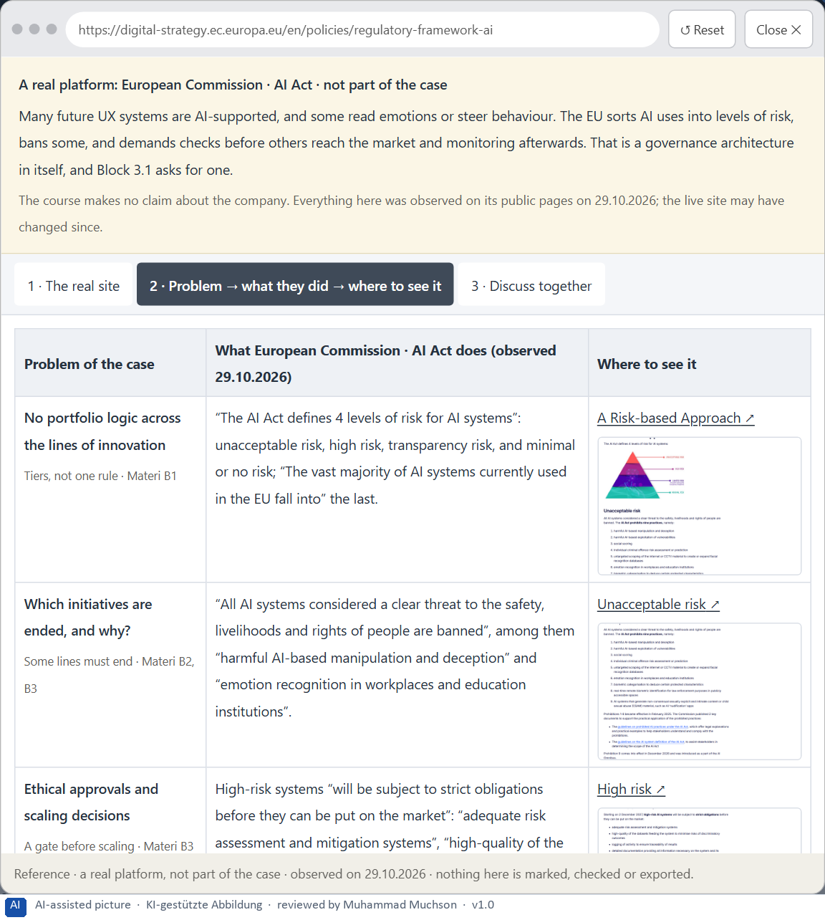
Figure 17 · A real platform that solved this, shown for the class discussion (2 of 3).
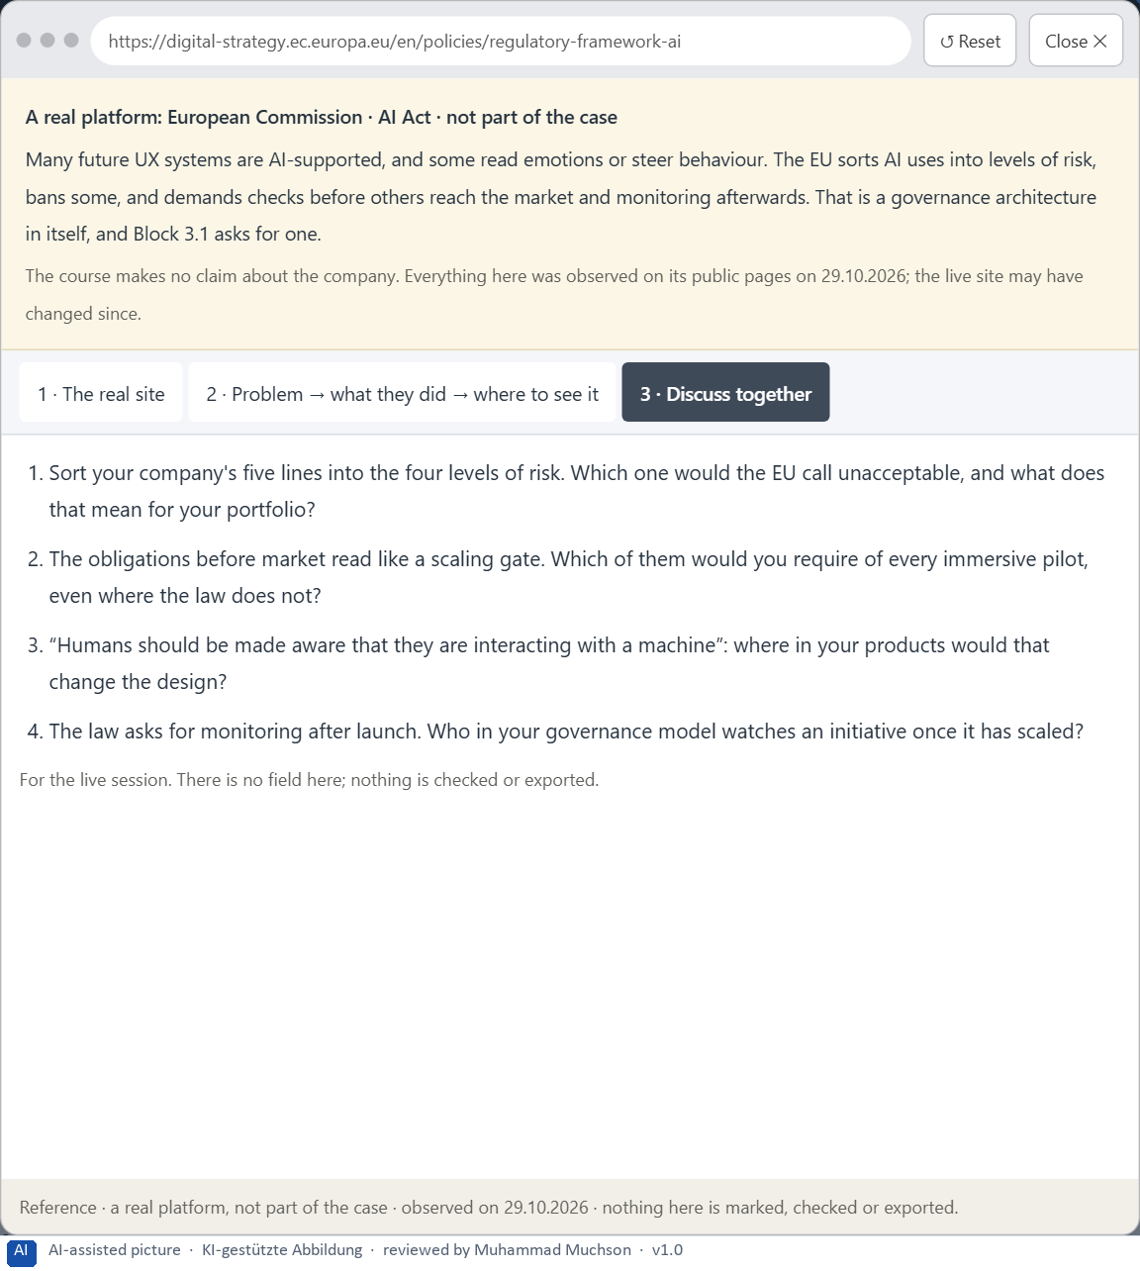
Figure 18 · A real platform that solved this, shown for the class discussion (3 of 3).
Question 1 of 7 · A guiding vision for future-proof UX: which form of innovation, user value and responsibility should the company pursue systematically?
One or two sentences about the kind of innovation and value the company wants, for whom, and how it takes responsibility.
How to build the answer:
- Say what kind of innovation and user value the company aims for, and for whom.
- Say how it takes responsibility: what it tests, limits or will not do.

Question 2 of 7 · Three strategic guiding decisions on prototyping, testing, scaling, ethics and the innovation portfolio
How to build the answer:
- Take your vision and ask which three choices would make it real.
- Write each as “we will …, even though that means …”.
Write them as a list, one decision per line, each with what it gives up.

Question 3 of 7 · A prioritised architecture of measures: which initiatives, technologies or product fields are continued, paused or ended first, and why?
Sort the initiatives into continue, pause and end, and give the reason for each.
How to build the answer:
- List the lines: AR advice in branches, VR safety training, the neuro-informed shop study, the AI chat assistant, the emotion-adaptive learning module.
- Continue what has proven value and is governable; pause what lacks evidence or approval; end what conflicts with the vision.
- Say why for each.

Question 4 of 7 · A risk analysis: which wrong assumptions about future technologies, market maturity, user acceptance and governance would be especially critical?
Name two or three assumptions and the harm if each is wrong.
How to build the answer:
- Write down what your concept assumes about the technologies and the market.
- Write down what it assumes about how people will accept them.
- Write down what it assumes about governance working in practice.

Question 5 of 7 · A governance model: who is responsible for evaluating innovation, ethical approvals, scaling decisions and portfolio adjustments?
Name roles, not people: who evaluates, who approves ethically, who decides to scale, pause or stop, who adjusts the portfolio, and how a conflict is decided.
How to build the answer:
- Name who owns the evaluation grid and scores every initiative.
- Name who approves ethically and on data protection, and who decides to scale, pause or stop.
- Say who adjusts the portfolio and how a conflict is decided.

Question 6 of 7 · A decision under uncertainty: make at least one prioritised decision despite incomplete data and justify it responsibly
Say what you decide, what you do not know, and why the decision is responsible all the same, for example when you would reverse it.
How to build the answer:
- State the decision in one sentence.
- Name what you do not know.
- Say why it is still responsible: it can be reversed, it can be checked soon, or waiting costs more.

Question 7 of 7 · A management statement: a recommendation to the management with a clear priority and a strategic reason
Four to six sentences: the direction first, then the priority, the reason and what you ask of the management.
How to build the answer:
- Start with the direction in one sentence.
- Name the priority and the reason that carries it.
- Say what you ask of the management and what you will report back.

Use in class: presentation and handout
Mark of use for the worksheet. Presentation is what the trainer shows on screen; Handout is what participants fill in and hand in.
Part of the worksheet | Presentation (shown in the Neuro-UX Lab) | Handout
The case: two projects on the UX team's desk, and NextWorld UX | The case read aloud or on screen | The case text
Block 1.1 · Judge how future-proof an immersive UX concept is: RealityFlow | The task wording at the start of the block (no answers are shown) | Worksheet block with answer boxes (Core)
Block 1.2 · Prioritise future-proof UX strategies under uncertainty: FutureInterac | The task wording at the start of the block (no answers are shown) | Worksheet block with answer boxes (Core)
Block 2.1 · Case study: a scaling decision for the immersive innovation programme | The task wording at the start of the block (no answers are shown) | Worksheet block with answer boxes (Core)
The situation: many experiments, no portfolio | The case read aloud or on screen | The case text
Block 3.1 · A future-proof UX and innovation governance for immersive and neuro-ba | The task wording at the start of the block (no answers are shown) | Worksheet block with answer boxes (Core)

Glossary
Every term below is used in this document. Terms stay plain text in the body; this list says what they mean in everyday words.
Term | In plain words | Example | Comes from
Attention | The mind's spotlight. Only a small part of a screen is processed at any moment; attention decides which part. | A flashing banner takes attention away from the form you were filling in. | Day 1
Case assumption | A fact made up for this exercise to fill a gap in the plan's case. It is marked so you know it is not part of the plan. | — | Day 1
Chief Experience Officer | The manager who is responsible for the experience customers have across all channels, and who decides where the company invests in it. | — | Day 1
Concept idea | A described possibility: what it could be and for whom. Nothing has been built or tested yet. | — | Day 16
Consistency | The same thing looks, is named and works the same way everywhere, so what people learn on one page holds on the next. | — | Day 2
Decision architecture | A set of connected decisions that are made on purpose and written down: what effect you want, what comes first, who decides and how conflicts are settled. It replaces many separate fixes. | — | Day 1
Evaluation grid | One set of criteria used for every idea, prototype and pilot, so that they can be compared and decided the same way. | — | Day 16
Governance | The rules about who may decide what, who is answerable for it and how disagreements are settled. | — | Day 1
Heatmap | A picture that colours a page by how long or how often people looked at each part, added up over people; it loses the order and the individual. | — | Day 15
Immersion | How much a technology surrounds the senses and shuts out the real surroundings; more immersion can mean more presence, and more load. | — | Day 14
Maturity | How far a technology is from an idea to reliable use: does it work, in the real environment, for real users, at scale? | — | Day 14
Organisational learning | An organisation getting better at deciding, by questioning not only what it did but the assumptions behind it. | — | Day 16
Pilot | A real use of a solution by real users in one limited place and time, to learn whether it works before it grows. | — | Day 16
Responsible innovation | Innovation that anticipates harm, reflects on its own assumptions, includes those affected and changes course when needed. | — | Day 16
Scalable solution | A solution that keeps working when many more people, places or devices use it, with support, maintenance and governance in place. | — | Day 16
Stakeholder | A person or department with an interest in a decision, such as marketing, compliance, IT or sales. | — | Day 1
Transition | The moment between two steps: what was done, what comes next and why. | — | Day 8
UX (user experience) | Everything a person goes through when using a product: what they notice, understand, feel and do, from the first look to the last step. The screens are only one part of it. | Finding the booking you want at once and feeling sure it went through is a good UX. | Day 1

The Neuro-UX Lab: where we practise online
In class we use the course website as the place to practise and to learn. Every day has its own address, in the same pattern: the day number is the last part.
What | Address
Neuro-UX Lab (course website) | https://aion-ux-lab.vercel.app/
Day 16 | https://aion-ux-lab.vercel.app/day/16/

On the day page, Route 1 (Levels 1 and 2) and Route 2 (Level 3) can be opened; the cards and the tasks of this document are there too. The pattern is the same up to Day 8, for example https://aion-ux-lab.vercel.app/day/6/.

