AION · UX DEVELOPER · PSYCHOLOGICAL UX DESIGN AND NEURO-UX
DAY 4 · MATERI A AND MATERI B · ROUTES 1 AND 2 · LEVELS 1 TO 3
UX laws and cognitive perception
Study material with real research, worked examples and the rules you use in the tasks
AI notice · KI-Hinweis
This document was produced with the help of an AI language model (Claude, Anthropic). The AI drafted the text and tables and built the pictures and working examples of the lab. The content was then read, corrected and approved by the reviewer named below, who is responsible for its accuracy. Every picture carries an AI label on the image. Check figures and sources before you quote them.
KI-Hinweis: Dieses Dokument wurde mit Unterstützung eines KI-Sprachmodells (Claude, Anthropic) erstellt. Texte und Tabellen wurden von der KI entworfen, die Abbildungen sind KI-gestützt erstellt und am Bild gekennzeichnet. Die fachliche Prüfung und Freigabe erfolgte durch die unten genannte Person.

Day | Day 4 · Module 3 (day 1 of 3): UX laws and cognitive perception
Document | Materi (study material). Materi A has five cards, Materi B has three.
Route and level | Materi A serves Route 1 (Levels 1 and 2, Task 1). Materi B serves Route 2 (Level 3, Task 2).
Time | Materi A about 60 min · Materi B about 60 min (facilitator-led)
Neuro-UX Lab (website) | https://aion-ux-lab.vercel.app/day/4/
Case | Worked examples use a made-up company in each card. The task case is MyEnergy (see the Task document).
Version | 1.0 · release date 29.10.2026
Review and approval | Muhammad Muchson, Mentor (subject-matter review and approval)

ABOUT THIS DOCUMENT
In class we also use the Neuro-UX Lab, the course website, as the place to practise and learn. Its address is at the end of this document.
Today is about why some interfaces feel effortless and others make people search, remember and guess. You learn how perception, attention, memory and action work together, three classic UX laws (Hick's law on choices, Miller's rule and the limits of working memory, Fitts's law on reaching a target), and what expectations, recognisability, mental models and a clear action logic do for intuitive use. Then you use them on three products and decide what to change first. This document holds everything you need to study Day 4 without the website. Every card says what the idea is in plain words, shows it in a picture, gives the details and ends with the rules you use in the tasks.

IN THIS DOCUMENT
Lesson plan: ten teaching units (Ablaufplan)
Case study and transfer project at a glance
A1 · Intuitive use is designed: perception, attention, memory and action · 12 min · Core
A2 · How people compare options and decide: Hick's law and the cost of choice · 12 min · Core
A3 · Expectations, recognisability and a clear action logic: mental models and Fitts's law · 12 min · Core
A4 · Memory and load: Miller's rule, and why load causes errors, abandonment and uncertainty · 12 min · Core
A5 · UX laws as tools against friction, and weighing a measure · 12 min · Core
B1 · Usability as a strategic factor: reducing friction in the whole system · 20 min · Core
B2 · Conflicts of goals: scope of functions against simplicity, completeness against efficiency · 20 min · Core
B3 · Who owns the interaction logic, and deciding with partial user data · 20 min · Core

Day at a glance
Day 4 has ten teaching units (UE). This document is the study material; it is used in UE1 (Materi A) and UE8 (Materi B). The day is built from three documents and the Neuro-UX Lab: Materi (study material), Task (worksheet) and Trainer (coaching, feedback and model solutions), plus the course website.

Lesson plan: ten teaching units (Ablaufplan)
UE | Min | Plan item | What happens | Material | Format
1 | 45 | Knowledge transfer · Level 1 | The trainer presents the cards of Materi A (A1, A2, A3, A4, A5, about 60 min of cards) in the Neuro-UX Lab; participants follow in the handout. | Materi A (Route 1) | Presentation + Handout
2 | 45 | Level 1 · Task 1 | Individual work on Block 1.1 (Core, about 10 min): the first product of the day is read and its effect described. Pairs then compare their results and the trainer collects open questions. | Task 1 · Part 1 · Block 1.1 | Handout (or in the lab)
3 | 45 | Level 1 · Task 2 | Three options are rated on the same criteria and one is chosen under the stated conditions: Block 1.2 (Core, about 8 min). | Task 1 · Part 1 · Block 1.2 | Handout (or in the lab)
4 | 45 | Coaching · transition from Level 1 to Level 2 | Trainer-led. A short talk on the day's coaching focus, then the reflection questions in pairs. The bridge: from describing an effect to a decision you answer for. There is no worksheet block in this unit. | Trainer document, section Coaching | Trainer only
5–6 | 90 | Level 2 · Case study MyEnergy (2 UE) incl. model solution | UE5: the trainer presents the case; participants work on Block 2.1 (Core, about 15 min). UE6: groups compare their results and defend them; the trainer closes with the model solution. | Task 1 · Part 2 · Block 2.1  Trainer document, section Case study | Handout; model solution shown after the work
7 | 45 | Level 2 + 3 · Feedback round with a management perspective | Groups present their reasoning, not only their result. The trainer asks the day's Level 3 input questions and leads the discussion. | Trainer document, section Feedback round | Presentation by the groups; Trainer only
8 | 45 | Level 3 · Transfer project, Chief Experience Officer (3 UE: UE8–10) | The trainer presents Materi B (B1, B2, B3; use the "In plain words" and "How to decide" boxes, the rest is handout) and sets the role and the situation. | Materi B (Route 2) | Presentation + Handout
9 | 45 | Level 3 · Transfer project | Individual work or in pairs on Block 3.1 (Core, about 20 min): the strategy memo. | Task 2 · Block 3.1 | Handout (or in the lab)
10 | 45 | Level 3 · Transfer project | Participants present their decision and what they give up, including the one decision made under uncertainty; the trainer debriefs with the model solution. | Task 2 · Block 3.1  Trainer document, section Transfer project | Handout; model solution shown after the work

One UE is counted as 45 minutes here; breaks are not shown. The times are a guide for the trainer. The Core blocks are enough for a complete answer.

Case study and transfer project at a glance
Component | UE | Duration | Participants work in | Model solution in
Level 2 case study (MyEnergy) | UE5–6 | 2 UE · 90 min | Task 1 · Part 2 (Block 2.1) | Trainer document, section Case study
Level 3 transfer project (Chief Experience Officer) | UE8–10 | 3 UE · 135 min | Materi B and Task 2 (Block 3.1) | Trainer document, section Transfer project

Materi A · Route 1 · Levels 1 and 2
How Materi A is used
About 60 minutes, five cards. Levels 1 and 2: find what makes an unfamiliar self-service portal hard to use, rate three navigation variants under conflicting goals, then analyse an energy portal, develop four measures for intuitive use, justify them and decide on the first 12 weeks. The cards give you the ideas and the rules you use in Task 1.

A1 · Intuitive use is designed: perception, attention, memory and action · 12 min · Core
Intuitive use is designed. Using an interface runs through perceiving, attending, remembering and acting; friction appears where a design asks too much of one of them. Looking simple is not being intuitive.
IN PLAIN WORDS
The idea. Intuitive use does not happen by chance; it is the result of design decisions. Using an interface runs through four steps: people perceive what is there, attend to part of it, hold what they need in memory, and act. Each step has limits, and friction appears wherever a design asks too much of one of them. A surface can look simple, with few elements and much white space, and still not be intuitive, if people cannot tell what to do next or have to guess what an icon means.
Why it matters. Block 1.1 asks where ServicePoint feels unclear or tiring and which obstacles stop intuitive use, and Block 2.1 asks for MyEnergy's problems of use and cognition. This card gives you the four steps to locate the friction and the difference between looking simple and being intuitive.
How to read the picture. First the four steps from seeing to acting. Then the same Pedalo screen twice: designed to look simple and designed to be intuitive.

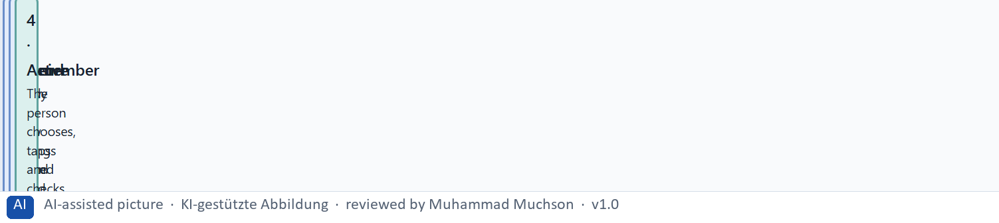
Figure 1 · From seeing to acting: four steps, each with a limit.
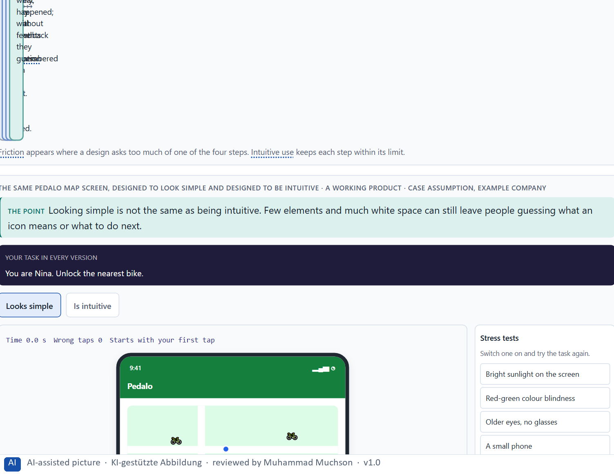
Figure 2 · The same Pedalo map screen, designed to look simple and designed to be intuitive. Shown here in its starting state; in the Neuro-UX Lab every version and every stress test can be used.
A simple-looking surface and truly intuitive guidance
Aspect | Looks simple | Is intuitive
Elements | Few, often unlabelled icons. | As many as the task needs, each named.
Next step | Has to be guessed. | Visible and clearly the main action.
Feedback | Nothing after an action. | Says that it worked and what comes next.
Checked by | How clean it looks. | Whether people finish their task without thinking about the interface.

Case assumption
Pedalo, Nina, Sam, Yusuf and Clara are made up for this example. Designing for how people perceive and act follows Norman (2013); the interaction principles (suitability for the task, self-descriptiveness, conformity with expectations) follow ISO 9241-110.

How to decide when this comes up in the task
- Walk through a task and note where you hesitate: that is where friction is.
- Locate each hesitation in one of the four steps: not seen (perceive), lost among others (attend), forgotten (remember), unsure what to do or whether it worked (act).
- Do not confuse few elements with intuitive use: unlabelled icons and hidden next steps look simple and make people guess.
- Ask whether the next step is visible, named and clearly the main action.

Extra · go deeper (optional reading)
ISO 9241-110 lists seven interaction principles: suitability for the task, self-descriptiveness, conformity with user expectations, learnability, controllability, use error robustness and user engagement. Most hesitations in a walkthrough break one of them, which gives the team a shared word for the problem.

Sources · Norman 2013 · ISO 9241-110 · Krug 2014

A2 · How people compare options and decide: Hick's law and the cost of choice · 12 min · Core
People take in the options, compare them and decide. The more equally weighted options there are, the longer the decision takes (Hick's law). Give frequent choices priority and group the rest.
IN PLAIN WORDS
The idea. People take in the options, compare them and then decide. Hick's law describes the cost: the more equally weighted options there are to choose from, the longer the decision takes. It matters most when the options are unfamiliar and look alike; a familiar, well-sorted list can be long without hurting. The way out is not to delete functions but to give the frequent choices priority, group the rest, and show them one step deeper.
Why it matters. Block 1.1 asks about ServicePoint's many equal menu items and new choices after every step, Block 1.2 asks you to rate WorkFlow Hub's variant with very many options against the reduced one, and Block 2.1 asks about MyEnergy's too many equal navigation items. This card gives you the reason and the limits of Hick's law.
How to read the picture. One Pedalo pass page in two forms: twelve equal passes, and three recommended passes with “All passes” below.

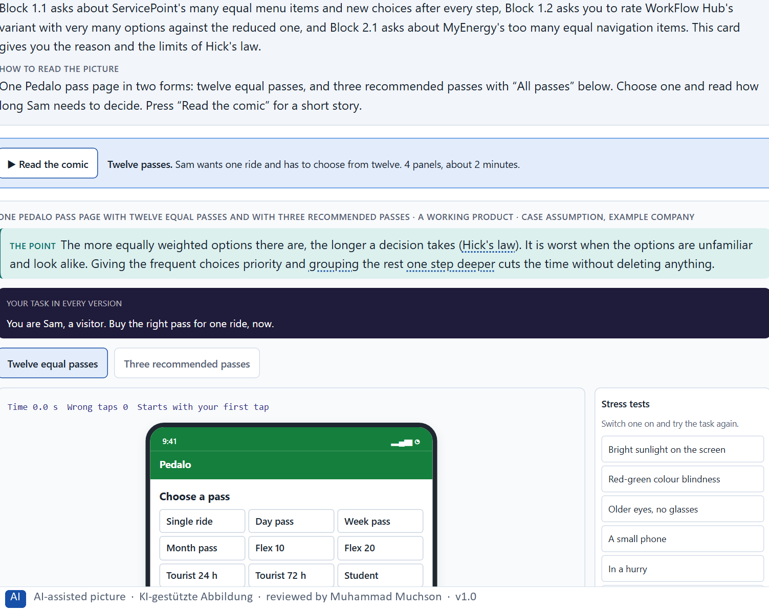
Figure 3 · One Pedalo pass page with twelve equal passes and with three recommended passes. Shown here in its starting state; in the Neuro-UX Lab every version and every stress test can be used.
When many options hurt, and when they do not
Situation | Effect of many options | What helps
Unfamiliar options that look alike | Slow decisions, wrong choices, giving up. | Priority for the frequent ones, a short line on who each is for.
A familiar, sorted list (countries, dates) | Little harm; people jump to what they know. | A clear order and search.
Experienced users who know the layout | Little harm; they go straight to their item. | Keep positions stable.
A choice after every step | Every step becomes a new decision. | One recommended path, alternatives as a secondary link.

Case assumption
Pedalo, Nina, Sam, Yusuf and Clara are made up for this example. Hick's law follows Hick (1952) and Hyman (1953); that many options can make people choose less follows Iyengar and Lepper (2000).

How to decide when this comes up in the task
- Count the equally weighted options at each decision point: menu items, tiles, buttons, passes.
- Hick's law bites hardest when the options are unfamiliar and look alike; a familiar, well-sorted list can be long.
- Do not delete functions; give the frequent ones priority and group the rest one step deeper.
- Watch for new choices after every step with no clear right path: each one is a new decision.
- Many options can attract interest and still make people choose less often.

Extra · go deeper (optional reading)
Hick and Hyman measured simple reactions to lights, not people choosing a tariff, so the law is a direction, not a formula for screens. What carries over is the shape: each extra equal option adds decision effort, and the effect shrinks when people already know where to look. That is why stable positions matter for experienced users as much as fewer options matter for new ones.

Sources · Hick 1952 · Hyman 1953 · Iyengar & Lepper 2000 · Yablonski 2020

A3 · Expectations, recognisability and a clear action logic: mental models and Fitts's law · 12 min · Core
People act on their mental model: they expect things where other products put them and the same element to work the same everywhere. A large, close target is reached faster and missed less (Fitts's law).
IN PLAIN WORDS
The idea. People bring a mental model of how things work, learnt from other products: the menu is at the top, the main button at the bottom right, the same element works the same everywhere. An interface that conforms to these expectations, keeps its elements recognisable and follows a clear action logic (what to do, in which order, and what happens) is used without thinking. Fitts's law adds the physical side: a target that is large and close is reached faster and missed less often than a small, distant one.
Why it matters. Block 1.1 asks about ServicePoint's unclear path and missing feedback, Block 1.2 asks about WorkFlow Hub's changing patterns between areas, and Block 2.1 asks about MyEnergy's invisible process logic. You need mental models and a clear action logic to say why these hurt.
How to read the picture. One Pedalo screen with three switches: the button where people expect it, a large target near the thumb, and the same pattern on every screen.

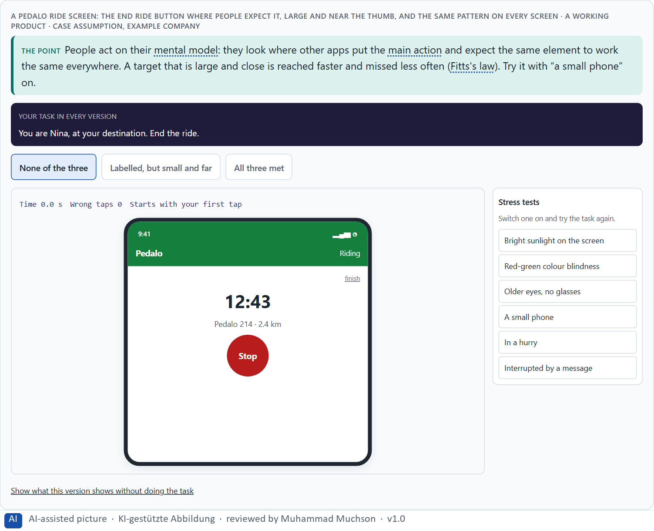
Figure 4 · A Pedalo ride screen: the End ride button where people expect it, large and near the thumb, and the same pattern on every screen. Shown here in its starting state; in the Neuro-UX Lab every version and every stress test can be used.
Four sources of intuitive action
Source | What it means | A sign it is missing
Conformity with expectations | Things are where people expect from other products. | The main button is somewhere unusual.
Recognisability | The same element looks and works the same everywhere. | A red button ends a ride on one screen and pauses it on another.
A clear action logic | Start, steps and end are visible. | New options appear without saying which path is right.
Fitts's law | Important targets are large and close. | A small button far from the thumb is missed.

Case assumption
Pedalo, Nina, Sam, Yusuf and Clara are made up for this example. Mental models follow Norman (2013); Fitts's law follows Fitts (1954); conformity with user expectations is an interaction principle of ISO 9241-110; Jakob's law is described by Yablonski (2020).

How to decide when this comes up in the task
- Ask where people would look for the main action, from habit with other products, and put it there.
- Check recognisability: the same element looks and works the same on every screen and in every area.
- Check the action logic: what to do, in which order, and what happens after each step.
- Apply Fitts's law: the frequent, important targets are large and close to where the hand or thumb already is.
- Changing patterns between areas make people relearn each area and cause wrong actions.

Extra · go deeper (optional reading)
Fitts's law has a corner case worth knowing: on a desktop screen, the edges and corners are effectively infinitely large targets, because the pointer stops there. On a phone the same thinking applies to the bottom of the screen, where the thumb rests: the most frequent actions belong there.

Sources · Norman 2013 · Fitts 1954 · ISO 9241-110 · Yablonski 2020

A4 · Memory and load: Miller's rule, and why load causes errors, abandonment and uncertainty · 12 min · Core
Working memory holds only a few things at once (Miller's rule; later research says nearer four). Making people remember raises the load, and with it errors, abandonment and uncertainty.
IN PLAIN WORDS
The idea. Working memory holds only a few things at once. Miller's rule (“seven, plus or minus two”) made the point; later research puts the limit nearer four chunks. When an interface makes people remember a code from one screen for the next, or compare many options in their head, the load rises, and with it errors, abandonment and uncertainty. Too many options, unclear structures and inconsistent patterns all add load. The fix is to let the system remember, show instead of asking people to recall, and keep patterns consistent.
Why it matters. Block 1.1 asks about ServicePoint's intermediate steps that must be remembered, and Block 2.1 asks about MyEnergy's information to remember across steps and its unclear feedback. This card gives you the limit and what it does to errors and abandonment.
How to read the picture. The same Pedalo unlock step twice: Sam has to remember a code from the previous screen, or the system carries it for him.

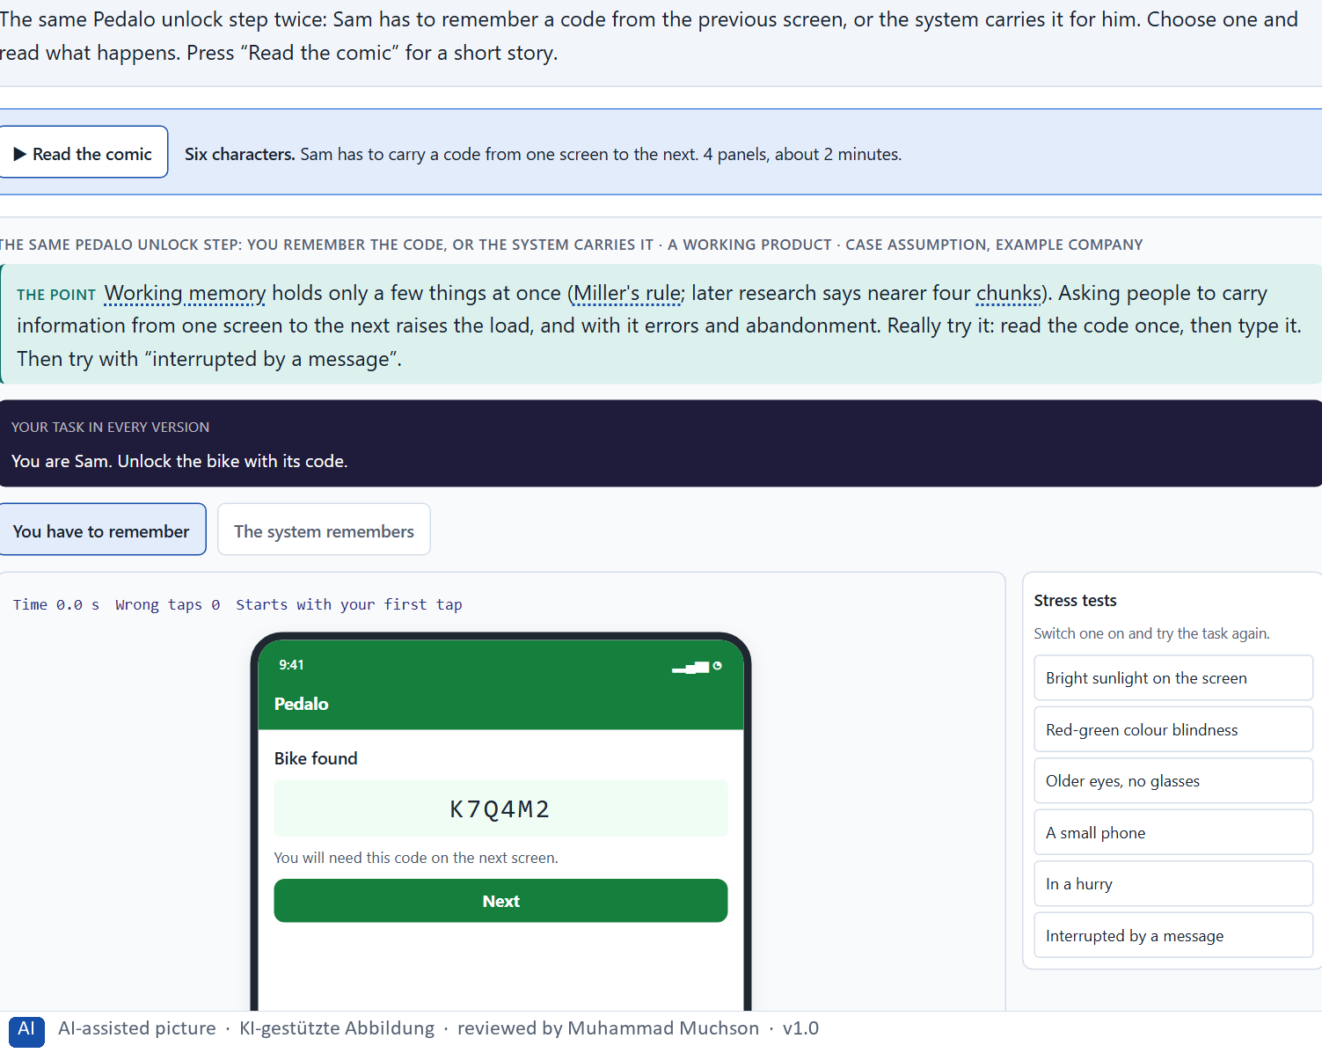
Figure 5 · The same Pedalo unlock step: you remember the code, or the system carries it. Shown here in its starting state; in the Neuro-UX Lab every version and every stress test can be used.
Where load comes from, and what it does
Source of load | What it does | What helps
Information to carry across steps | Forgotten or mistyped; the task starts again. | The system carries it over.
Too many options | Comparing in the head; slow and unsure. | Frequent options first.
Unclear structure | People do not know where they are. | Visible steps and a clear place.
Inconsistent patterns | What was learnt does not hold; wrong actions. | The same pattern everywhere.
No feedback | Uncertainty; repeated or abandoned actions. | A clear confirmation after each step.

Case assumption
Pedalo, Nina, Sam, Yusuf and Clara are made up for this example. The limits of short-term memory follow Miller (1956) and Cowan (2001); cognitive load follows Sweller (1988); recognition rather than recall is Nielsen's heuristic (1994).

How to decide when this comes up in the task
- List what a person has to keep in mind during a task: a code, a choice made two steps back, a term from another page.
- Let the system carry what it already knows; show instead of asking people to recall.
- Too many options, unclear structures and inconsistent patterns all add load, not only long texts.
- Load shows up as errors, abandoned processes and people unsure whether something worked; feedback after each step lowers the uncertainty.

Extra · go deeper (optional reading)
Miller's “seven, plus or minus two” is often quoted as a rule for menus (“never more than seven items”). That is a misreading: Miller wrote about holding items in memory, not about choosing from items that stay visible. A visible menu with ten items does not have to be remembered; a code on the previous screen does.

Sources · Miller 1956 · Cowan 2001 · Sweller 1988 · Nielsen 1994

A5 · UX laws as tools against friction, and weighing a measure · 12 min · Core
UX laws are tools: each points to a kind of friction and a kind of fix. To put measures in order, weigh each on effect on users, feasibility, risk and time pressure, with a reason.
IN PLAIN WORDS
The idea. UX laws are tools, not decoration: each one points to a kind of friction and a kind of fix. Hick: fewer equal choices, frequent ones first. Miller: less to remember, the system remembers. Fitts: important targets large and close. Expectations: put things where people look and keep patterns the same. To put measures in order, weigh each on the four questions Block 2.1 names: effect on users, feasibility, risk and time pressure. The reason next to each rating matters more than the rating.
Why it matters. Block 1.1 asks for the two biggest hurdles, Block 1.2 for a decision between three navigation variants, and Block 2.1 for four measures, their justification on these four criteria and a decision for 12 weeks. The example uses Pedalo and its own measures, so the answer for the task cases is not given.
How to read the picture. Three measures Pedalo considered, rated on effect on users, feasibility, risk and time pressure. A rating is a reading of the example, not a mark.

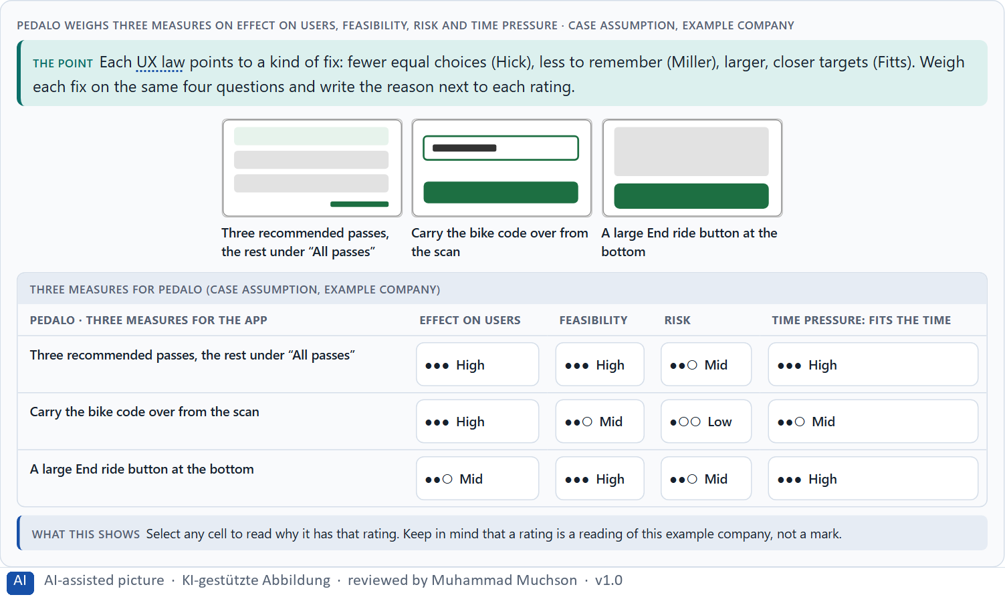
Figure 6 · Pedalo weighs three measures on effect on users, feasibility, risk and time pressure.
UX laws as tools
Law or principle | The friction it points to | The kind of fix
Hick's law | Too many equal choices. | Frequent ones first, the rest grouped.
Miller's rule | Too much to remember. | The system remembers; show, do not ask.
Fitts's law | Targets small or far away. | Important targets large and close.
Conformity with expectations | Things in unexpected places; changing patterns. | Familiar places, one pattern.

Case assumption
Pedalo, Nina, Sam, Yusuf and Clara are made up for this example. The laws as practical tools follow Yablonski (2020); rating options on the same criteria with a reason follows Gibbons (2018). The four criteria are the ones the plan names for the case study.

How to decide when this comes up in the task
- Use the laws to find fixes: Hick to fewer equal choices, Miller to less to remember, Fitts to larger, closer targets, expectations to familiar places and patterns.
- Rate every measure on the same four questions: effect on users, feasibility, risk, time pressure.
- A rating is a judgement with a reason, never a mark. A different order with a better reason is a better answer.
- Prefer fixes that remove a step or a choice over fixes that add explanation, such as help texts and videos.
- Ordering and grouping functions usually needs agreement from the teams that own them: count that in feasibility and risk.

Extra · go deeper (optional reading)
A help text or a tutorial video is often the cheapest-looking fix and the weakest: it adds something to read and remember, and it helps only the people who find it. When a team proposes one, ask which step or choice could be removed instead, so that the help is not needed.

Sources · Yablonski 2020 · Gibbons 2018 · Nielsen 1994

Materi B · Route 2 · Level 3
How Materi B is used
About 60 minutes, three cards, led by the facilitator. Level 3 in the Chief Experience Officer's chair: a guiding vision for intuitive use, three strategic decisions, an order of what is improved first, a risk analysis, a governance model for the interaction logic, one decision under uncertainty and a statement to the management. The cards give you the ideas you use in Task 2.

B1 · Usability as a strategic factor: reducing friction in the whole system · 20 min · Core
Usability is strategic when it decides what is done first. Organisations answer problems with new functions, which add load; leaders reduce friction in the whole system first.
IN PLAIN WORDS
The idea. Usability becomes a strategic factor when it decides which work is done first. Organisations often answer usability problems with new functions, which add options and load. A leader steers the other way: reduce friction in the whole system, in the processes customers run through several channels, before adding anything. The question is not “what else can the product do?” but “where do customers search, remember and guess, and what does that cost in support and abandonment?”.
Why it matters. Block 3.1 asks for a guiding vision for intuitive use, three decisions on orientation, efficiency, complexity and main tasks, and an order of the systems or processes to improve first, for a company that discusses new functions while central problems remain. You decide what comes first in the whole system.
How to read the picture. Left Pedalo answering problems with new functions, right reducing friction first. Below, the chain from a screen to the whole product system.

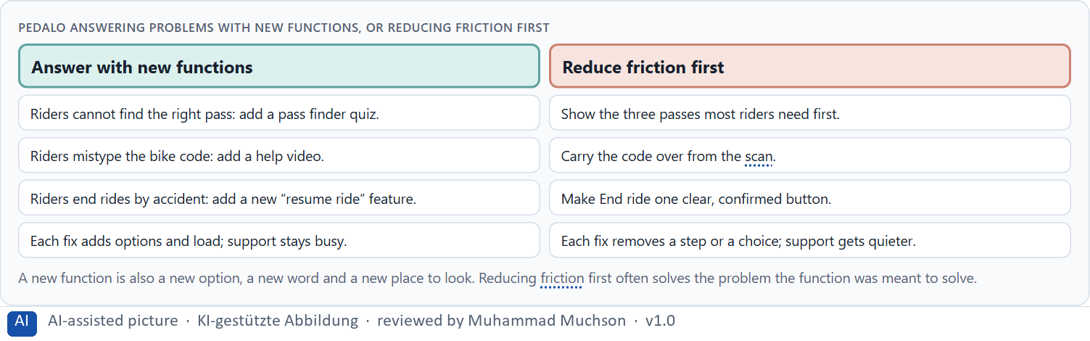
Figure 7 · Pedalo answering problems with new functions, or reducing friction first.
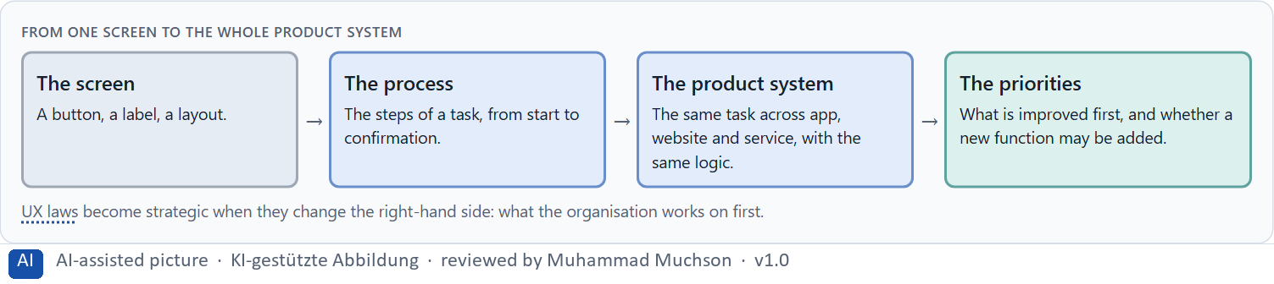
Figure 8 · From one screen to the whole product system.
Case assumption
Pedalo, Nina, Sam, Yusuf and Clara are made up for this example. Designing for how people act follows Norman (2013); the interaction principles follow ISO 9241-110.

How to decide when this comes up in the task
- Look at where customers search, remember and guess across all channels, and what it costs in support and abandonment.
- Before a new function, ask which existing friction it is meant to solve, and whether removing that friction would solve it.
- Think in processes across channels, not single screens: the same task in the portal, the app and the service should follow the same logic.
- Leaders steer usability as a factor of impact, not only provide functions.

Extra · go deeper (optional reading)
A simple test for a roadmap: for each planned function, write the user problem it solves and the step or choice it adds. If the problem could be solved by removing a step, the function waits. Teams that apply it usually find that the first quarter's work is in existing processes, not new ones.

Sources · Norman 2013 · ISO 9241-110 · Yablonski 2020

B2 · Conflicts of goals: scope of functions against simplicity, completeness against efficiency · 20 min · Core
Scope of functions against simplicity, completeness against efficiency, new against experienced users, the ideal against time. Keep every function, but order them: frequent tasks first.
IN PLAIN WORDS
The idea. Intuitive use sits between goals that pull against each other: the scope of functions against simplicity, a department's wish for completeness and visibility against efficiency for users, new users who need a calm start against experienced users who want everything in one click, and the ideal solution against time pressure and feasibility. A common way through is to keep every function, but order them: the frequent tasks first, the rest grouped and findable one step deeper. The work is to name the conflict, choose, and say what you give up.
Why it matters. Block 3.1 asks for three guiding decisions, a risk analysis about user behaviour and internal requirements, and a governance model for conflicts between departments that want variety and users who need simplicity. Each of these is a decision between conflicting goals.
How to read the picture. The matrix places five Pedalo designs by how many functions they show at once (to the right) and how easily riders finish their task (upwards). A position is a reading of the example, not a score.

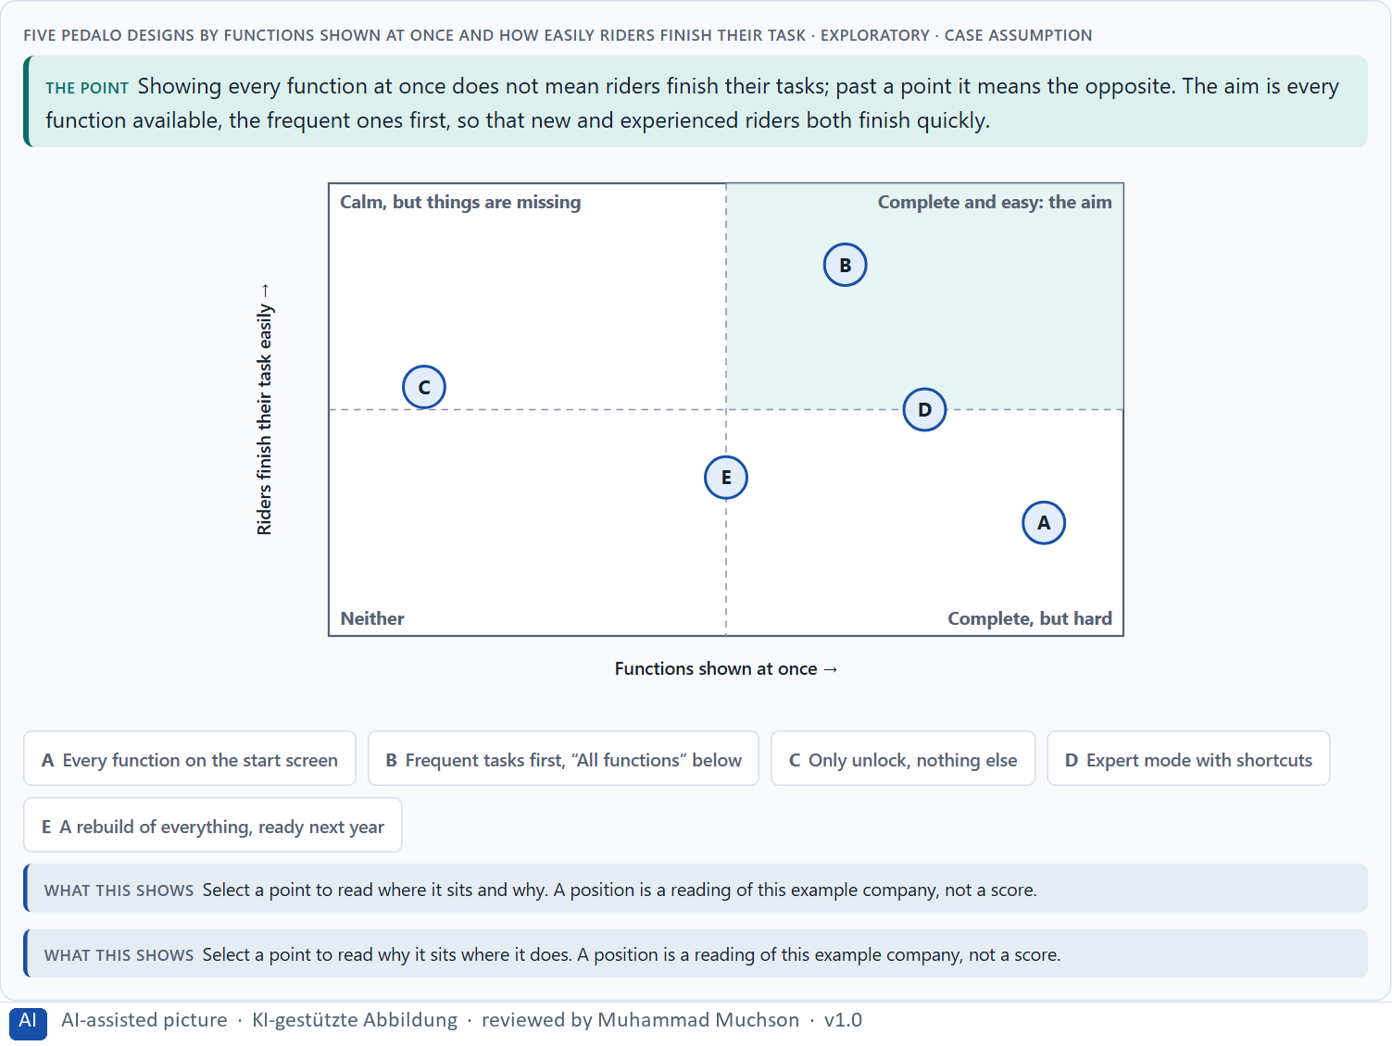
Figure 9 · Five Pedalo designs by functions shown at once and how easily riders finish their task · Exploratory.
Standing conflicts of intuitive use
Conflict | Who usually stands for each side | What to ask
Scope of functions against simplicity | Departments that want their functions seen, against users who need few choices. | Which tasks do most users do most often?
New against experienced users | A calm start, against everything in one click. | Can the frequent tasks serve both, with shortcuts for experts?
The ideal against time and feasibility | A full rebuild, against what fits the release. | What helps most users within the time there is?

Case assumption
Pedalo, Nina, Sam, Yusuf and Clara are made up for this example. That many options can make people choose less follows Iyengar and Lepper (2000); the matrix is a reading of the example, not a score.

How to decide when this comes up in the task
- Name the conflict as two goals and say who stands for each: a department, the UX team, new users, experienced users.
- Showing every function at once is not the same as people finishing their task; past a point it is worse.
- Keep every function reachable, give the frequent ones priority, and group the rest one step deeper with a clear entry and search.
- Under time pressure, prefer the change that helps most people soon over the ideal rebuild that helps nobody this year.
- Say what the choice gives up; a decision that gives up nothing has not been made.

Extra · go deeper (optional reading)
Departments often fear that a function one step deeper will not be used. A useful agreement: move it, give it a clear entry and search, and look at the use after a quarter. If it really drops for customers who need it, it moves back up. The fear becomes a check instead of a veto.

Sources · Iyengar & Lepper 2000 · Gibbons 2018 · Hick 1952

B3 · Who owns the interaction logic, and deciding with partial user data · 20 min · Core
The interaction logic needs an owner, or every team adds its function wherever it likes. A decision with partial user data says what it decides, what it does not know, when it would reverse it and what it gives up.
IN PLAIN WORDS
The idea. The interaction logic, meaning the order of tasks, the steps of each process and the patterns across channels, needs an owner, or every department adds its function wherever it likes. Departments own their content and rules; someone owns how it all fits together; and a rule decides conflicts, such as how often customers need a task and how much support it causes. Because user data is rarely complete, a decision under uncertainty says what you decide, what you do not know, when you would reverse it and what you give up.
Why it matters. Block 3.1 asks for a governance model for the interaction logic, a decision despite incomplete data, and a statement to the management. This card gives you the parts of each.
How to read the picture. The four boxes at the top are the parts of a decision, filled in for Pedalo. The two boxes below are the rule for future decisions.

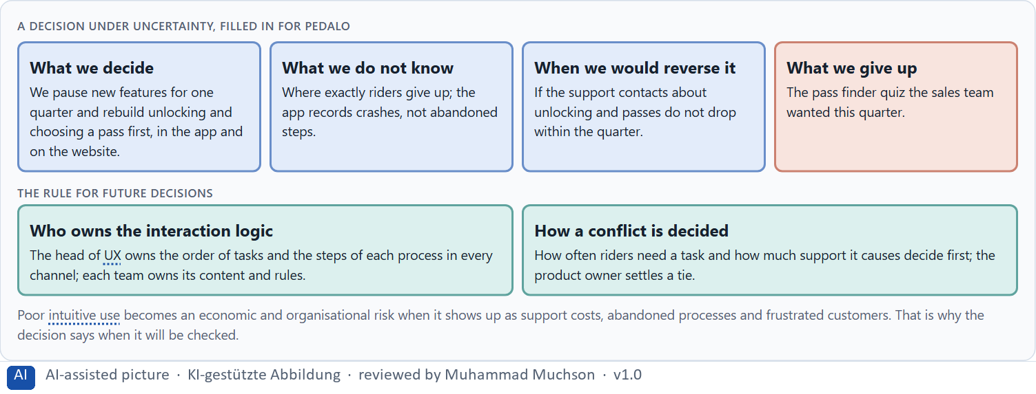
Figure 10 · A decision under uncertainty, filled in for Pedalo.
Three parts of a governance model for the interaction logic
Part | The question | An example (Pedalo)
Who owns what | Who owns the order of tasks and the steps; who owns content? | The head of UX owns the order and the steps; each team owns its content and rules.
How a request is decided | What happens when a team wants its function on top? | How often riders need it and how much support it causes decide.
When a function may be added | What must a new function bring? | A plan for where it sits and what it replaces.

Case assumption
Pedalo, Nina, Sam, Yusuf and Clara are made up for this example. Deciding with limited information follows Simon (1956); the premortem follows Klein (2007).

How to decide when this comes up in the task
- Name who owns the order of tasks, the steps of each process and the patterns across channels; departments own their content and rules.
- Give conflicts a rule: how often users need a task and how much support it causes, using the data there is; then a named person.
- Accept a new function only with a plan for where it sits and what it replaces.
- Say what you decide, what you do not know, when you would reverse it and what you give up.

Extra · go deeper (optional reading)
Imagine it is a year later and customers still call about the same tasks, and ask why (Klein 2007). Typical answers: a team added its function to the start screen anyway; a process was fixed in the app but not in the portal; the confirmation was written but never tested. Each answer points to a missing owner or a missing check.

Sources · Simon 1956 · Klein 2007 · ISO 9241-110

Use in class: presentation and handout
Mark of use for the study material. Presentation is what the trainer shows on screen; Handout is what participants read and keep.
Card | Presentation (shown in the Neuro-UX Lab) | Handout
A1 · Intuitive use is designed: perception, attention, memory and action (Core) | Scan line and Figures 1–2; the "In plain words" and "How to decide" boxes | The whole card
A2 · How people compare options and decide: Hick's law and the cost of choice (Core) | Scan line and Figure 3; the "In plain words" and "How to decide" boxes | The whole card
A3 · Expectations, recognisability and a clear action logic: mental models and Fitts's law (Core) | Scan line and Figure 4; the "In plain words" and "How to decide" boxes | The whole card
A4 · Memory and load: Miller's rule, and why load causes errors, abandonment and uncertainty (Core) | Scan line and Figure 5; the "In plain words" and "How to decide" boxes | The whole card
A5 · UX laws as tools against friction, and weighing a measure (Core) | Scan line and Figure 6; the "In plain words" and "How to decide" boxes | The whole card
B1 · Usability as a strategic factor: reducing friction in the whole system (Core) | Scan line and Figures 7–8; the "In plain words" and "How to decide" boxes | The whole card
B2 · Conflicts of goals: scope of functions against simplicity, completeness against efficiency (Core) | Scan line and Figure 9; the "In plain words" and "How to decide" boxes | The whole card
B3 · Who owns the interaction logic, and deciding with partial user data (Core) | Scan line and Figure 10; the "In plain words" and "How to decide" boxes | The whole card

References
Check each source and its current edition before you teach from it. Standards and laws marked as in flux can change.
Norman, D. A. (2013). The Design of Everyday Things (revised and expanded edition). Basic Books. (Mental models and conceptual models: a design works when what people believe it does matches what it does.)
ISO 9241-110:2020. Ergonomics of human-system interaction, Part 110: Interaction principles. (Suitability for the task, self-descriptiveness, conformity with user expectations, learnability, controllability, use error robustness and user engagement.) Check the current edition before you teach from it.
Krug, S. (2014). Don't Make Me Think, Revisited (3rd ed.). New Riders. (People scan rather than read, follow conventions they know, and should be able to tell at once where they are and what they can do.)
Hick, W. E. (1952). On the rate of gain of information. Quarterly Journal of Experimental Psychology, 4(1), 11–26. (Choice reaction time rises with the number of equally likely alternatives: Hick's law.)
Hyman, R. (1953). Stimulus information as a determinant of reaction time. Journal of Experimental Psychology, 45(3), 188–196. (The same relation holds for the information in the choice; familiar or likely options are chosen faster.)
Iyengar, S. S., & Lepper, M. R. (2000). When choice is demotivating: Can one desire too much of a good thing? Journal of Personality and Social Psychology, 79(6), 995–1006. (Many options can attract interest and still make people choose less often.)
Yablonski, J. (2020). Laws of UX: Using Psychology to Design Better Products & Services. O'Reilly. (Hick's, Fitts's and Jakob's law, Miller's rule and other principles as practical tools for interface decisions.)
Fitts, P. M. (1954). The information capacity of the human motor system in controlling the amplitude of movement. Journal of Experimental Psychology, 47(6), 381–391. (The time to reach a target grows with its distance and shrinks with its size: Fitts's law.)
Miller, G. A. (1956). The magical number seven, plus or minus two: Some limits on our capacity for processing information. Psychological Review, 63(2), 81–97. (Short-term memory holds only a small number of chunks: Miller's rule.)
Cowan, N. (2001). The magical number 4 in short-term memory: A reconsideration of mental storage capacity. Behavioral and Brain Sciences, 24(1), 87–114. (The limit of working memory is nearer four chunks than seven.)
Sweller, J. (1988). Cognitive load during problem solving: Effects on learning. Cognitive Science, 12(2), 257–285. https://doi.org/10.1207/s15516709cog1202_4 (Working memory is limited; effort spent on working out a screen is missing for the task itself.)
Nielsen, J. (1994, reviewed 2024). 10 Usability Heuristics for User Interface Design. Nielsen Norman Group. https://www.nngroup.com/articles/ten-usability-heuristics/ (Visibility of system status, consistency and standards, recognition rather than recall, aesthetic and minimalist design.)
Gibbons, S. (2018). Using Prioritization Matrices to Inform UX Decisions. Nielsen Norman Group. https://www.nngroup.com/articles/prioritization-matrices/ (Rate each option on the same few criteria, such as value to the user against effort, and put the reason next to each rating.)
Simon, H. A. (1956). Rational choice and the structure of the environment. Psychological Review, 63(2), 129–138. (With limited information and time, people choose an option that is good enough rather than the best one: a decision under uncertainty.)
Klein, G. (2007). Performing a project premortem. Harvard Business Review, 85(9), 18–19. (Imagine the plan has failed and ask why; it brings risks and wrong assumptions to the surface before the work starts.)

Glossary
Every term below is used in this document. Terms stay plain text in the body; this list says what they mean in everyday words.
Term | In plain words | Example | Comes from
Action logic | The order in which a task runs: where it starts, which steps follow, what each step asks and how the person knows they are done. | — | Day 4
Attention | The mind's spotlight. Only a small part of a screen is processed at any moment; attention decides which part. | A flashing banner takes attention away from the form you were filling in. | Day 1
Case assumption | A fact made up for this exercise to fill a gap in the plan's case. It is marked so you know it is not part of the plan. | — | Day 1
Chief Experience Officer | The manager who is responsible for the experience customers have across all channels, and who decides where the company invests in it. | — | Day 1
Chunk | A group of items the memory treats as one, such as a phone number split into blocks. Grouping information into chunks makes it easier to hold. | — | Day 4
Cognition | The thinking side of the mind: remembering, comparing, understanding and deciding. | — | Day 1
Cognitive load | How much a person has to hold in mind and work out at the same time. Every extra signal or choice adds to it; when it is too high, people skip, freeze or leave. | — | Day 1
Conformity with expectations | An interface behaves the way people expect from other products and from its own earlier screens: the menu where menus usually are, the same element working the same way. | — | Day 4
Consistency | The same thing looks, is named and works the same way everywhere, so what people learn on one page holds on the next. | — | Day 2
Decision effort | The mental work of comparing options and choosing one. Many equal options raise it. | — | Day 4
Findability | How easily people can find what they are looking for, by browsing the menu or by searching. | — | Day 2
Fitts's law | A target is reached faster and missed less often when it is large and close. Small, distant buttons cost time and cause wrong taps. | — | Day 4
Friction | Everything that slows people down or makes them think about the interface instead of their task: searching, choosing, remembering, guessing. | — | Day 4
Governance | The rules about who may decide what, who is answerable for it and how disagreements are settled. | — | Day 1
Grouping | Showing what belongs together, for example by putting it close together or making it look alike. The eye reads a group as one unit. | — | Day 2
Hick's law | The more equally weighted options people have to choose from, the longer the decision takes. It matters most for unfamiliar options that look alike. | — | Day 4
Intuitive use | Use that works without thinking about the interface: people find what they need, know what to do next and know when they are done. It is designed, not a matter of luck. | — | Day 4
Jakob's law | People spend most of their time on other products, so they expect yours to work the same way. Familiar patterns need no learning. | — | Day 4
Mental model | What a person believes a product is and how it works. A design feels natural when it fits that belief and confusing when it does not. | Most people expect a basket icon to show what they have chosen so far. | Day 1
Miller's rule | Short-term memory holds only a few things at once, about seven in Miller's old estimate and nearer four in later research. Interfaces should not make people remember what the system knows. | — | Day 4
Neuro-UX | Designing an interface with knowledge of how the brain sees, attends, feels and decides, so that the design steers these processes on purpose and responsibly. | — | Day 1
Orientation | Knowing where you are, what you can do here and what happens next. | — | Day 1
Perception | Taking in what the senses deliver, for example what the eyes see on a screen, before thinking about it. | — | Day 1
Primary action | The one thing most people on a screen came to do, such as “Report damage”. It should be the easiest thing to see and press. | — | Day 1
Progressive disclosure | Showing the few most important things first and the rest one step deeper, on request, so the first screen stays clear. | — | Day 2
Recognition instead of recall | Showing people the options and the next step so they can recognise them, instead of making them remember or hunt for them. | — | Day 2
Self-service portal | A website where customers do things themselves that once needed a call or a visit, such as reporting damage or downloading a document. | — | Day 1
UX (user experience) | Everything a person goes through when using a product: what they notice, understand, feel and do, from the first look to the last step. The screens are only one part of it. | Finding the booking you want at once and feeling sure it went through is a good UX. | Day 1
UX law | A well-tested finding about how people perceive, decide or act, used as a rule of thumb in design, such as Hick's law or Fitts's law. It explains why something is hard; it does not replace looking at the users. | — | Day 4
Working memory | The part of memory that holds what you are using right now, such as a code you just read. It is small and easily overloaded. | — | Day 4

The Neuro-UX Lab: where we practise online
In class we use the course website as the place to practise and to learn. Every day has its own address, in the same pattern: the day number is the last part.
What | Address
Neuro-UX Lab (course website) | https://aion-ux-lab.vercel.app/
Day 4 | https://aion-ux-lab.vercel.app/day/4/

On the day page, Route 1 (Levels 1 and 2) and Route 2 (Level 3) can be opened; the cards and the tasks of this document are there too. The pattern is the same up to Day 8, for example https://aion-ux-lab.vercel.app/day/6/.

