AION · UX DEVELOPER · PSYCHOLOGICAL UX DESIGN AND NEURO-UX
DAY 7 · MATERI A AND MATERI B · ROUTES 1 AND 2 · LEVELS 1 TO 3
Emotional bonding in design
Study material with real research, worked examples and the rules you use in the tasks
AI notice · KI-Hinweis
This document was produced with the help of an AI language model (Claude, Anthropic). The AI drafted the text and tables and built the pictures and working examples of the lab. The content was then read, corrected and approved by the reviewer named below, who is responsible for its accuracy. Every picture carries an AI label on the image. Check figures and sources before you quote them.
KI-Hinweis: Dieses Dokument wurde mit Unterstützung eines KI-Sprachmodells (Claude, Anthropic) erstellt. Texte und Tabellen wurden von der KI entworfen, die Abbildungen sind KI-gestützt erstellt und am Bild gekennzeichnet. Die fachliche Prüfung und Freigabe erfolgte durch die unten genannte Person.

Day | Day 7 · Module 4 (day 1 of 3): Emotional bonding in design
Document | Materi (study material). Materi A has five cards, Materi B has three.
Route and level | Materi A serves Route 1 (Levels 1 and 2, Task 1). Materi B serves Route 2 (Level 3, Task 2).
Time | Materi A about 60 min · Materi B about 60 min (facilitator-led)
Neuro-UX Lab (website) | https://aion-ux-lab.vercel.app/day/7/
Case | Worked examples use a made-up company in each card. The task case is LifeSupport (see the Task document).
Version | 1.0 · release date 29.10.2026
Review and approval | Muhammad Muchson, Mentor (subject-matter review and approval)

ABOUT THIS DOCUMENT
In class we also use the Neuro-UX Lab, the course website, as the place to practise and learn. Its address is at the end of this document.
Today is about the feelings a digital product creates and why they matter as much as its functions. You learn how emotions steer attention, motivation, trust, memory and decisions, the difference between being usable and being a good experience, the emotional factors that matter in UX (safety, control, joy, belonging, frustration, uncertainty, recognition), how visual mood, interaction, tone and feedback create them, and where emotion turns into over-emotionalisation or manipulation. Then you use it on three products. This document holds everything you need to study Day 7 without the website. Every card says what the idea is in plain words, shows it in a picture, gives the details and ends with the rules you use in the tasks.

IN THIS DOCUMENT
Lesson plan: ten teaching units (Ablaufplan)
Case study and transfer project at a glance
A1 · Emotions steer behaviour: attention, motivation, trust, memory and decisions · 12 min · Core
A2 · Usable is not enough: the emotional factors of an experience · 12 min · Core
A3 · Where feelings come from: visual mood, interaction, tone and feedback · 12 min · Core
A4 · Activation, overload and manipulation: when emotion turns against use · 12 min · Core
A5 · Trust and perceived competence, and weighing a measure · 12 min · Core
B1 · Emotional UX as part of the UX architecture, not a campaign · 20 min · Core
B2 · Seriousness against closeness: the conflicts of emotional UX · 20 min · Core
B3 · Who owns emotional UX, and deciding with little data on feelings · 20 min · Core

Day at a glance
Day 7 has ten teaching units (UE). This document is the study material; it is used in UE1 (Materi A) and UE8 (Materi B). The day is built from three documents and the Neuro-UX Lab: Materi (study material), Task (worksheet) and Trainer (coaching, feedback and model solutions), plus the course website.

Lesson plan: ten teaching units (Ablaufplan)
UE | Min | Plan item | What happens | Material | Format
1 | 45 | Knowledge transfer · Level 1 | The trainer presents the cards of Materi A (A1, A2, A3, A4, A5, about 60 min of cards) in the Neuro-UX Lab; participants follow in the handout. | Materi A (Route 1) | Presentation + Handout
2 | 45 | Level 1 · Task 1 | Individual work on Block 1.1 (Core, about 10 min): the first product of the day is read and its effect described. Pairs then compare their results and the trainer collects open questions. | Task 1 · Part 1 · Block 1.1 | Handout (or in the lab)
3 | 45 | Level 1 · Task 2 | Three options are rated on the same criteria and one is chosen under the stated conditions: Block 1.2 (Core, about 8 min). | Task 1 · Part 1 · Block 1.2 | Handout (or in the lab)
4 | 45 | Coaching · transition from Level 1 to Level 2 | Trainer-led. A short talk on the day's coaching focus, then the reflection questions in pairs. The bridge: from describing an effect to a decision you answer for. There is no worksheet block in this unit. | Trainer document, section Coaching | Trainer only
5–6 | 90 | Level 2 · Case study LifeSupport (2 UE) incl. model solution | UE5: the trainer presents the case; participants work on Block 2.1 (Core, about 15 min). UE6: groups compare their results and defend them; the trainer closes with the model solution. | Task 1 · Part 2 · Block 2.1  Trainer document, section Case study | Handout; model solution shown after the work
7 | 45 | Level 2 + 3 · Feedback round with a management perspective | Groups present their reasoning, not only their result. The trainer asks the day's Level 3 input questions and leads the discussion. | Trainer document, section Feedback round | Presentation by the groups; Trainer only
8 | 45 | Level 3 · Transfer project, Chief Experience Officer (3 UE: UE8–10) | The trainer presents Materi B (B1, B2, B3; use the "In plain words" and "How to decide" boxes, the rest is handout) and sets the role and the situation. | Materi B (Route 2) | Presentation + Handout
9 | 45 | Level 3 · Transfer project | Individual work or in pairs on Block 3.1 (Core, about 20 min): the strategy memo. | Task 2 · Block 3.1 | Handout (or in the lab)
10 | 45 | Level 3 · Transfer project | Participants present their decision and what they give up, including the one decision made under uncertainty; the trainer debriefs with the model solution. | Task 2 · Block 3.1  Trainer document, section Transfer project | Handout; model solution shown after the work

One UE is counted as 45 minutes here; breaks are not shown. The times are a guide for the trainer. The Core blocks are enough for a complete answer.

Case study and transfer project at a glance
Component | UE | Duration | Participants work in | Model solution in
Level 2 case study (LifeSupport) | UE5–6 | 2 UE · 90 min | Task 1 · Part 2 (Block 2.1) | Trainer document, section Case study
Level 3 transfer project (Chief Experience Officer) | UE8–10 | 3 UE · 135 min | Materi B and Task 2 (Block 3.1) | Trainer document, section Transfer project

Materi A · Route 1 · Levels 1 and 2
How Materi A is used
About 60 minutes, five cards. Levels 1 and 2: describe the emotional effect of an unfamiliar health platform, rate three designs of a career platform between warmth and credibility, then analyse a health-prevention portal, develop four measures, justify them and decide on the first 12 weeks. The cards give you the ideas and the rules you use in Task 1.

A1 · Emotions steer behaviour: attention, motivation, trust, memory and decisions · 12 min · Core
People feel before they judge, and the feeling steers attention, motivation, trust, memory and decisions. Emotional bonding is the result over time: the sense that a product is on your side.
IN PLAIN WORDS
The idea. People feel before they judge. Within moments a screen makes them feel welcome or distant, safe or unsure, and that feeling steers what they do next: where they look (attention), whether they go on (motivation), whether they believe what they read (trust), what they remember afterwards (memory) and what they choose (decisions). Psychology and neuro-design study these effects. Emotional bonding is the result over time: the sense that a product is on your side, which makes people come back.
Why it matters. Block 1.1 asks for the spontaneous emotional effect of WellTrack on a first-time user and for effect statements of the form “for users this could mean that …”. This card gives you the five things a feeling acts on, so you can say what it does.
How to read the picture. The same Moss & Pine order confirmation twice: cold and warm.

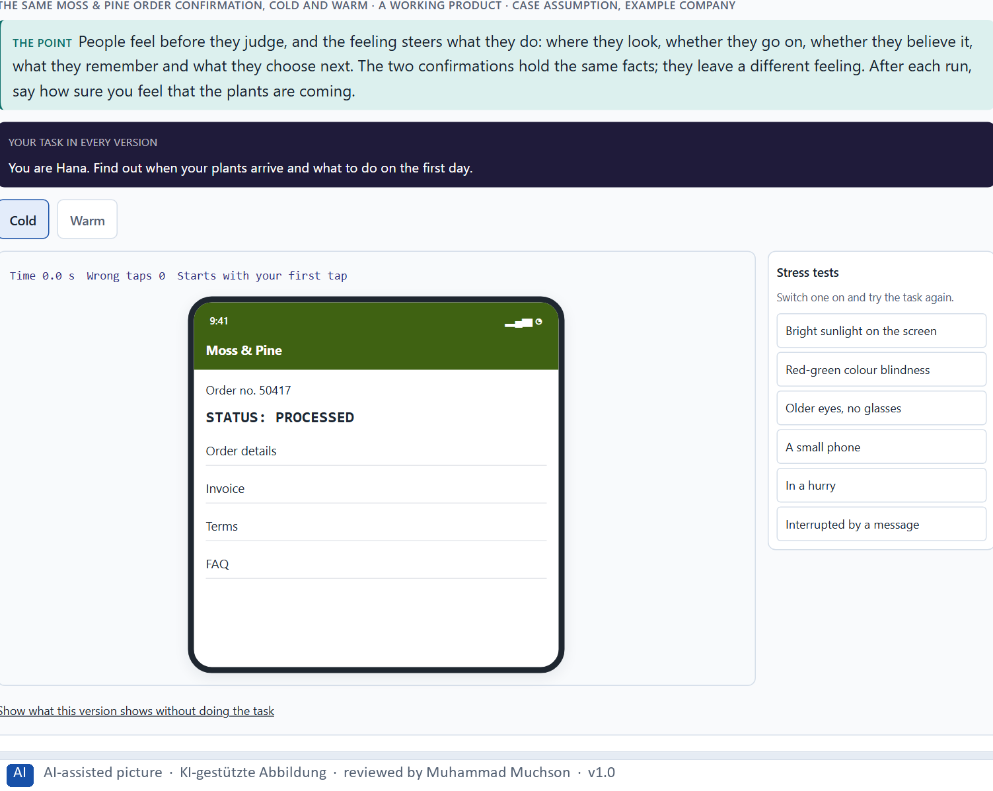
Figure 1 · The same Moss & Pine order confirmation, cold and warm. Shown here in its starting state; in the Neuro-UX Lab every version and every stress test can be used.
What a feeling acts on
Acts on | What it means | In an interface
Attention | What people notice and what they miss. | A worried person reads the warning, not the offer.
Motivation | Whether they go on or stop. | A sense of progress keeps people in a long form.
Trust | Whether they believe what they read. | A calm, clear confirmation is believed.
Memory | What stays after the visit. | The end of a visit colours the whole of it.
Decisions | What they choose next. | Uncertainty makes people postpone or go elsewhere.

Case assumption
Moss & Pine, Hana, Jonas, Wanda and Bruno are made up for this example. The three levels of emotional design follow Norman (2004); emotion as part of reasoning follows Damasio (1994); the peak-end rule follows Kahneman et al. (1993).

How to decide when this comes up in the task
- Describe the first feeling a screen gives, before you judge whether it works.
- Ask what the feeling does: where people look, whether they go on, whether they believe it, what they remember, what they choose.
- Write an effect as a hypothesis: “for users this could mean that …”.
- Look hardest at the strongest moment and at the end of a visit: people remember those.
- A correct product that feels distant is used once; a product that feels on your side is used again.

Extra · go deeper (optional reading)
Norman (2004) describes three levels on which a product acts. The visceral level is the immediate reaction to how it looks. The behavioural level is how it feels to use: whether it works, responds and lets you stay in control. The reflective level is what it means to you afterwards, what you tell others about it. A product can win one level and lose another: beautiful at first sight, frustrating to use, and remembered as frustrating.

Sources · Norman 2004 · Damasio 1994 · Kahneman et al. 1993

A2 · Usable is not enough: the emotional factors of an experience · 12 min · Core
Usable is not the same as a good experience. Safety, control, joy, belonging and recognition, and their opposites, frustration and uncertainty, decide how a usable product feels.
IN PLAIN WORDS
The idea. A product can be usable and still a poor experience. Usability asks whether people can reach their goal; emotional experience quality asks how it feels on the way and afterwards. The emotional factors that matter most in UX are safety (I know what is happening), control (I can steer and undo), joy (something is pleasant), belonging (this is for people like me), recognition (my effort is seen), and their opposites: frustration and uncertainty. A screen can pass every usability check and still leave people unsure, unseen or frustrated.
Why it matters. Block 1.1 asks you to sort WellTrack's observations into trust, safety, motivation, frustration, closeness and experience quality, Block 1.2 asks you to rate three designs on trust, motivation, safety, clarity and experience quality, and Block 2.1 asks you to sort LifeSupport's problems into five such categories. This card gives you the factors to name what you see.
How to read the picture. One Moss & Pine checkout with three switches: safety, control and recognition.

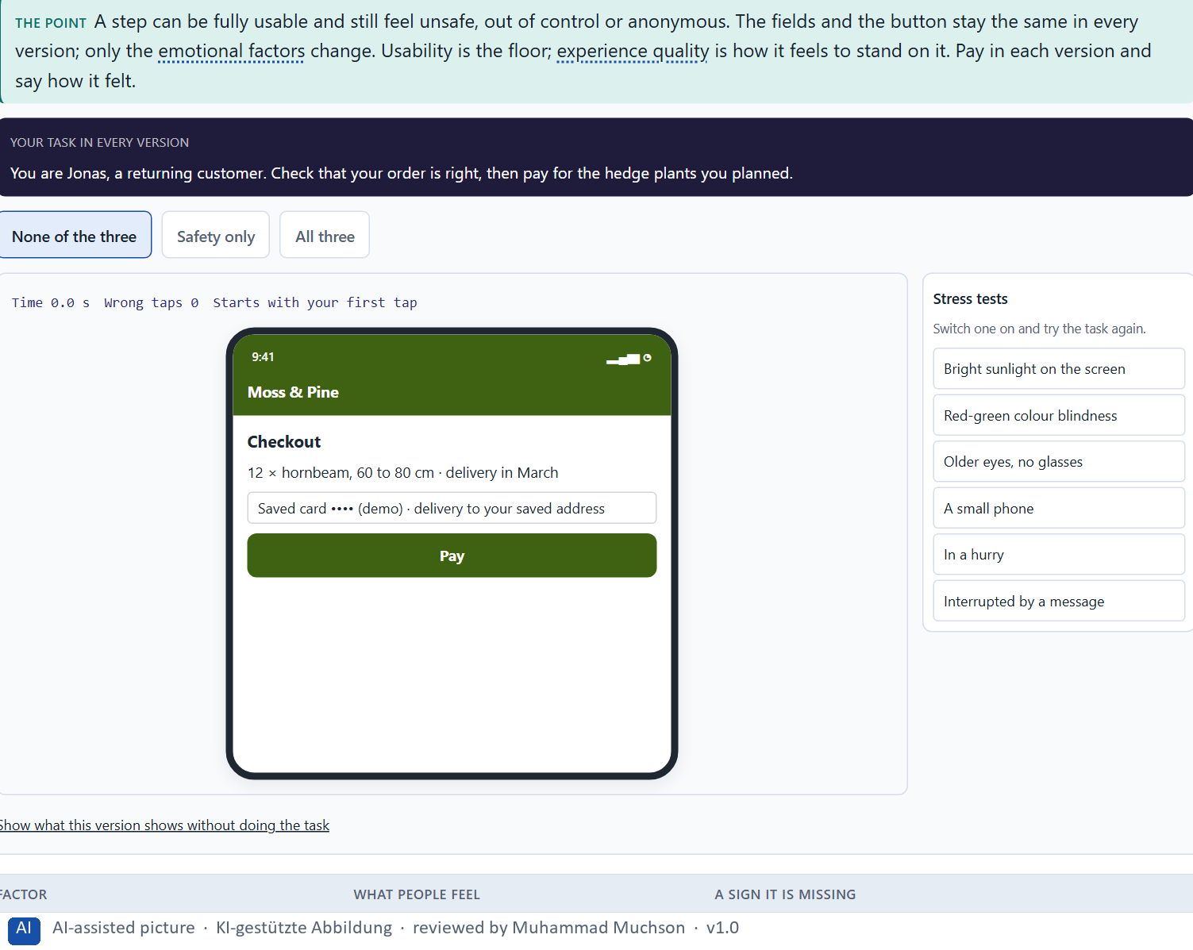
Figure 2 · A Moss & Pine checkout step: safety, control and recognition. Shown here in its starting state; in the Neuro-UX Lab every version and every stress test can be used.
The emotional factors of UX
Factor | What people feel | A sign it is missing
Safety | I know what is happening. | “Did it work?”
Control | I can steer and undo. | No way back from a step.
Joy | Something is pleasant. | Every step feels like a chore.
Belonging | This is for people like me. | Words and pictures for someone else.
Recognition | My effort is seen. | A finished task ends in silence.
Frustration and uncertainty | I am stuck, or I do not know. | Errors that blame; waiting without a word.

Case assumption
Moss & Pine, Hana, Jonas, Wanda and Bruno are made up for this example. Experience beyond usability follows Hassenzahl (2010); user experience as perceptions and responses before, during and after use follows ISO 9241-210.

How to decide when this comes up in the task
- First check usability: can people reach their goal? Then ask how it feels on the way.
- Safety: do people know what is happening and what comes next?
- Control: can they steer, change and undo?
- Recognition and belonging: does the product see their effort and feel made for people like them?
- Frustration and uncertainty: where do they get stuck or wonder whether something worked?

Extra · go deeper (optional reading)
Hassenzahl (2010) separates what a product does (its pragmatic quality: useful, usable) from what it means to people (its hedonic quality: stimulation, identification). Both shape the overall experience. A health or career product that is only pragmatic is used when people must; one that also gives a sense of competence and being understood is used when they could choose otherwise.

Sources · Hassenzahl 2010 · Norman 2004 · ISO 9241-210

A3 · Where feelings come from: visual mood, interaction, tone and feedback · 12 min · Core
Feelings come from four things on the screen: visual mood, interaction patterns, tone and feedback. Most of the effect sits in feedback and tone at critical moments: an error, a wait, a success.
IN PLAIN WORDS
The idea. Feelings in a product are not added by a campaign; they come from four things on the screen. Visual mood: colour, images, space and type set a temperature before anything is read. Interaction patterns: what happens when people act, how fast, and whether they can undo. Tone: the words, above all in microcopy, error messages and confirmations. Feedback: whether the product says what happened, what comes next and that it went well. Most of the emotional effect sits in feedback and tone at the critical moments: an error, a wait, a success.
Why it matters. Block 1.1 asks about WellTrack's technical errors and missing positive feedback, Block 1.2 asks about CareerPath's unclear feedback, and Block 2.1 asks about LifeSupport's distant visual language, technical feedback and correct but cold tone. This card gives you the four sources to say where a feeling comes from.
How to read the picture. One Moss & Pine error message written three ways: technical, cheerful and supportive.

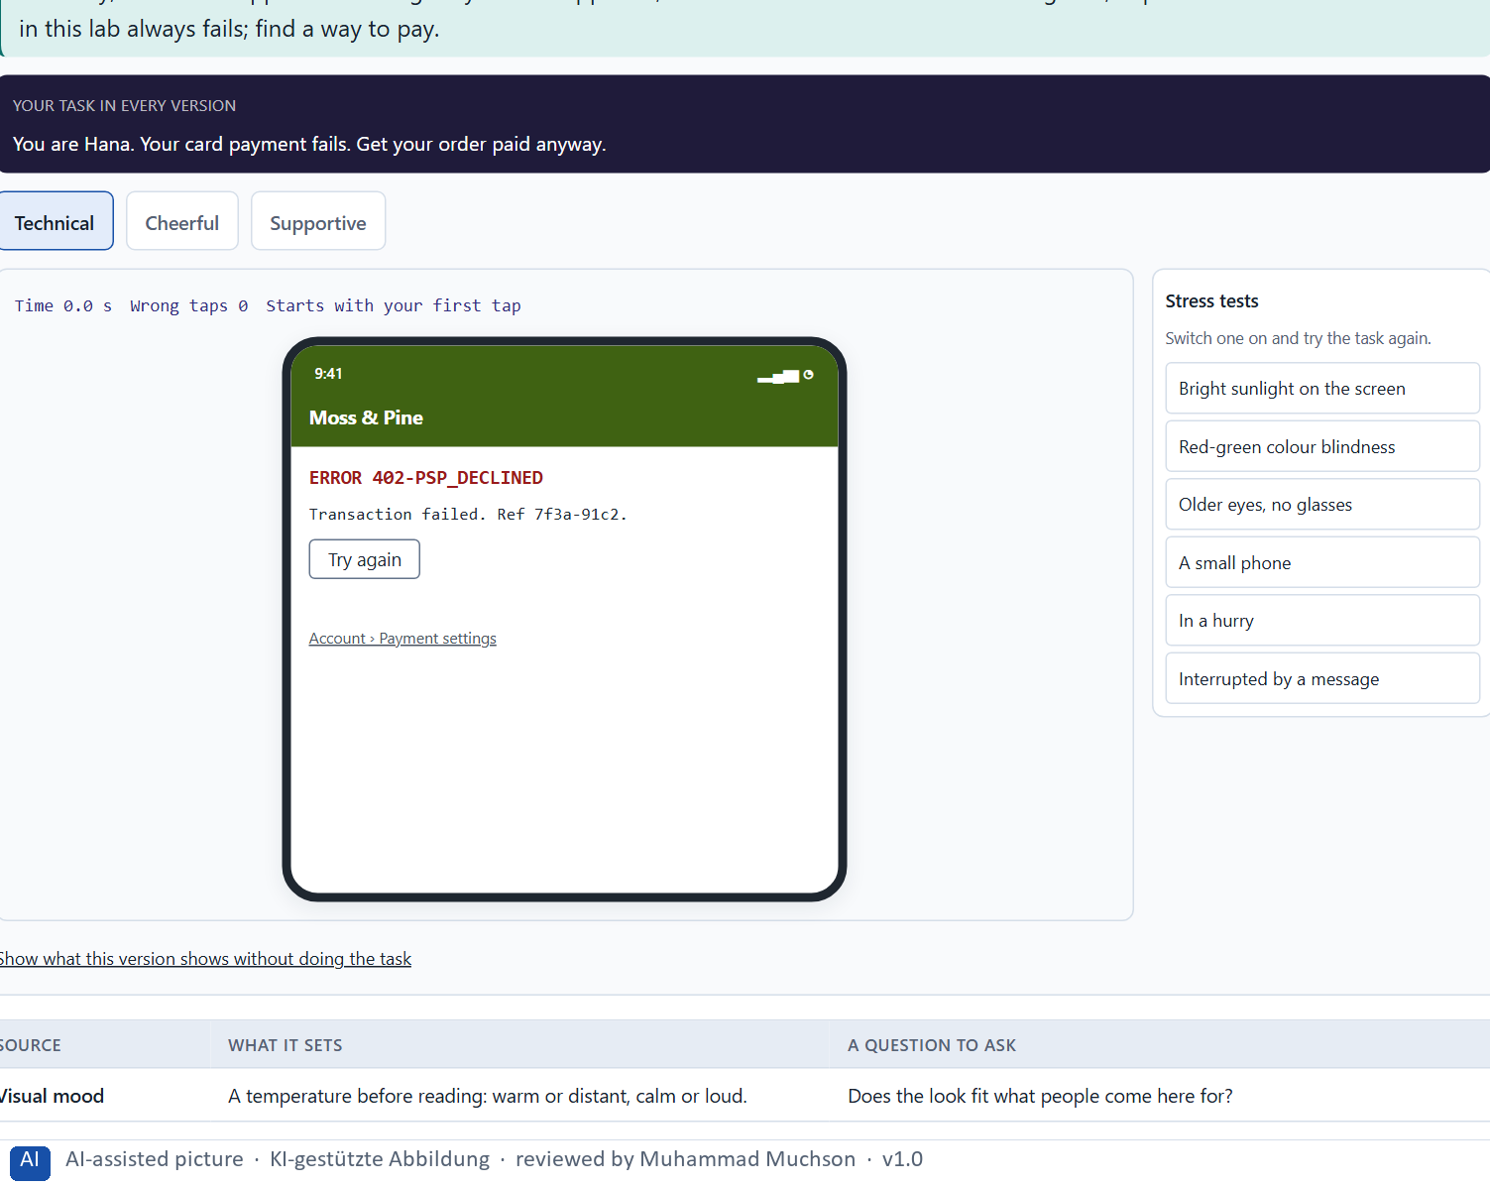
Figure 3 · One Moss & Pine payment error: technical, cheerful and supportive. Shown here in its starting state; in the Neuro-UX Lab every version and every stress test can be used.
Four sources of emotional effect
Source | What it sets | A question to ask
Visual mood | A temperature before reading: warm or distant, calm or loud. | Does the look fit what people come here for?
Interaction patterns | Whether people feel in control. | Is every step reversible and responsive?
Tone | Whether the product sounds like a person on their side. | Would a helpful person say it this way?
Feedback | Safety and recognition after each action. | Does it say what happened, what comes next, and that it went well?

Case assumption
Moss & Pine, Hana, Jonas, Wanda and Bruno are made up for this example. Tone and personality in interfaces follow Walter (2011); visibility of system status and helpful error messages are Nielsen's heuristics (1994); feedback as a basic design principle follows Norman (2013).

How to decide when this comes up in the task
- Visual mood: what temperature do colour, images, space and type set before anything is read?
- Interaction: what happens when people act, and can they undo it?
- Tone: read the error messages and confirmations aloud; would a person say that?
- Feedback: after every action, does the product say what happened and what comes next?
- Celebrate real successes calmly; a finished task that ends in silence wastes a moment of recognition.

Extra · go deeper (optional reading)
A supportive error message has four parts: what happened, in plain words; what it means for the person (was anything lost or charged?); what they can do now; and where help is. It never blames, never hides behind a code, and never jokes about a problem the person feels. The same four parts work for waiting: what is happening, how long it may take, what the person can do meanwhile.

Sources · Walter 2011 · Norman 2013 · Nielsen 1994

A4 · Activation, overload and manipulation: when emotion turns against use · 12 min · Core
Activation is not bonding. Many stimuli can overload and push; more feeling than the situation carries is over-emotionalisation; a feeling that does not fit is incongruent; emotion used against people is manipulation.
IN PLAIN WORDS
The idea. Emotion can activate people for a moment or bond them for years, and the two are not the same. Many stimuli, badges, countdowns and exclamation marks raise activation, but they can overload, tire and feel pushy. Over-emotionalisation is more feeling than the situation carries; incongruent address is a feeling that does not fit it, such as cheerfulness about a worry. Manipulation, often called dark patterns, uses emotion against people's own interest: false urgency, guilt, hidden costs. Lasting use comes from feelings that fit the situation and keep their promise.
Why it matters. Block 1.1 asks for WellTrack's two biggest emotional weaknesses, Block 1.2 asks you to judge CareerPath's Variant A with many emotional stimuli and to name the conflicts between emotionalisation and credibility, and Block 2.1 warns against measures that are only decoration. This card gives you the line between activation and manipulation.
How to read the picture. The matrix places five Moss & Pine messages by how strongly they activate (upwards) and how well they fit the situation (to the right). A position is a reading of the example, not a score.

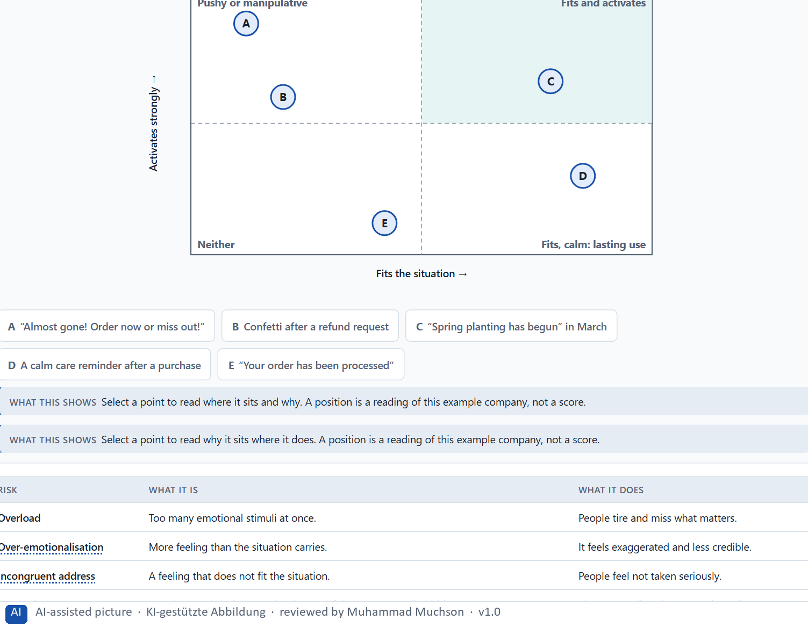
Figure 4 · Five Moss & Pine messages by how strongly they activate and how well they fit the situation · Exploratory.
Where emotion turns against use
Risk | What it is | What it does
Overload | Too many emotional stimuli at once. | People tire and miss what matters.
Over-emotionalisation | More feeling than the situation carries. | It feels exaggerated and less credible.
Incongruent address | A feeling that does not fit the situation. | People feel not taken seriously.
Manipulation | Emotion used against people's interest: false urgency, guilt, hidden costs. | Short-term clicks, long-term loss of trust.

Case assumption
Moss & Pine, Hana, Jonas, Wanda and Bruno are made up for this example. False urgency, scarcity and confirmshaming as dark patterns follow Mathur et al. (2019); the ethics of persuasive technology follow Fogg (2003).

How to decide when this comes up in the task
- Count the stimuli on a screen: badges, banners, countdowns, exclamation marks. Do they help the task or compete with it?
- Ask whether the feeling fits the situation: a worry needs calm, a success may be celebrated.
- Check every urgency or scarcity message: is it true?
- Ask whom the emotion serves: the user's goal, or only the company's?
- Prefer feelings that keep their promise; they build lasting use.

Extra · go deeper (optional reading)
A simple test for manipulation: would the message still work if the person knew exactly why it was written this way? A care reminder still works when people know it is meant to keep their plants alive. A countdown that resets every visit stops working the moment people see through it, and takes their trust in the next message with it.

Sources · Mathur et al. 2019 · Fogg 2003 · Walter 2011

A5 · Trust and perceived competence, and weighing a measure · 12 min · Core
Trust links thinking and feeling. People judge competence, honesty and goodwill from small signals. Weigh measures on effect on users, feasibility, risk and time pressure, with a reason.
IN PLAIN WORDS
The idea. Trust is where thinking and feeling meet. People trust a product when it seems competent (it knows what it is doing), honest (it says what will happen) and benevolent (it is on their side), and they judge all three from small signals: a clear confirmation, an error message that does not blame, information that says where it comes from. A beautiful design raises perceived competence at first; broken promises lower it fast. To put measures in order, weigh each on the four questions Block 2.1 names: effect on users, feasibility, risk and time pressure.
Why it matters. Block 1.1 asks about WellTrack's health information that does not build trust, Block 1.2 asks you to rate trust in three designs and choose one, and Block 2.1 asks for four measures, their justification on these four criteria and a decision for 12 weeks. The example uses Moss & Pine and its own measures, so the answer for the task cases is not given.
How to read the picture. First the chain from a small signal to trust and use. Then three measures Moss & Pine considered, rated on effect on users, feasibility, risk and time pressure.

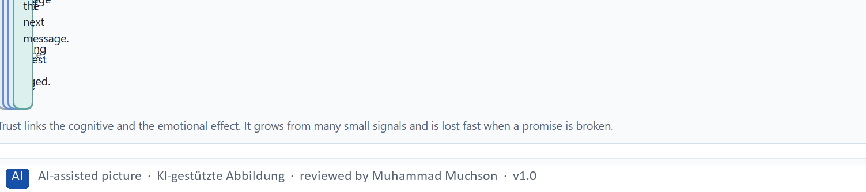
Figure 5 · From a small signal to trust and use.
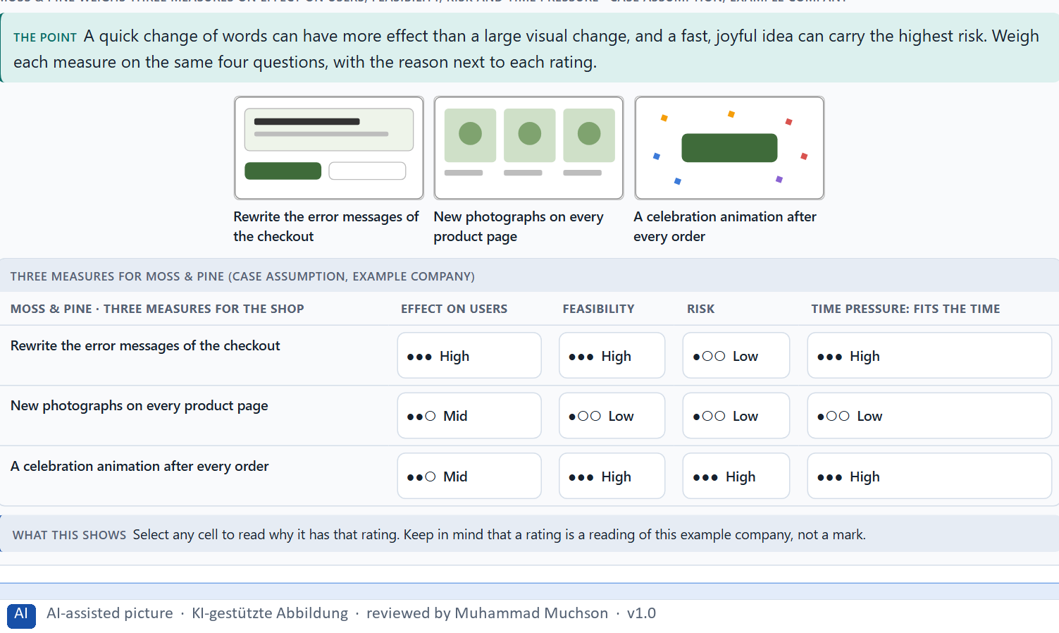
Figure 6 · Moss & Pine weighs three measures on effect on users, feasibility, risk and time pressure.
Case assumption
Moss & Pine, Hana, Jonas, Wanda and Bruno are made up for this example. Credibility and perceived competence follow Fogg (2003); first impressions within a fraction of a second follow Lindgaard et al. (2006); rating options on the same criteria with a reason follows Gibbons (2018). The four criteria are the ones the plan names for the case study.

How to decide when this comes up in the task
- Look for the small signals of competence: clear feedback, careful wording, information that says where it comes from.
- Look for signals of honesty: no surprises, no hidden conditions, errors that say what happened.
- A good look raises trust at first; a broken promise lowers it fast.
- Rate every measure on the same four questions: effect on users, feasibility, risk, time pressure.
- A rating is a judgement with a reason, never a mark.

Extra · go deeper (optional reading)
Fogg (2003) found that people judge the credibility of a website largely from surface signals: design, clarity, small errors. This is why a typo or a technical error message can cost more trust than its size suggests, and why careful wording in confirmations and errors is one of the cheapest ways to build it.

Sources · Fogg 2003 · Lindgaard et al. 2006 · Gibbons 2018

Materi B · Route 2 · Level 3
How Materi B is used
About 60 minutes, three cards, led by the facilitator. Level 3 in the Chief Experience Officer's chair: a guiding vision for emotional UX, three strategic decisions, an order of what is improved first, a risk analysis, a governance model for emotional UX principles, one decision under uncertainty and a statement to the management. The cards give you the ideas you use in Task 2.

B1 · Emotional UX as part of the UX architecture, not a campaign · 20 min · Core
What people feel in a product comes mostly from feedback, tone and interaction, which teams build every day. Emotional UX belongs in the UX architecture, with a vision, principles, a tone guide, patterns and an owner.
IN PLAIN WORDS
The idea. In many companies emotion is treated as a marketing question: a campaign, a slogan, a nicer picture. But what people feel in a product comes mostly from its feedback, its tone in critical moments and its interaction logic, which product teams build every day. Emotional UX therefore belongs in the UX architecture: principles for how every touchpoint should feel, a tone guide, patterns for confirmations, errors and waiting, and someone who owns them. At senior level it becomes a leadership task when it shapes loyalty, acceptance and how the company is perceived.
Why it matters. Block 3.1 asks for a guiding vision for emotional UX, three decisions on trust, emotional safety, motivation and supportive interaction, and an order of which touchpoints, interactions or communication patterns come first, for a company that sees emotion as marketing. You decide the principles, not the pictures.
How to read the picture. Left Moss & Pine treating emotion as a campaign, right building it into the UX architecture. Below, the layers from a guiding vision to every message.

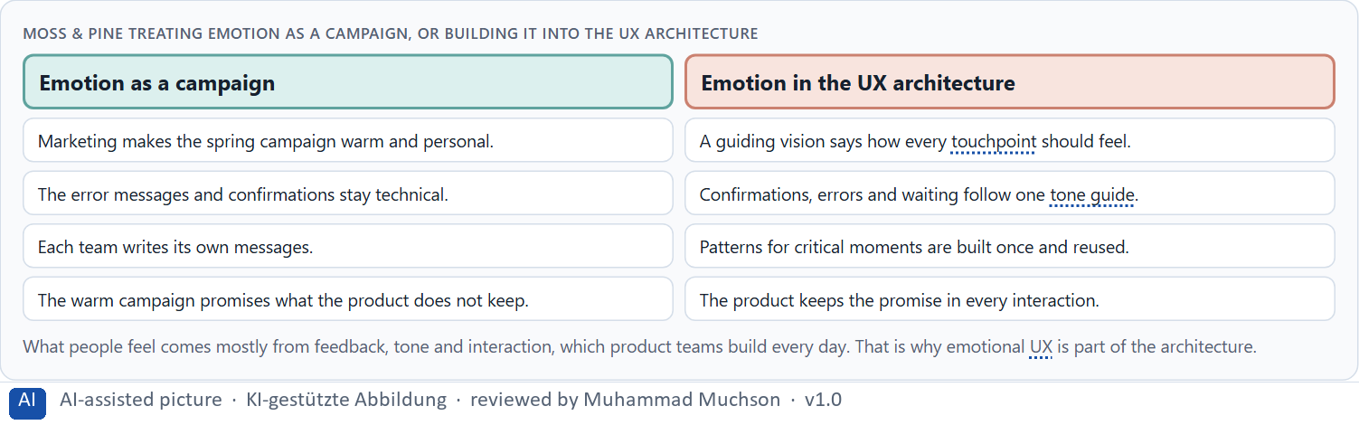
Figure 7 · Moss & Pine treating emotion as a campaign, or building it into the UX architecture.
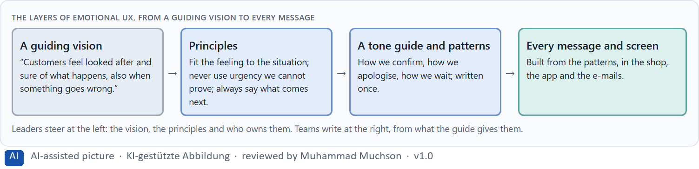
Figure 8 · The layers of emotional UX, from a guiding vision to every message.
Case assumption
Moss & Pine, Hana, Jonas, Wanda and Bruno are made up for this example. Emotion as a property of the product follows Norman (2004) and Hassenzahl (2010); tone and personality as a design system of their own follow Walter (2011).

How to decide when this comes up in the task
- Check where emotion is decided today: by marketing in campaigns, or in the product's feedback and tone?
- Write a guiding vision that says how people should feel in every touchpoint, including when something goes wrong.
- Turn it into a few principles and a tone guide every team uses.
- Build patterns once for the critical moments: confirmations, errors, waiting.
- At senior level, emotional UX is a leadership task when it shapes loyalty, acceptance and how the company is seen.

Extra · go deeper (optional reading)
A guiding vision for emotional UX is short and testable: one sentence that names the feeling and covers the hard moments. “Customers feel looked after and sure of what happens, also when something goes wrong” can be checked on every screen. “We delight our customers” cannot, and it invites over-emotionalisation.

Sources · Norman 2004 · Walter 2011 · Hassenzahl 2010

B2 · Seriousness against closeness: the conflicts of emotional UX · 20 min · Core
Seriousness against closeness, activation against credibility, brand effect against user effect. Over-emotionalisation and manipulation are strategic risks. Fit the feeling to the situation and say what each choice gives up.
IN PLAIN WORDS
The idea. Emotional UX sits between goals that pull against each other: seriousness against closeness (a brand that must be credible and approachable), activation against credibility (more stimuli against looking like a sales channel), brand effect against user effect (what marketing wants to say against what a worried user needs to hear), and speed against care. Over-emotionalisation and manipulation are not only design faults but strategic risks: they weaken credibility and acceptance. The way through is to fit the feeling to the situation, write the rule down, and say what each choice gives up.
Why it matters. Block 3.1 asks for three guiding decisions, a risk analysis of wrong assumptions about emotional effect, credibility and user behaviour, and a governance model for conflicts between brand, expertise and user effect. Each of these is a decision between conflicting goals.
How to read the picture. The same Moss & Pine reminder for four situations, with the feeling each one needs.

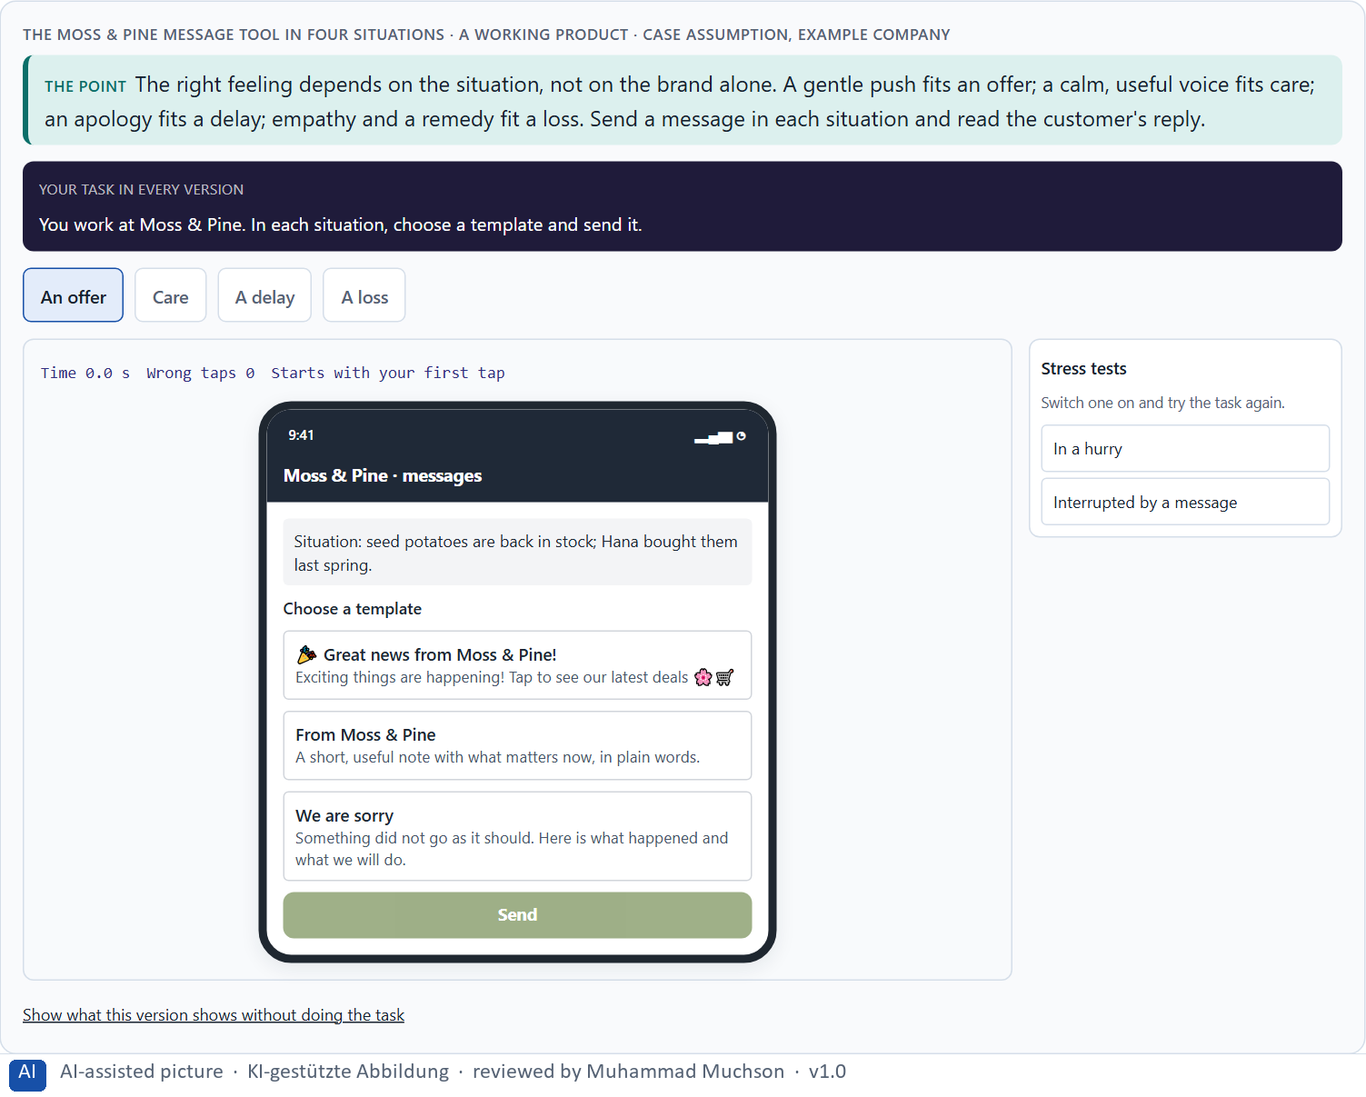
Figure 9 · The Moss & Pine message tool in four situations. Shown here in its starting state; in the Neuro-UX Lab every version and every stress test can be used.
Standing conflicts of emotional UX
Conflict | Who usually stands for each side | What to ask
Seriousness against closeness | The experts, against marketing and the brand. | Can it be warm and correct at once?
Activation against credibility | Marketing's targets, against long-term trust. | Would the message still work if people knew why it was written?
Brand effect against user effect | What the company wants to say, against what the person needs now. | What does this person need in this situation?

Case assumption
Moss & Pine, Hana, Jonas, Wanda and Bruno are made up for this example. The four situations are a reading of the example, not a rule for every product.

How to decide when this comes up in the task
- Name the conflict as two goals and say who stands for each: marketing, the experts, the product team, the users.
- Decide the feeling by the situation: offer, care, delay, loss; not by the brand alone.
- Treat every false urgency or inappropriate cheerfulness as a risk to credibility, not as a style question.
- Write the rule down, so the conflict is not fought again on every message.
- Say what the choice gives up; a decision that gives up nothing has not been made.

Extra · go deeper (optional reading)
Over-emotionalisation is often a symptom of a conflict that was never settled: marketing adds warmth to every message because no one decided where warmth belongs. A short matrix in the tone guide (which feeling for which situation) settles it once and gives every team the same answer.

Sources · Mathur et al. 2019 · Fogg 2003 · Gibbons 2018

B3 · Who owns emotional UX, and deciding with little data on feelings · 20 min · Core
Emotional quality lives only with governance: an owner of the principles and the tone guide, experts who check correctness, marketing who owns the brand, and a rule for conflicts. A decision with little data says what it decides, does not know, would reverse and gives up.
IN PLAIN WORDS
The idea. Emotional quality lives only with governance: someone who owns the principles and the tone guide, the experts who check that a warm message is still correct, marketing who owns the brand, and a rule for when they disagree. Data on feelings is rarely complete, so a decision under uncertainty says what you decide, what you do not know, when you would reverse it and what you give up. Small, reversible changes to words and feedback are the safest place to start, because they can be checked soon.
Why it matters. Block 3.1 asks for a governance model for emotional UX principles, a decision despite patchy data, and a statement to the management. This card gives you the parts of each.
How to read the picture. The four boxes at the top are the parts of a decision, filled in for Moss & Pine. The two boxes below are the rule for future decisions.

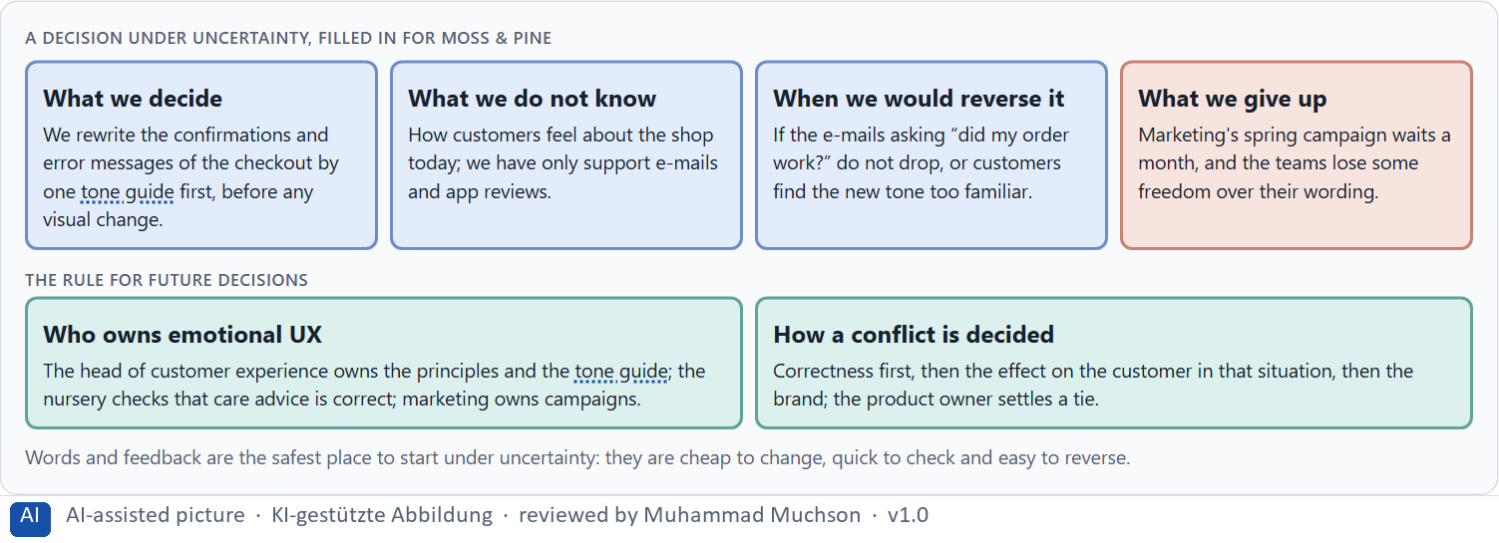
Figure 10 · A decision under uncertainty, filled in for Moss & Pine.
Three parts of emotional UX governance
Part | The question | An example (Moss & Pine)
Who owns what | Who owns the principles and the tone guide; who uses them? | The head of customer experience owns them; every team uses them.
Who checks | Who makes sure warmth stays correct? | The nursery checks care advice; marketing checks the brand.
How a conflict is decided | What happens when brand, expertise and user effect disagree? | Correctness, then the customer, then the brand; the product owner settles a tie.

Case assumption
Moss & Pine, Hana, Jonas, Wanda and Bruno are made up for this example. Deciding with limited information follows Simon (1956); the premortem follows Klein (2007).

How to decide when this comes up in the task
- Name who owns the emotional UX principles and the tone guide, and who only uses them.
- Give the experts a veto on correctness, and marketing ownership of campaigns.
- Settle conflicts by correctness first, then the effect on the person in that situation, then the brand.
- Say what you decide, what you do not know, when you would reverse it and what you give up.
- Start where changes are cheap, quick to check and easy to reverse: words and feedback.

Extra · go deeper (optional reading)
Imagine it is a year later and the new tone has failed, and ask why (Klein 2007). The usual answers: it sounded friendly but stopped being precise, so the experts withdrew; marketing used it for urgency; each team bent it until there were five tones again. Each answer is a governance gap, not a writing gap.

Sources · Simon 1956 · Klein 2007 · Walter 2011

Use in class: presentation and handout
Mark of use for the study material. Presentation is what the trainer shows on screen; Handout is what participants read and keep.
Card | Presentation (shown in the Neuro-UX Lab) | Handout
A1 · Emotions steer behaviour: attention, motivation, trust, memory and decisions (Core) | Scan line and Figure 1; the "In plain words" and "How to decide" boxes | The whole card
A2 · Usable is not enough: the emotional factors of an experience (Core) | Scan line and Figure 2; the "In plain words" and "How to decide" boxes | The whole card
A3 · Where feelings come from: visual mood, interaction, tone and feedback (Core) | Scan line and Figure 3; the "In plain words" and "How to decide" boxes | The whole card
A4 · Activation, overload and manipulation: when emotion turns against use (Core) | Scan line and Figure 4; the "In plain words" and "How to decide" boxes | The whole card
A5 · Trust and perceived competence, and weighing a measure (Core) | Scan line and Figures 5–6; the "In plain words" and "How to decide" boxes | The whole card
B1 · Emotional UX as part of the UX architecture, not a campaign (Core) | Scan line and Figures 7–8; the "In plain words" and "How to decide" boxes | The whole card
B2 · Seriousness against closeness: the conflicts of emotional UX (Core) | Scan line and Figure 9; the "In plain words" and "How to decide" boxes | The whole card
B3 · Who owns emotional UX, and deciding with little data on feelings (Core) | Scan line and Figure 10; the "In plain words" and "How to decide" boxes | The whole card

References
Check each source and its current edition before you teach from it. Standards and laws marked as in flux can change.
Norman, D. A. (2004). Emotional Design: Why We Love (or Hate) Everyday Things. Basic Books. (Products act on three levels, visceral, behavioural and reflective; how something feels shapes how it is used and remembered.)
Damasio, A. R. (1994). Descartes' Error: Emotion, Reason, and the Human Brain. Putnam. (Emotion is part of reasoning; without it people struggle to decide.)
Kahneman, D., Fredrickson, B. L., Schreiber, C. A., & Redelmeier, D. A. (1993). When more pain is preferred to less: Adding a better end. Psychological Science, 4(6), 401–405. (People remember an experience mostly by its strongest moment and its end: the peak-end rule.)
Hassenzahl, M. (2010). Experience Design: Technology for All the Right Reasons. Morgan & Claypool. (Experience is more than usability: products meet psychological needs such as competence, relatedness and stimulation.)
ISO 9241-210:2019. Ergonomics of human-system interaction, Part 210: Human-centred design for interactive systems. (Defines user experience as a person's perceptions and responses that result from the use or anticipated use of a product, system or service.) Check the current edition before you teach from it.
Walter, A. (2011). Designing for Emotion. A Book Apart. (Tone, personality and feedback in interfaces build an emotional relationship, on top of a usable and reliable base.)
Norman, D. A. (2013). The Design of Everyday Things (revised and expanded edition). Basic Books. (Mental models and conceptual models: a design works when what people believe it does matches what it does.)
Nielsen, J. (1994, reviewed 2024). 10 Usability Heuristics for User Interface Design. Nielsen Norman Group. https://www.nngroup.com/articles/ten-usability-heuristics/ (Visibility of system status, consistency and standards, recognition rather than recall, aesthetic and minimalist design.)
Mathur, A., Acar, G., Friedman, M. J., Lucherini, E., Mayer, J., Chetty, M., & Narayanan, A. (2019). Dark patterns at scale: Findings from a crawl of 11K shopping websites. Proceedings of the ACM on Human-Computer Interaction, 3(CSCW), 1–32. (False urgency, scarcity and confirmshaming are widespread ways of using emotion against users.)
Fogg, B. J. (2003). Prominence-interpretation theory: Explaining how people assess credibility online. CHI '03 Extended Abstracts, 722–723. (People judge credibility from the elements they notice and how they interpret them, such as the layout, the tone and the mix of content and advertising.)
Lindgaard, G., Fernandes, G., Dudek, C., & Brown, J. (2006). Attention web designers: You have 50 milliseconds to make a good first impression! Behaviour & Information Technology, 25(2), 115–126. (A first judgement of a web page forms within a fraction of a second and stays close to the judgement people give later.)
Gibbons, S. (2018). Using Prioritization Matrices to Inform UX Decisions. Nielsen Norman Group. https://www.nngroup.com/articles/prioritization-matrices/ (Rate each option on the same few criteria, such as value to the user against effort, and put the reason next to each rating.)
Simon, H. A. (1956). Rational choice and the structure of the environment. Psychological Review, 63(2), 129–138. (With limited information and time, people choose an option that is good enough rather than the best one: a decision under uncertainty.)
Klein, G. (2007). Performing a project premortem. Harvard Business Review, 85(9), 18–19. (Imagine the plan has failed and ask why; it brings risks and wrong assumptions to the surface before the work starts.)

Glossary
Every term below is used in this document. Terms stay plain text in the body; this list says what they mean in everyday words.
Term | In plain words | Example | Comes from
Activation | Getting people to act now, often with strong stimuli. It can help for a moment and tire or push people if overdone. | — | Day 7
Attention | The mind's spotlight. Only a small part of a screen is processed at any moment; attention decides which part. | A flashing banner takes attention away from the form you were filling in. | Day 1
Brand effect | How a design makes people recognise the company and what they feel about it, such as modern, serious or friendly. | — | Day 3
Case assumption | A fact made up for this exercise to fill a gap in the plan's case. It is marked so you know it is not part of the plan. | — | Day 1
Chief Experience Officer | The manager who is responsible for the experience customers have across all channels, and who decides where the company invests in it. | — | Day 1
Dark pattern | A design that uses emotion against people's own interest, such as false urgency, guilt or hidden costs. | — | Day 7
Design logic | A set of decided rules and shared components, such as which colour means what and which type levels exist, used for every screen so everything stays consistent. | — | Day 3
Emotional bond | The sense, built over time, that a product is on your side. It makes people trust it and come back. | — | Day 7
Emotional factors | The feelings that matter most in UX: safety, control, joy, belonging and recognition, and their opposites, frustration and uncertainty. | — | Day 7
Emotional safety | Feeling that you know what is happening, that nothing bad will follow from a mistake, and that help is there. | — | Day 7
Experience quality | How using a product feels, on the way and afterwards. It goes beyond usability, which only asks whether people reach their goal. | — | Day 7
Feedback | What the system tells people after they act: that a step worked, what happens next, or what went wrong and how to fix it. | — | Day 4
Governance | The rules about who may decide what, who is answerable for it and how disagreements are settled. | — | Day 1
Hypothesis | An assumption you could check later. “This red banner could make users uneasy” is a hypothesis; “this banner is bad” is only an opinion. | — | Day 1
Incongruent address | A feeling that does not fit the situation, such as a cheerful tone about a worry or a fault. | — | Day 7
Microcopy | The small pieces of text in an interface: button labels, hints, error messages and the lines around an upload. | — | Day 1
Neuro-UX | Designing an interface with knowledge of how the brain sees, attends, feels and decides, so that the design steers these processes on purpose and responsibly. | — | Day 1
Over-emotionalisation | More feeling than the situation carries: exclamation marks, confetti or warmth where people need calm facts. | — | Day 7
Peak-end rule | People remember an experience mostly by its strongest moment and how it ended, not by its average. | — | Day 7
Perceived competence | How capable a product or company seems to people, judged from small signals such as clear feedback and careful wording. | — | Day 7
Tone guide | A short written rule for how a product speaks: which words, how formal, how it sounds when something goes wrong. | — | Day 7
Touchpoint | Any place where a person meets the company: the website, the customer portal, the app, a chatbot or a phone call. | — | Day 1
UX (user experience) | Everything a person goes through when using a product: what they notice, understand, feel and do, from the first look to the last step. The screens are only one part of it. | Finding the booking you want at once and feeling sure it went through is a good UX. | Day 1

The Neuro-UX Lab: where we practise online
In class we use the course website as the place to practise and to learn. Every day has its own address, in the same pattern: the day number is the last part.
What | Address
Neuro-UX Lab (course website) | https://aion-ux-lab.vercel.app/
Day 7 | https://aion-ux-lab.vercel.app/day/7/

On the day page, Route 1 (Levels 1 and 2) and Route 2 (Level 3) can be opened; the cards and the tasks of this document are there too. The pattern is the same up to Day 8, for example https://aion-ux-lab.vercel.app/day/6/.

