AION · UX DEVELOPER · PSYCHOLOGICAL UX DESIGN AND NEURO-UX
DAY 9 · MATERI A AND MATERI B · ROUTES 1 AND 2 · LEVELS 1 TO 3
Gamification strategies, and storytelling with gamification
Study material with real research, worked examples and the rules you use in the tasks
AI notice · KI-Hinweis
This document was produced with the help of an AI language model (Claude, Anthropic). The AI drafted the text and tables and built the pictures and working examples of the lab. The content was then read, corrected and approved by the reviewer named below, who is responsible for its accuracy. Every picture carries an AI label on the image. Check figures and sources before you quote them.
KI-Hinweis: Dieses Dokument wurde mit Unterstützung eines KI-Sprachmodells (Claude, Anthropic) erstellt. Texte und Tabellen wurden von der KI entworfen, die Abbildungen sind KI-gestützt erstellt und am Bild gekennzeichnet. Die fachliche Prüfung und Freigabe erfolgte durch die unten genannte Person.

Day | Day 9 · Module 4 (day 3 of 3): Gamification strategies, and storytelling with gamification
Document | Materi (study material). Materi A has five cards, Materi B has three.
Route and level | Materi A serves Route 1 (Levels 1 and 2, Task 1). Materi B serves Route 2 (Level 3, Task 2).
Time | Materi A about 60 min · Materi B about 60 min (facilitator-led)
Neuro-UX Lab (website) | https://aion-ux-lab.vercel.app/day/9/
Case | Worked examples use a made-up company in each card. The task case is MoveWell (see the Task document).
Version | 1.0 · release date 29.10.2026
Review and approval | Muhammad Muchson, Mentor (subject-matter review and approval)

ABOUT THIS DOCUMENT
In class we also use the Neuro-UX Lab, the course website, as the place to practise and learn. Its address is at the end of this document.
Today is about why people start using a product and why they keep using it. You learn what gamification is and is not, why people react to progress, feedback, recognition, challenge and reaching a goal, what points, badges, levels, challenges, streaks and status displays can and cannot do, how gamification goes wrong (manipulation, overstimulation, reward inflation, lost motivation, lost trust), how a story makes the same mechanics mean more, why a quick spike is not lasting use, and when gamification stays credible in a serious field. Then you use it on three platforms, and you look at how two real ones decided. This document holds everything you need to study Day 9 without the website. Every card says what the idea is in plain words, shows it in a picture, gives the details and ends with the rules you use in the tasks.

IN THIS DOCUMENT
Lesson plan: ten teaching units (Ablaufplan)
Case study and transfer project at a glance
A1 · Gamification, playful design and a game: three different requests · 12 min · Core
A2 · Why people react to progress, feedback and recognition: the levers under a mechanic · 12 min · Core
A3 · Points, badges, levels, streaks: what each tool does, and how gamification goes wrong · 12 min · Core
A4 · Story and game together, and a quick spike against lasting use · 12 min · Core
A5 · Intrinsic motivation, credible gamification in serious fields, and weighing a measure · 12 min · Core
B1 · Gamification as activation architecture, not a game layer · 20 min · Core
B2 · Motivation against seriousness and autonomy: the conflicts of activation · 20 min · Core
B3 · Who answers for a mechanic, and deciding without knowing who stays · 20 min · Core

Day at a glance
Day 9 has ten teaching units (UE). This document is the study material; it is used in UE1 (Materi A) and UE8 (Materi B). The day is built from three documents and the Neuro-UX Lab: Materi (study material), Task (worksheet) and Trainer (coaching, feedback and model solutions), plus the course website.

Lesson plan: ten teaching units (Ablaufplan)
UE | Min | Plan item | What happens | Material | Format
1 | 45 | Knowledge transfer · Level 1 | The trainer presents the cards of Materi A (A1, A2, A3, A4, A5, about 60 min of cards) in the Neuro-UX Lab; participants follow in the handout. | Materi A (Route 1) | Presentation + Handout
2 | 45 | Level 1 · Task 1 | Individual work on Block 1.1 (Core, about 10 min): the first product of the day is read and its effect described. Pairs then compare their results and the trainer collects open questions. | Task 1 · Part 1 · Block 1.1 | Handout (or in the lab)
3 | 45 | Level 1 · Task 2 | Three options are rated on the same criteria and one is chosen under the stated conditions: Block 1.2 (Core, about 8 min). | Task 1 · Part 1 · Block 1.2 | Handout (or in the lab)
4 | 45 | Coaching · transition from Level 1 to Level 2 | Trainer-led. A short talk on the day's coaching focus, then the reflection questions in pairs. The bridge: from describing an effect to a decision you answer for. There is no worksheet block in this unit. | Trainer document, section Coaching | Trainer only
5–6 | 90 | Level 2 · Case study MoveWell (2 UE) incl. model solution | UE5: the trainer presents the case; participants work on Block 2.1 (Core, about 15 min). UE6: groups compare their results and defend them; the trainer closes with the model solution. | Task 1 · Part 2 · Block 2.1  Trainer document, section Case study | Handout; model solution shown after the work
7 | 45 | Level 2 + 3 · Feedback round with a management perspective | Groups present their reasoning, not only their result. The trainer asks the day's Level 3 input questions and leads the discussion. | Trainer document, section Feedback round | Presentation by the groups; Trainer only
8 | 45 | Level 3 · Transfer project, Chief Experience Officer (3 UE: UE8–10) | The trainer presents Materi B (B1, B2, B3; use the "In plain words" and "How to decide" boxes, the rest is handout) and sets the role and the situation. | Materi B (Route 2) | Presentation + Handout
9 | 45 | Level 3 · Transfer project | Individual work or in pairs on Block 3.1 (Core, about 20 min): the strategy memo. | Task 2 · Block 3.1 | Handout (or in the lab)
10 | 45 | Level 3 · Transfer project | Participants present their decision and what they give up, including the one decision made under uncertainty; the trainer debriefs with the model solution. | Task 2 · Block 3.1  Trainer document, section Transfer project | Handout; model solution shown after the work

One UE is counted as 45 minutes here; breaks are not shown. The times are a guide for the trainer. The Core blocks are enough for a complete answer.

Case study and transfer project at a glance
Component | UE | Duration | Participants work in | Model solution in
Level 2 case study (MoveWell) | UE5–6 | 2 UE · 90 min | Task 1 · Part 2 (Block 2.1) | Trainer document, section Case study
Level 3 transfer project (Chief Experience Officer) | UE8–10 | 3 UE · 135 min | Materi B and Task 2 (Block 3.1) | Trainer document, section Transfer project

Materi A · Route 1 · Levels 1 and 2
How Materi A is used
About 60 minutes, five cards. Levels 1 and 2: find where a further-training platform weakens and promotes activation and retention, rate three activation designs of a prevention platform under conflicting goals, then analyse a prevention platform's deficits, develop four measures, justify them and decide on the first 12 weeks. The cards give you the ideas and the rules you use in Task 1.

A1 · Gamification, playful design and a game: three different requests · 12 min · Core
Gamification borrows the structure of games (a goal, a position, feedback). Playful design changes only the tone. A game builds a world. They differ in effort and risk; gamification strategies aim at activation (starting) and retention (staying).
IN PLAIN WORDS
The idea. Three different things are called gamification. Gamification proper borrows the structure of games: a goal, a visible position, feedback, a challenge, inside something that is not a game. Playful design changes only the tone: colours, round shapes, cheerful words. A game builds a world with characters and a story of its own. They differ in effort (a few days for one person against months for a team) and in risk: structure helps almost any product, a playful tone can make a serious provider look careless, and a game that does not convince is worse than none. Gamification strategies aim at two different things: activation (people start and do something now) and retention (they keep coming back).
Why it matters. Block 1.1 asks what SkillRise's plain learning paths do to motivation and retention, Block 1.2 asks you to rate three activation designs for HealthJourney, and Block 2.1 asks for measures for MoveWell that keep it serious. This card gives you the words to say which of the three a design asks for.
How to read the picture. One Brightwater Savings task, “set up your savings goal”, in three versions: with structure, with a playful tone, and as a game.

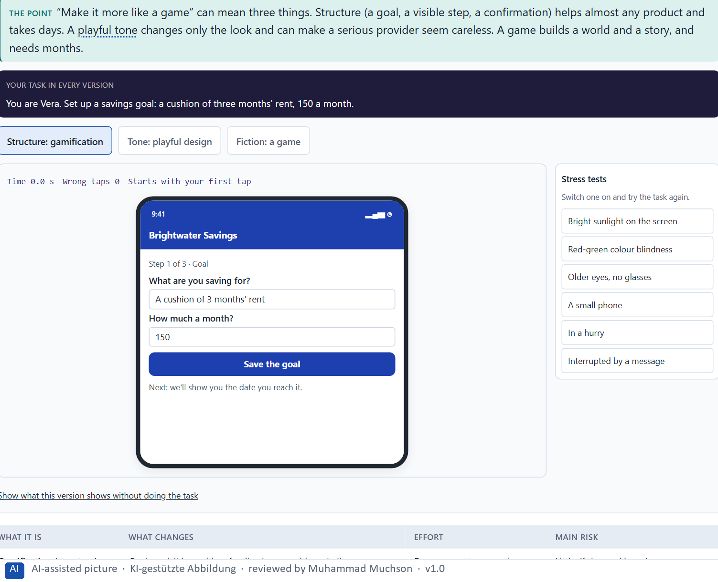
Figure 1 · One Brightwater task, “set up your savings goal”, as structure, as playful tone and as a game. Shown here in its starting state; in the Neuro-UX Lab every version and every stress test can be used.
Three things called gamification
What it is | What changes | Effort | Main risk
Gamification (structure) | Goals, a visible position, feedback, recognition, challenges. | Days; one or two people. | Little, if the goal is real.
Playful design (tone) | Colours, shapes, a cheerful voice. | Weeks; design and writing. | A serious provider looks careless.
A game (fiction) | A world, characters, a story of its own. | Months; a whole team. | Unconvincing fiction; looks childish.

Case assumption
Brightwater Savings, Vera, Kaspar, Rhea and Dominik are made up for this example. Gamification as game design elements in non-game contexts, apart from playful design and full games, follows Deterding et al. (2011); its context-dependent effects follow Hamari et al. (2014).

How to decide when this comes up in the task
- Ask which of the three a request wants: structure, tone or a game.
- Structure helps almost any product; check whether people can see their goal, their position and what a step did.
- Treat a playful tone in a serious field as a risk to credibility, not as a free extra.
- Treat a game as a project of months; do not accept it with the time and people of a small change.
- Say whether a measure aims at activation (people start now) or retention (they keep coming back).

Extra · go deeper (optional reading)
A health insurer, a bank or a public service can use the structure layer freely: visible progress, milestones, confirmation. What it can rarely risk is the playful tone: the moment a claims or a savings screen looks cheerful, people read it as a company that takes their situation less seriously than they do. Most failed gamification projects tried to build the fiction layer with the time and the team of a structure project.

Sources · Deterding et al. 2011 · Hamari et al. 2014 · Nicholson 2015

A2 · Why people react to progress, feedback and recognition: the levers under a mechanic · 12 min · Core
People react to information about their own position: progress, feedback, recognition, a challenge, a goal reached. Under every mechanic is a lever: reward, competence, self-efficacy, social validation, the experience of progress, an activation trigger.
IN PLAIN WORDS
The idea. People do not react to rewards as such. They react to information about their own position: how far they have come, whether what they just did counted, how much is left, whether they are good at it. Progress, feedback, recognition, a challenge and reaching a goal are ways of giving that information. Underneath every mechanic is a lever: reward, a feeling of competence, self-efficacy (believing you can do it), social validation, the experience of progress, or an activation trigger (a reminder, a nudge). The mechanic is what people see; the lever is what moves them. Choosing a mechanic without naming its lever is how a leaderboard lands in a product where nobody wants to be compared.
Why it matters. Block 1.1 asks you to sort SkillRise's weak spots into motivation, progress, recognition, feedback, retention and self-efficacy, and Block 2.1 asks the same for MoveWell. This card tells the six apart and shows which lever each mechanic pulls.
How to read the picture. One Brightwater Savings screen after a deposit, with five switches: progress, feedback, recognition, challenge and a reached goal.

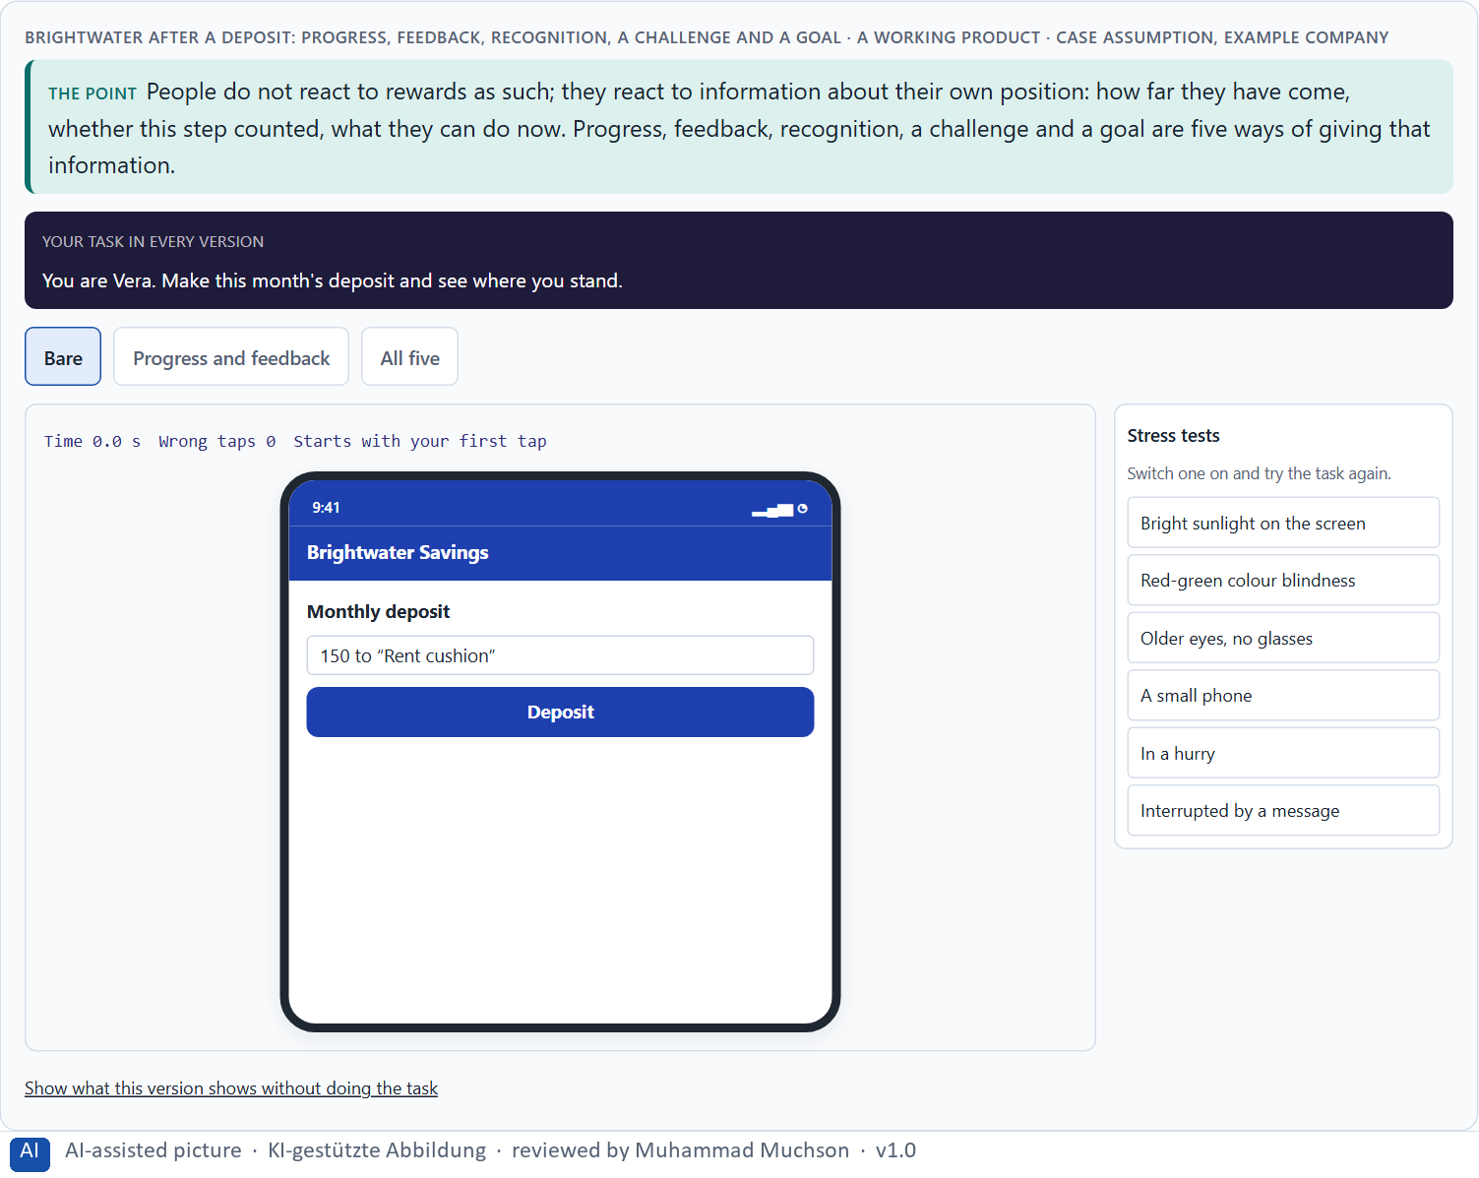
Figure 2 · Brightwater after a deposit: progress, feedback, recognition, a challenge and a goal. Shown here in its starting state; in the Neuro-UX Lab every version and every stress test can be used.
The motivation levers and the mechanics that pull them
Lever | What it means | Mechanics that pull it | Who it may put off
Reward | Getting something for an action. | Points, coins, prizes. | People who did it for its own sake.
Competence | Feeling good at something. | Levels named by skill, feedback. | Few, if levels are honest.
Self-efficacy | Believing you can do it. | Visible progress, “you can now …”. | Few.
Social validation | Others see or confirm it. | Rankings, sharing, likes. | Those at the bottom; private people.
Experience of progress | Getting closer to a goal. | Progress bars, milestones, stages. | Few, if the goal is theirs.
Activation trigger | A cue to act now. | Reminders, notifications, streaks. | People who feel pushed.

Case assumption
Brightwater Savings, Vera, Kaspar, Rhea and Dominik are made up for this example. Competence, autonomy and relatedness as needs behind lasting motivation follow Ryan and Deci (2000); self-efficacy follows Bandura (1977); social comparison follows Festinger (1954).

How to decide when this comes up in the task
- Progress: can people see how far they have come and how much is left?
- Feedback: does a finished step say what it did, in the person's terms?
- Recognition: is a real achievement noticed?
- Self-efficacy: does the product show people what they can now do?
- Name the lever under every mechanic before you choose it: whom does it move, and whom does it put off?

Extra · go deeper (optional reading)
In a prevention or health product, the people who most need to continue are often the ones doing worst. A ranking tells exactly those people, every week, that they are at the bottom, in a field where being at the bottom is already a source of shame. It works on the fittest few, who need it least. That is the clearest case of a mechanic that raises the average while harming the people the product exists for.

Sources · Ryan & Deci 2000 · Bandura 1977 · Festinger 1954

A3 · Points, badges, levels, streaks: what each tool does, and how gamification goes wrong · 12 min · Core
Points, badges, levels, challenges, streaks, feedback and status displays each have one job and one limit. Stacking them does not stack motivation. Bad gamification fails through manipulation, overstimulation, reward inflation, lost motivation and lost trust.
IN PLAIN WORDS
The idea. Each tool has one job. Points count activity; badges mark something rare; levels name a capability; challenges set a bounded task; streaks reward regularity; feedback says what an action did; a status display shows a position. Each also has a limit: points count effort, not value; badges lose meaning when there are many; streaks punish one missed day; a ranking motivates the top and shames the bottom. Stacking tools does not stack motivation: past a certain number each new one makes the others mean less. Bad gamification fails in five ways: manipulation (fake urgency, guilt), overstimulation (too many signals), reward inflation (more and bigger rewards for less), loss of motivation (the reward replaces the reason), and damage to trust. The first ones can be repaired by removing things; damaged trust repairs slowly, if at all.
Why it matters. Block 1.2 asks you to rate a variant with points, badges, daily challenges and rankings against two quieter ones on motivation, credibility, retention, clarity and acceptance, and to name the risks that remain. Block 2.1 asks for gamification that stays serious. This card gives you what each tool is for and how it goes wrong.
How to read the picture. The same Brightwater Savings home screen with one reward signal or with eight.

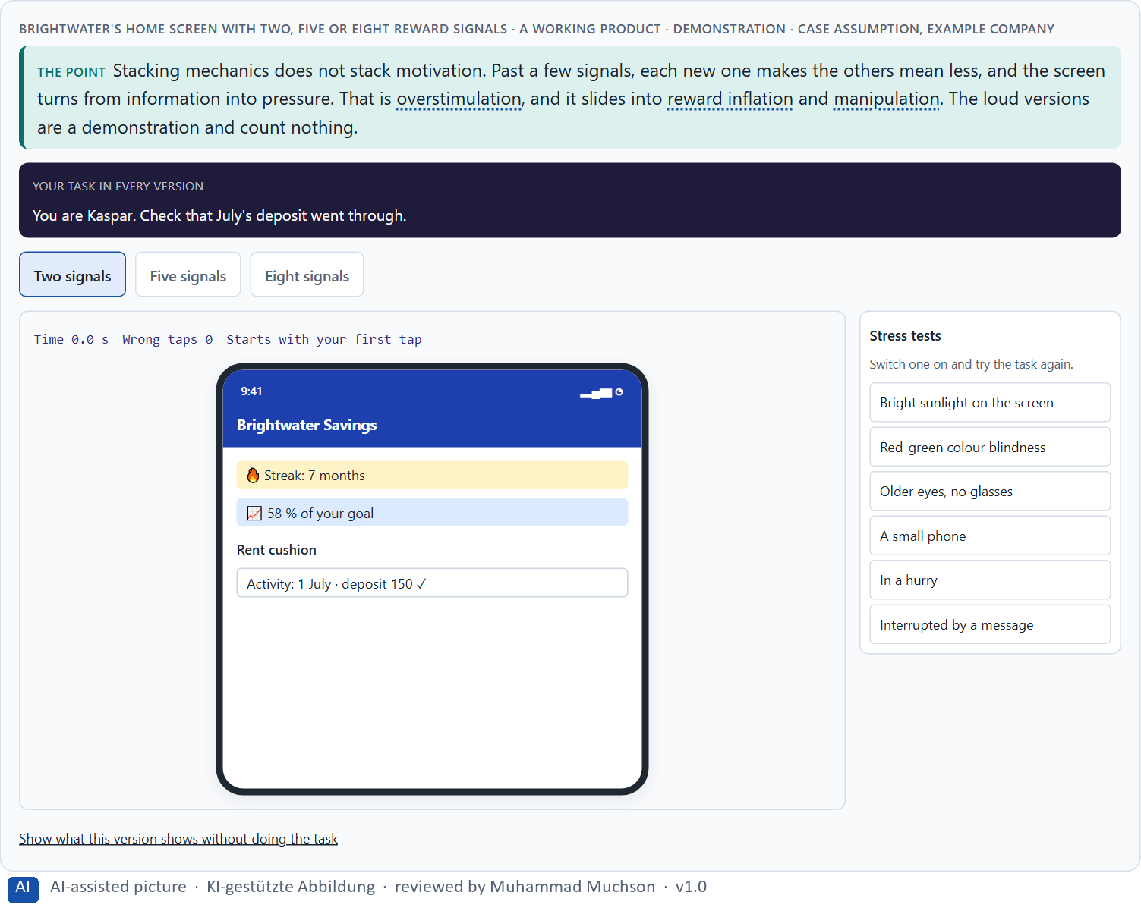
Figure 3 · Brightwater's home screen with two, five or eight reward signals · demonstration. Shown here in its starting state; in the Neuro-UX Lab every version and every stress test can be used.
The tools of gamification: their job and their limit
Tool | Its job | Where it stops working
Points | Count activity. | They count effort, not value; easy to game.
Badges | Mark something rare. | When there are many, none means anything.
Levels | Name a capability. | When they name activity (“Level 6”), not skill.
Challenges | Set a bounded task. | When they are daily duties, not invitations.
Streaks | Reward regularity. | One missed day resets them; people stop altogether.
Feedback | Say what an action did. | When it is technical or empty praise.
Status displays | Show a position or rank. | They motivate the top and shame the bottom.

Case assumption
Brightwater Savings, Vera, Kaspar, Rhea and Dominik are made up for this example. Mixed effects of gamification follow Hamari et al. (2014); rewards lowering intrinsic motivation follow Deci et al. (1999); loss aversion, the lever behind “don't lose your streak”, follows Tversky and Kahneman (1991).

How to decide when this comes up in the task
- Give each tool one job; if you cannot say its job, leave it out.
- Count the signals on a screen: past a few, each new one makes the others mean less.
- Check for manipulation: fake urgency, guilt, a countdown that never ends.
- Check for reward inflation: are rewards getting bigger for less?
- Remember the asymmetry: too much can be removed, lost trust repairs slowly.

Extra · go deeper (optional reading)
The five failures are not equally repairable. Overstimulation and lost motivation can be fixed by removing things. Reward inflation can be fixed slowly, because people expect the bigger rewards. Lost trust hardly repairs: once people decide a product is trying to trick them, they discount everything it says. In a game they would leave; in a bank, a health service or a public service they often cannot, so they stay and stop believing the messages. That is worse than leaving.

Sources · Hamari et al. 2014 · Deci et al. 1999 · Tversky & Kahneman 1991

A4 · Story and game together, and a quick spike against lasting use · 12 min · Core
Progress logic says where you are; a story says why it matters. Together they make the same mechanics mean more. Activation and retention differ: the loudest rewards win the first week and often lose the third month, so the period you measure picks the winner.
IN PLAIN WORDS
The idea. Progress logic answers “where am I?”; a story answers “why does this place matter?”. Put together, they make the same mechanics mean more: a step called “Month 3: your emergency fund covers a broken boiler” motivates more than “Step 3 of 12”, and nothing new had to be built. The story should be the real process told well, not an invented quest. Activation and retention are different results: heavy rewards win the first week and often lose the third month, because the levers that rise fastest wear off fastest. Which result you measure, and over which period, decides which design looks like the winner.
Why it matters. Block 1.2 asks you to judge a narrative variant against a heavily gamified one, and Block 2.1 asks for measures that combine visible progress, encouraging feedback and a narrative frame for MoveWell. This card shows how story and game work together and why a fast start is not lasting use.
How to read the picture. The same Brightwater Savings plan with numbered steps or with named stages; the mechanics underneath do not change. Then three designs and a choice of period: 1 week, 1 month or 3 months.

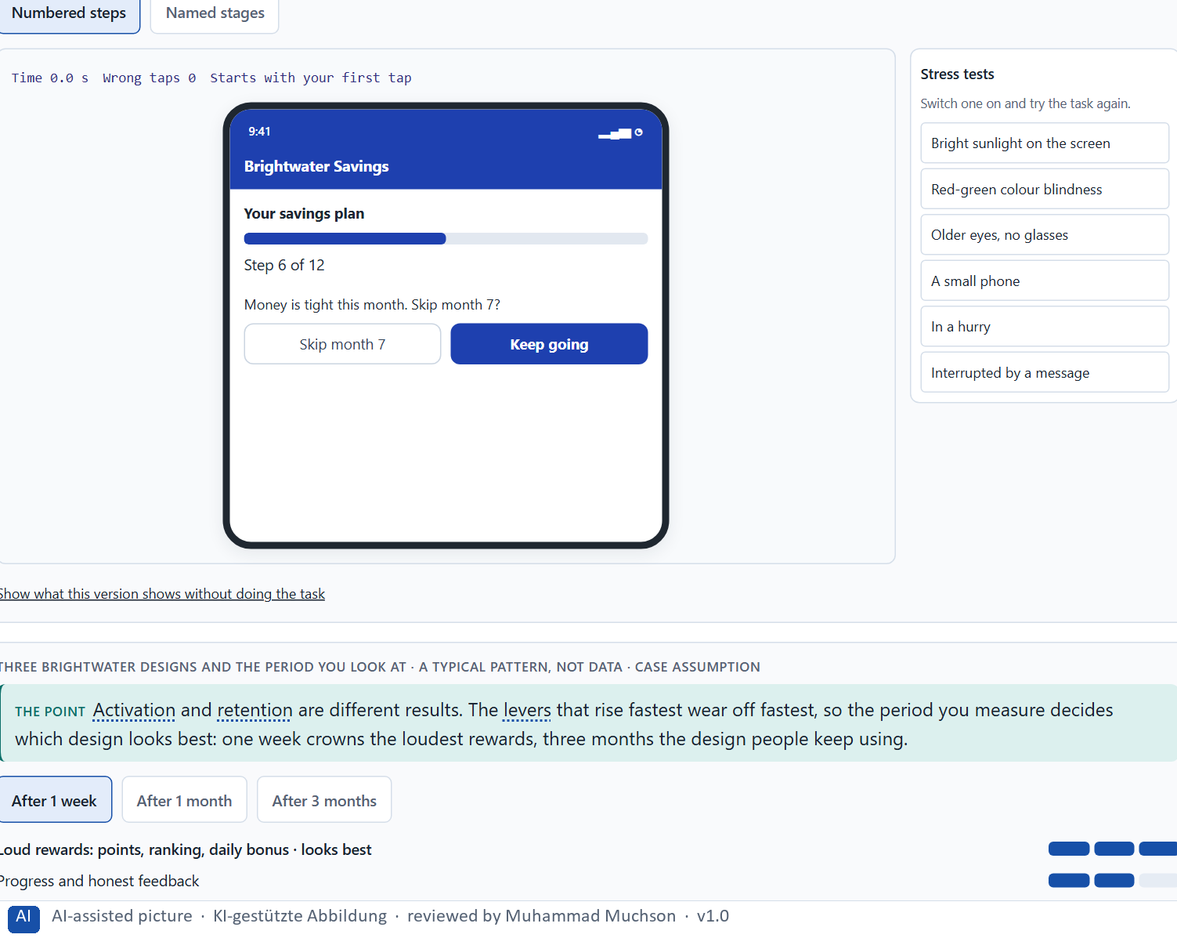
Figure 4 · The same Brightwater savings plan with numbered steps or with named stages. Shown here in its starting state; in the Neuro-UX Lab every version and every stress test can be used.
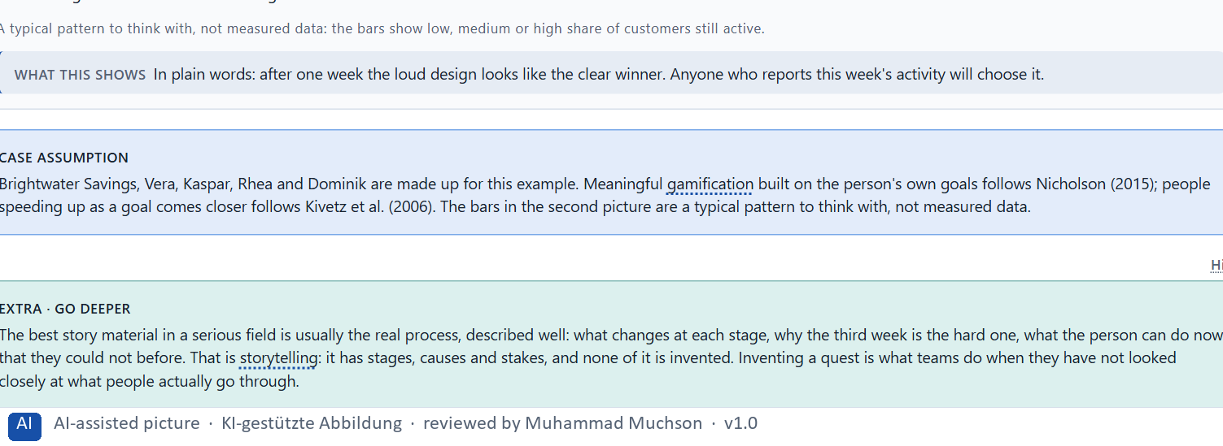
Figure 5 · Three Brightwater designs and the period you look at · a typical pattern, not data.
Case assumption
Brightwater Savings, Vera, Kaspar, Rhea and Dominik are made up for this example. Meaningful gamification built on the person's own goals follows Nicholson (2015); people speeding up as a goal comes closer follows Kivetz et al. (2006). The bars in the second picture are a typical pattern to think with, not measured data.

How to decide when this comes up in the task
- Give each stage a name that says what it means in the person's life.
- Tell the real process well; do not invent a quest.
- Keep the mechanics; let the story change their meaning.
- Say whether a design aims at activation or at retention.
- Judge a design over the period that matters for its goal, not over its launch week.

Extra · go deeper (optional reading)
The best story material in a serious field is usually the real process, described well: what changes at each stage, why the third week is the hard one, what the person can do now that they could not before. That is storytelling: it has stages, causes and stakes, and none of it is invented. Inventing a quest is what teams do when they have not looked closely at what people actually go through.

Sources · Nicholson 2015 · Kivetz et al. 2006 · Ryan & Deci 2000

A5 · Intrinsic motivation, credible gamification in serious fields, and weighing a measure · 12 min · Core
A reward for something people already do gladly can replace their own reason. In serious fields credible gamification is a different selection: structure and honest feedback yes, playful tone rarely, rankings and urgency almost never. Weigh measures on effect on users, feasibility, risk and time pressure.
IN PLAIN WORDS
The idea. People who already do something for its own sake can lose that reason when a reward is attached: they start doing it for the reward, and when the reward stops, so do they (the overjustification effect). So reward what people would not do anyway, and only report on what they already do gladly. In serious fields (health, money, public services, professional learning), credible gamification is a different selection, not a smaller dose: structure and honest feedback yes, a playful tone rarely, rankings and urgency almost never. Four questions decide whether a mechanic may ship: could we explain it in one plain sentence and would it still work; whom does it quietly put last; how does it read to someone in a bad moment; who can remove it later? To put measures in order, weigh each on effect on users, feasibility, risk and time pressure, the four Block 2.1 names.
Why it matters. Block 1.2 asks about credibility and user acceptance for HealthJourney, and Block 2.1 asks for four prioritised measures for MoveWell, justified on effect on users, feasibility, risk and time pressure, that keep the brand trustworthy. The example uses Brightwater Savings and its own measures, so the answer for the task cases is not given.
How to read the picture. First the four questions, asked of two Brightwater Savings mechanics. Then three measures Brightwater considered, rated on effect on users, feasibility, risk and time pressure.

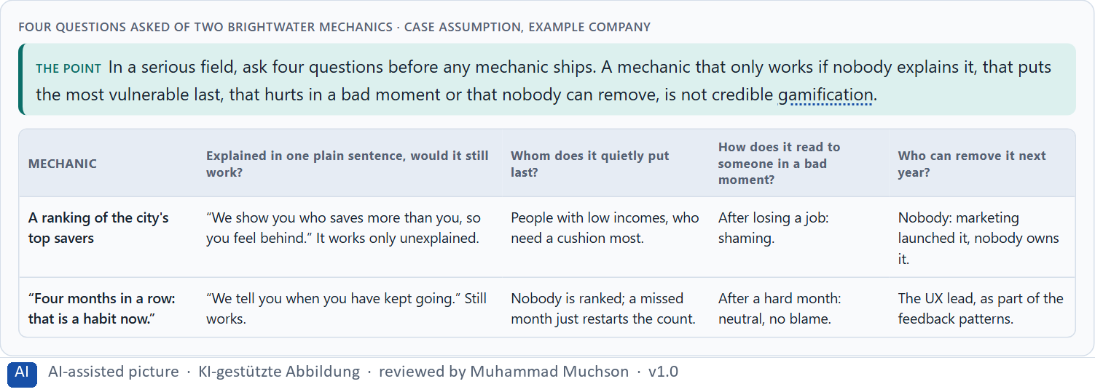
Figure 6 · Four questions asked of two Brightwater mechanics.
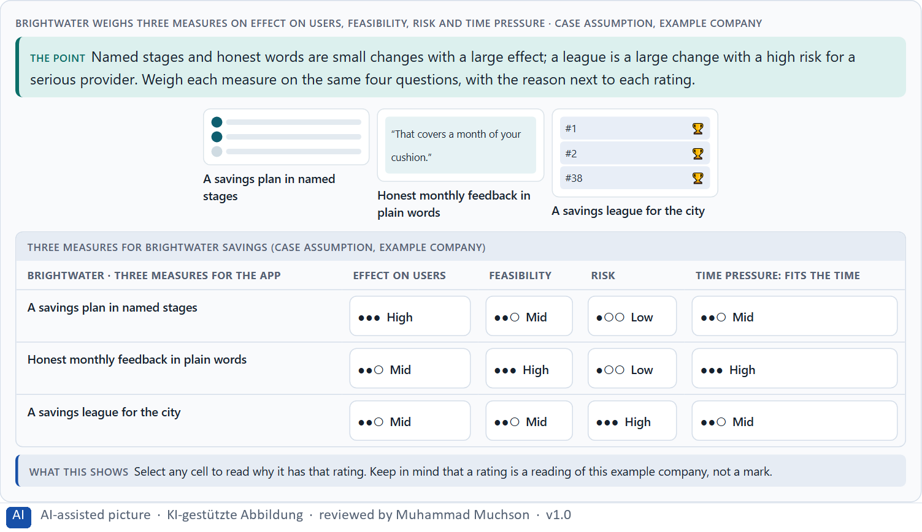
Figure 7 · Brightwater weighs three measures on effect on users, feasibility, risk and time pressure.
Case assumption
Brightwater Savings, Vera, Kaspar, Rhea and Dominik are made up for this example. The overjustification effect follows Lepper et al. (1973) and Deci et al. (1999); rating options on the same criteria with a reason follows Gibbons (2018). The four criteria are the ones the plan names for the case study.

How to decide when this comes up in the task
- Reward only what people would not do anyway; report on what they already do gladly.
- Ask: could we explain it in one plain sentence, and would it still work?
- Ask: whom does it quietly put last, and how does it read in a bad moment?
- Ask: who can remove it next year?
- Rate every measure on the same four questions, with a reason; a rating is a judgement, never a mark.

Extra · go deeper (optional reading)
In professional learning, health and public services, the people who take part without being pushed are the intrinsically motivated ones, and they are exactly the people a reward layer can damage. The people a points programme moves are often those who were not taking part, and they tend to stop again when the points stop. So a successful points quarter can leave a product weaker than it started: it lost some of the people it had and rented the people it wanted.

Sources · Lepper et al. 1973 · Deci et al. 1999 · Gibbons 2018

Materi B · Route 2 · Level 3
How Materi B is used
About 60 minutes, three cards, led by the facilitator. Level 3 in the Chief Experience Officer's chair: a guiding vision for activation and retention, three strategic decisions, an order of what comes first, a risk analysis, a governance model for activation principles, one decision under uncertainty and a statement to the management. The cards give you the ideas you use in Task 2.

B1 · Gamification as activation architecture, not a game layer · 20 min · Core
At senior level gamification is not a feature request but activation architecture: a guiding vision for what people should feel and do, principles on which levers the company uses and which not, patterns built once, and an order of what comes first. It steers behaviour, so it is a responsibility.
IN PLAIN WORDS
The idea. In many companies gamification arrives as a feature request: “add badges”, “make it fun”. At senior level it is part of the activation and experience architecture: a guiding vision for what people should feel and do, principles that say which levers the company uses and which it does not, patterns for progress, feedback and recognition built once for every product, and a plan for which journeys come first. It also steers behaviour, so it is a matter of responsibility: a mechanic that moves people should be one the company would explain to them.
Why it matters. Block 3.1 asks for a guiding vision for activation and retention, three decisions on progress, reinforcement, the depth of gamification, storytelling and long-term retention, and an order of which journeys, functions or touchpoints come first. You decide the architecture, not single mechanics.
How to read the picture. Left Brightwater Savings adding mechanics one request at a time, right building an activation architecture. Below, the layers from a guiding vision to every touchpoint.

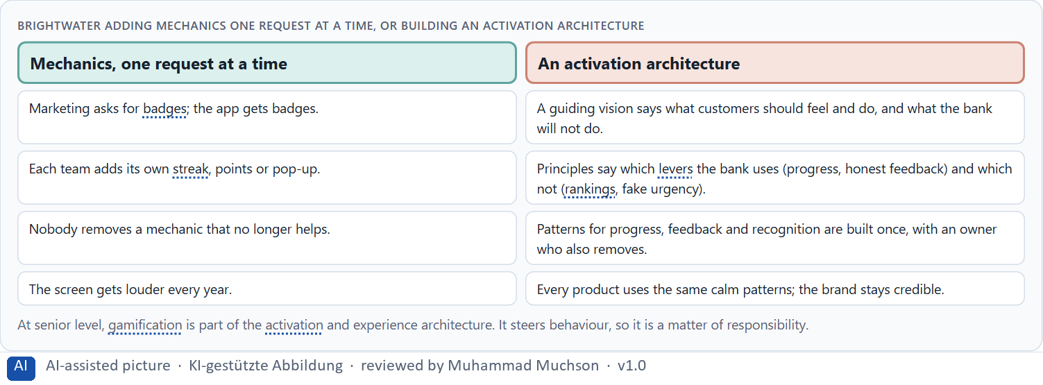
Figure 8 · Brightwater adding mechanics one request at a time, or building an activation architecture.
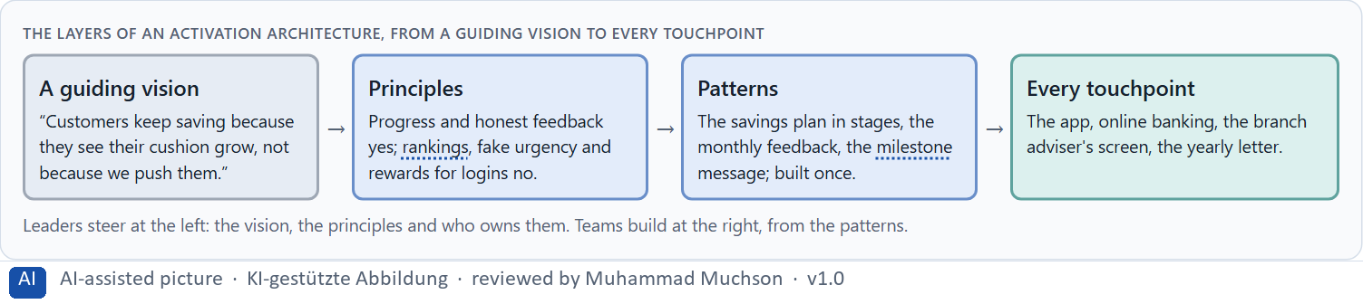
Figure 9 · The layers of an activation architecture, from a guiding vision to every touchpoint.
Case assumption
Brightwater Savings, Vera, Kaspar, Rhea and Dominik are made up for this example. Lasting motivation through competence and autonomy follows Ryan and Deci (2000); meaningful gamification follows Nicholson (2015).

How to decide when this comes up in the task
- Check where activation is decided today: in a vision, or one request at a time?
- Write a guiding vision that says what motivation people should feel, and what the company will not do.
- Turn it into principles on levers, and into patterns every team uses.
- Decide which journeys come first: where most people start and leave.
- Treat every mechanic that steers behaviour as something the company would explain to the people it steers.

Extra · go deeper (optional reading)
A guiding vision for activation is short and testable. “Customers keep saving because they see their cushion grow, not because we push them” can be checked on every screen: does this element show growth, or does it push? “Make saving fun” cannot be checked, and it invites every mechanic anyone suggests.

Sources · Nicholson 2015 · Ryan & Deci 2000 · Hamari et al. 2014

B2 · Motivation against seriousness and autonomy: the conflicts of activation · 20 min · Core
Activation sits between motivation and seriousness, between steering behaviour and user autonomy, between brand effect and the user's interest, and all of them against economic viability. Decide per lever and per journey, say what you give up, and choose what you measure on purpose.
IN PLAIN WORDS
The idea. Activation sits between goals that pull apart: motivation against seriousness (lively against trustworthy), activation against user autonomy (steering behaviour against letting people choose), brand effect against the user's interest, and all of these against economic viability (what it costs and what it brings). A metric can pull too: if the company counts sessions in the first week, the design that wins is the one with the loudest rewards. The way through is to decide per journey and per lever, say what you give up, and choose what you measure on purpose.
Why it matters. Block 3.1 asks for three guiding decisions, a risk analysis of wrong assumptions about motivation, target group and mechanics, and a governance model for conflicts between brand, user interest and economic viability. Each is a decision between conflicting goals.
How to read the picture. Three Brightwater Savings levers, each with what it gives and what it costs in trust or autonomy.

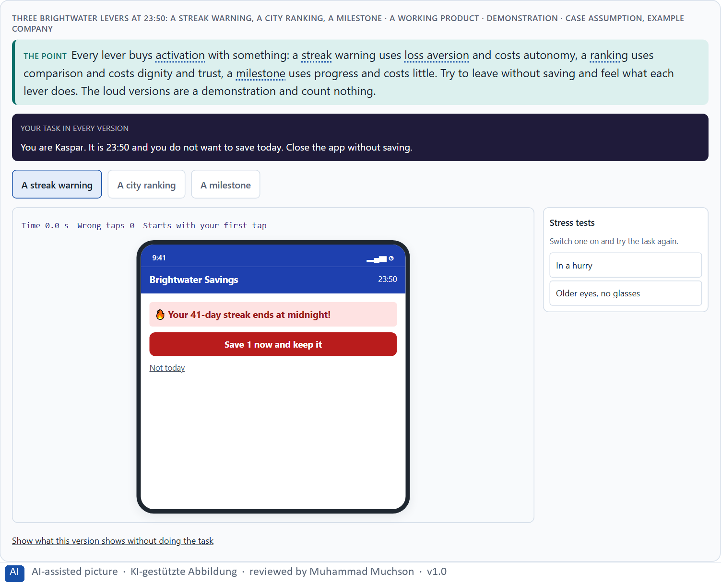
Figure 10 · Three Brightwater levers at 23:50: a streak warning, a city ranking, a milestone · demonstration. Shown here in its starting state; in the Neuro-UX Lab every version and every stress test can be used.
Standing conflicts of activation
Conflict | Who usually stands for each side | What to ask
Motivation against seriousness | Marketing, against the experts. | Can it be lively and credible at once?
Activation against autonomy | Growth targets, against the user's own choice. | Would people choose this push if asked?
Brand effect against user interest | Visibility for the company, against the user's goal. | Whose interest does this mechanic serve?
All of these against economic viability | Finance, against everyone. | What does it cost, and what does it bring over months?

Case assumption
Brightwater Savings, Vera, Kaspar, Rhea and Dominik are made up for this example. The three levers are a reading of the example, not a rule for every product.

How to decide when this comes up in the task
- Name each conflict as two goals and say who stands for each: marketing, sales, the experts, the users.
- Decide per lever: progress and honest feedback cost little; loss aversion costs autonomy; comparison costs trust.
- Treat the metric as a decision: what you count, and over which period, decides which design wins.
- Write the rule down, so the conflict is not fought again for every mechanic.
- Say what the choice gives up; a decision that gives up nothing has not been made.

Extra · go deeper (optional reading)
Activation numbers cannot see the risks of a lever. A streak warning at midnight raises daily activity; it does not show the people who stopped altogether after the streak broke, or the ones who now open the app with a small feeling of dread. Decide which numbers you will look at, and over which period, before you decide on the lever, or the lever will choose the numbers for you.

Sources · Tversky & Kahneman 1991 · Festinger 1954 · Deci et al. 1999

B3 · Who answers for a mechanic, and deciding without knowing who stays · 20 min · Core
Adding a mechanic needs only a champion; removing one needs a business case, so mechanics pile up. Governance: a named owner, written principles, a way to remove, an escalation rule. A decision with little data says what it decides, does not know, would reverse and gives up.
IN PLAIN WORDS
The idea. Mechanics pile up because adding one needs only a champion, while removing one needs a business case. Left alone for a few years, that makes a product loud without anyone having decided it. Governance corrects it: a named owner of the activation principles, a written rule for which levers are used, a way to remove a mechanic, and an escalation rule for conflicts between brand, user interest and economics. A works council, a regulator or a journalist will ask who decided, on what principle, and what would have changed the decision. With incomplete data, a decision says what you decide, what you do not know, when you would reverse it and what you give up.
Why it matters. Block 3.1 asks for a governance model for activation principles, a decision despite patchy data, and a statement to the management. This card gives you the parts of each.
How to read the picture. The four boxes at the top are the parts of a decision, filled in for Brightwater Savings. The two boxes below are the rule for future decisions.

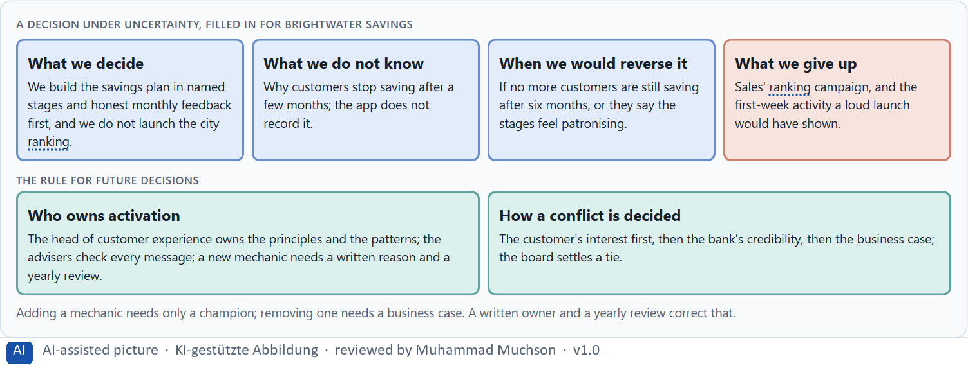
Figure 11 · A decision under uncertainty, filled in for Brightwater Savings.
Four parts of activation governance
Part | The question | An example (Brightwater)
Who owns what | Who owns the principles and patterns; who uses them? | The head of customer experience owns them; every team uses them.
Who checks | Who makes sure no mechanic harms or misleads? | The advisers check every message; legal checks rankings and data.
How a mechanic leaves | Who can remove a mechanic, and when? | A yearly review; the owner removes what no longer earns its place.
How a conflict is decided | What happens when brand, customer and business disagree? | Customer first, then credibility, then the business case; the board settles a tie.

Case assumption
Brightwater Savings, Vera, Kaspar, Rhea and Dominik are made up for this example. Deciding with limited information follows Simon (1956); the premortem follows Klein (2007).

How to decide when this comes up in the task
- Name who owns the activation principles and patterns, and who only uses them.
- Require a short written reason for every new mechanic: its lever, whom it may put last, who can remove it.
- Review every mechanic once a year, and remove what no longer earns its place.
- Settle conflicts by the user's interest, then credibility, then economics; say who settles a tie.
- Say what you decide, what you do not know, when you would reverse it and what you give up.

Extra · go deeper (optional reading)
A works council, a regulator and a journalist all ask the same thing in different words: who decided this, on what principle, and what would have led to a different decision? A company that can answer in one paragraph is in a different position from one that cannot, whatever the mechanic. In a field where trust is the product, a missing decision record is itself the finding. Write the paragraph before anyone asks.

Sources · Simon 1956 · Klein 2007 · Nicholson 2015

Use in class: presentation and handout
Mark of use for the study material. Presentation is what the trainer shows on screen; Handout is what participants read and keep.
Card | Presentation (shown in the Neuro-UX Lab) | Handout
A1 · Gamification, playful design and a game: three different requests (Core) | Scan line and Figure 1; the "In plain words" and "How to decide" boxes | The whole card
A2 · Why people react to progress, feedback and recognition: the levers under a mechanic (Core) | Scan line and Figure 2; the "In plain words" and "How to decide" boxes | The whole card
A3 · Points, badges, levels, streaks: what each tool does, and how gamification goes wrong (Core) | Scan line and Figure 3; the "In plain words" and "How to decide" boxes | The whole card
A4 · Story and game together, and a quick spike against lasting use (Core) | Scan line and Figures 4–5; the "In plain words" and "How to decide" boxes | The whole card
A5 · Intrinsic motivation, credible gamification in serious fields, and weighing a measure (Core) | Scan line and Figures 6–7; the "In plain words" and "How to decide" boxes | The whole card
B1 · Gamification as activation architecture, not a game layer (Core) | Scan line and Figures 8–9; the "In plain words" and "How to decide" boxes | The whole card
B2 · Motivation against seriousness and autonomy: the conflicts of activation (Core) | Scan line and Figure 10; the "In plain words" and "How to decide" boxes | The whole card
B3 · Who answers for a mechanic, and deciding without knowing who stays (Core) | Scan line and Figure 11; the "In plain words" and "How to decide" boxes | The whole card

References
Check each source and its current edition before you teach from it. Standards and laws marked as in flux can change.
Deterding, S., Dixon, D., Khaled, R., & Nacke, L. (2011). From game design elements to gamefulness: Defining “gamification”. Proceedings of the 15th International Academic MindTrek Conference, 9–15. (Gamification as game design elements in non-game contexts, apart from playful design and full games.)
Hamari, J., Koivisto, J., & Sarsa, H. (2014). Does gamification work? A literature review of empirical studies on gamification. Proceedings of the 47th Hawaii International Conference on System Sciences, 3025–3034. (Gamification has mostly positive but context-dependent effects; the users and the setting decide.)
Nicholson, S. (2015). A RECIPE for meaningful gamification. In T. Reiners & L. Wood (Eds.), Gamification in Education and Business (pp. 1–20). Springer. (Meaningful gamification builds on the user's own goals and reflection, not on points.)
Ryan, R. M., & Deci, E. L. (2000). Self-determination theory and the facilitation of intrinsic motivation, social development, and well-being. American Psychologist, 55(1), 68–78. (Competence, autonomy and relatedness as the needs behind lasting motivation.)
Bandura, A. (1977). Self-efficacy: Toward a unifying theory of behavioral change. Psychological Review, 84(2), 191–215. (Believing you can do something, built mostly by your own experience of success.)
Festinger, L. (1954). A theory of social comparison processes. Human Relations, 7(2), 117–140. (People judge themselves by comparison with others; comparison with those far ahead can discourage.)
Deci, E. L., Koestner, R., & Ryan, R. M. (1999). A meta-analytic review of experiments examining the effects of extrinsic rewards on intrinsic motivation. Psychological Bulletin, 125(6), 627–668. (Expected, tangible rewards for an interesting activity tend to lower intrinsic motivation.)
Tversky, A., & Kahneman, D. (1991). Loss aversion in riskless choice: A reference-dependent model. Quarterly Journal of Economics, 106(4), 1039–1061. (Losses weigh more than equal gains; the lever behind “don't lose your streak”.)
Kivetz, R., Urminsky, O., & Zheng, Y. (2006). The goal-gradient hypothesis resurrected: Purchase acceleration, illusionary goal progress, and customer retention. Journal of Marketing Research, 43(1), 39–58. (People speed up as they see themselves getting closer to a goal.)
Lepper, M. R., Greene, D., & Nisbett, R. E. (1973). Undermining children's intrinsic interest with extrinsic reward: A test of the “overjustification” hypothesis. Journal of Personality and Social Psychology, 28(1), 129–137. (The overjustification effect: a reward for something done gladly reduces doing it once the reward stops.)
Gibbons, S. (2018). Using Prioritization Matrices to Inform UX Decisions. Nielsen Norman Group. https://www.nngroup.com/articles/prioritization-matrices/ (Rate each option on the same few criteria, such as value to the user against effort, and put the reason next to each rating.)
Simon, H. A. (1956). Rational choice and the structure of the environment. Psychological Review, 63(2), 129–138. (With limited information and time, people choose an option that is good enough rather than the best one: a decision under uncertainty.)
Klein, G. (2007). Performing a project premortem. Harvard Business Review, 85(9), 18–19. (Imagine the plan has failed and ask why; it brings risks and wrong assumptions to the surface before the work starts.)

Glossary
Every term below is used in this document. Terms stay plain text in the body; this list says what they mean in everyday words.
Term | In plain words | Example | Comes from
Activation | Getting people to act now, often with strong stimuli. It can help for a moment and tire or push people if overdone. | — | Day 7
Activation architecture | A company's whole plan for why people start and keep using its products: a vision, principles on which levers it uses, shared patterns and an owner. | — | Day 9
Badge | A small symbol that marks something someone has done; it means something only while it is rare. | — | Day 9
Brand effect | How a design makes people recognise the company and what they feel about it, such as modern, serious or friendly. | — | Day 3
Case assumption | A fact made up for this exercise to fill a gap in the plan's case. It is marked so you know it is not part of the plan. | — | Day 1
Chief Experience Officer | The manager who is responsible for the experience customers have across all channels, and who decides where the company invests in it. | — | Day 1
Dark pattern | A design that uses emotion against people's own interest, such as false urgency, guilt or hidden costs. | — | Day 7
Gamification | Using the structure of games (a goal, a visible position, feedback, recognition, a challenge) in something that is not a game. | — | Day 9
Governance | The rules about who may decide what, who is answerable for it and how disagreements are settled. | — | Day 1
Intrinsic motivation | Doing something because it is worth it to you, not for a reward from outside. | — | Day 9
Loss aversion | People feel a loss more strongly than an equal gain; “don't lose your streak” uses it. | — | Day 9
Milestone | A visible point on the way that shows a part of the journey is done. | — | Day 8
Motivation lever | What a mechanic actually pulls on in people: reward, a feeling of competence, self-efficacy, social validation, the experience of progress, or a trigger to act. | — | Day 9
Neuro-UX | Designing an interface with knowledge of how the brain sees, attends, feels and decides, so that the design steers these processes on purpose and responsibly. | — | Day 1
Overjustification effect | When a reward is attached to something people already do gladly, they start doing it for the reward, and stop when the reward stops. | — | Day 9
Overstimulation | Too many signals at once (badges, sounds, pop-ups, counters), so people stop noticing any of them or feel pushed. | — | Day 9
Playful design | Changing only the look and tone of a product to feel light and fun (colours, round shapes, cheerful words), without adding goals or feedback. | — | Day 9
Ranking (leaderboard) | A list that orders people by points or results; it motivates those near the top and can shame those near the bottom. | — | Day 9
Retention | People coming back and staying active over time, not only trying something once. | — | Day 9
Reward inflation | Ever more and bigger rewards for less, until no single reward means anything. | — | Day 9
Self-efficacy | Believing you can do something; it grows mostly from your own experience of succeeding. | — | Day 9
Status colour | A colour that shows the state of something, such as sent, waiting or failed. It needs a word or a symbol next to it, because colour alone is missed or misread. | — | Day 3
Storytelling in UX | Building a digital journey so it has what a story has: a beginning that shows the goal, a way that shows progress, and an end that feels like an end. | — | Day 8
Streak | A count of days in a row on which someone did something; it rewards regularity and punishes a single missed day. | — | Day 9
Touchpoint | Any place where a person meets the company: the website, the customer portal, the app, a chatbot or a phone call. | — | Day 1
UX (user experience) | Everything a person goes through when using a product: what they notice, understand, feel and do, from the first look to the last step. The screens are only one part of it. | Finding the booking you want at once and feeling sure it went through is a good UX. | Day 1

The Neuro-UX Lab: where we practise online
In class we use the course website as the place to practise and to learn. Every day has its own address, in the same pattern: the day number is the last part.
What | Address
Neuro-UX Lab (course website) | https://aion-ux-lab.vercel.app/
Day 9 | https://aion-ux-lab.vercel.app/day/9/

On the day page, Route 1 (Levels 1 and 2) and Route 2 (Level 3) can be opened; the cards and the tasks of this document are there too. The pattern is the same up to Day 8, for example https://aion-ux-lab.vercel.app/day/6/.

