AION · UX DEVELOPER · PSYCHOLOGICAL UX DESIGN AND NEURO-UX
DAY 13 · TASK 1 AND TASK 2 · ROUTES 1 AND 2 · LEVELS 1 TO 3
LifeGuide: UX Analysis File and UX Strategy Memo
Describe the effect, choose the measures as a team member, and decide as Chief Experience Officer
AI notice · KI-Hinweis
This document was produced with the help of an AI language model (Claude, Anthropic). The AI drafted the text and tables and built the pictures and working examples of the lab. The content was then read, corrected and approved by the reviewer named below, who is responsible for its accuracy. Every picture carries an AI label on the image. Check figures and sources before you quote them.
KI-Hinweis: Dieses Dokument wurde mit Unterstützung eines KI-Sprachmodells (Claude, Anthropic) erstellt. Texte und Tabellen wurden von der KI entworfen, die Abbildungen sind KI-gestützt erstellt und am Bild gekennzeichnet. Die fachliche Prüfung und Freigabe erfolgte durch die unten genannte Person.

Day | Day 13 · Module 6 (day 2 of 2): Neurodiversity, inclusive patterns and assistive technologies
Document | Task (worksheet with answer spaces). Task 1 (UX Analysis File) and Task 2 (UX Strategy Memo).
Route and level | Task 1 = Route 1, Levels 1 and 2 (draws on Materi A). Task 2 = Route 2, Level 3 (draws on Materi B).
Time | Task 1 about 33 min · Task 2 about 20 min
Neuro-UX Lab (website) | https://aion-ux-lab.vercel.app/day/13/
Case | LifeGuide, the day's case study; other products appear as warm-ups
Version | 1.0 · release date 29.10.2026
Review and approval | Muhammad Muchson, Mentor (subject-matter review and approval)

ABOUT THIS DOCUMENT
In class we also use the Neuro-UX Lab, the course website, as the place to practise and learn. Its address is at the end of this document.
This is the worksheet for Day 13. Read the case once, study the evidence printed in this document, and write your answers in the boxes and tables. You can work through it on paper or type into the document. All blocks are Core. There are no answer keys and no scores; the reason you give matters more than the choice.

IN THIS DOCUMENT
Lesson plan: ten teaching units (Ablaufplan)
Case study and transfer project at a glance
The case: two platforms on the UX team's desk, and LifeGuide
Block 1.1 · Recognise neurodiverse hurdles in an interface: StudyPath · JUDGED · Core · about 10 min
Block 1.2 · Rate inclusive design approaches under conflicting goals: JobAccess · JUDGED · Core · about 8 min
Block 2.1 · Case study: an inclusive prototype for the service portal LifeGuide · JUDGED · Core · about 15 min
The situation: formally accessible, but not usable for every mind
Block 3.1 · A strategic UX architecture for neurodiverse and adaptive use · JUDGED · Core · about 20 min

Day at a glance
Day 13 has ten teaching units (UE). This document is the worksheet; it is used in UE2 to UE6 (Task 1) and UE8 to UE10 (Task 2). The day is built from three documents and the Neuro-UX Lab: Materi (study material), Task (worksheet) and Trainer (coaching, feedback and model solutions), plus the course website.

Lesson plan: ten teaching units (Ablaufplan)
UE | Min | Plan item | What happens | Material | Format
1 | 45 | Knowledge transfer · Level 1 | The trainer presents the cards of Materi A (A1, A2, A3, A4, A5, about 60 min of cards) in the Neuro-UX Lab; participants follow in the handout. | Materi A (Route 1) | Presentation + Handout
2 | 45 | Level 1 · Task 1 | Individual work on Block 1.1 (Core, about 10 min): the first product of the day is read and its effect described. Pairs then compare their results and the trainer collects open questions. | Task 1 · Part 1 · Block 1.1 | Handout (or in the lab)
3 | 45 | Level 1 · Task 2 | Three options are rated on the same criteria and one is chosen under the stated conditions: Block 1.2 (Core, about 8 min). | Task 1 · Part 1 · Block 1.2 | Handout (or in the lab)
4 | 45 | Coaching · transition from Level 1 to Level 2 | Trainer-led. A short talk on the day's coaching focus, then the reflection questions in pairs. The bridge: from describing an effect to a decision you answer for. There is no worksheet block in this unit. | Trainer document, section Coaching | Trainer only
5–6 | 90 | Level 2 · Case study LifeGuide (2 UE) incl. model solution | UE5: the trainer presents the case; participants work on Block 2.1 (Core, about 15 min). UE6: groups compare their results and defend them; the trainer closes with the model solution. | Task 1 · Part 2 · Block 2.1  Trainer document, section Case study | Handout; model solution shown after the work
7 | 45 | Level 2 + 3 · Feedback round with a management perspective | Groups present their reasoning, not only their result. The trainer asks the day's Level 3 input questions and leads the discussion. | Trainer document, section Feedback round | Presentation by the groups; Trainer only
8 | 45 | Level 3 · Transfer project, Chief Experience Officer (3 UE: UE8–10) | The trainer presents Materi B (B1, B2, B3; use the "In plain words" and "How to decide" boxes, the rest is handout) and sets the role and the situation. | Materi B (Route 2) | Presentation + Handout
9 | 45 | Level 3 · Transfer project | Individual work or in pairs on Block 3.1 (Core, about 20 min): the strategy memo. | Task 2 · Block 3.1 | Handout (or in the lab)
10 | 45 | Level 3 · Transfer project | Participants present their decision and what they give up, including the one decision made under uncertainty; the trainer debriefs with the model solution. | Task 2 · Block 3.1  Trainer document, section Transfer project | Handout; model solution shown after the work

One UE is counted as 45 minutes here; breaks are not shown. The times are a guide for the trainer. The Core blocks are enough for a complete answer.

Case study and transfer project at a glance
Component | UE | Duration | Participants work in | Model solution in
Level 2 case study (LifeGuide) | UE5–6 | 2 UE · 90 min | Task 1 · Part 2 (Block 2.1) | Trainer document, section Case study
Level 3 transfer project (Chief Experience Officer) | UE8–10 | 3 UE · 135 min | Materi B and Task 2 (Block 3.1) | Trainer document, section Transfer project

Which plan item each block answers
UE | Plan item (Strukturplan, Day 13) | Block in this document
UE2 | Level 1, task 1 · Recognise neurodiverse hurdles in an interface: StudyPath | Block 1.1 (Core)
UE3 | Level 1, task 2 · Rate inclusive design approaches under conflicting goals: JobAccess | Block 1.2 (Core)
UE4 | Coaching: from describing to deciding | A classroom talk led by the trainer; not a worksheet block
UE5–6 | Level 2 case study · Case study: an inclusive prototype for the service portal LifeGuide | Block 2.1 (Core)
UE7 | Feedback round with a management perspective | A classroom discussion led by the trainer; not a worksheet block
UE8–10 | Level 3 transfer project · A strategic UX architecture for neurodiverse and adaptive use | Block 3.1 (Core), in Task 2

Your name
Write your full name here. Use the same name on every Task document this week; it is how your work is matched.

Task 1 · Route 1 · UX Analysis File: find the hurdles for different minds, then design and plan a test

The case: two platforms on the UX team's desk, and LifeGuide
Read once · about 3 min
You work in the UX team of a digital agency. This week three platforms land on your desk. Two are warm-ups: StudyPath, a learning platform for further training and exam organisation, and JobAccess, a platform for applications, further training and career planning, with three designs for how it could develop. The main case is LifeGuide, a digital portal for health, counselling and support offers that is to be reworked for a very diverse group of users. First feedback shows that people with concentration difficulties, sensory sensitivity and reading hurdles in particular have problems with orientation, stimulus density and comprehensibility. The organisation wants a more inclusive experience and to prepare first usability tests on the basis of a prototype.
What the plan gives you | How the task runs · three blocks
• Block 1.1: StudyPath, with a start page full of hints, colours, notifications and action areas, unprioritised tasks, navigation and structure that vary between course areas, long dense complex texts, forms with many required fields and little help, and short unclear status messages  • Block 1.2: three designs for JobAccess; a very heterogeneous group, modern, inclusive and professional, a limited budget, release in 12 weeks, legal and reputational requirements, no data yet from specific neurodiverse user tests  • Block 2.1: LifeGuide, with €175,000 and 14 weeks, no complete relaunch, usable for broad groups, limited test data, and first prototypes to be tried soon | • Block 1.1: find the hurdles of StudyPath for different minds. Describe them, name five barriers with a view to ADHD, autism or dyslexia, sort them into six categories, write three effect statements and pick the two most serious hurdles.  • Block 1.2: rate three designs under conflicting goals. Rate each on six criteria, choose one, name the conflicts between standardisation, adaptability and effort and the remaining risks, and write a recommendation to the project lead.  • Block 2.1: the case study and the start of the practice project. The central deficits, sorted into six categories, four measures, justified on five criteria, a sketch of an inclusive prototype with what to test first, and a recommendation to the division management.

What is known and what is open
In the brief | Clear · Case assumption | Open · on purpose
• StudyPath: a crowded start page, unprioritised tasks, varying navigation, dense text, long forms, unclear status messages.  • JobAccess: three designs in words; a very heterogeneous group; 12 weeks; no neurodiverse test data yet.  • LifeGuide: many stimuli, inconsistent navigation, hard text, long forms, unhelpful feedback in stress, no options to reduce; €175,000 and 14 weeks; no relaunch. | • You review StudyPath and JobAccess as an agency would: by using them, without access to their code or their users.  • LifeGuide's most used journeys are booking a counselling appointment, finding a support offer near you, and applying for a course of support.  • Many LifeGuide users arrive in stressful moments: after a diagnosis, during a crisis at home, on behalf of someone they care for.  • The organisation can invite a small group of users, including people with ADHD, autistic people and people with dyslexia, for a first test. | • How many LifeGuide users are neurodivergent: nobody knows, and many have no diagnosis.  • Which JobAccess design neurodivergent users would prefer: no tests.  • How much of the €175,000 each measure would take: the plan does not say.  • Which adaptation modes people would actually use: never tested.

As in most projects, not everything is known. Decide anyway, and say what you assume.
Case assumption
The brief says: StudyPath's crowded start page, unprioritised tasks, varying navigation, long dense complex texts, forms with many required fields and little help, and short unclear status messages; JobAccess's three designs (A compact and dense with changing navigation, B calm, readable and consistent but less dynamic and brand-strong, C a good base with optional reading mode, stimulus reduction and simplified view but more effort) for a very heterogeneous group, modern, inclusive and professional, a limited budget, 12 weeks, legal and reputational requirements, no neurodiverse test data; LifeGuide's simultaneous stimuli, inconsistent navigation, hard texts, long forms, unhelpful feedback in stress and missing options to reduce, €175,000, 14 weeks, no relaunch, broad usability, limited test data, prototypes to be tried soon. Those are the plan's facts and its only figures. Everything else is made up for this exercise: the agency, the pages, the simulations and the facts marked “Clear”.

Part 1 · Find the hurdles, and weigh inclusive designs · Level 1 · Knowledge

Block 1.1 · Recognise neurodiverse hurdles in an interface: StudyPath · JUDGED · Core · about 10 min
Draws on: A1 · Neurodiversity · A2 · Stimuli and focus · A3 · Predictability · A4 · Readability.
You receive the description of a fictional learning platform, StudyPath, for digital further training and exam organisation. Open it and use it as a learner: find what you have to do this week, move between two course areas, read a course text, and register for an exam. You need no prior knowledge: notice what pulls your attention, where you lose your way, and what tires you. Then ask how it would feel for someone with ADHD, an autistic person, or someone with dyslexia. The aim is to recognise neurodiverse requirements systematically and to tell them apart from general usability.
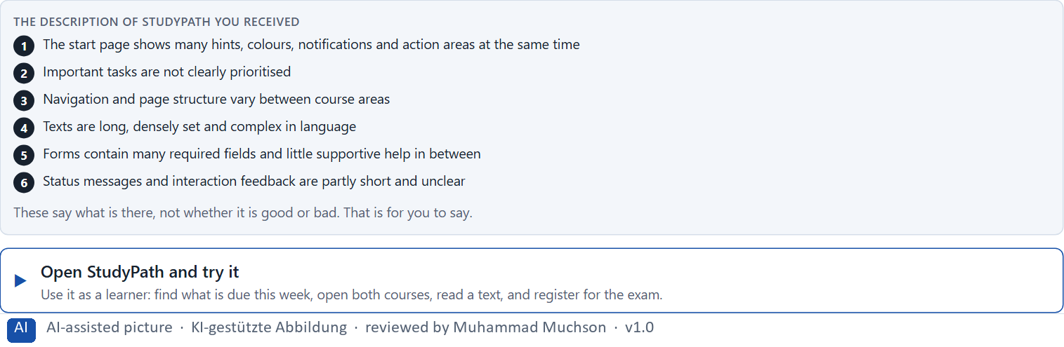
Figure 1 · The product to read, as the lab shows it (studypath).
Question 1 of 5 · Describe which hurdles the offer could have for people with different ways of perceiving and processing
Two to four sentences: which minds, and what loads or stops them.
How to build the answer:
- Open StudyPath and try to find what you have to do this week.
- Move between the two course areas, read a text, and register for an exam.
- Write what loads, confuses or tires whom.

Question 2 of 5 · Name at least 5 barriers with a view to ADHD, autism or dyslexia
How to build the answer:
- Go through your visit: the start page, the two course areas, the text, the form, the messages.
- For each barrier, say whom it loads most and why.
Write them as a list, one barrier per line, each with whom it loads most.

Question 3 of 5 · Assign the observations to the categories stimulus load, orientation, readability, predictability, clarity of the task and comprehensibility
Write the observations that belong to each category in a few words. One may fit two; put it where its effect is strongest.
How to build the answer:
- Take your barriers from question 2.
- Ask which of the six each one affects most, and write it there.
Category | The observations in this category
Stimulus load
Orientation
Readability
Predictability
Clarity of the task
Comprehensibility

Question 4 of 5 · Write an effect statement for three points: “For users this could mean that …”
How to build the answer:
- Pick three barriers from question 2.
- Finish the plan's sentence with what the user would feel, do or fail to do.
Write them as a list, one statement per line, each starting with the barrier and ending with what it could mean for users.

Question 5 of 5 · Prioritise the two most serious hurdles with regard to inclusive usability
How to build the answer:
- Look at your barriers with two questions: which stops people from finishing, and which loads the most people?
- Write the two, each with why it weighs most.
Write two lines: hurdle 1 and hurdle 2, each with why it weighs most.

Block 1.2 · Rate inclusive design approaches under conflicting goals: JobAccess · JUDGED · Core · about 8 min
Draws on: A2 · Stimuli and focus · A3 · Predictability · A4 · Readability · A5 · Inclusive patterns, assistive technologies, and testing a prototype.
JobAccess is a platform for applications, further training and career planning. Three variants for its development are described in words: A) visually modern and compact, but information-dense and with changing navigation patterns; B) clearly structured, calm, readable and consistent, but less dynamic and less brand-strong; C) a good base structure with optional adaptation functions such as a reading mode, stimulus reduction and a simplified view, but a higher implementation effort. The conditions: the target group is very heterogeneous, the company wants to look modern, inclusive and professional, the budget for technical development is limited, the release is in 12 weeks, legal and reputational requirements are relevant, and data from specific neurodiverse user tests is not yet available. Decide anyway, and say what you assume.
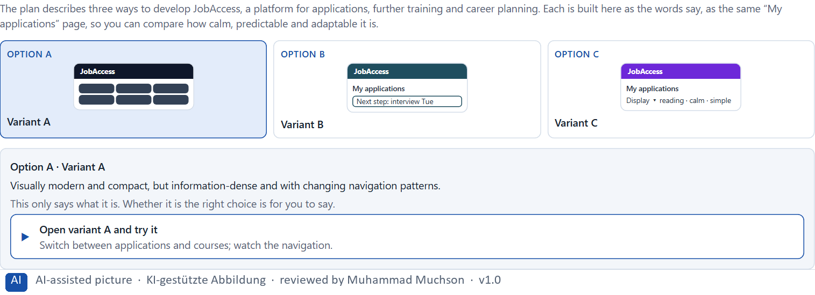
Figure 2 · The product to read, as the lab shows it (designs).
Question 1 of 5 · Rate each variant on inclusion, comprehensibility, predictability, adaptability, brand effect and feasibility
Write a few sentences for each variant that cover all six criteria. Many teams rate each criterion Low, Medium or High with a reason; you may do that or write it in your own words.
How to build the answer:
- Take one variant at a time and keep the conditions in mind: a very diverse group, 12 weeks, no neurodiverse test data.
- For each criterion, say how the variant does and why.
- Use the same six criteria for every variant.
Variant | Inclusion | Comprehensibility | Predictability | Adaptability | Brand effect | Feasibility
Variant A · modern, compact, dense
Variant B · calm, readable, consistent
Variant C · good base with adaptation modes

Question 2 of 5 · Decide which variant is the most viable under the given conditions
Choose one variant, then give your reason below. There is no single right choice; the reason has to rest on the users and the conditions.
How to build the answer:
- Say which condition weighs most for you.
- Say how your choice meets it better than the other two.
Tick one:
☐ Variant A · modern, compact, dense
☐ Variant B · calm, readable, consistent
☐ Variant C · good base with adaptation modes
Why this variant, under these conditions?
Give your reason with the conditions: a very heterogeneous group, modern, inclusive and professional, a limited budget, 12 weeks, legal and reputational requirements, no neurodiverse test data.
How to build the answer:
- Name the condition that weighs most for you.
- Say how your variant meets it and why the other two meet it less well.
- Say what your choice gives up and how you would deal with its weakness.

Question 3 of 5 · Name the conflicts of goals between standardisation, adaptability and effort
Name at least two conflicts, each as one goal against another, and who stands for each side.
How to build the answer:
- Look at what standardisation wants (one design for all), what adaptability needs (modes, settings) and what effort allows (12 weeks, budget, tests).
- Write each conflict as “… against …” and say who stands for each side.

Question 4 of 5 · Which risks remain despite your decision?
Name at least one risk that remains and who would feel it.
How to build the answer:
- Think of what your chosen variant is weak at.
- Say who would notice and what would happen.

Question 5 of 5 · Formulate a recommendation to the project management
Two to four sentences: what you recommend, why, and what you will test next.
How to build the answer:
- Lead with the recommendation.
- Give the one reason the project management can follow.
- Say what you will test before and after the release.

Part 2 · The case study and the start of the practice project · Level 2 · Application · Case study (2 UE)
Case study: 2 teaching units (UE5–6)
This part is the day's Level 2 case study. It takes 2 UE (about 90 minutes): UE5 for the briefing and your own work, UE6 for comparing your results with your group and for the trainer's closing. The block below needs about 15 minutes of writing; the rest of the time is discussion.

Block 2.1 · Case study: an inclusive prototype for the service portal LifeGuide · JUDGED · Core · about 15 min
Draws on: A1 · Neurodiversity · A2 · Stimuli and focus · A3 · Predictability · A4 · Readability · A5 · Inclusive patterns, assistive technologies, and testing a prototype.
A digital portal for health, counselling and support offers is to be reworked for a very diverse group of users. First feedback shows that people with concentration difficulties, sensory sensitivity and reading hurdles in particular have problems with orientation, stimulus density and comprehensibility. The organisation wants a more inclusive experience and to prepare first usability tests on the basis of a prototype. The observed problems: many simultaneous stimuli and competing information areas on central pages; inconsistent navigation patterns and low predictability; texts that are correct in content but hard to access in language and typography; long forms with little supportive structure; error messages and feedback that help too little in stressful situations; and no options to reduce stimuli or simplify the display. The conditions: a budget of €175,000, 14 weeks for the implementation, no complete relaunch, the platform must stay usable for broad groups, only limited test data from different groups exists, and first prototypes are to be tried soon. You work through six steps; step 5 is the start of the practice project.
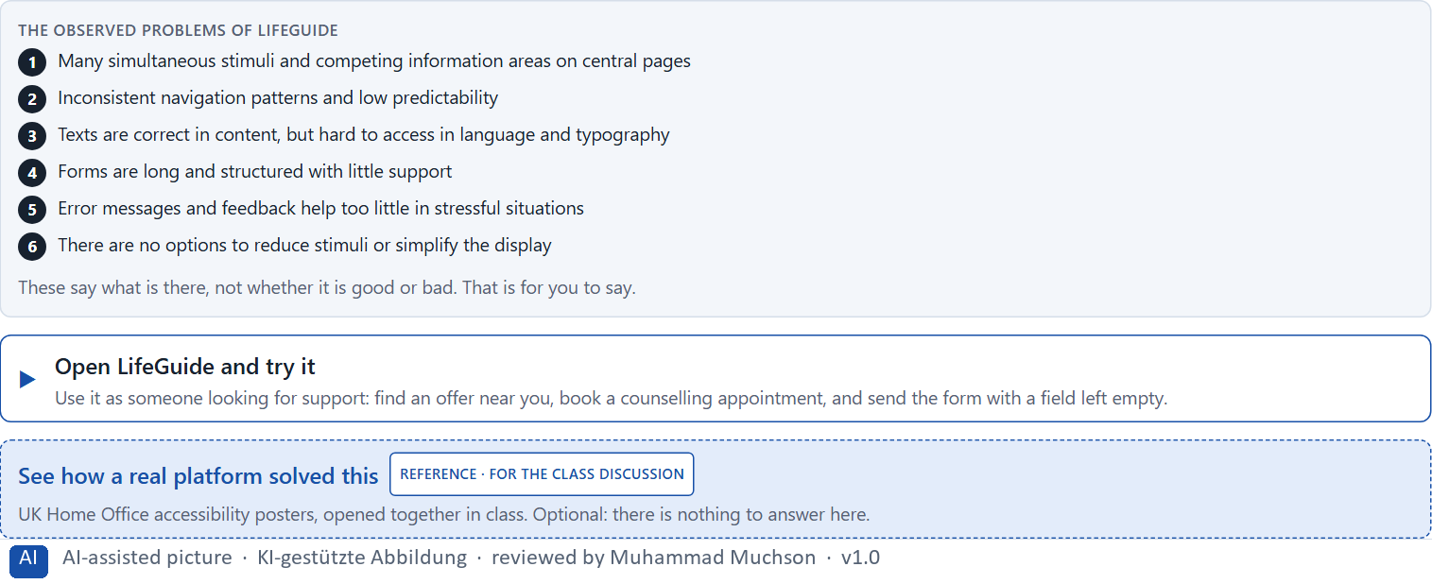
Figure 3 · The product to read, as the lab shows it (lifeguide).
Question 1 of 6 · Analyse the central deficits of the portal with a view to neurodiverse use
How to build the answer:
- Open LifeGuide as someone looking for support: find a counselling offer, book an appointment, fill in the form with a mistake, and switch on any option to reduce stimuli you can find.
- Write one deficit per line, and what it does.
Write them as a list, one deficit per line, each with what it does. At least five.

Question 2 of 6 · Assign the problems to the categories stimulus load, readability, predictability, task structure, error tolerance and adaptability
Write the problems that belong to each category in a few words.
How to build the answer:
- Take your deficits from question 1.
- Ask which category each affects most, and write it there.
Category | The problems in this category
Stimulus load
Readability
Predictability
Task structure
Error tolerance
Adaptability

Question 3 of 6 · Develop 4 prioritised measures for improvement
How to build the answer:
- Turn each group of problems into something you could change within 14 weeks and €175,000, without a relaunch.
- Put them in order: what lowers mental load and exclusion first.
Write them as a numbered list, the first priority first, each with what it changes for users.

Question 4 of 6 · Justify your selection using effect on users, gain for inclusion, feasibility, risk and time pressure
Use all five criteria and say how they support your selection and its order.
How to build the answer:
- Say what your first measures change for mental load and exclusion.
- Say what they gain for inclusion, and what is feasible without a relaunch.
- Keep the 14 weeks and the limited test data in mind.

Question 5 of 6 · Sketch an inclusive prototype approach and name which functions or patterns should be tested first
Say what the first prototype contains, which functions or patterns you test first, what you watch for, which situations you simulate and how you evaluate.
How to build the answer:
- Say what the prototype contains: which pages, journeys and forms.
- Name the functions or patterns you test first.
- Say what you observe, with whom, in which situations, and how you evaluate the results.

Question 6 of 6 · Formulate a recommendation to the division management
Three to five sentences: what you recommend, what has priority, and what you expect to change.
How to build the answer:
- Lead with the recommendation.
- Name the priorities.
- Say what you expect to change.

Task 2 · Route 2 · UX Strategy Memo: decide as Chief Experience Officer

The situation: formally accessible, but not usable for every mind
Read once · about 2 min
You take the perspective of the Chief Experience Officer of the organisation behind LifeGuide, which runs a website, a portal and an app. Its digital offers are formally accessible, but not yet usable enough for people with different cognitive and sensory needs. Complaints about overload, unclarity and reading difficulties are rising. Inside, people discuss whether extra options are enough or whether the base architecture of the product has to be rethought. The management expects a sound strategy for building neurodiverse requirements, inclusive design patterns, assistive technologies and testing systematically into the UX architecture. You are not to adapt single screens, but to develop a sound decision architecture for neurodiverse usability, inclusive standards, prototyping and test governance.
The framework | How the task runs · one block
• The budget is limited  • Several stakeholders pursue different goals  • Not all systems can be adapted at the same time  • Data from specific user tests is patchy  • Legal, reputational and quality requirements are relevant  • First improvements must be visible at short notice  • Wrong decisions can increase exclusion, support effort and loss of trust | • Block 3.1 asks seven questions: a guiding vision for neurodiverse UX, three strategic decisions, a prioritised architecture of measures, a risk analysis, a governance model, one decision under uncertainty and a management statement.

What is known and what is open
In the brief | Clear · Case assumption | Open · on purpose
• A website, a portal and an app, formally accessible.  • Not usable enough for different cognitive and sensory needs; complaints about overload, unclarity and reading.  • An internal debate: extra options, or a new base architecture?  • First improvements must show soon; test data is patchy. | • The organisation is the one behind LifeGuide in Route 1.  • Marketing wants the app to stay lively and branded; the product team proposes an “easy mode” switch as a quick win.  • A design system exists, but nobody owns it, and each product changes it. | • How large the budget is: “limited” is all the plan says.  • Which users struggle most: complaints are not sorted, and many users have no diagnosis.  • Whether an “easy mode” would be found and used: never tested.

As in most projects, not everything is known. Decide anyway, and say what you assume.
Case assumption
The brief says: an organisation with a website, a portal and an app, formally accessible but not usable enough for different cognitive and sensory needs, rising complaints about overload, unclarity and reading difficulties, a debate about extra options against a new base architecture, a limited budget, several stakeholders, not all systems at once, patchy test data, legal, reputational and quality requirements, first improvements soon, and the warning that wrong decisions can increase exclusion, support effort and loss of trust. Those are the plan's facts. That the organisation is the one behind LifeGuide and the facts marked “Clear” are made up for this exercise.

The memo is addressed to: The management. Subject: A UX architecture for neurodiverse and adaptive use.

Part 3 · Level 3 · Management decision · Transfer project (3 UE)
Transfer project: 3 teaching units (UE8–10)
UE8: the trainer presents Materi B and sets the role. UE9: you write the memo. UE10: you present the decision and what you give up; the trainer debriefs.

Block 3.1 · A strategic UX architecture for neurodiverse and adaptive use · JUDGED · Core · about 20 min
Draws on: B1 · Neurodiverse UX as better base architecture, not a special case · B2 · One standard or many modes · B3 · Who owns it, how it is tested, and deciding with patchy data.
Develop a strategic concept for the organisation. Your desk holds what the management, marketing, the product team, the design system team, user research and the support team say. Open it, then answer the seven questions; your answers build the memo below.
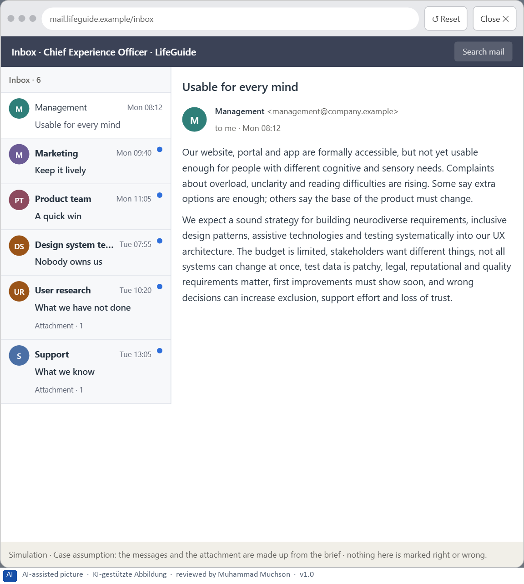
Figure 4 · Your desk: the messages that wait for you, shown in the lab as a mailbox (1 of 6).
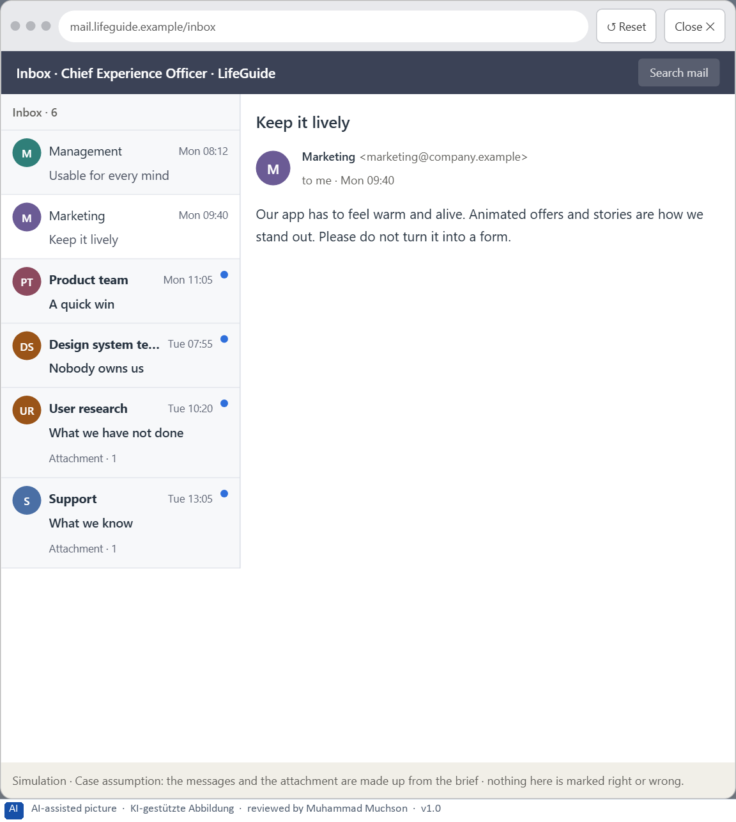
Figure 5 · Your desk: the messages that wait for you, shown in the lab as a mailbox (2 of 6).
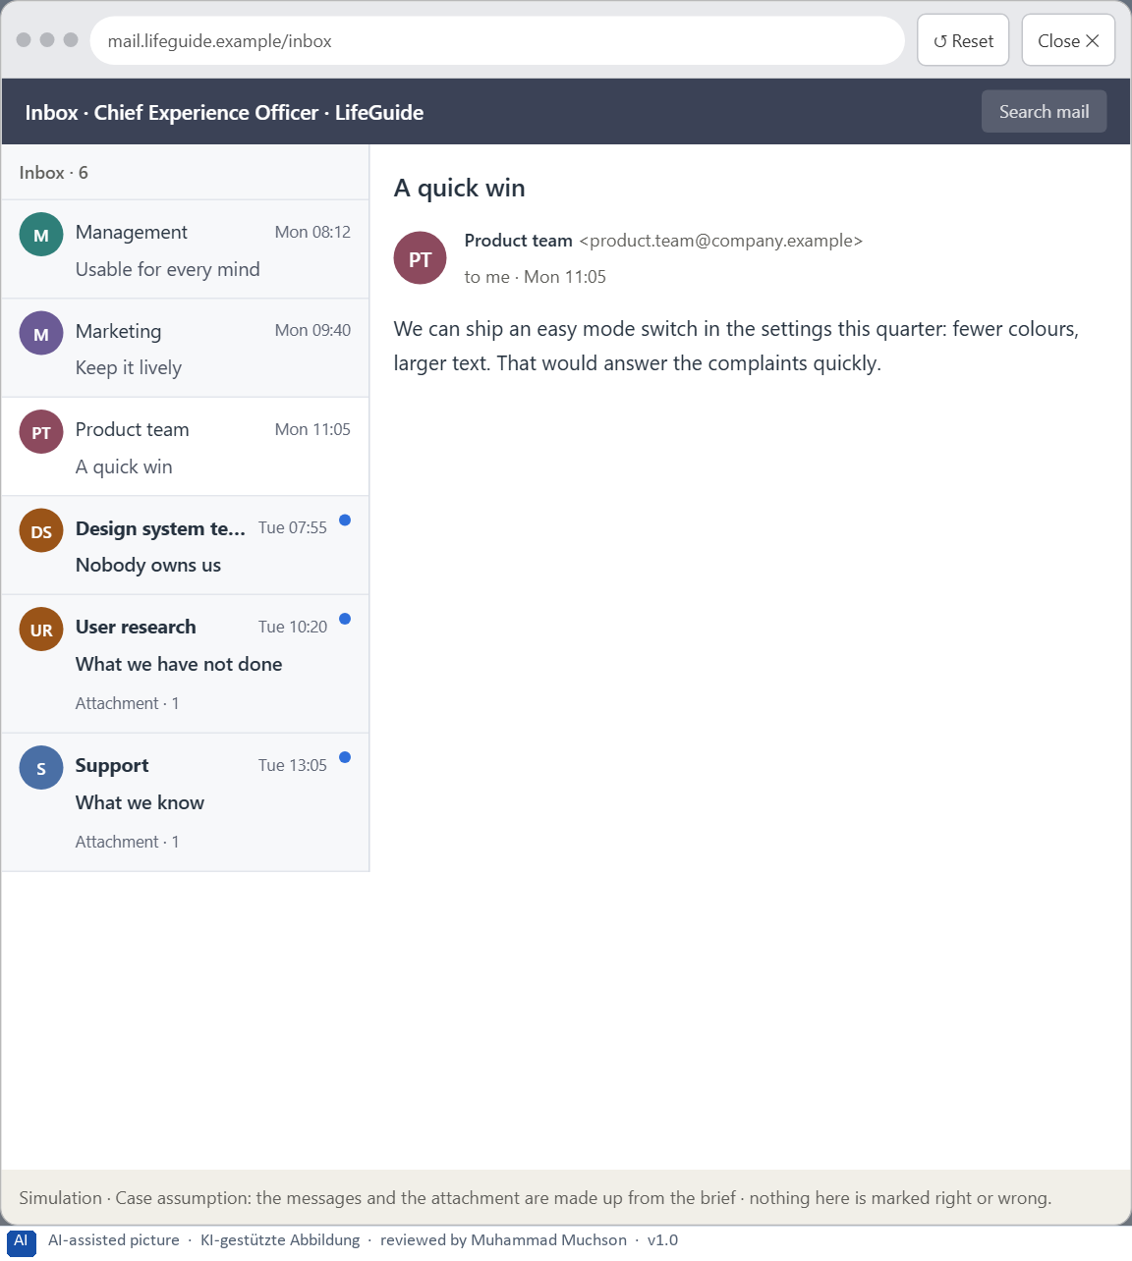
Figure 6 · Your desk: the messages that wait for you, shown in the lab as a mailbox (3 of 6).
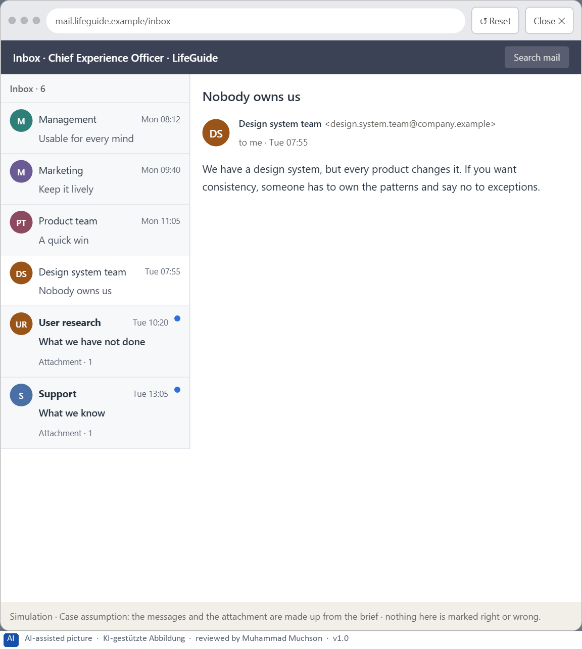
Figure 7 · Your desk: the messages that wait for you, shown in the lab as a mailbox (4 of 6).
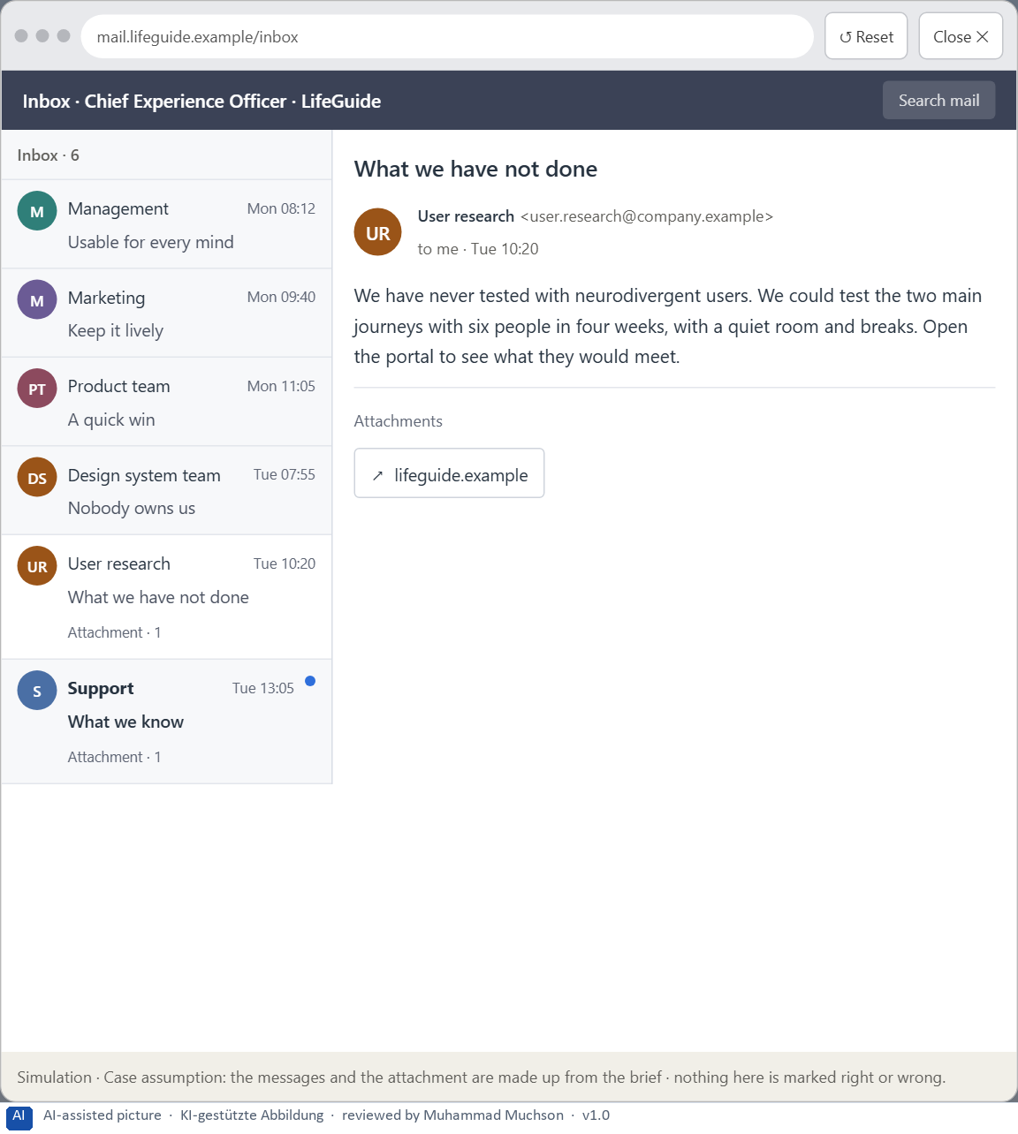
Figure 8 · Your desk: the messages that wait for you, shown in the lab as a mailbox (5 of 6).
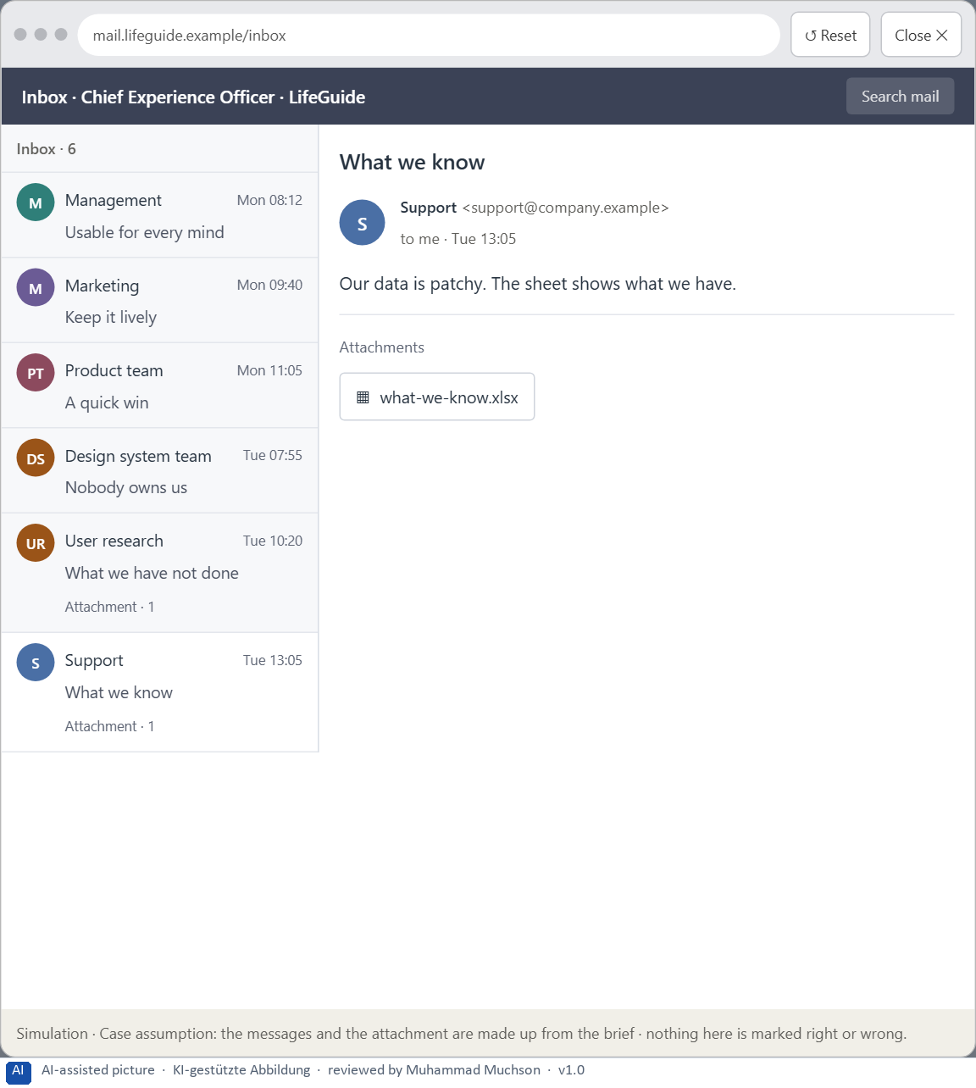
Figure 9 · Your desk: the messages that wait for you, shown in the lab as a mailbox (6 of 6).
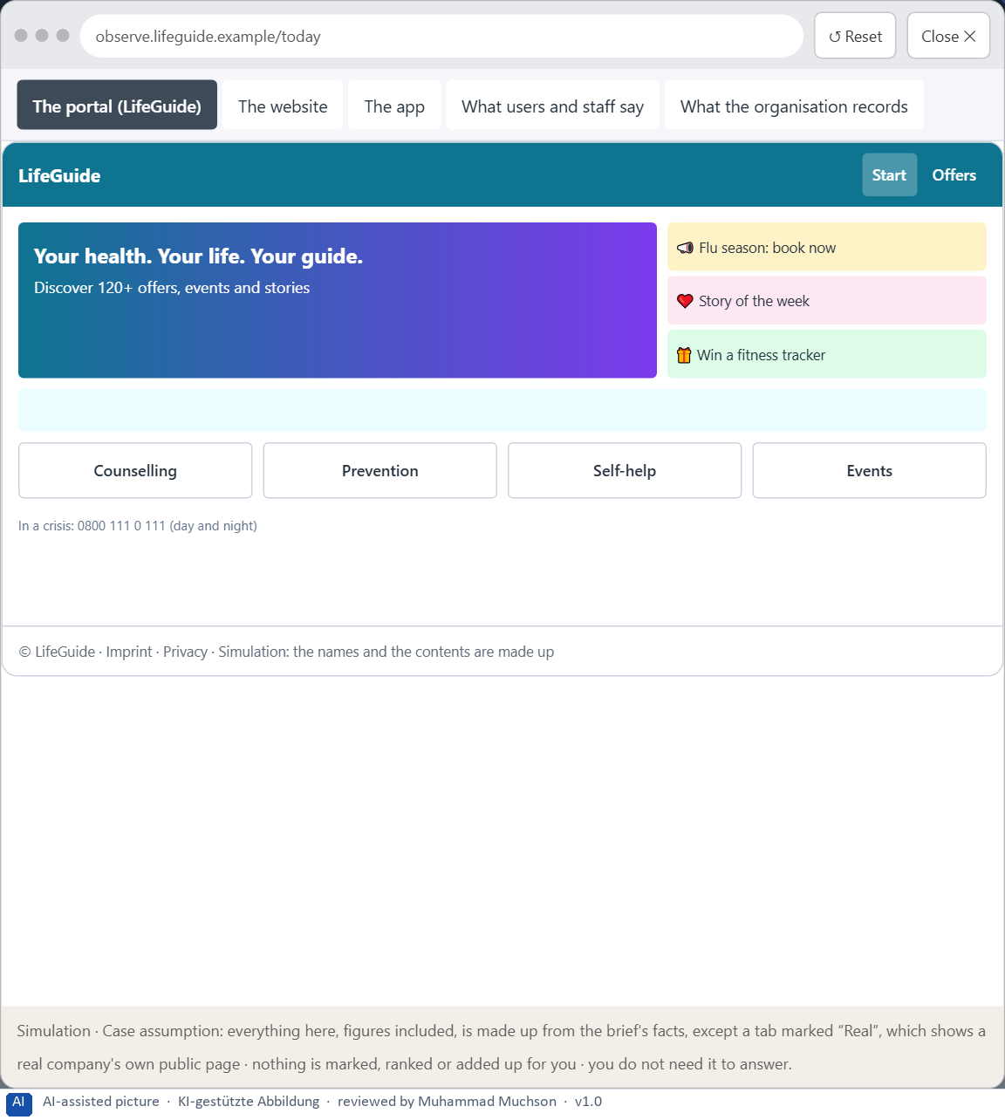
Figure 10 · The platform as it is today, as the lab lets you observe it (1 of 5).
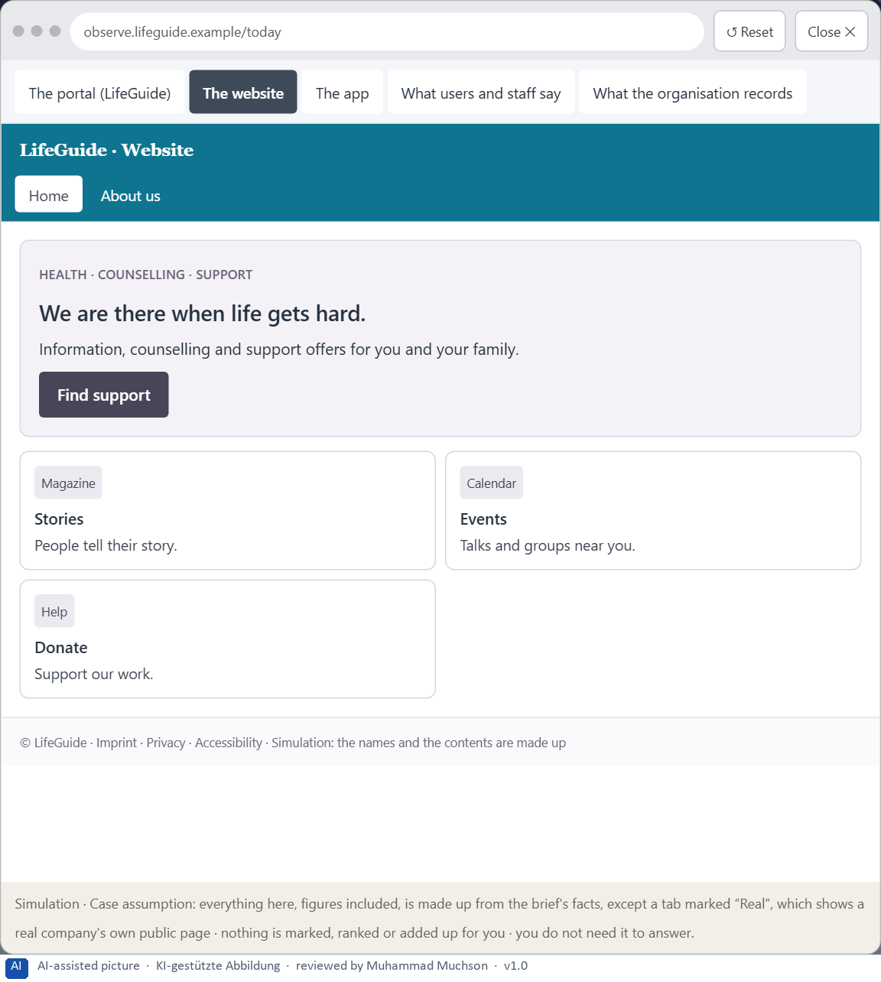
Figure 11 · The platform as it is today, as the lab lets you observe it (2 of 5).
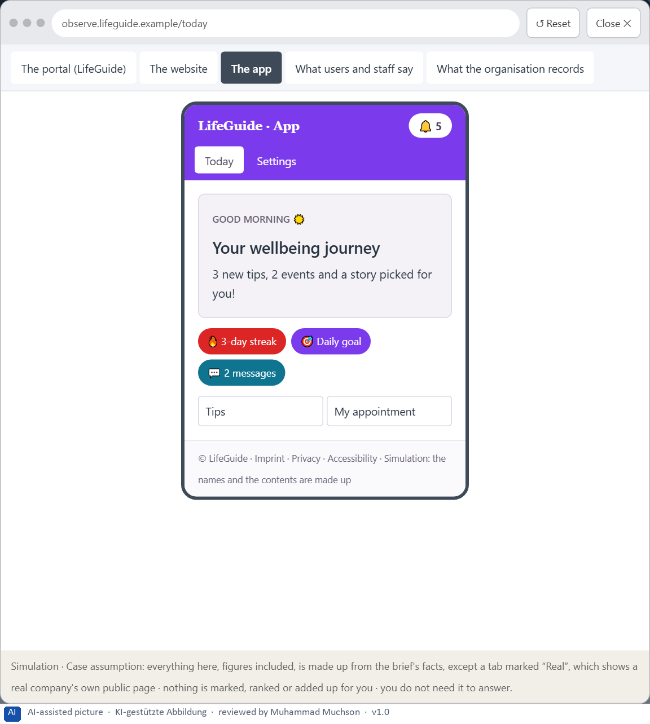
Figure 12 · The platform as it is today, as the lab lets you observe it (3 of 5).
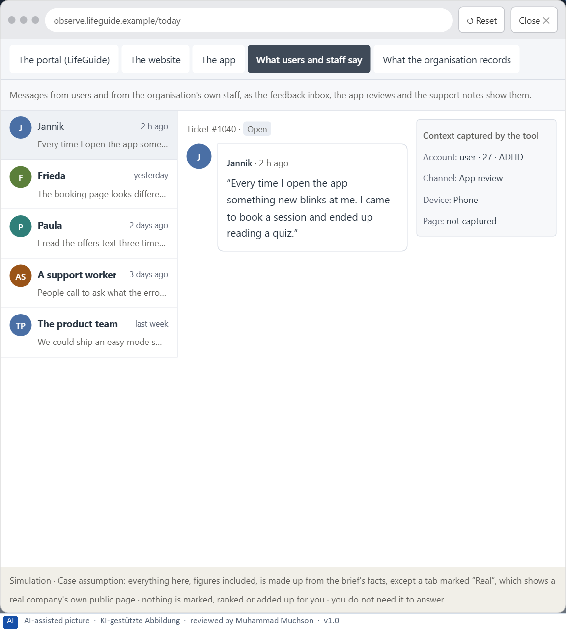
Figure 13 · The platform as it is today, as the lab lets you observe it (4 of 5).
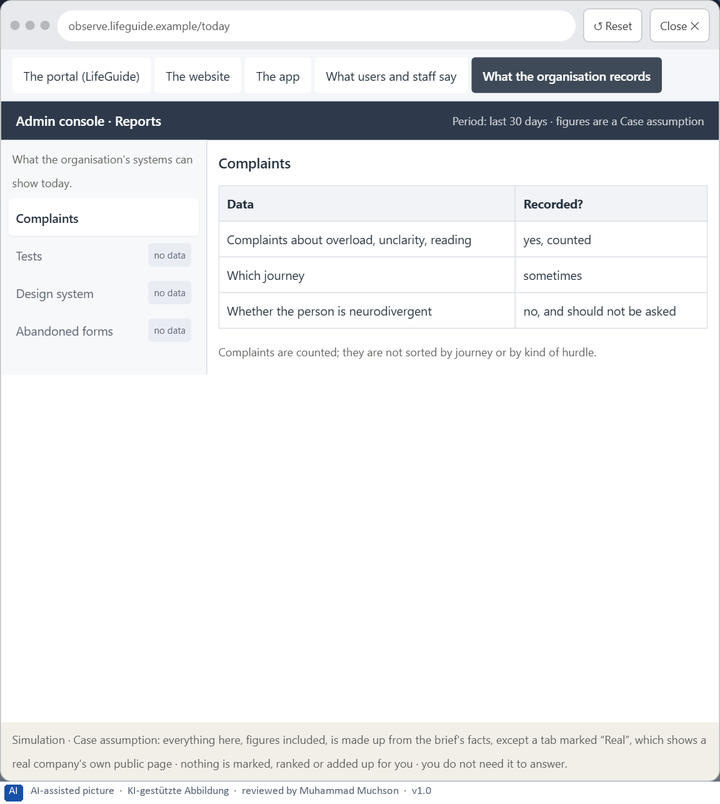
Figure 14 · The platform as it is today, as the lab lets you observe it (5 of 5).
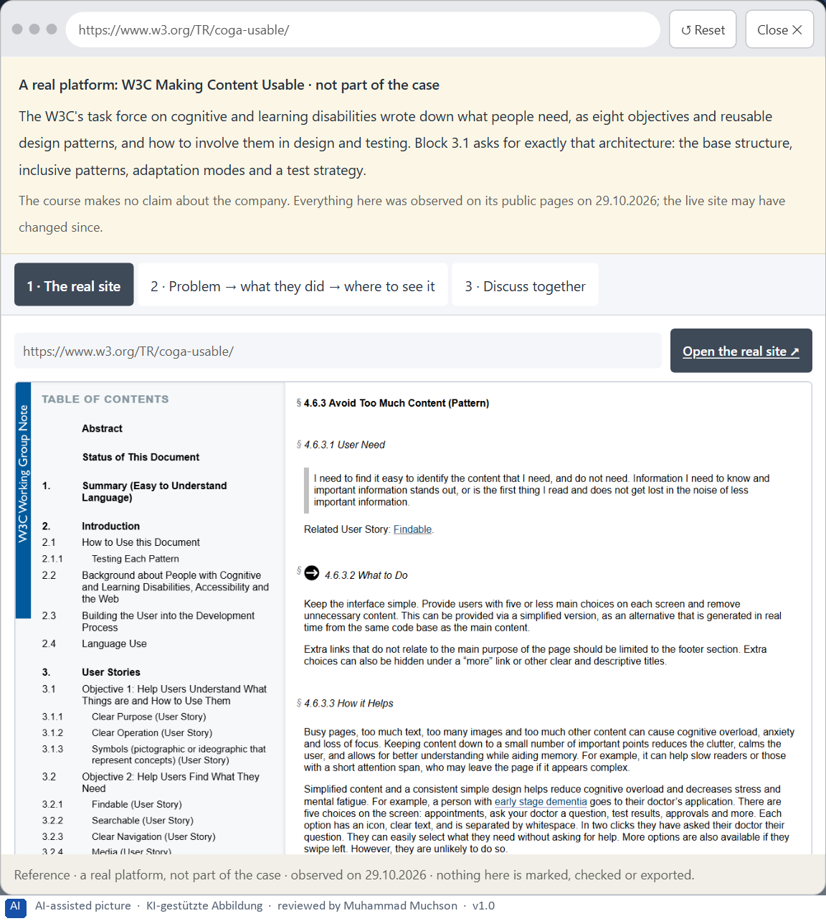
Figure 15 · A real platform that solved this, shown for the class discussion (1 of 3).
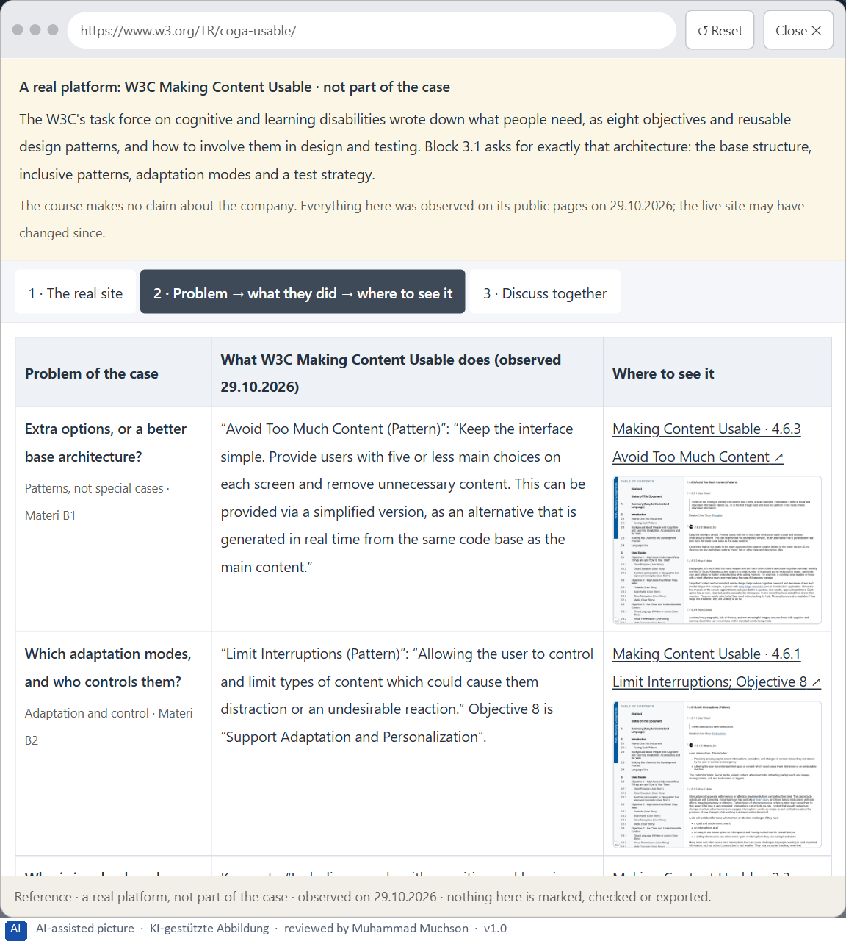
Figure 16 · A real platform that solved this, shown for the class discussion (2 of 3).
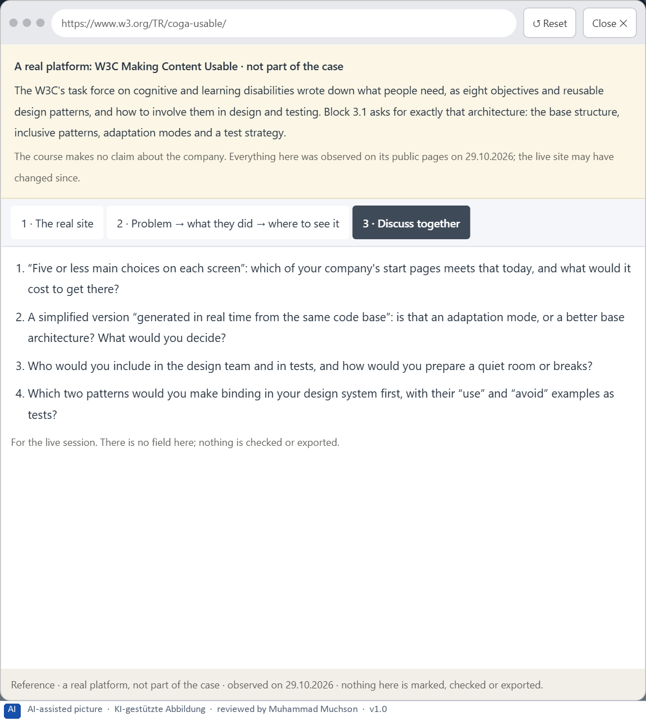
Figure 17 · A real platform that solved this, shown for the class discussion (3 of 3).
Question 1 of 7 · A guiding vision for neurodiverse UX: which form of relief, predictability, readability and adaptability should be guaranteed systematically?
One or two sentences about the relief, the predictability, the readability and the adaptability every product gives.
How to build the answer:
- Say what relief every product gives: calm, one thing at a time.
- Say what predictability and readability mean, and how people can adapt it.

Question 2 of 7 · Three strategic guiding decisions on base architecture, inclusive design patterns, assistive technologies, adaptation modes and test strategy
How to build the answer:
- Take your vision and ask which three choices would make it real.
- Write each as “we will …, even though that means …”.
Write them as a list, one decision per line, each with what it gives up.

Question 3 of 7 · A prioritised architecture of measures: which journeys, components or product areas are improved first, and why?
Put the journeys, components or product areas in an order and give the reason for the first ones.
How to build the answer:
- List the candidates: the start pages, the navigation, the forms component, the booking journey, the app's home, the content and texts, the modes.
- Put first what every product uses and what people in stress meet first.
- Say why the others wait.

Question 4 of 7 · A risk analysis: which wrong assumptions about user diversity, standardisation and economic viability would be especially critical?
Name two or three assumptions and the harm if each is wrong.
How to build the answer:
- Write down what your concept assumes about the users.
- Write down what it assumes about one standard for all.
- Write down what it assumes about cost and benefit.

Question 5 of 7 · A governance model: who is responsible for neurodiverse UX principles, and how are conflicts between brand, technology, product logic and inclusion decided?
Name roles, not people: who owns the principles and the patterns, who sets the test strategy, the roles of marketing, the product teams and the design system team, and how a conflict is decided.
How to build the answer:
- Name who owns the neurodiverse UX principles and the inclusive patterns.
- Say who sets the test strategy and how it is checked in every release.
- Say how a conflict between brand, technology, product logic and inclusion is decided.

Question 6 of 7 · A decision under uncertainty: make at least one prioritised decision despite patchy test and usage data and justify it responsibly
Say what you decide, what you do not know, and why the decision is responsible all the same, for example when you would reverse it.
How to build the answer:
- State the decision in one sentence.
- Name what you do not know.
- Say why it is still responsible: it can be reversed, it can be checked soon, or waiting costs more.

Question 7 of 7 · A management statement: a recommendation to the management with a clear priority and a strategic reason
Four to six sentences: the direction first, then the priority, the reason and what you ask of the management.
How to build the answer:
- Start with the direction in one sentence.
- Name the priority and the reason that carries it.
- Say what you ask of the management and what you will report back.

Use in class: presentation and handout
Mark of use for the worksheet. Presentation is what the trainer shows on screen; Handout is what participants fill in and hand in.
Part of the worksheet | Presentation (shown in the Neuro-UX Lab) | Handout
The case: two platforms on the UX team's desk, and LifeGuide | The case read aloud or on screen | The case text
Block 1.1 · Recognise neurodiverse hurdles in an interface: StudyPath | The task wording at the start of the block (no answers are shown) | Worksheet block with answer boxes (Core)
Block 1.2 · Rate inclusive design approaches under conflicting goals: JobAccess | The task wording at the start of the block (no answers are shown) | Worksheet block with answer boxes (Core)
Block 2.1 · Case study: an inclusive prototype for the service portal LifeGuide | The task wording at the start of the block (no answers are shown) | Worksheet block with answer boxes (Core)
The situation: formally accessible, but not usable for every mind | The case read aloud or on screen | The case text
Block 3.1 · A strategic UX architecture for neurodiverse and adaptive use | The task wording at the start of the block (no answers are shown) | Worksheet block with answer boxes (Core)

Glossary
Every term below is used in this document. Terms stay plain text in the body; this list says what they mean in everyday words.
Term | In plain words | Example | Comes from
Accessibility | Designing so that everyone can use a product, also people who see less well, see colours differently, or use a keyboard or a screen reader. | — | Day 3
Adaptation mode | An optional setting that changes how a product looks or behaves for someone's needs, such as fewer stimuli, a reading mode or a simplified view; it works best on top of a good default. | — | Day 13
ADHD | Attention deficit hyperactivity disorder: a different way of directing attention and controlling impulses; busy pages, distractions and long unstructured tasks are especially hard. | — | Day 13
Assistive technology | Tools people use to operate digital products, such as a screen reader that reads the screen aloud, a magnifier, a switch or voice control. | — | Day 12
Attention | The mind's spotlight. Only a small part of a screen is processed at any moment; attention decides which part. | A flashing banner takes attention away from the form you were filling in. | Day 1
Autism | A different way of perceiving and processing; inconsistent patterns, ambiguous words and sensory overload are especially hard, predictability helps. | — | Day 13
Brand effect | How a design makes people recognise the company and what they feel about it, such as modern, serious or friendly. | — | Day 3
Case assumption | A fact made up for this exercise to fill a gap in the plan's case. It is marked so you know it is not part of the plan. | — | Day 1
Chief Experience Officer | The manager who is responsible for the experience customers have across all channels, and who decides where the company invests in it. | — | Day 1
Cognitive load | How much a person has to hold in mind and work out at the same time. Every extra signal or choice adds to it; when it is too high, people skip, freeze or leave. | — | Day 1
Component | A reusable building block of an interface, such as a button, a form field or a status label, built once and used on many screens. | — | Day 6
Consistency | The same thing looks, is named and works the same way everywhere, so what people learn on one page holds on the next. | — | Day 2
Decision architecture | A set of connected decisions that are made on purpose and written down: what effect you want, what comes first, who decides and how conflicts are settled. It replaces many separate fixes. | — | Day 1
Design logic | A set of decided rules and shared components, such as which colour means what and which type levels exist, used for every screen so everything stays consistent. | — | Day 3
Dyslexia | A difference in reading and spelling; dense, justified text, unsuitable typography and complex language are especially hard. | — | Day 13
Governance | The rules about who may decide what, who is answerable for it and how disagreements are settled. | — | Day 1
Inclusive design | Designing with the full range of people from the start, including permanent, temporary and situational limits and different minds. | — | Day 12
Inclusive design pattern | A reusable solution that helps several groups at once, such as one task per screen, a step indicator or a summary before sending. | — | Day 13
Information density | How much a screen shows at once. Too much and everything competes; too little and people have to click a lot to reach anything. | — | Day 2
Neurodiversity | The natural variety of human minds, including ADHD, autism and dyslexia; designs that reduce distraction and use plain, predictable language help many of them. | — | Day 12
Orientation | Knowing where you are, what you can do here and what happens next. | — | Day 1
Predictability | Being able to tell in advance how something will work, because it works like what you have seen before. | — | Day 6
Readability | How easily a text can be read and understood: its size, contrast, line length, wording and how it is broken into parts. | — | Day 2
Stakeholder | A person or department with an interest in a decision, such as marketing, compliance, IT or sales. | — | Day 1
Status colour | A colour that shows the state of something, such as sent, waiting or failed. It needs a word or a symbol next to it, because colour alone is missed or misread. | — | Day 3
Stimulus load | How much competes for attention at once (colours, banners, movement, notifications); too much tires, distracts or overwhelms. | — | Day 13
Stimulus reduction | Showing or saying fewer things at once, so the mind can attend to what matters. | — | Day 11
Typography | How text is set: which typeface, which size, weight, line spacing and line length, and how the text is broken into levels and parts. | — | Day 3
UX (user experience) | Everything a person goes through when using a product: what they notice, understand, feel and do, from the first look to the last step. The screens are only one part of it. | Finding the booking you want at once and feeling sure it went through is a good UX. | Day 1

The Neuro-UX Lab: where we practise online
In class we use the course website as the place to practise and to learn. Every day has its own address, in the same pattern: the day number is the last part.
What | Address
Neuro-UX Lab (course website) | https://aion-ux-lab.vercel.app/
Day 13 | https://aion-ux-lab.vercel.app/day/13/

On the day page, Route 1 (Levels 1 and 2) and Route 2 (Level 3) can be opened; the cards and the tasks of this document are there too. The pattern is the same up to Day 8, for example https://aion-ux-lab.vercel.app/day/6/.

