AION · UX DEVELOPER · PSYCHOLOGICAL UX DESIGN AND NEURO-UX
DAY 11 · MATERI A AND MATERI B · ROUTES 1 AND 2 · LEVELS 1 TO 3
Voice interfaces, neuro-design and testing AI interfaces
Study material with real research, worked examples and the rules you use in the tasks
AI notice · KI-Hinweis
This document was produced with the help of an AI language model (Claude, Anthropic). The AI drafted the text and tables and built the pictures and working examples of the lab. The content was then read, corrected and approved by the reviewer named below, who is responsible for its accuracy. Every picture carries an AI label on the image. Check figures and sources before you quote them.
KI-Hinweis: Dieses Dokument wurde mit Unterstützung eines KI-Sprachmodells (Claude, Anthropic) erstellt. Texte und Tabellen wurden von der KI entworfen, die Abbildungen sind KI-gestützt erstellt und am Bild gekennzeichnet. Die fachliche Prüfung und Freigabe erfolgte durch die unten genannte Person.

Day | Day 11 · Module 5 (day 2 of 2): Voice interfaces, neuro-design and testing AI interfaces
Document | Materi (study material). Materi A has five cards, Materi B has three.
Route and level | Materi A serves Route 1 (Levels 1 and 2, Task 1). Materi B serves Route 2 (Level 3, Task 2).
Time | Materi A about 60 min · Materi B about 60 min (facilitator-led)
Neuro-UX Lab (website) | https://aion-ux-lab.vercel.app/day/11/
Case | Worked examples use a made-up company in each card. The task case is CityHelp Voice (see the Task document).
Version | 1.0 · release date 29.10.2026
Review and approval | Muhammad Muchson, Mentor (subject-matter review and approval)

ABOUT THIS DOCUMENT
In class we also use the Neuro-UX Lab, the course website, as the place to practise and learn. Its address is at the end of this document.
Today is about interfaces you talk to. You learn what voice does better than a screen and where it fails, what a good voice dialogue needs, what the brain needs from an intelligent interface, and how to prototype and test one before it meets real people. Then you use it on three voice assistants you can actually talk to (by typing, or by speaking where your browser allows it), and you look at how a voice platform and a government AI assistant handle errors, limits and testing. This document holds everything you need to study Day 11 without the website. Every card says what the idea is in plain words, shows it in a picture, gives the details and ends with the rules you use in the tasks.

IN THIS DOCUMENT
Lesson plan: ten teaching units (Ablaufplan)
Case study and transfer project at a glance
A1 · Screen, chat or voice: what voice can do and where it fails · 12 min · Core
A2 · A good voice dialogue: expectations, feedback, errors, repeat, control · 12 min · Core
A3 · Neuro-design: predictable, light on memory, calm · 12 min · Core
A4 · Prototyping and testing an AI interface · 12 min · Core
A5 · Where voice belongs, and weighing a measure · 12 min · Core
B1 · Voice and AI as a service architecture, not an innovation signal · 20 min · Core
B2 · Comfort, precision, trust, effort: the conflicts of voice · 20 min · Core
B3 · Voice principles, test standards and deciding with little test data · 20 min · Core

Day at a glance
Day 11 has ten teaching units (UE). This document is the study material; it is used in UE1 (Materi A) and UE8 (Materi B). The day is built from three documents and the Neuro-UX Lab: Materi (study material), Task (worksheet) and Trainer (coaching, feedback and model solutions), plus the course website.

Lesson plan: ten teaching units (Ablaufplan)
UE | Min | Plan item | What happens | Material | Format
1 | 45 | Knowledge transfer · Level 1 | The trainer presents the cards of Materi A (A1, A2, A3, A4, A5, about 60 min of cards) in the Neuro-UX Lab; participants follow in the handout. | Materi A (Route 1) | Presentation + Handout
2 | 45 | Level 1 · Task 1 | Individual work on Block 1.1 (Core, about 10 min): the first product of the day is read and its effect described. Pairs then compare their results and the trainer collects open questions. | Task 1 · Part 1 · Block 1.1 | Handout (or in the lab)
3 | 45 | Level 1 · Task 2 | Three options are rated on the same criteria and one is chosen under the stated conditions: Block 1.2 (Core, about 8 min). | Task 1 · Part 1 · Block 1.2 | Handout (or in the lab)
4 | 45 | Coaching · transition from Level 1 to Level 2 | Trainer-led. A short talk on the day's coaching focus, then the reflection questions in pairs. The bridge: from describing an effect to a decision you answer for. There is no worksheet block in this unit. | Trainer document, section Coaching | Trainer only
5–6 | 90 | Level 2 · Case study CityHelp Voice (2 UE) incl. model solution | UE5: the trainer presents the case; participants work on Block 2.1 (Core, about 15 min). UE6: groups compare their results and defend them; the trainer closes with the model solution. | Task 1 · Part 2 · Block 2.1  Trainer document, section Case study | Handout; model solution shown after the work
7 | 45 | Level 2 + 3 · Feedback round with a management perspective | Groups present their reasoning, not only their result. The trainer asks the day's Level 3 input questions and leads the discussion. | Trainer document, section Feedback round | Presentation by the groups; Trainer only
8 | 45 | Level 3 · Transfer project, Chief Experience Officer (3 UE: UE8–10) | The trainer presents Materi B (B1, B2, B3; use the "In plain words" and "How to decide" boxes, the rest is handout) and sets the role and the situation. | Materi B (Route 2) | Presentation + Handout
9 | 45 | Level 3 · Transfer project | Individual work or in pairs on Block 3.1 (Core, about 20 min): the strategy memo. | Task 2 · Block 3.1 | Handout (or in the lab)
10 | 45 | Level 3 · Transfer project | Participants present their decision and what they give up, including the one decision made under uncertainty; the trainer debriefs with the model solution. | Task 2 · Block 3.1  Trainer document, section Transfer project | Handout; model solution shown after the work

One UE is counted as 45 minutes here; breaks are not shown. The times are a guide for the trainer. The Core blocks are enough for a complete answer.

Case study and transfer project at a glance
Component | UE | Duration | Participants work in | Model solution in
Level 2 case study (CityHelp Voice) | UE5–6 | 2 UE · 90 min | Task 1 · Part 2 (Block 2.1) | Trainer document, section Case study
Level 3 transfer project (Chief Experience Officer) | UE8–10 | 3 UE · 135 min | Materi B and Task 2 (Block 3.1) | Trainer document, section Transfer project

Materi A · Route 1 · Levels 1 and 2
How Materi A is used
About 60 minutes, five cards. Levels 1 and 2: find where an energy assistant strengthens or weakens comprehensibility, trust and control, rate three voice designs of a health platform under conflicting goals, then analyse a city's voice assistant, develop four measures, justify them and decide on the first 14 weeks. The cards give you the ideas and the rules you use in Task 1.

A1 · Screen, chat or voice: what voice can do and where it fails · 12 min · Core
A screen shows every option at once, a chat keeps a written record, voice leaves nothing to look at. Voice offers hands-free use, speed, accessibility, situational relief and natural interaction; it fails through misunderstandings, lost context, error-proneness, invisible options and high expectations of naturalness.
IN PLAIN WORDS
The idea. The same task can be done on a screen, in a typed chat or by voice. A screen shows every option at once; a chat keeps a written record; voice leaves nothing to look at. Voice is strong when hands or eyes are busy, when speed matters, for people who find screens hard, and because talking is natural. It fails through misunderstandings, lost context, errors that are hard to notice, options nobody can see, and the expectation that it understands like a person.
Why it matters. Block 1.1 asks for the chances and risks of HomeAssist Voice, Block 1.2 rates three voice designs for CareVoice, and Block 2.1 asks what CityHelp Voice's assistant does well and badly. This card gives you the strengths and limits of voice by name.
How to read the picture. One Ladle task, scaling a recipe and setting a timer, on a screen, in a chat and by voice.

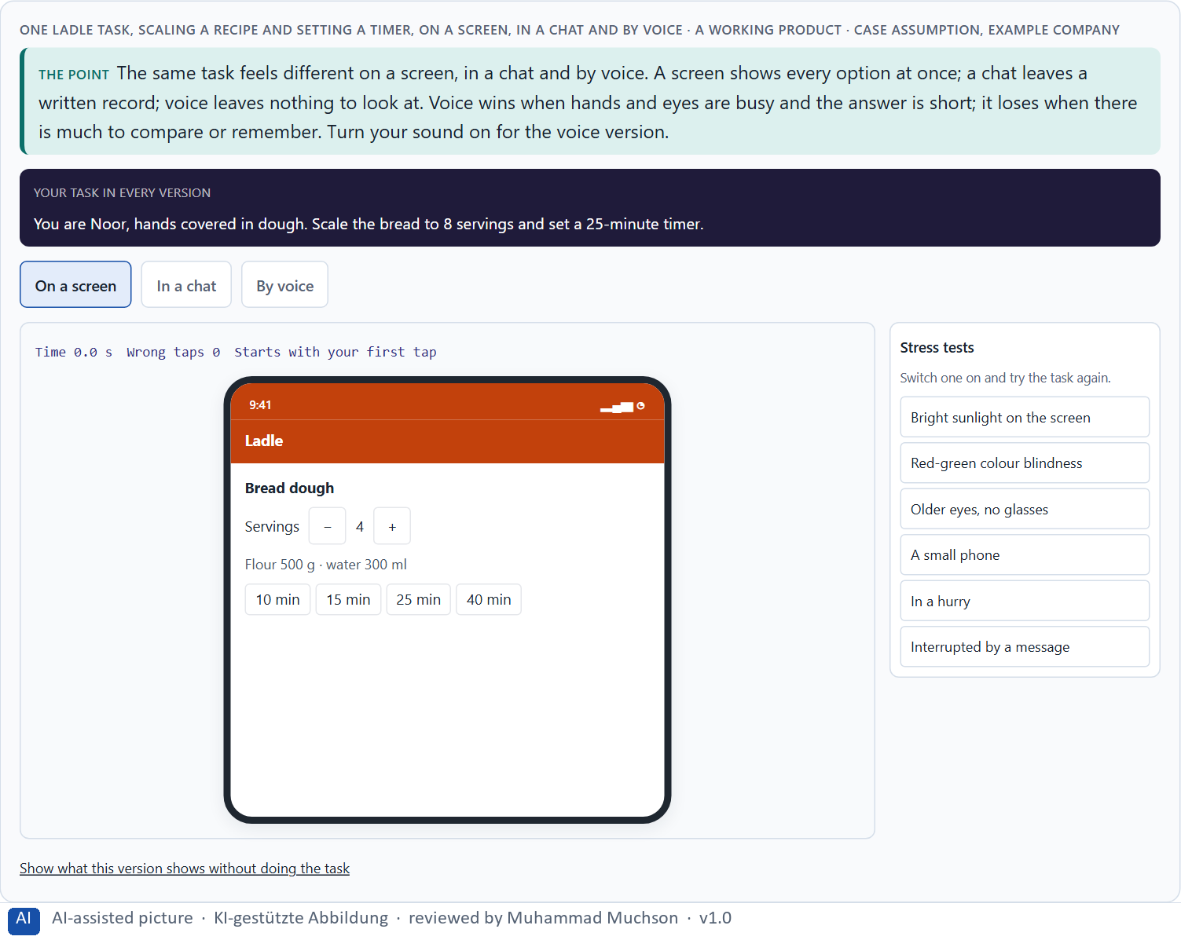
Figure 1 · One Ladle task, scaling a recipe and setting a timer, on a screen, in a chat and by voice. Shown here in its starting state; in the Neuro-UX Lab every version and every stress test can be used.
What voice can do, and where it fails
Chance | What it looks like | Limit | How it shows
Hands-free | Cooking, driving, carrying. | Misunderstandings | “Thirteen” for “thirty”.
Speed | One sentence instead of five taps. | Loss of context | “And for four people?” is not linked to the recipe.
Accessibility | For people who cannot see or use a screen well. | Error-proneness | Noise, accents, half sentences.
Situational relief | Help at the moment hands are busy. | Invisible options | Nobody sees what can be said.
Natural interaction | Talking is learned, not taught. | High expectations | People expect it to understand like a person.

What voice can do and where it fails: evidence
Topic | Real finding or rule | What it means for a screen
Accuracy in a test | A research system reached a word error rate of 5.1% on a standard test of telephone conversations, which the authors report as matching the human transcription error of the careful benchmark (Xiong et al. 2017). | Recognition can be very good under test conditions; the test is not your users' kitchen.
Accuracy for whom | In a study of five commercial speech recognition systems, the average word error rate was 0.35 for Black speakers and 0.19 for white speakers (Koenecke et al. 2020). | Test with the full range of your users' voices, or the error-proneness lands on some of them.
Hands-free is not risk-free | In a study of the infotainment systems of ten cars, mental distraction after a task lasted up to 27 seconds for the worst-performing systems, and practice did not remove it (Strayer et al. 2015, as reported). | Voice in a driving or cooking context still takes attention: keep dialogues short.
Voice and accessibility | WCAG 2.2 asks that the accessible name of a control contains its visible label (success criterion 2.5.3), so that people who control a screen by voice can say what they see. | Name the controls the way they are written on screen.

Case assumption
Ladle, Noor, Ole, Freya and Piet are made up for this example. Dialogue logic and the strengths and limits of spoken interfaces follow Cohen et al. (2004) and Pearl (2016). The findings in the table of real evidence are real research results, rules and cases; the sources are listed below.

How to decide when this comes up in the task
- Ask which mode a task needs: screen, chat or voice.
- Name the chance voice offers here: hands-free, speed, accessibility, relief, natural.
- Name the limit next to it: misunderstanding, lost context, error, invisible options, expectations.
- Check what people must remember after a spoken answer.
- Expect people to talk to it like a person; check what happens when it cannot keep up.

Extra · go deeper (optional reading)
Voice is often launched as a symbol: it shows that a company is modern. The test of whether it is more than a symbol is simple: would people miss it if it were gone, for a task they do often? A timer while cooking passes; “ask me anything” usually does not. When voice is a symbol, the cost is paid by the people who believed it and got stuck.

Sources · Cohen et al. 2004 · Pearl 2016 · Xiong et al. 2017 · Koenecke et al. 2020 · Strayer et al. 2015 · WCAG 2.2

A2 · A good voice dialogue: expectations, feedback, errors, repeat, control · 12 min · Core
A good voice interface needs clear dialogue logic, clear expectations, feedback, error handling, repeatability and user control. Without them a misunderstanding becomes a loop, and people stop trusting it.
IN PLAIN WORDS
The idea. A good voice interface needs six things. Clear dialogue logic: one question at a time, and it is clear whose turn it is. Clear expectations: people know what it can do. Feedback: it says what it understood and what it did. Error handling: when it does not understand, it asks a better question instead of repeating itself. Repeatability: “say that again” works. User control: people can stop, go back and change their mind.
Why it matters. Block 1.1 asks where HomeAssist Voice strengthens or weakens comprehensibility, trust and control, Block 1.2 asks about guided against free dialogues, and Block 2.1 asks for measures for CityHelp Voice's dialogue and error handling. This card gives you the six requirements.
How to read the picture. One Ladle voice dialogue with six switches, one per requirement.

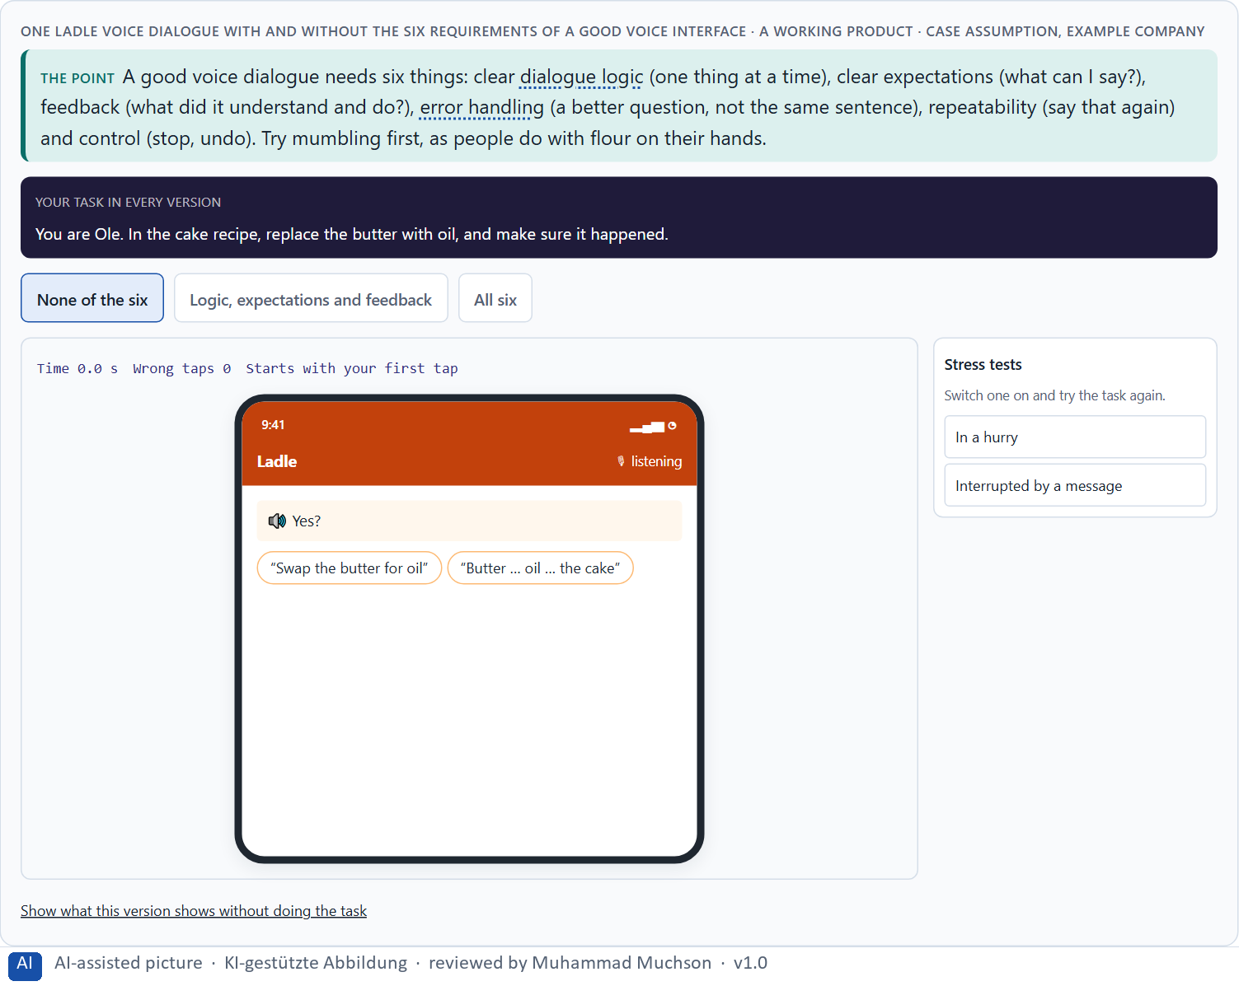
Figure 2 · One Ladle voice dialogue with and without the six requirements of a good voice interface. Shown here in its starting state; in the Neuro-UX Lab every version and every stress test can be used.
Six requirements, and the sentence that shows each
Requirement | Without it | With it (Ladle)
Dialogue logic | Four instructions and a question in one breath. | “Step 3: fold in the egg whites. Say next when ready.”
Clear expectations | People guess what it understands. | “You can say: next, repeat, timer, stop.”
Feedback | “Okay.” | “Timer for 5 minutes, for the nuts, started.”
Error handling | “Sorry, I didn't understand that.” Twice. | “Five minutes, or ten?” then the screen.
Repeatability | “We are at step 4.” | “Step 3: fold in the egg whites.”
User control | “Timer cannot be changed.” | “Timer stopped. Say start to start again.”

A good voice dialogue: principles with sources
Requirement | Real principle | What it means for a dialogue
Clear expectations | Norman calls the quality that makes the available actions visible discoverability (Norman 2013); with voice, nothing is visible unless the system says it. | Say what can be said, at the moment it matters: “You can say next, repeat, timer, stop.”
Feedback | One of the ten heuristics asks the system to keep users informed about what is going on, through appropriate feedback within a reasonable time (Nielsen 1994). | Repeat back what was understood: “Timer for 5 minutes, for the nuts, started.”
Error handling | Another heuristic asks that error messages are expressed in plain language, indicate the problem and suggest a solution (Nielsen 1994). | Ask a narrow question after a failure, and offer the screen as a way out.
Repeatability | Speech passes by and cannot be re-read; working memory holds about four chunks (Cowan 2001). | Let people say “repeat”, and keep each answer to a few chunks.
Design practice | Voice interface design books describe the same elements: dialogue logic, prompts, confirmation and recovery (Cohen et al. 2004; Pearl 2016). | Write the dialogue as a script and read it aloud before building it.

Case assumption
Ladle, Noor, Ole, Freya and Piet are made up for this example. Setting expectations, confirming and escalating errors follow Pearl (2016); feedback and visible options follow Norman (2013). The findings in the table of real evidence are real research results, rules and cases; the sources are listed below.

How to decide when this comes up in the task
- Dialogue logic: one question at a time, and it is clear whose turn it is.
- Expectations: does it say what it can do?
- Feedback: does it say what it understood and did?
- Error handling: after a miss, a better question; after the second, another way (a screen, a person).
- Repeat and control: can people hear it again, stop, change or go back?

Extra · go deeper (optional reading)
The hotline loop everybody knows, “Sorry, I didn't understand. Returning to the main menu”, is not a technical failure but a design decision: someone decided that a misunderstanding ends where it began. Error handling is where a voice interface earns or loses trust, because it is the moment people need it most and have the least patience.

Sources · Pearl 2016 · Cohen et al. 2004 · Norman 2013 · Nielsen 1994 · Cowan 2001

A3 · Neuro-design: predictable, light on memory, calm · 12 min · Core
Neuro-design asks what the brain needs: predictability, cognitive relief, trust, a clear mental model and fewer stimuli. Voice raises the load quickly, because everything said must be held in working memory, which holds only a few things.
IN PLAIN WORDS
The idea. Neuro-design asks what the brain needs from an intelligent interface. Predictability: the same request gives the same kind of answer. Cognitive relief: the interface remembers, so the person does not have to. Trust: it does what it says. A mental model: people can picture how it works. Stimulus reduction: fewer things at once. Voice raises the load quickly, because everything said must be held in working memory; a spoken list of eight options is much harder than one on a screen.
Why it matters. Block 1.1 asks about predictability and relief at HomeAssist Voice, Block 1.2 about comfort and comprehensibility, and Block 2.1 about CityHelp's users who do not know what is possible. This card explains why voice can relieve or overload the mind.
How to read the picture. A memory test: Ladle reads out a menu of options, then asks for one. Then a slider from calm to busy.

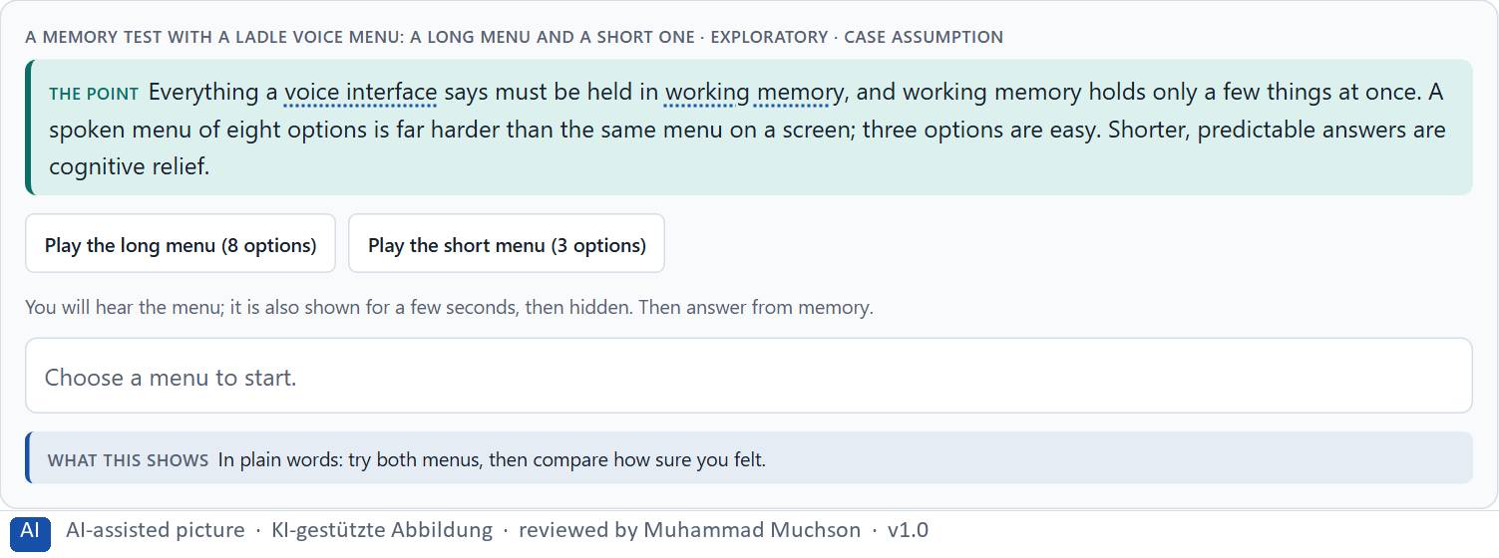
Figure 3 · A memory test with a Ladle voice menu: a long menu and a short one · Exploratory.
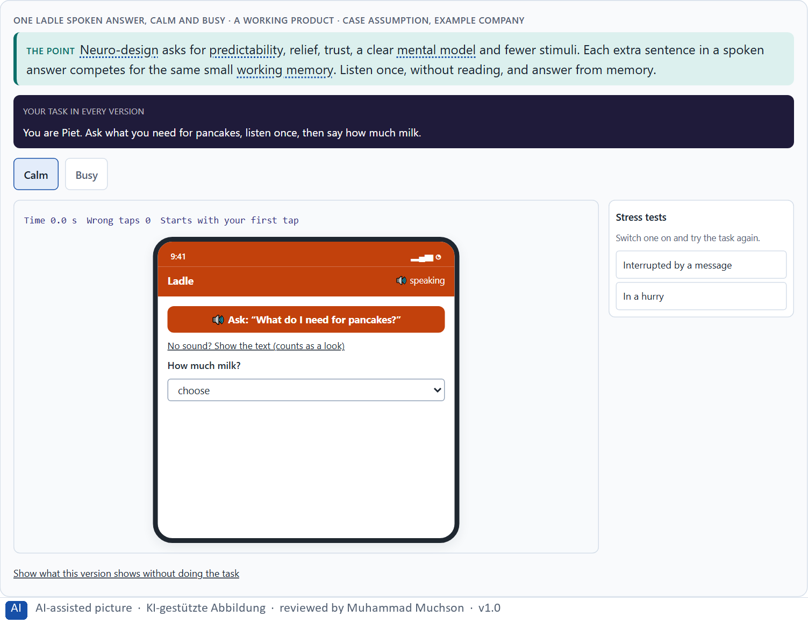
Figure 4 · One Ladle spoken answer, calm and busy. Shown here in its starting state; in the Neuro-UX Lab every version and every stress test can be used.
Predictable, light on memory, calm: evidence
Principle | Real finding | What it means for a voice screen
Light on memory | People hold about four chunks in mind at once (Cowan 2001). | Offer at most three options in one prompt, and say the most likely one first.
Less extraneous load | Effort spent on working out the interface is missing for the task (Sweller 1988). | Do not make people remember the commands: say them.
Load can be measured | Distraction ratings of voice systems in cars ranged from 2.4 for the best system to 4.6 for the worst on a five-point scale (Strayer et al. 2015, as reported). | Measure the load of a dialogue, for example with a dual task, before launch.
Mental models | People act on what they believe a system is and does (Norman 2013). | Tell the person what kind of assistant it is, and keep that behaviour stable.

Case assumption
Ladle, Noor, Ole, Freya and Piet are made up for this example. The small capacity of working memory follows Cowan (2001); extra load leaving less for the task follows Sweller (1988); mental models follow Norman (2013). The findings in the table of real evidence are real research results, rules and cases; the sources are listed below.

How to decide when this comes up in the task
- Predictability: does the same request give the same kind of answer?
- Relief: does the interface remember, so the person does not have to?
- Mental model: can people picture what it can and cannot do?
- Stimulus reduction: is there one thing per answer, or five?
- Count the options in a spoken answer: past three or four, people lose them.

Extra · go deeper (optional reading)
An intelligent interface can lower load (it remembers the recipe, the time, the last step) or raise it (it adds tips, offers and choices to every answer). The difference is rarely the technology; it is what the team decided to say. The calmer interface usually feels more intelligent, because people can follow it.

Sources · Cowan 2001 · Sweller 1988 · Norman 2013 · Strayer et al. 2015

A4 · Prototyping and testing an AI interface · 12 min · Core
A functional prototype tests whether the technology works, an interaction prototype how the dialogue feels (often a person secretly plays the system), a test prototype whether real users manage real tasks. Test comprehensibility, error robustness, met expectations, transparency and acceptance, and test risky situations on purpose.
IN PLAIN WORDS
The idea. AI interfaces are tested with three kinds of prototype. A functional prototype checks whether the technology works at all. An interaction prototype checks how the dialogue feels, often with a person secretly playing the system (“Wizard of Oz”). A test prototype is close to the real thing and is tried with real users on real tasks. Test five things: comprehensibility, error robustness, whether expectations are met, transparency and acceptance; and test the risky and ambiguous situations on purpose, not only the easy ones.
Why it matters. Block 2.1 asks for measures that include prototyping and testing CityHelp Voice with risk-based scenarios, and Block 1.2 notes that CareVoice's user tests exist only in first approaches. This card gives you the prototypes and what to test.
How to read the picture. Three Ladle questions, each answered by a different prototype. Below, a test plan by risk level.

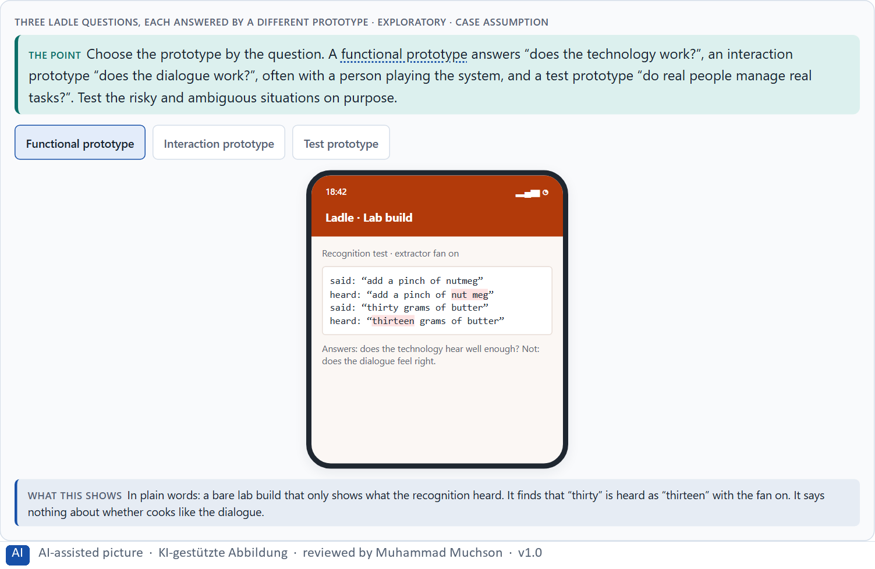
Figure 5 · Three Ladle questions, each answered by a different prototype · Exploratory.
A Ladle test plan by risk level
Risk level | Example scenario | Tested how | Must pass before
Low | Next step, repeat, timer. | Test prototype, a few cooks. | Launch.
Medium | Change a running timer; noise; half sentences. | Test prototype in real kitchens, on purpose. | Launch.
High | Allergy substitutes; paying. | Wizard of Oz first, then test prototype, with the nutrition team. | Any voice answer at all.

Prototyping and testing an AI interface: methods and findings
Method or finding | Real source | What it means for a test
Wizard of Oz | In the 1984 study of natural language office applications, a person played the part of the system behind the screen, so the design could be tested before it was built (Kelley 1984). | Test the dialogue with a hidden human first; build the recogniser later.
What a prototype is for | A prototype can answer questions about the role of a product, about its look and feel, and about its implementation (Houde and Hill 1997). | Say which of the three questions each prototype answers: functional, interaction or test prototype.
Test with all voices | Recognition error rates differ between groups of speakers (Koenecke et al. 2020). | Recruit test participants across accents, ages and speaking styles.
A test set is not the world | A word error rate of 5.1% was measured on a standard telephone test set (Xiong et al. 2017). | Test in the real setting: noise, half sentences, interruptions.

Case assumption
Ladle, Noor, Ole, Freya and Piet are made up for this example. Choosing a prototype by its question follows Houde and Hill (1997); the Wizard-of-Oz method follows Kelley (1984). The findings in the table of real evidence are real research results, rules and cases; the sources are listed below.

How to decide when this comes up in the task
- Name the question first, then choose the prototype.
- Try a dialogue with a person playing the system before building it.
- Test the five aspects: comprehensibility, error robustness, expectations met, transparency, acceptance.
- Sort test scenarios by risk; test the high-risk and ambiguous ones on purpose.
- Test with the people who will find it hardest, not only with colleagues.

Extra · go deeper (optional reading)
Most voice tests use the easy cases, because they make the demo look good. The cases that decide trust are the ambiguous and the sensitive ones, and they are exactly the ones nobody wants to try in front of the board. A risk-based test plan forces them onto the list before the public finds them.

Sources · Houde & Hill 1997 · Kelley 1984 · Koenecke et al. 2020 · Xiong et al. 2017

A5 · Where voice belongs, and weighing a measure · 12 min · Core
Voice belongs where tasks are simple, frequent and clear, hands or eyes are busy and a mistake is cheap. Leaders keep technology where it supports reliably instead of impressing. Weigh measures on effect on users, feasibility, risk and time pressure.
IN PLAIN WORDS
The idea. Not every task suits voice. Voice belongs where tasks are simple, frequent and clear, where hands or eyes are busy, and where a mistake is cheap; it does not belong where choices are many and unfamiliar or a mistake is costly. Leaders make sure the technology supports reliably instead of impressing. To put measures in order, weigh each on effect on users, feasibility, risk and time pressure, the four Block 2.1 names.
Why it matters. Block 2.1 asks for four prioritised measures for CityHelp Voice, justified on effect on users, feasibility, risk and time pressure, and Block 1.2 asks which CareVoice design holds. The example uses Ladle and its own measures, so the answer for the task cases is not given.
How to read the picture. Five questions that decide whether a task suits voice, tried on three Ladle tasks. Then three measures rated on effect on users, feasibility, risk and time pressure.

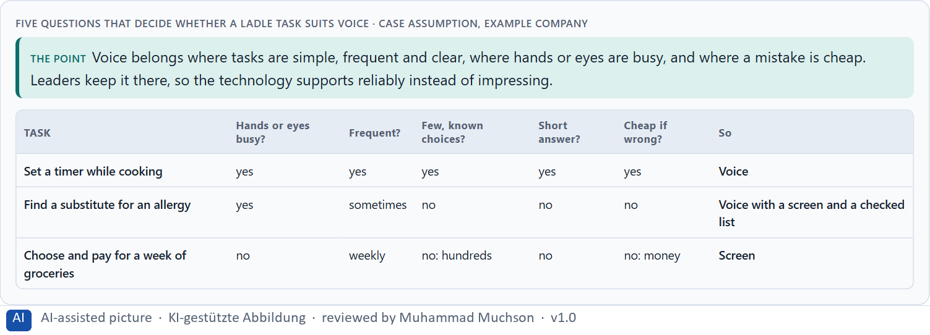
Figure 6 · Five questions that decide whether a Ladle task suits voice.
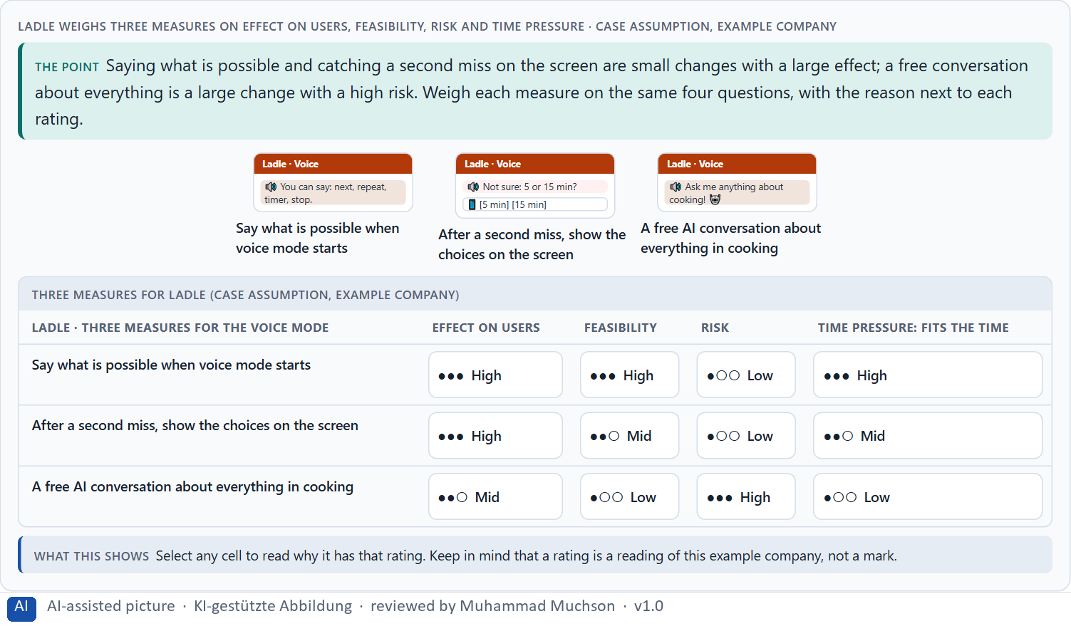
Figure 7 · Ladle weighs three measures on effect on users, feasibility, risk and time pressure.
Where voice belongs: evidence
Topic | Real finding or rule | What it means for a measure
Good fit | Hands and eyes are busy, the task is short and frequent, and the vocabulary is small (Pearl 2016). | Choose voice for the tasks that fit this profile.
Poor fit | Error rates differ between speakers (Koenecke et al. 2020), and invisible options make rare commands undiscoverable (Norman 2013). | Keep a screen path for rare and sensitive tasks.
Risk in context | Hands-free systems in cars still distract for many seconds after a task (Strayer et al. 2015, as reported). | Rate each voice journey by the cost of a wrong action and of lost attention.

Case assumption
Ladle, Noor, Ole, Freya and Piet are made up for this example. When voice is the wrong choice follows Pearl (2016); rating options on the same criteria with a reason follows Gibbons (2018). The four criteria are the ones the plan names for the case study. The findings in the table of real evidence are real research results, rules and cases; the sources are listed below.

How to decide when this comes up in the task
- Ask the five questions of every task: hands busy, frequent, few known choices, short answer, cheap if wrong.
- Keep voice where most answers are yes; give the rest a screen or a person.
- Prefer a reliable small voice service to an impressive broad one.
- Rate every measure on the same four questions, with a reason; a rating is a judgement, never a mark.
- Say what you leave out on purpose.

Extra · go deeper (optional reading)
A narrow voice service that always works earns the trust a broad one later needs. Teams that start broad meet their hardest cases first, in public, and spend the trust before they have it. The responsible choice often looks less innovative at launch and more innovative a year later.

Sources · Pearl 2016 · Gibbons 2018 · Koenecke et al. 2020 · Strayer et al. 2015 · Norman 2013

Materi B · Route 2 · Level 3
How Materi B is used
About 60 minutes, three cards, led by the facilitator. Level 3 in the Chief Experience Officer's chair: a guiding vision for voice and AI interaction, three strategic decisions, an order of what comes first, a risk analysis, a governance model for voice principles and test standards, one decision under uncertainty and a statement to the management. The cards give you the ideas you use in Task 2.

B1 · Voice and AI as a service architecture, not an innovation signal · 20 min · Core
Inside many companies voice is first an innovation signal. At senior level voice and AI interaction are part of the service architecture: which relief, control and service experience the company creates, where voice is used and where not, how it hands over, and how it is tested before it grows.
IN PLAIN WORDS
The idea. Inside many companies voice is first an innovation signal: a feature to show. At senior level voice and AI interaction are part of the service architecture: which kind of relief, control and service experience the company creates, in which journeys voice is used and where it is not, how it hands over to a screen or a person, and how it is tested before it grows. The rule of thumb: robust core uses first, broad coverage later.
Why it matters. Block 3.1 asks for a guiding vision for voice and AI interaction, three decisions on where voice is used, neuro-design, error robustness, prototyping and testing, and an order of which journeys come first. You decide the architecture, not single voice features.
How to read the picture. Left Ladle adding voice everywhere to look modern, right building a voice service architecture. Below, the layers from a guiding vision to every touchpoint.

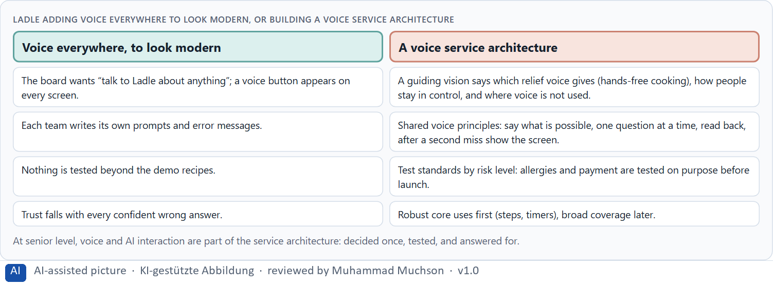
Figure 8 · Ladle adding voice everywhere to look modern, or building a voice service architecture.
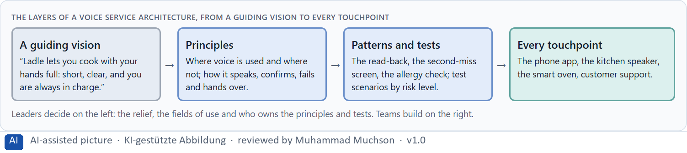
Figure 9 · The layers of a voice service architecture, from a guiding vision to every touchpoint.
Voice as a service architecture: structures
Part | Real example or source | What it means
Principles for speaking, confirming and failing | Voice design practice treats the persona, the prompts, the confirmation and the recovery as one designed whole (Cohen et al. 2004; Pearl 2016). | Define the principles once, for every voice journey.
A duty to tell | The EU AI Act (Article 50) requires that people are told when they interact with an AI system, unless that is obvious from the context. | Make the voice announce what it is.
Discoverability | Voice leaves the options invisible (Norman 2013). | Plan where the screen shows what the voice can do.

Case assumption
Ladle, Noor, Ole, Freya and Piet are made up for this example. The design of spoken services follows Pearl (2016). The findings in the table of real evidence are real research results, rules and cases; the sources are listed below.

How to decide when this comes up in the task
- Check where voice is decided today: in a vision, or one feature at a time?
- Write a guiding vision: the relief, the control, the service experience.
- Decide the fields of use for voice, and where it is not used.
- Decide how voice hands over to a screen or a person.
- Order the journeys: simple, frequent, clear and cheap if wrong first.

Extra · go deeper (optional reading)
A guiding vision for voice is short and testable. “Ladle lets you cook with your hands full: short, clear, and you are always in charge” can be checked on every dialogue: is this answer short, is it clear what to say, can the cook stop it? “Voice-first” cannot be checked, and it invites voice everywhere.

Sources · Pearl 2016 · Norman 2013 · Cohen et al. 2004 · EU AI Act 2024

B2 · Comfort, precision, trust, effort: the conflicts of voice · 20 min · Core
Voice sits between comfort and precision, trust and effort, robustness and natural conversation, and all of them against scalability. Decide per journey how free the dialogue may be, where a screen confirms and where a person takes over, and write down the assumptions the plan rests on.
IN PLAIN WORDS
The idea. Voice sits between goals that pull apart: comfort (say anything) against precision (understand it correctly), trust against effort, error robustness against natural conversation, and all of them against scalability: what works in one journey may not work in twenty. The way through is to decide per journey how free the dialogue may be, where a screen confirms, and where a person takes over, and to write down which assumptions about naturalness, behaviour and acceptance the plan rests on.
Why it matters. Block 3.1 asks for three decisions, a risk analysis of wrong assumptions about naturalness, user behaviour, acceptance and scalability, and a governance model for conflicts between innovation, trust and effort. Each is a decision between conflicting goals.
How to read the picture. Three Ladle journeys and how free the voice dialogue may be in each, with who stands for each side.

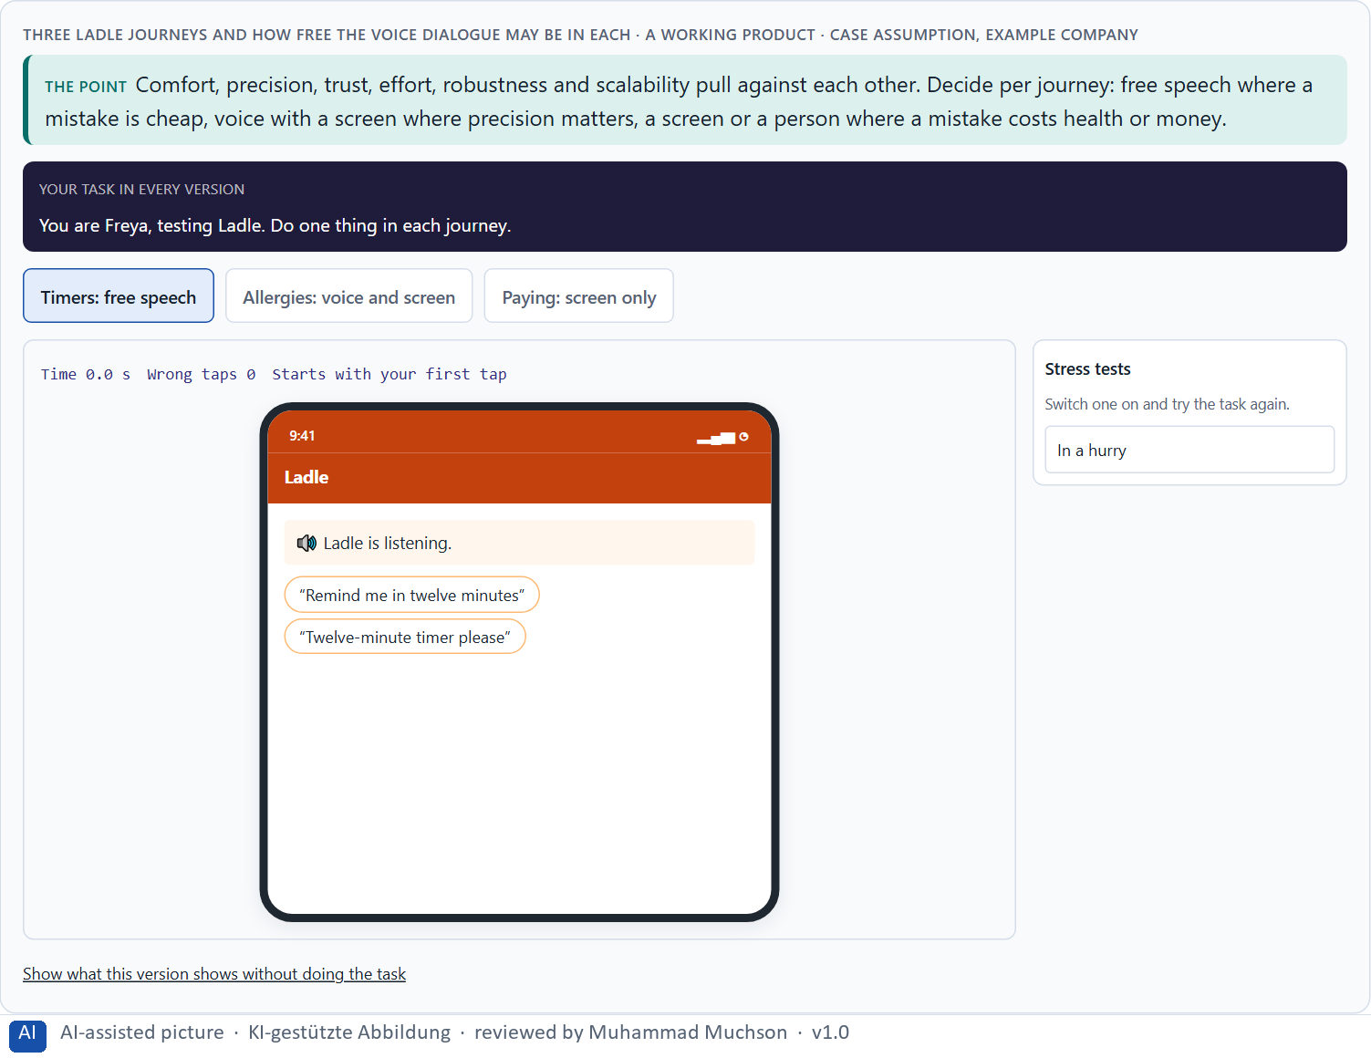
Figure 10 · Three Ladle journeys and how free the voice dialogue may be in each. Shown here in its starting state; in the Neuro-UX Lab every version and every stress test can be used.
Standing conflicts of voice
Conflict | Who usually stands for each side | What to ask
Comfort against precision | Product, against safety and service. | What happens if it hears the wrong word here?
Natural conversation against robustness | Marketing, against engineering and support. | How often will it fail, and where does the person go then?
Innovation against trust | The board, against the people who answer complaints. | What happens after its first public mistake?
All of these against effort and scalability | Finance and engineering, against everyone. | What does each new journey cost to build and to test?

Conflicts of voice, with evidence
Conflict | What the evidence says | A way to decide
Comfort against precision | Word error rates of 0.19 to 0.35 were found across the speakers of five systems (Koenecke et al. 2020). | Ask what happens if it hears the wrong word here, and confirm where the cost is high.
Natural conversation against robustness | A test result of 5.1% on a standard set does not predict the failure rate in real use (Xiong et al. 2017). | Plan how often it will fail and where the person goes then.
Innovation against trust | Distraction after hands-free tasks lasted up to 27 seconds in the weakest systems (Strayer et al. 2015, as reported). | Plan what happens after its first public mistake.

Case assumption
Ladle, Noor, Ole, Freya and Piet are made up for this example. The conflicts are a reading of the example, not a rule for every product. The findings in the table of real evidence are real research results, rules and cases; the sources are listed below.

How to decide when this comes up in the task
- Name each conflict as two goals and say who stands for each: product, safety, support, sales.
- Decide per journey: free speech, voice with a screen, or a screen or person.
- Write down the assumptions about naturalness, behaviour, acceptance and scalability, and which would be critical if wrong.
- Remember that what works for three journeys may not work for twenty.
- Say what the choice gives up.

Extra · go deeper (optional reading)
Scalability is the assumption most voice plans get wrong. Each new journey adds new words, new misunderstandings and new test cases, and they multiply rather than add. A plan that says “three journeys now, twenty next year” should say what has to be true for the next seventeen, and how the company will know.

Sources · Pearl 2016 · Cowan 2001 · Koenecke et al. 2020 · Xiong et al. 2017 · Strayer et al. 2015

B3 · Voice principles, test standards and deciding with little test data · 20 min · Core
Voice and AI interaction need owners: someone who owns the voice principles, test standards by risk level that must be met before a launch, the right to stop one, and a rule for when innovation, trust and effort disagree. With thin test data, a decision says what it decides, does not know, would reverse and gives up.
IN PLAIN WORDS
The idea. Voice and AI interaction need owners: someone who owns the voice principles (how it speaks, confirms, fails and hands over), test standards that say what must be tested before anything goes live (by risk level), and a rule for when innovation, trust and effort disagree. Test data is often thin; a decision under uncertainty says what you decide, what you do not know, when you would reverse it and what you give up. A small, well-tested core is a safe start.
Why it matters. Block 3.1 asks for a governance model for voice principles and test standards, a decision despite patchy data, and a statement to the management. This card gives you the parts of each.
How to read the picture. The four boxes at the top are the parts of a decision, filled in for Ladle. The two boxes below are the rule for future decisions.

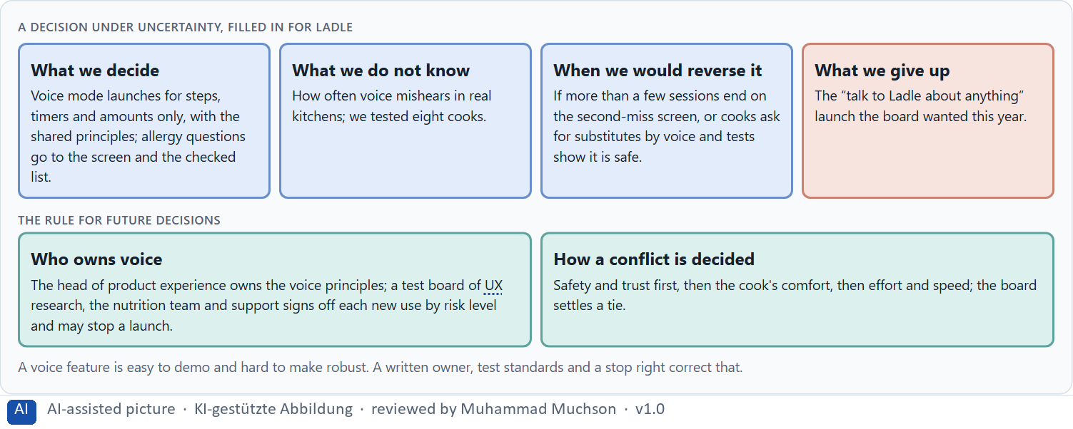
Figure 11 · A decision under uncertainty, filled in for Ladle.
Four parts of voice governance
Part | The question | An example (Ladle)
Who owns the principles | Who decides how it speaks, confirms, fails and hands over? | The head of product experience.
Test standards | What must be tested, by risk level, before a launch? | Low: a few cooks; high: Wizard of Oz and real kitchens, with the nutrition team.
The stop right | Who may stop a launch? | The test board of UX research, the nutrition team and support.
How a conflict is decided | What happens when innovation, trust and effort disagree? | Safety and trust first, then comfort, then effort; the board settles a tie.

Voice governance: test standards and rules
Part | Real example or rule | What it means
Test standards by risk | The automotive study rated ten systems with 257 drivers on a common scale, and a rating of 2 or more counted as potentially dangerous (Strayer et al. 2015, as reported). | Define the test and the threshold before the launch, by risk level.
Who may stop a launch | Differences in recognition between groups of speakers were found only because the systems were tested across groups (Koenecke et al. 2020). | Give a test board with UX research, the domain experts and support the right to stop.
The duty to inform | EU AI Act, Article 50. | Add the notice to the release checklist.

Case assumption
Ladle, Noor, Ole, Freya and Piet are made up for this example. Deciding with limited information follows Simon (1956); the premortem follows Klein (2007). The findings in the table of real evidence are real research results, rules and cases; the sources are listed below.

How to decide when this comes up in the task
- Name who owns how the assistant speaks, confirms, fails and hands over.
- Write test standards by risk level, and say who signs off.
- Give someone the right to stop a launch.
- Settle conflicts by safety and trust first, then comfort, then effort; say who settles a tie.
- Say what you decide, what you do not know, when you would reverse it and what you give up.

Extra · go deeper (optional reading)
A test standard is only real if someone can say no. Without a stop right, a test board becomes a reporting step: it writes down the risks the launch then ignores. Give the right to stop to the people who will answer the complaints.

Sources · Simon 1956 · Klein 2007 · Strayer et al. 2015 · Koenecke et al. 2020 · EU AI Act 2024

Use in class: presentation and handout
Mark of use for the study material. Presentation is what the trainer shows on screen; Handout is what participants read and keep.
Card | Presentation (shown in the Neuro-UX Lab) | Handout
A1 · Screen, chat or voice: what voice can do and where it fails (Core) | Scan line and Figure 1; the "In plain words" and "How to decide" boxes | The whole card
A2 · A good voice dialogue: expectations, feedback, errors, repeat, control (Core) | Scan line and Figure 2; the "In plain words" and "How to decide" boxes | The whole card
A3 · Neuro-design: predictable, light on memory, calm (Core) | Scan line and Figures 3–4; the "In plain words" and "How to decide" boxes | The whole card
A4 · Prototyping and testing an AI interface (Core) | Scan line and Figure 5; the "In plain words" and "How to decide" boxes | The whole card
A5 · Where voice belongs, and weighing a measure (Core) | Scan line and Figures 6–7; the "In plain words" and "How to decide" boxes | The whole card
B1 · Voice and AI as a service architecture, not an innovation signal (Core) | Scan line and Figures 8–9; the "In plain words" and "How to decide" boxes | The whole card
B2 · Comfort, precision, trust, effort: the conflicts of voice (Core) | Scan line and Figure 10; the "In plain words" and "How to decide" boxes | The whole card
B3 · Voice principles, test standards and deciding with little test data (Core) | Scan line and Figure 11; the "In plain words" and "How to decide" boxes | The whole card

References
Check each source and its current edition before you teach from it. Standards and laws marked as in flux can change.
Cohen, M. H., Giangola, J. P., & Balogh, J. (2004). Voice User Interface Design. Addison-Wesley. (Dialogue logic, prompts, confirmations and error recovery for spoken interfaces.)
Pearl, C. (2016). Designing Voice User Interfaces: Principles of Conversational Experiences. O'Reilly. (Setting expectations, confirming what was understood, escalating error handling, and when voice is the wrong choice.)
Xiong, W., Droppo, J., Huang, X., et al. (2017). The Microsoft 2017 conversational speech recognition system. arXiv:1708.06073. https://arxiv.org/abs/1708.06073 (A word error rate of 5.1% on the NIST 2000 Switchboard test set, reported as matching a careful human transcription benchmark; a result on one test set, not in real use.)
Koenecke, A., Nam, A., Lake, E., et al. (2020). Racial disparities in automated speech recognition. PNAS, 117(14), 7684–7689. https://doi.org/10.1073/pnas.1915768117 (Five commercial systems had an average word error rate of 0.35 for Black speakers and 0.19 for white speakers.)
Strayer, D. L., Cooper, J. M., Turrill, J., et al. (2015). Measuring Cognitive Distraction in the Automobile III: A Comparison of Ten 2015 In-Vehicle Information Systems. AAA Foundation for Traffic Safety. (Mental distraction lasted up to 27 seconds after a task in the worst-performing systems; figures from press coverage, check the report.)
W3C (2023). Web Content Accessibility Guidelines (WCAG) 2.2. https://www.w3.org/TR/WCAG22/ (Success criterion 1.4.1 Use of Color: colour must not be the only way to convey information; 1.4.3 Contrast (Minimum) for text.)
Norman, D. A. (2013). The Design of Everyday Things (revised and expanded edition). Basic Books. (Mental models and conceptual models: a design works when what people believe it does matches what it does.)
Nielsen, J. (1994, reviewed 2024). 10 Usability Heuristics for User Interface Design. Nielsen Norman Group. https://www.nngroup.com/articles/ten-usability-heuristics/ (Visibility of system status, consistency and standards, recognition rather than recall, aesthetic and minimalist design.)
Cowan, N. (2001). The magical number 4 in short-term memory: A reconsideration of mental storage capacity. Behavioral and Brain Sciences, 24(1), 87–114. (The limit of working memory is nearer four chunks than seven.)
Sweller, J. (1988). Cognitive load during problem solving: Effects on learning. Cognitive Science, 12(2), 257–285. https://doi.org/10.1207/s15516709cog1202_4 (Working memory is limited; effort spent on working out a screen is missing for the task itself.)
Houde, S., & Hill, C. (1997). What do prototypes prototype? In M. Helander, T. Landauer, & P. Prabhu (Eds.), Handbook of Human-Computer Interaction (2nd ed., pp. 367–381). Elsevier. (A prototype answers a question about role, look and feel, or implementation; choose it by the question.)
Kelley, J. F. (1984). An iterative design methodology for user-friendly natural language office information applications. ACM Transactions on Information Systems, 2(1), 26–41. (The Wizard-of-Oz method: a person secretly plays the system to test a dialogue before it is built.)
Gibbons, S. (2018). Using Prioritization Matrices to Inform UX Decisions. Nielsen Norman Group. https://www.nngroup.com/articles/prioritization-matrices/ (Rate each option on the same few criteria, such as value to the user against effort, and put the reason next to each rating.)
Regulation (EU) 2024/1689 of the European Parliament and of the Council laying down harmonised rules on artificial intelligence (Artificial Intelligence Act). Official Journal of the European Union, 12 July 2024. (Among other duties, people must be informed when they interact with an AI system; check the current state of its application before a course run.)
Simon, H. A. (1956). Rational choice and the structure of the environment. Psychological Review, 63(2), 129–138. (With limited information and time, people choose an option that is good enough rather than the best one: a decision under uncertainty.)
Klein, G. (2007). Performing a project premortem. Harvard Business Review, 85(9), 18–19. (Imagine the plan has failed and ask why; it brings risks and wrong assumptions to the surface before the work starts.)

Glossary
Every term below is used in this document. Terms stay plain text in the body; this list says what they mean in everyday words.
Term | In plain words | Example | Comes from
Accessibility | Designing so that everyone can use a product, also people who see less well, see colours differently, or use a keyboard or a screen reader. | — | Day 3
Attention | The mind's spotlight. Only a small part of a screen is processed at any moment; attention decides which part. | A flashing banner takes attention away from the form you were filling in. | Day 1
Case assumption | A fact made up for this exercise to fill a gap in the plan's case. It is marked so you know it is not part of the plan. | — | Day 1
Chief Experience Officer | The manager who is responsible for the experience customers have across all channels, and who decides where the company invests in it. | — | Day 1
Chunk | A group of items the memory treats as one, such as a phone number split into blocks. Grouping information into chunks makes it easier to hold. | — | Day 4
Dialogue logic | The order of turns in a voice conversation: who speaks when, one question at a time, and what happens after each answer. | — | Day 11
Error handling | What an assistant does when it does not understand: a good one asks a better question or hands over to a person instead of repeating itself. | — | Day 11
Functional, interaction and test prototype | Three kinds of prototype: one checks whether the technology works, one how the dialogue feels, one how real users manage real tasks. | — | Day 11
Governance | The rules about who may decide what, who is answerable for it and how disagreements are settled. | — | Day 1
Intelligent interface | An interface that supports people in a way that fits their situation: it suggests, adapts or helps, instead of only doing the same thing for everyone. | — | Day 10
Mental model | What a person believes a product is and how it works. A design feels natural when it fits that belief and confusing when it does not. | Most people expect a basket icon to show what they have chosen so far. | Day 1
Neuro-UX | Designing an interface with knowledge of how the brain sees, attends, feels and decides, so that the design steers these processes on purpose and responsibly. | — | Day 1
Predictability | Being able to tell in advance how something will work, because it works like what you have seen before. | — | Day 6
Stimulus reduction | Showing or saying fewer things at once, so the mind can attend to what matters. | — | Day 11
Touchpoint | Any place where a person meets the company: the website, the customer portal, the app, a chatbot or a phone call. | — | Day 1
UX (user experience) | Everything a person goes through when using a product: what they notice, understand, feel and do, from the first look to the last step. The screens are only one part of it. | Finding the booking you want at once and feeling sure it went through is a good UX. | Day 1
Voice user interface | An interface people use by speaking and listening; it has no screen to show what it understood, so it has to say it back. | — | Day 10
Wizard of Oz | A test where a person secretly plays the system, so a dialogue can be tried before it is built. | — | Day 11
Working memory | The part of memory that holds what you are using right now, such as a code you just read. It is small and easily overloaded. | — | Day 4

The Neuro-UX Lab: where we practise online
In class we use the course website as the place to practise and to learn. Every day has its own address, in the same pattern: the day number is the last part.
What | Address
Neuro-UX Lab (course website) | https://aion-ux-lab.vercel.app/
Day 11 | https://aion-ux-lab.vercel.app/day/11/

On the day page, Route 1 (Levels 1 and 2) and Route 2 (Level 3) can be opened; the cards and the tasks of this document are there too. The pattern is the same up to Day 8, for example https://aion-ux-lab.vercel.app/day/6/.

