AION · UX DEVELOPER · PSYCHOLOGICAL UX DESIGN AND NEURO-UX
DAY 6 · TASK 1 AND TASK 2 · ROUTES 1 AND 2 · LEVELS 1 TO 3
CitizenFlow: UX Analysis File and UX Strategy Memo
Describe the effect, choose the measures as a team member, and decide as Chief Experience Officer
AI notice · KI-Hinweis
This document was produced with the help of an AI language model (Claude, Anthropic). The AI drafted the text and tables and built the pictures and working examples of the lab. The content was then read, corrected and approved by the reviewer named below, who is responsible for its accuracy. Every picture carries an AI label on the image. Check figures and sources before you quote them.
KI-Hinweis: Dieses Dokument wurde mit Unterstützung eines KI-Sprachmodells (Claude, Anthropic) erstellt. Texte und Tabellen wurden von der KI entworfen, die Abbildungen sind KI-gestützt erstellt und am Bild gekennzeichnet. Die fachliche Prüfung und Freigabe erfolgte durch die unten genannte Person.

Day | Day 6 · Module 3 (day 3 of 3): Gestalt, hierarchy, progressive disclosure and design systems
Document | Task (worksheet with answer spaces). Task 1 (UX Analysis File) and Task 2 (UX Strategy Memo).
Route and level | Task 1 = Route 1, Levels 1 and 2 (draws on Materi A). Task 2 = Route 2, Level 3 (draws on Materi B).
Time | Task 1 about 33 min · Task 2 about 20 min
Neuro-UX Lab (website) | https://aion-ux-lab.vercel.app/day/6/
Case | CitizenFlow, the day's case study; other products appear as warm-ups
Version | 1.0 · release date 29.10.2026
Review and approval | Muhammad Muchson, Mentor (subject-matter review and approval)

ABOUT THIS DOCUMENT
In class we also use the Neuro-UX Lab, the course website, as the place to practise and learn. Its address is at the end of this document.
This is the worksheet for Day 6. Read the case once, study the evidence printed in this document, and write your answers in the boxes and tables. You can work through it on paper or type into the document. All blocks are Core. There are no answer keys and no scores; the reason you give matters more than the choice.

IN THIS DOCUMENT
Lesson plan: ten teaching units (Ablaufplan)
Case study and transfer project at a glance
The case: three platforms on the UX team's desk, and CitizenFlow
Block 1.1 · Recognise navigation and structure problems in a complex interface: OfficeSphere · JUDGED · Core · about 10 min
Block 1.2 · Rate progressive disclosure and visual hierarchy under conflicting goals: CareAssist · JUDGED · Core · about 8 min
Block 2.1 · Case study: consolidating the self-service system CitizenFlow · JUDGED · Core · about 15 min
The situation: the administration behind CitizenFlow, and years of separate solutions
Block 3.1 · A systemic UX architecture for navigation, disclosure and design governance · JUDGED · Core · about 20 min

Day at a glance
Day 6 has ten teaching units (UE). This document is the worksheet; it is used in UE2 to UE6 (Task 1) and UE8 to UE10 (Task 2). The day is built from three documents and the Neuro-UX Lab: Materi (study material), Task (worksheet) and Trainer (coaching, feedback and model solutions), plus the course website.

Lesson plan: ten teaching units (Ablaufplan)
UE | Min | Plan item | What happens | Material | Format
1 | 45 | Knowledge transfer · Level 1 | The trainer presents the cards of Materi A (A1, A2, A3, A4, A5, about 60 min of cards) in the Neuro-UX Lab; participants follow in the handout. | Materi A (Route 1) | Presentation + Handout
2 | 45 | Level 1 · Task 1 | Individual work on Block 1.1 (Core, about 10 min): the first product of the day is read and its effect described. Pairs then compare their results and the trainer collects open questions. | Task 1 · Part 1 · Block 1.1 | Handout (or in the lab)
3 | 45 | Level 1 · Task 2 | Three options are rated on the same criteria and one is chosen under the stated conditions: Block 1.2 (Core, about 8 min). | Task 1 · Part 1 · Block 1.2 | Handout (or in the lab)
4 | 45 | Coaching · transition from Level 1 to Level 2 | Trainer-led. A short talk on the day's coaching focus, then the reflection questions in pairs. The bridge: from describing an effect to a decision you answer for. There is no worksheet block in this unit. | Trainer document, section Coaching | Trainer only
5–6 | 90 | Level 2 · Case study CitizenFlow (2 UE) incl. model solution | UE5: the trainer presents the case; participants work on Block 2.1 (Core, about 15 min). UE6: groups compare their results and defend them; the trainer closes with the model solution. | Task 1 · Part 2 · Block 2.1  Trainer document, section Case study | Handout; model solution shown after the work
7 | 45 | Level 2 + 3 · Feedback round with a management perspective | Groups present their reasoning, not only their result. The trainer asks the day's Level 3 input questions and leads the discussion. | Trainer document, section Feedback round | Presentation by the groups; Trainer only
8 | 45 | Level 3 · Transfer project, Chief Experience Officer (3 UE: UE8–10) | The trainer presents Materi B (B1, B2, B3; use the "In plain words" and "How to decide" boxes, the rest is handout) and sets the role and the situation. | Materi B (Route 2) | Presentation + Handout
9 | 45 | Level 3 · Transfer project | Individual work or in pairs on Block 3.1 (Core, about 20 min): the strategy memo. | Task 2 · Block 3.1 | Handout (or in the lab)
10 | 45 | Level 3 · Transfer project | Participants present their decision and what they give up, including the one decision made under uncertainty; the trainer debriefs with the model solution. | Task 2 · Block 3.1  Trainer document, section Transfer project | Handout; model solution shown after the work

One UE is counted as 45 minutes here; breaks are not shown. The times are a guide for the trainer. The Core blocks are enough for a complete answer.

Case study and transfer project at a glance
Component | UE | Duration | Participants work in | Model solution in
Level 2 case study (CitizenFlow) | UE5–6 | 2 UE · 90 min | Task 1 · Part 2 (Block 2.1) | Trainer document, section Case study
Level 3 transfer project (Chief Experience Officer) | UE8–10 | 3 UE · 135 min | Materi B and Task 2 (Block 3.1) | Trainer document, section Transfer project

Which plan item each block answers
UE | Plan item (Strukturplan, Day 6) | Block in this document
UE2 | Level 1, task 1 · Recognise navigation and structure problems in a complex interface: OfficeSphere | Block 1.1 (Core)
UE3 | Level 1, task 2 · Rate progressive disclosure and visual hierarchy under conflicting goals: CareAssist | Block 1.2 (Core)
UE4 | Coaching: from describing to deciding | A classroom talk led by the trainer; not a worksheet block
UE5–6 | Level 2 case study · Case study: consolidating the self-service system CitizenFlow | Block 2.1 (Core)
UE7 | Feedback round with a management perspective | A classroom discussion led by the trainer; not a worksheet block
UE8–10 | Level 3 transfer project · A systemic UX architecture for navigation, disclosure and design governance | Block 3.1 (Core), in Task 2

Your name
Write your full name here. Use the same name on every Task document this week; it is how your work is matched.

Task 1 · Route 1 · UX Analysis File: find the structure problems, then decide what to change

The case: three platforms on the UX team's desk, and CitizenFlow
Read once · about 3 min
You work in the UX team of a digital agency. This week three products land on your desk. Two are warm-ups: OfficeSphere, an internal administration portal for processes, requests and approvals, and CareAssist, a service platform that has three possible structures. The main case is CitizenFlow, a public service platform that gives citizens access to applications, appointment bookings, certificates and status queries. It is extensive in functions, but in many areas it feels inconsistent and overwhelming: users often lose their orientation, abandon applications or contact support although self-service is available.
What the plan gives you | How the task runs · three blocks
• Block 1.1: OfficeSphere, with much information and no clear grouping, similar functions designed differently, primary and secondary actions equally strong, forms with every field at once, competing notices, status displays and navigation, and different patterns for similar tasks  • Block 1.2: three structures for CareAssist; experienced and inexperienced users, departments that want much information visible, a UX team that wants hierarchy and progressive disclosure, limited technical resources, release in 8 weeks, little user data  • Block 2.1: CitizenFlow, with €170,000 and 14 weeks, no complete relaunch, several departments with their own requirements, low consistency across service areas, usage data only partly available | • Block 1.1: find navigation and structure problems. Say where the portal feels unclear or overwhelming, sort your observations into five categories, name five problems, write three effect statements and pick the two biggest weaknesses.  • Block 1.2: rate three structures under conflicting goals. Rate each on five criteria, choose one, name the conflicts between visibility, simplicity and user safety, the remaining risks, and write a recommendation to the project lead.  • Block 2.1: the case study. The central problems of grouping, hierarchy and disclosure, sorted into five categories, four measures, justified on four criteria, a decision for the first 14 weeks and a recommendation to the division management.

What is known and what is open
In the brief | Clear · Case assumption | Open · on purpose
• OfficeSphere: no clear grouping, similar functions designed differently, primary and secondary actions equal, every form field at once, competing elements, different patterns.  • CareAssist: three structures in words; experienced and inexperienced users; limited technical resources; 8 weeks; little user data.  • CitizenFlow: inconsistent grouping, unseparated actions, every field at once, varying navigation, unprioritised help and warnings; €170,000 and 14 weeks; no relaunch. | • You review OfficeSphere and CareAssist as an agency would: from their screens, with no access to their data.  • CitizenFlow's service areas (residents, vehicles, family, business) were built by different departments; each has its own page layout.  • CitizenFlow's application form for a residence certificate shows the fields for foreign residents and for companies to everyone.  • Support at CitizenFlow hears most often: “Which fields do I have to fill in?” and “Where is the button to send it?” | • How many people use each service area: usage data is only partly available.  • Which CareAssist structure users would cope with best: there is little user data.  • Where exactly applications are abandoned: not recorded for every step.  • How much of the €170,000 each measure would take: the plan does not say.

As in most projects, not everything is known. Decide anyway, and say what you assume.
Case assumption
The brief says: OfficeSphere without clear grouping, with differently designed similar functions, equal primary and secondary actions, every form field at once, competing elements and different patterns; CareAssist's three structures for experienced and inexperienced users, departments against the UX team, limited resources, 8 weeks and little data; CitizenFlow with inconsistent grouping, unseparated actions, every field at once, varying navigation, unprioritised help and warnings, €170,000, 14 weeks, no relaunch, several departments and low consistency. Those are the plan's facts and its only figures. Everything else is made up for this exercise: the agency, the pictures, the simulations and the facts marked “Clear”.

Part 1 · Find the structure problems and weigh structures · Level 1 · Knowledge

Block 1.1 · Recognise navigation and structure problems in a complex interface: OfficeSphere · JUDGED · Core · about 10 min
Draws on: A1 · Gestalt laws for navigation · A2 · Visual hierarchy · A3 · Progressive disclosure · A4 · Hierarchy, navigation logic and relief.
You receive the description of a fictional administration portal, OfficeSphere, for internal processes, requests and approvals. Open it and try to request leave and approve a colleague's request, as an employee would. You need no prior knowledge: notice where the page feels unclear or overwhelming and where you cannot tell what belongs together. The aim is to recognise Gestalt and structure problems step by step and to describe their influence on navigation and mental load.
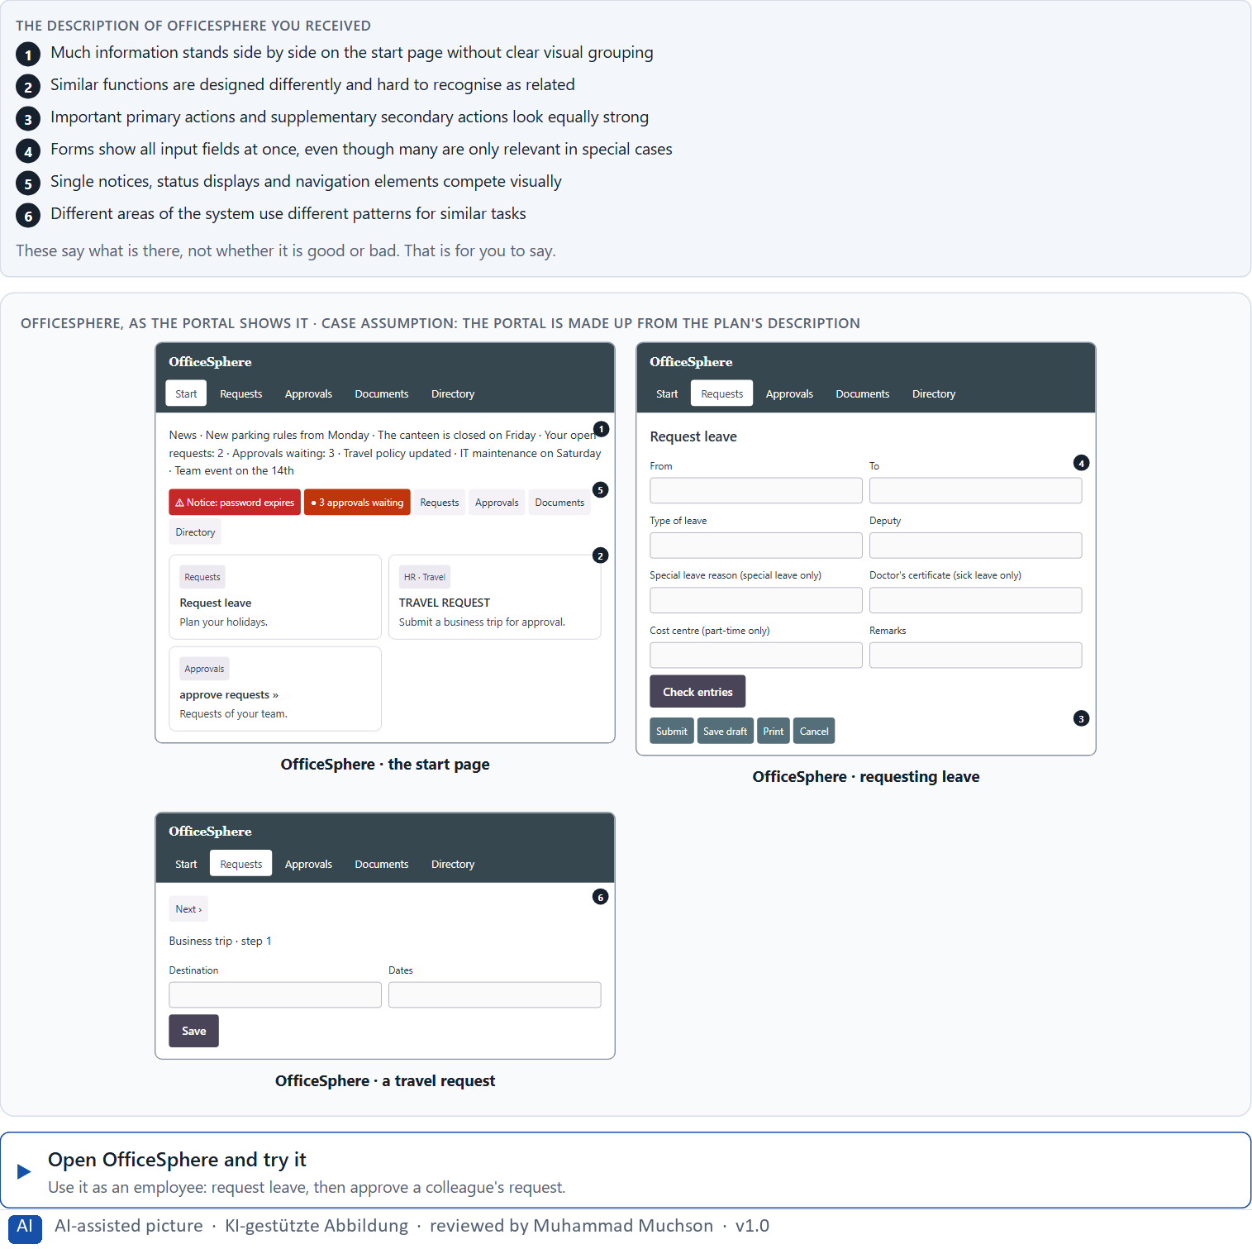
Figure 1 · OfficeSphere, as the portal shows it.
Question 1 of 5 · Describe which places could feel unclear or overwhelming from the user's point of view
Name the places where you could not tell what belongs together, what matters most or where to go, and say why.
How to build the answer:
- Open OfficeSphere and try to request leave, then to approve a request.
- Write down each place where you could not tell what belongs together, what is most important or which pattern to expect.
- For each, say what made it unclear or overwhelming.

Question 2 of 5 · Assign the observations to the categories Gestalt laws, visual hierarchy, amount of information, navigation logic and consistency
Write the observations that belong to each category in a few words. One may fit two categories; put it where its effect is strongest.
How to build the answer:
- Take your observations from question 1.
- Ask what each one is about: what is seen as a group, what stands out, how much is shown, how people move, or whether patterns repeat.
- Write it under that category.
Category | The observations in this category
Gestalt laws
Visual hierarchy
Amount of information
Navigation logic
Consistency

Question 3 of 5 · Name at least 5 problems that make intuitive navigation difficult
How to build the answer:
- Go back through your observations.
- Write each problem as something the portal does that makes it hard to find the way.
Write them as a list, one problem per line, and say what it makes hard.

Question 4 of 5 · Write an effect statement for three points: “For users this could mean that …”
How to build the answer:
- Pick three problems from question 3.
- Finish the plan's sentence with what the user would do, risk or fail to do.
Write them as a list, one statement per line, each starting with the problem and ending with what it could mean for users.

Question 5 of 5 · Prioritise the two biggest weaknesses with regard to orientation and cognitive relief
How to build the answer:
- Look at your problems with two questions: which one costs most orientation, and which one adds most mental load?
- Pick the two that weigh most and say why.
Write them as a list, the bigger weakness first, each with why it weighs most on orientation and cognitive relief.

Block 1.2 · Rate progressive disclosure and visual hierarchy under conflicting goals: CareAssist · JUDGED · Core · about 8 min
Draws on: A2 · Visual hierarchy · A3 · Progressive disclosure · A5 · From screens to components.
CareAssist is a service platform. Three structures are described in words: A) all information and options directly visible, a high transparency but a strong density of information; B) central content clearly prioritised, additional information only shown step by step; C) a modern, reduced layout with strong compression, but important context information partly hidden too deep. The conditions: the target group includes experienced and inexperienced users, the departments want as much information as possible visible at once, the UX team asks for a stronger hierarchy and progressive disclosure, technical resources for large changes are limited, the release is in 8 weeks, and only little user data is available. Decide anyway, and say what you assume.
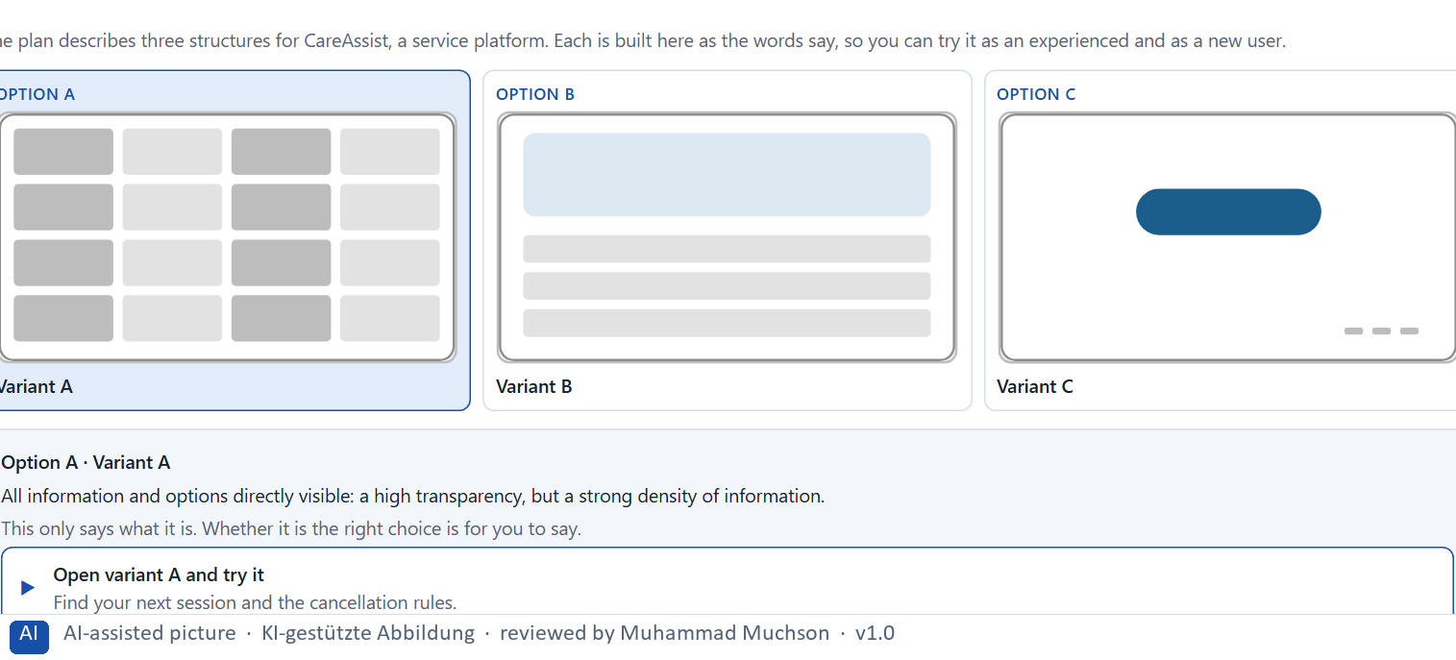
Figure 2 · The product to read, as the lab shows it (structures).
Question 1 of 5 · Rate each variant on orientation, transparency, cognitive load, navigation clarity and error risk
Write a few sentences for each variant that cover all five criteria. Many teams rate each criterion Low, Medium or High with a reason; you may do that or write it in your own words.
How to build the answer:
- Take one variant at a time and keep both groups in mind, experienced and inexperienced users.
- For each criterion, say how the variant does and why.
- Use the same five criteria for every variant, so you can compare them.
Variant | Orientation | Transparency | Cognitive load | Navigation clarity | Error risk
Variant A · everything visible, very dense
Variant B · central content first, more step by step
Variant C · reduced, context hidden too deep

Question 2 of 5 · Decide which variant is the most viable under the given conditions
Choose one variant, then give your reason below. There is no single right choice; the reason has to rest on the users and the conditions.
How to build the answer:
- Say which group and which condition weigh most for you.
- Say how your choice meets them better than the other two.
Tick one:
☐ Variant A · everything visible, very dense
☐ Variant B · central content first, more step by step
☐ Variant C · reduced, context hidden too deep
Why this variant, under these conditions?
Give your reason with the conditions: experienced and inexperienced users, departments against the UX team, limited technical resources, 8 weeks, little user data.
How to build the answer:
- Name the group and the condition that weigh most for you.
- Say how your variant meets them and why the other two meet them less well.
- Say what your choice gives up.

Question 3 of 5 · Name the conflicts of goals between visibility, simplicity and user safety
Name at least two conflicts, each as two goals that pull against each other.
How to build the answer:
- Look at the three goals the plan names: visibility, simplicity and the users' safety in deciding.
- Write each conflict as “… against …” and say who stands for each side.

Question 4 of 5 · Which risks remain despite your decision?
Name at least one risk that remains and who would feel it.
How to build the answer:
- Think of what your chosen variant is weak at.
- Say who would notice and what would happen.

Question 5 of 5 · Formulate a recommendation to the project management
Two to four sentences: what you recommend, why, and what you will check next.
How to build the answer:
- Lead with the recommendation.
- Give the one reason the project management can follow.
- Say what you will check after the release.

Part 2 · The case study · Level 2 · Application · Case study (2 UE)
Case study: 2 teaching units (UE5–6)
This part is the day's Level 2 case study. It takes 2 UE (about 90 minutes): UE5 for the briefing and your own work, UE6 for comparing your results with your group and for the trainer's closing. The block below needs about 15 minutes of writing; the rest of the time is discussion.

Block 2.1 · Case study: consolidating the self-service system CitizenFlow · JUDGED · Core · about 15 min
Draws on: A1 · Gestalt laws for navigation · A2 · Visual hierarchy · A3 · Progressive disclosure · A4 · Hierarchy, navigation logic and relief · A5 · From screens to components.
A public service platform gives citizens access to applications, appointment bookings, certificates and status queries. It is extensive in functions, but in many areas it feels inconsistent and overwhelming. Users often lose orientation, abandon applications or contact support although self-service is available. The observed problems: different page types group content differently, primary and secondary actions are not cleanly separated, forms show all fields at once, also optional and context-dependent ones, navigation patterns vary between areas with a similar function, additional information, help and warnings are not cleanly prioritised, and users have to work out themselves which information is relevant and which is only supplementary. The conditions: a budget of €170,000, 14 weeks for the implementation, a complete relaunch is ruled out, several departments have their own requirements, consistency across the service areas is low so far, and usage data is only partly available. You work through six steps.
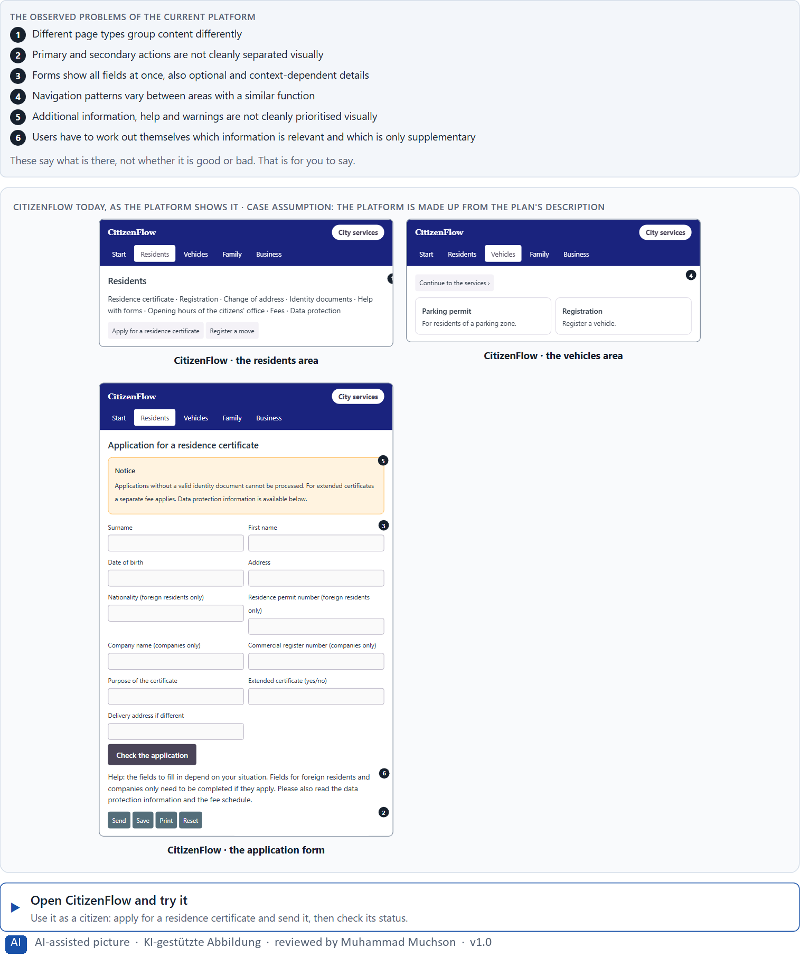
Figure 3 · CitizenFlow today, as the platform shows it.
Question 1 of 6 · Analyse the central problems with regard to Gestalt laws, visual hierarchy and progressive disclosure
How to build the answer:
- Open CitizenFlow and apply for a residence certificate, then book an appointment, as a citizen would.
- Write one problem per line as an effect on the user, and note whether it is about grouping, hierarchy or disclosure.
Write them as a list, one problem per line, each as an effect on the user. At least five.

Question 2 of 6 · Assign the problems to the categories grouping, prioritisation, disclosure of information, consistency and navigation logic
Write the problems that belong to each category in a few words. A problem may fit two categories.
How to build the answer:
- Take your problems from question 1.
- Ask which of the five categories each one affects most, and write it there.
Category | The problems in this category
Grouping
Prioritisation
Disclosure of information
Consistency
Navigation logic

Question 3 of 6 · Develop 4 prioritised measures for improvement
How to build the answer:
- Turn each group of problems into something you could change within 14 weeks and without a relaunch.
- Put them in order, and think about which measure keeps the others in place.
Write them as a numbered list, the first priority first, each with what it changes for users.

Question 4 of 6 · Justify your selection using effect on users, feasibility, risk and time pressure
Use all four criteria and say how they support your selection and its order.
How to build the answer:
- Say for your first measures how they lower overload and improve orientation.
- Say what is feasible without a relaunch and with several departments, and the risk of each.
- Say which measure keeps the others in place over time.

Question 5 of 6 · Make a prioritisation decision for the first 14 weeks
Say what you do in the first 14 weeks, in which order, and what you leave for later, with the reason.
How to build the answer:
- Say what comes first and why.
- Say what you do in parallel and what waits.
- Say how you deal with the departments' own requirements.

Question 6 of 6 · Formulate a recommendation to the division management
Three to five sentences: what you recommend, what has priority, and what you expect to change.
How to build the answer:
- Lead with the recommendation.
- Name the priorities.
- Say what you expect to change for users and for the organisation.

Task 2 · Route 2 · UX Strategy Memo: decide as Chief Experience Officer

The situation: the administration behind CitizenFlow, and years of separate solutions
Read once · about 2 min
You take the perspective of the Chief Experience Officer of the public administration that runs CitizenFlow. It has a citizen portal, an app and an internal administration interface, and over the years it has built many digital solutions. Single teams have set up different patterns for navigation, page structure, status displays and forms. Users therefore experience breaks, uncertainty and unnecessary searching. The management expects a sound strategy to turn the UX laws into an organisation-wide design system and into clear decision structures. You are not to correct single pages but to develop a sound decision architecture for visual hierarchy, progressive disclosure, navigation logic and design-system governance.
The framework | How the task runs · one block
• The budget is limited  • Several teams work in parallel on different systems  • Stakeholders pursue different priorities  • Consistency has been weak so far  • The data is partly incomplete  • First improvements must be visible in 3 months  • Wrong decisions increase support effort, frustration and follow-up costs in product development | • Block 3.1 asks seven questions: a guiding vision for systemic user guidance, three strategic decisions, a prioritised architecture of measures, a risk analysis, a governance model, one decision under uncertainty and a management statement.

What is known and what is open
In the brief | Clear · Case assumption | Open · on purpose
• A citizen portal, an app and an internal administration interface.  • Each team has its own patterns for navigation, page structure, status displays and forms.  • Users experience breaks, uncertainty and unnecessary searching.  • Several teams work in parallel; first improvements must show in 3 months. | • The organisation is the administration behind CitizenFlow in Route 1.  • There is a shared logo and colour palette, but no shared components: each team builds its own buttons, forms and status labels.  • Support records the subject of each contact; the portal records submitted applications; no one records abandoned steps. | • How large the budget is: “limited” is all the plan says.  • How much the inconsistency costs in development time: the data is partly incomplete.  • Which patterns users prefer: never tested.

As in most projects, not everything is known. Decide anyway, and say what you assume.
Case assumption
The brief says: a company with a customer portal, an app and an internal administration interface, many solutions built over years, teams with different patterns for navigation, page structure, status displays and forms, users with breaks, uncertainty and searching, a limited budget, teams working in parallel, different priorities, weak consistency, partly incomplete data, first improvements in 3 months, and the warning that wrong decisions raise support effort, frustration and follow-up costs. Those are the plan's facts. That the company is the public administration of Route 1 and the facts marked “Clear” are made up for this exercise.

The memo is addressed to: The management. Subject: A systemic UX architecture for navigation, disclosure and design governance.

Part 3 · Level 3 · Management decision · Transfer project (3 UE)
Transfer project: 3 teaching units (UE8–10)
UE8: the trainer presents Materi B and sets the role. UE9: you write the memo. UE10: you present the decision and what you give up; the trainer debriefs.

Block 3.1 · A systemic UX architecture for navigation, disclosure and design governance · JUDGED · Core · about 20 min
Draws on: B1 · Design systems for consistency, scale and steering · B2 · Conflicts of goals · B3 · Design-system governance, and deciding with incomplete data.
Develop a strategic concept for the administration. Your desk holds what the management, the teams and the data say. Open it, then answer the seven questions; your answers build the memo below.
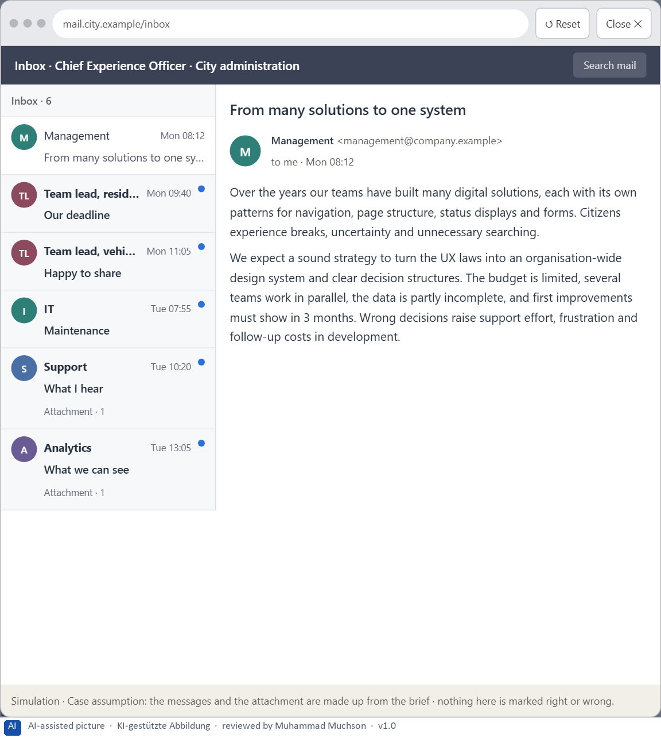
Figure 4 · Your desk: the messages that wait for you, shown in the lab as a mailbox (1 of 6).
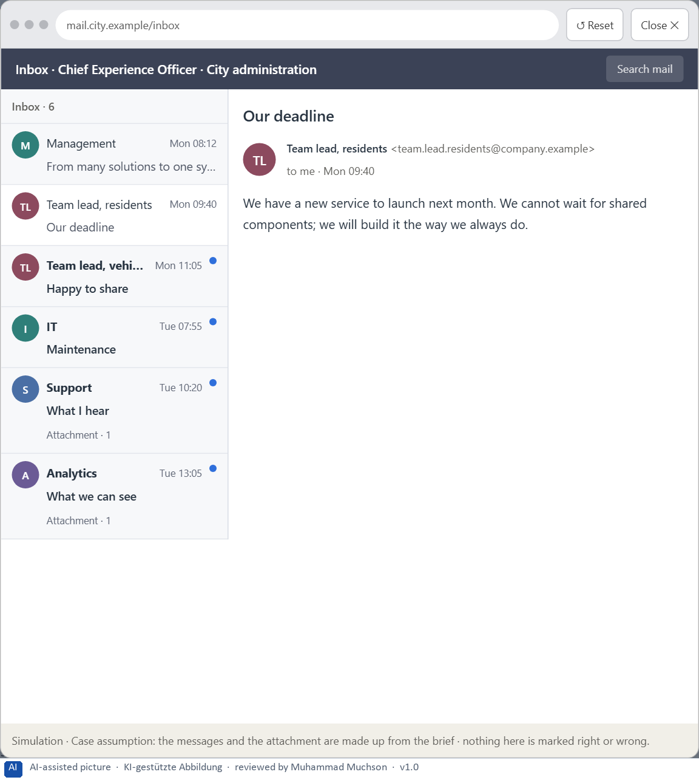
Figure 5 · Your desk: the messages that wait for you, shown in the lab as a mailbox (2 of 6).
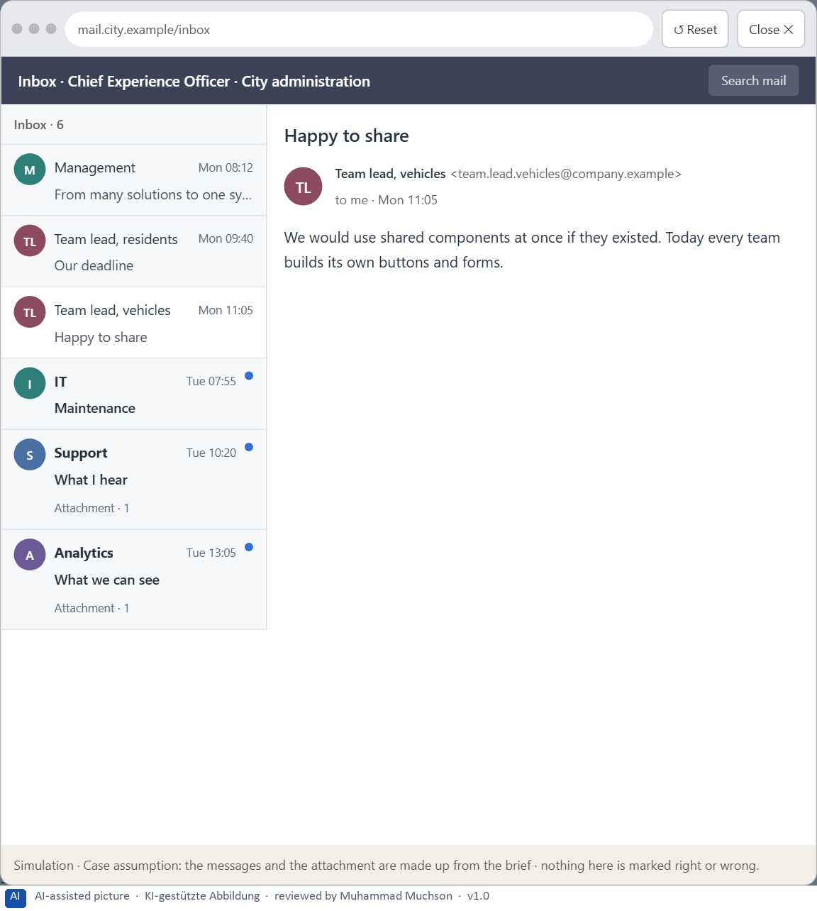
Figure 6 · Your desk: the messages that wait for you, shown in the lab as a mailbox (3 of 6).
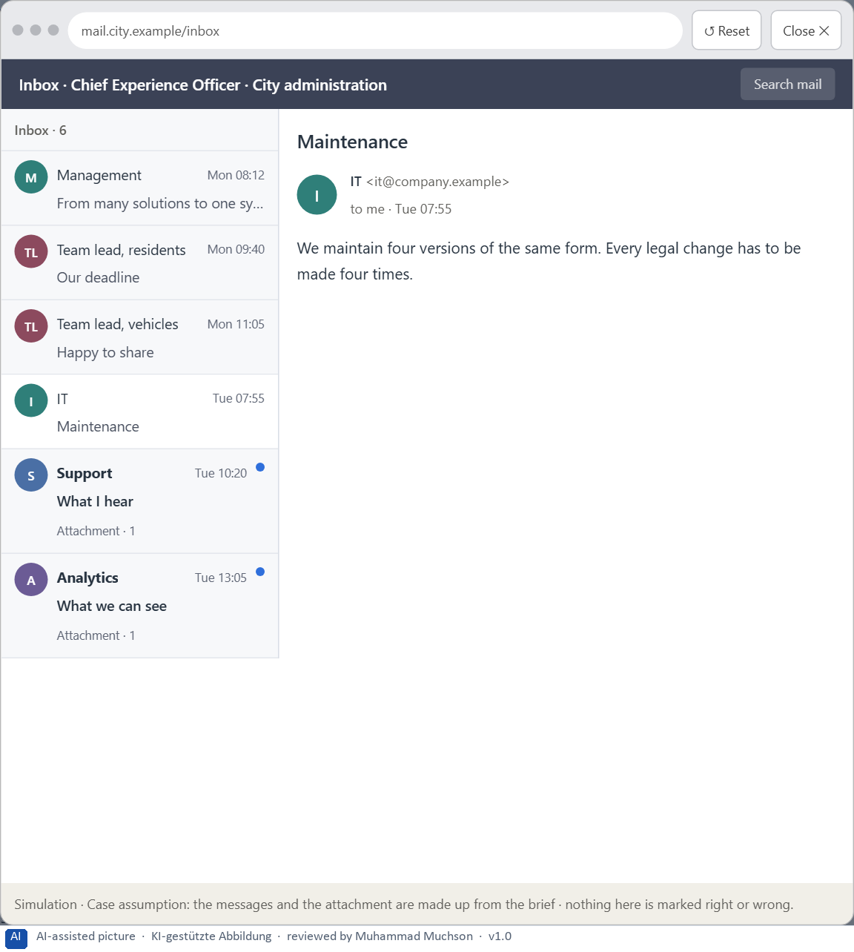
Figure 7 · Your desk: the messages that wait for you, shown in the lab as a mailbox (4 of 6).
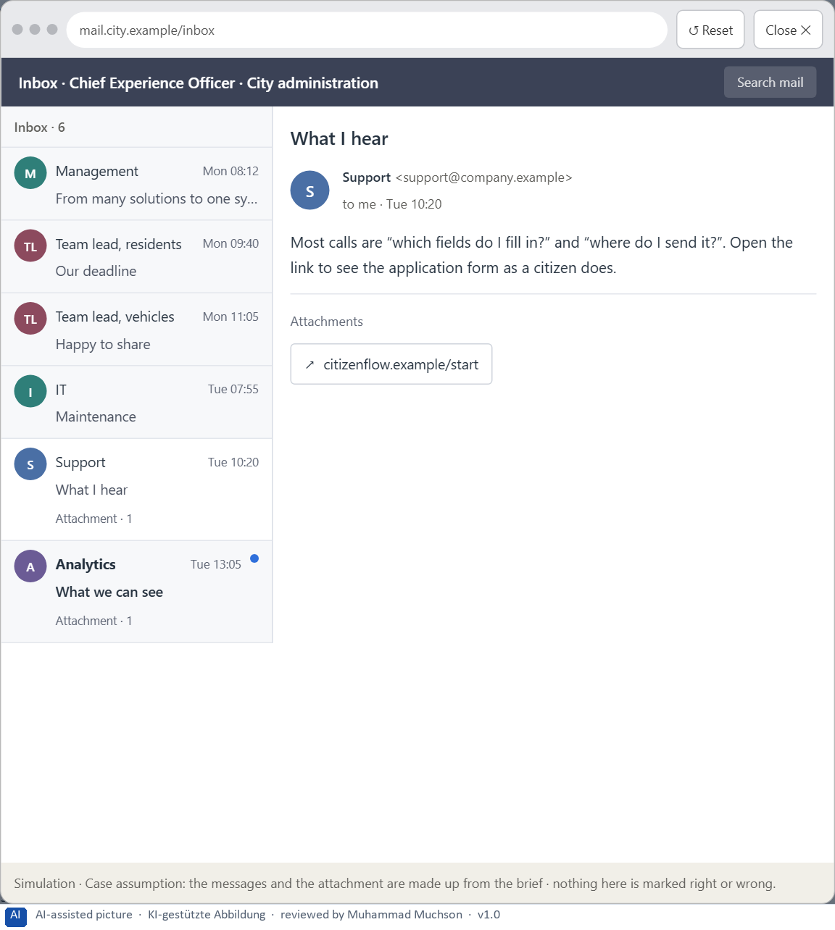
Figure 8 · Your desk: the messages that wait for you, shown in the lab as a mailbox (5 of 6).
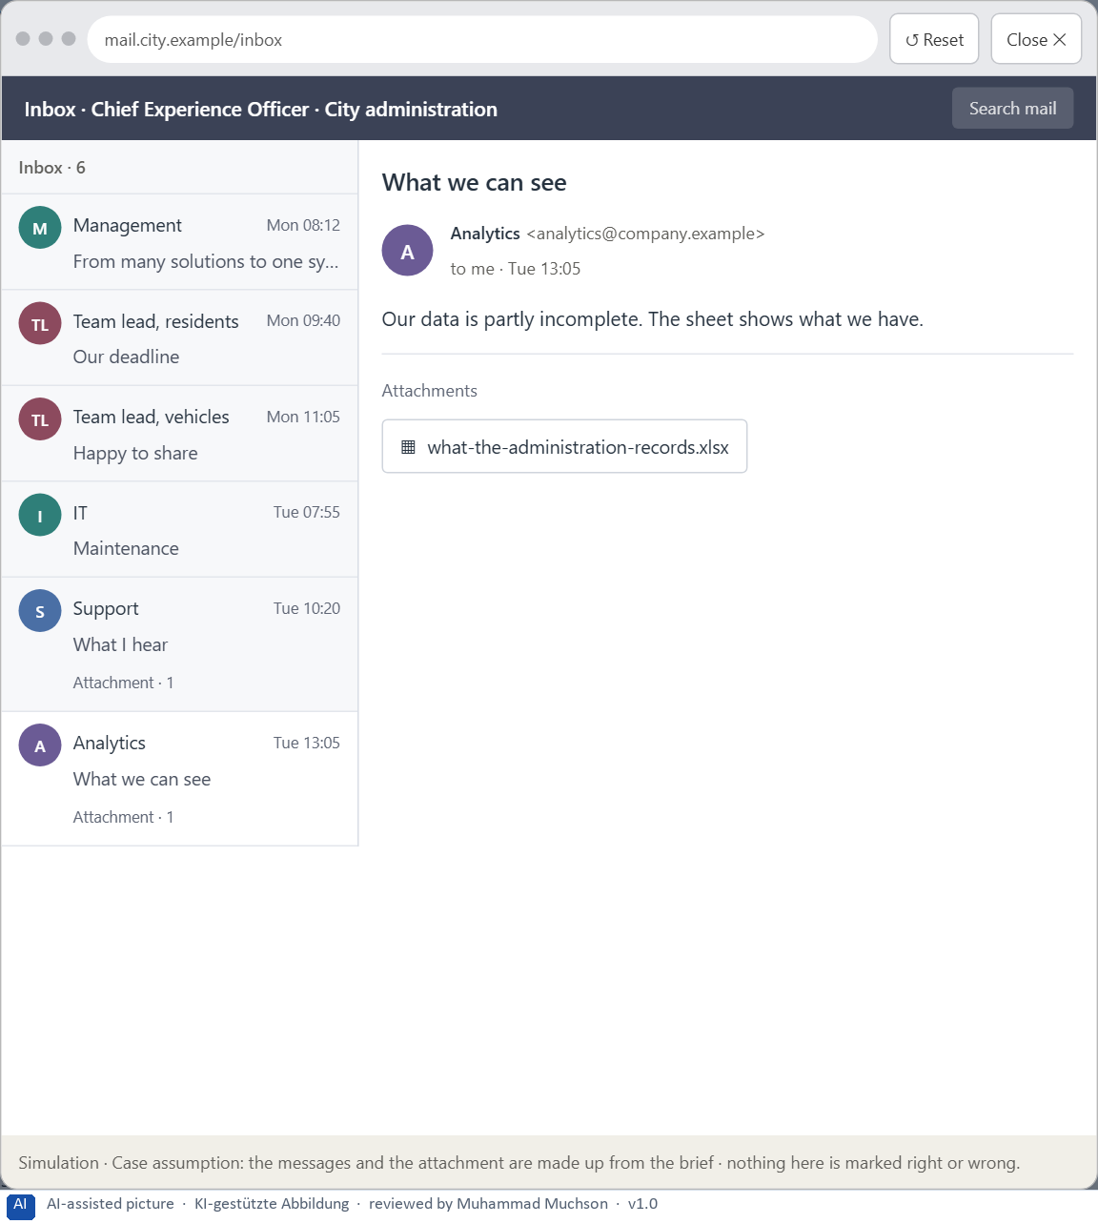
Figure 9 · Your desk: the messages that wait for you, shown in the lab as a mailbox (6 of 6).
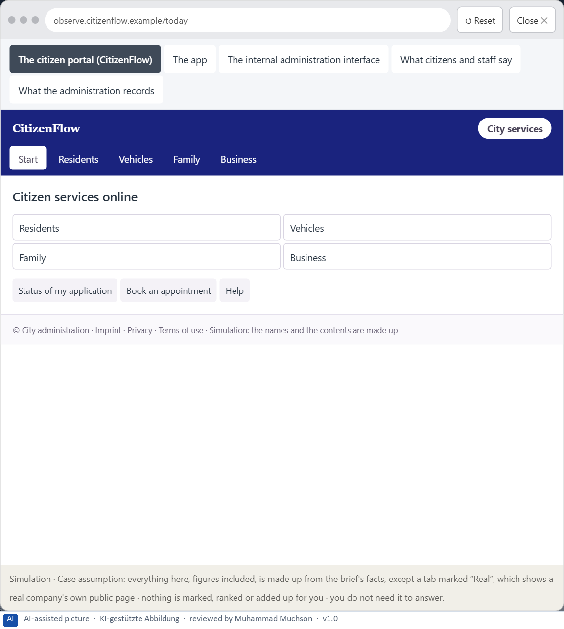
Figure 10 · The platform as it is today, as the lab lets you observe it (1 of 5).
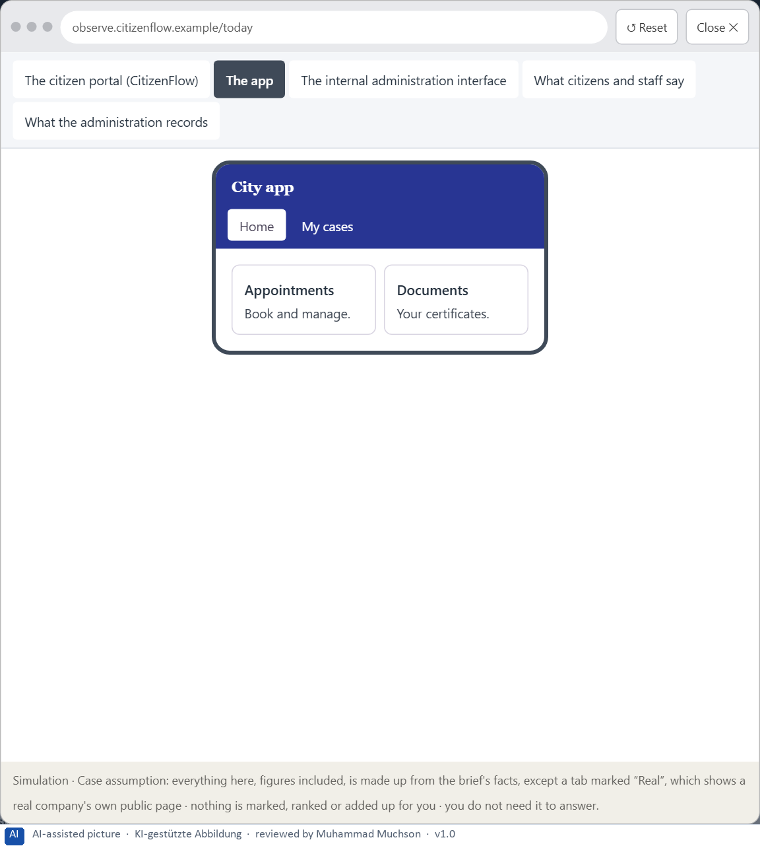
Figure 11 · The platform as it is today, as the lab lets you observe it (2 of 5).
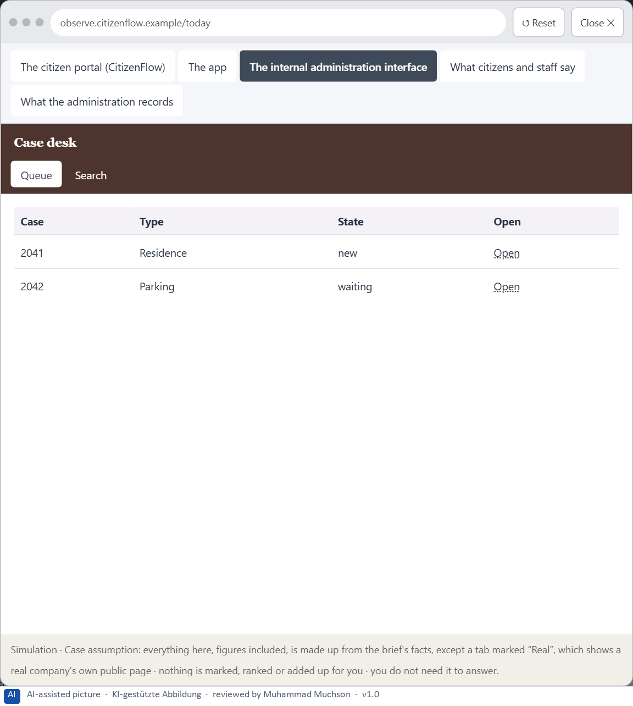
Figure 12 · The platform as it is today, as the lab lets you observe it (3 of 5).
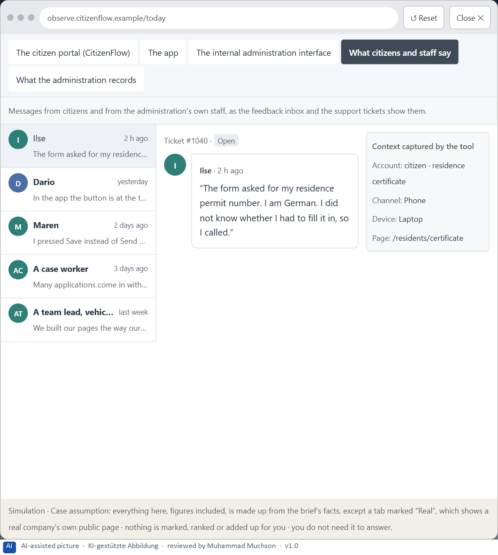
Figure 13 · The platform as it is today, as the lab lets you observe it (4 of 5).
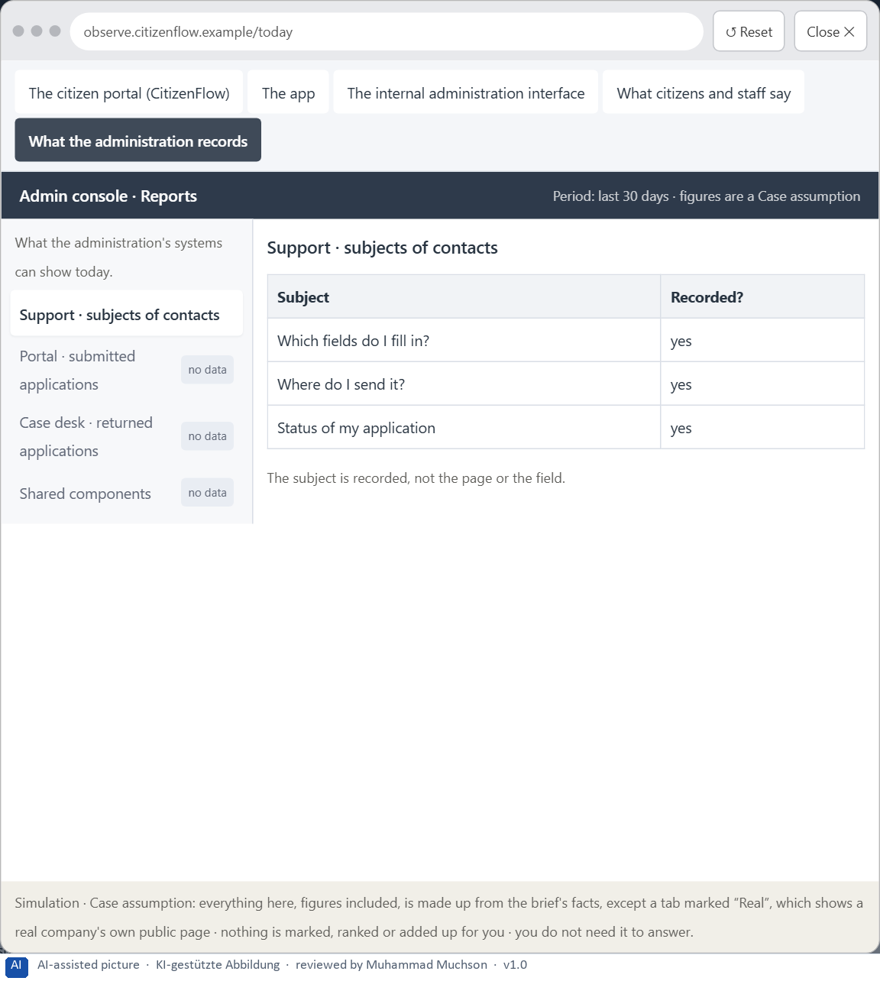
Figure 14 · The platform as it is today, as the lab lets you observe it (5 of 5).
Question 1 of 7 · A guiding vision for systemic user guidance: which orientation, relief and predictability should users experience systematically in future?
One or two sentences about what users should experience in every part of every channel.
How to build the answer:
- Say what users should always be able to tell, wherever they are.
- Say what they should never have to do: sort, guess or relearn.

Question 2 of 7 · Three strategic guiding decisions on Gestalt principles, visual hierarchy, progressive disclosure and the use of the design system
How to build the answer:
- Take your vision and ask which three choices would make it real.
- Write each as “we will …, even though that means …”.
Write them as a list, one decision per line, each with what it gives up.

Question 3 of 7 · A prioritised architecture of measures: which components, processes or product areas are standardised first, and why?
Put the components, processes or areas in an order and give the reason for the first ones.
How to build the answer:
- List the candidates: shared components, the most used processes, the product areas and channels.
- Put first what many screens use and where users struggle most.
- Say why the others can wait.

Question 4 of 7 · A risk analysis: which wrong assumptions about user behaviour, the need for transparency and standardisation would be especially critical?
Name two or three assumptions about how users behave, how much they need to see, or what standardisation achieves, and the harm if each is wrong.
How to build the answer:
- Write down what your concept assumes about users' behaviour.
- Write down what it assumes about how much information they need to see.
- Write down what it assumes about standardisation.

Question 5 of 7 · A governance model: who is responsible for the component standards and UX principles, and who decides conflicts of goals between teams?
Name roles, not people: who owns the design system, who decides a team's request for an exception, and on what basis.
How to build the answer:
- Name who owns the design system: its principles and components.
- Name how a team asks for a new component or an exception, and who decides.
- Say on what basis a conflict between teams is decided.

Question 6 of 7 · A decision under uncertainty: make at least one prioritised decision despite incomplete data and justify it responsibly
Say what you decide, what you do not know, and why the decision is responsible all the same, for example when you would reverse it.
How to build the answer:
- State the decision in one sentence.
- Name what you do not know.
- Say why it is still responsible: it can be reversed, it can be checked soon, or waiting costs more.

Question 7 of 7 · A management statement: a recommendation to the management with a clear priority and a strategic reason
Four to six sentences: the direction first, then the priority, the reason and what you ask of the management.
How to build the answer:
- Start with the direction in one sentence.
- Name the priority and the reason that carries it.
- Say what you ask of the management and what you will report back.

Use in class: presentation and handout
Mark of use for the worksheet. Presentation is what the trainer shows on screen; Handout is what participants fill in and hand in.
Part of the worksheet | Presentation (shown in the Neuro-UX Lab) | Handout
The case: three platforms on the UX team's desk, and CitizenFlow | The case read aloud or on screen | The case text
Block 1.1 · Recognise navigation and structure problems in a complex interface: Of | The task wording at the start of the block (no answers are shown) | Worksheet block with answer boxes (Core)
Block 1.2 · Rate progressive disclosure and visual hierarchy under conflicting goa | The task wording at the start of the block (no answers are shown) | Worksheet block with answer boxes (Core)
Block 2.1 · Case study: consolidating the self-service system CitizenFlow | The task wording at the start of the block (no answers are shown) | Worksheet block with answer boxes (Core)
The situation: the administration behind CitizenFlow, and years of separate solutions | The case read aloud or on screen | The case text
Block 3.1 · A systemic UX architecture for navigation, disclosure and design gover | The task wording at the start of the block (no answers are shown) | Worksheet block with answer boxes (Core)

Glossary
Every term below is used in this document. Terms stay plain text in the body; this list says what they mean in everyday words.
Term | In plain words | Example | Comes from
Case assumption | A fact made up for this exercise to fill a gap in the plan's case. It is marked so you know it is not part of the plan. | — | Day 1
Chief Experience Officer | The manager who is responsible for the experience customers have across all channels, and who decides where the company invests in it. | — | Day 1
Cognitive load | How much a person has to hold in mind and work out at the same time. Every extra signal or choice adds to it; when it is too high, people skip, freeze or leave. | — | Day 1
Component | A reusable building block of an interface, such as a button, a form field or a status label, built once and used on many screens. | — | Day 6
Consistency | The same thing looks, is named and works the same way everywhere, so what people learn on one page holds on the next. | — | Day 2
Decision architecture | A set of connected decisions that are made on purpose and written down: what effect you want, what comes first, who decides and how conflicts are settled. It replaces many separate fixes. | — | Day 1
Design logic | A set of decided rules and shared components, such as which colour means what and which type levels exist, used for every screen so everything stays consistent. | — | Day 3
Design system | A shared set of principles, components and patterns that every team uses to build its screens, so the product stays consistent and new screens are built faster. | — | Day 6
Error probability | How likely a person is to make a mistake at a given step. Small targets, many similar options and things to remember all raise it. | — | Day 5
Gestalt principles | Rules for how people see parts as a whole, such as proximity (close things belong together) and similarity (alike things belong together). | — | Day 2
Governance | The rules about who may decide what, who is answerable for it and how disagreements are settled. | — | Day 1
Grouping | Showing what belongs together, for example by putting it close together or making it look alike. The eye reads a group as one unit. | — | Day 2
Information density | How much a screen shows at once. Too much and everything competes; too little and people have to click a lot to reach anything. | — | Day 2
Orientation | Knowing where you are, what you can do here and what happens next. | — | Day 1
Page type | A kind of page that appears many times, such as a course page, a certificate page or a booking page. Each type should keep the same structure. | — | Day 2
Predictability | Being able to tell in advance how something will work, because it works like what you have seen before. | — | Day 6
Primary and secondary action | The primary action is the one thing most people should do now and should look strongest; secondary actions are other options and look quieter. | — | Day 6
Problematic hiding | When information people need to decide is buried so deep that they miss it. It looks like simplicity and makes decisions unsafe. | — | Day 6
Progressive disclosure | Showing the few most important things first and the rest one step deeper, on request, so the first screen stays clear. | — | Day 2
Stakeholder | A person or department with an interest in a decision, such as marketing, compliance, IT or sales. | — | Day 1
Status colour | A colour that shows the state of something, such as sent, waiting or failed. It needs a word or a symbol next to it, because colour alone is missed or misread. | — | Day 3
UX (user experience) | Everything a person goes through when using a product: what they notice, understand, feel and do, from the first look to the last step. The screens are only one part of it. | Finding the booking you want at once and feeling sure it went through is a good UX. | Day 1
UX law | A well-tested finding about how people perceive, decide or act, used as a rule of thumb in design, such as Hick's law or Fitts's law. It explains why something is hard; it does not replace looking at the users. | — | Day 4
Visual hierarchy | An order the eye can follow: the most important thing is clearly the strongest, the rest is quieter. Without it, everything competes equally. | — | Day 1

The Neuro-UX Lab: where we practise online
In class we use the course website as the place to practise and to learn. Every day has its own address, in the same pattern: the day number is the last part.
What | Address
Neuro-UX Lab (course website) | https://aion-ux-lab.vercel.app/
Day 6 | https://aion-ux-lab.vercel.app/day/6/

On the day page, Route 1 (Levels 1 and 2) and Route 2 (Level 3) can be opened; the cards and the tasks of this document are there too. The pattern is the same up to Day 8, for example https://aion-ux-lab.vercel.app/day/6/.

