AION · UX DEVELOPER · PSYCHOLOGICAL UX DESIGN AND NEURO-UX
DAY 4 · TASK 1 AND TASK 2 · ROUTES 1 AND 2 · LEVELS 1 TO 3
MyEnergy: UX Analysis File and UX Strategy Memo
Describe the effect, choose the measures as a team member, and decide as Chief Experience Officer
AI notice · KI-Hinweis
This document was produced with the help of an AI language model (Claude, Anthropic). The AI drafted the text and tables and built the pictures and working examples of the lab. The content was then read, corrected and approved by the reviewer named below, who is responsible for its accuracy. Every picture carries an AI label on the image. Check figures and sources before you quote them.
KI-Hinweis: Dieses Dokument wurde mit Unterstützung eines KI-Sprachmodells (Claude, Anthropic) erstellt. Texte und Tabellen wurden von der KI entworfen, die Abbildungen sind KI-gestützt erstellt und am Bild gekennzeichnet. Die fachliche Prüfung und Freigabe erfolgte durch die unten genannte Person.

Day | Day 4 · Module 3 (day 1 of 3): UX laws and cognitive perception
Document | Task (worksheet with answer spaces). Task 1 (UX Analysis File) and Task 2 (UX Strategy Memo).
Route and level | Task 1 = Route 1, Levels 1 and 2 (draws on Materi A). Task 2 = Route 2, Level 3 (draws on Materi B).
Time | Task 1 about 33 min · Task 2 about 20 min
Neuro-UX Lab (website) | https://aion-ux-lab.vercel.app/day/4/
Case | MyEnergy, the day's case study; other products appear as warm-ups
Version | 1.0 · release date 29.10.2026
Review and approval | Muhammad Muchson, Mentor (subject-matter review and approval)

ABOUT THIS DOCUMENT
In class we also use the Neuro-UX Lab, the course website, as the place to practise and learn. Its address is at the end of this document.
This is the worksheet for Day 4. Read the case once, study the evidence printed in this document, and write your answers in the boxes and tables. You can work through it on paper or type into the document. All blocks are Core. There are no answer keys and no scores; the reason you give matters more than the choice.

IN THIS DOCUMENT
Lesson plan: ten teaching units (Ablaufplan)
Case study and transfer project at a glance
The case: three products on the UX team's desk, and MyEnergy
Block 1.1 · Recognise the hurdles of use in a digital application: ServicePoint · JUDGED · Core · about 10 min
Block 1.2 · Rate UX decisions under conflicting goals: WorkFlow Hub · JUDGED · Core · about 8 min
Block 2.1 · Case study: reorganising the customer portal MyEnergy · JUDGED · Core · about 15 min
The situation: the energy supplier behind MyEnergy, and all its touchpoints
Block 3.1 · A strategy for intuitive use in a complex digital product system · JUDGED · Core · about 20 min

Day at a glance
Day 4 has ten teaching units (UE). This document is the worksheet; it is used in UE2 to UE6 (Task 1) and UE8 to UE10 (Task 2). The day is built from three documents and the Neuro-UX Lab: Materi (study material), Task (worksheet) and Trainer (coaching, feedback and model solutions), plus the course website.

Lesson plan: ten teaching units (Ablaufplan)
UE | Min | Plan item | What happens | Material | Format
1 | 45 | Knowledge transfer · Level 1 | The trainer presents the cards of Materi A (A1, A2, A3, A4, A5, about 60 min of cards) in the Neuro-UX Lab; participants follow in the handout. | Materi A (Route 1) | Presentation + Handout
2 | 45 | Level 1 · Task 1 | Individual work on Block 1.1 (Core, about 10 min): the first product of the day is read and its effect described. Pairs then compare their results and the trainer collects open questions. | Task 1 · Part 1 · Block 1.1 | Handout (or in the lab)
3 | 45 | Level 1 · Task 2 | Three options are rated on the same criteria and one is chosen under the stated conditions: Block 1.2 (Core, about 8 min). | Task 1 · Part 1 · Block 1.2 | Handout (or in the lab)
4 | 45 | Coaching · transition from Level 1 to Level 2 | Trainer-led. A short talk on the day's coaching focus, then the reflection questions in pairs. The bridge: from describing an effect to a decision you answer for. There is no worksheet block in this unit. | Trainer document, section Coaching | Trainer only
5–6 | 90 | Level 2 · Case study MyEnergy (2 UE) incl. model solution | UE5: the trainer presents the case; participants work on Block 2.1 (Core, about 15 min). UE6: groups compare their results and defend them; the trainer closes with the model solution. | Task 1 · Part 2 · Block 2.1  Trainer document, section Case study | Handout; model solution shown after the work
7 | 45 | Level 2 + 3 · Feedback round with a management perspective | Groups present their reasoning, not only their result. The trainer asks the day's Level 3 input questions and leads the discussion. | Trainer document, section Feedback round | Presentation by the groups; Trainer only
8 | 45 | Level 3 · Transfer project, Chief Experience Officer (3 UE: UE8–10) | The trainer presents Materi B (B1, B2, B3; use the "In plain words" and "How to decide" boxes, the rest is handout) and sets the role and the situation. | Materi B (Route 2) | Presentation + Handout
9 | 45 | Level 3 · Transfer project | Individual work or in pairs on Block 3.1 (Core, about 20 min): the strategy memo. | Task 2 · Block 3.1 | Handout (or in the lab)
10 | 45 | Level 3 · Transfer project | Participants present their decision and what they give up, including the one decision made under uncertainty; the trainer debriefs with the model solution. | Task 2 · Block 3.1  Trainer document, section Transfer project | Handout; model solution shown after the work

One UE is counted as 45 minutes here; breaks are not shown. The times are a guide for the trainer. The Core blocks are enough for a complete answer.

Case study and transfer project at a glance
Component | UE | Duration | Participants work in | Model solution in
Level 2 case study (MyEnergy) | UE5–6 | 2 UE · 90 min | Task 1 · Part 2 (Block 2.1) | Trainer document, section Case study
Level 3 transfer project (Chief Experience Officer) | UE8–10 | 3 UE · 135 min | Materi B and Task 2 (Block 3.1) | Trainer document, section Transfer project

Which plan item each block answers
UE | Plan item (Strukturplan, Day 4) | Block in this document
UE2 | Level 1, task 1 · Recognise the hurdles of use in a digital application: ServicePoint | Block 1.1 (Core)
UE3 | Level 1, task 2 · Rate UX decisions under conflicting goals: WorkFlow Hub | Block 1.2 (Core)
UE4 | Coaching: from describing to deciding | A classroom talk led by the trainer; not a worksheet block
UE5–6 | Level 2 case study · Case study: reorganising the customer portal MyEnergy | Block 2.1 (Core)
UE7 | Feedback round with a management perspective | A classroom discussion led by the trainer; not a worksheet block
UE8–10 | Level 3 transfer project · A strategy for intuitive use in a complex digital product system | Block 3.1 (Core), in Task 2

Your name
Write your full name here. Use the same name on every Task document this week; it is how your work is matched.

Task 1 · Route 1 · UX Analysis File: find the cognitive friction, then decide what to change

The case: three products on the UX team's desk, and MyEnergy
Read once · about 3 min
You work in the UX team of a digital agency. This week three products land on your desk. Two are warm-ups: ServicePoint, a self-service portal for contract changes, documents and support requests, and WorkFlow Hub, a work platform that has three variants for its navigation. The main case is MyEnergy, an energy supplier's portal for tariff changes, adjusting instalments, meter readings and bills. It offers many functions, but customers often say they cannot find tasks quickly, or they abandon processes. The company wants use to be more efficient and intuitive without cutting the functions much.
What the plan gives you | How the task runs · three blocks
• Block 1.1: ServicePoint, with many equal menu items, important functions not recognisable at once, steps to remember, technical terms, new choices after every step and no feedback whether the user is on the right way  • Block 1.2: three navigation variants for WorkFlow Hub; new and existing users, the department wants every function visible, the UX team wants reduction, a limited budget, release in 9 weeks, tests only partly available  • Block 2.1: MyEnergy, with €160,000 and 12 weeks, no complete relaunch, departments that want their functions prominent, and user data only partly available | • Block 1.1: find the hurdles of use. Say where the portal feels unclear or tiring, name five obstacles, sort them into five categories, write three effect statements and pick the two biggest hurdles.  • Block 1.2: rate three variants under conflicting goals. Rate each on five criteria, choose one, name the conflicts and the risks you accept under time pressure, and write a recommendation to the project lead.  • Block 2.1: the case study. The central problems of use and cognition, sorted into five categories, four measures, justified on four criteria, a decision for the first 12 weeks and a recommendation to the division management.

What is known and what is open
In the brief | Clear · Case assumption | Open · on purpose
• ServicePoint: many equal menu items, main functions hidden, steps to remember, internal terms, new choices after each step, no feedback.  • WorkFlow Hub: three navigation variants in words; new and existing users; 9 weeks; tests only partly available.  • MyEnergy: too many equal items, main tasks not prioritised, invisible process logic, technical language, information to remember, unclear feedback; €160,000 and 12 weeks; no relaunch. | • You review ServicePoint and WorkFlow Hub as an agency would: from their screens, with no access to their data.  • MyEnergy's meter reading asks for the meter number, which customers find only on their last bill, a different page.  • Each of MyEnergy's departments (tariffs, billing, metering, service) has its own item in the main menu.  • Support at MyEnergy hears most often: “Did my meter reading arrive?” and “Where do I change my instalment?” | • How many customers use each function: user data is only partly available.  • Which WorkFlow Hub variant users would cope with best: the tests are only partial.  • Where exactly customers abandon a process in MyEnergy: not recorded for every step.  • How much of the €160,000 each measure would take: the plan does not say.

As in most projects, not everything is known. Decide anyway, and say what you assume.
Case assumption
The brief says: ServicePoint with many equal menu items, hidden main functions, steps to remember, internal terms, new choices at every step and no feedback; WorkFlow Hub's three navigation variants for new and existing users, a department against the UX team, a limited budget, 9 weeks and partial tests; MyEnergy with too many equal items, unprioritised main tasks, invisible process logic, technical language, information to remember, unclear feedback, €160,000, 12 weeks, no relaunch and departments that want visibility. Those are the plan's facts and its only figures. Everything else is made up for this exercise: the agency, the pictures, the simulations and the facts marked “Clear”.

Part 1 · Find the friction and weigh variants · Level 1 · Knowledge

Block 1.1 · Recognise the hurdles of use in a digital application: ServicePoint · JUDGED · Core · about 10 min
Draws on: A1 · Intuitive use is designed · A2 · How people compare options and decide · A3 · Expectations, recognisability and a clear action logic · A4 · Memory and load.
You receive the description of a fictional self-service portal, ServicePoint, for contract changes, document downloads and support requests. Open it and try to change your contract as a customer would. You need no prior knowledge: notice where you hesitate, search, have to remember something or are not sure you are on the right way. The aim is to observe usability from the user's side and to recognise cognitive friction step by step.
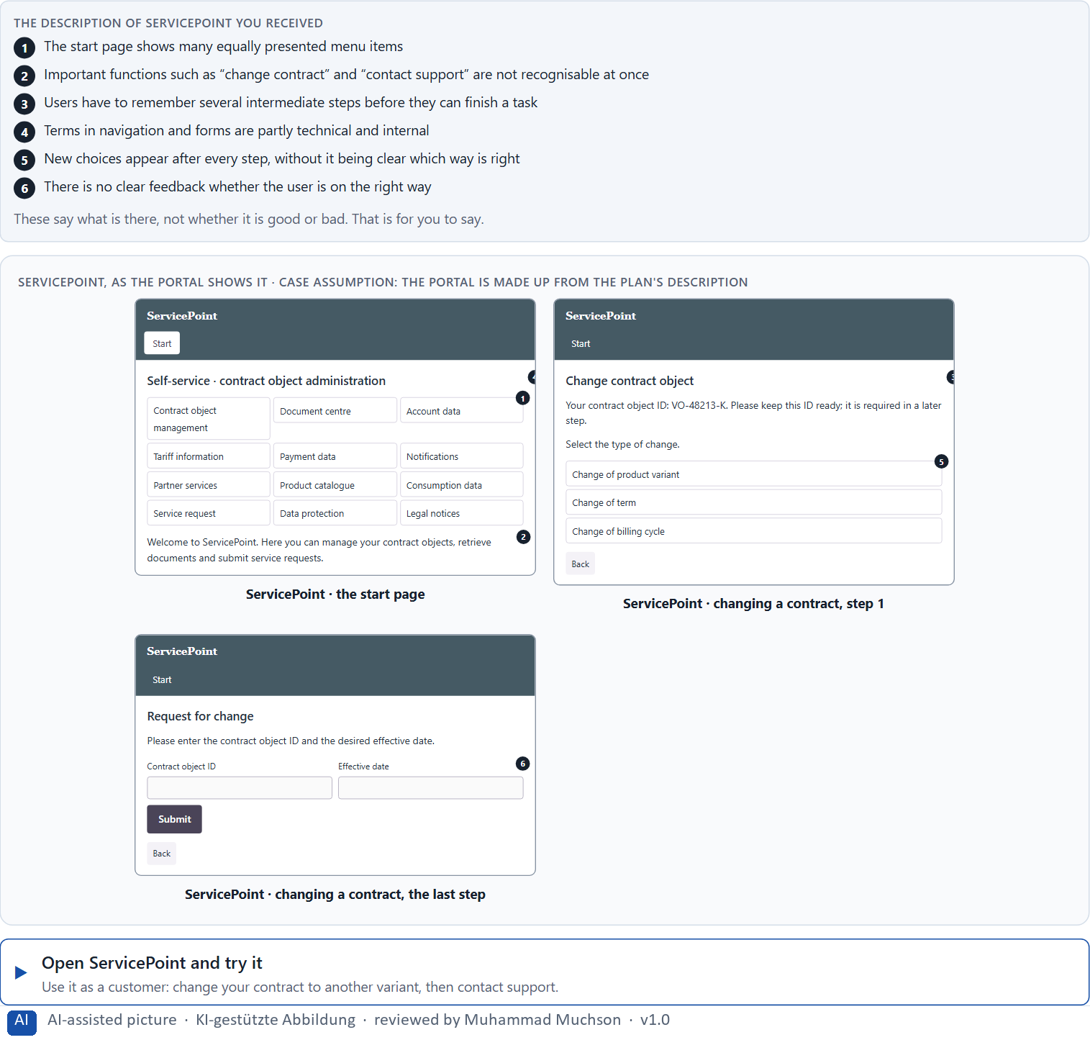
Figure 1 · ServicePoint, as the portal shows it.
Question 1 of 5 · Describe which places could feel unclear or tiring from the user's point of view
Name the places where you hesitated, searched or had to think, and say what made it tiring.
How to build the answer:
- Open ServicePoint and try to change your contract, then try to contact support.
- Write down every moment you hesitated, searched, went back or had to remember something.
- For each, say in a few words what made it tiring.

Question 2 of 5 · Name at least 5 possible obstacles to intuitive use
How to build the answer:
- Go back through your attempt from question 1.
- Write each obstacle as something the portal does that makes the user search, choose, remember or guess.
Write them as a list, one obstacle per line, and say what it makes the user do.

Question 3 of 5 · Assign the observations to the categories orientation, decision effort, memory load, understandability and action logic
Write the observations that belong to each category in a few words. One may fit two categories; put it where its effect is strongest.
How to build the answer:
- Take your obstacles from question 2.
- Ask what each one costs the user: finding the way, choosing, remembering, understanding, or knowing what to do next.
- Write it under that category.
Category | The observations in this category
Orientation
Decision effort
Memory load
Understandability
Action logic

Question 4 of 5 · Write an effect statement for three points: “For users this could mean that …”
How to build the answer:
- Pick three observations from questions 1 to 3.
- Finish the plan's sentence with what the user would do or fail to do.
Write them as a list, one statement per line, each starting with the observation and ending with what it could mean for users.

Question 5 of 5 · Prioritise the two biggest hurdles of use for a first-time user
How to build the answer:
- Think of someone who uses ServicePoint for the first time.
- Pick the two hurdles that would stop that person or lead them to a mistake, and say why.
Write them as a list, the bigger hurdle first, each with the reason it is so big for a first-time user.

Block 1.2 · Rate UX decisions under conflicting goals: WorkFlow Hub · JUDGED · Core · about 8 min
Draws on: A2 · How people compare options and decide · A3 · Expectations, recognisability and a clear action logic · A5 · UX laws as tools against friction, and weighing a measure.
WorkFlow Hub is a work platform. Three variants for its navigation are described in words: A) very many options directly visible and a large scope of functions, but a complex first impression; B) a reduced navigation with a clear focus on the main tasks, but some rare functions lie deeper in the system; C) a modern presentation with interactive elements, but patterns that change between the areas. The conditions: the product must work for new and for existing users, the department demands that all functions are fully visible, the UX team demands reduction and a clear priority, the budget for deep changes is limited, the release is in 9 weeks, and user tests are only partly available. Decide anyway, and say what you assume.
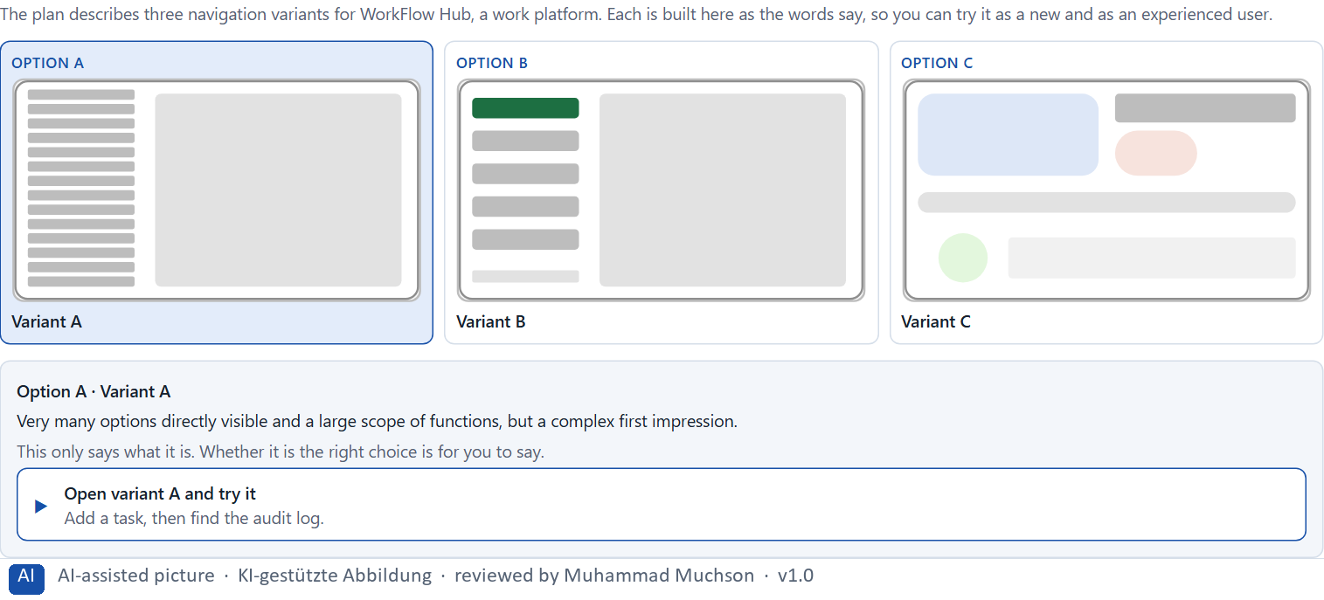
Figure 2 · The product to read, as the lab shows it (navigation).
Question 1 of 5 · Rate each variant on orientation, efficiency, understandability, learning effort and error risk
Write a few sentences for each variant that cover all five criteria. Many teams rate each criterion Low, Medium or High with a reason; you may do that or write it in your own words.
How to build the answer:
- Take one variant at a time and keep both groups in mind: new users and existing users.
- For each criterion, say how the variant does and why.
- Use the same five criteria for every variant, so you can compare them.
Variant | Orientation | Efficiency | Understandability | Learning effort | Error risk
Variant A · many options visible, complex first impression
Variant B · reduced, focus on main tasks, rare functions deeper
Variant C · modern and interactive, changing patterns

Question 2 of 5 · Decide which variant is the most viable at present
Choose one variant, then give your reason below. There is no single right choice; the reason has to rest on the users and the conditions.
How to build the answer:
- Say which group and which condition weigh most for you.
- Say how your choice meets them better than the other two.
Tick one:
☐ Variant A · many options visible, complex first impression
☐ Variant B · reduced, focus on main tasks, rare functions deeper
☐ Variant C · modern and interactive, changing patterns
Why this variant, under these conditions?
Give your reason with the conditions: new and existing users, the department against the UX team, a limited budget, 9 weeks, partial tests.
How to build the answer:
- Name the group and the condition that weigh most for you.
- Say how your variant meets them and why the other two meet them less well.
- Say what your choice gives up.

Question 3 of 5 · Name the conflicts of goals that influence your decision
Name at least two conflicts, each as two goals that pull against each other.
How to build the answer:
- Look at who wants what: the department, the UX team, new users, existing users.
- Write each conflict as “… against …” and say who stands for each side.

Question 4 of 5 · Which risks do you knowingly accept under time pressure?
Name at least one risk you accept and who would feel it.
How to build the answer:
- Think of what your chosen variant is weak at.
- Say who would notice and what would happen, and why you accept it within 9 weeks.

Question 5 of 5 · Formulate a decision recommendation for the project management
Two to four sentences: what you recommend, why, and what you will check next.
How to build the answer:
- Lead with the recommendation.
- Give the one reason the project management can follow.
- Say what you will check after the release.

Part 2 · The case study · Level 2 · Application · Case study (2 UE)
Case study: 2 teaching units (UE5–6)
This part is the day's Level 2 case study. It takes 2 UE (about 90 minutes): UE5 for the briefing and your own work, UE6 for comparing your results with your group and for the trainer's closing. The block below needs about 15 minutes of writing; the rest of the time is discussion.

Block 2.1 · Case study: reorganising the customer portal MyEnergy · JUDGED · Core · about 15 min
Draws on: A1 · Intuitive use is designed · A2 · How people compare options and decide · A3 · Expectations, recognisability and a clear action logic · A4 · Memory and load · A5 · UX laws as tools against friction, and weighing a measure.
An energy supplier runs MyEnergy, an online portal for tariff changes, adjusting instalments, submitting meter readings and retrieving bills. The portal offers many functions, but users often report that they cannot find tasks quickly or that they abandon processes. The company wants use to be more efficient and intuitive without reducing the scope of functions much. The observed problems: too many navigation items of equal rank make orientation hard, important tasks are not clearly prioritised, process steps build on each other without the logic being visible, technical language raises the effort of understanding, users have to remember information across several steps, and feedback in the process is unclear or too general. The conditions: a budget of €160,000, 12 weeks for the implementation, no complete relaunch, several departments want to keep their functions prominently visible, and user data is only partly available. You work through six steps.
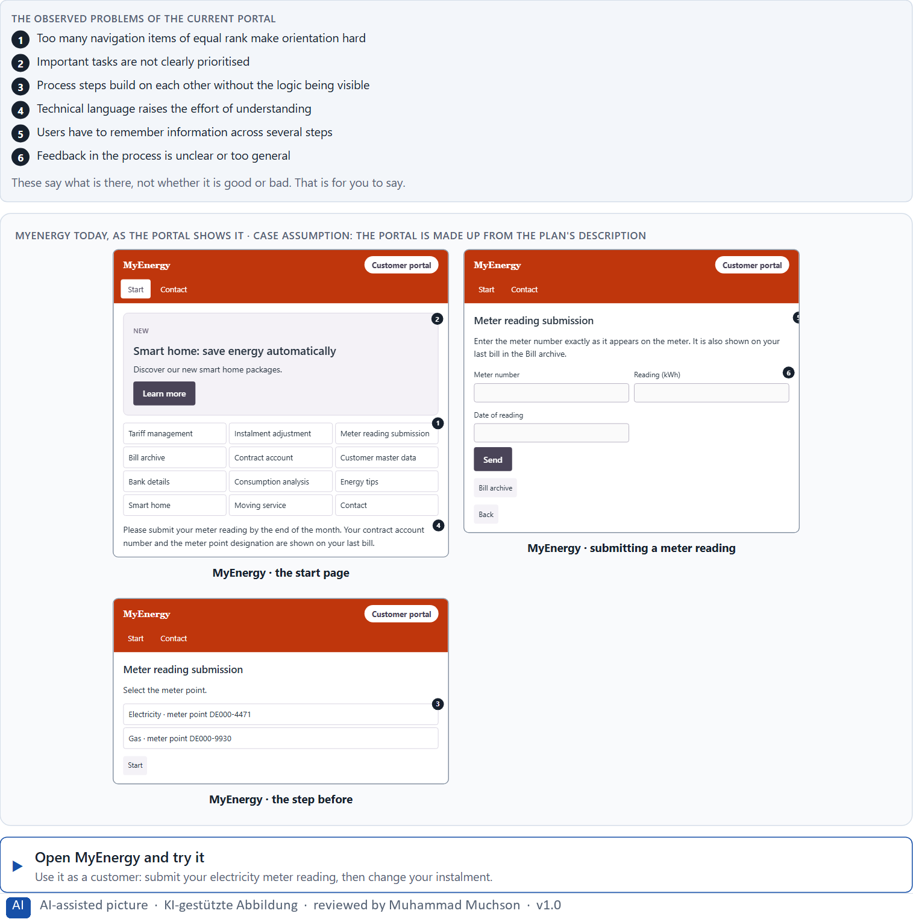
Figure 3 · MyEnergy today, as the portal shows it.
Question 1 of 6 · Analyse the central problems of use and cognition in the portal
How to build the answer:
- Open MyEnergy and submit a meter reading, then change your instalment, as a customer would.
- Write one problem per line as an effect on the user: what the portal makes them search, choose, remember or guess.
Write them as a list, one problem per line, each as an effect on the user. At least five.

Question 2 of 6 · Assign the problems to the categories orientation, decision effort, memory load, feedback and understandability
Write the problems that belong to each category in a few words. A problem may fit two categories.
How to build the answer:
- Take your problems from question 1.
- Ask which of the five categories each one affects most, and write it there.
Category | The problems in this category
Orientation
Decision effort
Memory load
Feedback
Understandability

Question 3 of 6 · Develop 4 prioritised measures to improve intuitive use
How to build the answer:
- Turn each group of problems into something you could change within 12 weeks, without a relaunch and without cutting functions.
- Put them in order: what lowers the load most and soonest first.
Write them as a numbered list, the first priority first, each with what it changes for users.

Question 4 of 6 · Justify your selection using effect on users, feasibility, risk and time pressure
Use all four criteria and say how they support your selection and its order.
How to build the answer:
- Say for your first measures how they lower the cognitive load.
- Say what is feasible without a relaunch and which risk each carries.
- Keep the departments and the 12 weeks in mind.

Question 5 of 6 · Make a prioritisation decision for the first 12 weeks
Say what you do in the first 12 weeks, in which order, and what you leave for later, with the reason.
How to build the answer:
- Say what comes first and why.
- Say what you do in parallel and what waits.
- Say how you deal with the departments that want visibility.

Question 6 of 6 · Formulate a recommendation to the division management
Three to five sentences: what you recommend, how, and what you expect to change.
How to build the answer:
- Lead with the recommendation.
- Say how it will be done.
- Say what you expect to change for users and for the company.

Task 2 · Route 2 · UX Strategy Memo: decide as Chief Experience Officer

The situation: the energy supplier behind MyEnergy, and all its touchpoints
Read once · about 2 min
You take the perspective of the Chief Experience Officer of the energy supplier that runs MyEnergy. The company has a customer portal, a mobile app and a service platform. Customers can do most tasks in principle, but only with much searching, uncertainty and support. Inside the company the discussion is about new functions, while the central problems of use remain unsolved. The management expects a sound strategy for more orientation and efficiency across all digital touchpoints. You are not to correct single screens but to develop a sound decision architecture for intuitive use based on cognitive principles.
The framework | How the task runs · one block
• The budget is limited  • Several stakeholders have different goals  • Departments want to secure the variety of functions  • User data is only partly available  • First improvements must be visible in 3 months  • Wrong priorities increase support costs, frustration and abandoned processes | • Block 3.1 asks seven questions: a guiding vision for intuitive use, three strategic decisions, a prioritised architecture of measures, a risk analysis, a governance model, one decision under uncertainty and a management statement.

What is known and what is open
In the brief | Clear · Case assumption | Open · on purpose
• A customer portal, a mobile app and a service platform.  • Most tasks can be done, but with much searching, uncertainty and support.  • Inside, the discussion is about new functions; the problems of use stay unsolved.  • First improvements in 3 months; user data only partly available. | • The company is the energy supplier behind MyEnergy in Route 1.  • Each department adds its functions to the channels it owns; nobody owns the flow of a task across channels.  • Support records the subject of each contact; the portal records finished processes; the app records crashes, not abandoned steps. | • How large the budget is: “limited” is all the plan says.  • Which task causes the most support: the data is only partial.  • Which functions customers never use: not measured.

As in most projects, not everything is known. Decide anyway, and say what you assume.
Case assumption
The brief says: a company with a customer portal, a mobile app and a service platform, users who can do most tasks only with much searching, uncertainty and support, an inside discussion about new functions, a limited budget, several stakeholders, departments that want variety of functions, partial user data, first improvements in 3 months, and the warning that wrong priorities increase support costs, frustration and abandonment. Those are the plan's facts. That the company is the energy supplier of Route 1 and the facts marked “Clear” are made up for this exercise.

The memo is addressed to: The management. Subject: A strategy for intuitive use across our digital touchpoints.

Part 3 · Level 3 · Management decision · Transfer project (3 UE)
Transfer project: 3 teaching units (UE8–10)
UE8: the trainer presents Materi B and sets the role. UE9: you write the memo. UE10: you present the decision and what you give up; the trainer debriefs.

Block 3.1 · A strategy for intuitive use in a complex digital product system · JUDGED · Core · about 20 min
Draws on: B1 · Usability as a strategic factor · B2 · Conflicts of goals · B3 · Who owns the interaction logic, and deciding with partial user data.
Develop a strategic concept for the energy supplier. Your desk holds what the management, the departments and the data say. Open it, then answer the seven questions; your answers build the memo below.
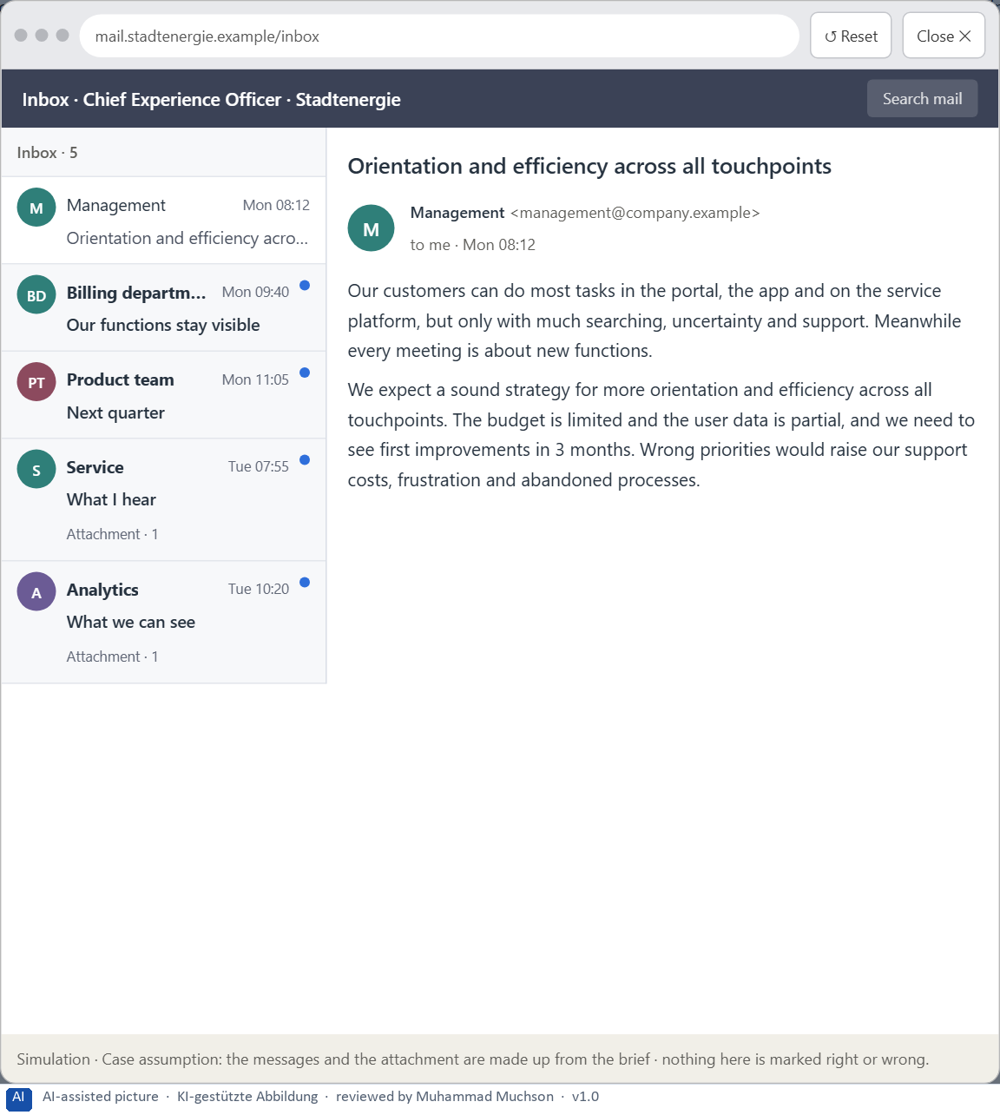
Figure 4 · Your desk: the messages that wait for you, shown in the lab as a mailbox (1 of 5).
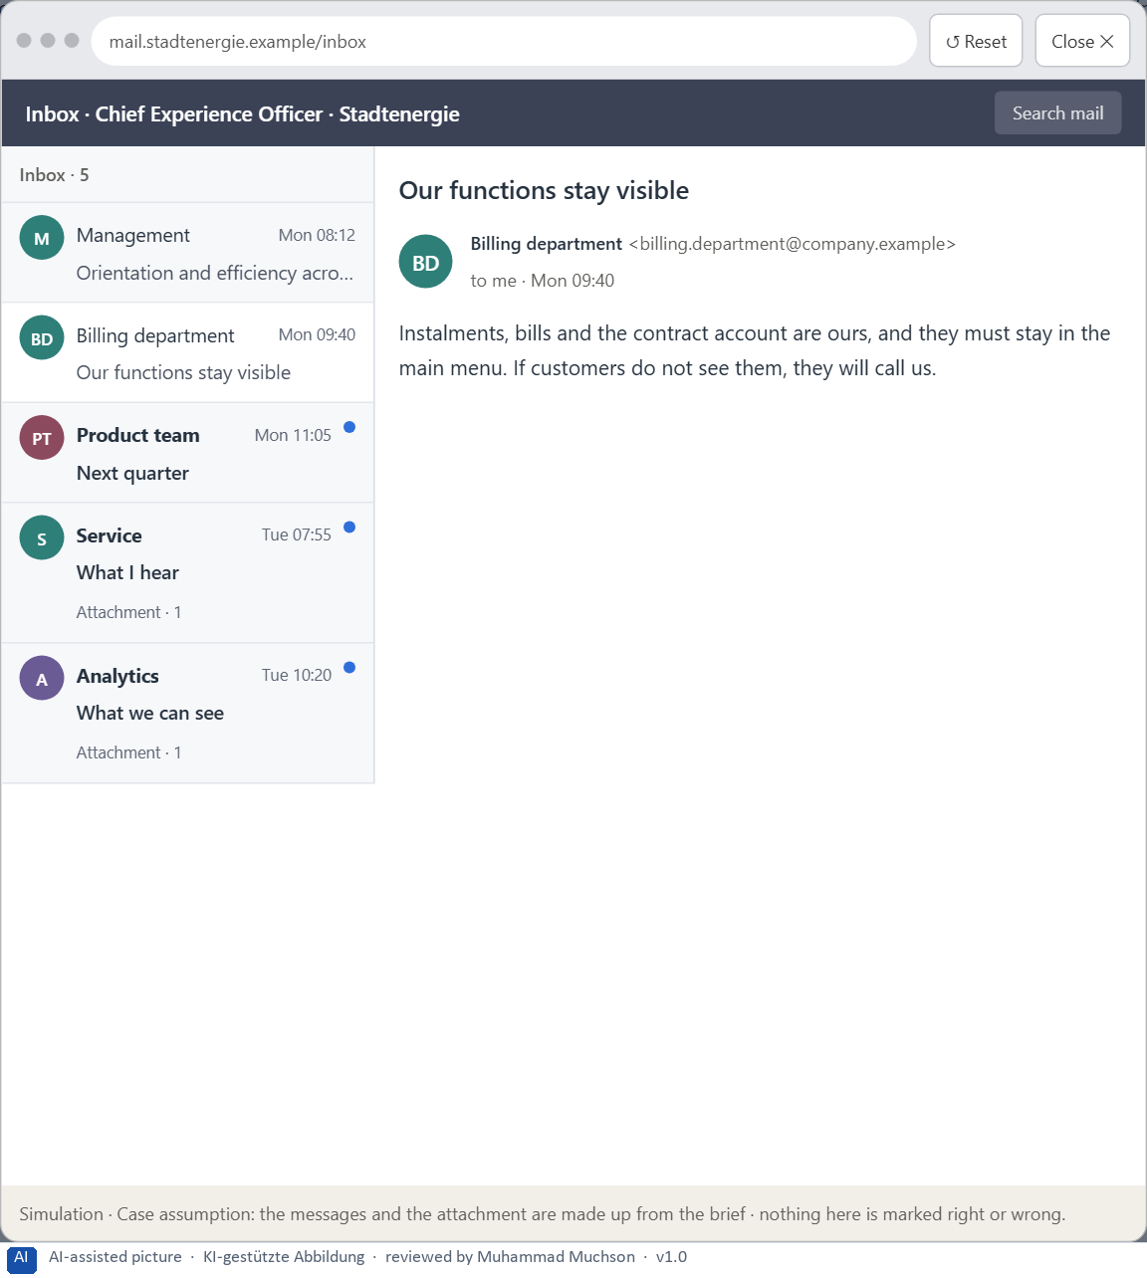
Figure 5 · Your desk: the messages that wait for you, shown in the lab as a mailbox (2 of 5).
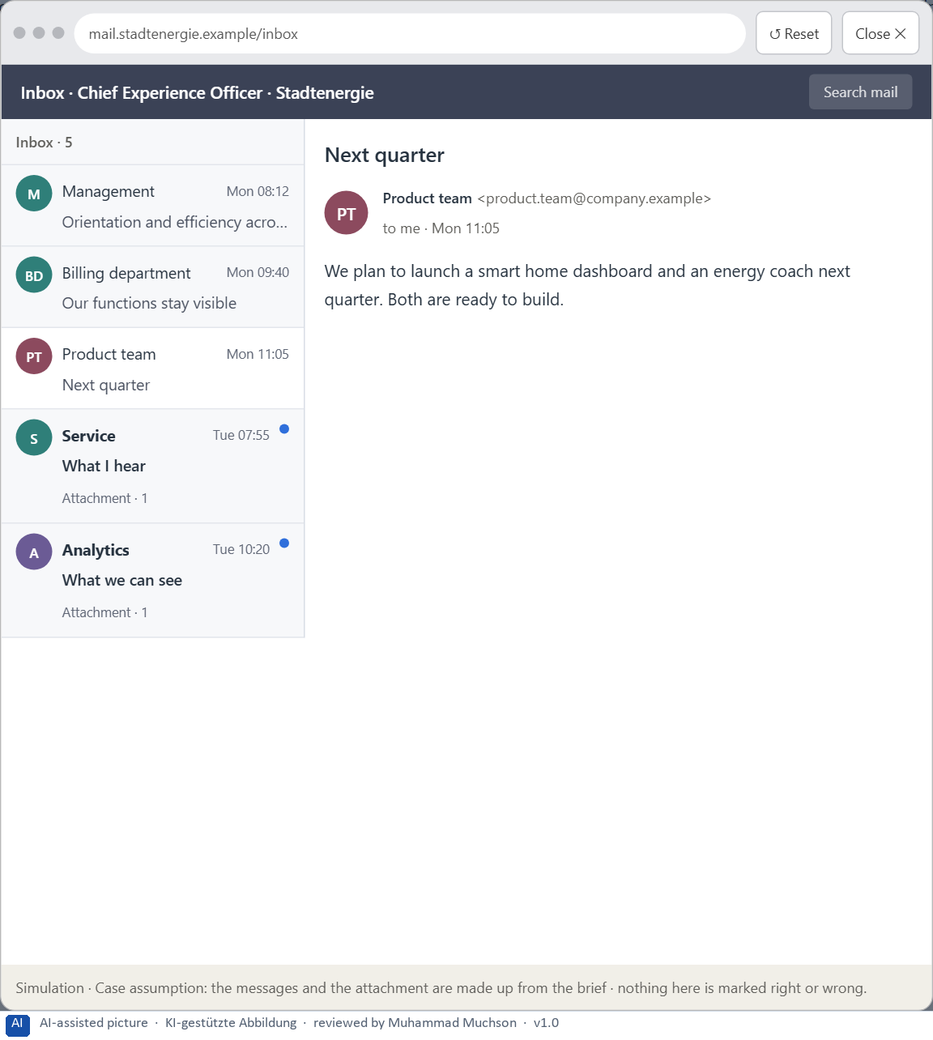
Figure 6 · Your desk: the messages that wait for you, shown in the lab as a mailbox (3 of 5).
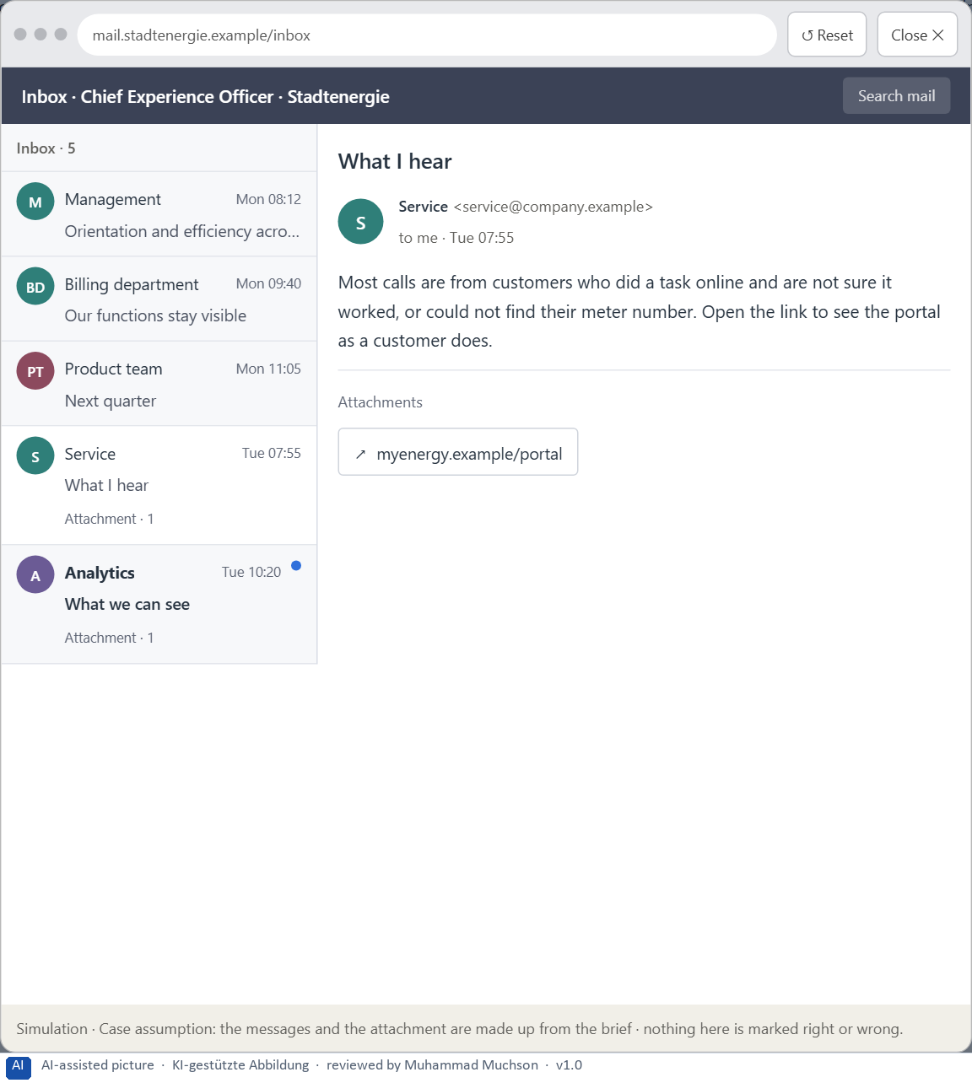
Figure 7 · Your desk: the messages that wait for you, shown in the lab as a mailbox (4 of 5).
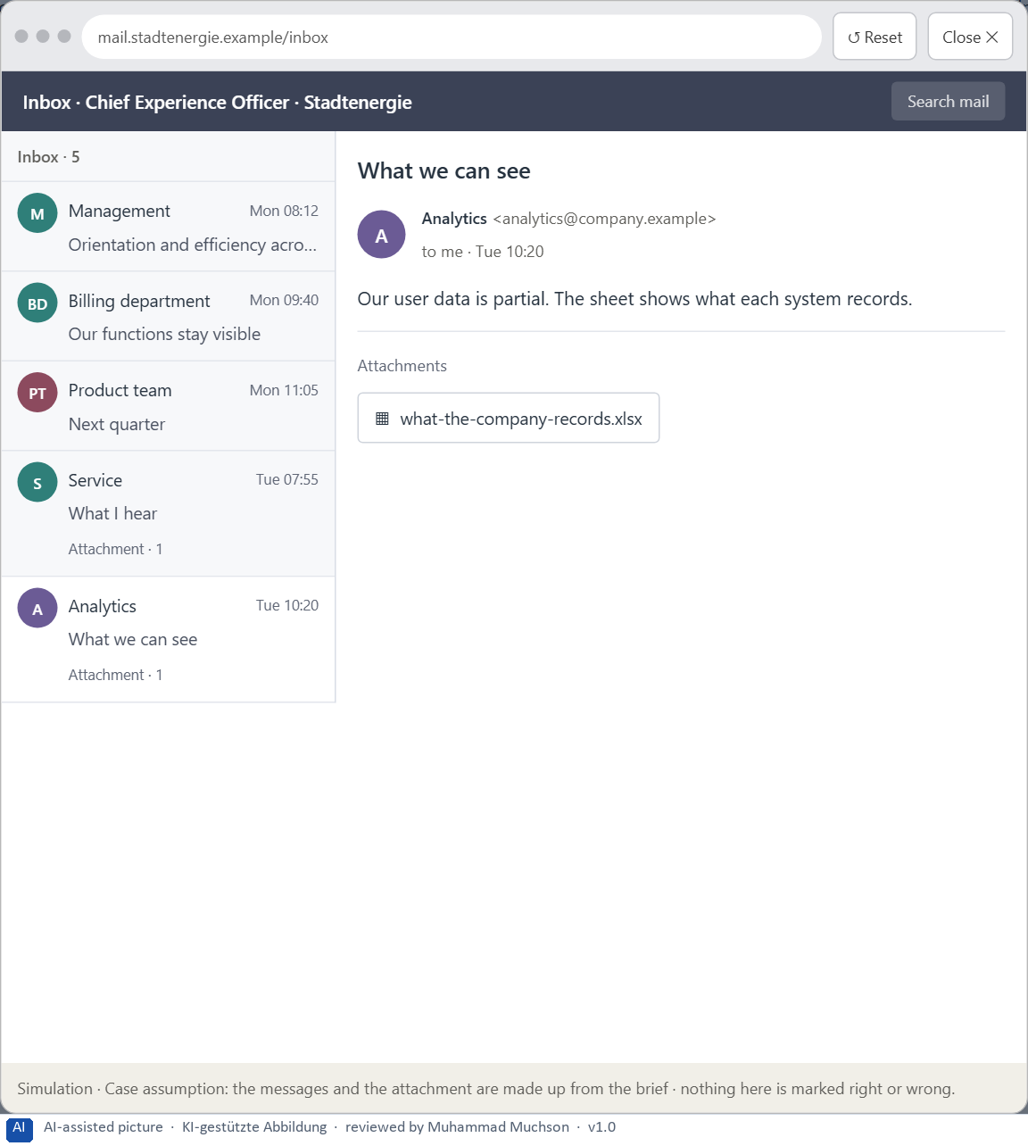
Figure 8 · Your desk: the messages that wait for you, shown in the lab as a mailbox (5 of 5).
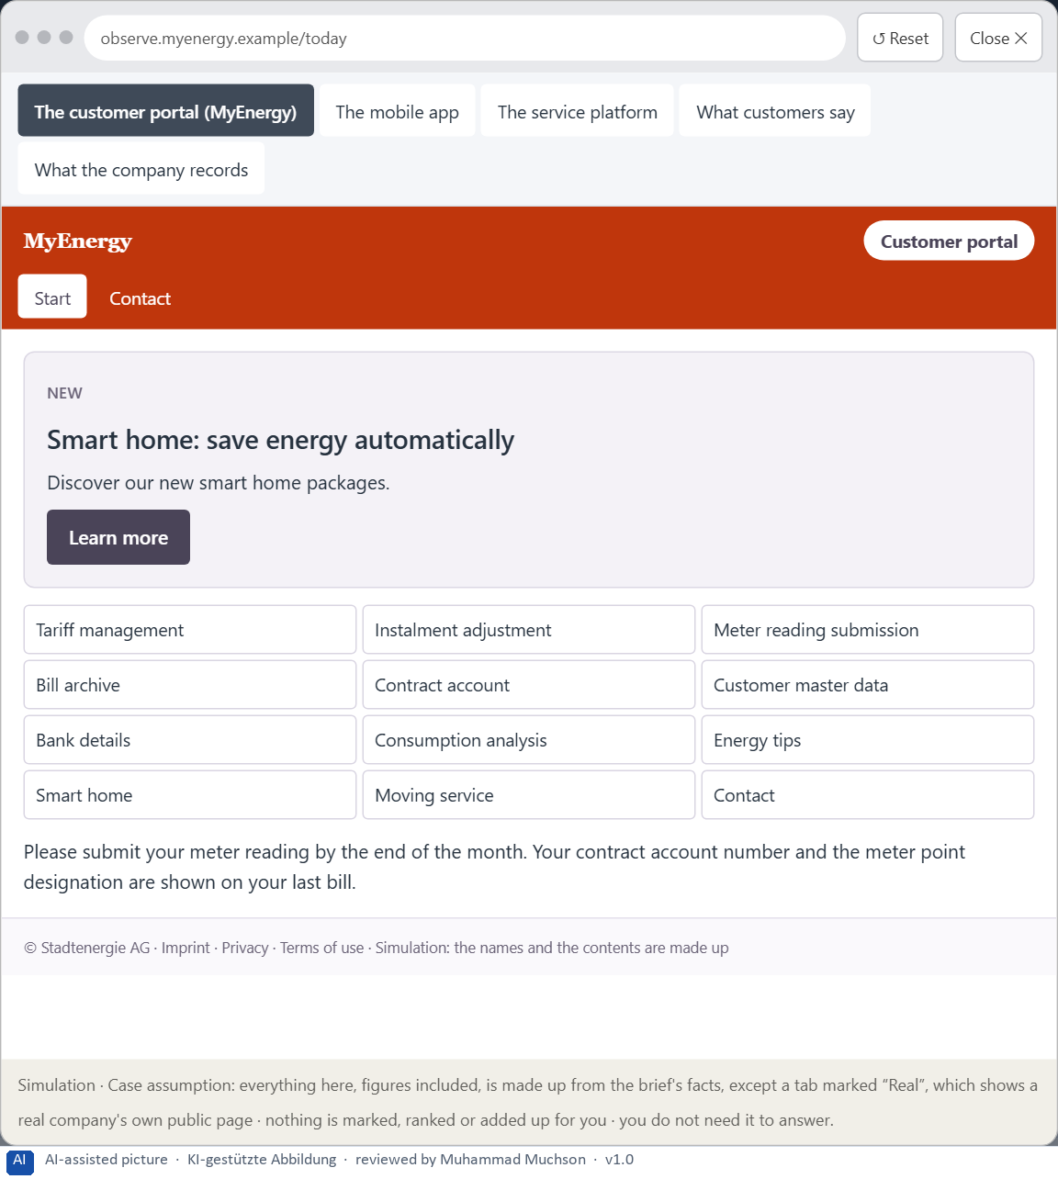
Figure 9 · The platform as it is today, as the lab lets you observe it (1 of 5).
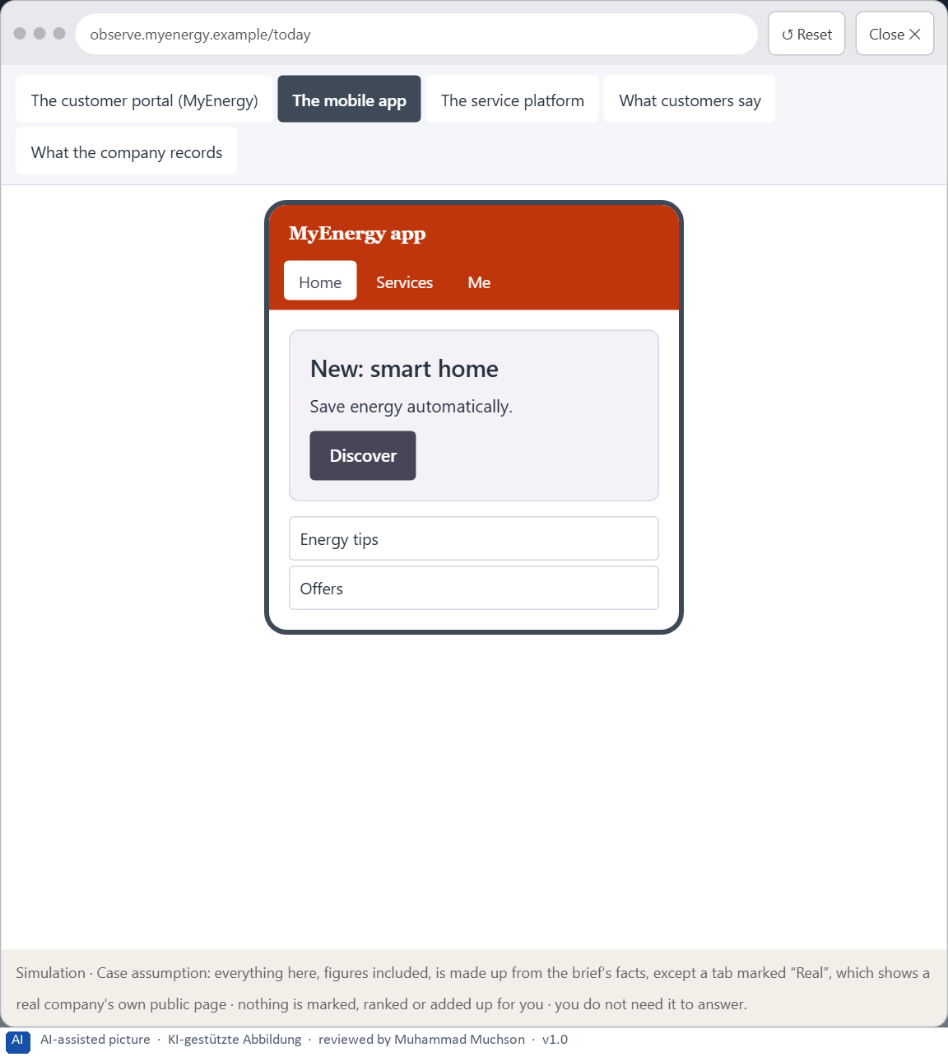
Figure 10 · The platform as it is today, as the lab lets you observe it (2 of 5).
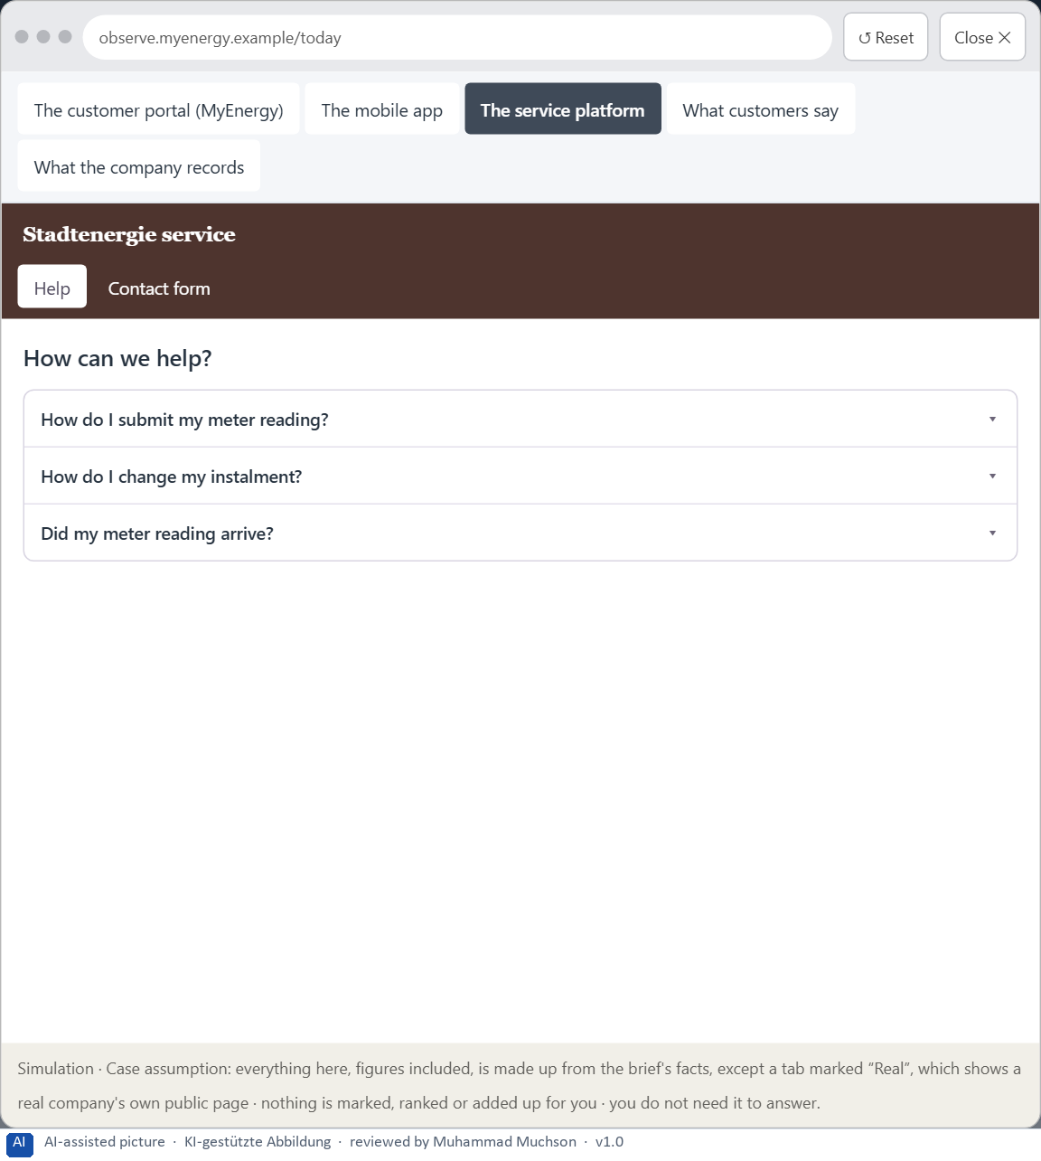
Figure 11 · The platform as it is today, as the lab lets you observe it (3 of 5).
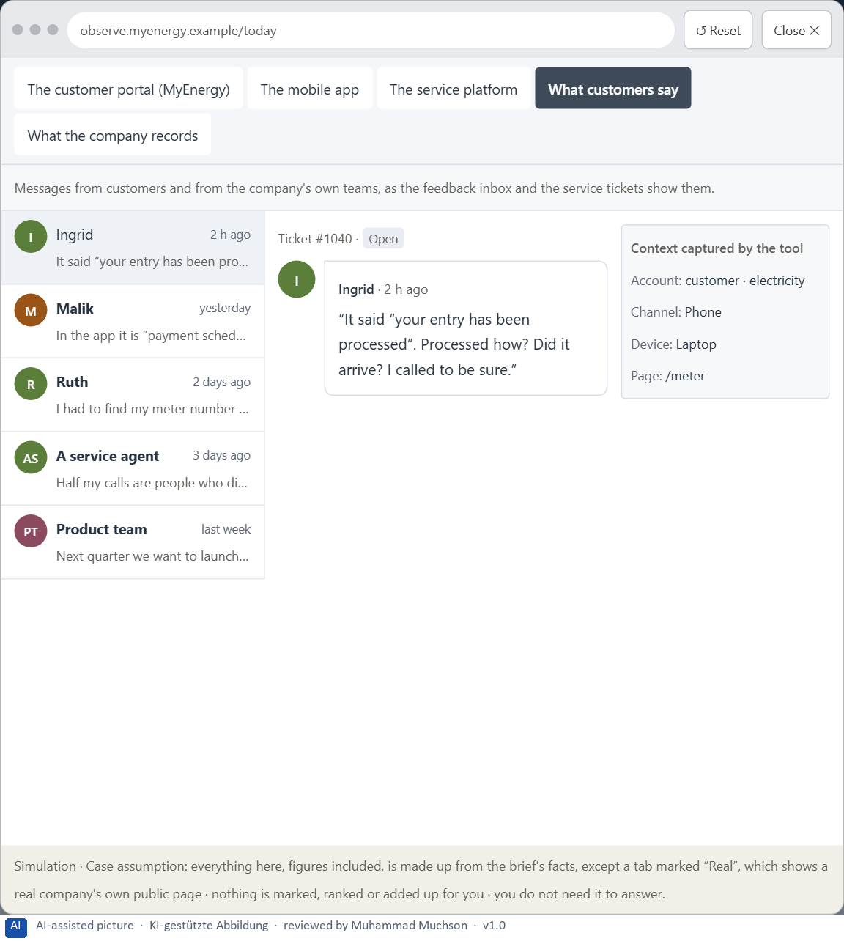
Figure 12 · The platform as it is today, as the lab lets you observe it (4 of 5).
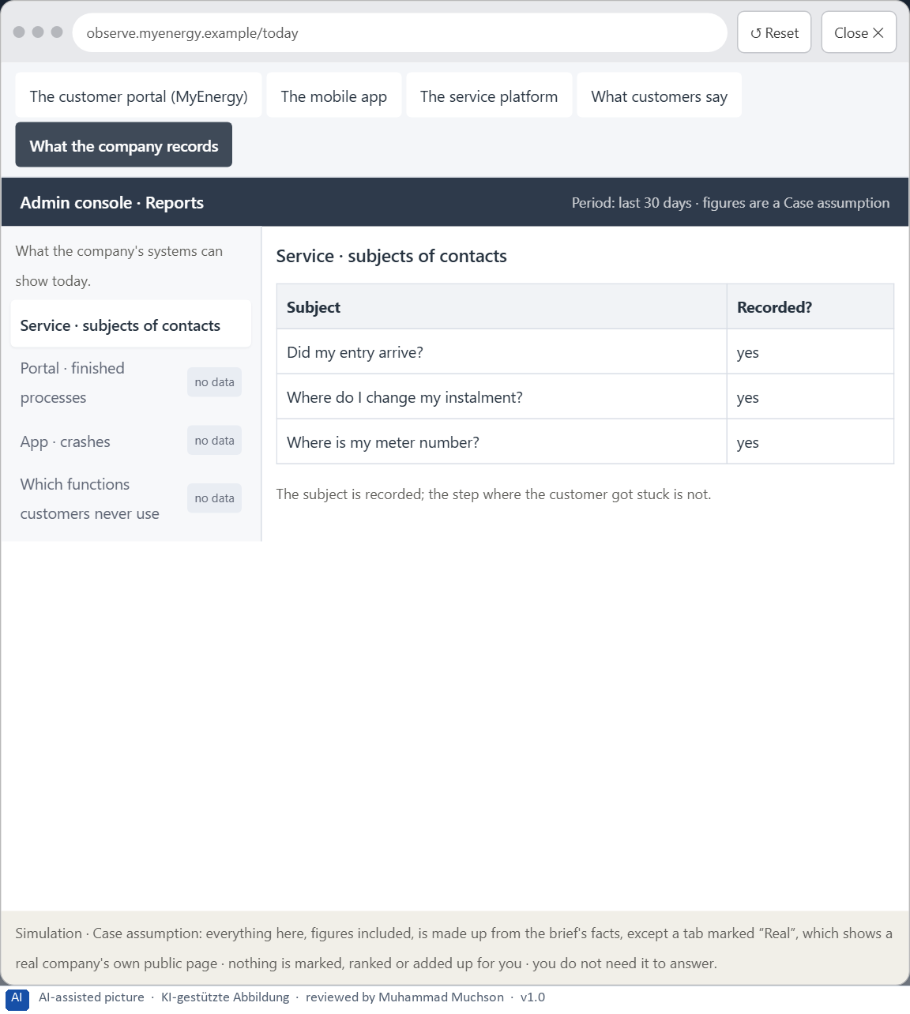
Figure 13 · The platform as it is today, as the lab lets you observe it (5 of 5).
Question 1 of 7 · A guiding vision for intuitive use: which user experience and which action logic should be enabled systematically?
One or two sentences about what customers should experience and how every task should work, in every touchpoint.
How to build the answer:
- Say what customers should be able to do without searching, remembering or guessing.
- Say the action logic every task should follow, in one line.

Question 2 of 7 · Three strategic guiding decisions on orientation, efficiency, reducing complexity and prioritising the main tasks
How to build the answer:
- Take your vision and ask which three choices would make it real.
- Write each as “we will …, even though that means …”.
Write them as a list, one decision per line, each with what it gives up.

Question 3 of 7 · A prioritised architecture of measures: which systems or processes are improved first, and why?
Put the systems or processes in an order and give the reason for the first ones.
How to build the answer:
- List the candidates: the processes customers do most, and the touchpoints they use.
- Put first what causes most searching, uncertainty and support.
- Say why the others can wait.

Question 4 of 7 · A risk analysis: which wrong assumptions about user behaviour and internal requirements would be especially critical?
Name two or three assumptions about how customers behave or what the departments need, and the harm if each is wrong.
How to build the answer:
- Write down what your concept assumes about customers.
- Write down what it assumes about the departments' requirements.
- For each, say what happens if it is wrong.

Question 5 of 7 · A governance model: who is responsible for decisions on the interaction logic, and how are conflicts of goals decided?
Name roles, not people: who owns the interaction logic across touchpoints, how a department's request is decided, and on what basis.
How to build the answer:
- Name who owns the interaction logic and the order of tasks across touchpoints.
- Name how a department's wish for visibility or a new function is decided.
- Say on what basis the conflict is decided.

Question 6 of 7 · A decision under uncertainty: make at least one prioritised decision despite incomplete data and justify it responsibly
Say what you decide, what you do not know, and why the decision is responsible all the same, for example when you would reverse it.
How to build the answer:
- State the decision in one sentence.
- Name what you do not know.
- Say why it is still responsible: it can be reversed, it can be checked soon, or waiting costs more.

Question 7 of 7 · A management statement: a recommendation to the management with a clear priority and a strategic reason
Four to six sentences: the direction first, then the priority, the reason and what you ask of the management.
How to build the answer:
- Start with the direction in one sentence.
- Name the priority and the reason that carries it.
- Say what you ask of the management and what you will report back.

Use in class: presentation and handout
Mark of use for the worksheet. Presentation is what the trainer shows on screen; Handout is what participants fill in and hand in.
Part of the worksheet | Presentation (shown in the Neuro-UX Lab) | Handout
The case: three products on the UX team's desk, and MyEnergy | The case read aloud or on screen | The case text
Block 1.1 · Recognise the hurdles of use in a digital application: ServicePoint | The task wording at the start of the block (no answers are shown) | Worksheet block with answer boxes (Core)
Block 1.2 · Rate UX decisions under conflicting goals: WorkFlow Hub | The task wording at the start of the block (no answers are shown) | Worksheet block with answer boxes (Core)
Block 2.1 · Case study: reorganising the customer portal MyEnergy | The task wording at the start of the block (no answers are shown) | Worksheet block with answer boxes (Core)
The situation: the energy supplier behind MyEnergy, and all its touchpoints | The case read aloud or on screen | The case text
Block 3.1 · A strategy for intuitive use in a complex digital product system | The task wording at the start of the block (no answers are shown) | Worksheet block with answer boxes (Core)

Glossary
Every term below is used in this document. Terms stay plain text in the body; this list says what they mean in everyday words.
Term | In plain words | Example | Comes from
Action logic | The order in which a task runs: where it starts, which steps follow, what each step asks and how the person knows they are done. | — | Day 4
Case assumption | A fact made up for this exercise to fill a gap in the plan's case. It is marked so you know it is not part of the plan. | — | Day 1
Chief Experience Officer | The manager who is responsible for the experience customers have across all channels, and who decides where the company invests in it. | — | Day 1
Cognition | The thinking side of the mind: remembering, comparing, understanding and deciding. | — | Day 1
Cognitive load | How much a person has to hold in mind and work out at the same time. Every extra signal or choice adds to it; when it is too high, people skip, freeze or leave. | — | Day 1
Decision architecture | A set of connected decisions that are made on purpose and written down: what effect you want, what comes first, who decides and how conflicts are settled. It replaces many separate fixes. | — | Day 1
Decision effort | The mental work of comparing options and choosing one. Many equal options raise it. | — | Day 4
Feedback | What the system tells people after they act: that a step worked, what happens next, or what went wrong and how to fix it. | — | Day 4
Friction | Everything that slows people down or makes them think about the interface instead of their task: searching, choosing, remembering, guessing. | — | Day 4
Governance | The rules about who may decide what, who is answerable for it and how disagreements are settled. | — | Day 1
Intuitive use | Use that works without thinking about the interface: people find what they need, know what to do next and know when they are done. It is designed, not a matter of luck. | — | Day 4
Memory load | How much a person has to keep in mind while using an interface, such as a number from an earlier screen or the option chosen two steps back. | — | Day 4
Orientation | Knowing where you are, what you can do here and what happens next. | — | Day 1
Self-service portal | A website where customers do things themselves that once needed a call or a visit, such as reporting damage or downloading a document. | — | Day 1
Stakeholder | A person or department with an interest in a decision, such as marketing, compliance, IT or sales. | — | Day 1
Touchpoint | Any place where a person meets the company: the website, the customer portal, the app, a chatbot or a phone call. | — | Day 1
UX (user experience) | Everything a person goes through when using a product: what they notice, understand, feel and do, from the first look to the last step. The screens are only one part of it. | Finding the booking you want at once and feeling sure it went through is a good UX. | Day 1
UX law | A well-tested finding about how people perceive, decide or act, used as a rule of thumb in design, such as Hick's law or Fitts's law. It explains why something is hard; it does not replace looking at the users. | — | Day 4

The Neuro-UX Lab: where we practise online
In class we use the course website as the place to practise and to learn. Every day has its own address, in the same pattern: the day number is the last part.
What | Address
Neuro-UX Lab (course website) | https://aion-ux-lab.vercel.app/
Day 4 | https://aion-ux-lab.vercel.app/day/4/

On the day page, Route 1 (Levels 1 and 2) and Route 2 (Level 3) can be opened; the cards and the tasks of this document are there too. The pattern is the same up to Day 8, for example https://aion-ux-lab.vercel.app/day/6/.

