AION · UX DEVELOPER · PSYCHOLOGICAL UX DESIGN AND NEURO-UX
DAY 8 · MATERI A AND MATERI B · ROUTES 1 AND 2 · LEVELS 1 TO 3
Storytelling in UX/UI design
Study material with real research, worked examples and the rules you use in the tasks
AI notice · KI-Hinweis
This document was produced with the help of an AI language model (Claude, Anthropic). The AI drafted the text and tables and built the pictures and working examples of the lab. The content was then read, corrected and approved by the reviewer named below, who is responsible for its accuracy. Every picture carries an AI label on the image. Check figures and sources before you quote them.
KI-Hinweis: Dieses Dokument wurde mit Unterstützung eines KI-Sprachmodells (Claude, Anthropic) erstellt. Texte und Tabellen wurden von der KI entworfen, die Abbildungen sind KI-gestützt erstellt und am Bild gekennzeichnet. Die fachliche Prüfung und Freigabe erfolgte durch die unten genannte Person.

Day | Day 8 · Module 4 (day 2 of 3): Storytelling in UX/UI design
Document | Materi (study material). Materi A has five cards, Materi B has three.
Route and level | Materi A serves Route 1 (Levels 1 and 2, Task 1). Materi B serves Route 2 (Level 3, Task 2).
Time | Materi A about 60 min · Materi B about 60 min (facilitator-led)
Neuro-UX Lab (website) | https://aion-ux-lab.vercel.app/day/8/
Case | Worked examples use a made-up company in each card. The task case is GreenHome (see the Task document).
Version | 1.0 · release date 29.10.2026
Review and approval | Muhammad Muchson, Mentor (subject-matter review and approval)

ABOUT THIS DOCUMENT
In class we also use the Neuro-UX Lab, the course website, as the place to practise and learn. Its address is at the end of this document.
Today is about the story a digital product tells while people use it. You learn why people experience a process as a journey and not only as a list of functions, the elements of narrative guidance (a starting situation, a goal, relevance, an obstacle, support, progress, a resolution), the dramaturgical means of tension, expectation, sequence, transition, confirmation and emotional context, how they raise orientation, motivation and memorability, and where storytelling turns into overload. Then you use it on three products. This document holds everything you need to study Day 8 without the website. Every card says what the idea is in plain words, shows it in a picture, gives the details and ends with the rules you use in the tasks.

IN THIS DOCUMENT
Lesson plan: ten teaching units (Ablaufplan)
Case study and transfer project at a glance
A1 · Why people experience a process as a story · 12 min · Core
A2 · The elements of narrative guidance: from starting point to resolution · 12 min · Core
A3 · Telling a story or guiding with one: dramaturgy in a journey · 12 min · Core
A4 · Orientation, motivation and memorability, and the risk of overload · 12 min · Core
A5 · Embedding an action in its context, and weighing a measure · 12 min · Core
B1 · Narrative UX as experience architecture, not communication · 20 min · Core
B2 · Efficiency against story: the conflicts of narrative UX · 20 min · Core
B3 · Who owns narrative UX, and deciding without seeing where people stop · 20 min · Core

Day at a glance
Day 8 has ten teaching units (UE). This document is the study material; it is used in UE1 (Materi A) and UE8 (Materi B). The day is built from three documents and the Neuro-UX Lab: Materi (study material), Task (worksheet) and Trainer (coaching, feedback and model solutions), plus the course website.

Lesson plan: ten teaching units (Ablaufplan)
UE | Min | Plan item | What happens | Material | Format
1 | 45 | Knowledge transfer · Level 1 | The trainer presents the cards of Materi A (A1, A2, A3, A4, A5, about 60 min of cards) in the Neuro-UX Lab; participants follow in the handout. | Materi A (Route 1) | Presentation + Handout
2 | 45 | Level 1 · Task 1 | Individual work on Block 1.1 (Core, about 10 min): the first product of the day is read and its effect described. Pairs then compare their results and the trainer collects open questions. | Task 1 · Part 1 · Block 1.1 | Handout (or in the lab)
3 | 45 | Level 1 · Task 2 | Three options are rated on the same criteria and one is chosen under the stated conditions: Block 1.2 (Core, about 8 min). | Task 1 · Part 1 · Block 1.2 | Handout (or in the lab)
4 | 45 | Coaching · transition from Level 1 to Level 2 | Trainer-led. A short talk on the day's coaching focus, then the reflection questions in pairs. The bridge: from describing an effect to a decision you answer for. There is no worksheet block in this unit. | Trainer document, section Coaching | Trainer only
5–6 | 90 | Level 2 · Case study GreenHome (2 UE) incl. model solution | UE5: the trainer presents the case; participants work on Block 2.1 (Core, about 15 min). UE6: groups compare their results and defend them; the trainer closes with the model solution. | Task 1 · Part 2 · Block 2.1  Trainer document, section Case study | Handout; model solution shown after the work
7 | 45 | Level 2 + 3 · Feedback round with a management perspective | Groups present their reasoning, not only their result. The trainer asks the day's Level 3 input questions and leads the discussion. | Trainer document, section Feedback round | Presentation by the groups; Trainer only
8 | 45 | Level 3 · Transfer project, Chief Experience Officer (3 UE: UE8–10) | The trainer presents Materi B (B1, B2, B3; use the "In plain words" and "How to decide" boxes, the rest is handout) and sets the role and the situation. | Materi B (Route 2) | Presentation + Handout
9 | 45 | Level 3 · Transfer project | Individual work or in pairs on Block 3.1 (Core, about 20 min): the strategy memo. | Task 2 · Block 3.1 | Handout (or in the lab)
10 | 45 | Level 3 · Transfer project | Participants present their decision and what they give up, including the one decision made under uncertainty; the trainer debriefs with the model solution. | Task 2 · Block 3.1  Trainer document, section Transfer project | Handout; model solution shown after the work

One UE is counted as 45 minutes here; breaks are not shown. The times are a guide for the trainer. The Core blocks are enough for a complete answer.

Case study and transfer project at a glance
Component | UE | Duration | Participants work in | Model solution in
Level 2 case study (GreenHome) | UE5–6 | 2 UE · 90 min | Task 1 · Part 2 (Block 2.1) | Trainer document, section Case study
Level 3 transfer project (Chief Experience Officer) | UE8–10 | 3 UE · 135 min | Materi B and Task 2 (Block 3.1) | Trainer document, section Transfer project

Materi A · Route 1 · Levels 1 and 2
How Materi A is used
About 60 minutes, five cards. Levels 1 and 2: describe the narrative gaps of an unfamiliar start-up platform, rate three journeys of a further-training platform between efficiency and dramaturgy, then analyse an onboarding flow, develop four measures, justify them and decide on the first 12 weeks. The cards give you the ideas and the rules you use in Task 1.

A1 · Why people experience a process as a story · 12 min · Core
People make sense of what they do as a story: where they start, where they are going, how far they have come. A process that shows only functions still gets read as a journey, and without a story it feels lost or endless.
IN PLAIN WORDS
The idea. People make sense of what they do as a story: where they started, where they want to go, what stands in the way and how far they have come. A digital process is experienced the same way, whether it was designed as a story or not. When it shows only functions and forms, people still look for the story, and when they cannot find one they feel lost, bored or left alone. Storytelling in UX/UI design means building the journey so that the story people look for is there: a beginning that shows the goal, a way that shows progress, and an end that feels like an end.
Why it matters. Block 1.1 asks for the effect of StartSmart on a first-time user and for effect statements of the form “for users this could mean that …”, and Block 2.1 asks why GreenHome's complete onboarding is abandoned. This card gives you the reason a working process can still feel like no journey at all.
How to read the picture. The same Lantern Kitchens planner twice: as a list of functions and as a journey.

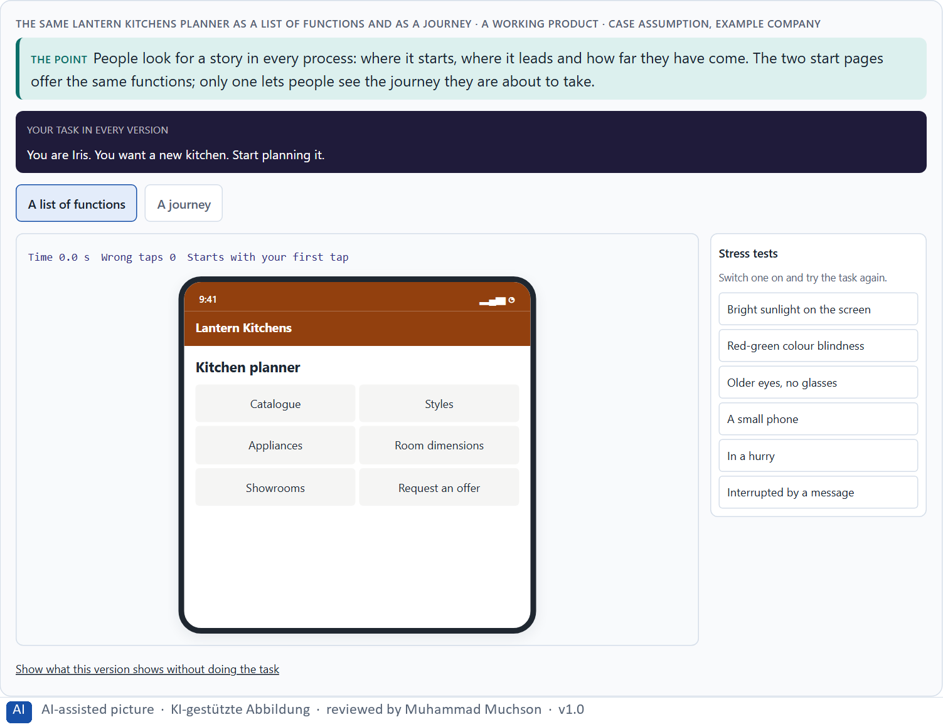
Figure 1 · The same Lantern Kitchens planner as a list of functions and as a journey. Shown here in its starting state; in the Neuro-UX Lab every version and every stress test can be used.
Processing a process as a story
People look for | What they ask | If it is missing
A beginning | Where do I start, and is this for me? | They browse and leave.
A goal | What will I have at the end? | No reason to begin or to go on.
A way | How far have I come, how much is left? | It feels endless; they give up halfway.
An end | Am I done, and was it worth it? | They are unsure it worked.

Why people experience a process as a story: evidence
Idea | Real finding | What it means for a screen
Narrative as a way of thinking | Jerome Bruner described narrative as one of two basic ways in which people order experience, next to logical argument (Bruner 1991). | People make sense of a sequence of steps as “what happens to me”, whether or not the designer meant a story.
Absorption | Green and Brock described transportation: absorption into a story through imagery, feeling and focused attention, which makes people more open to the story's view (Green and Brock 2000). | A well-told step holds attention; the same effect can carry a message that has not been checked, so tell only what is true.
Progress pulls | In a real café reward programme, customers bought coffee more often the closer they were to a free coffee, and customers who got a card with two stamps already filled in completed it faster (Kivetz et al. 2006). | Show where the person is on the way, because the felt distance to the goal drives effort.
A head start | At a car wash, customers who got a card that needed ten stamps with two filled in were compared with customers who got a card that needed eight (Nunes and Drèze 2006; the study is often quoted for its effect on completion). | A visible head start makes a long path feel begun.

Case assumption
Lantern Kitchens, Iris, Pavel, June and Arne are made up for this example. Narrative as a way of making sense of experience follows Bruner (1991); storytelling for user experience follows Quesenbery and Brooks (2010); design as a sequence with a beginning, tension and resolution follows Lupton (2017). The findings in the table of real evidence are real research results, rules and cases; the sources are listed below.

How to decide when this comes up in the task
- Look at the first screen and ask: does it show where the journey leads, or only what the product can do?
- Ask whether people can tell, at any point, where they are and how much is left.
- Ask whether the end of the journey feels like an end.
- Write an effect as a hypothesis: “for users this could mean that …”.
- A process that works but tells no story is still experienced as a journey: a poor one.

Extra · go deeper (optional reading)
Bruner (1991) argued that people do not store experience as a list of facts but as stories with actors, goals and turns. In a digital product the actor is the user, the goal is what they came to do, and the turns are the steps, the obstacles and the help. A product that does not offer this structure leaves people to build it themselves, and many give up before they do.

Sources · Bruner 1991 · Quesenbery & Brooks 2010 · Lupton 2017 · Green & Brock 2000 · Kivetz et al. 2006 · Nunes & Drèze 2006

A2 · The elements of narrative guidance: from starting point to resolution · 12 min · Core
Seven elements guide a journey: starting situation, goal, relevance, obstacle, support, progress and resolution. Without a visible goal and progress it feels endless; without a resolution it ends without achievement.
IN PLAIN WORDS
The idea. Narrative guidance has seven elements. The starting situation: where the user is now. The goal: what they will have at the end. Relevance: why it matters for them. The obstacle: what makes it hard, said honestly. Support: what helps them over it. Progress: how far they have come. The resolution: the end, where the goal is reached and seen. A process that leaves out the goal or the progress feels endless; one that leaves out the resolution ends without a sense of achievement.
Why it matters. Block 1.1 asks for five places where StartSmart's narrative guidance is missing and for its two biggest weaknesses, and Block 2.1 asks for GreenHome's central narrative deficits. This card gives you the seven elements to say which part of the journey is missing.
How to read the picture. One Lantern Kitchens planner with three switches: a goal, visible progress and a resolution.

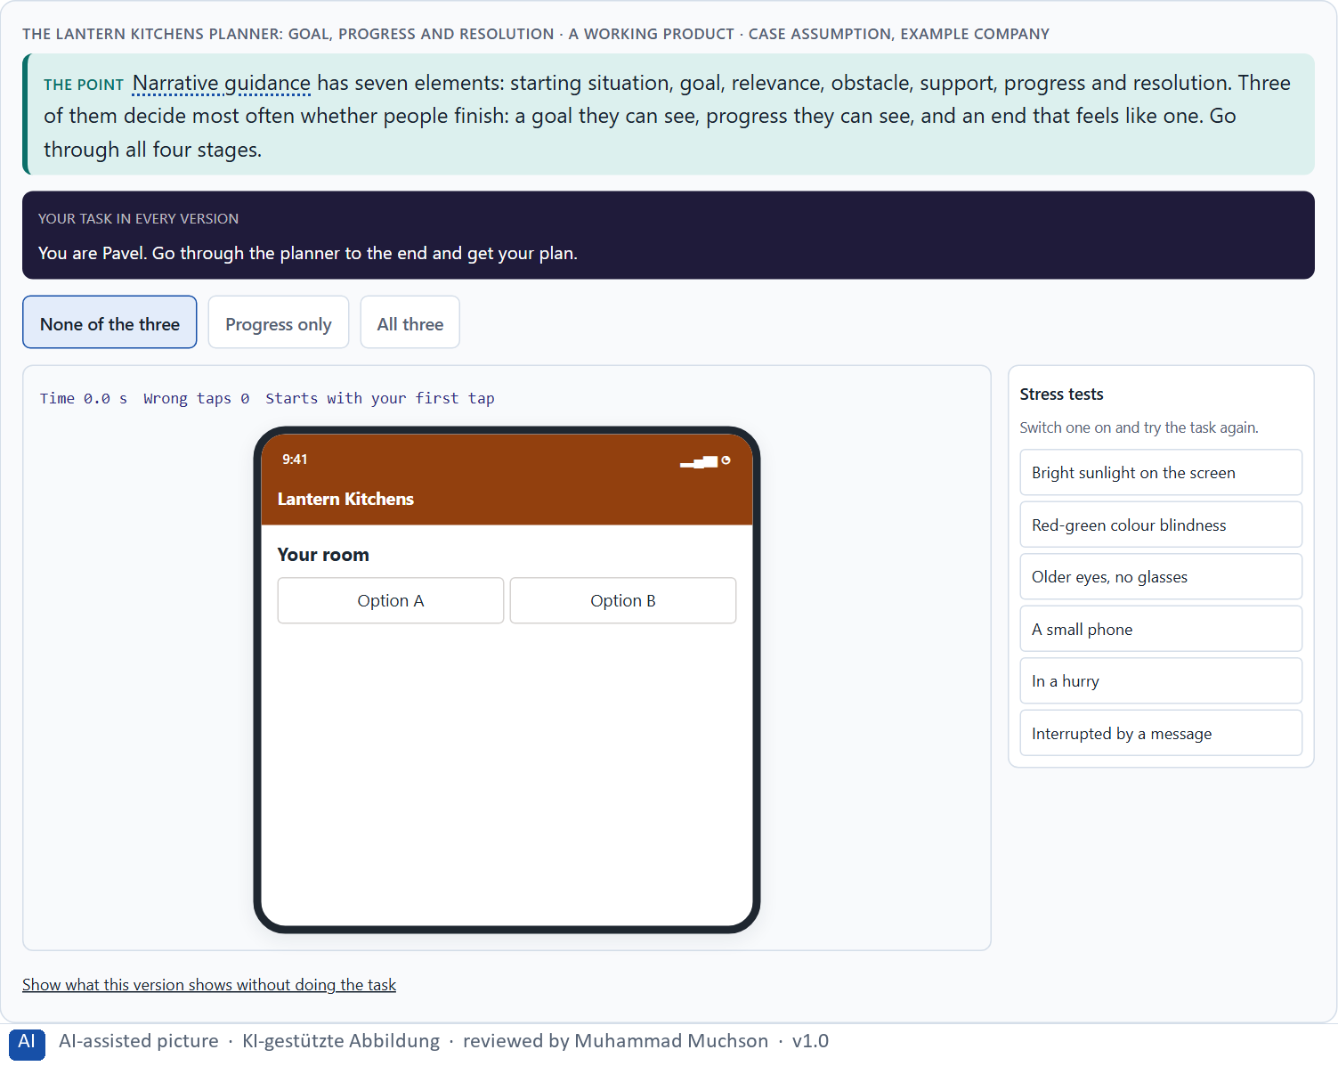
Figure 2 · The Lantern Kitchens planner: goal, progress and resolution. Shown here in its starting state; in the Neuro-UX Lab every version and every stress test can be used.
The seven elements of narrative guidance
Element | In a story | In a digital journey
Starting situation | Where the hero is. | “You have a room and an idea.”
Goal | What the hero wants. | “At the end you have a plan and an offer.”
Relevance | Why it matters. | “So your cabinets fit to the centimetre.”
Obstacle | What stands in the way. | “Measuring is the hardest part.”
Support | Who helps. | A short guide right at that step.
Progress | How far the hero has come. | A path of stages with “you are here”.
Resolution | The goal reached. | The plan shown, the next step named.

The elements of narrative guidance: sources and use
Source | Real finding or example | What it means for a screen
Dramatic structure | Gustav Freytag described a drama as a pyramid of exposition, rising action, climax, falling action and resolution (Freytag 1863). | Start with the situation, build to the decision, and end with a clear resolution.
Stories in UX | Quesenbery and Brooks describe how stories help teams and users with context, goals and obstacles (Quesenbery and Brooks 2010). | Write the starting situation and the goal in the person's words, not the company's.
One step at a time | The GOV.UK Design System asks, in its question pages pattern, to start with one question per page, so users understand what they are asked and can focus on it (GOV.UK Design System). | A sequence gives a path with an end: each page is a step.
Progress | Customers bought more often as they neared a reward (Kivetz et al. 2006). | Show a path of stages with “you are here”.

Case assumption
Lantern Kitchens, Iris, Pavel, June and Arne are made up for this example. The dramatic arc follows Freytag (1863); people speeding up as they see a goal come closer follows Kivetz et al. (2006). The findings in the table of real evidence are real research results, rules and cases; the sources are listed below.

How to decide when this comes up in the task
- Starting situation: does the journey begin where the user is, in their words?
- Goal and relevance: does it say what they will have and why it matters for them?
- Obstacle and support: does it say honestly what is hard and offer help at that point?
- Progress: can they see how far they have come?
- Resolution: does the end show that the goal is reached?

Extra · go deeper (optional reading)
Kivetz et al. (2006) showed the goal-gradient effect: people work faster the closer they see themselves to a goal, and even an illusion of progress (a card that starts with two stamps already filled) makes them finish more often. In a journey this is why visible progress matters most in the middle, where people are furthest from both the start and the end and most likely to stop.

Sources · Quesenbery & Brooks 2010 · Freytag 1863 · Kivetz et al. 2006 · GOV.UK Design System, Question pages

A3 · Telling a story or guiding with one: dramaturgy in a journey · 12 min · Core
Telling a story is not guiding with one. Dramaturgy in a journey is tension, expectation, sequence, transition, confirmation and emotional context, and it lives in small places: the first screen, the line between steps, the message after a step.
IN PLAIN WORDS
The idea. Telling a story about a product (a video, a slogan, a brand story) is not the same as guiding people with a story. Narratively structured guidance builds the journey itself: tension (something is at stake), expectation (people know what comes next), sequence (the steps follow a logic people can feel, not an administrative one), transition (each step leads to the next), confirmation (a finished step is acknowledged) and emotional context (the step is framed by what it means for them). Most of it lives in small places: the first screen, the line between two steps, the message after a step is done.
Why it matters. Block 1.1 asks about StartSmart's missing transitions and steps that are not picked up, Block 1.2 asks you to judge a strongly narrative journey against an efficient one, and Block 2.1 asks about GreenHome's administrative sequence and transitions. This card gives you the dramaturgical means to name them.
How to read the picture. The moment between two steps of the Lantern Kitchens planner, written three ways: a bare Next, a staged scene and a short transition.

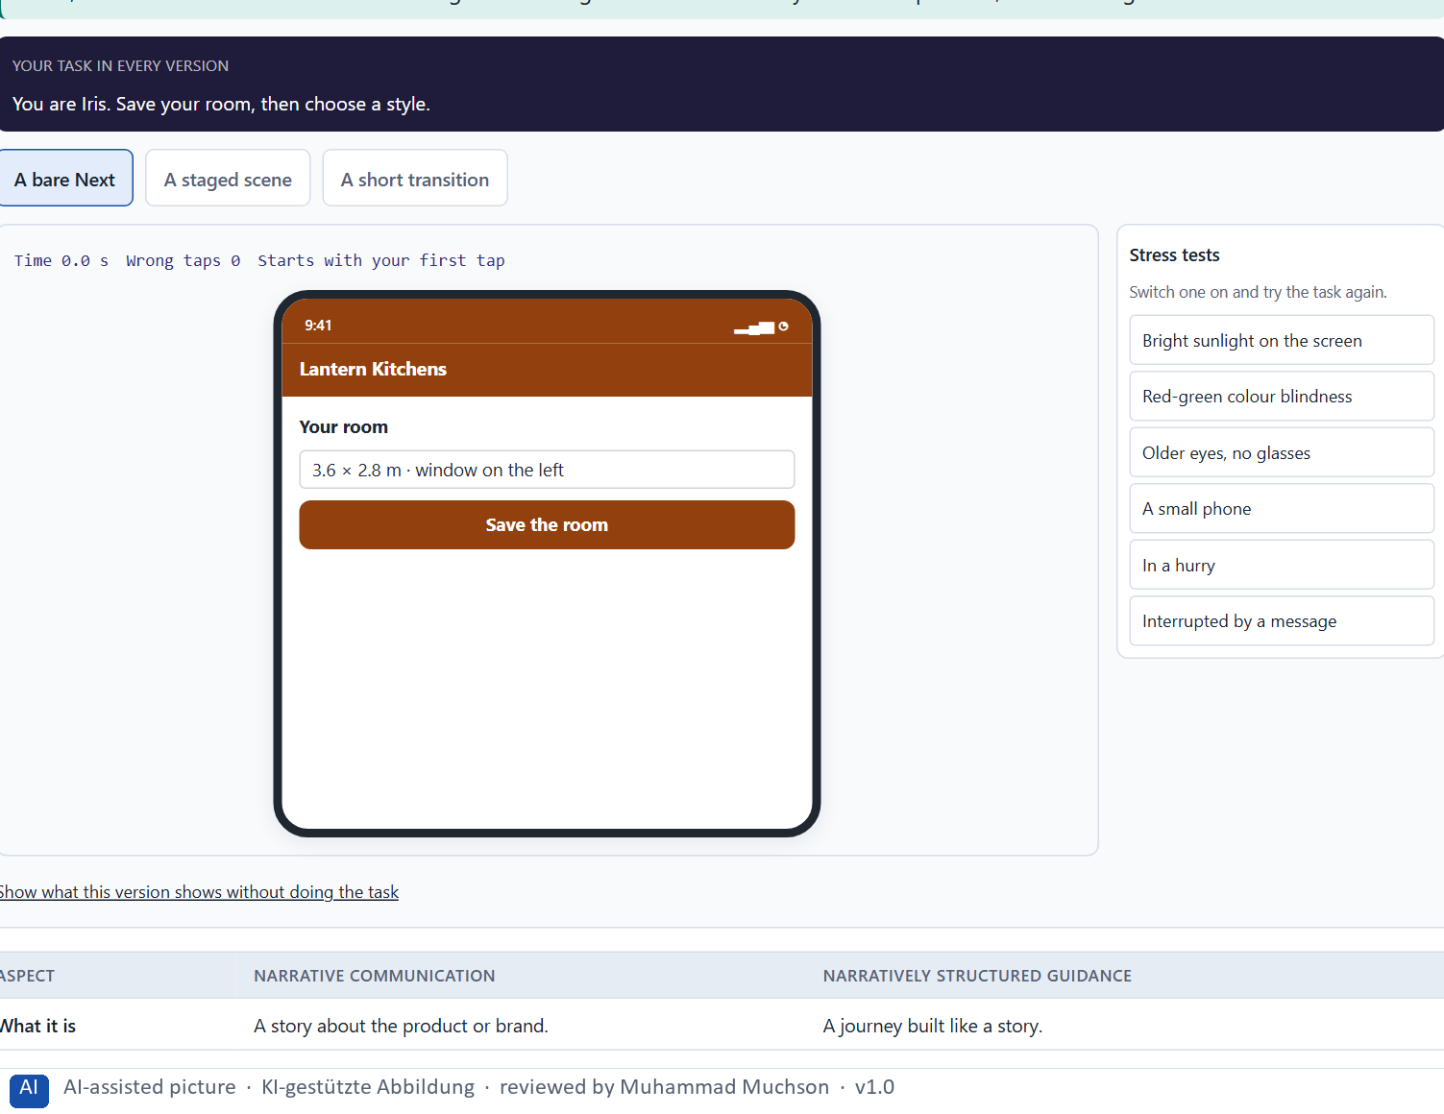
Figure 3 · The moment between two Lantern Kitchens steps: bare, staged and short. Shown here in its starting state; in the Neuro-UX Lab every version and every stress test can be used.
Narrative communication and narratively structured guidance
Aspect | Narrative communication | Narratively structured guidance
What it is | A story about the product or brand. | A journey built like a story.
Where it lives | Films, campaigns, the website. | The first screen, transitions, confirmations.
Whose story | The company's. | The user's.
Its cost | Attention and time before the task. | A line or two inside the task.

Narrative communication or narrative guidance: a real pattern
Topic | Real finding or example | What it means for a screen
A real pattern of guidance | The GOV.UK Service Manual advises to split a form across several pages with each page containing just one thing (GOV.UK Service Manual, Form structure). | Structure the journey by what the person decides now, page by page.
What it buys | A 2015 GDS design note found the one-question-per-page layout better at handling errors, branches, loops and saving progress than the alternatives it compared (Government Digital Service 2015). | The sequence is not only dramaturgy: it carries the logic of the process.
What it costs | The pattern lengthens a form, so a service should only ask for what it needs (Scottish Government Design System; GOV.UK Design System). | Count the pages: each transition needs a reason.
System status | Keep users informed about what is going on, through appropriate feedback within a reasonable time (Nielsen 1994). | Each transition says where you are and what comes next.

Case assumption
Lantern Kitchens, Iris, Pavel, June and Arne are made up for this example. The dramatic arc follows Freytag (1863) and its use in design follows Lupton (2017); visibility of system status is Nielsen's heuristic (1994). The findings in the table of real evidence are real research results, rules and cases; the sources are listed below.

How to decide when this comes up in the task
- Tension: does the user know what is at stake for them?
- Expectation: do they know what comes next, and roughly how much?
- Sequence: do the steps follow the user's logic, or the order of the database?
- Transition: does each step say what was done and lead to the next?
- Confirmation and emotional context: is a finished step acknowledged and framed by what it means for them?

Extra · go deeper (optional reading)
A good transition has three parts and fits in one line: a confirmation of what was done (“Your room is in.”), the expectation of what comes next (“Next: your style.”) and a word on its size or difficulty (“A few choices, all changeable.”). It is the cheapest piece of dramaturgy there is, and the one most often missing.

Sources · Lupton 2017 · Freytag 1863 · Nielsen 1994 · GOV.UK Service Manual, Form structure · Government Digital Service 2015 · GOV.UK Design System, Question pages

A4 · Orientation, motivation and memorability, and the risk of overload · 12 min · Core
A clear story raises orientation, motivation and memorability, and makes people feel the product is for them. Too much staging, too little clarity, more text and longer paths turn it into overload that costs time and trust.
IN PLAIN WORDS
The idea. A clear story raises three things. Orientation: people know where they are and what comes next. Motivation: they see that they are getting closer. Memorability: they remember the journey and its end. Narrative clarity, emotional bond and perceived relevance go together: when people see why a step matters for them, they feel the product is for them. But storytelling can overload: too much staging, too little clarity, more text and longer paths. Then it costs efficiency and trust instead of building them.
Why it matters. Block 1.1 asks for StartSmart's two biggest weaknesses, Block 1.2 asks you to rate three journeys on orientation, motivation, relevance, efficiency and experience quality and to name the conflicts between efficiency and dramaturgy, and Block 2.1 warns against measures that are only staging. This card gives you what a story does and where it stops helping.
How to read the picture. The matrix places five Lantern Kitchens journeys by how much story they carry (upwards) and how clear and quick they stay (to the right). A position is a reading of the example, not a score.

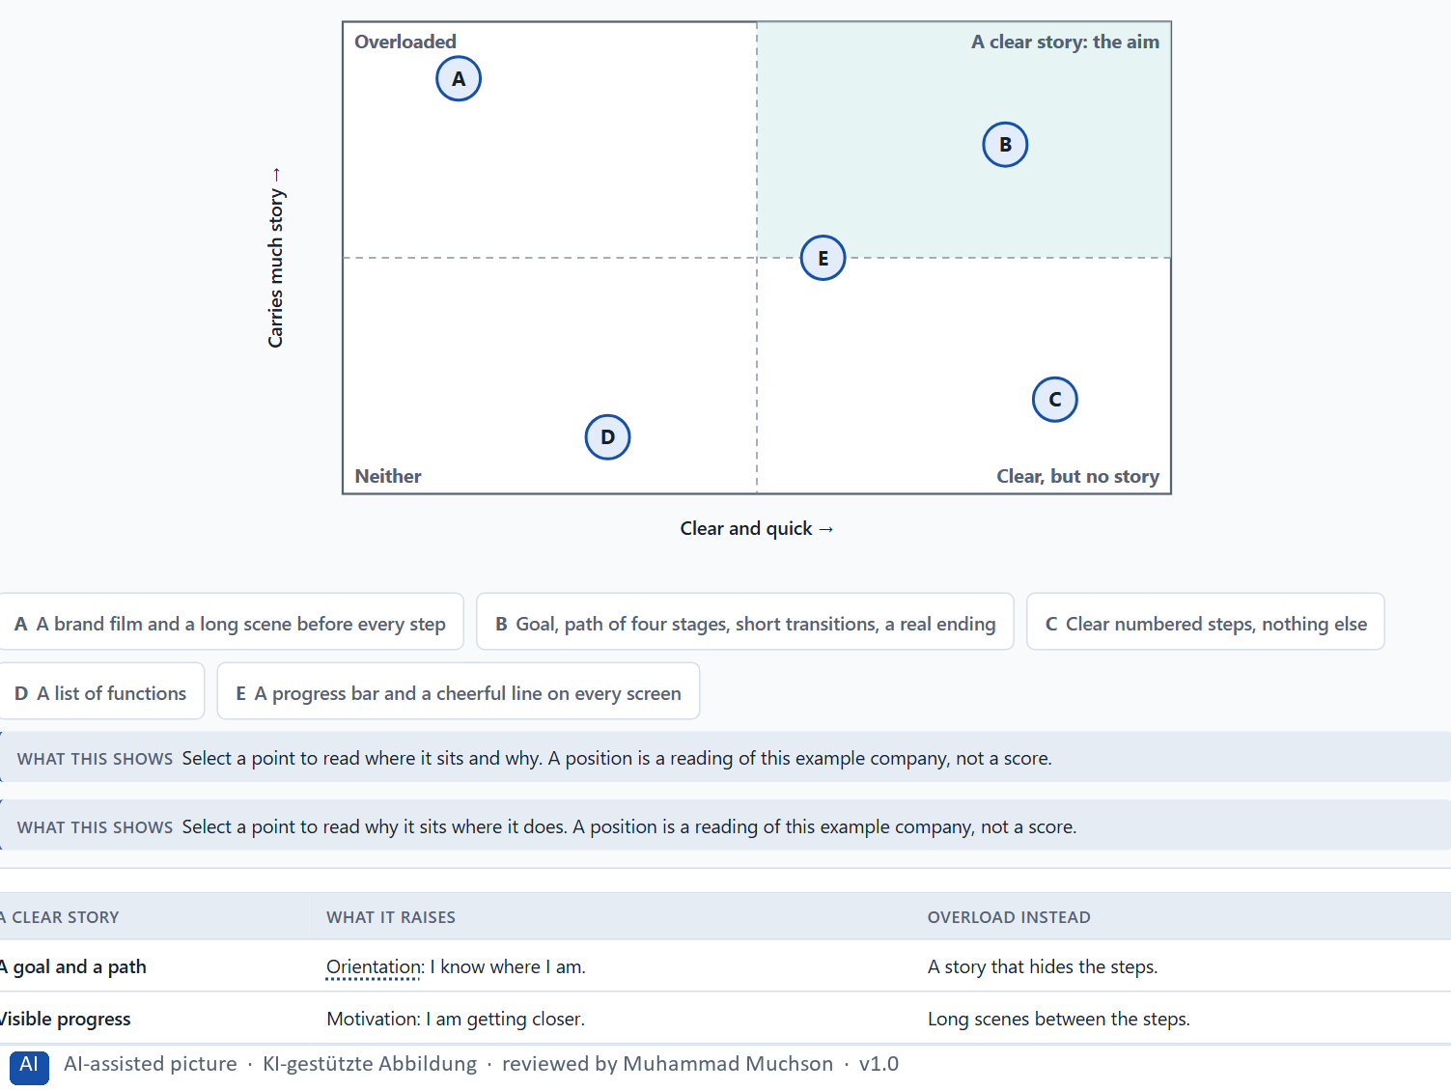
Figure 4 · Five Lantern Kitchens journeys by how much story they carry and how clear and quick they stay · Exploratory.
What a clear story does, and how it turns into overload
A clear story | What it raises | Overload instead
A goal and a path | Orientation: I know where I am. | A story that hides the steps.
Visible progress | Motivation: I am getting closer. | Long scenes between the steps.
A real ending | Memorability: I remember it worked. | A finale that delays the result.
The user's goal | Relevance and bond: this is for me. | The brand's story instead of mine.

Orientation, motivation, memory and overload: findings
Effect | Real finding | What it means for a screen
Orientation | A visitor should be able to tell at once where they are and what they can do (Krug 2014). | Every step names its place in the journey.
Motivation | Effort rises as the goal gets closer (Kivetz et al. 2006). | Show progress early, and show how much is left.
Memory | The end of an episode weighs more than its length in the memory of it (Kahneman et al. 1993, as reported). | Give the journey a real ending: the result, and the next step.
Overload | 79% of users always scanned a new page (Nielsen and Morkes 1997). | A scene that must be read before the task starts will be skipped; keep the story to a line or two inside the task.

Case assumption
Lantern Kitchens, Iris, Pavel, June and Arne are made up for this example. Being absorbed in a story and moved by it follows Green and Brock (2000); the goal-gradient effect follows Kivetz et al. (2006); not making people think follows Krug (2014). The findings in the table of real evidence are real research results, rules and cases; the sources are listed below.

How to decide when this comes up in the task
- Check that every narrative element serves the task: does it orient, motivate or give context?
- Count what the story adds: screens, words, seconds. Is it worth it for these users?
- Prefer a goal, a path and short transitions to scenes and long texts.
- Make the story about the user's goal, not about the brand.
- If the steps are harder to find than before, the story has become overload.

Extra · go deeper (optional reading)
Green and Brock (2000) found that stories move people when they are absorbed in them, and that absorption depends on the story fitting the reader. In a product, users absorbed in a staged story about someone else's kitchen are not absorbed in their own task. The narrative that works in a journey is the user's own: their goal, their progress, their result.

Sources · Green & Brock 2000 · Kivetz et al. 2006 · Krug 2014 · Kahneman et al. 1993 · Nielsen 1997

A5 · Embedding an action in its context, and weighing a measure · 12 min · Core
Storytelling activates, gives context and embeds an action in a meaning: a goal makes it easy to begin, a reason turns a demand into sense, a finished step framed as progress feels like achievement. Weigh measures on effect on users, feasibility, risk and time pressure.
IN PLAIN WORDS
The idea. Storytelling can activate people, give them context and embed what they do in a meaning. Activation: a goal and a next step make it easy to begin. Context: a line that says why a question is asked turns a demand into a reason. Emotional embedding: a finished step framed as progress towards their own goal feels like an achievement, not like paperwork. To put measures in order, weigh each on the four questions Block 2.1 names: effect on users, feasibility, risk and time pressure.
Why it matters. Block 1.2 asks for a decision between three journeys, and Block 2.1 asks for four measures, their justification on these four criteria and a decision for 12 weeks. The example uses Lantern Kitchens and its own measures, so the answer for the task cases is not given.
How to read the picture. First the chain from an action to its meaning for the user. Then three measures Lantern Kitchens considered, rated on effect on users, feasibility, risk and time pressure.

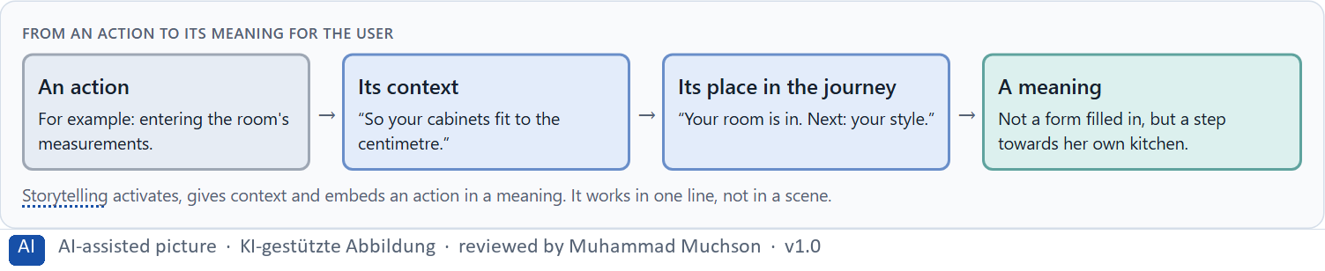
Figure 5 · From an action to its meaning for the user.
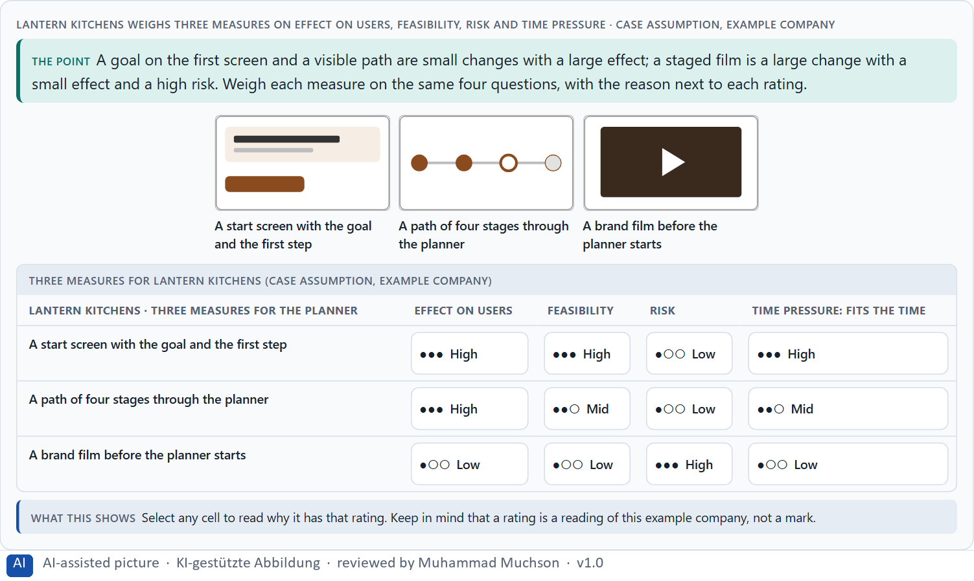
Figure 6 · Lantern Kitchens weighs three measures on effect on users, feasibility, risk and time pressure.
Embedding an action in its context: findings
Finding | What it shows | What it means for a measure
Context makes relevance | Transported readers take more of a story's view (Green and Brock 2000). | Explain why a step matters in the person's situation, in one line, before asking for the action.
Progress as context | Perceived distance to the goal drives effort (Kivetz et al. 2006). | A path of stages with “you are here” is a measure with a visible effect.
Credibility | The design look and the tone are read as signs of care (Fogg et al. 2003). | A story that reads as marketing in a serious context costs trust: weigh it.

Case assumption
Lantern Kitchens, Iris, Pavel, June and Arne are made up for this example. Designing around users' goals follows Quesenbery and Brooks (2010); rating options on the same criteria with a reason follows Gibbons (2018). The four criteria are the ones the plan names for the case study. The findings in the table of real evidence are real research results, rules and cases; the sources are listed below.

How to decide when this comes up in the task
- Activation: does the first screen give a goal and a clear first step?
- Context: does each demanding question say why it is asked?
- Emotional embedding: is each finished step framed as progress towards the user's goal?
- Rate every measure on the same four questions: effect on users, feasibility, risk, time pressure.
- A rating is a judgement with a reason, never a mark.

Extra · go deeper (optional reading)
Context turns a demand into a reason. “Enter your annual consumption” is a demand; “Your annual consumption shows which funding you can get” is the same field with a reason. The second needs a few more words, but it answers the question people ask silently at every field: why do they want this?

Sources · Quesenbery & Brooks 2010 · Kivetz et al. 2006 · Gibbons 2018 · Green & Brock 2000 · Fogg et al. 2003

Materi B · Route 2 · Level 3
How Materi B is used
About 60 minutes, three cards, led by the facilitator. Level 3 in the Chief Experience Officer's chair: a guiding vision for narrative UX, three strategic decisions, an order of which journeys come first, a risk analysis, a governance model for narrative UX principles, one decision under uncertainty and a statement to the management. The cards give you the ideas you use in Task 2.

B1 · Narrative UX as experience architecture, not communication · 20 min · Core
The journey people experience is built by product teams step by step, not by communication. Narrative UX designs it on purpose: a guiding vision, principles, patterns for entries, progress, transitions and endings, and an owner.
IN PLAIN WORDS
The idea. In many companies storytelling is a matter for communication: the brand story on the website, a campaign film. But the journey people experience is built by product teams, step by step, usually from the specialist logic. Narrative UX means designing that journey on purpose: a guiding vision for how every journey begins, carries people and ends, patterns for entries, progress, transitions and endings, and someone who owns them. At senior level it becomes a design logic for relevance, activation and bond, and part of the decision architecture.
Why it matters. Block 3.1 asks for a guiding vision for narrative UX, three decisions on entry, dramaturgical guidance, the experience of progress and narrative relevance, and an order of which journeys, touchpoints or interactions come first, for a company that sees storytelling as communication. You decide the journeys, not the texts.
How to read the picture. Left Lantern Kitchens treating storytelling as communication, right building it into the experience architecture. Below, the layers from a guiding vision to every step.

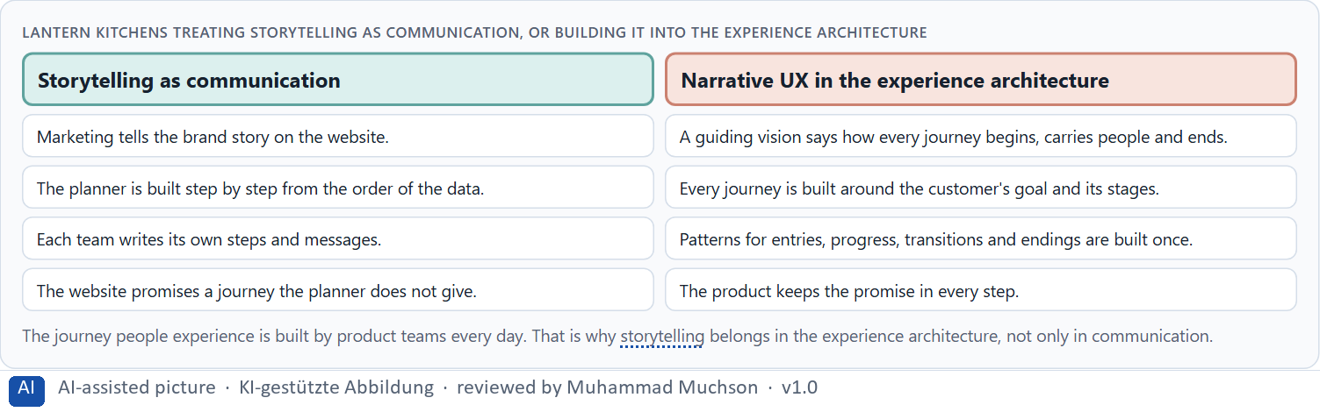
Figure 7 · Lantern Kitchens treating storytelling as communication, or building it into the experience architecture.
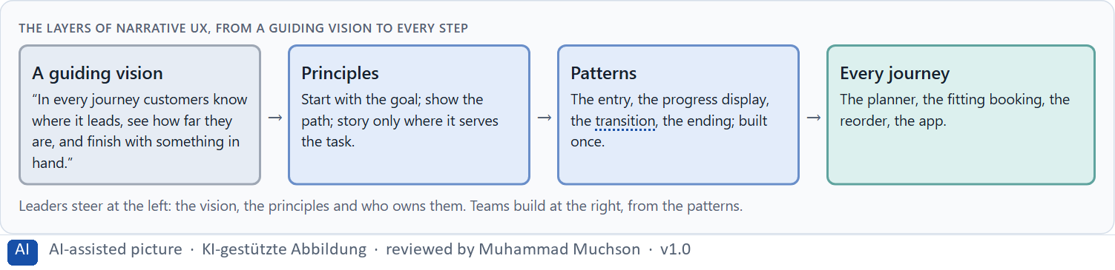
Figure 8 · The layers of narrative UX, from a guiding vision to every step.
Narrative UX as experience architecture: real structures
Part | Real example | What it means
A journey of single steps | The GOV.UK pattern of one thing per page turns a whole service into a sequence of small decisions (GOV.UK Service Manual). | Plan the journey as a sequence across channels, not as a campaign.
A tone by situation | A steady voice with a tone that follows the situation of the reader (Mailchimp, Voice and Tone). | Decide how the story sounds at each point of the journey.
A dramatic structure | Freytag's five parts give the arc of a journey: situation, build-up, decision, resolution (Freytag 1863). | Name the moment of decision and the moment of resolution of each journey.

Case assumption
Lantern Kitchens, Iris, Pavel, June and Arne are made up for this example. Storytelling as part of UX design follows Quesenbery and Brooks (2010) and Lupton (2017). The findings in the table of real evidence are real research results, rules and cases; the sources are listed below.

How to decide when this comes up in the task
- Check where the story is decided today: in campaigns, or in the journeys themselves?
- Write a guiding vision that says how every journey begins, carries people and ends.
- Turn it into a few principles and patterns every team uses.
- Decide by journey which ones need most guidance: the long, important ones first.
- At senior level, storytelling is a design logic for relevance, activation and bond, and part of the decision architecture.

Extra · go deeper (optional reading)
A guiding vision for narrative UX is short and testable: one sentence that names the beginning, the way and the end. “In every journey customers know where it leads, see how far they are, and finish with something in hand” can be checked on every flow. “Every click tells a story” cannot, and it invites staging.

Sources · Quesenbery & Brooks 2010 · Lupton 2017 · Bruner 1991 · GOV.UK Service Manual, Form structure · Mailchimp, Voice and Tone · Freytag 1863

B2 · Efficiency against story: the conflicts of narrative UX · 20 min · Core
Efficiency against dramaturgy, emotionalisation against seriousness, comprehensibility against staging, brand effect against the user's task. Use story only where it serves the task, keep it short, and decide by journey.
IN PLAIN WORDS
The idea. Narrative UX sits between goals that pull against each other: efficiency against dramaturgy (people with little time against a journey with moments), emotionalisation against seriousness (inspiring against credible), comprehensibility against staging (plain steps against a story), and brand effect against the user's task (what marketing wants to tell against what the user came to do). The way through is to use story only where it serves the task, keep it short, and decide by journey: a long, important journey needs more guidance than a quick routine one.
Why it matters. Block 3.1 asks for three guiding decisions, a risk analysis of wrong assumptions about user needs, storytelling and seriousness, and a governance model for conflicts between clarity, brand and experience quality. Each of these is a decision between conflicting goals.
How to read the picture. Three Lantern Kitchens journeys of different length and weight, with how much narrative guidance each needs.

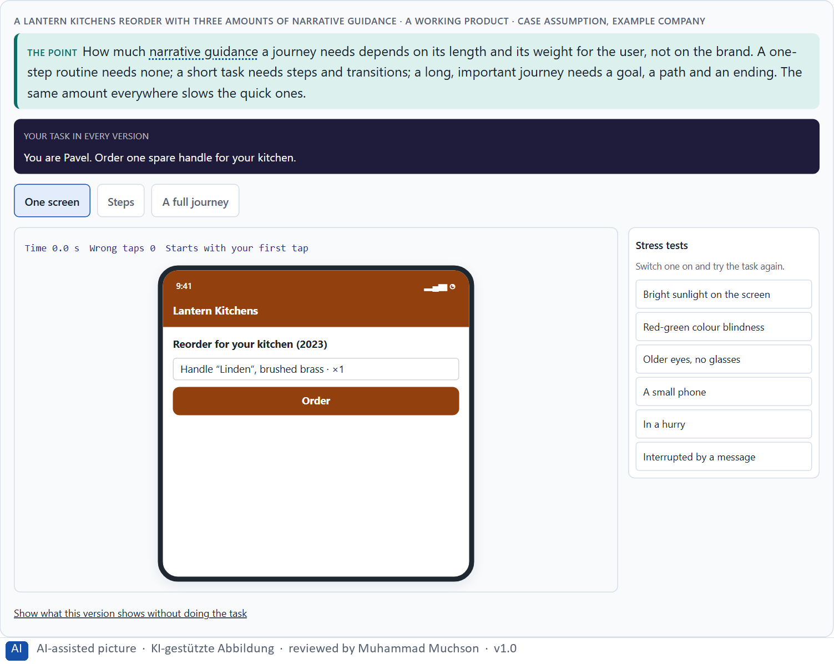
Figure 9 · A Lantern Kitchens reorder with three amounts of narrative guidance. Shown here in its starting state; in the Neuro-UX Lab every version and every stress test can be used.
Standing conflicts of narrative UX
Conflict | Who usually stands for each side | What to ask
Efficiency against dramaturgy | Users with little time, against a journey with moments. | How long and how important is this journey for them?
Emotionalisation against seriousness | Marketing, against the specialist department. | Can it be inspiring and correct in the same line?
Brand effect against the user's task | The brand story, against what the user came to do. | Whose story is this step telling?

Conflicts of narrative UX, with evidence
Conflict | What the evidence says | A way to decide
Efficiency against dramaturgy | 79% of users always scanned a new page (Nielsen and Morkes 1997), and a one-question-per-page form is longer (GOV.UK Design System). | Ask how long and how important the journey is for the person, and tell the story only where it helps the task.
Emotionalisation against seriousness | Pressure and false urgency were found on about 11% of the crawled shopping websites (Mathur et al. 2019). | Keep the emotion true to the situation; test whether the message would work if people knew why it was written.
Brand effect against the user's task | GOV.UK started from user needs, not from the existing way of working (Government Digital Service 2012). | Ask whose story each step tells.

Case assumption
Lantern Kitchens, Iris, Pavel, June and Arne are made up for this example. The three journeys are a reading of the example, not a rule for every product. The findings in the table of real evidence are real research results, rules and cases; the sources are listed below.

How to decide when this comes up in the task
- Name the conflict as two goals and say who stands for each: marketing, the department, the product team, the users.
- Decide by journey: a quick routine needs no story, a long and important one needs a goal, a path and an ending.
- Treat every staged scene and long text inside a flow as a cost to efficiency and clarity, and ask what it buys.
- Write the rule down, so the conflict is not fought again in every flow.
- Say what the choice gives up; a decision that gives up nothing has not been made.

Extra · go deeper (optional reading)
A simple rule settles most conflicts: the amount of narrative guidance grows with the length of the journey and its weight for the user. A rule like this, written into the principles, lets marketing tell its story where people have time for it (the website) and keeps it out of the steps where they do not.

Sources · Green & Brock 2000 · Krug 2014 · Gibbons 2018 · Nielsen 1997 · GOV.UK Design System, Question pages · Mathur et al. 2019 · Government Digital Service 2012

B3 · Who owns narrative UX, and deciding without seeing where people stop · 20 min · Core
Narrative UX lives only with governance: an owner of the principles and patterns, experts who check the facts, marketing who owns the brand story, and a rule for conflicts. A decision with little data says what it decides, does not know, would reverse and gives up.
IN PLAIN WORDS
The idea. Narrative UX lives only with governance: someone who owns the principles and the patterns, the experts who check that the story never blurs the facts, marketing who owns the brand story, and a rule for when they disagree. Data on journeys is often incomplete; people cannot be seen where they stop. A decision under uncertainty says what you decide, what you do not know, when you would reverse it and what you give up. An entry, a progress display and a transition are cheap to change and quick to check, which makes them a safe start.
Why it matters. Block 3.1 asks for a governance model for narrative UX principles, a decision despite patchy data, and a statement to the management. This card gives you the parts of each.
How to read the picture. The four boxes at the top are the parts of a decision, filled in for Lantern Kitchens. The two boxes below are the rule for future decisions.

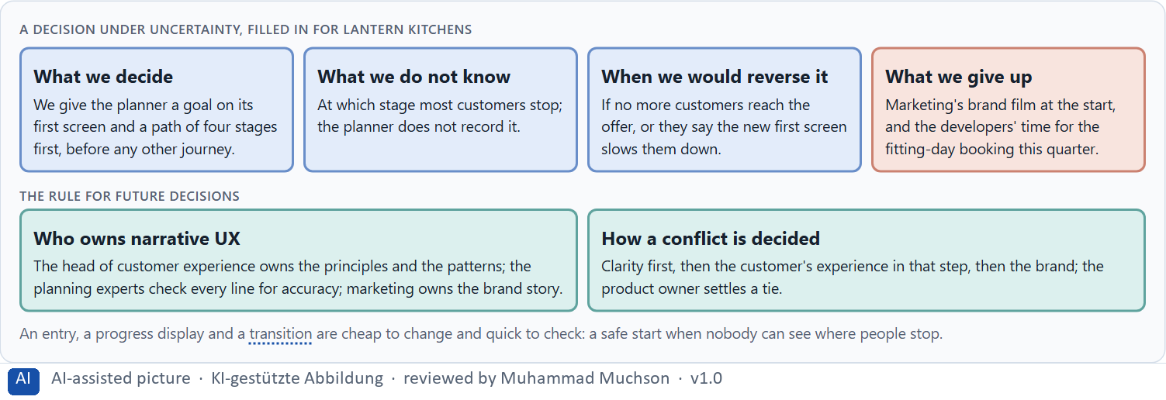
Figure 10 · A decision under uncertainty, filled in for Lantern Kitchens.
Three parts of narrative UX governance
Part | The question | An example (Lantern Kitchens)
Who owns what | Who owns the principles and patterns; who uses them? | The head of customer experience owns them; every team uses them.
Who checks | Who makes sure the story never blurs the facts? | The planning experts check every line; marketing checks the brand.
How a conflict is decided | What happens when clarity, brand and experience quality disagree? | Clarity, then the customer, then the brand; the product owner settles a tie.

Owning narrative UX: real rules and cases
Part | Real example or rule | What it means
Who owns the pattern | The GOV.UK Design System keeps its question pages pattern as a shared, reviewed standard (GOV.UK Design System). | Name an owner for the patterns and let teams use them.
Who checks | Article 25 of the EU Digital Services Act forbids manipulative interface design on online platforms. | Have the specialist and the legal view check every line that carries emotion.
A shared guide | Mailchimp's voice and tone guide is a public document its writers share (Mailchimp, Voice and Tone). | Publish the story and tone rules, so a conflict can be decided against them.

Case assumption
Lantern Kitchens, Iris, Pavel, June and Arne are made up for this example. Deciding with limited information follows Simon (1956); the premortem follows Klein (2007). The findings in the table of real evidence are real research results, rules and cases; the sources are listed below.

How to decide when this comes up in the task
- Name who owns the narrative UX principles and patterns, and who only uses them.
- Give the specialist department a veto on clarity, and marketing ownership of the brand story.
- Settle conflicts by clarity first, then the user's experience in that step, then the brand.
- Say what you decide, what you do not know, when you would reverse it and what you give up.
- Start where changes are cheap, quick to check and easy to reverse: entries, progress, transitions.

Extra · go deeper (optional reading)
Imagine it is a year later and the narrative journeys have failed, and ask why (Klein 2007). The usual answers: the story grew in every release until the steps were hard to find; marketing used the patterns for campaigns; the experts stopped checking the lines. Each answer is a governance gap, not a writing gap.

Sources · Simon 1956 · Klein 2007 · Quesenbery & Brooks 2010 · GOV.UK Design System, Question pages · EU Digital Services Act · Mailchimp, Voice and Tone

Use in class: presentation and handout
Mark of use for the study material. Presentation is what the trainer shows on screen; Handout is what participants read and keep.
Card | Presentation (shown in the Neuro-UX Lab) | Handout
A1 · Why people experience a process as a story (Core) | Scan line and Figure 1; the "In plain words" and "How to decide" boxes | The whole card
A2 · The elements of narrative guidance: from starting point to resolution (Core) | Scan line and Figure 2; the "In plain words" and "How to decide" boxes | The whole card
A3 · Telling a story or guiding with one: dramaturgy in a journey (Core) | Scan line and Figure 3; the "In plain words" and "How to decide" boxes | The whole card
A4 · Orientation, motivation and memorability, and the risk of overload (Core) | Scan line and Figure 4; the "In plain words" and "How to decide" boxes | The whole card
A5 · Embedding an action in its context, and weighing a measure (Core) | Scan line and Figures 5–6; the "In plain words" and "How to decide" boxes | The whole card
B1 · Narrative UX as experience architecture, not communication (Core) | Scan line and Figures 7–8; the "In plain words" and "How to decide" boxes | The whole card
B2 · Efficiency against story: the conflicts of narrative UX (Core) | Scan line and Figure 9; the "In plain words" and "How to decide" boxes | The whole card
B3 · Who owns narrative UX, and deciding without seeing where people stop (Core) | Scan line and Figure 10; the "In plain words" and "How to decide" boxes | The whole card

References
Check each source and its current edition before you teach from it. Standards and laws marked as in flux can change.
Bruner, J. (1991). The narrative construction of reality. Critical Inquiry, 18(1), 1–21. (People make sense of experience as narrative: with a beginning, a goal, obstacles and an outcome.)
Quesenbery, W., & Brooks, K. (2010). Storytelling for User Experience: Crafting Stories for Better Design. Rosenfeld Media. (Stories help teams understand users and shape journeys around their goals.)
Lupton, E. (2017). Design Is Storytelling. Cooper Hewitt, Smithsonian Design Museum. (A design leads people through a sequence with a beginning, tension and resolution; the narrative arc applies to interfaces.)
Green, M. C., & Brock, T. C. (2000). The role of transportation in the persuasiveness of public narratives. Journal of Personality and Social Psychology, 79(5), 701–721. (People absorbed in a story are moved by it; the effect depends on the story fitting them.)
Kivetz, R., Urminsky, O., & Zheng, Y. (2006). The goal-gradient hypothesis resurrected: Purchase acceleration, illusionary goal progress, and customer retention. Journal of Marketing Research, 43(1), 39–58. (People speed up as they see themselves getting closer to a goal.)
Nunes, J. C., & Drèze, X. (2006). The endowed progress effect: How artificial advancement increases effort. Journal of Consumer Research, 32(4), 504–512. (Customers of a car wash got a card with a head start of two stamps or a card without one; the head start group was compared on completion. Check the paper for the figures.)
Freytag, G. (1863). Die Technik des Dramas. Hirzel. (The classic arc of exposition, rising action, climax, falling action and resolution.)
GOV.UK Design System. Question pages. https://design-system.service.gov.uk/patterns/question-pages (Start by asking one question per page, so users understand what they are asked and can focus on it; the pattern lengthens a form, so ask only for what is needed.)
Nielsen, J. (1994, reviewed 2024). 10 Usability Heuristics for User Interface Design. Nielsen Norman Group. https://www.nngroup.com/articles/ten-usability-heuristics/ (Visibility of system status, consistency and standards, recognition rather than recall, aesthetic and minimalist design.)
GOV.UK Service Manual. Form structure. https://www.gov.uk/service-manual/design/form-structure (Start by splitting the form across multiple pages, each page containing just one thing.)
Government Digital Service (2015). One thing per page. GDS Design Notes, 3 July 2015. https://designnotes.blog.gov.uk/2015/07/03/one-thing-per-page/ (The one-question layout was better at handling errors, branches, loops and saving progress than the alternatives compared.)
Krug, S. (2014). Don't Make Me Think, Revisited (3rd ed.). New Riders. (People scan rather than read, follow conventions they know, and should be able to tell at once where they are and what they can do.)
Kahneman, D., Fredrickson, B. L., Schreiber, C. A., & Redelmeier, D. A. (1993). When more pain is preferred to less: Adding a better end. Psychological Science, 4(6), 401–405. (People remember an experience mostly by its strongest moment and its end: the peak-end rule.)
Nielsen, J. (1997). How Users Read on the Web. Nielsen Norman Group. https://www.nngroup.com/articles/how-users-read-on-the-web/ (Most users scan a page rather than read it word by word, picking out words, headings and links.)
Gibbons, S. (2018). Using Prioritization Matrices to Inform UX Decisions. Nielsen Norman Group. https://www.nngroup.com/articles/prioritization-matrices/ (Rate each option on the same few criteria, such as value to the user against effort, and put the reason next to each rating.)
Fogg, B. J., Soohoo, C., Danielson, D. R., Marable, L., Stanford, J., & Tauber, E. R. (2003). How do users evaluate the credibility of Web sites? A study with over 2,500 participants. Proceedings of DUX '03. (2,684 people judged the credibility of 100 live sites; the design look was the factor mentioned most often, in 46.1% of their comments.)
Mailchimp. Content Style Guide: Voice and Tone. https://styleguide.mailchimp.com/voice-and-tone/ (The voice stays steady and the tone changes with the situation and the feeling of the reader; the guide is published under a Creative Commons licence.)
Mathur, A., Acar, G., Friedman, M. J., Lucherini, E., Mayer, J., Chetty, M., & Narayanan, A. (2019). Dark patterns at scale: Findings from a crawl of 11K shopping websites. Proceedings of the ACM on Human-Computer Interaction, 3(CSCW), 1–32. (False urgency, scarcity and confirmshaming are widespread ways of using emotion against users.)
Government Digital Service (2012). Why GOV.UK matters, and the GOV.UK design principles. Government Digital Service blog. https://gds.blog.gov.uk/2012/10/17/why-gov-uk-matters (GOV.UK replaced Directgov and Business Link on 17 October 2012, starting from user needs; the design principles begin with “Start with user needs”. Reported figures such as 61% against 46% task success are the service's own.)
Simon, H. A. (1956). Rational choice and the structure of the environment. Psychological Review, 63(2), 129–138. (With limited information and time, people choose an option that is good enough rather than the best one: a decision under uncertainty.)
Klein, G. (2007). Performing a project premortem. Harvard Business Review, 85(9), 18–19. (Imagine the plan has failed and ask why; it brings risks and wrong assumptions to the surface before the work starts.)
Regulation (EU) 2022/2065 of the European Parliament and of the Council (Digital Services Act), Article 25. https://eur-lex.europa.eu/eli/reg/2022/2065/oj (Online platforms must not design their interfaces in a way that deceives or manipulates users or impairs their ability to make free and informed decisions.)

Glossary
Every term below is used in this document. Terms stay plain text in the body; this list says what they mean in everyday words.
Term | In plain words | Example | Comes from
Activation | Getting people to act now, often with strong stimuli. It can help for a moment and tire or push people if overdone. | — | Day 7
Attention | The mind's spotlight. Only a small part of a screen is processed at any moment; attention decides which part. | A flashing banner takes attention away from the form you were filling in. | Day 1
Brand effect | How a design makes people recognise the company and what they feel about it, such as modern, serious or friendly. | — | Day 3
Case assumption | A fact made up for this exercise to fill a gap in the plan's case. It is marked so you know it is not part of the plan. | — | Day 1
Chief Experience Officer | The manager who is responsible for the experience customers have across all channels, and who decides where the company invests in it. | — | Day 1
Dark pattern | A design that uses emotion against people's own interest, such as false urgency, guilt or hidden costs. | — | Day 7
Decision architecture | A set of connected decisions that are made on purpose and written down: what effect you want, what comes first, who decides and how conflicts are settled. It replaces many separate fixes. | — | Day 1
Design logic | A set of decided rules and shared components, such as which colour means what and which type levels exist, used for every screen so everything stays consistent. | — | Day 3
Dramaturgy | The order and rhythm of a journey: tension, expectation, sequence, transitions, confirmation and emotional context. | — | Day 8
Emotional bond | The sense, built over time, that a product is on your side. It makes people trust it and come back. | — | Day 7
Experience quality | How using a product feels, on the way and afterwards. It goes beyond usability, which only asks whether people reach their goal. | — | Day 7
Goal-gradient effect | People speed up and keep going as they see themselves getting closer to a goal. | — | Day 8
Governance | The rules about who may decide what, who is answerable for it and how disagreements are settled. | — | Day 1
Hypothesis | An assumption you could check later. “This red banner could make users uneasy” is a hypothesis; “this banner is bad” is only an opinion. | — | Day 1
Narrative guidance | Guiding people through a process as a journey: where they start, where they are going, why it matters, how far they have come and when they are done. | — | Day 8
Neuro-UX | Designing an interface with knowledge of how the brain sees, attends, feels and decides, so that the design steers these processes on purpose and responsibly. | — | Day 1
Onboarding | The first journey with a product, from signing up to being ready to use it. | — | Day 8
Orientation | Knowing where you are, what you can do here and what happens next. | — | Day 1
Storytelling in UX | Building a digital journey so it has what a story has: a beginning that shows the goal, a way that shows progress, and an end that feels like an end. | — | Day 8
Tone guide | A short written rule for how a product speaks: which words, how formal, how it sounds when something goes wrong. | — | Day 7
Touchpoint | Any place where a person meets the company: the website, the customer portal, the app, a chatbot or a phone call. | — | Day 1
Transition | The moment between two steps: what was done, what comes next and why. | — | Day 8
UI (user interface) | What a person sees and touches on a screen: buttons, colours, text, icons and their layout. It is the surface of the experience. | Changing a button from grey to blue is a UI change. | Day 1
UX (user experience) | Everything a person goes through when using a product: what they notice, understand, feel and do, from the first look to the last step. The screens are only one part of it. | Finding the booking you want at once and feeling sure it went through is a good UX. | Day 1

The Neuro-UX Lab: where we practise online
In class we use the course website as the place to practise and to learn. Every day has its own address, in the same pattern: the day number is the last part.
What | Address
Neuro-UX Lab (course website) | https://aion-ux-lab.vercel.app/
Day 8 | https://aion-ux-lab.vercel.app/day/8/

On the day page, Route 1 (Levels 1 and 2) and Route 2 (Level 3) can be opened; the cards and the tasks of this document are there too. The pattern is the same up to Day 8, for example https://aion-ux-lab.vercel.app/day/6/.

